March 7, 2024
FDEP Stream Biological Assessment Methods Training
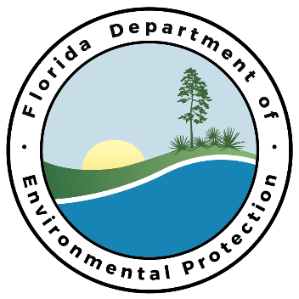
When: Thursday, March 7, 2024, 8:30-4:30 PM EST
Where: Starkey Environmental Education Center, in J.B. Starkey Wilderness Park
10500 Wilderness Park Rd. New Port Richey, FL 34655 (see map below)
To Register: Click here
What to bring: Chest waders, rain gear, clipboard with appropriate forms and SOPs (see table below), dipnet and long-handled brush (if you have them), lunch, and water.

Method | SOP sections (click to access most current SOP) | Form (click for current versions)
Stream Condition Index | SCI 1000 | None
Stream Habitat Assessment and  Phys/Chem | FT 3000 and FT 3100 | FD 9000-03  FD 9000-04  FD 9000-05
Rapid Periphyton Survey | FS 7230 | FD 9000-25
Linear Vegetation Survey | FS 7320 | FD 9000-32

Course Schedule (times may be approximate):
8:30-8:45 AM | Introductions
8:45-10:45 AM | HA and SCI presentations
10:45-11:00 AM | Break & Field Prep
11:00-12:30 PM | HA and SCI Field Practice
12:30-1:30 PM | Lunch (We suggest you bring a lunch)
1:30-2:30 PM | RPS and LVS presentations
2:30-2:45 PM | Break & Field Prep
2:45-3:45 PM | RPS and LVS field practice
4:00-4:30 PM | HA Examples and Wrap-Up
