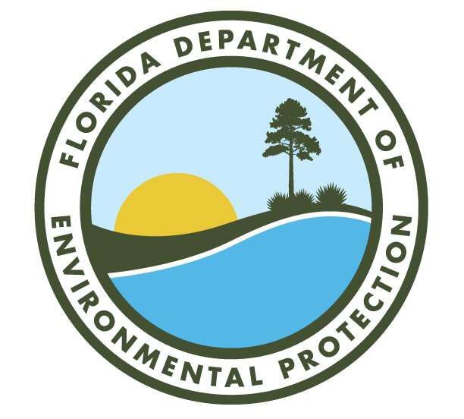
2018 Annual Quality Assurance Report to the Secretary
Division of Environmental Assessment and Restoration
Water Quality Standards Program
Florida Department of Environmental Protection
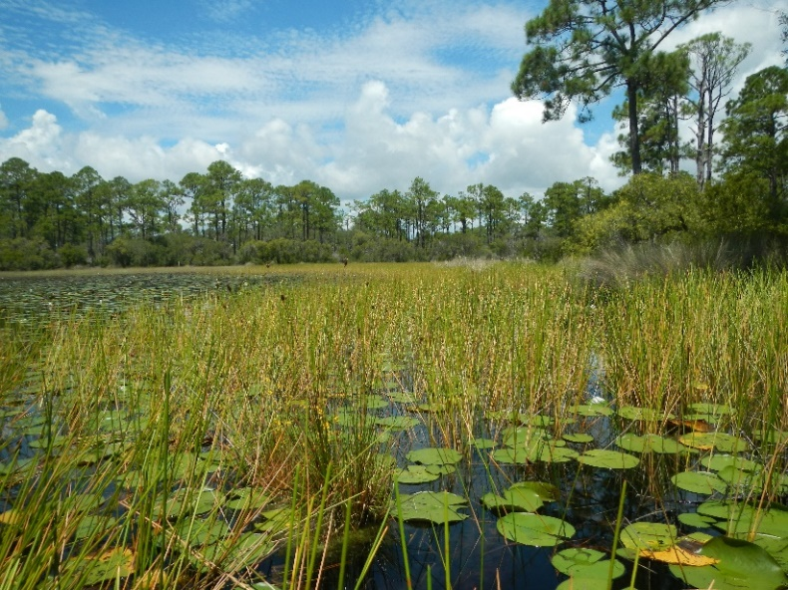

2018 Annual Quality Assurance Report to the Secretary
Division of Environmental Assessment and Restoration
Water Quality Standards Program
Florida Department of Environmental Protection

Acknowledgments
This document was prepared by staff in the Florida Department of Environmental Protection, Division of Environmental Assessment and Restoration, Water Quality Standards Program, Aquatic Ecology and Quality Assurance Section. The following reporting units within the Department contributed to this report:

Ecosystem Restoration Area
Division of Environmental Assessment and Restoration
Water Quality Standards Program
Watershed Assessment Section
Watershed Monitoring Section
Regional Operating Centers
Watershed Evaluation and Total Maximum Daily Loads Section
Groundwater Management Section
Water Quality Restoration Program
Watershed Services Program
Laboratories
Office of Ecosystem Projects
Office of Emergency Response
Office of Resilience and Coastal Protection, formerly Florida Coastal Office
St. Joseph Bay State Buffer Preserve
Rainbow-Oklawaha Florida Aquatic Preserve
Northwest Florida Aquatic Preserve
Central Panhandle Aquatic Preserve
Big Bend Aquatic Preserve
Wekiva River Aquatic Preserve
Tomoka Marsh Aquatic Preserve
Northeast Florida Aquatic Preserves
Indian River Lagoon Aquatic Preserves
Tampa Bay Aquatic Preserves
Rookery Bay Aquatic Preserves
Estero Bay Aquatic Preserve
Charlotte Harbor Aquatic Preserves
Florida Keys Aquatic Preserves
Biscayne Bay Aquatic Preserves
Florida Keys National Marine Sanctuary
Coral Reef Conservation Program
Rookery Bay NERR
Guana-Tolomato-Mantanzas NERR
Apalachicola NERR
Division of Water Restoration Assistance

Land and Recreation
Division of Recreation and Parks
Division of State Lands

Regulatory Programs
Division of Waste Management
Petroleum Restoration Program
Site Investigation Section
Solid and Hazardous Waste Section
Waste Cleanup Section
Federal Programs (DOD and Brownfields)
RCRA
Operational and Program Performance
Business and District Support
Division of Water Resources Management
Florida Geological Survey
District offices

Table of Contents
Acknowledgments iii
List of Figures vi
List of Tables vi
1.Introduction 1
1.1 Background and Overview 1
1.2 Report Organization 1
2. Quality System of the Agency 3
2.1 Overview 3
2.2 Quality Plans 3
2.3 Quality Assurance Officers 4
3. Ecosystem Restoration 5
3.1 Overview and Expected QA Activities 5
3.2 Quality System 9
3.3 Training 11
3.4 Audits 12
3.5 Data Repositories 14
4. Land and Recreation 15
4.1 Overview and Expected QA Activities 15
4.2 Quality System 16
4.3 Training 16
4.4 Audits 17
4.5 Data Repositories 17
5. Regulatory Programs 18
5.1 Division of Waste Management, Office of Emergency Response, and Florida Geological Survey 18
5.1.1 Quality System 21
5.1.2 Training 24
5.1.3 Audits 25
5.1.4 Data Repositories 26
5.2 Division of Water Resource Management (DWRM) & Districts 26
5.2.1 DWRM - QA and Training for Drinking Water Program 27
5.2.2 DWRM QA Wastewater 28
6. Summary and QA Goals 29
6.1 Quality System 29
6.2 Ecosystem Restoration 30
6.3 Lands and Recreation 30
6.4 Regulatory Programs 31
6.4.1 Division of Waste Management, Office of Emergency Response and Florida Geological Survey 31
6.4.2 DWRM & Districts 32
6.5 Overall Conclusions and Continual Efforts 32
Appendix A: QA Officer and Quality Plans by Program as of April 2018 34

List of Figures
Figure 2.1 Organization Units with Quality Plan in 2018 …………………………………………………………….…………..4
Figure 3.1 Diagram of organization & QA related Activities in Ecosystem Restoration………………….…………7
Figure 3.2 Diagram of organization & QA related Activities in Ecosystem Restoration ...…………………………8
Figure 3.3 Self-Reported program activities in Ecosystem Restoration…………………………………………………….9
Figure 3.4 Data Generator information for Ecosystem Restoration ……………………………………………………….10
Figure 3.5 Data User information for Ecosystem Restoration ………………………………………………………………..11
Figure 3.6 QA Training Categories in 2018………...…………………………………………………………………………………..12
Figure 3.7 Expectations of Audits Conducted by Reporting Units in Ecosystem Restoration…….………......13
Figure 4.1 Diagram of organization & QA related Activities in Lands and Recreation…………………….……….15
Figure 5.1 Diagram of organization & QA related Activities in Regulatory (DWM, OER, & FGS)…….……….20
Figure 5.2 Self-Reported program activities for DWM, OER, & FGS ……………………………………………………….21
Figure 5.3 Data Generator information for DWM, OER, & FGS ………………………………………………………………22
Figure 5.4 Data User information for DWM, OER, & FGS ………………………………………………………………………23
Figure 5.5 Employees Training for QA in 2018 for DWM, OER, & FGS ………...………………………………………..24
Figure 5.6 QA Training Categories in 2018 for DWM, OER, & FGS ……………...…………………………………………25

List of Tables
Table 3.1 Audits Reported by Ecosystem Restoration…………………………………………………………………………….12

List of Acronyms and Abbreviations
Anacronym | Definition
AEQAS | Aquatic Ecology and Quality Assurance Section
ANERR | Apalachicola National Estuarine Research Reserve
AP | Aquatic Preserve
BBAP | Biscayne Bay Aquatic Preserve
BBSAP | Big Bend Seagrass Aquatic Preserve
CHAP | Charlotte Harbor Aquatic Preserves
CPAP | Central Panhandle Aquatic Preserves
CRCP | Coral Reef Conservation Program
DBSP | District and Business Support Program
DEAR | Division of Environmental Assessment and Restoration
DEP/Department | Florida Department of Environmental Protection
DOD | Department of Defense Projects Section
DQO | Data Quality Objective
DRP | Division of Recreation and Parks
DSL | Division of State Lands
DW | Domestic Wastewater
DWM | Division of Waste Management
DWRA | Division of Water Restoration Assistance
DWRM | Division of Water Resource Management
EBAP | Estero Bay Aquatic Preserve
EPA | U.S. Environmental Protection Agency
FCO | Florida Coastal Office
FGS | Florida Geological Survey
FKAP | Florida Keys Aquatic Preserves
FKNMS | Florida Keys National Marine Sanctuary
GTM NERR | Guana-Tolomato-Mantanzas National Estuarine Research Reserve
GWMS | Groundwater Management Section
GWIS | Generalized Water Information System
HW | Hazardous Waste Program
IRLAP | Indian River Lagoon Aquatic Preserves
Labs | Florida Department of Environmental Protection Laboratory
MMP | Mining and Mitigation Program
NEAP | Northeast Florida Aquatic Preserves
NERR | National Estuarine Research Reserve
NWAP | Northwest Florida Aquatic Preserves
OEP | Office of Ecosystem Projects
OER | Office of Emergency Response
PRP | Petroleum Restoration Program
QA | Quality Assurance
QAO | Quality Assurance Officer
QC | Quality Control
QMP | Quality Management Plan
QP | Quality Plan
RBAP | Rookery Bay Aquatic Preserves
RBNERR | Rookery Bay National Estuarine Research Reserve
RCP | Office of Resilience and Coastal Protection
RCRA | Resource Conservation & Recovery Act
ROCs | Regional Operations Centers
SJBSBP | St. Joseph Bay State Buffer Preserve
SIS | Site Investigation Section
SOPS | Standard Operating Procedure
STORET | Storage and Retrieval (Database)
SW | Solid Waste Program
TMDL | Total Maximum Daily Loads
WAS | Watershed Assessment Section
WETMDL | Watershed Evaluation and Total Maximum Daily Loads
WMS | Watershed Monitoring Section
WQSP | Water Quality Standards Program
WQRP | Water Quality Restoration Program
WSC | Waste Site Clean-up
WSP | Watershed Services Program

Executive Summary
The Annual Quality Assurance (QA) Report to the Secretary of the Florida Department of Environmental Protection (department or DEP) summarizes QA activities of department programs and evaluates the effectiveness of DEP’s QA Directive (DEP 972) for each calendar year. Established in 2009 and revised in 2016, the QA Directive provides internal department QA policy and outlines the areas of staff responsibility for ensuring the quality of data used by the department. The QA Directive describes how the department will implement the requirements in the QA Rules (Chapter 62-160, Florida Administrative Code) through a distributed approach in which department reporting units develop, document, and maintain a Quality System with clear QA objectives for data they generate or use. This report details the QA efforts and accomplishments made by staff throughout the department in 2018 and identifies areas for improvement needed to fulfill QA management responsibilities outlined in the QA Directive. The only part of the agency not under the QA Directive is the Division of Air Resource Management (DARM), which manages its own QA program and is not included in this report.
Although all department reporting units, excluding DARM, operate under a common QA Rule Chapter and QA Directive, QA activities vary based on the purpose and function of the program, section, or reporting unit. For the 2018 Annual QA Report, Division of Environmental Assessment and Restoration (DEAR) QA staff in the Aquatic Ecology and Quality Assurance Section (AEQAS) collected information from programs via written surveys and personal communication with staff to assess the status of the Quality System for each program or reporting unit. DEAR staff received information from 43 reporting units, an increase from 2017. Staff organized the information by the three areas of the agency: Regulatory Programs, Ecosystems Restoration, and Lands and Recreation. Department programs provided an account of tasks completed in 2018 in the following four QA categories that address one or more department policies and areas of responsibility outlined in the Directive: 1) Quality System; 2) training; 3) audits; and 4) data repositories.
AEQAS uses two components to assess whether department reporting units have the minimum requirements for a Quality System: the designation of QA Officers (QAO) and the existence of current quality plans (QP). For 2018, most, but not all, reporting units have designated QAOs and current QPs that describe the policies and activities developed to help ensure that the quality of data generated or used by the program is defensible. District directors and program administrators within some units of the Regulatory area are still identifying the staff that will best serve in the role of QAOs and will work to develop a new QP for those programs in 2019. Due to ongoing evaluation of the existing quality system, metrics were not reported for every division in the agency, but division leadership provided a narrative for the state of the quality system. Some QPs for other Divisions need updating to reflect changes in the organizational structure, policies and/or activities of the programs covered by the plans.
Of the units that reported, most units that generate or use data indicate that they have data quality objectives (DQOs) to evaluate the quality of the data. DQOs are targets that describe the level of expected data quality and are important to ensure validity and defensibility of department decisions. Program areas that generate data have a stronger QA awareness, according to the self-reporting, than units that only use data. AEQAS worked with the Regulatory area in 2018 on the improvement of quality system documentation and how to implement review of department data with established DQOs in a consistent manner across District offices, and that work continues in 2019.
Based on the submissions from QAOs, the majority of department employees that are involved with the process of data generation, data receipt, data assessment, data archival storage, and data interpretation received training in 2018 to execute their assigned functions. Regulatory programs are reviewing the current employee development materials and identifying which trainings should be consistent across staff and how to track the training activities.
Based on conversations and interactions with program staff, AEQAS has determined that DEP staff need training in general requirements of the QA Rule, the QA Directive, and what QA resources are available. AEQAS staff are coordinating with staff in the Communications Section to determine how to best distribute trainings to ensure all DEP employees are exposed to a department-wide training on QA expectations for the agency.
It is the department’s policy per the QA Directive to develop procedures to audit the performance and record-keeping practices of data generators within and outside the Department. The extent to which agency programs conduct QA audits of any type varies widely, as does the use of established audit procedures and the oversight of required corrective actions. The Ecosystem Restoration area of the agency conducts the most audits within the agency. The need and feasibility of audits in the other areas of the agency are to be determined. The total number of audits increased within the Division of Environmental Assessment and Restoration and the Division of Waste Management.
Programs throughout the agency identified more than 40 different data repositories, both internal and external to the agency, where data are stored and retrieved for program-specific uses. Most of the reporting units that enter data have procedures in place for quality control and quality assurance (QA/QC), but improvements are being made in the documentation of these activities, primarily by reviewing procedures and including reference documents in QPs. Many of the programs that retrieve data rely on the QA/QC procedures of the data provider and lack documented protocols to verify data. Of the reporting units that manage data repositories, most perform QA/QC procedures for the data repositories, but only half have QA/QC procedures documented in their QPs.
The Regulatory Programs have determined that knowledge and awareness of QA/QC procedures through increased training and learning opportunities are important in improving their Quality System in 2019. QA workgroups were established within the Division of Water Resource Management in 2018 and charged with reviewing current QA resources and developing clearer guidance. Workshops facilitated by AEQAS are key in the development of a well-constructed Quality System. AEQAS will coordinate with the Division of Waste Management (DWM) to hold a QAO training event in 2019.
Overall, DEP continues to develop and maintain a functional Quality System, but improvement is needed in the implementation of procedures that have been designed to ensure that we are making decisions based on scientifically and legally defensible data. AEQAS provided trainings and workshops in the last quarter of 2017 and the beginning quarters of 2018 geared specifically to QAOs and managers that assist in making QA decisions. These efforts have further improved communications between AEQAS and QAOs and sparked awareness of QA requirements. To improve and maintain the existing Quality System, QAOs and department management need to have regular communication to discuss the distribution and effectiveness of QA activities. AEQAS will continue to reach out to QAOs and managers to provide training and other support to program staff to promote efforts and outcomes in the specific areas identified in this report. Leadership is encouraged to support the identification of overall QA goals and program-specific expectations for the evaluation of data quality. Leadership is asked to consider minimum requirements for QA training for all staff responsible for the generation or use of environmental data. Additionally, QA activities should be recognized as a priority in upholding DEP’s vision as an agency that values integrity and accountability.

- Introduction

Background and Overview
The Annual Quality Assurance (QA) Report to the Secretary of the Florida Department of Environmental Protection (department) has been compiled for the calendar year 2018 by the Aquatic Ecology and Quality Assurance Section (AEQAS) within the Division of Environmental Assistance and Restoration (DEAR), in coordination with the Quality Assurance Officers (QAO) for the department’s various reporting units and districts. The purpose of the Annual QA Report is to provide an assessment of the status of the department’s Quality System, per the functional responsibilities described in the department’s QA Directive (DEP 972). According to the Directive, DEAR is responsible for coordinating the department’s Quality System, and all programs within the agency are responsible for defining and implementing their individual Quality Systems. The QA policy in the Directive is applicable to all activities that include measurements of environmental matrices for biological, chemical or physical characterization (i.e., environmental data). The only part of the agency not under the QA Directive is the Division of Air Resource Management (DARM), which manages its own QA program.
This report provides a review of the Quality System within the three primary areas of the department (Regulatory Programs, Ecosystems Restoration, and Lands and Recreation), with the focus of the evaluation on whether reporting units conducted the QA activities expected for their program activities. As in previous years, AEQAS staff sent spreadsheet questionnaires (templates) to QAO throughout the department to gather information about their Quality System and QA activities in 2018.

Report Organization
The 2018 Annual QA Report further divides the three primary areas of the department into programs, offices, and districts. Each area of the agency conducts different activities and has a different mission. This division allows AEQAS to provide a more useful picture of the department’s Quality System by grouping programs based on mission and intent. For the purposes of this report, any section, program, or district that responded to AEQAS request for information is referred to as a reporting unit.
The “Quality System of the Agency” section of the report addresses the QA infrastructure of all reporting units in the department. The “Ecosystems Restoration,” “Lands and Recreation,” and “Regulatory Programs” sections outline broad categories of job functions to provide context for expected QA activities, and then report on the 2018 QA activities for that area.
The following four categories comprise the 2018 reported QA activities and address one or more department policies within the QA Directive:
- Quality System: Report of whether the reporting unit is a data user, generator, both or neither; and includes information on the associated data quality objectives (DQOs). Reporting units identifying themselves as data generators participate in activities that involve field sampling or laboratory analysis and are responsible for taking measures to ensure the quality of the data produced by those activities. Reporting units indicated a variety of DQO-related activities, including: following appropriate Standard Operating Procedures (SOPs), establishing DQOs, whether they have procedures to evaluate and qualify data, use of corrective actions when the data generated does not meet the DQOs, inclusion of pertinent QA information in their QP, and if they revised DQOs for the data generated in the reporting year. Reporting units that identified themselves as data users are involved in the use of environmental data generated by DEP or another source and are responsible for ensuring the quality of the data used. Data users reported on the source of data, written standards for the use of the data, data evaluation procedures, corrective actions taken when the data do not meet DQOs, inclusion of pertinent QA information in the QP, and if they revised DQOs for the data used in the reporting year. Some reporting units are involved in both data generation and data use.
- Training: Report of whether reporting units met all training needs, percentage of employees that received training in various categories, and how many training events reporting units were held.
- Audits: Report of instances where staff directly observed sample collection or analysis, conducted an in-depth review of data generation, validated and verified data records, reviewed records to reconstruct data generation, and evaluated data usability, per Rules 62-160.650, F.A.C., and 62-160.670, F.A.C. Audits were placed in one of three categories:
  - Performance: Evaluation of sampler’s or analyst’s technique and knowledge of DEP SOPs or other sampling and field testing, lab methods or record-keeping in the field or lab. Are they doing everything correctly?
  - Project: Tracking specific sample results through field records and/or lab records for data validation and usability assessment. Does the documentation show adherence to sampling/analytical procedures and documentation requirements?
  - System: Evaluation of procedures, equipment and documentation. These audits include lab certification audits and DEP Quality of Science Reviews.
- Data repositories: Report of whether the reporting unit entered, retrieved or managed data in repositories, and whether there are quality assurance procedures for the management of this data and whether those procedures are documented.

- Quality System of the Agency

Overview
A Quality System comprises policies, procedures and criteria utilized to monitor, evaluate, and improve an organization’s QA processes. With the adoption of the QA Directive, the department developed a structured management approach to distribute the functions necessary for the implementation of a Quality System and monitor QA requirements throughout the system.
A Quality System requires planning, implementation and assessment. Two key factors in a functioning Quality System are the use of documents to guide staff in carrying out QA activities, and designating QAOs to assist management and technical staff with the implementation and evaluation of QA activities throughout all levels of the department. The department’s Quality Management Plan (QMP), which is approved by the U.S. Environmental Protection Agency (EPA), documents the Quality System and incorporates other DEP QA documents, including the QA Rules [Chapter 62-160, Florida Administrative Code (F.A.C.)] and the Quality Plans (QPs) developed by the department programs and reporting units that detail their individual Quality Systems. The QMP Revision 8 was approved in 2018 and revision of Chapter 62-160, F.A.C., went into effect in 2017.

2.2 Quality Plans
Department programs and reporting units document their Quality System and describe the overall planning process in QPs. These QPs describe the organization of the program, designate one or more QAOs, and delineate staff QA responsibilities that will ensure data used by the Program are appropriate and reliable. Quality System details can vary among divisions, districts, and offices. It is the responsibility of each program and section administrator to ensure that their Quality System is fully operational and documented in a QP.
QPs are “living documents” and require revisions as program organization, duties and criteria evolve. AEQAS offers education and support to programs and divisions that are reviewing and updating their QPs. AEQAS staff conduct Quality of Science Reviews with program staff to help evaluate their Quality System, including a review of their QP to ensure QA activities are documented and carried out consistently. If administrators would like assistance from AEQAS for QP updates, a Quality of Science Review can be requested. AEQAS asks QAOs to submit their QPs for review and publishing on the QA webpage. There is not a required frequency with which QPs must be updated, but for the purposes of this report AEQAS targets documents older than four years for review to determine if they are out of date. AEQAS encourages annual review of QPs by QAOs and administrators. AEQAS publishes the QPs on the QP webpage once staff have resolved accessibility compliance issues (ADA section 508).
For the 2018 calendar year, 27 QPs were available on AEQAS’ webpage. Seven of the 27 QPs were out of date, mainly due to continuing work within the Regulatory Programs to update their QPs (Figure 2.1). The Division of Water Resource Management (DWRM) and the Division of Waste Management (DWM) are working to review their Quality Systems and update their QPs to provide specific information of QA functions, including those carried out by district offices. Units within the Office of Resilience and Coastal Protection (RCP, formally known as the Florida Coastal Office) have not established a consistent process for QP development. RCP set a goal in 2018 to evaluate and restructure their Quality System and continues to address that goal in 2019. A complete list of reporting units, their designated QAOs, and QP revision dates can be found in Appendix A.
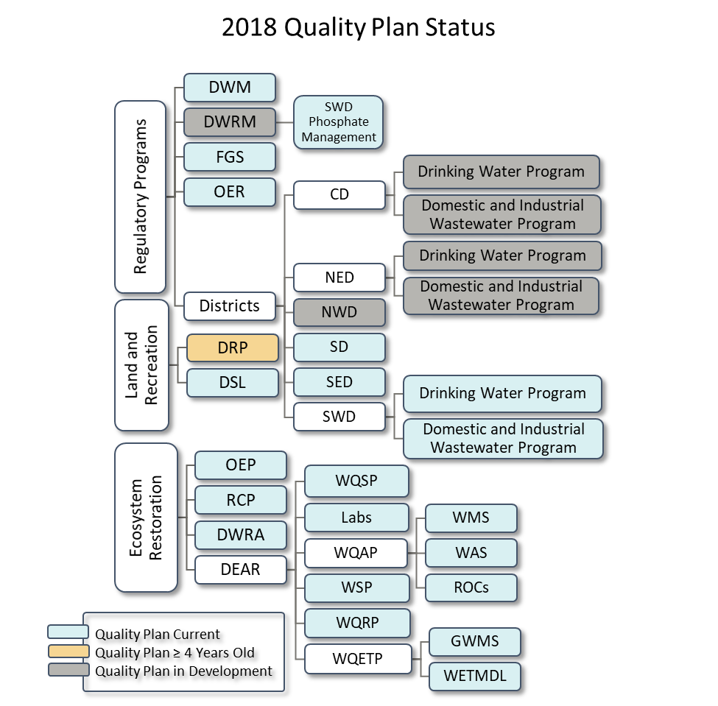
Figure 2.1. Quality Plans that are current, outdated, or in revision for programs in the department’s divisions, districts or offices for 2018. The number of plans required for each division, district or office is dependent on the program groupings included in each plan. Each box in the diagram represents a QP.

2.3 Quality Assurance Officers
The implementation of the internal policies outlined in the QA Directive requires active participation throughout all levels of the department. The department implements its Quality System with the execution of each program’s QP as well as through the coordination and direction of QA activities for the program by a designated QAO. The QA Directive lists the following duties of the QAOs: familiarity with and maintenance of Quality System documents, coordination and performance of internal and external audits, implementation of corrective actions after incidents of non-conformance with DQOs, communication with AEQAS, and tracking of staff training. Division and district directors, along with program and section administrators, are responsible for designating a QAO. The QAO is designated by management to represent specific reporting units.
For 2018, not all programs that required a QAO (as identified by Program and Section Administrators) had one or more designated QAOs. The role of the QAO for the water regulatory programs was under review. It was determined that each district would be responsible for identifying the subject matter expert in both drinking water and wastewater to act as the QAO. The QAO will be responsible for ensuring QA activities are consistent with the Quality Plan, reporting the QA metrics to the Division Office and AEQAS quarterly, attending QA training, and providing QA training/assistance to staff.
AEQAS held a training for DWRM in 2018 during the spring. These trainings were an excellent opportunity to build communication pathways and disseminate information about programs’ or sections’ functions and the role of the QAO in coordinating, recording, and reporting QA information. AEQAS will continue to host trainings for the remaining divisions to ensure that the entire agency receives the training required to fulfill the policies and responsibilities described in the QA Directive. Previously, AEQAS held quarterly teleconferences for QAOs. Due to low participation rates, the quarterly teleconferences were discontinued. AEQAS will take a more active role by participating in division and district teleconferences to better understand the activities of programs and the existing tasks of staff. By doing so, AEQAS staff hope to assist leadership of these divisions and districts in the development of QA activities perpetuating a culture of QA throughout the agency.
- Ecosystem Restoration

3.1 Overview and Expected QA Activities
The Ecosystem Restoration area protects and improves water quality and aquatic resources, including the Everglades, springs, and coastal resources. Restoration programs work with communities, local governments and other agencies to protect and restore water quality and provide funding assistance for water restoration and infrastructure projects. They also coordinate the protection of Florida’s submerged lands and coastal areas. This area of the agency consists of the Office of Ecosystem Projects (OEP), the Office of Resilience and Coastal Protection [RCP, formerly known as the Florida Coastal Office (FCO)], the Division of Environmental Assessment and Restoration (DEAR), and the Division of Water Restoration Assistance (DWRA). For 2018, there were 29 reporting units from the Ecosystem Restoration area, with a wide range of expected QA activities (Figures 3.1 and 3.2).
The OEP, which carries out certain Everglades restoration oversight activities, has one QA reporting unit and three organizational units. This reporting unit primarily manages contracts, grants and purchase orders that fund environmental sample collection and laboratory analysis. Staff should have training on how to assure that the agreements incorporate adequate QA measures, and how to review the agreements and deliverables with respect to the contracted DQOs.
The RCP houses the Florida Coastal Management Program, Aquatic Preserves, National Estuarine Research Reserves (NERRs), the Coral Reef Conservation Program, Clean Boating Program, Florida Resilient Coastlines Program, and the Florida Keys National Marine Sanctuary. The Clean Boating Program and Florida Resilient Coastlines Program have not collected environmental data and are not included in this report. AEQAS identified 22 organizational units, with 18 QA reporting units for RCP which includes 5 more units reporting than in 2017. One reporting unit did not submit the QA information to be included in the report. Various RCP offices collect environmental data for National Oceanic and Atmospheric Administration (NOAA) projects and the department, so some of their DQOs are aligned with NOAA expectations and some with DEP’s. Depending on the location and activities of the offices within RCP, data entry into databases may occur, along with limited data review. The RCP also manages department contractual agreements for environmental sampling and analysis. Reportable QA information for these activities include DQO establishment, training for SOPs, data entry and review of data with respect to DQOs and understanding QA requirements for the management of agreements.
DEAR monitors and assesses surface water and groundwater quality, which includes identifying, verifying and prioritizing impaired waters; developing strategies to address impairments; and implementing those strategies through comprehensive restoration action plans in partnership with local stakeholders. DEAR consists of nine QA reporting units and six organizational units. DEAR collects, analyzes, enters, reviews, and manages data in databases, and oversees agreements that include environmental sample collection. Reportable QA information for these activities includes DQO and SOP establishment, training for SOPs, evaluation of data, and auditing data providers both internal and external to the DEAR reporting unit.
DWRA is responsible for providing financial assistance to fund projects that improve the quality and quantity of the water resources of the state. The projects improve stormwater quality, reduce pollutants entering surface water and ground water, conserve energy or water, protect springs, collect and treat wastewater, produce and distribute drinking water, provide alternative water supply, and restore habitat and enhance recreation through the Deepwater Horizon program. DWRA has one QA reporting unit and six organizational units. DWRA staff do not generate or interpret data; the primary function of this division is to manage agreements. Reportable QA information for these activities includes establishment of DQOs, program-specific training related to QA requirements, and potential audits of the fund recipients.
The data reported in the following sections are based on 29 reporting units consisting of 18 from RCP, 9 from DEAR, and 1 from OEP. The QAO from DWRA did not provide a completed template for this report. Together, these units make up 100 percent of QA reporting units from Ecosystem Restoration.
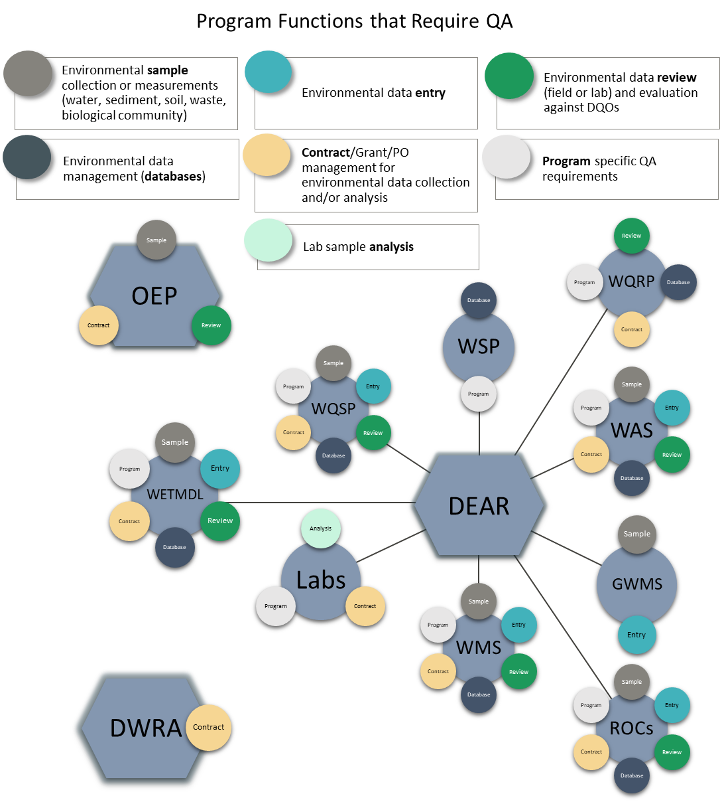
Figure 3.1. Diagram of reporting units from DEAR, OEP, and DWRA showing each work unit’s functions that require QA activities, represented by color-coded circles. The circles do not indicate whether that program or section reported on that function.
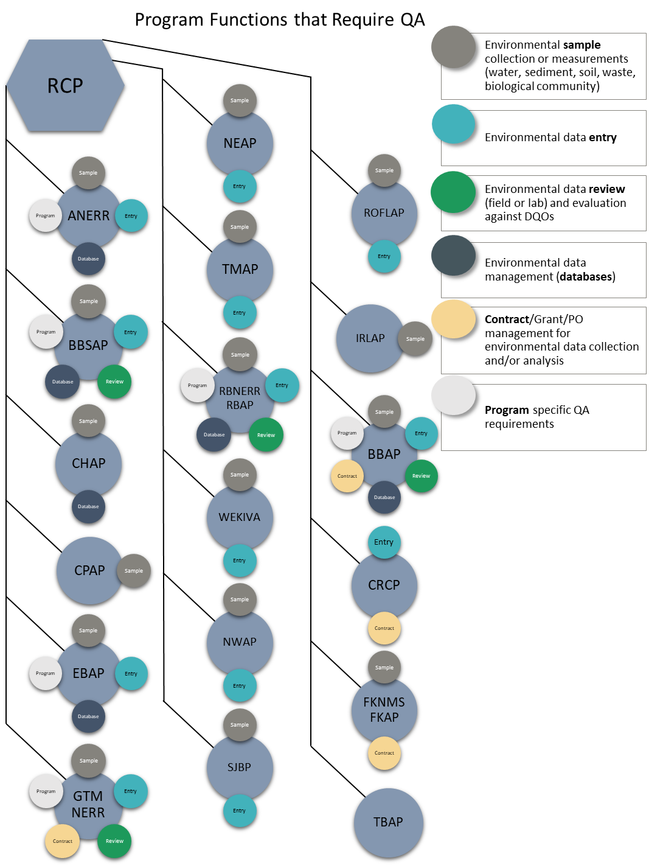
Figure 3.2. Diagram of reporting units from RCP showing each work unit’s functions that require QA activities, represented by color-coded circles. The circles do not indicate whether that program or section reported on that function.
Figures 3.1 and 3.2 provide context for the QA activities that AEQAS expects reporting units to report. All program functions listed require reporting units to have and document DQOs and provide adequate QA training to staff. Entities that collect or analyze environmental samples or measurements are expected to conduct internal audits and/or be audited by external parties to ensure proper collection and analysis of data. Reporting units that use data are expected to audit external entities who provide data to the department with some established consistency and frequency. Reporting units that manage contracts, grants, or purchase orders (PO) for environmental data collection or analysis may conduct audits of procured services. Reporting units that enter, retrieve data, or manage environmental data repositories must have documented procedures for QA/QC.

3.2 Quality System
The majority (57 percent) of reporting units from the Ecosystem Restoration area of the agency reported as both data generators and data users. More than a quarter of the 28 units reported only as data generators and a small number reported only as data users. One unit (Watershed Services Program) identified itself as neither a data generator nor a data user (Figure 3.3).

Figure 3.3. Number and percentage of reporting units within the Ecosystem Restoration area who identified their program activity functionality as data user, data generator, both or neither. (Does not include DWRA).
Percentages of reporting units with Quality System components as reported by data generators are illustrated in Figure 3.4. All programs that generate data follow DEP SOPs, other SOPs, or a combination of both. The majority use DEP SOPs. Only 13 of the 24 units that generate data reported that their QP incorporates all the SOPs used by the reporting unit, which means the remaining units need to revise their QPs to include references to SOPs. Eighteen reporting units indicated they have checklists to evaluate the data generated against the DQOs. However, only 14 of those 18 reporting units indicated the QP incorporates checklists, and all checklists should be included or cited in QPs. Fifteen reporting units stated that there were corrective actions for when data did not meet the DQOs, but only 12 units document the corrective actions and have the corrective actions in their QP. AEQAS instructs reporting units to include a process for documenting corrective actions in QPs. Three of the 24 reporting units that generate data revised their DQOs and corrective actions during 2018.
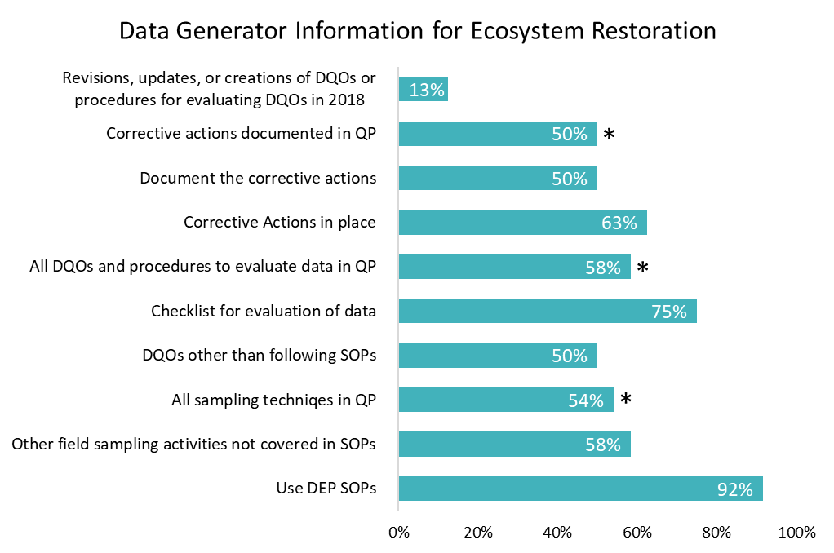Figure 3.4. Percentage of reporting units in the Ecosystem Restoration area who answered “yes” to dichotomous questions regarding data quality objective use and documentation specific to roles as data generator in the 2018 survey template. Bars with an asterisk (*) are expected to be 100 percent. There are 24 total data generators.
Percentages of reporting units with Quality System components as reported by data users are illustrated in Figure 3.5. Twelve of the 18 reporting units that identified as data users have written DQOs, and 13 reported that the data used are evaluated against the DQOs to ensure data quality for the unit’s purpose. Seven units reported that another DEP unit evaluates the data used. Eight units have a checklist for evaluation, and seven units documented the checklist in their QP. Nine reporting units have corrective actions for instances when data do not meet DQOs. Eight units reported following up with corrective actions and that those corrective actions are in their QP. Four reporting units revised corrective actions documented in their QP in 2018. It is department policy that all data users have established DQOs and corrective actions and document them in the QP.
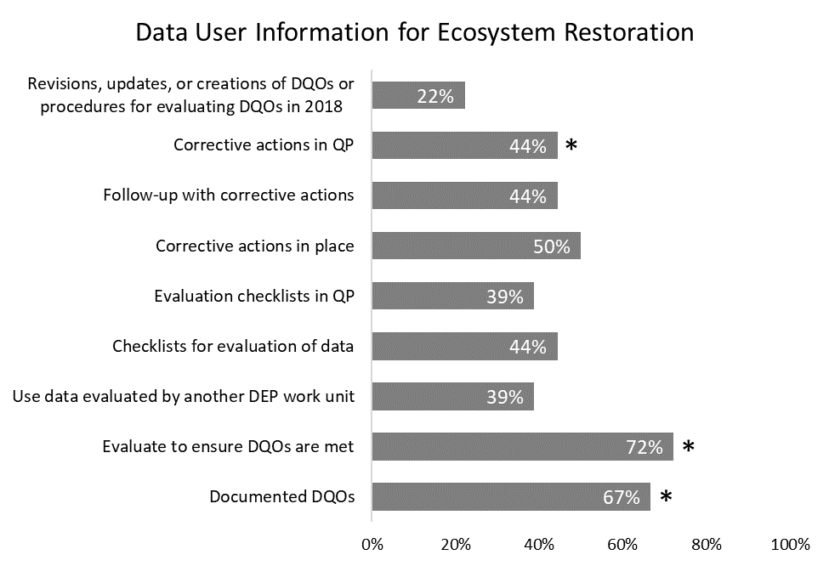Figure 3.5. Percentage of reporting units in the Ecosystem Restoration area who answered “yes” to dichotomous questions regarding data quality objective use and documentation specific to roles as data user in the 2018 survey template. Bars with an asterisk (*) are expected to be 100 percent. There are 18 total data users. (DWRA not included)

Training
QAOs identified QA training needs by reporting numbers of staff that needed the training versus the staff that received the training. Combining all staff from all reporting units and the training categories, 99.25 percent of employees received training for QA tasks in the Ecosystem Restoration area. When reviewing the 27 reporting units of Ecosystem Restoration that reported independent of each other, three units reported not having their training needs met, while seven reporting units did not identify training needs in 2018.
All employees in the Ecosystem Restoration area that required training in field sampling, laboratory analysis, contract or grant requirements, data assessment, and database management categories received the training (Figure 3.6). Only two percent of employees that required training on program-specific QA requirements did not receive it. DWRA reported that all staff in the Nonpoint Source program and some in Deepwater Horizon program received a training in 2018 to refresh their knowledge of the QA agreement attachment and the appropriate instances to include the document.

Figure 3.6. Percentage of staff in the Ecosystem Restoration area that received the required training within each QA training activity in 2018 (DWRA not included).

Audits
AEQAS asked reporting units within the Ecosystem Restoration area of the agency to tally their audits from four different perspectives (Table 3.1). In total, 57 audits were reported for 2018, an increase from the 46 reported in 2017.
Eight of the 24 reporting units were audited (by an external entity or themselves) in 2018, and six reporting units conducted at least one audit. The total number of audits conducted by Ecosystem Restoration reporting units in 2018 was 57; most of those were performance audits (Table 3.1). DWRA did not provide metrics for audits as its staff did not conduct audits of environmental data generation or use.
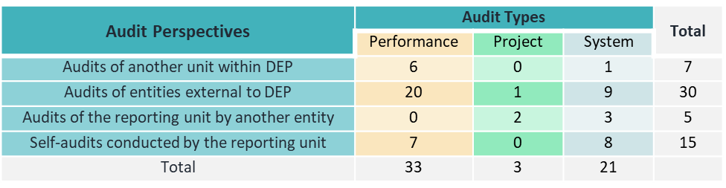Table 3.1. Audits reported by Ecosystem Restoration reporting units for 2018.
Two Ecosystem Restoration reporting units conducted a total of seven audits of other DEP reporting units. All units reported generating an audit report, and all the reporting units used checklists to conduct audits. Some reporting units established a required report time frame, but only about half met the established time frame goal (Figure 3.7).

Figure 3.7. Percentages of Ecosystem Restoration reporting units meeting seven QA criteria for conducting audits in two audit categories: external audits that are conducted by the reporting unit of entities within DEP and external audits conducted by the reporting unit of an entity outside of DEP.
In 2018, there were five audits performed by external parties on three Ecosystem Restoration reporting units. Two of the reporting units audited by an entity outside their unit during 2018 reported a required auditing frequency for those audits, though all three reporting units did follow through with corrective actions. Seven reporting units conducted one or more internal audits of their own unit, for a total of 15 audits. Of the seven units that conducted internal audits of itself, six had an established frequency requirement, but few had followed through with corrective actions at the time of reporting. Appropriate measures should be taken to ensure audits are performed and tracked in a consistent manner, following a reasonable timeframe for completion, and that corrective actions are completed.

3.5 Data Repositories
Of the reporting units within Ecosystem Restoration, 82 percent (24 of the 28 reporting units) indicated that the staff enter data into at least one data repository. Sixty-one percent (17 of 28 reporting units) retrieve data, and 25 percent (7 of 28 reporting units) are responsible for managing data in repositories.
Reporting units in the Ecosystem Restoration area of the department enter data into 20 different data repositories. Of the 23 reporting units that enter data, 19 reported that staff verify data entered for all of the repositories into which they enter data, and the remaining 4 units verify data entered into at least one repository. However, only 8 of the 20 reporting units that enter data have documented protocols for entering and verifying the data for all of the data repositories and an additional 4 reporting units have protocols for at least one data repository. Reports in previous years have shown this is consistently an area in need of improvement. To ensure consistent and correct data entry, protocols should be in place for each data repository used.
Nineteen reporting units retrieve data from forty-two different data repositories. Fourteen of the nineteen reporting units perform QA/QC checks on the data retrieved from at least one of their data repositories, but only half of those perform QA/QC checks on the data retrieved from all their data repositories. Seven reporting units had written protocols for the retrieval of data from at least one repository, with five of the seven reporting that there are written protocols for all the repositories used for retrieval. Sixteen reporting units have feedback mechanisms in place to notify the data generator of suspect data for at least one data repository, and thirteen have feedback processes for all data retrieved. Six reporting units indicated having feedback mechanisms described in their QP for at least one data repository, and another five had feedback mechanisms described in the their QP for all data repositories. To obtain data consistently and uniformly, protocols for QA/QC checks, data retrieval, and feedback mechanisms should be in place for retrieving data from each data repository utilized by a unit.
Seven reporting units within Ecosystem Restoration manage seven data repositories. Of those seven units, five reporting units perform checks on all data repositories managed, and the remaining two units perform checks on at least one of the repositories they manage. Three of the reporting units that manage data repositories have protocols documented for QC checks of the stored data for at least one data repository, and two of those have protocols for all the data repositories they manage. Four of the seven have a mechanism to provide feedback to the data generator for suspect data. Only two reporting units have all protocols and feedback mechanisms documented in the QP. For the validity of data housed, documented protocols should be in effect for all data repositories.

Land and Recreation

Overview and Expected QA Activities
The Land and Recreation area of DEP acquires and protects lands for preservation and recreation. It includes 175 state parks and trails, more than 12 million acres of public lands, and four million acres of coastal uplands and submerged lands. Land and Recreation includes two divisions: Division of Recreation and Parks (DRP) and Division of State Lands (DSL). DRP reports as one unit, though organizationally, there are eight programs. Within this division, there are also five unique districts. DSL also reports as one unit though six programs make up the division. Figure 4.1 indicates the functions of DRP and DSL that involve QA activities.
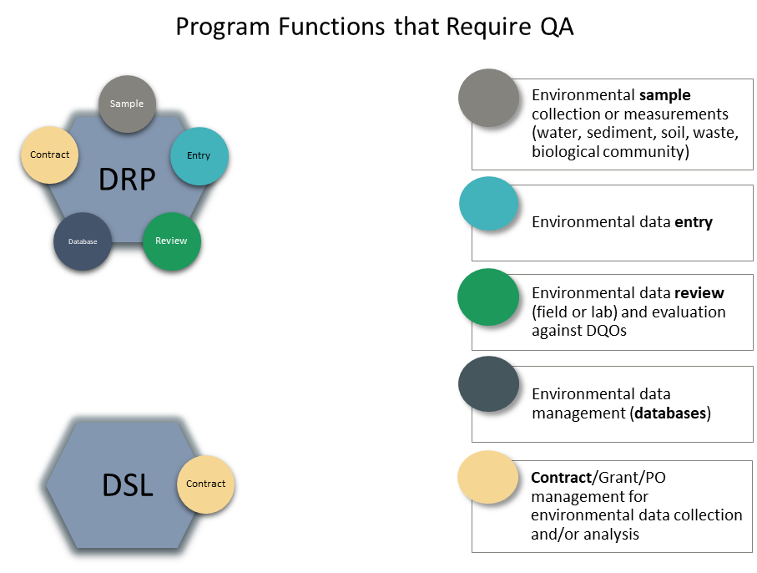
Figure 4.1. Diagram of the reporting units for DRP and DSL showing each unit’s functions that require QA activities, represented by color-coded circles. The circles do not indicate whether that program or section reported on that function.
Although its primary missions are to manage public land and provide recreational opportunities for the public, DRP collects some environmental data for the department, either directly or indirectly through purchase orders. Some sampling is for research purposes, while some is for compliance with drinking water, wastewater, and bathing beach monitoring requirements. Sampling projects and procedures vary across the DRP districts based on regional needs. For all sampling, expected QA activities include adherence to standard procedures (i.e., SOPs), training for SOPs, data entry, data review, and data management. Because DRP manages sampling agreements, it must have established DQOs, training for staff to review data against DQOs, and training to understand when to incorporate QA into agreements with the department.
DSL manages purchases, maintains state lands and conservation easements, and is not directly involved with the collection and analysis of environmental data; therefore, DSL has limited QA reporting. DSL reports on DQOs and training related to program-specific QA requirements, as well as limited data retrieval.
Figure 4.1 provides context for the QA activities that AEQAS expects reporting units to report. All program functions listed require reporting units to have and document DQOs and provide adequate QA training to staff. Entities that collect or analyze environmental samples or measurements are expected to conduct internal audits and/or be audited by external parties to ensure proper collection and analysis of data. Reporting units that use data are expected to audit external entities who provide data to the unit with some established consistency and frequency. Reporting units that manage contracts, grants, or POs for environmental data collection or analysis may conduct audits of procured services. Reporting units that enter, retrieve data, or manage environmental data repositories must have documented procedures for QA/QC.

Quality System
The DRP and DSL are both data users. Portions of DRP are also data generators. In 2018, DRP planned to determine which facilities and offices throughout the state were responsible for drinking water and recreational water testing as to better target QA needs and existing processes. Due to the intensity of the 2018 hurricane season, DRP efforts were shifted away from QA goals to other urgent issues. Currently, the QAO and leadership are working to focus on a more expanded QA system for the division. As counties and municipalities assume the responsibility for the water testing in parks through purchase agreements, training related to purchase order QA requirements and the authority of Chapter 62-160, F.A.C., should be increased. From previous reports, it has been acknowledged that DRP follows external SOPs for invasive plant surveys, nuisance exotic animal control, and imperiled species monitoring. When park staff were responsible for sample collection, they followed the DEP SOPs for compliance water sample collection. DRP reported that it has DQOs, but staff do not evaluate data to ensure that the data meet the DQOs. The QP is currently out of data, and the Quality System is being evaluated. To improve the validity of the data produced and used by DRP, procedures must be documented and agreed upon by the division. The most recent DRP QP does not document the following items: SOPs used, DQOs, procedures to review DQOs, and corrective actions for when data do not meet DQOs.
The DSL QP was updated in 2016 and contains DQOs and corrective actions, but no updates were made in 2018.

Training
No QA training was reported by the units within Land and Recreation.
The QAOs in the Land and Recreation area reported on training events conducted in their reporting units during the 2017 calendar year. DRP staff received field sampling training for FWC sea turtle monitoring and internal training on entering data into the Natural Resource Tracking System (NRTS).
AEQAS hopes to host a program-specific QA training for key staff in these divisions in 2019 regarding purchase order agreements and the importance of QA. Further discussion is required with DRP to determine the best course of action in building a comprehensive Quality System. AEQAS can assist the divisions with determining where staff’s tasks should be documented and what procedures are appropriate for the entire division.

Audits
The Land and Recreation Area did not report any audits. Reporting units within this area are not likely to report audits in the volume or frequency of other areas of the agency. However, environmental data collected through compliance monitoring or sampling for research is subject to audits.

Data Repositories
DSL reported that staff do not enter, retrieve or manage any environmental data. DRP did not report on its activities. For the 2017 report, DRP provided information for entering and retrieving data using the Natural Resources Tracking System (NRTS) data repository. DRP stated at the district level, staff enter data into NRTS, though there is no documented process. District staff also retrieve data from NRTS and perform informal checks, but there is no documented protocol or formal procedure to handle suspect data. DRP reported maintaining internal Excel files of environmental data in previous years and have indicated that the data are managed in these files using informal methods. DRP has not established a consistent protocol for the use of Excel files nor documented data repository activities in its QP.

Regulatory Programs

Division of Waste Management, Office of Emergency Response, and Florida Geological Survey
The Regulatory district offices (districts), Division of Waste Management (DWM), Division of Water Resource Management (DWRM), Office of Emergency Response (OER), and the Florida Geological Survey (FGS) comprise the Regulatory Programs area of the agency. The data presented in this section of the report are based on the 10 reporting units that submitted information for 2018 from DWM, OER and FGS, an increase from 8 reporting units in 2017. These two additional reporting units are from the DWM. Discussion of the districts and DWRM are in the next section. QA activities reported for DWM in this section do not include QA activities conducted in the districts. See Figure 5.1 for a list of reporting units and an overview of the expected QA activities within the reporting unit.
DWM works to implement state and federal laws to protect the environment from the improper handling and disposal of solid and hazardous wastes. Eight reporting units representing seven organizational units make up the DWM: District and Business Support Program (DBSP); Department of Defense (DOD), Brownfields, and CERCLA Programs (DMC); Site Investigation Section (SIS); Waste Site Cleanup (WSC) Section; Hazardous Waste (HW) Section; Solid Waste (SW) Section; Operation and Program Performance (OPP); and Petroleum Restoration Program (PRP). Brief responsibilities of each section/program are as follows:
The District and Business Support Program (DBSP) provides technical support services to the DWM and six district offices across the state. These services include professional consultation on all aspects of site assessment and remediation, including human health and ecological risk assessment.
The DOD, Brownfields and CERCLA Programs Section (DBC) provides oversite of site rehabilitation activities, program guidance and technical support at DOD sites and facilities in the State of Florida (which also includes sites in the Formerly Used Defense Sites or FUDS Program), works with the U.S. Environmental Protection Agency (EPA) to administer the Brownfields Program in the State of Florida, and conducts site screening assessments on sites with confirmed or suspected contamination to document if there was a release of hazardous substances and to evaluate the site for possible inclusion on the National Priority List (NPL).
The SIS investigates reports of known or suspected soil and groundwater contamination statewide and issues technical reports to support district assessment and cleanup decisions. The section also manages the State-Owned Lands Cleanup Program, which is responsible for addressing contaminated sites on land owned by the State of Florida.
The WSC Section is responsible for all activities relating to the cleanup of sites contaminated by various pollutants and for conducting investigations of ground water contamination. It is responsible for the cleanup of contamination resulting from the operation of eligible dry-cleaning facilities, coordination with EPA during EPA managed remediation of National Priority List Superfund sites in the state of Florida, and the cleanup of state-funded non-petroleum sites.
The HW Cleanup Section is working under the Resource Conservation and Recovery Act (RCRA) and is responsible for the remediation of hazardous waste sites.
The SW Section develops solid waste policy and provides technical assistance to the district offices concerning the permitting, compliance, and enforcement activities associated with solid waste facilities. These facilities can include landfills, material recovery facilities, transfer stations, composting/processing facilities, and waste tire management sites.
The OPP Section provides information and technology services related to data management, reporting, and presentation for DWM applications. They are responsible for the circulation, transfer and disposition of DWM’s property. The section also coordinates purchases and maintains property acquisition, storage, and disposal in accordance with DEP directives.
The PRP provides the technical oversight for assessment and cleanup of the sites contaminated by discharges of petroleum and petroleum products from stationary petroleum storage systems.
OER responds to environmental pollution threats in every form, from incidents involving petroleum spills caused by vehicle accidents to chemical plant explosions and coastal oil spills. There is one reporting unit for OER. The districts carry out this office’s responsibilities across the state. The QAO for OER reported for the division office as well as the district offices in 2018.
FGS collects, interprets and provides information about Florida’s water, mineral and energy resources. Their focus is on environmental problem-solving and geological hazards as they relate to public health and safety. FGS has one reporting unit encompassing five organizational units.
Figure 5.1 provides context for the QA activities that AEQAS expects reporting units to report. All listed program functions require reporting units to have and document DQOs and provide adequate QA training to staff. Entities that collect or analyze environmental samples or measurements are expected to conduct internal audits and/or be audited by external parties to ensure proper collection and analysis of data. Reporting units that use data are expected to audit external entities who provide data to the department with some established consistency and frequency. Reporting units that manage contracts, grants, or POs for environmental data collection or analysis may conduct audits of procured services. Reporting units that enter, retrieve data, or manage environmental data repositories must have documented procedures for QA/QC.
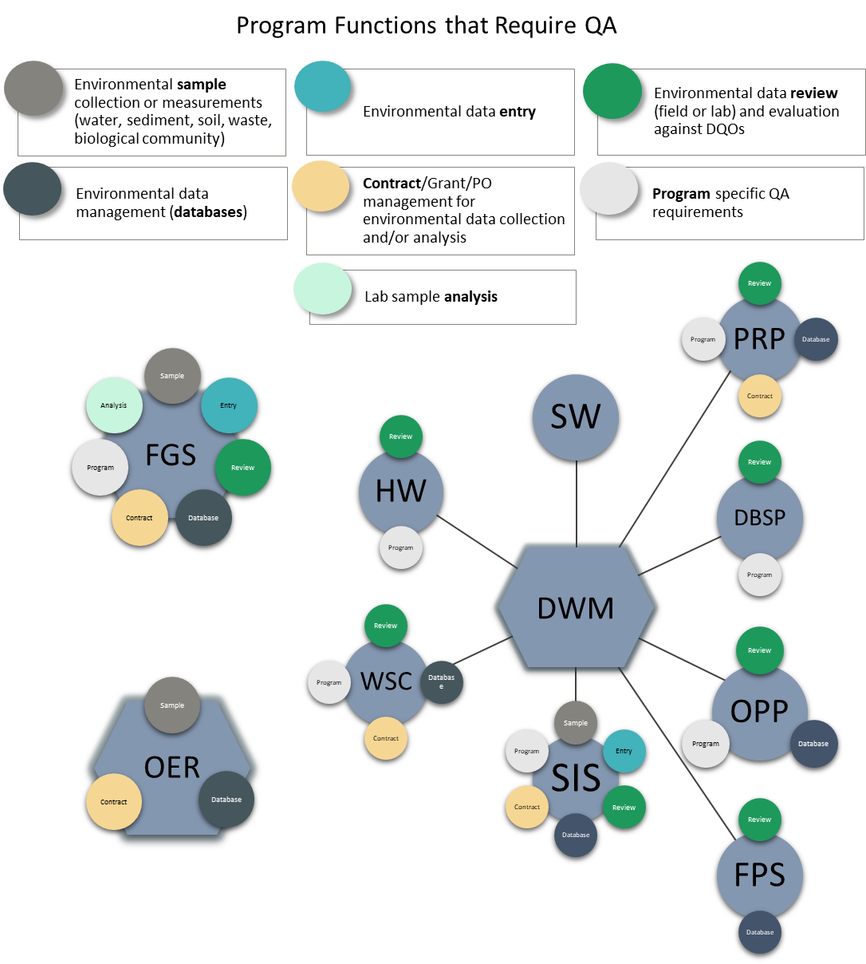Figure 5.1. Diagram of the reporting units from DWM, OER and FGS showing each unit’s functions that require QA activities, represented by color-coded circles. The circles do not indicate whether that program or section reported on that function.

Quality System
Ten units reported on the Quality System content for the 2018 Annual QA Report. Two units reported as both data generators and data users, and seven units reported as a data user only. One unit reported as solely a data generator (Figure 5.2).

Figure 5.2. Number and percentage of units in Regulatory Programs reporting as data users, data generators, both, or not reporting for the 2018 QA Annual Report. There are 10 reporting units total from DWM, OER and FGS combined.
Three units reported generating data for department use. Data generation includes sample collection and/or analysis. All data generating units indicated they follow DEP SOPs, other SOPs, or a combination of both (Figure 5.3). Two of the three data generating units indicated their QP incorporates all SOPs, and the other remaining unit should revise its QPs to include references to all SOPs used. One unit has DQOs other than SOPs. Two units indicated having checklists to evaluate the data generated against DQOs and have incorporated the checklists into the QP. However, all units should have checklists, and all the checklists should be included or cited in QPs. All units stated that there were corrective actions for when data did not meet the DQOs and the corrective actions are documented in the QP. None of the reporting units identifying as data generators revised their DQOs and corrective actions during 2018.
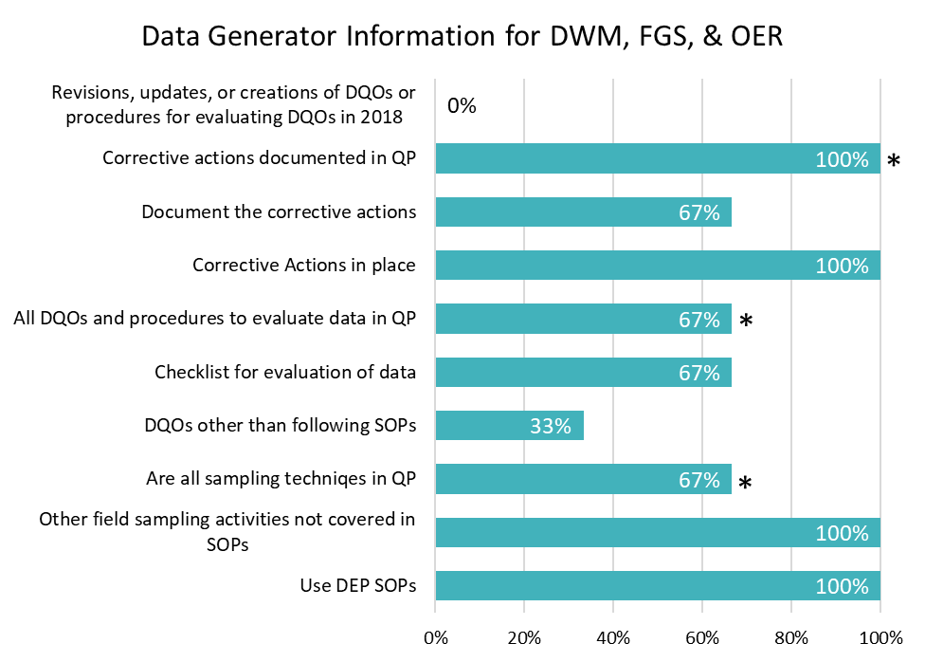
Figure 5.3. Percentage of Regulatory Program reporting units who answered “yes” to dichotomous questions regarding data quality objective use and documentation specific to roles as a data generator in the 2018 survey template. Bars with an asterisk (*) are expected to be 100 percent. There are 3 total data generators.
Nine of the ten units amongst DWM, OER, and FGS reported as data users. Five of those seven units reported using data generated by both the department and external sources, while four units indicated that they only use a source outside of DEP. All the data users reported having DQOs for the data used, and seven reporting units evaluate the data used to ensure data meet the DQOs (Figure 5.4). Four units indicated that another DEP unit evaluates the data used by their reporting unit. Seven units have documented the DQOs in their QP. Seven units reported that there are corrective actions in place when data do not meet DQOs. Six units follow up to ensure corrective actions are implemented. Five of the seven reporting units with corrective actions have documented them in their QPs. Only two reporting units indicated revising Quality System components in 2018.
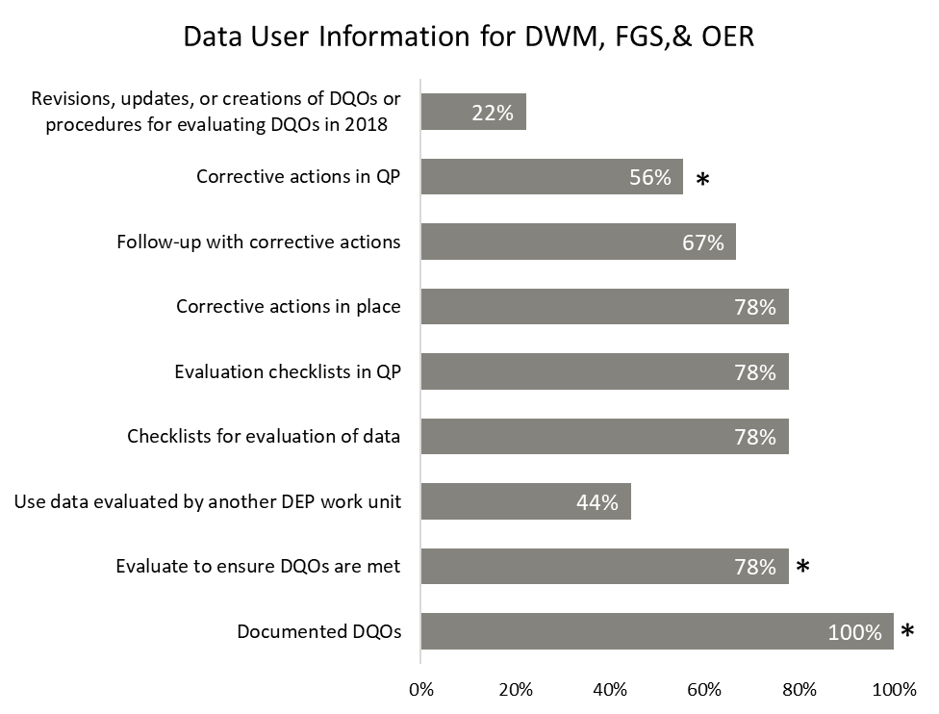
Figure 5.4. Percentage of Regulatory Program reporting units who answered “yes” to dichotomous questions regarding data quality objective use and documentation specific to roles as a data user in the 2018 survey template. Bars with an asterisk (*) are expected to be 100 percent. There are 9 total data users.

Training
QAOs reported the staff that required training and those that received training. Amongst DWM, OER, and FGS, 83 percent of employees that required training received the training during 2018 (Figure 5.5). The 17 percent of employees that were not trained for all tasks are in two of the ten units represented in this area and neither unit met its training needs in 2018. Three units did not report training needs or requirements for 2018 and do not have employees represented in the figure below.

Figure 5.5. Number and percentage of staff trained for QA activities in 2018. The total number includes staff of DWM, OER and FGS combined.
All employees in DWM, OER and FGS that required contract and grant management and data reporting training received the training they needed (Figure 5.6). Most staff that required training received it in all categories, except data assessment. Work units reported that lab analysis training was not needed in 2018. PRP reported sixty employees did not receive the needed data assessment training in 2018, and AEQAS plans to hold a data assessment training annually instead of biennially to help address this training need.
Only the Site Investigation Section (SIS) reporting unit within DWM provided trainings to entities external to DEP. They provided four trainings to approximately 120 people.

Figure 5.6. Percentage of staff in DWM, OER and FGS that received the required training within each QA training activity in 2018.

Audits
AEQAS asked reporting units within the Regulatory area of the agency to report on their audits from four different perspectives:
- audits of another unit within DEP;
- audits of entities external to DEP;
- audits of the reporting unit by a unit outside the unit; and
- self-audits conducted by the reporting unit.
RCRA was the only unit amongst DWM, OER, and FGS reporting units that conducted audits in 2018, per the definitions determined for this report. RCRA conducted 18 audits in 2018, an increase from 5 audits reported in 2017. Some reporting units conduct extensive data reviews of permit packages that do not constitute an audit. Others carefully review collection of the sample during each sampling event. Future reporting may include higher audit counts as DWM defines audits for the purposes of this report and sets goals for its programs.
No units within DWM, FGS, or OER reported conducting any audits of entities within DEP. All of the 18 audits reported by the RCRA section were audits of entities outside DEP. They conducted 17 performance audits and one system audit. There was a report generated for the audits, and the reporting unit tracked their completion. Auditors used checklists to perform the audits. The QAO reported that the unit always follows up with the corrective actions of the audits.
None of the reporting units within DWM, FGS, or OER were audited by an outside entity in 2018. No reporting units conducted internal audits of their unit.

Data Repositories
Amongst the reporting units of OER, FGS, and DWM, 50 percent (five of the ten reporting units) reported that staff in the unit enter data into at least one data repository. Sixty percent (six of the ten reporting units) retrieve data, and 50 percent (five of ten reporting units) are responsible for managing data in repositories.
Reporting units of DWM, OER and FGS enter data into twelve different data repositories. Three of the five reporting units that enter data indicated they verify data entered into all repositories, and an additional unit verifies data into at least one. Three of the five reporting units that enter data stated there are documented protocols for data entry for all the data repositories used. To ensure consistent and correct data entry, protocols should be in place for each data repository used.
Only one of the seven reporting units that retrieve data performs QA/QC checks on the data retrieved from data repositories, and only two of the seven have documented protocols for how they retrieve all data. Four out of seven reporting units that retrieve data have a mechanism to provide feedback to the data generator regarding suspect data for at least one data repository, and three reported having feedback mechanisms for all. Two of the seven reporting units indicated that their QP contains procedures for contacting data generators for at least one data repository, and one reporting unit has the mechanisms described in their QP for all data repositories. To obtain data consistently and uniformly, protocols should be in place for retrieving data from each data repository utilized by a unit.
Six reporting units manage eleven different data repositories. Of those, five reporting units perform checks on all data repositories managed, and one does not perform QA/QC checks on any repositories. Four of the six have protocols for QC checks of the stored data. Five of the six reporting units have mechanisms to provide feedback to the data generator regarding suspect data for all data repositories managed. Four of those five reporting units document the mechanism for providing feedback for all data repositories in the QP. For the validity of data housed, documented protocols should be in effect for all data repositories.
  - Division of Water Resource Management (DWRM) & Districts
DWRM is responsible for implementing state laws providing for the protection of the quality of Florida’s drinking water, ground water, rivers, lakes, estuaries and wetlands from permitted discharges or activities, as well as reclamation of mined lands and the preservation of the state’s beach and dune systems. DWRM currently has two reporting units: wastewater (domestic and industrial) and drinking water. As the QA process for the water regulatory programs is revised, additional programs will be added as reporting units.
As identified in the 2017 Annual Report, the QA system for the water regulatory programs was inconsistent between the Division office and the District offices. Recognizing the need for a unified Quality System, regulatory staff began an in-depth evaluation of the QA processes for the drinking water and wastewater programs.
In 2018, following a two-day QA workshop, drinking water and wastewater workgroups were established. These workgroups include representatives from the Division Office and the District Offices. The workgroups, with support from AEQAS, have established: 1) specific QA functions for drinking water and wastewater programs, 2) the role of the subject matter experts and the QAOs, 3) checklists and guidance documents for the QA activities, and 4) the level of effort for the QA evaluations. These efforts are described in more detail below.
The final goal of the water regulatory QA overhaul is to develop a Quality System that is meaningful to the Department’s QA requirements. To achieve this goal, the Division Office is revising the QPs for both programs. These plans will be used uniformly by the District and Division Offices. All of these efforts are ongoing, and implementation of the revised QA System is anticipated by July 1, 2019.
    - DWRM - QA and Training for the Drinking Water Program
The State of Florida implements the Federal Safe Drinking Water Act and its corresponding Florida Safe Drinking Water Act via Florida’s Public Water Systems Supervision (PWSS) program. The program is administered by the DEP and the Approved County Health Departments (ACHDs). The goal is to protect the public health of Floridians by providing safe drinking water. The program administers permitting of construction of facilities, compliance with water quality standards and monitoring requirements, operator staffing, enforcement of violations, and response to natural disasters. The program also partners with the Florida Rural Water Association (FRWA) under grant agreement to support the program.

Prior to 2018, the types of audits reported for the drinking water programs were inconsistent and not representative of program QA functions. One of the primary challenges was identifying reports that required QA and developing consistent naming conventions for each type of report or data set. Through collaborative efforts between the Division, Districts, and AEQAS, the workgroup was able to identify all of the drinking water reports and data sets that will be reviewed for QA objectives, as well as the percentage of reports that are to be reviewed. In addition, checklists and SOPs have been developed to accompany each of these reports and data sets. The reports and data sets are listed below with the level of effort for QA review presented in percentages.

Bacteriological Reports and Data Sets (1% of total level of effort)
- Groundwater
- Well survey
- Revised Total Coliform Rule
- Special (Precautionary Boil Water Notice and Clearance
Chemical Reports/Data Sets (5% of total level of effort)
- Primary Inorganics
- Asbestos Samples and Certification Forms
- Secondary Contaminants
- Volatile Organic Contaminants
- Synthetic Organic Contaminants
- Radionuclides
- Disinfection Byproducts
- Lead Copper Rule Analysis
- Water Quality Parameters
Monthly Operating Reports (5% of total level of effort)
- Monthly Operating Reports
- Surface Water

Training is provided throughout the year to Division and District Staff, the ACHDs and facility operators. The total training budget for DWRM and the Districts for 2018 was $483,000. Specific training related to drinking water QA included:
- Sampling Training
- The Focus on Change Seminar Series
- Lead and Copper Rule
- WACS and PA Database
- PWS Database Training
- PWS Reports Overview Training
- Revised Total Coliform Rule
- Advanced Sanitary Survey Training
- Florida’s Groundwater Rule
Division Staff also conduct program audits of each of the 7 ACHDs and two District Offices annually to ensure compliance with the federal Public Water System Supervision Program.
    - DWRM - QA and Training for the Wastewater Program
The Department Wastewater Management Program regulates domestic and industrial waste water discharges. The Division is responsible for the development and administration of rules and policies that regulate these discharges, and the District Offices are responsible for the permitting activities. Similar to the Drinking Water Programs, the QA functions of these programs have been under review by the Division, Districts, and AEQAS due to inconsistent QA implementation and reporting. The wastewater QA workgroup was able to identify the types of reports and data sets that require QA review, as well as the level of effort. Checklists and SOPs have been developed to accompany each of these reports and data sets. Each District’s wastewater program commits to inspect a specific number of permitted facilities on an annual basis that meets an established minimum level of service for NPDES and Non-NPDES facilities. Specific inspections types must be performed to meet the commitment expectations. The expectation is to conduct at least a Compliance Evaluation Inspection (CEI) on each of these facilities annually. The wastewater QA workgroup determined that staff will review QA elements for 20% of facilities annually at the time of inspection so that each facility has received a QA review within the permit renewal cycle.

The following report types will be reviewed for QA objectives at a level of 20% of reports annually:
- Discharge Monitoring Reports (Pre-treatment and Biosolid)
- Field Sheets
- Chain of Custody
- Lab Reports
- Groundwater Reports
- Reclaimed Analysis Reports
- Annual DMR for Specific Parameters

The following report types will be reviewed at the frequency yet to be specified:
- Bacteriological Reports for Crypto and Giardia
- Toxicity Reports
- DEW/PET
- Quality Reports for DMR

The Wastewater Management Programs also conduct training for Division and District Staff throughout the year. One of the primary training sessions is the NPDES Basic Inspector Training Workshop. This work is held annually to train new inspectors and cross-train existing inspectors in the proper techniques and procedures for conducting routine NPDES and Non-NPDES inspections. In addition to Basic Inspector Training, the wastewater programs train on the following items that include QA elements:
- NPDES Stormwater Monitoring Overview
- NPDES Stormwater Inspection Reports
- NPDES Expanded Effluent Testing and Analytical Methods MDL/PQL
- Biosolids Annual Summary Reviews
- Toxicity Testing Procedures
- Whole Effluent Toxicity (WET) Training
- Reviewing WET Lab Reports for Compliance
- Pretreatment Program Overview
- 316(b) Rule - the basics
- CAFO Rule Refresher Training
- Wastewater Water Quality Rules Training
- Florida Stormwater, Erosion, and Sedimentation Control Inspector Training & Certification Program
- StormwaterOne Qualified Preparer of SWPPPs (QPSWPPP) AND Qualified Compliance Inspector of Stormwater (QCIS)

The Division, with support from AEQAS, will conduct a two-day training for drinking water and wastewater staff on the revised QA functions and the revised Quality Plan in summer 2019. It is the goal of the Division to implement the new procedures in the first quarter of FY 19-20.

Summary and QA Goals

Quality System
AEQAS uses two components to assess whether department reporting units have the minimum requirements for a Quality System: the designation of QA Officers (QAO) and the existence of current quality plans (QP). For 2018, most reporting units have designated QAOs and current QPs. DWRM Regulatory programs and districts decided to reevaluate and reappoint QAOs as part of their QA program review. In 2019, they will determine which staff have the qualifications and experience to serve in this capacity. All other parts of the agency have designated QAOs. Some divisions and districts are missing QPs or have QPs that need to be updated. DWRM and DWM are currently updating their division-wide QPs as part of their QA program reviews. Some reporting units still have not incorporated all QA/QC elements and expectations into their QPs, and they should make efforts to do so in 2019. AEQAS is actively working with the programs that do not have QPs to establish the appropriate documentation for their Quality Systems and is willing to assist others with their QP updates.
Some department units are not reporting on QA activities, and some QAOs are not sufficiently aware of or involved with all QA related activities specific to their respective programs. QAOs need to actively collaborate within their reporting units to ensure that the data generated and used by their reporting unit are defensible and meet applicable DQOs. AEQAS is continuing to work with management and the current QAOs to identify expectations for QA activities for larger parts of the organization like DWM, DRP, RCP, and DWRA, as well as WSP within DEAR.

Ecosystem Restoration
The programs and sections of DEAR, OEP, DWRA, and the APs and NERRs within RCP make up the 29 reporting units within Ecosystem Restoration, up from the 24 units in 2017. The reporting units within Ecosystem Restoration function under an established Quality System, though improvements are needed in documentation of the Quality System and data repository use by all units. RCP’s Quality System requires further evaluation to determine which activities are appropriate for all reporting units within the Office.
In the Ecosystem Restoration area, only a few of the data generators cite SOPs in their QPs. Most of the data generators have checklists for evaluating the data produced, but few of the data users have checklists. The greatest deficiencies in this area of the department are the lack of follow up with corrective actions and the documentation of those corrective actions in the QP by both data generators and users. Also, the majority of data users lack consistent procedures for data evaluation.
Nearly all of the employees received required QA training, and some employees received training that was not required.
Reporting units in the Ecosystem Restoration area performed various field and lab audits, with sampling performance audits as the most common. More audits were conducted in 2018 than in 2017. All audits were reported to have generated reports and used checklists, ensuring consistency among audits. However, improvement is needed in completion of reports in their required time frame and the follow up of corrective actions to ensure deficiencies have been corrected. Most reporting units tracked internal audits but not external audits.
The majority of reporting units enter data into and retrieve data from repositories. Most units verify all entered data, but less than half have written protocols for either data entry or verification. A few reporting units perform QA/QC checks on all the data retrieved and have the checking procedures documented. Many of the units that retrieve data have established feedback mechanisms to initiate corrective actions for suspect data found in their data repositories, but these procedures are not documented in their QPs. Some reporting units are responsible for managing data repositories and perform QA/QC checks on the repository records, and many of the units have a mechanism to provide feedback to the generator for suspect data.

Lands and Recreation
The two reporting units in the Lands and Recreation area are the Division of State Lands (DSL) and the Division of Recreation and Parks (DRP). DRP indicated in the 2017 submission that it follows internal SOPs for projects specific to individual parks and uses DEP SOPs for drinking water and wastewater compliance sampling at individual park facilities. However, DRP did not report for the 2018 report. In 2017, DRP’s QP was missing key components for a well-documented Quality System such as sampling methods and data review protocols used by their staff. DRP intended to update the QP in 2018 to include this information, but the updates did not occur. DSL has an up-to-date QP, but AEQAS recommends that DSL evaluate their data use to determine whether staff should work to develop and document standard procedures for data review.
Neither reporting unit indicated QA training needs. However, DRP staff has reported training for sea turtle monitoring and conducted an internal training on data entry in the past. Both divisions received QA training from AEQAS in 2017.
The reporting units in DSL and DRP did not conduct any audits in 2018. While the frequency of audits is to be decided by DRP, performance audits are warranted for the environmental data generation activities conducted by DRP, such as sample collection and field observations or measurements.
Although DSL is a data user, they did not report any data repository activity involving environmental data. AEQAS will work with DSL to identify any environmental data use and appropriate QA procedures. DRP enters and retrieves data, and manages data repositories, but has not established QA guidance and procedures for data repositories.
Lands and Recreation has some needs for improving QA documentation and implementation of QA activities. AEQAS will work with these reporting units to ensure that all QA activities are documented, and consistently and appropriately carried out by staff.

Regulatory Programs

Division of Waste Management, Office of Emergency Response and Florida Geological Survey
More reporting units participated in the 2018 report from DWM, OER, and FGS than in 2017. The majority of reporting units from this group identified as data users, and a few as data generators. Most of the data generators have SOPs they follow and have checklists for evaluating data generated. However, only half of generators report that all their SOPs are included in the QP. Many data users have checklists to review the data they use. AEQAS can assist the reporting units in improving the QP to include pertinent information and tools.
Most employees within DWM, OER, and FGS received QA training. However, field sampling, data assessment, database management and program-specific requirements training needs were not met in some units, which may require a targeted approach for future training. AEQAS will work with these groups to identify the specifics of training the staff need, and work to determine the timeline and mode for providing trainings.
One reporting unit conducted 18 external audits, more than triple the number of audits in 2017. The auditors had checklists to conduct the audit and followed up with corrective actions if needed. Some reporting units conduct extensive data review of permit packages that were not included as audits. This report did not include DWM audit activities that may have been conducted in the districts. AEQAS will work with DWM in the coming year to evaluate QA goals, including those for training and auditing, as well as developing the appropriate tools to consistently conduct data reviews.
Based on the reported data management information, documentation of data verification and protocols for data repository use and management are not consistent across all reporting units. AEQAS encourages staff to ensure there is documentation for verification of data entry, protocols for use of data repositories, and mechanisms for follow-up action when suspect data are identified.
Although most areas within DWM submitted information for this report, an ongoing evaluation of QA activities within DWM should result in defined QA goals within the next year. The DWM quality plan still requires updates to include uniform QA activities and criteria to be implemented by the districts. DWM is working to create a more detailed, unified QP and ensure consistency in implementation among districts. DWM leadership has established the following QA goals for 2019:
- Improve knowledge and awareness of proper Quality Assurance and Quality Control (QA/QC) procedures by increasing training and learning opportunities through presentations, webinars and QA/QC focused discussion groups.
- Ensure better access, identification and distribution of QA/QC resources to promote greater attention to and understanding of the importance of QA/QC.
- Complete review of existing DWM QA/QC guidance, update and refine as necessary, and establish a curated library of QA resources.
- Hold an organizational workshop for fuller development of DWM QA/QC resources and understanding. Topics to include implementing all of the above goals.

DWRM & Districts
The 2016 Annual QA Report identified inconsistent QA measures reported by DWM, DWRM and the districts. After thorough evaluation of the QA metrics and how they relate to regulatory programs, DWRM staff determined they need to make significant revisions to the methods used for gathering and reporting QA information for DWRM. The QA workshop held in May 2018 between AEQAS, DWRM, and the districts was the first step in revising the QA procedures and reporting for drinking water and wastewater programs within DWRM.
Over the last year, DWRM and the district offices have developed checklists for staff to use in reviewing various reports that contain environmental data. Once these checklists are finalized, DWRM will begin to construct its drinking water and wastewater QP, which will replace the individual district QPs and ensure that all DWRM water programs are using the same methodologies for data collection, data review, and training. Goals and expectations for those reviews will also be incorporated into the new QP for the Division. In 2019, DWRM will provide staff training on the use of new data review checklists for drinking water and wastewater data and will develop a comprehensive QP for those program areas. Once that work is complete, DWRM will evaluate QA implementation in other division programs.

Overall Conclusions and Continual Efforts
Information gathered for this report indicates that some parts of the agency have a more established Quality System based on the staff’s knowledge of QA issues, staff workloads, and organizational relationship to AEQAS, while others need more specific training for their QA responsibilities and activities. QA has been an integral part of training and practice for data generators but has not been as consistently implemented by data users. New staff are often expected to process data (e.g., permit or contract deliverables), but lack the skills to evaluate the quality of those data.
AEQAS will continue its efforts to provide specialized training where needed and encourages leadership to support the continued establishment and documentation of QA goals and expectations. AEQAS is creating a general QA training that is tailored to and will potentially be required for employees whose job descriptions include environmental data generation or use.
AEQAS will assist in the continuous refinement and documentation of DEP reporting unit Quality Systems, to improve QA tools and clarify QA responsibilities of QAOs and staff. The sustainability of these efforts is dependent upon creating a pervasive culture of QA at DEP. AEQAS encourages leadership to incorporate QA activities as a priority in upholding DEP’s vision and values as an agency of integrity and accountability.

Appendix A: QA Officer and Quality Plans by Program as of April 2018
DIVISION OF WASTE MANAGEMENT

QA CONTACT | LOCATION | PROGRAM | QUALITY PLAN TITLE | QP DATE
John Winters | TLH | Waste Cleanup/DOD | Division of Waste QP | Apr-16
Lena Mollica | TLH | Waste Cleanup/Site Investigation | Division of Waste QP | Apr-16
Michael Pennington | TLH | Waste Cleanup/Waste Site Cleanup | Division of Waste QP | Apr-16
Amber Igoe | TLH | Hazardous Waste | Division of Waste QP | Apr-16
Chad Fetrow | TLH | Solid Waste | Division of Waste QP | Apr-16
Tamara Blyden | TLH | Petroleum Restoration Program | Division of Waste QP | Apr-16
Elena Compton | TLH | District and Business Support | Division of Waste QP | Apr-16
Clark Moore | TLH | Operational and Program Performance | Division of Waste QP | Apr-16

FLORIDA GEOLOGICAL SURVEY

QA CONTACT | LOCATION | PROGRAM | QUALITY PLAN TITLE | QP DATE
Mitra Khadka | TLH | Applied Geoscience Services | Quality Plan for the Florida Geological Survey | Dec-17

OFFICE OF EMERGENCY RESPONSE

QA CONTACT | LOCATION | PROGRAM | QUALITY PLAN TITLE | QP DATE
Brooke Kincaid | TLH | Office of Emergency Response | Bureau of Emergency Response QP | Apr-17

DIVISION OF ENVIRONMENTAL ASSESSMENT AND RESTORATION

QA CONTACT | LOCATION | PROGRAM | QUALITY PLAN TITLE | QP DATE
Jennifer Claypool | TLH | WQSP/Aquatic Ecology and Quality Assurance | Water Quality Standards Program | Jun-17
Chandra Chandrasekhar | TLH | Bureau of Labs, Scientific Services Support Program | Bureau of Lab QP | Jan-18
Jessica Mostyn | TLH | WQAP/Watershed Assessment | Watershed Assessment Section QP | Feb-11
Stephanie Sunderman-Barnes | TLH | WQAP/Watershed Monitoring | Watershed Monitoring Section QP | Jun-18
Kalina Warren | CD | WQAP/ Regional Operations Center | Division of Environmental Assessment and Restoration, Regional Operation Centers | Mar-18
Gary Maddox | TLH | WQE& TMDL/ GWM | Groundwater Management Section | Oct-17
James Albright | TLH | WQE&TMDL/ Watershed Evaluation &TMDL | Watershed Evaluation and TMDL Section QP | Apr-15
Anita Nash | TLH | WQRP/Watershed Planning and Coordination | Quality Plan for the  Watershed Planning and Coordination Section of the Water Quality Restoration Program | Jul-18
Lisa Schwenning | TLH | Office of Watershed Services | Watershed Data Services Section QP | Mar-16
OFFICE OF RESILIENCE AND COASTAL PROTECTION
QA CONTACT | LOCATION | PROGRAM | QUALITY PLAN TITLE | QP DATE
Kathryn Petrinec | Ponte Verda Beach | RCP GTM NERR | Varies by location; some offices have QA documents, but have not been submitted to AEQAS. | Various

OFFICE OF ECOSYSTEM PROJECTS

QA CONTACT | LOCATION | PROGRAM | QUALTIY PLAN TITLE | QP DATE
Rhapsodie Osborne | TLH | Office of Ecosystem Projects | Office of Ecosystem Projects | Jan-18

DIVISION OF WATER RESTORATION ASSISTANCE

QA CONTACT | LOCATION | PROGRAM | QUALITY PLAN TITLE | QP DATE
Amanda Peck | TLH | Nonpoint Source Management | Quality Assurance Management Plan for the Division of Water Restoration Assistance | Jul-17

DIVISION OF STATE LANDS
QA CONTACT | LOCATION | PROGRAM | QUALITY PLAN TITLE | QP DATE
Nicole Haugdahl | TLH | State Lands | State Lands | Jul-16

DIVISION OF RECREATION AND PARKS

QA CONTACT | LOCATION | PROGRAM | QUALITY PLAN TITLE | QP DATE
Gregg Walker | TLH | Florida Park Services | Florida Park Services | Dec-12

