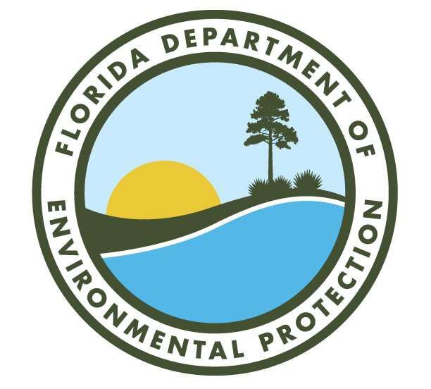
Annual Quality Assurance Report to the Secretary
2020
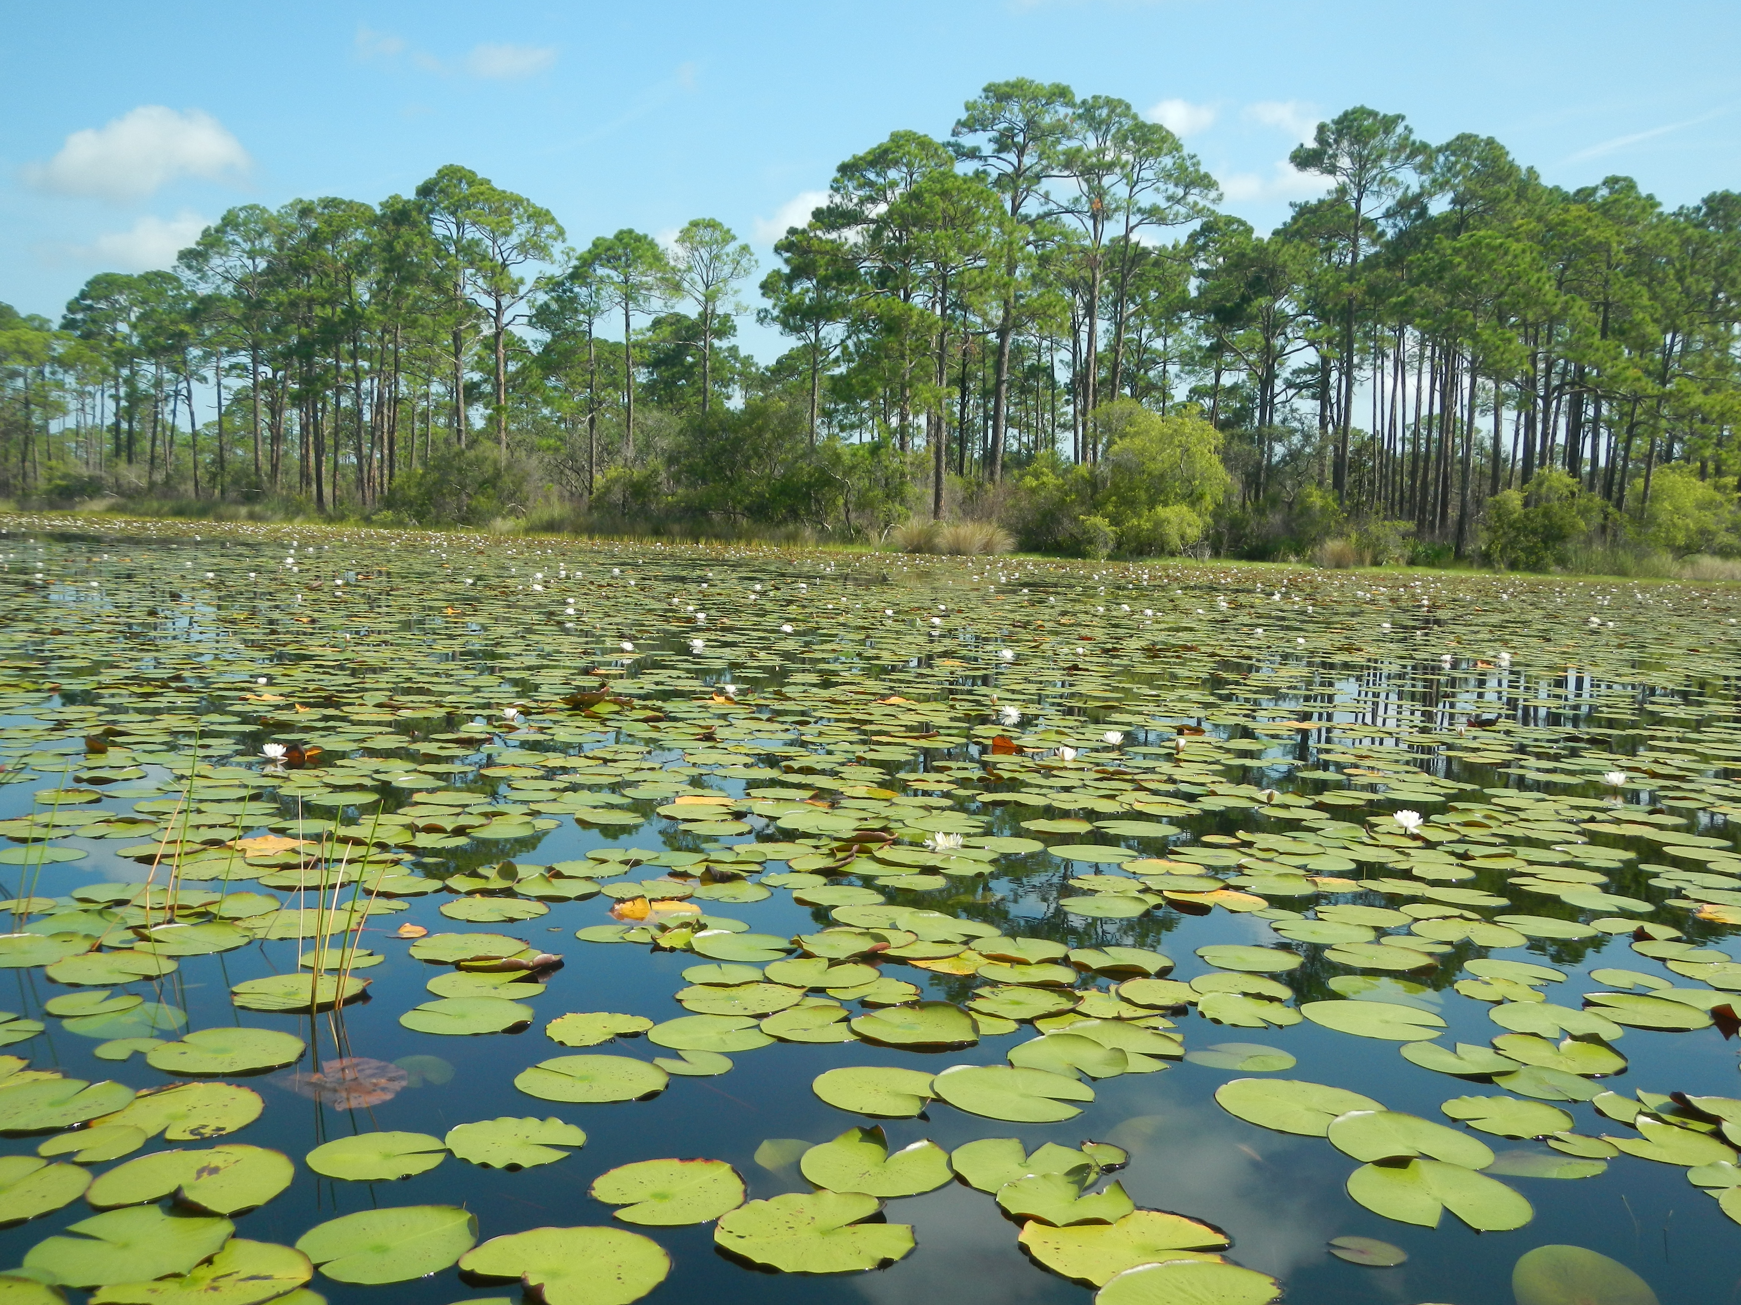
Division of Environmental Assessment and Restoration
Water Quality Standards Program
Florida Department of Environmental Protection

2020 Annual Quality Assurance Report to the Secretary
Division of Environmental Assessment and Restoration
Water Quality Standards Program
Florida Department of Environmental Protection

Acknowledgments
This document was prepared by staff in the Florida Department of Environmental Protection, Division of Environmental Assessment and Restoration, Water Quality Standards Program, Aquatic Ecology and Quality Assurance Section. The following reporting units within the department contributed to this report:

Ecosystem Restoration Area
Division of Environmental Assessment and Restoration
Water Quality Standards Program
Watershed Assessment Section
Watershed Monitoring Section
Regional Operating Centers
Watershed Evaluation and Total Maximum Daily Loads Section
Water Quality Restoration Program
Watershed Services Program
WIN/STORET
GIS
Laboratories
Office of Water Policy and Ecosystems Restoration
Office of Resilience and Coastal Protection
Northwest Florida Aquatic Preserves
Central Panhandle Aquatic Preserves
Big Bend Seagrasses Aquatic Preserve
Wekiva River Aquatic Preserve
Northeast Florida Aquatic Preserves
Indian River Lagoon Aquatic Preserves
Tampa Bay Aquatic Preserves
Rookery Bay Aquatic Preserves & NERR
Estero Bay Aquatic Preserve
Charlotte Harbor Aquatic Preserves
Florida Keys National Marine Sanctuary
Biscayne Bay Aquatic Preserves
Coral Reef Conservation Program
Guana River Marsh Aquatic Preserve & Guana Tolomato Matanzas (GTM NERR)
Apalachicola NERR
Rainbow-Oklawaha Florida Aquatic Preserve
Tomoka Marsh Aquatic Preserve
Division of Water Restoration Assistance
Non-point Source Management Program (NPSMP)
Deepwater Horizon (DWH)
Water Supply Restoration Funding Program (WSRFP)
Land and Recreation
Division of State Lands
Division of Recreation and Parks
Regulatory Programs
Division of Waste Management
Petroleum Restoration Program
Waste Cleanup Program
Site Investigation Section
Waste Site Cleanup Section
Federal Programs Section
Brownfields and CERCLA Site Screening
Business and District Support
Operational and Program Performance
Permitting and Compliance Assistance Program
Hazardous Waste Program & Permitting Section
Solid Waste Program & Permitting Section
Compliance Assistance Section
Waste Reduction & Registration Section
Division of Water Resources Management
Florida Geological Survey
Division of Law Enforcement
Central District
Northeast District
Northwest District
South District
Southeast District
Southwest District

Table of Contents
Acknowledgments iii
List of Figures vii
List of Tables viii
1. Introduction 1
1.1 Background and Overview 1
1.2 Report Organization 1
2. Quality System of the Agency 2
2.1 Overview 2
2.2 Quality Plans 3
2.3 Quality Assurance Officers 4
3. Ecosystems Restoration 5
3.1 Overview and Expected QA Activities 6
3.2 Quality System 10
3.3 Training 13
3.4 Audits 14
3.5 Data Repositories 15
4. Land and Recreation 19
4.1 Overview and Expected QA Activities 19
4.2 Quality System 20
4.3 Training 20
4.4 Audits 20
4.5 Data Repositories 21
5. Regulatory Programs 21
5.1 Division of Waste Management, Florida Geological Survey & Division of Law Enforcement and Emergency Response 21
5.1.1 Quality System 25
5.1.2 Training 27
5.1.3 Audits 28
5.1.4 Data Repositories 29
5.2 Division of Water Resource Management (DWRM) & Districts 32
5.2.1 DWRM - The Drinking Water Program 33
5.2.1.1 Drinking Water-Training 33
5.2.1.2 Drinking Water – Audits/Data Review 34
5.2.2 DWRM - The Wastewater Program 35
5.2.2.1 Wastewater-Training 35
5.2.2.2 Wastewater-Audits/Data Reviews 36
6. Summary of QA Activities, Successes and Goals 37
6.1 Quality System 37
6.2 Ecosystems Restoration 38
6.3 Lands and Recreation 39
6.4 Regulatory Programs 39
6.4.1 Division of Waste Management, Division of Law Enforcement and Emergency Response, and Florida Geological Survey 39
6.4.2 DWRM & Districts 40
6.5 Overall Conclusions and Continuing Efforts 41
Appendix A: QA Officer and Quality Plans by Reporting Unit as of March 2021 42
Appendix B: Survey results from data generators and users about quality system activities and documented components 46

List of Figures
Figure 2.1 Quality Plan Status in 2020 …………………………………………………………….……………..………………..……..4
Figure 3.1 Diagram of Organization & QA Related Activities in Ecosystems Restoration.……………….…..……8
Figure 3.2 Diagram of Organization & QA Related Activities in Ecosystems Restoration (RCP)…………………9
Figure 3.3 Self-Reported Program Activities in Ecosystems Restoration………………………………………….…….10
Figure 3.4 Data Generator Information for Ecosystems Restoration ………………………………………………...….11
Figure 3.5 Data User Information for Ecosystems Restoration………………………………………………………….…..12
Figure 3.6 Percentage of Ecosystems Restoration Employees that Received Training………….…….…….......13
Figure 3.7 Expectations of Audits Conducted by Reporting Units in Ecosystems Restoration…………….….15
Figure 3.8 Ecosystems Restoration Reporting Units with Quality Checks & Documentation for Data Entry……………………………………………………………………………………………………………………………………………………..16
Figure 3.9 Ecosystems Restoration Reporting Units with Quality Checks, Feedback Mechanisms and Documentation for Data Retrieval…………………………………………………………………………………………………………17
Figure 3.10 Ecosystems Restoration Reporting Units with Quality Checks, Feedback Mechanisms and Documentation for Data Management………………………………………………………………………………………………….18
Figure 4.1 Diagram of Organization & QA Related Activities in Lands and Recreation……….…………….…….19
Figure 5.1 Diagram of Organization & QA Related Activities in Regulatory (DWM, FGS & DLE)...……….24
Figure 5.2 Self-Reported Program Activities for DWM, FGS & DLE…………………………………………….……….25
Figure 5.3 Data Generator Information for DWM, FGS & DLE………………………………………………………….…26
Figure 5.4 Data User Information for DWM, FGS & DLE……………………………………………………………….….…27
Figure 5.5 Categories that Employees Received Training in QA in 2020 for DWM, FGS & DLE……….….28
Figure 5.6 DWM, FGS & DLE Reporting Units with Quality Checks & Documentation for Data Entry ……………...………………………………………………………………………………………………………………………………………………30
Figure 5.7 DWM, FGS & DLE Reporting Units with Quality Checks, Feedback Mechanisms and Documentation for Data Retrieval …………………………………………………………………………………………….…………31
Figure 5.8 DWM, FGS & DLE Reporting Units with Quality Checks, Feedback Mechanisms and Documentation for Data Management …………………………………………………………………………………….………….32
Figure 5.9 Drinking Water Training Needs per District……………………………………………………………………………34
Figure 5.10 Drinking Water Data Reviews per District……………………………………………………………………………35
Figure 5.11 Wastewater Training Needs per District………………………………………………………………………………36
Figure 5.12 Wastewater Data Reviews per District……………………………………………………………………………….37

List of Tables
Table 3.1 Audits Reported by Ecosystems Restoration………………………………………………………….……………….14
Table 5.1 Audits Reported by DWM, FGS & DLE…………………………………………………………………………………29
List of Acronyms and Abbreviations
ACHD | Approved County Health Departments
AEQAS | Aquatic Ecology and Quality Assurance Section
AP | Aquatic Preserve
CA | Compliance Assistance
CEI | Compliance Enforcement Inspection
CBP | Clean Boating Program
CD | Central District
DARM | Division of Air Resource Management
DEAR | Division of Environmental Assessment and Restoration
DEP/department | Florida Department of Environmental Protection
DLE | Division of Law Enforcement
DOD | Department of Defense Projects Section
DQO | Data Quality Objective
DRP | Division of Recreation and Parks
DSL | Division of State Lands
DWH | Deep Water Horizon
DWM | Division of Waste Management
DWRA | Division of Restoration Assistance
DWRM | Division of Water Resource Management
EPA | U.S. Environmental Protection Agency
FCMP | Florida Coastal Management Program
FGS | Florida Geological Survey
FRWA | Florida Rural Water Association
GIS | Geographical Information System Section
GWIS | Generalized Water Information System
HW | Hazardous Waste Program
IRLAP | Indian River Lagoon Aquatic Preserves
LABS | Florida DEP Laboratory
LOS | Level of Service
NASA | National Aeronautics and Space Administration
NED | Northeast District
NERR | National Estuarine Research Reserve
NOAA | National Oceanographic and Atmospheric Administration
NPL | National Priority List
NPSMP | Non-Point Source Management Program
NWD | Northwest District
OWPER | Office of Water Policy and Environmental Restoration
PO | Purchase Order
PPA | Performing Partnership Agreement
PWSS | Public Water Systems Supervision
QA | Quality Assurance
QAO | Quality Assurance Officer
QC | Quality Control
QMP | Quality Management Plan
QP | Quality Plan
RCP | Office of Resilience and Coastal Protection
RCRA | Resource Conservation & Recovery Act
ROCS | Regional Operating Centers Section
SD | South District
SED | Southeast District
SOP | Standard Operating Procedure
STORET | Storage and Retrieval (Database)
SW | Solid Waste Program
SWD | Southwest District
TMDL | Total Maximum Daily Loads
WAS | Watershed Assessment Section
WIN | Watershed Information Network
WMS | Watershed Management Section
WQAP | Water Quality Assessment Program
WQETP | Water Quality Evaluation and TMDL Program
WQRP | Water Quality Restoration Program
WQSP | Water Quality Standards Program
WSP | Watershed Services Program
WSRFP | Water Supply Restoration Funding Program

Executive Summary
The Annual Quality Assurance (QA) Report to the Secretary of the Florida Department of Environmental Protection (department or DEP) summarizes QA activities of department programs and evaluates the effectiveness of DEP’s QA Directive (DEP 972) for each calendar year. Established in 2009 and revised in 2016, the QA Directive provides internal department QA policy and outlines the areas of staff responsibility for ensuring the quality of data used by the department. The QA Directive describes how the department will implement the requirements in the QA Rules (Chapter 62-160, Florida Administrative Code) through a distributed approach in which department reporting units develop, document and maintain a Quality System with clear QA objectives for data they generate or use. This report details the QA efforts and accomplishments made by staff throughout the department in 2020 and identifies areas for improvement needed to fulfill QA management responsibilities outlined in the QA Directive. The only part of the agency not under the QA Directive is the Division of Air Resource Management (DARM), which manages its own QA program and is not included in this report.
Although all department reporting units, excluding DARM, operate under a common QA Rule Chapter and QA Directive, QA activities vary based on the purpose and function of the program, section or reporting unit. For the 2020 Annual QA Report, Division of Environmental Assessment and Restoration (DEAR) QA staff in the Aquatic Ecology and Quality Assurance Section (AEQAS) collected information from programs via written surveys and personal communication with staff to assess the status of the Quality System for each program or reporting unit. AEQAS received information from 48 reporting units, which is an increase from 2019 when 39 units reported. This increase is due to participation of the districts, Division of Recreation and Parks, and some reporting units choosing to report separately when they have reported together in previous years. AEQAS staff organized the QA information by the three areas of the agency: Regulatory Programs, Ecosystems Restoration, and Lands and Recreation. Department programs provided an account of tasks completed in 2020 in the following four QA categories that address one or more department policies and areas of responsibility outlined in the QA Directive: 1) Quality System; 2) training; 3) audits; and 4) data repositories.
AEQAS uses two components to assess whether department reporting units have the minimum requirements for a Quality System: the designation of QA officers (QAO) and the existence of current quality plans (QP). For 2020, most, but not all, reporting units had designated QAOs and current QPs that describe the policies and activities developed to help ensure that the quality of data generated or used by the program is defensible. Some QPs need to be updated to reflect changes in the organizational structure, policies and/or activities of the programs covered by the plans. Some noteworthy observations about QPs or QAOs include: 1) the Drinking Water and Wastewater Regulatory programs identified the staff that serve in the role of QAOs for those units within Tallahassee and the districts, and they plan to complete an updated, unified QP for those programs in 2021; 2) the Division of Water Restoration Assistance (DWRA) has previously reported as one unit that represented the entire division, but for 2020 the QAOs reported for three organizational units within the division, improving the coverage of DWRA in this report; 3) the Office of Resilience and Coastal Protection (RCP) programs are still working on a QP for their continuous monitoring efforts for the Aquatic Preserves; and 4) activities conducted in the regulatory district offices for Division of Waste Management (DWM) programs are not represented in this report.
Based on the submissions from QAOs, nearly all department employees who are involved with the process of data generation, data receipt, data assessment, data archival storage, and data interpretation received training in 2020 to execute their assigned functions. AEQAS added trainings to its website and coordinated with staff in the Communications Section to provide online training covering basic QA requirements for all DEP employees so that they can receive on-demand training on QA expectations for the agency. Throughout 2020, AEQAS also advertised and hosted webinars focused on QA guidance documents and principles.
It is the department’s policy, per the QA Directive, to audit the performance and record-keeping practices of data generators within and outside the department. However, the extent to which agency programs conduct QA audits of any type varies widely, as does the use of established audit procedures and the oversight of required corrective actions. The Ecosystems Restoration area of the agency conducts the most audits within the agency. The need and feasibility of audits in the other areas of the agency are to be determined by leadership. The total number of audits conducted decreased slightly within the Division of Environmental Assessment and Restoration during 2020, though this change reflects typical workload fluctuations. More reporting units are actively evaluating the importance of audits and determining if conducting and participating in more audits is feasible for their groups.
Programs throughout the agency identified more than 60 different data repositories, both internal and external to the agency, where data are stored and retrieved for program-specific uses. About half of the reporting units that enter data have procedures in place for quality assurance and quality control (QA/QC), and improvements should be made in the documentation of these activities, primarily by adding procedures and including reference documents in QPs. Many of the programs that retrieve data rely on the QA/QC procedures of the data provider and lack documented protocols to verify data. Of the reporting units that manage data repositories, most perform QA/QC procedures for the data repositories, but not all have QA/QC procedures documented in their QPs. Most of the reporting units that retrieve and manage data have mechanisms to provide feedback to the data generator for suspect data, but not all have described the feedback mechanisms in their QPs.
The regulatory programs have determined that improved knowledge and awareness of QA/QC procedures are important to the improvement of their Quality System and have provided increased training and learning opportunities. QAOs within the Division of Waste Management have increased communication about QA issues and requested AEQAS involvement in a variety of the issues. Drinking Water and Wastewater QA workgroups within the Division of Water Resource Management and the regulatory districts developed data review checklists and started implementing them with all districts meeting their set goals for QA reviews; this group is still working on their QP development.
Overall, DEP continues to develop and maintain a functional Quality System, but improvement is needed in the documentation of procedures that have been designed to ensure that we are making decisions based on scientifically and legally defensible data. AEQAS has maintained the increased number of training opportunities created in 2019 and will continue to add more on-demand trainings to its website. AEQAS staff met individually with QAOs to ensure they did not have any questions or concerns about QA reporting and to make sure they were aware of the available trainings. The one-on-one meetings increase the communication and rapport between AEQAS and QAOs. AEQAS will continue to reach out to QAOs and managers to provide training and other QA support to program staff to promote efforts to address the specific areas identified in this report. AEQAS asks leadership to encourage staff to participate in QA trainings and to recognize QA activities as a priority in upholding DEP’s vision as an agency that values integrity and accountability.


Introduction

1.1 Background and Overview
The Annual Quality Assurance (QA) Report to the Secretary of the Florida Department of Environmental Protection has been compiled for the calendar year 2020 by the Aquatic Ecology and Quality Assurance Section (AEQAS) within the Division of Environmental Assistance and Restoration (DEAR), in coordination with the Quality Assurance Officers (QAO) for the department’s various reporting units and districts. The purpose of the Annual QA Report is to provide an assessment of the status of the department’s Quality System, per the functional responsibilities described in the department’s QA Directive (DEP 972). According to the directive, DEAR is responsible for coordinating the department’s Quality System, and all programs within the agency are responsible for defining and implementing their individual Quality Systems. The QA policy in the directive is applicable to all activities that include measurements of environmental matrices for biological, chemical or physical characterization (i.e., environmental data). The only part of the agency not under the directive is the Division of Air Resource Management (DARM), which manages its own QA program.
This report provides a review of the Quality Systems within the three primary areas of the department (Regulatory Programs, Ecosystems Restoration, and Lands and Recreation), with the focus of the evaluation on whether reporting units conducted the QA activities expected for their program activities. As in previous years, AEQAS staff sent spreadsheet questionnaires (templates) to QAOs throughout the department to gather information about their Quality System and QA activities in 2020.

1.2 Report Organization
The 2020 Annual QA Report further divides the three primary areas of the department into programs, offices and districts. Organizational units within these areas are counted at a program level; this may vary by division as not all divisions identify organizational units as programs. For the purposes of this report, any section, program or district that responded to the AEQAS request for information is referred to as a reporting unit.
The Quality System of the Agency section of the report addresses the QA infrastructure of all reporting units in the department. The Ecosystems Restoration, Lands and Recreation and Regulatory Programs sections outline broad categories of job functions for each area to provide context for expected QA activities, and also report on the 2020 QA activities for those areas.
The 2020 reported QA activities fall into four main categories that address one or more department policies within the QA directive:
- Quality System: Report of whether the reporting unit is a data user, generator, both or neither; includes information on the associated data quality objectives (DQOs). Reporting units identifying themselves as data generators participate in activities that involve field sampling or laboratory analysis and are responsible for taking measures to ensure the quality of the data produced by those activities. Reporting units indicated a variety of DQO related activities, including following appropriate Standard Operating Procedures (SOPs); establishing DQOs; having procedures to evaluate and qualify data; using corrective actions when the data generated do not meet the DQOs; including pertinent QA information in their Quality Plan (QP); and revising DQOs for the data generated in the reporting year. Reporting units that identified themselves as data users are involved in the use of environmental data generated by DEP or another source and are responsible for ensuring the quality of the data used. Data users reported on the source of data, written standards for the use of the data, data evaluation procedures, corrective actions taken when the data do not meet DQOs, inclusion of pertinent QA information in the QP, and revision of DQOs for the data used in the reporting year. Some reporting units are involved in both data generation and data use. Individual reporting unit responses are located in Appendix B.
- Training: Report of whether reporting units met all training needs, percentage of employees who received training in various categories, and how many training events the reporting units held.
- Audits: Report of instances where staff directly observed sample collection or analysis, conducted an in-depth review of data generation, validated and verified data records, reviewed records to reconstruct data generation, or evaluated data usability, per Rules 62-160.650, Florida Administrative Code (F.A.C.), and 62-160.670, F.A.C. Audits were placed in one of three categories:
  - Performance: Evaluation of sampler’s or analyst’s technique and knowledge of sample collection and field testing, lab methods or record-keeping in the field or lab. Are they doing everything correctly?
  - Project: Tracking specific sample results through field records and/or lab records for data validation and usability assessment. The QA directive refers to these audits as Data Usability Audits. The audits evaluate whether the documentation shows adherence to sampling/analytical procedures and documentation requirements.
  - System: Evaluation of procedures, equipment and documentation. These audits include lab certification audits and DEP Quality of Science Reviews.
- Data repositories: Report of whether the reporting unit entered, retrieved or managed data in repositories, and if so, whether the reporting unit has QA procedures for data management in practice and documented in its QP.

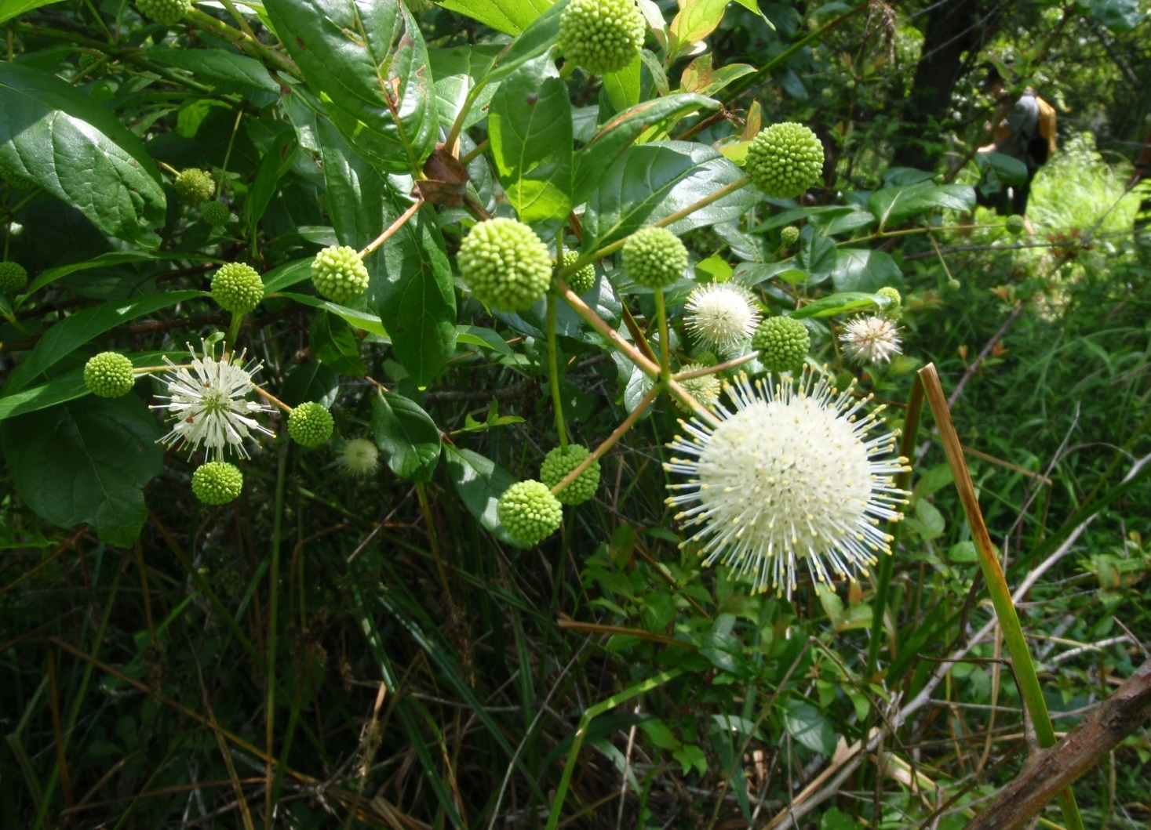

Quality System of the Agency

Overview
A Quality System includes policies, procedures and criteria utilized to monitor, evaluate, and improve an organization’s QA processes. With the adoption of the QA Directive, the department developed a structured management approach to distribute the functions necessary for the implementation of a Quality System and monitor QA requirements throughout the system.
A Quality System requires planning, implementation and assessment. Two key factors in a functioning Quality System are the use of documents to guide staff in carrying out QA activities and designating QAOs to assist management and technical staff with the implementation and evaluation of QA activities throughout all levels of the department. The department’s Quality Management Plan (QMP), which is approved by the U.S. Environmental Protection Agency (EPA), documents the Quality System for the department, with focus on department programs that receive funding from EPA. The QMP incorporates other DEP QA documents, including the QA Rules (Chapter 62-160, F.A.C.) and the QPs developed by the department programs and reporting units that detail their individual Quality Systems. The QMP Revision 9 was approved in 2020 and the latest revisions of Chapter 62-160, F.A.C., went into effect in 2017.

2.2 Quality Plans
Department programs and reporting units document their Quality System in QPs. These QPs describe the organization of the program, designate one or more QAOs, delineate staff QA responsibilities, and outline DQOs that will ensure data used by the program are appropriate and reliable. Quality System details vary among divisions, districts and offices. It is the responsibility of each program and section administrator to ensure that their Quality System is fully operational and documented in a QP.
QPs are “living documents” and require revisions as program organization, duties and criteria evolve. AEQAS offers education and support to programs and divisions that are reviewing and updating their QPs. Upon request, AEQAS staff also conduct Quality of Science Reviews with program staff to help evaluate their Quality System, including a review of their QP to ensure QA activities are documented and carried out consistently. If administrators would like assistance from AEQAS for QP updates, they should request a Quality of Science Review. AEQAS asks QAOs to submit their QPs for review. There is not a required frequency with which QPs must be updated, but for the purposes of this report AEQAS targets documents older than four years for review to determine if they are out of date and need revisions. AEQAS encourages annual review of QPs by QAOs and administrators. AEQAS publishes the QPs on the QP webpage once staff have resolved accessibility compliance issues (ADA section 508).
For the 2020 calendar year, 28 QPs were available on the AEQAS webpage. Eleven of the 28 QPs found on the webpage were out of date and updates are in progress. Regulatory programs and DRP are working to finalize QPs in 2021. The extra QP on the website is for the Groundwater Monitoring Section (GMS)within DEAR, which has been absorbed by another program. While the QP for the GMS is not illustrated in the figure, it is still maintained on the AEQAS webpage. A complete list of reporting units, their designated QAOs, and QP revision dates can be found in Appendix A.
Program-specific QP development efforts in 2020 (and early 2021) worth noting include:
- The Division of Water Resource Management provided and implemented a quality assurance document containing QA/QC review goals for the districts and the division in 2021. This document does not yet contain all of the components of a QP.
- The Watershed Quality Evaluation and TMDL Program finalized updates to their QP in 2021.
- The Office of Water Policy and Environmental Restoration is currently updating their QP and expects the revisions to be finalized in 2021.
- The Office of Resilience and Coastal Protection (RCP) reporting units have not established a consistent process for QP development, and AEQAS provided training in 2020 to help RCP reporting units better understand and prepare a QP. RCP set a goal in 2018 to evaluate and restructure its Quality System, but reorganization and COVID-19 quarantining slowed those efforts. RCP had a goal for 2020 that one reporting unit was to create and share a QP template that can be used by other RCP reporting units. During recent conversations, RCP would like to take a different approach to establish QPs and has agreed to coordinate the effort between AEQAS and RCP leaders. RCP provided a program-based QP for the Aquatic Preserve Continuous Monitoring Program to be used by all Aquatic Preserves in April of 2021. A complete list of reporting units, their designated QAOs, and QP revision dates can be found in Appendix A.
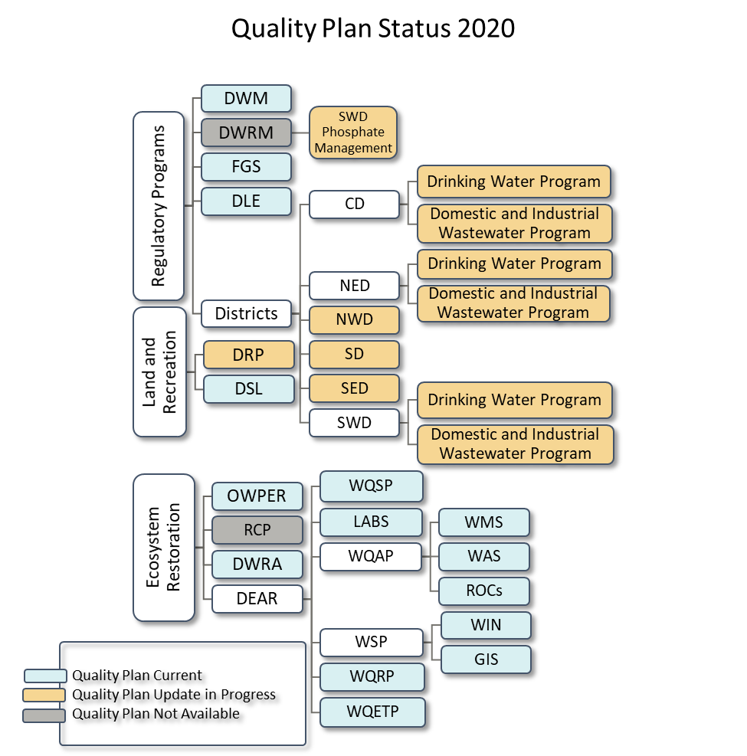
Figure 2.1. Quality Plans that are current, outdated or in revision for programs in the department’s divisions, districts or offices for 2020. The number of plans required for each division, district or office is dependent on the program groupings included in each plan. Each color-coded box in the diagram represents a quality plan found on the QP webpage. The white boxes show relationships between the work units.

2.3 Quality Assurance Officers
The implementation of the internal policies outlined in the QA Directive requires active participation throughout all levels of the department. The department implements its Quality System through the execution of each program’s QP and the coordination and direction of QA activities for the program by a designated QAO. The QA Directive lists the following duties of the QAOs: familiarity with and maintenance of Quality System documents; coordination and performance of internal and external audits; implementation of corrective actions after incidents of non-conformance with DQOs; communication with AEQAS; and attend, provide and track staff training. Division and district directors along with program and section administrators are responsible for designating QAOs to represent specific reporting units.
In 2020, the regulatory programs identified QAOs in the districts. This increases QA representation and helps AEQAS better distribute information throughout the agency and offices. There are still programs within DWRM and RCP that need to appoint QAOs and determine the level of QA activities that should be reported.
AEQAS held quarterly teleconferences for QAOs prior to 2019. Due to low participation rates, the quarterly teleconferences were discontinued. Instead, AEQAS now participates in division and district teleconferences to share information regarding QA and to better understand the activities of programs and the existing tasks of staff. AEQAS also meets in-person with each QAO annually to better understand their programs and unique QA needs. In 2020, AEQAS maintained the increased number of trainings created in 2019, despite travel restrictions due to COVID-19, and modified existing trainings to better educate staff on QA activities and principles.

Ecosystems Restoration
The following divisions, programs and sections contributed to this report:
Division of Environmental Assessment and Restoration (DEAR)
Water Quality Standards Program (WQSP)
Watershed Assessment Section (WAS)
Watershed Monitoring Section (WMS)
Regional Operating Centers (ROCs)
Watershed Evaluation and Total Maximum Daily Loads Section (WETMDL)
Water Quality Restoration Program (WQRP)
Watershed Services Program (WSP)
WIN/STORET
GIS
Laboratories (LABS)
Division of Water Restoration Assistance (DWRA)
Non-point Source Management Program (NPSMP)
Deepwater Horizon (DWH)
Water Supply Restoration Funding Program (WSRFP)
Office of Water Policy and Ecosystems Restoration (OWPER)
Office of Resilience and Coastal Protection (RCP)
Northwest Florida Aquatic Preserves (NWFLAP)
Central Panhandle Aquatic Preserves (CPAP)
Big Bend Seagrasses Aquatic Preserve (BBSAP)
Wekiva River Aquatic Preserve (WRAP)
Northeast Florida Aquatic Preserves (NEAP)
Indian River Lagoon Aquatic Preserves (IRLAP)
Tampa Bay Aquatic Preserves (TBAP)
Rookery Bay Aquatic Preserves & NERR (RB-AP & NERR)
Estero Bay Aquatic Preserve (EBAP)
Charlotte Harbor Aquatic Preserves (CHAP)
Florida Keys National Marine Sanctuary and Florida Keys Aquatic Preserves (FKNMS)
Biscayne Bay Aquatic Preserves (BBAP)
Coral Reef Conservation Program (CRCP)
Guana River Marsh Aquatic Preserve & Guana Tolomato Matanzas (GTM NERR)
Apalachicola NERR (ANERR)
Rainbow-Oklawaha Florida Aquatic Preserve (ROFLAP)
Tomoka Marsh Aquatic Preserve (TMAP)

3.1 Overview and Expected QA Activities
The Ecosystems Restoration area protects and improves water quality and aquatic resources, including the Everglades, springs and coastal resources. Restoration programs work with communities, local governments and other agencies to protect and restore water quality and provide funding assistance for water restoration and infrastructure projects. The programs also coordinate the protection of Florida’s submerged lands and coastal areas. This area of the agency consists of the Office of Water Policy and Ecosystems Restoration [OWPER, includes the former Office of Ecosystem Projects (OEP) and Office of Water Policy], the Office of Resilience and Coastal Protection (RCP), the Division of Environmental Assessment and Restoration (DEAR), and the Division of Water Restoration Assistance (DWRA). For 2020, there were 28 reporting units from the Ecosystems Restoration area, which is up from the 26 that reported in 2019. This increase is due to some offices within RCP reporting and DWRA programs choosing to report individually instead of as a division. The groups within the Ecosystems Restoration area have a wide range of expected QA activities (Figures 3.1 and 3.2).
The OWPER oversees Everglades restoration activities for Florida, exercises general supervisory authority over the state’s five water management districts, and ensures effective implementation of the department’s responsibilities under the Florida Water Resources Act (Chapter 373, Florida Statutes (F.S.)). The OWPER has one QA reporting unit and six organizational units. This reporting unit primarily manages contracts, grants and purchase orders that fund environmental sample collection and laboratory analysis. Staff should have training on how to ensure that the agreements incorporate adequate QA measures, and how to review the agreements and deliverables with respect to the contracted data quality objectives (DQOs). In addition, a limited number of staff are involved in the review and interpretation of data (data users).
The RCP houses the Florida Coastal Management Program (FCMP), Aquatic Preserves (AP), National Estuarine Research Reserves (NERRs), the Coral Reef Conservation Program (CRCP), Clean Boating Program (CBP), Florida Resilient Coastlines Program (FRCP), and the Florida Keys National Marine Sanctuary (FKNMS). The CBP and FRCP do not collect environmental data and are not included in this report. The following programs, which were moved from the regulatory area into the RCP at the start of 2020, have not provided annual QA reports in the past and are not discussed in this report: Beaches Field Services; Beaches, Inlets and Ports; and the Coastal Construction Control Line Program. These units new to RCP need to connect with the current QAO and evaluate what content should be included in their QP. AEQAS identified 23 organizational units within RCP, with 15 QA reporting units. Various RCP offices collect environmental data for National Oceanic and Atmospheric Administration (NOAA) projects and for the department, so some of their DQOs are aligned with NOAA expectations and some with DEP’s. Depending on the location and activities of the offices within RCP, data entry into databases may occur along with limited data review. The RCP also manages department contractual agreements for environmental sampling and analysis. Reportable QA information for these activities includes DQO establishment, training for SOPs, data entry, and review of data with respect to DQOs and understanding QA requirements for the management of agreements.
DEAR monitors, analyzes and assesses surface water and groundwater quality, which includes identifying, verifying and prioritizing impaired waters; developing strategies to address impairments; and implementing those strategies through comprehensive restoration action plans in partnership with local stakeholders. DEAR consists of 9 QA reporting units and six organizational units, including the department’s environmental laboratory. DEAR collects, analyzes, enters, reviews and manages data in databases, and oversees agreements that include environmental sample collection. Reportable QA information for these activities includes DQO and SOP establishment, training for SOPs, evaluation of data, and auditing data providers both internal and external to the DEAR reporting unit.
DWRA is responsible for providing financial assistance to fund projects that improve the quality and quantity of the water resources of the state. The projects improve stormwater quality, reduce pollutants entering surface water and ground water, conserve energy or water, protect springs, collect and treat wastewater, produce and distribute drinking water, provide alternative water supply, and restore habitat and enhance recreation through the Deepwater Horizon program. In prior years, DWRA reported as one unit for the entire division. For 2020, three of six DWRA programs (Water Supply Restoration Funding Program, Nonpoint Source Management Program, and Deepwater Horizon) provided information for this report. It was determined that these are the only programs within DWRA that need to report QA activities. The primary function of this division is to manage agreements, so staff are responsible for including appropriate QA requirements in contracts and grants and reviewing deliverables to ensure adherence to those requirements. Reportable QA information for these activities includes establishment of DQOs, program-specific training related to QA requirements, and potential audits of the fund recipients.
The data reported in the following sections are based on 28 reporting units consisting of 15 from RCP; 9 from DEAR; three from DWRA; and one from the Office of Water Policy and Ecosystems Restoration.
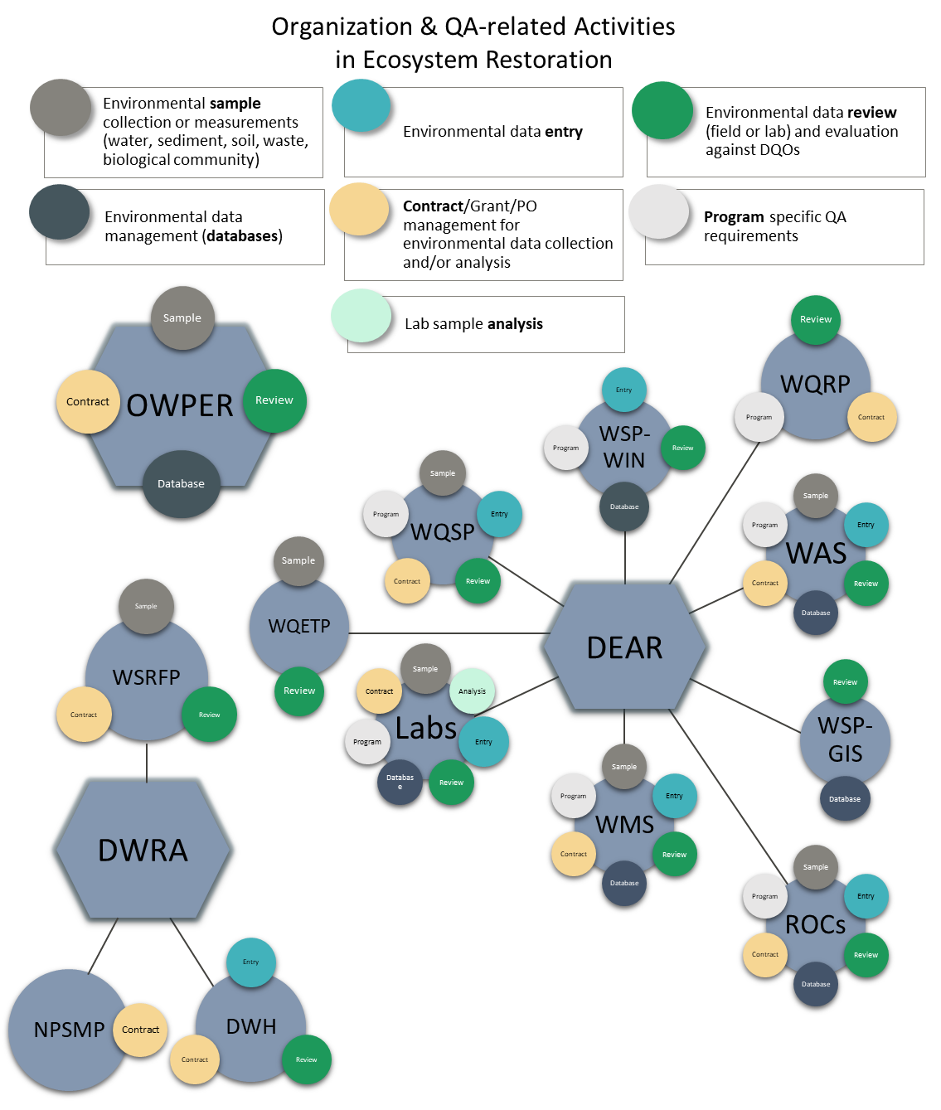
Figure 3.1. Diagram of reporting units from DEAR, OWPER and DWRA showing each work unit’s functions that require QA activities, represented by color-coded circles. The circles do not indicate whether that program or section reported on that function.
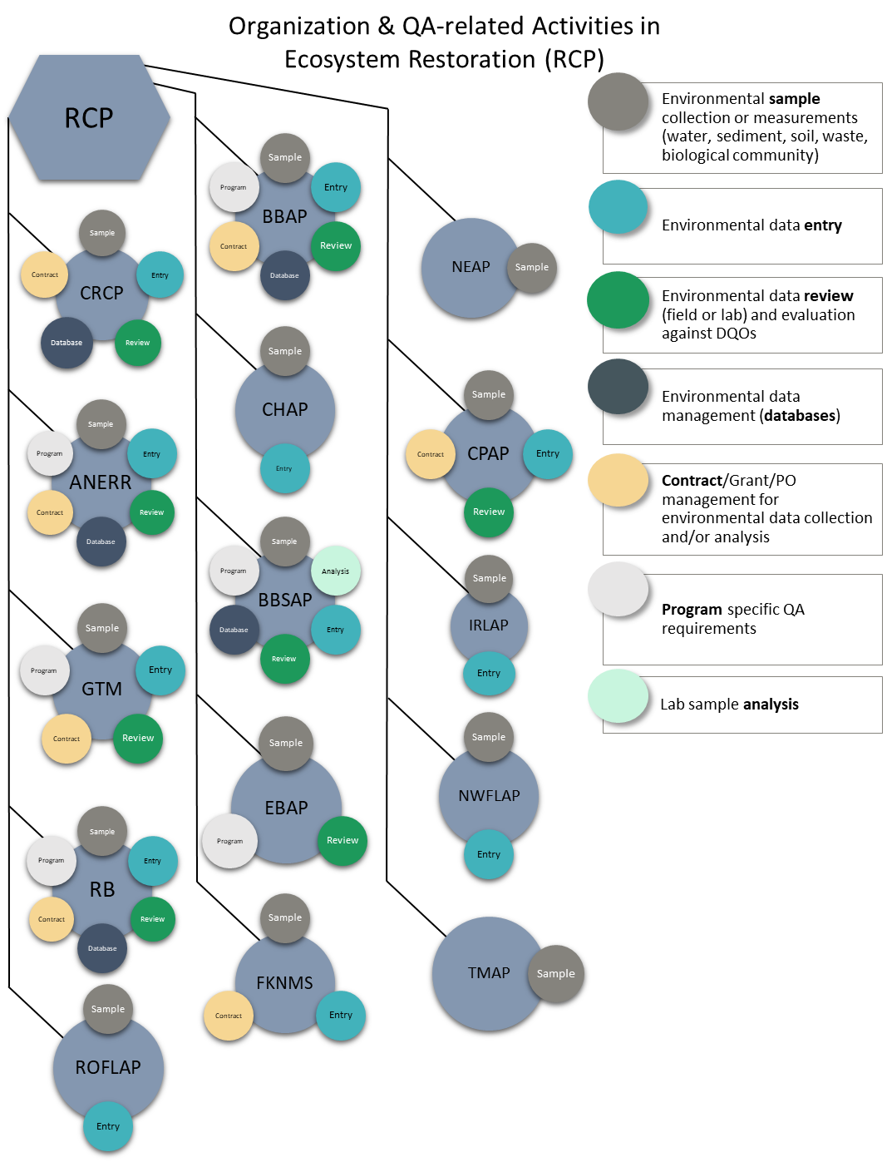
Figure 3.2. Diagram of reporting units from RCP showing each work unit’s functions that require QA activities, represented by color-coded circles. The circles do not indicate whether that program or section reported on that function.

Figures 3.1 and 3.2 provide context for the QA activities that AEQAS expects reporting units to report. All program functions listed require reporting units to have and document DQOs and provide adequate QA training to staff. Entities that collect or analyze environmental samples or measurements are expected to conduct internal audits and/or be audited by external parties to ensure proper collection and analysis of data. Reporting units that use data are expected to audit external entities that provide data to the department with some established consistency and frequency. Reporting units that manage contracts, grants or purchase orders (PO) for environmental data collection or analysis may conduct audits of procured services. Reporting units that enter data, retrieve data or manage environmental data repositories must have documented procedures for QA/QC.

3.2 Quality System
The majority (61 percent) of reporting units from the Ecosystems Restoration area of the agency reported as both data generators and data users. Less than a quarter (21 percent) reported only as data generators, and a small number (4 percent) reported only as data users. One unit (WSP-WIN) of the Watershed Services Program identified themselves as a data manager only, which is indicated as neither in the pie chart (Figure 3.3). A data managers section will be developed and included in future reports.
Figure 3.3. Number and percentage of reporting units within the Ecosystems Restoration area that identified their program activity functionality as data user, data generator, both or neither (data manager).
Percentages of reporting units with Quality System components as reported by data generators are illustrated in Figure 3.4. Individual reporting unit responses are located in Appendix B. All programs that generate data follow DEP SOPs, other SOPs, or a combination of both. The majority use DEP SOPs. Only 12 of the 23 units that generate data reported that their QP incorporates all the SOPs used by the reporting unit, which means the remaining units need to revise their QPs to include references to SOPs. Eighteen reporting units indicated they have checklists to evaluate the data generated against the DQOs. However, only 14 of the reporting units indicated the QP incorporates the checklists, and all checklists should be included or cited in QPs. Twenty reporting units stated that there were corrective actions for when data did not meet the DQOs, but 19 units document the corrective actions and only 11 units have the corrective actions in their QP. AEQAS instructs reporting units to include a process for documenting corrective actions in QPs. Seven of the 23 reporting units that generate data revised their DQOs. Twelve reporting units revised their QP in 2020, with six reporting units finalizing their QPs.

Figure 3.4. Percentage of reporting units in the Ecosystems Restoration area that answered “yes” to dichotomous questions regarding data quality objective use and documentation specific to roles as data generator in the 2020 survey template. Categories with three asterisks (***) are expected to be 100 percent. Other categories not reaching 100% are not deficiencies. There are 23 total data generators. Note that reporting units that indicated that the information is not included in the QP may not have a QP.
The percentages of reporting units with Quality System components as reported by data users are illustrated in Figure 3.5. Individual reporting unit responses are located in Appendix B. Seventeen of the 21 reporting units that identified as data users have written DQOs, and fifteen of the seventeen reporting units reported that data used are evaluated against DQOs. Two reporting units (EBAP and ROFLAP) have written DQOs but did not report that the data used are evaluated against DQOs. Two other reporting units (GTM and CRCP) indicated that they evaluate the data used to ensure that it meets their DQOs, but do not have the DQOs written down. Twelve units reported that another DEP unit evaluates the data used. Seventeen units have a checklist for evaluation, and eleven units documented the checklist in their QP. Thirteen reporting units have corrective actions for instances when data do not meet DQOs. Fifteen units reported following up with corrective actions, and ten reported that those corrective actions are in their QP. Four reporting units revised DQOs or procedures documented in 2020. Ten reporting units reported revising their QP in 2020, with three reporting units finalizing their revisions. It is department policy that all data users have established DQOs and corrective actions and document them in their QP.

Figure 3.5. Percentage of reporting units in the Ecosystem Restoration area that answered “yes” to dichotomous questions regarding data quality objective use and documentation specific to roles as data user in the 2020 survey template. Categories with three asterisks (***) are expected to be 100 percent. Other categories not reaching 100% are not deficiencies. There are 21 total data users. Note that reporting units that indicated that the information is not included in the QP may not have a QP.

Training
QAOs identified QA training needs by reporting the number of staff that needed the training versus the number of staff that received the training. Combining all staff from all reporting units and the training categories, 98 percent of employees received the required training for QA tasks in the Ecosystems Restoration area. When reviewing the information from individual reporting units, five units (LABS, BBSAP, RB, FKNMS, and BBAP) reported not having their training needs met, while four reporting units did not identify training needs in 2020.
All employees in the Ecosystems Restoration area who required training in laboratory analysis, data review, database management, and program-specific QA requirements received the training (Figure 3.7). Only one percent of employees who required training on field sampling did not receive it, and only 8 percent of employees who required training on data entry did not receive the training. However, a third (33%) of employees that needed contract/grant/PO training did not receive it in 2020. Figure 3.6. Percentage of employees in Ecosystems Restoration who required QA training in 2020 that received the training for their job responsibilities within each QA training category. Number of employees is included to provide more information.

Audits
AEQAS asked reporting units within the Ecosystems Restoration area of the agency to tally their audits from four different perspectives (Table 3.1). In total, 41 audits were reported for 2020, a slight decrease from the 50 reported for 2019. Slight increases or decreases are expected from year to year and are based on need. These 41 audits are composed of 13 performance audits, 17 project audits, and 11 system audits (Table 3.1).
Table 3.1. Audits reported by Ecosystems Restoration reporting units for 2020
Audit Perspectives |  | Audit Types
 | Performance | Project | System | Total
Audits of another unit within DEP | 4 | 4 | 1 | 9
Audits of entities external to DEP | 2 | 4 | 1 | 7
Audits of the reporting unit by another entity | 0 | 5 | 6 | 11
Self-audits conducted by the reporting unit | 7 | 4 | 3 | 14
Total | 13 | 17 | 11
Reporting units were also asked a series of questions to provide more information on the audits reported. Figure 3.7 includes seven QA criteria for evaluating the audits conducted by FDEP’s reporting units. They are as follows: (1) Do you generate a report for these audits? (2) Did your reporting unit track time frames of any of the audit activities, i.e. audit initiation, audit completion, or report compilation? (3) Were there written procedures or checklists for conducting these audits that ensured consistency between audits/auditors? (4) Is there a timeframe required for the audit report completion? (5) Was the report generated in the required timeframes? (6) Did the audited party respond to a preliminary audit report within a specified time frame? (7) Did your reporting unit follow up on any corrective actions for the audit? These questions are asked to better understand how reporting units manage their audits. At this time, there are no department-wide expectations for these criteria. Establishing expectations is the responsibility of the reporting units’ management.
Five reporting units conducted at least one audit. Three units (WQSP, WMS, and BBAP) conducted audits of entities within DEP, and five units (WQSP, WMS, OWPER, BBAP, and ANEER) conducted audits of entities external to DEP. The majority of units reported generating an audit report and used checklists to conduct audits. More than half of the reporting units established a required report time frame and met the established time frame goal (Figure 3.7). Only two of the five units that conduct audits of external entities (WMS and OWPER) follow up with corrective actions by the external entities, and only one reporting unit received responses to the report within the determined time frame. Reporting units should make efforts to encourage auditees to respond within the determined time frame but are not ultimately responsible for the audited parties’ timeliness.
Nine reporting units were audited by an external entity or themselves in 2020. WAS, ROCs, LABs, CPAP, CHAP and BBAP indicated they were audited by an entity outside of their reporting unit, and WQSP, ROCs, LABs, FKNMS, CPAP, CHAP, BBAP and ANERR conducted one or more internal audits of their work units. Of the six units that were audited by an entity outside of their reporting unit, five followed up with corrective actions. Of the eight units that conducted internal audits, all had an established frequency requirement and six followed through with corrective actions at the time of reporting. The internal audit is an important tool for work units to evaluate their practices and procedures, which provides their data users with greater confidence in the data. Units that generate data but do not conduct internal audits should evaluate the value of internal audits and possibly include internal audit goals in their QP. Currently nine reporting units have audit goals, with eight of the units having the audit goals discussed in their QP.


Figure 3.7. Percentages of Ecosystems Restoration reporting units meeting seven QA criteria for conducting audits in two audit categories: external audits that are conducted by the reporting unit of entities within DEP and external audits conducted by the reporting unit of an entity outside of DEP. Numbers of reporting units that answered “yes” to each criteria are included in the bars to provide more information.

Data Repositories
Of the reporting units within Ecosystems Restoration, 71 percent (20 of the 28 reporting units) indicated that staff enter data into at least one data repository. Sixty-four percent (18 of 28 reporting units) retrieve data, and 39 percent (11 of 28 reporting units) are responsible for managing data in repositories.
Reporting units in the Ecosystems Restoration area enter data into 24 different data repositories. The majority of reporting units verify the data that are entered (Figure 3.8). However, there are a few reporting units (WMS, GTM, and CPAP) that do not have verification steps in place for all data that are entered. There are a couple of reporting units (IRLAP and FKNMS) that do not have verification steps for any of the data that are entered. To ensure that data are entered correctly, reporting units without verification protocols should determine if data verification is needed to increase the reliability of its data. Of the reporting units that verify data entry, 35% have all of the protocols documented in the QP for all the repositories, quarter have protocols documented for some of the repositories in which data are entered, and 40% do not have any of the protocols documented in the GP. To safeguard against data entry errors and improve data repository understanding by staff, all protocols should be documented or referenced in QPs.

Figure 3.8. Number of reporting units in the Ecosystems Restoration area that enter data into data repositories in which data entered is verified with a second-level check for all repositories and have documented protocols in place for entering data for all repositories. Note that reporting units that indicated that the information is not included in the QP may not have a QP.
Eighteen reporting units retrieve data from 37 different data repositories. Almost half of the reporting units perform QA/QC checks on the data retrieved from all of their data repositories; a third (WMS, WSP-GIS, WETS, ROCs, RB, and GTM) perform QA/QC checks on the data retrieved from some of their data repositories; and the remaining fourth (WSRFP, EBAP, DWH, and CPAP) do not perform any checks on the data retrieved (Figure 3.9). Those programs that do not perform QA/QC checks on all data retrieved should determine whether QA/QC checks are necessary. Less than half of reporting units have written protocols for the retrieval of data from all repositories, with few reporting that there are written protocols for some of the repositories used for retrieval. The ten reporting units without written protocols should evaluate their QPs and include the protocols for data retrieval. The majority of reporting units have feedback mechanisms in place to notify the data generator of suspect data for all data repositories. However, only half of reporting units described these feedback mechanisms in their QP for all data repositories. The few reporting units without feedback mechanisms for all data repositories should evaluate the need for feedback mechanisms. The reporting units without feedback mechanisms described in their QP should revise the document to include the feedback mechanisms. To obtain data consistently and uniformly, protocols for QA/QC checks, data retrieval, and feedback mechanisms for retrieving data from each data repository utilized by a unit should be in place and described in their QP.

Figure 3.9. Number of reporting units in the Ecosystems Restoration area that retrieve data from data repositories in which data quality checks were performed on all data retrieved, documented protocols are in place for all repositories used, a feedback mechanism is in place to notify the data generator of suspect data for all repositories, and the feedback mechanism is described in the reporting unit’s quality plan for all repositories. Note that reporting units that indicated that the information is not included in the QP may not have a QP.
Eleven reporting units within Ecosystems Restoration manage 19 data repositories. Almost all reporting units perform checks on all data repositories managed and have protocols on how to perform quality checks in their QP. One unit (WSP-WIN) performs checks on only some of the repositories they manage, and one unit (WSP-GIS) does not perform checks on data stored or managed (Figure 3.10). Reporting units without protocols for checking data should evaluate the need for checks and add relevant documentation for performing checks of stored data in the QP.
Most reporting units have a mechanism to provide feedback to the data generator for suspect data. However, only a few reporting units (OWPER and LABS) have all protocols and feedback mechanisms documented in the QP (Figure 3.10). A couple of others have documented their feedback mechanism for some repositories. Reporting units without protocols and feedback mechanisms for all data repositories should evaluate their QPs and include the protocols for data storage. To validate data housed, documented protocols should be in effect and described in the QP for all data repositories.

Figure 3.10. Number of reporting units in the Ecosystems Restoration area that manage data repositories in which data quality checks were performed on all repositories managed, documented protocols are in place for quality control checks of the stored data for all repositories, a feedback mechanism is provided to the data generator for suspect data for all repositories, and the feedback mechanism is described in the reporting unit’s quality plan for all data repositories. Note reporting units indicating that the information is not included in the QP may not have a QP.

4. Land and Recreation
The following divisions, programs, and sections contributed to this report:
Division of Recreation and Parks (DRP)
Division of State Lands (DSL)

Overview and Expected QA Activities
The Land and Recreation area of DEP acquires and protects lands for preservation and recreation. It includes 175 state parks and trails, more than 12 million acres of public lands, and 4 million acres of coastal uplands and submerged lands. Land and Recreation includes two divisions: Division of Recreation and Parks (DRP) and Division of State Lands (DSL). DRP reports as one unit, though organizationally there are eight programs and five districts. DSL also reports as one unit, though six programs make up the division. Figure 4.1 indicates the functions of DRP and DSL that involve QA activities.
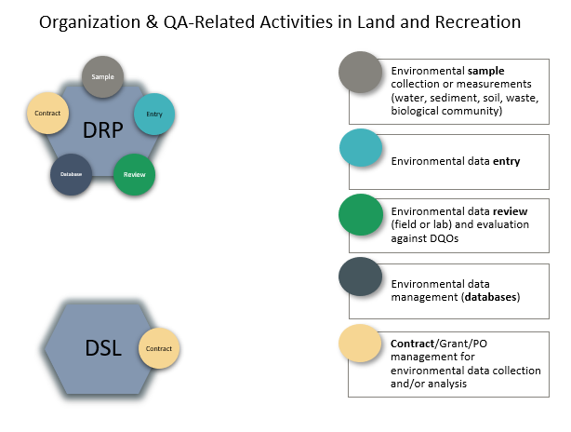
Figure 4.1. Diagram of the reporting units for DRP and DSL showing each unit’s functions that require QA activities, represented by color-coded circles. The circles do not indicate whether that program or section reported on that function.
Although its primary missions are to manage public land and provide recreational opportunities for the public, DRP collects some environmental data for the department, either directly or indirectly through purchase orders. Some sampling is for research purposes, while some is for compliance with drinking water, wastewater, and bathing beach monitoring requirements. Sampling projects and procedures vary across the DRP districts based on regional needs. For all environmental data collected for programmatic use, expected QA activities include using published or recognized methods, training staff and volunteers to appropriately use the methods as well as training for data entry, data review and data management. Because DRP manages sampling agreements, it must have established data quality objectives (DQOs), training for staff to review data against the DQOs, and training to understand when to incorporate QA into agreements with the department.
DSL manages, purchases and maintains state lands and conservation easements, and is not directly involved with the collection and analysis of environmental data; therefore, DSL has limited QA reporting. DSL reports on DQOs and training related to program-specific QA requirements. In previous years, they have reported limited data retrieval, but that activity was not performed in 2020. DSL did not report contract or grant management-related QA activities in 2020, though it is known that they have managed contracts or grants in the past that need QA oversight.
Figure 4.1 provides context for the QA activities that AEQAS expects reporting units to report. All program functions listed require reporting units to have and document DQOs and provide adequate QA training to staff. Entities that collect or analyze environmental samples or measurements are expected to conduct internal audits and/or be audited by external parties to ensure proper collection and analysis of data. Reporting units that use data are expected to audit external entities that provide data to the unit with some established consistency and frequency. Reporting units that manage contracts, grants or POs for environmental data collection or analysis may conduct audits of procured services. Reporting units that enter data, retrieve data, or manage environmental data repositories must have documented procedures for QA/QC.

Quality System

The DRP and DSL are both data users. Portions of DRP are also data generators. The DSL finalized revisions to their quality plan (QP) in the beginning of 2020. DRP’s QP is out of date but reported that revisions will be made in 2021. AEQAS is scheduled to conduct a Quality of Science Review in 2021 with the DRP QAO and other representatives to evaluate current implementation of DRP’s quality system and determine which specific QA-related tasks should be documented in this report.

Training
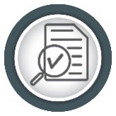
No QA training was reported by the DSL. DRP reported that they needed field sampling training for staff and all the applicable staff received the required training. AEQAS and DRP are discussing the need for some staff to receive contract/grant/PO QA training.

Audits
The Land and Recreation Area did not report any audits. Reporting units within this area are not likely to report audits in the volume or frequency of other areas of the agency. However, environmental data collected through compliance monitoring or sampling for research is subject to audits. For example, some of the data generated by DRP is subject to performance audits.


Data Repositories
DSL reported that staff do not enter, retrieve nor manage environmental data. DRP reported that staff enter and retrieve environmental data. DRP staff verify all data entered, but do not have documented protocols for data entry and verification. QA/QC checks are not performed on the data retrieved from repositories. There is a feedback mechanism for suspect data, but the feedback mechanism is not documented in their QP. DRP should work to update its QP to incorporate the protocols for data entry. They should also evaluate the need for QA/QC checks on data retrieved and include their feedback mechanism for suspect data in their QP.

5. Regulatory Programs
The following divisions, programs and sections contributed to this report:
Division of Waste Management (DWM)
Petroleum Restoration Program (PRP)
Site Investigation Section (SIS)
Solid Waste Program & Permitting Section (SW)
Waste Site Cleanup Section (WSCS)
Federal Programs Section (FPS)
Brownfields and CERCLA Site Screening (BCSS)
Hazardous Waste Program & Permitting Section (HW)
Operational and Program Performance (OPP)
Business and District Support Program (BDSP)
Permitting and Compliance Assistance Program (PCAP)
Florida Geological Survey (FGS)
Division of Law Enforcement and Emergency Response (DLEER)
Division of Water Resources Management (DWRM)

Division of Waste Management, Florida Geological Survey & Division of Law Enforcement and Emergency Response
The regulatory district offices (Districts), Division of Waste Management (DWM), Division of Water Resource Management (DWRM), the Florida Geological Survey (FGS), and Division of Law Enforcement (DLE), which includes the Office of Emergency Response comprise the Regulatory Programs area of the agency. The data presented in this section of the report are based on the 12 reporting units that submitted information for 2020 from DWM, DLE and FGS, which includes all organizational units for these offices. This is an increase from 11 reporting units in 2019. This additional reporting unit is from a unit in the DWM that reported as part of another unit in previous years. QA activities reported for DWM in this section do not include QA activities conducted in the districts. Discussion of the Drinking Water and Wastewater Regulatory Programs in the districts and DWRM are in the next section. See Figure 5.1 for a list of reporting units and an overview of the expected QA activities within each reporting unit.
DWM implements state and federal laws to protect the environment from the improper handling and disposal of solid and hazardous wastes. Nine reporting units representing seven organizational units make up the DWM: District and Business Support Program (DBSP); Federal Programs Section (FPS); Brownfields and CERCLA Site Screening (BCSS); Site Investigation Section (SIS); Waste Site Cleanup Section (WSCS); Hazardous Waste Program & Permitting (HW) Section; Solid Waste Program & Permitting (SW) Section; Operation and Program Performance (OPP) Section; Permitting & Compliance Assistance Program (PCAP); and Petroleum Restoration Program (PRP). Brief responsibilities of each section/program are as follows.
The DBSP provides technical support services to the DWM and six district offices across the state. These services include professional consultation on all aspects of site assessment and remediation, including human health and ecological risk assessment.
The Department of Defense (DOD), Brownfields and CERCLA programs reported as one unit (FPS) in 2019 but were split into three distinct programs in late 2019. For the 2020 report, they are addressed in two groups as the Federal Programs Section (FPS) and Brownfields and CERCLA Site Screening (BCSS). FPS provides oversight of site rehabilitation activities, program guidance and technical support at DOD and National Aeronautics and Space Administration (NASA) sites and facilities in Florida (which also includes sites in the Formerly Used Defense Sites or FUDS Program). BCSS works with the U.S. Environmental Protection Agency (EPA) to administer the Brownfields Program in Florida, and conducts site screening assessments on sites with confirmed or suspected contamination to document if there was a release of hazardous substances and to evaluate the site for possible inclusion on the National Priority List (NPL).
The SIS investigates reports of known or suspected soil and groundwater contamination statewide and issues technical reports to support district assessment and cleanup decisions. The section also manages the State-Owned Lands Cleanup Program, which is responsible for addressing contaminated sites on land owned by the state of Florida.
The WSCS is responsible for managing the Dry-cleaning Solvent Cleanup Program, which addresses contamination resulting from the operation of eligible dry-cleaning facilities. In addition, the WSCS coordinates with EPA during EPA-managed remediation of National Priority List (NPL)/Superfund sites in Florida. For sites that do not meet NPL criteria and have no viable responsible party, the WSCS manages these as “State-Lead” sites using state funding.
The HW Cleanup Section is working under the Resource Conservation and Recovery Act (RCRA) and is responsible for the remediation of hazardous waste sites.
The SW Section develops solid waste policy and provides technical assistance to the district offices concerning the permitting, compliance and enforcement activities associated with solid waste facilities. These facilities can include landfills, material recovery facilities, transfer stations, composting/processing facilities, and waste tire management sites.
The OPP Section provides information and technology services related to data management, reporting and presentation for DWM applications. The section is responsible for the circulation, transfer and disposition of DWM’s property. The section also coordinates purchases and maintains property acquisitions, storage and disposal in accordance with DEP directives.
The PCAP implements state and federal laws related to recycling, pollution prevention, solid and hazardous waste management, and storage tank compliance. The PCAP works closely with districts to implement permitting, compliance and enforcement activities in order to protect the environment from improper handling and disposal of solid and hazardous waste.
The PRP provides technical oversight for assessment and cleanup of sites contaminated by discharges of petroleum and petroleum products from stationary petroleum storage systems.
DLE responds to environmental pollution threats in every form, from incidents involving petroleum spills caused by vehicle accidents to chemical plant explosions and coastal oil spills. There is one reporting unit for DLE. The districts carry out this office’s responsibilities across the state. The QAOs for DLE report for the division office as well as the district offices.
FGS collects, interprets and provides information about Florida’s water, mineral and energy resources. The focus of FGS is on environmental problem-solving and geological hazards as they relate to public health and safety. FGS has one reporting unit encompassing five organizational units.
Figure 5.1 provides context for the QA activities that AEQAS expects reporting units to report. All listed program functions require reporting units to have and document DQOs and provide adequate QA training to staff. Entities that collect or analyze environmental samples or measurements are expected to conduct internal audits and/or be audited by external parties to ensure proper collection and analysis of data. Reporting units that use data are expected to audit external entities that provide data to the department with some established consistency and frequency. Reporting units that manage contracts, grants or POs for environmental data collection or analysis may conduct audits of procured services. Reporting units that enter data, retrieve data or manage environmental data repositories must have documented procedures for QA/QC.
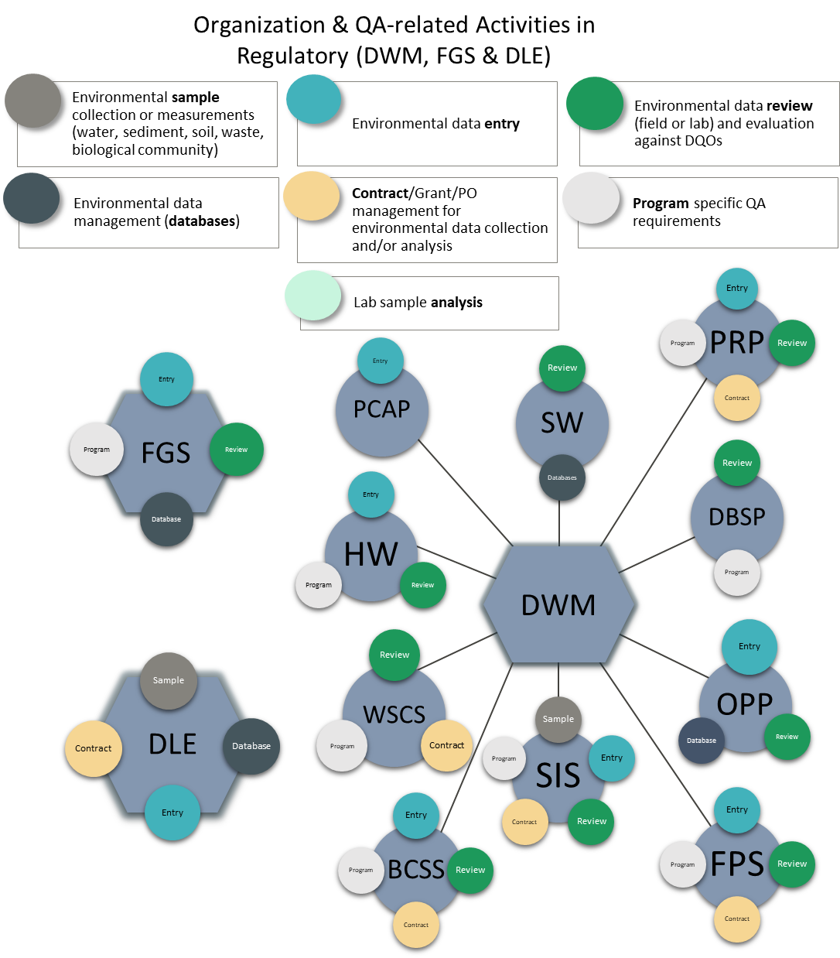
Figure 5.1. Diagram of the reporting units from DWM, FGS and DLE showing each unit’s functions that require QA activities, represented by color-coded circles. The circles do not indicate whether that program or section reported on that function.

Quality System
Twelve units reported on the Quality System content for the 2020 Annual QA Report. Three units reported as both data generators and data users, and nine units reported as a data user only (Figure 5.2). Individual reporting unit responses to the survey are located in Appendix B. Figure 5.2. Number and percentage of units in Regulatory Programs reporting as data users, data generators or both for the 2020 QA Annual Report. There are 12 reporting units total from DWM, DLE and FGS combined.
Three units reported generating data for department use. Data generation includes sample collection and/or analysis. All data generating units indicated they follow DEP SOPs, other SOPs, or a combination of both (Figure 5.3). Two of the three data generating units indicated their QP incorporates all SOPs, and the remaining unit should revise their QPs to include references to all SOPs used. One unit has DQOs other than SOPs. Only one unit indicated having checklists to evaluate the data generated against DQOs, but two have incorporated the DQOs and procedures to evaluate into the QP. All units should have checklists, and all the checklists should be included or cited in QPs. All units stated that there were corrective actions for when data did not meet the DQOs and the corrective actions are documented in the QP. None of the reporting units identifying as data generators revised their DQOs and corrective actions nor did they report revising their QP in 2020, such revisions may not have been necessary.

Figure 5.3. Percentage of Regulatory program reporting units that answered “yes” to dichotomous questions regarding data quality objective use and documentation specific to roles as a data generator in the 2020 survey template. Categories with three asterisks (***) are expected to be 100 percent. Other categories not reaching 100% are not deficiencies. There are three total data generators.
All 12 reporting units in DWM, DLE and FGS reported as data users. Nine of those 12 units reported using data generated by both the department and external sources, while three units indicated that they only use a source outside of DEP. All the data users reported having DQOs for the data used, and all but one reporting units evaluate the data used to ensure data meet the DQOs (Figure 5.4). Five units indicated that another DEP unit evaluates the data used by their reporting unit. All units have documented the DQOs in their QP. Ten units reported that there are corrective actions in place when data do not meet DQOs. Nine units follow up to ensure corrective actions are implemented. Eight of the 12 reporting units with corrective actions have documented them in their QPs. No reporting units indicated revising Quality System components, though three reporting units revised their QP and eight indicated they were part of the finalization of the DWM QP in 2020.

Figure 5.4. Percentage of Regulatory program reporting units that answered “yes” to dichotomous questions regarding data quality objective use and documentation specific to roles as a data user in the 2020 survey template. Categories with three asterisks (***) are expected to be 100 percent. Other categories not reaching 100% are not deficiencies. There are 12 total data users.

Training
QAOs reported the staff that required training and those that received training. For DWM, FGS and DLE, most employees that required training received the training during 2020. Three units did not report training needs or requirements for 2020. More employees were trained on contract and grant management requirements than any other training category in 2020 (Figure 5.5). One reporting unit (PCAP) provided training to entities external to DEP. The number of people who took the two trainings provided is unknown since trainings were online due to restrictions in place because of COVID-19.
Figure 5.5. Percentage and number of employees in DWM, FGS and DLE that received training within each QA training category in 2020.

Audits
AEQAS asked reporting units within the Regulatory area of the agency to tally their audits from four different perspectives (Table 5.1). In total, 19 audits were reported for 2020.
HW and PCAP were the two reporting units in DWM, DLE and FGS that conducted audits of other entities within and external to DEP in 2020. HW conducted fifteen audits in 2020. There were reports generated for the HW audits and follow up on corrective actions. PCAP conducted a system audit and generated a report, but did not track the completion of the audit, nor follow up with corrective actions. Both reporting units’ auditors used checklists to perform the audits.
Only one reporting unit (DLE) conducted an internal audit of its unit. One reporting unit (PCAP) conducted an audit of an entity within DEP; they were also audited by an outside entity in 2020. Many reporting units (HW, FPS, PRP, and WSCS) conduct extensive data reviews of permit packages that do not constitute an audit. Currently four reporting units indicated having audit goals in 2020, and three of the four reporting units have those audit goals documented in their QPs.
Table 5.1. Audits reported by DWM, FGS & DLE reporting units for 2020
Audit Perspectives |  | Audit Types
 | Performance | Project | System | Total
Audits of another unit within DEP | 0 | 0 | 1 | 1
Audits of entities external to DEP | 15 | 0 | 0 | 15
Audits of the reporting unit by another entity | 0 | 0 | 2 | 2
Self-audits conducted by the reporting unit | 1 | 0 | 0 | 1
Total | 16 | 0 | 3

Data Repositories
Among the reporting units of DLE, FGS and DWM, nine of the 12 reporting units reported that staff in the unit enter data into at least one data repository. Nine of the 12 reporting units retrieve data, and four of the 12 reporting units are responsible for managing data in repositories.
Reporting units of DWM, DLE and FGS enter data into 16 different data repositories. Most of the reporting units indicated they verify data entered into all repositories. Some have documented protocols for data entry for all the data repositories they use, while five reporting units DLE, BCSS, SIS, PRP, and OPP) do not. Four reporting units identified having written protocols for data entry in all repositories, one reporting unit has protocols documented in their QP for some of their repositories, while the remaining four units do not have any documented protocols (Figure 5.6). Reporting units that do not verify data entry should determine if verification would improve data quality. If verification protocols are enacted, the reporting units should document the protocols for each data repository used in their QP to ensure consistent and correct data entry.
Figure 5.6. Number of reporting units in DWM, DLE and FGS that enter data into data repositories in which data entered is verified with a second-level check for all repositories and documented protocols are in place for entering data for all repositories.
More than half of the reporting units that retrieve data perform QA/QC checks on the data retrieved from data repositories (Figure 5.7), but not all of them have documented protocols for how they retrieve all data. Four reporting units (PRP, SIS, OPP, and FGS) do not perform any QA/QC checks on the data retrieved from any data repositories. To obtain data consistently and uniformly, the reporting units without QA/QC checks for data retrieval should evaluate their need for protocols and determine if QA/QC checks are appropriate. If those checks are deemed appropriate and implemented, the reporting units should document the protocols in the QP. Most of the reporting units that retrieve data have a mechanism to provide feedback to the data generator regarding suspect data for all repositories. A few reporting units have feedback mechanisms described in their QP for contacting data generators for all repositories and indicated their QP contains the mechanism for some repositories. Five reporting units did not have any feedback mechanisms documented in their QP. Feedback mechanisms help maintain data quality throughout the data retrieval and use process. Reporting units without these mechanisms should evaluate the value of the protocol and include it in their QP if it is decided protocols are valuable.

Figure 5.7. Number of reporting units in DWM, DLE and FGS that retrieve data from data repositories in which data quality checks were performed on all data retrieved, documented protocols are in place for all repositories used, a feedback mechanism is in place to notify the data generator of suspect data for all repositories, and the feedback mechanism is described in the reporting units’ quality plan for all repositories.
Four reporting units manage ten different data repositories. Nearly all of those reporting units perform checks on all repositories managed and have written QC protocols of the stored data. Only one (OPP) does not perform QA/QC checks on any repositories, nor does it have protocols in its QP for QC checks (Figure 5.8). This reporting unit should evaluate the need to perform checks on stored data. If quality checks are found necessary, the protocols should be documented in their QP. All of the reporting units managing data repositories have mechanisms to provide feedback to the data generator regarding suspect data. Most reporting units document the mechanism for providing feedback for all data repositories in their QP. For the validity of data housed, documented protocols should be in effect for all data repositories. The remaining reporting unit should include its feedback mechanism for suspect data in their QP.

Figure 5.8. Number of reporting units in DWM, DLE and FGS that manage data repositories in which data quality checks were performed on all repositories managed, documented protocols are in place for quality control checks of the stored data for all repositories, a feedback mechanism is provided to the data generator for suspect data for all repositories, and the feedback mechanism is described in the reporting units’ quality plan for all data repositories.

Division of Water Resource Management (DWRM) & Districts
DWRM is responsible for implementation of state laws providing for the protection of the quality of Florida’s drinking water, ground water, rivers, lakes, estuaries and wetlands from permitted discharges or activities, as well as reclamation of mined lands and the preservation of the state’s beach and dune systems. DWRM currently has two reporting units: wastewater (domestic and industrial) and drinking water. As the QA process for the water regulatory programs is revised, additional programs will be added as reporting units.
As identified in the 2017 Annual Report, the QA system for the water regulatory programs was inconsistent between the division office and the district offices. Recognizing the need for a unified Quality System, regulatory staff began an in-depth evaluation of the QA processes for the Drinking Water and Wastewater programs.
In 2018, following a two-day QA workshop, DRWM established Drinking Water and Wastewater workgroups with representatives from the division office and the district offices. The workgroups, with support from AEQAS, established: 1) specific QA functions for Drinking Water and Wastewater Programs; 2) the role of the subject matter experts and the QAOs; 3) checklists and guidance documents for the QA activities; and 4) the level of effort for the QA evaluations. These efforts are described in more detail below.
Throughout 2019 and into 2020, DWRM leadership worked to document the QA goals and efforts expected of the district offices. QAOs were appointed in the district and division offices, and it was determined that QA efforts would be reported per district.
The primary QA function of the Drinking Water and Wastewater regulatory programs is to review environmental data they receive to ensure that sample collection and measurement or analysis meets the department’s QA requirements. To carry out that function, the division office created data review checklists for both programs and determined the frequency for which these checklists will be used. The checklists are used uniformly by the district and division offices. Training for the use of checklists was held in May 2020, and the checklists were distributed in July 2020 with implementation and goals distributed in September 2020. DWRM provided a final quality assurance document that includes training and easy access to the checklists.

5.2.1 DWRM - The Drinking Water Program
The state of Florida implements the Federal Safe Drinking Water Act and its corresponding Florida Safe Drinking Water Act via Florida’s Public Water Systems Supervision (PWSS) program. The program is administered by DEP and the approved county health departments (ACHDs). The goal is to protect the public health of Floridians by providing safe drinking water. The program administers permitting of construction of facilities, compliance with water quality standards and monitoring requirements, operator staffing, enforcing violations, and response to natural disasters. The program also partners with the Florida Rural Water Association (FRWA) under grant agreement to support the program.

5.2.1.1 Drinking Water-Training
Training is provided throughout the year to division and district staff, the ACHDs and facility operators. For the 2019 report, DWRM leadership provided a list of training specifically related to drinking water QA. The Drinking Water Regulatory Program tracked whether the required QA-related trainings were completed between September 1- December 31, 2020. The six regulatory districts reported 80 percent of staff that needed training received the training required (Figure 5.9). Two districts reported that not all staff that needed training received it. A total of 32 employees throughout the districts received training for drinking water QA activities in 2020.

Figure 5.9. Percentage of employees that received needed training for Drinking Water QA activities in the Regulatory districts from September 1-December 31, 2020.

5.2.1.2 Drinking Water – Audits/Data Review
Prior to 2018, the types of audits reported for the Drinking Water Programs were inconsistent and not representative of program QA functions. Through collaborative efforts between the division, districts, and AEQAS, the workgroup was able to identify all of the drinking water reports and data sets that will be reviewed for QA objectives and. set goals for the percentage of reports that are to be reviewed. Leadership determined the QA review process should be applied to five percent of the total Level of Service commitments for the following reports: bacteriological reports, chemical reports and monthly operating reports.
All districts, except one, met the QA review goals (Figure 5.10). In total, over 200 hours were spent on the review of drinking water documents and reports. All reviews were conducted with checklists developed by the QA workgroup established in 2018.

Figure 5.10. Data reviews conducted by each district and overall. Blue bars reaching one hundred percent indicate the data review goals were met in the district. Numbers in the bar indicate the count of data reviews.

DWRM - The Wastewater Program
The Wastewater Management Program regulates domestic and industrial wastewater discharges. This program within DWRM is responsible for the development and administration of rules and policies that regulate these discharges, and the district offices are responsible for the permitting activities. Similar to the Drinking Water Programs, the QA functions of these programs were reviewed by the division, districts, and AEQAS in response to inconsistent QA implementation and reporting. The wastewater QA workgroup was able to identify the types of reports and data sets that require QA review as well as the level of effort. Checklists and SOPs for use of the checklists have been developed to accompany each of these reports and data sets.

5.2.2.1 Wastewater-Training
The Wastewater Management Programs conduct training for division and district staff throughout the year and provided a list of required training for their staff for the 2019 report. The Wastewater Regulatory districts tracked whether the required QA-related trainings were completed between September 1- December 31, 2020.
Five of the six regulatory districts reported all staff that needed training received it (Figure 5.11). Only one district reported not all staff received needed training. A total 40 employees throughout the districts were trained for wastewater QA activities in 2020.

Figure 5.11. Percentage of employees that received needed training for Wastewater QA activities in the Regulatory districts from September 1-December 31, 2020.

5.2.2.2 Wastewater-Audits/Data Reviews
District offices are required to conduct a set number of inspections as part of their annual Level of Service (LOS) commitments for the EPA Performance Partnership Agreement (PPA). The expectation is to conduct at least one Compliance Evaluation Inspection (CEI) on each wastewater and stormwater facility with an active discharge or located in priority watershed areas annually. The wastewater QA workgroup determined that, beginning July 1, 2020, staff will review QA elements for 5% of facilities annually at the time of inspection, but the long-term goal is for each facility to receive a QA review within the permit renewal cycle.
The following reports and forms are reviewed for QA objectives at a level of 5% of the total number of regulated facilities annually: Discharge Monitoring Reports (Pre-treatment and Biosolid), Field Sheets, Chain of Custody Forms, Lab Reports, Groundwater Reports, Reclaimed Analysis Reports, Annual DMRs for Specific Parameters, Bacteriological Reports for Crypto and Giardia, Toxicity Reports, DEW/PET, and Quality Reports for DMR.
All of the districts met their data review goals, with two districts exceeding the goal by one review each for a total of 117 QA components as part of inspections. In total, the QA reviews required 529 hours of district staff’s time.

Figure 5.12. Data reviews conducted by each district and overall. Blue bars reaching one hundred percent indicate the data review goals were met in the district. Numbers in the bar indicate the count of data reviews.

6. Summary of QA Activities, Successes and Goals

Quality System
AEQAS uses two components to assess whether department reporting units have the minimum requirements for a Quality System: the designation of QA Officers (QAO) and the existence of current quality plans (QP). For 2020, most reporting units have designated QAOs and current QPs. DWRM regulatory programs and districts appointed QAOs in the districts for drinking water and wastewater, which increased QA representativeness throughout the agency. QAOs should be appointed for other programs within RCP and DWRM following evaluation of the QA activities in their programs. All other parts of the agency have designated QAOs.
Most divisions and districts have QPs, but some do not, and others have QPs that need to be updated. WETMDL within DEAR updated its QP in 2020 and finalized it in early 2021. The Office of Water Policy and Environmental Restoration is updating their QP and expects the revisions to be finalized in 2021. RCP has developed a QP for the continuous monitoring program carried out by all APs, but individual RCP work units do not have QPs and are working with AEQAS on the best approach to establish these QPs. DWRM provided a quality assurance document for the districts and the division in 2021, but it does not yet contain all of the components of a QP. DWM finalized its QP in 2020, but the regulatory districts did not adopt the DWM division-wide QP. DRP’s QP is outdated and expected to be updated in 2021. DSL finalized its QP in 2020.
Some reporting units still have not incorporated all QA/QC elements and expectations into their QPs, and they should make efforts to do so in 2021. AEQAS will give an annual training on the components of a QP in order to teach programs that do not have a QP or need to improve their QP how to establish the appropriate documentation for their Quality Systems. AEQAS is also willing to assist others with their QP updates. AEQAS also conducts Quality of Science Reviews for programs that want their QPs reviewed and their Quality System evaluated for consistency between documentation and QA/QC activities.
Some programs within RCP and parts of DWRM did not report on QA-related activities for the 2020 report. The parts of DWRM needing to report include: Mining and Reclamation, Oil and Gas, Phosphate Management, Submerged Lands, Compliance and Enforcement, NPDES Stormwater, and Aquifer Protection. Management and QAOs need to actively collaborate within their reporting units to meet expectations outlined in the “Areas of Responsibility” section of the QA Directive. This would ensure that the data generated and data used by their reporting unit are defensible and meet applicable DQOs. AEQAS met again with QAOs individually in 2021, as in 2020, to assist them with their reporting and help them understand their responsibilities. AEQAS is continuing to reach out and working to improve collaborative efforts with management and the current QAOs to identify expectations for QA activities.

Ecosystems Restoration
The programs and sections of DEAR, OWPER, DWRA, and the APs and NERRs within RCP make up the 28 reporting units within Ecosystems Restoration. The number of reporting units has remained consistent, though RCP needs to evaluate which other units may need to report. The reporting units within Ecosystems Restoration function under an established Quality System, though improvements are needed in documentation of the Quality System and data repository use by all units. RCP has had recent success in communicating with external data providers and has increased awareness of the QA requirements for data provided to the agency, both of which lead to higher quality data used by the department.
In the Ecosystems Restoration area, only half of the data generators cite all SOPs utilized in their QPs. The majority of the data generators have checklists for evaluating the data produced. Though not all the data users who have checklists incorporated the checklists in their QP, there has been a steady increase of checklist incorporation in QPs since 2017. Data users showed an increase in the documentation of DQOs and evaluation of data against the DQOs. There has also been an increase in the reporting units that follow-up with corrective actions, however, there has not been an increase in the documentation of those corrective actions in the QP by both data generators and users. Also, the majority of data users have established consistent procedures for data evaluation in the last three years.
Nearly all of the employees received required QA training in 2020, and some employees received training that was not required. The area where staff did not receive required training falls under contract/grant management, and AEQAS will increase the number of contract/grant trainings in 2021 to meet this need. Overall, training has remained consistent since 2019.
Reporting units in the Ecosystems Restoration area performed various field and lab audits, with project audits as the most common. The number of audits has been fairly consistent since 2017. The majority of programs that conducted audits generated reports and used checklists, however improvement is needed for receiving timely responses for audit reports. Some reporting units have established auditing goals, though not all have documented the goals in their QPs. AEQAS is working with QAOs and their management to establish audit goals and encouraging them to document the goals in their QPs.
The majority of reporting units enter data into and retrieve data from repositories. Most units verify all entered data, but less than half of those have written protocols for data entry and verification and there has been no improvement in this area over the last four years. Less than half of the units perform QA/QC checks on all the data retrieved and only a third of those units document the procedures. Most of the units that retrieve data have established feedback mechanisms to initiate corrective actions for suspect data found in their data repositories, but only half document the procedures in their QPs. Some reporting units are responsible for managing data repositories and most perform QA/QC checks on the repository records. The majority of the units have a mechanism to provide feedback to the generator for suspect data, but greater effort should be placed on documenting the corrective actions process.

Lands and Recreation
Both the Division of State Lands (DSL) and the Division of Recreation and Parks (DRP) have designated QAOs. DSL has an up to-date QP but has not reported training needs nor audits in the last three years. Although DSL is a data user, it did not report any data repository activity involving environmental data.
DRP did not report QA activities for 2018 or 2019 but has provided information for 2020. AEQAS is in communication with DRP and initiated a Quality of Science Review at the end of March 2021 to discuss the QA activities conducted throughout the division, review their QP, and work to establish QA activity goals for future reporting.

Regulatory Programs

Division of Waste Management, Division of Law Enforcement, and Florida Geological Survey
Twelve reporting units, an increase by one from 2019, participated in the 2020 report for DWM, DLE and FGS. The majority of reporting units from this group identified as data users only, and a few as both data generators and users. All of the data generators have SOPs they follow. However, only half of generators report that all their SOPs are included in their QP; FGS needs to include all of their SOPs in their QP. All the data generators have corrective actions in place when data do not meet DQOs, and the corrective actions are implemented and documented in their QPs. All of the data users have documented DQOs and almost all evaluate data to ensure that DQOs are met. Most data users have checklists to review the data they use, and the checklists are incorporated in their QPs.
Most staff within DWM, DLE and FGS received required QA training. Data entry is the only category where not all staff received the required training. QAOs commented they are satisfied with AEQAS participating in monthly calls and the frequent training opportunities.
Nineteen audits were reported by DWM, FGS and DLE reporting units; there was no substantial change in the number of audits reported from year to year. All fifteen audits conducted by reporting units (four additional audits were conducted by external entities) utilized checklists and generated reports. However, not all had corrective actions and required responses to their audits. Several reporting units conduct extensive data review of permit packages that are not included as audits. This report did not include DWM audit activities that may have been conducted in the districts.
There was a slight increase in verification of data entered and retrieved from data repositories in 2020 compared to 2019. There is some improvement of documentation of these procedures, though there are still reporting units that need to improve implementation and documentation of QA/QC procedures for data entry and retrieval. Most reporting units that retrieve data have a mechanism for providing feedback to entities that enter data. All reporting units that manage data repositories have a mechanism for providing feedback to the entities that enter data. AEQAS encourages staff to continue to improve the documentation for all activities involving the entry, retrieval and management of data repositories.
The DWM QP was updated in 2019 and finalized in 2020 to include more information about QA activities and criteria. However, the regulatory districts did not participate in the update nor did they adopt the QP updates. DWM leadership achieved the following QA goals in 2020:
- Published the QP on the AEQAS webpage.
- Encouraged staff to communicate with AEQAS regarding QA questions and concerns.
- Increased participation in the Annual QA Report to the Secretary.
In 2020, the DWM continues to improve knowledge and awareness of proper QA/QC procedures, and update and refine, as necessary, the existing 2020 DWM QA/QC guidance. Additionally, they have established the following goals:
- Continue improving knowledge and awareness of proper Quality Assurance and Quality Control (QA/QC) procedures by continuous training and learning opportunities through presentations, webinars and QA/QC focused discussion groups.
- Update and refine as necessary the existing 2020 DWM QA/QC guidance.
- Find a suitable replacement to the QA/QC screening software ADaPT.
- Consult the QA team on various projects that require deviations from the QA requirements in Chapter 62-160, F.A.C.
- Keep Quality Assurance Officers (QAOs) trained and inform Aquatic Ecology and Quality Assurance Section (AEQAS) as staff changes.

DWRM & Districts
As identified in the 2016 and 2017 Annual Report, the QA system for the water regulatory programs was inconsistent between the division office and the district offices. Recognizing the need for a unified Quality System, the DWRM staff evaluated the QA processes for the Drinking Water and Wastewater programs during 2018-2019. In 2020, DWRM made significant progress by implementing QA processes and appointing QAOs. However, there are other programs within DWRM that need to evaluate their Quality System and provide information for this report. The long-term goal is for all DWRM programs to have an established quality system and provide information for this report.
Drinking Water and Wastewater workgroups, which included representatives from the division office and the district offices, established: 1) specific QA functions for Drinking Water and Wastewater programs; 2) the role of the subject matter experts and the QAOs; 3) checklists and guidance documents for the QA activities; and 4) the minimum level of effort for the QA evaluations.
DWRM has met the following goals for 2020:
- Designated QAOs.
- Implemented QA processes throughout the districts with quantitative goals for reviews.
- Developed tracking and reporting mechanisms for training and data review QA functions in 2020.
Based on comments provided by the districts, the following goals are suggested for DWRM and the districts:
- Improve and finalize a comprehensive QP acceptable per the QMP and QA Directive.
- Improve SOPs that are precursors to the checklists.
- Increase communication regarding QA expectations of the districts.
- Maintain level of QA reviews.

Overall Conclusions and Continuing Efforts
The maintenance of an effective quality system for the agency is an adaptive and evolving process. AEQAS recognizes the following highlights and continuing efforts to improve QA processes for the 2020 reporting cycle.
2020 Highlights:
- AEQAS maintained the number of trainings given despite COVID-19 restrictions
- AEQAS developed QP training for reporting units, hosted quarterly webinars providing QA-specific training for all DEP staff, as well as expanded trainings and made them available to employees on-demand to adapt to frequent staffing changes
- DWRA increased its number of reporting units and improved the coverage of their division in this report
- DWRM appointed QAOs, which increased communication between regulatory district and AEQAS
- DWRM implemented a quality system for DW and WW which includes:
  - Level of Service requirements;
  - Data review checklists for its Drinking Water and Wastewater programs;
  - Range of data to be reviewed;
  - Training requirements;
  - Resolution of deficiencies;
  - QA Tracking; and
  - QA Monitoring and Maintenance.
AEQAS Continuing Efforts and Goals:
- Conduct a Quality of Science Review for DRP
- Assist in the continuous refinement and documentation of DEP reporting unit Quality Systems
- Improve QA tools and clarify QA responsibilities of QAOs and staff
- Continue annual check-in meetings between AEQAS staff and QAOs
Overall, DEP continues to develop and maintain a functional Quality System, but improvement is needed in the documentation of procedures that have been designed to ensure that we are making decisions based on scientifically and legally defensible data. AEQAS asks leadership to encourage staff to utilize the introductory QA training available on LMS and participate in available QA trainings. By recognizing QA activities as a priority, DEP’s core values of the integrity and accountability are upheld.

Appendix A: QA Officer and Quality Plans by Reporting Unit as of August 2021
DIVISION OF WASTE MANAGEMENT

QA Officers | LOCATION | PROGRAM/OFFICE Represented | QUALITY PLAN TITLE | QP DATE
Nadine Brooks | TLH | Federal Programs Section | Division of Waste QP | Feb-2020
Meredith Garren and Kelly Crain | TLH | Brownfields and CERCLA Site Screening | Division of Waste QP | Feb-2020
Karlee Fowler | TLH | Waste Cleanup/Site Investigation | Division of Waste QP | Feb-2020
Breck Dalton | TLH | Waste Cleanup/Waste Site Cleanup | Division of Waste QP | Feb-2020
Amber Igoe | TLH | Hazardous Waste | Division of Waste QP | Feb-2020
Chad Fetrow | TLH | Solid Waste | Division of Waste QP | Feb-2020
Chris Bayliss & Samuel Hankinson | TLH | Petroleum Restoration Program | Division of Waste QP | Feb-2020
Elena Compton | TLH | District and Business Support | Division of Waste QP | Feb-2020
Clark Moore | TLH | Operational and Program Performance | Division of Waste QP | Feb-2020
Glen Perrigan | TLH | Permitting and Compliance Assistance Program | Division of Waste QP | Feb-2020
DIVISION OF WATER RESOURCE MANAGEMENT

QA Officer | LOCATION | PROGRAM | QUALITY PLAN TITLE | QP DATE
Jamie Shaker, Katie Downey | TLH | Drinking Water | Draft DWRM & Regulatory District DW and WW QA Plan | Feb-2021
Mike Tanski | TLH | Wastewater | Draft DWRM & Regulatory District DW and WW QA Plan Unknown | Feb-2021

FLORIDA GEOLOGICAL SURVEY

QA Officer | LOCATION | PROGRAM | QUALITY PLAN TITLE | QP DATE
Mitra Khadka | TLH | Florida Geological Survey | Quality Plan for the Florida Geological Survey | Dec-2017

DIVISION OF LAW ENFORCEMENT

QA Officer | LOCATION | PROGRAM | QUALITY PLAN TITLE | QP DATE
Precious Boatwright | TLH | Division of Law Enforcement | Bureau of Emergency Response QP | Apr-2017

DISTRICTS

QA Officers | LOCATION | PROGRAM/OFFICE Represented | QUALITY PLAN TITLE | QP DATE
Herndon Sims, Cheryl Mitchell, Joni Petry | Jacksonville | Northeast District | Draft DWRM & Regulatory District DW and WW QA Plan | Feb-2021
Russel Sullivan, Krista McGraw, Dana Vestal | Pensacola | Northwest District | Draft DWRM & Regulatory District DW and WW QA Plan | Feb-2021
Lu Burson, Jenny Farrell | Orlando | Central District | Draft DWRM & Regulatory District DW and WW QA Plan | Feb-2021
Stephen DAcquisto | Temple Terrace | Southwest District | Draft DWRM & Regulatory District DW and WW QA Plan | Feb-2021
Lisa Self, Alannah Irwin | West Palm | Southeast District | Draft DWRM & Regulatory District DW and WW QA Plan | Feb-2021
Lucy Blair, Gary Maier | Marathon | South District | Draft DWRM & Regulatory District DW and WW QA Plan | Feb-2021

DIVISION OF ENVIRONMENTAL ASSESSMENT AND RESTORATION

QA Officer | LOCATION | PROGRAM | QUALITY PLAN TITLE | QP DATE
Jessica Patronis | TLH | WQSP/Aquatic Ecology and Quality Assurance | Water Quality Standards Program | Nov-2020
Chandra Chandrasekhar | TLH | Bureau of Labs, Scientific Services Support Program | Bureau of Lab QP | Jan-2020
Blake Spencer | TLH | WQAP/Watershed Assessment | Watershed Assessment Section QP | Mar-2020
Stephanie Sunderman-Barnes | TLH | WQAP/Watershed Monitoring | Watershed Monitoring Section QP | Jun-2020
Kalina Warren & Alicia Hogue | CD & TLH | WQAP/Regional Operations Center | Division of Environmental Assessment and Restoration, Regional Operation Centers | Jun-2018
James Albright | TLH | WQE & TMDL/Watershed Evaluation &TMDL | Watershed Evaluation and TMDL Section QP | Jan-2021
Anita Nash | TLH | WQRP/Watershed Planning and Coordination | Quality Plan for the  Watershed Planning and Coordination  Section of the Water Quality  Restoration Program | Jul-2018
Lisa Schwenning | TLH | Office of Watershed Services-WIN | Watershed Data Services Section QP | Aug-2019
Janis Morrow | TLH | Office of Watershed Services-GIS | Quality Plan for the Geographic Information Systems (GIS) Section | Jan-2021

OFFICE OF RESILIENCE AND COASTAL PROTECTION

QA Officer | LOCATION | PROGRAM | QUALITY PLAN TITLE | QP DATE
Kathryn Petrinec & Samantha Howe | Ponte Vedra Beach & TLH | RCP | Varies by location; some offices have QA documents that have not been submitted to AEQAS. | Unknown

OFFICE OF ECOSYSTEM PROJECTS

QA Officer | LOCATION | PROGRAM | QUALITY PLAN TITLE | QP DATE
Alyssa Gilhooly | TLH | Office of Water Policy & Ecosystem  Projects | Office of Ecosystem Projects | Jan-2018

DIVISION OF WATER RESTORATION ASSISTANCE

QA Officer | LOCATION | PROGRAM | QUALITY PLAN TITLE | QP DATE
Lauren Coleman | TLH | Water Supply Restoration Funding Section | Quality Assurance Management Plan for the Division of Water Restoration Assistance | Jul-2017
Amanda Peck | TLH | Nonpoint Source Management Program | Quality Assurance Management Plan for the Division of Water Restoration Assistance | Jul-2017

DIVISION OF STATE LANDS

QA Officer | LOCATION | PROGRAM | QUALITY PLAN TITLE | QP DATE
Nicole Haugdahl | TLH | State Lands | State Lands | Jan-2020

DIVISION OF RECREATION AND PARKS

QA Officer | LOCATION | PROGRAM | QUALITY PLAN TITLE | QP DATE
Gregg Walker | TLH | Division of Recreation and Parks | Florida Park Services | Dec-2012

Appendix B: Survey results from data generators and users about quality system activities and documented components
A “1” in the column indicates the unit answered “Yes”, a “0” indicates they answered “No”, and “N/A” is the indicator for a response of not applicable. Rows with asterisks associated with the first column are expected to be answered “Yes” by all reporting units.
Responses from data generators from Ecosystems Restoration (DEAR, OWPER and DWRA) used for Figure 3.4
Data Generators | WQSP | LABS | WAS | WMS | ROCs | WETS | WQRP | WSP-WIN | WSP-GIS | OWPER | WSRFP | DWH | NPSMP
Use DEP SOPs | 1 | 1 | 1 | 1 | 1 | 1 | N/A | N/A | N/A | 1 | 1 | N/A | N/A
Other field sampling activities not covered in SOPs | 0 | 0 | 1 | 1 | 0 | 1 | N/A | N/A | N/A | 1 | 0 | N/A | N/A
***All sampling techniques in QP | 1 | 1 | 0 | 1 | 1 | 1 | N/A | N/A | N/A | 1 | 1 | N/A | N/A
DQOs other than following SOPs | 0 | 1 | 1 | 1 | 1 | 1 | N/A | N/A | N/A | 0 | 0 | N/A | N/A
Checklist for evaluation of data | 1 | 1 | 1 | 1 | 1 | 0 | N/A | N/A | N/A | 1 | 1 | N/A | N/A
***All DQOs and procedures to evaluate data in QP | 1 | 1 | 1 | 1 | 1 | 1 | N/A | N/A | N/A | 1 | 1 | N/A | N/A
Corrective actions in place | 1 | 1 | 1 | 1 | 1 | 1 | N/A | N/A | N/A | 1 | 1 | N/A | N/A
Document and implement corrective actions | 1 | 1 | 1 | 1 | 1 | 1 | N/A | N/A | N/A | 1 | 0 | N/A | N/A
***Corrective actions documented in QP | 0 | 1 | 1 | 1 | 1 | 1 | N/A | N/A | N/A | 1 | 0 | N/A | N/A
Revisions, updates, or creations of DQOs or procedures for evaluating DQOs | 0 | 1 | 0 | 1 | 0 | 1 | N/A | N/A | N/A | 0 | 0 | N/A | N/A
Revise QP | 1 | 1 | 1 | 1 | 1 | 1 | N/A | N/A | N/A | 1 | 1 | N/A | N/A
Finalized QP revisions | 1 | 1 | 1 | 1 | 0 | 0 | N/A | N/A | N/A | 0 | 0 | N/A | N/A
Responses from data generators from Ecosystems Restoration (RCP) used for Figure 3.4
Data Generators | ANERR | BBSAP | CHAP | CPAP | EBAP | GTM | NEAP | ROFLAP | TMAP | RB | NWFLAP | IRLAP | BBAP | CRCP | FKNMS
Use DEP SOPs | 0 | 1 | 1 | 1 | 1 | 1 | 1 | 1 | 1 | 1 | 1 | 0 | 1 | 1 | 1
Other field sampling activities not covered in SOPs | 1 | 1 | 1 | 1 | 1 | 1 | 0 | 0 | 0 | 1 | 0 | 1 | 1 | 1 | 1
***All sampling techniques in QP | 1 | 1 | 1 | 0 | 0 | 0 | 0 | 0 | 0 | 0 | 1 | 0 | 0 | 0 | 1
DQOs other than following SOPs | 1 | 0 | 1 | 1 | 1 | 1 | 0 | 0 | 0 | 0 | 1 | 0 | 1 | 0 | 0
Checklist for evaluation of data | 1 | 1 | 1 | 1 | 1 | 1 | 0 | 0 | 0 | 1 | 1 | 0 | 1 | 1 | 1
***All DQOs and procedures to evaluate data in QP | 1 | 1 | 1 | 0 | 0 | 0 | 0 | 1 | 0 | 0 | 1 | 0 | 0 | 0 | 1
Corrective actions in place | 1 | 1 | 1 | 1 | 1 | 1 | 1 | 0 | 0 | 1 | 1 | 0 | 1 | 1 | 1
Document and implement corrective actions | 1 | 1 | 1 | 1 | 1 | 1 | 1 | 0 | 0 | 1 | 1 | 0 | 1 | 1 | 1
***Corrective actions documented in QP | 1 | 1 | 1 | 0 | 0 | 0 | 0 | 0 | 0 | 0 | 1 | 0 | 0 | 0 | 1
Revisions, updates, or creations of DQOs or procedures for evaluating DQOs | 0 | 1 | 0 | 0 | 0 | 1 | 0 | 0 | 0 | 0 | 0 | 0 | 1 | 0 | 1
Revise QP | 0 | 1 | 1 | 0 | N/A | 0 | 0 | 0 | 0 | 0 | 1 | 0 | N/A | 0 | 1
Finalized QP revisions | N/A | 0 | 1 | N/A | N/A | N/A | N/A | N/A | N/A | N/A | 1 | N/A | N/A | N/A | 0
Responses from data users from Ecosystems Restoration (DEAR, OWPER and DWRA) used for Figure 3.5
Data Users | WQSP | LABS | WAS | WMS | ROCs | WETS | WQRP | WSP-WIN | WSP-GIS | OWPER | WSRFP | DWH | NPSMP
Use data generated by DEP or other source | Both | N/A | Both | Both | DEP | Both | Both | N/A | Both | Both | Both | Both | Other
***Documented DQOs | 1 | N/A | 1 | 1 | 1 | 1 | 1 | N/A | 0 | 1 | 1 | 1 | 1
***Evaluate to ensure DQOs are met | 1 | N/A | 1 | 1 | 1 | 1 | 1 | N/A | 0 | 1 | 1 | 1 | 1
Use data evaluated by another DEP work unit | 1 | N/A | 1 | 0 | 0 | 1 | 1 | N/A | 0 | 1 | 1 | 1 | 0
Checklists for evaluation of data | 1 | N/A | 1 | 1 | 1 | 1 | 1 | N/A | 1 | 1 | 1 | 1 | 1
***Evaluation checklists in QP | 1 | N/A | 1 | 1 | 0 | 1 | 1 | N/A | 0 | 1 | 1 | 1 | 1
***Corrective actions in place | 1 | N/A | 1 | 1 | 0 | 1 | 1 | N/A | 0 | 1 | 1 | 1 | 1
Follow-up with corrective actions | 1 | N/A | 1 | 1 | 0 | 1 | 1 | N/A | 1 | 1 | 0 | 1 | 1
***Corrective actions documented in QP | 1 | N/A | 1 | 1 | 0 | 1 | 1 | N/A | 0 | 1 | 0 | 1 | 1
Revisions, updates, or creations of DQOs or procedures for evaluating DQOs | 0 | N/A | 0 | 1 | 0 | 0 | 0 | N/A | 0 | 0 | 0 | 0 | 0
Revise QP | 1 | N/A | 1 | 1 | 1 | 1 | 0 | N/A | 0 | 1 | 1 | 0 | 1
Finalized QP revisions | 1 | N/A | 1 | 1 | 0 | 0 | N/A | N/A | N/A | 0 | 0 | N/A | 0
Responses from data users from Ecosystems Restoration (RCP) used for Figure 3.5
Data Users | ANERR | BBSAP | CHAP | CPAP | EBAP | GTM | NEAP | ROFLAP | TMAP | RB | NWFLAP | IRLAP | BBAP | CRCP | FKNMS
Use data generated by DEP or other source | Other | Both | N/A | Both | Other | Both | N/A | DEP | N/A | Both | N/A | N/A | Both | DEP | DEP
***Documented DQOs | 1 | 1 | N/A | 1 | 1 | 0 | N/A | 1 | N/A | 1 | N/A | N/A | 1 | 0 | 0
***Evaluate to ensure DQOs are met | 1 | 1 | N/A | 1 | 0 | 1 | N/A | 0 | N/A | 1 | N/A | N/A | 1 | 1 | 0
Use data evaluated by another DEP work unit | 0 | 0 | N/A | 1 | 0 | 1 | N/A | 0 | N/A | 1 | N/A | N/A | 1 | 0 | 1
Checklists for evaluation of data | 1 | 1 | N/A | 0 | 0 | 1 | N/A | 0 | N/A | 1 | N/A | N/A | 1 | 1 | 0
***Evaluation checklists in QP | 1 | 1 | N/A | 0 | 0 | 0 | N/A | 0 | N/A | 0 | N/A | N/A | 0 | 0 | 0
***Corrective actions in place | 1 | 1 | N/A | 0 | 0 | 0 | N/A | 0 | N/A | 1 | N/A | N/A | 1 | 0 | 0
Follow-up with corrective actions | 1 | 1 | N/A | 1 | 0 | 0 | N/A | 0 | N/A | 1 | N/A | N/A | 1 | 1 | 0
***Corrective actions documented in QP | 1 | 1 | N/A | 0 | 0 | 0 | N/A | 0 | N/A | 0 | N/A | N/A | 0 | 0 | 0
Revisions, updates, or creations of DQOs or procedures for evaluating DQOs | 0 | 1 | N/A | 0 | 0 | 0 | N/A | 0 | N/A | 0 | N/A | N/A | 1 | 1 | 0
Revise QP | 0 | 1 | N/A | 0 | N/A | 0 | N/A | 0 | N/A | 0 | N/A | N/A | N/A | 0 | 1
Finalized QP revisions | N/A | 0 | N/A | N/A | N/A | N/A | N/A | N/A | N/A | N/A | N/A | N/A | N/A | 0 | 0
Responses from data generators from Regulatory (DWM, FGS and DLEER) used for Figure 5.3
Data Generators | OPP | PRP | SIS | Brownfields | FPS | SWS | WSC | DBSP | CAP | HW | FGS | DLEER
Use DEP SOPs | N/A | N/A | 1 | N/A | N/A | N/A | N/A | N/A | N/A | N/A | 1 | 1
Other field sampling activities not covered in SOPs | N/A | N/A | 1 | N/A | N/A | N/A | N/A | N/A | N/A | N/A | 1 | 0
***All sampling techniques in QP | N/A | N/A | 1 | N/A | N/A | N/A | N/A | N/A | N/A | N/A | 0 | 1
DQOs other than following SOPs | N/A | N/A | 0 | N/A | N/A | N/A | N/A | N/A | N/A | N/A | 1 | 0
Checklist for evaluation of data | N/A | N/A | 0 | N/A | N/A | N/A | N/A | N/A | N/A | N/A | 1 | 0
***All DQOs and procedures to evaluate data in QP | N/A | N/A | 0 | N/A | N/A | N/A | N/A | N/A | N/A | N/A | 1 | 1
Corrective actions in place | N/A | N/A | 1 | N/A | N/A | N/A | N/A | N/A | N/A | N/A | 1 | 1
Document and implement corrective actions | N/A | N/A | 1 | N/A | N/A | N/A | N/A | N/A | N/A | N/A | 1 | 1
***Corrective actions documented in QP | N/A | N/A | 1 | N/A | N/A | N/A | N/A | N/A | N/A | N/A | 1 | 1
Revisions, updates, or creations of DQOs or procedures for evaluating DQOs | N/A | N/A | 0 | N/A | N/A | N/A | N/A | N/A | N/A | N/A | 0 | 1
Revise QP | N/A | N/A | 0 | N/A | N/A | N/A | N/A | N/A | N/A | N/A | 0 | 0
Finalized QP revisions | N/A | N/A | N/A | N/A | N/A | N/A | N/A | N/A | N/A | N/A | N/A | N/A
Responses from data users from Regulatory (DWM, FGS and DLEER) used for Figure 5.4
Data Users | OPP | PRP | SIS | Brownfields | FPS | SWS | WSC | DBSP | CAP | HW | FGS | DLEER
Use data generated by DEP or other source | Other | Both | Both | Both | Both | Other | Both | Both | Both | Other | Both | Both
***Documented DQOs | 1 | 1 | 1 | 1 | 1 | 1 | 1 | 1 | 1 | 1 | 1 | 1
***Evaluate to ensure DQOs are met | 1 | 1 | 1 | 1 | 1 | 0 | 1 | 1 | 1 | 1 | 1 | 1
Use data evaluated by another DEP work unit | 0 | 0 | 1 | 1 | 1 | 1 | 0 | 0 | 0 | 0 | 1 | 0
Checklists for evaluation of data | 1 | 1 | 0 | 1 | 1 | 0 | 0 | 0 | 1 | 1 | 1 | 1
***Evaluation checklists in QP | 0 | 1 | 0 | 1 | 1 | 1 | 0 | 0 | 1 | 1 | 1 | 1
***Corrective actions in place | 1 | 1 | 0 | 1 | 1 | 1 | 1 | 0 | 1 | 1 | 1 | 1
Follow-up with corrective actions | 1 | 1 | 0 | 1 | 1 | 0 | 1 | 0 | 1 | 1 | 1 | 1
***Corrective actions documented in QP | 1 | 1 | 0 | 1 | 1 | 1 | 0 | 0 | 0 | 1 | 1 | 1
Revisions, updates, or creations of DQOs or procedures for evaluating DQOs | 0 | 0 | 0 | 0 | 0 | 0 | 0 | 0 | 0 | 0 | 0 | 0
Revise QP | 0 | 0 | 0 | 0 | 0 | 0 | 0 | 1 | 1 | 1 | 0 | 0
Finalized QP revisions | 1 | 1 | N/A | N/A | 1 | 1 | 1 | 1 | 1 | 1 | N/A | N/A

