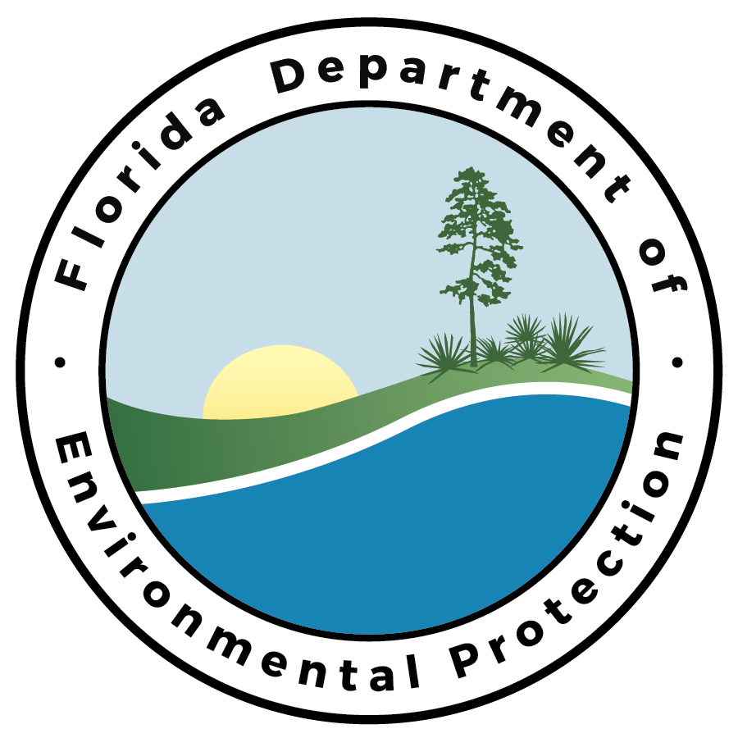

Quality Plan for the

Geographic Information Systems (GIS) Section

Watershed Services Program
Division of Environmental Assessment and Restoration
Florida Department of Environmental Protection

January 1, 2023
Signature Page

The undersigned have read and understood this Quality Plan, are charged with managing and improving the quality system and are responsible for ensuring that all staff properly execute the procedures discussed in the plan.

- Introduction
The Department of Environmental Protection (DEP) Quality Assurance (QA) program involves the implementation of a management system (planning, review, training, and assessment) to ensure that data collection, generation, interpretation, reporting, evaluation and archiving is of sufficient quality to support Department decisions. The effectiveness of our QA program is dependent upon the actions of all DEP staff, from “front line” employees to management, meaning QA is a function distributed throughout our organization. One aspect of our program is to ensure that Department QA activities are carried out according to commitments made to the Environmental Protection Agency as enumerated in the DEP Quality Management Plan (QMP) (Draft Revision 9/2/08).

The Watershed Services Program (WSP) GIS section has developed a system of documenting processes, projects, data creation and management. These documents describe the steps we take to ensure the best possible consistency and accuracy of geospatial data we generate and consume. It identifies the process of planning, training, execution, assessment and corrective action we undertake to ensure that geospatial data is the best possible or available quality.

- Basic Elements of the GIS Quality Plan
Our Quality Plan explains both the process and criteria by which the quality system is managed. The plan is utilized as an instrument of internal communication to inform our staff of current and future quality assurance activities. It discusses how specific QA duties are assigned to responsible staff. We will revise our Quality Plan as needed, and pledge to ensure the consistent application of procedures and criteria for the generation or use of our environmental data. The Quality Plan will also be used as a training document for new staff and as a reference for experienced personnel. The plan and its revisions also serve as an archival record of our formal quality system.

The elements of our plan are consistent with the Department’s Quality Management Plan, Quality Assurance Directive and Quality Assurance Rule (62-160 F.A.C.). Our plan addresses all activities associated with creating, editing and updating geospatial data as well as mapping products and on-line maps and applications for DEAR.

Where appropriate, we cite existing internal and external documents, including training manuals, guidance documents, SOPs, etc.

We expect all staff to understand and follow the procedures and criteria as discussed in this plan, and to carry out their assigned responsibilities for effective utilization of our quality system.

- Policy Statement
It is the policy of the GIS section to:
- Develop and implement the Quality System described in this document.
- Adaptively manage our Quality System to be consistent with provision of the DEP Quality Assurance Management Plan.
- Ensure that each staff is properly trained to execute their assigned functions.
- Implement procedures to evaluate the quality of the data we use and manage and to implement corrective actions when data do not meet our objectives.
- Conduct a yearly assessment of our quality assurance activities, with the finding submitted to the DEP QA Coordinator for use in compiling the Department-wide annual QA Report to the Secretary.

- Ethics
All employees of the GIS section are held to high professional ethical standards in the performance of their duties. All employees are required to read, understand and sign an ‘Ethics Statement’ attesting to their commitment to honesty and integrity in performance of their duties. In addition, all employees are required to attend an annual ethics training class. Improper, unethical or illegal actions will be dealt with according to the published Administrative Directives of the Florida Department of Environmental Protection.

- Organization and Responsibilities
The GIS section resides within the Watershed Service Program (WSP) of the Division of Environmental Assessment and Restoration (DEAR). The function of the GIS section is to provide geospatial analytical and editing services to DEAR.

The organization and responsibilities of the GIS section staff are as follows:
- Janis Morrow, Environmental Administrator
GIS Quality Assurance Officer, DEAR GIS Coordinator. Maintains spatial data, on-line maps, apps and data, supervises WSP GIS analyst and editor staff.
- Andrew Morris, Environmental Consultant
Land Use Land Cover (LULC) photo interpreter and team lead. Performs photo interpretation and QA of LULC editing in accordance with the Florida Land Use, Cover and Forms Classification System (FLUCCS), provides DEAR GIS support, including geographic analysis and map creation.
- Param Maharaj, Environmental Consultant
National Hydrography Dataset (NHD) Steward, NHD editing team lead. Edits the NHD and provides training and QA for other editors in compliance with USGS NHD capture standards.
- Ronald Hughes, Environmental Specialist III
Geospatial data library coordinator. Provides metadata review in coordination with the Office of Information and Technology Services (OTIS) GIS staff, provides DEAR GIS support, including geographic analysis and map creation.
- Thomas Balkcom, OPS Environmental Consultant
NHD editor. Edits and updates content in the NHD, manages GIS data for the DEAR Watershed Monitoring Section (WMS) and the ArcGIS Online (AGO) content for the Algal Bloom Survey.
- Patricia Mehaffy, OPS Environmental Consultant
NHD editor. Edits and updates content in the NHD, provides back up for WMS and AGO tasks.
- Alan Bockhaus, OPS Environmental Specialist III
LULC photo interpreter. Performs photo interpretation and editing of LULC in accordance with FLUCCS.

The GIS section provides the following services:
- Generates LULC datasets for the Northwest Florida Water Management District (NWFWMD) and Suwannee River Water Management District (SRWMD).
- Edits and maintains the Florida NHD dataset.
- Creates and manages data, maps, and other geospatial products for use by DEAR, DEP and the public.
- Provides GIS assistance and training for DEAR staff.

The WSP Program Administrator, Denise Miller, ensures that the GIS processes are fully operational within WSP and provides general oversight. The GIS section Environmental Administrator and designated GIS Section Quality Assurance Officer, Janis Morrow, evaluate the geospatial data, maps and GIS products of the section to ensure they meet WSP, DEAR and Office of Technology and Information Services (OTIS) GIS needs, and periodically evaluates the effectiveness of staff’s activities. The WSP and GIS administrators evaluate corrective action policies and procedures to be implemented when data do not meet program, DEAR or OTIS needs.

- Training
All GIS section personnel are properly trained to perform their duties. The GIS Environmental Administrator periodically assesses that GIS staff performance conforms with the policies and procedures of the GIS section.

Our training procedures consist of:

- Training Land Use photo interpreter to follow capture guidelines in the Florida Land Use Capture Codes (FLUCCs) document. This training occurs when a new employee begins working in the LULC position.
- Training NHD editors with both in-house and USGS NHD training. This training occurs when a new employee begins working in an NHD editor position.
- Providing peer-to-peer training for routine functions and designated GIS activities.
- External professional development courses to refresh and enhance GIS technical knowledge and skills.
Staff are evaluated by reviewing their performance to determine effectiveness of training. For example, after NHD training by experienced staff, new staff are observed by experienced staff before they are permitted to independently edit the NHD. Cross-training and evaluations also are conducted when staff exchange ideas and assist one another in troubleshooting and brainstorming sessions.
- Data Management
GIS section activities include updating the NHD and LULC geospatial data layers, as well as other geospatial data layers as needed by DEAR, creating and updating AGO geospatial content, and providing new or updated geospatial data layers to OTIS GIS for loading to DEP’s geospatial data library. Understanding the need to manage the data and products from those activities for accessibility, versioning and context, the GIS section maintains a spreadsheet identifying the geospatial data layers, maps and tools the GIS section manages which includes the GIS section and DEAR points of contact and the locations of those managed data at: \\fldep1\DEAR\GISRAID\GISCloud\Data_Map_Point_of_Contact.xlsx
- Documentation
Accurate documentation of processes and procedures is important to the success of GIS activities. The GIS system provides the following internal procedures for GIS activities:
- Land Use editing processes: \\fldep1\DEAR\GISRAID\giscloud\How-To\LandUse
- Land Use FLUCCs documents: \\fldep1\DEAR\GISRAID\gissub\exchange\LULC\Documents\PI_Key
- New NHD editor WSP training documents: \\fldep1\DEAR\GISRAID\NHD_Editors\NHD How To
- NHD to SDE updates, error correction, GNIS updates, and WIN processes documents: \\fldep1\DEAR\GISRAID\NHD_Editors\NHD How To\NHD Editing How To
- Algal Bloom AGO map documentation: \\fldep1\DEAR\GISRAID\giscloud\How-To\AlgalBloom_How_Tos
- Other AGO content documentation: \\fldep1\DEAR\GISRAID\giscloud\AGO\AGO Training.docx
- Steps for preparing and submitting data to OTIS geospatial data library: \\fldep1\DEAR\GISRAID\giscloud\SDE_Data_Preparing_and_Submitting_Procedures

- Audits and Corrective Actions
GIS section staff conduct routine internal audits of the following activities:
- NHD editing
- Editing of LULC data layers.

Corrective actions are taken, as necessary, based on the established protocol for the activity (document links are provided through section 8 above), and resulting products are documented via posting of the product (products link is provided through section 7 above).
- Report Compilation
To provide the Secretary with information regarding DEP’s ongoing QA efforts, the GIS section will describe and compile the results of all appropriate QA activities, and relay it to the Aquatic Ecology and Quality Assurance Section for an annual report.
Training
We will report on training to staff commensurate with their position responsibilities (e.g., training for new NHD editors or LULC editors, staff training for creation or modification of specific geospatial data layers). We also will report on professional development training that was provided.

Status of Quality Systems
We will document changes to or additions of processes and procedures, such as:
- Changes to FLUCCS guidelines.
- Changes to NHD feature capture rules.
- Changes to standards for uploading data to OTIS Spatial Data Engine (SDE).

Data Management
We will manage GIS data layers to their appropriate locations, including layers created and updated by the GIS section, and/or new or updated data layers the GIS section receives from other DEAR points of contact. We will report on the GIS and DEAR points of contact and the locations of geospatial data layers here: \\fldep1\DEAR\GISRAID\GISCloud\Data_Map_Point_of_Contact.xlsx
- References
General References:
- Chapter 62-160, Florida Administrative Code. Quality Assurance. Florida Department of Environmental Protection Quality Assurance Rule for Water, Waste and Resource Management. April 16, 2018.
Training Documents for WSP GIS editors:
- \\fldep1\DEAR\GISRAID\gissub\exchange\LULC\Documents\PI_Key
- \\fldep1\DEAR\GISRAID\NHD_Editors\ NHD How To's\NHD Editing How To’s.
Training Documents accessible to all staff:
- Land Use editing processes \\FLDEP1\DEAR\GISRAID\giscloud\How-To\LandUse
- Land Use FLUCCs \\fldep1\DEAR\GISRAID\gissub\exchange\LULC\Documents\PI_Key
- New NHD editor WSP training document \fldep1\DEAR\GISRAID\NHD_Editors\NHD How To's
- NHD to SDE updates, error correction, GNIS updates, and WIN processes document \\fldep1\DEAR\GISRAID\NHD_Editors\ NHD How To\NHD Editing How To
- Algal Bloom AGO map documentation \\fldep1\DEAR\GISRAID\giscloud\How-To\AlgalBloom_How_Tos
- Other AGO content documentation \\fldep1\DEAR\GISRAID\giscloud\AGO\AGO Training.docx
- Steps for preparing and submitting data to OTIS geospatial data library \\fldep1\DEAR\GISRAID\giscloud\SDE_Data_Preparing_and_Submitting_Procedures

