Dissolved Oxygen not less than a minimum concentration of 4.0 mg/L, and a Total Fractional Exposure not greater than 1.0 over an annual evaluation period as defined by the following equation:
Total Fractional Exposure = (Days between 4.0-<4.2 mg/L÷16 day Max) + (Days between 4.0-<4.2 mg/L÷21 day Max) + (Days between 4.0-<4.2 mg/L÷30 day Max) + (Days between 4.0-<4.2 mg/L÷47 day Max) + (Days between 4.0-<4.2 mg/L÷55 day Max)
or alternate view
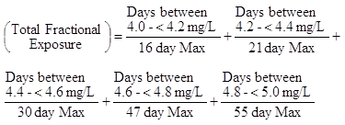
where the number of days in an interval is based on the daily average Dissolved Oxygen concentration. Applies year round.

