Comments to Proposed Changes to Water Quality Standards under the 2019 Triennial Review
Type II Site-Specific Alternative Criteria for Dissolved Oxygen (DO) for Stream in the St. Johns River Basin
Table 1. Streams in the St. Johns River Basin Proposed for Type II Site-specific alternative DO criteria (Category 4c - Impaired for one or more criteria or designated uses, but do not require TMDL development because the impairments are not caused by a pollutant):
Stream | Current Minimum DO Saturation  To Be Met or Exceeded at Least 90% of the Time | Proposed New Minimum | Equivalent DO, mg/L at 28° | Revised DO, mg/L at 28°C
Peters Creek | 34% | 27.1% | 2.65 | 2.12
Eaton Creek | 38% | 29.4% | 2.97 | 2.29
Blackwater Creek | 38% | 28.3% | 2.97 | 2.21
Taylor Creek | 38% | 33.2% | 2.97 | 2.59

SJRWMD comments and supporting data analysis to the proposed alternative DO criteria.

Peters Creek
Comment: SCIs indicating designated use achievement were performed in upstream segments of Peters Creek that support the current criterion. Criterion failure is only exhibited in the most downstream site, below the head of tide, in a reach that has been impacted by documented dairy runoff and high BOD loads. Peters Creek is also one of the few known habitats of the rare endemic Black Creek Crayfish, Procambarus pictus. Given these factors, we would comment that the FDEP delay the establishment of the lower SSAC for the entire length of Peters Creek, until SCIs confirming biological integrity for the below head of tide portion can be performed.
Analysis Results: SJRWMD monitored two sites in Peters Creek that are included in the FDEP SSAC evaluation (Table 2). The upstream site met the current DO criterion in all complete calendar years sampled from 2006-10, and exhibited a well-aerated oxygen regime, with an overall 10th percentile DO saturation of 60% (Table 3; Figure 1). The downstream site, which is below the head of tide, has an annual average criteria subcedence rate of 36.2 percent, and the overall 10th percentile DO % saturation of 14%, so clearly does not meet the current criterion.
SCIs supporting designated use were performed at the former SJRWMD upstream site, and at a site downstream at County Road 315 (21FLA 20030388). For the 18 FDEP samples collected at CR 315 from 2007-18, the mean DO % saturation was 88.1%, with the minimum recorded a value of 65.8%, also achieving the DO criterion. The below head of tide site that fails the DO criteria has historically been affected by dairy runoff, and is known to have accumulations of dairy manure and pasture solids in the sediments, which presumably exert a high sediment oxygen demand.
Peters Creek is one of the few know locations supporting the rare endemic Black Creek Crayfish, Procambarus pictus. No quantitative information is known regarding the specific oxygen tolerance of this species, though in their survey, Franz and Franz (1979) indicate “data gathered during this study shows that Procambarus pictus is extremely susceptible to human alteration of headwater areas and pollution.”, and, “Runoff from dairy farms and possibly human sewage have created essentially ‘open sewers’ of several South Fork tributaries originating near the town of Penney Farms. Procambarus pictus does not exist in these polluted streams.”

Eaton Creek
Comment: As the SCI evaluations supporting designated use attainment for Eaton Creek appear to have been collected during a time interval when corresponding DO data indicate a higher, criterion-achieving oxygen regime, and as downstream potions of Eaton Creek achieve the DO criterion, we ask that FDEP delay the downgrading of the oxygen for the entire length of Eaton Creek until additional SCI evaluations can be performed to confirm that the current DO regime supports a health faunal community.
Analysis Results: SJRWMD conducted monthly ambient sampling at two sites in Eaton Creek from 2014 through 2018 (Table 2). The upstream site (OR039), sampled at the County Road 314, had DO measured below the 38% threshold 45.9 percent of the time, and had an overall 10th percentile occurrence frequency of only 12% saturation (Table 3), and based on these data clearly fails to meet the criterion. The downstream site (MUDCR), located just above the mouth of the creek, had an annual mean failure rate of 7.9 percent, and had no sampling events for which DO % saturation was below the criteria in 4 of the 6 calendar years, hence meets the criterion. FDEP also performed regular sampling on Eaton Creek in 2011, with one additional sampling event in 2013, also near the CR 314 location. SCI evaluations were performed at this site on 2/22/11 and 4/8/13, producing scores of 73 and 68 indicative of a healthy macroinvertebrate community.
The DO % saturation occurrence frequency distributions for these three sampling efforts are plotted in Figure 1. The Eaton Creek plot for data collected at the upstream site at CR 314 (purple dots) from 2014 – 18 clearly show a lower DO distribution than for the contemporaneous sampling at the downstream site (red dots). The FDEP DO data, corresponding to the SCI data collected at CR 314 during 2011 and 2013 (green dots, superimposed the red dots of the downstream site), indicates that the DO regime during the time period in which the SCIs were performed met the current DO criteria, and the later SJRWMD sampling at the CR 314 site may not be representative of the earlier time period during which the SCI evaluations were performed.

Blackwater Creek
Comment: Regular early morning sampling at the SJRWMD monitoring site at County Road 44 (BWC44) appears to have produced biased data, indicating a DO regime lower than the actual mean condition. Downstream sites that were sampled later in the day support the current DO criterion. In addition, ongoing activities in the watershed may have an effect on the trophic state of the upstream headwaters lake, Lake Norris. For these reasons, we would comment that FDEP delay the establishment of the lower SSAC at this time that would apply to the entire length of Blackwater Creek. SJRWMD will review the current timing for the upstream site to with the goal of establishing a sampling regimen that produces data representative of the mean condition.
Analysis Results: SJRWMD has three long-term WQ monitoring sites in Blackwater Creek, and these data were incorporated in FDEP’s SSAC assessment. The sites exhibit an improving DO regime from headwaters to mouth, with values below the annual mean 38% saturation at the upstream site ocurring 44.2% of the time, improving to 11.9% of the time at the mid-point site, then to 6.2% of the time at the mouth (Table 3). The overall 10th percentile DO % saturation for the three sites is 18%, 40%, and 41%. SCIs performed 100 m above the SJRWMD upstream site, and approximately 400 m upstream of the midpoint site produced passing scores, though 2 of the 3 upstream site scores were relatively low (59 and 50).
In 2011, the SJRWMD Middle St. Johns River Basin Program conducted three, 2-week deployments of YSI continuous recording sondes in Blackwater Creek, and these data are useful to understand the diurnal variation in DO and how this relates to the DO levels collected in the instantaneous measurements of the ambient sampling data set. The sonde deployment site was approximately midway between the two downstream ambient sites, BWCCPB and BWCUWR. The lowest DO concentrations and saturation levels occurred in the deployment conducted in the first two weeks of April, and these data are plotted in Figure 2. DO saturation fell early in this deployment, associated with a rainfall and resulting discharge and stage increase, which lowered DO saturation from around 80% to levels around 40 – 50%. The minimum DO % saturation reached was 34.7% on April 5 at 7:45 am, and the minimum daily average occurred on the same date and was 40.5%. In the other two deployments, conducted February 3 - 22 and May 3 – 13, the minimum saturation values recorded were 69.5% and 71.6%.
Discernible diurnal variation is evident in the DO data, with the timing of minimums and maximums consistent with in situ primary production. Thus it would appear that even in this strongly net heterotrophic blackwater stream, primary production of rooted macrophytes or attached algae is a source of DO replenishment.
In Figure 3, the Instantaneous ambient % saturation data are superimposed on the April 2011 diel data, plotted by time of day. The tendency for the upstream ambient site to exhibit lower DO saturation is evident in this scatterplot, with a greater proportion of values falling below the current 38% criteria. A sampling time of day pattern is also evident, with all data tending to increase of the course of daylight hours, consistent with the 2011 diel data. The average times of day for sampling the three sites was 10:02, 11:02, and 12:26, and this regular order of sampling may have some effect on the consistently lower DO concentrations observed at the upstream site.
Lake Norris is the headwaters of Blackwater Creek. One of the tributaries flowing into the lake drains cattle pastures fertilized with class B biosolids, and is one of the three paired watershed sites in the District’s ongoing biosolids assessment. In 7 sampling events since March 2018, the biosolids affected tributary has a men TP concentration of 0.588 mg/L, reaching a maximum of 1.3 mg/L in July 2019, while the paired natural background tributary has a mean TP of 0.061 mg/L. Sampling was recently reinitiated in Lake Norris to track possible nutrient enrichment from this activity.

Taylor Creek
Comments: With the exception of the long term SJRWMD monitoring site at CR 532, other downstream sampled locations appear to support the current DO criterion. The long-term SJRWMD site nearly meets the criterion, slightly exceeding the occurrence rate by 2% of the time. The location of the SCIs performed demonstrating a healthy system is in a powerline clearing that would favor greater primary production and hence create a higher DO condition. Taylor Creek is exhibiting significantly increasing TP concentration, believed due in part to biosolids applications in the upstream watershed. This could lead to an increased trophic state for Taylor Creek Reservoir, and possibly constitute an anthropogenic impairment that would warrant a TMDL. For these reasons we would comment that the FDEP delay a lowering of the DO criterion of the entire length of Taylor Creek until additional SCI evaluations can be performed around and above CR 532.
Analysis Results: Most of the DO data (144 of 179 data points) for Taylor Creek were collected at the SJRWMD site on Osceola County Road 532, and indicate a DO regime that nearly meets the current criteria, with a mean of annual averages of 38 % saturation percentile occurrence of 12.1% (slightly exceeding the acceptable 10% occurrence rate), and an overall 10th percentile DO % saturation of 33% (Table 3). Of the 35 additional DO measurements included in the FDEP evaluation, from 10 other sites sampled over various intervals from 2006 – 2018, only 3 of those were below the 38% saturation criterion.
SCI evaluations indicating a healthy invertebrate community were collected at FDEP site 21FLCEN20011343 in 2013 and 2014. DO % saturation for the three sampling events at this site ranged from 49 – 60.8%. The site is located just downstream of the long-term SJRWMD site at CR 532, in a clearing at a powerline crossing. This environment would likely enhance primary production and result in a higher DO regime and possibly improve the suitability for a healthy macroinvertebrate community.

REFERENCES
Franz, R. and L.M. Franz. 1979. Distribution, habitat preference and status of populations of the Black Creek crayfish, Procambarus (Ortmannicus) pictus (Decapoda : Cambaridae). Florida Scientist 42(1): 13-17.

Data Analysis Notes:
SJRWMD obtained the WQ data used for the impairment assessment from Florida Department of Environmental Protection (FEP) to compare to the data available in the SJRWMD Environmental Data Base. SJRWMD sites accounted for 576 of the 690 data points used by FDEP. Duplicates and profile measurements included in the FDEP data set accounted for 55 of the total sample number, and these were removed from the SJRWMD data so there existed only one sample per site per day, collected at the surface. Those sites, the number of measurements, and the period of record (complete calendar years only) are listed in the table below.
Table 2. SJRWMD Long-Term monitoring sites for Proposed DO SSAC Tributaries
Station ID | Description | POR | Number
BWC44 | Blackwater Creek at SR 44 | 2006 - 2018 | 94
BWCCPB | Blackwater Creek Carter Property Bridge | 2006 - 2018 | 78
BWCUWR | Blackwater Creek above the Wekiva River | 2006 – 2010 | 59
MUDCR | Eaton Creek above mouth below Mud Lake | 2014 - 2018 | 58
OR039 | Eaton Creek at CR 314 | 2014 - 2018 | 53
PCRHR | Peters Creek upstream Rosemary Hill Road | 2006 - 2011 | 57
PTC | Peters Creek at CR 209 above mouth | 2006 - 2011 | 108
TCB | Taylor Creek at CR 532 below reservoir | 2006 - 2018 | 155

Table 3. Calendar year frequency of current criteria exceedance, determined using the NORMDIST function in Excel, with the point corresponding to the frequency of occurrence of below-criteria events determined through linear interpolation. These frequencies for the SJRWMD sites are listed in the Table 2.
 | Blackwater Creek |  |  | Eaton Creek |  | Peters Creek |  | Taylor Creek
YEAR | BWC44 (Upstream) | BWCCPB (Midpoint) | BWCUWR Above Mouth) | OR039 (Upstream) | MUDCR (Above Mouth) | PCRHR (Upstream) | PTC (Above Mouth) | TCB (Below Reservoir)
2006 | 18.6 | 0.0 | 0.0 |  |  | 0.0 | 32.3 | 36.1
2007 | 0.0 | 0.0 | 0.0 |  |  | 0.0 | 49.8 | 37.8
2008 | 50.5 | 14.0 | 21.9 |  |  | 0.0 | 29.7 | 0.0
2009 | 73.4 | 17.8 | 9.3 |  |  | 0.0 | 39.7 | 8.6
2010 | 43.1 | 0.0 | 0.0 |  |  | 0.0 | 29.3 | 0.0
2011 | 0.0 | 0.0 |  |  |  |  |  | 8.8
2012 | 47.2 | 13.5 |  |  |  |  |  | 1.5
2013 | 39.6 | 0.0 |  |  |  |  |  | 0.0
2014 | 81.3 | 32.0 |  | 39.1 | 11.9 |  |  | 14.9
2015 | 55.9 | 18.2 |  | 50.2 | 0.0 |  |  | 4.5
2016 | 32.2 | 5.4 |  | 11.7 | 0.0 |  |  | 21.7
2017 | 51.8 | 31.6 |  | 61.2 | 27.5 |  |  | 18.9
2018 | 80.3 | 21.7 |  | 67.3 | 0.0 |  |  | 3.9
AVG | 44.2 | 11.9 | 6.2 | 45.9 | 7.9 | 0.0 | 36.2 | 12.1
Est. 10% Occ. Min. DO %Sat. | 18 | 40 | 41 | 12 | 39 | 60 | 14 | 33

Figure 1. Overall continuous probability functions for DO % saturation. The bottom line of Table 3 above identifies the oxygen % saturation that coincides wit the 10 percent occurrence rate from these plots.
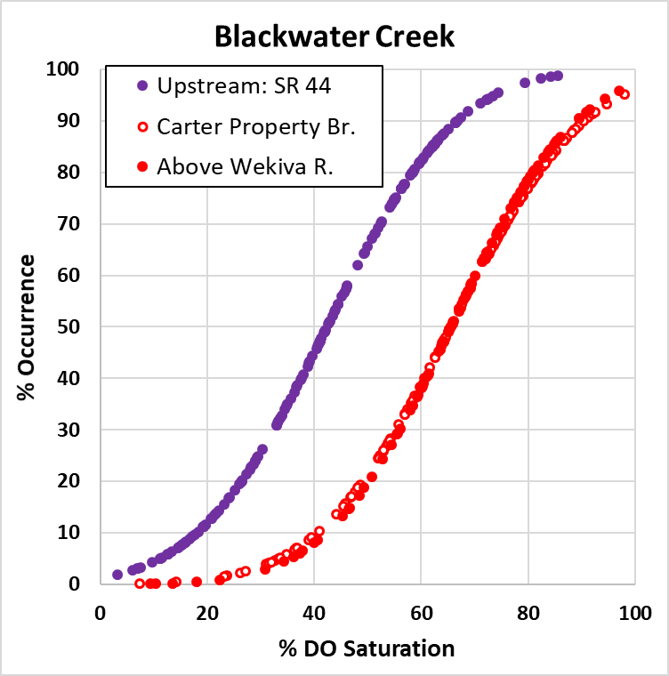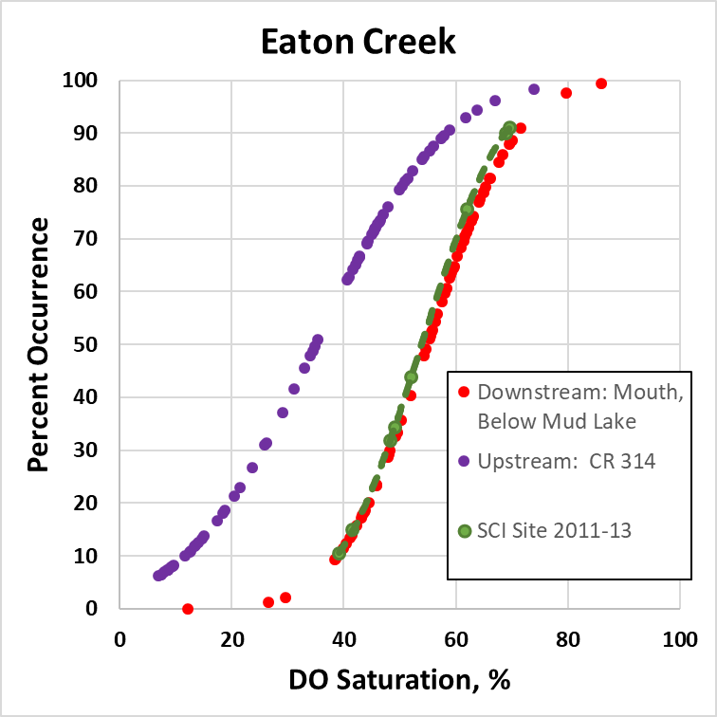
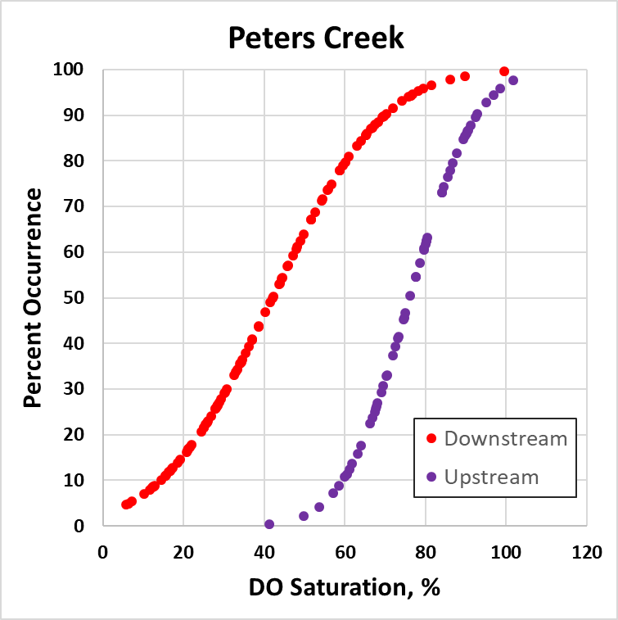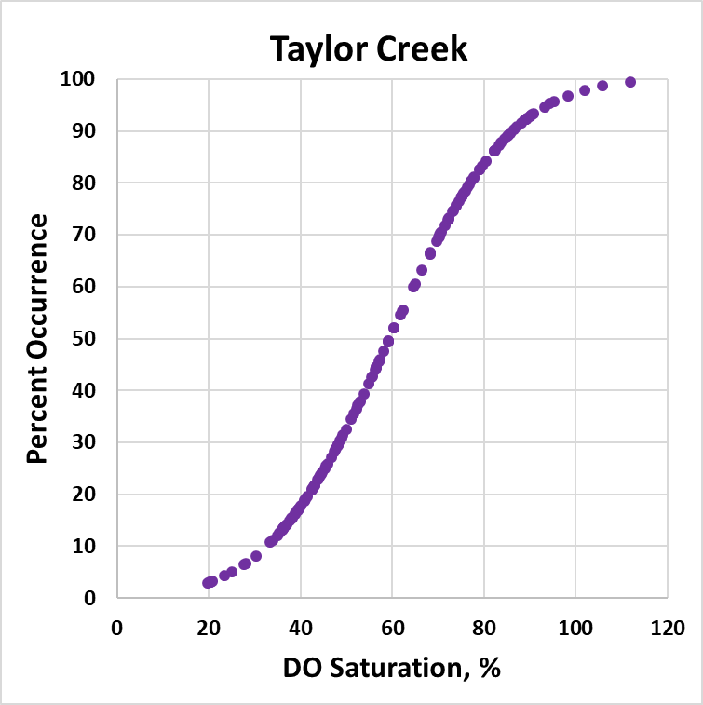

Figure 2. DO % saturation and water level for Blackwater Creek, March 30 – April 14 2011.
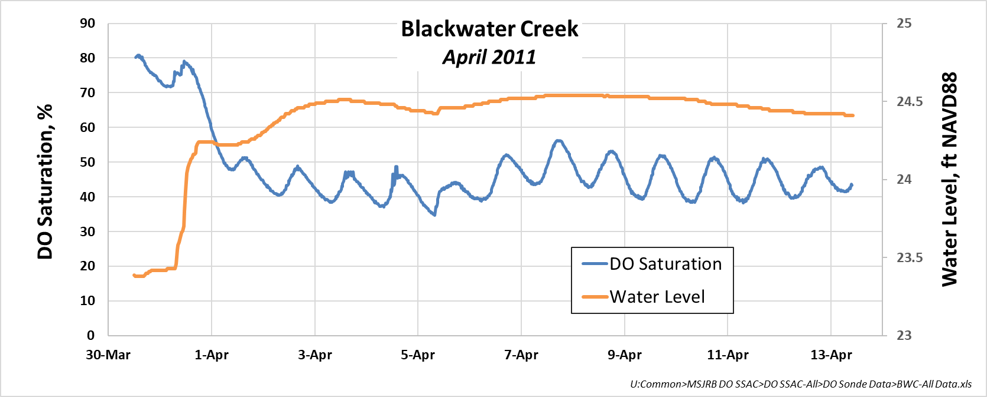

Figure 3. Overlapping DO data from the sonde deployment from early April, with the time of day of ambient sampling events overlain on the diel data.
