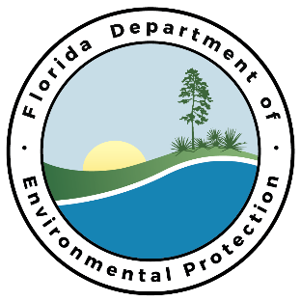

Public Meeting to Present the REVISED Assessment Lists for the Group 5 Springs Coast Basin

Meeting Agenda

DATE: Tuesday, March 6th, 2018

TIME: 2:00 PM

LOCATION: SWFWMD District Headquarters
Brooksville Boardroom
2379 Broad Street
Brooksville, Florida

THIS MEETING IS OPEN TO THE PUBLIC

- Opening Remarks – Kevin O’Donnell

- Presentations by Department Staff

  - Background Information About the Water Quality Assessment Program and Listing Process for Impaired Waters – Kevin O’Donnell

  - Presentation on REVISED Assessments in the Springs Coast Basin – Kevin O’Donnell

  - Assessment Alternatives – Kevin O’Donnell

- Public Comments/Questions – Kevin O’Donnell

- Adjournment

For more information on the REVISED Assessment Lists, please contact Kevin O’Donnell, 850-245-8469 or kevin.odonnell@dep.state.fl.us.

