Blank Detections – Reviewing & Summarizing Associated Data
(Example Shown for Grab, Repeat Same Procedure for POCIS & SPMD)
- Make copy of V59357MRES_Database_1.xlsx. Removed columns not needed for this summary. Only columns remaining were:

- Added column DEP FLAG – BLANK DETECTS.
- Sorted by SAMPLE_NO.

- Looked at Lab Blank results first. Sorted these by CONC_FOUND. Hid all results without value reported. Sorted remaining records by COMPOUND.
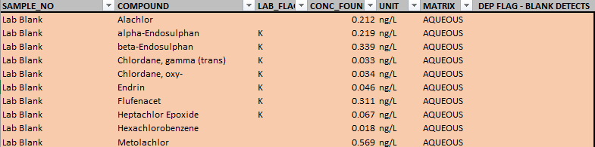

- Looked at QA/ QC BLANK SW FIELD results next. Sorted these by CONC_FOUND. Hid all results without value reported. Sorted remaining records by COMPOUND. Identified those compounds with detections in both Lab Blank and QA/QC BLANK SW FIELD. Added V qualifier to QA/QC BLANK SW FIELD record if value detected in blank was > 10% of value detected in QA/QC BLANK SW FIELD.
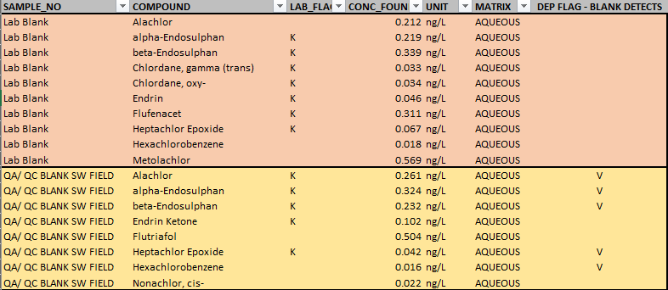

- Looked at results from all sites (combined) next. Sorted these by CONC_FOUND. Hid all results without value reported.

- Sorted remaining records (those with values reported) from all sites, and blanks by COMPOUND. Identified those compounds with detections in both Lab Blank and site. Added V qualifier to site record if value detected in Lab Blank was > 10% of value detected in site. Identified those compounds with detections in both QA/QC BLANK SW FIELD and site. Added G qualifier to site record if value detected in QA/QC BLANK SW FIELD was > 10% of value detected in site.
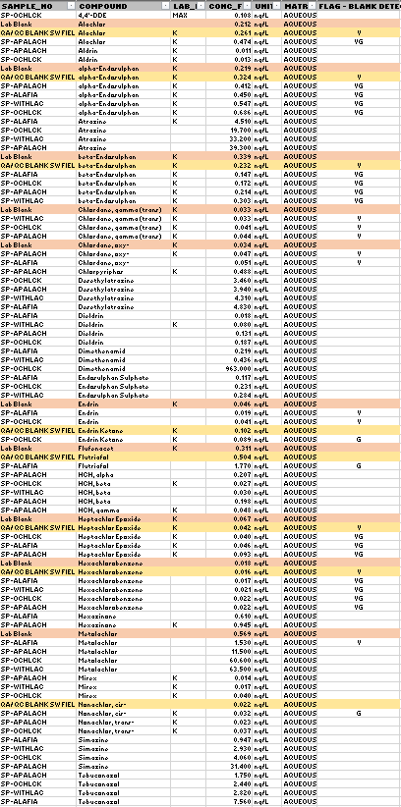
- Unhide the non-detect data. Create pivot table summarizing number of results per site affected by blank detections.
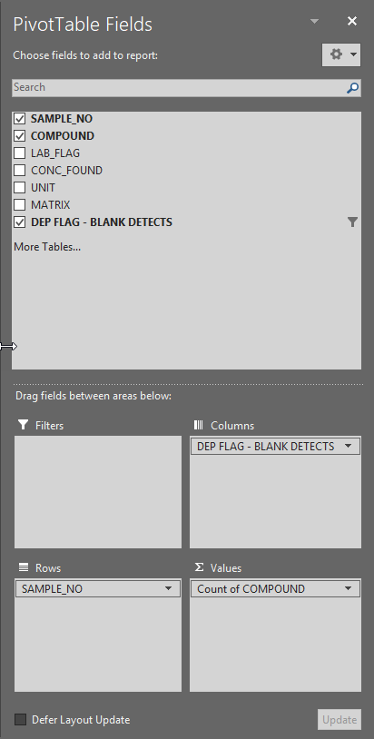
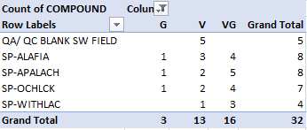

- Create second pivot table summarizing number of detects and non-detects.
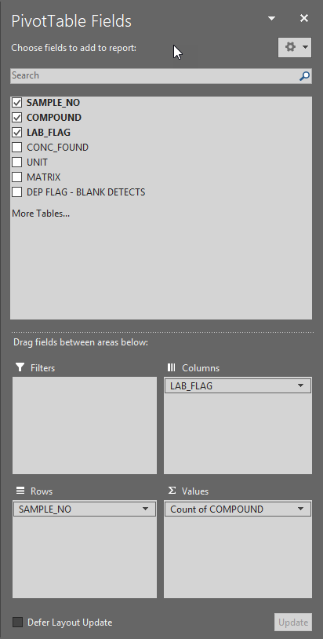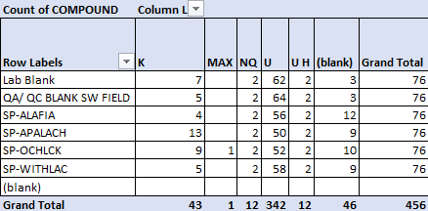
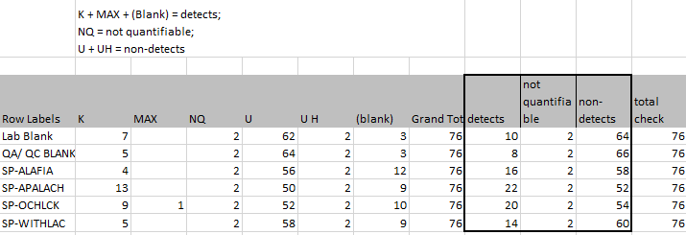
- Use paste values to combine information from pivot tables. (Yellow columns from 2nd table, Blue columns from first table, others are calculated values using information in yellow and blue columns).
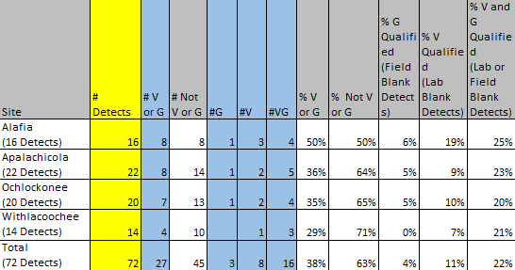

- Repeat above steps for other matrices.

- Use paste values to combine information from tables created in previous step for all matrices (POCIS, SPMD, Grab). Organize table so that it is easily used to create a column chart.
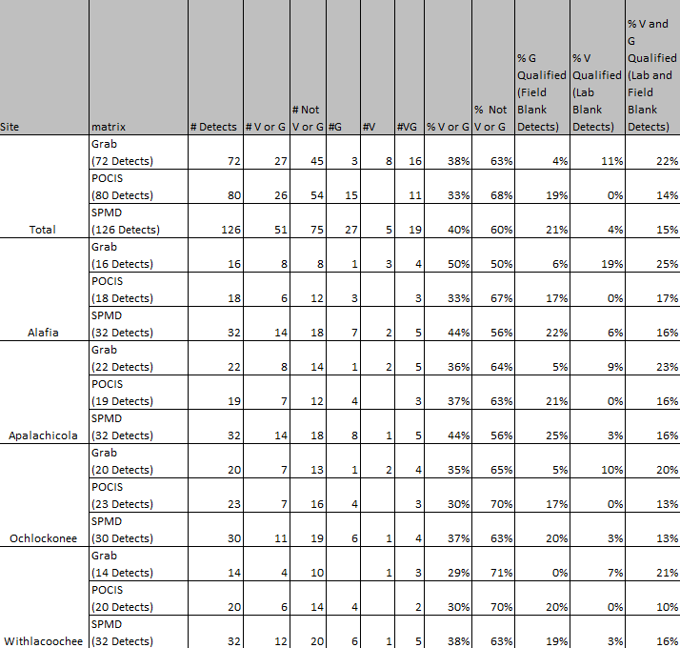

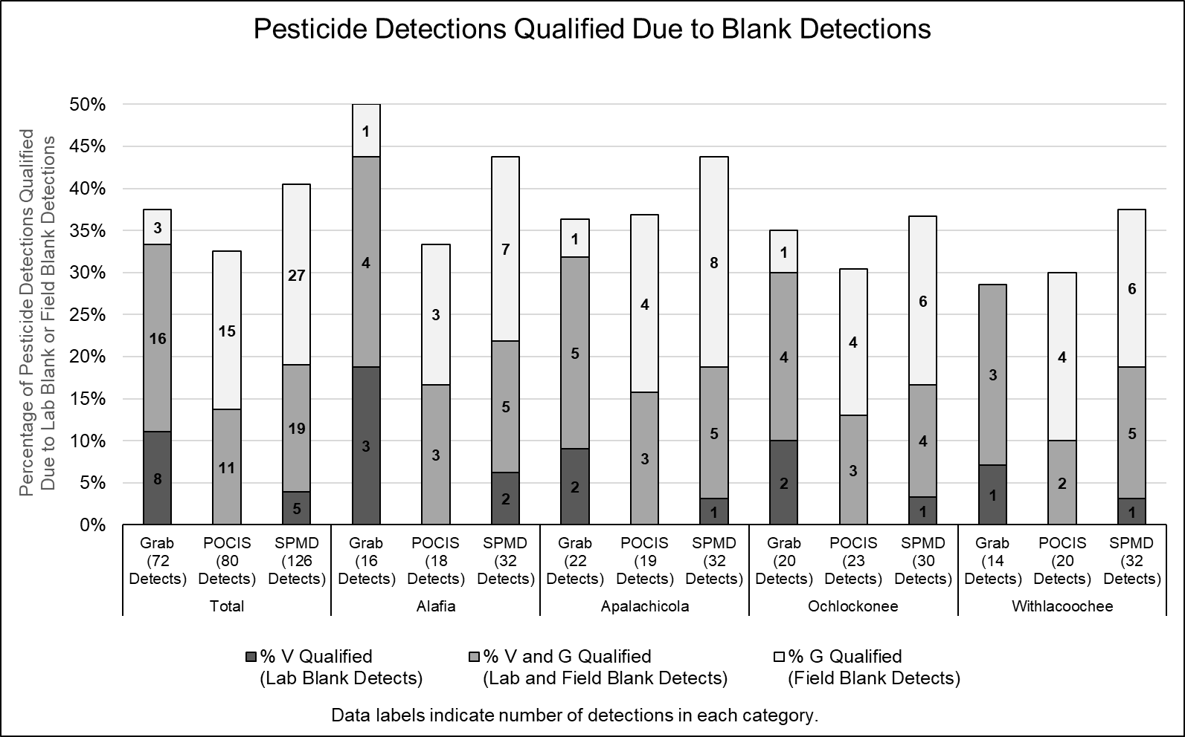

Checking Lists of Parameters Detected by Sample Type
- After qualifiers have been added for Lab and field blank detections, use paste values to copy data from all sites (no blanks) for all matrices to a new spreadsheet. Sort by matrix. Move conc_found and DEP flag for SPMD and Grab into separate columns (keep sample_no, and compound in the original columns).
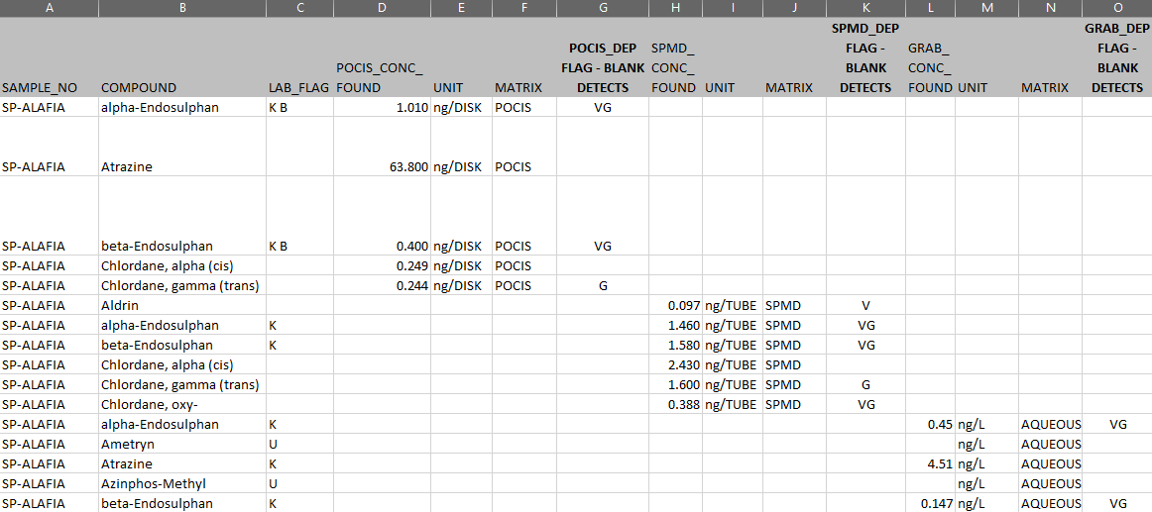

- Create pivot table summarizing the number of detections in each matrix for all sites (filter by SAMPLE_NO but set filter to all). Values in table will indicate number of sites that had detections for each compound in each matrix.
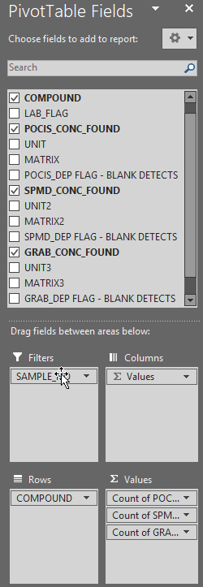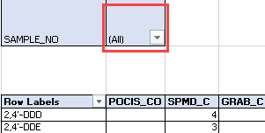
- Copy pivot table contents, paste values to new location in spreadsheet, sort by POCIS_conc_found then by SPMD_conc_found, then by Grab_conc_found. Compounds with no values listed were not detected in any matrix at any site, and do not need to be listed in summary graphics. Use remaining information to create summary graphics of all compounds detected in each matrix at any site (value = any number), and compounds detected in each matrix at all sites (value = 4).
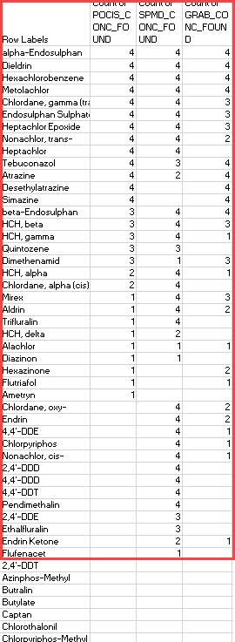

- Create pivot table summarizing the compounds detected in each matrix for each sites (filter by SAMPLE_NO and select one site, repeat process for each site).
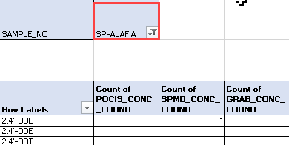

- Copy pivot table contents, paste values to new location in spreadsheet, sort by POCIS_conc_found then by SPMD_conc_found, then by Grab_conc_found. Compounds with no values listed were not detected in any matrix and do not need to be listed in summary graphics. Use remaining information to create summary graphics of all compounds detected in each matrix or combination of matrices (e.g. POCIS and SPMD).
