FDEP Prior Emerging Contaminant (EC) Work
Monitoring for chemical tracers in the environment is a powerful tool for characterizing potential anthropogenic pollutants and helping to identify sources. As instrument technology and the scientific understanding of chemical tracers continue to improve, it is now possible in many situations to use laboratory techniques to help detect unique chemical tracers present in certain types of waste streams. Based on a weight-of-evidence approach, these tracers can help identify or eliminate potential pollutant sources and thus provide a "toolbox" for developing a preponderance of evidence for environmental investigations.
DEP currently uses a number of chemical tracers with uniquely desirable characteristics for identifying sources of industrial, agricultural, pharmaceutical, hydraulic fracturing, and other ECs. By analyzing samples for tracer compounds and other known environmental pollutants, the combined information has proven extremely useful in identifying specific sources and pollution trends.
The compound sucralose (trade name Splenda) is almost ideal as a tracer. It is present in virtually every domestic wastewater discharge at detectable levels, does not occur naturally, has low toxicity, is highly soluble in water, is not effectively metabolized or removed by wastewater treatment processes, and persists in the environment (Labare and Alexander 1993; Oppenheimer et al. 2011; Soh et al. 2011; Tollefsen et al. 2012). DEP's monitoring of sucralose has helped identify sites for more intensive study, track contaminant migration routes in surface water and groundwater, and distinguish between abatable and non-abatable sites based on the impacts of human activities.
To better understand the extent of Florida’s fresh water resources potentially effected by emerging contaminants, DEP's Division of Environmental Assessment and Restoration (DEAR) has added wastewater tracers and imidacloprid to its Status and Trends Monitoring Networks (FDEP 2017) . DEAR sampled statewide for sucralose in both monitoring networks in 2012 and for sucralose, the pharmaceuticals acetaminophen, carbamazepine,and primidone, and the neonicotinoid pesticide imidacloprid in both monitoring networks in 2015. All of these compounds are hydrophilic and therefore may be highly mobile in the freshwater environment (Bonmatin et al. 2015; Jenner and Smithson 1989; Wishart et al. 2006).
Analyses of 2015 Status samples are summarized in Silvanima et al. 2018. Results generated from 528 sites showed ultra-trace detections of sucralose can be expected to be present in greater than 50 % of extents of the canal, river, stream, and large lake resources. Ultra-trace detections of acetaminophen, carbamazepine, and primidone were most prevalent in rivers, with 30 % of river kilometers expected to contain at least one of these compounds at ultra-trace levels. While, ultra-trace detections of imidacloprid are expected to be to present in 50 % or more of the canal and river resources. Imidacloprid was the only compound found to exceed any published toxicity or environmental effects standards. Geospatial analysis showed that the presence of sucralose and imidacloprid were significantly related to the percentage of urban land use, and to the percentage of urban and agricultural land use in watersheds, respectively.
DEAR also sampled the Status Monitoring Network unconfined aquifers in 2015, flowing waters in 2016, and lakes in 2017 for a full suite of organo-nitrogen and organo-phosphorus pesticides, in addition to wastewater indicators. Ultra-trace concentrations of at least one pesticide compound were commonly found (59 of 120 wells, 222 of 240 flowing surface water sites, and 157 of 168 lake sites). The most frequently detected pesticide compounds were (1) the herbicides atrazine, metolachlor, hexazinone, fluridone, bromacil, simazine, metibuzin, and ametryn; (2) the fungicide metalaxyl; and (3) the insecticides imidacloprid and fipronil. While none of the compounds exceeded published acute toxicity standards for aquatic organisms, or human drinking water standards, imidacloprid was found in concentrations known to impact the mayfly family Baetidae.
Results from monthly surface water trend monitoring conducted in 2012 were used to select the sample locations for this pilot study. Of the 75 stations sampled (refer to fig. X), the four containing the most frequent detections, as determined by using only values greater than the method and quantification limits of DEP’s instrumentation, were selected.
Figure x. 2012 Surface Water Trend Sites Selected for Pilot Study. Site Ids 3543, 3540, 3539 and 3554 on the Apalachicola, Ochlockonee, Withlacoochee, and the Alafia rivers respectively.
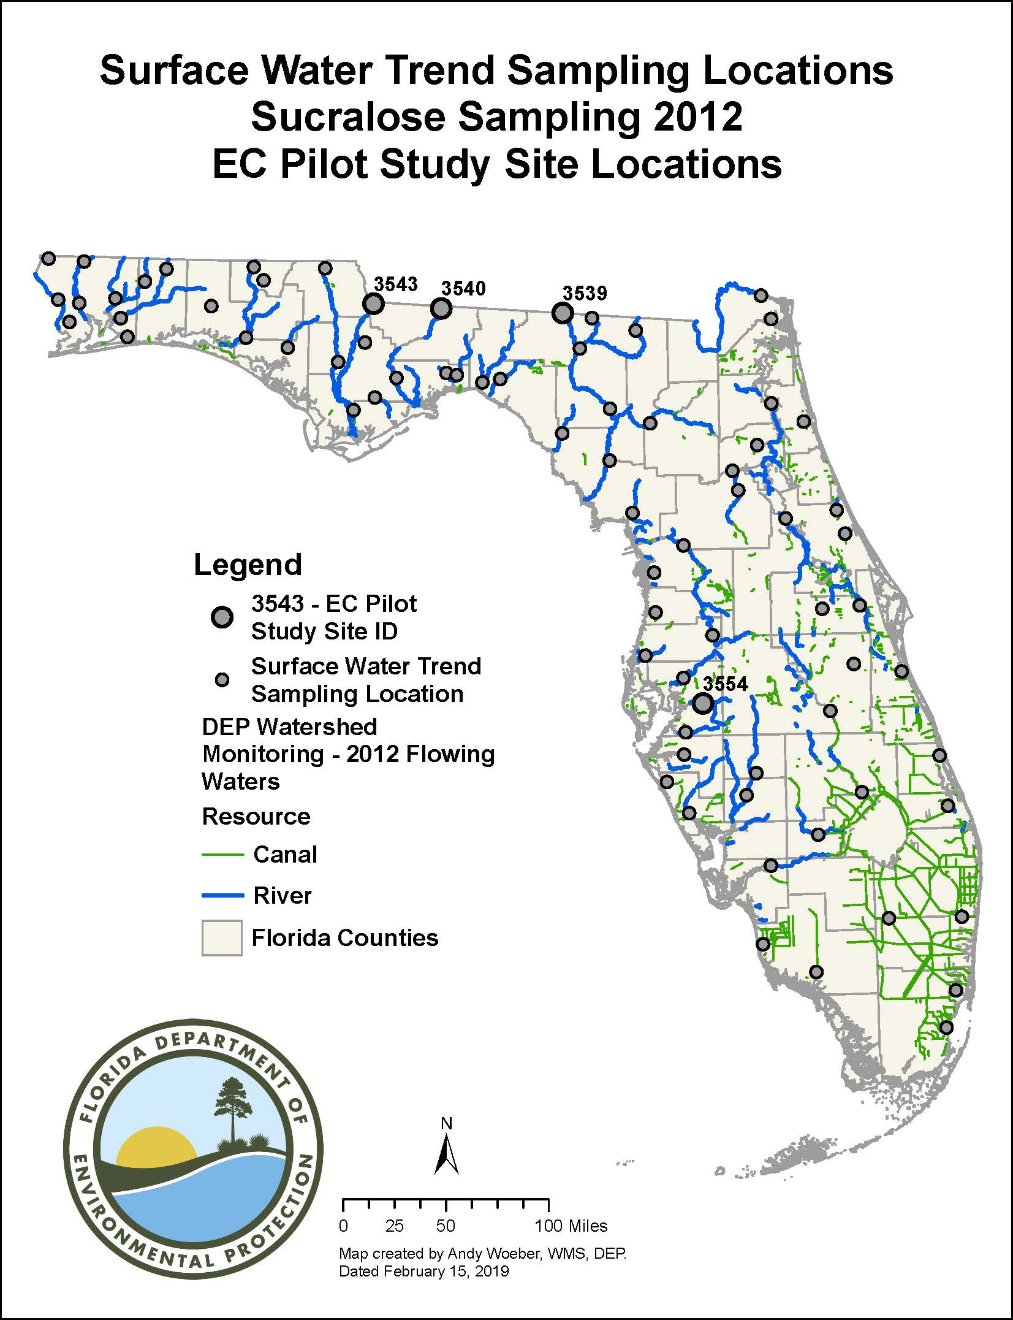

Literature cited
Bonmatin, J. M., Giorio, C., Girolami, V., Goulson, D., Kreutzweiser, D. P., Krupke, C., Liess, M., Long, E., Marzaro, M., Mitchell, D. A., Simon-Delso, N., & Tapparo, A. (2015). Environmental fate and exposure: neonicotinoids and fipronil. Environmental Science and Pollution Research, 22, 35–67. https://doi.org/10.1007/s11356-014-3332-7.
FDEP (Florida Department of Environmental Protection). (2015). Florida Watershed Monitoring Status and Trend Program design document, technical document, Division of Environmental Assessment and Restoration, Watershed Monitoring Section. http://publicfiles.dep.state.fl.us/dear/DEARweb/WMS/Reports_Docs_SOPs/Design_Docs/WMS-MonitoringDesignDocument2017.pdf. Accessed 15 Feb. 2019.
Jenner,M. R., & Smithson, A. (1989). Physicochemical properties of the sweetener sucralose. Journal of Food Science, 54, 1646–1649. https://doi.org/10.1111/j.1365-2621.1989.tb05179.x.
Labare, M. P., & Alexander, M. (1993). Biodegradation of sucralose, a chlorinated carbohydrate. In Samples of Natural Environments. Environmental Chemistry, 12, 797–804. https://doi.org/10.1002/etc.5620120502.
Oppenheimer, J., Eaton, A., Badruzzaman,M., Haghani, A.W., & Jacangelo, J. G. (2011). Occurrence and suitability of sucralose as an indicator compound of wastewater loading to surface waters in urbanized regions. Water Research, 45, 4019–4027. https://doi.org/10.1016/j.watres.2011.05.014.
Silvanima, J., Woeber, A., Sunderman-Barnes, S. et al. Environ Monit Assess (2018) 190: 435. https://doi.org/10.1007/s10661-018-6782-4
Tollefsen, K. E., Nizzetto, L., & Huggett, D. B. (2012). Presence, fate and effects of the intense sweetener sucralose in the aquatic environment. Science of the Total Environment, 438, 510–516. https://doi.org/10.1016/j.scitotenv.2012.08.060.
Wishart, D. S., Knox, C., Guo, A. C., Shrivastava, S., Hassanali, M., Stothard, P., Chang, Z.,&Woolsey, J. (2006). DrugBank: a comprehensive resource for in silico drug discovery and exploration. Nucleic Acids Research, 34, D668–D672. https://doi.org/10.1093/nar/gkj067.

