Occurrence of Emerging Substances of Concern in Florida’s Waterbodies

Approach, Strategy and Implementation

Division of Environmental Assessment and Restoration

Florida Department of Environmental Protection

June 19, 2019

Draft

2600 Blair Stone Road, MS 3525
Tallahassee, Florida 32399-2400
www.dep.state.fl.us

Acknowledgements

We would like to extend our appreciation to the following for their expert guidance and generous support.

David Alvarez, PhD – Columbia Environmental Research Center, United States Geological Survey
Nancy Denslow, PhD* – Center for Environmental and Human Toxicology, University of Florida
Joseph Hopkins Bisesi, Jr, PhD – Center for Environmental and Human Toxicology, University of Florida
Tara Sabo-Attwood, PhD – Center for Environmental and Human Toxicology, University of Florida
Luke Iwanowicz, PhD – Leetown Science Center, United States Geological Survey
Vicki Blazer, PhD – Leetown Science Center, United States Geological Survey

*Coauthor

FLORIDA DEPARTMENT OF ENVIRONMENTAL PROTECTION WORKGROUP

Division of Environmental Assessment and Restoration
Bureau of Laboratories
Timothy Fitzpatrick, retired
Chandrasekhar Thekkekalathil
David Whiting

Water Quality Assessment Program
Paul Blair
Jade Burtchett
Michael Eckles
Julie Espy
Alicia Hogue*
Thomas Seal*
Gail Sloane, retired
James Silvanima
Stephanie Sunderman*
Jonathan Woods

Water Quality Evaluation and TMDL Program
Brian Katz*

Water Quality Standards Program
Kaitlyn Summerfield
Kristten Sapp
Division of Waste Management
Jack Price, retired
Lauri Tennace, retired

*Coauthor

Contents

Acknowledgements i

abbreviations iv

Executive Summary 1

Background 2

Problem Statement 2

Potential Strategies 3

Florida-Specific Research, Monitoring, and Pilot Studies 3

Assessing Environmental Risk 5

Prioritization of ESOC to Investigate in Ambient Waterbodies 6

Chemical Screening with an Effects Based Approach: Pilot Study 7

Objective 7

Study Approach 7

Sucralose as a possible tracer for ESOC 8

Chemical screening 1

Biological screening 6

Land Use Assessment 16

Study Design 16

Literature Cited 25

Appendix A 32

Full Laboratory Suite of Compounds Analyzed 36

Appendix B 40

Appendix C 44

ESOC Monitoring QA/QC Literature Review Summary 44

Appendix D 45

Appendix E 48

Appendix F 51

Additional QA/QC requirements for laboratory analysis for ESOC pilot study 51

Abbreviations

ACEPD – Alachua County Environmental Protection Department
AR – Androgen receptor
BLYAS – Bioluminescence yeast androgen screen
BLYES - Bioluminescence yeast estrogen screen
DBD – DNA binding domain
DEP – Florida Department of Environmental Protection
DNA – Deoxyribonucleic acid
EDSTAC – Endocrine Disruptor Screening and Testing Advisory Committee
EPA – United States Environmental Protection Agency
ER – Estrogen receptor
ESOC – Emerging substances of concern
EST – Environmental Sampling Technologies, Inc
FDACS – Florida Department of Agriculture and Consumer Services
FP – Fluorescence polarization
FRET – Fluorescence resonance excitation transfer
HLB – Hydrophilic – lipophilic balance
LSC – USGS Leetown Science Center
mRNA – Messenger ribonucleic acid
OWC – Organic wastewater compound
PAH – Polyaromatic hydrocarbon
PBDE – Polybrominated diphenyl ether
PFC – Perfluorinated compounds
POCIS – Polar organic chemical integrative sampler
PPCP – Pharmaceuticals and personal care products
PRC – Performance reference compound
SPMD – Semipermeable membrane device
UAS – upstream activation site
USGS – United States Geological Survey
QA/QC – Quality assurance/quality control
YES – Yeast estrogen screen

Executive Summary

In 2008, a Florida Department of Environmental Protection (DEP) internal workgroup assessed various strategies to address a group of contaminants commonly referred to as emerging substances of concern (ESOC). These substances, which have been detected in low concentrations in surface waters throughout the U.S. and abroad, include chemicals found in pharmaceuticals and personal care products, flame retardants, pesticides and their degradates, fragrances and flavorants, detergent degradates, plasticizers, solvents, and polycyclic aromatic hydrocarbons (Kolpin et al., 2002; Pal et al., 2010). Several of these contaminants are known mutagenic and endocrine disruptor compounds; however, most them are unregulated (Chemical Abstracts Service, 2013).

The DEP workgroup reconvened January 2013 to evaluate how it can respond to the growing problem, now that many of the challenges posed in 2008 are being addressed by the federal government and scientific community. Cumulative impacts from several waste sources, multiple ESOC, as well as other anthropogenic and natural stressors can result in ecological impacts that cannot be predicted by chemical concentrations alone (e.g., the impact of compounds on fish in the Potomac River study of Alvarez et al., 2009). Therefore, a combination of approaches including biological and chemical assays may be the best strategy for addressing ESOC in the environment. The 2013 DEP workgroup recommends that DEP conduct a tiered study approach to determine the potential cause of biological effects on fish, such as intersex, by first employing screening assays to detect potential ecological effects, such as estrogenic activity occurring in Florida’s water.

Site selection for this study is determined based on the frequency of sucralose detections at Surface Water Trend sites from January – December 2012. Studies show that sucralose is not degraded through waste treatment processes (Labare et al., 1993 and Soh et al., 2011). Sucralose is being used as a tracer to determine if the site has an influence of human wastewater.

The main objective of the pilot project is to evaluate methods utilizing biomarkers which may be employed to assess the biological health of waterbodies. The pilot study will test the analytical and sampling methods’ effectiveness and efficiency in achieving the objective using a small-scale study design.

Background

In 2008, a Florida Department of Environmental Protection (DEP) internal workgroup assessed various strategies to address a group of contaminants commonly referred to as emerging substances of concern (ESOC). These substances, which have been detected in low concentrations in surface waters throughout the U.S. and abroad, include chemicals found in pharmaceuticals and personal care products, flame retardants, pesticides and their degradates, fragrances and flavorants, detergent degradates, plasticizers, solvents, and polycyclic aromatic hydrocarbons (Kolpin et al., 2002; Pal et al., 2010). Several of these contaminants are known mutagenic and endocrine disruptor compounds; however, the majority of them are unregulated (Chemical Abstracts Service, 2013). ESOC are part of the approximately 69 million commercially available compounds, making it a daunting task for any regulatory agency to track the occurrence, transport, toxicological effects, and their fate in the environment. Subsequently, the DEP workgroup described several strategies in its 2008 report that involved stakeholder education, assessing ESOC data quality, requests to the U.S. EPA for information on specific ESOC monitoring projects, and improved coordination with federal agencies (DEP, 2008).

Problem Statement

The 2008 DEP workgroup strategies did not involve a survey of Florida’s surface water or ground water systems that could be impacted by ESOC from various waste disposal practices. Without knowing which ESOC are present we can only assume that impacts on human health and sensitive aquatic organisms in Florida will be like those documented in other states. A study that derived provisional drinking water guideline values for 50 selected ESOC based on human toxicological information concluded that for most these compounds, the maximum concentrations were well below provisional guideline values (Schriks et al., 2010). However, the impacts on and risks to aquatic organisms in surface waters have been more pronounced (Smital et al., 2004; Pal et al., 2010). An association was observed between reproductive endocrine disruption in smallmouth bass and wastewater treatment plant flow, percent of agriculture, number of animal feeding operations, number of poultry houses, and animal density within the Potomac River basin (Blazer et al., 2011). Likewise, reproductive disruption in adult male fathead minnows was observed in the Boulder Creek, Colorado watershed due to endocrine-disruptor compounds in wastewater treatment plant effluent (Vajda et al., 2011).

The state of the science has moved past the point of simply detecting these compounds in the environment and has moved on to whether their occurrence results in any demonstrable environmental impacts. Synthetic estrogen from human birth control and estrogen-mimicking synthetic compounds are of concern because of links with intersex (gender-changing) fish (Guy et al., 2009). There are other studies linking wastewater with reproductive disruption in fish. A study on yellow perch in Maryland found fish from urbanized watersheds not only had abnormal reproductive development, but also had a higher percentage of DNA fragmentation than fish from less developed watersheds (Blazer et al., 2013). Cumulative impacts from multiple waste sources, multiple ESOC, and other anthropogenic and natural stressors can result in ecological impacts that cannot be predicted by chemical concentrations alone (e.g., the impact of compounds on fish in the Potomac River study of Alvarez et al., 2009). Therefore, a combination of approaches including biological as well as chemical assays may be the best strategy for addressing ESOC in the environment.

Potential Strategies

The 2008 workgroup recommended several strategies to address the ESOC problem. Since their pronouncement, two strategies have been implemented. The first strategy was to educate and involve the community on pollution prevention and this was spearheaded and driven by DEP’s Division of Waste Management. This strategy evolved into an ongoing cooperative effort involving DEP’s Division of Waste Management and organizations such as Florida Sheriffs’ and Police Departments, other state agencies and non-governmental organizations. Another strategy involving pesticide monitoring is currently underway through a partnership between DEP’s Division of Environmental Assessment and Restoration and the Florida Department of Agriculture and Consumer Services (FDACS). In January 2013, the DEP workgroup reconvened to evaluate how it can respond to the problem now that many of the challenges posed in 2008 are being addressed by the federal government and scientific community. The following sections highlight how these challenges are being overcome by scientists at both the state and federal level.

Florida-Specific Research, Monitoring, and Pilot Studies

Assistance from the United States Environmental Protection Agency (EPA) was recommended by the 2008 workgroup to address Florida-related ESOC problems. In response to Clean Water Act requirements, EPA has put together workgroups, projects, and screening programs dealing with endocrine disrupting compounds within the last decade. With the improvement of the science and technology in this field, guidelines and existing data can be used by DEP to address Florida-specific research, monitoring, or pilot studies. Projects currently underway include:

- Pesticide monitoring: The Florida Department of Agriculture and Consumer Services (FDACS) Bureau of Pesticides evaluates the potential impacts of pesticides on water quality. During multi-agency reviews of new pesticide registrations, FDACS runs computer simulations to predict the concentrations of pesticide residues in ground water and surface water under Florida-specific conditions, and evaluates the risks these estimated environmental concentrations pose to human health and non-target aquatic organisms. This method serves as an initial screening for detecting emerging ground water contamination problems caused by pesticides. Data from this network are coupled with efforts of DEP and the Florida Department of Health to test private potable wells for the presence of pesticides. Budgetary constraints have prevented agencies from conducting surface water testing on a scale like that applied to ground water. DEP and FDACS designed a pilot project for surface water sample collection and analysis that began February 2013. The critical elements in the pilot test include: identifying pesticides of interest, laboratory capabilities, resources for sample collection, locations for sampling, sample collection schedules, data management and interpretation, and reporting results. If our organization concurs with this approach, the results of surface water tests would be evaluated to determine whether continued and/or modified sampling is appropriate for subsequent years, or whether sampling should be terminated.

- Response-based methods: The 2008 DEP workgroup recommended that the EPA develop a strategy to assess potential harm to aquatic life. EPA published a white paper on the general challenges and recommendations pertaining to this strategy in 2008 and has since created a program to assess aquatic life criteria for endocrine disruptors (EPA, 2008). In response to the 2008 recommendation, the 2013 DEP workgroup recommends a tiered study approach to determine the potential cause of biological effects on fish, such as intersex, by first employing microbiological screening assays to detect estrogenic activity occurring in Florida’s water. ESOC’ effects on living organisms vary from endocrine disruption to acute toxicity depending on the exposure level.

- Many studies that include screening assays have been conducted by the United States Geological Survey (USGS), States such as New Jersey and California, and the global academic community. The next section, “Assessing Environmental Risk,” focuses on a pilot study designed specifically for Florida’s waterbodies using a chemical screening monitoring design coupled with bioassays to detect genotoxic and estrogenic activity. Candidate bioassay techniques include BLYES (bioluminescent yeast estrogen screen), mammalian cell lines, and a genotoxicity test, such as the Ames test or SOS Chromotest.

- Scoping studies: EPA began working on fish tissue contamination studies in 1998. EPA conducted a pilot study surveying personal care products and pharmaceuticals in fish tissue in 2009. Other studies related to tissue burdens and biomarkers have been published by USGS and several universities around the nation since 2005.

- Fish tissue analyses: The DEP workgroup plans to discuss the feasibility of combining ESOC surveillance with fish tissue studies already underway, such as the mercury total maximum daily load study, as an ESOC fish effects pilot study.

Assessing Environmental Risk

Though there are millions of chemicals deemed as ESOC, most can be categorized based on their structure, usage, and/or effects. Much of the concern is centered on the largely unknown risk that these chemicals may pose, specifically on the endocrine system. Many of these chemicals are suspected to cause endocrine disruption across both aquatic and terrestrial invertebrate and vertebrate species (Blazer, et al. 2011 and 2013, Guy, et al. 2009, Letcher, et al. 2010, Oetken, et al. 2004, Vos, et al. 2000).

Validation of toxicological screening methods for chemical prioritization has been underway with the Endocrine Screening Program since Congress called for a testing program under the Food Quality Protection Act and the Safe Drinking Water Act Amendments (USEPA, 2013). Endocrine Disruptor Screening and Testing Advisory Committee (EDSTAC) final report (EDSTAC, 1998) recommends:

- Tier 1 Screening should be conducted to identify chemicals that may interact with the human and wildlife endocrine system through a battery of in vitro and in vivo assays designed to detect endocrine disruption that meet the criteria outlined in Chapter V and VIII of the final report.
- The results of the Tier 1 Screen determine the tests to perform in Tier 2.
- Tier 2 Tests are strictly in vivo so that responses in metabolic activity in the whole organism are not missed.

The EDSTAC final report states that,

“Although many pesticides, and some industrial chemicals, have undergone extensive toxicological testing, this testing may have been inadequate to determine whether they interact with the endocrine system and whether additional testing is needed for the U.S. Environmental Protection Agency (EPA) to assess and characterize both human health and ecological risk.”

As a first step when assessing environmental risk posed by ESOC, research and regulatory scientists screen the biological response on aquatic organisms before characterizing the entire pollution problem (Kocak et al., 2010). While EPA is undergoing the Endocrine Disruption Screening Program on individual chemicals, an ecological screening can be conducted to assess the risks of the chemical mixture present in a waterbody pose to its inhabiting organisms and the predators of those organisms; i.e. fish and humans (Diamond et. al, 2011). Although in the beginning stages, DEP has developed a framework for conducting ecological screening on ambient water bodies to assess the occurrence of ESOC and the potential biological effects on aquatic life from the mixture of compounds present at the time of sample collection. This framework will assist in developing the overall risk assessment and management strategy for ESOC occurring in Florida waterbodies. The three main objectives in the ecological screening assessment are:

- Chemical prioritization
- Occurrences in Florida
- Effects on aquatic life

Prioritization of ESOC to Investigate in Ambient Waterbodies

The priority ESOC were selected by the DEP working group based on three factors.
- Global presence and exposure to humans and wildlife, bioaccumulative and toxic effects, persistence in the environment and ability to cause endocrine disruption.
- The top 25 pharmaceuticals to have occurrences cited in literature
- Detections of 50 pharmaceuticals greater than 24% of quantifiable data found in commercial laboratory database.

Priority ESOC compounds (Appendix A) are categorized based on their manufacturing or commercial use. Each category of ESOC compounds tends to have similar exposure routes, aquatic life effects, and chemical characteristics (Table 1). Appendix A contains a complete list of analytes proposed for this pilot study. The complete list of analytes is initially based on the 25 priority compounds with the addition of those compounds found within the analytical suite performed by the commercial laboratory. (Note: Commercial laboratories are selected following Florida Statute 287.)

Category | Exposure routes | Aquatic life effects | Water solubility
Brominated flame retardants | House dust, sediment, food web, breast milk, surface and ground water | Bioaccumulative, endocrine disrupting, carcinogenic, toxic, persistent | Low
Pharmaceuticals and personal care products (PPCP) | Surface and ground water | Endocrine disrupting | High
Synthetic hormones | Surface and ground water | Endocrine disrupting | High
Alkyphenols | Surface and ground water | Endocrine disrupting | High
Current use pesticides | Surface and ground water, sediment, food web | Toxic, may be endocrine disrupting | High
Perfluorinated compounds | Food web, breast milk | Bioaccumulative, endocrine disrupting | Low

Table 1. General Categories of ESOC (Dellinger et al., 2011)

Chemical Screening with an Effects Based Approach: Pilot Study

Objective

The main objective of the pilot project is to evaluate sampling technique and technology, analytical methods, and toxicological assays to assess the biological health of waterbodies. The pilot tests the ability of the sample collection devices and analytical methods’ effectiveness and efficiency in achieving the objective using a small-scale study design. The expected outcome from this study is to:
- Build a foundation of knowledge to drive future studies.
- Calculate cost efficiency in future studies.

Study Approach

To adequately monitor ESOC, an approach that furthers the evaluation beyond the physical and chemical characteristics of the aquatic ecosystem is warranted (Kocak et al. 2010). There are several factors to consider when determining methods to survey ESOC and their potential estrogenic and mutagenic effects in the aquatic ecosystem (Alvarez, 2010). These factors include the:
- Ability to screen for presence or absence of chemicals.
- Ability to capture time-integrated samples.
- Ability to determine ambient concentrations.
- Ability to determine possible estrogenic and mutagenic exposure to fish.
- Ability to effectively determine suitable sampling site characteristics.

Sucralose as a possible tracer for ESOC

In the aquatic environment, tracers are compounds that can indicate different water sources and are used to investigate whether other compounds associated with these sources might be present. Previous studies (Labare et al. 1993; Soh et al., 2011) have detected sucralose in ambient waters with wastewater and recreational (i.e. boating, swimming) influence. Sucralose, an artificial sweetener commercially marketed as Splenda™, is not metabolized to any significant degree by our bodies and passes into our wastewater treatment plants and septic systems (Soh et al., 2011). The clear majority of sucralose passes through these treatment systems without degrading or partitioning to the biosolids (Labare et al., 1993). It is not affected by chlorination treatment and has a low affinity to granular active carbon waste treatment processes. Research has demonstrated that biodegradation of sucralose is a slow process with limited microbial action (Labare et al., 1993). These findings indicate that sucralose is a good tracer for human wastewater discharges. Therefore, the compound was added to the surface and ground water Status and Trend Monitoring Networks for the 2012 calendar year.

Monthly samples for sucralose were collected from the Surface Water Trend Network, which consists of 75 sites distributed across the state (Table 1, Appendix B, Figure 1). Sucralose was detected at least once at 58 of the sites. Of these sites, 25 showed consistent detections, i.e., sucralose was found in greater than 80% of samples.

There are 3 categories of sucralose detection ():
- Consistent detections – Occurring ≥80% of the time;
- Inconsistent detections – Occurring <80% of the time; and
- No detection.

Sucralose concentration values above the MDL, and those between the MDL and PQL are considered to determine detection frequency. However, data points that fall between the laboratory’s MDL and the PQL are not used for statistical analysis. Four sites had consistent detections but did not meet the other QA requirements stated above: Golden Gate Canal (site ID 3495), Peace River at Arcadia (site ID 3556), (site ID 3551), and (site ID 21179). Figure 2 shows the range of concentrations observed at each site that will be used for statistical analyses.

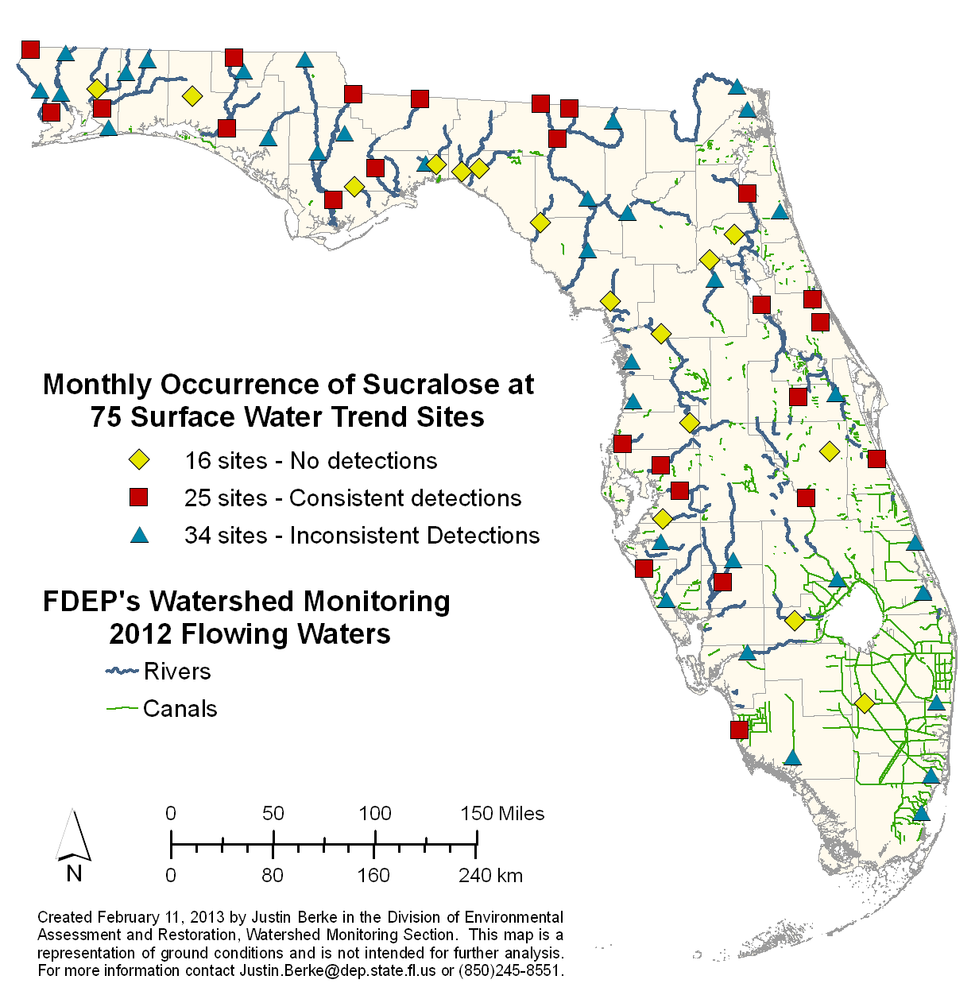
Figure 1. Surface Water Trend Network sites with sucralose detection categories.

Figure 2. Sucralose concentration ranges at surface water trend sites with consistent detections above laboratory PQL.

Chemical screening

Chemical screening for the occurrence of ESOC in Florida’s waterbodies provides information on the fate of these compounds after they are introduced into the environment. This information has yet to be collected on a statewide scale. To date, Alachua County Environmental Protection Department and USGS have conducted limited, area-specific ESOC sampling in Florida (ACEPD, 2012; Jacangelo et al., 2012; Foster et al., 2012; Foster and Katz, 2010; Lietz and Meyer, 2006; Kolpin et al., 2002).

Results from the most frequently detected compounds reported from the study will represent the environmental fate of chemicals with a variety of uses and sources as shown in Figure .

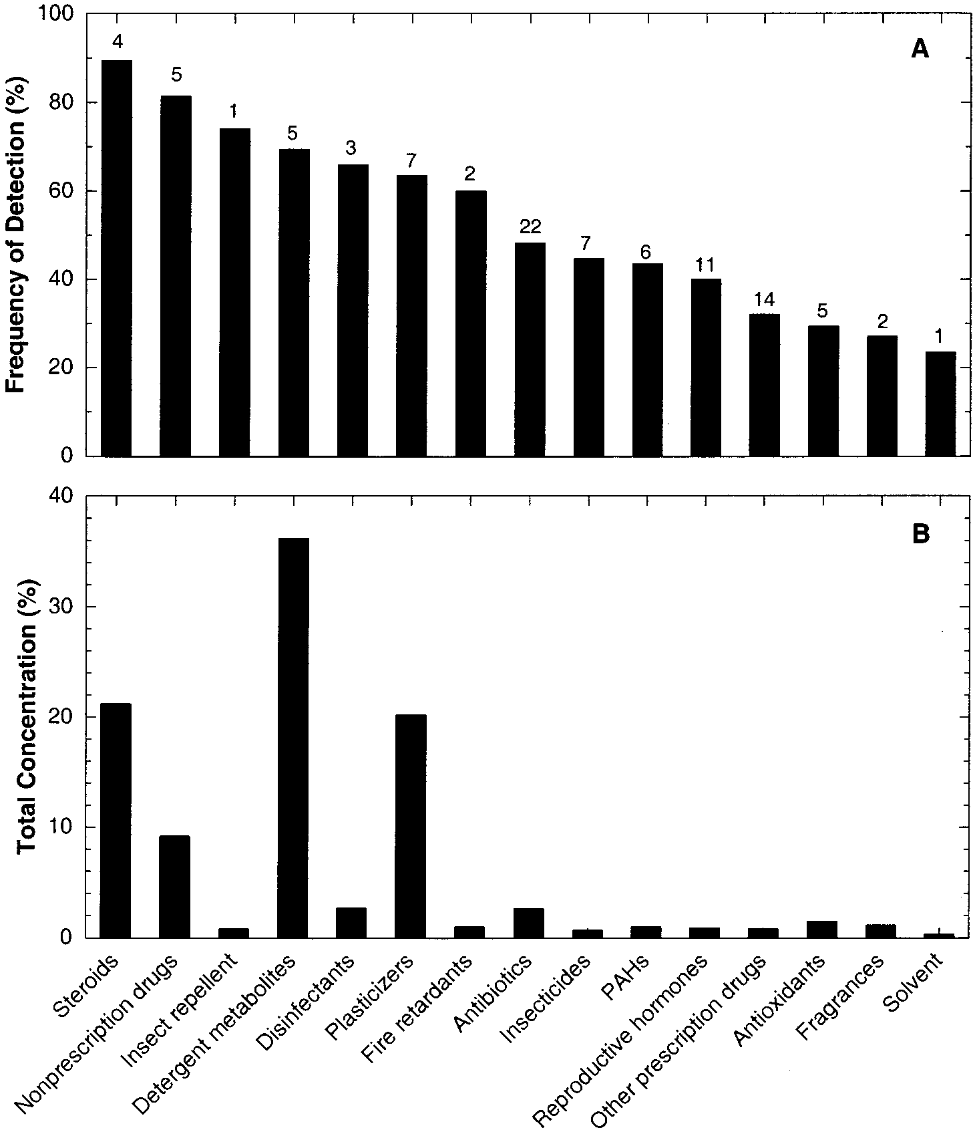
Figure 3. (A) Most frequently detected organic wastewater contaminants by general use category, and (B) percent of total measured concentrations (Kolpin et al., 2002).

To collect for ESOC in ambient water conditions, the use of passive samplers such as polar organic chemical integrative samplers (POCIS) and semipermeable membrane devices (SPMD), as well as traditional grab samples, are all viable methods to achieve the objective. Due to the source, release, and nature of the compounds, the greatest number of ESOC detections will occur when a combination sampling methods (POCIS, SPMD, and whole-water grabs) is used (Alvarez, 2010). To demonstrate the effectiveness of each sampling method, results will be tabulated from each method by most frequently detected analytes with their concentrations (see example Table , modified from Alvarez et al., 2005). These results will determine the necessity of specific sampling methods in future studies.

Analyte | Category/Use | Site 1 | Site 2 | Site 3 | Site 4
Chemical 1 | Pesticide | X.X (A, C) | ND | X.X (A) | ND
Chemical 2 | PPCP/Antibiotic | X.X (B) | ND | ND | ND
Chemical 3 | PPCP/Antibiotic | X.X (C) | ND | X.X (C) | ND
Chemical 4 | PPCP/Birth control hormone | X.X (C) | X.X (A) | X.X (A, C) | ND
Chemical 5 | PPCP/Musk fragrance | X.X (A) | ND | X.X (B) | ND
Chemical 6 | OWC/Detergent Metabolite | X.X (A) | ND | X.X (B) | ND
Chemical 7 | Flame retardant | X.X (C) | ND | ND | ND
Table 2. Comparison of hypothetical analyte concentrations measured by different sampling devices (modified from Alvarez et al., 2005). Letters found in parenthesis beside the result value indicates:
- chemical residues found in POCIS.
- chemical residues found in SPMD.
- chemical residues found in whole water.
Underlined text indicates an estimated ambient concentration. “ND” indicates chemical not detected in POSIC, SPMD, and whole water samples.

The POCIS device is designed to hold different types of solid sorbents that target hydrophilic compounds such as most pharmaceuticals, polar pesticides, and surfactants (Alvarez, 2010). The SPMDs are used for sampling compounds of neutral polarity such as chlorinated pesticides and brominated flame retardants (Alvarez, 2010). Table 3 shows the priority ESOC categories with their respective sampling collection methods.

Priority Chemical Category | Sample Collection Method
Priority Chemical Category | Whole Water | POCIS | SPMD
Sterols & Hormones | X | X
PPCP | X | X
Pesticides | X | X | X
Alkylphenols (Octylphenol, Nonylphenol, Nonylphenol ethoxylates) | X |  | X
Perfluorinated Compounds | X | X
Polybrominated Diphenyl Ethers | X |  | X
Table 3. ESOC Priority List and Sample Collection Methods

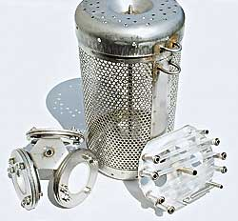
Figure 3. Sampling canister (center) which holds both POCIS (left) and SPMD (right). The canister will hold one POCIS carrier mounted with three POCIS and three standard SPMDs mounted on spider carriers. Source: www.est-lab.com.

There are advantages and disadvantages to collecting water samples from whole water grab samplers and passive samplers. The performance expectations of each collection technique is outlined below.

Whole water grab
- One or multiple sampling trips required depending on study design
- Quantitative results
- Direct comparison to known sucralose concentrations
- Will not capture episodic events such as facility breach or storm event
- Large number of non-detections

Integrative Sampling Devices
- Time-integrated sample (30-40 days)
- Higher number of detections based on larger water volumes
- May mimic contaminant accumulation in fish tissue
- Estimated water concentrations
- Opportunity for vandalism

While a one-liter grab sample will capture the possible contamination present during the sampling event, a passive sampler collects contaminants from a larger volume of water over a greater period of time. This means that a passive sampler will capture possible contamination present during any episodic events that occur during the deployment period (Alvarez, et al., 2009). The concentrations of compounds of interest present in one-liter grab samples may not be great enough to satisfy the laboratory method detection limit; this is unlikely to be an issue with the passive samplers. Furthermore, a passive sampler provides the ability to determine biologically relevant time-weighted average concentrations, and to test for potential responses to bioavailable compounds present using toxicological assays such as the BLYES (Alvarez et al., 2005).

One disadvantage to utilizing passive samplers is the chance of vandalism. Each site will need to be thoroughly evaluated to find hiding spots and/or ways to secure the device with steel cable or rebar (Figure 4).
Figure 4. Methods of hiding and securing passive samplers (Alvarez et al., 2010).

Biological screening

Biological response tests are used to measure endocrine activity to legacy chemicals such as Polychlorinated Biphenyls (Layton et al 2002) and novel chemicals. Data collected from biological assays can be compared with the sample’s chemistry results. Any relationship observed between the compounds detected and estrogenic, androgenic, and genotoxic responses can be evaluated. POCIS and SPMD extracts and whole water from each site will be screened using the tests described below. It is recognized that synergism, endocrine-disrupting chemicals not analyzed for in this study, and natural estrogenicity may add to the responses observed (Sanserivino et al., 2009). A site from which the water sample elicits a biological response from the screening tier (e.g. In Vitro methods) may then be an appropriate candidate for fish scoping studies such as fish tissue or fish biomarker studies (e.g. In Vivo methods).

The following in Vitro receptor assays were selected for this study based on their sensitivity, simplicity, and rapid results.

- Estrogen and androgen receptor (ER and AR) competitive binding assay
- Reporter Gene Assays
  - Bioluminescent yeast estrogen and androgen screens (BLYES and BLYAS)
  - Estrogen and androgen receptor (ER and AR) mammalian cell reporter gene assay
- SOS Chromotest

Receptor Assays
Contributed by: Nancy Denslow, PhD Center for Environmental and Human Toxicology, University of Florida

There are many kinds of receptors, some of which are found on the cell surface and some which are soluble receptors and these are found either in the cytoplasm of the cell or in the nucleus, where they have their effects. Cell surface receptors generally are found on the cell membrane and they interact with their ligands directly on the membrane. When a ligand binds, it stimulates them, they in turn release a signaling cascade that gets transmitted to the inner part of the cell, usually mediated by phosphorylation of proteins. The activity of membrane receptors can usually be measured by binding to the receptors and by their specific signaling cascades.

Sex hormones can activate some specific membrane receptors and initiate signaling cascades, but usually it is thought that they simply penetrate cells due their hydrophobicity and interact directly with the soluble receptors that are specific for each of the hormones. Thus, in the cell cytoplasm, one can find soluble receptors for sex hormones including estrogen, androgen, and progesterone, among others. In the case of these receptors, the ligands penetrate the cells and bind to intracellular receptors. Upon binding to these receptors, the ligands cause them to change shape (called conformation) and dimerize with another similar receptor. The dimerized receptor physically moves to the nucleus where it binds directly to control regions of specific target genes and turns on the transcription of the genes.

There are two basic assays for measuring the activity potential for these receptors. The first one is simply a binding assay that measures the ability of a ligand to bind specifically to the receptor and the other assay is a transactivation assay that tests the ability of the receptor to turn on transcription of genes.

Binding Assay – Cell Free Assay
Contributed by: Nancy Denslow, PhD Center for Environmental and Human Toxicology, University of Florida

The binding assay tests the ability of estrogen or an estrogen mimic to bind directly to the estrogen receptor, or an androgen mimic to bind directly to the androgen receptor. In the case of this assay, we measure just binding to the receptor, and thus cannot distinguish between an agonist (a chemical that turns on the activity of the receptor) or an antagonist (a chemical that interferes with the ability of the endogenous hormone to turn on the activity of the receptor). This assay measures just the interaction of the ligand with the ligand-binding domain of the receptor. It shows specific binding because the assay is configured to compete with the endogenous ligand, for example to compete with the ability of estrogen to bind to the receptor. In the case of our assay, the endogenous ligand is fluorescently labeled. When the endogenous ligand is bound, it exhibits different behavior than when it is unbound. These behaviors can be measured using fluorescence polarization. So, when a chemical that acts as an estrogen or androgen mimic is introduced to the assay at a high enough concentration it will displace the fluorescently labeled endogenous ligand. The competition with the labeled estrogen or androgen can be quantified and is related to the binding affinity of the mimic for the respective receptor. The assay is performed as a cell-free assay, meaning the receptors have been purified and configured totally in vitro for the assay. The assay particularly focuses on the ligand-binding domain of the receptor and uses a sophisticated method for testing the binding affinity of the test chemical for the receptor.

ER and AR Binding Assay Using Fluorescence Polarization (FP)

The competitive ligand binding assay using FP is one type of In Vitro assay in this broad category that uses fluorescent labeled molecule bound to the receptor molecule. The estrogen receptor ligand binding assay in this study uses a recombinant human estrogen receptor and a fluorescein-labeled estrone derivative as the ligand. The androgen receptor binding assay in this study employs the rat androgen receptor ligand binding domain. The competitor is identified by the hormone (e.g. estradiol) or hormone mimicking compound’s (e.g. Tamoxifin) ability to disrupt the binding of the fluorescent inhibitor molecule (EDSTAC).

With the use of fluorescence, the light wavelength is absorbed by the molecule, called an excitation state, and then the change in the wavelength specific to that molecule is emitted and measured (Weber, 1960a). The amount of fluorescent polarization (FP) emitted depends on the ability of the compound to displace the fluorescein ligand from the receptor molecule (Figure 5) (Parker et. al, 2000; Weber, 1960b). The amount of polarization emitted from estrogen receptor binding action during the state of excitation of the ligand is quantified by measuring the bound and free ratio (Ohno et. al, 2002). The amount of free labeled analog is inversely related to the amount of the bound compound (Kapp, et al).
When measured, the estrogen or estrogen mimicking compound’s agonistic effect is inversely related to its % inhibition (Figure 6) of the estrogen receptor (Denslow, 2013). The % inhibition is the concentration of estrogenic ligand in the sample that outcompete the fluorescein labeled inhibitor in the binding to the receptor by 50% (IC₅₀). The results from this assay are the IC₅₀ and the relative binding affinity. The receptor binding assay does not discriminate full (i.e. estradiol) or partial agonist from the antagonist (Sato et. al 1999). The non-competitive inhibition (false positive) and false negatives are rare with this assay type (EDSTAC). However, the IC₅₀ cannot be obtained if there is only partial displacement of the labeled estrone in the presence of a substance with a lower potency (Sato, et al. 1999).

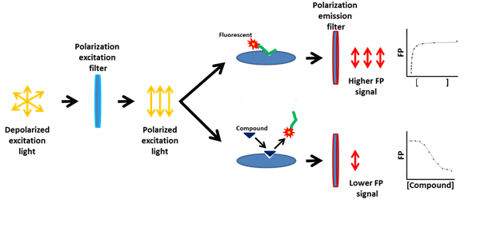
Receptor
Figure 5. The diagram shows the principle of how the polarization of the fluorescence is measured. When there is no competition, the fluorescent labeled derivative remains bound to the receptor resulting in a higher FP signal and vice versus when the estrogen or estrogen like compound displaces the analog (Parker, et. al 2000). The wavelengths specific to the compound go through the emission filter and those are measured. (www.thesgc.org, accessed 9/5/14; modified from original)

Figure 6. (Drs. Denslow et. al, 2014 presentation to DEP) This is an example of results from concentrated extracts from sample sites in Georgia. The researchers were looking for a method to determine total estrogenicity without the detection of every contaminant. The diagram below on the left shows the inhibitory effects (IC₅₀) of the estrogenic compound 17β – estradiol (E2) in the ER binding assay.

Receptor Transactivation Assay – Cell Based Assay
Contributed by: Nancy Denslow, PhD Center for Environmental and Human Toxicology, University of Florida

This assay tests for the ability of the activated receptor to turn on gene transcription. It requires the test compound to bind to the receptor in a way that will activate the receptor (by changing its conformation and allowing dimerization with a second receptor and then sitting on a control region of a gene to turn on the transcription of the gene to mRNA and then the translation into protein. These assays are done within live cells. In the case of the assays we have proposed, the DNA binding domain of the receptor has been altered to ensure that if receptor dimerization occurs the activated receptor will find a good binding site in a control region of the test gene. Also, the test gene has been configured to produce a protein that can easily be measured by an activity assay using FRET – fluorescence resonance excitation transfer – a method that is very sensitive so that if transcription occurs in response to the ligand activated receptor, the mRNA is translated into protein and we can measure the activity of the protein. Because this assay measures activity, we can distinguish between agonists and antagonists (i.e., estrogen mimics and anti-estrogens, for example).

Mammalian Cell Based Receptor Transactivation Assay using Reporter Gene

The mammalian cell based reporter gene assay that will be used in this study consists of mammalian (HEK293T) cells stably transfected with a reporter gene containing a genetically engineered DNA binding domain (DBD) and loaded with a fluorescent substrate (Invitrogen, 2010). By stably transfecting the cells, this allows the recombinant reporter gene to integrate into the nuclear genome of the cell. The transfected cells and the fluorescent substrate are purchased as a kit commercially produced by Invitrogen. The cell is transfected with a reporter gene found in many bacteria that produces the enzyme β-lactamase (Abraham, et al. 1940; Zlokarnick 2000). The reporter gene is engineered with a specific DBD called an activator site. The activator site contains an upstream activating sequence (UAS) from a yeast strain found to enhance the binding of a protein (Webster, et al. 1988), called an activator. The activator regulates gene expression by activating transcription. In this system, the yeast transcriptional activator, GAL4, specifically binds with the UAS (Webster, et al. 1988). To allow for an estrogen/androgen or estrogen/androgen mimicking substance to activate gene transcription, the DBD of the hormone receptor is replaced with the GAL4 DBD (Braselmann, et al. 1993). Then, the estrogen and androgen receptors function as the transcriptional activator in the transfected gene.

When an estrogenic/androgenic substance, depending on the assay, such as a water sample containing such compounds, is introduced to the transfected mammalian cells, the compound binds to the receptor activating transcription of the reporter gene. The information relayed from the activated gene initiates a series of cellular processes to produce the enzyme, β-lactamase (bla), and the gene is fully expressed. Gene expression is measured using fluorescence resonance energy transfer between the two fluorophores in the presence of bla production (Figure 8). If bla is not produced, the fluorescent molecules stay in tack causing the blue fluorophore coumarin to reach an excited state and transferring energy to the green fluorescein molecule resulting in the emission of a green light (Zlokarnik, et al 1998). The production of bla separates the fluorescent molecules so that the energy from the excited coumarin molecule cannot be transferred to the flouroscein resulting in the emission of blue light (Zlokarnik, et al 1998).

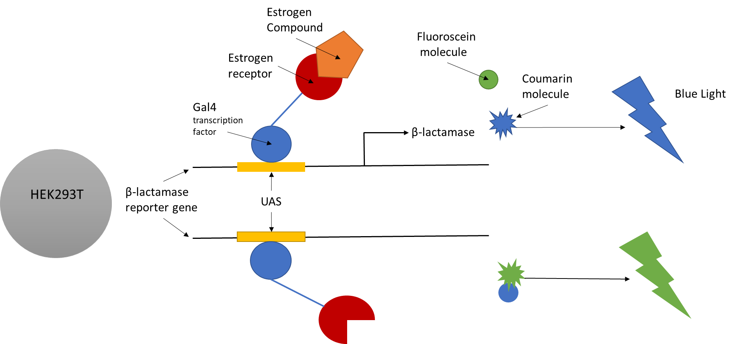
Figure 8. Diagram depicts the resulting response from the transcriptional activation assay with and without the presence of an estrogenic compound.

Yeast Based Reporter Gene Assays

The traditional yeast estrogen screen performance is less sensitive in detecting estrogenicity than in other reporter gene and cell proliferation assays (Leusch et. al, 2010) and is not recommended by the EDSTAC. However, the BLYES is used, in addition to the ER binding/transactivation assays, in this study because the sensitivity to estrogen receptor binding activity is greater than in the traditional YES and the processing time substantially decreased (Sanserivino, et al. 2005). The sensitivity to in each of the screens will be compared.

The BLYES and BLYAS test is used to detect water’s estrogenic and androgenic activity by promoting a light-generating or bioluminescent response in the yeast strain (Sanserivino et al., 2005). In the bioluminescent yeast reporter system, the yeast cell containing a human estrogen receptor – α gene and constructed bacterial DNA fused with reporter genes required for the bioluminescent reaction. Luminescence is generated when the yeast cell is dosed with a sample containing estrogen/estrogen-mimicking compounds (Error! Reference source not found. 9). In a similar manner to other reporter gene systems, the binding of the estrogenic substrate to the receptor activates translation of the reporter gene that produces the bioluminescent reaction.

In the BLYES, the estrogenic response activity is measured in the sample and compared to the equivalency of the estrogen compound 17β-estradiol, a naturally occurring hormone (Figure 10) (Routeledge et al., 1996). Induction of bioluminescence is relative to the 17β-estradiol control E2 (Alvarez et al. 2009). Because the BLYES test responds to estrogen hormones, estrogen xenobiotics, and their mixtures in the sample, it is possible to compare the response to the ESOC chemicals detected in the sample. The yeast chromosome for the BLYAS contains the human androgen receptor and the androgen response element on the reporter gene (Eldridge, et al. 2007).
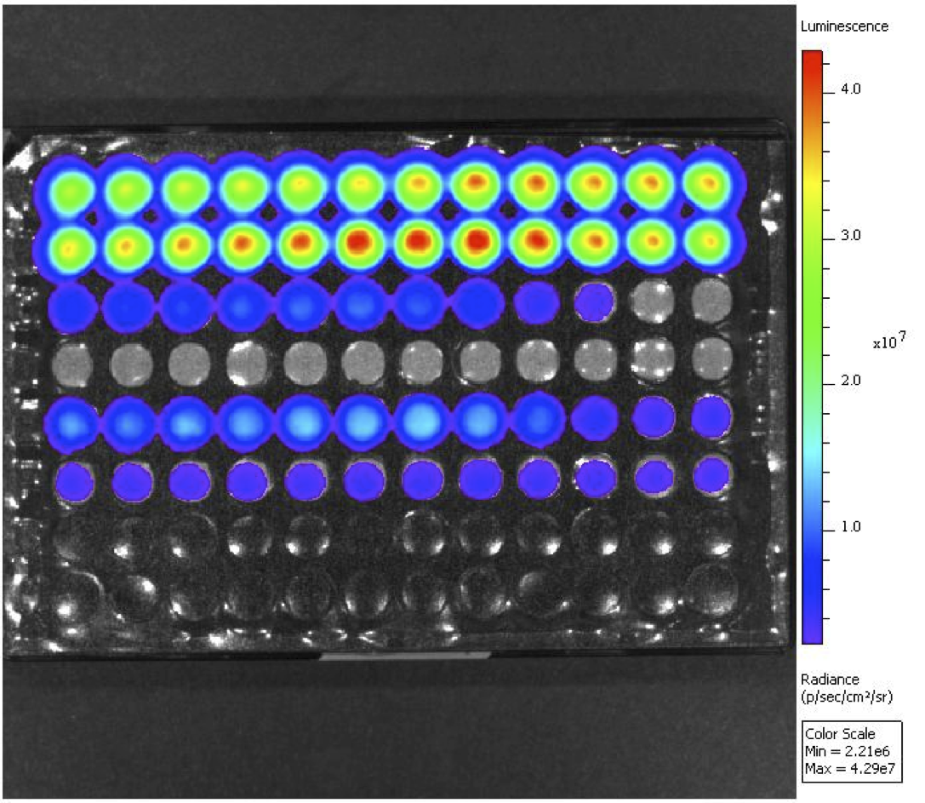
Figure 9. Illustration of BLYES results. Source: http://www.490biotech.com.

Figure 10. Response of bioluminescence induction for field blanks and POCIS from a) 2005 and b) 2006. Difference of bioluminescence induction in field blanks and POCIS as compared via one-way analysis of variance. The sites with different uppercase letters are statistically different. (Alvarez et al. 2009).

SOS Chromotest

Many of the ESOC compounds are also capable of causing DNA damage from carinogenic and other genotoxic substances in the exposed organism. DNA damage from these substances present in the waterbodies could affect reproductive success of aquatic organisms (Blazer, et al. 2013). In addition to screening for endocrine disruptors, this study will review the results from the genotoxicity test, SOS Chromotest and together serve as useful tools in assessing the aquatic life effects of ESOC. The SOS Chromotest is a colorimetric test that measures the reaction of bacteria to genotoxic compounds in water samples (Figure 11). When DNA damage occurs in the presence of a genotoxic water sample, the effect is detected by enzymatic activity that can be measured using the SOS Chromotest, a simple, rapid response colorimetric assay developed to detect genotoxins, particularly genotoxic carcinogens that cause DNA damage and cancer, or are used in cancer treatment (Figure 7) (Quillardet, et al. 1982). The system is a bacterial genotoxicity test that serves as a screen for environmental samples with complex mixtures (Xu et al., 1990). The amount of enzymatic activity produced from genotoxicity can be calculated resulting in a numerical value for genotoxicity (Xu et al., 1990). The genotoxicity levels can be compared to threshold values defined in different studies (Kocak et al., 2012).

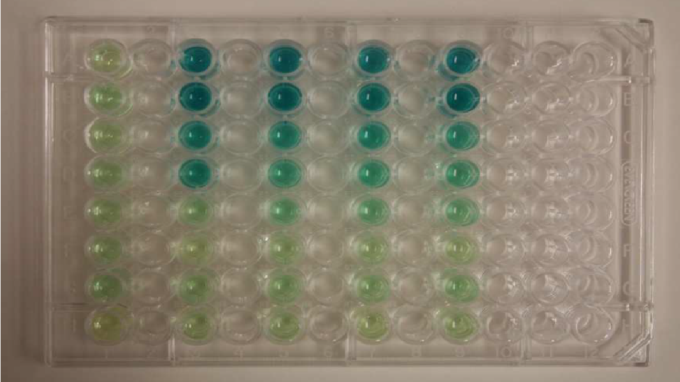
Figure 11. Colorimetric illustration of SOS Chromotest results. Source: www.wikipedia.org.

The results from the bioassays and chemical analyses may identify the possibility of utilizing the yeast bioreporter assay as a first-line screening to determine which samples need further chemical analysis for studies interested in the effects of estrogen on aquatic life, such as fish (Balsiger et al., 2011). Qualitative results can be used to compare estrogenicity between POCIS extracts from sampled sites (Figure 9. Illustration of BLYES results. Source: http://www.490biotech.com.

6).

Land Use Assessment

An evaluation of land use and permitted wastewater treatment discharges in the upstream watershed of the test site are useful to determine potential sources that are expected to contribute to inputs of ESOC, hormonal effects seen in screening assays, and/or observed effects on aquatic organisms such as amphibians and fish that may be found in an affected waterbody (Alvarez, et al. 2005, 2006; Blazer, et al. 2013). For this study, upstream land use for each site will be evaluated on a buffer zone scale and a watershed scale. The buffer zone land use will be evaluated based on the landscape development intensity index (LDI), if available for the sampling site. The LDI is a tool that DEP uses to estimate impacts on streams, wetlands, and lakes (http://www.dep.state.fl.us/water/bioassess/ldi-hdg-bcg.htm, accessed 10/29/2014). For this study, the LDI is used to screen for human impacts in a 100 m buffer of the waterbody for 10 km upstream of the test site. Coefficients are assigned to land uses in the watersheds and calculated spatially (Brown, et al. 2005). If the LDI of a site is greater than 2, then we can determine if the land – use has the potential to contribute to any ESOC that may be found at the site during sample collection. To assess potential priority ESOC contributions to the watershed upstream of a test site, land cover can be calculated from data obtained from the Georgia GIS Clearinghouse maintained by University of Georgia (https://www.georgiaspatial.org/) and municipal and industrial wastewater treatment discharge locations and permits are obtained from EPA Compliance and Enforcement System maintained through the Office of Wastewater Management.

Study Design

The 2012 Trend Network sucralose data are used as a first screening tool for sites where we expect human and animal waste influence and thus the presence of ESOC. The pilot study sites are selected based on Trend Network river sites that had the highest sucralose concentrations measured with detections occurring each of the 12 consecutive months during the study. Many cities located in these watersheds use rivers as a method of waste water treatment plant effluent disposal.

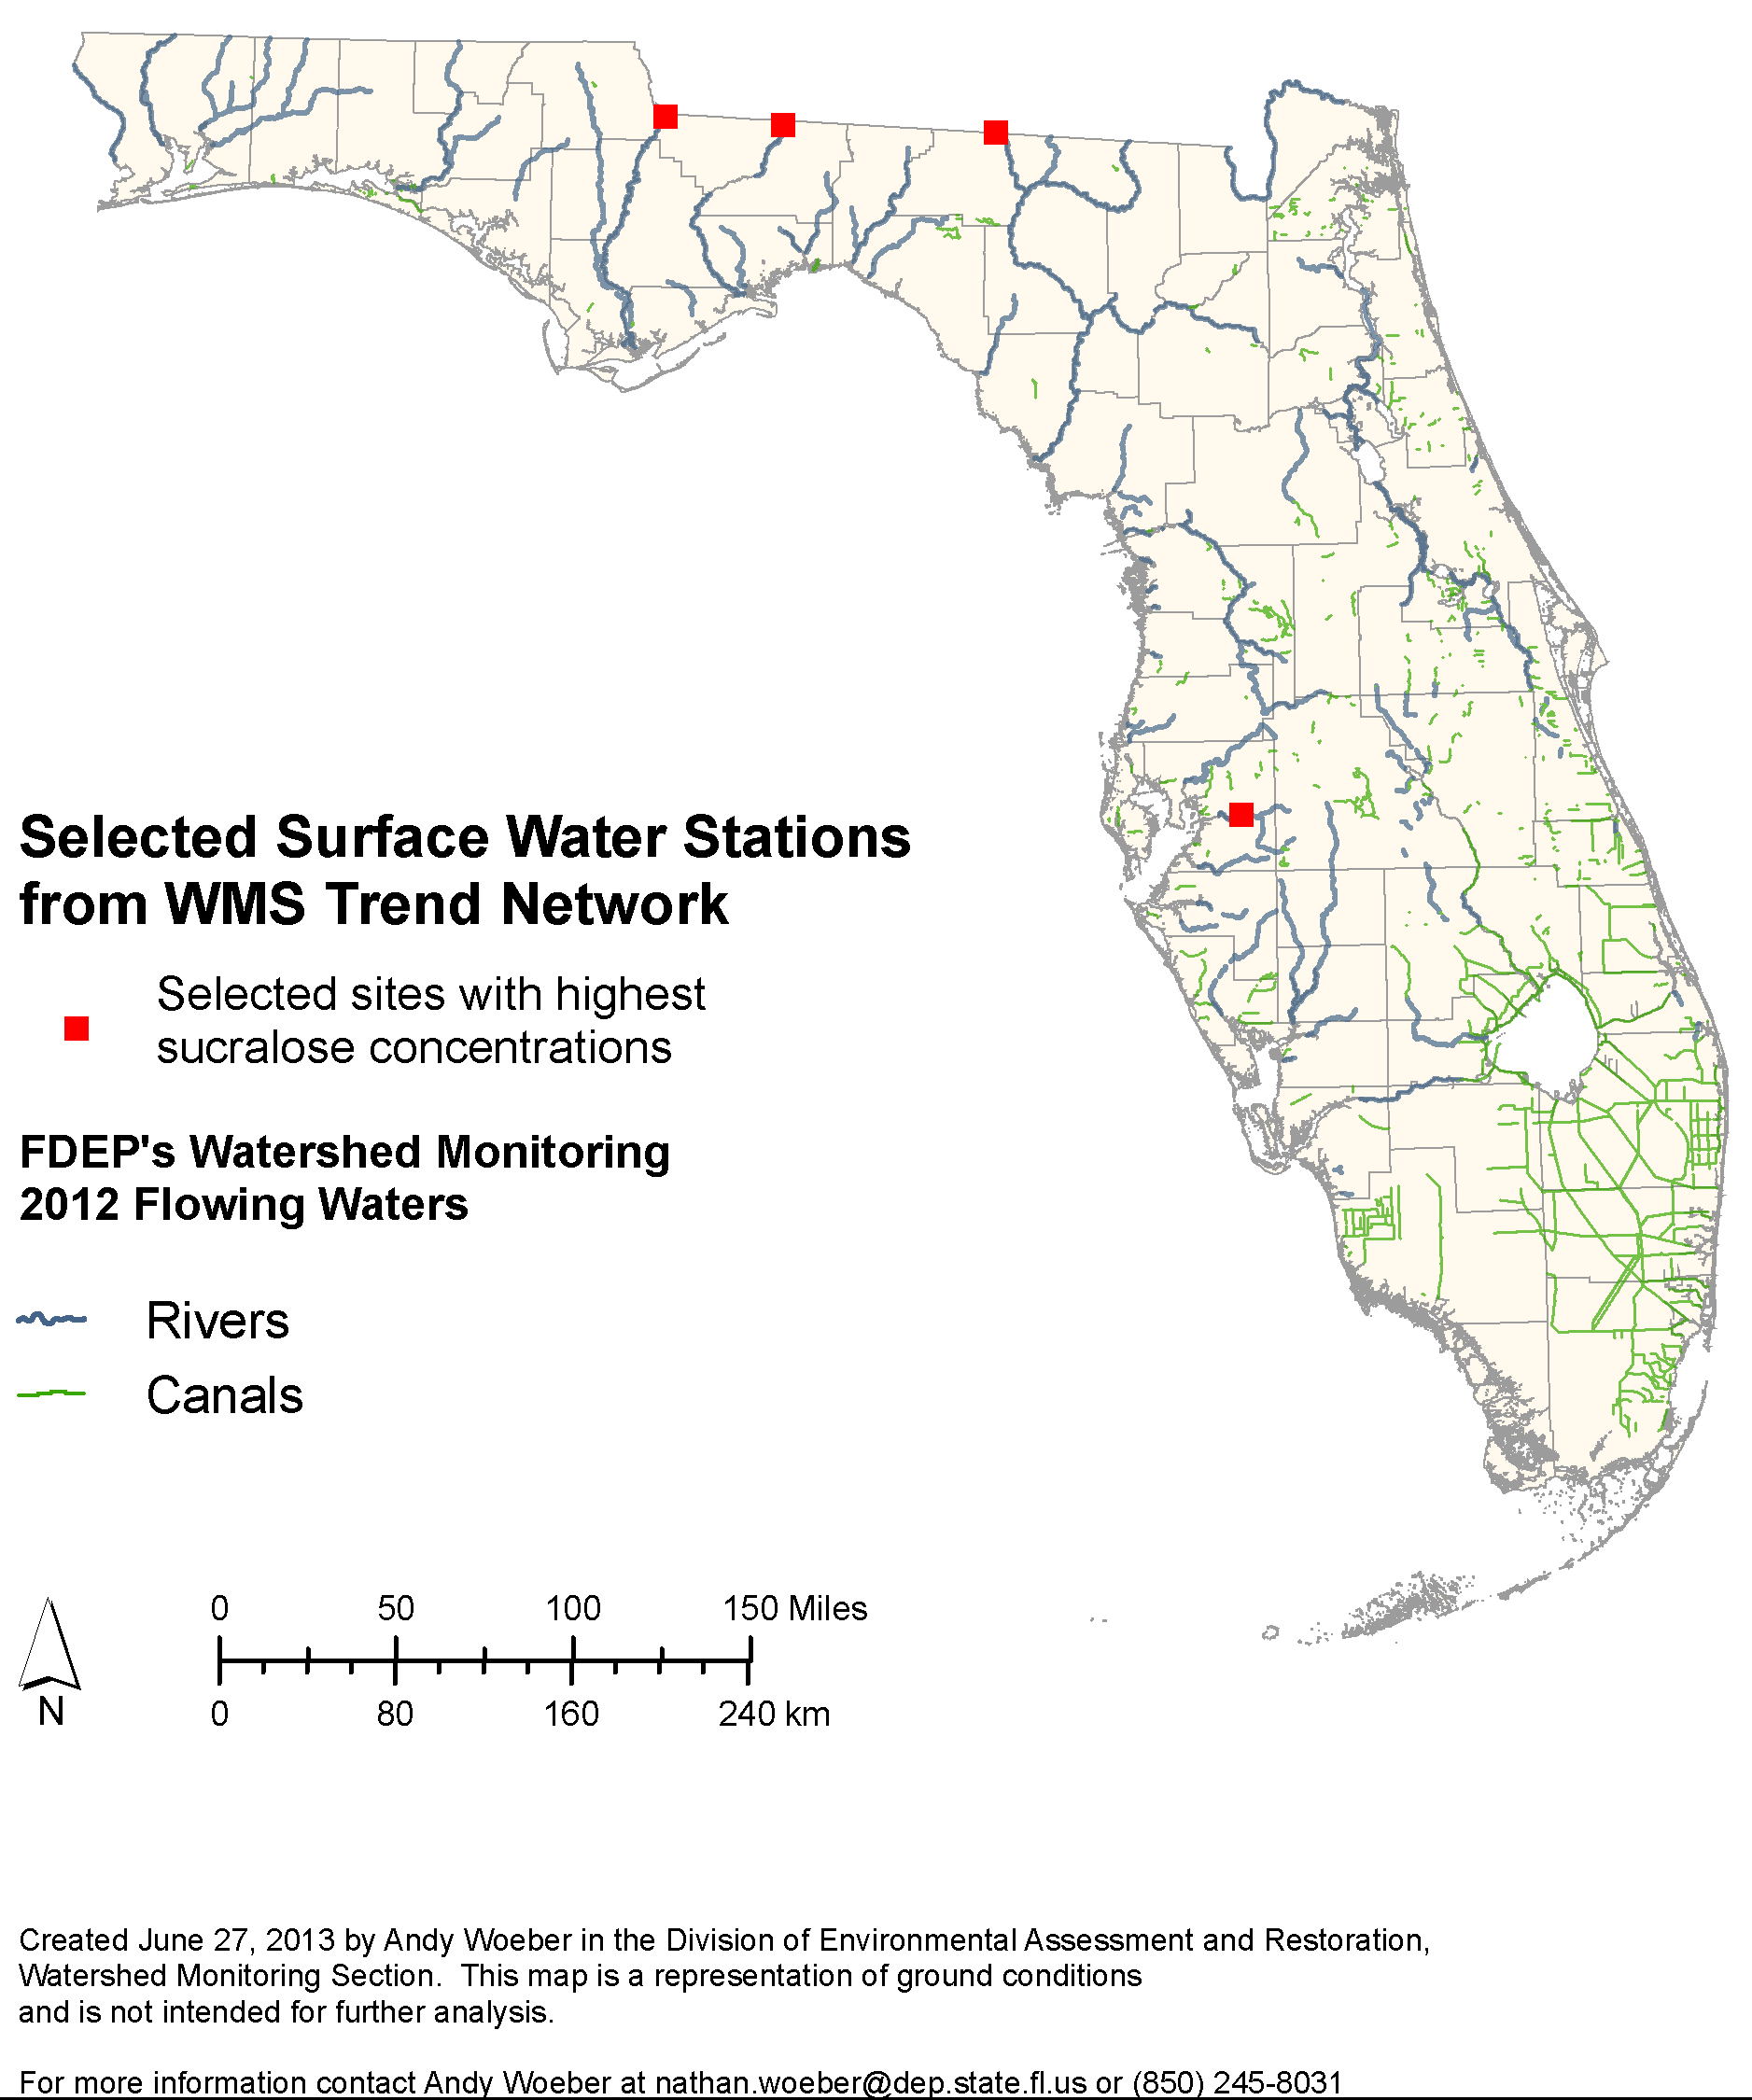
Figure 12. Site Selection from Surface Water Trend Network

Site Characterization

The four sites are river sites, each with a 15-year history of regular monthly sampling by Department staff for the suite of standard water quality analytes (e.g., nutrients, major ions). Three of the rivers, the Apalachicola, the Withlacoochee and the Ochlockonee, flow into Florida from Georgia over the Atlantic Coastal Plain province. The Ochlockonee and Withlacoochee Rivers each have significant amounts of agricultural and sylvicultural activity in their watersheds. The Apalachicola River, formed by the confluence of the Flint and the Chattahoochee Rivers near Albany Georgia, drains much of the state of Georgia. It is used for sanitary waste disposal by millions of people in many cities, including metro Atlanta, Griffin and Bainbridge. The Chattahoochee River has three federally maintained water control structures (dams) upstream, which slow flow and pool the river. This provides an opportunity for sedimentation to occur before the water is released further downstream. The fourth site is located on the Alafia River, which flows west into Tampa Bay from the center of the Florida peninsula, with its headwaters near the City of Lakeland.

One aspect of the ESOC study is to characterize the water quality at the study sites to ensure that there are no interferences with the monitoring effort (Table 5). The three north Florida rivers show approximately the same concentrations for a suite of standard water quality indicators. The Alafia River exhibits a higher specific conductivity, due to upstream mining impacts and waste water treatment plant additions, but none of the sites have unusual water quality characteristics that would warrant their removal from the study.

Analytes (Mean Value) | Alafia | Apalachicola | Withlacoochee | Ochlockonee
Color (Pt-Co Units) | 79 | 42 | 90 | 108
Specific Conductivity | 477 | 130 | 160 | 134
NOx (mg/L) | 0.44 | 0.40 | 0.34 | 0.58
Fecal Coliforms  (Colonies per 100 ml) | 853 | 48 | 119 | 109
Table 5. Summary of water quality at test sites

Integrative Sampling Devices

The SPMDs and POCIS were purchased from Environmental Sampling Technologies, Inc (EST), St. Joseph, Missouri. The SPMDs are a low-density polyethylene tubing filled with Triolein (99% purity). Two SPMD per site will contain a performance reference compound (PRC), perdeuterated PAHs, to account for increased or decreases in the uptake rate due to environmental factors such as water/air velocity, temperature changes, and biofouling (Alvalrez. 2010). The spiked SPMD dialysis will be performed and analyzed for ESOC compounds. One SPMDs will not be spiked and after dialysis performed will be used for biological screening. POCIS, marketed under the name Aquasense – P were also purchased from EST, is a solid resin held between two polyethersulfone membranes containing the sorbent Oasis HLB which is used to extract the pharmaceutical and more water-soluble compounds from the water (Alvarez, 2010). T

Deployment of the POCIS and SPMD

Three POCIS-HLB and three SMPDs contained in one large canister (Figure ) will be deployed at each of the four river sites for the pilot study. Three whole-water grab samples (one liter each) will be collected at the end of the deployment period. The devices will be deployed at each site for 30 – 35 days. A field blank for all three sampling methods (POCIS, SPMD, and whole water) will be collected at one of the sites. Refer to Appendix A for a list of the chemical compounds and associated analytical methods.

Site Specific Deployment Strategies

Most of sites have bridges for potential deployment opportunities. For sites where bridges may not be the best option, there is opportunity to deploy the device canister to a cypress tree in or near the water.

a) b) c)
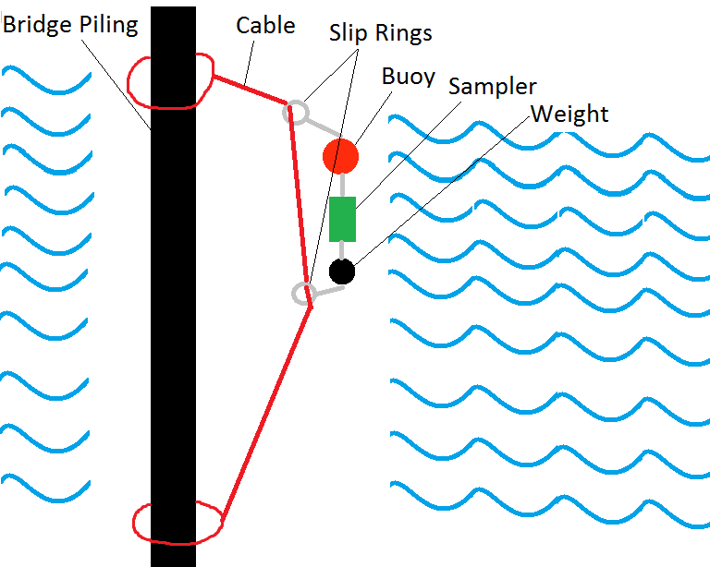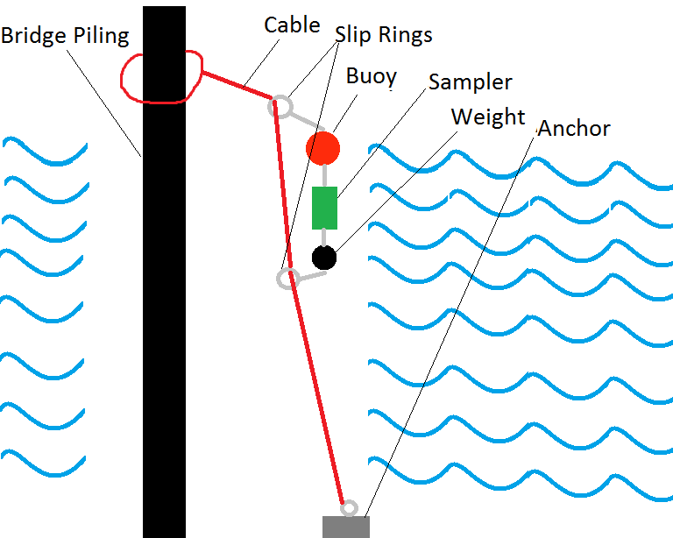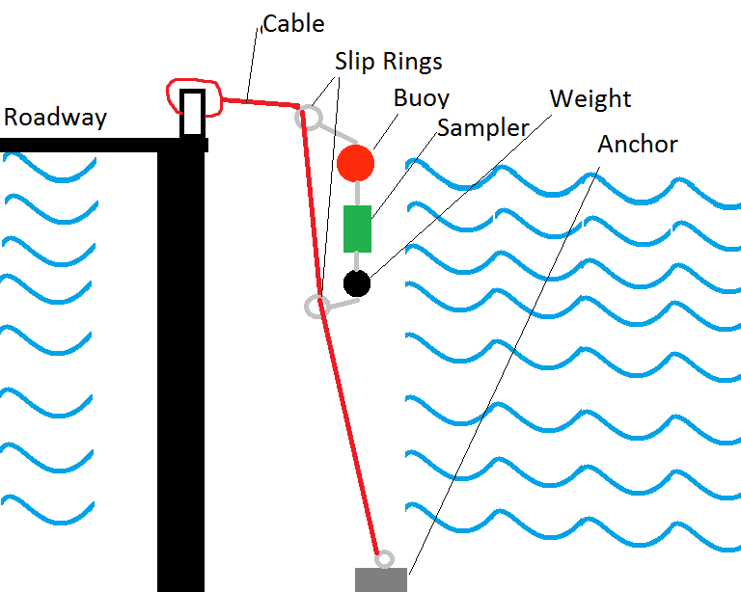
Figure 13 a - c. Bride deployment options.

Logistical considerations

Three of each passive sampling devices will be collected from each site at the end of the deployment period and shipped overnight to a commercial analytical laboratory that specializes in the elution and dilution from POCIS and SPMD, respectively, and the analysis of emerging contaminants from such samples. One SMPD from each site are notched to identify that no PRCs, i.e. spikes, were added. The analytical laboratory will split the un-spiked SPMD dilutions into two – 1 mL aliquots. One aliquot is sent from the analytical laboratory to USGS Leetown Science Center (LSC) in West Virginia to perform BLYES, BLYAS and SOS Chromotest. The second aliquot is sent to the Laboratories of Drs. Denslow and Sabo-Attwood at University of Florida to conduct the competitive binding and transactivation assays. Refer to Figure 12 for a diagram of the logistics for the shipment from the field to and between laboratories.

A single one-liter sample bottle will be collected at each site and shipped overnight to a commercial analytical laboratory that specializes in emerging contaminants he second one-liter sample bottle will be shipped directly to the USGS Leetown Science Center (LSC) in West Virginia and the third bottle shipped to Denslow’s Laboratory at UF for biological screening for estrogenicity, androgenicity, and genotoxicity. The fourth sample bottle will be shipped to the DEP Central Laboratory for pesticide analysis. The commercial laboratory will complete the extraction process on the passive sampling devices. One extracted sample from each device will be held at the commercial laboratory for chemical analysis. One additional extracted sample from each device will be sent from the analytical laboratory to LSC for biological screening.

QA/QC

Currently, DEP water quality sampling protocols for analytes collected at low levels such as those tabulated in Appendix A are not developed. While DEP sampling protocols address intermediate sampling devices, no protocols are yet developed for POCIS and SPMD. Therefore, a QA/QC subgroup of the ESOC workgroup comprised of DEP QA officers was created to provide a recommendation appropriate for the nature of the study design. In addition, a literature review consisting of 22 studies where ESOC were monitored was conducted by the subgroup (see Appendix B). The information gathered from the review assisted in the determination of the appropriate type and number of blanks recommended for the field collection of ESOC (see Appendix C, Tables 1 – 3). Appendix D, Table 1 and Appendix F includes minimum QA/QC requirements for laboratory chemical analysis.

Estimation of Ambient Water Concentrations for SPMD and POCIS

Estimating the water concentration for chemicals found in the SPMD and POCIS extracts requires the use of published sampling rates and help from models. The estimated water concentration is calculated using models, PRC loss data from SPMDs, and published sampling rates (Alvarez, 2010). There is a limitation in that not all chemicals have a published sampling rate.

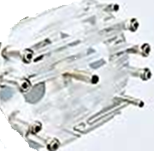
SPMD (1)
- No PRC addition (notched).
- Shipped from the field to Axys for extraction.
- Extracted separately from the other 2 SPMDs.
- No spike additions.
- SPMD hexane extraction process still in question. Tox labs request environmental samples.
- Axys ships a 1 mL extracted aliquot each to USGS LCS for BLYES and SOS Chromotest.
- Axys ships a 1 mL extracted aliquot to UF Denslow Lab for ER binding and transactivation assays.
- Axys ships spider carrier back to DEP.

SPMD (2)
- PRCs added.
- Shipped from field to AXYS for extraction.
- Spikes added.
- Composited and extracted for chemical analysis.
- Axys ships 1 mL aliquot to DEP Central lab for pesticide analysis.
- Axys ships spider carriers back to DEP.

POCIS-HLB (2)
- Shipped from the field to Axys for extraction.
- Spikes added.
- Composited and extracted for chemical analysis.
- Axys ships holders back to DEP.

POCIS-HLB (1)
- Shipped from the field to AXYS for extraction.
- No spike additions.
- Extracted separate from the other 2 POCIS.
- Axys ships a 0.5 mL extracted aliquot to USGS LCS for BLYES and SOS Chromotest.
- Axys ships a 0.5 mL extracted aliquot to UF Denslow Lab for ER binding and transactivation assays.
- Axys ships holder back to DEP.

Figure 12. Diagram showing the logistical considerations between the sample shipments from the field and the toxicological and analytical laboratories for the treatment of the devices and extracts from the POCIS and SPMD. Photo from EST-lab.com.

SPMD (2) – PRCs Added
- PRCs added.
- Shipped from field to AXYS for extraction.
- Spikes added.
- Composited and extracted for chemical analysis.

POCIS-HLB (2) - Spiked
- Shipped from the field to AXYS for extraction.
- Spikes added.
- Composited and extracted for chemical analysis.
- AXYS ships holders back to DEP.

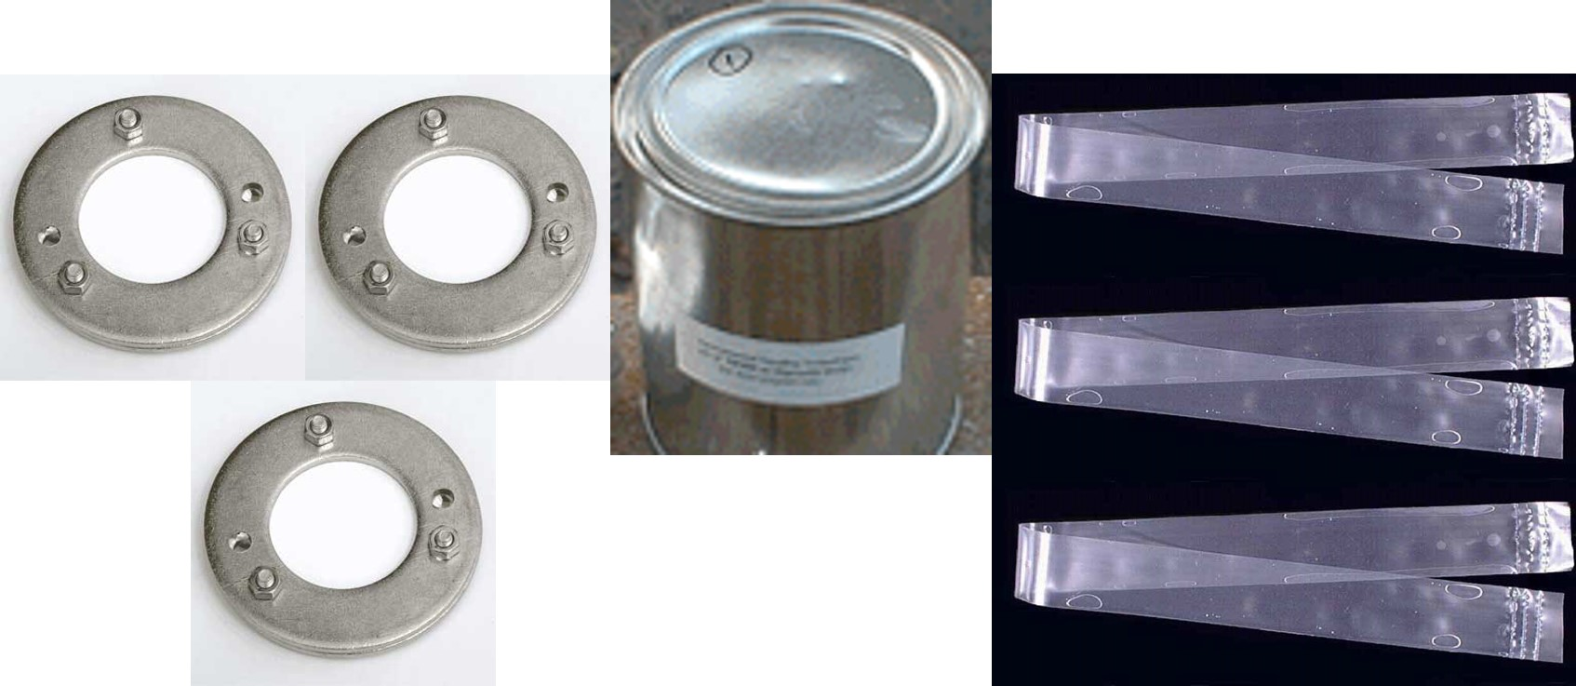

POCIS-HLB (1) – No Spikes Added
- Shipped from the field to AXYS for extraction.
- No spike additions.
- Extracted separate from the other 2 POCIS.
- AXYS ships a 0.5 mL extracted aliquot to USGS LCS for BLYES and SOS Chromotest.
- AXYS ships a 0.5 mL extracted aliquot to UF Denslow Lab for ER binding and transactivation assays.
- AXYS ships holder back to DEP.

SPMD (1) – No PRC Addition
- No PRC addition.
- Shipped from the field to AXYS for extraction.
- Extracted separately from the other 2 SPMDs.
- No spike additions.
- AXYS ships a 0.5 mL extracted aliquot to USGS LCS for BLYES and SOS Chromotest.
- AXYS ships a 0.5 mL extracted aliquot to UF Denslow Lab for ER binding and transactivation assays.

Figure 13. Diagram showing the aspects of the field blanks for the treatment of the POCIS and SPMD field blanks. Photos from EST-lab.com and USGS.

Sampling protocols

Sampling protocols for the study design were developed following the USGS National Field Manual for the Collection of Water Quality Data (Wilde et al., 2004-2009) and Guidelines for the use of the SPMD and the POCIS in environmental monitoring studies (Alvarez, 2010), as well as any necessary DEP protocols for collecting the pesticides to be analyzed by DEP Central Laboratory. F.A.C. 62 – 160 Quality Assurance is applied and enforced in all aspects of this study with oversight given by the State’s quality assurance officer. In instances where the USGS protocols differ from the DEP protocols, the DEP protocols will take precedence.

Data management and interpretation

The results from study will be delivered from the respective laboratory to DEP. The results will be tabulated and graphed into a format appropriate to the analysis and screening tool (see sections on chemical and biological screening).

Data reporting

The data collected from the pilot study on the occurrence of ESOC in Florida will be analyzed and reported in an DEP technical document. Other possible avenues for reporting are through peer-reviewed journal submissions. Should the results of the study be found to be of potential environmental concern, targeted follow-up studies may be required to evaluate environmental risk. Examples of such studies include an assessment of the impact to the aquatic organisms and an investigation of potential sources, a focus on a watershed, and predictions of ESOC occurrence and concentrations in municipal wastewater plant influent and effluent.

Literature Cited

Abraham, E.P. and E. Chain, 1940. An Enzyme from Bacteria able to Destroy Penicillin. Nature 146, p. 137.

Alachua County Environmental Protection Department, 2012. Results of a screening analysis for organic wastewater contaminants in treated wastewater effluent from four wastewater reclamation facilities and two surface water sites on Sweetwater Branch Alachua County, Florida. Accessed on July 3, 2013 at http://www.alachuacounty.us/Depts/EPD/WaterResources/CreeksAndLakes/Pages/default.aspx

Alvarez, D.A., Stackelberg, P., Petty, J. Huckins, J., Furlong, E., Zaugg, S. and Meyer, M., 2005. Comparison of a novel passive sampler to standard water column sampling for organic contaminants associated with wastewater effluents entering a New Jersey stream. Chemosphere, Vol. 61, pp. 610-622.

Alvarez, D.A., W.L. Cranor, S.D. Perkins, V. Schroeder, L.R. Iwanowicz, R.C. Clark, C.P. Guy, A.E. Pinkney, V.S. Blazer, and J.E. Mullican. 2009. Reproductive health of bass in the Potomac, USA Drainage: Part 2. Seasonal occurrence of persistent and emerging organic contaminants. Environmental Toxicology and Chemistry 28:1084-1095.

Alvarez, D.A., 2010, Guidelines for the use of the semipermeable membrane device (SPMD) and the polar organic chemical integrative sampler (POCIS) in environmental monitoring studies: U.S. Geological Survey, Techniques and Methods 1–D4, p 28.

Balsiger, H.A., de la Torre, R., Lee, W.Y., Cox, M.B., 2011. A four-hour yeast bioassay for the direct measure of estrogenic activity in wastewater without sample extraction, concentration, or sterilization. Sci total Environ. 408(6):1422-1429, DOI 10.1016/j.scitotenv.2009.12.027.

Blazer, V.S., Iwanowicz, L.R., Henderson, H., Mazik, P.M., Jenkins, J.A., Alvarez, D.A., Young, J.A., 2011. Reproductive endocrine disruption in smallmouth bass (Micropterus dolomieu) in the Potomac River basin: spatial and temporal comparisons of biological effects. Environmental Monitoring and Assessment, DOI 10.1007/s10661-011-2266-5.
Blazer, V.S., Pinkney, A.E., Jenkins, J.A., Iwanowicz, L.R., Minkkinen, S., Draugelis-Dale, R.O., Uphoff, J.H., 2013. Reproductive health of yellow perch Perca flavescens in selected tributaries of the Chesapeake Bay. Science of the Total Environment. Vol. 447, pp. 198 – 209.

Braselmann, S. Graninger, P, and Busslinger, M., 1993. A selective transcriptional induction system for mammalian cells based on Gal4 – estrogen receptor fusion proteins. Proc Natl Acad Sci, Vol. 90(4), pp. 1657 – 1667.

Brown, M.T., Vivas, M.B., Landscape Development Intensity Index. Environmental Monitoring and Assessment. Vol 101, pp. 289 – 309.

Chemical Abstracts Service, 2013. CAS Content at a Glance. Accessed July 3, 2013 at http://www.cas.org/content/at-a-glance.

Dellinger, M., Carvan, M., Ehlinger, T., 2011. Appendix J Human Health Effects Review on Chemicals of Emerging Concern. Great Lakes Water Quality Agreement 2009-2011 Priority Cycle Report International Joint Commission: Chemicals of Emerging Concern.

Denslow, Nancy. Bioanalytical methods to detect contaminants of emerging concern. Florida Department of Environmental Protection. Tallahassee, FL. 30 May 2013. Presentation.

Diamond, J.M., Latimer II, H.A., Munkittrick, K.R., Thornton, K.W., Bartell, S.M., and Kidd, K.A., 2011. Prioritizing Contaminants of Emerging Concern for Ecological Screening Assessments. Environmental Toxicology and Chemistry, Vol. 30 (11), pp. 2385 – 2394.

EDSTAC, 1998. Endocrine Disruptor Screening and Testing Advisory Committee (EDSTAC) final report. EPA/743/R-98/003. Office of Prevention, Pesticides, and Toxic Substances, U.S. Environmental Protection Agency, Washington, D.C.

Eldridge, M.L., Sanserverino, J., Layton, A., Easter, J.P., Schultz, T.W., and Sayler, G.S., 2007. Saccharomyces cerevisiae BLYAS, a New Bioluminescent bioreporter for

Detection of Androgenic Compounds. Applied and Environmental Microbiology. Vol. 73(19) pp. 6012 – 6018.

Florida Department of Environmental Protection, 2008. Emerging Substances of Concern (White paper). Accessed January 15, 2013 at http://publicfiles.dep.state.fl.us/dear/labs/sas/library/docs/esoc.pdf.

Foster, A.L., and Katz, B.G., 2010, Occurrence of organic compounds in source and finished samples from seven drinking-water treatment facilities in Miami-Dade County, Florida, 2008: U.S. Geological Survey Data Series 550, 22 p.

Foster, A.L., Katz, B.G., and Meyer, M.T., 2012, Occurrence and potential transport of selected pharmaceuticals and other organic wastewater compounds from wastewater-treatment plant influent and effluent to groundwater and canal systems in Miami-Dade County, Florida: U.S. Geological Survey Scientific Investigations Report 2012–5083,
64 p, plus appendixes.

Guy, C.P., A.E. Pinkney, V.S. Blazer, L.R. Iwanowicz, D.A. Alvarez, and J.E. Mullican. 2009. Assessment of endocrine disruption in smallmouth bass (Micropterus dolomieu) and largemouth bass Micropterus salmoides) in the Potomac River Watershed. CBFO-C09-01. U.S. Fish and Wildlife Service, Chesapeake Bay Field Office, Annapolis, MD. http://www.fws.gov/chesapeakebay/envcont.html

Invitrogen Corporation, 2010. GeneBlAzer® ER alpha GripTite™ DA and ER alpha-UAS-bla GripTite™ Cell-based Assay. Carlsbad, CA, Protocol part no. K1090.pps.

Jacangelo, J.G., Oppenheimer, J., Badruzzaman, M., Pinzon, J., Contreras, A., and Waller, P., 2012. Development of markers to identify nutrient sources impacting Florida’s surface water bodies. Water Reuse Research Foundation, Alexandria, VA., 152 p.

Kapp, R.W., Jr., Thomas, J.A. Principles and Methods of toxicology; 5th ed. A. Wallace Hayes. New York: Informa healthcare USA, Inc., 2008. p 1720. Print.

Kocak, E., Yetilmezsoy, K., Gonullu, M.T., Petek, M. 2010. A statistical evaluation of the potential genotoxic activity in the surface waters of the Golden Horn Estuary. Marine Pollution Bulletin. Vol. 60, pp. 1708 – 1717.

Kolpin, D.W., Furlong, E.T., Meyer, M.T., Thurman, M., Zaugg, S.D., Barber, L., B., Buxton, H.T., 2002. Pharmaceuticals, hormones, and other organic wastewater contaminants in U.S. streams, 1999-2000—A national reconnaissance. Environmental Science and Technology, Vol. 36, pp. 1202-1211.

Kolpin , D.W., Vicki, B.S., James G.L., Michael, F.J., Young, J.A. , Alvarez , D.A., Iwanowicz, L.R., Foreman, W.T. , Furlong, E.T., Speiran, G.K., Zaugg,S.D., Hubbard, L.E., Meyer, T.M., Sandstrom, M.W., Barber, L.B., 2012. Chemical contaminants in water and sediment near fish nesting sites in the Potomac River basin: Determining potential exposures to smallmouth bass (Micropterus dolomieu). Science of the Total Environment, Vol. 443, pp. 700 – 716.

Labare, Michael P. and Martin Alexander, 1993. Biodegradation of Sucralose, a Chlorinated Carbohydrate, in Samples of Natural Environments. Environmental Chemistry, Vol. 12, pp 797 – 804.

Letcher, Robert J., Jan Ove Bustnes, rune Dietz, Buorn M. Jenssen, Even H. Jorgensen, Christian Sonne, jonathan Verreault, Mathilakath M. Vijayan, geir W. Gabrielsen, 2010. Exposure and effects assessment of persistent organohalogen contaminants in arctic wildlife and fish. Science of the Total Environment, Vol. 408, pp. 2995 – 3043.

Lietz, A.C., and Meyer, M.T., 2006, Evaluation of emerging contaminants of concern at the South District Wastewater Treatment Plant based on seasonal events, Miami-Dade County, Florida, 2004: U.S. Geological Survey Scientific Investigations Report 2006-5240, 38 p.

Oetken, Matthias, Jean Bachmann, Ulrike Schulte-Oehlmann, and Jorg Oehlmann, 2004. Evidence for Endocrine Disruption in Invertebrates. International review of Cytology, Vol. 236.

Ohno, K., Fukushima, T., Santa, T., Waizumi, N., Tokuyama, H., Maeda, M., Imai, K., 2002. Estrogen Receptor Binding Assay Method for Endocrine Disruptors Using Fluorescence Polarization. Anal. Chem., Vol. 74, pp. 4391 – 4396.

Pal, A., Yew-Hoong Gin, K., Y-Chen Lin, A., and Reinhard, M., 2010. Impacts of emerging contaminants on freshwater resources: Review of recent occurrences, sources, fate and effects. Science of the Total Environment, Vol. 408, pp. 6062-6069.

Routledge, E. J., and J. P. Sumpter. 1996. Estrogenic activity of surfactants and some of their degradation products assessed using a recombinant yeast screen. Environmental Toxicology and Chemistry, Vol. 15, pp. 241–248.

Sanseverino, John, Rakesh K. Gupta, Alice C. Layton, Stacey S. Patterson, Steven A. Ripp, Leslie Saidak, Michael L. Simpson, T. Wayne Schultz, and Gary S. Sayler, 2005. Use of Saccharomyces cerivisia BLYES Expressing Bacterial Bioluminescence for Rapid, Sensitive Detection of Estrogenic Compounds. Applied and Environmental Microbiology, Vol. 71, No. 8, P 4455 – 4460.

Sato, A.M., Michaelson, C.L. Prechtl, N.V., Weill, B.C., and Sonnenschein, C., “In Vitro Endocrine Disruptor Screening,” Envionmental Toxicology and Risk Assessment: Standardization of Biomarkers for Endocrine Disruption and Envionmental Assessment: Eighth Volume, ASTM STP 1364, D.S. Henshel, M.C. Black, and M.C. Harrass, Eds., American Society for Testing and materials, West Conshohocken, PA, 1999.

Schriks, M., Heringa, N.B., van der Kooi, M.M.E., de Voogt, P., and van Wezel, A.P., 2010. Toxicological relevance of emerging contaminants for drinking water quality. Water Research, Vol. 44, pp. 461-476.

Smital, T., Luckenbach, T., Sauerborn, R., Hamdoun, A.M., Vega, R.L., and Epel, D., 2004. Emerging contaminants—pesticides, PPCPs, microbial degradation products and natural substances as inhibitors of multixenobiotic defense in aquatic organisms. Mutation Research, v. 552, pp. 101-117.

Soh, Lindsay, Kristin A. Connors, Bryan W. Brooks, and Julie Zimmerman, 2011. Fate of Sucralose through Environmental and Water Treatment Processes and Impact on Plant Indicator Species. Environmental Science & Technology, Vol. 45, pp 1365 – 1369.

Stevenson, D.L.., ed., 2012, Quality management system, U.S. Geological Survey National Water Quality Laboratory: unpublished U.S. Geological Survey Report, version 2.0, 3 January 2012, chapters variously paged. Accessed on December 20, 2012 at http://nwql.usgs.gov/qms_v2.shtml?qms

USEPA, 2008. Aquatic Life Criteria for Contaminants of Emerging Concern Part 1: General Challenges and Recommendations (White Paper).

USGS, April 11, 2011. Toxic Substances Hydrology Program. In Emerging Contaminants of Concern In the Environment. Accessed July 10, 2012 at http://toxics.usgs.gov/regional/emc/.

USEPA. May 28, 2012. Environmental Protection Agency: Water Home. In Contaminants of Emerging Concern. Accessed July 10, 2012 at http://water.epa.gov/scitech/cec/.
USEPA, June 24, 2013. Environmental Protection Agency: Endocrine Disruptor Screening Program. Accessed July 3, 2013 at http://www.epa.gov/endo/.

Vajda, A.M., Barber, L.B., Gray, J.L., Lopez, E.M., Bolden, A.M., Schoenfuss, H.L., and Norris, D.O., 2011, Demasculinization of male fish by wastewater treatment plant effluent. Aquatic Toxicology, v. 103, no. 3-4, p. 213-221.

Vos, J.G., Dybing, E., Helmut, A.G., Ladefoged, O., Lambré, C., Tarazona, J.V., Brandt, I., Vethaak, A.D., 2000. Health Effects of Endocrine-Disrupting Chemicals on Wildlife, with Special Reference to the European Situation. Critical Reviews in Toxicology, Vol. 30(1) pp. 71-133

Weber, Gregorio, 1960. Fluorescence-Polarization spectrum and Electronic-Energy Transfer in Tyrosine, Tryptophan and Related Compounds, Biochem. J., Vol. 75 pp 335 – 345.

Weber, Gregorio, 1960. Fluorescence-Polarization Spectrum and Electronic-Energy Transfer in Proteins, Biochem. J., Vol. 75pp 345 – 352.

Webster, N., Jin, J. R., Green, S., Hollis, M., Chambon, P. (1988). The yeast UASG is a transcription enhancer in human HeLa cells in the presence of the GAL4 trans-activator. Cell 52 (2): 169–78. doi:10.1016/0092-8674(88)90505-3. PMID 2830022.

Wilde, F.D., Radtke, D.B., Gibs, Jacob, and Iwatsubo, R.T., eds., 2004 with updates
through 2009. Processing of water samples (ver. 2.2): U.S. Geological Survey Techniques of Water-Resources Investigations, book 9, chap. A5, April 2004, accessed December 18, 2012 at http://pubs.water.usgs.gov/twri9A5/

Xu, Hau H. and Sch urr, Karl M. 1990. Genotoxicity of 22 pesticides in microtitration SOS chromotest. Toxicity Assessment. Vol. 5 (1), pp. 1 – 14.

Zlokarnick, G., Negulescu, P.A., Knapp, T.E., Mere, L., Fend, Whitney, M., Roemer, K., e al. 1998. Qantitation of transcription and clonal selection of single living cells with beta-lactamase as reporter. Science; Vol. 279, pp. 84 – 88.

Zlokarnick, G. 2000. Fusions to beta-lactamase as a reporter for gene expression in live mammalian cells. Methods Enzymol Vol. 329, pp. 221 – 244.

Appendix A

Table 1. DEP Priority Pharmaceuticals and Personal Care Products (PPCP) Analyte List
10-hydroxy-amitriptyline | Clarithromycin | Ibuprofen | Triamterene
2-Hydroxy-ibuprofen | Cocaine | Lincomycin | Triclosan
Albuterol | Codeine | Meprobamate | Trimethoprim
Amitriptyline | Cotinine | Metformin | Valsartan
Amitriptyline | Dehydronifedipine | Metoprolol | Verapamil
Amphetamine | Desmethyldiltiazem | Naproxen
Atenolol | Diltiazem | Oxycodone
Atenolol | Diphenhydramine | Propranolol
Azithromycin | Diphenhydramine | Ranitidine
Benzoylecgonine | Erythromysin | Salicylic acid
Bisphenol A | Fluoxetine | Sertraline
Caffeine | Furosemide | Sucralose
Carbamazepine | Gemfibrozil | Sulfamethoxozole
Cimetidine | Hydrochlorothiazide | Theophylline
Ciprofloxacin | Hydrocodone | Thiabendazole

Table 2. DEP Priority Hormone Compounds Analyte List
Androstenedione | 17β-Estradiol
Androsterone | Estriol
Desogestrel | Estrone
17α-Dihydroequilin | Mestranol
Equilenin | Norethindrone
Equilin | Norgestrel
17α-Estradiol | Progesterone
17α-Ethynyl Estradiol | 17β-Estradiol
Table 3. DEP Priority Brominated Diphenyl Ether Compounds Analyte List.
PBDE | Congener
2,4,4'-TrBDE | 28
2,2',4,4'-TeBDE | 47
2,2',4,4',5-PeBDE | 99
2,2',4,4',6-PeBDE | 100
2,2',4,4',5,5'-HxBDE | 153
2,2',4,4',5',6-HxBDE | 154
2,2',3,4,4',5',6-HpBDE | 183
DeBDE | 209

Table 4. DEP Priority Perfluorinated Compounds Analyte List
Analyte | Acronym | Analyte | Acronym
N-ethylperfluoro octanesulfonamidoacetic acid | NEtFOSAA | Perfluorotetradecanoic acid | PFTA
N-methyl perfluorooctanesulfonamidoacetic acid | NMeFOSAA | Perfluorotridecanoic acid | PFTrDA
Perfluorobutanesulfonic acid | PFBS | Perfluoroundecanoic acid | PFUnA
Perfluorodecanoic acid | PFDA | Perfluorooctanesulfonic acid | PFOS
Perfluorododecanoic acid | PFDoA | Perfluoro octanoic acid | PFOA
Perfluoroheptanoic acid | PFHpA | Perfluorono nanoic acid | PFNA
Perfluorohexanesulfonic acid | PFHxS | Perfluorohexanoic acid | PFHxA

Table 5. DEP Priority Pesticides Compound Analyte List.
ACET (Deethyl simazine)
Atrazine
Ametryn
Bromacil
DACT (Diamino chlorotriazine)
DEA (Diethyl atrazine)
DES (Desethyl simazine)
Diuron
Prometon
Simazine
Chlorantraniliprole + Cyhalothrin
Chlorpyrifos
Chlorpyrifos + cyhalothrin
Cyholathrin
Esfenvalerate
Fluometuron
Malathion
Methomyl
Permethrin
Phorate
Terbufos

Full Laboratory Suite of Compounds Analyzed

Table 1. Pharmaceuticals and Personal Care Products
Acetaminophen | Atenolol | 7-Dimethylxanthine
Ampicillin | Atorvastatin | Sulfamethoxazole
Azithromycin | Cimetidine | Sulfanilamide
Caffeine | Clonidine | Sulfathiazole
Carbadox | Codeine | Thiabendazole
Carbamazepine | Alprazolam | Trimethoprim
Cefotaxime | Amitriptyline | Tylosin
Ciprofloxacin | Amlodipine | Virginiamycin M1
Clarithromycin | Benzoylecgonine | 2-hydroxy-ibuprofen
Clinafloxacin | Benztropine | Ibuprofen
Cloxacillin | Betamethasone | Naproxen
Dehydronifedipine | Cocaine | Triclocarban
Digoxigenin | DEET | Triclosan
Digoxin | Propoxyphene | Warfarin
Diltiazem | Desmethyldiltiazem | Cotinine
Sulfamethizole | Diazepam | Enalapril
Diphenhydramine | Fluocinonide | Hydrocodone
Enrofloxacin | Fluticasone propionate | Metformin
Erythromycin | Norfloxacin | Oxycodone
Flumequine | 1 Norgestimate | Ranitidine
Fluoxetine | Ofloxacin | Triamterene
Lincomycin | Ormetoprim | Metoprolol
Lomefloxacin | Oxacillin 1 | Norfluoxetine
Miconazole | Oxolinic acid | Norverapamil
Bisphenol A | Penicillin G 1 | Paroxetine
Furosemide | 1 Penicillin V | Prednisolone
Gemfibrozil | Roxithromycin | Prednisone
Glipizide | Sarafloxacin | Promethazine
Glyburide | Sulfachloropyridazine | N-diethyl-m-toluamide)
Hydrochlorothiazide | Sulfadiazine | Propranolol
Albuterol | Sulfadimethoxine | Sertraline
Amphetamine | Sulfamerazine | Simvastatin
 | Sulfamethazine | Theophylline

Table 3. Hormone compounds are listed.
Hormones
Allyl Trenbolone
Androstenedione
Androsterone
Desogestrel
Estriol
Mestranol
Norethindrone
Norgestrel
Progesterone
Testosterone
17α-Dihydroequilin
Equilenin
Equilin
17α-Estradiol
17ß-Estradiol
Estrone
17α-Ethinylestradiol

Table 4. Brominated Diphenyl Ethers (BDE) with their congener.
BDE | Congener
2,4,4'-TrBDE | 28/33
2,2',4,4'-TeBDE | 47
2,2',4,4',5-PeBDE | 99
2,2',4,4',6-PeBDE | 100
2,2',4,4',5,5'-HxBDE | 153
2,2',4,4',5',6-HxBDE | 154
2,2',3,4,4',5',6-HpBDE | 183
DeBDE | 209

Table 7. Alkylphenolic Compounds
Alkylphenolic Compounds
Nonylphenol
4-Nonylphenol monoethoxylate
Nonylphenol diethoxylate or Total Nonylphenol diethoxylate
Octylphenol

Table 5. Perfluorinated Compounds
Carboxylic Acids
Perfluorobutanoate (PFBA)
Perfluoropentanoate (PFPeA)
Perfluorohexanoate (PFHxA)
Perfluoroheptanoate (PFHpA)
Perfluorooctanoate (PFOA)
Perfluorononanoate (PFNA)
Perfluorodecanoate (PFDA)
Perfluoroundecanoate (PFUnA)
Perfluorododecanoate (PFDoA)
Sulphonic Acids
Perfluorobutanesulfonate (PFBS)
Perfluorohexanesulfonate (PFHxS)
Perfluorooctanesulfonate (PFOS)
Perfluorooctane sulfonamide (PFOSA)

Table 6. Pesticides (EPA 1699 list with the addition of organo nitrogen pesticides)
Tecnazene | 4,4'-DDD | Fonofos | Pendimethalin
Hexachlorobenzene | 2,4'-DDE | Dimethoate | Tebuconazol
Quintozene | 4,4'-DDE | Pirimiphos-Methyl | Triallate
Heptachlor | 2,4'-DDT | Chlorpyriphos | Trifluralin
HCH, Alpha | Simazine | Fenitrothion | Metolachlor
HCH, Gamma | Atrazine | Malathion | Chlorpyriphos-Methyl
HCH, Beta | Ametryn | Parathion-Ethyl | Parathion-Methyl
HCH, Delta | Desethylatrazine | Chlorpyriphos-Oxon | Methoprene
Chlorothalonil | 4,4'-DDT | Disulfoton Sulfone | Disulfoton
Aldrin | Perthane | Ethion | Captan.
Dacthal | Endrin | Phosmet
Octachlorostyrene | Endosulphan-Sulphate | Azinphos-Methyl
Oxychlordane | Mirex | Total-Permethrins
Heptachlor-Epoxide | Methoxychlor | Total-Cypermethrins
T-Chlordane | Endrin-Ketone | Alachlor
C-Chlordane | Metribuzin. | Butralin
T-Nonachlor | Cyanazine. | Butylate
C-Nonachlor | Hexazinone. | Dimethenamid
Alpha-Endosulphan | Phorate | Ethalfluralin
Beta-Endosulphan | Terbufos | Flufenacet
Dieldrin | Diazinon-Oxon | Flutriafol
2,4'-DDD | Diazinon | Linuron

Appendix B

Table 1. Surface Water Trend Network stations showing the number of sucralose detections in a 12 month period in 2012. The table also shows which stations fall into the detection category.
Site ID | Station Description | No.of Detects | No. of Samples | Category
3495 | Golden Gate Canal at CR 31 | 12 | 12 | Consistent
3502 | Phillipe Creek near Bee Ridge RdB28B3:B3:B29 | 12 | 12 | Consistent
3508 | Indian River Lagoon - Crane Creek at Babcock Street | 12 | 12 | Consistent
3509 | Anclote River Mouth at SR 54 | 12 | 12 | Consistent
3515 | St. John's River near Astor | 12 | 12 | Consistent
3516 | Tomoka River at Eleventh Street Bridge | 12 | 12 | Consistent
3524 | Appalachicola River near Sumatra | 12 | 12 | Consistent
3534 | East Bay River at Hwy 87 | 12 | 12 | Consistent
3539 | WITHLACOOCHEE RIVER AT STATE LINE AT SR-145 | 12 | 12 | Consistent
3540 | Withlacoochee River near State Line at SR-145 | 12 | 12 | Consistent
3543 | Ochlocknee River at Leon CR 12 | 12 | 12 | Consistent
3548 | Appalachicola River. at Hwy 90 | 12 | 12 | Consistent
3550 | Choctawhatchee River at Hwy 2 | 12 | 12 | Consistent
3553 | Brushy Creek at Nakomis Road | 12 | 12 | Consistent
3554 | St. John's River at SR 16 | 12 | 12 | Consistent
3569 | Alafia River at Lithia | 12 | 12 | Consistent
3507 | Little Econlockhatchee River near Union Park | 11 | 12 | Consistent
3527 | Hillsborough River at Fowler Avenue | 11 | 12 | Consistent
3551 | Ochlockonee River at CR13 | 11 | 12 | Consistent
21179 | Yellow River at Hwy 87 Bridge | 11 | 12 | Consistent
3506 | Spruce Creek near Samsula | 10 | 12 | Consistent
3530 | Lower end of Lake Kissimmee on C-38 at S-65 | 10 | 12 | Consistent
3538 | Suwanne River at Ellaville Below US 90 | 10 | 12 | Consistent
3556 | Alapaha River near Jennings at CR 150 | 10 | 12 | Consistent
3565 | Peace River at Arcadia | 10 | 11 | Consistent
3541 | Elevenmile Creek at US 90, Taylor County | 9 | 12 | Inconsistent
3552 | Escambia River at Hwy 184 | 9 | 12 | Inconsistent
3557 | Chipola River at SR 71 | 9 | 12 | Inconsistent
3522 | St. John's River West SR 50 Bridge | 8 | 12 | Inconsistent
3549 | Escambia River at Hwy 4 Bridge near Century | 8 | 12 | Inconsistent
3519 | Suwanne River near Fanning Spring | 7 | 12 | Inconsistent
3542 | Perdido River at Barrinequ Park Bridge | 7 | 12 | Inconsistent
3547 | Cowart's Creek at SR 2 | 7 | 12 | Inconsistent
3566 | Weeki Wachee River near Brooksville | 7 | 12 | Inconsistent
3568 | Caloosahatchee River at SR 79 near Olga | 7 | 12 | Inconsistent
3571 | Black Creek Canal at SW 97 Avenue & 236 Street | 7 | 12 | Inconsistent
34879 | WAKULLA RIVER AT COUNTY ROAD 365 BRIDGE | 7 | 12 | Inconsistent
3544 | St. Mary's River near State Line at US 17 | 7 | 11 | Inconsistent
3501 | Kissimmee River at S-65E near Okeechobee | 6 | 12 | Inconsistent
3532 | ECONFINA CR @ CR 388 | 6 | 12 | Inconsistent
3533 | TELOGIA CR. SR20 | 6 | 12 | Inconsistent
3504 | Upstream of Weir S50 on C-25 | 5 | 12 | Inconsistent
21201 | Moultrie Creek at SR 207 | 5 | 12 | Inconsistent
3499 | Myakka River at Snook Haven Dock | 4 | 12 | Inconsistent
3500 | St. Lucie Canal below S-80 | 4 | 12 | Inconsistent
3517 | Oklawaha River at SR 316 | 4 | 12 | Inconsistent
3559 | Hillsboro Canal Near Margate | 4 | 12 | Inconsistent
3521 | Santa Fe River at US 441 Bridge | 2 | 12 | Inconsistent
3537 | Nassau River @ US 17 | 2 | 12 | Inconsistent
3546 | Yellow River Hwy 2 East of Oak Grove | 2 | 12 | Inconsistent
3561 | Charlie Creek at US 17 near Gardner | 2 | 12 | Inconsistent
3572 | Miami River at NW 42nd Avenue & Okeechobee Rd. | 2 | 12 | Inconsistent
21380 | Homosassa Spring Run at Homosassa River | 2 | 12 | Inconsistent
3494 | Barron River at SR 29 near Copeland | 1 | 12 | Inconsistent
3505 | Manatee River at Rye Road | 1 | 12 | Inconsistent
3535 | CHOCTAWHATCHEE RIVER NEAR BRUCE | 1 | 12 | Inconsistent
3545 | Blackwater River at Hwy 4 NW | 1 | 12 | Inconsistent
21460 | Wrights Creek at CR 177A | 1 | 12 | Inconsistent
3497 | Fisheating Creek | 0 | 12 | No detection
3558 | Miami River at S-8 near Lake Harbor | 0 | 12 | No detection
3564 | Waccasassa River at SR 326 near Gulf Hammock | 0 | 12 | No detection
6976 | Econfina River at Cabbage Grove | 0 | 12 | No detection
6978 | Steinhatchee River near Tennille (US19 & SR 51) | 0 | 12 | No detection
3513 | Withlacoochee River @ Stokes Ferry | 0 | 12 | No detection
3526 | Aucilla River @ US 98 Taylor County | 0 | 12 | No detection
3528 | St. Marks River @ Hwy 98 | 0 | 12 | No detection
3536 | SUWANNEE RIVER AT SR-6 OR NEAR BENTON | 0 | 12 | No detection
3560 | WITHLACOOCHEE RIVER NEAR DADE CITY | 0 | 12 | No detection
3563 | NEW RIVER @ OWENS BRIDGE NEAR SUMATRA | 0 | 12 | No detection
3570 | Aerojet Canal at US 1 & SW 518 Street | 0 | 12 | No detection
21200 | Rice Creek at SR 100 | 0 | 12 | No detection
21202 | Orange Creek at Hwy 21 Bridge | 0 | 12 | No detection
21461 | Big Coldwater Creek at CR 191 | 0 | 12 | No detection
24139 | Wekiva River near Sanford | 0 | 12 | No detection

Appendix C

ESOC Monitoring QA/QC Literature Review Summary

- 9 studies used SPMD
  - 2 had duplicates
  - 7 had field blanks
  - 2 had duplicate field blanks
  - 2 had fabrication blanks
  - 0 had trip blanks
- 9 studies used POCIS
  - 2 had duplicates
  - 8 had field blanks
  - 2 had duplicate field blanks
  - 2 had fabrication blanks
  - 0 had trip blanks
- 15 studies used water samples (grab samples)
  - 7 had duplicates
  - 14 had field blanks
  - 0 had duplicate field blanks
  - 0 had trip blanks

Appendix D

Table 1. Semipermiable Membrane Device (SPMD) Sample and blank type for field collection with description and frequency recommended for ESOC Water Quality Monitoring Pilot Study.
Type | QA Frequency Recommended | Description
Sample - chemistry | 1 set of 2 SPMD per site | Sampling device taken into the field, deployed for a specified time, and retrieved.
Sample - biology | 1 per site | Sampling device taken into the field, deployed for a specified time, and retrieved.
Field Blank - chemistry | 1 set of 2 SPMD per every 5 sites* | Device taken into the field and exposed to environmental conditions (air) during setup/retrieval. Accounts for contamination from exposure to airborne contaminants during deployment and retrieval / transportation / preparation / storage / processing / analysis.
Field Blank - biology | 1 per every 5 sites* | Device taken into the field and exposed to environmental conditions (air) during setup/retrieval. Accounts for contamination from exposure to airborne contaminants during deployment and retrieval / transportation / preparation / storage / processing / analysis.
*If number of sites is < 5, collection frequency should be 1 per project.

Table 2. Polar Organic Chemical Integrative Sampler (POCIS). Sample and blank type for field collection with description and frequency recommended for ESOC Water Quality Monitoring Pilot Study.
Type | QA Frequency Recommended | Description
Sample - chemistry | 1 set of 2 POCIS per site | Sampling device taken into the field, deployed for a specified time period, and retrieved.
Sample - biology | 1 per site | Sampling device taken into the field, deployed for a specified time period, and retrieved.
Field Blank - chemistry | 1 set of 2 POCIS per every 5 sites* | Device taken into the field and exposed to environmental conditions (air) during setup/retrieval. Accounts for contamination from exposure to airborne contaminants during deployment and retrieval / transportation / preparation / storage / processing / analysis.
Field Blank - biology | 1 per every 5 sites* | Device taken into the field and exposed to environmental conditions (air) during setup/retrieval. Accounts for contamination from exposure to airborne contaminants during deployment and retrieval / transportation / preparation / storage / processing / analysis.
*If number of sites is < 5, collection frequency should be 1 per project.

Table 3. Whole water grab sample Sample and blank type for field collection with description and frequency recommended for ESOC Water Quality Monitoring Pilot Study.
Type | QA Frequency Recommended | Description
Sample - chemistry | 1 set of 2 one liter bottles per site | Water is collected into sample bottles at the field site using direct grab sampling technique.
Sample - biology | 1 set of 2 one liter bottles per site | Water is collected into sample bottles at the field site using direct grab sampling technique.
Matrix Spike | 1 set of 2 one liter bottles per every 5 sites* | Aides in quantifying precision and accuracy in the sampling process.
Field Blank - chemistry | 1 per every 5 sites* | Analyte-free water taken into the field and collected directly into sample bottles. Accounts for contamination from on-site sampling environment / sampling equipment / transportation / sample bottles / analyte-free water / preservatives / storage / processing / analysis.
Field Blank - biology | 1 per every 5 sites* | Analyte-free water taken into the field and collected directly into sample bottles. Accounts for contamination from on-site sampling environment / sampling equipment / transportation / sample bottles / analyte-free water / preservatives / storage / processing / analysis.
*If number of sites is < 5, collection frequency should be 1 per project.

Appendix E

Table 1. Type and frequency of QA/QC for laboratory analysis QA/QC minimum requirements of chemical laboratory analysis for ESOC pilot study
Type | Frequency | Description
Method or Reagent Blank | 1 per batch | Lab de-ionized water (assumed to be free of the analytes of interest) that is processes simultaneously with, and under the same conditions as samples through all steps of the analytical procedure. Aids in quantifying contamination introduced via sample preparation and analysis. The blank level should be below the MDL for the method/analyte.
Lab Fortified Blank (LFB) or Laboratory Control Sample (LCS) | 2 per batch | Lab de-ionized water is fortified with known quantities of analytes and processed similarly to another sample. The spike levels used in LFBs are usually identical to the levels used in matrix spikes. LFB recoveries aid in quantifying both accuracy and precision of the analyles contained in the spike. A duplicate LFB is needed to estimate method precision.
Calibration Standards | Minimum of 5 calibration standards. Linear or second-order calibration (R > 0.995) | Calibration standards are standards that are usually prepared from a traceable standard (parent standard) by serial dilution usually at five or more concentrations. These standards are used to calibrate the instrument's response in order to quantify (unknown) levels of analytes in the samples.
SRM/CRM* (may not be available for some or most analytes) | 1 per analytical run | This is a reference material accompanied by a certificate, having a value, measurement uncertainty and stated metrological traceability chain to a national metrology organization such as NIST or ASTM. SRMs may be used to check the accuracy of the calibration.
Calibration Verification Standard | 1 per analytical run | This is a traceable standard from an independent source (independent of calibration standards) that is analyzed to check the accuracy of the calibration.
Continuing Calibration Blanks (CCB) | 1 per batch | Continuing Calibration Blanks are laboratory blanks that are analyzed at the beginning of an analytical batch, usually before a CCV (sse below). They are used to monitor drift in the instrument's response during the course of the analytical run.
Continuing Calibration Verifications (CCV) | Beginning and end of every analytical batch | The continued calibration verification (CCV) standard is included at the beginning of every analytical batch after the blank and is made from the same source as the initial calibration standard. The CCV includes all compounds to be reported. The CCV is normally spiked at a mid-range level and must meet the criteria given in the analytical SOP or referenced method. For analyses utilizing mass spectrometric detectors, unless otherwise specified in the method, a CCV is prepared and analyzed at the beginning of the sampling batch, for every 12 hours of analysis time, and at the end of each analysis batch. CCVs are used to monitor the instrument's calibration during the course of the run. For sample data to be valid, the data must be bracketed by passing CCVs. A failing CCV on either end would require reanalysis of the extract or qualification of any reported data.
Surrogates | Added to all samples , blanks and spikes | Surrogates are pure analyte(s) that are added to all samples, blanks and spikes at sample analysis. Surrogates must be similar in behavior and chemical structure to the method analytes, but not found naturally in the sample. To assure this, deuterated analogs of some of the target analytes are frequently selected as surrogates. Surrogate recoveries give an indication of method accuracy and are a good check for gross inaccuracy (i.e., incorrect volumes, concentration problems, etc.) in all of the samples.
Internal Standard | Added to all samples | Internal standards are pure analytes of known amount that are added to every sample prior to analysis. An internal standard is used to measure the relative response of other analytes and surrogates and is useful in correcting for system variations. It is also used as a reference peak, to correct for retention time drift, not to exceed 20 seconds, during an analysis sequence. Internal standards must be compounds that are not found naturally in the sample.
Matrix Spikes | 2 per batch | Sample matrix spikes are samples that are fortified with a known amount of the analyte(s) of interest. They are prepared for the purpose of assessing method accuracy and, when performed in duplicate, for assessing precision on "real" samples in the presence of matrix effects. Matrix spikes samples are routinely prepared in duplicate with each sample batch in order to assess the true method precision in the presence of matrix effects. Spike recoveries are used as indicators for potential sample matrix interference and may be used to monitor analyte losses or other matrix effects. Spike levels are typically the same as those used in LFBs.

Appendix F

Additional QA/QC requirements for laboratory analysis for ESOC pilot study

Experience requirements for chemical analysis:

- Methodologies developed for analysis of extracts from whole water, POCIS and SPMD for analytes listed in Appendix A for the appropriate category (Table 1).
- Experience conducting analysis under developed methodologies for POCIS extracts of the analytes in the PPCP and hormone categories listed in Appendix A.
- Publications available from performing analysis of each priority category listed in Table 1 for governmental agencies.
- References available from governmental and commercial entities.

Table 1. ESOC priority chemical category and expected analytical instrumentation for analysis of POCIS and SPMD extracts and whole water.
Priority Chemical Category | Analytical Instrumentation | Matrix – Water/Extract
 |  | Whole | POCIS | SPMD
Hormones | LC-MS/MS |  | X
Hormones | HR-GC/MS | X
Pharmaceuticals and Personal Care Products | LC-MS/MS | X | X
Pesticides | HR-GC/MS | X | X | X
Alkylphenols (Octylphenol, Nonylphenol, Nonylphenol ethoxylates | Low Resolution GC/MS | X |  | X
PFCs | LC-MS/MS | X | X
PBDE | LC-MS/MS | X |  | X

