Intro/Background
In 2008, a Florida Department of Environmental Protection (FDEP) internal workgroup assessed various strategies to address a group of compounds commonly referred to as emerging contaminants (EC). These substances, which have been detected in low concentrations in surface waters throughout the U.S. and abroad, include chemicals found in pharmaceuticals and personal care products, flame retardants, pesticides and their degradates, fragrances and flavorants, detergent degradates, plasticizers, solvents, and polycyclic aromatic hydrocarbons (Kolpin et al., 2002; Pal et al., 2010). Several of these compounds are known mutagens and endocrine disruptors; however, most them are unregulated (CAS, 2013). The FDEP workgroup reconvened January 2013 to evaluate how it can respond to the growing problem, now that many of the challenges posed in 2008 are being addressed by the federal government and scientific community. The 2013 FDEP workgroup recommended that a study be conducted to determine the potential cause of biological effects by employing screening assays to detect potential ecological effects, such as estrogenic activity occurring in Florida’s water. Site selection for this study was determined based on the frequency of sucralose detections at Surface Water Trend sites from January – December 2012. The main objective of the study was to evaluate sampling technique and technology, analytical methods, and toxicological assays to assess the biological health of waterbodies. The study tested the ability of the sample collection devices and analytical methods’ effectiveness in achieving the objective using a small-scale study design. Chemical screening for the occurrence of EC in Florida’s waterbodies provides information on the presence of these compounds in the aquatic environment.
Historical context
Due to the source, release, and nature of the compounds, the greatest number of EC detections are expected when a combination of sampling methods (POCIS, SPMD, and whole-water grabs) are used (Alvarez, 2010).
Monitoring for chemical tracers in the environment is a powerful tool for characterizing anthropogenic pollutants and identifying potential pollutant sources (i.e. point and non-point sources). The compound sucralose (trade name Splenda) is an effective compound to use as a tracer. The characteristics that make sucralose useful as a tracer include its presence in domestic wastewater discharge at detectable levels, no natural occurrence, low toxicity, high solubility in water, ineffective metabolization and removal by wastewater treatment processes, and its persistence in the environment (Labare and Alexander 1993; Oppenheimer et al. 2011; Soh et al. 2011; Tollefsen et al. 2012). FDEP's monitoring of sucralose has helped identify sites for intensive study and track contaminant migration routes in surface water and groundwater.
To better understand the extent of Florida’s freshwater resources potentially effected by emerging contaminants, FDEP's Division of Environmental Assessment and Restoration (DEAR) added wastewater tracers and imidacloprid to its status and trends monitoring networks (FDEP 2017). DEAR sampled statewide for sucralose in both monitoring networks in 2012 (Seal et al. 2016) and for sucralose, the pharmaceuticals acetaminophen, carbamazepine, and primidone, and the neonicotinoid pesticide imidacloprid in both monitoring networks in 2015 (Silvanima et al. 2018). All of these compounds are hydrophilic and therefore may be highly mobile in the freshwater environment (Bonmatin et al. 2015; Jenner and Smithson 1989; Wishart et al. 2006).
Sucralose was commonly detected at ultra-trace concentrations in both networks in 2012 and 2015. Sucralose was found in all freshwater resources monitored, rivers, streams, canals, large and small lakes and unconfined and confined aquifer wells. Statewide status network sucralose detection frequencies for combined water resources were 43.3 (2012) and 55.3% (2015), respectively. Status network sampling in 2015 provided statewide ultra-trace detection frequencies of 16.5% for the occurrence of any of the pharmaceuticals, and of 39.4% for imidacloprid. Of the water resources sampled, rivers consistently produced the highest detection frequencies for the three compound classes listed above.
Study Design
Site Selection
Four sites were selected for the 2017 study based on sucralose results from monthly surface water trend monitoring conducted in 2012. Of the 75 stations sampled (Fig. 1), the four containing the most frequent detections, as determined by using only values greater than the method and quantification limits of FDEP’s instrumentation, were selected.

Figure 1. 2012 Surface Water Trend Sites Selected for Study. Site Ids 3543, 3540, 3539 and 3554 on the Apalachicola, Ochlockonee, Withlacoochee, and the Alafia rivers respectively.
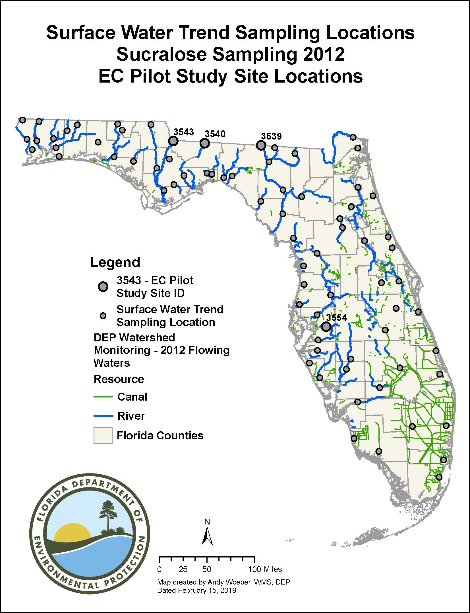
Site Characterization
The four sites are river sites, each with a 15-year history of regular monthly sampling by Department staff for the suite of standard water quality analytes (e.g., nutrients, major ions). Three of the rivers, the Apalachicola, the Withlacoochee and the Ochlockonee, flow into Florida from Georgia over the Atlantic Coastal Plain province. The Ochlockonee and Withlacoochee Rivers each have significant amounts of agricultural and sylvicultural activity in their watersheds. The Apalachicola River, formed by the confluence of the Flint and the Chattahoochee Rivers near Albany Georgia, drains much of the state of Georgia. It is used for sanitary waste disposal by millions of people in many cities, including metro Atlanta, Griffin and Bainbridge. The Chattahoochee River has three federally maintained water control structures (dams) upstream, which slow flow and pool the river. This provides an opportunity for sedimentation to occur before the water is released further downstream. The fourth site is located on the Alafia River, which flows west into Tampa Bay from the center of the Florida peninsula, with its headwaters near the City of Lakeland.
Sampling Technique
For this study, polar organic chemical integrative samplers (POCIS), semipermeable membrane devices (SPMD) and whole water grab samples were utilized to evaluate the surface waters at each site. Three POCIS and three SMPDs contained in one large canister (Figure 2) were deployed at each of the 4 river sites for the study. Whole-water grab samples were collected when the passive devices were retrieved. The devices were deployed at each site for 30 – 35 days. A field blank for each sampling method (POCIS, SPMD, and whole water) was collected at the Apalachicola River site.
Figure 2. Diagram of the Polar Organic Chemical Integrative Samplers (POCIS) and POCIS holder, Semipermeable Membrane Device (SPMD) and SPMD holder, and a large canister to contain the passive samplers.
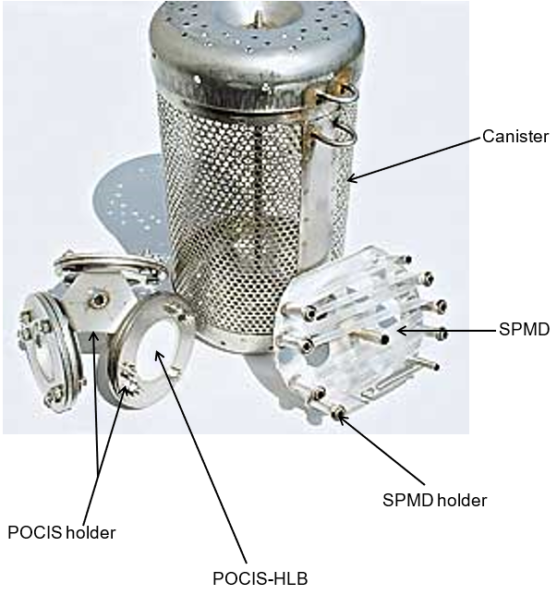

EC Categories
Many of the compounds evaluated as part of this study are suspected to cause endocrine disruption effects in both aquatic and terrestrial invertebrate and vertebrate species (Blazer, et al. 2011 and 2013, Guy, et al. 2009, Letcher, et al. 2010, Oetken, et al. 2004, Vos, et al. 2000). EC are categorized based on their manufacturing or commercial use. Each category of EC compounds tends to have similar exposure routes, aquatic life effects, and chemical characteristics (Table 1).

Category | Primary Routes of Potential Human Exposure | Aquatic Life Effects | Polarity /  Water Solubility
Pesticides | Dermal contact; ingestion (e.g. contaminated food or water); inhalation (e.g. breathing vapors, dust, or spray particles); ocular exposure | Toxic, potential endocrine disruptor (ED) | Most are polar and have high solubility
Pharmaceuticals and Personal Care Products (PPCPs) | Ingestion (e.g. oral medications); inhalation (e.g. aerosol hair products, perfumes); dermal contact (e.g. topical medications, deodorants, lotions) | ED | Most are polar and have high solubility
Synthetic Hormones | Ingestion (e.g. contaminated food or water, oral medications); inhalation (e.g. dust and particulates); dermal contact | ED | Polar and have high solubility
Perfluorinated Compounds (PFCs) | Ingestion (e.g. contaminated food or water, breast milk); hand-to-mouth from surfaces that contain PFCs | Bioaccumulative, ED | Polar and have high solubility
Polybrominated Diphenyl Ethers (PBDEs) | Ingestion (e.g. contaminated food, water, breast milk); inhalation; dermal contact | Toxic, Bioaccumulative, ED, Carcinogenic | Nonpolar / low water solubility
Alkylphenols | Ingestion (contaminated food or water); contact with some personal care products and detergents; inhalation (primarily indoor air, dusts) | ED | Range of polarities / generally low water solubility
Table 1. General Categories of EC (Adapted from Dellinger et al., 2011)
Overview of Laboratory Analysis
Chemical
The group of laboratory analyses performed was determined based on the type of sampling device (Table 2). SGS AXYS Laboratories and Florida Department of Environmental Protection (FDEP) Laboratory conducted the analyses.
Biological
Several emerging contaminants are known to be estrogenic and androgenic, such as pesticides and hormones. Estrogenicity and androgenicity in rivers can cause reproductive changes in fish and wildlife (USGS, 2019). EC may also cause genotoxic effects (DNA damage) to aquatic life. Biological response tests were used to measure endocrine activity in cell lines exposed to samples. The biological screening was conducted by University of Florida (UF) and United States Geological Survey (USGS). POCIS dialysis, SPMD extracts, and whole water from each site were screened using the in Vitro receptor assays detailed in Table 3 below.
Results
The chemistry results for the study are presented by the EC categories and by analytical laboratory (Table 2). Combined chemistry results per station are listed in Table 4. The biology results are presented by laboratory and test type (Table 3).
Pesticides – SGS Lab
Analysis was performed on all samples for 76 pesticide compounds; 42 of which were detected at one or more stations, in at least one sample type (SPMD, POCIS, or grab samples). Forty-one of the 42 compounds detected were found using a combination of SPMD and grab samples. Thirty-one compounds were detected at all stations (N = 4). Detections for 18 compounds were qualified due to lab or field blank detections.

Table 2. Number of Compounds Analyzed in Each Category
* The FDEP lab used a reduced analyte list for some sampling devices. POCIS samples were not analyzed for 29 pesticide compounds. SPMD samples were not analyzed for 1 pesticide compounds. **SPMD samples were not analyzed for PPCPs by the SGS lab.
Category | Sampling Devices Used | Study Samples:  Number of Compounds Analyzed
Category | Sampling Devices Used | SGS Lab | FDEP Lab
Pesticides | POCIS, SPMD, & Grab | 76 | 88*
Pharmaceuticals and Personal Care Products (PPCPs) | POCIS, SPMD**, & Grab | 127 | 4
Hormones | POCIS & Grab | 17 | N/A
Perfluorinated Compounds (PFCs) | POCIS & Grab | 13 | N/A
Polybrominated Diphenyl Ethers (PBDEs) | SPMD & Grab | 8 | N/A
Alkylphenols | SPMD & Grab | 4 | N/A

Table 3.
Assay Category | Assay Name | Entity that conducted assay
Receptor Binding Assay | Estrogen and androgen receptor binding by fluorescence polarization | UF
Receptor Transactivation Assay | Estrogen and androgen transactivation assay by using both agonist and antagonist modes | UF
Receptor Binding Assay | Bioluminescent yeast estrogen and androgen screens (BLYES and BLYAS) | USGS
Genotoxicity Assay | SOS Chromotest | USGS

Pharmaceuticals and Personal Care Products (PPCPs) – SGS Lab
Analysis was performed on POCIS and grab samples for 127 PPCP compounds; 39 were detected at one or more stations, in at least one sample type. Of the 39 compounds detected, 31 compounds were found in POCIS samples and 24 compounds were found in grab samples. Seven compounds were detected at all stations (N = 4). Detections for 3 compounds were qualified due to lab or field blank detections.

Hormones – SGS Lab

Analysis was performed on POCIS and grab samples for 17 hormone compounds; 5 compounds were detected at one or more stations, in at least one sample type. All compounds detected were found in the POCIS samples, and 2 of the compounds detected were found in grab samples. One compound was detected at all stations (N = 4). All grab sample detections were qualified due to lab or field blank detections, but no data from POCIS samples were qualified due to this reason.

Perfluorinated Compounds (PFCs) – SGS Lab

Analysis was performed on POCIS and grab samples for 13 PFC compounds; 10 compounds were detected at one or more stations, in at least one sample type. Eight of the compounds detected were found in the POCIS samples, and seven of the compounds detected were found in grab samples. Three compounds were detected at all stations (N = 4). No PFC data were qualified due to lab or field blank detections.

Polybrominated Diphenyl Ethers (PBDEs) – SGS Lab

Analysis was performed on SPMD and grab samples for 8 PBDE compounds, all of which were detected by both sampling types at one or more sites. For SPMD, all compounds were found at all sites, whereas 4 of the 8 were detected at all sites for grab. All SPMD detections and 92% of grab detections were qualified due to lab or field blank detections.

Alkylphenols – SGS lab

Analysis was performed on SPMD and grab samples for 4 alkylphenol compounds; 2 compounds were detected at all sites (N=4), in at least one sample type. Both compounds detected were found in the SPMD samples, but only one was found in the grab samples. All alkyphenol data were qualified due to lab or field blank detections.

Pesticides and PPCPs - FDEP lab

Grab samples were analyzed for all 92 compounds (88 pesticides and 4 PPCPs), SPMDs were analyzed for 91 compounds (87 pesticides and 4 PPCPs), and POCIS were analyzed for 63 compounds (59 pesticides and 4 PPCPs). Thirty-two compounds (29 pesticides and 3 PPCPs) were detected at one or more stations, in at least one sample type. Fourteen compounds were detected at all stations (N = 4). No data from this laboratory were qualified due to lab or field blank detections.

Table 4. Summary of the compound class detections by sampling method for each of the four study sites. Refer to Appendix B. for a complete list of compounds detected.

Category | Apalachicola | Ochlockonee | Withlacoochee | Alafia
Pesticides | P₁₂S₁₂G₁₂ | P₁₂S₁₂G₁₂ | P₁₂S₁₂G₁₂ | P₁₂S₁₂G₁₂
Pharmaceuticals and Personal Care Products (PPCPs) | P₁₂G₁₂ | P₁₂G₁₂ | P₁₂S₂G₁₂ | P₁₂G₁₂
Hormones | PG | PG | PG | G
Perfluorinated Compounds (PFCs) | PG | PG | P | PG
Polybrominated Diphenyl Ethers (PBDEs) | SG | SG | SG | SG
Alkylphenols | SG | SG | SG | SG

P = Detected in POCIS samples, S = Detected in SPMD samples, G = Detected in Grab Samples. For Pesticides and PPCPs, ₁ = samples analyzed by SGS laboratory, ₂ = samples analyzed by FDEP laboratory.

University of Florida Results

The University of Florida conducted bioanalytical assays (receptor binding and transactivation) on whole water grab samples and extracts from the SPMD and POCIS samplers. For the receptor binding assays, interference from background fluorescence was an issue when analyzing the whole water grab and POCIS extract samples. This interference from background fluorescence was likely due to the naturally high Total Organic Carbon (TOC) and humic acids in the water present at the study sites. The high levels of background fluorescence preclude any conclusions from being drawn concerning the presence or absence of estrogenic or androgenic compounds in POCIS and grab samples. However, background fluorescence did not cause notable interference in the interpretation of the binding assay results for the SPMD extracts. For the SPMD extracts, on a qualitative basis, there was a positive indication of estrogen receptor and androgen receptor binding chemicals at each of the study sites. The transactivation assays also yielded variable results due to interference. Further analysis of additional river sites and use of additional sample clean-up steps for dark water rivers are needed before conclusions about the presence or absence and effects of estrogenic or androgenic compounds can be drawn with confidence.

USGS Results

USGS used the SOS Chromotest to test each of the sample types (POCIS, SPMD, grab) at each river site and on a field blank. All sites were negative for genotoxicity in all sample types, except at the Alafia River site, where the POCIS and SPMD samples tested positive.

USGS also tested samples at all sample sites and from all sample types using the BLYES and BLYAS (Tables X). The grab samples from the Alafia, Apalachicola, Withlacoochee River sites were found to be estrogenic. POCIS samples were found to be estrogenic at all sites, while SPMD samples were not estrogenic at any site. No androgenic activity was found in any sample type nor any site.
Lessons learned and recommendations
Sampling and chemical testing for EC’s is a sensitive process; this is evident by the frequent detections in quality control samples (field and lab blanks). Analytes of interest should be used to determine sampling device selection; however, individual analysis methods, because of their reliance on the physical properties of individual analytes, play an important role in sampling device selection. For this study, our extensive analyte lists generated a large volume of data. These complex analyses are accompanied by lengthy QC reports which must be carefully reviewed when determining use of the data. Reducing the analyte list while selecting sampling and analysis methods based on the goals and objects of the study would reduce the data burden in future studies..
Determining which of these data are salient for the determination of biological effects proved to be challenging. For the passive sampling devices, using time-weighted averages of analyte concentration per POCIS disc or SPMD membrane is sufficient for determining biological exposure rates. For test protocols that measure the estrogenicity and androgenicity, it was discovered that the high level of color in Florida waters caused interference in detections. Because of this further refinement of the field and laboratory methods used for the determination of estrogenicity and androgenicity is recommended.
Future studies of EC in Florida’s waterbodies should focus on those waterbodies directly impacted by known sources of EC, e.g. river segments continually impacted by wastewater overflows. This will allow us to tailor our analyte list and sampling methods for compounds we know are being introduced into the waterway for a more focused study. Additionally we should use known data to target waterbodies for EC sampling, e.g. waterbodies known to have water quality impairments due to biologic metrics for which no known pollutant is identified. To study bioaccumulative effects and address concerns related to public health, a fish and sediment study could provide information on the persistence of EC. These studies could pair whole grab samples with biological community monitoring to provide information on the current state of the ecosystem and insight on what concentrations affect a targeted community. Finally, periodic statewide sample surveys for indicators of EC should be conducted so that we can track the extent of waters impacted by these compounds.

Acknowledgements
Florida Department of Environmental Protection wish to thank David Alvarez (USGS) and Terri Spencer (EST, Inc.) who walked us through the world of POCIS and SPMDs, Luke Iwanowicz (USGS) for remaining determined to provide us with expertise with the BLYES, BLYAS, and SOS Chromotest, and Nancy Denslow, Tara Sabo-Atwood, and Joseph Bisesi (UF) for guiding us through the transactivation and binding assays results.

Supplemental information can be found at the following link.

References
Bonmatin, J. M., Giorio, C., Girolami, V., Goulson, D., Kreutzweiser, D. P., Krupke, C., Liess, M., Long, E., Marzaro, M., Mitchell, D. A., Simon-Delso, N., & Tapparo, A. (2015). Environmental fate and exposure: neonicotinoids and fipronil. Environmental Science and Pollution Research, 22, 35–67. https://doi.org/10.1007/s11356-014-3332-7.
FDEP (Florida Department of Environmental Protection). (2015). Florida Watershed Monitoring Status and Trend Program design document, technical document, Division of Environmental Assessment and Restoration, Watershed Monitoring Section. http://publicfiles.dep.state.fl.us/dear/DEARweb/WMS/Reports_Docs_SOPs/Design_Docs/WMS-MonitoringDesignDocument2017.pdf. Accessed 15 Feb. 2019.
Jenner,M. R., & Smithson, A. (1989). Physicochemical properties of the sweetener sucralose. Journal of Food Science, 54, 1646–1649. https://doi.org/10.1111/j.1365-2621.1989.tb05179.x.
Labare, M. P., & Alexander, M. (1993). Biodegradation of sucralose, a chlorinated carbohydrate. In Samples of Natural Environments. Environmental Chemistry, 12, 797–804. https://doi.org/10.1002/etc.5620120502.
Oppenheimer, J., Eaton, A., Badruzzaman,M., Haghani, A.W., & Jacangelo, J. G. (2011). Occurrence and suitability of sucralose as an indicator compound of wastewater loading to surface waters in urbanized regions. Water Research, 45, 4019–4027. https://doi.org/10.1016/j.watres.2011.05.014.
Seal, T., Woeber, N. A., & Silvanima, J. (2016). Using tracers to infer potential extent of emerging contaminants in Florida’s ground waters. Florida Scientist, 79, 279 – 289. https://fas.fit.edu/media/site-specific/fasfitedu/wwwfloridaacademyofsciencesorg/wp-content/uploads/2017/05/flsc-79-04-cov.pdf.
Silvanima, J., Woeber, A., Sunderman-Barnes, S. et al. Environ Monit Assess (2018) 190: 435. https://doi.org/10.1007/s10661-018-6782-4
Tollefsen, K. E., Nizzetto, L., & Huggett, D. B. (2012). Presence, fate and effects of the intense sweetener sucralose in the aquatic environment. Science of the Total Environment, 438, 510–516. https://doi.org/10.1016/j.scitotenv.2012.08.060.
U.S Environmental Protection Agency. (2017). Aquatic life benchmarks and ecological risk assessments for registered pesticides. https://www.epa.gov/pesticide-science-and-assessing-pesticide-risks/aquatic-life-benchmarks-and-ecological-risk. Accessed 23 May 2018.
Wishart, D. S., Knox, C., Guo, A. C., Shrivastava, S., Hassanali, M., Stothard, P., Chang, Z.,&Woolsey, J. (2006).
DrugBank: a comprehensive resource for in silico drug discovery and exploration. Nucleic Acids Research, 34, D668–D672. https://doi.org/10.1093/nar/gkj067.
USGS (United States Geological Survey). (2019). Estrogenicity in Streams of New York State. https://www.usgs.gov/centers/ny-water/science/estrogenicity-streams-new-york-state?qt-science_center_objects=0#qt-science_center_objects. Accessed 5 Apr. 2019.

