The 2012 Trend Network sucralose data were used as a first screening tool for sites where we expect human and animal waste influence and thus the presence of ESOC. Four sites were selected for the 2017 pilot study based on Trend Network river sites that had the highest sucralose concentrations measured with detections (Figure X). Many cities located in these watersheds use rivers as a method of waste water treatment plant effluent disposal. To collect for ESOC, the use of passive samplers such as polar organic compound integrative samplers (POCIS) and semipermeable membrane devices (SPMD), as well as whole water grab samples, were considered viable methods to achieve the objective. Due to the source, release, and nature of the compounds, the greatest number of ESOC detections were expected to occur when a combination of sampling methods (POCIS, SPMD, and whole-water grabs) are used (Alvarez, 2010). Chemical screening for the occurrence of ESOCs in Florida’s waterbodies provides information on the fate of these compounds after they are introduced into the environment. The main objective of the study was to evaluate sampling technique and technology, analytical methods, and toxicological assays to assess the biological health of waterbodies. The study tested the ability of the sample collection devices and analytical methods’ effectiveness and efficiency in achieving the objective using a small-scale study design.

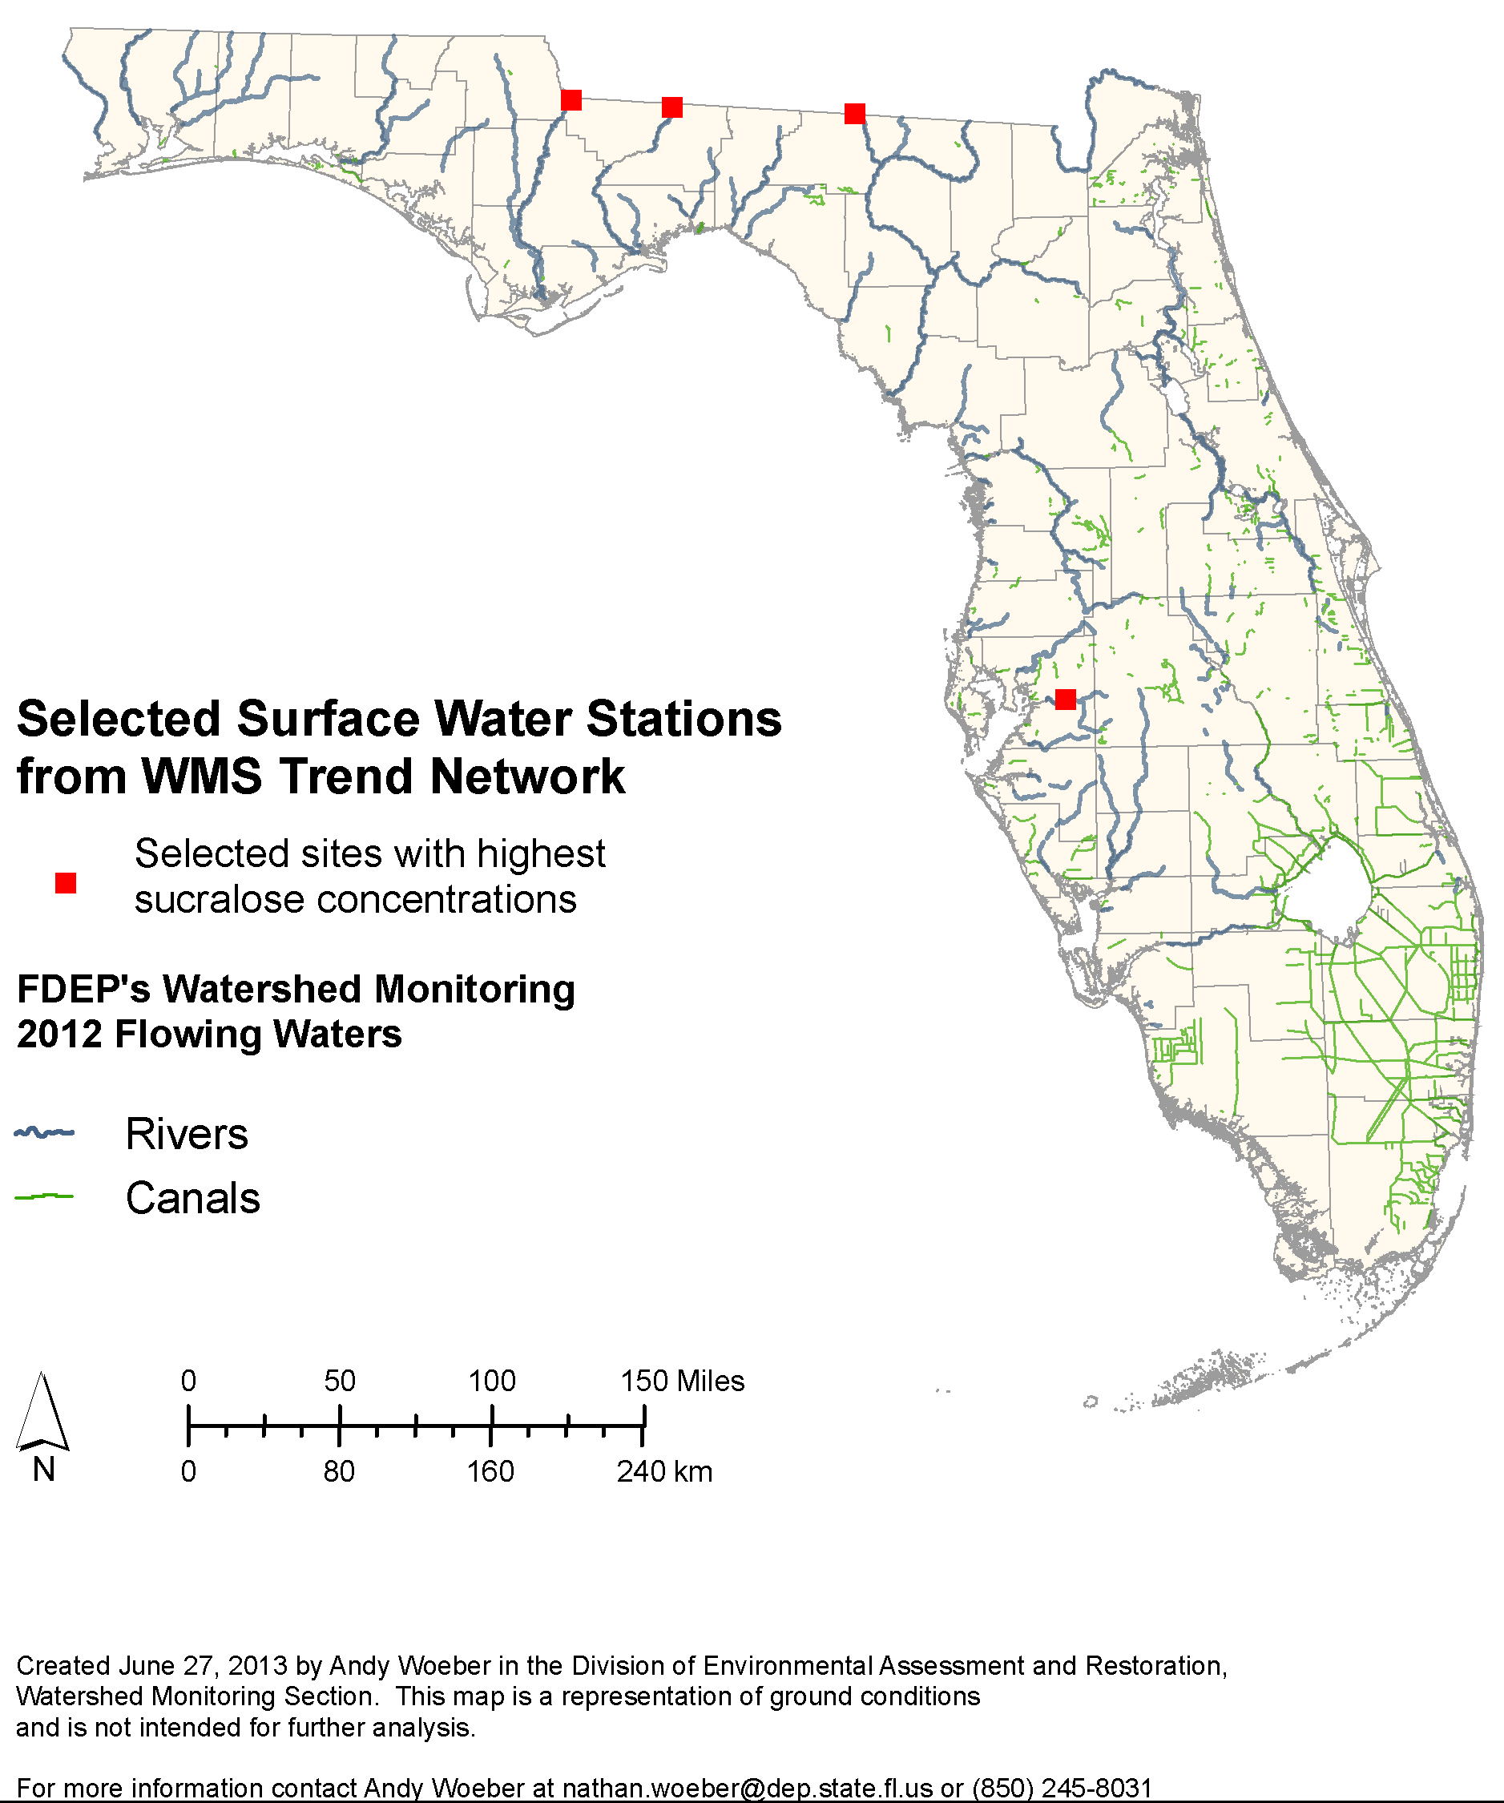
Figure X. Site Selection from Surface Water Trend Network

Study Area

The four sites are river sites, each with a 15-year history of regular monthly sampling by Department staff for the suite of standard water quality analytes (e.g., nutrients, major ions). Three of the rivers, the Apalachicola, the Withlacoochee and the Ochlockonee, flow into Florida from Georgia over the Atlantic Coastal Plain province. The Ochlockonee and Withlacoochee Rivers each have significant amounts of agricultural and sylvicultural activity in their watersheds. The Apalachicola River, formed by the confluence of the Flint and the Chattahoochee Rivers near Albany Georgia, drains much of the state of Georgia. It is used for sanitary waste disposal by millions of people in many cities, including metro Atlanta, Griffin and Bainbridge. The Chattahoochee River has three federally maintained water control structures (dams) upstream, which slow flow and pool the river. This provides an opportunity for sedimentation to occur before the water is released further downstream. The fourth site is located on the Alafia River, which flows west into Tampa Bay from the center of the Florida peninsula, with its headwaters near the City of Lakeland.

Deployment of the POCIS and SPMD

The SPMDs and POCIS were purchased from Environmental Sampling Technologies, Inc (EST), St. Joseph, Missouri. Three POCIS and three SMPDs contained in one large canister (Figure XX) were deployed at each of the 4 river sites for the study. Three whole-water grab samples was collected at the end of the deployment period. The devices were deployed at each site for 30 – 35 days. A field blank for all three sampling methods (POCIS, SPMD, and whole water) was collected at one of the sites.
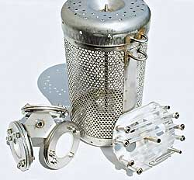
POCIS
SPMD
Figure XX. POCIS, SPMD, and container
Chemical Screening
ESOC compounds are categorized based on their manufacturing or commercial use. Each category of ESOC compounds tends to have similar exposure routes, aquatic life effects, and chemical characteristics. Chemical analysis of the sample was determined based on the type of sampling device used (Stephanie Table). Chemical analyses were conducted by SGS AXYS Laboratories and Florida Department of Environmental Protection (FDEP) Laboratory.

Biological Screening
Biological response tests are used to measure endocrine activity to legacy chemicals such as Polychlorinated Biphenyls (Layton et al 2002) and novel chemicals. POCIS dialysis, SPMD extracts, and whole water from each site were screened using the following in Vitro receptor assays.

- Estrogen and androgen receptor (ER and AR) competitive binding assay
- Reporter Gene Assays
  - Bioluminescent yeast estrogen and androgen screens (BLYES and BLYAS)
  - Estrogen and androgen receptor (ER and AR) mammalian cell reporter gene assay
- SOS Chromotest

