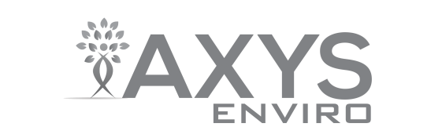

CHAIN OF CUSTODY

2045 Mills Road West TEL: (250) 655-5800
Sidney, British Columbia, Canada V8L 5X2 FAX: (250) 655-5811 AXYS CLIENT #: 4114
REPORT TO: | Dept. of Environmental Protection |  |  | INVOICE TO: |  | Dept. of Environmental Protection |  |  | ANALYSIS REQUESTED
Company | Water Quality Assessment Program |  |  | Company |  | Water Quality Assessment Program |  |  | Hormones | MRES 1699 Pesticides with ONs |  | Alkylphenols | PBDEs (Short List) | PPCPs (Lists 1, 3, 4, 5, 6) | PFCs
Address | 2600 Blair Stone Road, MS# MS3525 |  |  | Address |  | 2600 Blair Stone Road, MS# MS3525
 | Tallahassee, Florida 32399 |  |  |  |  | Tallahassee, Florida 32399
 | United States |  |  |  |  | United States
Contact | Alicia Hogue |  |  | Contact |  | Alicia Hogue
Phone | 850-245-8553 |  |  | Phone |  | 850-245-8553
FAX |  |  |  | FAX
E-mail | alicia.hogue@dep.state.fl.us |  |  | E-mail |  | alicia.hogue@dep.state.fl.us
Project Name/Number: |  |  |  | Sampler’s Name:
FL DEP Emerging Contaminants (ESOC) Pilot Study |  |  |  | Signature:
Client Sample Identification |  | Matrix | Sampling Date | Sampling Time | Container Type/No. |  | AXYS Lab Sample ID (Lab use only)
 |  | water |  |  | 1L glass / 8 |  |  |  | X | X |  | X | X
 |  | water |  |  | 1 L HDPE / 4 |  |  |  |  |  |  |  |  | X
 |  | water |  |  | 500mL HDPE / 2 |  |  |  |  |  |  |  |  |  | X
Relinquished by (Signature) Date Time |  |  |  | Received by (Signature)  Date Time |  |  |  | Courier  FedEx |  | Waybill No.
Relinquished by (Signature) Date Time |  |  |  | Received by (Signature)  Date Time |  |  |  | Sample Receipt
Remarks |  |  |  |  |  |  |  |  |  |  | Cooler
 |  |  |  |  |  |  |  | Temp °C
 |  |  |  |  |  |  |  | Custody Seal #
 |  |  |  |  |  |  |  | Seal Intact Y / N
 |  |  |  |  |  |  |  | Sample Tags Y / N

