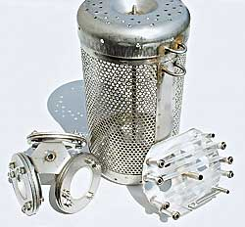
POCIS holder
SPMD holder
SPMD
Canister

POCIS

This is a diagram of the Polar Organic Compound Integrative Sampler (POCIS) containing neutral Oasis hydrophilic-lipophilic balance (HLB) with the POCIS holder, Semipermeable Membrane Device (SPMD) with the SPMD holder, and a large sized canister. The large canister holds up to 5 SPMD or 2 POCIS and 3 SMPD.

