Central Panhandle Aquatic Preserves ~ State of the Coast Report 2009 Draft
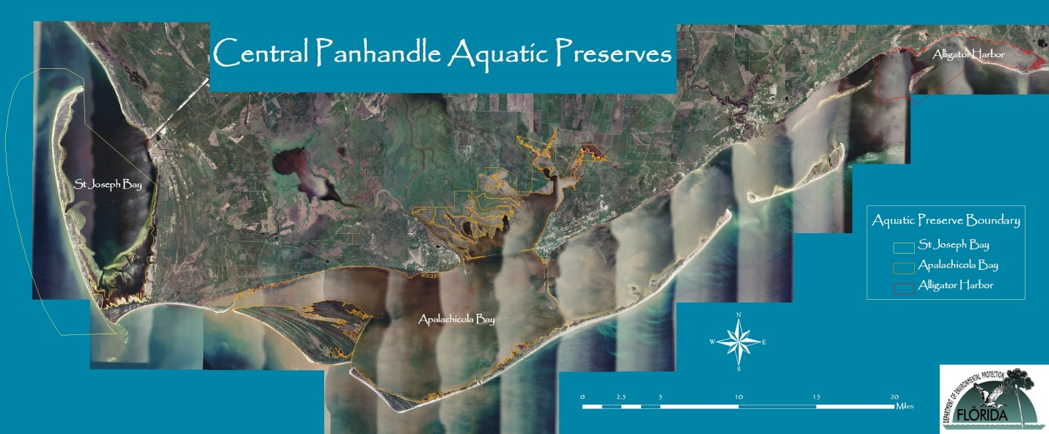
Listed Species Research and Monitoring
The beaches adjacent to the preserve on the St. Joseph Peninsula serve as valuable nesting habitat for the threatened loggerhead sea turtle (Caretta caretta) and the endangered green sea turtle (Chelonia mydas). These turtles nest along the entire 17-mile stretch of the peninsula. Sea turtle nesting activity has been monitored by volunteers since 1995. The six mile stretch of beach adjacent to the preserve from the state park boundaries to the Stumphole is currently monitored by a volunteer-based turtle patrol that is supported by the Friends of the St. Joseph Bay Preserve’s group and the St. Joseph Bay Aquatic Preserve. St. Joseph peninsula has the highest density of nesting loggerheads in the panhandle and genetic studies have shown that the loggerhead sea turtles nesting in this area are a separate population from those nesting in other parts of the Southeast United States (Gulf Coast Conservation Association, 2004). This means that the loggerheads nesting along the St. Joseph peninsula do not nest anywhere else in the world. If the turtles disappear from these beaches, they are not likely to ever return or repopulate. Since 2002, sea turtle nesting numbers have drastically declined (see Figure 1). Increasing development, lighting issues, recreational impacts due to beach driving and severely eroded shorelines may all play a role in this decline. Human presence on beaches during the nesting season can also negatively impact sea turtles. Human activity including noise, use of flashlights, campfires and construction on the beach at night can deter nesting females and disorientate hatchlings. Litter left by humans can obstruct both nesting females and hatchlings and food may attract predators to the nest area. Recreational beach equipment left on the beach at night, including beach furniture, cabanas, umbrellas, small boats, and beach cycles can obstruct both nesting females and hatchlings, damage nests, and hamper hatchlings' progress towards the sea (Butler, 1998).

In 2001, with assistance from aquatic preserve staff/FDEP, FWC and USFWS, Gulf County established a lighting ordinance to create regulations for the protection of sea turtles and other enumerated species within certain beaches of the county. The intent of this ordinance is to protect state and federally listed species that utilize the beach habitat of Gulf County, more specifically, nesting female and hatchling marine turtles, beach mice and shorebirds, from the adverse effects of artificial lighting and from injury or harassment caused by such lighting and its effects. Although some beachfront lighting is necessary for safety and security, light management measures can help prevent interference with sea turtle nesting habitat while still addressing human safety concerns (Butler, 1998). These measures include turning off unnecessary lights during the nesting season; using a smaller number or lower lumens of lights; repositioning, shielding, redirecting, lowering, or recessing fixtures so light does not reach the beach; using timers and motion detector switches; planting native dune vegetation to screen light; and reducing interior lighting by moving lights from windows, drawing curtains or blinds after dark, and tinting windows (Butler, 1998). In addition, sea turtles are less affected by red, yellow, and low-pressure sodium-vapor lights, which can be substituted for ordinary lights. In an effort to educate residents and renters to the impacts of lighting and beach activities on these species the preserve continues to coordinate with Gulf County and the code enforcement officer as well as the Friends group on outreach activities. The preserve created a “Lights Out for Sea Turtles” sign that was purchased by the Friends group and is placed on the only incoming/outgoing road to the peninsula every year during turtle season (see Figure 2). The county received additional grant funds through the University of Florida’s Wildlife Cooperative Unit to purchase two additional signs to place on the east and west side of the county road leading to Cape San Blas Road. Funds will be used to purchase smaller signs as well that will be placed at each beach access area on the peninsula. In addition, biweekly “Turtle Talks” will be scheduled during the season to educate residents/visitors on the importance of this nesting beach, newspaper articles are written each month to discuss nesting activities, slides with photos and educational material are submitted to the local TV station and educational materials are supplied to local real estate offices for distribution in rental units. The valuable partnerships the preserve has established with Gulf County, FWC, FWS and the Friends group will be beneficial in the continued protection and conservation of these listed species.

Figure 1. St. Joseph Peninsula Sea Turtle Nesting Activity 1995-2009.
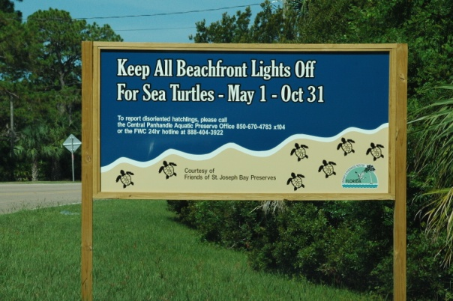

Figure 2. “Lights Off for Sea Turtles” sign created by the St. Joseph Bay Aquatic Preserve and purchased by the Friends of St. Joseph Bay Preserves Citizen’s Support Organization (CSO) Group.

St. Joseph Bay Juvenile Sea Turtle Monitoring
In addition to the valuable habitat on the Gulf side beaches adjacent to the preserve, the extensive seagrass beds of St. Joseph Bay provide significant foraging habitat for the endangered juvenile green sea turtle and for the Kemp’s ridley sea turtle(Lepidochelys kempii), the most endangered turtle in the world (see Figure 3). Juvenile green turtles use specific foraging habitats, and are capable of navigating to specific habitats if artificially displaced due to cold stunning events. St. Joseph Bay has recently been documented as a very important developmental habitat for green turtles in the northeastern Gulf of Mexico (McMichael, 2004). Population models have suggested that the most crucial stages for sea turtle population recovery include juveniles, which rely on the nearshore environment (Crouse, Crowder & Caswell, 1987). Juveniles utilize nearshore habitats as development grounds, while larger juveniles or sub-adults use them as foraging areas (McMichael, 2004). In January 2001, when water temperatures dropped below 6° C in St. Joseph Bay, 403 marine turtles were found stranded and cold-stunned within the bay. Ten Kemp’s ridley, 5 loggerhead and 388 green turtles were collected, making this the largest stranding event ever documented in the United States (Blackwelder, 2001). In 2003, 42 juvenile turtles stranded in St. Joseph Bay, including 39 green turtles, 2 Kemp’s ridleys, and 1 loggerhead. The presence of juvenile turtles in northwestern Florida waters at this time of year suggests that these turtles were overwintering in this area and entered a torpid state once water temperatures decreased below an unspecified threshold temperature (McMichael, 2004). This information, therefore, indicates that this valuable endangered, green sea turtle population is utilizing the bay habitat year-round. Further in-water research is needed to fully understand how sea turtles utilizing near shore habitats throughout their life cycle so that adequate protection can be given to these threatened and endangered species.

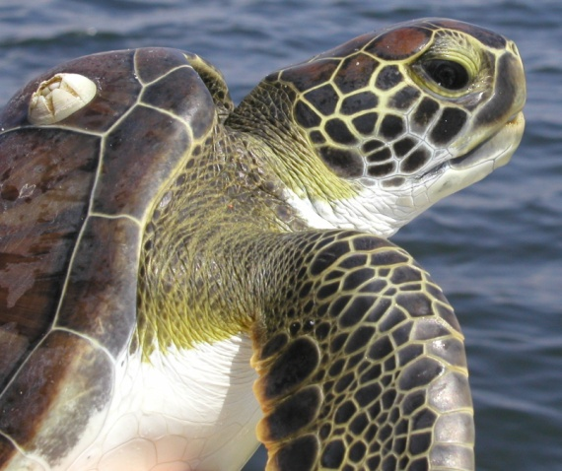
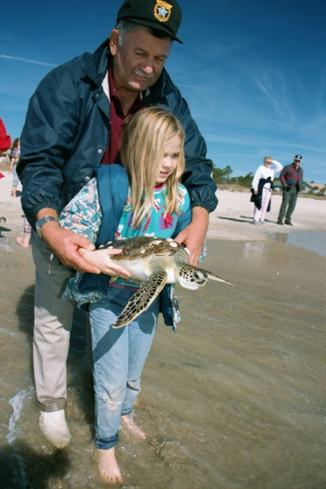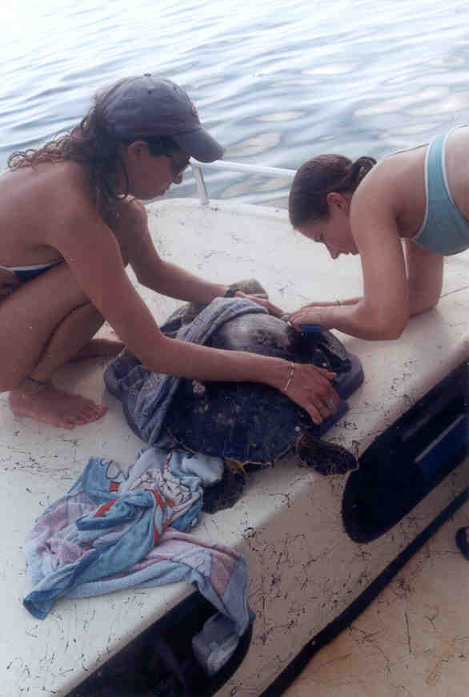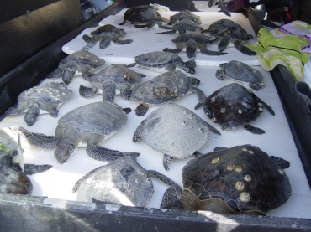
Figure 3. Florida’s northwest coastal bays play a significant role in juvenile sea turtle development.

The University of Florida has been using netting techniques (set-netting and strike-netting) to capture turtles in St. Joseph Bay since 2001 to gather information regarding species assemblage, population abundance, size classes, growth, seasonal movements, and overwintering behaviors. In addition, this work has provided the opportunity to collect material for future DNA analysis to determine the origin of these turtles. Furthermore, data collected during this project is being used to address the theory of developmental migration in turtles using the Gulf of Mexico. Research is expected to continue through 2011 in St. Joseph Bay and will be expanded to include St. Andrews Bay and Apalachicola Bay to elucidate species assemblages, population levels and habitat use, thereby contributing important new data to support management and stewardship in these unstudied areas where increasing development and recreation certainly prescribe increasing human/sea turtle interactions. Past studies in St. Joseph Bay yielded approximately 70 turtles caught per year using both netting methods and future increased efforts foresee the possibility of capturing up to 150 turtles per year (750 over the 5 year period). Continued netting will further delineate important foraging areas, provide information on residence times and seasonality of use, elucidate sea turtle population parameters and use of these habitats at multiple scales, and identify potential threats, while expanding our knowledge of in-water sea turtle populations.
Although the northern Gulf of Mexico appears to provide critical habitat for several species of juvenile sea turtles, our research indicates it may be especially important to green turtles. Of the 275 turtles caught in St. Joseph Bay since 2001, 80% were green turtles, 15% were Kemp’s ridleys, and 5% were loggerheads (McMichael 2004). The majority of the green turtles using this habitat were smaller juveniles, with a straight carapace length of 30-45 cm. Recapture data suggests that the juvenile population in St. Joseph Bay is composed, at least in part, of resident turtles (McMichael 2004). It appears these turtles are present in St. Joseph Bay year-round and do not undergo seasonal movements. Initial data also indicates that both green and Kemp’s ridley turtles display habitat preferences during their developmental stages.
St. Joseph Bay Scallop Spat Recruitment Monitoring

Scallop numbers fluctuate from year to year in St. Joseph Bay but this area continues to have one of the healthiest populations of bay scallops (Argopecten irradians) in Florida. Bay scallops are generally distributed within the shallow waters along the southeastern, southern, and southwestern shores of the bay. In 1995 the preserve established a partnership with the Molluscan Fisheries program at the Florida Fish and Wildlife Conservation Commission’s Fish and Wildlife Research Institute (FWRI) and began assisting with bay scallop recruitment rate monitoring efforts in St. Joseph Bay Aquatic Preserve. Two different methods are used to examine adult population abundance and recruitment rates along the west coast of Florida between Pine Island Sound in the south and St. Andrews Bay in the northwest. The intent of the adult surveys is to monitor the status of representative scallop populations in Florida and to assess changes in population abundance that may occur in response to management and restoration efforts instituted by the State of Florida since 1994. Sampling methods consist of diver transect surveys at twenty replicate and randomly located stations during the spring. At each station, one diver is deployed on each side of a 300 meter transect line and will search for scallops within one meter of the line along its length. All scallops within that two by 300 meter area are counted. Each station comprises a 600 m2 survey area resulting in approximately 12,000 m2 of potential bay scallop habitat that is monitored at most sites. Within each site, differences in mean scallop abundance among years are statistically compared using a Waller-Duncan K-ratio t-test (SAS, 1985). If significant differences are found among years within a site, then those differences are noted in each table of population abundance. The scallop population in St. Joseph Bay decreased from a healthy population in 2007, to a transitional one in 2008 (See Table 1).



Table 1. Adult bay scallop density at each of 20 stations sampled at the St. Joseph Bay study site 1994 -2008. Scallop density at each station is reported per 600 m2 transect. Results of the Waller-Duncan (W.D.) comparison of means (letters) are presented with the population means; similar letters denote averages that were not different at a significance level of 0.05.

Scallops were not recorded at six of the 20 stations, the majority of these lining the western shore of the bay south of the state park (see Figure 4). In 2008, the average per transect was roughly one fifth of the mean of the previous 14 years. The bay is susceptible to red tide blooms, and the event observed in November 2007, most likely reduced the available spawning stock and number of recruits settling onto grass blades and collectors translating into low adult abundances during spring 2008.

Figure 4. Adult abundance monitoring sites in St. Joseph Bay.

Recruitment of new individuals to the scallop population is estimated using spat collectors (see Figure 5). These devices consist of a vexar mesh panel encased within a citrus bag that is tied to a polypropylene rope. The rope is anchored to a cement block and is supported with a round surface float (Arnold et al., 1998). Upon recovery, collectors are shipped to the laboratory for visual examination and enumeration of all recruits. The preserve currently monitors 24 spat collectors at 4 sites in this southern portion of the bay, at a depth of approximately one meter. Traps are allowed to soak for six to eight weeks prior to retrieval. There is an overlapping deployment and retrieval schedule to ensure that any recruitment event that occurs just prior to recovery of one series of collectors can be detected on the overlapping collector. The daily recruitment rate is found by dividing the total number of spat from each collector by the number of days deployed. Daily recruitment rates are compared among stations in St. Joseph Bay. Because larval supply may be a primary determinant of the following adult abundance, a more complete understanding of scallop larval dispersal patterns and scales, and subsequent larval supply, is necessary for the proper ecological and economic management of this marine resource. Through this study information will be obtained that will aid in the effective restoration and management of this important marine resource. In December 2008, the Preserve initiated recruitment monitoring in Alligator Harbor Aquatic Preserve and is currently monitoring 8 spat collectors at 4 sites with the preserve.

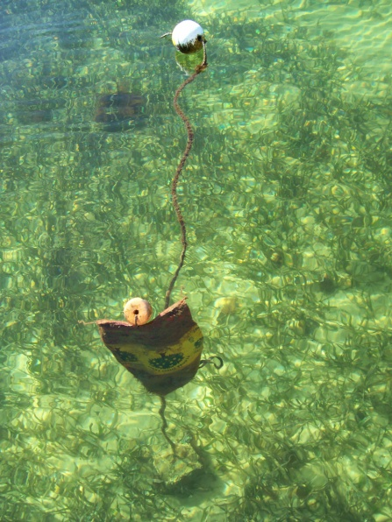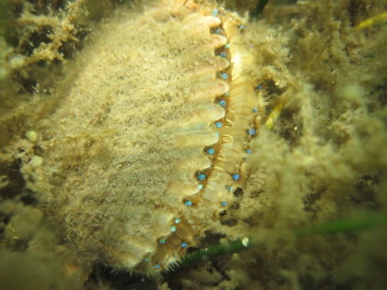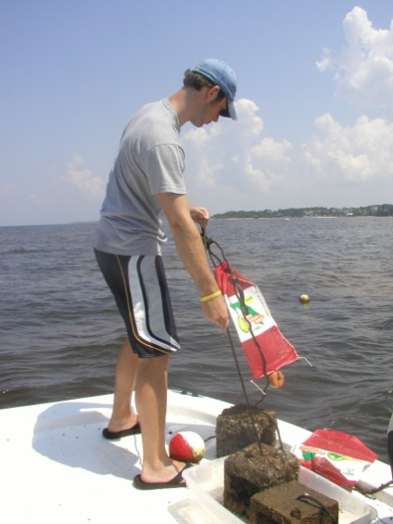

Figure 5. Scallop spat collectors are used to estimate the recruitment of new individuals to the scallop population.

In 2008, recruitment was limited at the four St. Joe Bay stations and was likely the result of a red tide event in November 2007. Data indicates a small peak in February, with the majority of recruits located at Station 1 near the mouth of the Bay, and then minimal recruitment until November. A strong peak, the highest in the state in 2008, was observed in December, with 3,258 scallops settling on the 12 collectors deployed. While the December spat fall occurred at all stations, 86.8% was recorded at the two stations near the mouth of the bay, possibly suggesting that the larvae were transported into the bay from an alternative source. Of the 132 collectors deployed in 2008, 16 (12.1%) were not retrieved, 69 (52.3%) retrieved had zero scallops, and 47 (35.6%) had bay scallops.

In conclusion, 2008 was by and large a good year for bay scallop recruitment in Florida waters. St. Joseph Bay did not have a high level of adults, yet succeeded in having the highest recruitment during December 2008. Data for the 2009 season is currently being analyzed but preliminary review of adult scallops indicates that the scallop populations are increasing in the bay (see Figure 6). The fact that there hasn’t been a major red tide event since 2007 may be a key factor is in the increase. The 2009 Annual Bay Scallop report due out in 2010 will discuss this in greater detail. Future goals include the establishment of additional monitoring sites to help provide more insight into bay scallop larval movement around the Gulf coast and help to elucidate the apparent difference in recruit to adult ratios between bays and open coastal ecosystems.

Figure 6. Mean density of adult bay scallops in St. Joseph Bay Aquatic Preserve 1994-2009.
CPAP-Fish Distribution and Abundance Monitoring
In January 2006, the preserve established seven monitoring stations in St. Joseph Bay to collect data on the abundance, size structure and habitat associations of fishes and selected invertebrates. Each of these sites is monitored on a monthly basis and will identify essential habitat that species requiring protection use during critical life stages. A 70 foot (21.3 meter) seine net is used to collect species. Fish standard length measurements are taken for up to 20 individuals per species and the rest are counted. This project is modeled after the juvenile fish-sampling project that the Fisheries Independent Monitoring of FWRI has conducted for 15 years in systems throughout the state. Water quality parameters, including, salinity, temperature, dissolved oxygen, and pH are collected at each site with a hand-held YSI meter. A turbidity sample is also collected along with wind speed and direction, tide and weather data. The goal of the project is to describe the major trends in the spatial and temporal distribution of major fish and invertebrate species between habitats within the St. Joseph Bay system and relate the occurrence, abundance, and seasonality of fish and invertebrate species to natural environmental variations such as temperature and salinity regimes and periodic events such as storms (relationships to environmental factors). This project will also estimate relative abundance and monitor the size class distribution of fish species in seagrass areas. To date, this project has provided base line data on species utilizing shallow seagrass habitat within the preserve (see Table 2). It has become apparent that to gather more significant data on economically valuable fish species that this project would need more staff, additional sites and a larger net to look at adult populations. This project is currently on hold due to budget cuts and staff reductions.
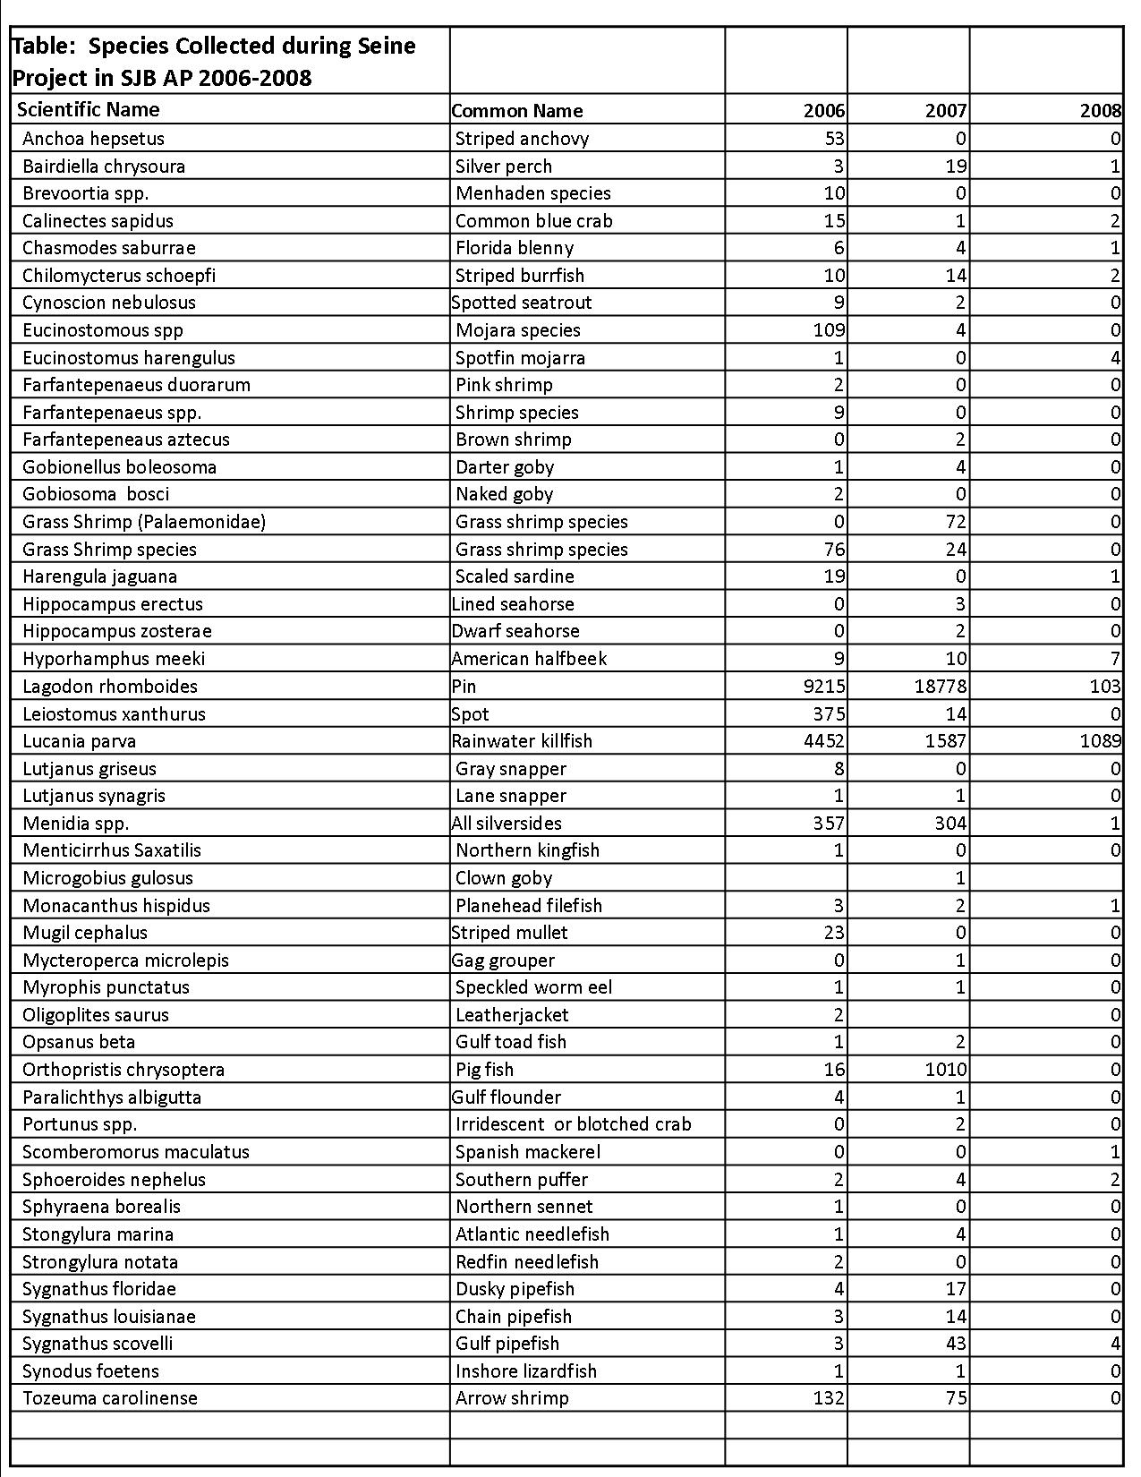
Table 2. Species collected at six shallow seagrass sites using a 70-foot seine net in St. Joseph Bay Aquatic Preserve 2006-2008.
Coral Assessment Monitoring/Mapping
The coral monitoring project was initiated by the preserve in 2006 after staff observed a stony coral
species, ivory bush coral (Oculina diffusa), along the western shoreline of the bay at depths of .9 meters (see Figure 7).Typically this species is found at depths of 2-3 meters and up to 10-20 meters. Colonies grow to approximately 1 foot in diameter, with branches generally less than 1/2 inch in diameter. This species has been studied in the Indian River Lagoon and reef temperatures recorded for Oculina diffusa off Fort Pierce, Florida ranged from 13 - 31 °C and averaged 24.6 °C. Salinities recorded for Oculina diffusa off Ft. Pierce ranged from 26 - 36.4 (ppt). O. diffusa feeds on plankton and tiny fish and may also suspension feed to a smaller extent using mucous films to trap fine particles.

Goals of the preserve project are to determine the distribution and abundance of the species through mapping efforts as well as to determine how it may be affected by future development pressures (Figure 8). This species provides habitat for a variety of commercially and recreationally important invertebrate and fish species and, therefore, has a positive economic impact on the bay. It will be important to examine how this species of coral may act as an indicator in determining the health of the bay system and its water quality. Underwater video documentation will provide a permanent record of the species and an education component will be added to the project once baseline data is established and a better understanding of the species in St. Joseph Bay is obtained.
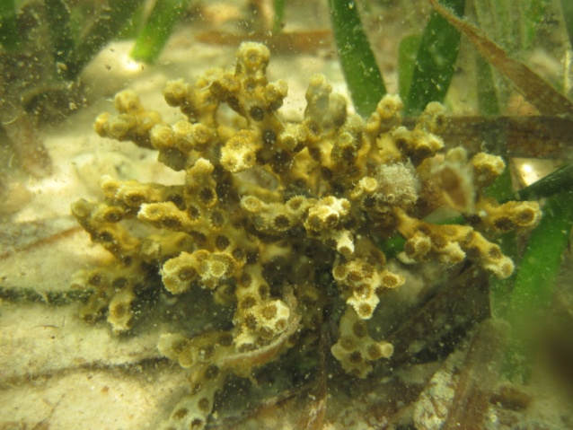
Figure 7. Oculina diffusa, ivory bush coral, found along the western shoreline of St. Joseph Bay.
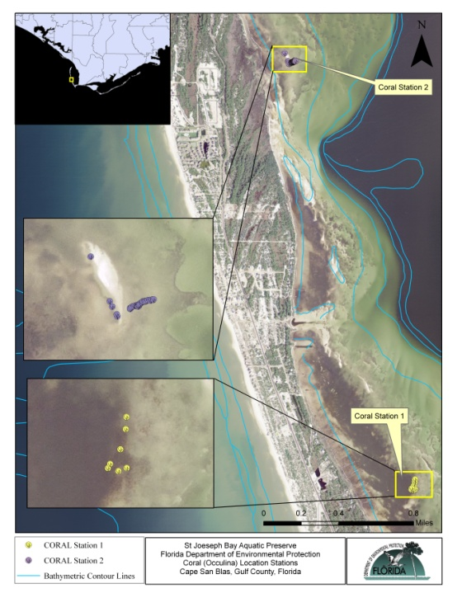
Figure 8. Oculina diffusa monitoring/mapping sites in St. Joseph Bay Aquatic Preserve.
Seagrass Monitoring and Mapping
Seagrass communities are considered to be the most productive ecosystems in the world. They are a vital component of Florida’s coastal ecology and economy. Seagrass habitat is an important natural resource that performs a number of significant functions. Seagrasses provide nurseries, nutrition and shelter for a wide variety of commercial and recreational fish and invertebrate species; they provide critical habitat for animals such as wading birds, manatees and sea turtles; and their extensive root systems stabilize sediments on the bay bottom, helping to improve water quality and clarity which in turn, keeps the bay healthy. The health and status of many commercially and recreationally important seafood species such as shrimp, crabs, scallops, redfish, trout and mullet is directly proportional to the health and acreage of seagrass habitat. Monitoring seagrasses has quickly become one of the best methods to determine the overall health and condition of the aquatic environment. Seagrasses have shown particular promise in detecting specific factors that may influence both short and long-term changes to nearshore aquatic ecosystems. Because they are sensitive to changes in water quality, seagrasses serve as indicator species and a decline in coverage could be a sign of decreased water quality.
In an effort to preserve and protect the seagrasses in the local bays, the aquatic preserve began a preliminary seagrass monitoring project in the spring of 2002. The Aquatic Preserve’s objectives focus on management issues regarding the seagrass communities in Alligator Harbor, Apalachicola Bay and St. Joseph Bay and the environmental and human surroundings that impact them. The project was established using protocols from the Southwest Florida Water Management District (SWFWMD) and the Charlotte Harbor Aquatic Preserve and utilized fixed-transect surveys to gather baseline data on seagrass health. Seagrass sites were chosen to be widely distributed and representative of seagrass conditions in specific locations and included 5 sites in St. Joseph Bay, 4 sites in Apalachicola Bay, and 3 sites in Alligator Harbor. All transects were monitored biannually, in the beginning of the growing season (May/June) and towards the end of the growing season (September/October). At each location a 1m² quadrat was used and the following data was collected; identification of seagrass species, percent coverage using Braun-Blanquet coverage estimates, canopy height, water depth, secchi depth, epiphyte coverage (identified as clean, light, medium or heavy), three shoots of each species for epiphyte load, four core samples were taken to determine above and below ground biomass, and sediment was collected for grain size analysis. Dissolved oxygen, salinity, temperature, turbidity, pH and photosynthetic active radiation (PAR) measurements were also taken at each location. Fixed transect monitoring has been valuable to start defining what species are present and to give baseline information on seagrass health, however, this method proved to be very time consuming with 1-2 staff and did not give a fair representation of the entire bay system. The use of point sampling, either fixed or varying, random or non-random, is commonly used in larger systems and the preserve migrated to using fixed point sampling in 2005 to cover more ground. Using this method the preserve would choose additional fixed sites and began monitoring four replicate 1m² quadrats at each coastal site.
During the 2006 season, the preserve was able to acquire additional staff, more advanced technology and a CZM grant which in turn provided additional data on the bays resources. CAMA secured a Coastal Zone Management (CZM) grant to use St. Joseph Bay Aquatic Preserve as a “pilot project” for hyperspectral mapping efforts in coordination with the Florida Environmental Research Institute (FERI). St. Joseph Bay is a unique and fragile ecosystem that is host to one of the richest and most abundant concentrations of marine grasses along the north Florida coast. Five different species of seagrasses are known to occur within theses vast meadows that cover approximately one-sixth of the bay bottom. Because of the good water clarity in St. Joseph Bay, hyperspectral analysis is an excellent means of obtaining high resolution imagery of bathymetry, seagrass coverage, bottom types and some water quality measures. Groundtruthing efforts then provide the necessary information to connect the aerial images to the vegetation. Data was acquired in October 2006 and the response to the highly resolved color imagery produced by FERI has been very positive (see Figure 9). It is a goal for CAMA to create current and accurate submerged resource maps of its aquatic preserves and research reserves. These maps not only inform resource managers as to the coverage, extent and health of seagrass beds, oyster reefs, etc., but will present a tool that may be used by the regulatory, research and recreational communities. Precise bathymetric and submerged resource maps can inform regulators in their decision making about issues like new docks or placing spoil or ramps or whether or not to provide deep-water access. The combination of identifying the location of resources and threats to those resources (ex. propeller dredging) will aid resource managers in their protection efforts like establishing appropriate zoning in preserves and reserves. In addition, the preserve implemented the use of a handheld computer with differential geographical positioning systems technology (GeoXT Trimble Unit TM) to collect and map seagrass data in the field (see Figure 10). Customized geodatabases are created and stored and resources can be mapped simultaneously in order to assess changes over time and to link historical data with current data. This information can then be used to determine if restoration or management efforts are successful.
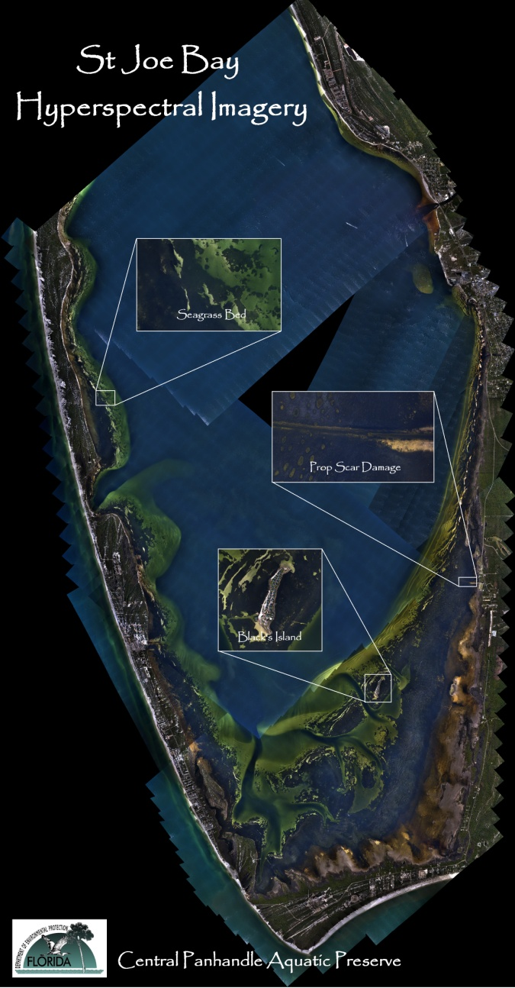
Figure 9. Hyperspectral imagery of St. Joseph Bay has provided the preserve with an invaluable tool for documenting the extent of seagrass habitat in the bay and for determining the extent of prop scar damage in the bay.
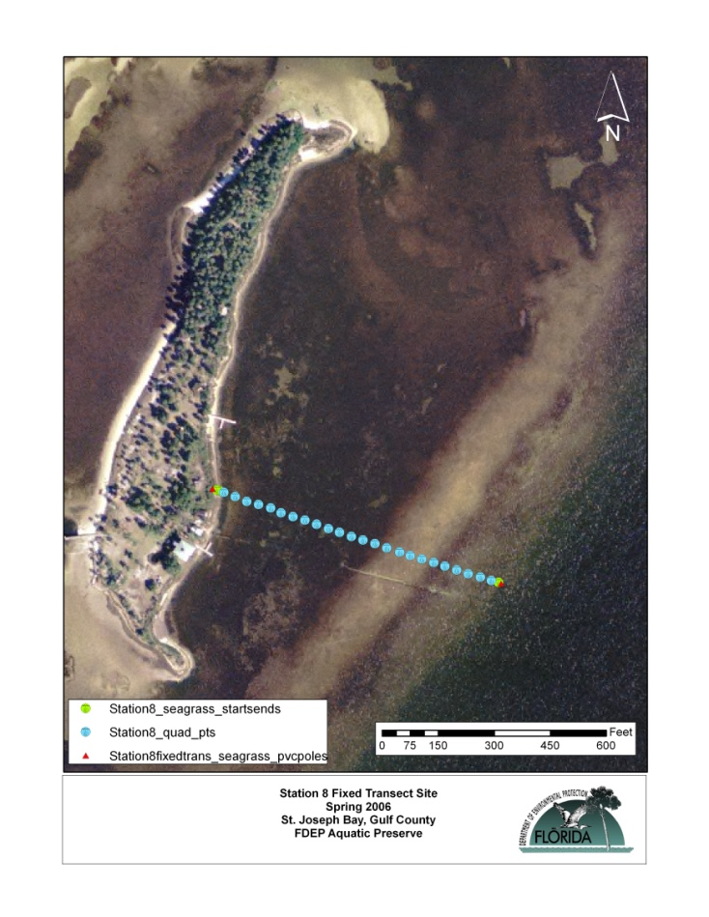
Figure 10. Map illustrating the use of the GeoXt unit at seagrass sites. Each point represents an area where quadrat data was collected.

In December 2008, CAMA secured a CZM grant for additional post processing of the 2006 data to determine seagrass coverage/extent and to produce an accurate high resolution bathymetric map of St. Joseph Bay. Areal extent, abundance and productivity of seagrass meadows, as well as shallow water bathymetry (<2m) were quantified and mapped across the bay using a combination of algorithms and models (see Figure 11). The publication in review by Hill et.al., Ocean Color Remote Sensing of Seagrass Meadows in St. Joseph Bay, Florida, by Hyperspectral Airborne Imagery estimates the areal extent of seagrass in the Bay to be 27 km2 (6,672 acres), which is 17% of the total footprint of the bay. The benthic productivity of these seagrass meadows was calculated to be 92 tons C km-2, with an annual production of 29,000 ton C yr-1. When compared to the estimated water column production of 23,500 ton C yr-1, seagrass contributes 57% of the bay wide annual primary production. This considerable biomass is likely recycled within the bay where it helps support the highly diverse community of primary and secondary consumers. Reliable methods for landscape-scale assessment of seagrass distributions provide an important tool for managing this critical resource in the context of a changing ocean climate, and for assessing the ecological impact of these important ecosystem engineers on coastal biogeochemical processes, particularly carbon cycling. The long term management of seagrass habitats depends on accurate and quantitative measurements of areal coverage and bed density (Hill, et.al 2009). In situ surveys provide accurate determination of biomass in a sampled quadrat, but lack the spatial resolution required to detect subtle changes across the submarine landscape (Orth and Moore 1983; Peterson and Fourqurean 2001). Data acquired in October 2006 indicates a significant increase in the extent of prop scar damage in the southern portion of the bay since the development of the Florida Wildlife Research Institute’s (FWRI) 1995 technical report, Scarring of Florida’s Seagrass: Assessment and Management Options (see Figure 12). The aerial imagery available in 1995 was limited and areas less than one acre were not mapped due to the small-scale maps that were used (FWRI 1995). Because of the mapping procedure and differing map scales used, small portions of bare substrate, channels, and open water were included in some polygons. As a consequence, some unscarred areas were incorporated within the polygons (FWRI 1995). The 2006 hyperspectral mapping project acquired imagery with a pixel size of approximately one meter and provided an excellent means of obtaining high-resolution imagery of seagrass coverage. Hyperspectral sensors and analyses have provided more information from remotely sensed imagery than ever possible before. The 2006 imagery provided six inch resolution and has allowed preserve staff to “zoom in” and analyze problem areas because we can clearly see them (see Figure 13).

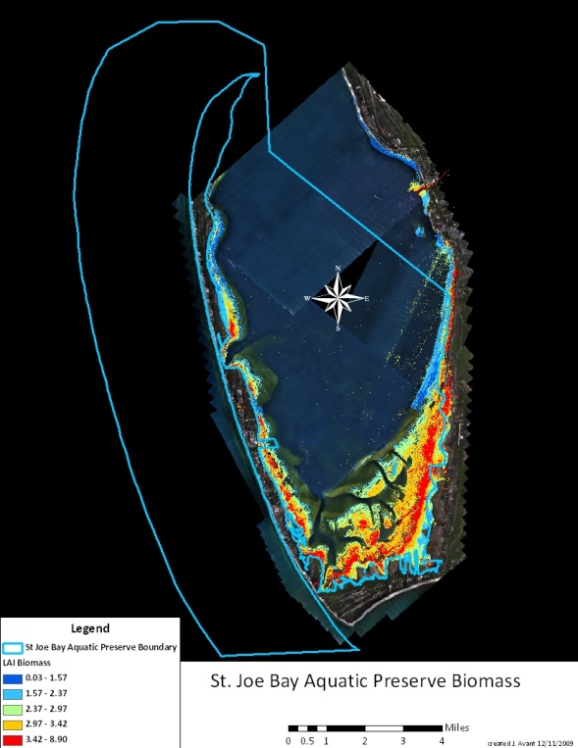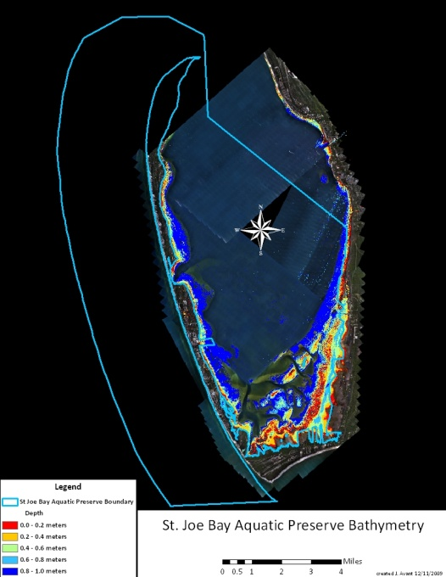
Figure 11. These maps illustrate the areal extent of seagrass biomass in bay and the bathymetry from the top of the seagrass canopy. While this advanced technology provides a great deal of information on seagrass biomass and bathymetry, there are some limitations in data analysis. *Analysis of benthic properties based on ocean color imagery relies on sunlight being reflected from the sea bed or submerged algae and making it back out into the atmosphere and the sensors before being absorbed or scattered again. If areas have been wrongly classified as seagrass this means that the water leaving sunlight signal looks green like seagrass, hence in really turbid water like the entrance of the Canal, and will be misclassified as seagrass. So while the biomass coverage is not a definitive areal coverage number, it is a very good estimate. This data allows us to see in a snapshot the general seagrass coverage (Hill V., pers. comm. 2009).

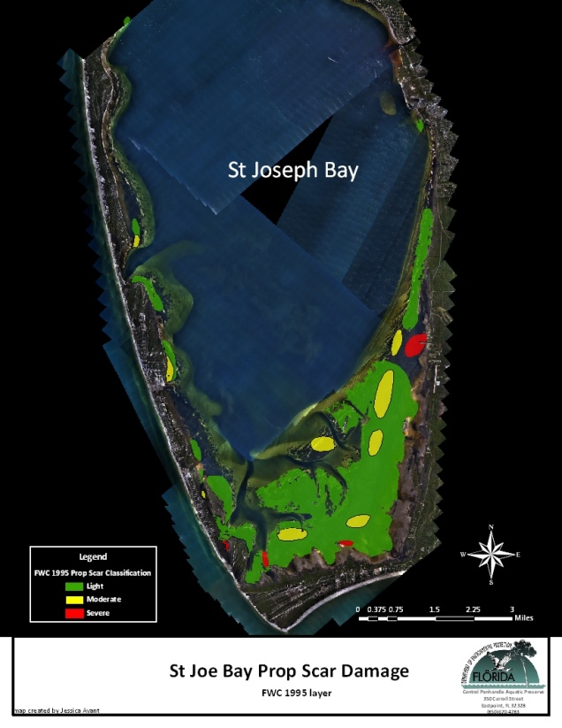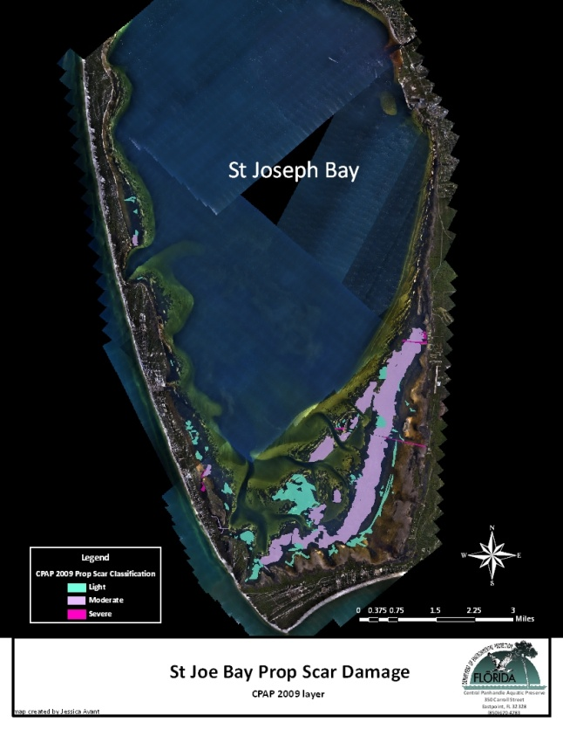

Figure 12. These maps illustrate the increase in the prop scar damage in St. Joseph Bay from 1995 data.

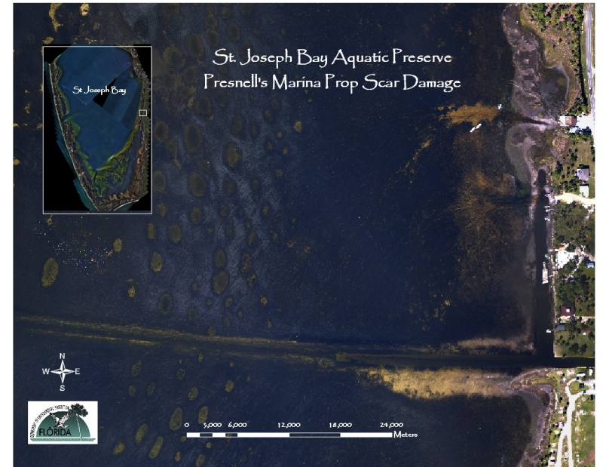

Figure 13. Hyperspectral imagery illustrating severe prop scar damage to seagrass habitat on the eastern shoreline of St. Joseph Bay Aquatic Preserve.

Further analysis of hyperspectral imagery by preserve staff indicated that there are approximately 6,600 acres of seagrass habitat in the bay and that 1,898 acres of this habitat are lightly to severely scarred. This amounts to approximately 75-329 acres of actual prop scars. The intensity of scarring in each polygon was categorized based upon the Comparison Chart for Visual Estimation of Percentage Composition (after Terry and Chilingar 1955) that was used in FWRI’s 1995 study. Polygons were designated as light in areas where less than 5 percent of the seagrasses were scarred, moderate polygons contained areas with 5 to 20 percent scarring, and severe polygons delineated areas with more than 20 percent scarring. Acquiring updated data will also allow managers to assess whether this trend is continuing in locations with seagrass buoys and will provide additional details on whether specific seagrass beds are improving or declining.
There is rapid land use change around the Bay which includes high density development, marinas and ultimately more boat traffic. Because much of the Bay is shallow and possesses an extensive coverage of seagrasses it is very likely that changes on the land will translate in changes in the submerged community. The acquisition of high resolution imagery will set a baseline for many of these resource parameters that future mapping efforts may be compared against. Prior to any comparisons the resulting maps will be effectively used for resource management and protection as described above.
Ideally mapping efforts should continue to be performed approximately every three to five years to determine changes in the amount and condition of the submerged habitats. The preserve is proud to announce that it has secured an additional CZM grant for the fiscal year 2010-2011 to collect updated aerial imagery of the St. Joseph Bay Aquatic Preserve completed. This project will be a repetitive effort of the Hyperspectral Mapping pilot project that took place in October 2006 and will involve hyperspectral data acquisition with a pixel size of approximately one meter and interpretation of the imagery (orthorectificaton). Seagrass species, coverage, depth, and the extent of prop scar damage, etc. will be analyzed in house and ARC GIS 9.3 software will be used to compare 2006 and 2010 images. This will be the most significant seagrass data collection effort to date in St. Joseph Bay as it will provide details on how the habitat is increasing or declining in the bay, and whether prop scar damage has declined in light of recent outreach efforts or is still continuing to increase.
In conclusion, the protection of critical resources is a high priority item for each of the Central Panhandle’s Aquatic Preserves. In order to adequately manage the preserve, natural and historical resources, which are integral to maintaining the productivity of the bay, must be monitored, documented and mapped. This will allow for the identification of areas within the preserves where increased management emphasis is necessary. Existing resource maps are limited in accuracy and coverage and the continued mapping of seagrass habitat is much needed. Between 2005 and 2008 the preserve gathered data at 64 locations in St. Joseph Bay, 20 locations in Apalachicola Bay, and 16 locations in Alligator Harbor. In 2008, the preserve coordinated closely with the northwest Florida regulatory office by providing information on the department’s draft consent order (CO) for a mitigation project in St. Joseph Bay. Essentially it was determined that as mitigation the private island located within the preserve would purchase and deploy 13 buoys around and near the island in locations for optimal safe navigation and seagrass avoidance. These locations are currently monitored by the preserve to determine optimum protection for seagrasses and boating safety. In addition, the publication and distribution of an informational guide on seagrass and boating safety was required as well as signage at two local boat ramps (see Figure 14).
Figure 14. Signage at local boat ramps educating users on the buoy system and the shallow seagrass habitat in the area.
In 2009, the preserve added 9 sites to St. Joseph Bay, 5 sites to Apalachicola Bay and 2 sites to Alligator Harbor and is now monitoring 164 quadrat locations within the three preserves (see Figures 15-17).
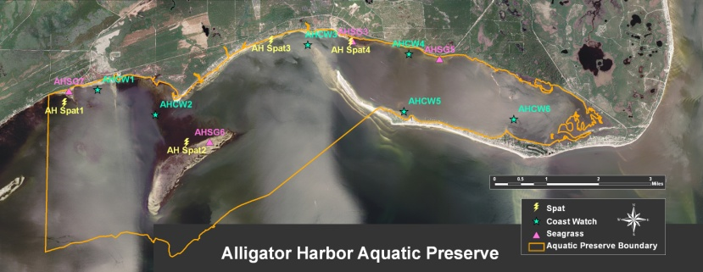
Figure 15. Alligator Harbor Aquatic Preserve Monitoring Sites.
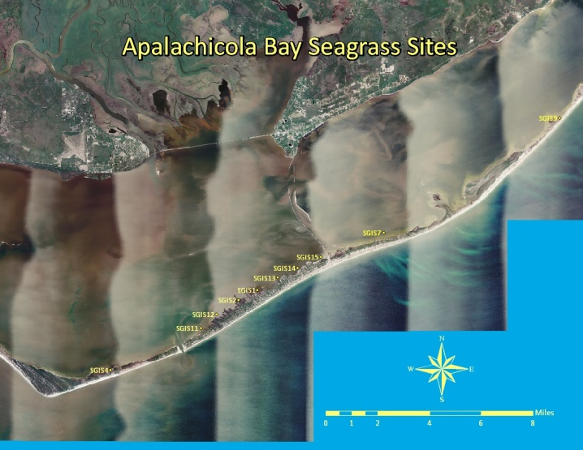
Figure 16. Apalachicola Bay Aquatic Preserve Seagrass Monitoring Sites.
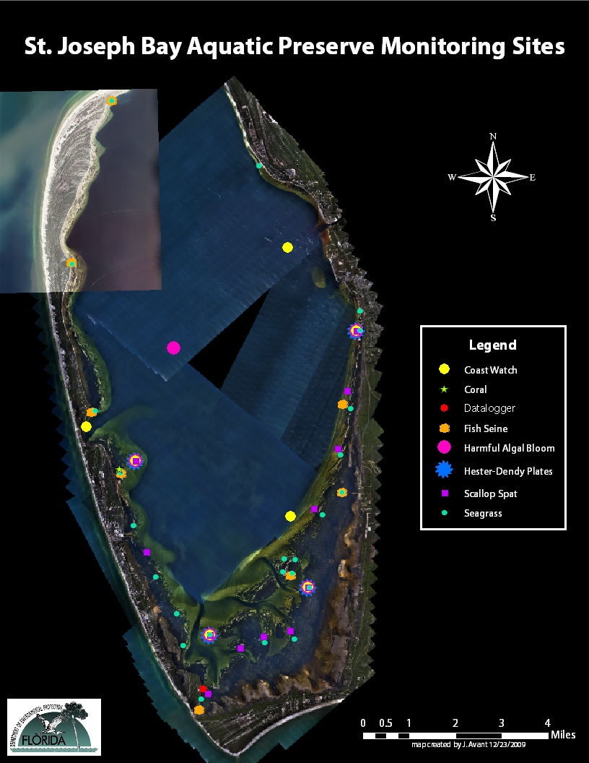
Figure 17. St. Joseph Bay Aquatic Preserve Monitoring Sites.
The preserve continues to collect data on indicators that prove to be the most accessible and comparable including; seagrass and macroalgae abundance, seagrass species composition, depth distribution, canopy height, water quality measurements (DO, pH, temp, salinity, turbidity, color), PAR, epiphyte load, sediment type/grain size, and other organisms present in the bed. Core sampling has been discontinued on an annual basis because it is destructive and takes extra time in the field and lab that could be better spent sampling additional sites. Additional cores may be taken if there is a demonstrated need for additional biomass information. Monitoring these coastal sites has allowed the preserve to answer and address many questions including; what seagrass species are present/absent and what is their frequency of occurrence, what is the abundance of these species, what is the average water depth these species occur in, what is the epiphyte density on the most common species, what is above and below ground biomass at each site, what type of sediment is found at each site, what are the average blade lengths of the most common species, and what are the average water quality parameters collected at each site. See Figures 18-23 below for examples of some of the data the preserve continues to collect. This project has continued to evolve over the years to determine the best methods for acquiring meaningful data on this habitat. Past methods have allowed the preserve to acquire baseline data and to gain insight into the health of the system in the shallow areas of the bays but data on deep water seagrass locations has been limited.

Figure 18. Frequency of occurrence of seagrass species in Alligator Harbor 2005-2009.

Figure 19. Average depth of seagrass species in Alligator Harbor 2005, 2007-2009.

Figure 20. Frequency of occurrence of seagrass species and average depth in Apalachicola Bay 2005-2009.

Figure 21. Mean annual Braun-Blanquet (BB) abundance and average blade lengths for Halodule wrightii in Apalachicola Bay 2005-2009.

Figure 22. Mean annual epiphyte density of Halodule wrightii in Apalachicola Bay 2005-2009.

Figure 23. Frequency of occurrence of seagrass species in St. Joseph Bay 2003-2009.
Prominent and increasing prop scar damage is evident in the Central Panhandle Aquatic Preserves and with increased visitor use this trend is expected to continue. The extent of this valuable habitat as well as the extent of damage must be mapped, documented and monitored and efforts to mark these shallow, sensitive areas should be a high priority effort. In addition, educating the public on the significance of the habitat, and how to protect it while enjoying the bay, will be essential in protecting the resource. Impaired water clarity due to turbidity, algal blooms and excessive nutrients may also impact seagrass habitat. All three preserves show evidence of increasing epiphyte density at specific locations. Therefore, an adequate water quality monitoring project is also necessary in determining the overall health of the local bays.
The data collected from all monitoring events (2002-2009) is currently being put together in a summary that will be a valuable step towards providing essential information about the health of seagrasses throughout the Central Panhandle region. This data along with larger seagrass mapping efforts and the creation of an annual data summary report will provide an outlet for creating strategies for the long-term viability of this habitat and for documenting the health and functioning of this vital resource.
Future Plans
- Plans for 2010 include the development of a probabilistic sampling design which will improve the statistic power of the study and will make it more comparable to data collected elsewhere throughout the state (Carlson and Yarbro 2009). Fixed-site studies are appropriate when measuring the impacts of a point source or along a known stress gradient and specific point sampling sites will continue to be monitored for these reasons. Using a random probabilistic sampling design will allow the preserve to extend its monitoring efforts to “deeper” habitat to cover even more area. The roots of seagrass monitoring and probabilistic sampling design extends back to the 1980’s when the Environmental Protection Agency (EPA) established the EMAP program in an effort to move beyond point-source discharge monitoring (Carlson and Yarbro 2009). Seagrass scientists have taken to heart EMAP’s emphasis on reliable indicators of community health, and they have also adopted the spatially-distributed, random sampling (SDRS) design developed by the EMAP program. The advantages of the SDRS design are that 1) it prevents clumping of sample points by distributing them in an array of tessellated hexagons laid over the study area while 2) locating sampling points randomly within each hexagon, permitting the use of parametric statistics (Carlson and Yarbro 2009). Furthermore, seagrass habitat is being documented by underwater photography and video with the hope of creating an interactive DVD in the future on the value of seagrass beds to the Gulf of Mexico. This product could be used at local government meetings, workshops, in local schools, on the local television channel, and at the Buffer Preserve Center as an educational/outreach tool.
- In 2007 satellite imagery was collected for tax purposes on St. George Island and along Alligator Point (see Figures 24 and 25). This images that were acquired captured the seagrass habitat located along the island in Apalachicola Bay as well as the shallow areas in the Alligator Harbor. This imagery is currently being mapped by preserve staff and will be ground truthed in 2010-2011 to determine the extent of seagrass habitat in these areas. According to ANERR’s A River Meets the Bay (A Characterization of the Apalachicola River and Bay System), there are 1,145 acres of Halodule wrightii seagrass habitat in the bay. Preserve staff will compare this number, which was acquired by Continental Shelf Associates in 1985, with newly mapped data.

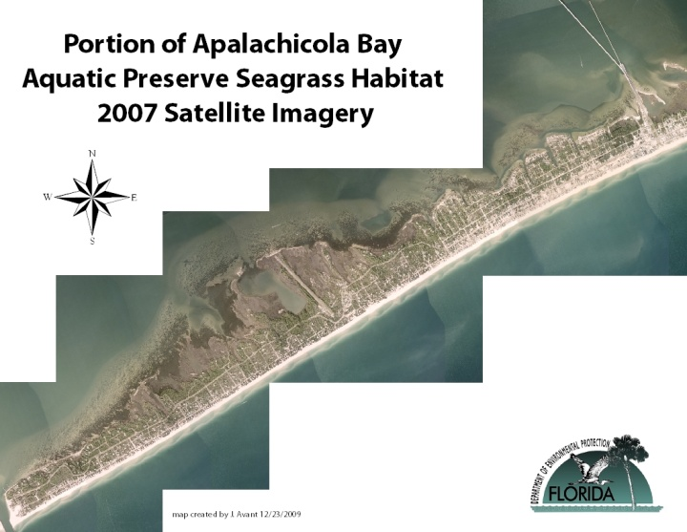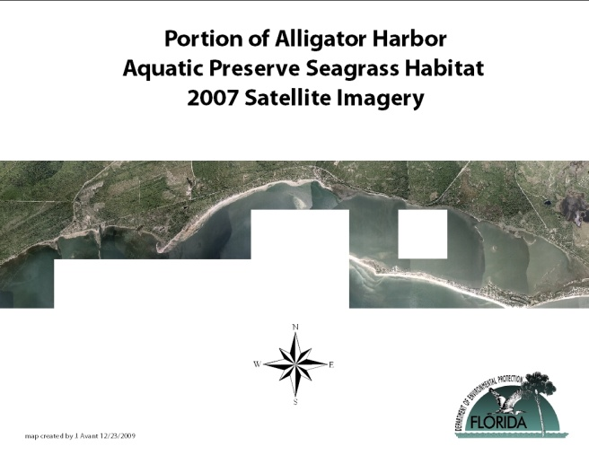
Figures 24 and 25. Portions of the Apalachicola Bay and Alligator Harbor Aquatic Preserve seagrass habitat captured by 2007 DOQQ satellite imagery.

Education and Outreach
The human dimension is an essential component of resource and ecosystem management. Education and outreach are tools managers can use to address the human dimensions of resource issues. Combined with research, regulations, and habitat management, education and outreach provide a comprehensive approach to resource protection. The adoption and implementation of education and outreach programs improves the public’s knowledge for species and habitat protection and conservation. The intent of the Aquatic Preserve education and outreach efforts is to foster informed and responsible stakeholders of the natural resources in the bay (see Figure 26). Goals include educating citizens, coastal managers, target groups and developers to use the environment in ways that preserve it, consider environmental issues when planning and making decisions which could affect the environment, and take part in decisions affecting nearby natural resources. The Preserve is currently accomplishing this goal through outreach efforts including participation in coastal training program workshops, local festivals and events such as, Estuaries Day, Seagrass Awareness Month, Bay Day, the Apalachicola Seafood Festival, the Port St. Joe Scallop Festival and the Carrabelle River Festival. In addition, Boater’s Guides and Aquatic Preserve brochures are distributed at the local city ramps. This information is also distributed to the local state parks, marinas and businesses. In addition, preserve continues to work with valuable partners to give presentations, write articles for local newspapers and a variety of newsletters, design education signage for local kiosks, display posters and judge science fairs at local schools. In March of 2009, the preserve began its first annual “Bringing the Bay to School Day” at Port St. Joe High School to promote Florida’s Aquatic Preserves and to promote Seagrass Awareness Month. Students viewed segments of the DVD Living Waters, Aquatic Preserves of Florida and discussed the value of seagrass habitat with the preserve manager.
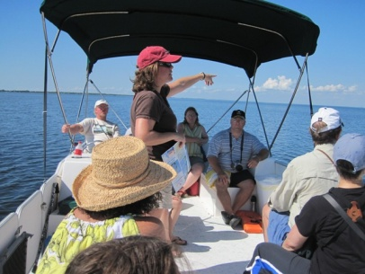
Figure 26. The preserve manager talks to visitors to St. Joseph Bay Aquatic Preserve at the annual Bay Day event.
In 2004, the preserve partnered with the Florida Division of Aquaculture (FDACS) to create an education kiosk at a local boat ramp in Alligator Harbor Aquatic Preserve (Figure 27). The kiosk consists of three panels; one that discusses the preserve and two that discuss the history of shellfish harvesting and the clam aquaculture leases within the preserve. In 2006, the two agencies partnered again to create a kiosk at a busy local ramp in Apalachicola. This kiosk consists of a panel on each side of the structure that discusses the Apalachicola oyster industry and the importance of the bay to the community as well as the bay’s designations as an Aquatic Preserve, Research Reserve, Outstanding Florida Water and Class II Shellfish Harvesting Area. A brochure holder for the Apalachicola Bay Boater’s Guides is also attached to the structure.
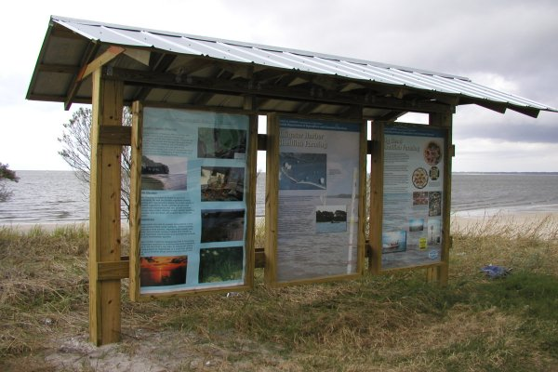
Figure 27. Educational kiosk at local boat ramp in Alligator Harbor.
In 2008 the Friends of the St. Joseph Bay Preserves funded the construction of an informational kiosk at the St. Joseph Bay Canoe and Kayak Launch in the southern portion of the bay (Figure 28). This kiosk provides information on Florida’s Aquatic Preserves and CAMA as well as general information on the bay’s valuable natural resources.
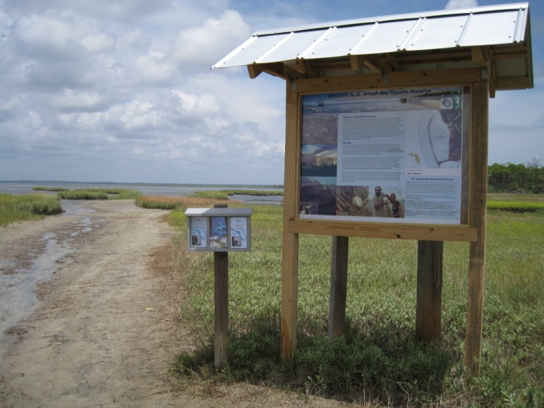
Figure 28. Educational kiosk at St. Joseph Bay Aquatic Preserve canoe and kayak launch on St. Joseph Peninsula.
Water Quality Monitoring
Monitoring water quality allows researchers to document short-term variability and long-term changes in the status of the bay’s health and facilitates in implementing appropriate protection for waterways. Water quality issues influence human and environmental health, therefore, monitoring changes to the bays waterways and having an adequate monitoring program is essential to being able to recognize and prevent contamination problems. Good water quality is essential to the production of healthy seafood, enjoyable recreational activity and many other aspects of our valued Florida lifestyle (FDEP, 2006).
A healthy bay contains a balanced amount of nutrients and normal fluctuations in salinity and temperature. It also has plenty of oxygen, which is a basic requirement for nearly all aquatic biota, and little suspended sediment, so that living aquatic resources can breathe or receive enough sunlight to grow. Nutrients, like nitrogen and phosphorus, occur naturally in water, soil and air. Just as nutrient fertilizers are used to promote plant growth on lawns and farm fields, nutrients in the bay encourage the growth of aquatic plants and algae. Although nutrients are essential to all plant life within the bay, an excess of these nutrients can be harmful. Stormwater runoff is considered the primary water quality threat in most of the watershed. It causes habitat degradation, fish kills and closure of shellfish beds and swimming areas.
The Preserve’s current water quality monitoring project utilizes several methods to examine water column characteristics. Basic water quality parameters are monitored to provide a record of environmental conditions at the time of sampling and this data provides information to assess the condition of biological assemblages. To properly characterize many water quality conditions, long-term data sets are required. While routine water quality monitoring detects effects of nutrient enrichment, it is not designed to detect trace levels of toxicants or contaminants. Biological assessments, coupled with habitat assessment, such as physical and chemical measurements, will aid in identifying probable causes of impairment not detected by physical and chemical water quality analyses alone, such as nonpoint source pollution and contamination, erosion, or poor land use practices (EPA, 2000). Over time, a baseline of data has been established providing one of the useful tools for managing the water quality in the bay. In 2001, the Aquatic Preserve partnered with the University of Florida’s LAKEWATCH/COASTWATCH program which had expanded to include bay systems and began a water quality monitoring project focused on nutrients. This data has been used to document nutrient levels, including total nitrogen and phosphorous, algae content, and water clarity. Water samples are collected at seven sites in St. Joseph Bay and Alligator Harbor on a monthly basis and are analyzed by the University of Florida’s water chemistry lab at the Department of Fisheries and Aquatic Sciences. The data acquired is stored in a computerized database and is available to the public. This data has established a baseline record of nutrient concentrations in the bay for comparison with future data (see Figures 29-33).
Figure 29. Mean annual total nitrogen in AHAP 2001-2008.
Figure 30. Mean annual phosphorus in AHAP 2001-2008.
Figure 31. Mean annual chlorophyll in AHAP 2001-2008.

Figure 32. Mean annual chlorophyll in SJB SP 2001-2008.
Figure 33. Mean annual total phosphorus in SJB AP 2001-2008.
Chlorophyll a concentrations are an indicator of phytoplankton abundance and biomass in coastal and estuarine waters. High levels often indicate poor water quality and low levels often suggest good conditions. However, elevated chlorophyll a concentrations are not necessarily a bad thing. It is the long-term persistence of elevated levels may cause a problem. For this reason, annual median chlorophyll a concentrations in a waterway are an important indicator of the state of the ecosystem. Of all the essential nutrients, nitrogen and phosphorus are the two nutrients that most often limit the growth of primary producers. Because these nutrients largely control primary productivity, we are primarily concerned about their addition to our coastal waters. Due to an increase in nitrogen concentrations in St. Joseph Bay (see Figure 34)and a slight increase in nitrogen and phosphorus at specific sites in Alligator Harbor (see Figures 35-36), it will be necessary to continue long-term monitoring in these areas and to identify sources of this pollution to protect the natural resources.
Figure 34. Mean annual total nitrogen in SJB AP 2001-2008.

Figure 35. Total nitrogen concentrations at Alligator Harbor Coast Watch site 1 from 2001-2008.

Figure 36. Total nitrogen and phosphorus at Alligator Harbor Coast Watch site 6 from 2001-2008.
In July 2005 as a CAMA-wide initiative, the Central Panhandle Aquatic Preserve began monitoring water quality with the use of dataloggers (see Figure 37). This statewide water quality monitoring effort is modeled after the National Estuarine Research Reserve’s (NERR) System-Wide Monitoring Program (SWMP) that uses nationally-standardized methods of data collection to ensure continuity and accuracy. Two stations have been established in St. Joseph Bay and abiotic factors, including, dissolved oxygen, salinity, temperature, conductivity, pH, turbidity and water level are continuously monitored every thirty minutes on a year-round basis. Data is checked by multiple preserve staff to ensure quality and is then analyzed and graphed in order to determine trends for specific areas to allow the preserve to track environmental changes in the ecosystem. The data is also used to support other projects conducted within the preserves. At this time there is no data management office providing archival storage, therefore, the information is stored on a local server. In addition, water quality parameters are collected using a hand-held YSI at each site to measure dissolved oxygen, salinity, temperature and pH and meteorological data is collected monthly by the Buffer Preserve weather station located on the southeastern shoreline of St. Joseph Bay.
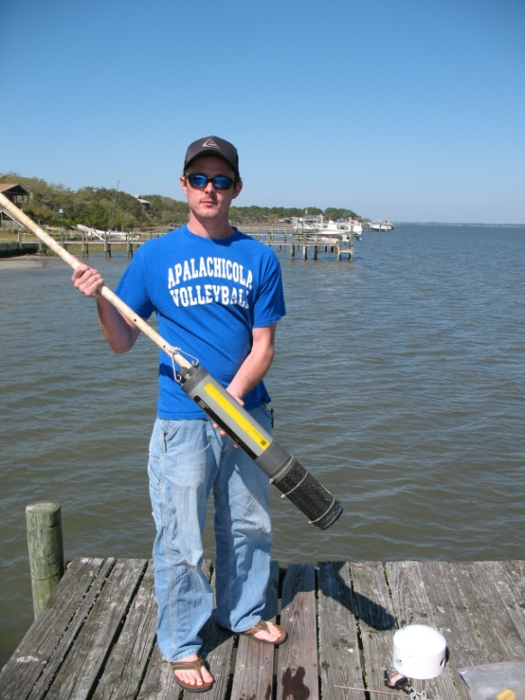
Figure 37. Dataloggers are instruments used to monitor water quality continuously in the bay.
St. Joseph Bay is unique in being the only sizeable embayment body of water in the eastern portion of the Gulf of Mexico that is not markedly influenced by the inflow of freshwater. Therefore, the salinity in the bay is essentially the same as the Gulf. Numerous small bayous, creeks, and ditches drain into the bay, but the principal sources of freshwater into the bay include rainfall, the underlying confined Upper Floridan aquifer, overland drainage and the Gulf County Canal, a constructed waterway that connects the bay with the Gulf Intracoastal Waterway and adjacent shallow ground water (Berndt, 1999). Estimates for Upper Floridan aquifer discharge rates for the St. Joseph Bay area range from 0.5 to 2 inches per year (in/yr) (Bush and Johnston, 1988). Net precipitation, defined as the difference between precipitation and lake evaporation, for the St. Joseph Bay area are estimated between 8 and 9 in/yr (Visher and Hughes, 1975). One preliminary estimate of a long-term average annual freshwater flow from the Canal is 1,740 cubic feet per second (ALA Environmental, Inc. 1996). On a daily basis, this inflow would amount to less than one percent (0.56%) of the bay’s total volume (Brim et al. 2000). Because of this minimal freshwater influence, St. Joseph Bay essentially remains a high salinity coastal lagoon, with some estuarine qualities near the mouth of the Canal. Sediment loading, a phenomenon related to inflow, topography, and terrestrial geologic conditions, has no significant impact on the bay and thus it has remained quite deep since a rise in sea level flooded the coastal plain approximately 5,000 years ago (Stewart and Gorsline, 1962). The bay has a mean depth of 21 feet, with the deepest parts being approximately 35 feet near the northern tip of the spit.
Richardson’s Hammock station collects baseline water quality data in the southern most portion of St Joseph’s Bay. Richardson’s Hammock is surrounded by lush seagrass beds, is known as a shark breeding ground, and supports congregating snapper populations as well as juvenile green turtles. This southern portion of St Joe Bay has low flow compared to the northern portion of the Bay which Gulf water flushes out more frequently. Richardson’s Hammock is separated from the Gulf of Mexico by a narrow strip of land. In the event of a large storm, it is possible that this area could be washed out and the Gulf waters would flow directly into the Bay. Therefore, gathering baseline data is valuable in this area and will be useful in comparing the before and after affects on this habitat. The following are examples of some of the data the preserve is collecting at each site. Richardson’s Hammock salinity values ranged from 23 parts per thousand (ppt) to 40 ppt from 2005-2008 with an average of 33 ppt (see Figure 38). The southern portion of the bay is shallow and has an average depth of 3 feet (see Figure 39), which is consistent with most of the bay’s shallow shoreline. The bay is considered a coastal lagoon primarily because it functions as a closed system, and currents do not have any impacts at depths greater than 1.7 meters (Stewart and Gorsline, 1962). Dissolved oxygen (DO) in the southern portion of the bay is related to season variations such as temperature and saturation averages 98% (see Figure 40). Hydrogen ion concentrations (pH) in the bay are also within the normal range expected for this type of system and average 8 (see Figure 41). Water temperatures range from 7 °C to 41 °C with peak temperatures generally occurring in July and August and lowest temperatures occurring in December and January (see Figure 42). Turbidity values are measured in Nephelometric Turbidity Units (NTU) and typically range from 0-49 NTU’s (see Figure 43.) Higher turbidity values are usually associated with storm events.

Figure 38. Graph depicting average daily salinity (ppt) for Richardson’s Hammock 2005-2008.

Figure 39. Graph depicting average daily depth (m) for Richardson’s Hammock datalogger site 2005-2008.
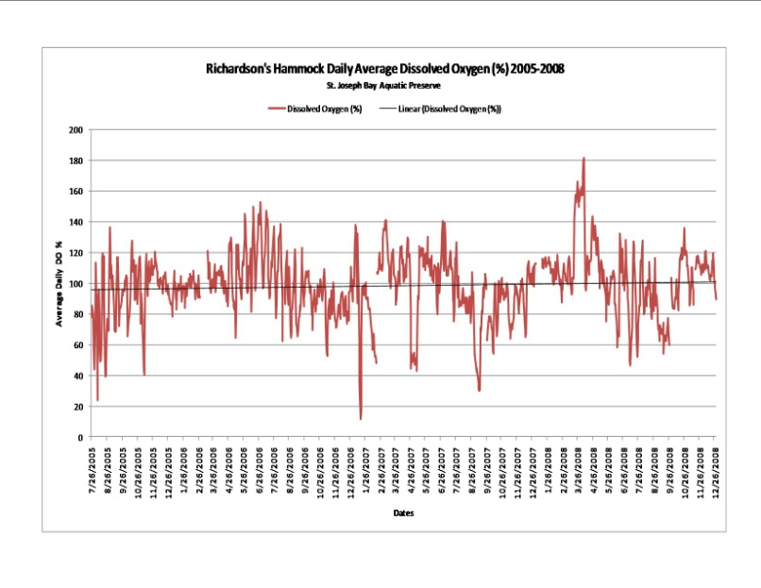
Figure 40. Graph depicting average daily dissolved oxygen (%) for Richardson’s Hammock 2005-2008.

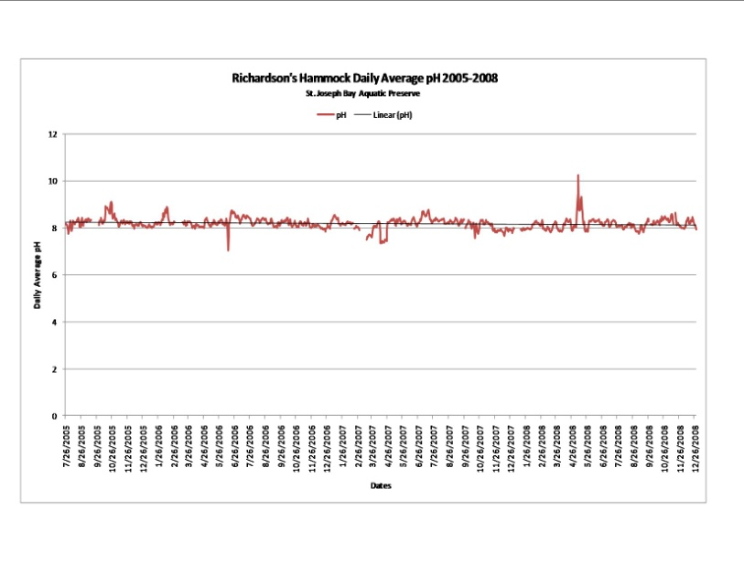

Figure 41. Graph depicting average daily pH for Richardson’s Hammock 2005-2008.

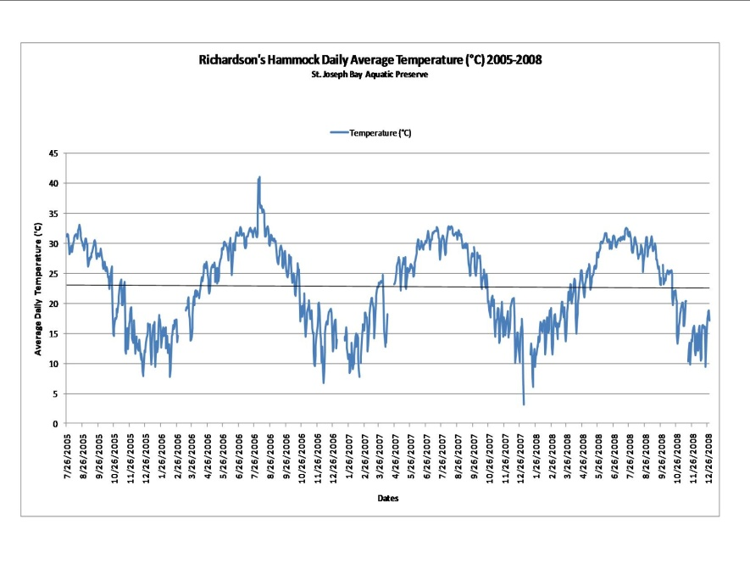

Figure 42. Graph depicting average daily temperature (‘C) for Richardson’s Hammock 2005-2008.

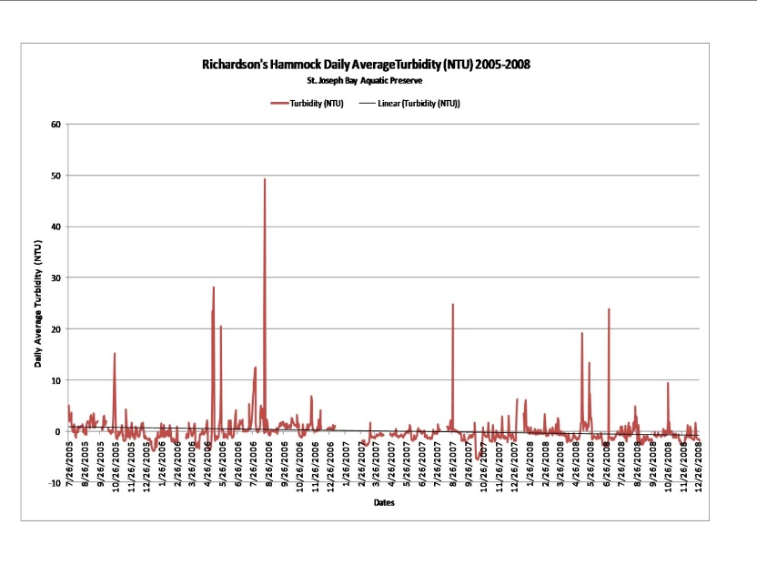
Figure 43. Graph depicting average daily turbidity (NTU) for Richardson’s Hammock 2005-2008.

An additional monitoring station, Windmark, was added to the north eastern portion of the bay in August 2006. The Windmark site is great influenced by the Gulf since Gulf waters enter the bay from the north and travel south. This site is being developed by the St. Joe Company and is in its early stages. The idea behind the establishment of this site was to monitor any changes in water quality that may be linked to increasing development in this area. However, establishing a monitoring site in Alligator Harbor where little is known about the water quality became a priority for the preserve, especially with the upcoming management plan revisions, and this site was discontinued in September 2007.
In October 2007 a datalogger monitoring site was established in the interior southeastern portion of Alligator Harbor at the end of a private dock accessible by vehicle or boat when the tide permits. This site was created to record baseline water quality data in the harbor. The Division of Aquaculture and Consumer Services (DACS) has an additional datalogger located in the central part of the harbor near the aquaculture clam leases. Data was recorded between October 2007 and August 2008 and the project was discontinued to find a more suitable monitoring location as this site was frequently out of the water at low and mid tides. The Preserve has recently been granted permission to attach a datalogger monitoring station to one of the Alligator Point Marina’s channel markers and will resume monitoring in 2010.
In 2005, due to the increased reoccurrence of red-tide (Karenia brevis) in St. Joseph Bay, the Preserve partnered with FWRI to begin collecting water samples at five sites within the bay on a monthly basis. These samples are used to detect any concentrations of brevitoxins and domoic acid in the water column and to determine what time of year these numbers may escalate or be absent. This information is placed on the Florida Fish and Wildlife Conservation Commission (FWC) Red Tide Status Report for Northwest Florida. If not for these efforts, red tide events would be monitored in this area only as a response to the obvious presence of red tide via fish kills or respiratory irritation.
Many pathogens associated with fecal material are discharged into coastal waters. Because monitoring for all human pathogens is not feasible, an indicator group of bacteria is used to assess the likelihood that human pathogens are present. Fecal coliform is the indicator group of bacteria used by the Florida Department of Agriculture and Consumer Services (FDACS). The Department routinely monitors fecal coliform and water quality parameters at established stations in each of Florida's shellfish harvesting areas. The standards for safe limits of fecal coliform bacteria in shellfish harvesting area is a median MPN (most probable number) of 14/100 ml of water and should not exceed 43MNP/100 ml more than 10 percent of the time (Edmiston 2008). In Apalachicola Bay there are 101,000 acres of conditionally approved Class II Shellfish Harvesting Waters; in Alligator Harbor 3,273 acres of conditionally approved and in St. Joseph Bay 34,097 acres of conditionally approved waters (See Figure 44).
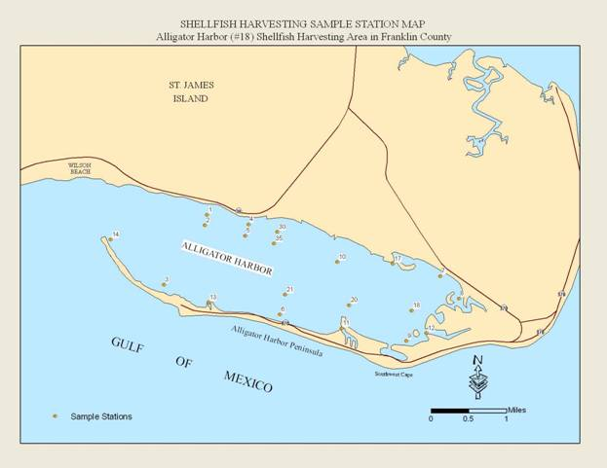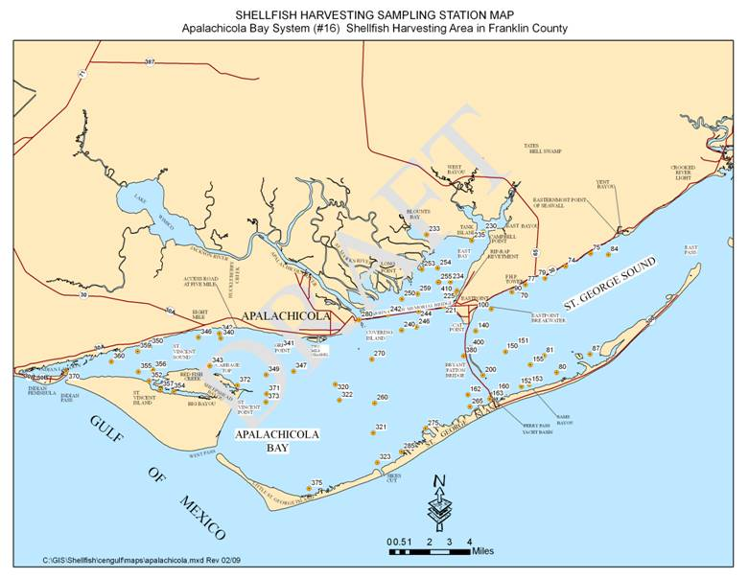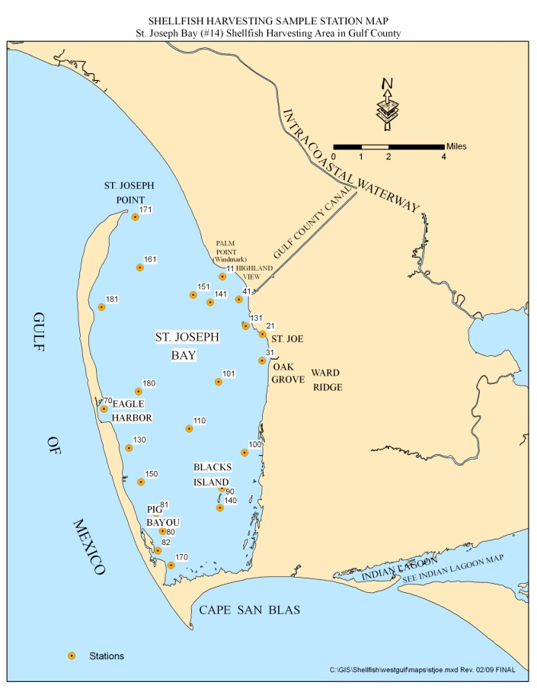
Figure 44. Bacteriological water quality monitoring sampling stations in Alligator Harbor, Apalachicola Bay and St. Joseph Bay Preserves.

Revision of St. Joseph Bay Aquatic Preserve Management Plan
After eleven years the St. Joseph Bay Aquatic Preserve Management Plan was revised and approved by the Governor and Cabinet in 2008. The purpose of these plans is to incorporate, evaluate and prioritize all relevant information about the site into a cohesive management strategy, allowing for appropriate access to the managed areas while protecting the long term health of the ecosystems and their resources. The Preserve is currently working on the revision of the Apalachicola Bay Aquatic Preserve plan that will be included in ANERR’s revised plan. The current Alligator Harbor Aquatic Preserve Management Plan is 23 years old and will be revised in 2011-2012.

