Recent Cold Snap Causes the Mass Stranding of Sea Turtles Along the Coast of Florida.
The waters of St. Joseph Bay Aquatic Preserve provide optimal foraging grounds for several species of sea turtles including juvenile endangered green turtles. These young turtles visit the bay to feed on the extensive seagrass habitat. Sea turtles depend on ambient temperatures to regulate their body’s core temperature. Like other reptiles, sea turtles respond to seasonal changes in temperatures by hibernating or migrating. Decreases in temperature however may occur rapidly leaving little time for foraging juvenile turtles to escape the shallow cold waters of the bay and migrate to warmer water.
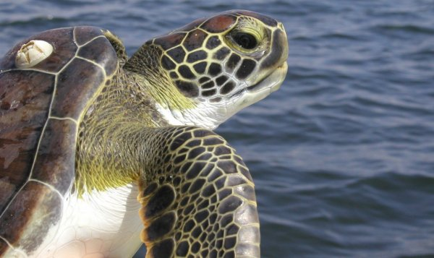
Lush seagrass meadows in St. Joseph Bay Aquatic Preserve provide optimal foraging grounds for endangered green sea turtles.
"Cold-stunning" is a process that causes sea turtles to become immobile due to the dramatic decrease in water temperature. When the water temperature drops below 50 degrees, sea turtles are at risk of becoming cold stunned. Their bodies cannot withstand such cold conditions and they become paralyzed, helplessly floating near the surface where they are vulnerable to scavengers and illness. A cold-stunned turtle may appear to be dead, but may actually be alive. In January 2001, northern Florida experienced a prolonged period of unusually cold temperatures that resulted in the largest cold-stunning event ever recorded in the United States. Water temperatures in St. Joseph Bay dropped to approximately 43°F and 403 marine turtles were found stranded and cold-stunned in the southwestern corner of the bay.
During the first week of January 2010, this record was beat when temperatures dipped below 40°F in St. Joseph Bay. Water temperatures remained low for about a week and resulted in the stranding of approximately 1,750 sea turtles. The majority of the turtles affected by the cold weather were green turtles (endangered) but Kemp’s ridley (endangered) and loggerhead (threatened) turtles were also collected. If not for these rescue efforts, many of the turtles would have been attached by predators, hit by boats, or simply drowned. Collected turtles were taken to Gulf World in Panama City where they were placed in large, swimming areas that are gradually heated to allow for recovery. All turtles were weighed, measured, photographed and tagged.

During the first week of January 2010, water temperatures in St. Joseph Bay dropped below 50°F resulting in the largest sea turtle cold stun event on record for the area.
These rescue efforts may prove beneficial to these animals in the long run. Biologists were able to tag more turtles than ever before during this event which we will enable them to learn more about the biology of these animals. Valuable information on size, geographic distribution, health status and other factors will be gathered. Genetic information obtained from the turtles will also provide a better understanding on where they originally hatched. In addition, tagged turtles will provide information for years to come on where they travel and their survival rate.
(a)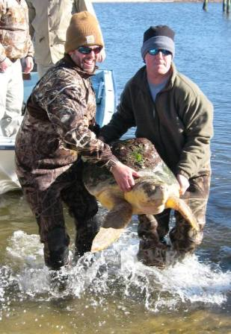(b)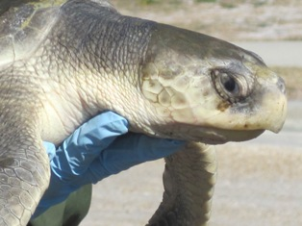
Most of the turtles rescued in St. Joseph Bay were juvenile green turtles, however, larger loggerheads (a) and Kemp’s ridley turtles (b) were also found floating and immobilized from the cold temperatures.
Through the collaborative work of many dedicated volunteers, agencies, Gulf World, and others, nearly 80% of these turtles were able to be rehabilitated and released. The week following the cold stun event the US Coast Guard offered three vessels to take the rehabilitated turtles eight to thirteen miles offshore into the Gulf of Mexico’s warmer waters (60°F or warmer). It is important to get the turtles back into their marine habitat as soon as logistics and weather permit.
Five hundred turtles did not make it back to the Gulf but out of this number only about 20 died while in captivity; the rest were already deceased upon arrival. According to recent research, the presence of these juvenile turtles in St. Joseph Bay at this time of year suggests that these turtles overwinter in this area and are in the bay year round. Turtles may remain in a torpid state on the bottom of the bay once water temperatures begin to decrease but once water temperatures drop below the critical point they are unable to respond and are left stranded. If you are interested in more information please contact the Central Panhandle Aquatic Preserve Office at 850/670-4783 x. 104.

