Tracking TMDL progress in the tributary watersheds in the Caloosahatchee River and Estuary BMAP
February 2021
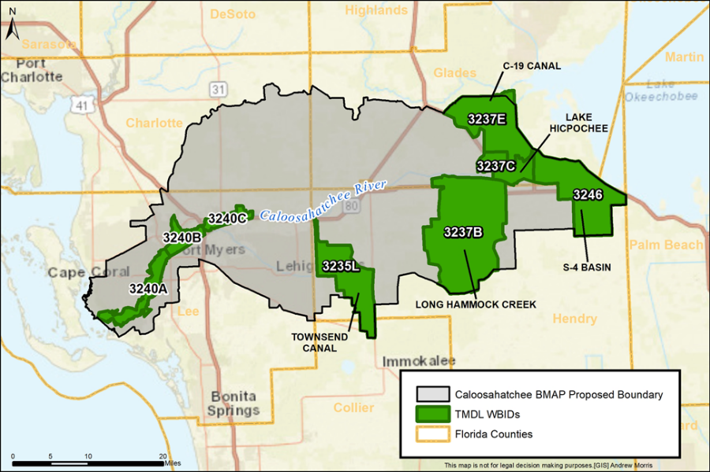
Overview
- Caloosahatchee Estuary has a TN TMDL.
- Caloosahatchee tributaries have TN and TP TMDLs.
- We need a methodology to track progress towards the five tributary TMDLs.

BMAP Allocation Information
- Starting loads and required reductions for each tributary watershed have been calculated using the LET.
- Starting loads and required reductions for each stakeholder in the tributary watersheds have also been calculated using the LET: The estuary reduction and tributary reduction were compared, and the greater reduction was used as the TN requirement for each stakeholder.
  - The first step in determining the required reductions was to calculate the TN required reduction for each stakeholder to achieve the estuary TMDL. The next step was to calculate the TN required reduction for each stakeholder to achieve the tributaries TMDL. For stakeholders within multiple tributaries, the TN required reductions were summed into one total tributary reduction.
  - The TP load required reduction in the tributary watersheds was calculated for each stakeholder with jurisdiction in those watersheds. These were assigned as the tributary stakeholders TP required reductions.
- The table on the slide summarizes the TN and TP starting loads for each tributary and the required reductions calculated by applying the TMDL percent reductions.
Tributary | TN Starting Load  (lbs/yr) | TN Required Reduction (lbs/yr) | TP Starting Load  (lbs/yr) | TP Required Reduction (lbs/yr)
C-19 | 60,244 | 28,917 | 3,036 | 1,457
Lake Hicpochee | 25,437 | 508 | 1,375 | 27
Long Hammock | 437,365 | 183,692 | 28,094 | 11,799
S-4 Basin | 153,336 | 41,401 | 10,493 | 2,938
Townsend Canal | 254,468 | 94,154 | 23,065 | 8,765

Project Calculation Process
- Use the project treatment area shapefiles to identify project areas in the tributary watersheds.
- Calculate the estimated project starting loads in the treatment area using the unattenuated loads in the LET.

- Calculate the project reductions by applying the appropriate BMP efficiencies to the TN and TP unattenuated loads.
- Compare the total project reductions in each tributary watershed to the required reductions for that watershed to determine the percent of required reductions achieved in each tributary (see table on the slide for example tracking).
  - Each tributary project will have estimated load reductions for both the estuary (based on the attenuated loads) and tributaries (based on the unattenuated loads).
Tributary | TN Required Reductions (lbs/yr) | TN Reductions Achieved (lbs/yr) | Percent Completed | TP Required Reductions (lbs/yr) | TP Reductions Achieved (lbs/yr) | Percent Completed
C-19 | 28,917 | TBD | TBD | 1,457 | TBD | TBD
Lake Hicpochee | 508 | TBD | TBD | 27 | TBD | TBD
Long Hammock | 183,692 | TBD | TBD | 11,799 | TBD | TBD
S-4 Basin | 41,401 | TBD | TBD | 2,938 | TBD | TBD
Townsend Canal | 94,154 | TBD | TBD | 8,765 | TBD | TBD

For Discussion
- The project tables in the BMAP are only for the estuary reductions so we will need to set up new rows in the table for each tributary project.
- For projects in the tributaries that are already receiving credit towards the estuary TMDL, we will list those projects in new rows with unique numbers and the location specifying the TMDL.
  - Prefixes for project numbers with tributary-specific identifiers (Ex: TC-HC-06 for Hendry County project 6 within the Townsend Canal watershed)
    - C19 (C-19)
    - LAH (Lake Hicpochee)
    - LOH (Long Hammock)
    - S4 (S-4 Basin)
    - TC (Townsend Canal)

- So in summary, we will be tracking collective progress within each tributary watershed using a table similar to this example; and we will also be tracking individual stakeholder’s progress toward their overall required TN and TP reductions.

Next Steps (2/26)
- Working on gathering project information for those projects that are in the trib watersheds
- Reach out to Andrew and Marcy to ask if they have additional information
- Work on calculating the project loading numbers
- Work on establishing the milestones and progress tracking charts
March 2021
SF Meeting (3/2)
- Kenny looked at the language to tracking trib progress in Calo
- Similar language in Lake O and St.Lucie
- Subsection 5 of NEEPP statute only required TMDL development for R and estuary but doesn't talk about the tribs
- Conclusion: No need to create milestones for the trib watersheds
Project Follow-Up (3/25)
- Started a new project in GIS titled Calo_Trib_Tracking_2021
- Shapefiles Used
  - WBID
  - Basins
  - Project Points (from 2020 Storymap)
  - Created Project Points Shp from Metrics Workbook (March 2021) with Lat/Longs for new projects that were added this year
  - For the CA projects, I downloaded the BDWMD_OEPC_Water_Proj shapefile from the SFWMD website:
    - https://geo-sfwmd.hub.arcgis.com/datasets/sfwmd-surface-water-projects-1?geometry=-88.724%2C25.089%2C-73.288%2C28.520

Process
  - Added the shapefiles above to the map
  - Definition Query the Basins shp to
    - Where Basin2019 is equal to C19
    - Or Basin2019 is equal to Lake Hicpochee
    - Or Basin2019 is equal to Long Hammock
    - Or Basin2019 is equal to Lake S4
    - Or Basin2019 is equal to Lake Townsend
  - Visually ID the project points that are within (or close to the boundary in) each WBID
  - Create an excel table with project info for each of the projects identified
  - Determine which projects we have polygon shapefiles for and which projects we do not have shapefiles for
  - For the CA projects, I downloaded the BDWMD_OEPC_Water_Proj shapefile from the SFWMD website:
    - https://geo-sfwmd.hub.arcgis.com/datasets/sfwmd-surface-water-projects-1?geometry=-88.724%2C25.089%2C-73.288%2C28.520
April 2021
Projects Identified
Lead Entity | ProjectNumber | Trib Boundary | In Boundary? | ProjectName | Shapefile? | Project Status
Barron WCD | BD-04 | Long Hammock | No | Canal/Ditch Bank Berms | N | Planned
Coordinating Agency | CA-01 | Long Hammock | Yes | C-43 West Basin Storage Reservoir | Y | Underway
Coordinating Agency | CA-02 | Lake Hicpochee | Yes | Lake Hicpochee Storage and Shallow Hydrologic Enhancement, Phase 1 | Y | Completed
Coordinating Agency | CA-03 | Lake Hicpochee | Yes | Lake Hicpochee Storage and Shallow Hydrologic Enhancement Expansion | Y | Planned
Coordinating Agency | CA-04 | Townsend | No | BOMA Flow Equalization Basin (FEB) | Y | Planned
Cow Slough WCD | CSW-04 | Townsend | Yes | Canal/Ditch Bank Berms | N | Completed
City of Clewiston | CW-04 | S4 | Yes | Reverse Osmosis WTP Dry Pond | N | Completed
City of Clewiston | CW-05 | S4 | Yes | Sweet Lake Villas Community Association, Inc. | N | Underway
Cow Slough WCD | CW-06 | S4 | Yes | East Ventura Water Quality | N | Planned
FDOT District 1 | FDOT-29 | Long Hammock | No | SR 80 from Dalton Lane to CR 833 (408286-5 &-6) | N | Completed
Gerber Groves WCD | GG-04 | Long Hammock | No | Canal/Ditch Bank Berms | N | Planned
LA-MSID (formerly ECWCD) | LA-12 | Townsend | No | Hendry Canal Widening | N | Underway
LA-MSID (formerly ECWCD) | LA-13 | Townsend | Yes | CREST | N | Completed
LA-MSID (formerly ECWCD) | LA-14 | Townsend | Yes | CREST | N | Underway
City of Moore Haven | MH-02 | C19 | Yes | Sanitary Sewer Hook-Up Project | N | Completed
*Completed projects to be prioritized are highlighted in yellow
Next Steps (4/13)
CA-02 is the only completed project within a trib WBID boundary that we have a shapefile for and could calculate progress towards, but the shp from SFWMD may not be the treatment area and we would need to confirm. The next steps would be to continue to gather shapefiles from lead entities and apply the calculation process described above. I would recommend prioritizing the completed, in boundary projects followed by the completed, outside of boundary projects.

