The Caloosahatchee Estuary has experienced frequent occurrences of cyanobacteria in recent years, most commonly Microcystic aeruginosa. Algal community composition and Harmful Algal Blooms (HABs) are not currently being monitored in the estuary, and it is unclear whether these harmful algae are growing in the estuary or whether they are transported downstream from the freshwater river or Lake Okeechobee. A deeper dive into algal community compositions is also an area of research that may help us get a better idea under what conditions we begin to see HABs. The information will help inform managers and the public on potential threats to marine and freshwater resources, coastal communities, and human health.

The Department of Environmental Protection (DEP) recommends setting up a multi-year monitoring effort to better understand the growth and transport dynamics of phytoplankton within the Caloosahatchee hydrologic system. The goal of the project is to complement local stakeholder efforts to help provide a monitoring network for the detection, composition, and spatial/temporal distribution of algal community composition and HABs in the Caloosahatchee Estuary.

The DEP proposes to sample water quality and algal community composition at four sites, one within the freshwater portion of the Caloosahatchee River and three within the marine portion co-located with flow sites, for two years. Proposed sampling locations are downstream of the S78 structure, within Whiskey Creek (downstream of the USGS station 02293230), within Orange River (downstream of the USGS station 02293055), and within Popash Creek (downstream of the USGS station 02293090) (Figure 1).

Biological and water quality samples would be conducted on a monthly basis to align with local stakeholder sampling frequency. Water analytes would include nutrient species (total phosphorus, TKN, and NO₂+NO₃), corrected chlorophyll a, turbidity, true color, dissolved oxygen, pH, specific conductance, and temperature. In addition to the analysis of samples collected at these three sites, water analytes will be analyzed by the DEP lab in a subset of samples collected by the local stakeholder, with the remaining stakeholder samples being analyzed by a NELAP-certified lab. Phytoplankton samples will also be collected monthly and processed to map the complete community composition. Algal taxa will be identified to the lowest taxonomic level possible, preferably species or genus.

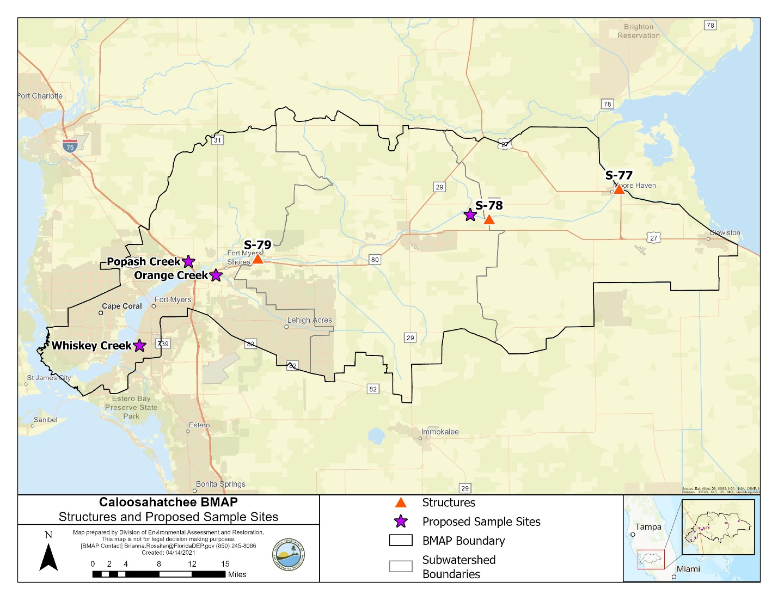
Figure 1. Proposed sampling sites.

