Everglades West Coast Geodatabase Project
Objective: Build an example geodatabase to store all of the project shapefiles for the Everglades West Coast (EWC) BMAP.
Purpose: To develop a methodology and structure to organize and manage BMAP projects in a geodatabase. The EWC BMAP was chosen because of its size and scope of available shapefiles. In comparison to some of the other larger BMAPs (e.g. Lake Okeechobee, Caloosahatchee) the EWC project shapefiles are easily digestible and potentially less overwhelming. The methodology and structure are meant to be a transparent and palpable guide for others looking to organize their projects in a new geodatabase.
Instructions: This methodology is intended to walk the user through the process of building a gdb. Shapefiles are displayed in purple, GIS actions are displayed in orange, GIS field names are displayed in blue.
Geodatabase Building Steps:
- Located project files for Pine Lake Preserve (BS-10)

- Identified...
- Project Location: Pine_Lake_Preserve_Location_BR
- Project Treatment Area: PLP_digitized_py_BR
- Project Clip (Land Use): SFWMD_2004_05_LU_PLP_clip_BR
  - Storymap Points: EWC_Projects_2020_BR

- Created new gdb titled “EWC”
- Catalog -> Databases -> New File Geodatabase (EWC)
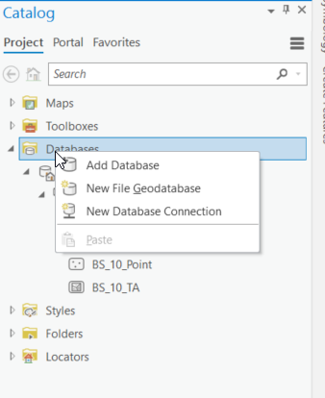

- Edited gdb domains: Restricts the input on particular field to a list or range of valid values
- Catalog -> Databases -> EWC -> Domains
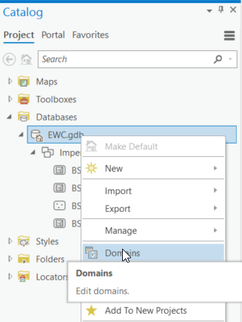

(Details in table shown below)

- Created new feature dataset: by basin
- EWC -> New -> Feature dataset (Imperial_River)
- DO NOT PUT SPACES IN YOUR FEATURE DATASET NAME
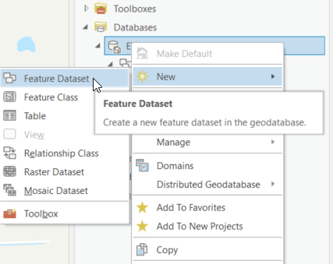

- Naming Conventions for Feature Classes (based on previous discussions)
  - Treatment Area (BS_10_TA)
  - Project Location/Area (BS_10_PA)
  - Project Clips (BS_10_Clip)
  - Storymap Points (BS_10_Point)

- Created new feature classes
- Imperial River -> New -> Feature class
- Storymap Point: (BS_10_Point)
      - Project Number
      - Latitude- linked to domain
      - Longitude- linked to domain
- Project Area: (BS_10_PA)
      - Project ID
      - Project Number
      - Project Type- linked to domain
      - Acres Treated- linked to domain
- Treatment Area: (BS_10_TA)
      - Project Number
      - Project Type- linked to domain
      - Lead Entity- linked to domain
      - Year Added- linked to domain
      - Acres Treated- linked to domain
    - Project Clip: (BS_10_clip)
      - Project Number
      - Project Type- linked to domain
      - Lead Entity- linked to domain
      - Year Added- linked to domain
      - Acres Treated- linked to domain

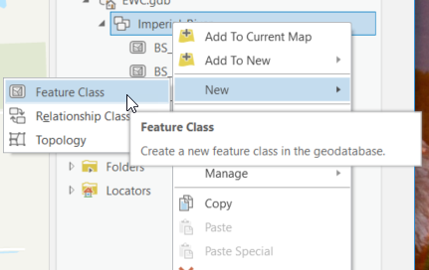

- Imported feature data into new feature classes
  - BS_10_Point -> Load Data -> Input Datasets
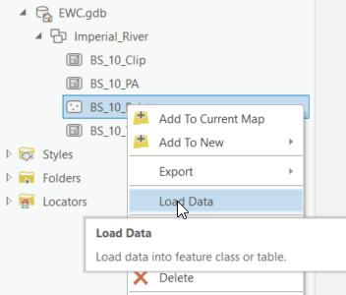

Domain Details:
Domain Name | Field Type | Domain Type | Details | Notes
Acres | Double | Range | Min=0  Max= 55,469 | EWC BMAP acres
Acres_Treated | Short | Range | Min=0  Max= 30000 | Max number of acres treated in EWC metrics workbook is ~5,300
Latitude | Double | Range | Min= -88  Max= 80 | FL Latitude Lines
Lead_Entity | Text | Coded Value | City of Bonita Springs  Lee County  FDOT  FDACS | (4) Entities in EWC
Longitude | Double | Range | Min= 24  Max=31 | FL Longitude Lines
Proj_Type | Text | Coded Value | All projects types | Pulled tables from annual project update instructions
ProjID | Short | Range | Min: 2240  Max: 10000 | Greatest project ID is currently 2340
Year_Added | Short | Range | Min: 2012  Max: 2040 | BMAP adopted in 2012
Files Located: X:\WPCS\WPCS\BASINS\Everglades_West_Coast\GIS\EWC_BR

