Integrated Water Quality Assessment for Florida:
2014 305(b) Report
and 303(d) List Update

Division of Environmental Assessment and Restoration
Florida Department of Environmental Protection

March 2013

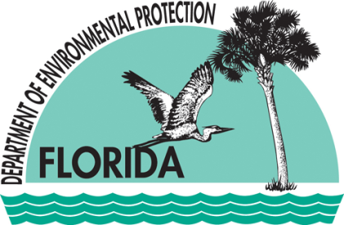
2600 Blair Stone Road, MS 3525
Tallahassee, Florida 32399-2400
www.dep.state.fl.us
This page intentionally left blank.

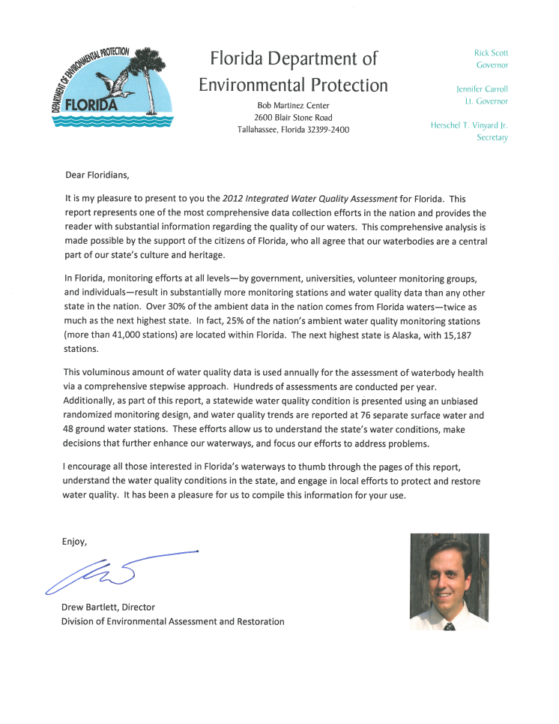

ACKNOWLEDGMENTS

This document was prepared by staff in the following bureaus of the Division of Environmental Assessment and Restoration, and the Division of Water Resource Management, within the Florida Department of Environmental Protection:
- Bureau of Assessment and Restoration Support:
- Standards and Assessment Section
- Watershed Assessment Section
- Watershed Monitoring Section

- Bureau of Watershed Restoration:
- Ground Water Management Section
- Nonpoint Source Management Section
- Watershed Evaluation and Total Management of Daily Loads (TMDL) Section
- Watershed Planning and Coordination Section

- Bureau of Laboratories:
- Biology Section

- Bureau of Water Facilities Regulation:
- Domestic Wastewater Section
- Drinking Water Section
- National Pollutant Discharge Elimination System (NPDES) Stormwater Section
- Wastewater Compliance and Evaluation Section

Many thanks to staff at the Florida Fish and Wildlife Conservation Commission (FWC) for their valuable help in updating the section on cyanobacteria in Chapter 3.

Table of Contents

List of Acronyms and Abbreviations xvi
Executive Summary xxi
Chapter 1: Introduction 1
Purpose 1
Federal Assessment and Reporting Requirements 1
Integrating the Federal Requirements into Florida’s Watershed Management Approach 3
Chapter 2: Background Information 5
Overview 5
Population 7
Climate 7
Surface Water and Ground Water Resources 10
Streams and Rivers 10
Lakes 11
Estuaries and Coastal Waters 12
Wetlands 12
Aquifers and Springs 13
Hydrogeology 14
Surface Water 14
Ground Water 14
Surface Water–Ground Water Interactions 15
Chapter 3: ISSUES OF ENVIRONMENTAL INTEREST and Initiatives 17
Issues of Environmental Interest 17
Drinking Water 17
Healthy Beaches Program 20
Deepwater Horizon (MC252) Oil Spill 21
Bacterial and Mercury Contamination 22
Harmful Algal Blooms 23
Initiatives 27
Chapter 4: Florida’s Approach to Monitoring Surface Water and Ground Water 34
Background 34
Florida’s Integrated Water Resources Monitoring Program 38
Element 1: Monitoring Objectives 40
Element 2: Monitoring Strategy 40
Element 5: Quality Assurance 41
Element 6: Data Management 42
Element 9: Program Evaluation 42
Element 10: General Support and Infrastructure Planning 43
Evolving Approaches to Monitoring 43
Chapter 5: Design for the Status and Trend Networks 45
Background 45
Status Network Monitoring 46
Water Resource Types 47
Geographic Design and Site Selection 48
Sampling and Frequency 48
Status Network Core and Supplemental Indicators 49
Status Monitoring Network Design Changes 52
Future Design and Reporting 52
Trend Network 53
Surface Water Trend Network 55
Ground Water Trend Network 55
Trend Network Core and Supplemental Indicators 58
Data Evaluation 58
Chapter 6: Results of the Status and trend NeTWORK Assessments for 2009–10 59
Summary of Status Network Surface Water Results 59
Introduction 59
Rivers, Streams, Large Lakes, and Small Lakes 61
Sediment Quality Evaluation 70
Summary of Status Network Ground Water Results 76
Summary of Surface and Ground Water Trend Network Results 82
Surface Water Trends 82
Ground Water Trends 94
Chapter 7: overview of STRATEGIC MONITORING AND Assessment methodology for Surface water 114
Historical Perspective on the Assessment Methodology 114
Assessment Methodology: The Impaired Surface Waters Rule 114
Description of the Watershed Management Approach 115
Implementation of the TMDL Program under the Rotating Basin Approach 115
Focus on Outcomes 117
Assessment Periods for the Planning and Verified List Assessments 118
Determination of Use Attainment 118
Sources of Data 121
IWR Strategic Monitoring 125
Quality Assurance/Quality Control Criteria 125
Rationales for Not Using Existing Data 125
Chapter 8: Results for attainment of designated uses in surface waters 130
Surface Waters Assessed 130
303(d) Listed Waters 131
Summary of Causes of Impairment 132
Delisting 139
Biological Assessment 141
Use and Interpretation of Biological Results 141
Special Focus: Lakes 143
Lake Trends for Nutrients 143
Approaches to Controlling Lake Pollution and Lake Water Quality 145
Publicly Owned Lakes with Impaired Uses 145
Drinking Water Use Support 145
Overlap of Source Water Areas and Impaired Surface Waters 146
Chapter 9: Introduction to Ground Water Monitoring 149
Summary of Ground Water Monitoring Programs 149
Ground Water and Springs Monitoring Programs Maintained by the Department 150
Potable Water Monitoring by FDOH/Departmental Water Supply Restoration Program 151
Public Water System Monitoring 151
Monitoring of Discharges to Ground Water 152
Chapter 10: Results of the Ground Water Assessments 153
Overall Ground Water Quality 153
Ground Water Quality Issues and Contaminants of Concern, Including Potable Water Issues 156
Volatile Organic Compounds 156
Synthetic Organic Chemicals/Pesticides 160
Nitrate 160
Primary Metals 161
Saline Water 162
Radionuclides 162
Trihalomethanes 163
Bacteria (Coliform) 163
Summary of Ground Water Contaminant Sources 163
Petroleum Facilities 164
Drycleaning Solvent Facilities 164
Federal and State Waste Cleanup and Monitoring Sites 164
Nonpoint Sources 164
Ground Water–Surface Water Interaction 165
Setting and Pathways 165
Ground Water Influence on Impaired Surface Waters 165
Springs and Spring-Related Issues 166
Phosphorus 168
Chapter 11: Water Protection and Restoration Programs 171
Florida’s Water Resource Management Programs 171
Overview of Surface Water Monitoring Programs 172
Watershed-Based Monitoring and Reporting 172
Overview of Surface Water Protection Programs 173
Water Quality Standards Program 173
Watershed Assessment Program 174
Public Participation 181
Surface Water Improvement and Management Program 181
Point Source Control Program 182
Nonpoint Source Management Program 184
Land Acquisition 191
Costs and Benefits of Implementing Florida’s Surface Water Protection Programs to Meet the CWA’s Objectives 191
Coordination with Other State, Tribal, and Local Agencies 194
Wetlands Program 196
Results of Florida’s Surface Water Protection Programs 202
References 204
Appendices 218
Appendix A: Discussion of Status Network Surface Water Indicators for Rivers, Streams, and Lakes, and Ground Water Indicators for Confined and Unconfined Aquifers 218
Surface Water Indicators for Rivers, Streams, and Lakes 218
Ground Water Indicators for Confined and Unconfined Aquifers 220
Appendix B: Tables and Maps from the 2009–10 Status Network Assessment Results for Large Lakes, Small Lakes, Rivers, Streams, Confined Aquifers, and Unconfined Aquifers 224
Appendix C. IWR Methodology for Evaluating Impairment 238
Aquatic Life Based Use Attainment 238
Primary Contact and Recreation Use Attainment 239
Fish and Shellfish Consumption Use Attainment 239
Drinking Water Use Attainment 240
Evaluation and Determination of Use Attainment 240
Appendix D: Impaired Lakes in Florida, Group 1–5 Basins 247

List of Tables

Table 2.1. Florida Atlas 6
Table 4.1a. The Department's Tier I Monitoring Programs 39
Table 4.1b. The Department's Tier I and Tier II Blended Monitoring Programs 39
Table 4.1c. The Department’s Tier II Monitoring Programs 39
Table 4.1d. The Department's Tier III Monitoring Programs 39
Table 5.1a. Status Network Core and Supplemental Indicators for Field Measurements 50
Table 5.1b. Status Network Core and Supplemental Indicators for Biological and Microbiological Indicators 50
Table 5.1c. Status Network Core and Supplemental Indicators for Organic and Nutrient Indicators 50
Table 5.1d. Status Network Core and Supplemental Indicators for Major Ion Indicators 51
Table 5.1e. Status Network Core and Supplemental Indicators for Metal Indicators 51
Table 5.1f. Status Network Core and Supplemental Indicators for Physical Property Indicators 51
Table 5.2a. Status Network Organic and Nutrient Indicators for Sediment Analysis in Lakes 51
Table 5.2b. Status Network Metal Indicators for Sediment Analysis in Lakes 52
Table 5.3a. Trend Network Field Measurement Indicators 53
Table 5.3b. Trend Network Biological and Microbiological Indicators 54
Table 5.3c. Trend Network Organic and Nutrient Indicators 54
Table 5.3d. Trend Network Major Ion Indicators 54
Table 5.3e. Trend Network Metal Indicators 55
Table 5.3f. Trend Network Physical Property Indicators 55
Table 6.1. Summary of Surface Water Resources Assessed by the Status Network’s Probabilistic Monitoring, 2009–10 59
Table 6.2a. Status Network Physical/Other Indicators/Index for Aquatic Life Use with Water Quality Criteria/Thresholds 60
Table 6.2b. Status Network Microbiological Indicators/Index for Recreational Use with Water Quality Criteria/Thresholds 60
Table 6.2c. The Department’s Freshwater Lake Sediment Contaminant Thresholds for Metals 60
Table 6.3a. Explanation of Terms Used in Tables 6.3b through 6.3e 61
Table 6.3b. Statewide Percentage of Rivers Meeting Threshold Values for Indicators Calculated Using Probabilistic Monitoring Design 63
Table 6.3c. Statewide Percentage of Streams Meeting Threshold Values for Indicators Calculated Using Probabilistic Monitoring Design 65
Table 6.3d. Statewide Percentage of Large Lakes Meeting Threshold Values for Indicators Calculated Using Probabilistic Monitoring Design 67
Table 6.3e. Statewide Percentage of Small Lakes Meeting Threshold Values for Indicators Calculated Using Probabilistic Monitoring Design 69
Table 6.4a. Statewide Percentage of Large Lakes Meeting Sediment Contaminant Threshold Values 72
Table 6.4b. Statewide Percentage of Small Lakes Meeting Sediment Contaminant Threshold Values 74
Table 6.5. Status Network Physical/Other Indicators/Index for Potable Water Supply for Ground Water with Water Quality Criteria/Thresholds 76
Table 6.6a. Legend for Terms Used in Tables 6.6b and 6.6c 77
Table 6.6b. Statewide Percentage of Confined Aquifers Meeting Threshold Values for Indicators Calculated Using Probabilistic Monitoring Design 79
Table 6.6c. Statewide Percentage of Unconfined Aquifers Meeting Threshold Values for Indicators Calculated Using Probabilistic Monitoring Design 81
Table 6.7. Surface Water Trend Summary (1999–2010) 83
Table 6.8a. Legend for the Acronyms and Abbreviations Used in Tables 6.8b and 6.8c 83
Table 6.8b. Trends for Specified Analytes for Surface Water Trend Network Stations that Are Associated with a USGS Gauging Station and Adjusted for River Flow 84
Table 6.8c. Trends for Specified Analytes for Surface Water Stations from the Trend Network and not Adjusted for River Flow 85
Table 6.9. Ground Water Trend Summary (1999–2010) 94
Table 6.10a. Legend for the Acronyms and Abbreviations Used in Tables 6.10b and 6.10c 95
Table 6.10b. Trends for Specified Analytes for Stations in the Ground Water Trend Monitoring Network, Confined Aquifers 96
Table 6.10c. Trends for Specified Analytes for Stations in the Ground Water Trend Monitoring Network, Unconfined Aquifers 97
Table 7.1. Basin Groups for Implementing the Watershed Management Cycle, by Departmental District 115
Table 7.2. Phases of the Basin Management Cycle 116
Table 7.3. Data Used in Developing the Planning and Verified Lists for the Basin Rotation Cycles 118
Table 7.4. Designated Use Attainment Categories for Surface Waters in Florida 119
Table 7.5. Categories for Waterbodies or Waterbody Segments in the 2012 Integrated Report 120
Table 7.6. Organizations Providing Data Used in the IWR Assessments 123
Table 7.7. Types of Data Excluded from IWR Assessments 128
Table 8.1. Total Number of Waterbody Segments and Size of Assessed Waterbody Segments by Waterbody Type 131
Table 8.2a. Assessment Results for Pathogens by Waterbody Type and Assessment Category 133
Table 8.2b. Assessment Results for Nutrients by Waterbody Type and Assessment Category 134
Table 8.2c. Assessment Results for Mercury by Waterbody Type and Assessment Category 134
Table 8.3a. Miles of Rivers/Streams Impaired by Cause 134
Table 8.3b. Square Miles of Lakes Impaired by Cause 135
Table 8.3c. Square Miles of Estuaries Impaired by Cause 135
Table 8.3d. Square Miles of Coastal Waters Impaired by Cause 136
Table 8.4a. Distribution of Biological Results by Assessment Type and Aquatic Life Use Support 142
Table 8.4b. Summary of Biological Results by Assessment Type and Aquatic Life Use Support 143
Table 8.5. Total Miles of Rivers/Streams and Square Miles of Lakes/Reservoirs Designated for Drinking Water Use 145
Table 8.6. Waterbodies Designated for Drinking Water Use by Assessment Category (Results for Assessments Including Criteria for All Use Support) 147
Table 8.7. Summary of Impaired River/Stream Miles and Lake/Reservoir Square Miles Overlapping Source Water Areas of Community Water Systems 148
Table 9.1a. Summary of Ground Water Monitoring Programs and Data Sources: Monitoring Networks Maintained by the Department 149
Table 9.1b. Summary of Ground Water Monitoring Programs and Data Sources: Programs that Include Potable Ground Water Sampling: Monitoring Networks Maintained by the Department 150
Table 10.1. Summary of Percent Ground Water Samples Achieving Primary Ground Water Standards for Selected Analytes by Basin 154
Table 10.2a. Summary of Recent Exceedances of Primary Ground Water Standards in Untreated Samples from Private Wells and Ground Water–Based Public Water Systems 158
Table 10.2b. Summary of Recent Exceedances of Primary Ground Water Standards in Untreated Samples from Private Wells and Ground Water–Based Public Water Systems 159
Table 10.3. Median Concentrations of Ground Water–Surface Water Constituents in Unconfined Aquifers (2000–11) 167
Table 11.1. Status of Ongoing BMAP Efforts 179
Table 11.2. Number of Enrolled Acres and NOIs as of June 30, 2011 186
Table 11.3. Florida Legislative Appropriations for Nonpoint Sources and TMDLs, 2000–11 192
Table 11.4. Results of the 2008 Clean Watersheds Needs Survey for Florida 193
Table 11.5. Primary Coordination Mechanisms for Managing State, Regional, and Local Water Resources 194
Table 11.6. Historical Estimates of Wetlands in Florida, 1780–1980 197
Table 11.7. Open Mitigation Banks in Florida¹ 201
Table 11.8. Acreage of Affected Wetlands Regulated by the Department and the WMDs (2010–11) 203
Table A.1. Status Monitoring Network Water Quality Standards for Surface Water 218
Table A.2. Status Monitoring Network Water Quality Standards for Ground Water 220
Table B.1. 2009 Statewide Percentage of Rivers Meeting Threshold Values for Indicators Calculated Using Probabilistic Monitoring Design 225
Table B.2. 2010 Statewide Percentage of Rivers Meeting Threshold Values for Indicators Calculated Using Probabilistic Monitoring Design 226
Table B.3. 2009 Statewide Percentage of Streams Meeting Threshold Values for Indicators Calculated Using Probabilistic Monitoring Design 227
Table B.4. 2010 Statewide Percentage of Streams Meeting Threshold Values for Indicators Calculated Using Probabilistic Monitoring Design 228
Table B.5. 2009 Statewide Percentage of Large Lakes Meeting Threshold Values for Indicators Calculated Using Probabilistic Monitoring Design 229
Table B.6. 2010 Statewide Percentage of Large Lakes Meeting Threshold Values for Indicators Calculated Using Probabilistic Monitoring Design 230
Table B.7. 2009 Statewide Percentage of Small Lakes Meeting Threshold Values for Indicators Calculated Using Probabilistic Monitoring Design 231
Table B.8. 2010 Statewide Percentage of Small Lakes Meeting Threshold Values for Indicators Calculated Using Probabilistic Monitoring Design 232
Table B.9. Status Monitoring Network Water Quality Criteria/Thresholds for Ground Water 233
Table B.10. 2009 Statewide Percentage of Confined Aquifers Meeting Threshold Values for Indicators Calculated Using Probabilistic Monitoring Design 234
Table B.11. 2010 Statewide Percentage of Confined Aquifers Meeting Threshold Values for Indicators Calculated Using Probabilistic Monitoring Design 235
Table B.12. 2009 Statewide Percentage of Unconfined Aquifers Meeting Threshold Values for Indicators Calculated Using Probabilistic Monitoring Design 236
Table B.13. 2010 Statewide Percentage of Unconfined Aquifers Meeting Threshold Values for Indicators Calculated Using Probabilistic Monitoring Design 237
Table C.1. Sample Counts for Analytes Having Numeric Criteria in the Florida Standards 240
Table C.2. SCI Metrics for the Northeast, Panhandle, and Peninsula Regions of Florida 245
Table C.3. BioRecon Metrics for the Northeast, Panhandle, and Peninsula Regions of Florida 245
Table C.4. BioRecon Sample Size and Index Range 246

List of Figures

Figure 2.1. Florida’s Population Distribution, 2010 8
Figure 2.2. Florida’s Average Annual Rainfall, 1981–2010 9
Figure 2.3. Springs of Florida 14
Figure 5.1. Status Monitoring Network Reporting Units 46
Figure 5.2. Status Network Sampling Periods for 2009 and 2010 48
Figure 5.3. Surface Water Trend Network Sites 56
Figure 5.4. Ground Water Trend Network Sites with Sufficient Period of Record 57
Figure 6.1. Statewide River Sample Locations 62
Figure 6.2. Statewide Summary of River Results 63
Figure 6.3. Statewide Stream Sample Locations 64
Figure 6.4. Statewide Summary of Stream Results 65
Figure 6.5. Statewide Large Lake Sample Locations 66
Figure 6.6. Statewide Summary of Large Lake Results 67
Figure 6.7. Statewide Small Lake Sample Locations 68
Figure 6.8. Statewide Summary of Small Lake Results 69
Figure 6.9. Statewide Summary of Large Lake Sediment Results 73
Figure 6.10. Statewide Summary of Small Lake Sediment Results 75
Figure 6.11. Statewide Confined Aquifer Well Locations 78
Figure 6.12. Statewide Summary of Confined Aquifer Results 79
Figure 6.13. Statewide Unconfined Aquifer Well Locations 80
Figure 6.14. Statewide Summary of Unconfined Aquifer Results 81
Figure 6.15. Surface Water Trends for Nitrate + Nitrite, 1999–2010 86
Figure 6.16. Surface Water Trends for TKN, 1999–2010 87
Figure 6.17. Surface Water Trends for TP, 1999–2010 88
Figure 6.18. Surface Water Trends for TOC, 1999–2010 89
Figure 6.19. Surface Water Trends for Chlorophyll a, 1999–2010 90
Figure 6.20. Surface Water Trends for Fecal Coliform Bacteria, 1999–2010 91
Figure 6.21. Surface Water Trends for pH, 1999–2010 92
Figure 6.22. Surface Water Trends for DO, 1999–2010 93
Figure 6.23. Ground Water Trends for Temperature, 1999–2010 98
Figure 6.24. Ground Water Trends for Specific Conductance, 1999–2010 99
Figure 6.25. Ground Water Trends for pH, 1999–2010 100
Figure 6.26. Ground Water Trends for Depth to Water, 1999–2010 101
Figure 6.27. Ground Water Trends for Total Dissolved Solids, 1999–2010 102
Figure 6.28. Ground Water Trends for Nitrate + Nitrite, 1999–2010 103
Figure 6.29. Ground Water Trends for Phosphorus, 1999–2010 104
Figure 6.30. Ground Water Trends for Potassium, 1999–2010 105
Figure 6.31. Ground Water Trends for Sulfate, 1999–2010 106
Figure 6.32. Ground Water Trends for Sodium, 1999–2010 107
Figure 6.33. Ground Water Trends for Chloride, 1999–2010 108
Figure 6.34. Ground Water Trends for Calcium, 1999–2010 109
Figure 6.35. Ground Water Trends for Magnesium, 1999–2010 110
Figure 6.36. Ground Water Trends for Alkalinity, 1999–2010 111
Figure 6.37. Ground Water Trends for Total Coliform, 1999–2010 112
Figure 6.38. Ground Water Trends for Fecal Coliform, 1999–2010 113
Figure 7.1. Period of Record Assessment Flow Chart 122
Figure 8.1a. Results of Florida’s Surface Water Quality Assessment: EPA Assessment Categories for Pathogens 137
Figure 8.1b. Results of Florida’s Surface Water Quality Assessment: EPA Assessment Categories for Nutrients 138
Figure 8.1c. Results of Florida’s Surface Water Quality Assessment: EPA Assessment Categories for Mercury 139
Figure 8.2. Decision Tree for Delisting for Nutrient Impairment Based on Chlorophyll a (Chl-a) 140
Figure 10.1. Statewide Summary of Primary MCL Exceedances Reported for Untreated Public Water Systems and Private Wells in a Recent Two-Year Period 157
Figure 10.2. Median Nitrate + Nitrite Concentrations in the Spring Network (2001–06) 169
Figure 10.3. Median Orthophosphate Concentrations in the Spring Network, 2001–06 170
Figure 11.1. Agencies Responsible for Water Resource Coordination and Management in Florida 196
Figure B.1. 2009 Statewide Summary of River Results 225
Figure B.2. 2010 Statewide Summary of River Results 226
Figure B.3. 2009 Statewide Summary of Stream Results 227
Figure B.4. 2010 Statewide Summary of Stream Results 228
Figure B.5. 2009 Statewide Summary of Large Lake Results 229
Figure B.6. 2010 Statewide Summary of Large Lake Results 230
Figure B.7. 2009 Statewide Summary of Small Lake Results 231
Figure B.8. 2010 Statewide Summary of Small Lake Results 232
Figure B.9. 2009 Statewide Summary of Confined Aquifer Results 234
Figure B.10. 2010 Statewide Summary of Confined Aquifer Results 235
Figure B.11. 2009 Statewide Summary of Unconfined Aquifer Results 236
Figure B.12. 2010 Statewide Summary of Unconfined Aquifer Results 237

List of Acronyms and Abbreviations

μg Microgram
μg/L Micrograms per Liter
μS MicroSiemen
μS/cm MicroSiemens per Centimeter
ALK Alkalinity
As Arsenic
ASR Aquifer Storage and Recovery
ATAC Allocation Technical Advisory Committee
β-BHC Beta Benzenehexachloride
BGD Billion Gallons per Day
BioRecon BioReconnaissance
BMAP Basin Management Action Plan
BMP Best Management Practice
BOD Biological Oxygen Demand
BRACE Bay Regional Atmospheric Chemistry Experiment
Ca Calcium
CaCO3 Calcium Carbonate
CAMA Coastal and Aquatic Managed Areas
CARL Conservation and Recreation Lands
CBI Compliance Biomonitoring Inspection
CBIR Community Budget Initiative Request
CCMP Comprehensive Conservation and Management Plan
CCUA Clay County Utility Authority
CEI Compliance Evaluation Inspection
CERCLA Comprehensive Environmental Response Compensation and Liability Act
CERP Comprehensive Everglades Restoration Plan
cfs Cubic Feet per Second
CFU/100mL Colony-Forming Units per 100 Milliliters
Chl-a Chlorophyll a
Cl Chloride
cm Centimeter
CSI Compliance Sampling Inspection
CSO Combined Sewer Overflow
CWA Clean Water Act
CWNS Clean Watersheds Needs Survey
CWSRF Clean Water State Revolving Fund
DEAR Division of Environmental Assessment and Restoration
DEP Department of Environmental Protection
DMR Discharge Monitoring Report
DO Dissolved Oxygen
DOSS Dioctylsulfosuccinate-NA
DPBE Dipropylene Glycol Butyl Ether
DSCP Drycleaning Solvent Cleanup Program
DWMP District Water Management Plan
EDB Ethylene Dibromide
ELRA Environmental Litigation Reform Act
EMAP Environmental Monitoring and Assessment Program
EPA U.S. Environmental Protection Agency
ERP Environmental Resource Permit
ESOCs Emerging Substances of Concern
F.A.C. Florida Administrative Code
FC Fecal Coliform
FDACS Florida Department of Agriculture and Consumer Services
FDCA Florida Department of Community Affairs
FDEO Florida Department of Economic Opportunity
FDER Florida Department of Environmental Regulation
FDOH Florida Department of Health
FDOT Florida Department of Transportation
FFL Florida-Friendly Landscaping
FGS Florida Geological Survey
FL STORET Florida Storage and Retrieval (Database)
FMRI Florida Marine Research Institute
F.S. Florida Statutes
FWC Florida Fish and Wildlife Conservation Commission
FWCI Florida Wetland Condition Index
FWRA Florida Watershed Restoration Act
FWRI Fish and Wildlife Research Institute
FWRMC Florida Water Resources Monitoring Council
FWVSS Foodborne, Waterborne, and Vectorborne Disease Surveillance System
FY Fiscal Year
FYI Fifth Year Inspection
GIS Geographic Information System
GRTS Generalized Random Tessellation Stratified
GWTV Ground Water Temporal Variability
HAB Harmful Algal Bloom
HAL Health Advisory Limit
HDG Human Disturbance Gradient
HUC Hydrologic Unit Code
IBI Impact Bioassessment
IMAP Inshore Marine Monitoring and Assessment Program
IMC International Minerals and Chemicals Corporation
IRL Indian River Lagoon
ISD Insufficient Data
IWR Impaired Surface Waters Rule
IWRM Integrated Water Resources Monitoring
K Potassium
kg Kilogram
kg/yr Kilograms per Year
L Liter
LID Low-Impact Development
LVI Lake Vegetation Index
LVS Linear Vegetation Survey
MCL Maximum Contaminant Level
MDL Method Detection Limit or Minimum Detection Limit
mg Milligram
Mg Magnesium
MGD Million Gallons per Day
mg/kg Milligrams per Kilogram
mg/L Milligrams per Liter
mL Milliliter
MML Mote Marine Laboratory
MS4 Municipal Separate Storm Sewer System
MSSW Management and Storage of Surface Water
NO_{X} Nitrate + Nitrite
N Nitrogen
Na Sodium
N/A Not Available or Not Applicable
NCRS Natural Conservation Resources Service
NEEPP Northern Everglades and Estuaries Protection Program
NELAC National Environmental Laboratory Accreditation Conference
NEP National Estuary Program
NHD National Hydrography Dataset
NOAA National Oceanic and Atmospheric Administration
NOI Notice of Intent
NOV Notice of Violation
NPDES National Pollutant Discharge Elimination System
NPL National Priorities List
NRDC Natural Resources Defense Council
NSP Neurotoxic Shellfish Poisoning
NSTP National Status and Trends Program
NWFWMD Northwest Florida Water Management District
OAWP Office of Agricultural Water Policy
OFW Outstanding Florida Water
OSTDS Onsite Sewage Treatment and Disposal Systems
P Phosphorus
P-2000 Preservation 2000
PAHs Polynuclear Aromatic Hydrocarbons
PAI Performance Audit Inspection
PAM Polyacrylamides
Pb Lead
PBS Performance-Based Systems
PBS&J Post, Buckley, Schuh, and Jernigan, Inc.
PCBs Polychlorinated Biphenyls
PCE Tetrachloroethylene
PCU Platinum Cobalt Unit
PEC Probable Effects Concentration
PLRG Pollutant Load Reduction Goal
ppb Parts per Billion
PQL Practical Quantification Limit
psu Practical Salinity Unit
PWS Public Water System
PWS ID# Public Water System Identification Number
QA Quality Assurance
QA/QC Quality Assurance/Quality Control
QPS Qualitative Periphyton
RFA Restoration Focus Areas
rNHD Re-Leveled National Hydrography Dataset
RPS Rapid Periphyton Survey
SO₄ Sulfate
SB Senate Bill
SC Specific Conductance
SCI Stream Condition Index
SERCC Southeast Regional Climate Center
SERT State Emergency Response Team
SFWMD South Florida Water Management District
SJRWMD St. Johns River Water Management District
SK Seasonal Kendall
SOCs Synthetic Organic Chemicals
SOP Standard Operating Procedure
SOR Save Our Rivers
SRF State Revolving Fund
SRWMD Suwannee River Water Management District
SSACs Site-Specific Alternative Criteria
STA Stormwater Treatment Area
STAG State and Tribal Assistance Grant
STCM Storage Tank Contamination Monitoring
STORET Storage and Retrieval (Database)
SWAPP Source Water Assessment and Protection Program
SWFWMD Southwest Florida Water Management District
SWIM Surface Water Improvement and Management
TAC Technical Advisory Committee
TC Total Coliform
TCE Trichloroethylene
TDS Total Dissolved Solids
TEC Threshold Effects Concentration
Th-232 Thorium-232
The Department The Florida Department of Environmental Protection
THMs Trihalomethanes
TKN Total Kjeldahl Nitrogen
TMDL Total Maximum Daily Load
TN Total Nitrogen
TOC Total Organic Carbon
TP Total Phosphorus
TSI Trophic State Index
TSS Total Suspended Solids
TV Temporal Variability
U-238 Uranium-238
UF University of Florida
UF-IFAS University of Florida Institute of Food and Agricultural Sciences
UIC Underground Injection Control
UMAM Uniform Mitigation Assessment Method
USACOE U.S. Army Corps of Engineers
U.S.C. U.S. Code
USDA U.S. Department of Agriculture
USGS U.S. Geological Survey
VISA Very Intense Study Area
VOCs Volatile Organic Compounds
WBID Waterbody Identification Number
WHO World Health Organization
WL Water Level
WMD Water Management District
WMS Watershed Monitoring Section
WQBELs Water Quality–Based Effluent Limitations
WQI Water Quality Inspection
WQS Water Quality Standard
WQX Water Quality Exchange
WRP Wetland Resource Permit
WSRP Water Supply Restoration Program
WWTF Wastewater Treatment Facility
XSI Toxic Sampling Inspection

Executive Summary

Purpose and Contents

This report provides an overview of the status and overall condition of Florida’s surface and ground water quality addressing reporting requirements of Sections 305(b) and 303(d) of the Federal Clean Water Act (CWA). Section 305(b) requires each state to report to the U.S. Environmental Protection Agency (EPA) on the condition of its surface waters, and Section 303(d) requires each state to report on its impaired waterbodies (those not meeting water quality standards). Using the information from all the states, the EPA provides Congress with a national inventory of water quality conditions and develops priorities for future federal actions to protect and restore aquatic resources.
In preparing this report, the Florida Department of Environmental Protection (the Department) assessed an abundance of available water quality data, including data from the Department’s Ambient Monitoring Networks (the “Status” and “Trend” monitoring networks), ambient data from data providers statewide, and data collected in support of the Total Maximum Daily Load (TMDL) Program. There are tens of millions of data records maintained electronically and stored in the Florida Storage and Retrieval (STORET) database. These data are used to identify impaired waters, as well as for the development of numeric criteria and analysis of other water quality issues. In addition to surface water data, several programs track ground water data, which are becoming increasingly important to evaluate the many issues that affect ground water quality.
Overall, there are approximately 54,836 miles of rivers and streams, 49,128 miles of canals and ditches, over 1,811,329 acres of lakes, reservoirs, and ponds, and more than 1,000 springs in the state (Table 2.1). Additionally, there are thousands of wells that provide fresh water for potable and irrigation uses. Monitoring and characterizing these waters is a tremendous undertaking. The sheer extent of these waters requires several monitoring approaches (“tiers”) to appropriately and adequately report water quality conditions. The first of these tiers is a big-picture, statewide statistical estimate of condition. The second critical tier is to identify those waterbodies and reaches that are impaired , thus requiring remediation. The next level of assessment is to carry out site-specific, cause-and-effect monitoring. Each of these tiers plays a critical role in a comprehensive report on water quality.
Statewide Status and Trend Monitoring Results for Surface and Ground Water

The Status Monitoring Network uses an EPA-designed probabilistic monitoring network to estimate with known confidence the water quality of 100% of the fresh waters in the state that can be sampled. These waters include rivers, streams, lakes, and ground water resources. Standard physical/chemical and biological metrics are collected, as applicable. The entire state is assessed each year.
This report summarizes (in Chapter 6) the results of 2 statewide sampling events (cycles) conducted in 2009 and 2010. Of note, the state’s surface and ground water resources are predominantly in good condition based on the indicators assessed. This is the benefit of the probabilistic approach, as it allows assessment of all ambient waters as opposed to focusing on impaired reaches and lakes of the state. The results provide data indicating areas that may need further assessment, but also indicate areas that can be slated for protection rather than remediation.
For instance, several resources had multiple indicators below 80% attainment. Results from the streams resource indicated that fecal coliform and dissolved oxygen (DO) fall below 80% attainment throughout the state. Of note, many state streams naturally exceed the applicable DO and fecal coliform criteria. Results from large lakes indicate that the Trophic State Index (TSI) results fall below 80% attainment. Differences in the percentages of attainment throughout the state may result from different land uses, alterations of the resource, geology, or other climatic conditions.
An analysis of data from the Trend Monitoring Network, which consists of 76 surface water stations (e.g., rivers and streams) and 48 ground water wells located throughout Florida, did not identify any general surface water trends (when present, they were indicator specific), but identified some ground water trends that imply changes in water sources, water levels, or matrix interactions. The ground water wells show increasing trends for saltwater encroachment indicators (calcium, sodium, chloride, and potassium) and for rock-matrix indicators (calcium, magnesium, potassium, and alkalinity) with an associated decreasing trend in pH. These ground water results corroborate those presented in the Department’s Florida Geological Survey Special Bulletin No. 69 (Copeland et al. 2009) and are considered the primary concern for the state’s ground waters.
Summary of Water Quality Standards Attainment for Assessed Rivers/Streams, Lakes, Estuaries, Coastal Waters, and Beaches

For the determination of use support (described in detail in Chapter 8), the Department assessed 14,454.2 miles of rivers and streams, 1,964.6 square miles of lakes, 5,473.1 square miles of estuaries, 6,486.9 square miles of coastal waters, and 104.3 miles of beaches using the methodology in the Impaired Surface Waters Rule (IWR) (Rule 62-303, Florida Administrative Code [F.A.C.]) for the identification of impaired waters. The tables below list the assessment results for the most frequently cited causes of impairment by waterbody type (rivers/streams, lakes, estuaries, coastal waters, and beaches) and EPA reporting category.

Assessment Results for the Most Frequent Causes of Impairment
by Waterbody Type and Assessment Category
Each of the 3 tables below has 11 columns. Column 1 lists the waterbody type assessed, Columns 2 through 10 list the number of each waterbody type in each of the EPA reported categories, and Column 11 summarizes the total number of waterbody segments in each of the reporting categories.

Notes: There are no waters in EPA Category 1 (attaining all designated uses) because the Department does not sample for all uses. Category 2 comprises waters attaining all the uses that are sampled for.

The EPA Integrated Report categories are as follows:
1—Attains all designated uses;
2—Attains some designated uses;
3a—No data and information are available to determine if any designated use is attained;
3b—Some data and information are available, but they are insufficient for determining if any designated use is attained;
3c—Meets Planning List criteria and is potentially impaired for one or more designated uses;
4a—Impaired for one or more designated uses and a TMDL has been completed;
4b—Impaired for one or more designated uses, but no TMDL is required because an existing or proposed pollutant control mechanism provides reasonable assurance that the water will attain standards in the future;
4c—Impaired for one or more designated uses but no TMDL is required because the impairment is not caused by a pollutant;
4d—No causative pollutant has been identified;
4e—Impaired, but recently completed or ongoing restoration activities should restore the designated uses of the waterbody; and
5—Water quality standards are not attained and a TMDL is required.

- = Empty cell/no data

PATHOGENS
Waterbody Type | Cat.  2 | Cat.  3B | Cat. 3C | Cat. 4A | Cat. 4B | Cat. 4C | Cat. 4D | Cat. 4E | Cat.  5 | Total
Beach | 170 | 12 | 9 | - | - | - | - | - | 77 | 268
Coastal | 91 | 13 | - | - | - | - | - | - | 19 | 123
Estuary | 213 | 44 | 11 | 4 | - | - | - | - | 154 | 426
Lake | 291 | 537 | 11 | - | - | - | - | - | 11 | 850
Stream | 398 | 726 | 80 | 23 | - | - | - | - | 343 | 1,570
Total | 1,163 | 1,332 | 111 | 27 | 0 | 0 | 0 | 0 | 604 | 3,237

NUTRIENTS
Waterbody Type | Cat.  2 | Cat.  3B | Cat. 3C | Cat. 4A | Cat. 4B | Cat. 4C | Cat. 4D | Cat. 4E | Cat.  5 | Total
Coastal | 41 | 49 | 1 | - | - | - | - | 1 | 1 | 93
Estuary | 105 | 178 | 31 | 12 | 6 | - | - | 1 | 111 | 444
Lake | 214 | 744 | 52 | 22 | - | - | 1 | - | 43 | 1,076
Stream | 398 | 859 | 67 | 22 | - | - | 3 | 10 | 206 | 1,565
Total | 758 | 1,830 | 151 | 56 | 6 | 0 | 4 | 12 | 361 | 3,178

MERCURY
Waterbody Type | Cat.  2 | Cat.  3B | Cat. 3C | Cat. 4A | Cat. 4B | Cat. 4C | Cat. 4D | Cat. 4E | Cat.  5 | Total
Coastal | - | - | - | - | - | - | - | - | 221 | 221
Estuary | - | 1 | 1 | - | - | - | - | - | 504 | 506
Lake | 3 | 1 | 43 | - | - | - | - | - | 127 | 174
Stream | 16 | 1 | 32 | - | - | - | - | - | 249 | 298
Total | 19 | 3 | 76 | 0 | 0 | 0 | 0 | 0 | 1,101 | 1,199

Ground Water Monitoring Results

Ground water, which provides more than 90% of Florida’s drinking water, is highly vulnerable to contamination in much of the state. Generally, the overall quality of the evaluated potable aquifers was good for the parameters that were evaluated by the Department’s monitoring networks (Table 10.1). However, a number of ground water issues will require continued attention.
Ground water contaminants of concern were evaluated using recent sampling data from private wells and public water systems served by wells (in Chapter 10, Figure 10.1; Tables 10.2a and 10.2b). Contamination by arsenic and the pesticide dieldrin are the contaminants of greatest concern based on recent private well sampling results. However, well contamination by nitrate and volatile organic compounds continues to be an issue for private well users. Fewer exceedances were detected in public water system samples, but data from a recent two-year period showed that radionuclides (a natural condition), metals (mainly arsenic), and salinity (as sodium) are the contaminants exceeding primary drinking water standards most often in untreated water (but not the water that is delivered to customers, which meets standards). Nitrate remains the greatest issue to surface waters that receive significant inputs of ground water since it can cause excessive growth of algae and can impair clear-water systems, particularly springs (Figure 10.2).
Conclusion

Since the passage of the CWA, the Department has made tremendous progress statewide in identifying and addressing surface and ground water contamination. However, much more work remains to be done, especially in the face of Florida’s continued population growth.
In cooperation with other agencies and stakeholders, the Department continues to implement numerous programs and activities to continue its goal of protecting, managing, and restoring the state’s surface water quality, aquatic habitats, and aquatic life, as well as potable water supplies (see Chapter 11). It has also identified a number of issues of environmental interest and initiatives (see Chapter 3), including the following:
- The development of numeric criteria to address the nutrient impairment of surface waters caused by a variety of sources, including septic tanks, higher fertilizer use, and the increased number of residential landscapes accompanying the state’s growing population;
- The continued development and implementation of best management practices (BMPs) to further reduce environmental effects from agricultural runoff;
- The continued monitoring and investigation of increased nitrate concentrations in springs that can cause the overgrowth of aquatic plants—including blue-green algae, which can produce toxins that affect humans and wildlife;
- Scientific studies to quantify the reductions needed to address the mercury impairment of surface waters statewide;
- The creation of a multiagency, statewide working group to address increased saltwater intrusion and encroachment into freshwater supplies;
- An ongoing study of the temporal variability of arsenic concentrations in selected wells that tap the Floridan aquifer system;
- The development of strategies for effectively addressing Emerging Substances of Concern (ESOCs), which are man-made chemicals in many consumer goods such as pharmaceuticals and personal care products that have been found in water, soils, and the air;
- The revision of fecal coliform criteria and methods to assess human health issues at beaches and shellfish-harvesting areas more rapidly and accurately; and
- The revision of dissolved oxygen (DO) criteria to more clearly define “natural conditions” and to better understand the natural variability of DO and nutrient levels in freshwater aquatic systems statewide.

Chapter 1: Introduction

Purpose

Contents

- Chapter 1 provides background information on the federal assessment and reporting requirements and how they are integrated into Florida’s watershed management approach.
- Chapter 2 contains background information on the state’s population, surface water and ground water resources, climate, and hydrogeology.
- Chapter 3 summarizes issues of environmental interest and initiatives.
- Chapter 4 discusses Florida’s general approach to monitoring surface water and ground water.
- Chapter 5 describes the statewide Status and Trend Monitoring Networks. These surface and ground water ambient monitoring programs allow estimates of the percentage of waters statewide that meet or do not meet water quality thresholds for their designated uses, or track changes in water quality over time.
- Chapter 6 summarizes the results of the Status Monitoring Network from 2009 through 2010, as well as long-term trends in surface and ground water quality.
- Chapter 7 describes the Strategic Monitoring design.
- Chapter 8 summarizes the significant surface water quality findings for Strategic Monitoring and the attainment of designated uses for rivers and streams, lakes, estuaries, and coastal waters.
- Chapter 9 discusses the state’s ground water monitoring programs.
- Chapter 10 presents significant ground water quality findings, summarizes ground water contaminant sources, and characterizes ground water–surface water interactions. Evaluating ground water resources is particularly important because 90% of the state’s drinking water supplies come from ground water.
- Chapter 11 describes Florida’s water resource management program to monitor and protect surface water resources.
- The Appendices provide background information and supporting data.
This report provides an overview of Florida’s surface water and ground water quality as of 2011. Referred to as the Integrated Report because it fulfills the reporting requirements under Sections 305(b) and 303(d) of the federal Clean Water Act (CWA), the report must be submitted to the U.S. Environmental Protection Agency (EPA) every two years.

Federal Assessment and Reporting Requirements
Section 305(b) of the CWA requires states and other jurisdictions to submit biennial water quality reports to the EPA. These reports, referred to as 305(b) reports, describe surface water and ground water quality and trends, the extent to which waters are attaining their designated uses (such as drinking water, recreation, and shellfish harvesting), and major impacts to surface water and ground water. Under Section 303(d) of the CWA, states are also required to identify waters that are not attaining their designated uses, submit to the EPA a list of these impaired waters (referred to as the 303[d] list), and develop Total Maximum Daily Loads (TMDLs) for them.

A TMDL represents the maximum amount of a given pollutant that a waterbody can assimilate and still meet its designated uses.
Water quality monitoring and data analysis are the foundation of water resource management decisions. The EPA and its state partners have worked together to develop an integrated 305(b) and 303(d) assessment approach to address water quality monitoring strategies, data quality and data quantity needs, and data interpretation methodologies. This 2012 Integrated Report continues the consolidation and alignment of the 305(b) and 303(d) assessment and reporting requirements. It also includes Section 314 reporting on the status and trends of significant publicly owned lakes.
The Integrated Report allows states to document whether water quality standards are being attained, documents the availability of data and information for each waterbody segment, identifies trends in water quality conditions, and provides information to managers in setting priorities for future actions to protect and restore the health of Florida’s aquatic resources. This comprehensive approach to assessment enhances Florida’s ability to track important programmatic and environmental goals of the CWA and, ideally, speeds up the pace of achieving these goals.
Florida’s integrated approach to monitoring and assessment consists of three tiers: statewide ambient monitoring networks for status and trends, strategic monitoring for verification of impairment and identification of causative pollutants, and specialized, site-specific studies.
The Status Network component of the ambient monitoring program is a probabilistic assessment that is used to develop statistical estimates of water quality across the entire state, based on a stratified random sample design. The use of probability assessments produces an unbiased picture of water quality conditions statewide and provides a cost-effective benchmark of the success of Florida’s water quality programs. The results can also provide information on whether it would be useful to target certain waters for further assessment, or if limited resources for water quality assessment can be used more effectively in other ways. The Florida Department of Environmental Protection (the Department) also implements a Trend Monitoring Network consisting of 76 surface water and 48 ground water stations. Trend analyses for surface and ground water resources are used to examine changes in water quality over time. Florida’s statewide Status and Trend monitoring networks enable the Department to satisfy some of the reporting requirements for Sections 106 and 305(b) of the CWA.
A variety of basin- and waterbody-specific assessments are conducted as part of the second tier monitoring, or Strategic Monitoring. The primary focus of strategic monitoring is to collect sufficient data to verify whether waters that have limited data indicating they are potentially impaired are in fact impaired, and to the extent possible, determine the causative pollutant for waters listed for dissolved oxygen (DO) or bioassessment failures. However, the Department also conducts other types of strategic monitoring to better evaluate specific water resources (springs, for example).
Site-specific monitoring (the third tier) includes intensive surveys for TMDLs, monitoring for the development of water quality standards and site-specific alternative criteria (SSAC), and fifth-year inspections for permit renewals for facilities that discharge to surface waters. Special monitoring programs are used to address other program-specific needs, such as monitoring to develop predictive models, including the mercury TMDL being developed for Florida. Ground water arsenic studies address natural vs. anthropogenic sources of arsenic in aquifers, and restoration efforts are measured by project-specific studies.
All readily available ambient water quality data, regardless of the monitoring tier, are considered part of the 303(d) assessment for the determination of impaired waters, and each result is placed into one of five assessment categories, based on available data. According to the EPA, this approach allows the states to document the attainment of applicable water quality standards and develop monitoring strategies that effectively respond to the needs identified in the assessment, while ensuring that the attainment status of each water quality standard applicable to a particular waterbody segment is addressed. The five broad categories are as follows:
Category 1: All designated uses are supported; no use is threatened.
Category 2: Available data and/or information indicate that some, but not all, of the designated uses are supported.
Category 3: There are insufficient available data and/or information to make a use support determination.
Category 4: Available data and/or information indicate that at least one designated use is not being supported or is threatened, but a TMDL is not needed.
Category 5: Available data and/or information indicate that at least one designated use is not being supported or is threatened, and a TMDL is needed.

In addition to using these broad categories, the EPA allows states to develop and use individual subcategories to fit unique or specialized sets of circumstances. These subcategories (see Chapter 7) must be consistent with the purpose of the more general category and be approved by the EPA during its review of each state’s methodology for developing lists of impaired waters.

Integrating the Federal Requirements into Florida’s Watershed Management Approach
For the 2012 Integrated Report, the Department has continued to move towards a comprehensive assessment by integrating the federal assessment and reporting requirements into its watershed management approach. Federal requirements state that the following information should be provided:
- The extent to which the water quality of the state’s waters provides for the protection and propagation of a balanced population of shellfish, fish, and wildlife and allows for recreational activities in and on the water;
- An estimate of the extent to which CWA control programs have improved or will improve water quality, and recommendations for future actions;
- An estimate of the environmental, economic, and social costs and benefits needed to achieve CWA objectives and an estimate of the date for such achievements;
- A description of the nature and extent of nonpoint source pollution and recommendations needed to control each category of nonpoint sources; and
- An assessment of the water quality of all publicly owned lakes, including lake trends, pollution control measures, and publicly owned lakes with impaired uses.

The 1999 Florida Watershed Restoration Act (FWRA) directed the Department to implement a comprehensive, integrated watershed approach for evaluating and managing cumulative impacts to the state’s waters. The act clarified the TMDL Program and directed the Department to develop an assessment methodology that allows for the consideration of whether water quality standards are being exceeded based on credible data, studies, and reports. Those waters determined to not meet water quality standards should then be included on the state’s 303(d) list of impaired waters, or those waters needing a TMDL, and the appropriate TMDLs should be developed (see Chapter 11 for more information). These objectives are carried out through coordination with the water management districts (WMDs), Florida Department of Agriculture and Consumer Services (FDACS), Soil and Water Conservation Districts, environmental groups, regulated parties, and local stakeholders during all phases of the TMDL process.
The implementation of the watershed management approach was initiated in 2000. Florida’s 52 basins were divided into 29 groups that are distributed among the Department’s 6 districts. There are 5 basins each in the Northwest, Central, Southwest, South, and Southeast Districts, and 4 basins in the Northeast District. One basin is assessed in each district every year. Using a rotating basin management cycle, which ensures that each basin is assessed every 5 years, the Department and local stakeholders assess individual basins, identify impaired waters requiring the development of TMDLs, and develop Basin Management Action Plans (BMAPs) (see Chapter 11 for more information) and Reasonable Assurance Plans to restore water quality.
The assessment, consisting of multiple phases, has been completed in all of the state’s basins (the Group 1–5 basins) twice. As part of its watershed management approach, the Department developed Verified Lists of impaired waters for the Group 1–5 basins in 2002, 2003, 2004, 2005, and 2006, respectively. Cycle 2 of the rotating basin approach was initiated in 2007 with Verified Lists of impaired waters for the Group 1, Group 2, Group 3, and Group 4 basins completed through 2010. Assessments and list development for Group 5 were completed in January 2012. As required by Subsection 403.067(4), Florida Statutes (F.S.), the lists are adopted by Secretarial Order. The resulting Verified Lists of impaired waters and waters to be delisted in those basins amend the 1998 303(d) list of impaired Florida waters maintained by the EPA. The Department intends to continue to submit annual amendments to its 303(d) list as part of the watershed management approach.
The Status and Trend Monitoring results are a component of the CWA Section 106 monitoring work plan for the Department. The results of these monitoring programs are reported internally through statewide assessments, published by the Watershed Monitoring Section (WMS) on the Department’s Watershed Monitoring website. In 2009, the monitoring shifted to an annual estimate of condition. This report presents the results for 2009 and 2010 statewide monitoring.
An additional requirement for CWA Section 106 is the submittal of the Department monitoring strategy, which addresses the suite of monitoring programs in this document, using the EPA’s March 2003 Elements of a State Water Monitoring and Assessment Program guidance. As part of the report, the design document for the Department Watershed Monitoring Program is updated as any changes to the design of the monitoring program or strategy occur.

Chapter 2: Background Information

Overview
Florida's 65,758 square miles support abundant, diverse natural resources (Statistical Abstract of the United States 2010). Some of these resources—such as the Everglades—are found nowhere else. Florida also contains the only coral reef in the continental United States. The state has a total of 12,154 square miles of water, with 5,373 square miles of inland water area (ranking third in the country in inland water area) and large supplies of fresh water in its underground aquifers. Florida depends on water resources in many ways—for example, for its $8.2 billion fishing and $62.7 billion tourism industries (Morris and Morris 2009; Visit Florida 2012).
The pressures of population growth, its accompanying development, and the 70 million tourist visitors a year are impacting the state’s freshwater, ground water, and saltwater resources. Although the state ranks 22nd in the country in total area, it currently ranks 4th in population, and that population continues to grow. Most Floridians live in coastal areas where less fresh water is available, and about three-fourths of new Florida residents choose coastal locations for their new homes. As development continues, different users vie for water resources. Major challenges include maintaining overall water quality and supplies, protecting public health, satisfying competing and rapidly increasing demands for finite quantities of fresh water, minimizing damage to future water reserves, and ensuring healthy populations of fish and wildlife.
Despite the fact that water is plentiful in many areas, water quantity and quality are critical issues. In 1950, Florida’s population of 2.8 million used about 1.5 billion gallons per day (BGD) of fresh ground water and surface water. In 2005, that number had risen to 6.9 BGD (Marella 2009), and consumption is projected to rise to 9.3 BGD by 2020 (Morris and Morris 2009). Surface water and ground water quality has been impacted by industrial, residential, and agricultural land uses in areas throughout the state. While many point sources of pollution such as sewage treatment plant discharges have been eliminated, addressing pollutant loading from widespread, diffuse nonpoint sources such as urban development and agriculture remains a challenge.
This chapter provides background information about Florida’s population, water resources, climate, and physical features. Table 2.1 summarizes basic information on the state and its surface water resources.

Table 2.1. Florida Atlas
This is a two-column table. Column 1 lists individual statistics for the state, and Column 2 lists the numbers for Florida associated with those statistics.

Statistic | Number
2010 estimated population (U.S. Census Bureau) | 18,801,310 people
Ranking by population among 50 states | 4th largest
% change, 2000–10 | + 17.6%
Total surface area (as of 2008) | 65,758 square miles
Ranking by total area among 50 states | 22rd in size
Land surface area | 53,603 square miles
Ranking by land area among 50 states | 26th in size
Total water area (as of 2008) | 12,154 square miles
Inland water area (as of 2008)¹ | 5,373 square miles
Ranking by inland water area among 50 states | 3rd largest
Coastal waters² | 1,128 square miles
Territorial waters | 5,653 square miles
Number of counties | 67
Number of U.S. Geological Survey (USGS) hydrologic units (i.e., watersheds with hydrologic unit codes, or HUCs) | 52
Total number of rivers and streams | More than 1,700
Total number of river and stream miles | 54,836 miles
Total river miles bordering other states | 238 miles
Chattahoochee River | 26 miles
Perdido River | 63 miles
St. Marys River | 139 miles
Longest river (entirely in Florida) | St. Johns River (273 miles)
Largest discharge | Apalachicola River (average flow of  25,374 cubic feet per second [cfs])
Total number of ditch and canal miles | 49,128 miles
Number of lakes, reservoirs, and ponds | 12,288 (area greater than or equal to 10 acres)
Area of lakes, reservoirs, and ponds | 1,811,329 acres
Area of largest lake | Lake Okeechobee (423,680 acres)
Area of freshwater and tidal wetlands | 16,812 square miles
Prominent wetland systems | Everglades and Big Cypress Swamp, Green Swamp, Okefenokee Swamp, Big Bend coastal marshes, St. Johns River marshes
Number of islands greater than 10 acres | 4,510 islands
Area of islands greater than 10 acres | 840,727 acres
Total coastline (measurement of general outline) | 1,350 statute miles
Total tidal shoreline (includes bays, sounds, etc.) | 8,426 statute miles
Number of known springs | More than 1,000
Combined spring outflow | 17, 017 cfs
Largest noncoastal spring | Silver Springs (average discharge of 851 cfs)
Largest coastal spring | Spring Creek Springs (average discharge  of 2,000 cfs)
Number of first-magnitude springs  (discharge greater than 100 cfs) | 33
Number of state parks (as of 2009–10) | 160
Total attendance at state parks, aquatic preserves, and greenways and trails (2009–10) | 25,545,099

¹ Inland water is defined as lakes, reservoirs, ponds and rivers, canals, estuaries, and bays from the point downstream at which they are narrower than 1 nautical mile to the point upstream where they appear as a single line feature on the U.S. Census Bureau’s TIGER file.
² Coastal waters are within embayments separated from territorial waters by 1 to 24 nautical miles. They exclude territorial waters (waters between the 3-mile limit and the shoreline).

Population
According to the U.S. Census Bureau (2012a), Florida’s population in 2010 was 18,801,310. Population growth has slowed during the current economic downturn, and is expected to reach only 0.85% from 2011–14 (Florida Legislature Bureau of Economic and Demographic Research 2011). However, Florida is still projected to become the third most populated state sometime before 2016, behind California and Texas. Within the next two decades, the state’s total population is expected to increase by 9.9 million people (U.S. Census Bureau 2012b). Florida is also expected to gain 1.8 million people through international migration between 1995 and 2025, the third largest net gain in the country (Campbell 1997).
As the baby-boom generation (those born between 1946 and 1964) reaches retirement age, the number of residents aged 65 and over will accelerate rapidly in all states. In Florida, the proportion of people over 65 was 17.42% as of 2009, and this number is projected to grow to 19.5% in 2015 (U.S. Census Bureau 2010a).
The state has a number of large, expanding population centers, including southeastern Florida (Dade, Broward, and Palm Beach Counties), Jacksonville, Tampa–St. Petersburg, southwest Florida (from Sarasota to Naples), and Orlando (Figure 2.1). In contrast, other relatively large areas of Florida are sparsely populated.

Climate
The state’s climate ranges from a transitional zone between temperate and subtropical in the north and northwest, to tropical in the Florida Keys. Summers are long, with periods of very warm, humid air. Maximum temperatures average about 90°F, although temperatures of 100°F or greater can occur in some areas. Winters are generally mild, except when cold fronts move across the state. Frosts and freezes are possible, but typically, temperatures do not remain low during the day, and cold weather usually lasts no more than two or three days at a time.
Rainfall across the state varies with location and season. On average, more than 60 inches per year falls in the far northwest and southeast, while the Florida Keys receive about 40 inches annually (Figure 2.2). The heaviest rainfall occurs in northwestern Florida and in a strip 10 to 15 miles inland along the southeast coast. Variability in rainfall, both spatially and temporally, can contribute to local water shortages. Historically, Florida has had periods of high rainfall along with periods of low rainfall (e.g., drought). Precipitation data are available for rain gauges across the state for a period of record from 1895 to the present. Based on these data, 2006 and 2007 were the driest back-to-back calendar years Florida has experienced in 50 years (Southeast Regional Climate Center [SERCC] 2011).
Except for the northwestern part of the state, most of Florida has a rainy season and a relatively long dry season. In the peninsula, half of the average annual rainfall usually falls between June and September. In northwestern Florida, a secondary rainy season occurs in late winter to early spring. The lowest rainfall for most of the state occurs in fall (October and November) and spring (April and May). The varying patterns of rainfall create differences in the timing of high and low discharges from surface waters.

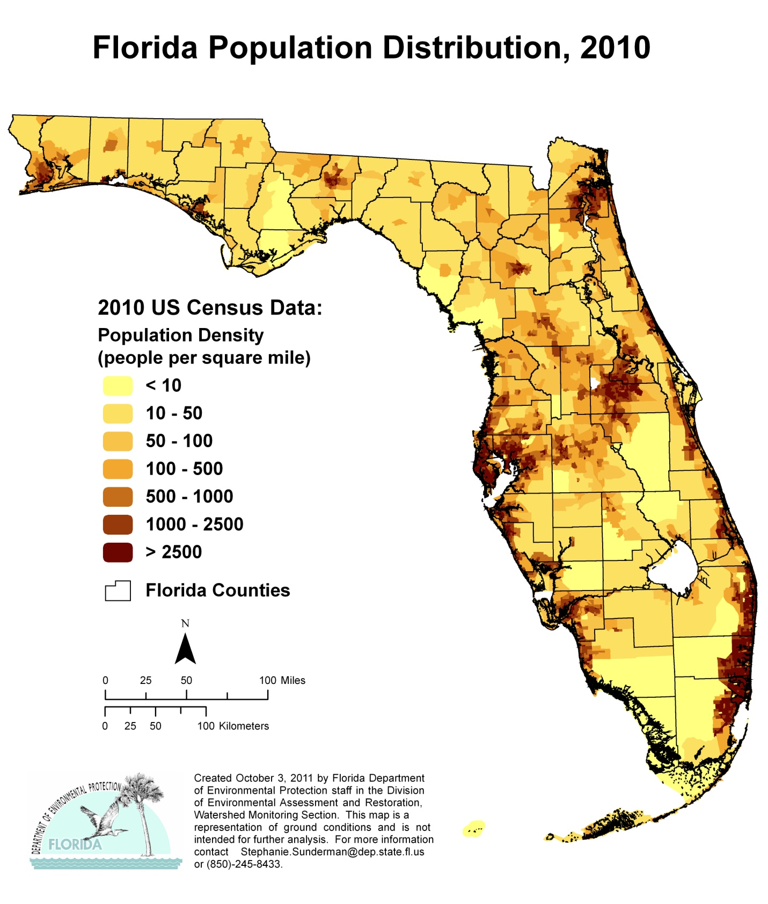

Figure 2.1. Florida’s Population Distribution, 2010

Figure 2.2. Florida’s Average Annual Rainfall, 1981–2010

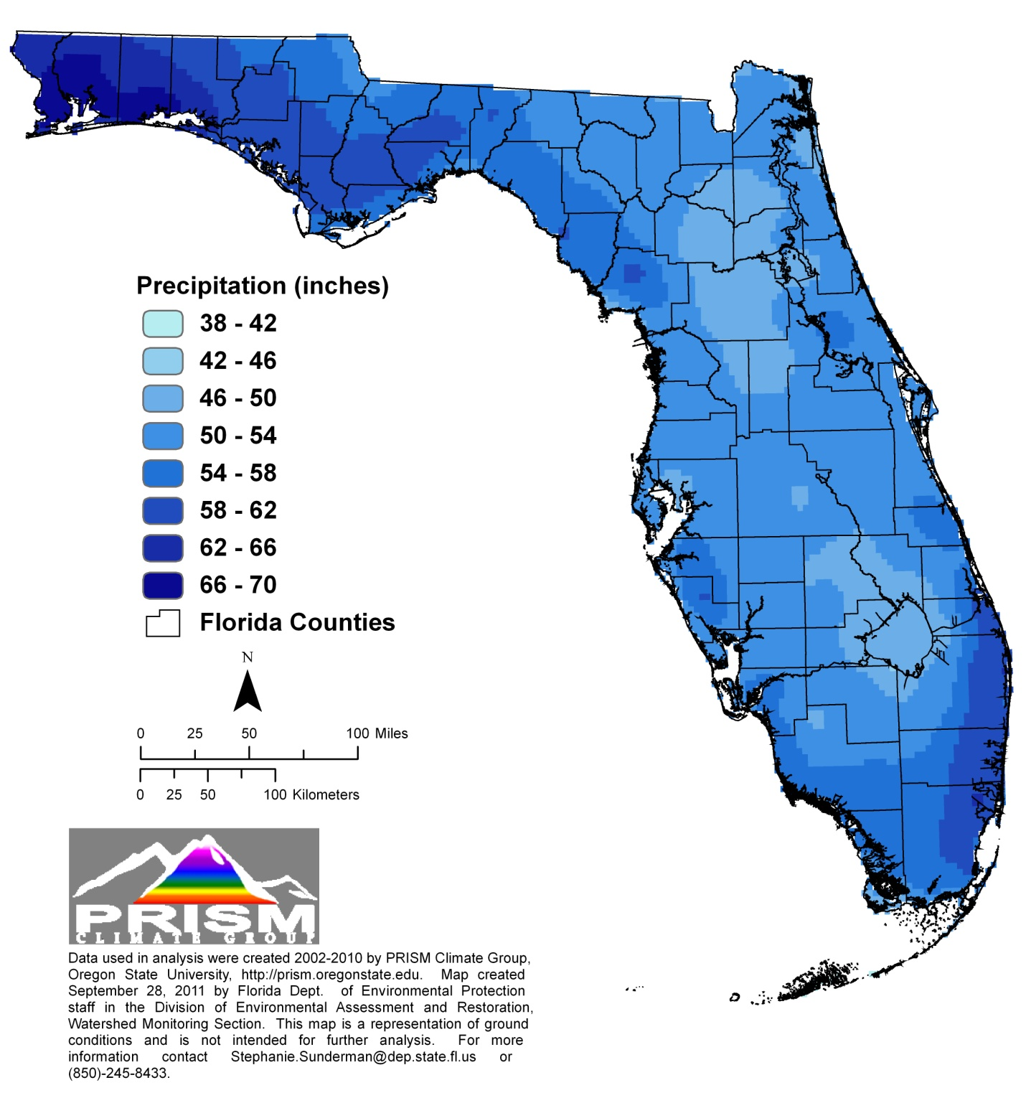

An approximate diagonal line drawn from the mouth of the St. Johns River at the Atlantic Ocean to the boundary of Levy and Dixie Counties on the Gulf of Mexico depicts a climatic river basin divide. North and northwest of the divide, streams have high discharges in spring and late winter (March and April) and low discharges in the fall and early winter (October and November). A second low-water period occurs from May to June. South of the climatic divide, high stream discharges occur in September and October, and low discharges occur from May to June.

Surface Water and Ground Water Resources
Even though Florida has many water sources, it is critical to the state’s well-being that both water quality and quantity be protected. The state has 54,836 miles of streams and rivers and 49,128 miles of ditches and canals. It has more than 12,288 lakes greater than 10 acres in size, with a total surface area of 1,811,329 acres. Florida also has 16,812 square miles of freshwater and tidal wetlands, and a coastline ranking second in length only to Alaska. A line running from the northeast corner of the state to Key West and back up to the northwest corner along the Gulf Coast would extend 1,350 statute miles (U.S. Census Bureau 2010b). If the distance around barrier islands and estuaries (tidal shoreline) were included, the line would stretch 8,426 statute miles (U.S. Census Bureau 2010b). Several sources of high-quality ground water underlie virtually all of Florida. Ninety percent of the state’s population relies on these ground water resources for their drinking water. Springs, another ground water resource, are very prominent throughout the state.

Streams and Rivers
The state has more than 1,700 streams and rivers. Differences in climate, hydrogeology, and location all affect their water quality. The longest river entirely in the state is the St. Johns, which flows north as a recognizable stream about 273 miles from the St. Johns Marsh in northern St. Lucie County, to its mouth at Jacksonville. The river drains a land area equal to about one-sixth of Florida's surface. The Apalachicola River, in the Florida Panhandle, has the largest discharge flow, averaging more than 25,374 cfs from 1977 to 1992. Its basin, draining about 19,600 square miles within Alabama, Georgia, and Florida (Northwest Florida Water Management District [NWFWMD] 2012), extends to north Georgia’s southern Appalachian Mountains. In the Panhandle, spring discharges give rise to rivers, where the ground water base flow comprises 80% of river flows.
The state has several types of natural river systems, including blackwater streams, spring runs, and estuarine or tidal streams, and these systems can be perennial or intermittent. Most of Florida’s rivers exhibit characteristics of more than one type of river system, either at different places along their length or at different times of the year. The links between surface water and ground water can also affect natural systems. For example, the Suwannee River, which originates in the Okefenokee Swamp as a blackwater stream, becomes spring fed south of Ellaville. During periods of high flow, it carries sand and sediments, behaving like a true alluvial stream (sediment carrying). During low flow, however, the river’s base flow comes from multiple springs, including several first-magnitude springs. These variations in flow affect the downstream stretches of the river and the receiving estuary. Ground water in the region has elevated nitrate concentrations that can affect animals and plants downstream (Suwannee River Water Management District 2010).
In north and northwest Florida, many rivers are alluvial. The Choctawhatchee, Apalachicola, and Escambia Rivers best represent this type of river. Common features include a well-developed floodplain, levees, terraces, oxbows, and remnant channels (sloughs) that parallel the active riverbed. Typically, because flows fluctuate more than with other types of rivers, habitats are more diverse.
Florida contains many blackwater streams and rivers. Blackwater rivers usually have acidic, highly colored, slowly moving waters containing few suspended sediments. These systems typically drain acidic flatwoods or swamps. The upper Suwannee River and north New River are examples of this type of river system.
Many major river systems that originate as springs are found in central and north Florida, the Big Bend area of the Gulf Coast, and the southern portion of the Tallahassee Hills. Chemically, these rivers are clear, alkaline, and well buffered. They have little temperature variation, relatively constant flows, and little sediment. Their clear water encourages the growth of submerged plants that provide habitat for diverse animal species. Many spring-fed rivers flow directly into estuaries, and the constant temperatures offer protection from temperature extremes to a number of species, including estuarine fish such as spotted seatrout and red drum, as well as marine mammals, such as manatees.
Major dams have been built on the Apalachicola, Ocklawaha, Ochlockonee, Hillsborough, and Withlacoochee (Citrus County) Rivers. The most extreme alterations were damming the Ocklawaha to create the Cross-Florida Barge Canal and channelizing the Kissimmee River. The hydrology of the southern third of Florida's peninsula has been significantly altered, and few naturally flowing streams and rivers remain. Most fresh waterbodies in south Florida are canals.
Several efforts are under way to reverse some of the alterations, thus restoring natural flows and function to waterbodies. Significant work on the Kissimmee River since the 1990s has successfully restored flow in portions of the historical river channel, leading to improved habitat, fisheries, and water quality. Additional information on the Kissimmee restoration is available on the South Florida Water Management District Kissimmee River website.

Lakes
Florida's lakes provide important habitats for plant and animal species and are a valuable recreational resource. The state has more than 12,288 lakes, which occupy approximately 4% of its surface area. The largest, Lake Okeechobee (covering 423,680 acres), is the 9th largest lake in surface area in the United States and the second largest freshwater lake wholly within the conterminous United States (Fernald and Purdum 1998). Most of the state’s lakes are shallow, averaging 7 to 20 feet deep, although many sinkhole lakes and parts of other lakes can be much deeper.
Florida’s lakes are physically, chemically, and biologically diverse. Some lakes are spring fed; others are seepage lakes fed by ground water, and still others are drainage lakes fed by surface water sources. Most Florida lakes are seepage lakes—nearly 70% of the lakes in Florida have no surface water streams flowing into or out of them (Palmer 1984). Florida lakes are classified according to water pH, water color, and the ecoregion of the lake basin. The Department identified 47 different lake regions as part of its Lake Bioassessment/Regionalization Initiative.
Within each lake region, the lakes have similar geology, soils, chemistry, hydrology, and biology, and lakes in one region may differ significantly from those in another region. For example, most lakes in the New Hope Ridge/Greenhead Slope lake region in northwestern Florida (Washington, Bay, Calhoun, and Jackson Counties) have lower total nitrogen (TN), lower total phosphorus (TP), lower chlorophyll concentrations, and higher clarity compared with other Florida lakes. In contrast, lakes in the Lakeland/Bone Valley Upland lake region in central Florida (Polk and Hillsborough Counties) have higher TN, higher TP, higher chlorophyll concentrations, and lower clarity. Additional information on Florida lake regions and the ecology of Florida’s lakes is available from the LAKEWATCH website and the EPA Ecoregions of Florida website.

Estuaries and Coastal Waters
With more than 8,400 coastal miles, Florida is second only to Alaska in amount of coastline. The state’s west coast alone contains almost 22% of the Gulf Coast estuarine acreage in the United States. Florida's estuaries are some of the nation's most diverse and productive. They include embayments, low- and high-energy tidal salt marshes, lagoons or sounds behind barrier islands, mangrove swamps, coral reefs, oyster bars, and tidal segments of large river mouths. Florida has more Estuaries of National Significance (Tampa Bay, Sarasota Bay, Charlotte Harbor, and Indian River Lagoon), designated by EPA, than any other state in the nation.
The Atlantic coast of Florida from the mouth of the St. Marys River to Biscayne Bay is a high-energy shoreline bordered by long stretches of barrier islands, behind which lie highly saline lagoons. This 350-mile stretch of coast contains only 18 river mouths and inlets. Biscayne Bay spans the transition from high- to low-energy shorelines.
At the southern end of the state lie Florida Bay and the Ten Thousand Islands, both of which are dominated by mangrove islands fronting expansive freshwater marshes on the mainland. Many tidal creeks and natural passes connect the islands and marshes. Historically, the area’s fresh water came mainly from sheet flow across the Everglades.
Florida's west coast has low relief, and the continental shelf extends seaward for many miles. Unlike the east coast, numerous rivers, creeks, and springs contribute to estuarine habitats. Generally, the west coast’s estuaries are well-mixed systems with broad variations in salinity. They often lie behind low-energy barrier islands or at the mouths of rivers that discharge into salt marshes or mangrove-fringed bays. The Big Bend coast from the Anclote Keys north to Apalachee Bay is low-energy marsh shoreline. While it does not conform to the classical definition of an estuary, its flora and fauna are typically estuarine. Many freshwater rivers and streams feeding the shoreline here are either spring runs or receive significant quantities of spring water. The Florida Panhandle from Apalachee Bay west to Pensacola Bay comprises high-energy barrier islands, with sand beaches fronting the Gulf of Mexico.
Major coastal and estuarine habitats vary from northern to southern Florida. Salt marshes dominate from Apalachicola Bay to Tampa Bay and from the Indian River Lagoon north to the Georgia state line, while there are few salt marshes west of Apalachicola Bay. Mangrove swamps dominate the southwestern Florida coast and are found along the southeastern coast. There are about 6,000 coral reefs between the city of Stuart on the Atlantic Coast south and west to the Dry Tortugas. Seagrasses are most abundant in the Big Bend region, from Tarpon Springs to Charlotte Harbor, and from Florida Bay to Biscayne Bay (Hale et al. 2004).

Wetlands
Because of its low elevation and peninsular nature, Florida has many varied types of wetlands, including estuarine Spartina and mangrove salt marshes, as well as freshwater sawgrass marshes, cypress swamps, and floodplain marshes. Wetlands comprise almost one-third of the state. The largest and most important are as follows:
The Everglades and the adjacent Big Cypress Swamp. Including the Water Conservation Areas (diked portions of the original Everglades system) and excluding the developed coastal ridge, this system extends from about 20 miles south of Lake Okeechobee to Florida Bay.
The Green Swamp in the state’s central plateau.
The Big Bend coast from the St. Marks River to the (south) Withlacoochee River.
Vast expanses of Spartina salt marsh between the Nassau and St. Mary’s Rivers.
The system of the St. Johns River marshes. Before alteration by humans, all but the northernmost one-fifth of the river basin was an extensive freshwater system of swamps, marshes and lakes (Kushlan 1990). Even today, half of the length of the St. Johns River is actually marsh, and in many respects it functions like a northern-flowing Everglades.
The headwaters and floodplains of many rivers throughout the state, especially the Apalachicola, Suwannee, St. Johns, Ocklawaha, Kissimmee, and Peace Rivers.

In the past, many wetlands were drained for agriculture and urban development, and numerous rivers were channelized for navigation. The modifications were most intense in south Florida, where, beginning in the 1920s, canals and levees were built to control flooding and to drain wetlands. These modifications resulted in the loss of much of the original Everglades wetlands from Lake Okeechobee south. The Everglades restoration under way is intended to improve water quality. There are preliminary successes; however, restoration is a long-term effort involving many agencies working to revitalize the heavily altered system.

Aquifers and Springs
Florida lies atop aquifer systems that provide potable water to most of the state’s population. Ground water naturally discharges into streams, lakes, wetlands, coastal waters, and springs. Florida has more than 1,000 known springs (Florida Department of Environmental Protection 2011), which discharge a total of about 17,017 cfs; the state may contain the largest concentration of freshwater springs on Earth. The largest coastal spring by discharge is Spring Creek Springs, with an average discharge of 2,000 cfs; the largest noncoastal spring, Silver Springs, has an average discharge of 851 cfs. Florida also contains 33 of the 78 first-magnitude springs (defined as springs that discharge on average at least 100 cfs) in the United States (Figure 2.3). Several river systems in the state originate as or are largely supported by spring discharges.
Archaeological evidence indicates that humans have been attracted to Florida’s life-giving springs for thousands of years. Fourteen of Florida’s state parks named for springs attract millions of visitors each year, and private spring attractions and parks are a multimillion-dollar tourist industry.
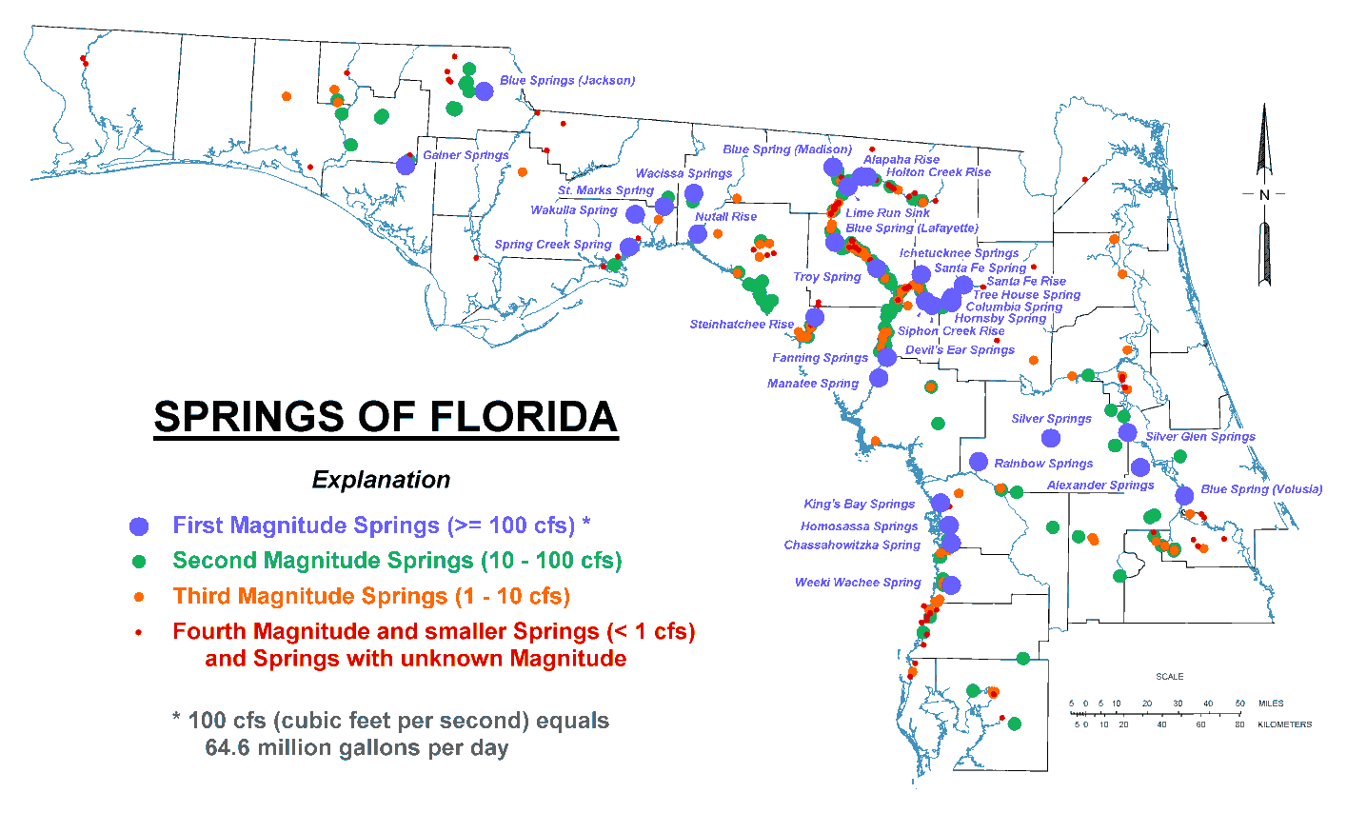
Figure 2.3. Springs of Florida

Hydrogeology

Surface Water
Most of Florida is relatively flat. At 345 feet, Britton Hill (near Lakewood, in Walton County) has the highest elevation in the state (americasroof.com website 2010). The longest river, the St. Johns on Florida’s east coast, only falls about a tenth of a foot per mile from the headwaters to the mouth. Surface drainage and topographic relief are greatest in the streams and rivers entering north and northwest Florida from Alabama and Georgia. Most of these streams are alluvial, or sediment carrying. As the land flattens farther south, surface drainage becomes less distinct, and the rivers and streams are typically slower moving, meandering, and nonalluvial.
Many of Florida’s rivers have their headwaters in wetlands. In its natural setting, the Green Swamp in central Florida is the headwater for five major river systems: Withlacoochee (South), Ocklawaha, Peace, Kissimmee, and Hillsborough. In north Florida, the Suwannee and St. Marys Rivers originate in the Okefenokee Swamp. Throughout the state, smaller streams often disappear into wetlands and later re-emerge as channeled flows.

Ground Water
Florida is in the Coastal Plain physiographic province, which is blanketed by surficial sands and underlain by a thick sequence of bedded limestone and dolomite. Together the surficial sands, limestone, and dolomites form enormous reservoirs that provide proportionally larger quantities of ground water than is found in any other state.
These sources of high-quality, potable ground water underlying virtually all of Florida supported average withdrawals of more than 4,247 million gallons per day (MGD) in 2005 (Marella 2009). This remarkable resource supplies more than 90% of the drinking water for more than 18 million residents. In addition, ground water resources supply over 50% of all water needs, including agricultural, industrial, mining, and electric power generation.
Florida primarily relies on the following four aquifer systems as drinking water sources:
- The Floridan aquifer system, one of the most productive sources of ground water in the United States, extends beneath all of Florida, southern Georgia, and adjoining parts of Alabama and South Carolina. Many public water systems—including those of Jacksonville, Orlando, Clearwater, St. Petersburg, and Tallahassee—tap into the Floridan. It is also a major supplier of water for industrial, irrigation, and rural use. This aquifer provides 60% (4,124 MGD) of Florida’s potable water supplies.
- Unnamed surficial and intermediate aquifers, which are present over much of the state, are used when the deeper aquifers contain nonpotable water. They supply water needs for about 10% of the population, especially in rural locations. These aquifers provide 20% (1,375 MGD) of the state’s potable water supplies.
- In southeast Florida, the Biscayne aquifer supplies virtually all the water needs for over 4 million residents in densely populated Dade, Broward, Palm Beach, and Monroe Counties. This aquifer provides 18% (1,237 MGD) of Florida’s potable water supplies. The EPA has designated the Biscayne aquifer as a sole source drinking water aquifer.
- The sand and gravel aquifer, the major source of water supply in the western part of the Florida Panhandle, provides 2% (137 MGD) of Florida’s potable water.

Surface Water–Ground Water Interactions
Florida’s low relief, coupled with its geologic history, has created unique hydrogeologic features. Large areas are characterized by karst topography, which forms when ground water dissolves limestone. Landforms in these areas include streams that disappear underground, springs and seeps where ground water rises to the surface, sinkholes, and caves. Surface water commonly drains underground and later reappears, sometimes in a completely different surface water basin from where it entered the ground. For example, drainage from a large karst area in Marion County provides water for Silver Springs and Rainbow River, which discharges to the Ocklawaha River and then to the St. Johns River and the Atlantic Ocean. Karst areas in western Marion County provide water for Rainbow Springs, which discharges to the Withlacoochee River and then to the Gulf of Mexico. The entire Suwannee River drainage basin depends on ground water discharge via springs to support base flow to rivers.
Florida's porous and sandy soils, high average rainfall, and shallow water table promote close and extensive interactions between ground water and surface water. By the same mechanisms, surface waters recharge underlying aquifers. The fact that Florida contains more than one-third of the first-magnitude springs in the United States is an indication of significant ground water and surface water interchange in the extensive areas of the state dominated by karst terrain. Most lakes and streams receive water from and discharge water to ground water. In general, ground water base flow can be 40% to 60% of the total stream flow, and in karst areas where springs discharge, it can provide 70% to 80% of the flow to streams.
Although there are many surface water–ground water interactions, a hydrologic divide exists that interrupts the movement of Florida’s water resources. The divide is represented by an approximate line extending from near Cedar Key on the Gulf Coast to New Smyrna Beach on the Atlantic Coast. Except for the St. Johns and Ocklawaha Rivers, little, if any, surface water or ground water flows south across this barrier. Most major rivers north of the line receive part of their discharges from outside Florida, in addition to rain. South of the divide, rain is the sole fresh water source. Hydrologically, the half of Florida lying south of the divide is isolated. About 75% of the state’s population lives in this area in peninsular Florida.

Chapter 3: ISSUES OF ENVIRONMENTAL INTEREST and Initiatives
This chapter describes the major water quality issues of environmental interest and initiatives being undertaken by the state. It is important to note that Florida has well-established programs, including the permitting and TMDL programs, that address these issues, and that Florida has made great progress in reducing pollutant discharges to state waters and restoring impaired waters. Chapter 11 describes these programs in detail, as well as specific initiatives designed to address emerging concerns. Specific examples of the progress that Florida has made towards reducing nutrient pollution in the Indian River Lagoon, Lake Apopka, Sarasota Bay, and Tampa Bay are available on the EPA’s Watershed Improvement Summaries website.
In addition to these programs and initiatives, the Department has launched the Florida Water Resources Monitoring Council (FWRMC), in order to facilitate discussion and communication among monitoring stakeholders throughout the state. The council comprises federal, state, local, and volunteer monitoring organizations, and is chaired by the Department. It is implementing action items in a plan developed by an earlier iteration of the FWRMC.
Until the advent of the FWRMC, there had been no single venue to determine whether entities were monitoring the same waterbody, or at the same station. The group will undertake the development of a statewide monitoring atlas to display the locations of monitoring stations and the entities responsible for monitoring these sites. Metadata associated with the sites will be made available via this platform to better facilitate the monitoring programs’ design and specifics.
Other initiatives will include developing regional councils, establishing a salinity-monitoring network based on existing monitoring stations, establishing better coordination and liaison between freshwater and marine monitoring efforts, and providing a mechanism for data providers throughout the state to offer input for developing a STORET-style data repository that manages Florida’s monitoring data before they are submitted to the EPA’s Water Quality Exchange (WQX) database.

Issues of Environmental Interest

Drinking Water
The Department has the primary role of regulating public water systems in Florida, under Chapter 403, Part IV, F.S., and by delegation of the federal program from the EPA. The section entitled Overview of Ground Water Protection Programs in Chapter 11 describes the Department’s ongoing efforts to protect drinking water supplies.
A public water system (PWS) is one that provides water to 25 or more people for at least 60 days each year or serves 15 or more service connections. These public water systems may be publicly or privately owned and operated. There are more than 5,500 PWSs in Florida serving over 19 million residents. Community water systems regularly test for over 80 contaminants, including bacteria, metals, organic and synthetic chemicals, and radiological parameters. Florida’s compliance rate is one of the nation’s highest and ranges from 91% to 96% annually. The contaminants of greatest occurrence and concern are total coliform bacteria and the disinfection byproducts of trihalomethane and haloacetic acid. Systems that do have a violation of standards must inform the public and take corrective action to fix the problem, install additional treatment, or modify their operations. Additional information is available on the Department’s Drinking Water Program website.
The Florida Department of Health (FDOH) and the county health departments regulate very small water systems that provide water for public consumption, but that do not fall under the definition of public water systems. Additional information is available on the FDOH Bureau of Water Programs website. The WMDs regulate the construction of water wells, both public and private, and the quantities of water that may be extracted. The use of drinking water from private wells is not regulated, but the Department and FDOH have a program to monitor water quality from private wells in areas where ground water contamination is suspected and to assist well owners with water treatment or alternative drinking water sources.

Arsenic
Arsenic has been detected in ground water samples from potable water wells and monitoring wells throughout Florida. Regions with high arsenic ground water exceedance levels include the Springs Coast, Lower St. Johns, Ocklawaha, Suwannee, Withlacoochee, and Tampa Bay Tributaries Basins. To date, samples from more than 1,400 private wells in Florida have been found to exceed the 10 micrograms per liter (µg/L) drinking water standard for arsenic (Rule 62.550, F.A.C.). The largest numbers of arsenic-contaminated wells have been found in Hernando, Dixie, Pasco, and Hillsborough Counties.
Arsenic in ground water may occur naturally, may be introduced as a contaminant, or may be released from the geologic material into ground water because of human activities. Throughout Florida, arsenic is a stable element often found in association with pyrite, a minor mineral found in most of Florida’s aquifer systems. Also, a recent unpublished study suggests that arsenic may occur in association with the mineral powellite, although much less is known about its distribution in Florida rocks.
Potential anthropogenic arsenic sources include arsenic-based pesticides applied to cotton fields and citrus groves; road, railroad, and power line rights-of-way; golf courses; and cattle-dipping vats (which were reportedly used until the 1960s). As of 2012, the use of arsenical pesticides is restricted only to cotton fields. However, residues from past use, when bound to soil particles, do not readily dissipate. Higher numbers of reported exceedances may also be an artifact of the change in the EPA arsenic standard for ground water, which was reduced from 50 to 10 μg/L in 2001, and was fully implemented in 2006.
Recent studies indicate human disturbance that introduces water or oxygen into arsenic-bearing limestone can lead to the release of soluble arsenic from the rock matrix. Activities such as mining, well drilling, Aquifer Storage and Recovery (ASR) projects (Arthur et al. 2002; Price and Pichler 2006), or overpumping have all been shown to release previously stable arsenic into ground water. In addition, drought can lower the water table, allowing oxygen to permeate and leach arsenic compounds from sediments.

Nitrate
Contamination of wells by nitrate remains one of Florida’s most significant ground water quality concerns. This occurs mainly in rural areas where the population is served by private wells and where agriculture is the dominant land use. However, it can also be a problem in localized settings where domestic onsite waste treatment and disposal systems (septic systems) are clustered. From 1999 to the present, more than 2,700 private drinking water wells have been found to be contaminated by nitrate at concentrations greater than the 10 milligrams per liter (mg/L) drinking water standard. Most of these have been found in areas where farming occurs on well-drained sandy soils and the aquifer is vulnerable, but a smaller percentage have been found in areas where septic tanks could have been the source.
The largest numbers of wells found contaminated by nitrate are in counties that lie within the ridge citrus-growing region (Highlands, Polk, Lake, and Orange Counties). Soil in this area is sandy, low in fertility, and tends to leach fertilizer, and the underlying ground water resource used for water supply is highly vulnerable to contamination. Citrus growers need to fertilize frequently and at higher rates, and private wells near the groves can become contaminated. Other counties with extensive agriculture and similar soil and ground water conditions that have led to a significant number of nitrate-contaminated wells include Hillsborough, Hardee, Suwannee, and Jackson.
Ground water contamination by nitrate remains an ongoing problem and a challenge to water resource managers. One effort to reduce fertilizer leaching into wells is the implementation of agricultural best management practices (BMPs) by farmers. Another aspect that may be reducing contamination is the land use transition from agricultural to residential, resulting in less fertilizer use in some agricultural areas. Also, in some of these transitioning areas, public water supplies have become available to homeowners who were previously on individual wells. These factors may be partially responsible for the decrease in the number of wells found to be contaminated in recent years.

Dieldrin
The insecticide dieldrin was widely used in Florida from the 1950s until 1974, when it was banned by the EPA for all uses except termite control. Its use as a termiticide was banned in 1987. Until the 1974 ban, this pesticide was widely used for insect control for corn, cotton, and citrus. In 2005, FDOH issued a new health advisory limit (HAL) of 0.002 µg/L for dieldrin in drinking water. This new advisory limit is lower than the previous HAL that was used in Florida by 2 orders of magnitude. There is currently no regulatory standard for dieldrin in drinking water.
Despite dieldrin’s low mobility in the soil, it is very persistent and has found its way to ground water throughout the state. Since the new HAL was issued, samples from more than 400 private wells have exceeded the Florida HAL. The counties with the largest number of private well exceedances to date include Dade, Volusia, Jackson, and Lake Counties. The detections of dieldrin in the ground water are not limited to agricultural areas because it was also widely used for termite control beneath buildings in urban areas. The counties with the largest numbers of detections all have sandy soils and vulnerable aquifer systems.
The Department is currently working with FDOH and the Volusia County Health Department to determine the source of dieldrin contamination in a large subdivision near the city of Deland. This contaminated area, as of October 28, 2011, was found to have 113 residential wells with dieldrin detections above the HAL. This is the largest cluster of dieldrin-impacted residential wells identified in Florida to date. These sample results are relatively recent and are not part of the ground water assessments provided in Chapter 10 of this report.

Healthy Beaches Program
As part of Florida’s Healthy Beaches Program, which began in 1998, FDOH monitors the state’s coastal beaches for elevated levels of bacteria. In August 2000, the beach water sampling program was extended to all 34 of Florida's coastal counties through state legislation (Senate Bill [SB] 1412 and House Bill 2145) and funding. With additional funding from the EPA in 2002, the program was expanded to include weekly sampling for fecal coliform and enterococci bacteria at 304 beach locations throughout Florida.
The program has undergone changes in 2011 to reflect the current budget situation. These changes have led to a statewide baseline program that consists of biweekly sampling for enterococci bacteria and the discontinuation of fecal coliform sampling. Also, year-round sampling will continue only in 15 counties, which include Volusia County, those counties south of Pasco County on the west coast, and those counties south of Brevard County on the east coast. In the remaining counties, biweekly sampling will occur from March 1 through October 31. In addition, the geometric mean will no longer be used as a water quality indicator in this monitoring program. If local funding is available, some counties may still sample weekly for enterococci and maintain fecal coliform testing and the geometric mean as a standard.
In a healthy environment, an array of bacteria is normally found in the soil, on plants, on and in ourselves, our pets and other animals, and in water. When concentrations of bacteria are too high, they can present problems, or they can be an indicator of other organisms that can cause problems to humans. Enterococci is one of the two bacteria types that normally inhabit the intestinal tract of humans and animals, and is used as an indicator of fecal pollution.
The presence of elevated levels of these bacteria in water is an indication of possible pollution that may come from stormwater runoff, pets, wildlife, or human sewage. While not necessarily pathogenic, their presence in high concentrations in recreational waters indicates that pathogens may be present. If waste pathogens are present and they are ingested while swimming, or if they enter the skin through a cut or sore, the bacteria may cause illness. The most commonly reported ailments are gastrointestinal distress and skin rashes. The rationale for selecting enterococci for analysis and the implications of the sampling results are described in more detail on the FDOH Florida Healthy Beaches Program website.
When a sample exceeds the single sample maximum of 104 colony-forming units per 100 milliliters of water (CFU/100mL) of enterococci, a resample to confirm the exceedance may be taken immediately; upon confirmation of the exceedance a public health advisory will be issued. If a resample is not collected, a public health advisory will be issued immediately. Local media will be alerted and the public will be notified by way of the media, the Healthy Beaches Program website, and signs posted at the particular beach under advisory.
Florida has a history of very good water quality at most beach locations. Only about 4% of all samples collected for the Healthy Beaches Program return poor results. This is one of the lowest rates in the nation. Of the 100,000 total beach days (every day that an individual beach is open counts as a beach day) in 2011, only about 2,600 beach days included swimming advisories.
The most recent sampling results and information on beach advisories are available on the Healthy Beaches Program website. On the same website is a program overview with the sampling history of the original counties included (1998–2000) and the counties that were added.

Deepwater Horizon (MC252) Oil Spill
On April 20, 2010, an explosion occurred onboard the Deepwater Horizon oil drilling rig off the coast of Louisiana. The explosion was the result of a wellhead blowout that ultimately discharged an estimated 4.9 million barrels of crude oil into the Gulf of Mexico by the time it was finally capped on July 15, 2010.
Preimpact Sampling
Baseline water and sediment samples were collected by Departmental staff from the Division of Environmental Assessment and Restoration (DEAR) and the Office of Coastal and Aquatic Managed Areas (CAMA) starting in Escambia County on April 30, 2010, and concluding in Nassau County on the east coast on July 15, 2010 (see the Florida State Emergency Response Team [SERT] Natural Resource Damage Assessment website for sample locations). The data collected during the baseline sampling were used later as part of the Natural Resource Damage Assessment.
Postimpact Sampling
DEAR established routine beach water quality monitoring for polynuclear aromatic hydrocarbons (PAHs) on June 1, 2010, for the seven westernmost Florida Gulf Coast counties. Samples for a constituent of the Corexit oil dispersants commonly called DOSS (Dioctylsulfosuccinate-NA) were also collected several times throughout the summer. This monitoring was established to provide FDOH with data that it could compare with human health screening levels for petroleum contaminants in order to make decisions regarding beach advisories.
The sampling method used and the media sampled depended on the intended use of the results:
- Routine Beach Water Quality Monitoring – Routine beach quality samples were collected when there was no significant oil contamination in the water to sample. These general water samples were collected weekly at wadable depths. The purpose of this sampling was to monitor beach water quality by county, even if significant oil contamination was not present.
- Targeted – Multiple samples of water or sediment, both affected and unaffected by oil product, were collected in an attempt to characterize water and sediment quality in areas where bathers could not reasonably expect to swim or walk without coming into contact with the product. These data could be compared against human health benchmarks to support beach advisory or closure decisions.
- Dispersant – Dispersant sampling was performed in an attempt to detect or semiquantify the concentration of dispersant in the water where oil contamination has been observed. Samplers avoided getting actual oil product in the dispersant sample. These data were used to support beach advisory or closure decisions.
- Proximity Sampling – Water samples were collected at known distances from oil (tarball, tarmat, sheen, mousse), and the distance was recorded. The samplers intentionally avoided collecting the actual oil product in the water sample. This sampling was performed when the oil contamination was sparse enough that a bather might reasonably expect to swim in the water without coming into contact with significant amounts of oil. These data were compared against human health benchmarks to support beach advisory or closure decisions.
- Oil Characterization – Oil characterization samples were samples of actual oil product (tarball, tarmat, sheen, mousse) used to determine the state of product weathering or for source characterization (fingerprinting). These samples may contain water or sediment/soil in addition to the oil, but the intent was not to quantify the concentration of the oil in the media collected.

Deepwater Horizon oil first hit Florida’s shores on June 4, 2010. A total of 381 water samples were collected from designated beaches within the seven westernmost Florida counties between June 1 and September 9, 2010. Only 19 of these samples contained measurable concentrations of PAHs (see the Department’s Water Sampling Data website). While none of these samples contained PAHs that exceeded the EPA’s May 20, 2010, proposed human health benchmark values (see the EPA’s Human Health Benchmarks for Chemicals in Water ), they did exceed the more conservative FDOH Human Health Screening Values, which were established during the fall of 2010. Almost all of these detects occurred during a 2-week period between June 22 and July 3, 2010, when a weather system and high waves brought large amounts of oil onto Florida’s Panhandle beaches. Perdido Key and the beaches along Fort Pickens National Park were particularly hard hit. Detectable concentrations of DOSS were observed in only 2 of 23 samples with PAHs (also see the Department’s Water Sampling Data website).
The lack of detectable concentrations of PAHs in the oil spill-affected waters off Florida’s western Panhandle beaches was attributed to the significant weathering of the oil during its migration from the spill site off the coast of Louisiana to Florida’s waters. While some oil was observed in the form of a sheen or mousse, the vast majority of oil reaching Florida’s waters was in the form of tarballs or larger tar mats.
Due to the lack of detectable petroleum product in routine water samples from July 4 through September 9, 2010, regular beach water monitoring was discontinued. Routine beach water monitoring was resumed the week of February 7, 2011, from Escambia through Wakulla County, in order to provide assurance to the public that Florida’s beaches were safe for recreational bathing prior to the spring break season. Water samples were collected and analyzed for PAHs and two constituents of the Corexit dispersant, DOSS and DPBE (dipropylene glycol butyl ether [DPBE]). This monitoring was continued until mid-August 2011.
A total of 1,147 samples were collected during this period (see the Department’s Beach Health Results). PAHs were detected in 7 out of 473 samples. However, those 7 samples contained trace levels of naphthalene, which were attributed to sample contamination due to a similar number of hits occurring in the field blank samples and the beach water samples. DOSS was detected in 7 out of 386 samples. These were also attributed to field or laboratory contamination due to a similar number of hits in the field blanks and in the beach water samples. DOSS was present in relatively high concentrations in the absorbent paper used to cover the chemistry laboratory bench tops. DPBE was not detected in any of the 288 samples analyzed.

Bacterial and Mercury Contamination
Assessment results for bacterial and mercury contamination indicate that several human health-related designated uses are not always maintained in Florida’s surface waters. Specifically, primary contact and recreation use support and shellfish harvesting use support are sometimes limited by the presence of bacteria in the water column, and fish consumption use support is commonly limited by the presence of mercury in fish tissue for a number of species in many waters across the state.
It is important to note, however, that these impairments are not based on documented impacts on public health. Florida has extensive monitoring programs that issue beach advisories, shellfish bed closures, and fish consumption advisories when ambient samples reach predetermined thresholds. These thresholds are conservatively designed to protect public health against the potential effects of exposure to bacteria (in water and shellfish) and mercury (in fish tissue).
the Department’s Mercury in Aquatic Ecosystems in Florida website provides information on the mercury issue and links to other useful websites dealing with mercury. Information on the latest fish consumption advisories is available on the FDOH Fish Consumption Advisories website. Information on shellfish bed closures is available on the FDACS Shellfish Harvesting website. Recent sampling results and information on beach closures are available on the FDOH Florida Healthy Beaches Program website.

Harmful Algal Blooms
Florida closely tracks harmful algal blooms (HABs) in fresh waters as well as estuarine and marine waters because of their potential health threat. As with all blooms, their increase in biomass results from a combination of physical, chemical, and biological mechanisms that are for the most part poorly understood. Most HABs are caused by either dinoflagellates or cyanobacteria, but other classes of algae, including diatoms, may form HABs under proper but unknown conditions (Glibert et al. 2005). HABs may produce toxins that can harm humans through exposure to contaminated shellfish, fish, dermal contact, and even the inhalation of aerosols. They can also affect plant and animal communities. Additional information on HABs is available on the FDOH Aquatic Toxins Program website. Any illnesses caused by exposure to harmful algae can be reported to FDOH’s toll-free Aquatic Toxins Hotline (1-888-232-8635).

Freshwater HABs
The occurrence of cyanobacteria (or blue-green algae) blooms has received increased attention in recent years because of their potential to produce toxins that can harm humans, livestock, domestic animals, fish, and wildlife. While blooms of cyanobacteria can occur naturally, they are frequently associated with elevated nutrient concentrations, slow-moving water, and warm temperatures; however, significant blooms can occur almost any time of year due to Florida’s subtropical climate.
Cyanotoxins are bioactive compounds naturally produced by some species of cyanobacteria that can damage the liver (hepatotoxins), nervous system (neurotoxins), and skin (dermatotoxins) of humans and other animals. Several cyanotoxins, namely microcystins and the lyngbyatoxins, are potential tumor promoters. Three classes of cyanotoxins (anatoxin-a, microcystin-LR, and cylindrospermopsin) are on the 2009 EPA Contaminant Candidate 3 List. The EPA uses this list to prioritize research and criteria development.
Potentially toxigenic cyanobacteria have been found statewide in river and stream systems, as well as lakes and estuaries. There are also concerns that freshwater cyanotoxins can be transported into coastal systems. The results of the Cyanobacteria Survey Project (1999–2001), managed by the Harmful Algal Bloom Task Force at the Florida Fish and Wildlife Conservation Commission (FWC) Fish and Wildlife Research Institute (FWRI), indicated that the taxa Microcystis aeruginosa, Anabaena spp., and Cylindrospermopsis raciborskii were the dominant species, while species with the genera Aphanizomenon, Planktothrix, Oscillatoria, and Lyngbya were also observed statewide but not as frequently. Cyanotoxins (microcystins, saxitoxin, cylindrospermopsins, and anatoxin) were also found statewide. Other cyanobacteria of concern in Florida are reported in Abbott et al. (2009).
Measured concentrations of microcystins have been reported in some post-processed finished water from drinking water facilities in Florida. Over a period of about 9 months, the 2000 Cyanobacteria Survey Project focused on water treatment plants that produced drinking water from surface waters. On 6 occasions, microcystin levels (hepatotoxins) in finished samples were above the World Health Organization’s (WHO) suggested guideline level of 1 to 10 μg/L for drinking water. However, this level has a safety factor of 1,000 and is based on long-term exposure. Further, the sample deviation at these low concentrations raised the issue of quality assurance, particularly considering the use of new analytical procedures and the lack of laboratory certification. The results of a 2007 study by the Department’s Bureau of Laboratories indicated that there is as much as an order of magnitude difference in reported values between laboratories using different analytical methods.
Neither the EPA nor Florida has established any water quality standards for cyanotoxins, and the WHO threshold is used as an indicator of potential adverse effects in potable drinking water. There are no established limits for fish tissue concentrations or recreational exposure. The FWC does not discourage people from eating fish from cyanobacteria bloom waters so long as there is no ongoing or recent history of a fish kill and if fish are active and appear healthy on the fishing line. FDOH recommends that people do not drink, recreate, or irrigate with water that is experiencing a cyanobacteria bloom.
Research by the Department’s Bureau of Laboratories on Microcystis aeruginosa bloom samples from Lake Munson in Leon County, Florida, indicates that even nontoxin-producing blooms can contain strains of M. aeruginosa that possess the gene for toxin production. This suggests that, for reasons yet unknown, nontoxin-producing blooms can become toxin-producing blooms under the right environmental conditions. This finding supports the FDOH guidance to stay out of bloom waters regardless of the toxin concentrations that may have been reported, as conditions and toxin concentrations can change rapidly.
Several drinking water facilities in Florida monitor for cyanotoxins. Reports from the WHO and other researchers around the world indicate that conventional treatment processes are effective at eliminating the algae and the toxin, so long as treatment media (e.g., activated carbon) in the systems are maintained. The taste, odor, and color associated with the bloom provide a clear indication of its presence and initiate the use of additional treatment. While these treatment techniques are used to control the taste, odor, and color of the water, they are also very effective at removing or degrading the toxins.
FDOH, the Department, and other state agencies have collaborated to create a new Cyanobacteria Bloom Module in the FDOH Foodborne, Waterborne, and Vectorborne Disease Surveillance System (FWVSS) database. The module allows each potential responding agency (e.g., FDOH and local county health units, the Department, FWC, the WMDs, and FDACS) to enter a new case identification number for a cyanobacteria bloom. This system can send email notifications to the cyanobacteria bloom contacts in each agency whenever a new bloom is reported or a significant update is made to an existing case. The use of the new tool should help improve state agencies’ response to cyanobacteria blooms.

Estuarine and Marine HABS
There are more than 50 marine and estuarine HAB species that occur in Florida with the potential to affect public health, cause economic losses, affect living resources, disturb ecosystems, and generate water quality problems. Any highly concentrated bloom can reduce water quality because decomposing and respiring cells contribute to the reduction (hypoxia) or absence of oxygen (anoxia), the production of nitrogenous byproducts, or the formation of toxic sulfides. Declining water quality can lead to animal mortality or chronic diseases, species avoidance of an area, and reduced feeding. Such sublethal, chronic effects on habitats can have far-reaching impacts on animal and plant communities.
Within the Gulf of Mexico, the National Oceanic and Atmospheric Administration (NOAA) Harmful Algal Bloom Operational Forecast System website provides information on the location, extent, and potential for the development or movement of HABs. The Gulf of Mexico Alliance, a partnership between Alabama, Florida, Louisiana, Mississippi, and Texas, is working to increase regional collaboration to enhance the Gulf’s ecological and economic health. Reducing the effects of HABs is one of its water quality priorities.

Red Tide
While most blooms of the dinoflagellate Karenia brevis occur on the west coast of Florida, red tides occasionally are entrained by the Gulf Stream and move to the east coast. Florida’s red tides may contribute to significant economic losses, causing declines in fisheries and adversely impacting businesses that depend on local tourism. Historically, K. brevis red tides producing brevetoxins, which disrupt normal neurological processes, have caused the most significant problems. Blooms of K. brevis have led to threats to the public from aerosolized toxins or to a lesser extent from Neurotoxic Shellfish Poisoning (NSP), caused the deaths of thousands of fish, and impacted marine mammals, turtles, and birds (Magaña et al. 2003). Fish kills caused by K. brevis were first documented in 1844, but the cause was not identified until the 1946–47 red tide.
Although human shellfish poisonings have been known to occur in Florida since the 1880s, the connection with filter-feeding shellfish, toxicity, and K. brevis red tides was not identified until the 1960s. Over the past 40 years in Florida, human cases of NSP have only occurred when shellﬁsh were harvested illegally from closed shellﬁsh beds or unapproved areas, yet no human fatalities have been recorded. People and marine mammals can experience respiratory irritation and other pulmonary effects when brevetoxins become aerosolized.
FWC–FWRI monitors state waters for K. brevis blooms in cooperation with other state regulatory agencies, such as FDACS, FDOH, and the Department; a volunteer network of boaters, charter boat captains, ﬁshermen, citizens; and Mote Marine Laboratory (MML). All analyses involve either on-site, onboard, or onshore laboratory testing. Results are posted weekly on the FWC–FWRI website and include data from a variety of sources. A toll-free number (1–866–300–9399) is also available to access current Florida red tide monitoring information.
To protect public health during bloom events, FDACS’ Division of Aquaculture closes shellﬁsh areas to harvesting when K. brevis cell counts are above 5,000 cells per liter. They are reopened when test results provided by FWC–FWRI are acceptable. The FDACS Shellfish Harvesting website lists current shellﬁsh area closures. The protocol is in compliance with Florida’s Marine Biotoxin Control Plan (FDACS 2007).
The Harmful Algal Bloom Integrated Observing System is a web-based tool developed by a regional coalition of U.S. and Mexican federal and state agencies, as well as international researchers, to collect and disseminate information on K. brevis.
The historical FWC–FWRI red tide database had a number of inconsistencies, including the presence of data collected for different purposes (experiments vs. monitoring), different sampling efforts over the years, and differences in collection and analysis techniques. Because of these issues, the FWC contracted with biostatisticians at the University of Florida (UF) to analyze the red tide data for long-term trends to determine what statistical conclusions could be drawn. UF concluded that the nature of the data prevented any valid statistical interpretation concerning trends and human influences on K. brevis blooms. A summary of the UF analysis is available on the FWC–FWRI website.
K. brevis blooms are natural events that start offshore; however, there is an ongoing scientific debate on whether land-based human influences affect the longevity and persistence of red tides once they come close to shore. Current available data from the past 10 years suggest that K. brevis blooms may utilize a multitude of nutrient sources, depending on along-shore and offshore locations (Vargo et al. 2008). The data suggest that no single nutrient source (including terrestrially derived nutrients) is sufficient to support these blooms, and while K. brevis can utilize these nearshore sources. There is a salinity restriction on K. brevis survival, which does not occur at salinity levels below 24 practical salinity units (psu), and argues against a direct link to land-based sources of nutrients. While data linking nutrient loading with K. brevis occurrence do not currently exist, the FWC’s FWRI is currently conducting research on this issue.

Other HAB Species
One of the most important HAB species in Florida, other than K. brevis, is the saxitoxin-producing dinoflagellate Pyrodinium bahamense. As a tropical species, it has seldom been observed at bloom levels north of Tampa Bay on the west coast and the Indian River Lagoon on the east coast, where the blooms are generally limited to May through October (Phlips et al. 2006). Pyrodinium can form intense blooms, which have been linked to the bioaccumulation of the neurotoxin in shellfish and fish (Landsberg et al. 2006). While these blooms raise serious concerns about impacts on the ecology of effected ecosystems and human health, the blooms have been occurring naturally at levels toxic to nearshore Florida fishes and seabirds for 25 million years (Emslie et al. 1996).
In Florida, Pyrodinium is most prevalent in flow-restricted lagoons and bays with long water residence times and salinities between 10 and 30 psu. The latter conditions competitively favor Pyrodinium because of its slow growth rates and euryhaline character (Phlips et al. 2006). Blooms also appear to be accentuated during periods of elevated rainfall and nutrient loads to lagoons (Phlips et al. 2010a), suggesting a link between coastal eutrophication and the intensity and frequency of blooms. However, discharges of naturally tannic waters from wetlands during high rainfall events can also produce favorable conditions for this organism. These observations also point to the potential role of future climate trends in defining the dynamics of HAB species in Florida (Phlips et al. 2010a).
The other bloom-forming marine species that could have potentially harmful impacts in Florida are roughly divided into two categories: toxin-producing species and taxa that form blooms associated with other important problems, such as low oxygen concentrations, physical damage to organisms, or general loss of habitat. Potential toxin-producing planktonic marine HAB species include the diatom group Pseudo-nitzschia spp., the dinoflagellates Alexandrium monilatum, Takayama pulchella, Karenia mikimotoi, K. selliformis, Karlodinium veneﬁcum, Prorocentrum minimum, P. rhathymum, and Cochliodinium polykrikoides, and the microflagellates Prymnesium spp., Chrysochromulina spp., and Chattonella sp. (Landsberg 2002). Many of these species are associated with fish or shellfish kills in various ecosystems around the world (Landsberg 2002). Additionally, benthic cyanobacteria and macroalgae blooms have been observed on Florida’s coral reefs and have been associated with mortality and disease events involving various organisms (Lapointe et al. 2004; Paul et al. 2005; Richardson et al. 2007).
Although many HAB species have been observed at bloom levels in Florida (Phlips et al. 2010b), considerable uncertainty remains over the relative toxicity of the specific strains. Certain species of benthic microalgae also produce toxins that can impact human health, such as the ciguatoxin-producing dinoflagellate Gamberdiscus toxicus, implicated in ciguatera incidents in south Florida (Landsberg 2002).
In addition to ichthyotoxic HAB species that directly cause fish kills, the list of HAB species linked to hypoxia or other density-related issues (e.g., allelopathy, physical damage to gills of fish) is very long and includes almost any species that reaches exceptionally high biomass. Examples include the widespread bloom-forming planktonic dinoflagellate Akashiwo sanguinea, in the Indian River Lagoon and the St. Lucie Estuary, and the cyanobacterium Synechococcus in Florida Bay (Phlips et al. 1999; Phlips et al. 2010b). Many ﬁsh kills, particularly those occurring in the early morning hours, are due to low DO levels in the water associated with the algal blooms and are not necessarily the result of toxins.
Another important issue associated with HABs is the loss or alteration of overall habitat quality. Prolonged and intense coastal eutrophication can result in the domination by a select few species, resulting in loss of diversity and alteration of food web structure and function. For example, during major Pyrodinium blooms, 80% to 90% of total phytoplankton biomass is attributable solely to this species (Phlips et al. 2006). Similar domination by a single species occurs in benthic ecosystems, where massive blooms of green and red macroalgae have periodically over-run some shallow habitats of the Florida coast (Lapointe and Bedford 2007).
The FWC responds to discolored water, ﬁsh kills, and other mortality or disease events to determine whether the cause is environmental or human related. A statewide ﬁsh kill hotline
(1-800-636-0511) has been in operation for 17 years. The FWC ﬁsh kill database contains information on ﬁsh kills and other aquatic animal health events in Florida reported to the FWC from 1972 to the present. New ﬁsh kill reports can be submitted through the website.

Initiatives
The Department has identified a variety of ongoing and emerging state concerns related to water quality and is addressing these through the following special projects and initiatives:
- Nutrient Impairment. Significant progress has been made in reducing nutrient loads to state waters (see Chapter 11, which summarizes TMDL and BMAP activities that address nutrient loading to impaired waters and describes the permitting programs that have reduced nutrient loading from point sources and from new development). However, nutrient loading and changes in biological communities continue to be an issue. While the occurrence of blue-green algae is natural and has occurred throughout history, algal growth caused by human sources (such as fertilizers and septic tanks) associated with a growing population and the resulting increase in residential landscapes) is an ongoing concern.
The state has collected and assessed large amounts of data related to nutrients. the Department convened a Numeric Nutrient Criteria Technical Advisory Committee (Nutrient TAC) that met 23 times beginning in 2003. The Department began rulemaking for the establishment of numeric nutrient criteria in lakes and streams in 2009, but suspended its rulemaking efforts when the EPA signed a Settlement Agreement that included a detailed schedule for the EPA to promulgate nutrient criteria. The Department provided its data to the EPA, which promulgated criteria in November 2010, with a 15-month delayed implementation date. The Department recently (December 2011) completed its rulemaking process to establish numeric nutrient criteria similar to the EPA’s, but with more specificity concerning assessment and implementation. The Department’s rule also provides criteria for approximately half of the state’s marine waters, with a schedule to finish the remainder by 2015. The EPA is scheduled to propose numeric nutrient criteria for south Florida canals and Florida's estuarine and coastal waters, as well as additional flowing waters criteria designed to protect downstream estuaries (termed “Downstream Protection Values”), in May 2012.
Additional information is available on the Department’s Numeric Nutrient Criteria Development website. The University of Florida Institute of Food and Agricultural Sciences (UF–IFAS) document, A Guide to EPA’s Proposed Numeric Nutrient Water Quality Criteria for Florida, provides summary information.
- Algal Growth in Springs. Water quality has declined in most springs since the 1970s; in particular, levels of nitrate (a nutrient) and blue-green algal growth in springs are widespread. Recognizing the need to assess the status of blue-green algae not just in springs but all waters, in 1998 the Florida Legislature approved funding for the FWC’s Harmful Algal Bloom Task Force. This task force was initiated to address potential concerns regarding microalgae—including blue-green algae—through monitoring and investigation. The state continues to monitor blue-green algae closely and is taking measures to reduce nutrient loading and improve water quality. FDOH’s Aquatic Toxins Program, in coordination with the Department, has derived and implemented several tools to help identify and assess blue-green algae blooms.
- Mercury in Fish Tissue. In many coastal and inland waters, excessive concentrations of mercury in the tissue of some fish species limit the attainment of the designated use of fish consumption. Mercury levels in fish are the leading cause of water quality impairment in Florida’s lakes, coastal waters, and estuaries, and the second leading cause of impairment in the state’s rivers.
To address this issue, the Department initiated the development of a statewide TMDL for mercury in fresh water and estuaries in 2008 that is scheduled to be completed by September 2012. The project consists of gathering and assessing a complex suite of data (on mercury emissions, deposition, and aquatic cycling bioaccumulation) and conducting modeling to quantify the needed mercury reductions in order to address mercury-related impairment in surface waters.
Elements of the proposed statewide mercury TMDL study include the following:
- Collecting comprehensive, highly temporally resolved measurements of wet and dry mercury deposition at four locations, along with a suite of tracers that may be used to link deposition with sources. These sampling areas are referred to as “Supersites.”
- Identifying all significant sources of mercury, whether fixed or mobile, in Florida (an emissions inventory).
- Conducting atmospheric modeling (both dispersion and receptor models) to quantify Florida mercury sources versus those sources outside Florida that must be controlled to satisfy the TMDL.
- Developing an empirical, probabilistic aquatic-cycling model to predict mercury levels in fish as a function of water quality parameters.

About one-third of the freshwater fish sampled in Florida exceed the EPA-recommended methyl-mercury criterion (0.3 mg/kg) for human health. Currently over 300 freshwater waterbodies in Florida have a consumption limit on recreationally caught fish. Twenty species of freshwater fish are under some level of advisory.
Marine and estuarine fish are of particular concern because they are overwhelmingly the primary source of human exposure to methyl-mercury; the consumption of these species accounts for more than 90% of Americans’ total fish consumption. For the entire coast of Florida (Gulf and Atlantic), over 60 species of marine fish are under a limited consumption advisory due to mercury in fish. In addition, the five states bordering the Gulf of Mexico (as well as Florida’s entire Atlantic coast) have issued a “do not eat” advisory for king mackerel, a marine species. The FDOH Fish Consumption Advisories website contains the most up-to-date information for Florida.
The Gulf of Mexico is a very significant fishery, accounting in 2010 for 16% of the nation’s marine commercial fish landings and 41% of the marine recreational fish catch. Because mercury levels in a high proportion of fish in the Gulf exceed the recommended EPA fish tissue criterion for safe consumption (0.3 mg/kg), this waterbody is a significant source of human exposure to methyl-mercury. Currently, about 5% to10% women of childbearing age in the Gulf region are overexposed to mercury from consuming contaminated fish.
The issue of elevated mercury levels in Gulf fish, however, should not be addressed only by the five Gulf states. As with other pollutants such as nutrients, 31 states in the Mississippi River Basin contribute mercury inputs to the Gulf through surface water runoff, and 94% of U.S. Gulf waters are under federal jurisdiction. The Gulf is a single waterbody with fish moving from one state’s waters to another’s, with water currents moving mercury around the Gulf, and with atmospheric emissions of mercury from one state being deposited in other states’ waters; thus a Gulf-wide research and TMDL approach is needed. Currently, the Department is submitting grant applications to the EPA and NOAA for funding for research to assist in developing a Gulf of Mexico mercury TMDL.
- Saltwater Encroachment. Investigations by the Department’s Florida Geological Survey (FGS) and the Watershed Monitoring Section (WMS) indicate that spring flow and ground water levels in many parts of Florida are declining. As they decline, there is a tendency for ground water supplies to be affected by saltwater encroachment. Florida, which is surrounded by high-salinity marine waters, has a “lens” of fresh ground water that “floats” above saline ground water. The overpumping of ground water can induce saline water upwelling and/or marine water encroachment. Ground water usage is becoming a significant environmental challenge, since the state needs plentiful water for drinking, agricultural, and industrial use, and the maintenance of natural communities.
To examine ground water quality concerns, the FGS and WMS have proposed the creation of a new multiagency working group to align local, state, and federal monitoring efforts. Beginning in 2011, the Department, along with other state agencies, the WMDs, and the USGS, have been working towards the establishment of a statewide “salinity” ground water monitoring network. The objective of the proposed network will be to monitor saltwater encroachment.
- Arsenic in Ground Water. To address the issue of arsenic contamination in ground water, the Department’s Ground Water and Watershed Monitoring Sections, the FGS, and the Southwest Florida Water Management District (SWFWMD) have initiated two studies to answer the following questions:
- What are the concentrations of trace metals, with an emphasis on arsenic, in each aquifer system in the study area?
- How do the concentrations vary over space and time by aquifer system?
- How are concentrations related to human-induced land use and water use activities?

The first study, completed in early 2011, focused on characterizing natural and anthropogenic sources of arsenic in ground water in the Tampa Bay region. Forty-eight wells, tapping the surficial, intermediate, and Floridan aquifer systems in a four-county area near Tampa Bay, were sampled for arsenic during the wet and dry seasons of 2009.
The analysis evaluated the relationships and interactions among the lithology, water levels, and land use in the area. Of the three factors, land use was found to be the most significant; lithology was found to interact with land use. Study results indicate that managers and policy makers will need to consider the interrelationships between land use and lithology, which may be ultimately understood from investigating geochemical processes.
The current study, which addresses the geochemical influences on the temporal variability of arsenic in private wells, will be completed in late 2012. It is designed to identify geochemical processes relating to the temporal variability of arsenic concentrations in selected wells that tap the Floridan aquifer system. Objectives include the following:
- Examining the temporal correlation between arsenic concentrations and variables potentially contributing arsenic to ground water;
- Developing a better understanding of the relationship between the ground water oxygen-reduction (redox) state and arsenic concentrations in ground water; and
- Evaluating the relationship between solid-phase arsenic and its concentration in ground water.

Monthly monitoring is being conducted at three monitoring wells and three private supply wells at two locations in Florida. The results from the study will ultimately contribute to the overall understanding of the natural and anthropogenic causes of arsenic mobilization.
- Emerging Substances of Concern (ESOCs). In December 2008, a Departmental workgroup released a report on strategies to effectively address a wide variety of potential contaminants in surface water and ground water. These contaminants, which are commonly referred to as ESOCs, include global organic contaminants, endocrine-modulating chemicals, nanoparticles, and biological metabolites. Recent improvements in laboratory analytical methods have enabled the identification of these substances. ESOCs are particularly challenging for regulatory agencies because of their sheer numbers (there are about 14 million commercially available compounds in the United States) and because environmental risk cannot currently be meaningfully assessed for the vast majority of them.
The report identified several potential strategies for addressing ESOCs, including the following:
- Preventing pollution through stakeholder education;
- Assessing ESOCs data quality to better understand the magnitude of ESOCs concentrations in the environment, given the incorrect reporting of ESOCs levels by some key researchers;
- Asking the EPA for specific ESOCs monitoring projects; and
- Improving coordination with federal agencies.

While the report describes all of the strategies, the workgroup concluded that preventing ESOCs from entering the environment is the most effective control strategy, and the Department’s initial efforts to address ESOCs have focused on public education. Additional information and the workgroup report are available on the Department’s Watershed Management website.
Analytes for the 2012 ground water monitoring network will include “tracers,” which are elements that can be measured to determine the presence of products found exclusively in human waste. These compounds, if found in a sample, indicate that other contaminants including ESOCs may be present.
The Department’s Watershed Monitoring Section is also looking into the possible addition of some ESOCs that have been identified in Florida waters from federal studies.
- Ocean Acidification. In 2010, the EPA solicited comments on the topic of ocean acidification with regard to impaired waters assessments and TMDLs. In November 2010, the agency issued guidance to the states on how they should work towards addressing this issue. In response to this guidance, the Department solicited information from researchers within the state in order to help understand the status of this issue in Florida’s coastal waters. Florida has many aquatic species that are sensitive to shifts in pH and site-specific studies in Florida are needed. The Department continues to monitor the progress of research being done within the state but currently has no funded projects under way.
- Revision of Recreational Water Quality Criteria. Based on beach advisories, shellfish bed closures, and ambient water quality monitoring data, concentrations of indicator bacteria above water quality standards in the water column sometimes limit primary contact and recreational use, as well as shellfish harvesting. However, these advisories or closures may not accurately identify the true risk to human health due to the limitations of the criteria used to assess these uses. Current methods for evaluating whether recreational and shellfish-harvesting areas meet water quality criteria are based on the culture of fecal indicator bacteria; these evaluations require 24 hours or more to perform and are not source specific, making them impractical for short-term (same-day) management decision making.
The EPA is currently in the process of revising its 1986 recreational water quality criteria and recently proposed new criteria. The EPA has stated that the revised criteria will continue to include its current culture-based fecal indicator bacteria (e.g., E. coli and Enterococcus) but will also include a more rapid molecular method (e.g., q-PCR general Enterococcus) for bathing beach monitoring; however, this method has a number of disadvantages, as follows:
- It will still not be source specific;
- It will still not be rapid enough for beach managers to use for same day beach notifications unless many new labs are established and sampling strategies are developed to monitor a limited number of beaches per lab in order to facilitate rapid turn-around-times for the analysis and dissemination of results;
- It will result in even greater numbers of waters being listed as impaired with no greater accuracy in predicting risk to human health;
- It will, at least in the short-term, be significantly more expensive than the culture-based methods; and
- It will result in questionable gains in human health protection since the general marker molecular methods are no better at discriminating bacteria associated with anthropogenic sources of fecal matter from those that are naturally present in the environment.

The Department is exploring alternative molecular methods to better distinguish when elevated fecal indicator levels are associated with actual fecal contamination, and not environmental strains of bacteria that have no known association with increased human health risk, in order to prioritize restoration efforts in areas with the greatest probable risk to human health.
- Revision of DO Criteria. Florida’s freshwater DO criterion currently requires that DO “shall not be less than 5.0 mg/L in Class I and III fresh waters. Additionally, normal daily and seasonal fluctuations above this level shall be maintained” (Subsection 62-302.530[31], Florida Administrative Code [F.A.C.]). Florida’s fresh waters are exposed to temperatures ranging from temperate to tropical, and many originate in low-oxygen environments, such as swamps and aquifers. These sources are naturally low in DO and have daily and seasonal fluctuations where DO falls below 5.0 mg/L. Since these levels result from natural conditions and native flora and fauna have adapted to this variability, they generally do not impact a waterbody’s designated use. Furthermore, Subsection 62-302.300(15), F.A.C., states that “the Department shall not strive to abate natural conditions.”
To better understand the natural variability of DO in freshwater aquatic systems around the state, the Department conducted a major DO study in 2005–06. Approximately 350 sites in 6 different waterbody types were monitored quarterly. Data were collected on water quality, water chemistry, and biology. The results of the DO study confirmed that Florida’s existing 5.0 mg/L freshwater DO criterion was not suitable for a large number of the state’s waterbodies. DO concentrations in approximately 70% of the minimally disturbed streams and 52% of the minimally disturbed lakes sampled during the study would inappropriately fail the existing criterion (with 10% of the diel measurements falling below the criterion).
In 2010 and 2011, the Department also assessed available DO data for Florida estuaries and confirmed that, as was the case for fresh waters, many Florida estuaries naturally do not attain the state’s marine DO criterion (“shall not average less than 5.0 mg/L in a 24-hour period and shall never be less than 4.0 mg/L”).
Given that many state waters do not attain the criteria, in 2011, the Department developed draft revised DO criteria for both freshwater and marine waters, and prepared a Technical Support Document, Derivation of Dissolved Oxygen Criteria to Protect Aquatic Life in Florida’s Fresh and Marine Waters. The document was recently peer reviewed, and the Department plans to initiate rulemaking to revise the DO criteria in 2012. Revising Florida’s DO criteria will allow the Department to determine when DO has been altered below these natural conditions and focus its TMDL development and restoration efforts on abating the causes of those alterations.

Chapter 4: Florida’s Approach to Monitoring Surface Water and Ground Water

Background
The Department‘s approach to comprehensive surface water monitoring is designed to meet the monitoring-related requirements of the federal CWA, as well as Florida’s statutory and regulatory monitoring requirements. Broadly stated, these requirements are as follows:
Determine water quality standards attainment and identify impaired waters;
Identify the causes and sources of water quality impairments;
Establish, review, and revise water quality standards;
Support the implementation of water management programs;
Establish special monitoring for unique resources; and
Support the evaluation of program effectiveness.

The Department continues to carry out extensive statewide monitoring in order to meet these federal and state requirements. However, other governmental entities at federal, state, regional, and local levels, as well as volunteer and private organizations, carry out monitoring. The bulk of the data used in this report comes from approximately 79 data providers across the state who conduct ambient monitoring of water chemistry, collect biological data, and sample sediments. In most cases, these data are initially loaded into the FL(orida) STOrage and RETrieval (STORET) database (FL STORET), and annually uploaded to the EPA national STORET database. The Department evaluates these data to establish whether they meet the quality assurance requirements of Rule 62-160, F.A.C., and whether the data can be used to determine the health of the state’s ambient waters. Some qualifiers are placed on these data. For example, by law Florida LAKEWATCH data can be used only for nonregulatory proceedings and cannot be used for regulatory or enforcement activities. Chapter 5 provides additional details on these qualifiers.
Each governmental agency and volunteer or private organization has its own monitoring objectives, strategy, design, and indicators, as well as procedures for quality assurance, data management, data analysis and assessment, and reporting. Data derived by these organizations are beyond the scope of this report. The various federal, state, regional, and local agencies and organizations, including the Department, that carry out water quality monitoring statewide, are as follows:
Federal Monitoring Agencies/Organizations

- Apalachicola National Estuarine Research Reserve
- Avon Park Air Force Range
- Charlotte Harbor National Estuary Program
- Eglin Air Force Base
- Guana Tolomato Matanzas National Estuarine Research Reserve
- Indian River Lagoon National Estuary Program
- National Oceanic and Atmospheric Administration
- Rookery Bay National Estuarine Research Reserve
- Sarasota Bay National Estuary Program
- Tampa Bay National Estuary Program
- U.S. Army Corps of Engineers
- U.S. Environmental Protection Agency
- U.S. Geological Survey

Out-of-State Monitoring Agencies/Organizations

- Georgia Department of Natural Resources

Florida Monitoring Agencies/Organizations

- Charlotte Harbor Aquatic/Buffer Preserves
- Estero Bay Aquatic Preserve
- Florida Department of Agriculture and Consumer Services
- Florida Department of Environmental Protection
- Florida Department of Health
- Florida Fish and Wildlife Conservation Commission
- Florida Marine Research Institute

Regional Monitoring Agencies/Organizations

- Choctawhatchee Basin Alliance
- Loxahatchee River District
- Peace River Manasota Regional Water Authority (PBS&J)
- Pensacola Bay Nutrient Study (Gulf Breeze)
- Northwest Florida Water Management District (NWFWMD)
- South Florida Water Management District (SFWMD)
- Southwest Florida Water Management District (SWFWMD)
- Southwest Florida Water Management District (Coast Project)
- St. Johns River Water Management District (SJRWMD)
- Suwannee River Water Management District (SRWMD)

Local Monitoring Agencies/Organizations

- Alachua County
- Bay County
- Broward County Environmental Monitoring Division
- Charlotte County Storm Water
- City of Cape Coral
- City of Jacksonville
- City of Lakeland
- City of Lynn Haven
- City of Key West
- City of Maitland
- City of Naples
- City of Orlando
- City of Panama City Beach
- City of Port St. Joe Project (Gulf Breeze)
- City of Port St. Joe Wastewater Treatment Plant
- City of Port St. Lucie
- City of Punta Gorda Utilities
- City of Sanibel
- City of Tallahassee
- City of Tampa
- City of West Palm Beach
- Collier County Pollution Control
- Dade County Environmental Resource Management
- East County Water Control District
- Escambia County Utility Association
- Hillsborough County
- Lake County Water Resource Management
- Lee County Environmental Laboratories
- Lee County Hyacinth Control District
- Manatee County Environmental Management
- McGlynn Laboratories and Leon County
- Okaloosa County Environmental Council
- Orange County Environmental Protection Division
- Palm Beach County Environmental Resource Management
- Pinellas County Department of Environmental Management
- Polk County Natural Resources Division
- Reedy Creek Improvement District Environmental Services
- Sarasota County Environmental Services
- Seminole County Public Works Roads/Stormwater
- Seminole Improvement District
- St. Johns County
- Volusia County Environmental Health Lab

Volunteer/Private Monitoring Agencies/Organizations

- Baskerville Donovan, Inc.
- Baywatch
- Biological Research Associates
- Bream Fisherman's Association
- Conservancy of Southwest Florida
- Environmental Research and Design, Inc
- Florida Center for Community Design + Research
- Florida LAKEWATCH (identification of potentially impaired waters only)
- Gulf Power Company
- IMC Agrico/Phosphates
- Janicki Environmental
- The Nature Conservancy of the Florida Keys
- Palm Coast Community Service Corp.
- Sanibel Captiva Conservation Foundation
- Southeast Environmental Research Center

Florida’s Integrated Water Resources Monitoring Program
As discussed earlier, water resource monitoring in Florida is conducted by the Department, the WMDs, local governments, and other entities. Over the past decade, the Department has worked closely with these monitoring entities to establish an Integrated Water Resources Monitoring (IWRM) Program that integrates surface water and ground water monitoring. Since it is fiscally and logistically prohibitive to sample every segment of river or stream, every acre of lake, or each individual monitoring well in the state annually, the IWRM also integrates three tiers of monitoring—statewide ambient monitoring networks that allow statistical inferences to be made about all waters in the state (Tier 1); strategic monitoring for verification of impairment and identification of causative pollutants (Tier 2); and specialized, site-specific monitoring (Tier 3) (Tables 4.1a through 4.1d). These three tiers are composed of several core monitoring programs in the Department’s Division of Water Resource Management and Division of Environmental Assessment and Restoration. These tiers are not to be viewed as a prioritization structure; they simply reflect different categorical objectives.
The IWRM approach is consistent with the 2003 EPA guidance document, Elements of a State Water Monitoring and Assessment Program. In 2009, the Department prepared and submitted a report on these elements for the different monitoring programs. The report, Elements of Florida’s Water Monitoring and Assessment Program, addresses the following 10 elements:
- Monitoring objectives;
- Monitoring strategy;
- Monitoring design;
- Indicators;
- Quality assurance;
- Data management;
- Data analysis and assessment;
- Reporting;
- Programmatic evaluation; and
- General support and infrastructure planning.

This section broadly discusses Elements 1 (monitoring objectives), 2 (monitoring strategy), 5 (quality assurance), 6 (data management), 9 (programmatic evaluation), and 10 (general support and infrastructure planning). The methodology and assessment sections of this report address Elements 3 (monitoring design), 4 (indicators), 7 (data analysis and assessment), and 8 (reporting).

Table 4.1a. The Department's Tier I Monitoring Programs
This is a three-column table. Column 1 lists the program, Column 2 summarizes its activities, and Column 3 lists the water resources addressed.
Program | Summary | Resources Addressed
Status Network | Consists of a probabilistic monitoring design to estimate water quality across the entire state based on a representative subsample of water resource types. | Large lakes, small lakes, rivers, streams, confined aquifers, and unconfined aquifers
Trend Network | Comprises a fixed station design to examine changes in water quality and flow over time throughout the state. | Rivers, streams, confined aquifers, and unconfined aquifers

Table 4.1b. The Department's Tier I and Tier II Blended Monitoring Programs
This is a three-column table. Column 1 lists the program, Column 2 summarizes its activities, and Column 3 lists the water resources addressed.
Program | Summary | Resources Addressed
Spring Monitoring Program | Consists of a fixed station network of freshwater springs intended to enhance the understanding of Florida’s springs, evaluate spring flow, and assess spring health. | First-magnitude springs, second-magnitude springs, subaquatic conduits, river rises, and coastal submarine springs

Table 4.1c. The Department’s Tier II Monitoring Programs
This is a three-column table. Column 1 lists the program, Column 2 summarizes its activities, and Column 3 lists the water resources addressed.
Program | Summary | Resources Addressed
Strategic Monitoring Program | Addresses questions in specific basins and stream segments that are associated with determinations of waterbody impairment for the TMDL Program. | All surface waters based on the schedule in the watershed management cycle

Table 4.1d. The Department's Tier III Monitoring Programs
This is a three-column table. Column 1 lists each program, Column 2 summarizes its activities, and Column 3 lists the water resources addressed.
Program | Summary | Resources Addressed
Intensive Surveys for TMDLs | Provides detailed, time-limited investigations of the conditions of specific surface water resources that are identified as impaired. | Specific surface water resources identified as impaired
Water Quality Standards Development | Develops, evaluates, and revises new and existing surface water quality standards. Carries out monitoring to determine concentrations to protect aquatic life and human health. | Surface water and ground water
Site-Specific Alternative Criteria | Develops moderating provisions unique to a waterbody that does not meet particular water quality criteria, due to natural background conditions or human-induced conditions that cannot be controlled or abated. | Surface waterbodies to which particular ambient water quality criteria may not be applicable
Fifth-Year Inspections | Achieves and maintains compliance through sound environmental monitoring and permitting practices. | Surface waters that receive point source discharges

Element 1: Monitoring Objectives
The goal of the Department’s monitoring activities is to determine the overall quality of the state’s surface and ground water, how they are changing over time, and the effectiveness of water resource management, protection, and restoration programs. Monitoring activities collectively address the following broad objectives:
Identify and document the condition of Florida’s water resources, spatially and temporally, with a known certainty;
Collect data on important chemical, physical, and biological parameters to characterize waterbodies based on thresholds in Rule 62-302, F.A.C.;
Collect data from impaired waters that will be used to evaluate changes over time in response to restoration activities;
Establish a database with known data quality objectives and quality assurance for the purpose of determining a basin’s long-term ecological health and establishing water quality standards; and
Provide reliable data to managers, legislators, agencies, and the public, and aid in management decision making.

Element 2: Monitoring Strategy
Under the Department’s IWRM approach, there are three tiers of monitoring, ranging from the general to the specific, designed to fill data gaps or support specific regulatory needs. Each of the Department’s core monitoring programs has a detailed monitoring design, a list of core and supplemental water quality indicators, and specific procedures for quality assurance, data management, data analysis and assessment, reporting, and programmatic evaluation. The Department relies on both chemical and biological sampling in its monitoring programs, and also conducts the bulk of the biological sampling that is carried out statewide. Tables 4.1a through 4.1d briefly describe the Department’s approach and the water resources addressed for each Departmental monitoring program.
Based on the goals and objectives of each individual core monitoring program, sample locations are selected, monitoring parameters and sampling frequencies are determined, and sample collection and analysis are coordinated among the Department’s six districts and cooperating federal, state, and county agencies. This close coordination with other monitoring entities around the state is essential to prevent duplication and to maximize the number of waterbodies that are monitored on a regular basis.
The Department’s three tiers of monitoring are as follows:
- Tier I consists of the statewide surface water and ground water Status and Trend Networks. The Status Network employs a probabilistic monitoring design to estimate water quality statewide, based on a representative subsample of water resource types. The Trend Network uses a fixed station design to examine changes in water quality over time at selected sites throughout the state. The objective of these networks is to provide scientifically defensible information on the important chemical, physical, and biological characteristics of surface waters and major aquifer systems of Florida. Both networks are designed to measure condition using a variety of threshold values, including water quality standards, water quality indices, and other appropriate ecological indicators.
- Tier II includes the Strategic Monitoring Program, which is designed to address questions in specific basins and stream segments that are associated with determinations of waterbody impairment for the TMDL Program. In addition, this tier includes the Spring Monitoring Program, which encompasses all of the extensive monitoring activities begun in 1999 to address the needs of Florida’s freshwater spring systems.
- Tier III addresses questions that are site-specific or regulatory in nature. Examples of Tier III monitoring activities include monitoring to determine whether moderating provisions such as site-specific alternative criteria (SSACs) should apply to certain waters, monitoring tied to regulatory permits issued by the Department, monitoring to establish TMDLs (intensive surveys), and monitoring associated with evaluating the effectiveness of BMPs. Tier III also includes monitoring activities for the development of water quality standards.

Element 5: Quality Assurance
Because water quality monitoring is carried out by many agencies and groups statewide, the Department has a centralized quality assurance (QA) program to ensure that data are properly and consistently collected. A Quality Assurance Officer coordinates and oversees data quality activities for each program. However, QA is the responsibility of everyone associated with sampling, monitoring, and data analysis. In September 2009, the Secretary of the Department approved a program directive, DEP 972, which further outlines this distributed responsibility, including each employee’s obligation to ensure that decisions are based upon defensible scientific information. Additionally, in support of the QA directive (DEP 972), all organizational units are required to update existing quality assurance manuals and plans describing internal QA procedures and criteria applied to all scientific data generation, review and use. A comprehensive QA report will be compiled from these manuals/plans and submitted to the Secretary of the Department on an annual basis.
Training classes, which are conducted by Departmental staff, focus on program-specific sampling requirements. Any updates or changes to an individual program’s monitoring protocols are communicated through project management meetings, statewide meetings, and an Internet website.
The accuracy of field measurements is assessed through internal Departmental programs. Staff also monitor the on-site sampling environment, sampling equipment decontamination, sample container cleaning, the suitability of sample preservatives and analyte-free water, and sample transport and storage conditions, to control the impact that these activities may have on sample integrity and representativeness.
For each monitoring program, field staff are instructed to follow a comprehensive set of Departmental Standard Operating Procedures (SOPs) for sample collection and field testing (e.g., field meter measurements). These are incorporated by reference in Rule 62-160, F.A.C., Quality Assurance, and are specified in the Departmental document, Standard Operating Procedures for Field Activities (DEP-SOP-001/01, March 31, 2008). Other mandatory quality assurance requirements detailed in Rule 62-160, F.A.C., are also followed.
Water quality samples are sent to the Department’s Central Laboratory for analysis for the majority of programs; however, some external and overflow laboratories are also used. Departmental laboratories have SOPs for handling and analyzing samples; for reporting applicable precision, accuracy, and method detection limits (MDLs); and for reporting data. Laboratory certification is maintained as required by Section 62-160.300, F.A.C. The Quality Assurance Rule (Rule 62-160, F.A.C.) (current effective date of December 3, 2008), requires all entities submitting data to the Department be certified by the National Environmental Laboratory Accreditation Conference (NELAC) through FDOH. The certification process requires the laboratory to develop a comprehensive quality manual for internal operations, analyze performance testing samples twice a year, and undergo periodic systems audits conducted by FDOH inspectors. In addition, other mandatory QA requirements specified in Rule 62-160, F.A.C., are followed. Contracted overflow labs are held to identical QA requirements via detailed contract language.
The sampling and testing performance of field teams is evaluated by auditors from the Department’s QA program, which is administered by the Standards and Assessment Section. Staff from other organizational units who have been trained as auditors also conduct these evaluations. The criteria for field performance are those specified by Rule 62-160, F.A.C., the Departmental SOPs, internal quality manuals or plans, and where applicable, contractual requirements.
The quality of laboratory data and its usability for specific applications is also evaluated by auditors from the Department’s QA program and other organizational units. The criteria for laboratory data usability are those specified by Rule 62-160, F.A.C.; the FDOH certification rule, Rule 64E-1, F.A.C.; the NELAC standards, which are incorporated by reference in Rule 64E-1, F.A.C.; data quality objectives specified in internal Departmental quality manuals or plans; other applicable Departmental program rules; and, where applicable, contractual requirements. In addition, a document describing the data evaluation process (Process for Assessing Data Usability, DEP-EA-001/07, March 31, 2008) is incorporated by reference into Rule 62-160, F.A.C.
Various checklists have been developed to ensure the application of consistent and systematic procedures for auditing field and laboratory data.

Element 6: Data Management
The smooth and timely flow of water quality data from sample collectors and analytical agencies to data analysts is a high priority. The Department’s Bureau of Assessment and Restoration Support and Bureau of Watershed Restoration house or oversee the majority of the surface and ground water resource monitoring programs described in this report. There are program-specific data management requirements; however, these bureaus serve as the principal warehouses for monitoring data. Assisted by cooperating federal, state, and county agencies, sample locations are selected, monitoring parameters and frequencies determined, and sample collection and analysis coordinated to meet data quality objectives.

Element 9: Program Evaluation
The Department, in consultation with the EPA, reviews each monitoring program to determine how well the program serves its water quality decision needs for all state waters. EPA and Departmental QA audits are used in evaluating each program to determine how well each of the EPA’s recommended elements is addressed and how to incorporate needed changes and additions into future monitoring cycles. Additionally, DEP 972 (QA Directive) outlines the Department’s distributed responsibility for ensuring that Departmental programs and organizational units meet established data quality objectives.

Element 10: General Support and Infrastructure Planning
The EPA’s general support and infrastructure planning element is encompassed by a number of activities. The Department’s Central Laboratory provides laboratory support for all the core monitoring programs. Staff from all programs provide substantial support for planning and refining field logistics, and also provide data management, review, analysis and reporting. The results are often used to pursue and implement management actions to address areas of concern via differing program mechanisms.

Evolving Approaches to Monitoring
Florida continues to develop new approaches to monitoring. The Department has developed a number of biological indices to characterize the condition of surface waters and has adopted these indices for use in water resource assessments at all three tiers of monitoring. The following indicators are currently used to measure the biological health of surface waters:
The Stream Condition Index (SCI) is a carefully calibrated macroinvertebrate index for use in flowing streams, and is used as a definitive measure of biological health for impairment. Data generated on the species composition and abundance of organisms in a stream are used to calculate 10 biological metrics (e.g., sensitive taxa, filter feeders, clingers, very tolerant taxa, Ephemeroptera and Trichoptera taxa). Points are assigned for each metric, based on regionally calibrated criteria. The score at which the designated use of the waterbody is being met (threshold) has been determined through analysis of reference site data and a BioCondition Gradient exercise.
The Linear Vegetation Survey (LVS) is a rapid assessment tool for evaluating ecological condition in flowing waters based on vascular plants. To employ the LVS method, a trained biologist surveys a 100-meter segment of a stream, divides the stretch into 10-meter sampling units, and identifies the plant species present to the typical high-water mark, including submersed, floating, and emergent plants. The Department uses the LVS to determine if the stream floral community meets its designated use by a comparison with the reference condition.
The Rapid Periphyton Survey (RPS) is a rapid assessment tool for demonstrating a lack of or abundance of nuisance or problematic algal growth in streams. To conduct the RPS method, a trained biologist visits 99 points within a 100-meter segment of a stream or river, and determines the presence and thickness of algae at each point. If thick algae are abundant, the algae are identified to determine if nuisance taxa are present. The Department uses the RPS to determine if the stream algal community meets its designated use by a comparison with reference condition.
The Lake Vegetation Index (LVI) is a multimetric index to evaluate plant (macrophyte) community health in Florida lakes. Macrophyte species lists are generated during a rapid visual field and transect survey and summarized in four metrics. The score at which the designated use of the waterbody is being met (threshold) has been determined through an analysis of reference site data and a BioCondition Gradient exercise.
A Wetland Condition Index, using vegetation, macroinvertebrates, and algae, has been developed for some freshwater wetland systems (forested wetlands and depressional wetlands; a pilot study for strands and floodplains was completed in 2005). This tool was used to refine the Department’s rapid wetland assessment methodology for permitting and mitigation, and is being used to assess the effectiveness of wetland restoration projects and in other special studies.

Chapter 5: Design for the Status and Trend Networks

Background
The 2002 EPA Integrated Report guidance on the requirements for water quality assessment, listing, and reporting under Sections 303(d) and 305(b) of the CWA states that “. . . a probabilistic monitoring design applied over large areas, such as a state or territory, is an excellent approach to producing, with known confidence, a ‘snapshot’ or statistical representation of the extent of waters that may or may not be impaired. A probabilistic monitoring design can assist a state or territory in determining monitoring priorities and in targeting monitoring activities” (Wayland 2001). Beginning in 2000, the Department’s Status Monitoring Network (Status Network), based on this probabilistic design, provided an unbiased, cost-effective subsampling of these resources. Florida adopted this approach so that the condition of the state’s surface and ground water resources could be estimated with a known statistical confidence. Data produced by the Status Network complement traditional CWA 305(b) and 303(d) reporting.
In addition, the Department has designed a Trend Monitoring Network (Trend Network) to monitor changes in water quality in rivers, streams, and aquifers (via wells) over time. To achieve this goal, sites at fixed locations are sampled monthly or quarterly. The Trend Network complements the Status Network by providing spatial and temporal information about resources and potential changes from anthropogenic or natural influences, including extreme events (i.e., droughts and hurricanes).
The following resources are monitored in the Status and/or Trend Networks:
- Rivers, Streams, and Canals: Rivers, streams, and canals that are sampled include linear waterbodies with perennial flow that are waters of the state (Chapter 403, F.S.) or flow into waters of the state. For the Status Network, canals were included only in the 2009 resource coverage.
- Lakes (Status Network Only): Lakes include natural bodies of standing water and reservoirs that are waters of the state and are designated as lakes on the USGS 24K National Hydrography Dataset (NHD). The lakes population does not include many types of artificially created waterbodies, or streams/rivers impounded for agricultural use or private water supply.
- Ground water (Confined and Unconfined Aquifers): The term ground water, as used here, refers to those portions of Florida’s aquifers that have the potential for supplying potable water or affecting the quality of currently potable water. However, this does not include ground water that lies directly within or beneath a permitted facility’s zone of discharge or water influenced by deep well injection (Class I and II wells).

Neither the Status Network nor the Trend Network is currently intended to monitor estuaries, wetlands, or marine waters. Other sections within the Department regulate and monitor these resources.

Status Network Monitoring
Stratified, random sampling (probabilistic) networks, such as the Status Network, sample predefined geographic subunits (zones) that together comprise the whole state. The resulting data can address questions at statewide and regional (zonal) scales. The Status Network divides the state into six zones (Figure 5.1).
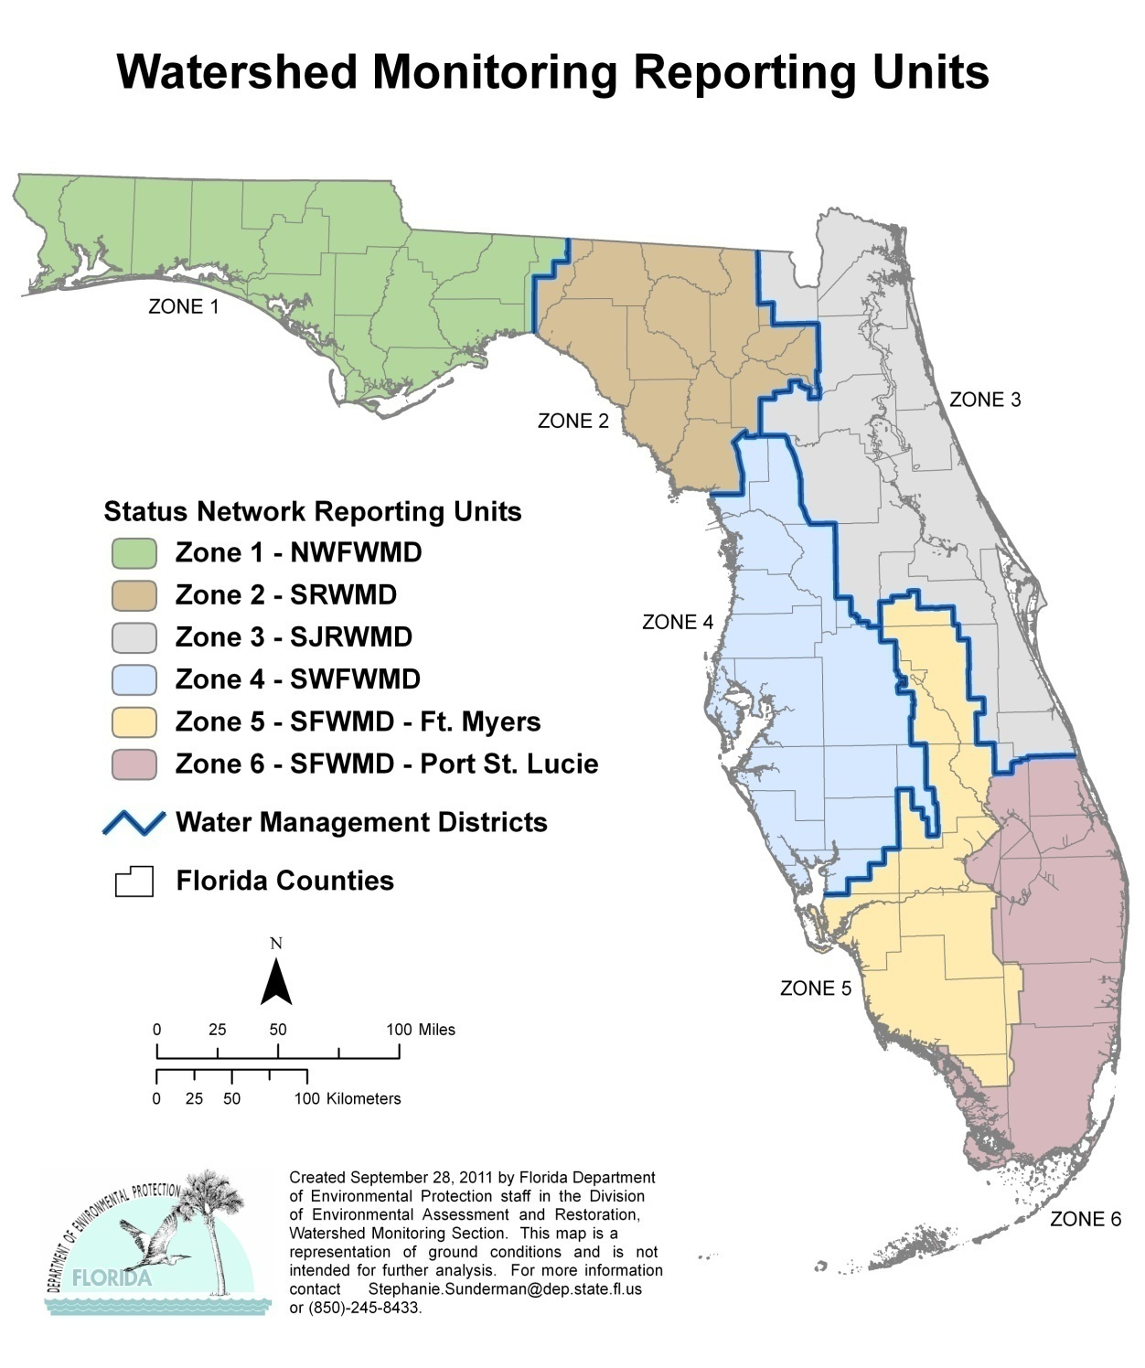
Figure 5.1. Status Monitoring Network Reporting Units

The Status Network uses the Generalized Random Tessellation Stratified (GRTS) sampling design sampling design, supported by the EPA’s Aquatic Resource Monitoring approach, to select sampling sites. Geographic stratification breaks the state into nonoverlapping areas (zones), from which the sample sites are chosen from a target population (list frame) using a spatially balanced site selection process. GRTS design ensures that the sites are representative of the target resources and that their selection is not biased.
The Department adjusted the GRTS sample design due to the unequal distribution of water resources. For example, there are few lakes in the southern portion of the state, which is dominated by wetlands and canals. Other factors, such as periods of drought or denials of access from large landowners, can limit the list of possible sites to sample. Target resource lists are continually updated based on field staff comments.

Water Resource Types
The parent populations for the Status Network are all statewide surface and ground waters. The following water resources are the target populations:
- Surface Water—Florida’s surface waters are diverse and challenging to categorize. Surface waters are divided into two groups: flowing (lotic) or still (lentic). The lotic group consists of rivers, streams, springs, and canals. In Florida, the lentic group consists of many types of natural lakes, including sandhill lakes, sinkhole lakes, oxbow lakes, and established reservoirs. These range in size from less than an acre to over 350,000 acres. Artificial waterbodies, such as stormwater retention ponds, impoundments used for agriculture, golf course ponds, or other man-made water features that are not waters of the state, are common but are not part of the target population and are removed from the resource list frame.
- Rivers, Streams, and Canals—Flowing surface waters that are waters of the state are divided into rivers or streams based on size, as recommended by Departmental and WMD staff. Rivers are initially identified, and the remaining, smaller flowing surface waters are classified as streams. Rivers and streams that are mostly or entirely channelized are deemed canals and are still considered part of the target population in 2009, but excluded in 2010. Segments of rivers and streams that are impounded are not included in this resource.
- Large and Small Lakes—Lakes are subdivided into two populations: (1) small lakes between 2.5 and 25 acres; and (2) large lakes over 25 acres. The differentiation on the basis of size is intended to accommodate different sampling strategies and allows a better representation of the resource types. If all lakes were in one category, the size of large lakes would skew site selection and cause small lakes to be under-represented.

- Ground Water—Ground water resources are subdivided into two target populations for the purposes of sampling and resource characterization:
(1) unconfined aquifers, and (2) confined aquifers. Unconfined aquifers are near the land surface and can be readily affected by human activities. The confined aquifer target population includes aquifers that are below a confining unit. Individual wells are selected annually from an updated list provided to the WMS by various state and federal governmental agencies. The ground water target population is chosen to represent ambient ground water conditions, including public supply wells but avoiding facility wells used for compliance. Compliance wells are not intended to represent ambient aquifer conditions and are excluded from the Status Monitoring Network.

Geographic Design and Site Selection
Location information for the state’s water resources resides in a Geographic Information System (GIS) database. WMS staff use GIS data, with associated information (metadata), to select sample sites. Florida’s 6 zones (Figure 5.1) facilitate the spatial distribution of sites throughout the state. Annually, 10 random sites (primary sites) and a 9-time oversample (alternate sites), for a total of 100 possible sites, are selected from each surface water resource type in each zone, resulting in 600 potential sample sites statewide. Twenty primary sites and a 9-time oversample, for a total of 200 possible sites, are selected annually from each ground water resource type in each zone, resulting in 1,200 potential sample sites statewide. The alternate sites are required due to the high probability of sampling problems, such as landowner denials of access, dry resources, and other challenges associated with random versus fixed station sampling designs.

Sampling and Frequency
The annual goal of the Status Network is to collect 10 samples from each surface water resource type in each zone, for a total of 60 samples statewide and 20 samples from each ground water resource type in each zone, for a total of 120 samples statewide. Figure 5.2 represents the sampling scheme used in 2009 and 2010. Each ground water resource type was sampled over a 2-month period. The surface water resource types were sampled over a 1- month period with a resample (revisit) performed in an opposing season. The results will be used to determine how seasonality affects the results of these analyses.

Figure 5.2. Status Network Sampling Periods for 2009 and 2010

Status Network Core and Supplemental Indicators
While most water quality monitoring has historically focused on chemistry, the Department’s Status and Trend Networks expand this scope to include biological and physical indicators. Together, the chemical, physical, and biological indicators provide scientific information about the condition of the state’s water resources and whether they meet their designated uses based on state and EPA guidance.
Core indicators provide information about the chemical, physical, and biological status of surface and ground water, including suitability for human and aquatic uses. These data can be used to gauge condition based on water quality standards or guidance. Supplemental indicators provide additional information and aid in screening for potential pollutants of concern. Certain biological indicators are collected only in rivers, streams, and lakes (i.e., chlorophyll a). Appendix A discusses the surface water indicators for rivers, streams, and lakes.
These core and supplemental indicators are often chosen to support special projects or used to develop water quality criteria. Some indicators are combined to form indices that evaluate waterbody condition—for example, the Trophic State Index (TSI) uses TN, TP, and chlorophyll a values to provide a broader understanding of a waterbody’s status. Selected indicators, such as chloride, nitrate, and bacteria, serve to assess the suitability of ground water for drinking water purposes. Likewise, the indicator lists for surface water resources are selected to detect threats to water quality, such as nutrient enrichment, which can lead to eutrophication and habitat loss. The Status Network has supported the development of biological indices to evaluate waterbody condition in Florida, and includes sampling for both the Stream Condition Index (SCI) and the Lake Vegetation Index (LVI).
In addition to the suite of water quality indicators (Tables 5.1a through 5.1f), sediment chemistry is a useful supplemental indicator of an aquatic system’s ecological health (Tables 5.2a and 5.2b). Florida has developed geochemical- and biology-based tools to assess sediment quality. The interpretation of sediment metals data is not straightforward because metals occur naturally in Florida sediment. Thus, depending on the source region, Florida sediment metal concentrations range between two orders of magnitude. The Department uses the guidance outlined in An Interpretative Tool for the Assessment of Metal Enrichment in Florida Freshwater Sediment (Carvalho and Schropp et al. 2003), which estimates contamination through the use of a statistical normalizing technique. Additionally, the Department follows the guidance outlined in Development and Evaluation of Numerical Sediment Quality Assessment Guidelines for Florida Inland Waters (MacDonald et al. 2003), a biology-based tool that estimates the effects of potentially toxic contaminants in lake sediments.

Table 5.1a. Status Network Core and Supplemental Indicators for Field Measurements

Note: For Tables 5.1a through 5.1f, all samples are unfiltered unless stated. All methods, unless otherwise stated, are based on EPA 600, Methods for Chemical Analysis of Water and Wastes.

This is a three-column table. Column 1 lists the indicator, Column 2 lists the analytical method numbers, and Column 3 lists the sampled resource(s).

Field Measurement Indicator | Analysis Method | Sampled Resource(s)
pH | Method 150.1 | Lakes, Streams/Rivers, Aquifers
Temperature | Method 170.1 | Lakes, Streams/Rivers, Aquifers
Specific Conductance | Method 120.1 | Lakes, Streams/Rivers, Aquifers
Dissolved Oxygen (DO) | Method 360.1 | Lakes, Streams/Rivers, Aquifers
Turbidity | DEP-SOP-001/01 FT 1600 | Aquifers
Secchi Depth | Welch (1948); EPA 620/R-97/001 | Lakes, Streams/Rivers
Total Depth | Manual/electronic measuring device | Lakes, Streams/Rivers, Aquifers
Sample Depth | Manual/electronic measuring device | Lakes, Streams/Rivers
Micro Land Use | Sampling manual (01/11), Section 4 | Aquifers
Depth to Water | Manual/electronic measuring device | Aquifers

Table 5.1b. Status Network Core and Supplemental Indicators for Biological and Microbiological Indicators
This is a three-column table. Column 1 lists the indicator, Column 2 lists the analytical method numbers, and Column 3 lists the sampled resource(s).

¹ Dropped QPS from rivers and streams on July 22, 2009.
² Adopted new criteria for performing SCI on May 1, 2010.
Biological/Microbiological Indicator | Analysis Method | Sampled Resource(s)
Chlorophyll a | SM 10200 H (modified) | Lakes, Streams/Rivers
Qualitative Periphyton (QPS)¹ | SOP AB03.1, SOP AB03 | Streams/Rivers
Rapid Periphyton Survey (RPS) | SOP FS 7130 | Streams/Rivers
Biological Community (SCI)² | SM 10500 C (modified) | Streams/Rivers
Habitat Assessment | DEP-SOP-001/01 FT 3000 | Streams/Rivers
Lake Vegetation Index (LVI) | DEP-SOP-001/01 FS 7220 | Lakes
Total Coliform | SM 9222B | Aquifers
Fecal Coliform | SM 9222D | Lakes, Streams/Rivers, Aquifers
Enterococci | EPA 1600 | Lakes, Streams/Rivers

Table 5.1c. Status Network Core and Supplemental Indicators for Organic and Nutrient Indicators

This is a three-column table. Column 1 lists the indicator, Column 2 lists the analytical method numbers, and Column 3 lists the sampled resource(s).

¹ Added TOC for aquifers on October 1, 2010.
Organic/Nutrient Indicator | Analysis Method | Sampled Resource(s)
Total Organic Carbon (TOC) | SM 5310 B | Lakes, Streams/Rivers, Aquifers¹
Nitrate + Nitrite | Method 353.2 | Lakes, Streams/Rivers, Aquifers
Ammonia | Method 350.1 | Lakes, Streams/Rivers, Aquifers
Total Kjeldahl Nitrogen (TKN) | Method 351.2 | Lakes, Streams/Rivers, Aquifers
Phosphorus | Method 365.1/365.4 | Lakes, Streams/Rivers, Aquifers

Table 5.1d. Status Network Core and Supplemental Indicators for Major Ion Indicators

This is a three-column table. Column 1 lists the indicator, Column 2 lists the analytical method numbers, and Column 3 lists the sampled resource(s).

Major Ion Indicator | Analysis Method | Sampled Resource(s)
Chloride | Method 300 | Lakes, Streams/Rivers, Aquifers
Sulfate | Method 300 | Lakes, Streams/Rivers, Aquifers
Fluoride | SM 4500 F-C | Lakes, Streams/Rivers, Aquifers
Calcium | Method 200.7/200.8 | Lakes, Streams/Rivers, Aquifers
Magnesium | Method 200.7/200.8 | Lakes, Streams/Rivers, Aquifers
Potassium | Method 200.7/200.8 | Lakes, Streams/Rivers, Aquifers
Sodium | Method 200.7/200.8 | Lakes, Streams/Rivers, Aquifers

Table 5.1e. Status Network Core and Supplemental Indicators for Metal Indicators

This is a three-column table. Column 1 lists the indicator, Column 2 lists the analytical method numbers, and Column 3 lists the sampled resource(s).

Metal Indicator | Analysis Method | Sampled Resource(s)
Aluminum, Arsenic, Cadmium, Chromium, Copper, Iron, Lead, Manganese, Zinc | Method 200.7/200.8 | Aquifers

Table 5.1f. Status Network Core and Supplemental Indicators for Physical Property Indicators
This is a three-column table. Column 1 lists the indicator, Column 2 lists the analytical method numbers, and Column 3 lists the sampled resource(s).

¹ True color replaced apparent color for laboratory analysis on January 1, 2010.
Physical Property Indicator | Analysis Method | Sampled Resource(s)
Alkalinity | SM 2320 B | Lakes, Streams/Rivers, Aquifers
Turbidity (Lab) | Method 180.1 | Lakes, Streams/Rivers, Aquifers
Specific Conductance (Lab) | Method 120.1 | Lakes, Streams/Rivers, Aquifers
Color¹ | SM 2120 B | Lakes, Streams/Rivers, Aquifers
Total Suspended Solids | SM 2540 D | Lakes, Streams/Rivers
Total Dissolved Solids | SM 2540 C | Lakes, Streams/Rivers, Aquifers

Table 5.2a. Status Network Organic and Nutrient Indicators for Sediment Analysis in Lakes
This is a two-column table. Column 1 lists the indicators and Column 2 lists the analytical method numbers.

Note: For Tables 5.2a through 5.2b, all methods, unless otherwise stated, are based on EPA 600, Methods for Chemical Analysis of Water and Wastes.

Sediment Organic/Nutrient Indicator | Analysis Method
TOC | In-house based on 415.1
TP | Method 365.4
TKN | Method 351.2
Sulfate | Method 300 (modified)

Table 5.2b. Status Network Metal Indicators for Sediment Analysis in Lakes
This is a two-column table. Column 1 lists the indicators and Column 2 lists the analytical method numbers.

Sediment Metal Indicator | Analysis Method
Aluminum, Arsenic, Cadmium, Chromium, Copper, Iron, Lead, Nickel, Silver, Zinc | Method 6010B/6020
Mercury | DEP-SOP-001/01 Hg-008-3 (based on EPA 7471)
Methyl Mercury | SOP Hg-003-2 (based on EPA 1630)

Status Monitoring Network Design Changes
Starting in 2009, the Status Network was changed to an annual assessment of statewide water resource condition (a strategy described in the 2009–11 Monitoring Design Document). A long-term benefit of the annual approach for both surface and ground water is the ability to examine trends in water quality over time. The annual probability approach, coupled with the existing Trend Network monthly sampling (discussed in the next section), will provide a more comprehensive picture of changes in water quality. The Status Network design has been changed in scope but is still based on collecting a statistically valid number of samples for all resources to make an annual estimate of the condition of the state’s water resources.
For this assessment, the state is divided into 6 zones or reporting units (Figure 5.1). As previously stated, the design is based on 4 surface water resources (rivers, streams, large lakes, and small lakes) and 2 ground water resources (confined and unconfined aquifers). Sixty sites for each surface water resource type are distributed throughout the state (10 in each of the 6 zones), and 120 sites for each ground water resource type are distributed throughout the state (20 in each zone). Overall, fewer samples will be collected to make the statewide estimate; however, statewide condition will be assessed and can be reported on annually, rather than every 5 years. Based on these sample sizes, the 95% confidence interval for the estimate of statewide condition is ±12% for surface water and ± 9% for ground water.
Another significant design change during 2009–10 is that surface water samples were collected twice a year at each site. This addresses questions about whether surface waters may be influenced by seasonality and changes due to rainfall or drought events. The results from these two events will be evaluated to determine if the response compared with the thresholds is significant enough to warrant the second sample. In contrast to surface water, previous ground water studies indicated minimal seasonal trends in water quality, and no repeat samples were collected for ground water resources.

Future Design and Reporting
The 2011 statewide annual assessment and revisit analyses from the Status Network will be included in the 2014 Integrated Report. The results from both the Status and Trend Networks will continue to provide data on chemical, physical, and biological indicators to managers, other programs, and data users to complement their programs. Revisions to the design are anticipated as agency or other program needs change, and will be reported through the modification of the Monitoring Design Document submitted to the EPA.

Trend Network
The Trend Network is designed to determine if selected water quality indicators (Tables 5.3a through 5.3f) are changing over time in the state’s major rivers and aquifers at fixed locations. To complete a statistically valid trend analysis, any periodicity implicit in the data must be identified by collecting a sufficient number of samples at regular intervals. For example, variability in data over seasons (e.g., seasonality) has been shown for many surface water analytes; therefore, an effort is made to collect at least one sample in each season, four per year at a minimum. However, surface waters are much more likely to be influenced by seasonal changes than ground water, and therefore surface water trend sampling is conducted more frequently.
Trend Network data provide a temporal reference on a regional scale for the Status Network. To facilitate the comparison of Trend Network results with those of the Status Network, the Department separates the Trend Network into surface water (rivers and streams) and ground water (confined and unconfined aquifers) resources.

Table 5.3a. Trend Network Field Measurement Indicators

Note: For Tables 5.3a through 5.3f, all methods, unless otherwise stated, are based on EPA 600, Methods for Chemical Analysis of Water and Wastes.

This is a four-column table. Column 1 lists the indicator, Column 2 lists the analytical method number, Column 3 lists the sampling regime for surface waters, and Column 4 lists the sampling regime for ground waters.

¹ Completed once a year per site.
X = Other sample or measurement
N/A = Not applicable
Field Measurement Indicator | Analysis Method | Surface Water | Ground Water
pH | Method 150.1 | X | X
Temperature | Method 170.1 | X | X
Specific Conductance/Salinity | Method 120.1 | X | X
DO | Method 360.1 | X | X
Turbidity | DEP-SOP-001/01 FT 1600 | N/A | X
Secchi Depth | Welch (1948); EPA 620/R-97/001 | X | N/A
Total Depth | Manual/electronic measuring device | X | X
Sample Depth | Manual/electronic measuring device | X | N/A
Micro Land Use | Sampling manual (01/11), Section 4 | N/A | X¹
Depth to Water | Manual/electronic measuring device | N/A | X

Table 5.3b. Trend Network Biological and Microbiological Indicators

This is a four-column table. Column 1 lists the indicator, Column 2 lists the analytical method number, Column 3 lists the sampling regime for surface waters, and Column 4 lists the sampling regime for ground waters.

¹ Dropped the Qualitative Periphyton Survey (QPS) from rivers and streams on July 22, 2009.
² Collected once a year per site.
³ Collected twice a year per site.
⁴ Adopted new criteria for performing the SCI on May 1, 2010.
T = Total sample (unfiltered sample)
X = Other sample or measurement
N/A = Not applicable
Biological/Microbiological Indicator | Analysis Method | Surface Water | Ground Water
Chlorophyll a | SM 10200 H (modified) | T | N/A
QPS¹ | SOP AB03.1, SOP AB03 | X² | N/A
RPS | SOP FS 7130 | X³ | N/A
Biological Community (SCI)⁴ | SM 10500 C (modified) | X² | N/A
Habitat Assessment | DEP-SOP-001/01 FT 3000 | X³ | N/A
Total Coliform | SM 9222B | N/A | T
Fecal Coliform | SM 9222D | T | T
Enterococci | EPA 1600 | T | N/A

Table 5.3c. Trend Network Organic and Nutrient Indicators
This is a four-column table. Column 1 lists the indicator, Column 2 lists the analytical method number, Column 3 lists the sampling regime for surface waters, and Column 4 lists the sampling regime for ground waters.

¹ Collected once a year per site.
² Prior to October 2009, total analytes were collected once a year; dissolved analytes were collected quarterly
T = Total sample (unfiltered sample)
D = Dissolved sample (filtered sample)
N/A = Not applicable
Organic/Nutrient Indicator | Analysis Method | Surface Water | Ground Water
TOC | SM 5310 B | T | T
Nitrate + Nitrite | Method 353.2 | T | D¹/T²
Ammonia | Method 350.1 | T | D¹/T²
TKN | Method 351.2 | T | D¹/T²
Phosphorus | Method 365.1/365.4 | T | D¹/T²
Orthophosphate | Method 365.1 | N/A | D

Table 5.3d. Trend Network Major Ion Indicators
This is a four-column table. Column 1 lists the indicator, Column 2 lists the analytical method number, Column 3 lists the sampling regime for surface waters, and Column 4 lists the sampling regime for ground waters.

¹ Collected once a year per site.
² Prior to October 2009, total analytes were collected once a year; dissolved analytes were collected quarterly.
T = Total sample (unfiltered sample)
D = Dissolved sample (filtered sample)
Major Ion Indicator | Analysis Method | Surface Water | Ground Water
Chloride | Method 300 | T | D¹/T²
Sulfate | Method 300 | T | D¹/T²
Fluoride | SM 4500 F-C | T | D1/T²
Calcium | Method 200.7/200.8 | T | D¹/T²
Magnesium | Method 200.7/200.8 | T | D¹/T²
Sodium | Method 200.7/200.8 | T | D¹/T²
Potassium | Method 200.7/200.8 | T | D¹/T²

Table 5.3e. Trend Network Metal Indicators
This is a four-column table. Column 1 lists the indicator, Column 2 lists the analytical method number, Column 3 lists the sampling regime for surface waters, and Column 4 lists the sampling regime for ground waters.

¹ Collected quarterly at predetermined SCI-applicable sites beginning in October 2009.
² Collected once a year per site.
T = Total sample (unfiltered sample)
N/A = Not applicable
Metal Indicator | Analysis Method | Surface Water | Ground Water
Arsenic, Cadmium, Chromium, Copper, Lead, Zinc | Method 200.7/200.8 | T¹ | N/A
Arsenic, Iron, Lead | Method 200.7/200.8 | N/A | T²

Table 5.3f. Trend Network Physical Property Indicators
This is a four-column table. Column 1 lists the indicator, Column 2 lists the analytical method number, Column 3 lists the sampling regime for surface waters, and Column 4 lists the sampling regime for ground waters.

¹ Collected once a year per site.
² Prior to October 2009, total analytes were collected once a year; dissolved analytes were collected quarterly
³ True color replaced apparent color for laboratory analysis on January 1, 2010.
⁴ Dropped total suspended solids (TSS) for ground water on October 1, 2009.
T = Total sample (unfiltered sample)
D = Dissolved sample (filtered sample)
Physical Property Indicator | Analysis Method | Surface Water | Ground Water
Alkalinity | SM 2320 B | T | D¹/T²
Turbidity (Lab) | Method 180.1 | T | T
Specific Conductance (Lab) | Method 120.1 | T | T
Color³ | SM 2120 B | T | T
TSS⁴ | SM 2540 D | T | T
Total Dissolved Solids (TDS) | SM 2540 C | T | T

Surface Water Trend Network
The Surface Water Trend Network consists of 76 fixed sites that are sampled monthly (Figure 5.3); however, only 74 stations have a sufficient period of record. Most of these sites are located on the nontidal portions of rivers at or near USGS gauging stations, often at the lower end of a watershed. The sites enable the Department to obtain biology, chemistry, and loading data at a point that integrates land use activities. Some surface water trend sites are also located at or near the Florida boundary with Alabama and Georgia. These are used to obtain chemistry and loading data for rivers or streams entering Florida. Data from Surface Water Trend Network sites are used to evaluate temporal variability in Florida’s surface water resources and determine indicator trends. They are not designed to monitor point sources of pollution, since these sites are located away from known outfalls or other regulated sources.

Ground Water Trend Network
The Ground Water Trend Network consists of 48 fixed sites that are used to obtain chemistry and field data in confined and unconfined aquifers; however, only 47 stations have a sufficient period of record (Figure 5.4). These data are used to quantify temporal variability in ground water resources. Water samples are collected quarterly at all wells in the Ground Water Trend Network. Field analytes are measured monthly at the unconfined aquifer sites. A land use form, completed at all sites annually, aids in determining potential sources of contamination for ground water resources.

Figure 5.3. Surface Water Trend Network Sites

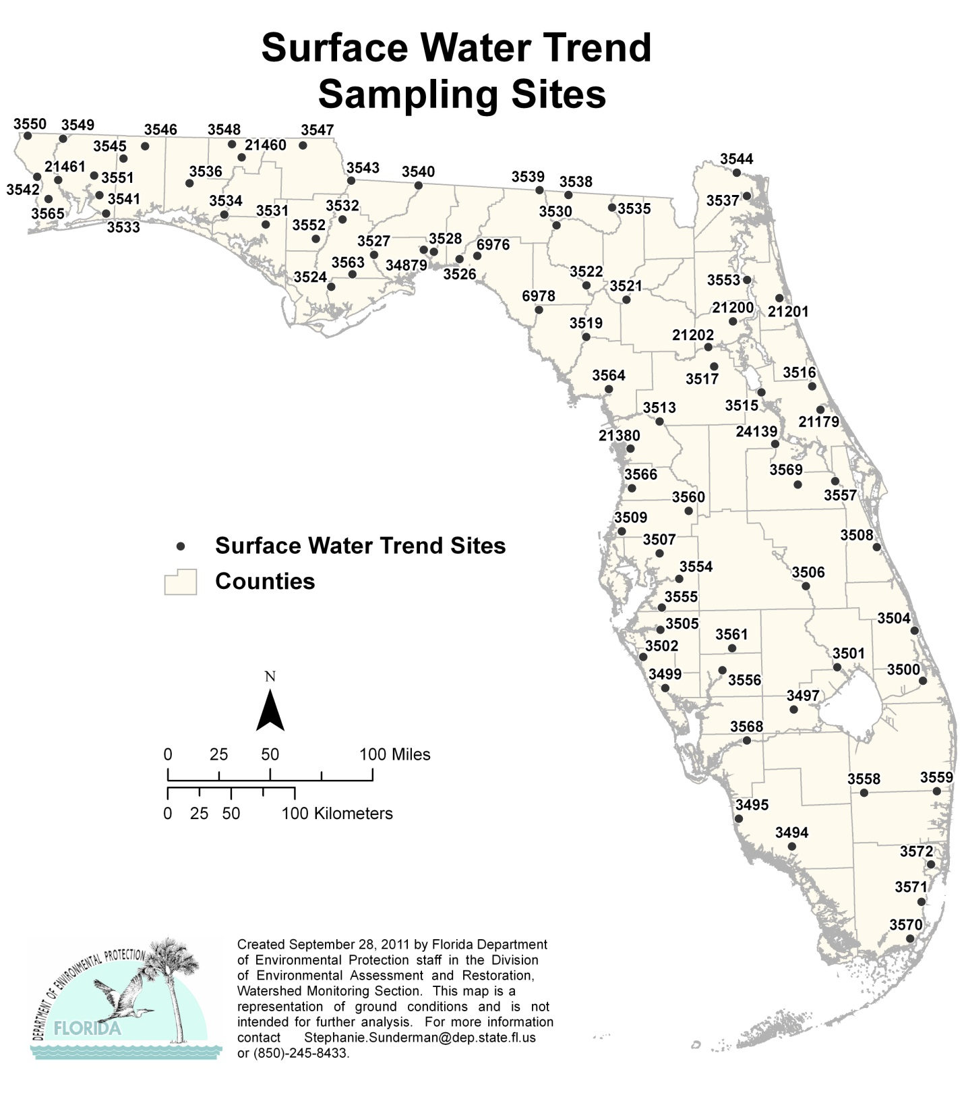

Figure 5.4. Ground Water Trend Network Sites with Sufficient Period of Record
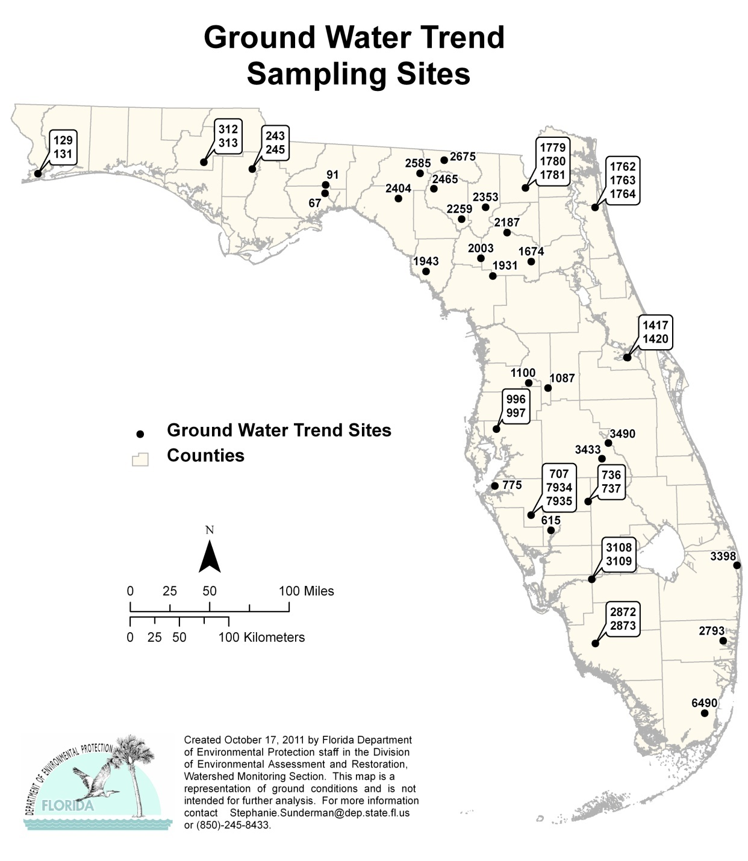

Trend Network Core and Supplemental Indicators
For data comparability, many of the same indicators are included in both the Status and Trend Network indicator lists. To maintain the historical aspect of the data, changes to the indicator list are minimized.

Data Evaluation
Prior to data analyses for Status and Trend reporting, all data were checked to ensure the accuracy of the results. Data from the Trend Network that were qualified with an O, V, or Y were excluded before any analysis was conducted. Additionally, some data qualified with a J were excluded from the trend analysis. All remaining data were used.
The Trend Network consists of 48 ground water and 76 surface water stations; of these, 1 ground water and 2 surface water stations were either recently added to the network or do not have enough data to conduct a Seasonal Kendall (SK) analysis. Seasonal cyclicity (seasonality) has been shown for many surface water constituents; therefore, an effort should be made to collect at least 1 sample in each season, 4 per year as a bare minimum. If seasonality, or any other form of cyclicity, is present, the long-term trend of the constituent may be determined only after statistically adjusting the data. This is referred to as deseasonalizing the data. The SK analysis requires a reasonable amount of data, consisting of at least 2 seasons and 12 data points in order to determine if a trend exists.
The SK is a nonparametric test that is insensitive to outliers, missing values, and censored data. It can be conducted on all analytes as it does not require a standard or threshold value to determine the results. The alpha level at which the hypothesis is either accepted or rejected, has been set at 0.05, indicating a 95% confidence level about the trend decision.
The statewide assessments provide a broad overview of the results obtained by the Status Network, while zonewide results may depict areas of concern for specific indicators. Statewide assessments can hide or minimize the impact an indicator may have within a zone. This document does not present assessments by zone as there are insufficient data to conduct the analysis.

Chapter 6: Results of the Status and trend NeTWORK Assessments for 2009–10

Summary of Status Network Surface Water Results

Introduction
The probabilistic approach discussed in Chapter 5 is used to sample and report on the condition of surface water resources from the entire state. This chapter summarizes the results of the combined statewide assessment for 2009 and 2010.
Four surface water resources were assessed: rivers, streams, large lakes, and small lakes. Table 6.1 summarizes the miles of rivers and streams, and acres and numbers of large and small lakes, for the waters assessed. Approximately 10 samples were collected annually from each resource, in each zone, for 60 samples statewide.

Table 6.1. Summary of Surface Water Resources Assessed by the Status Network’s Probabilistic Monitoring, 2009–10
This is a two-column table. Column 1 lists the waterbody type, and Column 2 lists the miles of rivers and streams, and acres and numbers of large and small lakes.

Note: The estimates in the table do not include coastal or estuarine waters. These calculations are from the 1:24,000 NHD.

Waterbody Type | Assessed
Rivers | 3,927 miles
Streams | 16,861 miles
Large Lakes | 1,725 lakes (1,006,574 acres)
Small Lakes | 2,676 lakes (40,905 acres)

The indicators selected for surface water reporting include fecal coliform, DO, un-ionized ammonia, chlorophyll a (rivers and streams), and TSI (lakes). Tables 6.2a through 6.2c summarize the indicators and their threshold values. Tables 5.1a through 5.1f and 5.2a through 5.2b contain the complete list of indicators used in the Status Monitoring Network.
The main source of information for these indicators is Rule 62-302, F.A.C., which contains the surface water quality standards for Florida. The water quality criteria and thresholds are derived from the following:
- Section 62-302.530, F.A.C., Criteria for Surface Water Classifications;
- Rule 62-550, F.A.C., Drinking Water Standards;
- Rule 62-303, F.A.C., Identification of Impaired Surface Waters; and
- Section 62-520.420, F.A.C., Standards for Class G-I and Class G-II Ground Water.

It is important to note that the diversity of Florida’s aquatic ecosystems also means there is a large natural variation in some water quality parameters. For example, surface waters that are dominated by ground water inflows or flows from wetland areas will have lower DO levels. Therefore, some Florida aquatic systems naturally exhibit DO levels less than the state’s standard of 5.0 mg/L.

Table 6.2a. Status Network Physical/Other Indicators/Index for Aquatic Life Use with Water Quality Criteria/Thresholds
This is a two-column table. Column 1 lists the indicators and Column 2 lists the water quality criteria/thresholds.

¹ Both TSI and chlorophyll a are not criteria, but thresholds used to estimate the impairment of state waters. These thresholds are used in the analysis of Status Monitoring Network data, based on single samples. The analysis and representation of these data are not intended to infer the verification of impairment, as defined in Rule 62-303, F.A.C.
² PCUs = Platinum cobalt units
³ SU = Standard units

Physical/Other Indicators/  Index for Aquatic Life Use  (Surface Water) | Criterion/Threshold
DO | ≥ 5 mg/L
Un-ionized Ammonia | ≤ 0.02 mg/L
Fluoride | ≤10 mg/L
Chlorophyll a¹ | ≤ 20 µg/L
TSI¹ | Color ≤ 40 PCUs,³ then TSI ≤ 40  Color > 40 PCUs, then TSI ≤ 60

Table 6.2b. Status Network Microbiological Indicators/Index for Recreational Use with Water Quality Criteria/Thresholds
This is a two-column table. Column 1 lists the indicators and Column 2 lists the water quality criteria/thresholds.

Microbiological Indicator/  Index for Recreation Use  (Surface Water) | Criterion/Threshold
Fecal Coliform Bacteria | < 400 colonies/100mL

Table 6.2c. The Department’s Freshwater Lake Sediment Contaminant Thresholds for Metals
This is a three-column table. Column 1 lists the metals, Column 2 lists the threshold effects concentration, and Column 3 lists the probable effects concentration.

Metal | Threshold Effects Concentration  (mg/kg) | Probable Effects Concentration  (mg/kg)
Arsenic | 9.8 | 33
Cadmium | 1.00 | 5
Chromium | 43.4 | 111
Copper | 32 | 149
Lead | 36 | 128
Mercury | 0.18 | 1.06
Nickel | 23 | 48
Zinc | 121 | 459
Silver | 1 | 2.2

Rivers, Streams, Large Lakes, and Small Lakes
The following pages present the surface water Status Network results for rivers, streams, large lakes, and small lakes. For each resource, there is a map showing the sample site locations (Figures 6.1, 6.3, 6.5, and 6.7), a figure with a summary of the statewide results (Figures 6.2, 6.4, 6.6, and 6.8), and a table of the statewide results for each indicator for a particular resource (Tables 6.3b through 6.3e). Table 6.3a explains the terms used in the statewide summary tables.

Table 6.3a. Explanation of Terms Used in Tables 6.3b through 6.3e
This is a two-column table. Column 1 lists the terms used and Column 2 explains each term.

Term | Explanation
Analyte | Indicators chosen to base assessment of condition of waters of the state.
Target Population | Estimate of actual extent of resource from which threshold results were calculated. Excludes % of resource that was determined to not fit definition of resource.
Number of Samples | Number of samples used for statistical analysis after qualified data and resource exclusions are eliminated from the data pool.
% Meeting Threshold | % estimate of resource that meets a specific indicator’s criterion/threshold value.
95% Confidence Bounds  (% Meeting Threshold) | Upper and lower bounds for 95% confidence of % meeting a specific indicator’s criterion/threshold value.
% Not Meeting Threshold | % of estimate of extent of resource that does not meet a specific indicator’s criterion/threshold value.
Assessment Period | Duration of probabilistic survey sampling event.

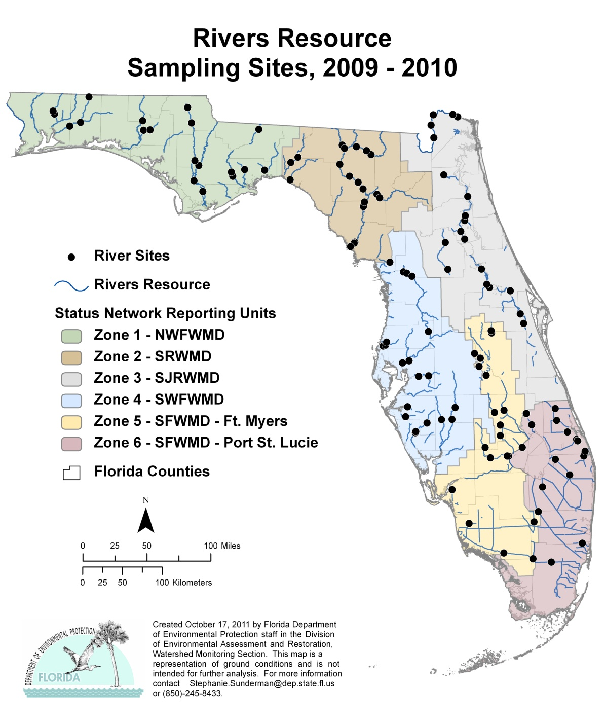

Figure 6.1. Statewide River Sample Locations

Table 6.3b. Statewide Percentage of Rivers Meeting Threshold Values for Indicators Calculated Using Probabilistic Monitoring Design
Status Network Designated Use: Recreation and Aquatic Life Units: Miles
This is a 7-column table. Column 1 lists the analyte, Column 2 lists the target population, Column 3 lists the number of samples, Column 4 lists the percent meeting threshold, Column 5 lists the 95% confidence bounds, Column 6 lists the percent not meeting the threshold, and Column 7 lists the assessment period.

Analyte | Target Population  (miles) | Number of Samples | % Meeting Threshold | 95%  Confidence Bounds  (% meeting threshold) | % Not Meeting Threshold | Assessment Period
Chlorophyll a | 3,927 | 119 | 85.6 | 79.9-91.4 | 14.4 | 2009–10
Un-ionized Ammonia | 3,927 | 119 | 99.6 | 99.0-100.0 | 0.4 | 2009–10
Fecal Coliform | 3,927 | 119 | 97.2 | 94.1-100.0 | 2.8 | 2009–10
DO | 3,927 | 119 | 88.0 | 84.1-92.0 | 12.0 | 2009–10

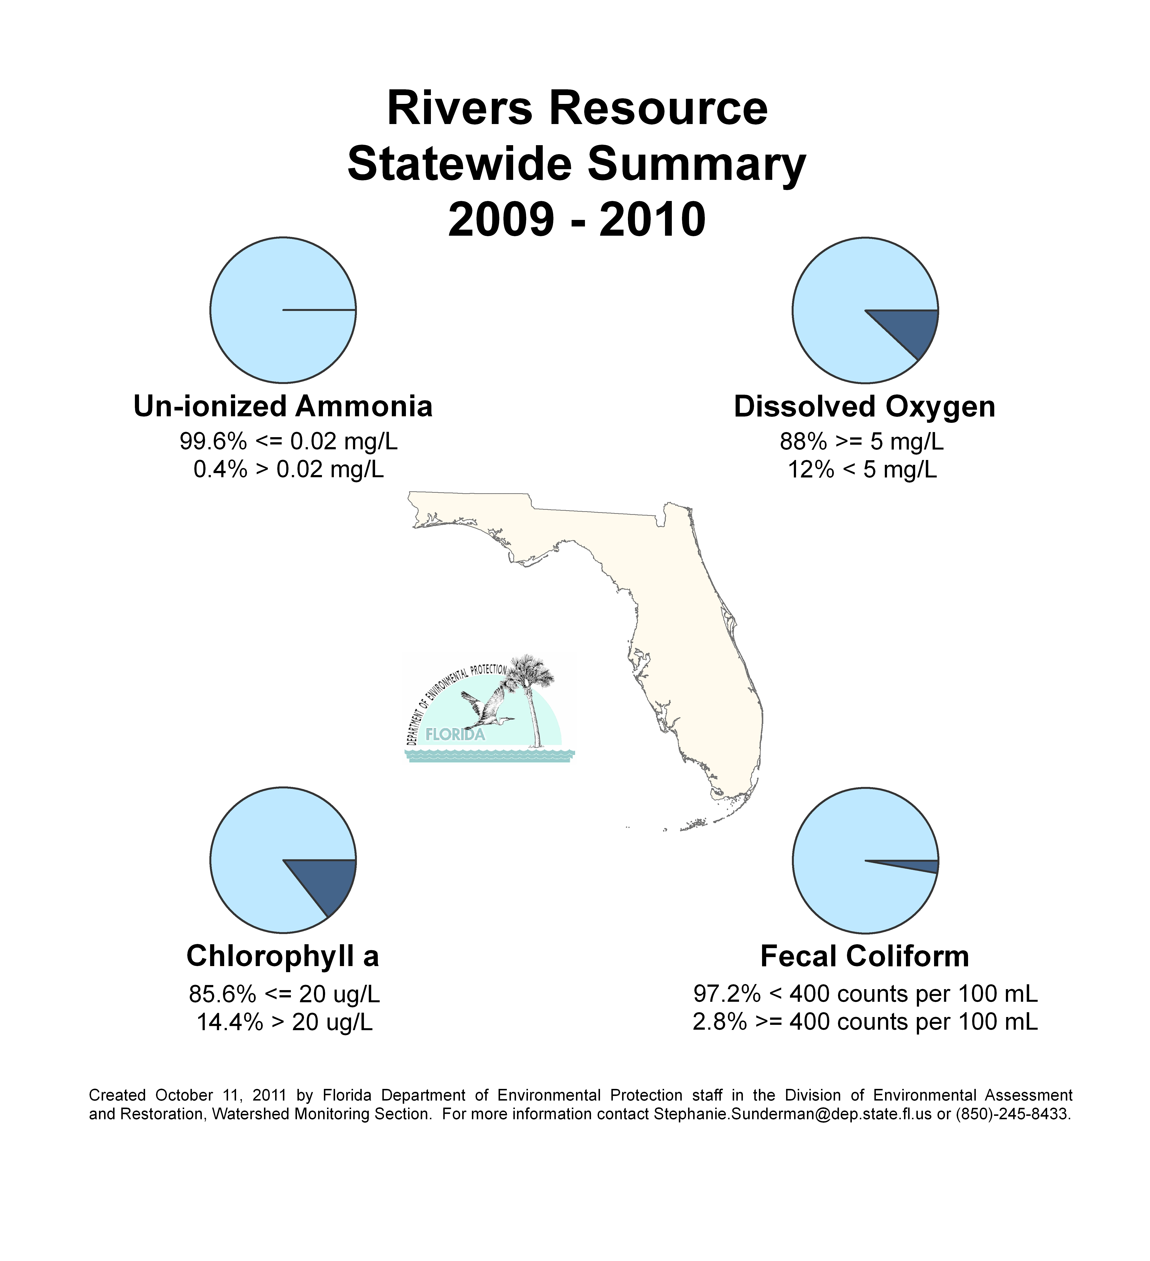

Figure 6.2. Statewide Summary of River Results

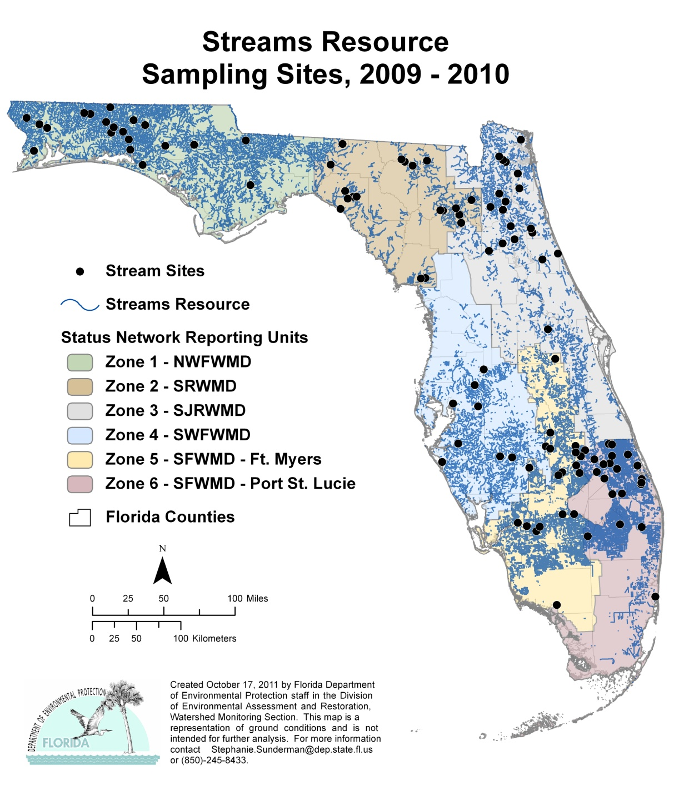
Figure 6.3. Statewide Stream Sample Locations

Table 6.3c. Statewide Percentage of Streams Meeting Threshold Values for Indicators Calculated Using Probabilistic Monitoring Design
Status Network Designated Use: Recreation and Aquatic Life Units: Miles
This is a 7-column table. Column 1 lists the analyte, Column 2 lists the target population, Column 3 lists the number of samples, Column 4 lists the percent meeting the threshold, Column 5 lists the 95% confidence bounds, Column 6 lists the percent not meeting the threshold, and Column 7 lists the assessment period.

Analyte | Target Population  (miles) | Number of Samples | % Meeting Threshold | 95%  Confidence Bounds  (% meeting threshold) | % Not Meeting Threshold | Assessment Period
Chlorophyll a | 16,861 | 90 | 95.0 | 90.2-99.8 | 5.0 | 2009–10
Un-ionized Ammonia | 16,861 | 90 | 97.6 | 93.5-100.0 | 2.4 | 2009–10
Fecal Coliform | 16,861 | 90 | 75.3 | 67.1-83.5 | 24.7 | 2009–10
DO | 16,861 | 90 | 74.3 | 64.5-84.1 | 25.7 | 2009–10

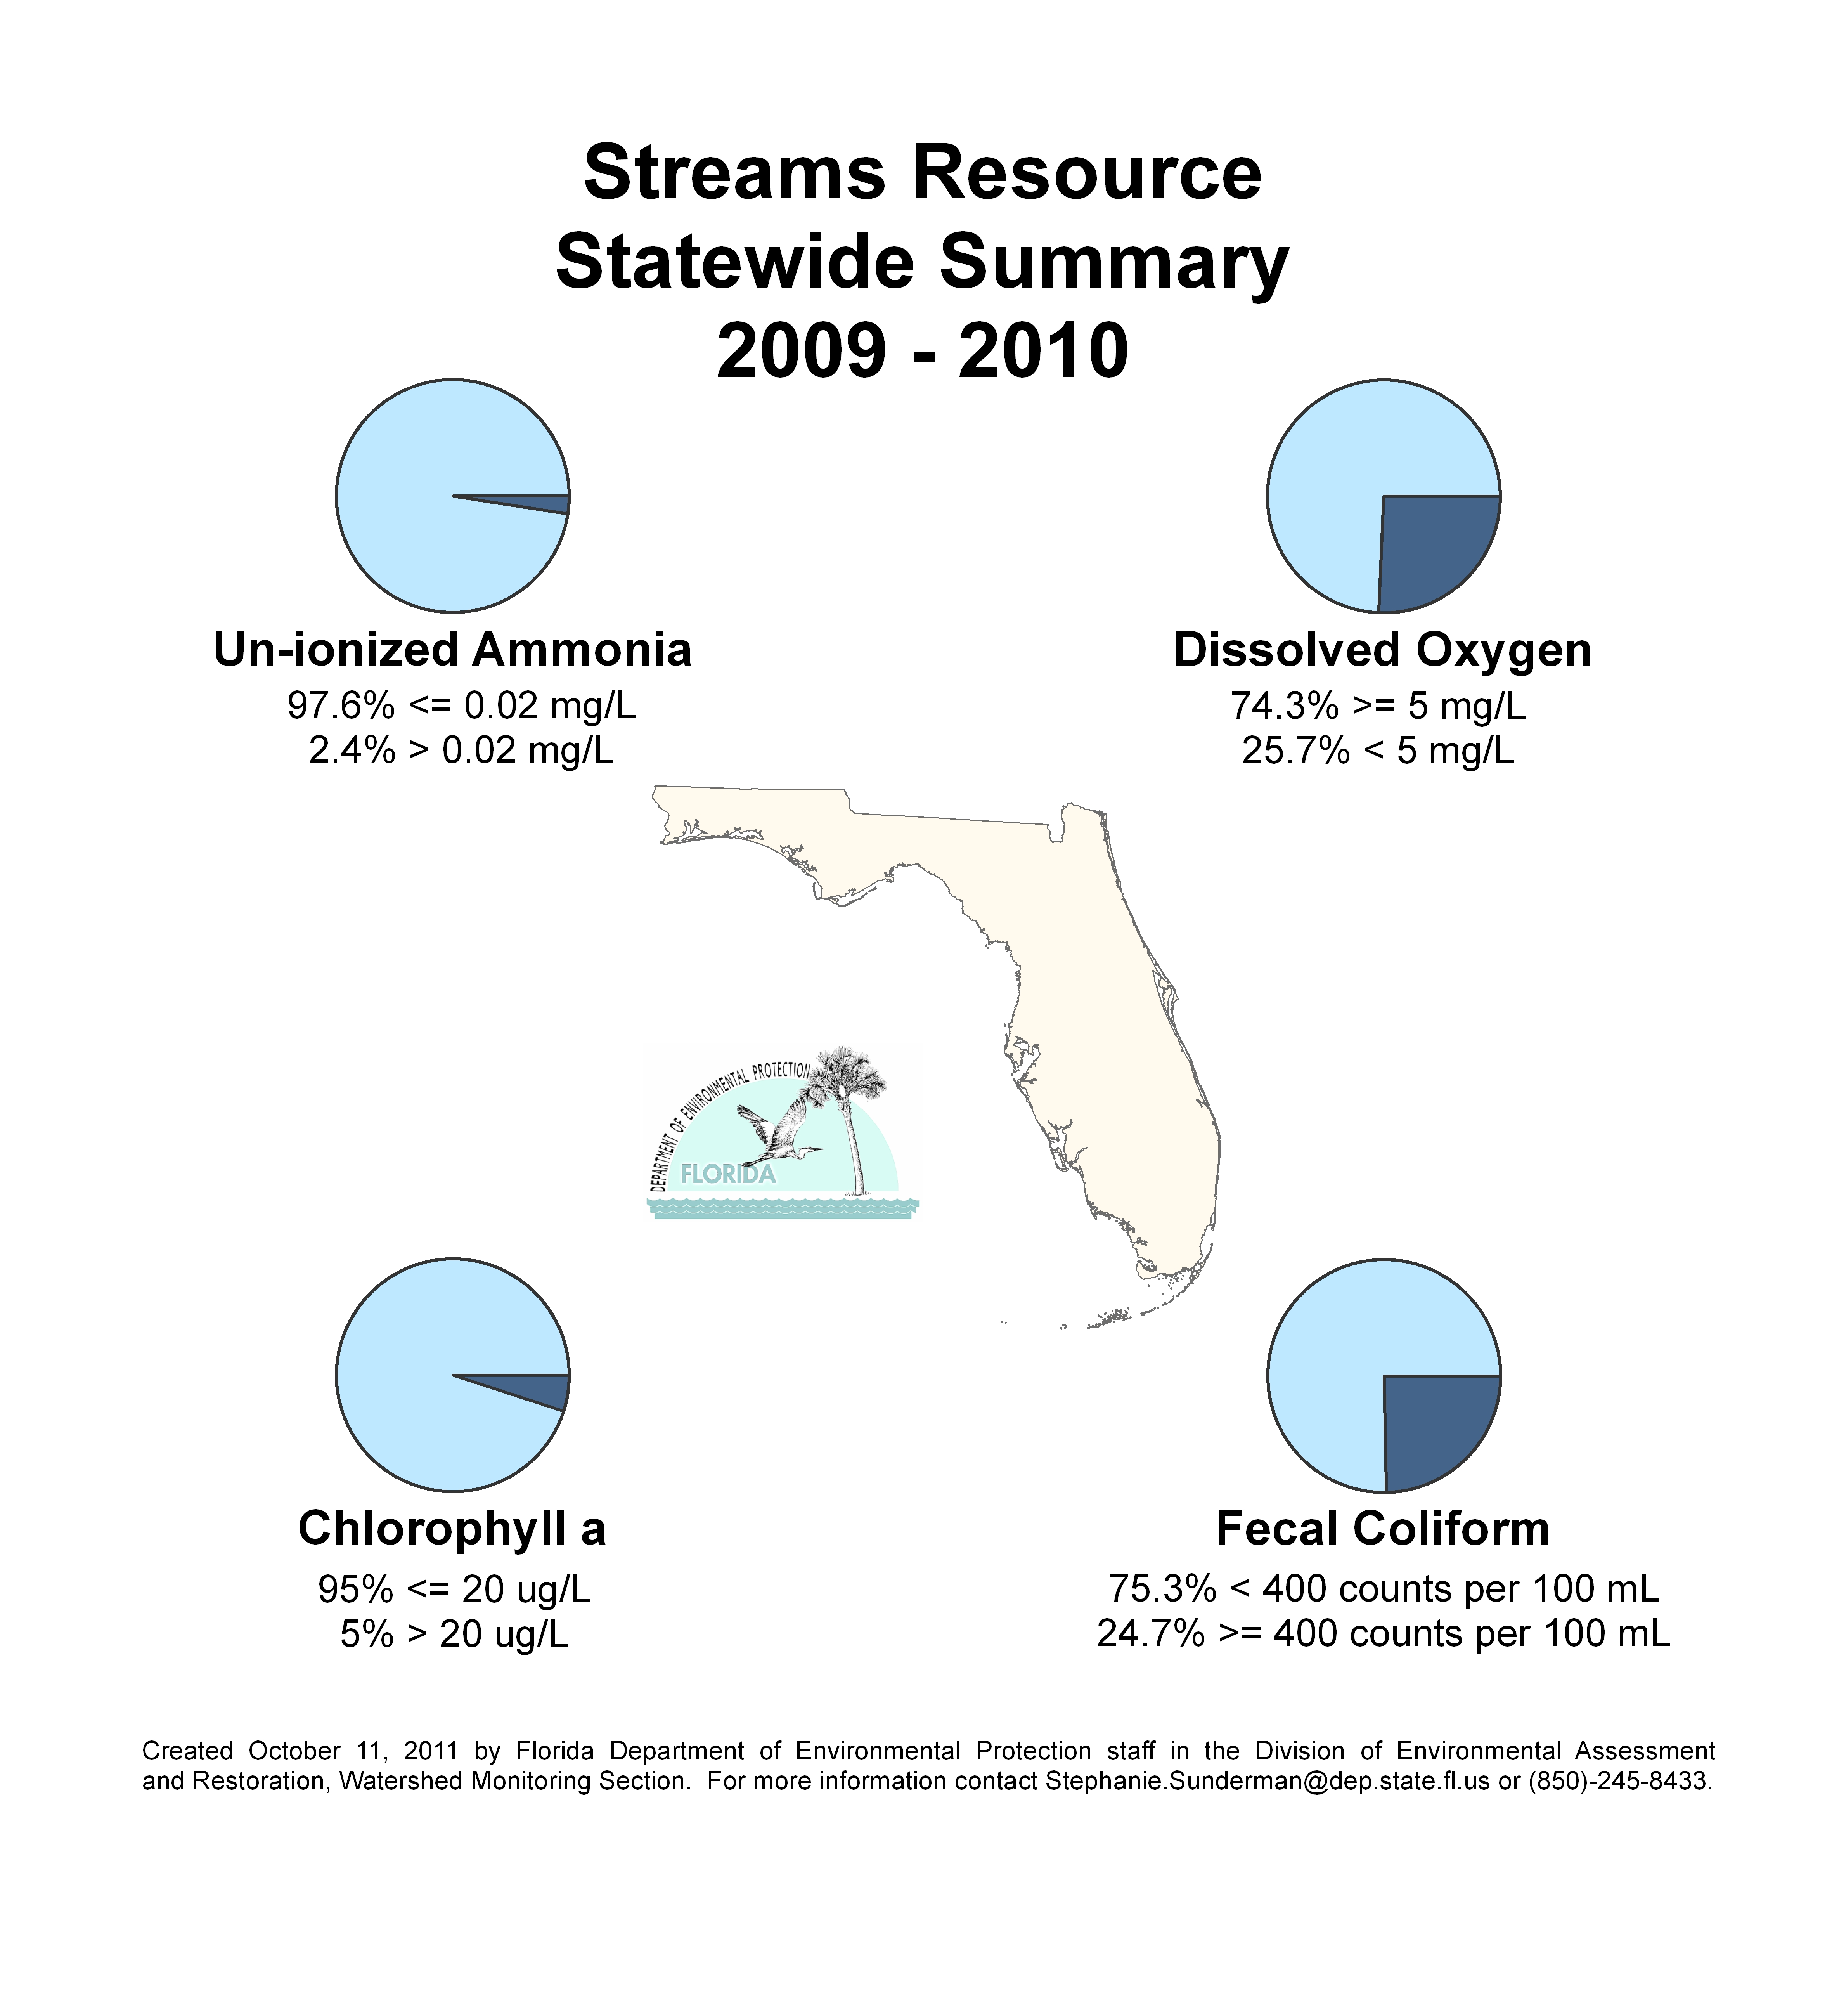

Figure 6.4. Statewide Summary of Stream Results

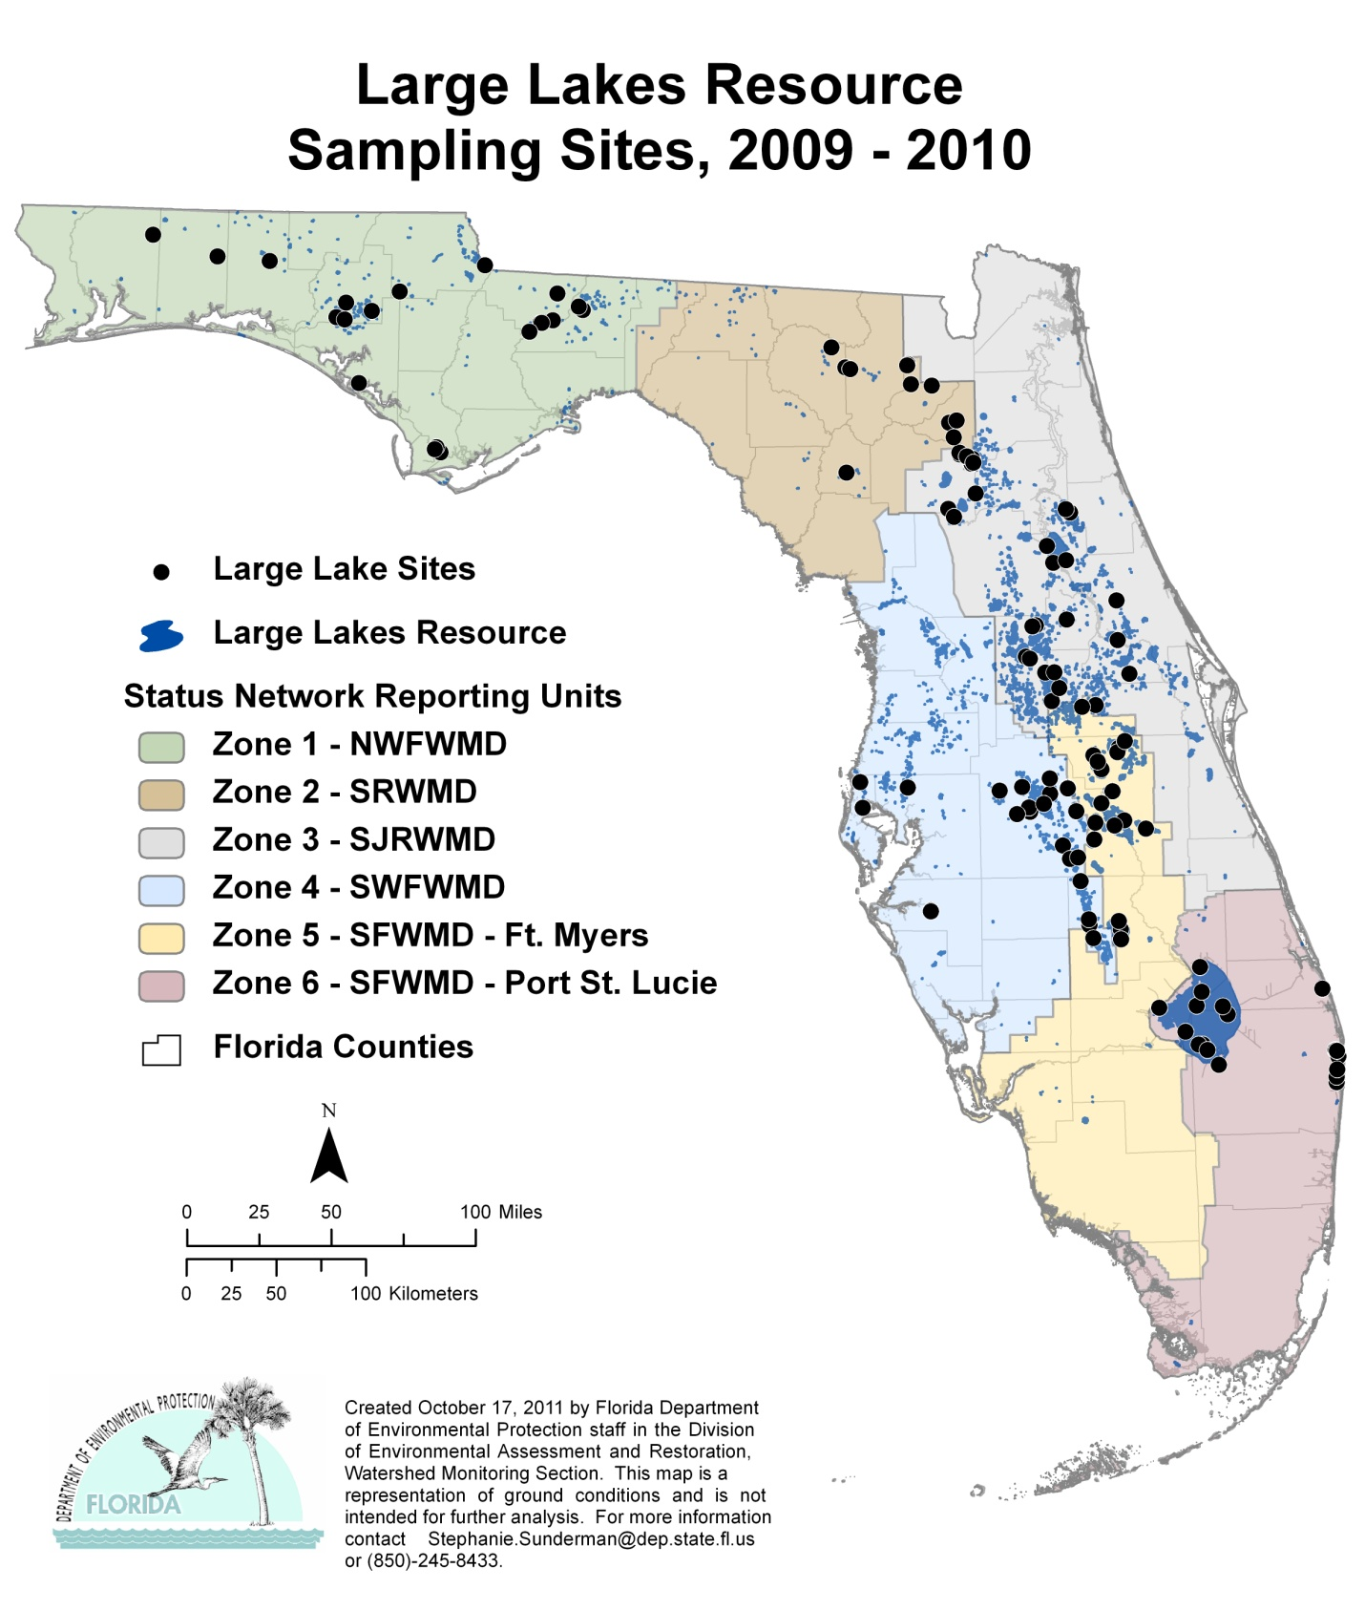

Figure 6.5. Statewide Large Lake Sample Locations

Table 6.3d. Statewide Percentage of Large Lakes Meeting Threshold Values for Indicators Calculated Using Probabilistic Monitoring Design
Status Network Designated Use: Recreation and Aquatic Life Units: Acres
This is a 7-column table. Column 1 lists the analyte, Column 2 lists the target population, Column 3 lists the number of samples, Column 4 lists the percent meeting the threshold, Column 5 lists the 95% confidence bounds, Column 6 lists the percent not meeting the threshold, and Column 7 lists the assessment period.

Analyte | Target Population  (acres) | Number of Samples | % Meeting Threshold | 95%  Confidence Bounds  (% meeting threshold) | % Not Meeting Threshold | Assessment Period
TSI | 1,006,574 | 120 | 62.6 | 51.1-74.1 | 37.4 | 2009–10
Un-ionized Ammonia | 1,006,574 | 120 | 95.0 | 90.5-99.5 | 5.0 | 2009–10
Fecal Coliform | 1,006,574 | 120 | 98.7 | 96.4-100.0 | 1.3 | 2009–10
DO | 1,006,574 | 120 | 90.4 | 83.2-97.6 | 9.6 | 2009–10

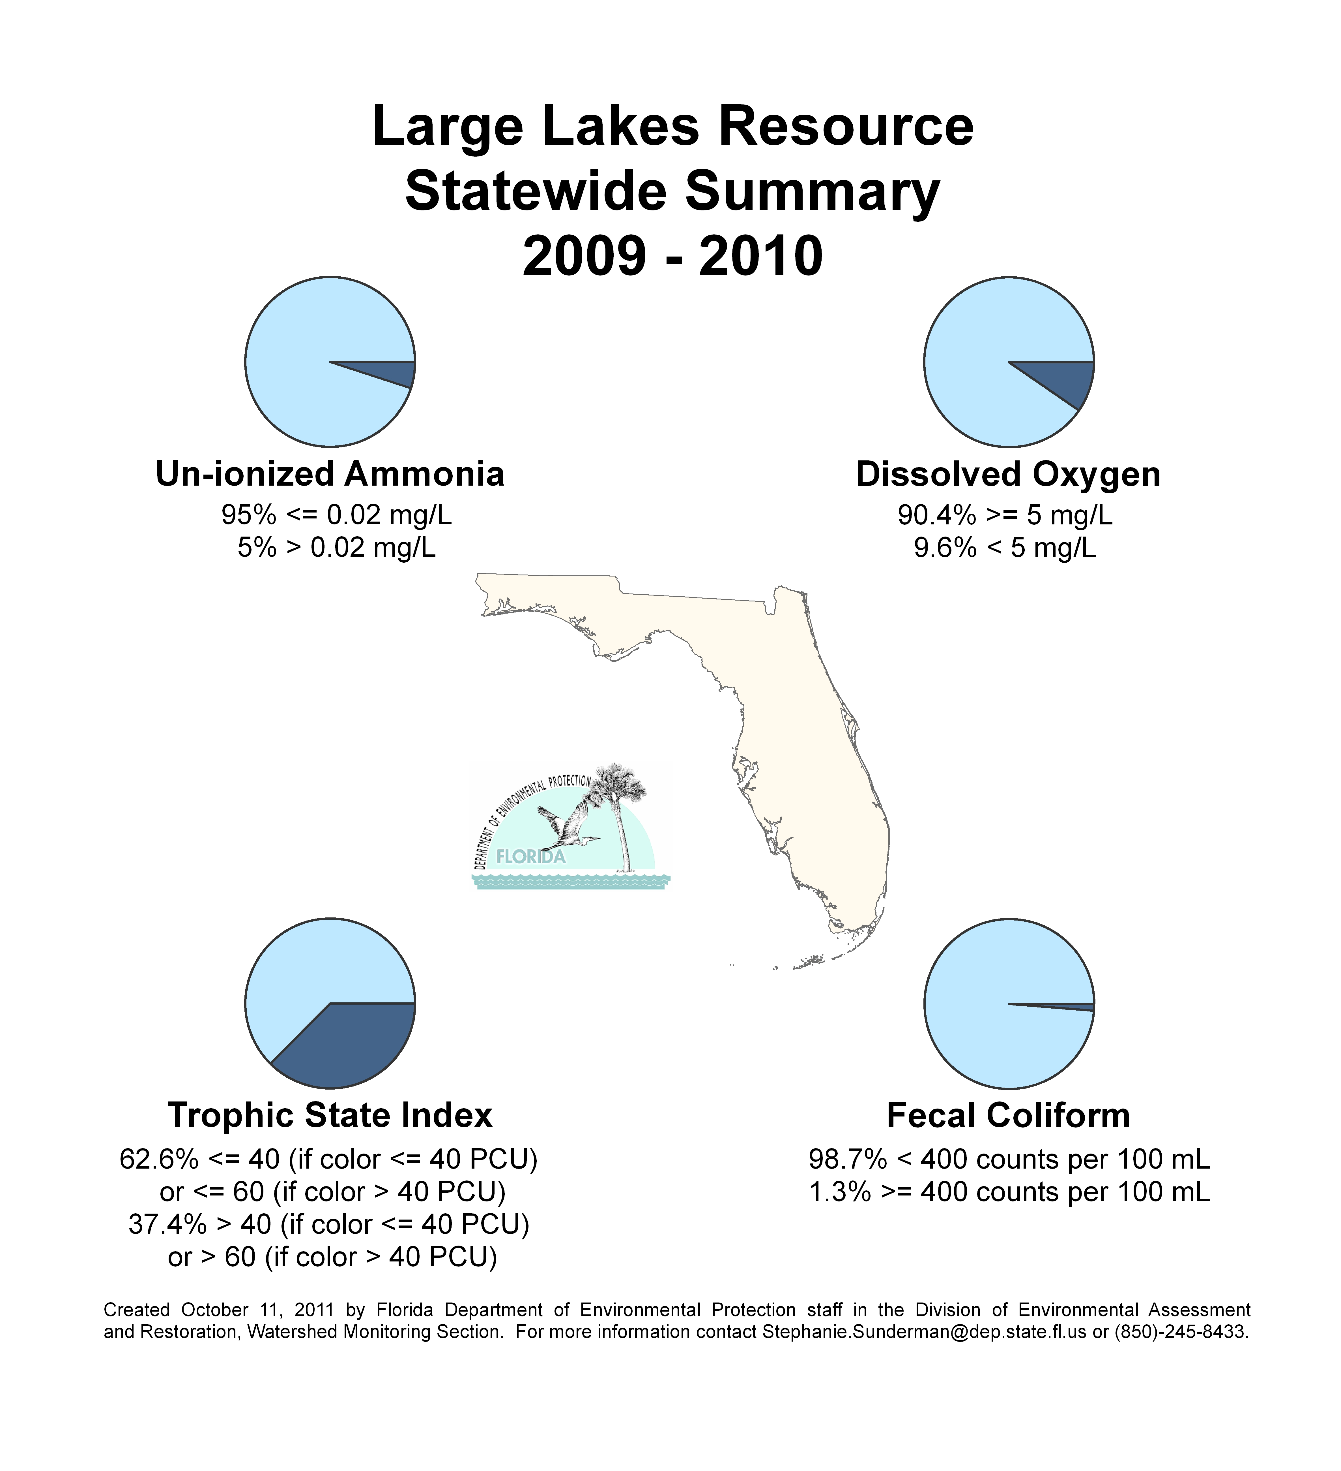
Figure 6.6. Statewide Summary of Large Lake Results

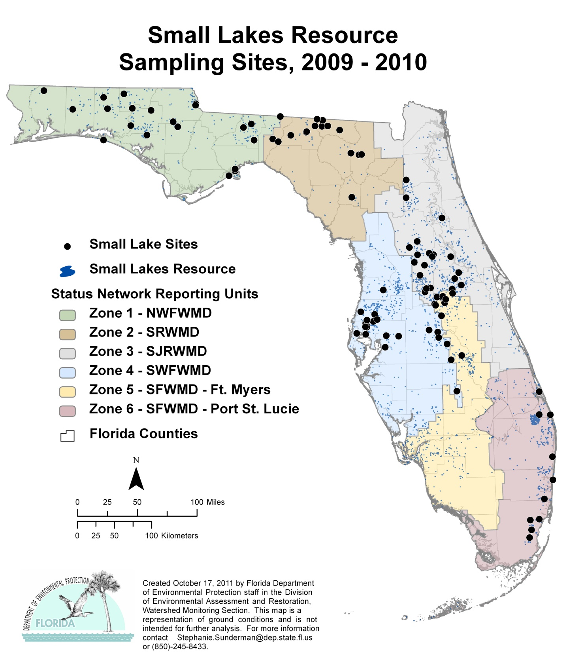

Figure 6.7. Statewide Small Lake Sample Locations

Table 6.3e. Statewide Percentage of Small Lakes Meeting Threshold Values for Indicators Calculated Using Probabilistic Monitoring Design
Status Network Designated Use: Recreation and Aquatic Life Units: Lakes
This is a 7-column table. Column 1 lists the analyte, Column 2 lists the target population, Column 3 lists the number of samples, Column 4 lists the percent meeting the threshold, Column 5 lists the 95% confidence bounds, Column 6 lists the percent not meeting the threshold, and Column 7 lists the assessment period.

Analyte | Target Population  (lakes) | Number of Samples | % Meeting Threshold | 95%  Confidence Bounds  (% meeting threshold) | % Not Meeting Threshold | Assessment Period
TSI | 2,676 | 106 | 87.3 | 80.7-93.8 | 12.7 | 2009–10
Un-ionized Ammonia | 2,676 | 106 | 100.0 | 100.0 | 0.0 | 2009–10
Fecal Coliform | 2,676 | 106 | 99.6 | 98.9-100.0 | 0.4 | 2009–10
DO | 2,676 | 106 | 96.7 | 91.6-100.0 | 3.3 | 2009–10

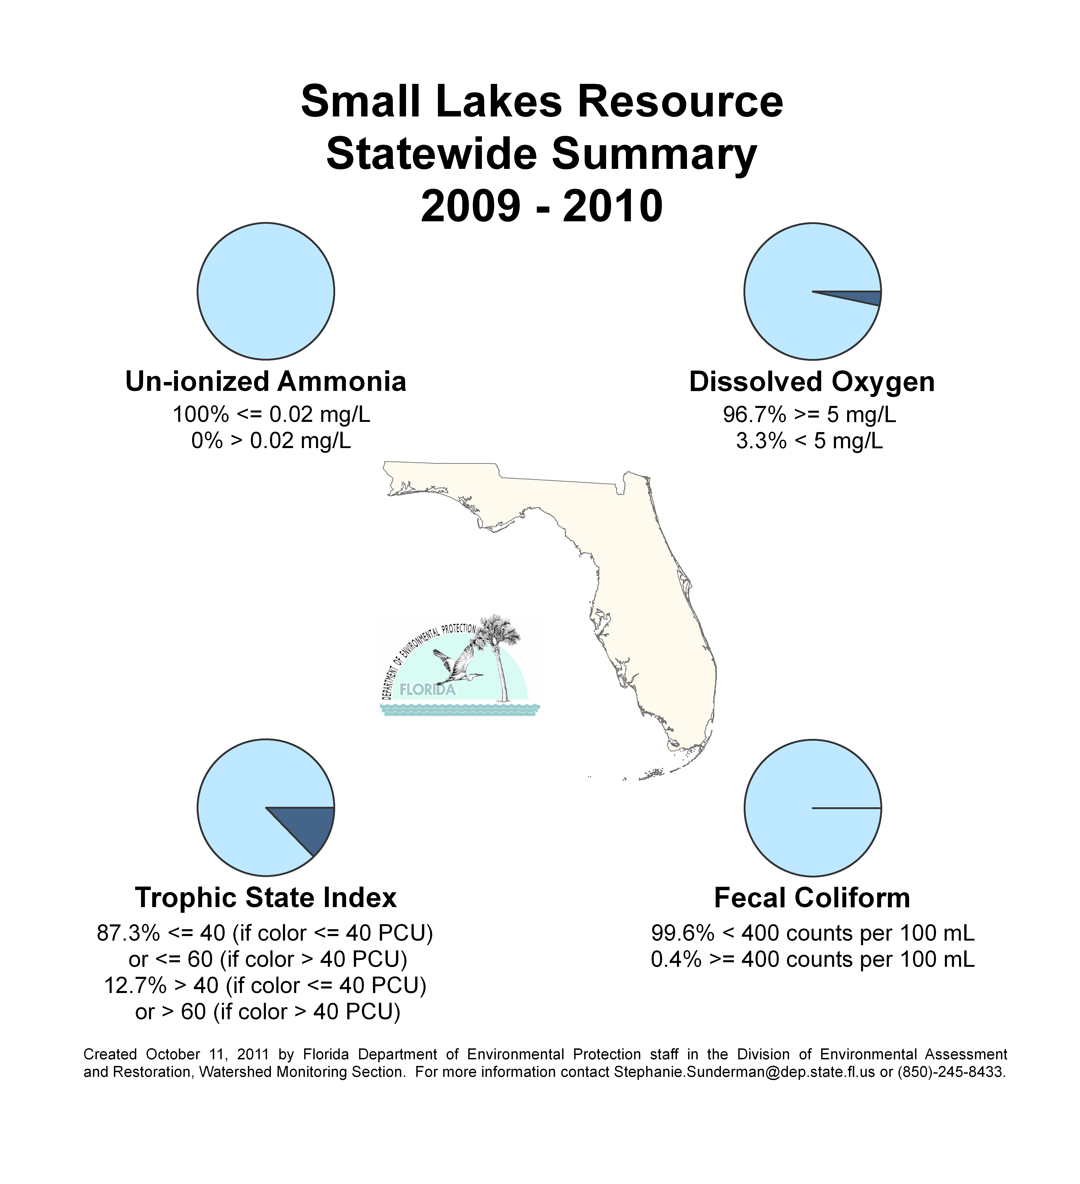
Figure 6.8. Statewide Summary of Small Lake Results

Sediment Quality Evaluation

Background
In healthy aquatic environments, sediments provide essential habitat but, at the same time, they are a source of contamination and recycled nutrients as substances accumulate over time from upland discharges, the decomposition of organic material, and atmospheric deposition. Knowledge of a site’s sediment quality is also important for environmental managers in evaluating restoration and dredging projects. In contrast to the standards established for many water column constituents, the Department has no standards (criteria) for sediment and no statutory authority to establish criteria. Therefore, it is important to use scientifically defensible thresholds to estimate the condition of sediments and determine the ecological significance of the chemical results.
The interpretation of sediment metals data is not straightforward because metallic elements are natural constituents in sediment. The geochemistry of a region must be factored into the analysis of sediment chemistry data. For example, marine sediments in the northern part of the state tend to be fine-grained , while sediments farther south in the Peninsula coastal regions are coarser and predominantly carbonate in nature. Sediments in the north have a higher natural burden of metals, and in comparison to sediments from the southern region of the state may appear to be contaminated. However, a closer examination based on the geology of the region “normalizes” the results so that scientifically defensible inferences can be made.
For sediment metals data analysis, the Department developed two interpretive tools, detailed in the following publications: A Guide to the Interpretation of Metals Concentrations in Estuarine Sediments (Schropp and Windom 1988) and Development of an Interpretive Tool for the Assessment of Metal Enrichment in Florida Freshwater Sediment (Carvalho and Schropp 2003). These documents use a statistical normalization technique to predict background concentrations of metals in sediments, regardless of their composition.
Programs evaluating sediment metals concentrations must distinguish between natural background levels of metals in the environment versus what human activity introduced. The metals interpretive tool can be used to determine natural levels of the metals arsenic, cadmium, chromium, lead, nickel, and zinc, and then determine which might be elevated above expected background concentrations. This tool was applied to the dataset to identify sediments with elevated trace metals.

However, the presence of higher levels of metals alone does not mean that the sediment metal level will cause a biological effect. To address the elevated metals concentrations issue, and to determine whether these levels are ecologically significant, the Department developed additional metrics to interpret sediment chemistry.
During the 1990s, several state and federal agencies developed concentration-based guidelines used to evaluate biological effects from sediment contaminants. These agencies employed several approaches, including a weight-of-evidence statistical strategy, which derived guidelines from studies containing paired sediment chemistry and associated biological responses. The Department selected this weight-of-evidence approach to develop biological based sediment guidelines. To provide guidance in the interpretation of sediment contaminant data, two documents were published: Approach to the Assessment of Sediment Quality in Florida Coastal Waters (MacDonald 1994) and Development and Evaluation of Numerical Sediment Quality Assessment Guidelines for Florida Inland Waters (MacDonald et al. 2003).
Rather than traditional pass/fail criteria, the weight-of-evidence approach selected by the Department uses two guidelines to assess each sediment contaminant: a lower guideline, the Threshold Effects Concentration (TEC), and a higher guideline, the Probable Effects Concentration (PEC). A value below the TEC indicates a low probability of harm occurring to sediment-dwelling organisms. Conversely, sediment values above the PEC have a high probability of causing biological harm. These guidance values are used to determine whether the sediments at the sampling site may need further evaluation, such as toxicity testing to verify that the presence of metals or organic contaminants would have a deleterious ecological effect.

Small and Large Lakes
Of the four Status Network surface water resources, lakes were selected as the most appropriate resource to evaluate sediment contaminants, since lakes integrate runoff within watersheds. Both the geochemical metals tool and the freshwater biological effects guidance values (MacDonald et al. 2003) were used to evaluate lake sediment chemistry data.
In 2009 and 2010, 223 sediment samples were collected from the state’s 2 lake resources: 107 from small lakes and 116 from large lakes. Samples were analyzed for major elements (aluminum and iron), a suite of trace metals, and 3 sediment nutrients (Tables 5.2a through 5.2b). To ensure accurate metals data, samples were prepared for chemical analysis using EPA Method 3051 (total digestion) rather than with the EPA’s 200.2 method (referred to as the total recoverable method).
Departmental staff compared the sediment metal concentrations with the Department’s freshwater sediment guidelines (Table 6.2c). When the concentration exceeded the TEC, the metal concentration was evaluated. If the concentration was within a naturally occurring range, the sediment sample was reclassified as “not elevated.”
Results are found in Figures 6.9 and 6.10 and Tables 6.4a and 6.4b. The tables display two rows for each metal. The first row contains the uncorrected results for each metal (raw chemical result), while the second row contains the corrected results after applying the previously described metals normalization analysis. This evaluation illustrates that the number of metal exceedances is lower than expected if concentration were the only measure used to determine ecological impact. Some sites that appear impacted exhibit expected sediment metal concentrations. Copper (still widely employed as an aquatic herbicide), lead, and zinc are the most elevated metals in many small lakes. Elevated lead and zinc concentrations are frequently associated with stormwater input. Arsenic, cadmium, chromium, and silver occasionally exceed the sediment guidelines. Sediment metals are highest in lakes located in urbanized areas, with the highest number of elevated metals results from lakes in peninsular Florida.

Table 6.4a. Statewide Percentage of Large Lakes Meeting Sediment Contaminant Threshold Values
This is a six-column table. Column 1 lists the metal (uncorrected and corrected), Column 2 lists the percent meeting the TEC threshold, Column 3 lists the percent not meeting the TEC threshold, Column 4 lists the percent not meeting the PEC threshold, Column 5 lists the percent of stations greater than the TEC that include naturally occurring metal concentrations, and Column 6 lists the percent of stations greater than the PEC that include naturally occurring metal concentrations.

N/A = Not applicable
Metal | % Meeting TEC Threshold | % Not Meeting TEC Threshold | % Not Meeting PEC Threshold | % of Stations >TEC Due to Natural Metal Concentrations | % of Stations >PEC Due to Natural Metal Concentrations
Arsenic Uncorrected | 92.2 | 7.8 | 0 | N/A | N/A
Arsenic Corrected | 92.2 | 0 | 0 | 7.8 | 0
Cadmium Uncorrected | 92.2 | 7.8 | 0 | N/A | N/A
Cadmium Corrected | 92.2 | 1.8 | 0 | 6.0 | 0
Chromium Uncorrected | 79.3 | 20.7 | 0 | N/A | N/A
Chromium Corrected | 79.3 | 0 | 0 | 20.7 | 0
Copper Uncorrected | 85.3 | 12.1 | 2.6 | N/A | N/A
Copper Corrected | 85.3 | 10.4 | 2.6 | 1.7 | 0
Silver Uncorrected | 100 | 0 | 0 | N/A | N/A
Silver Corrected | 100 | 0 | 0 | 0 | 0
Nickel Uncorrected | 95.7 | 4.3 | 0 | N/A | N/A
Nickel Corrected | 95.7 | 0 | 0 | 4.3 | 0
Lead Uncorrected | 72.4 | 25.9 | 1.7 | N/A | N/A
Lead  Corrected | 72.4 | 19.0 | 1.7 | 6.9 | 0
Mercury Uncorrected | 62.9 | 37.1 | 0 | N/A | N/A
Mercury Corrected | 62.9 | 3.5 | 0 | 33.6 | 0
Zinc Uncorrected | 94.8 | 5.2 | 0 | N/A | N/A
Zinc  Corrected | 94.8 | 5.2 | 0 | 0 | 0

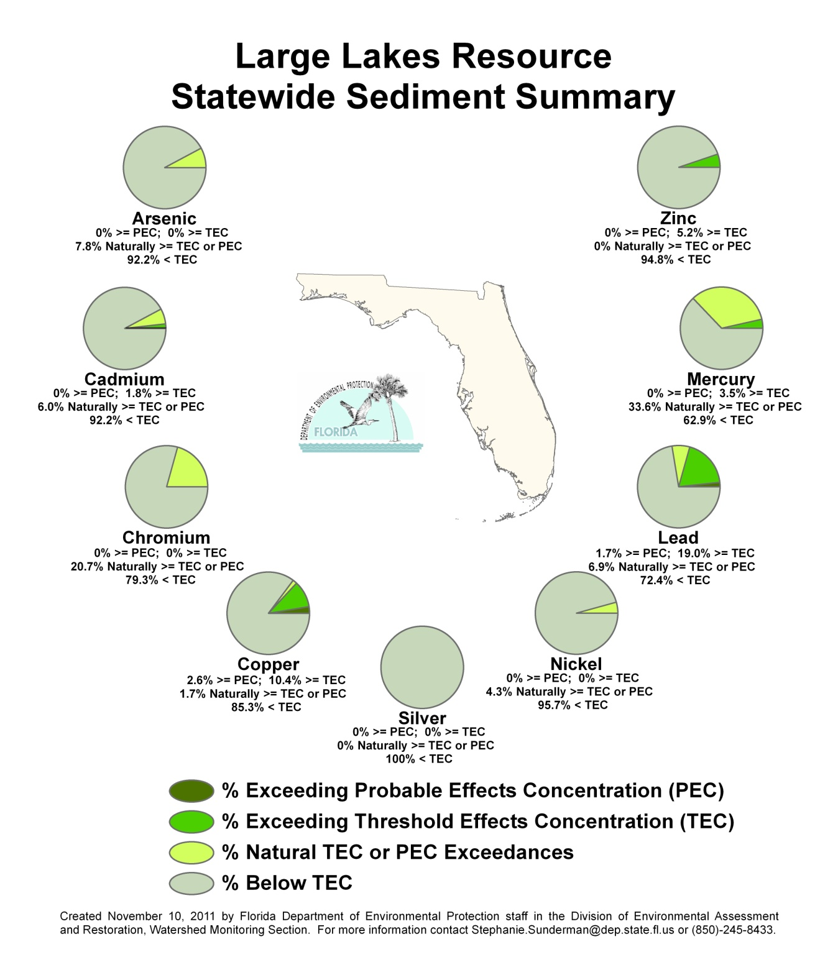

Figure 6.9. Statewide Summary of Large Lake Sediment Results

Table 6.4b. Statewide Percentage of Small Lakes Meeting Sediment Contaminant Threshold Values
This is a six-column table. Column 1 lists metal (uncorrected and corrected), Column 2 lists the percent meeting the TEC threshold, Column 3 lists the percent not meeting the TEC threshold, Column 4 lists the percent not meeting the PEC threshold, Column 5 lists the percent of stations greater than the TEC that include naturally occurring metal concentrations, and Column 6 lists the percent of stations greater than the PEC that include naturally occurring metal concentrations.

N/A = Not applicable
Metal | % Meeting TEC Threshold | % Not Meeting TEC Threshold | % Not Meeting PEC Threshold | % of Stations >TEC Due to Natural Metal Concentrations | % of Stations >PEC Due to Natural Metal Concentrations
Arsenic Uncorrected | 80.4 | 18.7 | 0.9 | N/A | N/A
Arsenic  Corrected | 80.4 | 5.6 | 0.9 | 13.1 | 0
Cadmium Uncorrected | 82.2 | 16.9 | 0.9 | N/A | N/A
Cadmium Corrected | 82.2 | 3.7 | 0.9 | 13.2 | 0
Chromium Uncorrected | 60.7 | 37.4 | 1.9 | N/A | N/A
Chromium Corrected | 60.7 | 0 | 0 | 37.4 | 1.9
Copper Uncorrected | 49.5 | 40.2 | 10.3 | N/A | N/A
Copper  Corrected | 49.5 | 36.5 | 10.3 | 3.7 | 0
Silver Uncorrected | 96.3 | 3.7 | 0 | N/A | N/A
Silver  Corrected | 96.3 | 2.8 | 0 | 0.9 | 0
Nickel Uncorrected | 89.7 | 10.3 | 0 | N/A | N/A
Nickel  Corrected | 89.7 | 1.9 | 0 | 8.4 | 0
Lead  Uncorrected | 30.9 | 57.0 | 12.1 | N/A | N/A
Lead  Corrected | 30.9 | 44.9 | 12.1 | 12.1 | 0
Mercury Uncorrected | 49.6 | 49.5 | 0.9 | N/A | N/A
Mercury Corrected | 49.6 | 8.4 | 0.9 | 41.1 | 0
Zinc  Uncorrected | 61.7 | 30.8 | 7.5 | N/A | N/A
Zinc  Corrected | 61.7 | 23.4 | 7.5 | 7.4 | 0

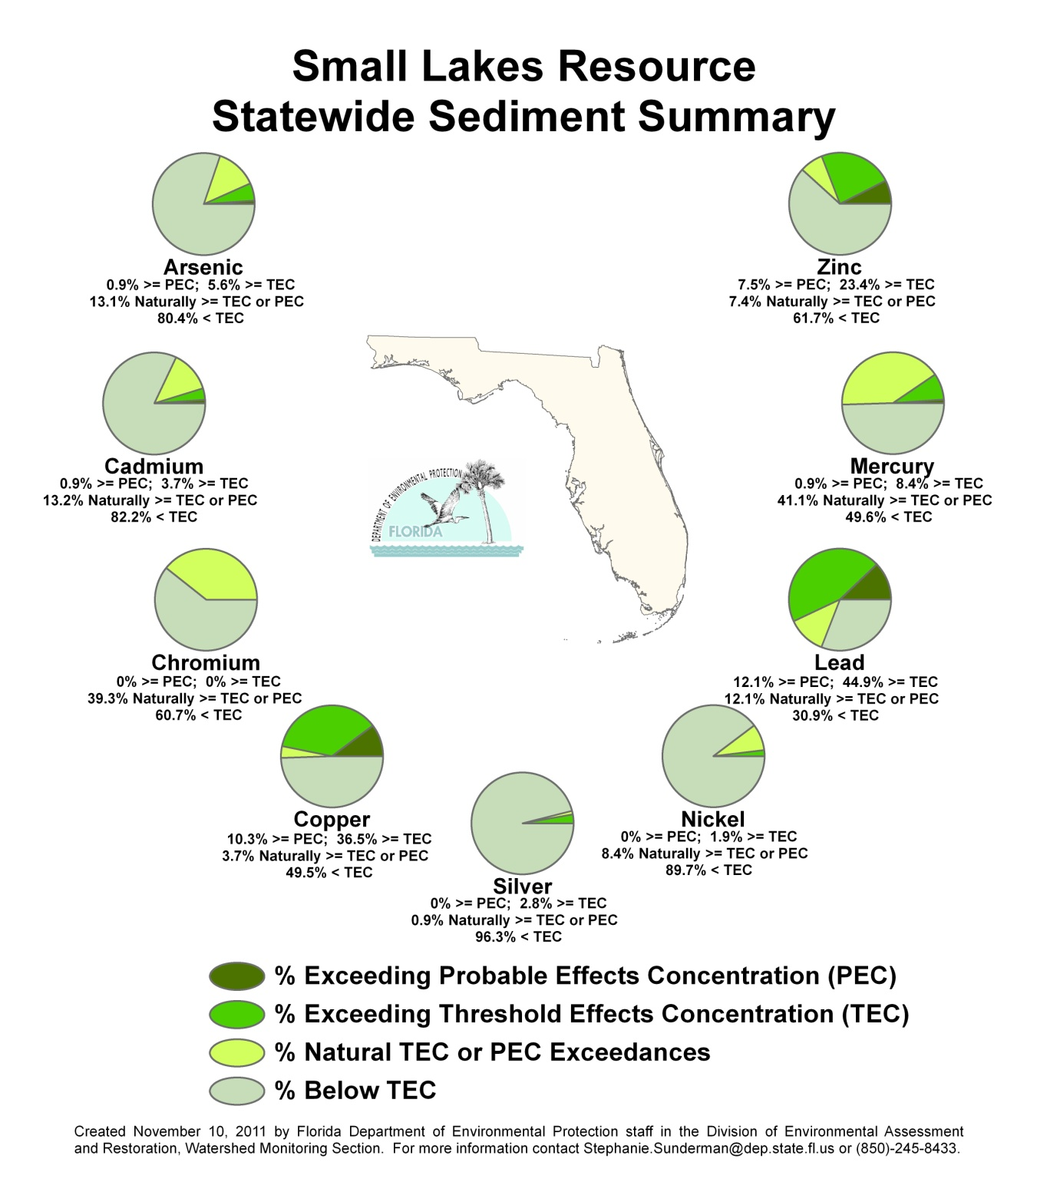

Figure 6.10. Statewide Summary of Small Lake Sediment Results

Summary of Status Network Ground Water Results
The Department’s Watershed Monitoring Section has monitored ground water quality since 1986 in both confined and unconfined aquifers. The current Status Network ground water monitoring program uses a probabilistic monitoring design to estimate confined and unconfined aquifer water quality across the state. This estimate is, by necessity, based on a subsampling of wells representing both the confined and unconfined aquifers. The wells used in this evaluation include private, public, monitoring, and agricultural irrigation wells. Figures 6.11 and 6.13 depict the randomly selected wells that were sampled for confined and unconfined aquifers, respectively.
The assessment period for this report is January 2009 through December 2010. Table 6.5 describes the ground water indicators used in the analysis and lists primary drinking water standards (thresholds). Some of the more important analytes include total coliform, nitrate-nitrite, trace metals such as arsenic and lead, and sodium (salinity), all of which are threats to drinking water quality.

Table 6.5. Status Network Physical/Other Indicators/Index for Potable Water Supply for Ground Water with Water Quality Criteria/Thresholds
This is a two-column table. Column 1 lists the indicator, and Column 2 lists the water quality criteria/threshold for that indicator.

Primary Indicator/Index  for Potable Water Supply  (Ground Water) | Criterion/Threshold
Fluoride | ≤4 mg/L
Arsenic | ≤10 µg/L
Cadmium | ≤5 µg/L
Chromium | ≤100 µg/L
Lead | ≤15 µg/L
Nitrate-Nitrite | ≤10 mg/L
Sodium | ≤160 mg/L
Fecal Coliform | < 2/100mL
Total Coliform Bacteria | ≤4 /100mL

For each Status Network ground water resource (confined aquifers and unconfined aquifers), there is a map showing the sample site locations (Figures 6.11 and 6.13), a figure summarizing the statewide results (Figures 6.12 and 6.14), and a table containing the statewide results for each indicator for a particular resource (Tables 6.6b and 6.6c). Table 6.6a contains a legend for the terms used in Tables 6.6b and 6.6c. Tables 6.6b and 6.6c provide an estimate of the quality of Florida’s confined and unconfined aquifers by listing the percentage of the resource that meets a potable water threshold.

Table 6.6a. Legend for Terms Used in Tables 6.6b and 6.6c
This is a two-column table. Column 1 lists the terms and Column 2 provides an explanation.

Term | Explanation
Analyte | Indicators chosen to base assessment of the condition of waters of the state.
Target Population | Number of wells from which inferences are based. Excludes % of resource that was determined to not fit definition of resource.
Number of Samples | Number of samples used for statistical analysis after qualified data and resource exclusions are eliminated from the data pool.
% Meeting Threshold | % estimate of resource extent that meets a specific indicator’s criterion/threshold value.
95% Confidence Bounds  (% Meeting Threshold) | Upper and lower bounds for 95% confidence of % meeting a specific indicator’s criterion/threshold value.
% Not Meeting Threshold | % of estimate of extent of resource that does not meet a specific indicator’s criterion/threshold value.
Assessment Period | Duration of probabilistic survey’s sampling event.

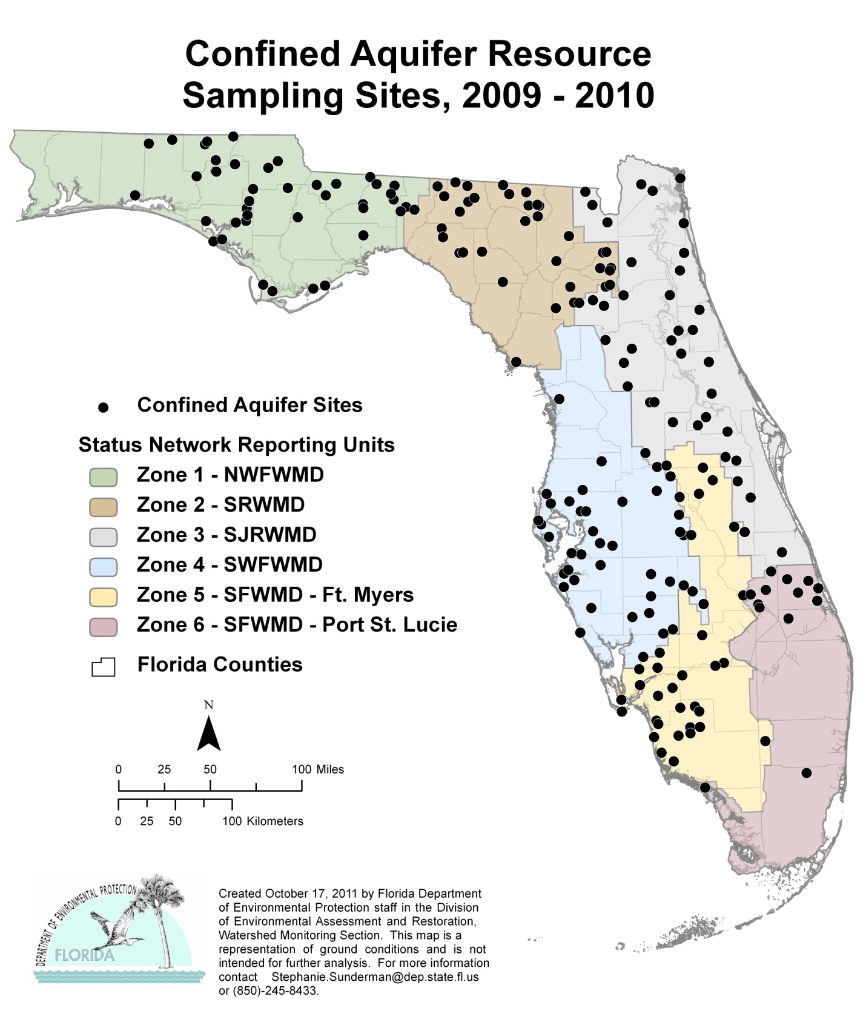

Figure 6.11. Statewide Confined Aquifer Well Locations

Table 6.6b. Statewide Percentage of Confined Aquifers Meeting Threshold Values for Indicators Calculated Using Probabilistic Monitoring Design
Status Network Designated Use: Primary Drinking Water Standards
Units: Number of wells in list frame
This is a seven-column table. Column 1 lists the analyte, Column 2 lists the target population, Column 3 lists the number of samples, Column 4 lists the percent meeting the threshold, Column 5 lists the 95% confidence bounds, Column 6 lists the percent not meeting the threshold, and Column 79 lists the assessment period.

Analyte | Target Population  (wells in list frame) | Number of Samples | % Meeting  Threshold | 95%  Confidence Bounds  (% meeting) | % Not Meeting  Threshold | Assessment Period
Arsenic | 9,018 | 219 | 98.2 | 95.5-100.0 | 1.8 | 2009–10
Cadmium | 9,018 | 219 | 100.0 | 100.0 | 0.0 | 2009–10
Chromium | 9,018 | 209 | 100.0 | 100.0 | 0.0 | 2009–10
Lead | 9,018 | 219 | 99.7 | 99.5-99.9 | 0.3 | 2009–10
Nitrate-Nitrite | 9,018 | 180 | 100.0 | 100.0 | 0.0 | 2009–10
Sodium | 9,018 | 219 | 95.5 | 93.8-97.1 | 4.5 | 2009–10
Fluoride | 9,018 | 219 | 100.0 | 100.0 | 0.0 | 2009–10
Fecal Coliform | 9,018 | 218 | 100.0 | 100.0 | 0.0 | 2009–10
Total Coliform | 9,018 | 174 | 93.8 | 89.0-98.6 | 6.2 | 2009–10

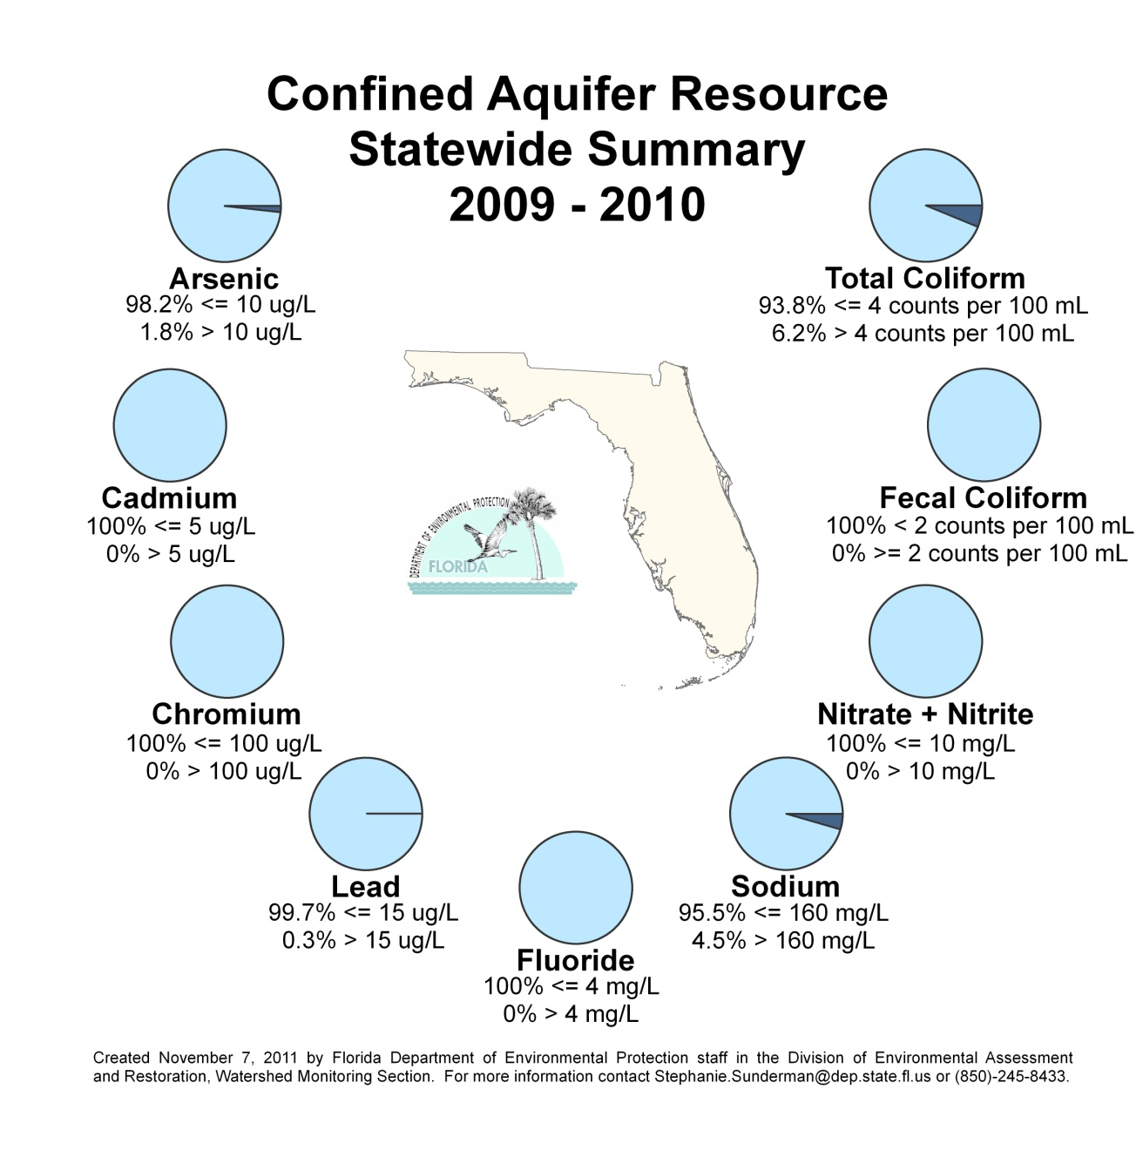
Figure 6.12. Statewide Summary of Confined Aquifer Results

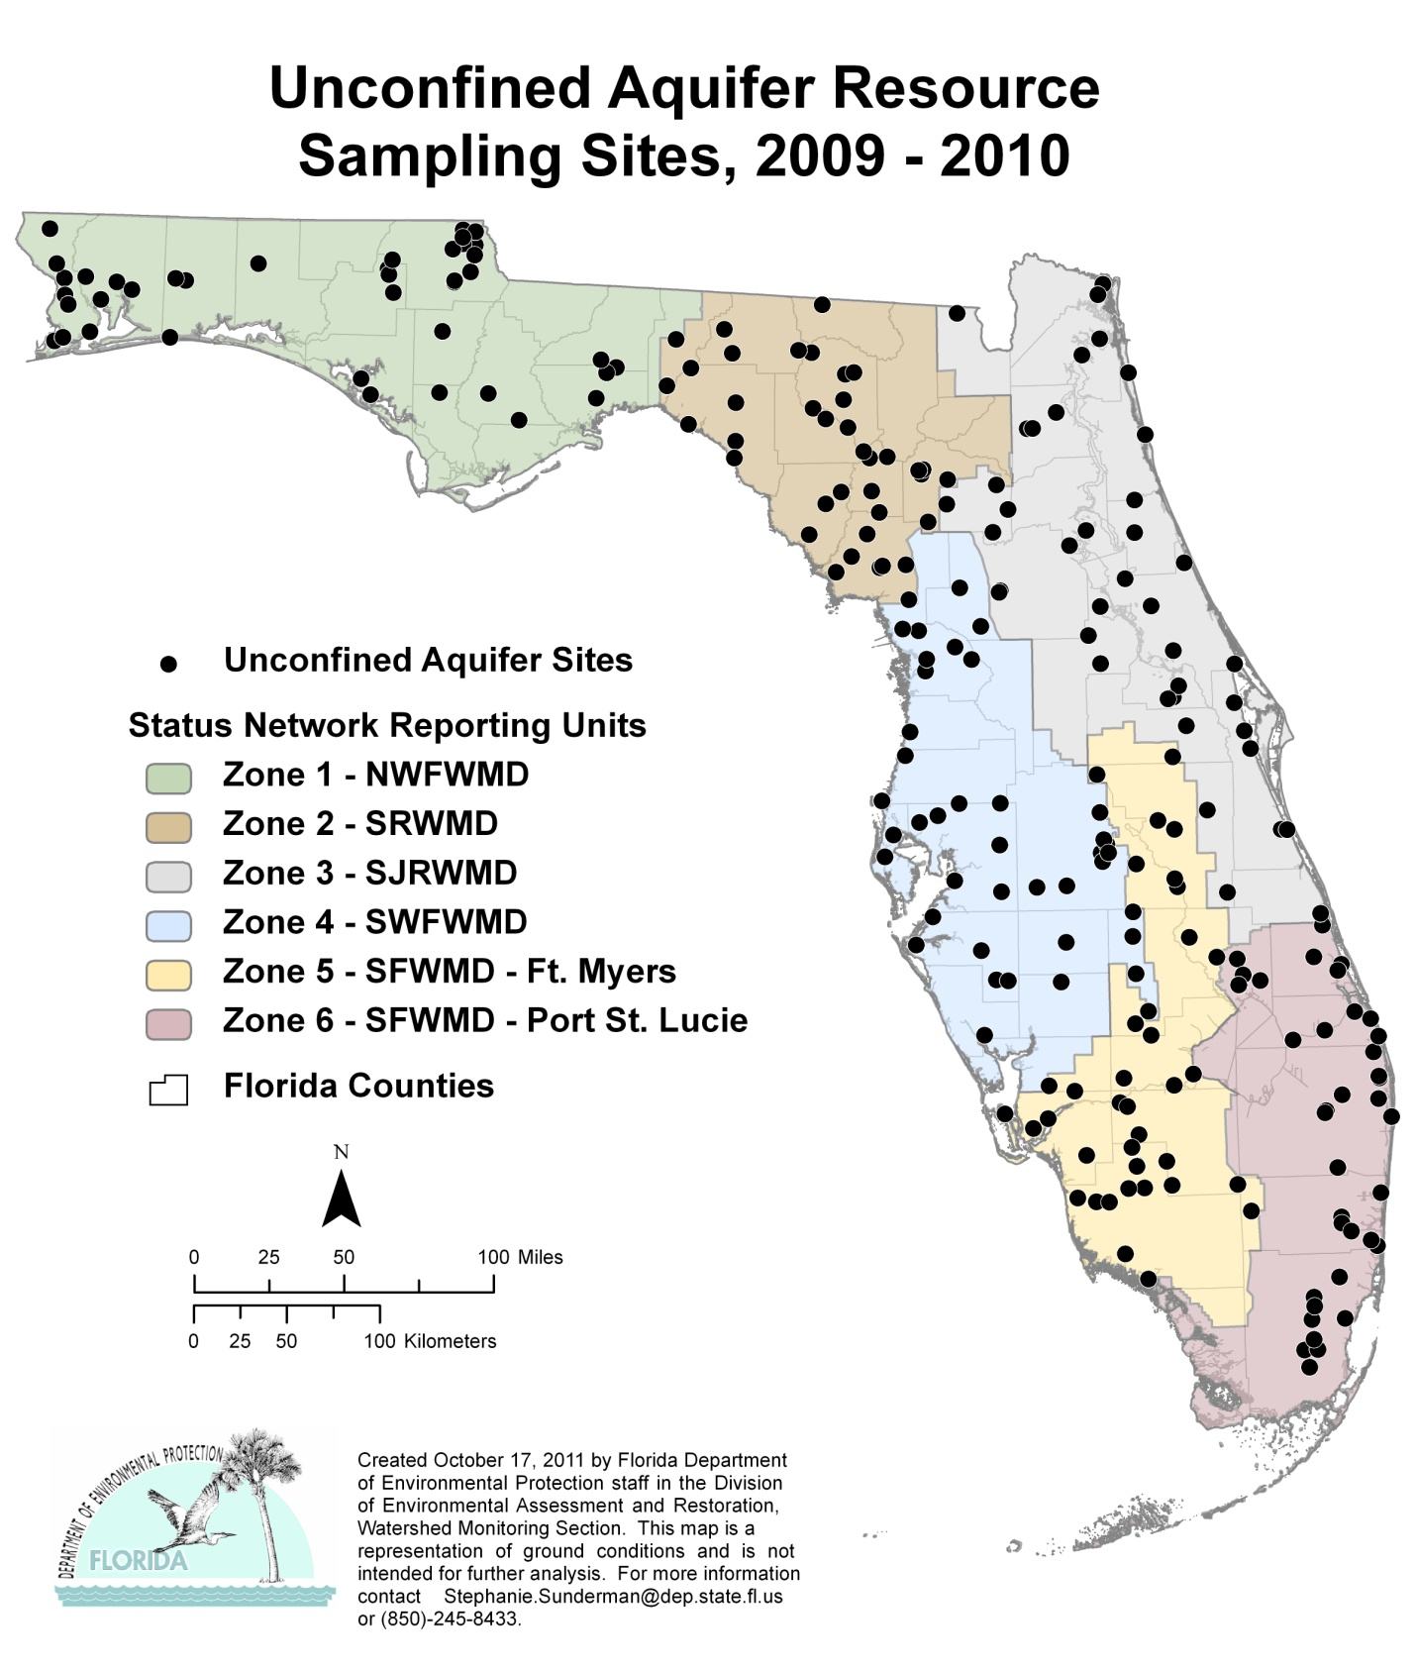

Figure 6.13. Statewide Unconfined Aquifer Well Locations

Table 6.6c. Statewide Percentage of Unconfined Aquifers Meeting Threshold Values for Indicators Calculated Using Probabilistic Monitoring Design
Status Network Designated Use: Primary Drinking Water Standards
Units: Number of wells in list frame
This is a seven-column table. Column 1 lists the analyte, Column 2 lists the target population, Column 3 lists the number of samples, Column 4 lists the percent meeting the threshold, Column 5 lists the 95% confidence bounds, Column 6 lists the percent not meeting the threshold, and Column 7 lists the assessment period.

Analyte | Target Population  (wells in list frame) | Number of Samples | % Meeting  Threshold | 95%  Confidence Bounds  (% meeting) | % Not Meeting  Threshold | Assessment Period
Arsenic | 8,551 | 222 | 99.1 | 98.4-99.9 | 0.9 | 2009–10
Cadmium | 8, 551 | 222 | 99.9 | 99.7-100.0 | 0.1 | 2009–10
Chromium | 8, 551 | 222 | 100.0 | 100.0 | 0.0 | 2009–10
Lead | 8, 551 | 207 | 97.9 | 96.5-99.3 | 2.1 | 2009–10
Nitrate-Nitrite | 8, 551 | 191 | 98.6 | 96.8-100.0 | 1.4 | 2009–10
Sodium | 8, 551 | 222 | 98.5 | 97.6-99.5 | 1.5 | 2009–10
Fluoride | 8, 551 | 222 | 100.0 | 100.0 | 0.0 | 2009–10
Fecal Coliform | 8, 551 | 222 | 95.4 | 95.9-100.0 | 4.6 | 2009–10
Total Coliform | 8, 551 | 222 | 83.6 | 75.3-91.9 | 16.4 | 2009–10

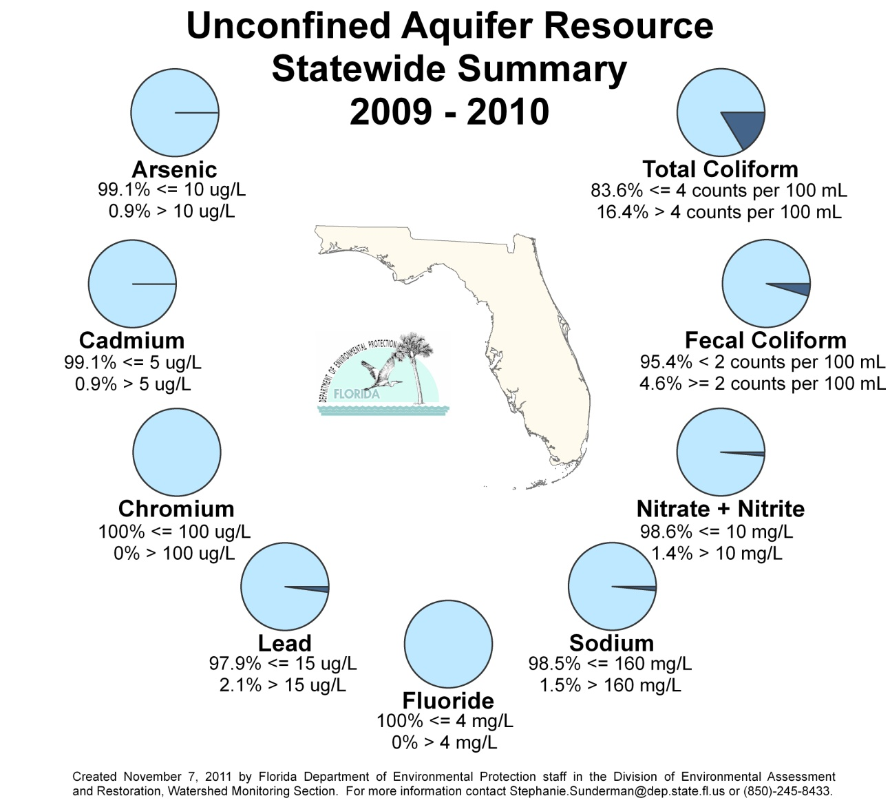

Figure 6.14. Statewide Summary of Unconfined Aquifer Results

Summary of Surface and Ground Water Trend Network Results

Surface Water Trends
The flow rate of rivers can be highly variable and can complicate data analysis unless taken into consideration. Where available, flow rates from associated USGS gauging stations were collected at the same time as surface water samples. The surface water quality data were adjusted for flow before SK data analysis. Since ground water flows very slowly, there is little to no seasonality to the data. Therefore, no adjustment to the ground water data was necessary prior to any analysis was performed. If a trend was found to exist for either seasonally adjusted or nonadjusted data, the corresponding slope was determined using the Sen Slope (SS) estimator (Gilbert 1987). The estimator measures the median difference between successive concentration observations over the time series. SS was used only to measure the direction of the slope, not as a hypothesis test. Therefore, reporting the trend as increasing, decreasing, or no trend indicates the direction of the slope and does not indicate the impairment or improvement of the analyte being measured in the waters.
Forty-three surface water stations were adjusted for flow, while the remaining 33 stations were not flow adjusted. Table 6.7 provides a general statewide overview of the analyses conducted on the surface water trend data (1999–2010). For the results of the analyses by station, see Tables 6.8a through 6.8c. Table 6.8a contains the legend for the acronyms and abbreviations used in Tables 6.8b and 6.8c. Tables 6.8b and 6.8c present the results of the trend analyses, and Figures 6.15 through 6.22 show the results graphically for each indicator.

Table 6.7. Surface Water Trend Summary (1999–2010)
This is a nine-column table. Column 1 lists the indicator, Columns 2 and 6 show the pie chart for the indicator, Columns 3, 4, and 5 list the flow-adjusted percentages, and Columns 7, 8, and 9 list the nonflow-adjusted percentages.

Note: Light blue segments of the pie charts represent the percentage of stations sampled that exhibit an increasing trend for the specified analyte. Dark blue segments represent the percentage of stations sampled that exhibit a decreasing trend for the specified analyte. Gray segments represent the percentage of stations sampled that exhibit no trend for the specified analyte. Flow-adjusted site percentages were calculated based on a sample size of 43 stations that are associated with a USGS gauging station and adjusted for water flow. Nonflow- adjusted site percentages were calculated based on a sample size of 31 stations.

Indicator | Flow-Adjusted Sites | % Increasing | % Decreasing | % No Trend | Nonflow- Adjusted Sites | % Increasing | % Decreasing | % No Trend
Nitrate + Nitrite | 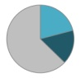 | 20.9% | 16.3% | 62.8% | 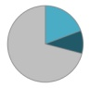 | 19.4% | 9.7% | 71.0%
Total Kjeldahl Nitrogen | 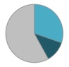 | 30.2% | 11.6% | 58.1% | 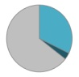 | 32.3% | 3.2% | 64.5%
Total Phosphorus | 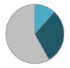 | 11.6% | 30.2% | 58.1% | 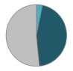 | 3.2% | 45.2% | 51.6%
Total Organic Carbon | 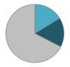 | 16.3% | 16.3% | 67.4% | 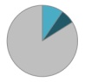 | 9.7% | 6.5% | 83.9%
Chlorophyll a | 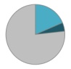 | 18.6% | 4.7% | 76.7% | 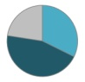 | 32.3% | 45.2% | 22.6%
Fecal Coliform | 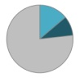 | 14.0% | 9.3% | 76.7% | 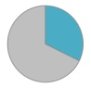 | 32.3% | 0.0% | 67.7%
pH | 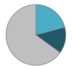 | 20.9% | 14.0% | 65.1% | 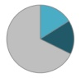 | 16.1% | 16.1% | 67.7%
DO | 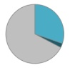 | 30.2% | 2.3% | 67.4% | 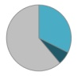 | 32.3% | 6.5% | 61.3%

Table 6.8a. Legend for the Acronyms and Abbreviations Used in Tables 6.8b and 6.8c
This is a two-column table. Column 1 lists the acronym or abbreviation, and Column 2 spells out the acronym.

Acronym/Abbreviation | Indicator
TKN | Total Kjeldahl Nitrogen
TP | Total Phosphorus
TOC | Total Organic Carbon
DO | Dissolved Oxygen
pH | pH, Field

Table 6.8b. Trends for Specified Analytes for Surface Water Trend Network Stations that Are Associated with a USGS Gauging Station and Adjusted for River Flow
This is a 10-column table. Column 1 lists the station, Column 2 lists the river, and Columns 3 through 10 list the analytes.
Positive trends are indicated with a plus sign (+), negative trends are indicated with a minus sign (-), and no trends are indicated by zero (0).
Station | River | Nitrate-Nitrite | TKN | TP | TOC | Chlorophyll a | Fecal Coliform | pH | DO
3494 | Barron | + | + | 0 | + | 0 | 0 | 0 | 0
3497 | Fisheating Creek | 0 | 0 | 0 | 0 | 0 | 0 | 0 | 0
3500 | St. Lucie | 0 | o | - | 0 | 0 | - | + | +
3501 | Kissimmee | 0 | 0 | 0 | 0 | 0 | 0 | 0 | 0
3509 | Anclote | - | - | - | 0 | - | + | - | o
3513 | Withlacoochee | + | + | 0 | + | 0 | 0 | 0 | 0
3515 | St. Johns | 0 | - | 0 | 0 | - | 0 | 0 | 0
3517 | Ocklawaha | 0 | 0 | 0 | + | 0 | + | 0 | 0
3519 | Suwannee | 0 | 0 | 0 | 0 | 0 | 0 | 0 | 0
3521 | Santa Fe | - | + | + | + | 0 | 0 | 0 | 0
3522 | Suwannee | 0 | 0 | 0 | 0 | 0 | 0 | 0 | 0
3524 | Apalachicola | + | 0 | - | 0 | + | 0 | 0 | +
3527 | Ochlockonee | 0 | 0 | 0 | 0 | + | 0 | 0 | +
3528 | St. Marks | 0 | 0 | 0 | - | 0 | + | + | +
3530 | Suwannee | + | 0 | 0 | 0 | + | 0 | 0 | 0
3531 | Econfina Creek | + | + | 0 | 0 | 0 | 0 | + | +
3532 | Telogia Creek | 0 | 0 | - | 0 | 0 | 0 | 0 | +
3534 | Choctawhatchee | + | 0 | - | 0 | + | 0 | - | +
3535 | Suwannee | 0 | + | + | + | 0 | 0 | 0 | 0
3538 | Alapaha | 0 | 0 | 0 | 0 | 0 | 0 | 0 | 0
3539 | Withlacoochee | + | 0 | 0 | - | + | 0 | 0 | 0
3541 | Escambia | 0 | + | - | 0 | + | 0 | 0 | +
3542 | Perdido | - | + | + | + | 0 | - | 0 | 0
3543 | Apalachicola | 0 | 0 | 0 | 0 | + | 0 | + | 0
3545 | Blackwater | 0 | 0 | - | 0 | 0 | 0 | 0 | +
3549 | Escambia | 0 | + | 0 | 0 | + | 0 | 0 | +
3554 | Alafia | - | + | - | 0 | 0 | 0 | 0 | 0
3555 | Little Manatee | 0 | + | - | + | o | + | - | 0
3556 | Peace | - | 0 | + | 0 | 0 | 0 | 0 | 0
3557 | St. Johns | 0 | 0 | 0 | 0 | 0 | 0 | 0 | 0
3558 | Miami Canal | - | 0 | - | 0 | 0 | 0 | + | 0
3559 | Hillsboro Canal | 0 | 0 | 0 | - | 0 | - | 0 | 0
3560 | Withlacoochee | 0 | 0 | 0 | 0 | 0 | + | 0 | 0
3561 | Charlie Creek | 0 | + | + | 0 | 0 | 0 | - | 0
3563 | New | 0 | - | 0 | - | 0 | 0 | 0 | 0
3564 | Waccasassa | 0 | + | 0 | 0 | 0 | 0 | 0 | +
3565 | Eleven Mile Creek | 0 | 0 | 0 | 0 | 0 | 0 | - | 0
3566 | Weeki Wachee | + | + | - | 0 | 0 | - | - | -
3568 | Caloosahatchee | 0 | 0 | 0 | - | 0 | 0 | + | +
3569 | Little Econlockhatchee | - | - | - | - | 0 | + | + | 0
3571 | Black Creek Canal | + | 0 | 0 | 0 | 0 | 0 | + | 0
3572 | Miami | 0 | 0 | - | - | 0 | 0 | 0 | +
21380 | Homosassa Spring | 0 | - | 0 | 0 | 0 | 0 | + | 0

Table 6.8c. Trends for Specified Analytes for Surface Water Stations from the Trend Network and not Adjusted for River Flow
This is a 10-column table. Column 1 lists the station, Column 2 lists the river, and Columns 3 through 10 list the analytes.

Positive trends are indicated with a plus sign (+), negative trends are indicated with a minus sign (-), no trends are indicated by zero (0), and ISD indicates insufficient data to determine a trend.
Station | River | Nitrate-Nitrite | TKN | TP | TOC | Chlorophyll a | Fecal Coliform | pH | DO
3495 | Golden Gate Canal | 0 | + | 0 | 0 | + | 0 | + | +
3499 | Myakka | 0 | + | 0 | + | + | 0 | - | 0
3502 | Phillippe Creek | 0 | + | 0 | 0 | + | 0 | - | -
3504 | C-25 Canal | 0 | 0 | 0 | 0 | + | 0 | 0 | 0
3505 | Manatee | + | + | - | 0 | + | + | 0 | 0
3506 | C-38 Canal | 0 | 0 | - | - | + | + | - | -
3507 | Hillsborough | 0 | 0 | 0 | 0 | 0 | 0 | 0 | 0
3508 | Indian River Lagoon | 0 | 0 | - | - | 0 | 0 | + | 0
3516 | Tomoka | + | 0 | + | 0 | - | + | + | 0
3526 | Aucilla | 0 | + | 0 | 0 | - | + | 0 | 0
3533 | East Bay | - | 0 | - | 0 | - | 0 | - | 0
3536 | Alaqua Creek | 0 | + | - | + | - | 0 | 0 | +
3537 | Nassau | 0 | + | 0 | 0 | + | 0 | 0 | 0
3540 | Ochlockonee | 0 | 0 | - | 0 | + | 0 | 0 | +
3544 | St. Marys | - | 0 | - | 0 | - | 0 | 0 | 0
3546 | Yellow | 0 | 0 | 0 | 0 | 0 | + | 0 | +
3547 | Cowarts Creek | + | 0 | - | 0 | - | o | 0 | +
3548 | Choctawhatchee | 0 | 0 | 0 | 0 | + | 0 | 0 | +
3550 | Brushy Creek | - | 0 | - | 0 | - | 0 | 0 | 0
3551 | Yellow | 0 | + | 0 | 0 | 0 | 0 | 0 | +
3552 | Chipola | 0 | 0 | - | 0 | 0 | 0 | 0 | +
3553 | St. Johns | 0 | 0 | 0 | 0 | + | 0 | + | +
3570 | Aerojet Canal | + | + | - | 0 | 0 | + | + | +
6976 | Econfina | 0 | + | 0 | + | - | + | 0 | 0
6978 | Steinhatchee | + | 0 | 0 | 0 | - | 0 | 0 | 0
21179 | Spruce Creek | 0 | 0 | - | 0 | 0 | 0 | 0 | 0
21200 | Rice Creek | 0 | 0 | - | 0 | - | 0 | 0 | 0
21201 | Moultrie Creek | 0 | 0 | 0 | 0 | - | 0 | 0 | 0
21202 | Orange Creek | + | - | - | 0 | - | + | 0 | 0
21460 | Wrights Creek | 0 | 0 | 0 | 0 | - | + | 0 | 0
21461 | Big Coldwater Creek | 0 | 0 | 0 | 0 | - | + | - | 0
34879 | Wakulla | ISD | ISD | ISD | ISD | ISD | ISD | ISD | ISD
24139 | Wekiva | ISD | ISD | ISD | ISD | ISD | ISD | ISD | ISD

Figure 6.15. Surface Water Trends for Nitrate + Nitrite, 1999–2010

Highlights

- There were 15 stations with increasing trends and 10 stations with decreasing trends for nitrate-nitrite around the state. The far western Panhandle had 3 of the decreasing trend stations, while the remaining stations were located throughout the rest of the state. Trends in nitrate-nitrite may indicate changes in anthropogenic input.
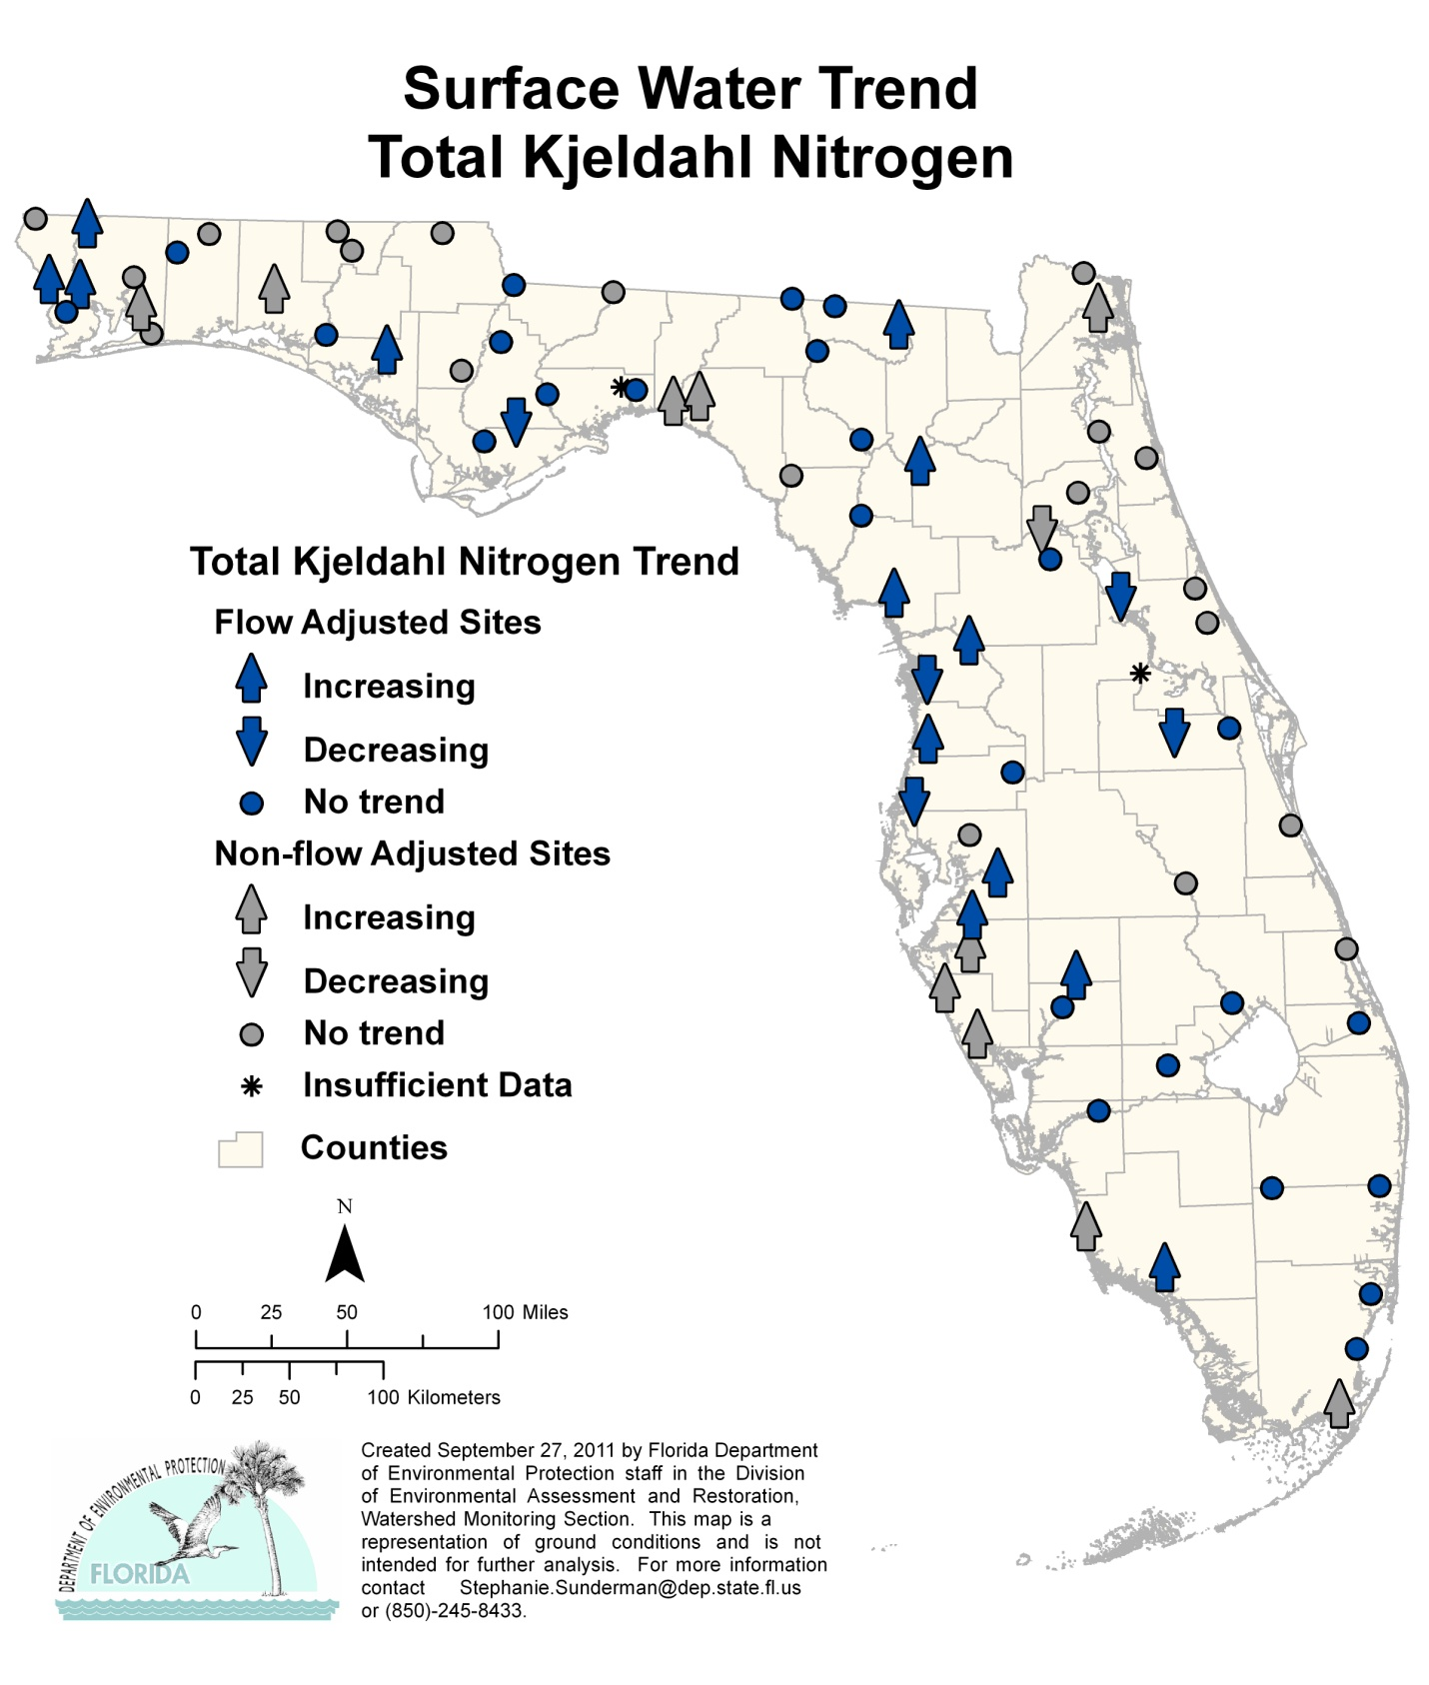

Figure 6.16. Surface Water Trends for TKN, 1999–2010

Highlights

- TKN had 23 stations with increasing trends and 6 stations had decreasing trends. TKN is ammonia plus organic nitrogen.

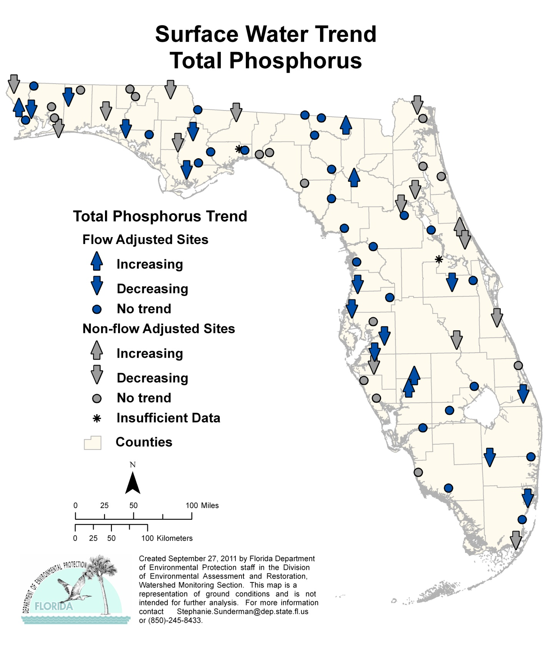

Figure 6.17. Surface Water Trends for TP, 1999–2010

Highlights

- TP had 6 stations with increasing trends and 27 stations with decreasing trends across the state. The areas of increasing trends are the Suwannee River and Bone Valley where phosphate mining occurs. Phosphorus is found naturally in ground water in many areas of the state.

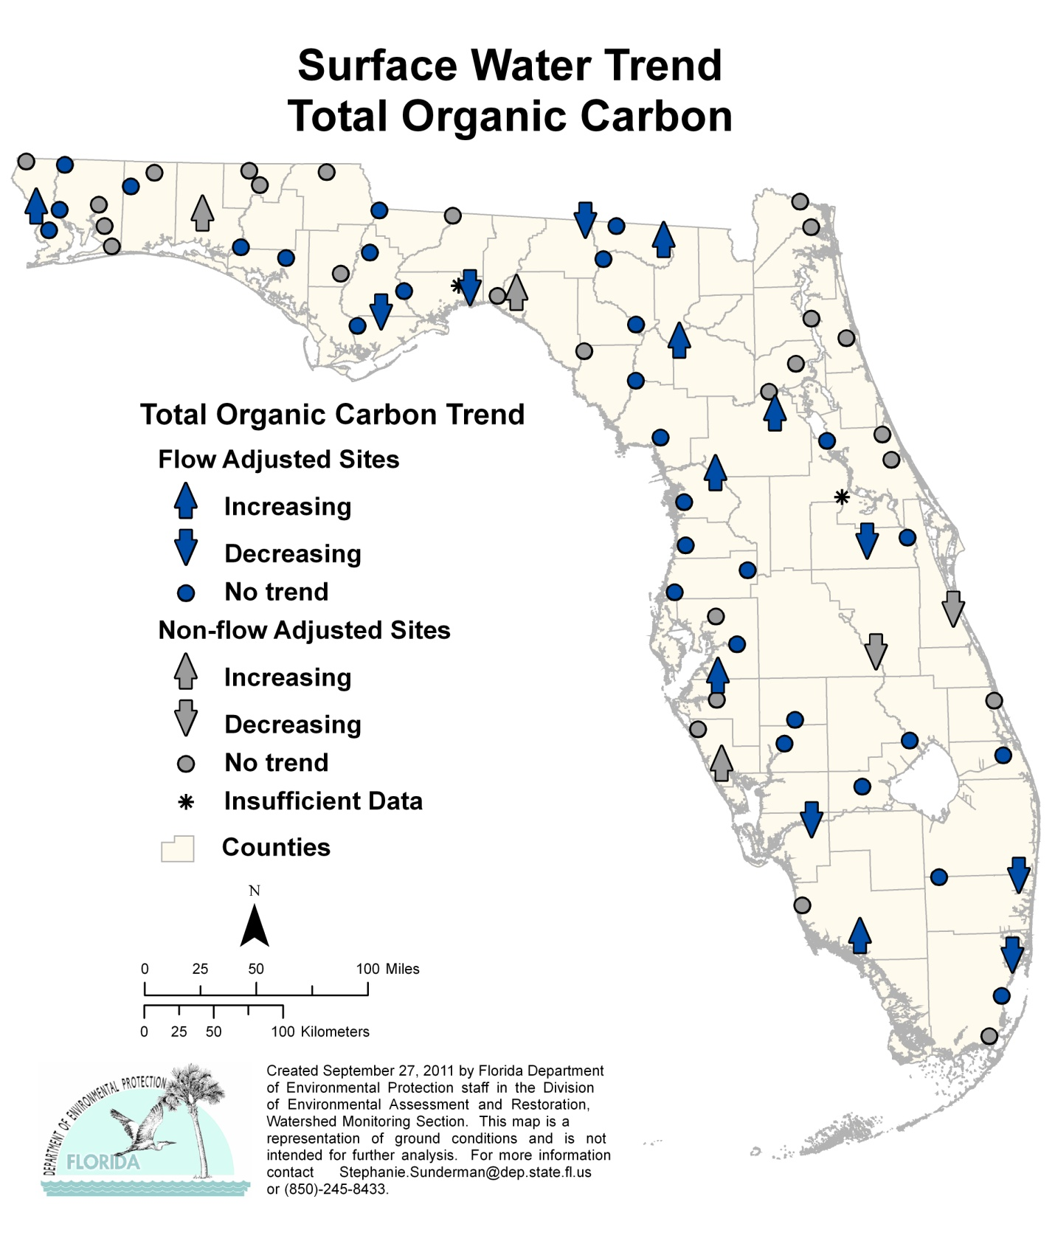
Figure 6.18. Surface Water Trends for TOC, 1999–2010

Highlights

- There were 10 stations with increasing trends and 9 stations with decreasing trends for TOC across the state. There is no distinct pattern to either the increasing or decreasing trends.

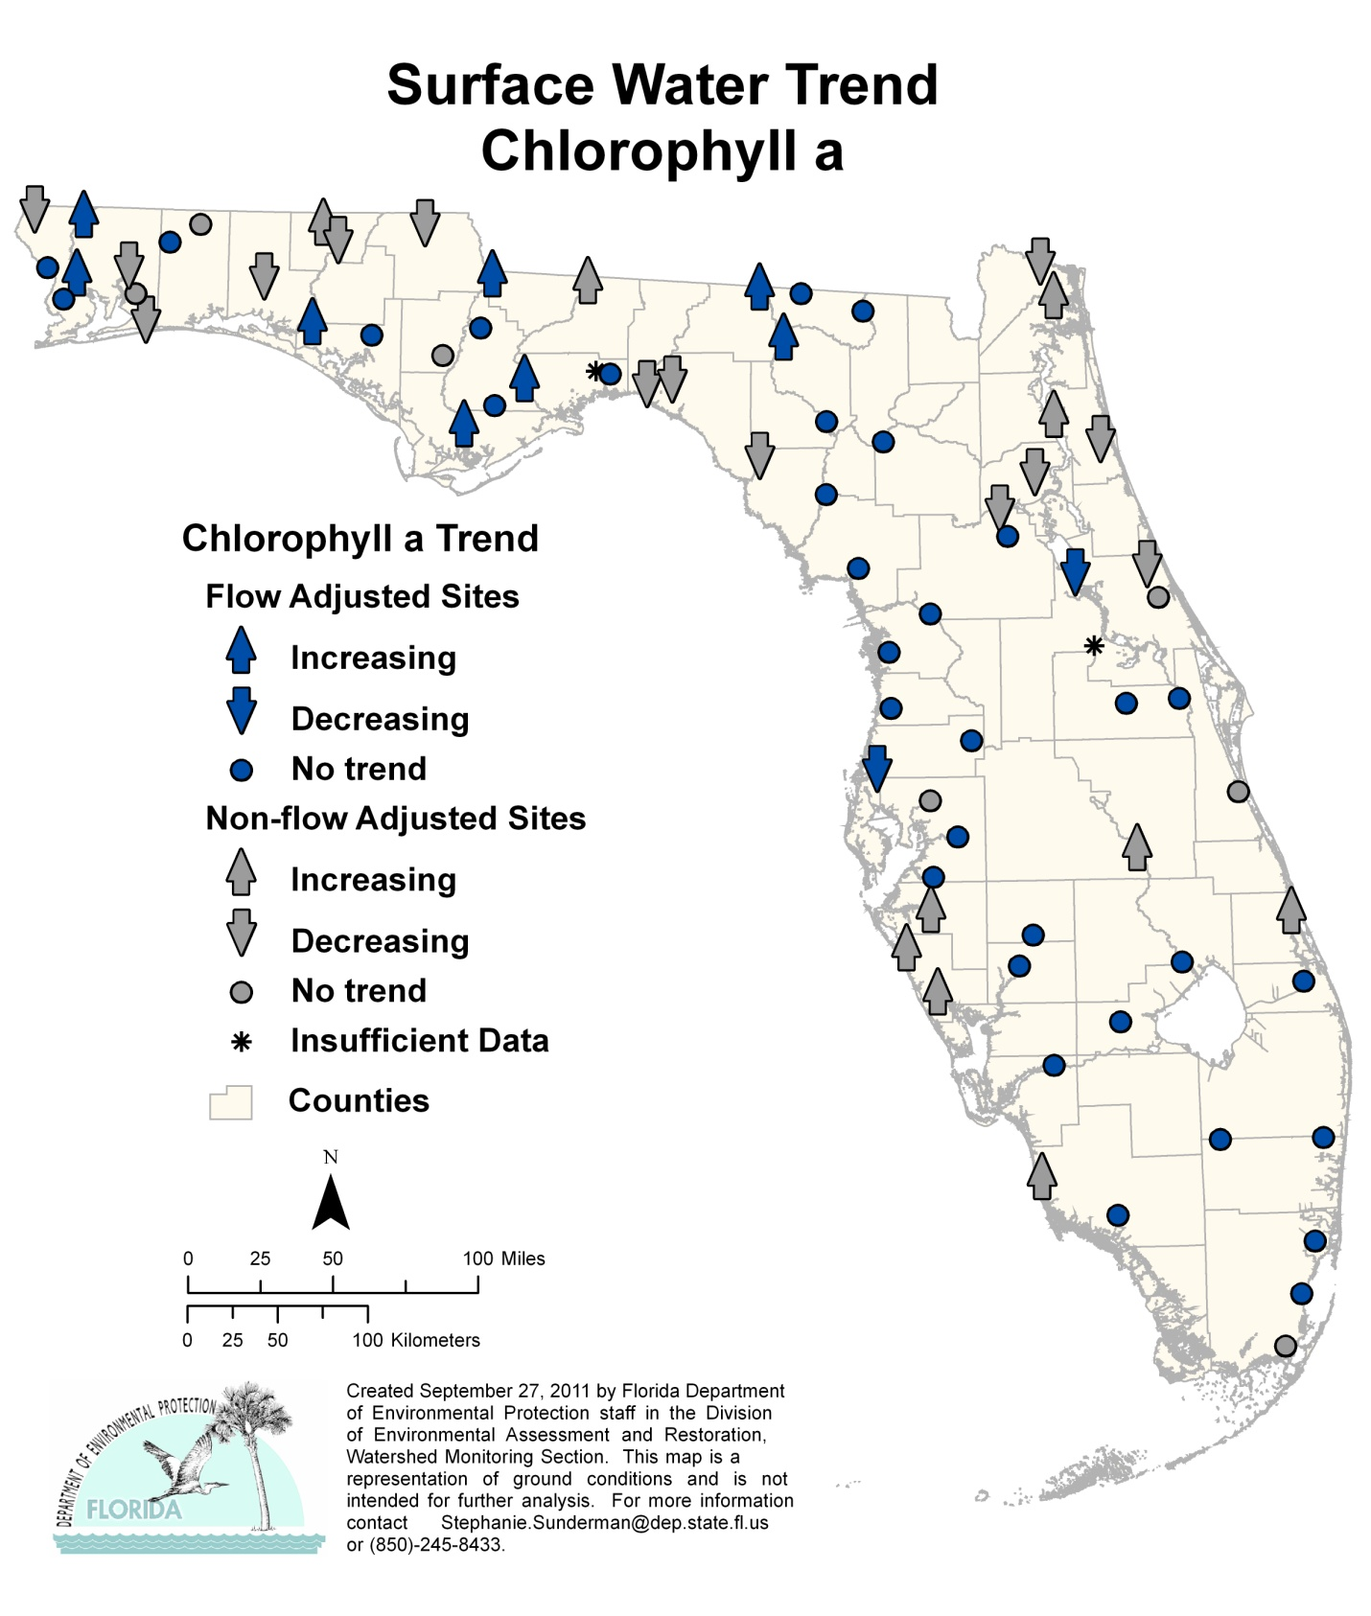
Figure 6.19. Surface Water Trends for Chlorophyll a, 1999–2010

Highlights

- The trends for chlorophyll a were mixed, with 18 stations having an increasing trend and 16 stations a decreasing trend, with no apparent pattern around the state. Chlorophyll a is a photosynthetic pigment and may be used as a surrogate indicator of changes in plant biomass related to nutrients.

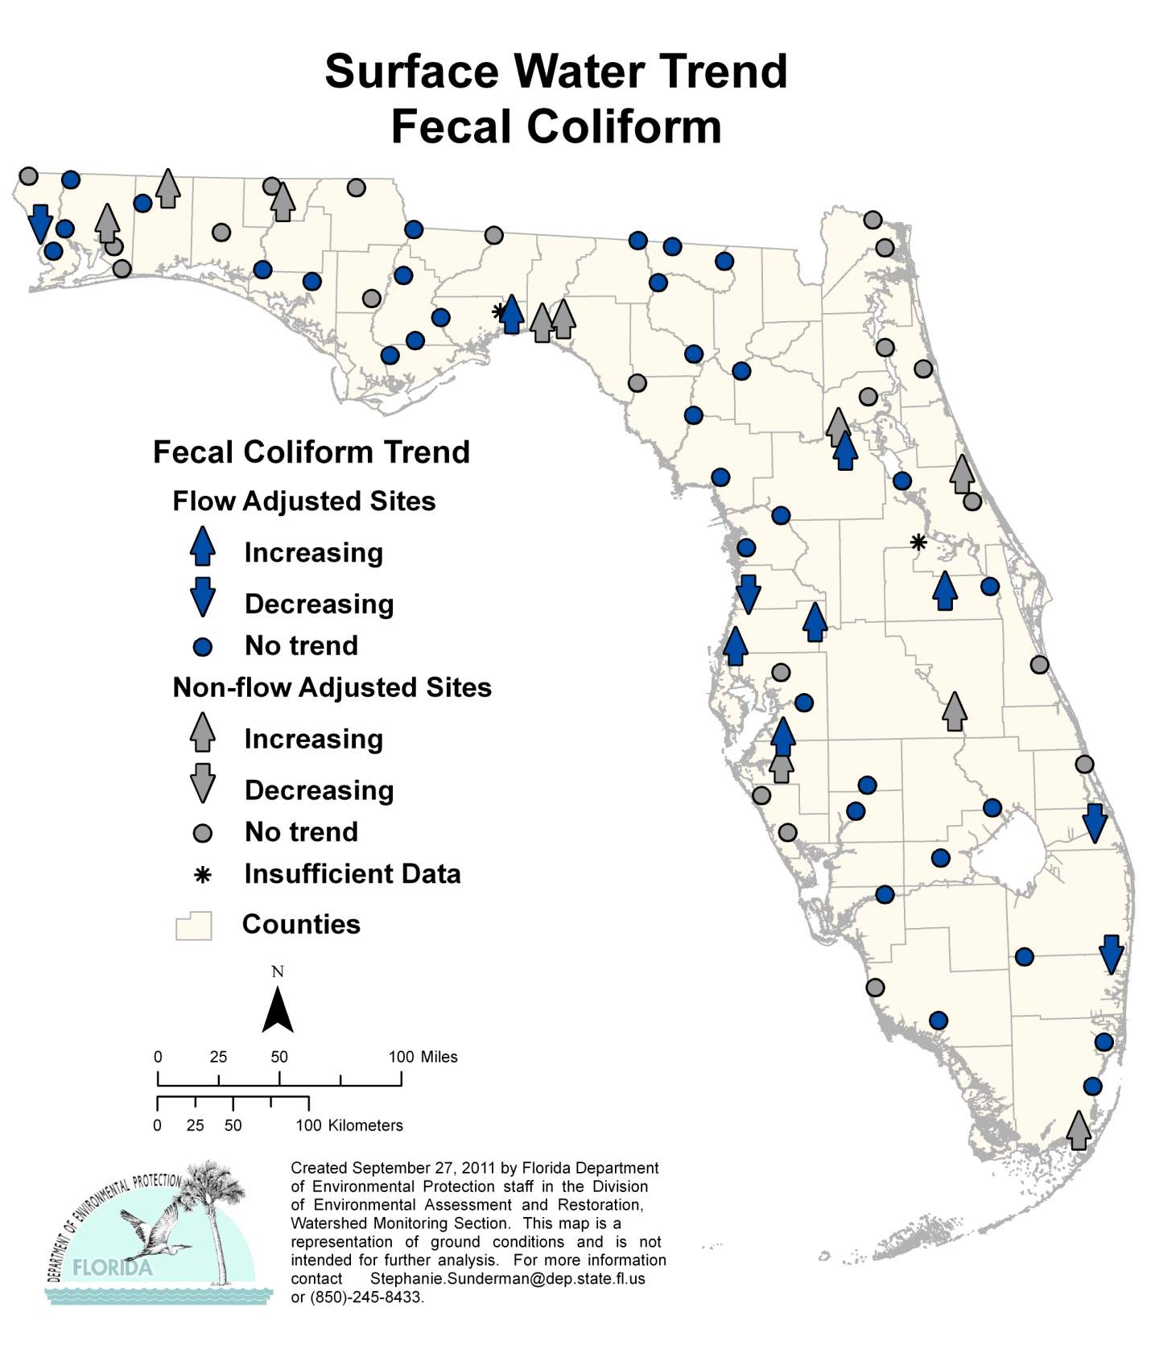
Figure 6.20. Surface Water Trends for Fecal Coliform Bacteria, 1999–2010

Highlights

- There were 16 stations with an increasing trend for fecal coliform bacteria and 4 stations with a decreasing trend. Increased levels of fecal coliform in surface waters can indicate inadequate treatment of domestic wastewater, sewer line spills, or failing septic tanks; however, there are also many natural sources of coliform, and the EPA no longer supports the use of fecal coliform as an indicator organism.

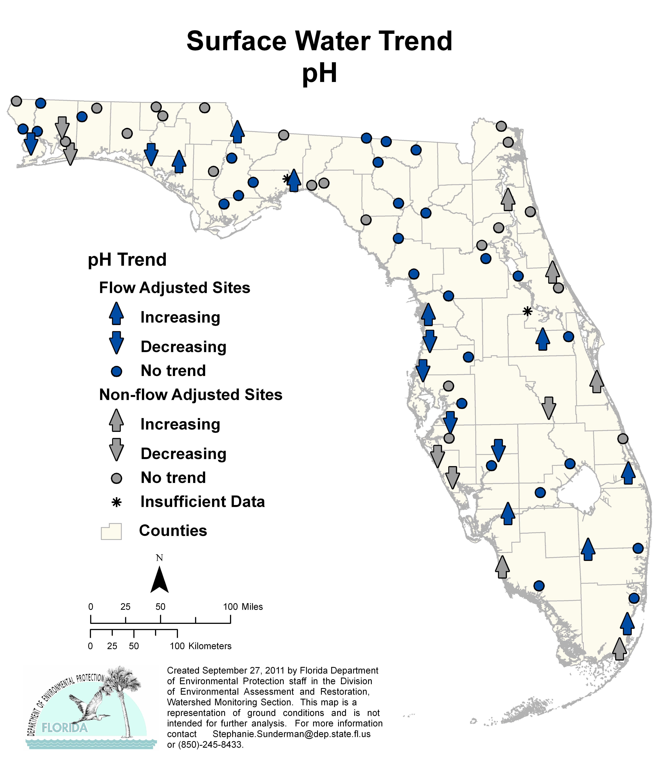

Figure 6.21. Surface Water Trends for pH, 1999–2010

Highlights

- There were 13 stations with increasing trends and 11 stations with decreasing trends for pH around the state.

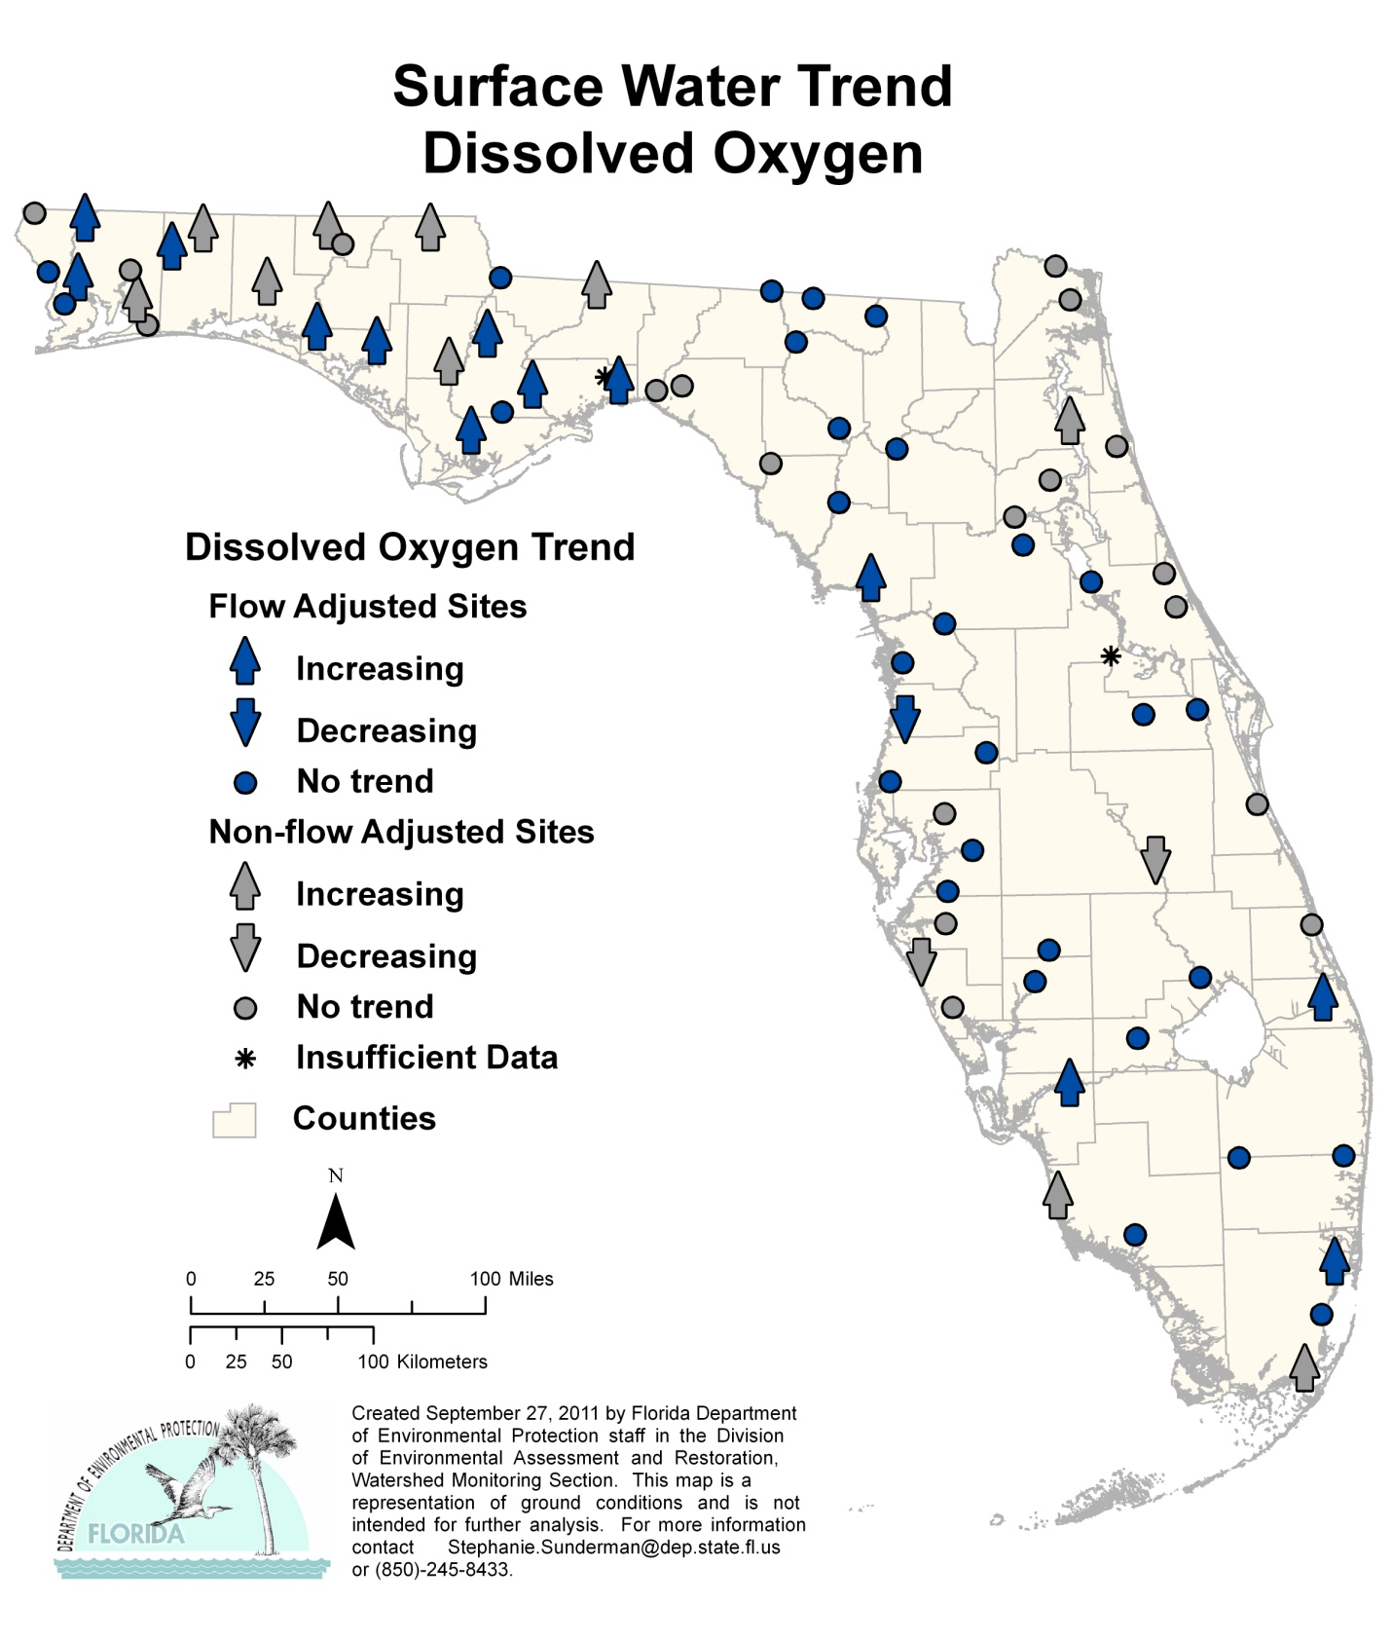
Figure 6.22. Surface Water Trends for DO, 1999–2010

Highlights

- There were 23 stations with an increasing trend for DO concentrations and 3 stations with a decreasing trend. There was no pattern to the trends, but more stations with increasing trends were located in the Panhandle.

Ground Water Trends
Ground water trend analyses were performed in the same manner as the surface water trend analyses. As stated previously, reporting the trend as increasing, decreasing, or no trend indicates the direction of the slope and does not indicate the impairment or improvement of the analyte being measured in the waters.
Forty-seven of the 48 ground water stations (wells) had a complete set of field and analytical data. Twenty-two of the wells tap confined aquifers, while 26 tap unconfined aquifers. Table 6.9 provides a general statewide overview of the analyses conducted on the ground water trend data (1999–2010). For the results of the analyses by station, see Tables 6.10a through 6.10c. Tables 6.10b and 6.10c present the results of the trend analyses, and Figures 6.23 through 6.38 show the results graphically for each analyte. At some locations there are multiple wells tapping different areas of the aquifers. These are shown in the figures as a bubble grouping. Table 6.10a contains the legend for the acronyms and abbreviations used in Tables 6.10b and 6.10c.

Table 6.9. Ground Water Trend Summary (1999–2010)
This is a nine-column table. Column 1 lists the indicator, Columns 2 and 6 show the pie chart for the indicator, Columns 3, 4, and 5 list the unconfined aquifer percentages, and Columns 7, 8, and 9 list the confined aquifer percentages.

Note: Light blue segments of the pie charts represent the percentage of stations sampled that exhibit an increasing trend for the specified analyte. Dark blue segments represent the percentage of stations sampled that exhibit a decreasing trend for the specified analyte. Gray segments represent the percentage of stations sampled that exhibit no trend for the specified analyte. Unconfined aquifer percentages were calculated based on a sample size of 25 stations, except for depth to water, where the sample size was 24 stations. Confined aquifer percentages were calculated based on a sample size of 22 stations, except for depth to water, nitrate + nitrite, phosphorus, potassium, sulfate, and fecal coliform, where the sample size was 21 stations.

Indicator | Unconfined Aquifer | % Increasing | % Decreasing | % No Trend | Confined Aquifer | % Increasing | % Decreasing | % No Trend
Temperature | 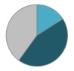 | 16.0% | 44.0% | 40.0% | 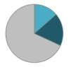 | 13.6% | 18.2% | 68.2%
Specific Conductance | 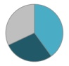 | 40.0% | 28.0% | 32.0% | 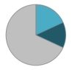 | 18.2% | 13.6% | 68.2%
pH | 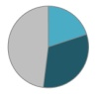 | 20.0% | 32.0% | 48.0% | 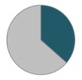 | 0.0% | 36.4% | 63.6%
Depth to Water | 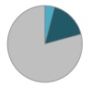 | 4.2% | 16.7% | 79.2% | 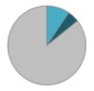 | 9.5% | 4.8% | 85.7%
Total Dissolved Solids | 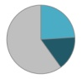 | 24.0% | 16.0% | 60.0% | 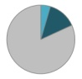 | 4.5% | 13.6% | 81.8%
Nitrate + Nitrite | 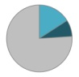 | 16.0% | 8.0% | 76.0% | 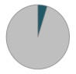 | 0.0% | 4.8% | 95.2%
Phosphorus | 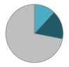 | 12.0% | 16.0% | 72.0% | 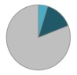 | 4.8% | 14.3% | 81.0%
Potassium | 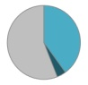 | 40.0% | 4.0% | 56.0% | 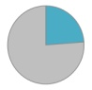 | 23.8% | 0.0% | 76.2%
Sulfate | 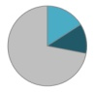 | 16.0% | 12.0% | 72.0% | 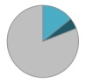 | 14.3% | 4.8% | 81.0%
Sodium | 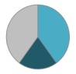 | 40.0% | 20.0% | 40.0% | 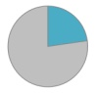 | 22.7% | 0.0% | 77.3%
Chloride | 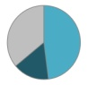 | 48.0% | 16.0% | 36.0% | 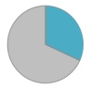 | 31.8% | 0.0% | 68.2%
Calcium | 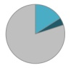 | 16.0% | 4.0% | 80.0% | 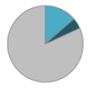 | 13.6% | 4.5% | 81.8%
Magnesium | 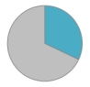 | 32.0% | 0.0% | 68.0% | 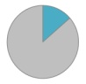 | 13.6% | 0.0% | 86.4%
Alkalinity | 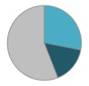 | 28.0% | 16.0% | 56.0% | 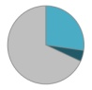 | 27.3% | 4.5% | 68.2%
Total Coliform | 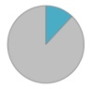 | 12.0% | 0.0% | 88.0% |  | 0.0% | 0.0% | 100.0%
Fecal Coliform | 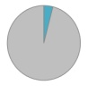 | 4.0% | 0.0% | 96.0% |  | 0.0% | 0.0% | 100.0%

Table 6.10a. Legend for the Acronyms and Abbreviations Used in Tables 6.10b and 6.10c
This is a two-column table. Column 1 lists the acronym or abbreviation, and Column 2 spells out the acronym.

Acronym/Abbreviation | Indicator
Temp | Temperature (°C)
SC | Specific Conductance, Field
pH | pH, Field
WL | Depth to Water (from measuring point)
TDS | Total Dissolved Solids (TDS measured)
NO_{X} | Nitrate + Nitrite, Dissolved (as N)
P | Phosphorus, Dissolved (as P)
K | Potassium, Dissolved
SO₄ | Sulfate, Dissolved
Na | Sodium, Dissolved
Cl | Chloride, Dissolved
Ca | Calcium, Dissolved
Mg | Magnesium, Dissolved
ALK | Alkalinity, Dissolved (as calcium carbonate [CaCO3])
TC | Coliform, Total (MF method)
FC | Coliform, Fecal (MF method)

Table 6.10b. Trends for Specified Analytes for Stations in the Ground Water Trend Monitoring Network, Confined Aquifers
This is a 17-column table. Column 1 lists the stations, and Columns 2 through 17 list the individual analytes.

Note: A positive trend is indicated with a plus sign (+), a negative trend is indicated with a minus sign (-), no trend is indicated by a zero (0), and ISD indicates insufficient data to determine a trend.
Station | Temp | SC | pH | WL | TDS | NO_{X} | P | K | SO₄ | Na | Cl | Ca | Mg | ALK | TC | FC
243 | 0 | + | 0 | 0 | 0 | 0 | 0 | 0 | 0 | + | 0 | 0 | + | + | 0 | 0
312 | 0 | + | - | 0 | + | 0 | + | 0 | 0 | 0 | 0 | + | 0 | + | 0 | 0
615 | - | 0 | - | + | 0 | 0 | 0 | + | 0 | 0 | + | 0 | 0 | 0 | 0 | 0
707 | 0 | 0 | - | 0 | 0 | 0 | 0 | 0 | 0 | 0 | 0 | 0 | 0 | 0 | 0 | 0
737 | 0 | 0 | - | 0 | 0 | 0 | - | + | 0 | + | 0 | 0 | 0 | 0 | 0 | 0
775 | + | 0 | - | 0 | 0 | 0 | 0 | 0 | 0 | 0 | 0 | 0 | 0 | 0 | 0 | 0
997 | - | 0 | - | 0 | 0 | 0 | 0 | 0 | 0 | + | 0 | 0 | 0 | + | 0 | 0
1420 | + | 0 | 0 | 0 | 0 | 0 | 0 | 0 | 0 | 0 | 0 | 0 | + | 0 | 0 | 0
1674 | 0 | - | - | 0 | 0 | - | 0 | 0 | - | 0 | + | - | 0 | - | 0 | 0
1762 | 0 | 0 | 0 | 0 | 0 | 0 | 0 | + | 0 | 0 | + | 0 | 0 | 0 | 0 | 0
1763 | - | 0 | 0 | 0 | - | 0 | 0 | + | + | 0 | + | + | 0 | 0 | 0 | 0
1779 | 0 | 0 | 0 | 0 | 0 | 0 | 0 | 0 | 0 | 0 | 0 | 0 | 0 | 0 | 0 | 0
1780 | 0 | - | 0 | - | 0 | 0 | 0 | 0 | 0 | 0 | 0 | 0 | 0 | 0 | 0 | 0
2187 | 0 | - | 0 | + | 0 | ISD | ISD | ISD | ISD | 0 | 0 | 0 | 0 | 0 | 0 | ISD
2353 | 0 | + | 0 | 0 | 0 | 0 | 0 | 0 | 0 | 0 | 0 | + | 0 | + | 0 | 0
2404 | + | 0 | 0 | 0 | - | 0 | 0 | 0 | + | 0 | + | 0 | 0 | 0 | 0 | 0
2585 | 0 | + | 0 | 0 | 0 | 0 | 0 | 0 | 0 | + | 0 | 0 | 0 | + | 0 | 0
2675 | - | 0 | 0 | 0 | 0 | 0 | 0 | + | 0 | 0 | 0 | 0 | 0 | 0 | 0 | 0
2873 | 0 | 0 | 0 | 0 | - | 0 | - | 0 | 0 | 0 | + | 0 | 0 | 0 | 0 | 0
3108 | 0 | 0 | 0 | 0 | 0 | 0 | 0 | 0 | 0 | 0 | 0 | 0 | 0 | 0 | 0 | 0
3433 | 0 | 0 | 0 | ISD | 0 | 0 | - | 0 | 0 | 0 | 0 | 0 | + | + | 0 | 0
7935 | 0 | 0 | - | 0 | 0 | 0 | 0 | 0 | + | + | + | 0 | 0 | 0 | 0 | 0

Table 6.10c. Trends for Specified Analytes for Stations in the Ground Water Trend Monitoring Network, Unconfined Aquifers
This is a 17-column table. Column 1 lists the stations, and Columns 2 through 17 list the analytes.

Note: A positive trend is indicated with a plus sign (+), a negative trend is indicated with a minus sign (-), no trend is indicated by zero (0), and ISD indicates insufficient data to determine a trend.
Station | Temp | SC | pH | WL | TDS | NO_{X} | P | K | SO₄ | Na | Cl | Ca | Mg | ALK | TC | FC
67 | - | 0 | 0 | ISD | 0 | 0 | 0 | 0 | 0 | 0 | + | 0 | 0 | + | + | 0
91 | 0 | 0 | 0 | 0 | + | 0 | + | 0 | + | + | + | 0 | 0 | 0 | 0 | 0
129 | - | 0 | 0 | - | 0 | 0 | 0 | 0 | 0 | + | 0 | 0 | 0 | - | 0 | 0
131 | 0 | + | - | - | + | 0 | 0 | + | 0 | + | + | + | + | 0 | 0 | 0
245 | 0 | + | 0 | 0 | 0 | 0 | 0 | + | 0 | + | + | 0 | 0 | 0 | 0 | 0
313 | 0 | + | + | 0 | 0 | 0 | 0 | + | 0 | 0 | - | 0 | 0 | 0 | 0 | 0
736 | 0 | 0 | 0 | 0 | 0 | 0 | 0 | 0 | 0 | + | 0 | 0 | 0 | 0 | 0 | 0
996 | - | - | - | 0 | 0 | + | - | - | - | 0 | + | 0 | 0 | 0 | 0 | 0
1087 | - | 0 | - | 0 | 0 | 0 | 0 | 0 | 0 | 0 | + | + | + | 0 | 0 | 0
1100 | 0 | - | - | 0 | + | + | 0 | 0 | 0 | + | + | + | + | + | 0 | 0
1417 | + | 0 | - | 0 | 0 | + | 0 | + | 0 | + | 0 | 0 | 0 | + | 0 | 0
1764 | - | 0 | 0 | - | 0 | 0 | + | + | + | 0 | 0 | 0 | + | + | 0 | 0
1781 | - | - | - | - | - | + | - | 0 | 0 | + | + | 0 | 0 | - | 0 | 0
1931 | 0 | + | 0 | 0 | + | - | 0 | + | + | + | 0 | 0 | 0 | + | 0 | 0
1943 | - | + | - | 0 | 0 | - | 0 | + | 0 | 0 | 0 | - | 0 | 0 | 0 | 0
2003 | 0 | 0 | 0 | 0 | - | 0 | + | + | 0 | - | - | 0 | + | - | + | 0
2259 | 0 | + | - | 0 | + | 0 | 0 | 0 | 0 | 0 | + | 0 | + | 0 | + | +
2465 | + | + | 0 | 0 | 0 | 0 | 0 | + | 0 | - | 0 | 0 | 0 | + | 0 | 0
2793 | - | + | 0 | 0 | 0 | 0 | 0 | 0 | - | - | + | 0 | 0 | 0 | 0 | 0
2872 | + | - | 0 | 0 | - | 0 | 0 | 0 | - | 0 | + | 0 | 0 | 0 | 0 | 0
3109 | - | + | + | 0 | + | 0 | 0 | + | + | + | + | + | + | - | 0 | 0
3398 | - | + | + | 0 | 0 | 0 | 0 | 0 | 0 | 0 | 0 | 0 | + | 0 | 0 | 0
3490 | + | - | 0 | 0 | - | 0 | - | 0 | 0 | - | - | 0 | 0 | 0 | 0 | 0
6490 | - | - | + | 0 | 0 | 0 | - | 0 | 0 | 0 | 0 | 0 | 0 | + | 0 | 0
7934 | 0 | - | + | + | 0 | 0 | 0 | 0 | 0 | - | - | 0 | 0 | 0 | 0 | 0

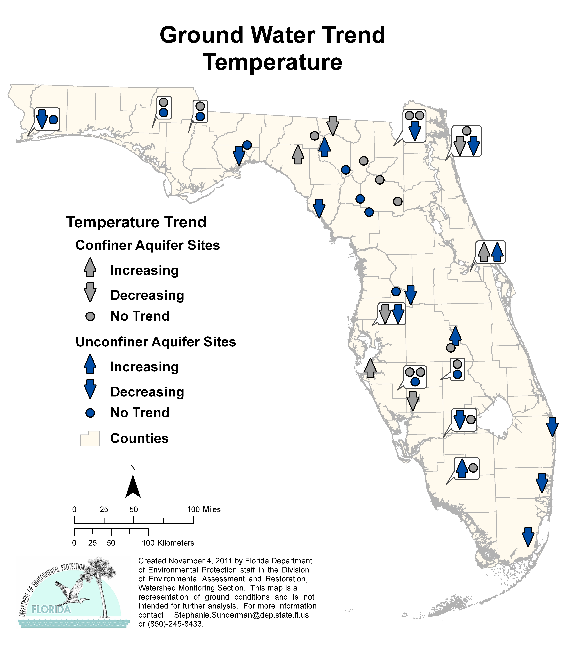
Figure 6.23. Ground Water Trends for Temperature, 1999–2010

Highlights:

- The trend analysis for the confined aquifer wells reported 3 stations with an increasing trend and 4 stations with a decreasing trend for temperature.
- There were 4 stations with increasing trends in the unconfined aquifer wells and 11 stations with a decreasing trend.

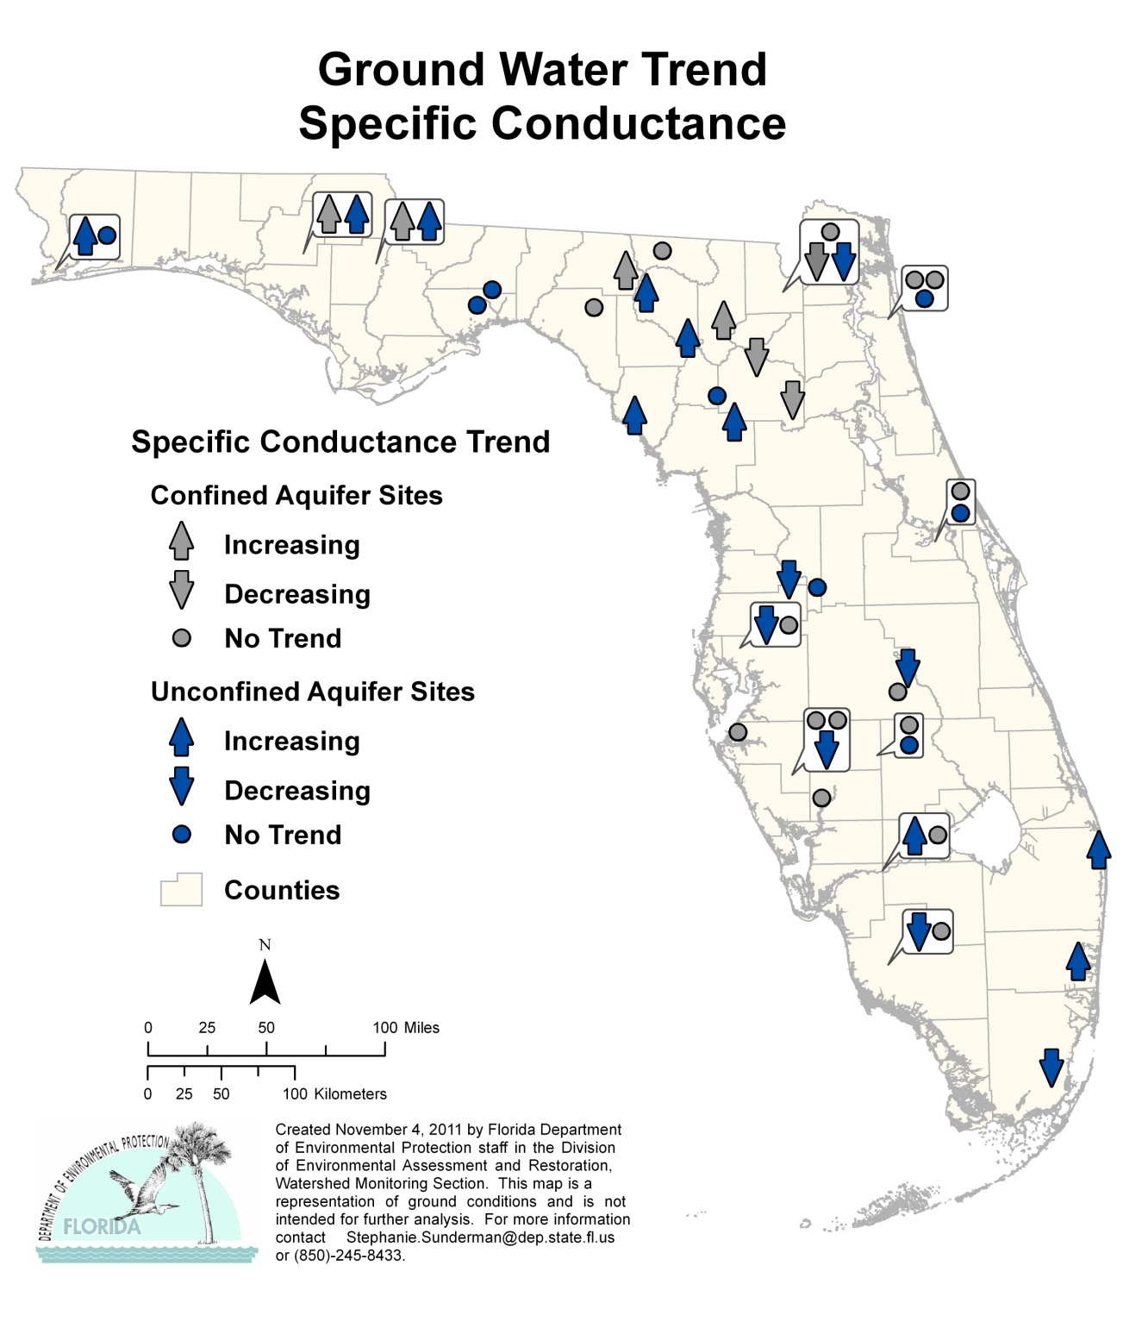
Figure 6.24. Ground Water Trends for Specific Conductance, 1999–2010

Highlights:

- The trend analysis for the confined aquifer wells reported 4 stations with an increasing trend and 3 stations with a decreasing trend for specific conductance.
- There were 10 stations with increasing trends in the unconfined aquifer wells and 7 stations with a decreasing trend.

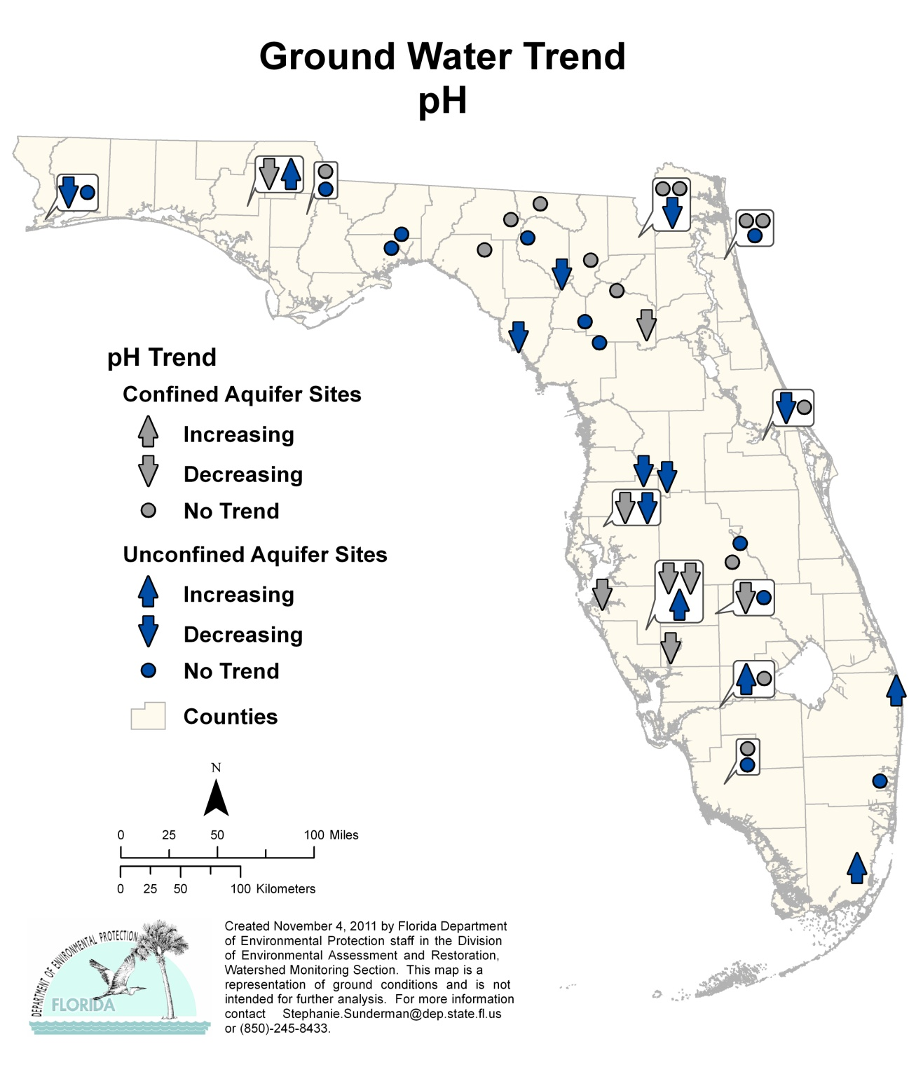

Figure 6.25. Ground Water Trends for pH, 1999–2010

Highlights:

- The trend analysis for the confined aquifer wells reported none of the stations with an increasing trend and 8 stations with a decreasing trend for pH.
- There were 5 stations with increasing trends in the unconfined aquifer wells and 8 stations with a decreasing trend.

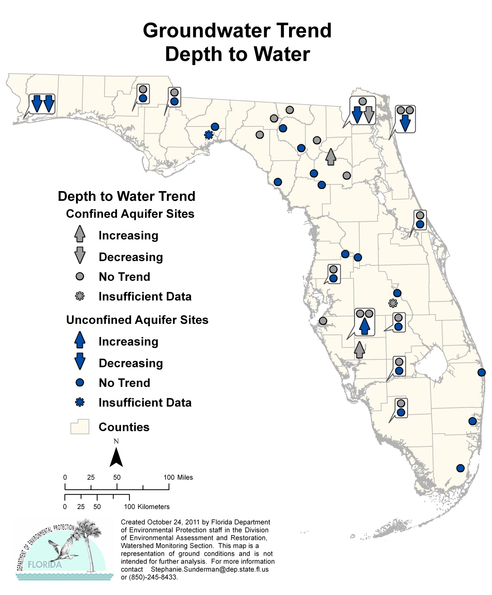
Ground Water Trend
Depth to Water

Figure 6.26. Ground Water Trends for Depth to Water, 1999–2010

Highlights:

- The trend analysis for the confined aquifer wells reported 2 stations with an increasing trend and 1 station with a decreasing trend for depth to water. One station did not have enough data to determine if a trend exists (ISD). An increasing trend indicates the water level in the well is decreasing relative to mean sea level; a decreasing trend indicates the water level in the well is increasing.
- There was 1 station with an increasing trend in the unconfined aquifer wells and 4 stations with a decreasing trend. One station did not have enough data to determine if a trend exists (ISD).
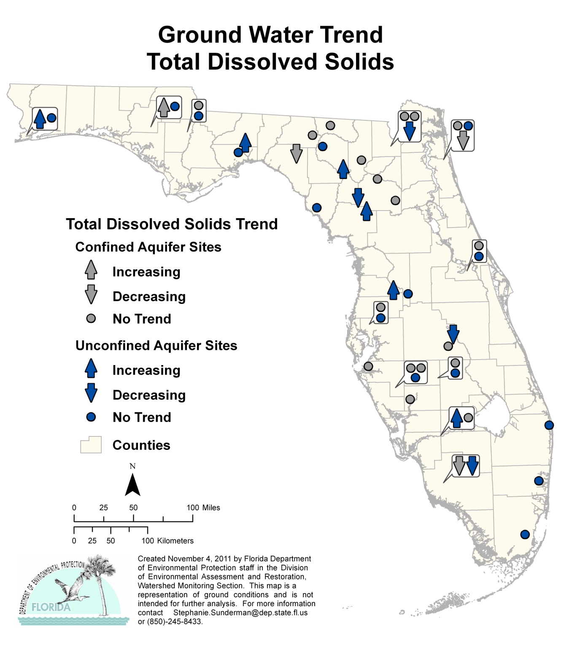

Figure 6.27. Ground Water Trends for Total Dissolved Solids, 1999–2010

Highlights:

- The trend analysis for the confined aquifer wells reported 1 of the stations with an increasing trend and 3 stations with a decreasing trend for total dissolved solids.
- There were 6 stations with an increasing trend in the unconfined aquifer wells and 4 stations with a decreasing trend.

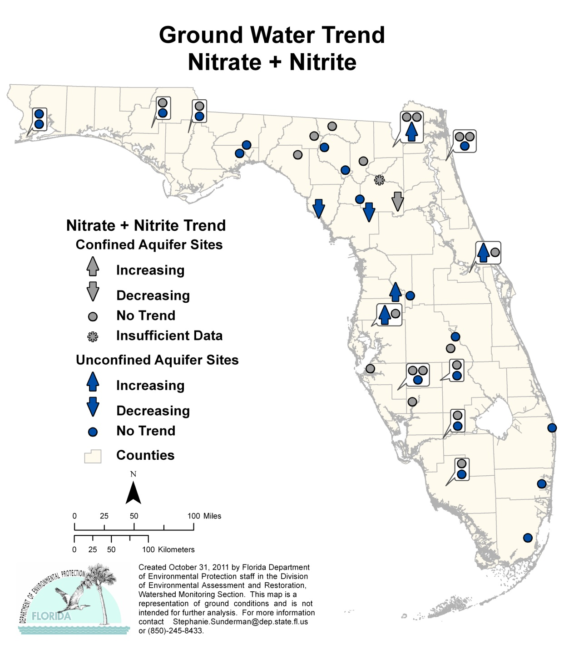
Figure 6.28. Ground Water Trends for Nitrate + Nitrite, 1999–2010

Highlights:

- The trend analysis for the confined aquifer wells reported no stations with an increasing trend and 1 of the stations with decreasing trend for nitrate + nitrite.
- There were 4 stations with an increasing trend in the unconfined aquifer wells and 2 stations with a decreasing trend.

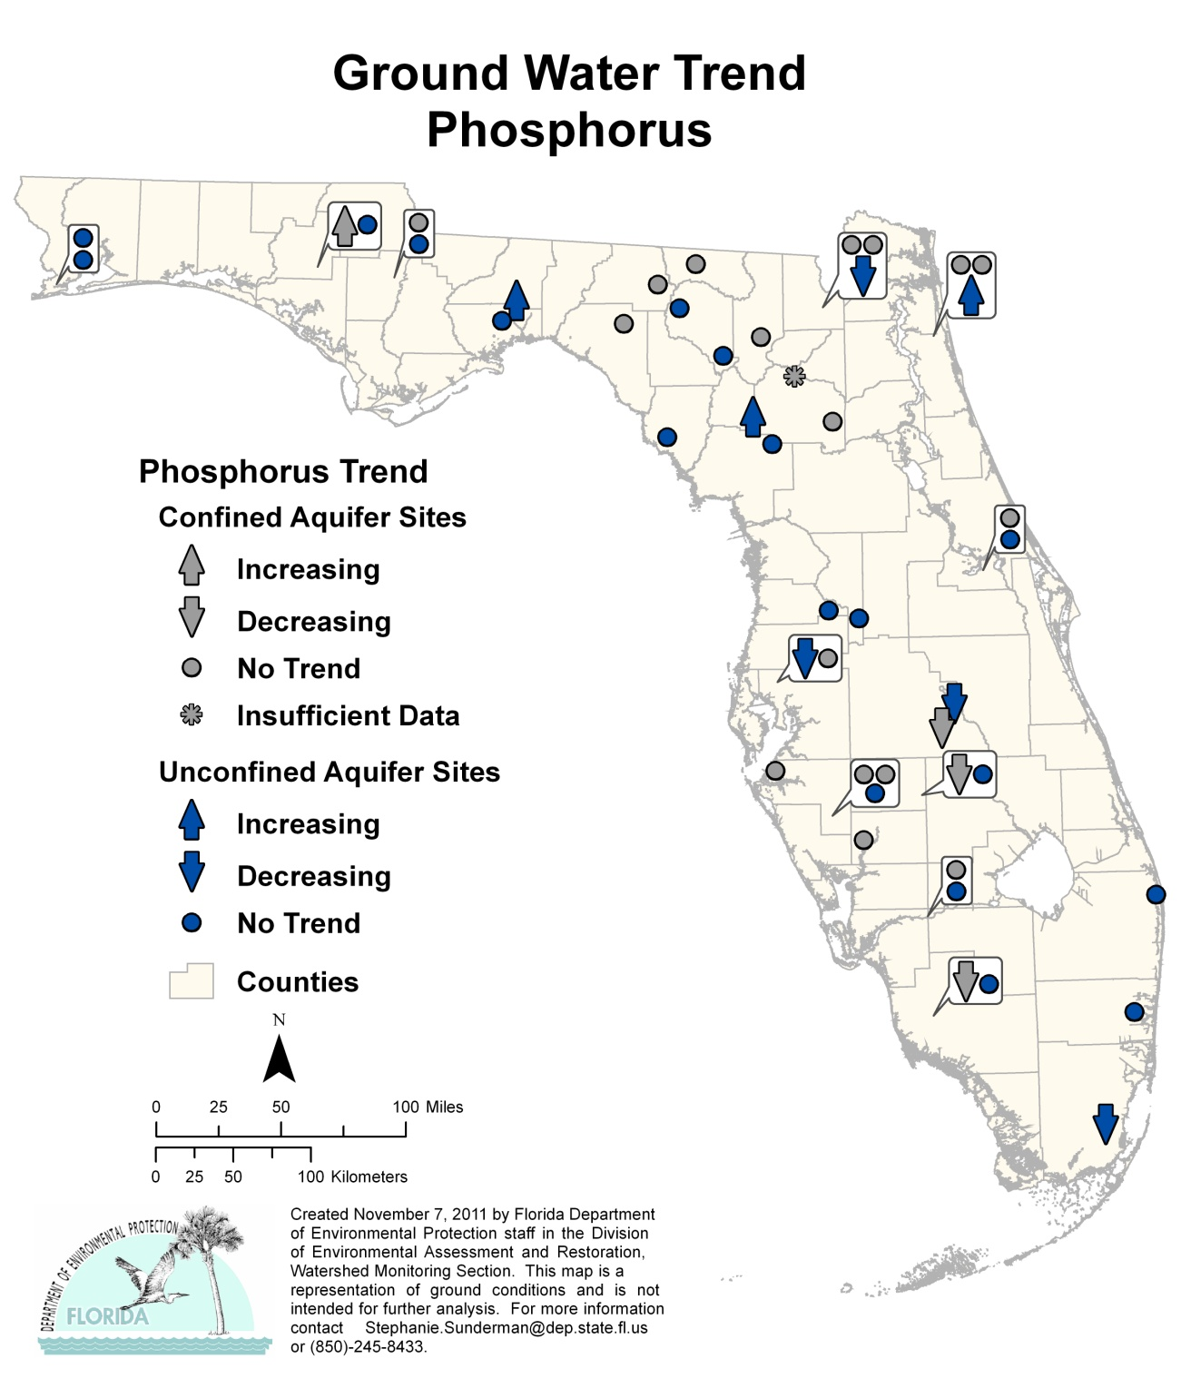
Figure 6.29. Ground Water Trends for Phosphorus, 1999–2010

Highlights:

- The trend analysis for the confined aquifer wells reported 1 station with an increasing trend and 3 stations with a decreasing trend for phosphorus.
- There were 3 stations with an increasing trend in the unconfined aquifer wells and 4 stations with a decreasing trend.

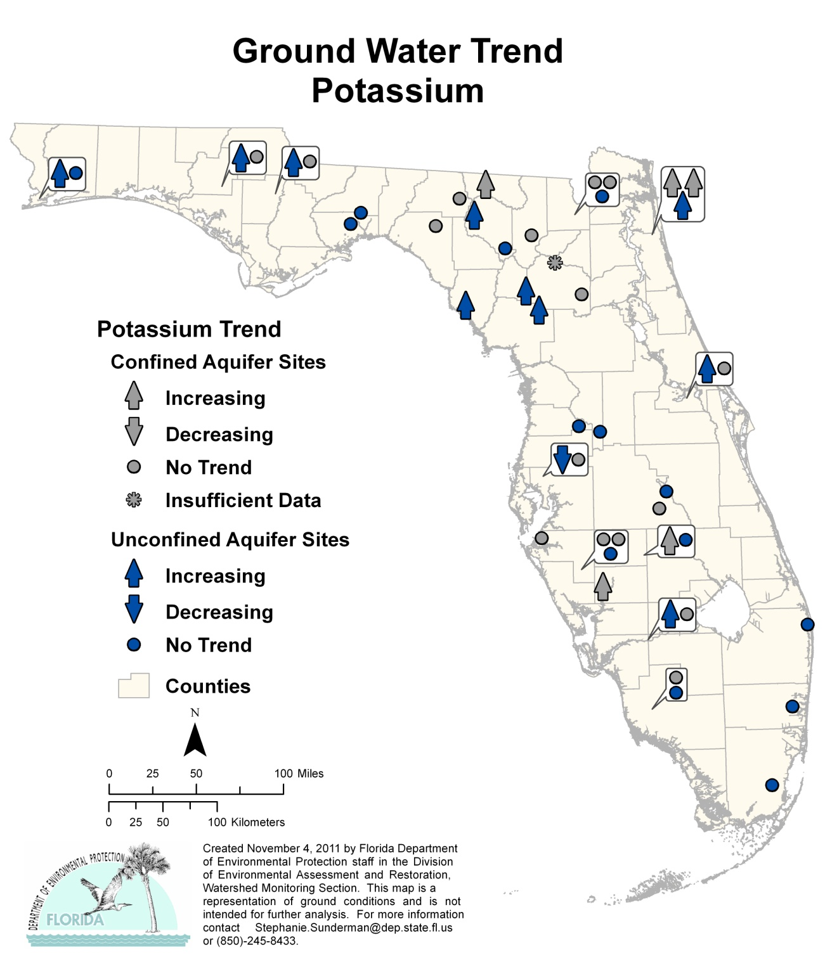
Figure 6.30. Ground Water Trends for Potassium, 1999–2010

Highlights:

- The trend analysis for the confined aquifer wells reported 5 stations with increasing trends and none of the stations with a decreasing trend for potassium.
- There were 10 stations with an increasing trend in the unconfined aquifer wells, and 1 station with a decreasing trend.

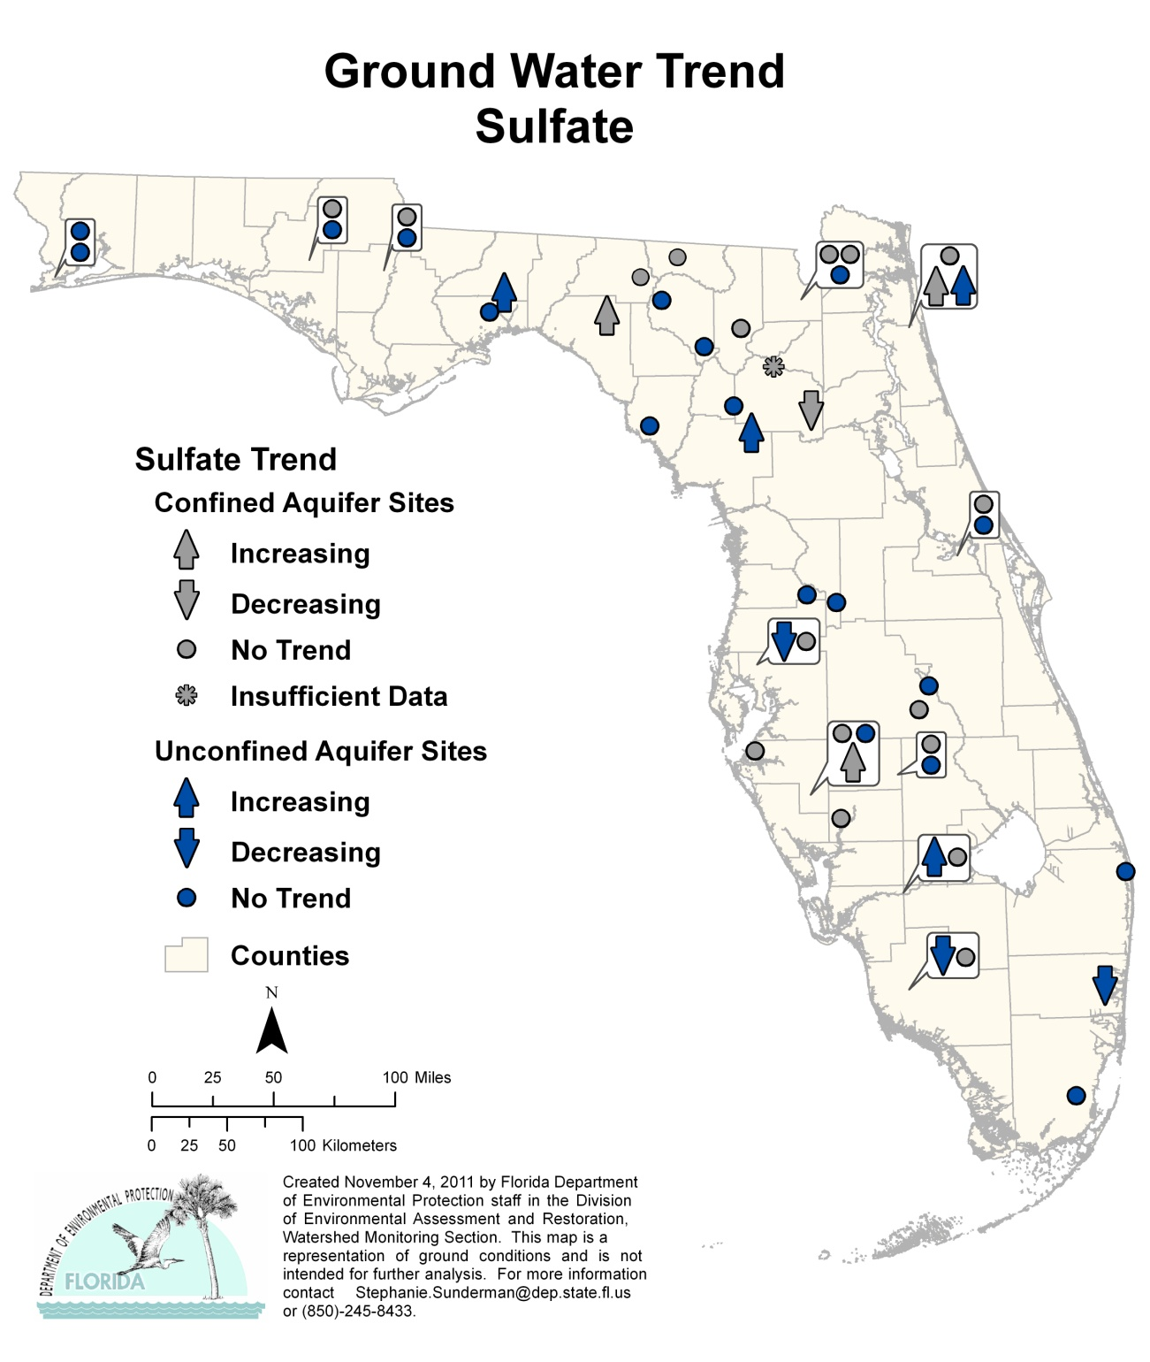
Figure 6.31. Ground Water Trends for Sulfate, 1999–2010

Highlights:

- The trend analysis for the confined aquifer wells reported 3 stations with an increasing trend and 1 of the stations with a decreasing trend for sulfate.
- There were 4 stations with an increasing trend in the unconfined aquifer wells and 3 stations with a decreasing trend.

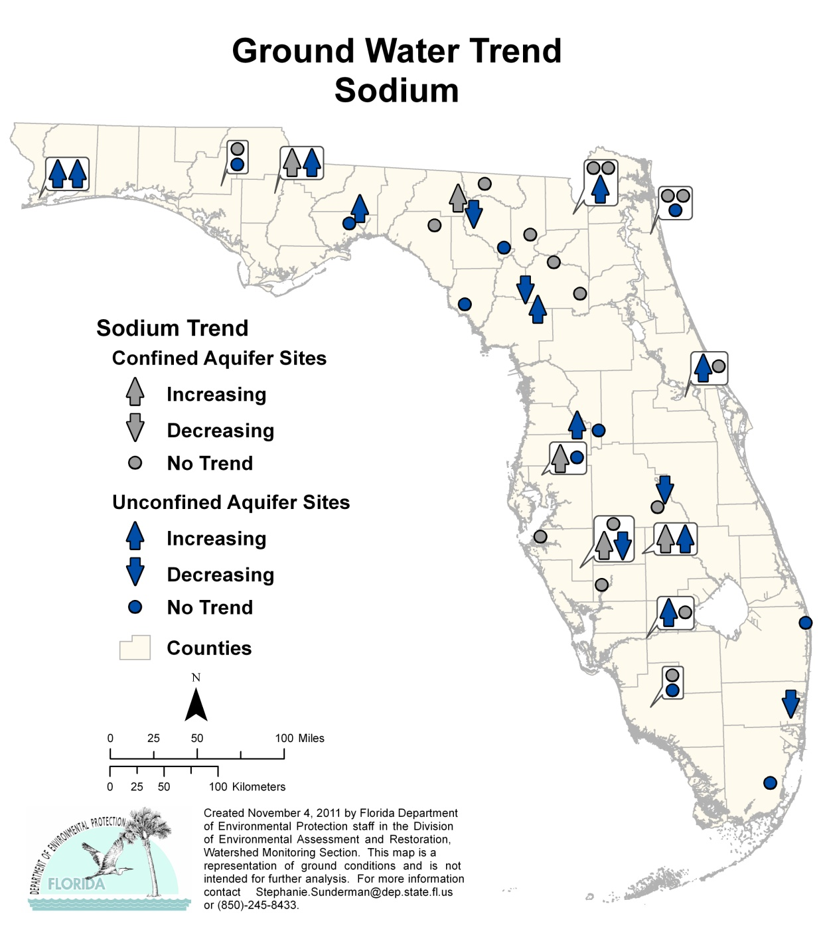
Figure 6.32. Ground Water Trends for Sodium, 1999–2010

Highlights:

- The trend analysis for the confined aquifer wells reported 5 stations with an increasing trend and no stations with a decreasing trend for sodium.
- There were 10 stations with an increasing trend in the unconfined aquifer wells and 5 stations with a decreasing trend.

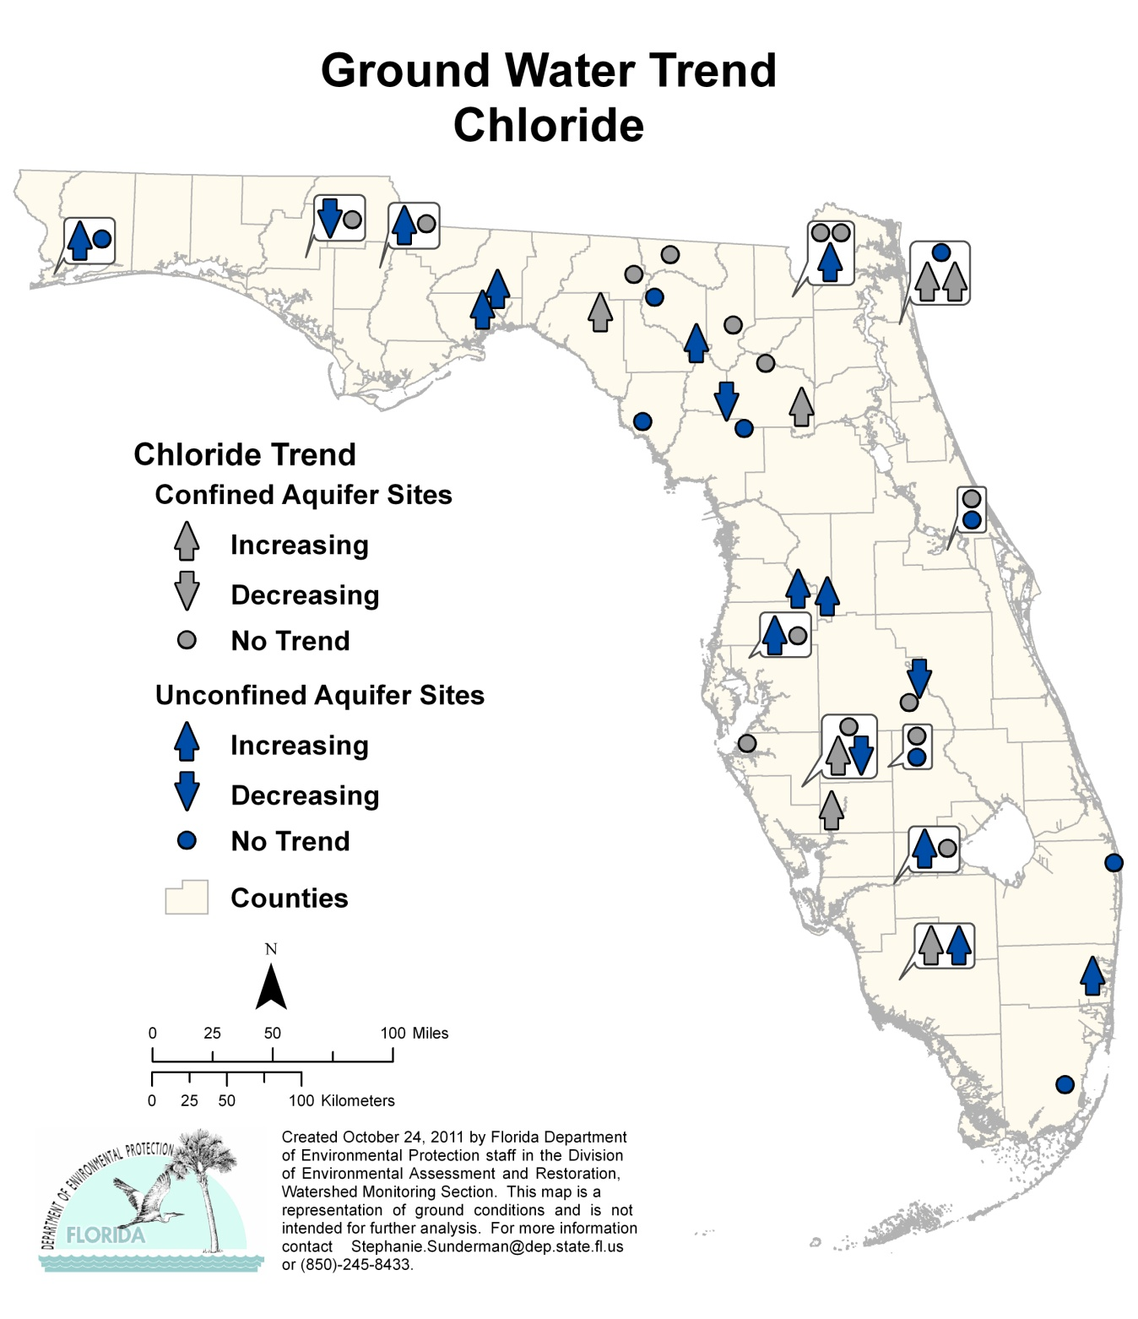
Figure 6.33. Ground Water Trends for Chloride, 1999–2010

Highlights:

- The trend analysis for the confined aquifer wells reported 7 stations with an increasing trend and no stations with a decreasing trend for chloride.
- There were 12 stations with an increasing trend in the unconfined aquifer wells and 4 stations with a decreasing trend.

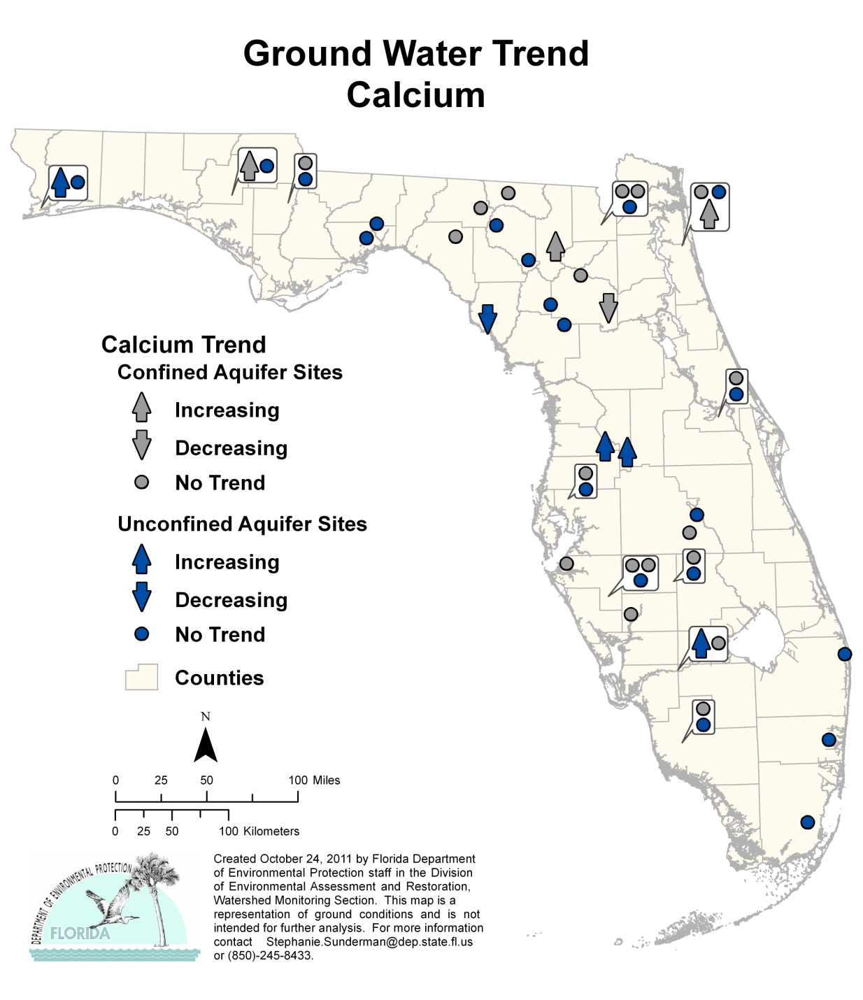
Figure 6.34. Ground Water Trends for Calcium, 1999–2010

Highlights:

- The trend analysis for the confined aquifer wells reported 3 stations with an increasing trend and 1 station with a decreasing trend for calcium.
- There were 4 stations with an increasing trend in the unconfined aquifer wells and 1 station with a decreasing trend.

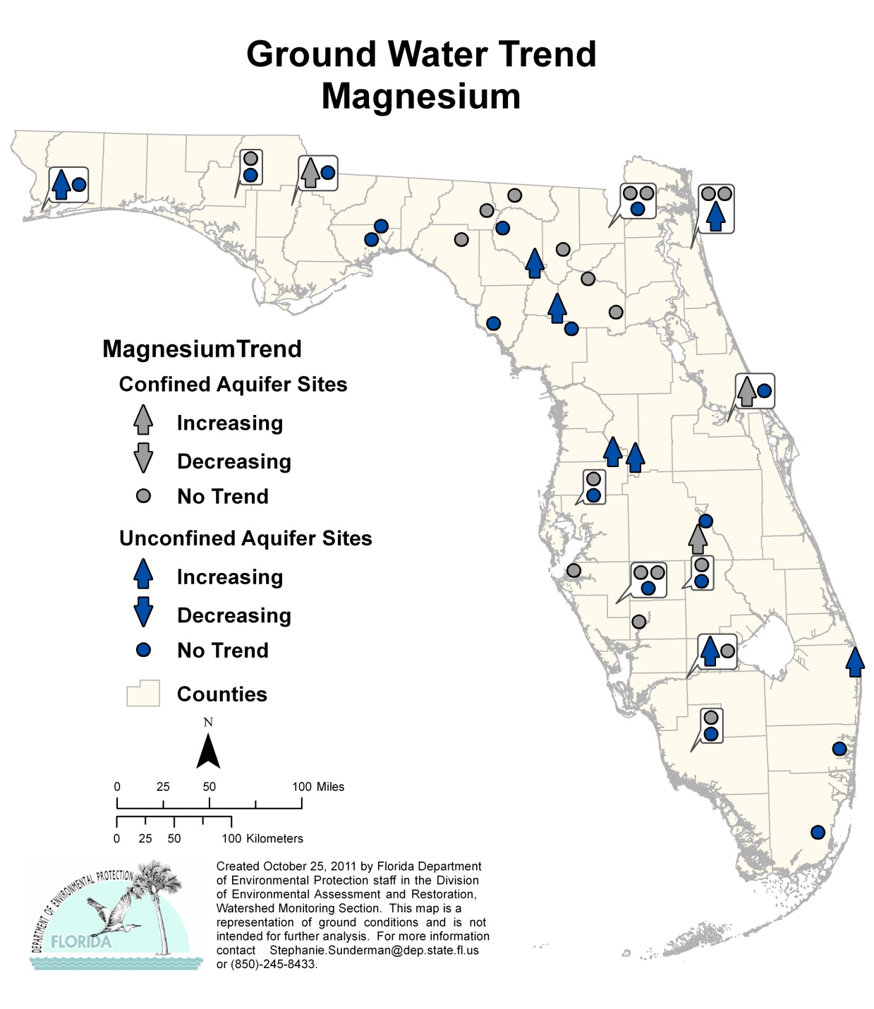
Figure 6.35. Ground Water Trends for Magnesium, 1999–2010

Highlights:

- The trend analysis for the confined aquifer wells reported 3 stations with an increasing trend and no stations with a decreasing trend for magnesium.
- There were 8 stations with an increasing trend in the unconfined aquifer wells and no stations with a decreasing trend.

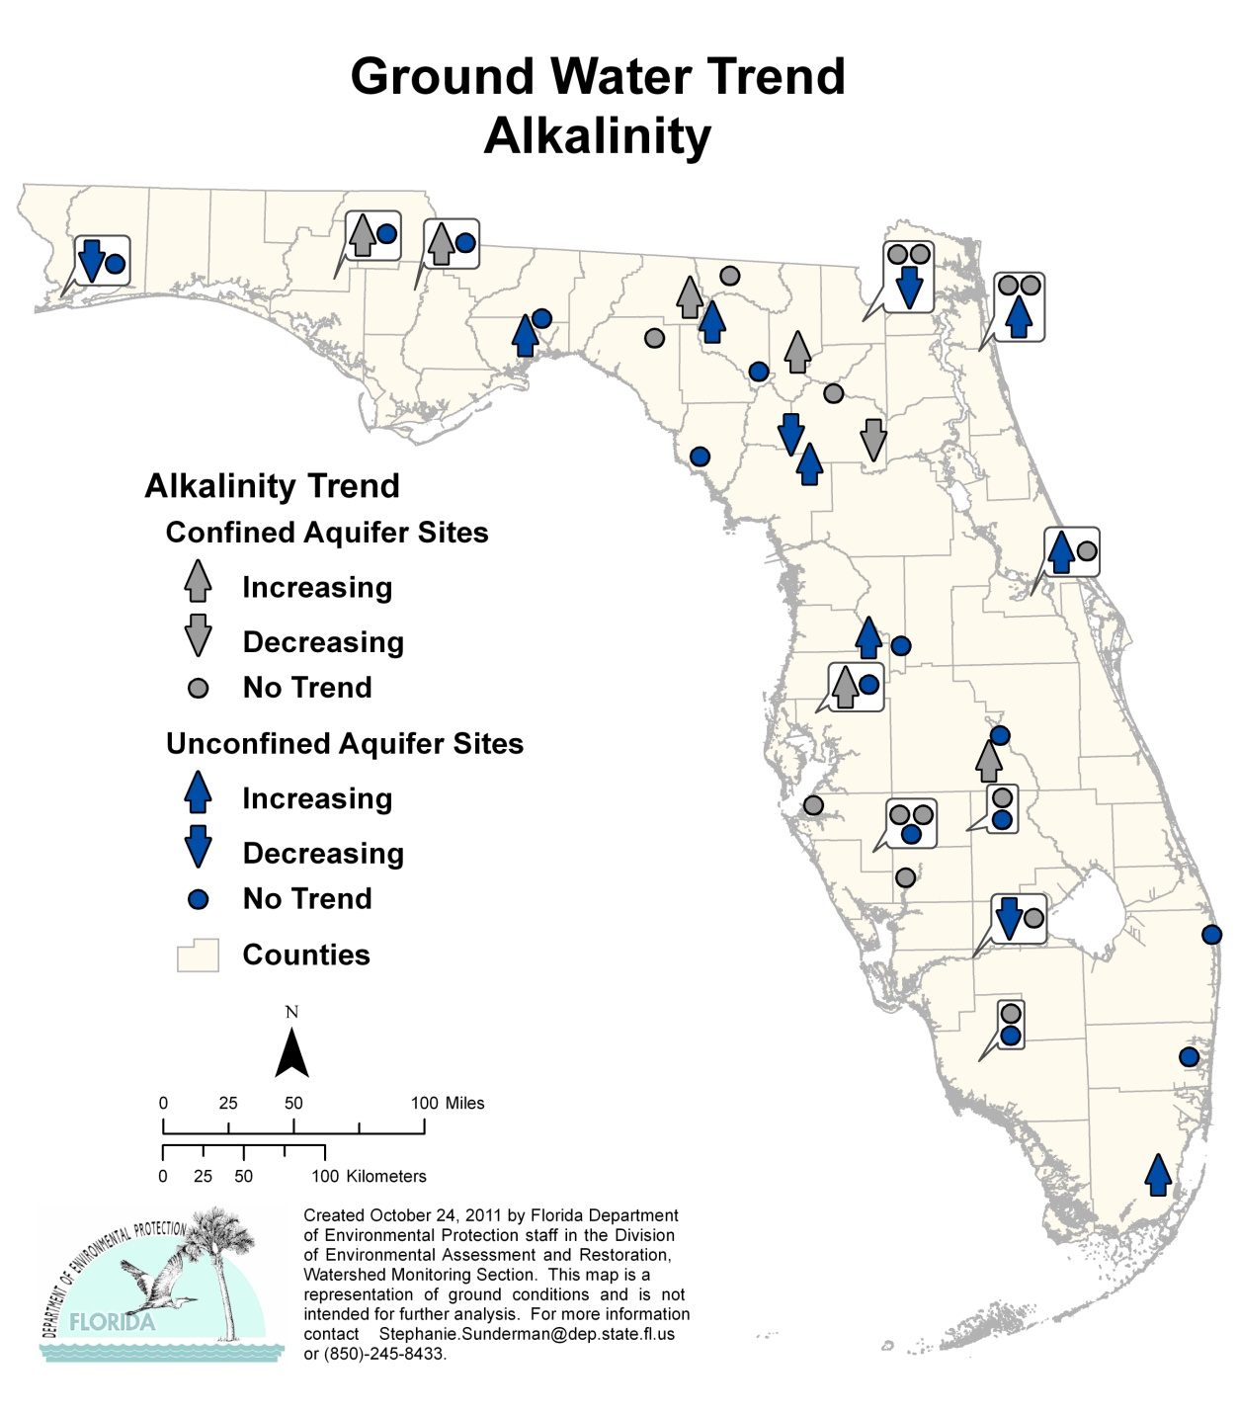
Figure 6.36. Ground Water Trends for Alkalinity, 1999–2010

Highlights:

- The trend analysis for the confined aquifer wells reported 6 stations with an increasing trend and 1 station with a decreasing trend for alkalinity.
- There were 7 stations with an increasing trend in the unconfined aquifer wells and 4 stations with a decreasing trend.

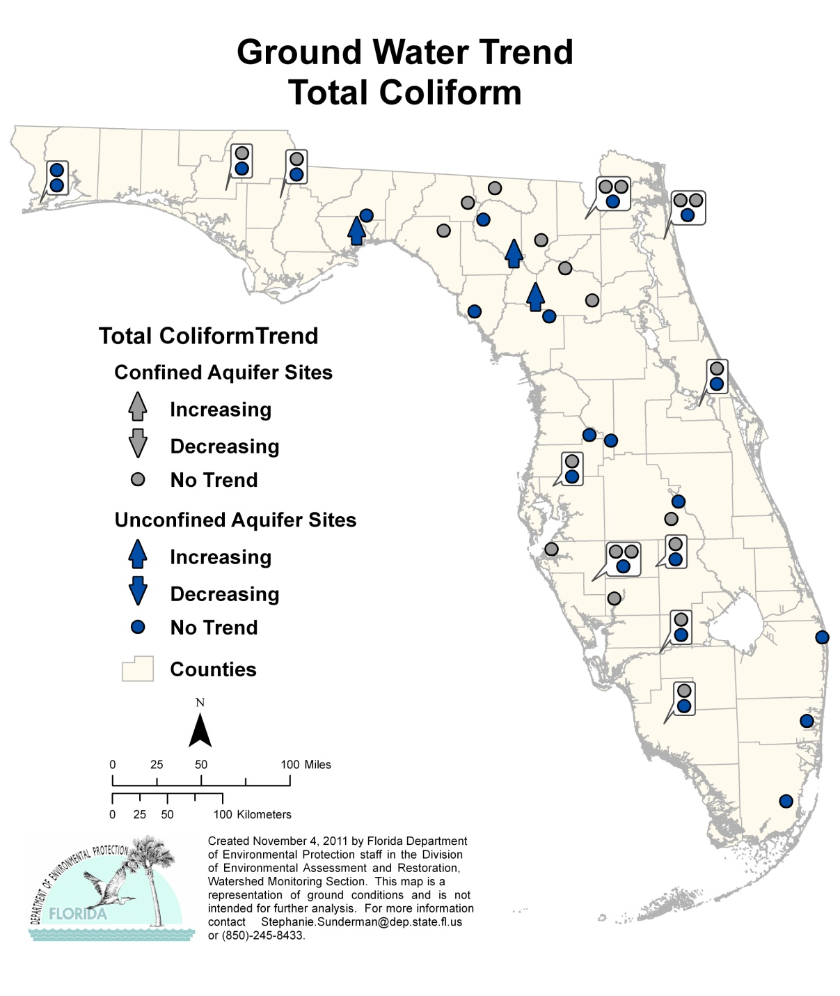
Figure 6.37. Ground Water Trends for Total Coliform, 1999–2010

Highlights:

- The trend analysis for the confined aquifer wells reported no stations with either an increasing or decreasing trend for total coliform.
- There were 3 stations with an increasing trend in the unconfined aquifer wells and no stations with a decreasing trend.

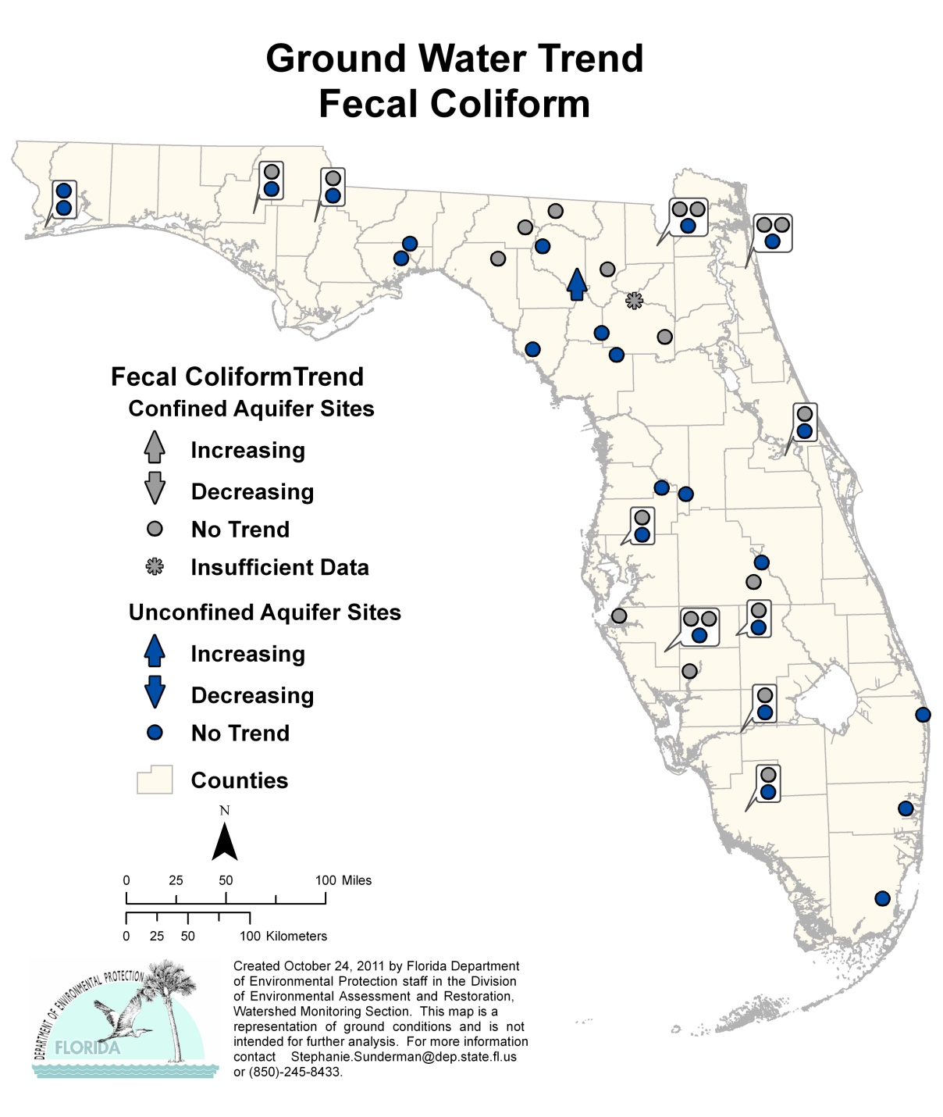
Figure 6.38. Ground Water Trends for Fecal Coliform, 1999–2010

Highlights:

- The trend analysis for the confined aquifer wells reported no stations with either an increasing or decreasing trend for fecal coliform.
- There was 1 station with an increasing trend in the unconfined aquifer wells and no stations with a decreasing trend.

Chapter 7: overview of STRATEGIC MONITORING AND Assessment methodology for Surface water

Section 305(b) water quality reports and Section 303(d) lists of impaired waters are submitted to the EPA by states to provide information used in setting national priorities and in implementing water quality controls and protection activities. In 2001, to develop a more complete understanding of the status of waters on a nationwide basis, the EPA provided states, territories, and authorized tribes guidance for the development and submission of an Integrated Report that would satisfy both the listing requirements of Section 303(d) and the reporting requirements of Section 305(b), as well as those of Section 314 for lakes.
The Integrated Report provides a more comprehensive inventory of the water quality status of waters within the state. It is built on an integrated assessment in which the assessment and listing methodology is supplemented with the results of monitoring data used to develop the report (Wayland 2001; Regas 2005).

Historical Perspective on the Assessment Methodology
In 1999, the Florida Legislature enacted the FWRA, Section 403.067, F.S., which authorized the Department to develop a rule under which waters of the state would be assessed to determine impairment status for the purpose of developing TMDLs, as required by the CWA.
Beginning in July1999, the Department held extensive meetings of a Technical Advisory Committee to establish and develop the scientific basis for the new rule. At the conclusion of this process, the Environmental Regulation Commission adopted Florida’s Identification of Impaired Surface Waters Rule (IWR) (Rule 62-303, F.A.C.) on April 26, 2001. Although the IWR has been amended since it was adopted, the basic methodology has not changed (the current IWR is available online).

Assessment Methodology: The Impaired Surface Waters Rule
According to the EPA, “The assessment methodology constitutes the decision process (including principles of science, statistics, and logic used in interpreting data and information relevant to water quality conditions) that a state employs to determine which of the five integrated reporting categories a waterbody segment belongs. It is important that assessment methodologies must be consistent with applicable WQSs [Water Quality Standards]. They should also be consistent with sound science and statistics” (Regas 2005).
The Department evaluates the water quality of the waters of the state using the science-based methodology described in Rule 62-303, F.A.C. (the IWR). The IWR outlines a process by which impaired waters of the state (waterbody segments) are identified and includes a statistical methodology (the binomial method) for identifying waters with exceedances of water quality criteria designed to protect aquatic life.
The methodology has been designed to provide a required level of confidence to ensure that the outcome of the water quality assessment is correct. In addition to assessment and listing thresholds, the IWR also (1) describes data sufficiency requirements, (2) addresses data quality concerns, and (3) describes the requirements for delisting segments previously identified as impaired, or those listed on the 1998 303(d) list. Appendix C describes the provisions of the IWR methodology in greater detail.

Description of the Watershed Management Approach
The IWR is implemented following the Department’s watershed management approach. Under this approach, which is based on a 5-year basin rotation, Florida’s 52 HUC basins (51 HUCs plus the Florida Keys) have been distributed among 29 basin groups. These basin groups are located within the 6 statewide Departmental districts, with 5 basin groups in each of the Northwest, Central, Southwest, South, and Southeast Districts, and 4 basin groups in the Northeast District. One basin group in each district is assessed each year (except for the Northeast). Table 7.1 lists the basin groups for each of the Departmental districts that are included in each year of the basin rotation

Table 7.1. Basin Groups for Implementing the Watershed Management Cycle, by Departmental District
This is a six-column table. Column 1 lists the Departmental districts, and Columns 2 through 5 list the basin groups for each of the basin rotations, Groups 1 through 5, respectively.

- = No basin assessed
Departmental District | Group 1  Basins | Group 2  Basins | Group 3  Basins | Group 4  Basins | Group 5  Basins
Northwest | Ochlockonee–  St. Marks | Apalachicola–Chipola | Choctawhatchee– St. Andrew | Pensacola | Perdido
Northeast | Suwannee | Lower St. Johns | - | Nassau–St. Marys | Upper East Coast
Central | Ocklawaha | Middle St. Johns | Upper St. Johns | Kissimmee River | Indian River Lagoon
Southwest | Tampa Bay | Tampa Bay Tributaries | Sarasota Bay–Peace–Myakka | Withlacoochee | Springs Coast
South | Everglades West  Coast | Charlotte Harbor | Caloosahatchee | Fisheating Creek | Florida Keys
Southeast | Lake Okeechobee | St. Lucie–Loxahatchee | Lake Worth Lagoon–  Palm Beach Coast | Southeast Coast–Biscayne Bay | Everglades

Implementation of the TMDL Program under the Rotating Basin Approach
The implementation of the TMDL Program (monitoring, assessment, identification of impaired waters, development of TMDLs, and implementation) under the rotating basin approach includes five distinct phases (Table 7.2), as follows:

Table 7.2. Phases of the Basin Management Cycle
This is a three-column table. Column 1 lists the phase of the basin rotation, Column 2 lists the corresponding year of the five-year basin rotation, and Column 3 provides the activities associated with each phase.

Phase | Schedule | Activities
Phase 1:  Preliminary Basin Evaluation | Year 1 | • Identify stakeholders/participants  • Obtain data and enter into Florida STORET  • Conduct public meeting to introduce cycle  • Primary Products:  –Develop Planning List of potentially impaired waters  –Develop Strategic Monitoring Plan for assessments performed in support of TMDL Program
Phase 2:  Strategic Monitoring | Years 2–3 | • Carry out strategic monitoring to collect additional data identified in Phase 1  • Acquire additional data and enter into Florida STORET  • Evaluate new data and incorporate findings into draft version of Verified List of  Impaired Waters and Delist List  • Distribute draft Verified List of Impaired Waters and Delist List for review  • Conduct public meetings and solicit comments from stakeholders on draft  version of Verified List of Impaired Waters and Delist List  • Primary Products:  –Finalize Verified List of Impaired Waters and Delist List for Secretarial adoption  –Adopt Verified List of Impaired Waters and Delist List by Secretarial Order  –Submit finalized Verified List of Impaired Waters and Delist List to EPA as update to 303(d) list
Phase 3:  TMDL Development | Years 2–4 | • Complete TMDLs for verified impaired waters according to prioritization
Phase 4:  Development of BMAPs | Year 4 | • Finalize management goals/objectives  • Develop draft BMAP, including TMDL allocation  • Identify monitoring and management partnerships, needed rule changes and  legislative action, and funding opportunities  • Develop Monitoring and Evaluation Plans  • Seek funding  • Obtain participant commitment to implement plans
Phase 5:  Implementation | Year 5+ | • Implement BMAPs  • Carry out rule development/legislative action

- Phase 1: Development of the Planning List
During the first phase of any basin rotation cycle, the Department initially evaluates all readily available water quality data, using the methodology described in the IWR. During this phase, water segments that are identified as potentially not meeting water quality standards are included on a Planning List.

- Phase 2: Development of the Verified List of Impaired Waters
During the second phase of the basin rotation, the Department implements additional sampling and strategic monitoring activities, focusing on those waters that were identified and placed on the Planning List during the first phase of the basin rotation. The goal of these activities is to ensure that sufficient data and/or ancillary information are available to determine (i.e., to “verify”)—using the methodology described in the IWR—whether a waterbody segment is impaired and if the impairment is caused by a pollutant. In conjunction with the determination of impairment status, the Department actively solicits stakeholder input, and assessment results are finalized at the end of the second phase based on available data.
To conclude the second phase of the basin rotation, after the assessments have been completed, those waterbody segments identified and verified as impaired are placed on the state’s Verified List of impaired waters. Correspondingly, those waterbody segments determined to be no longer impaired or in need of a TMDL are placed on the Delist List. Both the Verified and Delist Lists are adopted by Secretarial Order and submitted to the EPA to update the state’s 303(d) list.
Waterbody segments identified as not meeting water quality standards due to a pollutant are prioritized for TMDL development. The priority ranking considers the severity of the impairment and the designated uses of the segment, taking into account the most serious water quality problems, most valuable and threatened resources, and risk to human health and aquatic life.
Segments verified as impaired are initially assigned a medium priority. A high priority is assigned if (a) the impairment poses a threat to potable water supplies or to human health, or (b) the impairment is due to a pollutant that has contributed to the decline or extirpation of a federally listed threatened or endangered species. Impairments due to exceedances of fecal coliform criteria are assigned a low priority. Waters listed due to fish consumption advisories for mercury are designated high priority. The Department plans to address mercury through a statewide TMDL that is scheduled to be completed in 2012.
The Department intends to address all listings with a high priority within 5 years after they are added to the Verified List, to address listings with a medium priority within 5 to 10 years (subject to available resources), and to address listings with a low priority within 10 years.

- Phase 3: TMDL Development
The third phase of the basin rotation cycle consists primarily of TMDL development and is initiated when the Verified List is adopted by Secretarial Order. When TMDLs are completed for segments on the Verified List, they are adopted by rule, and those segments are subsequently removed from the state’s Verified List of impaired waters.

- Phases 4 and 5: BMAP Development and Implementation
During the fourth phase of the watershed management cycle, a watershed management plan (or BMAP) aimed at reducing the pollutant loads linked to the verified impairments may be developed, and implementation is initiated in the fifth phase of the basin rotation cycle to achieve the pollutant reduction goals of the TMDL.

Focus on Outcomes
One of the key benefits provided by the iterative nature of the watershed management cycle is the ability to evaluate the effectiveness of management activities (i.e., BMAP and TMDL implementation, the extent to which water quality objectives are being met and whether individual waters are no longer impaired) using the results of monitoring conducted in subsequent cycles of the basin rotation. For example, each adopted BMAP includes a monitoring component designed to assess progress in improving water quality in conjunction with the implementation of pollutant load reduction projects. The monitoring program (ambient and stormwater) is developed collaboratively with local stakeholders to ensure that there is cooperation in the sampling effort and that the sampling program is adequately robust to demonstrate water quality changes in the impaired waterbody. Monitoring results are reported to Florida STORET, and water quality trend evaluations are conducted during the basin rotation cycle. These results are used to inform future monitoring, assessment, and restoration activities.

Assessment Periods for the Planning and Verified List Assessments
Table 7.3 displays the time frames for the assessment periods for the Planning and Verified Lists for each of the five basin groups for the first three cycles of the basin rotation. Assessments for the second basin rotation were recently completed, and assessments for the waters in the first basin group for the third cycle will be performed during the upcoming year.

Table 7.3. Data Used in Developing the Planning and Verified Lists for the Basin Rotation Cycles
This is a four-column table. Column 1 lists the cycle rotation, Column 2 lists the basin group, Column 3 lists the planning period, and Column 4 lists the verified period.

Cycle Rotation | Basin Group | Planning Period | Verified Period
1 | 1 | 1989–1998 | 1/1/1995–6/30/2002
1 | 2 | 1991–2000 | 1/1/1996–6/30/2003
1 | 3 | 1992–2001 | 1/1/1997–6/30/2004
1 | 4 | 1993–2002 | 1/1/1998–6/30/2005
1 | 5 | 1994–2003 | 1/1/1999–6/30/2006
2 | 1 | 1995–2004 | 1/1/2000–6/30/2007
2 | 2 | 1996–2005 | 1/1/2001–6/30/2008
2 | 3 | 1997–2006 | 1/1/2002–6/30/2009
2 | 4 | 1998–2007 | 1/1/2003–6/30/2010
2 | 5 | 1999–2008 | 1/1/2004–6/30/2011
3 | 1 | 2000–09 | 1/1/2005–6/30/2012
3 | 2 | 2001–10 | 1/1/2006–6/30/2013
3 | 3 | 2002–11 | 1/1/2007–6/30/2014
3 | 4 | 2003–12 | 1/1/2008–6/30/2015
3 | 5 | 2004–13 | 1/1/2009–6/30/2016

Determination of Use Attainment
Section 303(c) of the CWA requires that water quality standards established by the states and tribes include appropriate uses to be achieved and protected for jurisdictional waters. The CWA also establishes the national goal of “fishable and swimmable” for all waters wherever that goal is attainable.
In Florida, the designated uses for waters of the state are established and protected within a surface water quality classification system (Rule 62-302, F.A.C.). Class-specific water quality criteria for specific analytes describe the water quality necessary to meet the present and future most beneficial designated uses for surface water in the state. The section on Florida’s Water Quality Standards Program in Chapter 11 of this report provides the details of this classification system.
Table 7.4 summarizes the EPA reporting categories based on designated use attainment and the corresponding surface water classifications that have been implemented in the Florida Water Quality Standards (Rule 62-302, F.A.C.)

Table 7.4. Designated Use Attainment Categories for Surface Waters in Florida
This is a two-column table. Column 1 lists the designated use attainment category used in the IWR evaluation, and Column 2 lists the applicable Florida surface water classification.

Designated Use Attainment Category Used  in the IWR Evaluation | Applicable Florida  Surface Water Classification
Aquatic Life Use Support-Based Attainment | Class I, II, and III
Primary Contact and Recreation Attainment | Class I, II, and III
Fish and Shellfish Consumption Attainment | Class II
Drinking Water Use Attainment | Class I
Protection of Human Health | Class I, II, and III

Although the IWR establishes the assessment methodology for identifying impaired waters, the EPA has actively encouraged states to use a five-category reporting system in reporting the status of all jurisdictional waters (segments) in meeting their relevant water quality standards. Under this reporting system, states may establish additional subcategories to further enhance or refine the framework provided by the EPA.
The system that the Department has developed and implemented to report use attainment based on IWR assessment results and listing decisions is based on EPA’s five-category system, but includes additional subcategories (see Table 7.5). For example, under the EPA reporting framework, Category 3 identifies segments for which there are insufficient data to determine whether water quality standards are being met. The Department has implemented Subcategories 3a and 3b to distinguish between segments for which no data and/or information are available (3a), and those waterbody segments for which some data and/or information may be available, but those data do not meet the data sufficiency requirements as described in the IWR (3b).
Although assessments performed under the IWR and listing decisions are based on specific assessment periods, the EPA has also encouraged listing decisions for specific segments to incorporate an additional review of all water quality data from the entire period of record. To accommodate this request, the Department has developed a process to incorporate additional data from the entire period of record (when these are available and can be determined to meet Departmental QA requirements).
Figure 7.1 illustrates the process by which additional data from the period of record are incorporated into assessments performed under the IWR.

Table 7.5. Categories for Waterbodies or Waterbody Segments in the 2012 Integrated Report
This is a three-column table. Column 1 lists the waterbody categories, Column 2 describes the category, and Column 3 provides comments regarding the Department’s use of the category.

Note: The descriptions in this table reflect the EPA’s use attainment categories. In the Basin Status Reports for Groups 1 through 3 and in the Water Quality Assessment Reports for Groups 1 through 2 that were previously produced, Categories 4b and 4c were reversed. That is, the description of Category 4b was previously listed as Category 4c, and the description of Category 4c was listed as Category 4b.

¹ TMDLs are established only for impairments caused by pollutants (a TMDL quantifies how much of a given pollutant a waterbody can receive and still meet its designated uses). For purposes of the TMDL Program, pollutants are chemical and biological constituents, introduced by humans into a waterbody that may result in pollution (water quality impairment). Other causes of pollution, such as the physical alteration of a waterbody (for example, canals, dams, and ditches) are not linked to specific pollutants.
Category | Description | Comments
1 | Indicates that all designated uses are attained. | Currently not used by the Department.
2 | Indicates that sufficient data are available to determine that at least one designated use is attained and insufficient data or no information are available to determine if remaining uses are attained. | If attainment is verified for some designated uses of a waterbody or segment, the Department will propose partial delisting for those uses that are attained. Future monitoring will be recommended to acquire sufficient data and/or information to determine if remaining designated uses are attained.
3a | Indicates that no data and/or information are available to determine if any designated use is attained. | Future monitoring will be recommended to acquire sufficient data and/or information to determine if designated uses are attained.
3b | Indicates that although some data and/or information are available, available data are insufficient to determine if the designated use is attained. | Future monitoring will be recommended to acquire sufficient data and/or information to determine if designated uses are attained.
3c | Indicates that sufficient data are available to determine that at least one designated use is not attained using the Planning List methodology in the IWR. | These waters are placed on the Planning List and will be prioritized for future monitoring to acquire sufficient data and/or information to determine if designated uses are attained.
3d | Indicates that sufficient data are available to determine that at least one designated use is not attained using the Verified List methodology. | It has been determined that water quality standards for these waters are not being met. However, no impairment has yet been verified, and it has not yet been determined whether TMDL development will be required.
4a | Indicates a segment that has been identified as not attaining one or more designated uses, but TMDL development is not needed because a TMDL has already been completed. | After the EPA approves a TMDL for the impaired waterbody or segment, it will be included in a BMAP to reduce pollutant loading toward attainment of designated use(s).
4b | Indicates a segment that has been identified as not attaining one or more designated uses, but does not require TMDL development because the water will attain water quality standards due to existing or proposed pollution control measures. | Pollutant control mechanisms designed to attain applicable water quality standards within a reasonable time frame have either already been proposed or are already in place.
4c | Indicates a segment that has been identified as not attaining one or more designated uses, but the impairment is not caused by a pollutant and therefore TMDL development is not needed.¹ | This category includes segments that do not meet their water quality standards due to naturally occurring conditions or pollution; such circumstances more frequently appear linked to impairments for low DO or elevated iron concentrations. In these cases, the impairment observed is not caused by specific pollutants but is believed to represent a naturally occurring condition, or to be caused by pollution.
4d | Indicates a segment that has been identified as not attaining one or more designated uses, but no causative pollutant has been identified. | This category includes segments that do not meet their water quality standards, but no causative pollutant has been identified. This typically applies to low DO or failed biological assessments.
4e | Indicates a segment that has been identified as not attaining one or more designated uses, but recently completed or ongoing restoration activities are expected to restore the designated uses. | Restoration activities for this waterbody have been completed or are ongoing, such that once the activities are completed or the waterbody has had a chance to stabilize, the Department believes it will meet its designated uses.
5 | One or more designated uses is not attained and a TMDL is required. | Waterbodies or segments in this category are impaired for one or more designated uses by a pollutant or pollutants. Waters in this category are included on the basin-specific Verified List adopted by the Secretary of the Department as Florida’s impaired waters list and submitted to the EPA as Florida’s 303(d) list of impaired waters at the end of Phase 2.

Sources of Data
Rule 62-303, F.A.C., provides that the primary source for data used for assessment purposes is Florida STORET (or its successor database). Although the vast majority of IWR assessments rely almost entirely on data from Florida STORET, this data source is supplemented, as required, with data obtained from other sources. Data acquired from Legacy STORET currently account for approximately only 35% of the data available for assessment purposes, with data from Florida STORET accounting for the majority of the remainder. A relatively small proportion of the data used in the IWR assessment is provided directly by individual organizations and data providers without having first been loaded into Florida STORET.
Table 7.6 lists the organizations that have provided data used for assessments performed under the IWR. These data are routinely made available by the Department in the IWR database, which is linked to the Watershed Assessment Program website (data for many of these agencies and organizations are available via links on their own website[s]).
Additional information used to assess waterbody health is acquired from FDOH, including fish consumption advisories and information for beach closures, advisories, and/or warnings. FDACS provides information pertaining to the classification of shellfish-harvesting areas.

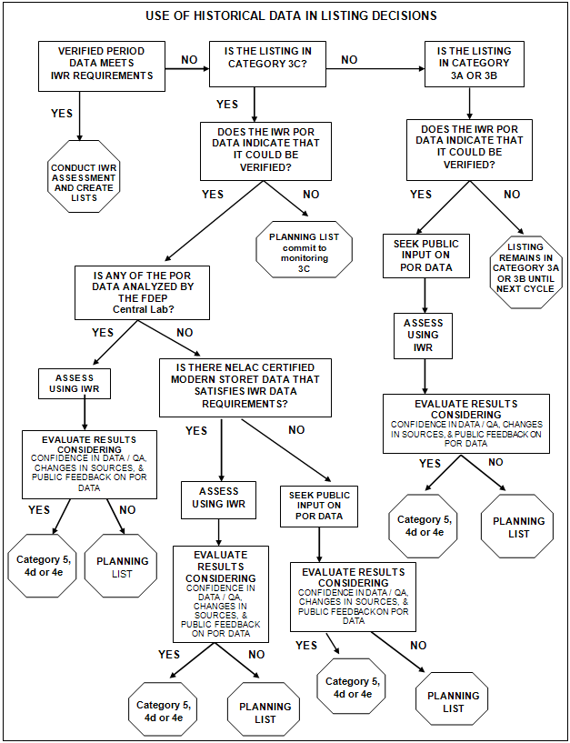

Figure 7.1. Period of Record Assessment Flow Chart

Table 7.6. Organizations Providing Data Used in the IWR Assessments
This is a single-column table listing the organizations providing data.

Name of Organization
Alabama Department of Environmental Management
Alachua County Environmental Protection Department
Apalachicola National Estuarine Research Reserve
Avon Park Air Force Range
Babcock Ranch
Bay Watch
Biological Research Associates (ENTRIX)
Biology data from the Department’s SBIO (Retired)
Bream Fishermen Association
Brevard County Office of Natural Resource Management
Brevard County Stormwater Utility Department
Broward County Environmental Protection Department
Charlotte County Stormwater Division
Charlotte Harbor Aquatic/Buffer Preserves (the Department)
Charlotte Harbor National Estuary Program
Choctawhatchee Basin Alliance
Citizens Monitoring Program (the Department)
City of Cape Coral
City of Jacksonville
City of Key West
City of Lakeland
City of Maitland
City of Naples
City of Orlando
City of Port St. Joe Wastewater Treatment Plant
City of Port St. Lucie
City of Punta Gorda
City of Sanibel Natural Resources Department
City of Tallahassee Stormwater Management Division
City of Tampa Bay Study Group
City of West Palm Beach
Collier County Pollution Control and Prevention Department
Conservancy of Southwest Florida
Dade County Environmental Resources Management
East County Water Control District
Emerald Coast Utility Authority
Environmental Research and Design, Inc
Estero Bay Aquatic Preserve (the Department)
Florida Department of Agriculture and Consumer Services
Florida Department of Environmental Protection
Florida Department of Environmental Regulation
Florida Department of Health
Florida Fish and Wildlife Conservation Commission
Florida Keys National Marine Sanctuary
Florida LAKEWATCH
Florida Marine Research Institute
Georgia Department of Environmental Resources
Georgia Environmental Protection Division
Gilchrist County Well Watch
Guana Tolomato Matanzas National Estuarine Research Reserve
Gulf Ecology Division Laboratory (U.S. Environmental Protection Agency)
Gulf Power Company
Hillsborough County Environmental Protection Commission
IMC-Agrico
Indian River County
Jacksonville Electric Authority
Lake County Water Resource Management Division
Lake Worth Drainage District
Lee County Environmental Laboratory
Lee County Hyacinth Control District
Leon County Public Works
Loxahatchee River District
Manatee County Environmental Management Department
Marine Resources Council of East Florida
McGlynn Laboratories
Mote Marine Laboratory
National Park Service (Water Resources Division)
Northwest Florida Water Management District
Orange County Environmental Protection Division
Palm Beach County Department of Environmental Resources Management
Palm Coast Community Service Corporation
Pasco County Stormwater Management Division
Peace River-Manasota Regional Water Supply Authority
Pinellas County Department of Engineering and Environmental Services
Polk County Natural Resources Division
Post, Buckley, Schuh & Jernigan, Inc. (now Atkins)
Reedy Creek Improvement District
Rookery Bay National Estuarine Reserve (the Department)
Sanibel-Captiva Conservation Foundation
Sarasota County Environmental Services
Save the Bay Associations
Seminole County
SMR Communities
South Florida Water Management District
Southwest Florida Water Management District
St. Johns County
St. Johns River Water Management District
St. Lucie Mosquito Control District
Suwannee River Water Management District
Tampa Bay Water
The Nature Conservancy Florida Keys Program
U.S. Army Corps of Engineers
U.S. Environmental Protection Agency
U.S. Environmental Protection Agency (Southeast Region)
U.S. Forest Service (Region 8)
U.S. Geological Survey
Volusia County Environmental Health Laboratory
Watershed Action Volunteers

IWR Strategic Monitoring
The goal of the IWR strategic monitoring is to ensure that sufficient data are available with which to make reliable assessment decisions. IWR strategic monitoring is driven by a set of Strategic Monitoring Plans (SMPs) that are provided to each of the Department’s district offices annually. Samples collected by district staff may be supplemented by contract sampling when required to ensure that an adequate sample size will be available to perform assessments under the IWR, particularly in the case of high-priority waters.
Analyses of samples that are collected under the SMPs are primarily performed by the Department’s Central Laboratory. Results for analyses of samples collected under the SMPs are subsequently made available for IWR assessment purposes and, more generally, to the entire TMDL Program, as well as for other programmatic needs and public consumption, after they have been loaded into Florida STORET.

Quality Assurance/Quality Control Criteria
The IWR addresses quality assurance/quality control (QA/QC) by requiring all data providers to use established SOPs and NELAC certified laboratories to generate results intended for use in assessments performed under the IWR. In addition, all data are required to meet QA rule requirements (Rule 62-160, F.A.C.).
To ensure that the QA/QC objectives of the TMDL Program are being met, the Department’s Environmental Assessment Section (EAS) upon request conducts audits of data providers on behalf of the TMDL Program.

Rationales for Not Using Existing Data
In assessing surface water quality under the IWR, the Department attempts to assemble and use all existing and readily available ambient surface water quality data. Measurements or observations that are known not to be representative of ambient waters (e.g., data for water coming out of a discharge pipe or known to have been collected within approved mixing zones) are not included in assessments performed under the IWR. Data gathered from locations that may not be representative, or during periods that are unrepresentative, of the general condition of the waterbody (e.g., samples collected during or immediately after a hurricane, or linked to a short-term event such as a sewage spill) are subject to additional review before they are included in the IWR assessment process.
During the review of water quality data, specific errors or discrepancies that may preclude data from being used for assessment purposes are sometimes encountered. These types of errors or discrepancies may include systemic issues in the data received from a particular data provider (e.g., errors in the conversion of units, errors caused by using an incorrect fraction to characterize an analyte, or other data-handling errors that may have occurred in conjunction with the data-loading process).
When such errors or discrepancies are encountered, the data are excluded from further processing, and the Department works with the data provider to resolve the issue. After the problems have been resolved, the corrected data are (re)loaded to Florida STORET and made available for assessments performed under the IWR.
If, as a result of QA/QC audits performed on behalf of the TMDL Program, deficiencies are noted, specific portions of the data received from the audited agency may be excluded from assessments performed under the IWR. For audits of agencies where deficiencies have been identified, the EAS will provide a recommendation for data use to the TMDL Program. Such recommendations generally apply only to the water quality data for specific analytes, and within a specific time frame.
Specific sets of data may also be excluded for regulatory reasons. For example, although the Florida Legislature has precluded the use of Florida LAKEWATCH data in any regulatory proceeding, data generated by this statewide volunteer monitoring group are used in developing the Planning List of potentially impaired waters, evaluating pollutant loading to lakes, and modeling lake function for the Department’s TMDL Program. LAKEWATCH data can also be used to document long-term water quality trends and provide general background information, but they cannot be used to verify impairment, nor can they be used in support of enforcement actions.
Table 7.7 provides additional details about the specific types of data that have been excluded from assessments performed under the IWR.

Public Participation in the Process
During the assessment and list development process, the Department provides numerous opportunities for public participation in meetings and workshops held during each listing cycle within assessed basins throughout the state. Citizens, stakeholders, and other interested parties are encouraged to provide comments and feedback on the draft lists in person at basin-specific public meetings held throughout the state, and/or in writing.
The public is notified of upcoming list development activities through e-mails to basin-specific interested parties via distribution lists that are maintained by the Department, as well as in announcements in the Florida Administrative Weekly. Notices may also be published in selected newspapers located throughout the state. In addition, this information is posted on the Department’s Watershed Assessment website.
The types of information solicited by the Department through the public participation process typically include the following:
- Comments on the appropriateness of the listing for individual waterbody segments;
- Updated and/or more recent information about the listed waters, including water quality and bioassessment data;
- Additional supporting information (such as evidence of algal blooms or site-specific studies about nutrient impairment in area waters); and
- Information about planned pollution control mechanisms.

Additional types of information of particular interest to the Department during the most recently completed assessment cycle also included the following:
- Information on ocean acidification and methods that can be used to determine when ocean acidification is impacting biological communities; and
- Information on the existing uses of waterbodies and other designated uses that may no longer be attained (e.g., shellfish harvesting).

When additional information or data is provided prior to and/or during the public comment period, it is evaluated and, if necessary, the assessment results may be revised before the lists are finalized by Secretarial adoption and subsequently submitted to the EPA.

Table 7.7. Types of Data Excluded from IWR Assessments
This is a single-column table listing the types of excluded data.

Excluded Data
- Results reported in Florida STORET that did not include units, or included units that were inappropriate for the particular analyte. These were excluded because the result values could not accurately be quantified or relied upon for assessment purposes under the IWR.
- Results reported as negative values. It was concluded that, except in cases where documentation was presented that indicated otherwise, any results reporting a negative value for the substance analyzed represent reporting errors. Credible data could not have any values less than the detection limit (in all cases a positive value) reported, and therefore results reported as negative values could not be relied upon for assessment purposes under the IWR.
- Results reported as “888" "8888" "88888" "888888" "8888888" and "999" "9999" "99999" "999999" "9999999." Upon investigation, all data reported using these values were found to be provided by a particular WMD. The district intentionally coded the values in this manner to flag the fact that they should not be used, as the values reported from the lab were suspect. The data coded in this manner were generally older.
- J-qualified results from the same WMD were excluded from the assessments after the district brought to the Department’s attention that its intent in using the
J-qualifier was not consistent with the Department’s use of the J-qualifier.
- Extremely old USGS data (from the beginning of the previous century). These results did not have complete date information available, and accurate date information is required to be able to assess results under the IWR. USGS data using USGS parameter codes 32230 or 32231 were also excluded from assessments performed under the IWR, based on information in a memo that was sent from the USGS.
- Results for iron that were confirmed to be entered into dbHydro using an incorrect Legacy STORET parameter code. These results were limited to a subset of the results reported by a particular WMD.
- Results reported associated with “K,” "U," "W," and "T" qualifier codes (all of which suggest that the result was below the method detection limit [MDL]) when the reported value of the MDL was greater than the criterion, or the MDL was not provided. To be able to compare a nondetect result with a criterion value, it is necessary to know that it was possible to measure as low as the numeric value of the criterion.
- Results reported using an “l” qualifier code (meaning that the result value was between the MDL and the practical quantification limit [PQL]) if the MDL was not provided, or where the MDL and PQL were inconsistent with the rest of the data record.
- Results reported for metals using an “I” qualifier code if the applicable criterion was expressed as a function of hardness, and the numeric value of the metal criteria corresponding to the reported hardness value was between the MDL and PQL.
- Results reported using an “L” qualifier code (meaning that the actual value was known to be greater than the reported value) where the reported value for the upper quantification limit was less than the criterion. The reasoning for excluding these data follows a similar logic as the cases discussed above for results reported as below the MDL.
- Results reported with a “Z” qualifier code (which indicates that the results were too numerous to count). These results were excluded because there was no consistency among data providers in how data using this qualifier code were reported. Some data providers entered numeric estimates of bacteria counts, while others entered the dilution factor. As a result, the meaningful interpretation of data reported using this qualifier was not uniformly possible.
- Results reported with an “F” qualifier code (which indicates female species). Since the IWR does not assess any analytes for which this qualifier code would be appropriate, the intended meaning of the use of this code is unknown. The reported result is therefore rendered uninterpretable (although there are very few instances of the use of this qualifier code in the IWR dataset, and some agencies may use this to indicate a field measurement).
- Results reported with an “O” qualifier code (which indicates that the sample was collected but that the analysis was lost or not performed). The exclusion of results reported using this qualifier code is self-explanatory.
- Results reported with an “N” qualifier code (which indicates a presumption of evidence of the presence of the analyte). Comparing concentrations of analytes with water quality criteria requires a numeric result value. Presence or absence, for the purposes of assessments performed under the IWR, is not sufficient information upon which to base an impairment decision.
- Results reported with a "V" or "Y" qualifier code (which indicates the presence of an analyte in both the environmental sample and the blank, or a laboratory analysis that was from an unpreserved or improperly preserved sample). Such data may not be accurate. The use of these codes indicates that the reported result was not reliable enough to be used in IWR assessments.
- Results reported with a “Q” qualifier code (which indicates that the holding time was exceeded). These data were reviewed to validate whether the appropriate holding times were used, and if so, whether the holding time was exceeded. When appropriate, such data were excluded from the assessments. These reviews were performed manually, not as part of the automated processing of the IWR data.
- Results reported for mercury not collected and analyzed using clean techniques, as required by the IWR. The use of clean techniques removes the chance for contamination of samples collected and analyzed for mercury. Mercury concentrations obtained from contaminated samples would not be representative of the true mercury concentrations in the target waterbody segments.
- Results recommended for exclusion from the Department’s EAS as a result of lab audits performed on behalf of the TMDL Program. The data excluded based on lab audits were generally analyte specific and referred to a specific time frame. While the data issues encountered were variable, the lack of acceptable, or verifiable, records was a common issue.
- Certain DO measurements collected using a field kit (as opposed to a meter).

Chapter 8: Results for attainment of designated uses in surface waters

Surface Waters Assessed
For assessment purposes, the Department has delineated the waters of the state into assessment units, each having a unique waterbody identification (WBID) number, with each WBID representing a relatively homogenous and hydrologically distinct segment of a major surface water feature of the state. Each WBID is further characterized by a waterbody type (including rivers/streams, lakes, estuaries, coastal waters, and beaches) and a waterbody class. For assessments performed under the IWR during the most recent basin rotation, there were 6,539 distinct assessment units (WBIDs) in the state’s waterbody system.
Historically, river and stream segments have averaged about 5 miles long, most frequently bounded by headwaters, river mouths, or other major intersecting streams, and include only perennial waters of significant size. Estuary segments have averaged approximately 5 square miles in size (often bounded by bridges). For small lakes, segments may encompass an entire lake; however, for larger lakes, or for those lakes having areas characterized by distinct water quality, a lake may be represented by multiple segments. To the extent possible, mileages for streams and square miles for lakes and estuaries were derived from the 1:24,000 NHD GIS coverage.
The use support determinations presented in this report are based on assessments performed under the IWR for the most recently completed cycle of the basin rotation. The assessment results that are summarized in this report correspond to assessment results previously submitted to the EPA, updated with the most recent set of assessment results for the Group 5 waters. Combined, these data represent the assessment results for 14,454.2 miles of rivers and streams, 1,964.6 square miles of lakes, 5,473.1 square miles of estuaries, 6,486.9 square miles of coastal waters, and 104.3 miles of beaches (Table 8.1).
Under the IWR methodology, assessments compare measures of surface water quality parameters with the class-specific criteria from the Florida Water Quality Standards (Rule 62-302, F.A.C.), which provide a benchmark against which the attainment of designated use can be determined. Attainment status is reported using the state’s implementation of the EPA reporting categories and subcategories. Although individual assessments performed under the IWR are waterbody and analyte specific, use support for each WBID has been determined by summarizing the results of individual assessments over all assessments performed for the respective WBID to determine a summary assessment category. Based on the summary assessment category, a corresponding use attainment status is determined.

Table 8.1. Total Number of Waterbody Segments and Size of Assessed Waterbody Segments by Waterbody Type
This is a three-column table. Column 1 lists the waterbody type, Column 2 lists the number of waterbody segments, and Column 3 lists the miles or square miles of waters assessed.

Note: Waters in EPA category 3a are not included when reporting the miles or square miles of the waterbody segments that were assessed, but are included in the total number of waterbodies.

- = Empty cell/no data
Waterbody Type | Total Number of Waterbody Segments | Size of Waters Assessed
Rivers/Streams | 4,030 | 14,454.2 miles
Lakes | 1,394 | 1,964.6 square miles
Estuaries | 592 | 5,473.1 square miles
Coastal Waters | 226 | 6,486.9 square miles
Beaches | 297 | 104.3 miles
Total | 6,539 | -

303(d) Listed Waters
Only those waterbody segments assessed under the IWR that are placed in EPA Category 5 are included on the state’s Verified List of impaired waters adopted by Secretarial Order. The Category 5 waterbody segments are those that will require the development of a TMDL and are subsequently submitted to the EPA as additions to the 303(d) list.
Although water quality standards are not met for waterbody segments placed in EPA Category 4 (including Subcategories 4a, 4b, 4c, 4d, or 4e), these segments are not included on the Verified List.
- Although waterbody segment/analyte combinations in Subcategory 4a do not meet water quality standards, a TMDL is not required, as one has already been developed; and
- Although waterbody segment/analyte combinations in Subcategories 4b or 4c do not meet water quality standards, a TMDL is not needed to restore waterbody health (waterbody segment/analyte combinations in Subcategory 4c actually do support their designated uses).

Waterbody segment/analyte combinations that are in Categories 4d or 4e are included on the 303(d) list submitted to the EPA because it has been determined they do not meet water quality standards and a TMDL may be required in the future to restore waterbody health:
- For waterbody segment/analyte combinations in Subcategory 4d, more information is needed to determine the causative pollutant that needs to be reduced in a TMDL; and
- Waterbody segment/analyte combinations in Subcategory 4e already have ongoing restoration activities; however, should these activities not be successful in restoring waterbody health, a TMDL would then be required.

Summary of Causes of Impairment
The most frequently cited causes of impairment for rivers and streams, as well as for lakes and estuarine segments, are DO, fecal coliform, mercury (in fish tissue) and nutrients. The most common causes of impairment are list here by waterbody type:
Out of 4,030 river/stream segments assessed: DO, fecal coliform, mercury (in fish tissue), and nutrients (based on the assessment of chlorophyll a).
Out of 1,394 lake segments assessed: Mercury (in fish tissue), DO, and nutrients (TSI).
Out of 592 estuarine segments assessed: Mercury (in fish tissue), DO, nutrients (based on the assessment of chlorophyll a), and fecal coliform.
Out of 226 coastal segments assessed: Mercury (in fish tissue) and DO.

The water quality standard currently in use for DO is based on outdated national guidance that used the results of research from the 1960s and 1970s. More recently, the Department has conducted Florida-specific research to revise the existing DO criteria for both fresh and marine waters to reflect the needs of Florida’s aquatic species and its subtropical environment, which results in unique water quality conditions compared with the rest of the country.
Changing these criteria to reflect natural differences will improve assessment decisions and reduce the number of cases where waters are assessed as impaired for DO when designated uses are, in fact, being supported. This will better focus public resources towards meaningful environmental action. The Department has presented the science underpinning revisions to DO criteria to a peer review committee of leading scientific experts.
Tables 8.2a through 8.2c present the distribution of impairments by waterbody type and EPA reporting category for the most frequently identified causes of impairment (other than DO) for each waterbody type (including rivers/streams, lakes, estuaries, and coastal waters). For the summary information presented in these tables, assessment results were categorized into groupings depending on whether the assessment that was performed fell into the following categories:

1. Pathogens: Assessment results classified as pathogens included results for all waterbody segments that were assessed for fecal coliform, results for all assessed waterbody segments that had a waterbody type of BEACH, and results for all Class 2 waterbody segments that were assessed for changes in shellfish classification.
2. Nutrients: Assessment results classified as nutrients included results for all waterbody segments that were assessed for either nutrients (chlorophyll a) or nutrients (historic chlorophyll) when the waterbody type was not a lake; and nutrients (TSI), nutrients (historic TSI), or nutrients (TSI trend) for waterbody segments that were lakes (note here that due to data sufficiency requirements, it would be extremely rare, if not impossible, to have a waterbody segment that had not been assessed for nutrients [TSI] but that was assessed for nutrients [TSI trend]).
3. Mercury: Assessment results classified as mercury included only those assessments based on the results of fish tissue studies for mercury performed by FDOH.

All results representing EPA Category 3a were excluded from this analysis. Results were first summarized by applying a ranking order to the assessment results within each of the groupings based on EPA categories, in order to develop a single grouping-specific assessment to represent each waterbody segment. Results were then summarized by waterbody type and EPA reporting category.
Tables 8.3a through 8.3d summarize the number and size of waterbody segments that have been assessed as impaired (and for which a TMDL may be required—i.e., in assessment Subcategories 4d, 4e, or 5) by impairment cause. Summary assessment results for lakes are largely influenced by assessment results for Lake Okeechobee. Covering 730 square miles, Lake Okeechobee is by far the largest lake in the state and is included among the Category 5 waters.
In addition, all estuaries and coastal waters have been assessed for mercury (based on analyses of mercury in fish tissue) and are also included among the waters assessed as impaired (in EPA Category 5).

Table 8.2a. Assessment Results for Pathogens by Waterbody Type and Assessment Category
The three tables below are each 11-column tables. Column 1 lists the waterbody type assessed, Columns 2 through 10 list the number of each waterbody type in each of the EPA reported categories, and Column 11 summarizes the total number of waterbody segments in each of the reporting categories.

Notes: There are no waters in EPA Category 1 (attaining all designated uses) because the Department does not sample for all uses. Category 2 comprises waters attaining all the uses that are sampled for.

The EPA Integrated Report categories are as follows:
1—Attains all designated uses;
2—Attains some designated uses;
3a—No data and information are available to determine if any designated use is attained;
3b—Some data and information are available, but they are insufficient for determining if any designated use is attained;
3c—Meets Planning List criteria and is potentially impaired for one or more designated uses;
4a—Impaired for one or more designated uses and a TMDL has been completed;
4b—Impaired for one or more designated uses, but no TMDL is required because an existing or proposed pollutant control mechanism provides reasonable assurance that the water will attain standards in the future;
4c—Impaired for one or more designated uses but no TMDL is required because the impairment is not caused by a pollutant;
4d—No causative pollutant has been identified;
4e—Impaired, but recently completed or ongoing restoration activities should restore the designated uses of the waterbody; and
5—Water quality standards are not attained and a TMDL is required.

- = Empty cell/no data

Waterbody Type | Cat.  2 | Cat.  3B | Cat. 3C | Cat. 4A | Cat. 4B | Cat. 4C | Cat. 4D | Cat. 4E | Cat.  5 | Total
Beach | 170 | 12 | 9 | - | - | - | - | - | 77 | 268
Coastal | 91 | 13 | - | - | - | - | - | - | 19 | 123
Estuary | 213 | 44 | 11 | 4 | - | - | - | - | 154 | 426
Lake | 291 | 537 | 11 | - | - | - | - | - | 11 | 850
Stream | 398 | 726 | 80 | 23 | - | - | - | - | 343 | 1,570
Total | 1,163 | 1,332 | 111 | 27 | 0 | 0 | 0 | 0 | 604 | 3,237

Table 8.2b. Assessment Results for Nutrients by Waterbody Type and Assessment Category

- = Empty cell/no data
Waterbody Type | Cat.  2 | Cat.  3B | Cat. 3C | Cat. 4A | Cat. 4B | Cat. 4C | Cat. 4D | Cat. 4E | Cat.  5 | Total
Coastal | 41 | 49 | 1 | - | - | - | - | 1 | 1 | 93
Estuary | 105 | 178 | 31 | 12 | 6 | - | - | 1 | 111 | 444
Lake | 214 | 744 | 52 | 22 | - | - | 1 | - | 43 | 1,076
Stream | 398 | 859 | 67 | 22 | - | - | 3 | 10 | 206 | 1,565
Total | 758 | 1,830 | 151 | 56 | 6 | 0 | 4 | 12 | 361 | 3,178

Table 8.2c. Assessment Results for Mercury by Waterbody Type and Assessment Category

- = Empty cell/no data
Waterbody Type | Cat.  2 | Cat.  3B | Cat. 3C | Cat. 4A | Cat. 4B | Cat. 4C | Cat. 4D | Cat. 4E | Cat.  5 | Total
Coastal | - | - | - | - | - | - | - | - | 221 | 221
Estuary | - | 1 | 1 | - | - | - | - | - | 504 | 506
Lake | 3 | 1 | 43 | - | - | - | - | - | 127 | 174
Stream | 16 | 1 | 32 | - | - | - | - | - | 249 | 298
Total | 19 | 3 | 76 | 0 | 0 | 0 | 0 | 0 | 1,101 | 1,199

Table 8.3a. Miles of Rivers/Streams Impaired by Cause
This is a three-column table. Column 1 lists the parameter assessed, Column 2 lists the number of impaired waterbodies, and Column 3 lists the total miles impaired.

Parameter Assessed | Number  Impaired | Miles  Impaired
DO | 699 | 5,975
Fecal Coliform | 338 | 2,685
Mercury (in fish tissue) | 249 | 2,903
Nutrients (chlorophyll a) | 153 | 1,014
Biology | 36 | 320
Nutrients (other than chlorophyll a) | 28 | 18
Iron | 17 | 314
Lead | 14 | 123
Specific conductance | 10 | 111
Bacteria (shellfish harvesting classification) | 10 | 82
Turbidity | 10 | 83
Un-ionized Ammonia | 7 | 69
TP | 6 | 76
Biochemical Oxygen Demand | 2 | 21
Copper | 2 | 3
Total Dissolved Solids | 2 | 6
Silver | 1 | 6
Chloride | 1 | 0
Dioxin | 1 | 2
Total Suspended Solids | 1 | 3

Table 8.3b. Square Miles of Lakes Impaired by Cause
This is a three-column table. Column 1 lists the parameter assessed, Column 2 lists the number of impaired waterbodies, and Column 3 lists the total square miles impaired.

Parameter Assessed | Number  Impaired | Square Miles  Impaired
Mercury (in fish tissue) | 127 | 1,344
DO | 112 | 280
Nutrients (TSI) | 36 | 107
Fecal Coliform | 11 | 15
Iron | 7 | 526
Lead | 5 | 7
pH | 4 | 308
Un-ionized Ammonia | 3 | 4
Copper | 2 | 19
Turbidity | 2 | 1
Silver | 1 | 12
Nutrients (other than TSI) | 1 | 0
Thallium | 1 | 6

Table 8.3c. Square Miles of Estuaries Impaired by Cause
This is a three-column table. Column 1 lists the parameter assessed, Column 2 lists the number of impaired waterbodies, and Column 3 lists the total square miles impaired.

Parameter Assessed | Number Impaired | Square Miles  Impaired
Mercury (in fish tissue) | 504 | 5,163
DO | 151 | 1,198
Fecal Coliform | 99 | 896
Nutrients (chlorophyll a) | 92 | 678
Bacteria (shellfish harvesting classification) | 76 | 1084
Copper | 28 | 378
Iron | 18 | 162
Nutrients (other than  chlorophyll a) | 13 | 76
Lead | 4 | 29
Biochemical Oxygen Demand | 1 | 38
Turbidity | 1 | 11

Table 8.3d. Square Miles of Coastal Waters Impaired by Cause
This is a three-column table. Column 1 lists the parameter assessed, Column 2 lists the number of impaired waterbodies, and Column 3 lists the total square miles impaired.

Parameter Assessed | Number Impaired | Square Miles  Impaired
Mercury (in fish tissue) | 221 | 6,487
DO | 17 | 220
Copper | 9 | 32
Bacteria (shellfish harvesting classification) | 6 | 377
Fecal Coliform | 2 | 377
Nutrients (chlorophyll a) | 1 | 102

Figures 8.1a through 8.1c geographically present the results of statewide assessment results for pathogens, nutrients, and mercury, respectively. A statewide TMDL to address all fresh waters listed as impaired for mercury and marine waters that were listed as impaired for mercury on the 1998 303(d) list is nearly complete, with a scheduled completion date of September 2012.

Figure 8.1a. Results of Florida’s Surface Water Quality Assessment:
EPA Assessment Categories for Pathogens
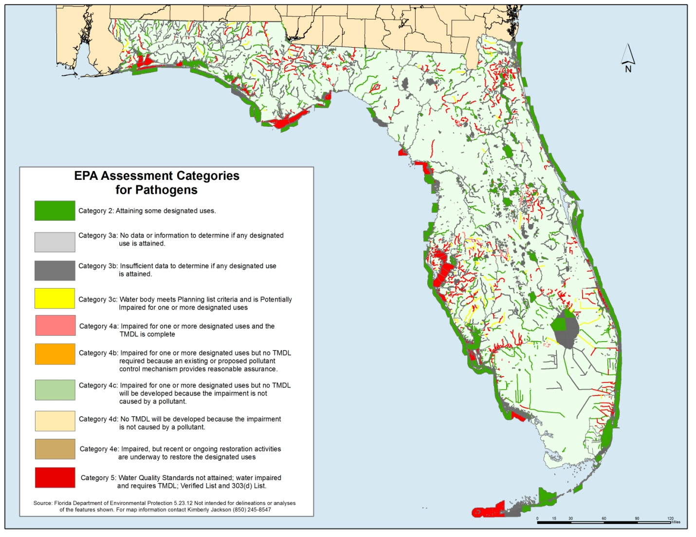

Figure 8.1b. Results of Florida’s Surface Water Quality Assessment:
EPA Assessment Categories for Nutrients
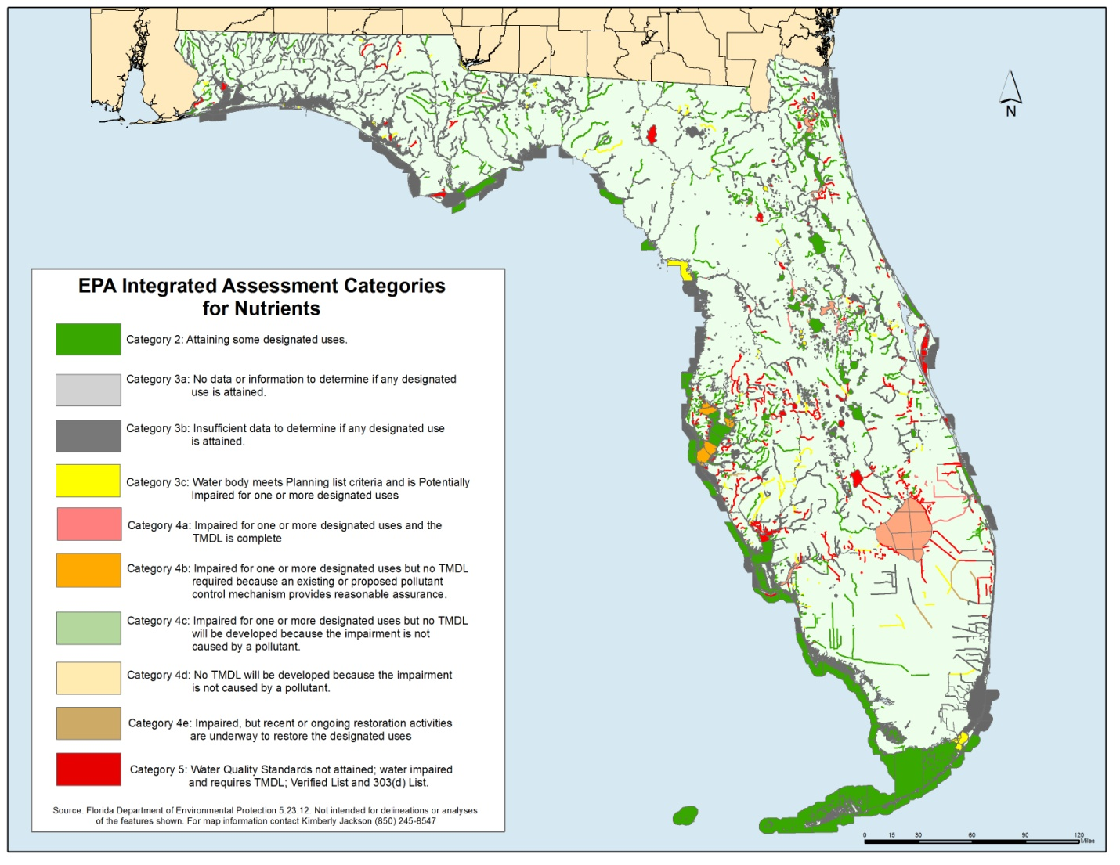

Figure 8.1c. Results of Florida’s Surface Water Quality Assessment:
EPA Assessment Categories for Mercury
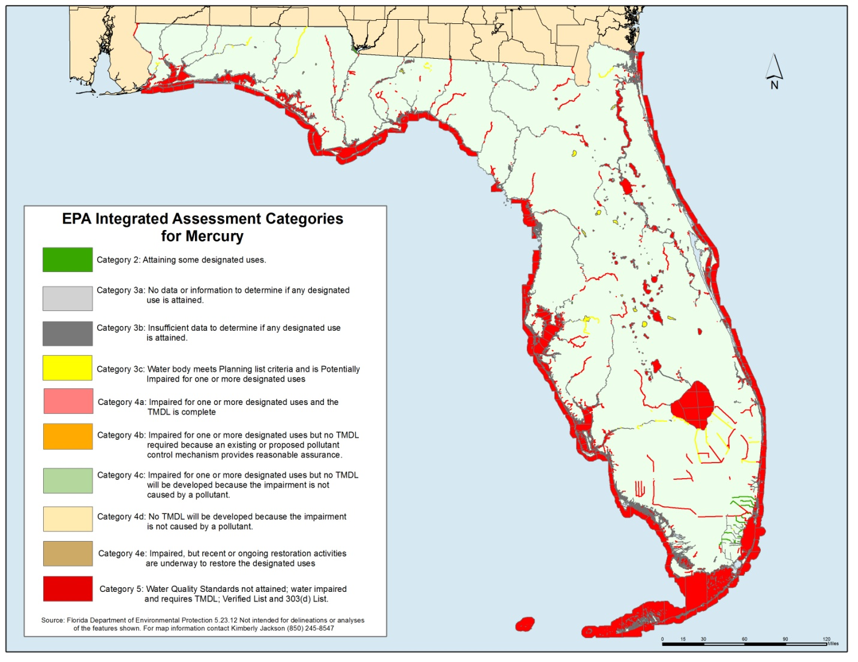

Delisting
When it is demonstrated that water quality criteria are currently being met for a waterbody or segment/analyte combination that was previously included on either the 303(d) list, or on the state’s Verified List of impaired waters, the waterbody segment may be proposed for delisting. If it is demonstrated that water quality criteria are met for some, but not all, parameters, the Department may propose partial delisting for those parameters; additional monitoring would be required to determine attainment for the remaining parameters.
Waterbody segments may also be proposed for delisting for other reasons (e.g., if it can be demonstrated that the original listing was in error, or if an impairment is determined to be due to natural causes). Although the IWR specifies the conditions for delisting, determining the ultimate assessment category (or subcategory) for some analytes is not necessarily straightforward.
For example, the EPA has provided guidance that a waterbody previously verified as impaired for nutrients based on chlorophyll a or TSI can be delisted if the waterbody does not exceed IWR threshold values. However, until sufficient site-specific information is available to demonstrate designated use attainment, these waterbody segments are placed in Category 3b rather than Category 2. The required site-specific information can include, but is not limited to, measures of biological response such as the SCI and macrophyte or algal surveys.
Even when a waterbody meets the delisting thresholds in the IWR for nutrients based on chlorophyll a or TSI assessments, if the waterbody has been verified as impaired for DO, and if either TN or TP has been identified as the causative pollutant, then the waterbody cannot be delisted unless site-specific information is available to demonstrate support of aquatic life use. Figure 8.2 illustrates the decision process for delisting waters that have been verified as impaired for nutrients.
Figure 8.2. Decision Tree for Delisting for Nutrient Impairment
Based on Chlorophyll a (Chl-a)

Biological Assessment
Under the IWR, biological assessments can provide the basis for impairment determinations, or can be used as an adjunct to support assessment determinations made for other parameters. For example, for some waterbodies that have naturally low DO concentrations, it may be possible to demonstrate that aquatic life use is fully supported by using biological information. For such waterbody segments, when there is biological information to demonstrate that aquatic life use is fully supported, a TMDL would not be required, and the waterbody segment would be placed in Subcategory 4c.

Use and Interpretation of Biological Results
Biological assessment tools used in conjunction with assessments performed under the IWR consist primarily of the SCI and the BioRecon. Since 1992, the Department has processed 3,441 SCI and 1,117 BioRecon samples.
Since the BioRecon is used as a screening tool, low BioRecon scores are not used as the sole basis for making an impairment determination. To determine impairment based on biological information, the Department requires follow-up sampling with the SCI, which provides a more comprehensive measure of aquatic life use support. In addition, a single SCI with a score less than the acceptable value is not sufficient to support an impairment determination. When SCIs are used in conjunction with impairment determinations, the Department requires two temporally independent SCIs having an average value that is below the minimum score associated with a healthy, well-balanced aquatic community.
Bioassessment methods, and the corresponding interpretation of bioassessment results (calibration), have changed over time. The BioRecon was revised in 1992, in 2004, and again in 2008; the SCI was revised in 1992 and 2007. The current version of the SCI used by the Department is based on a Human Disturbance Gradient (HDG) approach that was not explicitly included in previous versions of the SCI. Consequently, the use and interpretation of the biological data generated by these tools depend on the specific version of the biological tool used.
Table 8.4a presents the distribution of bioassessment results for the version-specific bioassessment tools. Apparent changes in the distribution of bioassessment results may be artifactual: without additional information, it is difficult to know the extent to which such changes in the distribution are representative of actual changes in the biological health of waterbody segments statewide, or whether such changes may be related to revisions and refinements that have been made to the methodology.
Table 8.4b summarizes the results of biological assessments performed by assessment type and aquatic life use support. From 1992 to 2011, 33% of BioRecons performed statewide required additional follow-up SCI sampling to determine aquatic life use support. During the same period, 18% of the SCI values were below the minimum score associated with a healthy, well-balanced aquatic community (however, 2 temporally independent SCI failures would be required for an impairment determination).

Table 8.4a. Distribution of Biological Results by Assessment Type and Aquatic Life Use Support
This is a four-column table. Column 1 lists the biological assessment, Column 2 lists the result of the biological assessment, Column 3 lists the corresponding aquatic life use support status, and Column 4 lists the number of measurements.

Biological  Assessment and Year | Result  Category | Meets Aquatic Life Use Support? | Number of  Measurements
BioRecon 1992 | Healthy | Yes | 337
BioRecon 1992 | Suspect | Yes | 314
BioRecon 1992 | Impaired | Requires follow-up sampling | 282
BioRecon 2004 | Pass | Yes | 79
BioRecon 2004 | Fail | Requires follow-up sampling | 75
BioRecon 2008 | Category 1 | Yes | 15
BioRecon 2008 | Category 2 | Yes | 7
BioRecon 2008 | Category 3 | Requires follow-up sampling | 8
SCI 1992 | Excellent | Yes | 1,208
SCI 1992 | Good | Yes | 448
SCI 1992 | Poor | No (if 2 independent samples are collected in a water segment) | 182
SCI 1992 | Very Poor | No (if 2 independent samples are collected in a water segment) | 48
SCI 2007 | Category 1 | Yes | 340
SCI 2007 | Category 2 | Yes | 820
SCI 2007 | Category 3 | No (if 2 independent samples are collected in a water segment) | 395

Table 8.4b. Summary of Biological Results by Assessment Type and Aquatic Life Use Support
This is a four-column table. Column 1 lists the type of biological assessment, Column 2 lists the aquatic life use support status associated with the result, Column 3 lists the number of results for each biological assessment type, and Column 4 lists the percentages.

- = Empty cell/no data
Biological  Assessment  Type | Meet Aquatic Life Use Support? | Number  of  Results | %
BioRecon | Requires follow-up sampling | 365 | 32.68
BioRecon | Yes | 752 | 67.32
Total | - | 1,117 | 100
SCI | No (if 2 independent samples are collected in a water segment) | 625 | 18.16
SCI | Yes | 2,816 | 81.84
Total | - | 3,441 | 100

Special Focus: Lakes
Lakes are a particular focus of the EPA’s Integrated Report guidance. This section addresses CWA Section 314 reporting requirements, providing information on lake trends, approaches to controlling lake pollution and lake water quality, and publicly owned lakes with impaired uses.
Table 8.2 summarizes the square miles of lakes assessed in each of the EPA Integrated Report categories. Table 8.3b lists the square miles of lakes impaired by the cause of impairment.

Lake Trends for Nutrients
Although assessments performed to identify impaired lake segments evaluate current nutrient status, the IWR incorporates additional methodologies that evaluate trends in the nutrient enrichment status of lakes. The latter methodologies interpret trends in the annual average TSI as indicative of changes in lake water quality (details of the methodology to identify both long- and short-term trends indicative of declining lake water quality are described in Subsection 62-303.352[3], F.A.C.). Both long- and short- term trends are addressed as follows:
- To identify long-term trends in nutrient status, segment-specific baseline (“historical minimum”) TSI values are determined. Baseline values are then used to develop segment-specific threshold values that are calculated as a 10-unit increase in the TSI. Subject to data sufficiency requirements, for each lake segment and year in the current assessment period, annual average TSI values are calculated and compared with segment-specific threshold values. Annual average TSI values from the current assessment period that exceed threshold values are interpreted as an indication that lake water quality has deteriorated over time.
- The identification of short-term trends is limited to analyses of annual average TSI values from the current assessment period. Since the IWR methodology focuses on identifying impaired waters of the state, it has not explicitly sought to identify trends where water quality is improving over time. However, if for a particular lake segment the historical average TSI from the current assessment period is less than the historical baseline TSI, this suggests that lake water quality for that lake segment has improved over time.

Methodology To Establish Lake Segment–Specific Baseline TSI Values
The following methodology is used to establish lake segment–specific baseline TSI values:
- Individual TSI values used in the calculation of seasonal averages for the entire period of record up to, but not including, the current assessment period are calculated using an adaptation of the TSI described in the state’s 1996 305(b) report;
- Subject to data sufficiency requirements, for each sampling location, individual TSI values are used to calculate four-day station median TSIs;
- For each lake segment and for each year, seasonal average TSI values are calculated as the average of all four-day station median TSI values over all sampling locations within the lake segment;
- Subject to data sufficiency requirements, for each lake segment and for each year, annual average TSIs values are calculated as the average of the four seasonal TSIs;
- Using the annual averages from the entire period of record (up to, but not including, the current assessment period, and subject to additional data sufficiency requirements), five-year moving average TSI values are calculated; and
- The five-year moving average TSI values are used to establish a baseline TSI value, defined as the minimum of the five-year moving average TSIs over the entire period of record (up to, but not including, the current assessment period).

Identification of Long-Term Nutrient Trends
Under the IWR, long-term increasing trends in nutrient enrichment are indicated by an increase of more than 10 units in the annual average TSI over historical values. Consequently, the threshold value with which annual average TSI values from the current assessment period are compared is taken as the baseline TSI value + 10.
Annual average TSI values from the current assessment period are compared with the threshold value. Lake segments having annual average TSI values that exceed the threshold value for two consecutive years are identified as those for which nutrient enrichment indicates a deterioration of water quality over time (long-term trend). This methodology provides the basis for one of the three components of nutrient assessments performed for lakes under the IWR.

Identification of Short-Term Nutrient Trends
Short-term increasing trends in nutrient enrichment over the current assessment period are indicated by a positive slope in the annual average TSI values plotted versus time. However, when evaluating the slope of the annual average TSIs over time, an increase of at least five TSI units over the assessment period is first required. To evaluate short-term trends over time, the IWR specifies the use of Mann’s one-sided, upper-tail test for trend at a 95% confidence level.
For assessments performed under the IWR, subject to data sufficiency, annual average TSI values from the current assessment period are analyzed using Mann’s test. Lake segments having a positive slope based on the results of this analysis are identified as those for which water quality shows evidence of a decline (short-term trend). This test provides the basis for an additional component of the nutrient assessments performed for lakes under the IWR.

Approaches to Controlling Lake Pollution and Lake Water Quality
The TMDL assessment process described in Chapter 7 provides an approach to controlling the point and nonpoint source pollution entering Florida’s lakes and restoring lake water quality. In particular, BMAPs developed for impaired waterbodies describe specific management activities and BMPs for reducing pollution. Each BMAP also provides interim and final targets for evaluating water quality improvements, a mechanism for tracking the implementation of management actions, procedures for monitoring and reporting on progress, data management and QA/QC procedures, a description of methods used to evaluate progress towards goals, strategy and schedule for periodically reporting results to the public, and procedures to determine whether additional corrective actions are needed and whether plan components need to be revised.

Publicly Owned Lakes with Impaired Uses
Appendix D provides an alphabetical list of the impaired lakes in the state, the parameter causing impairment, the basin group, and the river basin within which each lake is located.

Drinking Water Use Support
Although earlier sections of this chapter discussed impaired waters by waterbody type, this section provides assessment results for waterbodies designated as Class I (potable water supply). Table 8.5 lists the total miles of rivers/streams and square miles of lakes/reservoirs designated for drinking water use.

Table 8.5. Total Miles of Rivers/Streams and Square Miles of Lakes/Reservoirs Designated for Drinking Water Use
This is a three-column table. Column 1 lists the waterbody type, Column 2 lists the number of waterbodies in the state designated for drinking water use, and Column 3 lists the stream miles and lake square miles with that designation.

Waterbody Type | Number | Total in State
Streams | 91 | 559 miles
Lakes | 23 | 773 square miles

In addition to being protective of potable water supplies, Class I waters must also be protective of fish consumption, aquatic life, and recreational uses. Class I rivers/streams and lakes are assessed for all applicable criteria, including those that are protective of these other uses. Nonattainment for criteria for aquatic life use support or recreation does not affect whether a waterbody is suitable as a potable water supply, since treatment requirements for drinking water sources that rely on surface waters are sufficiently stringent that potable water supply use is attained.
In fact, the impairments for Class I waters determined in assessments performed under the IWR have been those that pertain to uses other than those associated with providing safe drinking water. Table 8.6 lists the miles of rivers/streams and square miles of lakes/reservoirs designated for drinking water use that are assigned to each of the EPA’s five reporting categories. Note that Lake Okeechobee is a Class I waterbody and comprises 730 square miles of the total 773 square miles of Class I lakes that are currently impaired under the IWR.

Overlap of Source Water Areas and Impaired Surface Waters
About 13% of Florida's public drinking water systems receive some or all of their water from a surface water source. Of 5,483 public drinking water systems statewide, 17 obtain their water from surface water. An additional 57 systems wholly or partially purchase water from these 17 systems. Because it is expensive to operate a surface water system (given that filtration and advanced disinfection are costly), most such systems are quite large.
In conjunction with the integrated assessment, the adopted Verified Lists of impaired surface waters were compared with the coverage of the source water assessment areas generated for the Source Water Assessment and Protection Program (SWAPP). The source water assessment area coverage for community drinking water systems was modeled based on a 3-day travel time to the intake within surface waters and their 100-year floodplains. Table 8.7 lists the river/stream miles (including springs) and square miles of lakes/reservoirs that overlap source water areas for community water systems that are impaired for fecal coliform.

Table 8.6. Waterbodies Designated for Drinking Water Use by Assessment Category (Results for Assessments Including Criteria for All Use Support)
This is a five-column table. Column 1 lists the waterbody type, Column 2 lists the assessment category, Column 3 lists the assessment status, Column 4 lists the number of waterbody/analyte combinations, and Column 5 lists the mile/analyte combinations (for streams) and square mile/analyte combinations (for lakes).

Note:
The EPA Integrated Report categories are as follows:
1—Attains all designated uses;
2—Attains some designated uses;
3a—No data and information are available to determine if any designated use is attained;
3b—Some data and information are available, but they are insufficient for determining if any designated use is attained;
3c—Meets Planning List criteria and is potentially impaired for one or more designated uses;
4a—Impaired for one or more designated uses and a TMDL has been completed;
4b—Impaired for one or more designated uses, but no TMDL is required because an existing or proposed pollutant control mechanism provides reasonable assurance that the water will attain standards in the future;
4c—Impaired for one or more designated uses but no TMDL is required because the impairment is not caused by a pollutant;
4d—No causative pollutant has been identified;
4e—Impaired, but recently completed or ongoing restoration activities should restore the designated uses of the waterbody; and
5—Water quality standards are not attained and a TMDL is required.

* These impairments are not related to criteria specifically designed to protect drinking water supplies.
Waterbody  Type | Assessment  Category | Assessment  Status | Number of Waterbody/Analyte Combinations | Mile/Analyte Combinations (for Streams) and  Square Mile/Analyte Combinations (for Lakes)
Rivers/Streams | 2 | Not Impaired | 476 | 3,915
Rivers/Streams | 3A | No Data | 280 | 2,497
Rivers/Streams | 3B | Insufficient Data | 444 | 3,107
Rivers/Streams | 3C | Planning List | 64 | 588
Rivers/Streams | 4A | TMDL Complete | 2 | 7
Rivers/Streams | 4B | Reasonable Assurance | 7 | 92
Rivers/Streams | 4C | Natural Condition | 4 | 11
Rivers/Streams | 4D | No Causative Pollutant | 18 | 241
Rivers/Streams | 4E | Ongoing Restoration | 2 | 27
Rivers/Streams | 5* | Impaired | 55 | 287
Lakes/Reservoirs | 2 | Not Impaired | 181 | 4,680
Lakes/Reservoirs | 3A | No Data | 104 | 559
Lakes/Reservoirs | 3B | Insufficient Data | 225 | 10,135
Lakes/Reservoirs | 3C | Planning List | 13 | 626
Lakes/Reservoirs | 4A | TMDL Complete | 26 | 1,788
Lakes/Reservoirs | 4D | No Causative Pollutant | 1 | 5
Lakes/Reservoirs | 5* | Impaired | 41 | 1,810

Table 8.7. Summary of Impaired River/Stream Miles and Lake/Reservoir Square Miles Overlapping Source Water Areas of Community Water Systems
This is a three-column table. Column 1 lists the surface water type, Column 2 lists the length or area of impaired waters overlapping source water areas in Groups 1–5, and Column 3 lists the percent of total length or area in Groups 1–5.

Note: The analysis is based on Verified Lists of impaired surface waters based on the Cycle 2 assessments for the Group 1–5 basins. The parameter of interest was fecal coliform.
Surface Water Type | Length or Area of Impaired Surface Waters Overlapping Source Water Areas in Basin Groups 1–5 | % of Total Length or Area in Basin  Groups 1–5
Streams/Rivers | 59 miles | 0.41
Lakes/Reservoirs | 9 square miles | 0.05

Chapter 9: Introduction to Ground Water Monitoring

Summary of Ground Water Monitoring Programs
The quality of ground water is of foremost concern in Florida, because ground water is so heavily used as a potable water source and because ground water inputs into surface water systems are so important. Over the years, ground water quality monitoring has been incorporated into several programs. The programs pertinent to this report are discussed below and summarized in Tables 9.1a and 9.1b.

Table 9.1a. Summary of Ground Water Monitoring Programs and Data Sources:
Monitoring Networks Maintained by the Department
This is a three-column table. Column 1 lists the monitoring network or program, Column 2 lists the period over which it has operated, and Column 3 provides a description.

Monitoring Network or Program | Period | Description
Status Network | 1999–2003;  2004–08 | The statewide rotating basin, probabilistic sampling network was based on sampling 60 wells from several basins per year. The 1999–2003 cycle (Cycle 1) completed a statewide survey in 4 years. During 2004–08, the state adopted the TMDL 29-basin design (Cycle 2), completing the statewide survey in 5 years. These sample locations were randomly selected from a list frame of wells, with samples collected from 30 unconfined and 30 confined aquifers in each 5 to 6 reporting units. This report presents the results from Cycle 2.
Status Network | 2009–ongoing | This statewide probabilistic sampling network samples 240 wells annually. Sample locations are randomly selected from a list frame of wells, with samples collected from 20 unconfined and 20 confined aquifers in each of 6 reporting units. The data used to characterize water quality on a statewide scale, and the parameters monitored, correspond with those targeted in surface water evaluations.
Background Network and  Temporal Variability (TV) Subnetwork | 1985–1999 | A statewide network of 1,600 water wells and monitoring wells used to spatially monitor general background water quality of local aquifers (surficial, intermediate, and Floridan). On average, each well was sampled once every 3 years for an extensive list of analytes. TV network wells are sampled monthly to quarterly.
Ground Water Temporal Variability (GWTV) Subnetwork | 1999–ongoing | The current network consists of 46 wells statewide. It is designed to help correlate Status Network results with seasonal hydrologic variations, and estimate the temporal variance of analytes.
Very Intense Study Area (VISA) Network | 1989–1999 | The network monitored the effects of land uses on ground water quality in 23 selected areas of the state. Individual VISAs consisted of approximately 20 wells sampled 3 times over an 11-year period. Sampling was carried out for a targeted list of analytes.
Springs Monitoring Network | 2001–2010 | Until 2010, 58 samples were collected quarterly from 23 first-magnitude and 9 second-magnitude spring clusters. Since then, the quarterly network has been reduced to eliminate redundancy with stations also monitored by Florida’s WMDs. Since 2010, the network has consisted of 24 springs. The basic analyte list is similar to that used for the Status Network but also includes isotopes for nitrogen sourcing.

Table 9.1b. Summary of Ground Water Monitoring Programs and Data Sources: Programs that Include Potable Ground Water Sampling:
Monitoring Networks Maintained by the Department
This is a three-column table. Column 1 lists the monitoring network or program, Column 2 lists the period over which it has operated, and Column 3 provides a description.

Monitoring Network or Program | Period | Description
Public Water System (PWS)  Monitoring | Ongoing | Under Rule 62-550, F.A.C., all public water systems are required to monitor and report water quality at regular intervals within their compliance cycle. Ground water is the primary source of potable water in the state.
FDOH/Departmental Water Supply Restoration Program (WSRP)–Private Well Sampling Program | Ongoing | This consists of private well data collected in investigations of potential ground water contamination, maintained in a Departmental WSRP database. The parameter list is variable, depending on the contaminants of concern.
Monitoring of discharges  to ground water | Ongoing | Under Rule 62-520, F.A.C., facilities discharging to ground water are required to implement a ground water monitoring plan and report those results to the Department.

Ground Water and Springs Monitoring Programs Maintained by the Department
The Department established a ground water quality monitoring network in 1984, under the authority and direction of the 1983 Water Quality Assurance Act. From 1984 to1999, the Background Network was maintained to establish the background and baseline ground water quality of major aquifer systems in Florida. In 1999, the Department initiated a probabilistic sampling Status Network to assess ground water and surface water quality on a basinwide scale. This sampling has been integrated into the agency’s watershed management approach. Since the Status Network’s inception, three statewide samplings have been completed.
Monitoring results for the Ground Water Temporal Variability Network (GWTV), which also began in 1999, are used to assess seasonal and long-term variability in ground water quality. Other, historical monitoring efforts include the Background Network, the VISA Network, and FDOH’s Private Water Well Quality Survey. Additional information on all these monitoring networks is available on the Department’s Watershed Monitoring website.
This report includes the Status Network monitoring data in the dataset used to evaluate overall ground water quality and ground water parameters of particular concern that may influence receiving surface waters.
The Department established a springs monitoring network under the Florida Springs Initiative and has continued quarterly monitoring and data acquisition. Beginning in 2001, this effort initially included quarterly monitoring at each of the state’s first-magnitude springs but has since expanded to include important second-magnitude springs as well. Currently, the Department samples 24 spring stations quarterly and also integrates spring monitoring data from other providers into its database. In this report, quarterly spring monitoring data collected by the Department as well as the regional WMDs are evaluated to identify spring water quality with respect to nutrients.

Potable Water Monitoring by FDOH/Departmental Water Supply Restoration Program
Contaminated drinking water wells are identified through the sampling efforts of the local county public health units, supported by Departmental funding. To optimize resources, wells are sampled in areas of known or suspected contamination, such as agricultural areas, areas of known off-site contamination near regulated facilities, landfills, or near underground storage tanks.
The FDOH Petroleum Surveillance Program concentrates its efforts in areas suspected to have petroleum-related contamination and targets drinking water wells near known storage tanks for sampling.
The FDOH Drinking Water Toxics Program looks for contamination related to the use of pesticides and fertilizers, and contamination from solvents and metals. The program is a cooperative effort between FDOH, county public health units, and the Department. The program is funded by the Department through a contract with FDOH, and FDOH directs the sampling effort by local public health units.
In this report, the Water Supply Restoration Program (WSRP) database maintained by the Department was used in the evaluation of the ground water contaminants of concern identified in private drinking water wells. The database currently has water quality records for approximately 40,000 private wells. A caveat to their use in this evaluation is that these wells are not evenly distributed because they were sampled in areas of known or suspected contamination. Thus, the number of exceedances in a particular basin can be misleading because the results may depend on well density and distribution in relationship to a given problem area.

Public Water System Monitoring
Approximately 5,600 PWSs in Florida rely on ground water. These are served by over 10,000 wells. Rule 62-550, F.A.C., sets the drinking water standards and the monitoring requirements and treatment techniques to be met by PWSs, and also mandates that testing must be conducted by FDOH-certified laboratories. The ultimate concern of the PWS supervision program is the quality of water when the water reaches consumers, but PWS monitoring involves the direct sampling of wells in some instances. Water quality results include samples from various entry points into the water system and points in the distribution system, include treated water, and for some parameters may include composite samples. Not all samples included in the data are used to determine compliance with Rule 62-550, F.A.C.
The monitoring framework for PWSs is a nine-year compliance cycle containing specific monitoring requirements for individual parameter groups and specific actions based on the detection of parameters above action limits or maximum contaminant levels (MCLs). Water quality data in the PWS database are reported by the public water system identification number (PWS ID#). While individual sample results collected for this report may exceed an action level or MCL, that exceedance does not necessarily translate directly into a violation of water delivered to the consumer because of the compositing or blending of water mentioned above, or because averaging with subsequent samples was below the action level or MCL. Additional information is available on the Department’s Drinking Water Program website.
Water quality data in the PWS database were used in the evaluation of regional and statewide contaminants of concern. These data can either represent one individual well or a composite sample from multiple wells that comprise a system. Generally, the most densely populated areas of the state have public supply systems with multiple wells, while less populated areas may rely on only one well. Each public supply well was assigned to a basin or, in the case of a system, the basin that represents the majority of those wells. In the analysis of contaminants of concern, the number of MCL exceedances is not weighted, and thus each exceedance may represent one individual well or a composite of many wells in a system. Drinking water standards, monitoring requirements, and the frequency of sampling for public water supply wells are based on Rule 62-550, F.A.C.

Monitoring of Discharges to Ground Water
The Department implements a comprehensive ground water quality protection program that regulates discharges to ground water. The program establishes ground water quality standards and classifications and permitting criteria. Several Departmental rules contain construction and operation requirements, minimum setbacks, and ground water monitoring criteria.
Most permitted discharges to ground water are required to submit and implement a ground water monitoring plan showing the location of the proposed upgradient and downgradient monitoring wells, construction details, and a ground water sampling and analysis protocol. At a minimum, these plans require three monitoring wells: a background well, an intermediate well, and a compliance well. These wells are generally sampled quarterly by the permittee, and the analysis is submitted to the Department to ensure compliance with Florida’s ground water standards.

Chapter 10: Results of the Ground Water Assessments

Overall Ground Water Quality
Data from the in-house ground water monitoring program were used to evaluate the overall quality of ground water based on several categories of primary ground water MCLs. The data were sorted into analyte groups, and an “indicator” analyte was selected to determine ground water quality for wells in each of the basins. The groups used in this evaluation include metals, bacteria, nitrate, and saline water, which represent some of the most common threats to drinking water noted by the EPA in national surveys. Organics and radionuclides were not included in the Status Network parameter list but are addressed in a later section. The ground water evaluation used the same source of data as the Status and Trends reporting in Chapter 5. This evaluation also provided information by basin rather than statewide as was done with the assessments reported in Chapter 5.
The wells used in this statewide evaluation of overall ground water quality consist of a mixture of drinking water, irrigation, production, and monitoring wells used by the Department for monitoring ground water quality. It should also be noted that the main network from which these data were obtained uses randomly selected wells for each sampling cycle, and new wells are sampled each time a basin is sampled. These data are meant to represent general basin-scale conditions, and there is no attempt to target specific localized ground water problem areas. Thus, for the purposes of this analysis the water quality in these wells represents overall ground water conditions.
Table 10.1 presents the results of this evaluation, with the results provided by individual basin and combined for statewide statistics. The results in the table are further broken down to show the results from the past two years and prior data back to 2000. Older (pre-2000) data may include nonrepresentative artifacts from sample collection and analysis, and so these were not included in the assessment. Overall, bacteria (as total coliform) and salinity (as sodium) were the analyte groups with the largest percentage of MCL exceedances in ground water samples.
Coliform bacteria can occur in well casing and water distribution systems, and their detection in water samples from wells may not always indicate a ground water contamination problem. For that reason, coliform data should always be scrutinized carefully. The next section on Ground Water Issues and Contaminants of Concern discusses the occurrence of coliform bacteria in ground water in greater detail.

Table 10.1. Summary of Percent Ground Water Samples Achieving Primary Ground Water Standards for Selected Analytes by Basin
This is a six-column table. Column 1 lists the basins, and Columns 2 through 6 list the results for arsenic, lead, total coliform, nitrate + nitrite (as N), and total sodium, respectively, in 2000–09 and 2009–11.

Notes: Data are from the Department’s Status and Trends Network. For some basins, datasets are limited. Values for basins with five or fewer samples are indicated by shading and boldface type.
¹ Metals assessments were conducted for arsenic (As) and lead (Pb), the two primary metals most commonly exceeding their MCL.
N/A = Not available
Basin | Metals, Arsenic¹  2000–09 / 2009-11 | Metals, Lead¹  2000–09 / 2009–11 | Coliform, Total  2000–09 / 2009-11 | Nitrate + Nitrite (as N)  2000–09 / 2009–11 | Sodium, Total  2000–09 / 2009–11
Apalachicola–Chipola | 100% - 97% | 100% - 100% | 93% - 85% | 100% - 96% | 100% - 100%
Caloosahatchee | 93% - 95% | 98% - 100% | 69% - 58% | 100% - 100% | 71% - 88%
Charlotte Harbor | 95% - 100% | 97% - 100% | 86% - 100% | 100% - 100% | 56% - 50%
Choctawhatchee–St. Andrew | 100% - 100% | 99% - 96% | 91% - 93% | 100% - 100% | 99% - 100%
Everglades | 100% - 100% | 100% - 100% | 72% - 80% | 96% - 100% | 96% - 100%
Everglades West Coast | 93% - 97% | 87% - 87% | 76% - 67% | 100% - 100% | 72% - 74%
Fisheating Creek | 100% - 100% | 100% - 100% | 96% - 75% | 100% - 100% | 89% - 75%
Florida Keys | 87% - N/A | 100% - N/A | 75% - N/A | 100% - N/A | 0% - N/A
Indian River Lagoon | 96% - 75% | 98% - 75% | 86% - 100% | 98% - 100% | 70% - 100%
Kissimmee River | 100% - 100% | 97% - 96% | 88% - 81% | 91% - 96% | 98% - 100%
Lake Okeechobee | 100% - 100% | 97% - 100% | 98% - 100% | 100% - 100% | 78% - 67%
Lake Worth Lagoon–  Palm Beach Coast | 91% - 100% | 87% - 100% | 69% - 80% | 100% - 100% | 100% - 100%
Lower St. Johns | 100% - 95% | 100% - 100% | 81% - 74% | 100% - 100% | 97% - 85%
Middle St. Johns | 100% - 100% | 97% - 100% | 76% - 46% | 95% - 100% | 90% - 92%
Nassau–St. Marys | 98% - 100% | 96% - 100% | 89% - 70% | 100% - 100% | 98% - 100%
Ochlockonee–St. Marks | 97% - 94% | 100% - 100% | 73% - 87% | 100% - 100% | 99% - 100%
Ocklawaha | 97% - 100% | 97% - 95% | 70% - 84% | 100% - 96% | 98% - 100%
Pensacola | 100% - 100% | 98% - 100% | 92% - 100% | 100% - 100% | 98% - 100%
Perdido | 100% - 100% | 97% - 100% | 97% - 100% | 100% - 100% | 97% - 100%
Sarasota Bay–Peace–Myakka | 97% - 100% | 100% - 89% | 64% - 65% | 100% - 100% | 93% - 93%
Southeast Coast–Biscayne Bay | 100% - 100% | 98% - 92% | 59% - 50% | 100% - 100% | 91% - 100%
Springs Coast | 89% - 100% | 97% - 87% | 86% - 87% | 100% - 100% | 74% - 75%
St. Lucie–Loxahatchee | 100% - 100% | 95% - 100% | 87% - 91% | 100% - 91% | 84% - 54%
Suwannee | 97% - 97% | 99% - 100% | 85% - 82% | 99% - 97% | 96% - 98%
Tampa Bay | 95% - 100% | 97% - 100% | 79% - 67% | 100% - 100% | 86% - 87%
Tampa Bay Tributaries | 94% - 100% | 98% - 100% | 76% - 57% | 100% - 100% | 94% - 100%
Upper East Coast | 98% - 100% | 98% - 100% | 84% - 75% | 100% - 100% | 77% - 100%
Upper St. Johns | 98% - 89% | 97% - 100% | 92% - 89% | 98% - 100% | 87% - 56%
Withlacoochee | 98% - 100% | 97% - 100% | 84% - 67% | 96% - 100% | 100% - 100%
STATEWIDE SUMMARY | 97% - 98% | 97% - 97% | 82% - 79% | 99% - 99% | 86% - 89%

The statewide assessment shows that data from the past 2 years were similar to the 2000–09 median in the number of samples achieving the MCL (79% compared with 82% of the samples). Table 10.1 shows the basins with the highest and lowest percentages of wells achieving the ground water standards. The Middle St Johns, Southeast Coast–Biscayne Bay, Tampa Bay Tributaries, and Caloosahatchee Basins had the lowest percentage of wells achieving the MCL for total coliform in the recent 2-year period. As previously noted, some of the reported exceedances may not all be attributable to actual aquifer conditions.
Sodium can be used as an indicator of saline ground water influence on freshwater aquifers. Higher salinity can be related to increased ground water usage that creates the upward seepage of mineralized ground water from deeper aquifers or the lateral intrusion of seawater if wells are located in coastal areas. Saline water (as sodium) was found to be a potential issue in several of the basins based on their percentage of samples meeting the sodium MCL. The Caloosahatchee, Charlotte Harbor, St. Lucie–Loxahatchee, and Upper St. Johns Basins had the lowest percentages of wells achieving the MCL. The statewide assessment shows that data from the past 2 years were similar to the 2000–09 median in the number of samples achieving the MCL (89% in comparison to 86% of the samples). Table 10.1 shows the basins with the highest and lowest percentages of ground water samples achieving the MCL for sodium.
Statewide, one or more metals exceeding a primary ground water MCL occurred in only about 3% of the samples. The most common metal with exceedances was arsenic. Lead also exceeded its MCL in a few instances. Elevated lead concentrations in samples are sometimes related to well casing or plumbing material, but when arsenic is found, it is most likely associated with an actual condition in the aquifer.
Nitrate - nitrogen is a conservative contaminant, and concentrations are not typically biased by well materials or sampling technique. The compound nitrite - nitrogen is seldom detected in ground water and, if present, occurs in only minute concentrations. Therefore, when concentrations of nitrate + nitrite - nitrogen are reported together, as they are in Table 10.1, it can be safely assumed that the value represents the nitrate concentration. Elevated nitrate levels reflect the presence of nutrient sources such as fertilizers, animal waste, or domestic wastewater.
According to the statewide assessment, nitrate above the MCL is a concern in only 1% of the samples analyzed. Table 10.1 lists the basins with the highest and lowest percentage of samples achieving the MCL for nitrate. The vast majority of wells in the Department’s network that were sampled for nitrate were below the MCL. However, ground water samples from several basins exceeded the MCL. The basins with the lowest percentage of wells meeting the MCL for nitrate during the recent 2-year period were the St. Lucie–Loxahatchee, Kissimmee, Ocklawaha, and Apalachicola–Chipola Basins.
This analysis of the regional data shows that ground water quality in the state is good overall, when considering these parameters. However, it also indicates that there are some ground water quality issues in some basins. Depending on the contaminant, these can be very significant on a localized or regional scale. The following section describes the contaminants of concern in Florida and their observed occurrences in potable ground water.

Ground Water Quality Issues and Contaminants of Concern, Including Potable Water Issues
As discussed in the analysis of ambient data, the overall quality of ground water in Florida is good. However, there are ground water quality issues in specific areas. Private well sampling data and public water system data (which include both treated and raw water samples) were used to develop a summary of the categories of parameters that were most frequently found at levels exceeding primary MCLs in Florida’s aquifers used for potable supply. Data were obtained for an approximate 2-year period of record from November 2009 through October 2011. The number and distribution of the samples that exceed specific MCLs for ground water during this period help identify current issues and contaminants of concern. The reporting of these exceedances in wells and water systems is not meant to imply that well owners or public water customers are consuming contaminated ground water. Alternative sources or treatment systems are provided to private well owners, and water from public water systems is most often treated but sometimes blended to reduce contaminants to safe levels.
Figure 10.1 summarizes statewide findings by contaminant category. Tables 10.2a and 10.2b summarize contaminant categories in each of the state’s 29 major basins, showing the numbers of exceedances reported for public water systems and private wells since the 2010 Integrated Report data were compiled. The data for this evaluation were compiled for an approximate 2-year period (November 2009 through October 2011). The contaminant of concern categories include volatile organic compounds (VOCs), pesticides/synthetic organic chemicals (SOCs), nitrate, primary metals, salinity (measured as sodium), and radionuclides. This evaluation is limited to contaminants that have potable ground water primary MCLs. Although not included in the summary tables, trihalomethanes and bacteria are also significant contaminants affecting water supplies and are discussed in this section.

Volatile Organic Compounds
Volatile organics can be highly mobile and persistent in ground water, and incidences of ground water contamination by VOCs have historically been fairly widespread in mainly urban areas. Table 10.2a summarizes the numbers of water systems and private wells for which samples contained above-MCL levels of VOCs that have primary drinking water MCLs. Only 8 public water systems had VOC exceedances during this 2-year period. A total of 93 private wells had VOC exceedances in the recent 2-year period, and of these the highest numbers of wells were in the Middle St. Johns Basin, followed by the Lower St. Johns Basin
Benzene has historically been the compound that most frequently exceeded MCLs in each of the two sets of water quality data, followed by trichloroethylene (TCE) and tetrachloroethylene (PCE). The VOCs with the most frequent MCL exceedances in the past two years in private wells were benzene, vinyl chloride, 1,1-dichloroethylene, 1,2-dichloroethane, and carbon tetrachloride. Based on the last two years of data, vinyl chloride was the VOC with the highest number of exceedances in public water systems, but exceedances were also noted for these same compounds found in private wells as well as tetrachloroethene and dichloromethane.

Figure 10.1. Statewide Summary of Primary MCL Exceedances Reported for Untreated Public Water Systems and Private Wells in a Recent Two-Year Period

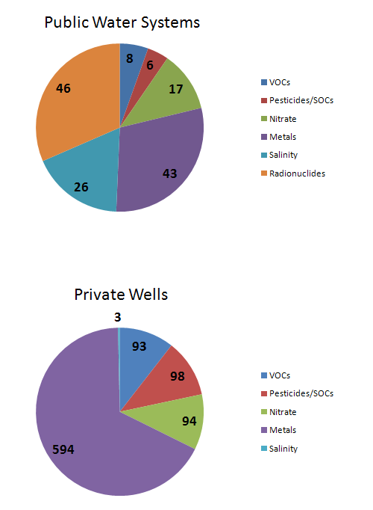

Table 10.2a. Summary of Recent Exceedances of Primary Ground Water Standards in Untreated Samples from Private Wells and Ground Water–Based Public Water Systems
This is a seven-column table. Column 1 lists the basin and aquifer. Columns 2 and 3 list the number of public water systems and private wells, respectively, exceeding primary standards for VOCs since the 2010 report. Columns 4 and 5 list the number of public/private exceedances, respectively, for pesticides/SOCs over the same period; and Columns 6 and 7 list the number of public/private exceedances, respectively, for nitrate.

¹ Public water systems or private wells with samples that exceeded primary MCLs for VOCs, excluding trihalomethanes and ethylene dibromide (EDB).
² Public water systems or private wells with samples that exceeded primary MCLs for pesticides (also known as SOCs).
³ Public systems or private wells with samples that exceeded MCLs for nitrate or nitrate + nitrite.
⁴ PWS data not restricted to wells only. Some parameter results are for other entry points into a system or composite samples. Data are from systems that operate their own wells. While individual sample results collected for this report may exceed an action level or MCL, that exceedance does not necessarily translate directly into a violation of water delivered to the consumer (1) because of the compositing or blending of water mentioned above, or (2) because averaging with subsequent samples was below the action level or MCL.
⁵ Private well sampling under the WSRP is targeted sampling conducted in areas of suspected contamination, and the parameters analyzed are specific to contaminants of concern.
- = Empty cell/no data; ND = No data
- | Contaminant Categories and Number of Private Well and Water Systems with Samples Exceeding Primary Standards  (period of record November 2009–October 2011)
Basin—Aquifer | VOCs¹ in Public Water Systems⁴ | VOCs¹ in Private Wells (WSRP)⁵ | Pesticides/  SOCs² in Public Water Systems⁴ | Pesticides/  SOCs² in Private Wells (WSRP)⁵ | Nitrate³ in Public Water Systems⁴ | Nitrate³ in Private Wells (WSRP)⁵
Apalachicola–Chipola—Floridan Aquifer | 0 | 1 | 1 | 24 | 0 | 6
Caloosahatchee—Surficial Aquifer | 0 | 0 | 0 | 0 | 0 | 0
Charlotte Harbor—Floridan Aquifer (SW) | 0 | 5 | 0 | 0 | 0 | 0
Choctawhatchee–St. Andrew—Floridan Aquifer | 0 | 2 | 0 | 0 | 0 | 0
Everglades—Surficial Aquifer (SW) | 1 | ND | 0 | 0 | 0 | ND
Everglades West Coast—Surficial Aquifer | 0 | 0 | 0 | 0 | 0 | ND
Fisheating Creek—Surficial Aquifer | 0 | 0 | 0 | 0 | 0 | 0
Florida Keys—None | 0 | ND | 0 | ND | 0 | ND
Indian River Lagoon—Floridan and Surficial Aquifers | 0 | 4 | 0 | 0 | 0 | 0
Kissimmee River—Floridan, Intermediate, and Surficial Aquifers | 1 | 3 | 0 | 15 | 2 | 25
Lake Okeechobee—Surficial Aquifer (SW) | 0 | 0 | 0 | 0 | 0 | ND
Lake Worth Lagoon–Palm Beach Coast—Surficial Aquifer | 1 | 0 | 0 | 0 | 0 | ND
Lower St. Johns—Floridan Aquifer | 0 | 13 | 0 | 0 | 0 | 0
Middle St. Johns—Floridan Aquifer | 0 | 35 | 0 | 0 | 0 | 3
Nassau–St. Marys—Floridan Aquifer | 0 | 0 | 0 | 0 | 0 | 0
Ochlockonee–St. Marks—Floridan Aquifer | 0 | 0 | 1 | 0 | 0 | 0
Ocklawaha—Floridan Aquifer | 2 | 5 | 1 | 23 | 0 | 12
Pensacola—Sand-and-Gravel Aquifer | 0 | 0 | 2 | 1 | 0 | 0
Perdido—Sand-and-Gravel Aquifer | 0 | 0 | 0 | 0 | 0 | ND
Sarasota Bay–Peace–Myakka—Floridan and Surficial Aquifers | 0 | 4 | 1 | 31 | 1 | 31
Southeast Coast–Biscayne Bay---Biscayne Aquifer | 0 | 4 | 0 | 1 | 1 | 1
Springs Coast—Floridan Aquifer | 1 | 0 | 1 | 0 | 1 | 1
St. Lucie–Loxahatchee—Surficial Aquifer | 1 | 5 | 0 | 0 | 0 | ND
Suwannee—Floridan Aquifer | 1 | 4 | 0 | 0 | 2 | 3
Tampa Bay—Floridan Aquifer | 0 | 1 | 0 | 0 | 1 | 2
Tampa Bay Tributaries—Floridan Aquifer | 0 | 4 | 0 | 0 | 9 | 7
Upper East Coast—Floridan Aquifer and Surficial Aquifer | 0 | 1 | 0 | 0 | 0 | ND
Upper St. Johns—Floridan Aquifer and Surficial Aquifer | 0 | 1 | 0 | 0 | 0 | 0
Withlacoochee—Floridan Aquifer | 0 | 1 | 0 | 2 | 0 | 3
STATEWIDE SUMMARY—All Results | 8 | 93 | 6 | 98 | 17 | 94

Table 10.2b. Summary of Recent Exceedances of Primary Ground Water Standards in Untreated Samples from Private Wells and Ground Water–Based Public Water Systems
This is a seven-column table. Column 1 lists the basin/aquifer. Columns 2 and 3 list the number of public water systems and private wells, respectively, exceeding primary standards for primary metals since the 2010 report. Columns 4 and 5 list the number of public/private exceedances, respectively, for saline water over the same period; and Columns 6 and 7 list the number of public/private exceedances, respectively, for radionuclides.

¹ Public water systems or private wells with samples that exceeded MCLs for primary metals.
² Public water systems or private wells with samples that exceeded MCL for sodium, an indicator of salinity.
³ Public water systems or private wells with samples that exceeded MCL for radionuclides, measured as Radium-226, Radium-228, gross Alpha, and/or gross Beta.
⁴ PWS data not restricted to wells only. Some parameter results are for other entry points into a system or composite samples. Data are from systems that operate their own wells. While individual sample results collected for this report may exceed an action level or MCL, that exceedance does not necessarily translate directly into a violation for water delivered to the consumer (1) because of the compositing or blending of water mentioned above, or (2) because averaging with subsequent samples was below the action level or MCL.
⁵ Private well sampling under the WSRP is targeted sampling conducted in areas of suspected contamination, and the parameters analyzed are specific to contaminants of concern.
- = Empty cell/no data; ND = No data
- | Contaminant Categories and Number of Private Well and Water Systems with Samples Exceeding Primary Standards  (period of record November 2009–October 2011)
Basin—Aquifer | Primary Metals¹ in Public Water Systems⁴ | Primary Metals¹ in Private Wells (WSRP) ⁵ | Saline Water² in Public Water Systems⁴ | Saline Water² in Private Wells (WSRP) ⁵ | Radionuclides³ in Public Water Systems ⁴ | Radionuclides³ in Private Wells (WSRP) ⁵
Apalachicola–Chipola—Floridan Aquifer | 0 | 2 | 0 | 0 | 0 | ND
Caloosahatchee—Surficial Aquifer | 0 | 0 | 2 | ND | 1 | ND
Charlotte Harbor—Floridan Aquifer | 0 | 1 | 2 | ND | 1 | ND
Choctawhatchee–St. Andrew—Floridan Aquifer | 0 | 3 | 1 | 0 | 0 | ND
Everglades—Surficial Aquifer | 0 | ND | 0 | ND | 0 | ND
Everglades West Coast—Surficial Aquifer | 1 | 1 | 2 | ND | 0 | ND
Fisheating Creek—Surficial Aquifer | 0 | 0 | 0 | ND | 0 | ND
Florida Keys—None | 0 | ND | 0 | ND | 0 | ND
Indian River Lagoon—Floridan and Surficial Aquifers | 0 | 0 | 2 | ND | 1 | ND
Kissimmee River—Floridan, Intermediate, and Surficial Aquifers | 1 | 2 | 0 | 0 | 3 | ND
Lake Okeechobee—Surficial Aquifer | 0 | 2 | 1 | 0 | 1 | ND
Lake Worth Lagoon–Palm Beach Coast—Surficial Aquifer | 1 | 1 | 2 | ND | 2 | ND
Lower St. Johns—Floridan Aquifer | 0 | 4 | 0 | 0 | 0 | ND
Middle St. Johns—Floridan Aquifer | 1 | 0 | 0 | 1 | 1 | ND
Nassau–St. Marys—Floridan Aquifer | 1 | 1 | 0 | ND | 0 | ND
Ochlockonee–St. Marks—Floridan Aquifer | 0 | 1 | 0 | ND | 0 | ND
Ocklawaha—Floridan Aquifer | 2 | 10 | 1 | 0 | 1 | ND
Pensacola—Sand-and-Gravel Aquifer | 0 | 0 | 2 | 0 | 2 | ND
Perdido—Sand-and-Gravel Aquifer | 0 | 0 | 0 | 0 | 1 | ND
Sarasota Bay–Peace–Myakka—Floridan and Surficial Aquifers | 1 | 8 | 5 | 0 | 18 | ND
Southeast Coast–Biscayne Bay–Biscayne Aquifer | 2 | 6 | 0 | ND | 1 | ND
Springs Coast—Floridan Aquifer | 7 | 146 | 0 | 2 | 0 | ND
St. Lucie–Loxahatchee—Surficial Aquifer | 1 | ND | 2 | ND | 0 | ND
Suwannee—Floridan Aquifer | 1 | 135 | 0 | ND | 1 | ND
Tampa Bay—Floridan Aquifer | 4 | 17 | 2 | 0 | 4 | ND
Tampa Bay Tributaries—Floridan Aquifer | 15 | 107 | 0 | 0 | 7 | ND
Upper East Coast—Floridan Aquifer and Surficial Aquifer | 1 | 0 | 0 | ND | 0 | ND
Upper St. Johns—Floridan Aquifer and Surficial Aquifer | 2 | 9 | 1 | ND | 1 | ND
Withlacoochee—Floridan Aquifer | 2 | 138 | 1 | 0 | 1 | ND
STATEWIDE SUMMARY—All Results | 43 | 594 | 26 | 3 | 46 | ND

Synthetic Organic Chemicals/Pesticides
Over the years, EDB is the compound that has most frequently been detected in public water systems and private drinking water wells in Florida. This nematocide, which was used heavily in the 1980s on citrus and other croplands, was found to be highly mobile and a threat to potable ground water supplies. In response to the Department’s identification of EDB as an issue, FDOH conducted a comprehensive sampling program in areas where it was suspected to have been applied. In 16 basins, this work identified thousands of private drinking water wells contaminated by the compound, prompting the formal delineation of ground water contamination areas. Since the 1980s, EDB has been banned from use, but it is still detected in well water samples in areas where it was formerly used.
Table 10.2a shows the distribution of MCL exceedances of SOCs/pesticides (mainly EDB) in samples reported for the recent 2-year period. Although much less widespread, EDB has also been found in some public water systems. Over the past 2 years, there were only 6 public water systems with SOC exceedances (2 for EDB). During that period, 98 private wells were found with exceedances, mainly for EDB. The majority of the private wells with exceedances were in the Sarasota–Peace–Myakka, Ocklawaha, Apalachicola, and Kissimmee Basins, and most exceedances were for EDB. The EDB concentrations in many of the private wells with earlier detections have decreased to below detection limits.
More recently applied pesticides such as bromacil and alachlor were detected at levels exceeding their human health criteria in private drinking water wells. Bromacil has a HAL, and alachlor has a primary MCL. Elevated detections of bromacil were found (mainly in the 1990s) in the citrus-growing area of central Florida, which includes parts of the Kissimmee, Tampa Bay Tributaries, Middle St. Johns, and Ocklawaha Basins. In the 1990s, both compounds were found (along with dieldrin) at elevated levels in numerous wells in an agricultural area of Jackson County in the Apalachicola–Chipola Basin. FDACS has since prohibited the application of bromacil in citrus areas with vulnerable soils and high leaching potential. Also, alachlor is now listed as a restricted use pesticide.
Dieldrin, an insecticide that the EPA banned from use in 1987, has become a significant concern in Florida in recent years due to ground water contamination. In 2005, FDOH issued a new HAL for dieldrin in ground water that significantly lowered the threshold used in Florida. As a result, exceedances of the HAL have become more prevalent. Significant clusters of private wells contaminated by dieldrin have been identified in Miami–Dade and Volusia Counties (the Biscayne Bay–Southeast Coast and Middle St. Johns Basins, respectively). Since 2005, samples from more than 400 wells have been found to exceed the Florida HAL. Dieldrin detections are not reflected in Table 10.2b, as the HAL has not been formally adopted by rule as a ground water MCL.

Nitrate
Elevated nitrate concentrations in ground water have been associated with inorganic fertilizers, animal waste and domestic wastewater and residuals (Harrington et al. 2010). Nitrate has occasionally been found at concentrations greater than the MCL of 10mg/L in public water systems, most commonly those in the Tampa Bay Tributaries Basin. Over the past 2 years, samples from 17 systems using ground water have reported nitrate detections above the MCL. Historically, most of the private wells with nitrate above the MCL were found in the Kissimmee, Ocklawaha Basin, and Sarasota Bay–Peace–Myakka Basins. Elevated concentrations of nitrate in private wells continue to be detected in FDOH sampling. For the recent 2-year period, approximately 100 private wells had MCL exceedances. From previous years this is a decrease, but only because FDOH sampling resources have been focused on other contaminants of concern (arsenic and dieldrin). The distribution of public water systems and private wells with nitrate exceedances for the recent 2-year period is shown in Table 10.2a.
Nitrate contamination of ground water remains a significant issue in some areas of Florida. The basins with the highest number of MCL exceedances in water systems and wells include large citrus-growing areas or areas where citrus was previously grown on top of vulnerable aquifers. An area within portions of the Kissimmee and Ocklawaha Basins with the highest number of above-MCL concentrations of nitrate in private wells is known as the Ridge Citrus Area. In the early 1990s, FDACS began implementing a BMP program for growers in the Ridge Citrus Area to use fertilizers more efficiently and reduce nitrate concentrations in ground water. It is hoped that this program will eventually help to reduce the number of nitrate exceedances in wells in this area.

Primary Metals
Metals have been detected at concentrations above the MCL in public water systems. At times, these detections have been due to the materials containing and conveying the water, rather than actual concentrations in ground water. Metal well casings, piping, storage tanks, and plumbing fixtures, in addition to sampling techniques, often cause bias in the analysis of ground water samples for metals. Lead and cadmium have historically been found at concentrations above the MCL in samples from public water systems, and both metals are very frequently associated with impurities in water distribution and storage systems. Galvanized coatings on metal surfaces, paint, and lead solder are documented sources of metals contamination in water systems.
Arsenic has recently arisen as the metal of concern in public water systems and private wells. In the past 2 years, there have been 43 metals exceedances in samples from public water systems. The Tampa Bay Tributaries and Springs Coast Basins have had the highest number of water systems reporting samples with concentrations above the MCL in the past 2 years, primarily for arsenic and lead. In the past 2 years, a total of 594 private wells sampled have had exceedances for primary metals, mainly arsenic and to a lesser extent lead. The basins with the highest number of wells with exceedances for the recent 2-year period are the Springs Coast, Withlacoochee, Suwannee, and Tampa Bay Tributaries Basins. Lead, again, may be an artifact of well materials, piping, or plumbing fixtures, but arsenic, which is responsible for the vast majority of exceedances, is not typically associated with any of these. Table 10.2b summarizes the exceedances of MCLs for primary metals during the recent 2-year period.
Arsenic in ground water may be naturally occurring, of anthropogenic origin due to human-induced geochemical changes, or a true contaminant released as a result of human activities. Throughout Florida, arsenic is a stable element associated with the minor mineral pyrite. In addition, a recent unpublished study suggests that arsenic may occur in association with the mineral powellite, although much less is known about its distribution in Florida rocks. The prevalence of elevated arsenic detections in the southwest Florida basins and the Suwannee Basin may be due to the chemical makeup of the aquifer in these areas.
In addition to this natural source, potential anthropogenic sources include arsenic-based pesticides applied to cotton fields; citrus groves; road, railroad, and power line rights-of way; golf courses; and cattle-dipping vats (which were reportedly used until the 1960s). In recent years, the use of arsenical pesticides has significantly decreased, and as of 2012 its use is restricted only to cotton fields. However, residues from past use, when bound to soil particles, do not readily dissipate. Higher numbers of reported exceedances may be considered an artifact of the change in the EPA arsenic standard for ground water, which was reduced from 50 to 10 µg/L in 2001, and was fully implemented in 2006.
Recent studies indicate that human disturbance which introduces water or oxygen into arsenic-bearing limestone leads to the release of soluble arsenic from the rock matrix. Activities such as mining, well drilling, stormwater discharge into drainage wells, Aquifer Storage and Recovery (ASR) projects (Arthur et al. 2002; Price and Pichler 2006), and overpumping can potentially release previously stable arsenic into ground water. In addition, drought can lower the water table, allowing oxygen to permeate the aquifer matrix and cause the release of arsenic compounds from limestone.

Saline Water
Saltwater intrusion has been a well-documented concern in some coastal areas of the state where the wedge of salt water is drawn inland by well pumpage and dewatering of wetland areas (Harrington et al. 2010). In several areas of the state, not necessarily on the coast, the upward seepage of brackish water from deeper zones has also been an issue. In this assessment, an exceedance of the MCL for sodium was used as an indicator of possible saline water impacts.
Historically, elevated sodium concentrations were found in samples from public water systems in the Tampa Bay Tributaries, Middle St. Johns, and Ocklawaha Basins. Over the recent 2-year period, however, 26 public water systems scattered among 14 basins reported sodium exceedances. Although private wells are not frequently sampled for sodium, data from the recent 2-year period show that 3 private well samples in the Lower St. Johns, Middle St. Johns, and Sarasota Bay–Peace–Myakka Basins have exceeded the MCL. Table 10.2b summarizes these results for the recent 2-year period for the state’s basins.
Public drinking water supplies with the highest number of sodium exceedances are typically in areas of the state where consumptive use has caused saline water to migrate into potable aquifers. Protracted drought conditions and the increased consumption of ground water in Florida are probable causes of these exceedances. Florida’s WMDs have been working on alternative water supplies in areas of the state where this is a problem.

Radionuclides
In Florida, most elevated radionuclide levels are due to natural conditions, but these conditions may still result in MCL exceedances and a potential health concern. Radionuclides occur naturally as trace elements in rock and soil as a consequence of the radioactive decay of uranium-238 (U-238) and thorium-232 (Th-232). Elevated radionuclide levels occur most commonly from phosphate mineral deposits that are present throughout much of the state. Measurements for radionuclides in ground water include gross Alpha, gross Beta, and analysis for the isotopes radium 226 and radium 228. Of these, gross Alpha is the most commonly measured parameter. Table 10.2b summarizes radionuclide MCL exceedances in water from public water systems. There have been no samples collected from private wells for radionuclides in the past two years.
Historically, public water systems in the west-central area of the state have most frequently had MCL exceedances for radionuclides. Over the two-year period, samples of ground water from 46 public water systems exceeded MCLs for radionuclides. Most were from systems in the Sarasota Bay–Peace–Myakka and Tampa Bay Tributaries Basins where natural phosphate is abundant. These basins include one of the three largest phosphate-mining areas in the world that encompasses large areas of Manatee, Sarasota, Polk, and Hillsborough Counties. FDOH infrequently samples private wells for radionuclides, and there are no private well data from the recent two-year period. Historically, based on limited data, the highest number of MCL exceedances in private wells was in the Tampa Bay Tributaries Basin.

Trihalomethanes
Trihalomethanes (THMs) are an unfortunate byproduct of chlorinating source water that contains organic matter and are not normally an issue with the actual ground water resource. Chlorination is a disinfection treatment practiced by public water systems to kill potentially harmful bacteria. Unlike a number of states, Florida requires public water systems to provide disinfection. Chloroform, dibromochloromethane, bromodichloromethane, and bromoform are the most common THMs found in treated water. Some public water systems are using alternative disinfection methods (such as the use of chloramine) to reduce or eliminate the creation of THMs.

Bacteria (Coliform)
Bacteria are not typically a concern to public water systems, because the water is disinfected before distribution. However, the bacterial contamination of private drinking water wells is a common issue addressed by FDOH. Unfortunately, the number of bacterial exceedances in private wells is poorly documented and not maintained in a central database. Of all water quality issues evaluated, bacterial contamination, as indicated by elevated total coliform counts, is one of the most prevalent issues in ground water samples collected from monitoring wells (Table 10.1).
However, the significance of bacteria in water samples as it relates to the ground water resource must still be determined. The presence of bacteria may be a result of improper well construction, poor hygiene at the wellhead, animal waste or septic tank issues and/or flooding, and the surface water infiltration of a water system. These considerations highlight the fact that individual well assessments are necessary, and that in many cases, bacterial contamination is localized and may not be an issue outside of the individual wells themselves.

Summary of Ground Water Contaminant Sources
The EPA’s 2004 Florida Source Water Assessment identified the top five potential sources of contamination in Florida. These are (1) underground storage tanks (not leaking), (2) gasoline service stations (including historical gas stations), (3) municipal sanitary waste treatment and disposal (commercial, domestic, and industrial waste), (4) known contamination sites/plumes (equivalent to the Department’s delineated areas), and (5) drycleaning facilities. Several of these have commonly been the focus of waste cleanup and monitoring activities in Florida.
However, there are also instances where ground water has been degraded as the result of nonpoint activities. This section discusses the most significant ground water degradation sources, based on waste cleanup, monitoring, and restoration actions taken by the Department and other agencies concerned with ground water quality.

Petroleum Facilities
The Department’s Storage Tank Contamination Monitoring (STCM) contains information on all storage tank facilities registered with the Department and tracked for active storage tanks, storage tank history, or petroleum cleanup activity. Currently, the STCM database lists approximately 64,000 registered petroleum storage tanks, and it shows that approximately 25,000 storage tank facilities have had documented ground water contamination by petroleum constituents. Petroleum sites and petroleum problems are concentrated in the most populated areas of the state, as well as along major transportation corridors. The main petroleum constituents found in ground water are benzene, toluene, ethylbenzene, xylenes, and methyl tert-butyl ether. Contaminants at older petroleum sites may also contain lead and EDB.
Florida’s Petroleum Cleanup Program encompasses the technical oversight, management, and administrative activities necessary to prioritize, assess, and clean up sites contaminated by the discharges of petroleum and petroleum products from stationary petroleum storage systems. These include sites determined to be eligible for state-funded cleanup using preapproved contractors designated by the property owner or responsible party and state lead contractors under direct contract with the Department, as well as nonprogram or voluntary cleanup sites funded by responsible parties.

Drycleaning Solvent Facilities
Approximately 1,400 drycleaning facilities (mainly retail) have signed up for eligibility for contaminant cleanup under the Department’s Drycleaning Solvent Cleanup Program (DSCP) due to evidence of contamination. Of those, approximately 190 are actively being assessed and may be under remedial action. Drycleaning solvent constituents (PCE, TCE, dichloroethenes, and vinyl chloride) are among the most mobile and persistent contaminants in the environment.
The Florida Legislature established a state-funded program, administered by the Department, to clean up properties that are contaminated as a result of the operations of a drycleaning facility or wholesale supply facility (Chapter 376, F.S.). The drycleaning industry sponsored the statute to address environmental, economic, and liability issues resulting from drycleaning solvent contamination. The program limits the liability of the owner, operator, and real property owner of drycleaning or wholesale supply facilities for cleaning up drycleaning solvent contamination, if the parties meet the eligibility conditions stated in the law.

Federal and State Waste Cleanup and Monitoring Sites
The Federal Superfund Program (authorized under the Comprehensive Environmental Response Compensation and Liability Act [CERCLA]) and Florida’s Hazardous Waste Site Cleanup Program were developed to provide mechanisms for addressing contamination on uncontrolled or abandoned hazardous waste sites. In the state, there are currently 50 Superfund sites on the National Priorities List (NPL) and 72 sites on Florida’s Hazardous Waste Cleanup Program list. Many of these sites have documented ground water contamination.

Nonpoint Sources
Degraded ground water quality is sometimes not associated with a single contaminant source but instead may be related to multiple sources or land use practices in an area. In many cases, the cumulative effect of human activities through leaching from nonpoint sources of pollution creates ground water quality problems. In urban areas, ground water can receive contaminants from a variety of sources, including residential septic systems, leaking sewer lines, urban stormwater, residential fertilizers and pesticide applications, and pet waste. In more rural areas, significant nonpoint sources can include fertilizers and pesticides used on agricultural fields, animal wastes from pastures and confined animal feeding operations, wastewater application sites, and road and utility rights-of-way. The magnitude of the impacts to ground water is highly dependent on the vulnerability of the ground water resource. Ground water is particularly vulnerable in karst (limestone) areas, where it is not protected and discharges can have a direct, unfiltered pathway to the drinking water resource via sinkholes.
Unfortunately, the potable ground water resource in some areas dominated by agricultural activities is often susceptible to direct impacts by fertilizer and agrichemical use. The Ridge citrus area in central Florida, mentioned previously, is an example of an area with known nitrate impacts to ground water. Ridge citrus growers are encouraged to address nonpoint impacts through the Agricultural Nonpoint Source Program, using voluntary fertilizer management practices as a primary BMP to reduce their inputs of nitrate to ground water. This work has served as a model for the development of other BMPs to protect ground water from contamination caused by the use of fertilizers on agricultural lands. Similar BMPs have been developed to help address urban sources of nutrients. These BMP programs can help reduce the contamination of ground water from some of these nonpoint sources.

Ground Water–Surface Water Interaction

Setting and Pathways
The dependence of Florida’s surface waters on ground water contributions cannot be overemphasized. For example, in many areas surface water flows into ground water through sinkholes or reversing springs. As mentioned previously, spring-fed stream systems can depend almost entirely on ground water discharge. Canals can also contain mostly ground water. Other streams and lakes may receive over half of their total inflows via ground water seepage, and natural estuaries rely on ground water seepage as a significant source of fresh water. In areas where the Floridan aquifer system is near the surface, and in southern parts of the state where porous limestone is present near the surface, conduit systems in the limestone material efficiently deliver ground water to streams and canals at high rates. In other areas of the state, ground water discharge occurs as seepage from the surficial aquifer system.

Ground Water Influence on Impaired Surface Waters
Nutrients, DO, and iron are the ground water parameters most likely to influence water quality in impaired or potentially impaired surface waters. Table 10.3 summarizes the median concentrations of these parameters in unconfined aquifers of the state’s 29 major basins and compares them against typical values for Florida’s streams.
The addition of relatively low concentrations of nitrate and phosphorus can create nutrient imbalances in surface water and contribute to impairments. Nitrate is always attributable to human influence, but in Florida phosphorus can be naturally occurring.
Nitrate in ground water is associated with anthropogenic sources such as atmospheric deposition, fertilizers, animal waste, and human wastewater. Elevated nitrogen concentrations are of particular concern to clear-water surface water systems, such as some rivers and estuaries, where algal smothering and excessive chlorophyll in the water column can cause biological imbalances. Elevated nitrate is a significant issue with springs, as discussed in a following section.
The more common anthropogenic sources of phosphorus include fertilizers, animal waste, and domestic wastewater/residuals. However, in much of the state naturally occurring phosphate is a significant source of phosphorus in surface waters. In several of Florida’s basins, phosphorus occurs naturally at high concentrations in ground water because of its contact with mineral phosphate in the aquifer material. Phosphorus in ground water in several basins along the east coast is also elevated and is most likely derived from phosphatic sands and shell beds that make up the aquifer material.
Low DO is a normal characteristic of ground water. Depressed DO in springs, spring runs, spring-fed rivers, and many drainage canals is often primarily or entirely attributable to ground water inflows. In instances where ground water contributions to surface waterbodies are high, low DO is a typical consequence, and many DO exceedances in Florida waters are partially attributable to ground water.
Iron is another ground water constituent that occurs at high concentrations naturally due to the leaching of ferric iron from iron-rich clay soils and sediment. Iron in the environment also has an affinity for organic materials. Streams that are high in iron concentration typically tend to have a high to moderate ground water component, low DO, and high dissolved organic carbon content. Many of the iron exceedances in surface waters in Florida are due to this set of natural conditions.
Specific conductance is also sometimes an indicator of ground water discharge to surface waters. In some basins, the specific conductance of ground water discharging to surface water (quite often via springs) is higher than 1,000 microSiemens per centimeter (μS/cm), which may reflect an exceedance of the specific conductance criterion for fresh surface waters (the criterion is stated as 50% above background or 1,275 μS/cm, whichever is higher).

Springs and Spring-Related Issues
Nutrient overenrichment causes the impairment of many surface waters, including springs. The two major nutrients that are monitored are nitrogen and phosphorus, which are essential nutrients to plant life, including algae. For aquatic vegetation and algae to grow, both nutrients have to be present. In fact, one can be present in excess but if the other is not present, the overgrowth of vegetation or algae is not likely to occur. Historically, many spring systems have had sufficient phosphorus to cause an overabundance of plant growth, but this was limited by very low concentrations of nitrogen. With increases in nitrate due to human influences, these springs have become impaired due to algal smothering. A detailed report on the water quality of springs in Florida was prepared by Harrington et al. (2010).
Historically, nitrogen was only a minor constituent of spring water, and typical nitrate concentrations in Florida were less than 0.2 mg/L until the early 1970s. However, increases in fertilizer use, intensive animal feeding operations, and the development of population centers near springs have caused increases in nitrate concentrations in ground water and springs. Now, nitrate concentrations greater than 1 mg/L are found in many springs. Data from the Spring Monitoring Network indicate that elevated nitrate (expressed as nitrate + nitrite – total) is a widespread problem (Figure 10.2), and with sufficient phosphorus in the water column, seemingly low nitrate concentrations can actually cause a significant shift in the balance of spring ecological communities, leading to the degradation of biological systems due to the increased growth of algae and sometimes aquatic plants.

Table 10.3. Median Concentrations of Ground Water–Surface Water Constituents in Unconfined Aquifers (2000–11)
This is a six-column table. Column 1 lists the individual basins, Column 2 lists the median concentration for nitrate + nitrite (as N), Column 3 for phosphorus, Column 4 for DO, Column 5 for iron, and Column 6 for specific conductance.

Notes: Ground water data provided from the Department’s Status and Trends Network, all representing unconfined aquifers that have the potential to interact with surface water. For some basins, datasets are limited.
* An asterisk and boldface type indicate values that are concentrations higher (or in the case of DO, lower) than median values for typical streams in Florida (per Hand et al. 2009).
Basin | Nitrate + Nitrite (as N) (mg/L) | TP  (mg/L) | DO  (mg/L) | Iron  (μg/L) | Specific Conductance (μS/cm)
Apalachicola–Chipola | 1.7* | 0.012 | 5.91 | 20.5 | 160
Caloosahatchee | 0.005 | 0.053 | 0.67* | 1,330* | 830*
Charlotte Harbor | 0.01 | 0.044 | 0.58* | 846* | 970*
Choctawhatchee–St. Andrew | 0.19* | 0.011 | 5.07* | 59 | 77
Everglades | 0.006 | 0.015 | 0.56* | 15 | 1,260*
Everglades West Coast | 0.006 | 0.044 | 0.46* | 770* | 762*
Fisheating Creek | 0.012 | 0.032 | 0.62* | 259 | 197
Florida Keys | 0.005 | 0.019 | 1.29* | 57.5 | 5,400*
Indian River Lagoon | 0.013 | 0.19* | 0.70* | 780* | 1,010*
Kissimmee River | 0.28* | 0.042 | 0.99* | 467* | 302
Lake Okeechobee | 0.002 | 0.23* | 0.3* | 620* | 488*
Lake Worth Lagoon–Palm Beach Coast | 0.002 | 0.55* | 0.23* | 289 | 684*
Lower St. Johns | 0.009 | 0.046 | 0.65* | 389* | 186
Middle St. Johns | 0.037 | 0.042 | 1.28* | 680* | 170
Nassau–St. Marys | 0.007 | 0.065 | 0.98* | 408* | 252*
Ochlockonee–St. Marks | 0.1* | 0.024 | 2.5* | 188 | 170
Ocklawaha | 0.6* | 0.091* | 3.79* | 115 | 320*
Pensacola | 0.3* | 0.002 | 7.54 | 24 | 30
Perdido | 0.35* | 0.002 | 6.45 | 50.5 | 39
Sarasota Bay–Peace–Myakka | 0.01 | 0.26* | 1.19* | 1,325* | 404*
Southeast Coast–Biscayne Bay | 0.13* | 0.014 | 1.63* | 564* | 625*
Springs Coast | 0.024 | 0.052 | 1.17* | 710* | 397*
St. Lucie–Loxahatchee | 0.01 | 0.12* | 0.19* | 1,100* | 737*
Suwannee | 0.097* | 0.054 | 1.98* | 297 | 383*
Tampa Bay | 0.014 | 0.039 | 0.54* | 583* | 760*
Tampa Bay Tributaries | 0.0125 | 0.088* | 1.1* | 1,059* | 215
Upper East Coast | 0.013 | 0.26* | 0.59* | 820* | 735*
Upper St. Johns | 0.002 | 0.195* | 0.8* | 744* | 578*
Withlacoochee | 0.02 | 0.056 | 0.84* | 1,030* | 401*
Statewide | 0.18* | 0.014 | 0.36* | 381* | 390*
Typical Value for Streams in Florida | 0.051 | 0.076 | 5.8 | 367 | 251

Research into the relationship of nutrients to algal growth in springs has led the Department and the EPA to propose a surface water criterion of 0.35 mg/L for nitrate in springs. Based on the past 2 years of monitoring data, the median nitrate + nitrite concentration for all springs with recent Departmental data was 0.62 mg/L, nearly twice as high as this proposed criterion. Based on the proposed criterion, about three-quarters (over 74%) of the springs in this dataset have median nitrate + nitrite concentrations high enough to promote algal growth problems. Jackson Blue, Fanning, Apopka, and Lithia Major Springs are among the most nitrate-laden springs in the network, with nitrate + nitrite concentrations approaching 3 mg/L or higher. Of these, Fanning Spring has the highest median nitrate + nitrite concentration (5 mg/L). It is noteworthy that these 3 springs are located in areas that are dominated by agriculture and/or former agricultural areas undergoing urbanization.
Today, only a small number of springs in the state exhibit nitrate concentrations close to predevelopment conditions. The nitrate detected in these background springs must be due to atmospheric deposition, since they are mostly located in remote settings such as national forests. Some springs previously considered as background springs have had increases in their nitrate concentrations to the point that they are no longer considered as such. This may be due to increased atmospheric deposition or other factors.

Phosphorus
Phosphorus is measured as both TP and orthophosphate by the spring monitoring program. TP consists of organic and inorganic fractions. The soluble inorganic form of phosphorus is orthophosphate. There is very little organic phosphorus in ground water and, with few exceptions, only inorganic (orthophosphate) is found in springs. Orthophosphate is the natural form of phosphorus found in geologic material and also the form of phosphorus found in conventional fertilizers. Throughout much of Florida, the Miocene-age Hawthorn Group comprises a massive geologic unit that is naturally rich in phosphorus. This material lies on top of the porous and permeable limestone in which spring systems occur, and it can provide a continuing source of phosphorus to ground water.
The natural abundance of phosphorus varies across the state, and as a result background ground water concentrations vary. Table 10.3 summarizes the median phosphorus concentrations in ground water of the nine basins that have springs.
Springs in the Suwannee and Middle St. Johns River Basins have the highest orthophosphate concentrations, with many springs in these basins having phosphorus concentrations significantly higher than the median value of 0.03 mg/L for all the springs in the recent two-year dataset (Figure 10.3). The springs with the highest orthophosphate concentrations are Rock, Hornsby, Volusia Blue, Fanning, Ichetucknee Group, and DeLeon. In contrast, springs in the Choctawhatchee–St. Andrew Basin have low concentrations of phosphorus, which is consistent with ground water concentrations.

Figure 10.2. Median Nitrate + Nitrite Concentrations in the Spring Network (2001–06)
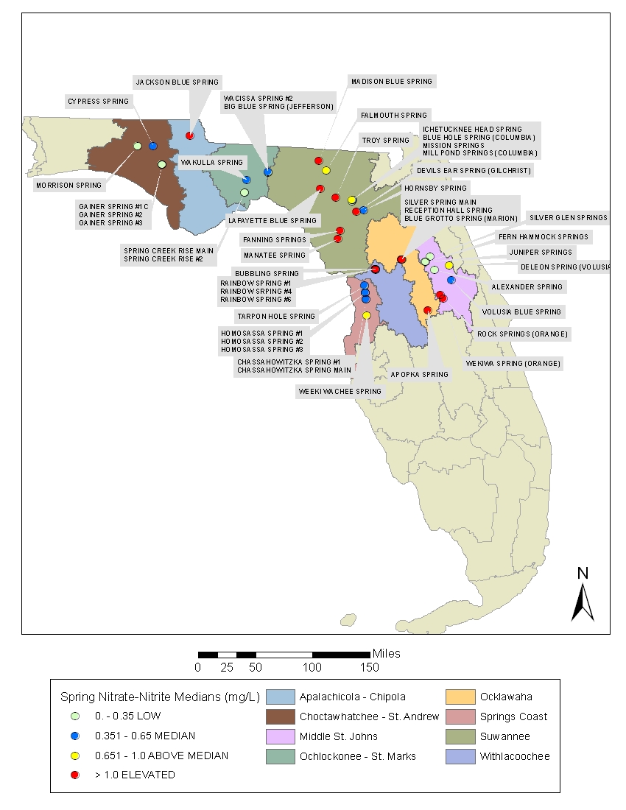

Figure 10.3. Median Orthophosphate Concentrations in the Spring Network, 2001–06
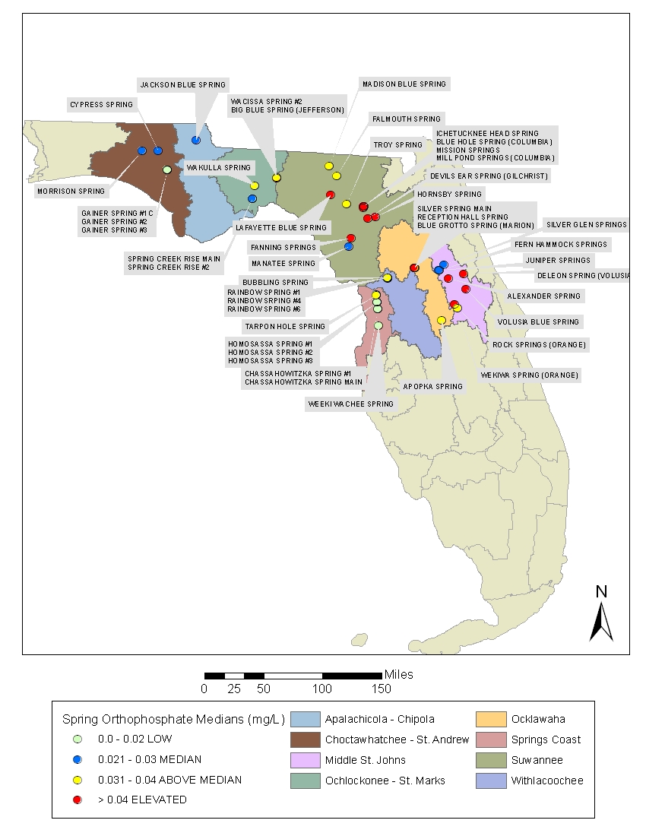

Chapter 11: Water Protection and Restoration Programs

Maintaining overall water quality and supplies, protecting potable water supplies, satisfying competing and rapidly increasing demands for finite quantities of fresh water, minimizing damage to future water reserves, addressing habitat loss and associated aquatic life use, and ensuring healthy populations of fish and wildlife are major objectives of water resource management and protection. To meet these objectives, many different programs and agencies throughout the state, including the Department, work to address activities and problems that affect surface water and ground water quality and quantity. In cooperation with other agencies and stakeholders, the Department has also initiated a number of programs and activities, which are discussed in this chapter, to expand the scientific understanding of Florida’s water resources and improve the protection, management, and restoration of surface water and ground water.

Florida’s Water Resource Management Programs
In 1972, the Florida Legislature, recognizing the importance of the state’s water resources, passed the Florida Water Resources Act, 373, F.S., and the Florida Air and Water Pollution Control Act, Chapter 403, F.S. Many goals and policies in the State Comprehensive Plan, Chapter 187, F.S., also address water resources and natural systems protection.
In addition to the Department’s district offices around the state, Florida is unique in that there are also five regional WMDs, as follows, broadly established along natural watershed boundaries:
- Northwest Florida;
- St. Johns River;
- Southwest Florida;
- South Florida; and
- Suwannee River.

The statute gives the Department “general supervisory authority” over the districts and the authority to exercise any power authorized to be exercised by the districts. The Department exercises its general supervisory authority through several means, including reviewing and approving district rules, carrying out coordinated planning, and providing program, policy, and rule guidance through the Water Resource Implementation Rule (Rule 62-40, F.A.C.).
This approach combines state-level oversight with regional decision making. It facilitates appropriate statewide consistency in the application of Florida water law, while maintaining regional flexibility where necessary to accommodate the wide-ranging climatic, geological, and environmental conditions that affect the state’s water resources.
The water management activities of the Department and the WMDs are divided into the following four areas of responsibility:
- Water Supply: Promoting the availability of sufficient water for all existing and future reasonable and beneficial uses and natural systems.
- Flood Protection and Floodplain Management: Preventing or minimizing damage from floods, and protecting and enhancing the natural system values of floodplains.
- Water Quality Management: Improving, protecting, and maintaining the quality of surface and ground water.
- Natural System Management: Preserving, protecting, and restoring natural systems.

These responsibilities are carried out through a variety of activities, including planning, watershed management, assessment through the application of water quality standards, the management of nonpoint source pollution, wastewater facilities permitting, ambient water quality monitoring, ground water protection, educational programs, and land management.

Overview of Surface Water Monitoring Programs

Watershed-Based Monitoring and Reporting
Different types of monitoring, ranging from the general to the specific, are needed to answer questions about water quality at varying scales. Questions may pertain to larger national, statewide, or regional/local conditions; whether trends exist in water quality over time; or whether there are problems in individual surface or ground waters. Other monitoring may include gathering project-specific information to develop standards or to fill data gaps if there is a need to address specific regulatory problems. To that end, the Department has developed diverse monitoring programs to resolve questions in response to these needs.
The Department has embraced a tiered monitoring approach and is reporting the results of statewide ambient monitoring networks (Tier I; Chapter 5 and Chapter 6), strategic monitoring for the verification of impairment and identification of causative pollutants, (Tier II; Chapter 7 and Chapter 8,) and specialized, site-specific monitoring (Tier III). Tier I consists of the Department’s statewide Status Monitoring (probabilistic) and Trend Monitoring Networks, TMDL basin- and waterbody-specific monitoring, and site-specific monitoring for special projects and regulatory needs, such as statewide DO and nutrient criteria monitoring.
The Tier I Status Network used a statewide probabilistic monitoring design to estimate water quality across the entire state during 2009–10, based on a representative subsample of water resource types. These estimates are based on a variety of threshold values, including water quality standards, water quality indices, and other appropriate ecological indicators. The Trend Network uses a fixed station design to examine changes in water quality over time in select river and stream sites throughout the state.
Strategic monitoring (Tier II) includes monitoring designed to address data gaps in order to verify impairment in potentially impaired waterbodies and monitoring in response to citizen concerns and environmental emergencies. Another example, the Spring Monitoring Program, encompasses all of the extensive monitoring activities begun in 1999 to address the needs of Florida’s freshwater spring systems, a fragile and unique resource type that is at risk.
Tier III monitoring addresses questions that are regulatory in nature or that support specific program needs and quality objectives. Examples include monitoring to determine whether moderating provisions such as SSACs should apply to certain waters, monitoring tied to regulatory permits issued by the Department (including fifth-year inspections of wastewater facilities under the National Pollutant Discharge Elimination System [NPDES] Program), intensive surveys for the development of TMDLs, monitoring to evaluate the effectiveness of BMPs, and monitoring to establish or revise state water quality standards.
Each of the Department’s core monitoring programs has a monitoring design, a list of core and supplemental water quality indicators, and specific procedures for quality assurance, data management, data analysis and assessment, reporting, and programmatic evaluation. The Department relies on both chemical and biological sampling in all of its monitoring programs and conducts the bulk of the biological sampling statewide. The remainder of this chapter contains information about these programs, their objectives, and the results of each of their efforts.

Overview of Surface Water Protection Programs

Water Quality Standards Program
Florida’s surface water quality standards are described in Rule 62-302, F.A.C. The components of this system, which are described below, include water quality classifications; water quality criteria; an antidegradation policy; and moderating provisions.

Water Quality Classifications
Florida’s Water Quality Standards Program, the foundation of the state’s program of water quality management, designates the “present and future most beneficial uses” of the waters of the state (Subsection 403.061[10], F.S.). Florida’s surface water is protected for five designated use classifications, as follows:
Class I Potable water supplies
Class II Shellfish propagation or harvesting
Class III Recreation, propagation, and maintenance of a healthy, well-balanced population of fish and wildlife
Class IV Agricultural water supplies (large agricultural lands, located mainly around Lake Okeechobee)
Class V Navigation, utility, and industrial use (there are no state waters currently in this class)

Class I waters generally have the most stringent water quality criteria and Class V the least. However, Class I, II, and III surface waters share water quality criteria established to protect recreation and the propagation and maintenance of a healthy, well-balanced population of fish and wildlife. All waters of the state are considered to be Class III, except for those specifically identified in Section 62-302.600, F.A.C. All waters of the state are required to meet the “Minimum Criteria for Surface Waters,” as identified in Section 62-302.500, F.A.C.
The Department has proposed the establishment of a Class III subclassification (Class III Limited) for some wholly artificial and altered waters, in acknowledgment that many of these waters have physical or habitat limitations that preclude support of the same type of aquatic ecosystem as a natural stream or lake. Chapter 7 discusses the relationship between the state and the EPA’s designated use classifications.

Water Quality Criteria
Water quality criteria, expressed as numeric or narrative limits for specific parameters, describe the water quality necessary to maintain designated uses (such as fishing, swimming, and drinking water) for surface water and ground water. These criteria are presented in Rule 62-302, F.A.C., and specifically in Section 62-302.530, F.A.C.

Antidegradation Policy
The Florida Antidegradation Policy (Sections 62-302.300 and 62-4.242, F.A.C.) recognizes that pollution which causes or contributes to new violations of water quality standards or to the continuation of existing violations is harmful to the waters of the state. Under this policy, the permitting of new or previously unpermitted existing discharges is prohibited where the discharge is expected to reduce the quality of a receiving water below the classification established for it. Any lowering of water quality caused by a new or expanded discharge to surface waters must be in the public interest (that is, the benefits of the discharge to public health, safety, and welfare must outweigh any adverse impacts on fish and wildlife or recreation). Further, the permittee must demonstrate that other disposal alternatives (for example, reuse) or pollution prevention are not economically and technologically reasonable alternatives to the surface water discharge.

Moderating Provisions
Florida’s water quality standards include a variety of moderating provisions (provided in Subsection 62-302.300[10] and Rules 62-4 and 62-6, F.A.C., and described in Sections 62-302.300, 62-4.244, 62-302.800, and 62-4.243, F.A.C., and Sections 403.201 and 373.414, F.S.), which include mixing zones, zones of discharge, SSACs, exemptions, and variances. These provisions are intended to moderate the applicability of water quality standards where it has been determined that, under certain special circumstances, the social, economic, and environmental costs of such applicability outweigh the benefits.

Watershed Assessment Program
The primary tasks of the Watershed Assessment Program include coordinating strategic monitoring; implementing the IWR (Rule 62-303, F.A.C.); ensuring the completion of the biannual Integrated Report; and submitting annual updates of Florida’s 303(d) list to the EPA . Section 303(d) of the federal CWA requires states to submit to the EPA lists of surface waters that do not meet applicable water quality standards (i.e., their designated uses or water quality criteria) and establish TMDLs for each of these waters on a schedule. Pollution limits are then allocated to each pollutant source in an individual river basin. A waterbody that does not meet its designated use is defined as impaired.

Florida Watershed Restoration Act
The 1999 FWRA (Section 403.067, F.S.) clarified the Department’s statutory authority to establish TMDLs, required the Department to develop a scientifically sound methodology for identifying impaired waters, specified that the Department could develop TMDLs only for waters identified as impaired using this new methodology, and directed the Department to establish an Allocation Technical Advisory Committee (ATAC) to assure the equitable allocation of load reductions when implementing TMDLs.
Another significant component of the FWRA was the requirement for FDACS and the Department to adopt, by rule, BMPs to reduce urban and agricultural nonpoint sources of pollution. As Florida already has an urban stormwater regulatory program, this new authority was particularly important in strengthening Florida’s agricultural nonpoint source management program. This section of the law requires FDACS to adopt, by rule, BMPs to reduce agricultural nonpoint source pollution, and for the Department to verify the effectiveness of the BMPs in reducing pollutant loads.
Once FDACS adopts the BMPs, landowners must submit a Notice of Intent (NOI) to FDACS, specifying the BMPs that will be applied on specific land parcels and the schedule for BMP implementation. The landowners also must maintain records, such as fertilizer use, and allow FDACS staff to inspect the BMPs. By submitting a NOI, the landowners become eligible for state and federal cost-share funding to implement BMPs and receive a presumption of compliance that they are meeting water quality standards. The BMP rules and the associated BMP manuals that have been adopted are available from FDACS’ Office of Agricultural Water Policy website.
The FWRA identifies BMAPs as the primary mechanism for implementing TMDLs to restore water quality. BMAPs are developed cooperatively with local stakeholders over an 18- to 24-month period following TMDL development. The strategies developed in each BMAP are implemented in NPDES permits for wastewater facilities and municipal separate storm sewer system (MS4) permits.
The 2005 Florida Legislature’s amendments to the FWRA focused on the development and adoption of BMAPs as an appropriate method for implementing TMDLs. The Legislature also established a long-term funding source that provided $20 million per year for urban stormwater retrofitting projects to reduce pollutant loadings to impaired waters; however, that level of funding has not been consistently provided. Additionally, the 2005 amendments provide the Department with the ability to take enforcement action against nonpoint sources that do not implement the BMPs that they agreed to implement in the BMAP.

Impaired Surface Waters Rule
Waterbodies are assessed and TMDLs are developed and implemented using the methodology in Florida’s IWR (Rule 62-303, F.A.C.). This science-based methodology for evaluating water quality data in order to identify impaired waters establishes specific criteria for impairment based on chemical parameters, the interpretation of narrative nutrient criteria, biological impairment, fish consumption advisories, and ecological impairment. The IWR also establishes thresholds for data sufficiency and data quality, including the minimum sample size required and the number of exceedances of the applicable water quality standard for a given sample size that identify a waterbody as impaired. The number of exceedances is based on a statistical approach designed to provide greater confidence that the outcome of the water quality assessment is correct. Waters that are identified as impaired through the IWR are prioritized for TMDL development and implementation.
In 2006, and again in 2007, the IWR was amended to address legal challenges that arose following its original adoption in 2001. After the state rulemaking process was completed, the revised IWR was submitted to the EPA on September 14, 2007, as a change to water quality standards. On February 19, 2008, the EPA sent a letter of approval to the Department acknowledging that the IWR was an approved change to water quality standards.

Watershed Management Approach
The Department's statewide tactic for water resource management, called the watershed management approach, is the framework for developing and implementing the provisions of Section 303(d) of the CWA, including the development of TMDLs, as required by federal and state laws.
Watershed management is a comprehensive approach to managing water resources on the basis of hydrologic units—which are natural boundaries such as river basins—rather than arbitrary political or regulatory boundaries. It does not focus on individual causes of pollution. Instead, each basin is assessed as an entire functioning system, and aquatic resources are evaluated from a basinwide perspective that considers the cumulative effects of human activities.
On a simple level, Florida’s watershed management approach provides a mechanism to focus resources on specific units (river or estuary basins), rather than trying to work on all state waters at one time. An important feature is the involvement of all the stakeholders who have an interest in an individual basin (including federal, state, regional, tribal, and local governments and individual citizens) in a cooperative effort to define, prioritize, and resolve water quality problems. Existing programs are coordinated to manage basin resources without duplicated effort. The watershed management approach is not new, nor does it compete with or replace existing programs. Rather than relying on single solutions to water resource issues, it is intended to improve the health of surface and ground water resources by strengthening coordination among such activities as monitoring, stormwater management, wastewater treatment, wetland restoration, land acquisition, and public involvement.
Florida’s watershed management approach involves a multiple-phase, five-year, rotating basin cycle. During Phase 1, a Planning List of potentially impaired waters is prepared in a collaborative process with stakeholders. During this phase, the Department works closely with local monitoring staff to determine when and where additional monitoring is needed to verify the impairments. This culminates in the preparation of a Strategic Monitoring Plan that is implemented the following year, during Phase 2 of the cycle.
The key product of Phase 2 is the Verified List of impaired waters. These lists are developed through applying the Florida Surface Water Quality Standards in Rule 62-302, F.A.C., as well as the methodologies provided in Rule 62-303, F.A.C. Generally draft lists are provided to stakeholders for comment. Lists are finalized based on public comment and any additional information received throughout the process.
During Phase 3 of the cycle, watershed and waterbody modeling are carried out to develop TMDLs for impaired waters and the preliminary allocations to point and nonpoint sources. Typically, a Basin Working Group is formalized during this phase and begins the process of developing the BMAP that will guide TMDL implementation activities. The Department works closely with the Basin Working Group and other watershed stakeholders to ensure that they understand and support the approaches being undertaken to develop the TMDL.
To date, the Department has adopted a total of 234 TMDLs. Of those 234, 138 were developed for DO and/or nutrients, 92 were developed for bacteria, and 4 are for other parameters such as un-ionized ammonia. These TMDLs represent areas in all basin groups and cover many of the largest watersheds within the state (e.g., St. Johns River, St. Lucie Estuary). Many more TMDLs have been drafted or are in various stages of development.
During Phase 4 of the cycle, the Basin Working Group and other stakeholders—especially other state agencies, WMDs, and representatives of county and municipal governments, including local elected officials—develop the BMAP. This process typically takes about two years and culminates in the formal adoption of the BMAP by the Secretary of the Department.
Both the BMAP and the Verified List of impaired waters are adopted by Secretarial Order, while all TMDLs are adopted by rule. Like all official agency actions, these adoptions are subject to state administrative procedures set forth in Chapter 120, F.S. Once a BMAP, Verified List, or TMDL is adopted, a notice is published in the Florida Administrative Weekly and any affected party has the opportunity to request an administrative hearing to challenge the adoption.
Florida continues to develop an integrated database of assessment information that reflects whether water quality standards are being attained. The Verified Lists of impaired waters, lists of waters to be delisted, Basin Status and Water Quality Assessment Reports, BMAPs, TMDL reports, and other information are available on the Department’s Watershed Assessment Program website.

BMAP Development Activities to Date
To date 9 BMAPs have been fully adopted and are under implementation in the following basins: Upper Ocklawaha, Orange Creek, Long Branch, Lower St. Johns River Mainstem, Lower St. Johns River Tributaries (2), Hillsborough River, Lake Jesup, and Bayou Chico. The Santa Fe River BMAP is anticipated to be adopted in 2012. These 10 BMAPs encompass restoration activities in 78 impaired WBIDs. BMAP development activities are currently under way and in various stages of completion in an additional 11 basins around the state: the Upper Peace River and Winter Haven Chain of Lakes, Wekiva River, Suwannee River, Indian River Lagoon, Caloosahatchee River, Everglades West Coast, St. Lucie River, Lakes Monroe and Harney, Middle Trout River, Alafia River, and Manatee River. Table 11.1 describes the current status of these ongoing BMAP efforts. In addition to these BMAPs, local governments and WMDs are concurrently carrying out restoration activities in many other waterbodies statewide.
BMAPs are Florida’s primary mechanism for implementing TMDLs adopted through Chapter 403.067, F.S. As discussed earlier, they are developed in collaboration with the Basin Working Group and other stakeholders, and are then adopted by Departmental Secretarial Order. The goals of each BMAP are to reach consensus on the scientific foundation of the TMDL, determine detailed allocations as appropriate, and reach agreement on how the required load reductions will be accomplished. A BMAP includes defined water quality restoration goals, refined source identification, detailed allocations by entity where appropriate, load reduction projects, a monitoring plan, and local commitments. Implementation projects may include structural and nonstructural BMPs, educational and outreach activities, additional research and studies, changes to programs and permits, and changes to local ordinances and policies.
The Lower St. Johns River Mainstem BMAP provides an excellent example of both the extent of the efforts required to address TMDL requirements and the substantial efforts being made by local stakeholders to move forward in carrying them out. The TMDL required a reduction of 1,076,403 kilograms per year (kg/yr) TN in the marine portion of the river. Through 2010, the responsible entities have achieved reductions of 717,877 kg/yr TN. In the freshwater section, the TMDL required reductions of 1,543,989 kg/yr TN and 99.285 kg/yr TP. Through 2010, stakeholders have achieved reductions of 150,039 kg/yr TN and 38,124 kg/yr TP. In order to meet the full TMDL reductions, significant additional reductions must occur within the upstream basins. Much of that may be accomplished through the implementation of the Lake Jesup (adopted 2010) and Lakes Harney/Monroe (in development) BMAPs. Additional reductions will need to be addressed in the Upper St. Johns Basin.
During 2010, one wastewater treatment facility (WWTF) project in the freshwater section of the river was completed with a reduction of 6,314 kg/yr TN. This project, in conjunction with previously completed projects, has achieved the TN reductions required for WWTFs in the freshwater reach. In addition, 3 wastewater projects were completed in the marine section for a total reduction of 134,115 kg/yr TN.
In 2010, 2 municipal separate storm sewer system (MS4) projects were completed in the freshwater section of the river for a total reduction of 829 kg/yr TN. The total reductions in TN have achieved the required reductions for the MS4s in the freshwater reach. The TP reductions were met with the completion of the projects in 2009. An additional 11 MS4 projects were completed in the marine section for a reduction of 11,297 kg/yr TN. In the freshwater section, 3 non-MS4 TP projects were completed this year, yielding 723.2 kg/yr TP reductions. A total of 7 non-MS4 projects completed this year for TN reduced 7,879 kg/yr TN. There were also 3 non-MS4 projects completed in the marine reach for 881 kg/yr TN reduction.
FDACS has continued to sign up growers under the vegetable and agronomic crop, leatherleaf ferns, sod, and cow/calf BMP manuals. To date, no producers have opted to monitor water quality instead of implementing BMPs. In addition, the SJRWMD contractors have completed a technical memorandum and associated BMP Optimization Model addressing a nutrient reduction strategy for the freshwater reach for the remainder of the agricultural reductions. Land use assessments of the marine section showed that the dairy operations included in the TMDL loading have since been abandoned; therefore, it does not appear that additional regional treatment options are needed in the marine reach.
BMAP monitoring plan efforts have continued in the freshwater section, marine section, and tributaries. The river transect sampling in the freshwater section occurred on schedule from April through October 2011. The two new BMAP continuous DO stations were reinstalled in the marine section. Stakeholders have continued the ambient water quality sampling in the tributaries and the high-flow sampling.
The Lake Jesup BMAP, adopted in May 2010, includes commitments for projects to reduce TP by 10,167.5 pounds per year (lbs/yr) over the next 5 years (approximately 54% of the total 18,748 lbs/yr reduction required by the TMDL, which will be fully met within 15 years). Many projects have already been completed demonstrating the commitment of local stakeholders to the restoration of their local waterbodies.
In March 2011 the Department completed the document Implementation Guidance for the Fecal Coliform Total Maximum Daily Loads Adopted by the Florida Department of Environmental Protection. It provides local stakeholders with useful information for identifying sources of fecal coliform bacteria in their watersheds and examples of management actions to address these sources.
Information on the Department’s BMAP activities can be found on the Department’s Watershed Management website.

Table 11.1. Status of Ongoing BMAP Efforts
This is a four-column table. Column 1 lists the basin, Column 2 lists the status of BMAP development, Column 3 lists the impairment(s) addressed by the BMAP, and Column 4 lists comments.

- = Empty cell/no data
Basin | Status | Impairment(s) Addressed by BMAP | Comments
Suwannee | Santa Fe BMAP adoption is anticipated in 2012. Individual stakeholder discussions and stakeholder technical meetings will be initiated in the remaining Suwannee Basin. | Nutrients/DO | The Santa Fe River BMAP is expected to be adopted in 2012. Following the adoption of the Santa Fe River BMAP, efforts will switch to the remainder of the Suwannee Basin. The Santa Fe BMAP will be used as the template for the larger Suwannee Basin BMAP as similar conditions are found there. The next stage of activities will include initiating general stakeholder meetings and meeting individually with basin stakeholders (counties, cities, and agricultural interests). The Department, FDACS, and other stakeholders will work cooperatively to identify Restoration Focus Areas (RFAs) within the Santa Fe Basin and subsequently the overall Suwannee Basin.
Wekiva | Basin Working Group meetings are ongoing. | Nutrients/DO | BMAP efforts began in March 2009, and the most recent Basin Working Group meeting was held on September 29, 2010. Technical work continues in the interim. Current BMAP activities include building a common understanding of sources, developing the allocation/sufficiency of effort approach, and compiling a list of preliminary projects. The BMAP will be sensitive to local concerns connected to other Wekiva Protection Area activities.
Upper Peace (Hancock Chain, Winter Haven Chain, and Upper Peace Creek) | BMAP activities are on hold pending the resolution of issues related to the effectiveness of management options and completion of a local watershed master plan. | Nutrients,  Fecal Coliform | A technical review of the TMDLs and lake processes has led to questions about the effectiveness of management options in attempting to meet TMDLs. A comprehensive watershed master plan has been developed for the city of Winter Haven and SWFWMD. The Department is coordinating with the city of Winter Haven regarding the next steps in moving forward with a BMAP for the Southern Chain of Lakes.
Indian River Lagoon | Rotating meetings among sub-basins are continuing. | Nutrients/DO | The Indian River Lagoon (IRL) Mainstem Basin is divided into three sub-basins (Banana River, North, and Central) for BMAP development. A seagrass distribution target has been developed as a mechanism for assessing success in implementing the TMDL. The Banana River and North IRL sub-basin allocations have been drafted and project information collection is under way. The Central IRL currently appears to be meeting the seagrass distribution target. A BMAP will be developed that takes a “hold the line” approach and will document additional projects being implemented by local stakeholders. The Monitoring Plan discussions are under way, with primary and secondary objectives being developed in coordination with local stakeholders.
St. Lucie | Technical meetings and individual stakeholder meetings are continuing. | Nutrients/BOD | BMAP activities were started in July 2009. The last BMAP technical meeting was held in May 2011. An evaluation continues of the Northern Everglades and Estuaries Protection Program (NEEPP) Regional Watershed Protection Plan applicability and implementation/allocation approach document. Departmental staff are collecting and reviewing information on pollutant load reduction projects proposed by local stakeholders. Draft allocations have been developed and are under review.
Everglades West Coast | Technical meetings and individual stakeholder meetings are continuing. | Multiple | Basic Watershed Management Modeling to determine current loading was completed, and details have been presented to stakeholders. One-on-one meetings have been held with stakeholders to discuss the current loading calculation process and projects eligible for BMAP credit. Departmental staff are currently evaluating the list of nutrient reduction projects implemented since the TMDL verified period and calculating BMP efficiencies for the projects submitted. Staff are awaiting results from a nutrient source tracking and ground water input study conducted in June 2010. BMAP stakeholder technical meetings are continuing.
Caloosahatchee | Technical meetings and individual stakeholder meetings are continuing. | Nutrients | The current loading calculation process and potential allocation approaches have been discussed with local stakeholders. One-on-one meetings were held with several stakeholders to address concerns and discuss the types of projects that would receive credit in the BMAP. Staff are currently evaluating the list of nutrient reduction projects implemented since the TMDL verified period and working on calculating BMP efficiencies for projects submitted. They are finalizing current loading calculations and draft potential allocation approach calculations. BMAP stakeholder technical meetings are continuing. The Department is working on a revised TMDL for the estuarine Caloosahatchee and developing a TMDL for the upstream reaches of the river.
Lakes Monroe and Harney | Technical meetings and individual stakeholder meetings are continuing. | - | This BMAP effort was initiated in October 2010. Draft allocations have been developed and stakeholder projects are being collected and reviewed. A monitoring plan is being developed. BMAP technical stakeholder meetings are continuing.
Alafia River Basin | Technical meetings and individual stakeholder meetings are continuing. | Multiple | This BMAP effort was initiated in June 2011 and encompasses six impaired WBIDs.
Manatee River Basin | Technical meetings and individual stakeholder meetings are continuing. | Multiple | This BMAP effort was initiated in June 2011 and encompasses four impaired WBIDs.
Middle Trout River | Technical meetings and individual stakeholder meetings are continuing. | DO and Nutrients | This BMAP effort was initiated in December 2010. Draft allocations have been developed, stakeholder projects are being collected and reviewed, and a monitoring plan is being developed. Local stakeholders are proposing a plan of study to reassess the impairment status of this waterbody. The Department may suspend further BMAP development pending the results of this effort.

Public Participation
The success of Florida’s water resource management program, especially its watershed management approach/TMDL Program, depends heavily on input from local stakeholders in each watershed. This process is highly collaborative, and Departmental staff closely coordinate and communicate with stakeholders in all phases of the five-year, rotating basin cycle.
The Department works with a variety of stakeholders in developing a draft Verified List of impaired waters for each basin. The draft lists are placed on the Department’s Watershed Assessment Program website and are also sent by request to interested parties via mail or email. As part of the review process, public workshops are advertised and held in each basin to help explain the process for developing the Verified Lists, exchange information, and encourage public involvement. The workshops are noticed in the Florida Administrative Weekly and on the website. Stakeholders are given the opportunity to comment on the draft lists in person at public workshops and/or through email and letters. If additional information or data are provided during the public comment period or before, the Department typically creates a revised draft Verified List for further review and comment before submitting the final proposed list to the Secretary for adoption and then to the EPA.
All public meetings are recorded, and specific comments are noted in written meeting summaries. Significant comments typically receive a written response. All written comments received and the Department’s responses are kept in a permanent file maintained by the Department. These are included in an Appendix to each Water Quality Assessment Report. The reports are available on the Department’s Watershed Management website.

Surface Water Improvement and Management Program
In 1987, the Florida Legislature passed the Surface Water Improvement and Management (SWIM) Act, Sections 373.451 through 373.4595, F.S. The act directed the state to develop management and restoration plans for preserving or restoring priority waterbodies. The legislation designated 6 SWIM waterbodies: Lake Apopka, Tampa Bay, Indian River Lagoon, Biscayne Bay, Lower St. Johns River, and Lake Okeechobee. Currently, 29 waterbodies are on the priority list. Additional information and the list of priority waterbodies are available on the Department’s SWIM Program website.
The SWIM Program addresses a waterbody’s needs as a system of connected resources, rather than isolated wetlands or waterbodies. Its goals are protecting water quality and natural systems, creating governmental and other partnerships, and managing watersheds. While the Department oversees the program, the WMDs are responsible for its implementation—including developing lists of additional high-priority waterbodies and waterbody plans (outlined under Rule 62-43, F.A.C.). The districts also provide matching funds for state revenues. In a collaborative effort, other federal and state agencies, local governments, and the private sector provide funds or in-kind services.
SWIM plans must contain the following:
- A description of the waterbody;
- A list of governmental agencies with jurisdiction;
- A description of land uses;
- A list of point and nonpoint source discharges;
- Restoration strategies;
- Research or feasibility studies needed to support restoration strategies;
- A restoration schedule;
- An estimate of costs; and
- Plans for interagency coordination and environmental education.

Pollutant Load Reduction Goals
A pollutant load reduction goal (PLRG) is an estimated reduction in stormwater pollutant loadings needed to preserve or restore designated uses in SWIM waterbodies that receive stormwater. Ultimately, water quality in a receiving water should meet state water quality standards, and PLRGs provide benchmarks toward which specific strategies can be directed. Interim PLRGs are best-judgment estimates of the pollution reductions from specific corrective actions. Final PLRGs are goals needed to maintain water quality standards.
The Water Resource Implementation Rule (Rule 62-40, F.A.C.) requires the WMDs to establish PLRGs for SWIM priority waters and other waterbodies, and include them as part of a SWIM plan, other watershed management plan, or districtwide or basin-specific rules.

Point Source Control Program
Florida's well-established wastewater facility regulatory program was revised in 1995 when the EPA authorized the Department to administer a partial NPDES Program, and then expanded again in 2000 when the EPA authorized the Department to administer the NPDES Stormwater Program. While the federal program only regulates discharges to surface waters, the state wastewater program issues permits for facilities that discharge to either surface water or ground water. Of about 3,652 wastewater facilities in Florida, approximately 506 are permitted to discharge to state surface waters under individual permits. While an additional 486 facilities discharge to surface waters under general (called generic) permit authorization (and many others discharge stormwater to surface waters under the NPDES Stormwater Program), most wastewater facilities in Florida discharge indirectly to ground water via land application or reuse.
An important component of the state’s wastewater management is the encouragement and promotion of reuse. Florida leads the nation in reuse. In fact, the current reuse capacity (2010 data) represents about 62% of the total permitted domestic wastewater treatment capacity in Florida.
The Department's six district offices handle most of the permitting process, with the Tallahassee office overseeing the program, conducting rulemaking, providing technical assistance, managing the state and federal wastewater databases that are the repositories of all program data, and coordinating with the EPA. The Tallahassee office also oversees the administrative relief mechanisms for applicants that are allowed under Florida law, as well as permits for steam electric–generating power plants that discharge to waters of the state, and the implementation of the pretreatment component of the NPDES Program. Wastewater permits, issued for up to five years, set effluent limits and monitoring requirements to provide reasonable assurance that water quality criteria will be met. A permit may allow a mixing zone when there is enough dilution to ensure that a waterbody's designated use will not be affected. In other special cases, a variance allows certain water quality standards to be exceeded temporarily.
Facilities that cannot comply with new requirements may be issued or reissued a permit containing the effluent limitations to be met and an administrative order setting out the steps required to achieve compliance. This procedure applies only to facilities complying with an existing permit, and is not used in lieu of enforcement when a permittee is out of compliance with an existing permit or operating without a required permit.
All facilities must meet, at a minimum, the appropriate technology-based effluent limitations. In many cases, water quality–based effluent limitations (WQBELs) may also be necessary. Two types of WQBELs are used (as defined in Rule 62-650, F.A.C.). Level I WQBELs are generally based on more simplified evaluations for streams and for permit renewals. To determine Level II WQBELs, which are typically calculated for more complicated situations, a waterbody is generally sampled intensively, and computer models are used to predict its response to a facility’s discharge.

Permit Compliance
The primary objective of the Department’s Wastewater Program is to protect the quality of Florida's surface water and ground water by ensuring that permitted wastewater facilities meet the conditions of their permits, and to quickly identify unpermitted pollution sources and those facilities that do not meet water quality standards or specific permit conditions. To provide proper oversight of the wastewater facilities in the state, the Department’s Wastewater Compliance Evaluation Section developed a compliance inspection strategy based on its five-year permitting cycle (permits are issued for five years).
For NPDES-permitted facilities, the goal is to conduct at least an annual Compliance Evaluation Inspection (CEI) and to conduct a Performance Audit Inspection (PAI) immediately following permit renewal. When an NPDES-permitted facility is approximately one year away from submitting a permit renewal application, a much more comprehensive inspection, or Fifth-Year Inspection (FYI), is scheduled. The FYI consists of an overview of the facilities operation but also includes an in-depth sampling plan consisting of a Compliance Sampling Inspection (CSI), Toxic Sampling Inspection (XSI), Compliance Biomonitoring Inspection (CBI), Impact Bioassessment (IBI), and Water Quality Inspection (WQI). The results of these inspections help to determine if current permit limits are adequate to protect the quality of the receiving waters. Land application facilities are also inspected annually as resources allow; however, they are not sampled as intensely as the surface water dischargers.
District compliance and enforcement staff make every effort to work with permittees to resolve minor problems before beginning a formal enforcement action. During an inspection, it is the inspector’s responsibility to determine if a facility is in compliance with its permit limits and compliance schedules. This is accomplished by verifying the accuracy of facility records and reports, plant operation and maintenance requirements, effluent quality data (Discharge Monitoring Reports, or DMRs), and the general reliability of the facility’s self-monitoring program.

Enforcement
The Department’s Wastewater Program uses the Office of General Council’s Enforcement Manual as a guide for developing specific types of enforcement actions such as Consent Orders and Notices of Violations (NOVs). However, in order to provide guidance on specific wastewater issues related directly to the Wastewater Program, the Wastewater Program’s Enforcement Response Guide was developed to aid inspectors in determining the proper course for corrective actions. The guide also provides consistency in addressing enforcement actions specifically related to wastewater issues.
When formal enforcement is necessary, staff attempt to negotiate a consent order, which is a type of administrative order in which civil penalties (such as fines) and corrective actions for noncompliance can be assessed. Consent Orders also establish step-by-step schedules for complying with permit conditions and Florida law, and set a final compliance date for the facility to return to compliance.
In 2001, the Florida Legislature enacted the Environmental Litigation Reform Act (ELRA) to provide a fair, consistent, and expedient method for determining appropriate penalty amounts for violations. If a settlement cannot be reached through the consent order process, the Department has the authority to issue an NOV to collect penalties (up to $10,000), as specified in ELRA. The NOV can also be used when only corrective actions are needed and no penalties are being sought. When a serious violation endangers human health or welfare, or the environment, the Department issues a complaint for injunctive relief or takes other legal action, including an immediate final order for corrective action.

Nonpoint Source Management Program
The importance of minimizing nonpoint source pollution, especially from new development, was recognized in Florida in the late 1970s when the state’s growth rate increased greatly. Over the past 25 years, Florida has implemented one of the most comprehensive and effective urban and agricultural nonpoint source management programs in the country and has made significant progress towards addressing elevated nutrients.
However, nutrient impairment is still an ongoing challenge, as evidenced by eutrophic conditions in some state surface waters and increased nitrates in ground water. Nutrient impairment remains a concern due to higher fertilizer use by the state’s intensive agricultural industry and continued population growth, both of which increase wastewater and nonpoint source nutrient loads. Discharges from urban stormwater systems, especially those built before the Stormwater Rule was implemented in 1982, and septic tanks continue to be a leading source of loading to Florida’s surface and ground waters. The cumulative impacts of nonpoint source pollution, also called “pointless personal pollution,” continue to be an issue.
It is important to remember that many activities resulting in nonpoint source pollution often are not regulated and that public education, cultural change, and personal stewardship are essential to protecting Florida’s water resources. A simple example is controlling pet wastes, which can add nutrients and fecal bacteria to the landscape that are washed off with each rain storm. Picking up and properly disposing of pet waste is essential to preventing this source of “pointless personal pollution.” This was demonstrated and documented by the very successful Think About Pointless Personal Pollution (TAPP) public service ads on pet waste. These multimedia ads increased awareness of the problem (to over 90% of the population) and increased the percentage of pet owners who pick up their pet waste and dispose of it properly by 30%. In addition, the city of Tallahassee estimated that the load reduction associated with the increased proper disposal of pet waste saved $2.5 million per year in potential capital improvement costs associated with a traditional stormwater retrofitting project.
The Department’s comprehensive Nonpoint Source Management Program, in collaboration with the TMDL Program (which is being implemented through the watershed management approach), provides the institutional, technical, and financial framework to address these issues. The program includes a mixture of regulatory, nonregulatory, restoration and financial assistance, and public education components, which are discussed below.

Urban Stormwater Rule
The cornerstone of Florida’s urban nonpoint source program is the state’s Environmental Resource Permit (ERP) Program. Florida was the first state in the country to establish a statewide stormwater permitting program that requires the treatment of stormwater from all new development. The state’s first Stormwater Rule was adopted in 1979, with a more comprehensive rule going into effect in 1982. New developments, except for single-family dwellings, and modifications to existing discharges must obtain stormwater permits. Projects must include a stormwater management system that provides flood control and BMPs such as retention, detention, or wetland filtration to reduce stormwater pollutants. This technology-based Stormwater Rule establishes design criteria for various stormwater treatment BMPs to obtain the minimum level of treatment established in the state’s Water Resource Implementation Rule (Rule 62-40, F.A.C.). Specifically, these BMPs are designed to remove at least 80% of the average annual load of pollutants that would cause or contribute to violations of state water quality standards (Paragraph 62-40.432[2][a][1]), F.A.C.
For Outstanding Florida Waters (OFWs), some other sensitive waters (such as shellfish-harvesting areas), and waters that are below standards, BMPs must be designed to remove 95% of the average annual load of pollutants that would cause or contribute to violations of state water quality standards (Paragraph 62-40.432[2][a][2], F.A.C.). The ERP also provides the mechanism for wetland protection. Today, the Department continues to monitor and evaluate BMPs to be used with its development of the statewide Stormwater Rule.

Wetlands Protection and Permitting
A second important nonpoint source regulatory program is the state’s wetlands protection law and permitting program. This program has been instrumental in minimizing the loss of wetlands, especially isolated wetlands. The section on the Wetlands Program at the end of this chapter provides additional details.

Agricultural Nonpoint Source Management
Under the ERP Program, only certain agricultural discharges may be subject to permitting, depending on the rules of the specific WMD. For example, the SFWMD permits new agricultural activities in a manner similar to urban development, while the SJRWMD only requires permits for certain pumped agricultural discharges.
However, as discussed earlier in this chapter (in the section on the Watershed Assessment Program), the FWRA requires FDACS’ Office of Agricultural Water Policy (OAWP) to develop and adopt, by rule, BMPs to reduce agricultural nonpoint source pollution. Under the FWRA, Paragraph 403.067(7)(c), F.S., the Department is charged with providing initial verification that the BMPs are reasonably expected to be effective, which includes monitoring their effectiveness. To date, FDACS has developed and/or adopted BMP manuals for citrus in the Lake Wales, Indian River, Peace River, and Gulf areas; forage grasses in the SRWMD; leatherleaf ferns in and around Volusia County; vegetable and agronomic crops; container nurseries; aquaculture; cow/calf operations; sod farms; manure application; water conservation; and, most recently, equine operations. FDACS is currently prioritizing a statewide citrus BMP manual, as well as a fruit/nut BMP manual. The BMP rules and the associated BMP manuals that have been adopted are available on the FDACS Office of Agricultural Water Policy website.
This nonregulatory program provides agricultural producers with incentives to implement BMPs. Participation in the program opens the door for state and federal cost-share dollars to implement BMPs, and it provides the landowner with a presumption of compliance that water quality standards are being met. To participate, landowners must submit a NOI to FDACS, specifying the lands to be covered, the BMPs to be implemented, the BMP implementation schedule, and the annual tracking requirements such as fertilizer use. Under the FWRA, Section 403.067, F.S., agricultural nonpoint sources of pollution are required to submit a NOI to FDACS to implement BMPs when located in specified impaired watersheds, unless they monitor to prove compliance with reductions specified in the BMAP. Table 11.2 provides the most recent statistics on the number of enrolled acres and NOIs as of June 30, 2011.

Table 11.2. Number of Enrolled Acres and NOIs as of June 30, 2011
This is a three-column table. Column 1 lists the program/manual, Column 2 lists the enrolled acres, and Column 3 lists the number of NOIs.

Program/Manual | Enrolled Acres | Number of NOIs
Citrus – Gulf | 97,529.48 | 76
Citrus – Indian River | 220,935.09 | 562
Citrus – Peace River | 64,274.85 | 352
Citrus – Ridge | 116,824.92 | 2,026
Container Nurseries | 27,409.96 | 1,089
Forage Grass | 8,709.98 | 74
Lake Okeechobee Protection Program | 529,013.56 | 240
Statewide Cow/Calf | 969,418.78 | 255
Statewide Dairy Program | 4,574.01 | 3
Statewide Sod | 22,532.45 | 39
Vegetable and Agronomic Crops | 885,340.89 | 649
Total | 2,946,563.98 | 5,365

Recent Nonpoint Source Management Program Enhancements
Restoring Florida’s impaired waters and protecting its pristine waters is a critical part of Florida’s Nonpoint Source Management Program. The program is responsible for overseeing restoration efforts occurring throughout the state through the distribution of federal and state grants aimed at addressing nonpoint sources. A significant focus of grant funding is retrofitting urban areas to treat urban stormwater runoff. However, state funding also goes to agricultural BMP development and implementation, sediment and erosion control, bioassessment of the state’s waters, and public outreach and education. Recent and current initiatives include the following:

Carrying Out Stormwater BMP Effectiveness Monitoring
As discussed in the section on Ongoing and Emerging Issues of Concern, the Department has undertaken a broad array of projects and policy revisions to better address the impacts of nutrients on Florida’s surface and ground water. In cooperation with the WMDs and local governments, the Department has been carrying out stormwater BMP monitoring over the past 10 years to increase the effectiveness of Florida’s urban stormwater program in reducing pollutant loadings, especially nutrient loadings. A variety of projects have been completed to quantify the benefits and refine the design criteria for both traditional and innovative BMPs. These projects have included the monitoring of traditional BMPs such as wet detention systems, underdrain filtration systems, and dry detention systems. They also include innovative BMPs such as managed aquatic plant systems or floating wetland mats, soil amendments to increase nutrient removal in retention basins, and polyacrylamides (PAM) floc logs.

Promoting Low-Impact Development
The Department is currently developing a revised statewide stormwater treatment rule that will increase the minimum level of treatment of nutrients from stormwater discharges. It is also working with the development community and local governments to promote low-impact development (LID) and practices such as green roofs, pervious pavements, and stormwater harvesting. During the past year, an excellent demonstration site for LID was completed at the Escambia County One Stop Center, where all development permits are issued. The site includes a traditional and LID parking lot to demonstrate the differences, as well as the largest green roof in Florida.
LID practices such as green roof/cistern systems, pervious pavements, and stormwater harvesting have been extensively monitored. The data obtained from these projects have helped to promote the acceptance of LID practices by the WMDs and local governments. As part of the Springs Initiative, a model LID land development code was developed to make it easier for local governments to revise their land development regulations to allow and even encourage low-impact design.

Reducing Potential Fertilizer Impacts
Another major focus has been reducing potential nutrient impacts from the fertilization of urban landscapes. This is being implemented through the UF–IFAS Florida-Friendly Landscaping Program (which includes Florida Yards and Neighborhoods)), the Green Industries BMP Training and Certification Program, the development of a Florida-Friendly Model Landscape Ordinance, and a change in Florida’s fertilizer labeling rules so that only “Florida-friendly fertilizers” with low or no phosphorus and slow-release nitrogen are sold in Florida. Changes to the Florida Statutes in recent years also now require the following:
1. All local governments within a watershed with a waterbody that is impaired for nutrients must implement a Florida-friendly fertilizer ordinance; and
2. All commercial applicators of fertilizer must be trained through the Green Industries BMP Training Program and receive, by January 1, 2014, a limited certification for urban landscape commercial fertilizer application.

Since 1994, Florida has educated homeowners on Florida-friendly landscaping, including BMPs for fertilizer application. In 2009, the Florida Legislature found “that the use of Florida-friendly landscaping (FFL) and other water use and pollution prevention measures to conserve or protect the state’s water resources serves a compelling public interest and that the participation of homeowners’ associations and local governments is essential to the state’s efforts in water conservation and water quality protection and restoration” (Paragraph 373.185[3][a], F.S.). From the FFL Program grew the Green Industries BMP Program, a science-based educational program for green industry workers (lawn-care and landscape maintenance professionals) in order to teach environmentally safe landscaping practices that help conserve and protect Florida’s ground and surface waters. These programs have produced numerous publications, including the manual Florida Friendly Best Management Practices for Protection of Water Resources by the Green Industries.
In part due to the successes of these programs, in 2009 the Florida Legislature took aim at the overuse and misuse of fertilizer in urban landscapes. The new statute encourages all county and municipal governments “to adopt and enforce the Model Ordinance for Florida-Friendly Fertilizer Use on Urban Landscapes or an equivalent requirement” and went as far as requiring every “county and municipal government located within the watershed of a water body or water segment that is listed as impaired by nutrients [to] adopt the Department’s Model Ordinance for Florida-Friendly Fertilizer Use on Urban Landscapes” (Paragraphs 403.9337[1] and [2], F.S.).
Additionally, the Nonpoint Source Management Program addresses fertilizer application at golf courses in a widely accepted and industry-supported program. The 2007 manual, BMPs for Enhancement of Environmental Quality on Florida Golf Courses, discusses the approach for environmental stewardship and pollution prevention at golf courses.
Onsite Sewage Treatment and Disposal Systems (OSTDS)
On March 27, 2008, in accordance with the Coastal Zone Management Act, the EPA and NOAA found that “the state of Florida has satisfied all conditions placed on approval of the Florida coastal nonpoint pollution control program….” To date, of the 29 coastal states (excluding territories), Florida is one of 17 states to have a fully approved program.
FDOH regulates OSTDS in Florida. The Department’s Nonpoint Source Management Program also provides financial and technical support to OSTDS inventorying, maintenance, educational efforts, and inspection and enforcement. Between federal fiscal years 2004 and 2010, the Department dedicated nearly $2 million of Section 319(h) grant funds to OSTDS projects.
During the past few years, the Department, in cooperation with Florida State University, has monitored traditional OSTDS and performance-based systems (PBS) to better quantify the nutrient loads discharged to ground water and the performance of these systems in removing nutrients. In addition, the Department contracted with the University of Central Florida on a research project to develop, demonstrate, and quantify the ability of passive nutrient-removing OSTDS. The final report, On-Site Sewage Treatment and Disposal Systems Evaluation for Nutrient Removal, was published in April 2011. Two types of passive systems show great potential with an ability to reduce TN to under 10 mg/L: a subsurface flow wetland and a traditional OSTDS with a modified drainfield that includes an aerobic and an anaerobic zone, together with a green sorption media filter.

Public Education and Outreach
Public education is an important component of Florida’s Nonpoint Source Management Program. Over the past 20 years, a wide variety of educational materials have been developed and distributed. Nearly all of these materials are now available electronically and can be downloaded either from the Department’s website or from the University of Central Florida Stormwater Management Academy website. During the past year a new educational website, WatershedED, was implemented to provide nonpoint source managers even greater accessibility to educational materials to assist them implement and evaluate their programs. Given the state’s rapid growth rate, and the number of people arriving from out of state, these materials are important in teaching residents how they contribute to nonpoint source pollution and how they can be part of the solution to “pointless personal pollution.”

Nonpoint Source Funding
Funding for these nonpoint source initiatives and activities comes from multiple funding sources across the state, including, but not limited to, Section 319(h) grant funding, TMDL Water Quality Restoration Grant funding, State Revolving Fund grant and loan funding, and legislatively appropriated grant funding (such as SWIM Program development).
Section 319(h) Grants. The Nonpoint Source Management Section within the Department’s Bureau of Watershed Restoration administers grant money it receives from EPA through Section 319(h) of the federal CWA. These grant funds are used to implement projects or programs that will help to reduce nonpoint sources of pollution. Florida requires all retrofit projects to include at least a 40% nonfederal match. In recent years, the Department has awarded between $4 million and $5 million each year in Section 319(h) funds to local governments and others in Florida to implement projects designed to reduce the impacts of nonpoint source pollution.
Between federal fiscal years 2005 and 2011, more than $28 million in grant funds have been spent on restoration projects under the Section 319(h) Program. However, funding has also been used for demonstration projects (for agricultural and urban BMPs), training opportunities, and educational programs. Between federal fiscal years 2005 and 2011, nearly $3.5 million has gone directly to agricultural projects, while nearly $7 million has gone to education and outreach, including the Florida-Friendly Landscaping Program, Green Industries BMP Program, and OSTDS Program efforts (inventorying, monitoring, and public education and outreach), described above. Unfortunately, since FY2007 the annual amount of funding has fallen from $7.5 million to $6.5 million.
TMDL Water Quality Restoration Grants. The Department receives documentary stamp funding for the implementation of projects to reduce urban nonpoint source pollution discharged to impaired waters. These funds are restricted to projects to reduce stormwater pollutant loadings from lands developed without stormwater treatment that discharge to waterbodies on the state’s Verified List of Impaired Waters, waterbodies with a TMDL proposed or adopted by the Department, or waterbodies with a BMAP proposed or adopted by the Department. The funds are used for urban stormwater retrofitting projects undertaken by local governments, WMDs, or other government entities. Grant funds may not be used to provide stormwater treatment for new development or redevelopment activities.
In 2008, the Department adopted Rule 62-305, F.A.C. (TMDL Water Quality Grants), to set forth the procedures for administering these grant funds. All retrofit projects require a minimum of 50% matching funds, with at least 25% of the match coming from the local government. Projects are evaluated, ranked, and selected for funding three times each year based on the criteria found in the TMDL Water Quality Restoration Grant Rule (Rule 62-305, F.A.C.). The criteria for project evaluation and ranking include the impairment status of the receiving waterbody, anticipated load reduction of the pollutants of concern, percentage of local matching funds, cost-effectiveness of the project in terms of cost per pound of pollutant removed per acre treated, inclusion of an educational component, and whether the local government sponsor has implemented a dedicated funding source for stormwater management, such as a stormwater utility.
Since 1999, the Department has also received additional funds for the TMDL Program from the Florida Legislature both for program operations to reduce pollutant loads from urban stormwater discharges.
With state funding, the Department has issued over $11 million in contracts for urban BMP research, with the results of these projects being used to improve stormwater design in Florida. Unfortunately, the 2009 economic crisis led the Legislature to eliminate this funding source; however, some limited funding was provided for Fiscal Year (FY) 2010–11 and FY2011–12.
Clean Water State Revolving Fund (CWSRF) Program. The CWSRF Program provides low-interest loans for water pollution control activities and facilities. Water pollution sources are divided into point sources (typically domestic and industrial wastewater discharges) and nonpoint sources (generally related to leaching or runoff associated with rainfall events from various land uses). Since the program began in 1989, the Department has made over $3.2 billion in loans. The program revolves in perpetuity, using state and federal appropriations, loan repayments, investment earnings, and bond proceeds.
This program evolved from the federal Construction Grants Program as a result of the 1988 amendments to the CWA. Between 1958 and 1988, almost $2 billion was disbursed from the Construction Grants Program to help municipalities meet the enforceable requirements of the CWA, particularly applicable NPDES permit requirements. Only a few federal construction grants were awarded after 1988, with the last grant awarded in 1994 to Marathon.
Projects eligible for CWSRF loans include wastewater management facilities, reclaimed wastewater reuse facilities, stormwater management facilities, widely accepted pollution control practices (sometimes called BMPs) associated with agricultural stormwater runoff pollution control activities, brownfields associated with the contamination of ground water or surface water, and estuary protection activities and facilities.
For the CWSRF Program, a total of $2.9 billion has been disbursed to date from funds awarded to the following sources:
- Wastewater: $3,098,595,047
- Stormwater: $133,798,315
- Nonpoint sources: $4,809,571

Dedicated Funding. In 1986, legislation was passed authorizing local governments to implement stormwater utility fees to provide funding for stormwater treatment and infrastructure. Today, approximately 154 of Florida’s local governments have implemented a stormwater utility fee.
In 2011, the Florida Stormwater Association conducted a Stormwater Utility Survey to which 81 utilities responded. It found that a utility services an average of 40,419 residential accounts and 3,599 nonresidential accounts (including commercial, industrial, and institutional). Most use impervious area as a basis for setting the fee. The average rate per month was $5.22, an increase over the average of $4.88 found in 2009. The average revenue generated among the 81 respondents was $3,905,226, up from $3,130,842 in 2009 and $2,708,763 in 2005.
Additionally, many jurisdictions require stormwater management permits or stormwater management plan reviews and collect fees for permits, reviews, or inspections. It should be noted that many jurisdictions use other revenue sources beyond their stormwater utility fee revenue to implement their stormwater capital construction program.
Legislative Appropriations. The Florida Legislature has shown strong support for protecting Florida’s natural resources and investing in cleaner water. In 1994, the Legislature adopted the Nitrate Bill, which imposed a small fee on nitrogen fertilizers. These funds are used to fund research to develop BMPs to reduce the leaching of nitrogen into ground water, especially from agricultural producers. In 2004, the Nitrate Bill was expanded to add a fee for phosphorus fertilizers and also to address the eutrophication of surface waters. Additionally, the Legislature has supported retrofitting the urban environment, providing for the development of BMPs, and assessing waterbodies, as seen in Table 11.3.

Land Acquisition
Land acquisition is an essential component of the state’s surface water protection and restoration activities. The state’s first environmental land acquisition program was enacted by the Florida Legislature in 1972 (the Environmentally Endangered Lands Act). In 1981, the Save our Coasts and Save our Rivers Programs were enacted to expand land acquisition. In 1989, recognizing the importance of accelerating land acquisition, given the state’s rapid population growth, the Preservation 2000 program was enacted. This decade-long program provided $300 million annually for land acquisition. In 1999, Preservation 2000 was extended for another decade by the enactment of the Florida Forever Program, which continued the $300 million annual commitment for another decade. These programs have led to the acquisition of over 2.5 million acres of sensitive lands.

Costs and Benefits of Implementing Florida’s Surface Water Protection Programs to Meet the CWA’s Objectives
The EPA, in partnership with the states, conducts the Clean Watersheds Needs Survey (CWNS) to identify and document the cost of projects needed to address water quality and public health in all 50 states, the District of Columbia, and U.S.-held territories. The CWNS includes detailed estimates of the capital costs eligible for funding under the CWSRF Program established by the 1987 Amendments to the CWA—that is, CWSRF-eligible costs. The CWNS includes publicly owned municipal wastewater collection and treatment facilities, facilities for the control of combined sewer overflows (CSOs), activities designed to control stormwater runoff, activities designed to control nonpoint source pollution, and activities associated with implementing approved Comprehensive Conservation and Management Plans (CCMPs) under the National Estuary Program (NEP) established by Section 320 of the CWA.

Table 11.3. Florida Legislative Appropriations for Nonpoint Sources and TMDLs, 2000–11
This is a four-column table generated from budgets passed by the Legislature. Column 1 lists the budget year, Column 2 lists the state appropriation to the Department’s nonpoint source activities, Column 3 lists the state appropriation to TMDL programs, and Column 4 lists the aid to local governments for nonpoint source activities, including restoration.

- = Empty cell/no data
¹ The TMDL Program was not specifically appropriated funds until 2006–07. Prior to that, the program was funded with Section 106 funds and general appropriations to the Department.
Year | State Appropriation to Nonpoint Sources  (does not include Departmental /WMD salaries or expenses) | State Appropriation to TMDL Programs | Aid to Local Governments
2000–01 | N/A¹ | N/A¹ | $453,000 (SRWMD)  $250,000 (WMDs)
2001–02 | $2,800,000 | N/A¹ | $453,000 (SRWMD)  $250,000 (WMDs)
2002–03 | $2,800,000 | N/A¹ | $453,000 (SRWMD)  $250,000 (WMDs)
2003–04 | $3,000,000 | N/A¹ | $453,000 (SRWMD)  $250,000 (WMDs)
2004–05 | $9,280,552 | N/A¹ | $453,000 (SRWMD)  $250,000 (WMDs)
2005–06 | $8,500,000 | N/A¹ | $123,562,460 (nonpoint source restoration projects; includes some wastewater repairs and sewering)  $453,000 (SRWMD)  $250,000 (WMDs)
2006–07 | $12,900,000 | $17,000,000 | $215,733,274 (nonpoint source restoration projects; includes some wastewater repairs and sewering)  $10,000,000 (SWIM projects)  $453,000 (SRWMD)  $250,000 (WMDs)
2007–08 | $8,500,000 | $16,500,000 | $153,350,000 (nonpoint source restoration projects; includes some wastewater repairs and sewering)  $10,000,000 (SWIM projects)  $453,000 (SRWMD)  $250,000 (WMDs)
2008–09 | $3,175,706 | $7,148,228 | $66,500,000 (nonpoint source restoration projects; includes some wastewater repairs and sewering)  $453,000 (SRWMD)  $250,000 (WMDs)
2009–10 | $1,000,000 | $1,000,000 | $453,000 (SRWMD)  $100,000 (WMDs)
2010–11 | $2,410,000 | $6,250,000 | $800,000 (nonpoint source restoration project) $453,000 (SRWMD)  $100,000 (WMDs)
Total | $54,366,258 | $47,898,228 | $586,925,734

Key elements of the survey are as follows:
Facilities must be publicly owned and operated;
Costs represent capital needs (operating and maintenance costs are not represented); and
Costs must be documented.

Historically, the costs have been interpreted as representing 20-year design needs, but since the 1996 survey, costs have been documented by planning and design documents representing horizons of 10 years or less. The survey is conducted every four years, and the results are published in the Clean Watersheds Needs Survey Report to Congress. The 2008 survey results are available on the EPA’s Clean Watershed Needs survey website. Table 11.4 summarizes the most recent survey results for Florida.
These needs are being addressed by several funding mechanisms, most notably the CWSRF Program; direct congressional appropriations through the State and Tribal Assistance Grant (STAG) Program; state appropriations through the Community Budget Initiative Request (CBIR) Program; the Comprehensive Everglades Restoration Plan (CERP) (a joint 50/50 program funded by Florida and the EPA); Section 319 nonpoint source grants; TMDL Water Quality Restoration Grants; and local county, municipal, and WMD programs.

Table 11.4. Results of the 2008 Clean Watersheds Needs Survey for Florida
This is a two-column table. Column 1 lists the category of need, and Column 2 lists the dollar amount needed.

Category of Need | Needs ($000)
Category I – Secondary Treatment | $ 0
Category II – Advanced Treatment | $ 9,356
Category III-A – Inflow/Infiltration Correction | $ 135
Category III-B – Major Sewer Rehabilitation | $ 1,529
Category IV-A – New Collector Sewers | $ 3,013
Category IV-B – New Transmission Facilities | $ 1,828
Category V – Combined Sewer Overflow Correction | 0
Category VI – MS4 Permitted Stormwater Management | $ 2,498
Category VII – Nonpoint Source BMPs | $ 2,079
Category VIII – Confined Animals Point Source | 0
Category IX – Mining Point Source | 0
Category X – Recycled Reclaimed Water Distribution | $ 1,198
Category XI – Estuary Management | $ 2,151
Florida’s Total Needs | $15,861

Coordination with Other State, Tribal, and Local Agencies
Florida’s surface water protection programs all emphasize the need for interagency coordination in achieving statewide water management goals. Table 11.5 lists the primary state, local, and regional coordination mechanisms for managing water resources. Figure 11.1 shows the agencies responsible for water resource management and coordination in Florida, and lists their principal activities.

Table 11.5. Primary Coordination Mechanisms for Managing State,
Regional, and Local Water Resources
This is a two-column table. Column 1 lists the function/entity, and Column 2 lists the primary coordination mechanisms.

Function/Entity | Primary Mechanisms
General supervision over WMDs (policies, plans, and programs)  (The Department) | a. Water Resources Coordinating Commission  b. Meetings of the WMDs’ executive directors  c. Water Resource Implementation Rule (Rule 62-40, F.A.C.)  d. Florida Water Plan/District Water Management Plan (DWMP) work group  e. Issue-specific work groups (policy and rule development)  f. Reuse Coordinating Committee  g. Memoranda of Understanding (delegation of programs and authorities)  h. Permit streamlining, mitigation banking  i. Departmental review of WMD rules and budgets, auditing
Statewide watershed management approach (The Department) | a. Implementation of rotating basin watershed management cycle for assessing the state’s river basins  b. Process for verifying impaired waterbodies in each basin  c. Development of TMDLs for verified impaired waters  d. Adaptive management
State Comprehensive Plan  (Governor’s Office) | Overall coordination by Governor’s Office
Florida Transportation Plan  (Florida Department of Transportation [FDOT]) | Interagency plan review process
Strategic regional policy plans  (Regional Planning Councils) | a. Florida Water Plan/DWMP work group  b. Plan review process (Subsection 186.507[2], F.S., and Rule 27E-5, F.A.C.)
Agricultural interests  (FDACS) | Agricultural Water Policy Committee
Local comprehensive plans  (Florida Department of Economic Opportunity [FDEO]) | Interagency review of local government comprehensive plans and plan amendments (Chapter 163, Part II, F.S.)
Water supply planning, wastewater management, stormwater management, solid waste management  (Local governments) | Departmental and WMD programs for technical and financial assistance
Reuse of reclaimed water  (The Department, WMDs, FDOT, Public Service Commission) | Reuse Coordinating Committee
U.S. Army Corps of Engineers (USACOE) | a. Public works program  b. State clearinghouse review process  c. Quarterly meetings between the Department and the USACOE  d. Joint Departmental/USACOE permit application process (CWA, Section 404)  e. Memoranda of Understanding  f. Potential delegation of Section 404 permitting to the Department
U.S. Environmental Protection Agency (EPA) | a. EPA/ Departmental yearly work plans and grants  b. EPA technical assistance and special projects  c. Delegation of EPA/CWA programs to the Department  d. NEP annual work plans and grants
National Oceanic and Atmospheric Administration (NOAA) | a. Grants  b. Cooperative agreements and special projects
U.S. Geological Survey (USGS) | a. Contracts for technical services and data  b. Cooperative agreements
U.S. Department of Agriculture (USDA) Natural Resources Conservation Service (NRCS) (formerly Soil Conservation Service) | Contracts for technical services and data
U.S. Forest Service | Ecosystem Management teams
U.S. Fish and Wildlife Service | a. Acquisition programs  b. Ecosystem Management teams  c. Special projects
National Park Service | a. Acquisition programs  b. Ecosystem Management teams
Alabama and Georgia | a. Memorandum of Agreement for Apalachicola–Chattahoochee–Flint/Alabama–Coosa–Tallapoosa Rivers Comprehensive Study  b. Suwannee River Coordinating Committee  c. St. Marys River Management Committee  d. Florida–Alabama Water Resources Coordinating Council

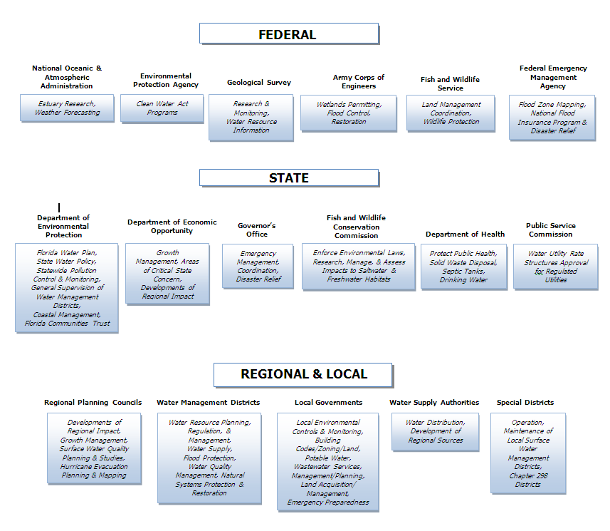
Figure 11.1. Agencies Responsible for Water Resource Coordination and Management in Florida

Wetlands Program

Wetlands Inventory and Wetlands Protection
This section provides an inventory of the major wetlands and historical coverage of wetlands in the state, the development of wetlands water quality standards, and management and protection efforts for wetlands and other surface waters. Due to a lack of sufficient funding and resources, Florida does not have a program to comprehensively monitor the areal extent (gains or losses of wetland acreage) or health (water quality and functions) of wetlands on a statewide basis. Some monitoring is required in the process of reviewing and granting permits for dredging and filling in wetlands and other surface waters, particularly when the permit authorizes mitigation for work in wetlands or other surface waters, and for activities that discharge wastewater to wetlands.

Historical Wetlands Coverage in Florida
Although information on the historical extent of Florida’s wetlands is limited, one researcher estimates that the state lost as many as 46% of its original wetlands between the 1780s and the 1980s. Table 11.6 contains estimates of Florida’s historical wetlands at a number of different points in time.

Table 11.6. Historical Estimates of Wetlands in Florida, 1780–1980
This is a three-column table. Column 1 lists the period for the estimate, Column 2 lists the wetlands acreage during that period, and Column 3 lists the information source.

Period | Wetlands Acreage | Source
circa 1780 | approx. 200,000,000 | unknown
mid-1950s | 12,779,000 | Hefner 1986
mid-1970s | 11,334,000 | Hefner 1986
mid-1970s | 11,298,600 | Frayer and Hefner 1991
1979–80 | 11,854,822 | Tiner 1984
circa 1980 | 11,038,300 | Dahl 1990

What is notable about the table above is that the rate of wetland loss has significantly slowed since the mid-1970s, corresponding to when federal and state dredge-and-fill regulatory programs were enacted. There is no single, current, comprehensive way to estimate the wetland acreage in Florida. The state developed its own wetland delineation methodology, which has been adopted as Rule 62-340, F.A.C. This methodology, used by all state and local agencies throughout the state, requires field-based, site-specific determinations on a case-by-case basis—including an assessment of on-site soils, hydrology, and vegetation. As such, wetland estimates using the Florida methodology cannot be determined based on aerial surveys or mapping. The U.S. Fish and Wildlife Service have estimated wetlands coverage nationwide, including Florida, using the National Wetlands Inventory, and many of the estimates in the table are based on that inventory. However, wetlands mapped in the inventory have not been ground-truthed and maps produced using the inventory do not directly correspond to either the state methodology or the wetland mapping methodology used by the USACOE.

Development of Wetlands Water Quality Standards
Florida does not have separate water quality standards for wetlands. Wetlands are considered surface waters of the state, although water quality standards do not apply to wetlands that are wholly owned by one person other than the state, except with respect to discharges offsite and into ground water. Wetlands in which water quality standards apply are subject to the same water quality standards as other surface waters, including the same five functional classifications described earlier and the state's anti-degradation rules (as set out in Sections 62-302.300 and 62-4.242, F.A.C.). Most wetlands, like most surface waters in Florida, are designated as Class III Waters, except where a wetland is part of the landward extent of another waterbody that is classified otherwise (as Class I, II, IV, or V waters), in which case the water quality standards that apply to the wetland are the same as the waterbody with which the wetlands are associated.

Florida’s rules already contain qualitative and quantitative biological criteria—for example, substances shall not be present in concentrations that will result in a dominance of nuisance species, and there is a maximum allowable degradation of biological integrity. The state has developed procedures for assessing biological communities in streams and lakes, defining relevant ecoregions, and identifying relatively pristine reference sites. Florida has also developed and implemented the toughest standards for phosphate loading in the country (10 parts per billion [ppb] for the Everglades). Lake Apopka (in central Florida), which has long been degraded by agricultural runoff and wastewater discharges, and its associated wetlands also have a special standard of 55 ppb for TP.

Wetlands Management and Protection
Florida implements an independent state regulatory permitting program that operates in addition to the federal dredge-and-fill permitting program. Under the authority of Part IV, Chapter 373, F.S., the state’s regulatory permit program, known as the ERP Program, governs the construction, alteration, operation, maintenance, abandonment or removal of any surface water management system (including stormwater management systems), dam, impoundment, reservoir, appurtenant work or works, including dredging or filling in wetlands and other surface waters, and for the maintenance and operation of existing agricultural surface water management systems or the construction of new agricultural surface water management systems dredging and filling. A separate regulatory program under Sections 403.9321 through 403.9333, F.S., governs the trimming and alteration of mangroves, which consist of tropical to subtropical wetland swamp vegetation growing within tidal environments, primarily in south Florida.
As discussed below, Florida’s ERP Program is implemented jointly by the Department and the five WMDs, as well as by one delegated local government. As such, there are some differences in how the program is implemented statewide. Rules regulating impacts to wetlands and other surface waters have been adopted by the Department and each of the WMDs. These include Rules 62-25, 62-312, 62-330, 62-340, 62-341, 62-343, 62-346, 40A-4, 40B-4, 40B-400, 40C-4, 40C-40, 40C-41, 40C-400, 40D-4, 40D-40, 40D-400, 40E-4, 40E-40, 40E-41, and 40E-400, F.A.C. A requirement for issuing a permit is that the activity must not be contrary to the public interest, or, if located in OFWs, the activity must be clearly in the public interest. The major provisions of the ERP Program are as follows:
- Statewide, the ERP Program regulates virtually all alterations to the landscape, including all tidal and freshwater wetlands and other surface waters (including isolated wetlands) and uplands. The ERP addresses dredging and filling in wetlands and other surface waters, as well as stormwater runoff quality (i.e., stormwater treatment) and quantity (i.e., stormwater attenuation and flooding of other properties), including that resulting from alterations of uplands. The program regulates everything from the construction of single-family residences in wetlands, to convenience stores in uplands, to dredging and filling for any purpose in wetlands and other surface waters (including maintenance dredging), to the construction of roads located in uplands and wetlands, to agricultural alterations that impede or divert the flow of surface waters. Issuance of the ERP also constitutes a water quality certification or waiver under Section 401 of the CWA, 33 U.S.C. 1341. In addition, the issuance of an ERP in coastal counties constitutes a finding of consistency under the Florida Coastal Zone Management Program under Section 307 (Coastal Zone Management Act). The ERP Program is implemented jointly by the Department, five WMDs, and one (as of 2009) delegated local government (Broward County), in accordance with operating agreements that identify the respective divisions of responsibilities. In addition, the WMDs administer permits for surface water and ground water withdrawals (consumptive use permitting) under Part II, Chapter 373, F.S.
- In the Panhandle (encompassing the geographic territory of the NWFWMD, west of and including mid-Jefferson County), a Wetland Resource Permit (WRP) under Rule 62-312, F.A.C., and, in some cases, a separate stormwater permit under Rule 62-25, F.A.C., is required instead of an ERP for activities “grandfathered” under Subsections 373.414(11) through (16), F.S., or Paragraph 373.4145(1)(a), F.S. The WRP regulates dredging and filling in surface waters of the state that are connected (directly or via one or more natural or artificial waters) to other bays, bayous, streams, rivers, lakes, estuaries, or the Gulf of Mexico. It does not regulate dredging or filling in isolated wetlands. The stormwater rule (Rule 62-25, F.A.C.) only addresses water quality, not water quantity.

- The following special provisions apply to agriculture and forestry:
- Sections 373.406 and 403.927, F.S., exempt certain agricultural activities from the need for an ERP. These include the rights of any person engaged in the occupation of agriculture, silviculture, floriculture, or horticulture to alter the topography for purposes consistent with the practice of such occupation, provided the alteration is not for the sole or predominant purpose of impounding or obstructing surface waters. Permit applicants must show that they will not harm wetlands (including isolated wetlands) of five acres or larger. The review of all agricultural activities, including permitting, compliance, and enforcement, is the responsibility of Florida’s five WMDs. FDACS, in cooperation with the Department and the WMDs, developed various BMP handbooks to help the agricultural community work in a manner that minimizes adverse impacts to wetlands and other surface waters.
- Certified aquaculture activities that apply appropriate BMPs adopted under Section 597.004, F.S., are exempt from the need for permits under Part IV, Chapter 373, F.S. Compliance, enforcement, and permitting of such aquaculture activities are the responsibility of FDACS. Compliance, enforcement, and permitting of activities that are not so certified continue to be the responsibility of the Department.

In addition to the regulatory permit programs described above, activities that are located on submerged lands owned by the state (otherwise called sovereign submerged lands) also require a proprietary authorization for such use under Chapter 253, F.S., and Rule 18-21, F.A.C. Such lands generally extend waterward from the mean high water line (of tidal waters) or the ordinary high water line (of fresh waters) both inland and out to the state’s territorial limit (approximately 3 miles into the Atlantic Ocean, and 10 miles into the Gulf of Mexico).
If such lands are located in certain designated Aquatic Preserves, the authorization also must meet the requirements of Chapter 258, F.S., and Rule 18-18, F.A.C. (in the Biscayne Bay Aquatic Preserve), and Rule 18-20, F.A.C. (in all the other aquatic preserves). Such authorization considers issues such as riparian rights, impacts to submerged land resources, and the preemption of other uses of the water by the public. Authorizations typically are in the form of consents of use, easements, and leases. This program is implemented jointly by the Department and four of the state’s five WMDs, in accordance with the same operating agreement that governs the ERP Program. The program is structured so that applicants who do not qualify at the time of the permit application for both the regulatory permit and the proprietary authorization cannot receive either a permit or an authorization.
Although each Departmental and WMD office has its own enforcement officers, the public reports many violations. Public education occurs through several state pamphlets and documents, technical and regulatory workshops, and newspaper coverage. The press has done a good job of reporting on wetlands issues.
As discussed above, Florida uses its own methodology (Rule 62-340, F.A.C.), rather than the federal methodology, to delineate the boundaries of wetlands and other surface waters. This approach, designed specifically for Florida wetland communities, determines the landward extent of wetlands and other surface waters. It applies to both isolated and contiguous wetlands, with some exceptions in northwest Florida, and must be used by all local, state, and regional governments.
Numerous programs are working to restore both freshwater and estuarine wetlands—most notably the Everglades system. Over 60,000 acres of filtration marshes, known as stormwater treatment areas (STAs), are being built to reduce the phosphorus in agricultural runoff entering the Everglades.
Land acquisition is crucial to wetlands preservation. The state has bought thousands of acres of wetlands and other environmentally sensitive lands since 1963, mainly through the Florida Forever and Conservation and Recreation Lands (CARL) Programs, administered by the Department, and the Save Our Rivers (SOR) Program, administered by the WMDs. Both are funded primarily by the documentary stamp tax on the transfer of property. Additional funding comes from the Preservation 2000 (P-2000) Trust Fund. In addition to outright land purchases, the state and WMDs can enter into agreements where the owner retains use of the property with certain restrictions such as conservation easements, the purchase of development rights, leasebacks, and sale with reserved life estates.
Mitigation, which is often used to offset otherwise unpermittable wetlands impacts, may include the restoration, enhancement, creation, or preservation of wetlands, other surface waters, or uplands. Before 2004, the recommended ranges of ratios for offsetting wetland impacts through mitigation generally ranged from 1.5:1 to 4:1 for created or restored marshes, 2:1 to 5:1 for created or restored swamps, 4:1 to 20:1 for wetlands enhancement, 10:1 to 60:1 for wetlands preservation, and 3:1 to 20:1 for uplands preservation.
In 2004, the Department, in consultation with the WMDs, adopted a statewide Uniform Mitigation Assessment Method (UMAM) in Rule 62-345, F.A.C. All state, regional, and local agencies in the state use UMAM to determine the amount of mitigation required to offset impacts to wetlands and other surface waters. As of August 2005, the USACOE, Jacksonville District, also began using this method. It is used to determine the amount of functional loss caused by a proposed project, and the amount of “lift” need to offset that loss of function.
The Department and the WMDs adopted rules governing mitigation banks in 1994 (Rule 62-342, F.A.C.). A mitigation bank is a large area set aside for enhancement, restoration, and preservation. Mitigation credits are the increase in ecological value from restoring, creating, enhancing, or preserving wetlands. Permit applicants can use mitigation credits to offset damage to wetlands functions. Table 11.7 lists all open mitigation banks in the state and the agency administering each of them.

Table 11.7. Open Mitigation Banks in Florida¹
This is a six-column table. Column 1 lists the bank name, Column 2 the administrative agency, Column 3 the acreage, Column 4 the potential credits, Column 5 the credits released, and Column 6 the credits used.

- = Empty cell/no data
¹ Current data were updated as indicated by the superscript date.
² SFWMD = South Florida Water Management District
SJRWMD – St. Johns River Water Management District
SWFWMD = Southwest Florida Water Management District
Bank Name | Administrative Agency² | Acres | Potential Credits | Credits Released | Credits  Used
Bear Point^{Apr-11} | The Department | 317.00 | 49.80 | 49.80 | 5
Breakfast Point^{Dec-08} | The Department | 4,637.00 | 1,011.28 | 194.19 | 30.58
Corkscrew^{Jun-11} | The Department | 635.00 | 351.80 | 155.69 | 113.06
Devils Swamp^{Apr-10} | The Department | 3,049.20 | 516.74 | 208.20 | 10.36
FMB^{Apr-11} | The Department | 1,582.00 | 847.50 | 847.50 | 815.50
FPL/EMB I^{Nov-10} | The Department | 4,125.00 | 390.71 | 390.71 | 281.57
FPL/EMB II^{Apr-11} | The Department | 9,026.00 | 1,769.53 | 547.27 | 208.77
GarconNov-10^{Oct-07} | The Department | 337.00 | 172.39 | 77.40 | 25.41
Graham^{Oct-07} | The Department | 66.00 | 32.50 | 29.25 | 5.50
Lox^{Nov-10} | The Department | 1,264.00 | 641.60 | 470.60 | 336.50
LPI^{Apr-11} | The Department | 1,264.00 | 807.00 | 330.60 | 236.85
NOKUSE^{Feb-11} | The Department | 2220.00 | 273.83 | 27.38 | 0.00
San Pedro^{Dec-08} | The Department | 6,748.00 | 1,083.00 | 388.60 | 31.30
Sand Hill Lakes^{Oct-10} | The Department | 2,155.00 | 298.40 | 178.90 | 87.36
Wekiva River^{Jan-10} | The Department | 1,643.00 | 258.24 | 97.53 | 28.95
Big Cypress^{Aug-08} | SFWMD | 1,280.00 | 1,001.78 | 641.19 | 246.23
Bluefield^{Aug-09} | SFWMD | 2,695.00 | 1,244.00 | 868.00 | 408.00
Panther^{Aug-08} | SFWMD | 2,788.00 | 934.64 | 880.85 | 851.63
Reedy Creek^{Aug-08} | SFWMD | 2,993.00 | 627 | 590.13 | 416.00
RG Reserve^{Aug-08} | SFWMD | 638.00 | 32.48 | 10.00 | 2.55
Treasure Coast | SFWMD | 2,545.14 | 1,033.43 | - | -
Barberville^{Dec-08} | SJRWMD | 366 | 84.30 | 58.30 | 57.42
Blackwater^{Dec-08} | SJRWMD | 347.00 | 152.13 | 15.31 | 2.01
Brick Road ^{Dec-08} | SJRWMD | 2945.00 | 451.41 | - | -
CGW ^{Dec-08} | SJRWMD | 150.00 | 66.20 | 54.60 | 42.70
Colbert ^{Dec-08} | SJRWMD | 2,604.00 | 718.80 | 560.30 | 515.90
East Central ^{Dec-08} | SJRWMD | 1,061.00 | 286.30 | 286.30 | 286.04
Farmton ^{Dec-08} | SJRWMD | 23,992.00 | 4,585.00 | 783.20 | 720.87
Lake Louisa ^{Dec-08} | SJRWMD | 1,007.00 | 297.90 | 246.00 | 245.90
Lake Monroe ^{Dec-08} | SJRWMD | 603.00 | 199.90 | 130.00 | 114.58
Loblolly ^{Dec-08} | SJRWMD | 6,247.00 | 2,031.80 | 1,074.51 | 1,008.50
Longleaf ^{Dec-08} | SJRWMD | 3,021.00 | 808.30 | 444.58 | 169.13
Mary A ^{Dec-08} | SJRWMD | 2,069.00 | 1,252.80 | 707.29 | 394.92
NE Florida ^{Dec-08} | SJRWMD | 779.00 | 407.30 | 393.90 | 376.98
Port Orange ^{Dec-08} | SJRWMD | 5,719.00 | 1,176.30 | 237.90 | 112.10
Sundew ^{Dec-08} | SJRWMD | 2,107.00 | 698.30 | 192.01 | 129.85
Thomas Creek ^{Dec-08} | SJRWMD | 594.00 | 72.48 | 20.91 | -
TM-Econ ^{Dec-08} | SJRWMD | 5,199.00 | 1,568.60 | 879.46 | 538.94
Toso ^{Dec-08} | SJRWMD | 1,312.00 | 185.00 | 185.00 | 152.90
Tupelo ^{Dec-08} | SJRWMD | 1,524.80 | 459.70 | 258.76 | 209.37
Boran ^{Dec-08} | SWFWMD | 237.00 | 108.59 | 108.59 | 100.70
Hammock Lakes ^{Dec-08} | SWFWMD | 819.00 | 58.04 | - | -
Myakka ^{Dec-08} | SWFWMD | 380.00 | 224.60 | 38.20 | 12.09
Tampa Bay ^{Dec-08} | SWFWMD | 161.200 | 111.55 | - | -
Upper Coastal ^{Dec-08} | SWFWMD | 149.00 | 47.62 | - | -
Wetlandsbank ^{Dec-08} | SFWMD | 420.00 | 370.00 | 367.37 | 367.37
Split Oak ^{Dec-08} | SFWMD | 1,049.00 | 206.50 | 88.80 | 88.80

Integrity of Wetlands Resources
Table 11.8 shows the acreage of wetlands that have been authorized to be dredged, filled, created, improved, and preserved as a result of ERPs and WRPs issued by the Department and the WMDs from 2010 to 2011.

Results of Florida’s Surface Water Protection Programs
Despite the increase in Florida’s population over the past 35 years, from 6.8 million to more than 18 million, the state’s surface water management programs have been successful in preventing and minimizing pollution from new sources, especially from new nonpoint sources of pollution, and in reducing existing pollutant loadings, especially from point sources of pollution. This has been accomplished by implementing new technologies, requiring better treatment of wastewater discharges, eliminating many surface water discharges, and treating stormwater.

Table 11.8. Acreage of Affected Wetlands Regulated by the Department and the WMDs (2010–11)
This is a five-column table. Column 1 lists the agency, Column 2 lists the wetlands acreage permanently lost, Column 3 lists the acreage created, Column 4 lists the acreage preserved, and Column 5 lists the acreage improved.

¹ Departmental data coverage is from October 2010 to September 2011.
² Data do not represent impacts from nonregulated or unpermitted activities.
³ Wetlands destroyed.
⁴ Wetlands created where none existed.
⁵ Wetlands with additional protective devices placed on them (i.e., conservation easements).
⁶ Poor or lesser quality jurisdictional wetlands enhanced through various activities (i.e., improved hydrology; the removal of exotics, the re-establishment of native flora).
Agency | Wetlands Acreage Permanently Lost³ | Wetlands Acreage Created⁴ | Wetlands Acreage Preserved⁵ | Wetlands Acreage Improved⁶
The Department ¹ | 11.85 | 4.23 | 96.19 | 7.56
NWFWMD | 13.07 | 2.65 | 93.41 | 9.76
SWFWMD | 430.20 | 1,088.34 | 3,947.53 | 1,743.49
SJRWMD | 872.00 | 61.17 | 3,676.24 | 627.17
SFWMD | 577.00 | 1,108.04 | 3,327.75 | 3,067.73
SRWMD | 5.58 | 0.00 | 28.64 | 0.75
Total² | 1,909.70 | 2,264.43 | 11,169.76 | 5,456.46

References

Abbott, J.P., L.J. Flewelling, and J.H. Landsberg. 2009. Saxitoxin monitoring of three species of Florida puffer ﬁsh. Harmful Algae 8: 343–348.
Abbott, G.M., J.H. Landsberg, A.R. Reich, K.A. Steidinger, S. Ketchen, and C. Blackmore. 2009. Resource guide for public health response to harmful algal blooms in Florida. Florida Fish and Wildlife Conservation Commission, Fish and Wildlife Research Institute, Technical Report TR-14. Available: http://research.myfwc.com/engine/download_
redirection_process.asp?file=TR_14screen.pdf&objid=20125&dltype=article.
American Public Health Association. 1995. Standard methods for the examination of water and wastewater resources. 19th Edition. Baltimore, MD: United Book Press.
American Safety Council. 2010. Florida quickfacts. Available: http://www.
stateofflorida.com/Portal/DesktopDefault.aspx?tabid=95.
Americasroof.com. 2012. Florida highest named summits. Available: http://www.americasroof.com/highest/fl.shtml.
Arthur, J.A., A.A. Dabous, and J.B. Cowart. 2002. Mobilization of arsenic and other trace elements during aquifer storage and recovery, southwest Florida. U.S. Geological Survey Open File Report 02–89. USGS Artificial Recharge Workshop Proceedings. Available: http://water.usgs.gov/ogw/pubs/ofr0289/jda_mobilization.htm.
Azanza, R.V., and F.J.R.M. Taylor. 2001. Are Pyrodinium blooms in the Southeast Asianregion recurring and spreading? A view at the end of the millennium. Ambio 30: 356–364.
Backer, L.C. 2009. Impacts of Florida red tides on coastal communities. Harmful Algae 8: 618–622.
Backer, L.C., L.E. Fleming, A.D. Rowan, and D.G. Baden. 2003. Epidemiology, public health and human illnesses associated with harmful marine algae. In: G.M. Hallegraeff, D.M. Anderson, and A.D. Cembella (Eds.), Manual on harmful marine microalgae (Paris, France: Intergovernmental Oceanographic Commission of UNESCO, pp. 723–750).
Bay Regional Atmospheric Chemistry Experiment (BRACE). 2011. Tampa, FL: University of South Florida, Health Sciences Center, College of Public Health, Environmental and Occupational Health. Available: http://hsc.usf.edu/publichealth/EOH/BRACE/.
Blair, J.A., and R. Jones. Updated January 15, 2008. Consumer Fertilizer Task Force: Final report to the 2008 Florida Legislature. Tallahassee, FL: Florida State University, Florida Conflict Resolution Consortium. Available: http://consensus.fsu.edu/fertilizer-task-force/pdfs2/Fertilizer_Task_Force_Final_Report11408-3.pdf.
Bodager, D. 2002. Outbreak of saxitoxin illness following consumption of Florida pufferﬁsh. Florida Journal of Environmental Health 179: 9–13.
Brown, M.T., K.C. Reiss, M.J. Cohen, J.M. Evans, P.W. Inglett, K.S. Inglett, K.R. Reddy, T.K. Frazer, C.A. Jacoby, E.J. Phlips, R.L. Knight, S.K. Notestein, R.G. Hamann, and K.A. McKee. April 28, 2008. Summary and synthesis of the available literature on the effects of nutrients on spring organisms and systems. Gainesville, FL: University of Florida Water Institute. Available: http://www.dep.state.fl.us/springs/reports/files/UF_SpringsNutrients_
Report.pdf.
Burns, J. 2008. Toxic cyanobacteria in Florida waters. Adv. Exp. Med. Biol. 619: 127–137.
Burns, J., C. Williams, and A. Chapman. 2002. Cyanobacteria and their toxins in Florida surface waters. In: D. Johnson and R.D. Harbison (Eds.), Proceedings of health effects of exposure to cyanobacteria toxins: State of the science (August 13–14, 2002, Sarasota, FL, pp. 16–21).
Campbell, P. May 1997. Current population reports: Population projections: States, 1995–2025. Washington, DC: U.S. Census Bureau. Available: http://www.census.gov/prod/2/pop/p25/p25-1131.pdf.
Carvalho, A., W. Schropp, G.M. Sloane, T.P. Biernacki, and T.L. Seal. 2003. Development of an interpretive tool for assessment of metal enrichment in Florida freshwater sediment. Jacksonville, FL: Taylor Engineering and Florida Department of Environmental Protection. Prepared for the Florida Department of Environmental Protection. Available: http://www.dep.state.fl.us/water/monitoring/docs/seds/FFW_Metals_Report_Final.pdf.
Chang, N.B., M. Wanielista, A. Daranpob, F. Hossain, and Z. Xuan et al. April 17, 2011. On-site sewage treatment and disposal systems evaluation for nutrient removal. Florida Department of Environmental Protection Project #WM 928. Orlando, FL: University of Central Florida, Civil, Environmental, and Construction Engineering Department, Stormwater Management Academy. Available: http://stormwater.ucf.edu/research/UCF_OSTDSFinalReport04192011.pdf.
Chapman, A.D., and C.L. Schelske. 1997. Recent appearance of Cylindrospermopsis (Cyanobacteria) in five hypereutrophic Florida lakes. J. Phycology 33: 191–195.
Comprehensive Everglades Restoration Plan. 2012. Available: http://www.evergladesplan.org/.
Conover, W.J. 1999. Practical nonparametric statistics. New York: Wiley.
Copeland, R., N.A. Doran, A.J. White, and S.B. Upchurch. 2009. Regional and statewide trends in Florida’s spring and well groundwater quality. Florida Geological Survey Bulletin No. 69. Tallahassee, FL. Available: http://ufdcweb1.uflib.ufl.edu/ufdc/
?b=UF00095137&v=00001.
Crabbe, N. February 28, 2008. Drought just tip of water problems. Gainesville Sun.
Dahl, T.E. 1990. Wetlands: Losses in the United States, 1780s to 1980s. U.S. Fish and Wildlife Service Report to Congress. St. Petersburg, FL: National Wetlands Inventory. Available: http://www.npwrc.usgs.gov/resource/wetlands/wetloss/.
———. 2005. Florida's wetlands: An update on status and trends, 1985 to 1996. Washington, DC: U.S .Department of the Interior, Fish and Wildlife Service. Available: http://www.fws.gov/wetlands/Documents/Floridas-Wetlands-An-Update-on-Status-and-Trends-1985-to-1996.pdf#search.
Emslie, S.D., W.D. Allmon, F.J. Rich, J.H. Wrenn, and S.D. Defrance. 1996. Integrated taphonomy of an avian death assemblage in marine sediments from the late Pliocene of Florida. Palaeogeogr. Palaeocl. 124, 107–136.
Fernald, E.A., and E.D. Purdum (Eds.). 1998. Water resources atlas of Florida. Tallahassee, FL: Florida State University, Institute of Science and Public Affairs.
Fleming, L.E., D.G. Baden, J.A. Bean, R. Weisman, and D.G. Blythe. 1998. Marine seafood toxin diseases: Issues in epidemiology and community outreach. In: Environmental health resources for community outreach and education: Marine science (Miami, FL: National Institute of Environmental Health Sciences, Marine and Freshwater Biomedical Sciences Center). Available: http://iodeweb1.vliz.be/odin/bitstream/1834/758/1/Lora%20E5.pdf.
Flewelling, L.J., J.P. Naar, J.P. Abbott, D.G. Baden, and N.B. Barros et al. 2005. Brevitoxicosis: Red tides and marine mammal mortalities. Nature 435 (7043), 755–756.
Florida Administrative Code. August 8, 2007. Section 5E-1.003, Fertilizer: Labels or tags. Available: https://www.flrules.org/gateway/ChapterHome.asp?Chapter=5E-1.
Florida Administrative Weekly. 2012. Available: https://www.flrules.org/Default.asp.
Florida Department of Agriculture and Consumer Services. Revised November 29, 2007. Contingency plan for the control of shellﬁsh potentially contaminated by marine biotoxin. Tallahassee, FL.
———. 2006. Shellfish harvesting. Division of Aquaculture. Available: http://www.floridaaquaculture.com/SEAS/SEAS_intro.htm.
———. 2006. Red tide. Available: http://www.floridaaquaculture.com/RedTide/RedTideInfo.htm.
———. 2010. Office of Agricultural Water Policy. Available: http://www.floridaagwaterpolicy.com/.
Florida Department of Environmental Protection. 1994. Florida coastal sediments contaminants atlas. Available: http://publicfiles.dep.state.fl.us/FGS/FGS_Publications/
FGS%20Library%20Documents/FLCoastSedContamAtlas.pdf.
———. 2000. Integrated water quality assessment for Florida: 2000 305(b) report and 303(d) list update. Tallahassee, FL: Bureau of Watershed Management. Available: http://www.dep.state.fl.us/water/docs/2004_Integrated_Report.pdf.
———. 2000–06. Basin status reports and water quality assessment reports. Available: http://www.dep.state.fl.us/water/basin411/default.htm.
———. February 2001. A report to the Governor and the Legislature on the allocation of Total Maximum Daily Loads in Florida. Tallahassee, FL: Bureau of Watershed Management.
———. January 2003. Interpretative tool for the assessment of metal enrichment in Florida freshwater sediment. Available: http://www.dep.state.fl.us/water/monitoring/fwseds.htm.
———. 2004. Integrated water quality assessment for Florida: 2004 305(b) report and 303(d) list update. Tallahassee, FL: Bureau of Watershed Management. Available: http://www.dep.state.fl.us/water/docs/2004_Integrated_Report.pdf.
———. December 22, 2004 (revised March 30, 2005). Elements of Florida’s water monitoring and assessment program. Tallahassee, FL: Division of Water Resource Management, Bureau of Watershed Management. Available: http://www.dep.state.fl.us/water/monitoring/docs/monitoring-strategy-2009.pdf.
———. 2006a. South Florida Mercury Science Program. Available: http://www.dep.state.fl.us/water/sas/mercury/index.htm.
———. 2006b. Criteria for surface water quality classifications. Available: http://www.dep.state.fl.us/water/wqssp/classes.htm.
———. 2006c. Florida’s springs: Protecting native gems. Available: www.floridasprings.org.
———. 2006d. Drinking Water Program. Available: http://www.dep.state.fl.us/
water/drinkingwater/index.htm.
———. 2006e. STORET Program. Available: http://www.dep.state.fl.us/water/
storet/index.htm.
———. May 2, 2006. Integrated water quality assessment for Florida: 2006 305(b) report and 303(d) list update. Tallahassee, FL: Bureau of Watershed Management. Available: http://www.dep.state.fl.us/water/docs/2006_Integrated_Report.pdf.
———. December 2006. Canal recharge: A report to the Legislature and Governor. Preliminary draft report. Division of Water Resource Management in consultation with the South Florida Water Management District. Available: http://www.dep.state.fl.us/water/wqssp/docs/CanalRechargeReport.pdf.
———. January 2007. Best management practices for the enhancement of environmental quality on Florida golf courses. Available: http://www.dep.state.fl.us/water/nonpoint/docs/nonpoint/glfbmp07.pdf.
———. September 2007. Plan for development of a statewide total maximum daily load for mercury (mercury TMDL). Tallahassee, FL: Division of Water Resource Management and Division of Air Resource Management, Bureau of Laboratories. Available: http://www.dep.state.fl.us/water/sas/mercury/docs/merc-tmdl-plan-draft.pdf.
———. 2008. Florida friendly best management practices for protection of water resources by the green industries. Available: http://fyn.ifas.ufl.edu/pdf/GIBMP_Manual_WEB_2_17_11.pdf .
———. March 31, 2008a. Standard operating procedures for field activities. DEP-SOP-001/01.
———. March 31, 2008b. Process for assessing data usability. DEP-EA-001/07.
———. October 2008. Integrated water quality assessment for Florida: 2009 305(b) report and 303(d) list update. Tallahassee, FL: Bureau of Watershed Management. Available: http://www.dep.state.fl.us/water/docs/2008_Integrated_Report.pdf.
———. December 3, 2008. Standard operating procedures for field activities. Available: http://www.dep.state.fl.us/water/sas/sop/sops.htm.
———. 2010. 1:24,000 high-resolution, National Hydrography Dataset.
———. 2011. 2011 Springs database. Tallahassee, FL: Ground Water Management Section.
———. March 2011. Implementation guidance for the fecal coliform total daily maximum loads adopted by the Florida Department of Environmental Protection. Tallahassee, FL: Division of Environmental Assessment and Restoration, Bureau of Watershed Restoration. Available: http://www.dep.state.fl.us/water/watersheds/docs/fcg_toolkit.pdf.
———. July 2011. Derivation of dissolved oxygen criteria to protect aquatic life in Florida’s fresh and marine waters. Draft technical support document. Tallahassee, FL: Division of Environmental Assessment and Restoration. Available: http://www.dep.state.fl.us/water/wqssp/docs/do/do_tsd.pdf.
———. August 29, 2011. Monitoring design document. Tallahassee, FL: Watershed Monitoring Program. Available: http://www.dep.state.fl.us/water/monitoring/docs/watershed-monitoring-design-document.pdf.
———. 2012a. Agricultural Nonpoint Source Program. Available: http://www.dep.state.fl.us/water/nonpoint/agsrc.htm.
———. 2012b. Basin management action plans—News and announcements. Available: http://www.dep.state.fl.us/water/watersheds/bmap.htm.
———. 2012c. Beach health results. Available: http://www.dep.state.fl.us/labs/cgi-bin/beach_health/index.asp.
———. 2012d. Blue-green algae. Available: http://www.dep.state.fl.us/water/
bgalgae/index.htm.
———. 2012e. Bureau of Petroleum Storage Systems. Available: http://www.dep.
state.fl.us/waste/categories/pss/default.htm.
———. 2012f. Chapter 303, Identification of impaired surface waters. Florida Administrative Code. Available: http://www.dep.state.fl.us/legal/Rules/shared/62-303/62-303.pdf.
———. 2012g. Delineation Program. Available: http://www.dep.state.fl.us/water/
groundwater/delineate.htm.
———. 2012h. Drinking Water Program. Available: http://www.dep.state.fl.us/water/drinkingwater/.
———. 2012i. Drinking Water Toxics Program. Available: http://www.myfloridaeh.com/water/drinkingwatertoxics.html.
———. 2012j. Drycleaning Solvent Cleanup Program. Available: http://www.dep.state.fl.us/waste/categories/drycleaning/default.htm.
———. 2012k. Emerging substances of concern fact sheet. Available: http://www.dep.state.fl.us/water/esoc.htm.
———. 2012l. Florida Action Team on Energy and Climate Change. Available: http://www.flclimatechange.us/index.cfm
.———. 2012m. Florida Forever Program. Available: http://www.dep.state.fl.us/lands/fl_forever.htm.
———. 2012n. Florida-friendly landscaping. Green industries best management practice training and program overview. Available: http://fyn.ifas.ufl.edu/professionals/BMP_overview.htm.
———. 2012o. Florida Geological Survey. Available: http://www.dep.state.fl.us/geology/.
———. 2012p. Florida’s springs. Available: http://www.floridasprings.org/.
———. 2012q. Florida State Emergency Response Team natural resource damage assessment. Available: http://nrdata.org/.
———. 2012r. Florida’s surface water quality standards: Refining designated uses and classifications. Available: http://www.dep.state.fl.us/secretary/designateduse.htm.
———. 2012w. Hazardous Waste Cleanup Program. Available: http://www.dep.state.fl.us/waste/categories/wc/pages/cleanup/default.htm.
———. 2012t. Interpretative tool spreadsheet for assessment of metal enrichment in Florida freshwater sediment. Available: http://www.dep.state.fl.us/WATER/monitoring/fwseds.htm.
———. 2012u. Mercury in aquatic systems in Florida. Available: http://www.dep.state.fl.us/water/sas/mercury/index.htm.
———. 2012v. Nonpoint Source Management Program. Available: http://www.dep.
state.fl.us/water/nonpoint/.
———. 2012w. Development of numeric nutrient criteria for Florida’s waters. Available: http://www.dep.state.fl.us/water/wqssp/nutrients/index.htm.
———. 2012x. Petroleum Cleanup Program. Available: http://www.dep.state.fl.us/waste/categories/pcp/default.htm.
———. 2012y. Sediment guidelines. Available: http://www.dep.state.fl.us/water/
monitoring/sediments.htm.
———. 2012. Status Monitoring Network. Available: http://www.dep.state.fl.us/water/monitoring/status.htm.
———. 2012z. Source Water Assessment and Protection Program. Available: http://www.dep.state.fl.us/swapp/.
———. 2012aa. Statewide stormwater treatment rule development. Available: http://www.dep.state.fl.us/Water/wetlands/erp/rules/stormwater/index.htm.
———. 2012bb. Statistical abstract: Geographical summary. Available: http://www.dep.state.fl.us/secretary/stats/geographical.htm.
———. 2012cc. Storage tank and petroleum contamination/cleanup monitoring. Available: http://www.dep.state.fl.us/waste/quick_topics/database_reports/pages/stcm/stcm_reports.htm.
———. 2012dd. STORET. Available: http://www.dep.state.fl.us/water/storet/index.htm.
———. 2012ee. Surface water improvement and management. Available: http://www.dep.state.fl.us/water/watersheds/swim.htm.
———. 2012ff. Temporal Variability (Trend) Monitoring Network. Available: http://www.dep.state.fl.us/water/monitoring/trend.htm.
———. 2012gg. TMDL Program. Available: http://www.dep.state.fl.us/water/tmdl/
index.htm.
———. 2012hh. Wastewater permitting. Available: http://www.dep.state.fl.us/water/wastewater/permitting.htm.
———. 2012ii. Water sampling data. Available: http://www.dep.state.fl.us/deepwaterhorizon/water.htm.
———. 2012jj. Underground Injection Control Program. Available: http://www.dep.
state.fl.us/water/uic/.
———. 2012ll. Watershed Assessment Program. Available: http://www.dep.state.fl.us/water/watersheds/assessment/index.htm.
———. 2012mm. Watershed monitoring. Available: http://www.dep.state.fl.us/water/monitoring/index.htm.
———. 2012nn. Watershed Supply Restoration Program. Available: http://www.dep.state.fl.us/water/wff/wsupply/.
———. 2012oo. Wellhead protection. Available: http://www.dep.state.
fl.us/water/groundwater/wellhead.htm.
Florida Department of Health. 2011. Human health based screening levels for petroleum products impacting Gulf coastal waters and beach sediments. Available: http://www.dep.state.fl.us/deepwaterhorizon/files2/FLScreeningLevels.pdf.
———. 2012a. Healthy Beaches Program. Available: http://esetappsdoh.doh.state.fl.us/
irm00beachwater/default.aspx.
———. 2012b. Bureau of Water Programs. Available: http://www.doh.state.fl.us/environment/water/index.html.
———. 2012c. Fish consumption advisories. Available: http://www.doh.state.fl.us/environment/medicine/fishconsumptionadvisories/index.html.
———. 2012d. Healthy Beaches Program history. Available: http://esetappsdoh.doh.state.fl.us/irm00beachwater/history/hisintro.htm.
———. 2012e. Petroleum Surveillance Program (Super Act). Available: http://www.doh.state.fl.us/Environment/water/petroleum/saindex.html.
Florida Fish and Wildlife Conservation Commission. 2010a. Fish and Wildlife Research Institute. Available: http://research.myfwc.com/.
———. 2010b. Fish kill database. Available: http://research.myfwc.com/fishkill/.
———. 2010c. Harmful Algal Bloom Task Force. Available: http://myfwc.com/research/redtide/task-force/.
———. 2012a. The economic impact of saltwater fishing in Florida. Available: http://myfwc.com/conservation/value/saltwater-fishing/.
———. 2012b. Most recent commercial landings data for freshwater fisheries in Florida. Available: http://myfwc.com/research/freshwater/fish-projects/commercial-fisheries/commercial-landings-data/.
———. 2012c. The economic impact of freshwater fishing in Florida. Available: http://myfwc.com/conservation/value/freshwater-fishing/.
Florida LAKEWATCH. October 1999. A beginner’s guide to water management: The ABCs. Gainesville, FL: University of Florida, Department of Fisheries and Aquatic Sciences, Institute of Food and Agricultural Sciences. Available: http://lakewatch.ifas.ufl.edu/
circpdffolder/ABCsInt.pdf.
———. 2012. Gainesville, FL: University of Florida, Institute of Food and Agricultural Sciences. Available: http://lakewatch.ifas.ufl.edu/.
Florida Legislature Bureau of Economic and Demographic Research. 2011. Available: http://edr.state.fl.us/Content/.
Florida Springs Task Force. November 2000. Florida’s springs: Strategies for protection and restoration. Available: http://www.dep.state.fl.us/springs/reports/files/
SpringsTaskForceReport.pdf.
Florida Trend. 2009. 2009 economic yearbook: Bad case of the blues.
Fore, L.S., R. Frydenborg, D. Miller, T. Frick, and D. Whiting et al. March 2007. Development and testing of biomonitoring tools for macroinvertebrates in Florida streams (Stream Condition Index and BioRecon: Final report. Prepared for the Florida Department of Environmental Protection, Nonpoint Source Bioassessment Program, by Statistical Design, Inc., Seattle, WA. Available: http://publicfiles.dep.state.fl.us/dear/labs/sas/sopdoc/sci_final.pdf.
Fore, L.S., R. Frydenborg, N. Wellendorf, J. Espy, and T. Frick et al. December 2007. Assessing the biological condition of Florida lakes: Development of the Lake Vegetation Index (LVI). Prepared for the Florida Department of Environmental Protection, Nonpoint Source Bioassessment Program, by Statistical Design, Inc., Seattle, WA. Available: http://publicfiles.dep.state.fl.us/dear/sas/sopdoc/lvi_final07.pdf.
Frayer, W.E., and J.M. Hefner. 1991. Florida wetlands status and trends, 1970s to 1980s. Atlanta, GA: U.S. Fish and Wildlife Service, Southeast Region. Available: http://books.google.com/books?id=iL5ywoshPl0C&pg=PA335&lpg=PA335&dq=frayer+florida+wetlands+status+and+trends,+1970s+to+1980s&source=bl&ots=CcDtpki0N4&sig=_qiGb7K-02n6pOVJStBTvlENfmc&hl=en#v=onepage&q=frayer%20florida%20wetlands%20status%20and%20trends%2C%201970s%20to%201980s&f=false.
Fujiki, H., M. Suganuma, H. Surguri, S. Yoshizawa, and K. Takagi et al. 1990. New tumor promoters from marine natural products. In: S. Hall and G. Strichartz (Eds.), Marine toxins: Origin, structure and molecular pharmacology (Washington, DC: American Chemical Society, pp. 232–240).
Gabriel, M.C., D.M. Axelrad, T. Lange, and T. Dirk. 2010. Chapter 3B. Mercury and sulfur monitoring: Research and environmental assessment in south Florida. In: 2010 South Florida environmental report, Volume I (West Palm Beach, FL: South Florida Water Management District). Available: https://my.sfwmd.gov/portal/page/portal/
pg_grp_sfwmd_sfer/portlet_sfer/tab2236037/2010%20report/v1/chapters/v1_ch3B.pdf.
Gao, X. 2007. TMDL report: Nutrient TMDLs for the Wekiva River (WBIDs 2956, 2956A, and 2956C) and Rock Springs Run (WBID 2967), Draft 11/15/07. Tallahassee, FL: Florida Department of Environmental Protection, Watershed Assessment Section. Available: http://www.dep.state.fl.us/water/tmdl/docs/tmdls/final/gp2/Wekiva_MainStem04182008.pdf.
Gerritsen, J., B. Jessup, E. Leppo, and J. White. July 2000. Development of Lake Condition Indexes (LCI) for Florida. Prepared for the Florida Department of Environmental Protection by Tetra Tech, Inc., Owings Mills, MD. Available: http://publicfiles.dep.state.fl.us/
dear/labs/sas/sopdoc/lci_final.pdf.
Gilbert, R.O. 1987. Statistical methods for environmental pollution monitoring. New York, NY: Van Nostrand.
Glibert, P.M., D.M. Anderson, P. Gentien, E. Graneli, and K.G. Sellner. 2005. The global, complex phenomena of harmful algal blooms. Oceanography 18, 2 (2005): 136–147.

Governor’s Action Team on Energy and Climate Change. October 15, 2008. Florida energy and climate change action plan. Available: http://www.flclimatechange.us/documents.cfm.
Gulf of Mexico Alliance. 2010. Available: http://gulfofmexicoalliance.org/.
Hale, J.A., T.K. Frazer, D.A. Tomasko, and M.O. Hall. 2004. Changes in the distribution of seagrass species along Florida's Central Gulf Coast—Iverson and Bittaker revisited. Estuaries 27(1): 36-43.
Hand, J., N. Lewis, and L. Lord. April 2009. Typical water quality values for Florida lakes, streams, blackwaters, coastal waters, and estuaries. Tallahassee, FL: Florida Department of Environmental Protection, Watershed Assessment Section.
Harrington, D., G. Maddox, and R. Hicks. 2010. Florida Springs Initiative monitoring network report and recognized sources of nitrate. Tallahassee, FL: Florida Department of Environmental Protection, Division of Environmental Assessment and Restoration. Available: http://www.dep.state.fl.us/springs/reports/files/springs_report_102110.pdf.
Hefner, J.M. 1986. Wetlands of Florida 1950s to 1970s. In: E.D. Estevez, J. Miller, J. Morris, and R. Hamman (Eds.), Proceedings of the conference: Managing cumulative effects in Florida wetlands (Madison, WI: Omnipress). New College Environmental Studies Program, Publication No. 37.
Heil, C.A., and K.A. Steidinger. 2009. Monitoring, management, and mitigation of Karenia blooms in the eastern Gulf of Mexico. Harmful Algae 8: 611–617.
Heil, D. 2009. Karenia brevis monitoring, management, and mitigation for Florida molluscan shellﬁsh harvesting areas. Harmful Algae 8(4): 608–610.
Jones, G.W, and T. Pichler. 2007. The relationship between pyrite stability and arsenic Mobility during aquifer storage and recovery in southwest central Florida. Environmental Science and Technology 41-3, 723–730.
Kirkpatrick, B., L.E. Fleming, L.C. Backer, J.A. Bean, R. Tamer, G. Kirkpatrick, T. Kane, A. Wanner, D. Dalpra, A. Reich, and D.G. Baden. 2006. Environmental exposures to Florida red tides: Effects on emergency room respiratory diagnoses admissions. Harmful Algae 5: 526–533.
Kirkpatrick, B., L. Fleming, D. SquicciarinI, L. Backer, R. Clark, W. Abraham, J. Benson, Y.S. Cheng, D. Johnson, R. Pierce, J. Zaias, J.D. Bossart, and D.G. Baden. 2004. Literature review of Florida red tide: Implications for human health. Harmful Algae 3: 99–115.
Kushlan, J.A. 1990. Freshwater marshes. In: R.L. Myers and J.J. Ewel (Eds.), Ecosystems of Florida (Orlando, FL: University of Central Florida Press).
Landsberg, J.H. 2002. The effects of harmful algal blooms on aquatic organisms. Reviews in Fisheries Science 10: 113–390.
Landsberg, J.H., S. Hall, J.N. Johannessen, K.D. White, S.M. Conrad, and J.P. Abbott et al. 2006. Saxitoxin puffer fish poisoning in the United States, with the first report of Pyrodinium bahamense as the putative toxin source. Environ. Health Persp. 114: 1502–1507.
Lane, C.R., M.T. Brown, M. Murray-Hudson, and M.B. Vivas. September 2003. The Wetland Condition Index (WCI): Biological indicators of wetland condition for isolated depressional herbaceous wetlands in Florida. Report submitted to the Florida Department of Environmental Protection under Contract #WM-683. Gainesville, FL: University of Florida, H.T. Odum Center for Wetlands. Available: http://publicfiles.dep.state.fl.us/dear/labs/
sas/library/docs/wet_herb.pdf.
Lapointe, B.E., and B.J. Bedford. 2007. Drift rhodophyte blooms emerge in Lee County, Florida, USA: Evidence of escalating coastal eutrophication. Harmful Algae 6:421–437.
Lapointe, B.E., P.J. Barile, and C.A. Yentsch. 2004. The physiology and ecology of macroalgal blooms (green tides) on coral reefs off northern Palm Beach County, Florida (USA). Harmful Algae 3:185–268.
Long, E.R., and L.G. Morgan. 1990. The potential for biological effects of sediment-sorbed contaminants tested in the National Status and Trends Program. National Oceanic and Atmospheric Administration Technical Memorandum NOS OMA 52. Seattle, WA: National Oceanic and Atmospheric Administration.
MacDonald, D.D. 1994. Approach to the assessment of sediment quality in Florida coastal waters. MacDonald Environmental Sciences Ltd. Prepared for the Florida Department of Environmental Protection. Available: http://www.dep.state.fl.us/waste/quick_topics/
publications/documents/sediment/volume2.pdf.
MacDonald Environmental Sciences Ltd. and U.S. Geological Survey. 2003. Development and evaluation of numerical sediment quality assessment guidelines for Florida inland waters. Available: http://www.dep.state.fl.us/water/monitoring/docs/seds/SQAGs_for_
Florida_Inland_Waters_01_03.PDF.
Magaña, H.A., C. Contreras, and T.A. Villareal. 2003. A historical assessment of Karenia brevis in the western Gulf of Mexico. Harmful Algae 2, 163–171.

Marella, R.L. 2009. Water withdrawals, use, and trends in Florida, 2005. U.S. Geological Survey Scientific Investigations Report 2009-5125. Available: http://pubs.usgs.gov/
sir/2009/5125/.
Morris, A., and J.P. Morris. 2009. The Florida handbook: 2009–2010. 32nd biennial edition. Tallahassee, FL: Peninsular Publishing Company.
National Oceanic and Atmospheric Administration. January 6, 2009. New economic report finds commercial and recreational saltwater fishing generated more than two million jobs. Available: http://www.noaanews.noaa.gov/stories2009/20090105_nmfseconomics.html.
———. 2010. Harmful Algal Bloom Operational Forecast System. Available: http://tidesandcurrents.noaa.gov/hab/.
Natural Resources Defense Council. April 2007. Florida’s coastal and ocean future: A blueprint for economic and environmental leadership. Florida Ocean and Coastal Coalition. Issue Paper. Available: http://www.nrdc.org/water/oceans/florida/flfuture.pdf.
Netstate.com. 2010. The state of Florida. Available: http://www.netstate.com/
states/intro/fl_intro.htm.
Northwest Florida Water Management District. September 19, 2007. Environmental resource permitting in Florida’s Panhandle. Brochure. District Publication Number PIC 07-01.
———. 2011. Apalachicola River. Available: http://www.nwfwmd.state.fl.us/recreation/apalachicolariver.html.
———. 2012. NWFWMD wetland programs: Apalachicola River and Bay watershed. Available: http://nwfwmdwetlands.com/Watershed.php?watershed_id=5.
Obreza, T., M. Clark, B. Boman, T. Borisova, and M. Cohen et al. Revised March 2011. A guide to EPA's numeric nutrient water quality criteria. Publication SL316. Tallahassee, FL: University of Florida, Soil and Water Science Department, Florida Cooperative Extension Service, Institute of Food and Agricultural Sciences. Available: http://edis.ifas.ufl.edu/pdffiles/SS/SS52800.pdf.
Ollis, S., and G. Redfield. 2010. Introduction. In: 2010 South Florida environmental report, Volume I, Chapter 1 (West Palm Beach, FL: South Florida Water Management District). Available: https://my.sfwmd.gov/portal/page/portal/pg_grp_sfwmd_sfer/
portlet_sfer/tab2236037/2010%20report/v1/chapters/v1_ch1.pdf.
Palmer, S.L. 1984. Chapter 6: Surface water. In: E.A. Fernald and D.J. Patton (Eds.), Water resources atlas of Florida (Tallahassee, FL: Florida State University, pp. 54–67).
Paul, V.J., R.W. Thacker, and K. Banks. 2005. Benthic cyanobacterial bloom impacts the reefs of South Florida (Broward County, USA). Coral Reefs 24:693–697.
Phlips, E.J., S. Badylak, and T.L. Lynch. 1999. Blooms of the picoplanktonic Cyanobacterium Synechococcus in Florida Bay. Limnol. Oceanogr. 44:1166–1175.
Phlips, E.J., S. Badylak, E.L. Bledsoe, and M. Cichra. 2006. Factors influencing the distribution and abundance of Pyrodinium bahamense in coastal ecosystems of Florida. Mar. Ecol. Progr. Ser. 322:99–115.
Phlips, E.J., S. Badylak, M. Christman, and M. Lasi. 2010a. Climatic trends and temporal patterns of phytoplankton composition, abundance and succession in the Indian River Lagoon, Florida, USA. Estuaries and Coasts 33:498–513.
Phlips, E.J., S. Badylak, M. Christman, J. Wolney, J. Garland, and L. Hall et al. 2010b. Scales of variability of harmful algae blooms in the Indian River, Florida, USA. Harmful Algae, accepted for publication.
Phlips, E.J., E. Bledsoe, M. Cichra, S. Badylak, and J.Frost. 2002. The distribution of potentially toxic cyanobacteria in Florida. In: D. Johnson and R.D. Harbison (Eds.), Proceedings of health effects of exposure to cyanobacteria toxins: State of the science, August 13–14, 2002, Sarasota, FL, pp. 22–29.
Poli, M.A., S.M. Musser, R.W. Dickey, P. Eilers, and S. Hall. 2000. Neurotoxic shellﬁsh poisoning and brevetoxin metabolites: A case study from Florida. Toxicon 38: 981–993.
Price, R.E. and T. Pichler. 2006. Abundance and mineralogical association of arsenic in the Suwannee Limestone (Florida): implications for arsenic release during water-rock interaction. Invited paper for special issue of Chemical Geology 228 (1-3), 44–56.
Regas, D. July 29, 2005. 2006 integrated report guidance. Washington, DC: U.S. Environmental Protection Agency. Available: http://water.epa.gov/lawsregs/lawsguidance/cwa/tmdl/2006IRG_index.cfm.
Reiss, K.C., and M.T. Brown. June 2005a. The Florida Wetland Condition Index (FWCI): Developing biological indicators for isolated depressional forested wetlands. Report submitted to the Florida Department of Environmental Protection under Contract #WM-683. Gainesville, FL: University of Florida, Howard T. Odum Center for Wetlands. Available: http://publicfiles.dep.state.fl.us/dear/labs/sas/library/docs/wet_depf.pdf.
———. June 2005b. Pilot study—The Florida Wetland Condition Index (FWCI): Preliminary development of biological indicators for forested strand and floodplain wetlands. Report submitted to the Florida Department of Environmental Protection under Contract #WM-683. Gainesville, FL: University of Florida, Howard T. Odum Center for Wetlands. Available: http://publicfiles.dep.state.fl.us/dear/labs/sas/library/docs/wet_stfp.pdf.
Richardson, L., R. Sekar, J.L. Meyers, M. Gantar, and J.D. Voss et al. 2007. The presence of the cyanobacterial toxin microcystin in black band disease of corals. FEMS Microbiol Letts 272: 182–187.
Sato, K., A. Kitahara, K. Satoh, T. Ichikawa, M. Tatematsu, and N. Ito. 1984. The placental form of glutathione S-transferase as a new marker protein for preneoplasia in rat chemical carcinogenesis. Gann 75: 199–202.
Schropp, S., and H. Windom. 1988. A guide to the interpretation of metals concentrations in estuarine sediments. Tallassee, FL: Florida Department of Environmental Regulation, Coastal Zone Management Section. Available: http://www.dep.state.fl.us/WATER/
monitoring/docs/seds/estuarine.pdf.
Scott, T.M., G.H. Means, R.P. Meegan, R.C. Means, S.B. Upchurch, R.E. Copeland, J. Jones, T. Roberts, and A. Willet. 2004. Springs of Florida. Florida Geological Survey. Bulletin 66. Available: http://www.dep.state.fl.us/geology/geologictopics/springs/bulletin66.htm.
Seal, T., F. Calder, G. Sloane, S. Schropp, and H. Windom. 1994. Florida coastal sediment contaminants atlas: A summary of coastal sediment quality surveys. Florida Department of Environmental Protection. Available: http://publicfiles.dep.state.fl.us/FGS/
FGS_Publications/FGS%20Library%20Documents/FLCoastSedContamAtlas.pdf.
South Florida Water Management District. 2010a. Available: http://www.sfwmd.
gov/portal/page/portal/sfwmdmain/home%20page.
———. 2010b. About Everglades. Available: https://my.sfwmd.gov/portal/page/
portal/pg_grp_sfwmd_watershed/subtabs_evergladesflbay_home/tab1834093/flbayalgalbloom.pdf.
———. 2012c. Kissimmee Basin. Available: http://www.sfwmd.gov/portal/page/portal/xweb%20protecting%20and%20restoring/kissimmee%20river.
Southeast Regional Climate Center. September 8, 2011. Florida state averaged precipitation data, 1895–2011. Available: http://www.sercc.com/climateinfo_files/monthly/Florida_prcp.html.
———. 2012. Available: http://www.sercc.com/
Southwest Florida Water Management District. 2012. Available: http://www.swfwmd.state.fl.us/.
St. Johns River Water Management District. 2012. Management and storage of surface waters (MSSW) applicant’s handbook. Available: http://www.sjrwmd.com/handbooks/msswhandbook.html.
Steidinger, K.A., P. Carlson, D. Baden, C. Rodriguez, and J. Seagle. 1998. Neurotoxic shellﬁsh poisoning due to toxin retention in the clam Chione cancellata. In: B. Reguera, J. Blanco, M.L. Fernández, and T. Wyatt (Eds.), Harmful algae (Paris, France: Xunta de Galicia and Intergovernmental Oceanographic Commission of UNESCO, pp. 457–458).
Steidinger, K.A., J.H. Landsberg, C.R. Tomas, and J.W. Burns. 1999. Harmful algal blooms in Florida. Unpublished technical report submitted to the Florida Harmful Algal Bloom Task Force. St. Petersburg, FL: Florida Fish and Wildlife Conservation Commission, Fish and Wildlife Research Institute. Available: http://research.myfwc.com/features/
view_article.asp?id=26925.
Steidinger, K.A., J.H. Landsberg, E.W. Truby, and B.S. Roberts. 1998. First report of Gymnodinium pulchellum Larsen 1994 (Dinophyceae) in North America and associated fish kills in the Indian River, Florida. J. Phycology 34: 431–437.
Stevenson, R.J, A. Pinowska, A. Albertin, and J.O. Sickman. 2007. Ecological condition of alga and nutrients in Florida springs: The synthesis report. Michigan State University, Department of Zoology, Florida Department of Environmental Protection Contract WM858. Available: http://publicfiles.dep.state.fl.us/dear/labs/sas/library/docs/springs/
synthesisreport.pdf.
Suwannee River Water Management District. 2010. Nitrate information. Available: http://www.srwmd.state.fl.us/index.aspx?NID=332.
———. 2012. Available: http://www.srwmd.state.fl.us/.
Tiner, R.W., Jr. 1984. Wetlands of the United States: Current status and recent trends. Washington, DC: U.S. Fish and Wildlife Service, National Wetlands Inventory.
U.S. Census Bureau. 2010a. Resident population by age and state—Projections: 2010 and 2015. Available: http://www.census.gov/compendia/statab/2010/tables/10s0018.pdf.
———. 2010b. Statistical abstract of the United States 2011. 130th Edition. Washington, DC: U.S. Government Printing Office.
———. 2012a. State and county quickfacts: Florida. Available: http://quickfacts.census.gov/qfd/states/12000.html.
———. 2012b. State and county quickfacts. Available: http://quickfacts.census.gov/qfd/states/12000lk.html.
U.S. Environmental Protection Agency. May 20, 2002. EPA review of 2002 Section 303(d) lists and guidelines for reviewing TMDLs under existing regulations issued in 1992. Available: http://water.epa.gov/lawsregs/lawsguidance/cwa/tmdl/guidance.cfm.
———. March 2003. Elements of a state water monitoring and assessment program. Washington, DC: Office of Wetlands, Oceans and Watersheds. EPA 841-B-03-003. Available: http://www.epa.gov/owow/monitoring/elements/.
———. July 29, 2005. Guidance for 2004 assessment, listing, and reporting requirements under Sections 303(d) and 305 (b) of the Clean Water Act. Watershed Branch, Office of Wetlands, Oceans and Watersheds.
———. 2006a. Ecoregions of Florida. Available: http://www.epa.gov/wed/pages/
ecoregions/fl_eco.htm.
———. 2006b. TMDLs in Florida. Available: http://www.epa.gov/region4/water/tmdl/florida/.
———. 2006c. National STORET/WQX Program. http://www.epa.gov/storet/.
———. 2008. Clean watersheds needs survey 2008: Report to Congress. Available: http://water.epa.gov/scitech/datait/databases/cwns/upload/cwns2008rtc.pdf.
———. 2009. Contaminant candidate 3 list. Available: http://www.epa.gov/ogwdw000/ccl/ccl3.html#chemical.
———. January 14, 2009. Letter to Michael Sole, Florida Department of Environmental Protection Secretary, from Benjamin Grumbles, Assistant Administrator. Washington, DC: Office of Water.
———. 2010a. Clean Watersheds Needs Survey. Available: http://www.epa.gov/cwns/.
———. 2012b. Aquatic resource monitoring. Available: http://www.epa.gov/nheerl/arm/index.htm.
———. 2012c. Human health benchmarks for chemicals in water. Available: http://www.epa.gov/BPSpill/health-benchmarks.html.
———. 2012d. National Priorities List. Available: http://www.epa.gov/superfund/sites/npl/.
———. 2012e. Watershed improvement summaries. Available: http://www.epa.gov/region4/water/watersheds/watershed_summaries.html.
U.S. Fish and Wildlife Service, National Wetlands Inventory, Branch of Resource and Mapping Support. 2010. Wetlands status and trends. Available: http://www.fws.gov/wetlands/Status-and-Trends/index.html.
U.S. Geological Survey. May 1995. Springs of Florida. Fact Sheet FS-151-95. Tallahassee, FL. Available: http://fl.water.usgs.gov/PDF_files/fs151_95_spechler.pdf.
———. 2008. Historical water use by category, 1970–2000. Available: http://fl.water.usgs.gov/WaterUse/Historical_Tables_Miscellaneous/florida-historical-category.1970-2000.htm.
———. 2012a. The Apalachicola-Chattahoochee-Flint (ACF) River National Water Quality Assessment (NAWQA) Program study. Basin description: Apalachicola River Basin. Atlanta, GA: Georgia Water Science Center. Available: http://ga.water.usgs.gov/nawqa/basin/apalachicola-basin.html).
———. 2012b. Water resources of the United States. Available: http://water.usgs.gov/.
U.S. Geological Survey and Florida Water Science Center Environmental Data Server. 2010. Available: http://www.envirobase.usgs.gov/.
University of Central Florida Stormwater Management Academy. 2012. Orlando, FL. Available: http://www.stormwater.ucf.edu/.
University of Florida Institute of Food and Agricultural Sciences. February 2010. A guide to EPA’s proposed numeric nutrient water quality criteria for Florida. SL316. Gainesville, FL: Soil and Water Science Department, Florida Cooperative Extension Service. Available: http://edis.ifas.ufl.edu/pdffiles/SS/SS52800.pdf.
———. 2012. Florida-Friendly Landscaping Program. Available: http://fyn.ifas.ufl.edu/
Visit Florida, Florida Commission on Tourism. 2012. Research. Available: http://media.visitflorida.org/research.php.
Vogel, M. April 2006. Economic yearbook 2006: Good migrations. Florida Trend.
Water Quality Association. 2006. Water quality glossary: pH. Available: http://www.wqa.
org/glossary.cfm?gl=1146.
Watkins, S.M., A. Reich, L.E. Fleming, and R. Hammond. 2008. Neurotoxic shellﬁsh poisoning. Marine Drugs 6: 431–455.
Wayland, R.H. November 19, 2001. 2002 Integrated water quality monitoring and assessment report guidance. Memorandum. Washington, DC: U.S. Environmental Protection Agency.
Wekell, J.C., J. Hurst, and K.A. Lefebvre. 2004. The origin of the regulatory limits for PSP and ASP toxins in shellﬁsh. J. Shellﬁsh Res. 23: 927–930.
Welch, P.S. 1948. Limnological methods. New York, NY: John Wiley and Sons, Inc.
Williams, C.D., M.T. Aubel, A.D. Chapman, and P.E. D’Aiuto. 2007. Identification of cyanobacterial toxins in Florida’s freshwater systems. Lake and Reservoir Management 23: 144–152.
Williams, C.D., J. Burns, A. Chapman, M. Pawlowicz, and W. Carmichael. 2006. Assessment of cyanotoxins in Florida’s surface waters and associated drinking water resources. Final report to the St. Johns River Water Management District, Palatka, FL. Available: http://greenwaterlab.com/articles/Assess%20of%20Cyano%202006.pdf.

Appendices

Appendix A: Discussion of Status Network Surface Water Indicators for Rivers, Streams, and Lakes, and Ground Water Indicators for Confined and Unconfined Aquifers

Surface Water Indicators for Rivers, Streams, and Lakes
Table A.1 contains the list of surface water analytes, with the associated criterion for each analyte.

Table A.1. Status Monitoring Network Water Quality Standards for Surface Water
This is a three-column table. Column 1 lists the indicator, Column 2 lists the criterion/threshold, and Column 3 lists the designated use.

¹ mL – milliliters; mg/L – milligrams per liter; μg/L – micrograms per liter; PCUs – platinum cobalt units
Indicators | Criterion/Threshold¹ | Designated Use
Fecal Coliform Bacteria | < 400 counts/100mL | Recreation
DO | ≥ 5 mg/L | Aquatic Life
Un-ionized Ammonia | ≤ 0.02 mg/L | Aquatic Life
Chlorophyll a | ≤ 20 μg/L | Aquatic Life
TSI | Color ≤ 40 PCUs, then TSI ≤ 40  Color > 40 PCUs, then TSI ≤ 60 | Aquatic Life

Fecal Coliform Bacteria
The threshold for fecal coliform bacteria is 400 colonies per 100 mL of water. Additionally, twice that number (800), as cited in Rule 62-302, F.A.C., indicates a highly contaminated result, and is used for regulatory purposes. The presence of these bacteria can indicate the contamination of a waterway or well and the possible presence of other pathogenic organisms.
Fecal coliform bacteria can enter water through the discharge of waste from mammals and birds, agricultural and stormwater runoff, and untreated human sewage. Septic tanks for individual homes can become overloaded during the rainy season and allow untreated human wastes to flow into drainage ditches and nearby waters. Agricultural practices that fail to contain animal wastes during the rainy season, as well as spreading manure and fertilizer on fields during rainy periods, and allowing livestock access to streams, can all contribute fecal coliform contamination.

DO
The state criterion for DO is greater than or equal to 5 mg/L. DO is a measure of water quality indicating free oxygen dissolved in water. Oxygen is measured in its dissolved form. If more oxygen is consumed than is produced, DO levels decline and some sensitive aquatic animals may move away, weaken, or die. Levels vary with water temperature; therefore, cold water holds more oxygen than warm water.
Surface water gains oxygen from the atmosphere and plants as a result of photosynthesis. Running water contains more oxygen than still water because of its flow. Respiration by aquatic animals, decomposition, and various chemical reactions consume oxygen.
Wastewater from sewage treatment plants often contains organic materials that are decomposed by microorganisms, which use oxygen in the process. Other sources of oxygen-consuming waste include stormwater runoff from farmland or urban streets, feedlots, and failing septic systems. Ground water is naturally low in DO. Surface water contact with ground water seepage or upwelling can cause a natural lowering of DO levels.

Un-ionized Ammonia
The threshold for un-ionized ammonia is ≤0.02 mg/L as ammonia and is calculated using temperature, salinity, ammonia, and pH. This criterion applies to predominantly fresh waters in Florida. In water, ammonia occurs in two forms, which together are called total ammonia nitrogen, or TAN. Chemically, these two forms are represented as NH₄⁺ and NH₃. NH₄⁺ is called ionized ammonia because it has a positive electrical charge, and NH₃ is called un-ionized ammonia as it has no charge. Un-ionized ammonia (abbreviated as UIA), is the form that is toxic to fish and invertebrates. Water temperature and pH affect the form of ammonia that is predominant at any given time in an aquatic system.

Chlorophyll a
The threshold for chlorophyll a is ≤ 20 μg/L. This threshold is applied to the rivers and streams resources in the Status Monitoring Network. It is not a criterion under Rule 62-302, F.A.C.; rather, it is listed as a measure to identify impairment in surface waters in Section 62-303.351, F.A.C., which describes the assessment of nutrients in streams.
Chlorophyll is the pigment that allows plants—including algae—to convert sunlight into organic compounds during the process of photosynthesis. Chlorophyll a is the predominant type found in algae and cyanobacteria (blue-green algae), and its abundance is a measurable indicator of the amount of algae present in a surface waterbody.
Excessive quantities of chlorophyll a can indicate the presence of algal blooms. These usually consist of species undesirable for fish and other predators to consume. Unconsumed algae sink to the bottom and decay, using up the oxygen required by other plants and benthic organisms to survive. The presence of too many nutrients, such as nitrogen and phosphorus, can stimulate algal blooms and reduce water clarity.
Chlorophyll a also plays a direct role in reducing the amount of light available to plants in shallow-water habitats. Like their terrestrial cousins, these plants need sunlight to grow. As chlorophyll a levels increase, the amount of sunlight reaching underwater plants declines.

Trophic State Index
TSI and chlorophyll a are the primary measures used to assess nutrient impairment in waterbodies. TSI is measured using chlorophyll, nitrogen, and phosphorus concentrations. There are two thresholds for TSI that are based on the color of a lake. Dark-water lakes with a mean color greater than 40 PCUs are impaired when their annual mean TSI exceeds 60. Clear and low-color lakes with a mean color less than or equal to 40 PCUs are impaired when their annual mean TSI exceeds 40. A 10-unit increase or decrease in the index represents a doubling or halving, respectively, of the number of algal cells present
Note: Both chlorophyll a and TSI are not standards, but thresholds used to estimate the condition of state waters. These thresholds are used in the analysis of Status Monitoring Network data based on single samples in a basin during a predetermined index period. The analysis and representation of these data are not intended to infer the verification of impairment in these waters, as defined in Rule 62-303, F.A.C.

Ground Water Indicators for Confined and Unconfined Aquifers
Analytes with primary drinking water standards have been added to measure the condition of Florida’s aquifers. Table A.2 contains the list of ground water analytes with the associated criterion for each analyte. Primary standards mean that the criterion for an analyte is based on human health effects.
Key indicator contaminants for ground water (e.g., chloride, nitrate, metals, and bacteria) serve to assess its general suitability for drinking water purposes. Aquifer samples collected for the Status Monitoring Network between 1999 and 2003 (Cycle 1) were filtered to mitigate well construction factors, and the analytes were measured as dissolved constituents. Aquifer samples collected for the Status Monitoring Network between 2004 and 2010 were not filtered and were analyzed as total constituents. These samples represent more closely the conditions of water as it comes directly from the aquifer. Additionally, standards are measured using unfiltered water, and so unfiltered samples allow consistency with standards.

Table A.2. Status Monitoring Network Water Quality Standards for Ground Water
This is a three-column table. Column 1 lists the indicator, Column 2 lists the criterion/threshold, and Column 3 lists the designated use.

1 The Minimum Detection Limit (MDL) for fecal coliform, per Departmental SOP MB-X, is 2 counts/100mL.
Indicators | Criterion/Threshold | Designated Use
Arsenic | ≤ 10 μg/L | Potable Water (drinking water)
Cadmium | ≤ 5 μg/L | Potable Water (drinking water)
Chromium | ≤ 100 μg/L | Potable Water (drinking water)
Lead | ≤ 15 μg/L | Potable Water (drinking water)
Nitrate–Nitrite | ≤ 10 mg/L | Potable Water (drinking water)
Sodium | ≤ 160 mg/L | Potable Water (drinking water)
Fluoride | ≤ 4 mg/L | Potable Water (drinking water)
Total Coliform Bacteria  (counts/100mL) | ≤ 4 (sample maximum) | Potable Water (drinking water)
Fecal Coliform Bacteria  (counts/100mL) | < 2 (sample maximum)1 | Potable Water (drinking water)

Total Coliform Bacteria
The EPA has determined that the presence of total coliform is a possible health concern. Total coliform bacteria are common in the environment and are generally not harmful themselves. The presence of these bacteria in drinking water, however, is a result of a problem with water treatment or the pipes that distribute the water, and indicates that the water may be contaminated with organisms that can cause disease.
The EPA and the state have set an enforceable drinking water standard for total coliform of 4 counts/100mL to reduce the risk of adverse health effects. Drinking water that meets this standard is usually not associated with a health risk from disease-causing bacteria and should be considered safe.

Fecal Coliform Bacteria
The EPA has determined that the presence of fecal coliform bacteria is a possible health concern because these are usually associated with sewage or animal wastes. Their presence in drinking water generally results from a problem with water treatment or pipes that distribute the water, and indicates that the water may be contaminated with organisms that can cause disease. In addition, ground water can become contaminated with fecal coliform from surface water interactions in karst (limestone) terrains, such as those found in Florida.
The EPA and the state have set an enforceable drinking water standard for fecal coliform to reduce the risk of adverse health effects. Under this standard, all drinking water samples must be free of fecal coliform bacteria. The Department’s Bureau of Laboratories has an MDL per sample of 2 counts/100mL, and so the presence of any detectable fecal coliform is considered an exceedance. Drinking water that meets this standard is associated with little or no health risk and should be considered safe.

Arsenic
Arsenic, a naturally occurring element, is widely distributed in the earth’s crust. Two main categories are found: inorganic and organic arsenic. Inorganic arsenic compounds are mainly used to preserve wood. Organic arsenic compounds, found in animals and plants, occur when arsenic combines with carbon and hydrogen. Organic arsenic compounds are used as pesticides.
Many arsenic compounds can dissolve in water and can be transported into ground water. Arsenic can affect human health. Several studies have shown that inorganic arsenic can increase the risk of lung, skin, bladder, liver, kidney, and prostate cancers. The World Health Organization (WHO), the U.S. Department of Health and Human Services (DHHS), and the EPA have determined that inorganic arsenic is a human carcinogen. For this reason, the EPA and the Department have set an enforceable drinking water standard of 10 parts per billion (ppb) for arsenic.
Organic arsenic compounds are less toxic than inorganic arsenic compounds. However, exposure to high levels of some organic arsenic compounds may cause similar effects to those of inorganic arsenic.

Cadmium
The EPA and the Department set the drinking water standard for cadmium at 5 ppb to protect against the risk of adverse health effects. Cadmium, a naturally occurring heavy metal whose chemical properties are similar to those of zinc, does not occur uncombined in nature. A byproduct of smelting and refining zinc and lead ores, it is used for its anticorrosive properties in the electroplating of steel, in its sulfide form in the manufacture of paint pigments, and in the manufacture of batteries and other electrical components. Cadmium also occurs as a byproduct in many chemical fertilizers that are produced from phosphate ores. Cadmium enters the ambient air primarily from local smelting operations, it enters soil from local mining operations and from chemical fertilizers, and it enters water from fertilizer runoff and/or industrial wastewater.
This inorganic metal is a contaminant in the metals used to galvanize pipe. It generally enters water by the corrosion of galvanized pipes or by improper waste disposal. Drinking water that meets the EPA standard is associated with little to none of this risk and is considered safe with respect to cadmium.

Chromium
This inorganic metal, which occurs naturally in the ground, is often used in electroplating metals. It generally enters water from runoff from old mining operations and improper waste disposal from plating operations. Some humans exposed to high levels of chromium have suffered liver and kidney damage, dermatitis, and respiratory problems. The EPA has set the drinking water standard for chromium at 100 ppb to protect against the risk of adverse health effects. Drinking water that meets the EPA standard is associated with little to none of this risk and is considered safe with respect to chromium.

Fluoride
EPA regulations require fluoride, which occurs naturally in some water supplies, not to exceed a concentration of 4.0 mg/L in drinking water. Extended exposure to drinking water levels above 4.0 mg/L may result in crippling skeletal fluorosis, a serious bone disorder.
State regulations require notification of the public when monitoring indicates that the fluoride in a drinking water system exceeds 2.0 mg/L. This is intended to alert families about dental problems that might affect children under 9 years of age. Fluoride in children's drinking water at levels of approximately 1 mg/L reduces the number of dental cavities. However, some children exposed to levels of fluoride greater than about 2.0 mg/L may develop dental fluorosis. In its moderate and severe forms, this is a brown staining and/or pitting of the permanent teeth.
Because dental fluorosis occurs only when developing teeth (before they erupt from the gums) are exposed to elevated fluoride levels, households without children are not expected to be affected by this level of fluoride. Families with children under the age of nine are encouraged to seek other sources of drinking water for their children to avoid the possibility of tooth staining and pitting.

Lead
The EPA and the Department set the drinking water standard for lead at 15 ppb to protect against the risk of adverse health effects. Lead toxicity affects the nervous system, blood, kidney, heart, and reproductive system. Infants and young children whose nervous and circulatory systems are not fully developed are more susceptible to the adverse health effects from lead exposure. Irreversible learning difficulties, mental retardation, and delayed neurological and physical development can occur from long-term exposure to even low levels of lead.
Materials that contain lead have frequently been used in the construction of water supply distribution systems, and in plumbing systems in private homes and other buildings. The most commonly found materials include service lines, pipes, brass and bronze fixtures, and solders and fluxes. Lead in these materials can contaminate drinking water as a result of the corrosion that takes place when water comes into contact with those materials.

Nitrate-Nitrite
The EPA has set the drinking water standard at 10 parts per million (ppm) for nitrate to protect against the risk of adverse effects. Excessive levels of nitrate in drinking water have caused serious illness and sometimes death in infants less than 6 months of age. Nitrate is used in fertilizer and is found in sewage and wastes from human and/or farm animals; it generally enters drinking water from these activities.
The EPA has also set a drinking water standard for nitrite at 1 ppm. To allow for the fact that the toxicity of nitrate and nitrite is additive, the EPA has established a standard for the sum of nitrate and nitrite at 10 ppm. Drinking water that meets the EPA standard is associated with little to none of this risk and is considered safe with respect to nitrate.

Sodium
The EPA has set the drinking water standard for sodium (salt) at 160 ppm to protect individuals who are susceptible to sodium-sensitive hypertension or diseases that cause difficulty in regulating body fluid volume. Sodium is monitored so that individuals on sodium-restricted diets may take the sodium in their water into account. Sodium naturally occurs in food and drinking water. Food is the common source of sodium. Drinking water contributes only a small fraction (less than 10%) of an individual’s overall sodium intake.

Appendix B: Tables and Maps from the 2009–10 Status Network Assessment Results for Large Lakes, Small Lakes, Rivers, Streams, Confined Aquifers, and Unconfined Aquifers

The Status Network design focuses on the following four surface water resource types:
- Rivers are major rivers of the state;
- Streams are the remaining streams;
- Large Lakes are 25 acres or greater; and
- Small Lakes are 2.5 to less than 25 acres in size.

Status Network indicators include the following:
- Rivers and Streams:
- DO
- Fecal coliform
- Un-ionized ammonia (calculated)
- Chlorophyll a

- Large and Small Lakes:
- DO
- Fecal coliform
- Un-ionized ammonia (calculated)
- TSI

The threshold criteria for these indicators are as follows:
- DO: 5.0 mg/L or above.
- Fecal coliform: Less than 400 counts/100mL.
- Un-ionized ammonia: Less than or equal to 0.02 mg/L.
- Chlorophyll a: Less than or equal to 20 μg/L.
- TSI: For samples with color less than or equal to 40 PCUs, the threshold is less than or equal to 40. For samples with color greater than 40 PCUs, the threshold is less than or equal to 60.

The light blue portion of each individual pie chart is the portion that meets the threshold for each indicator.
Note: Appendix A provides additional information on whether the thresholds listed in the tables in this appendix are water quality standards or screening levels.

Table B.1. 2009 Statewide Percentage of Rivers Meeting Threshold Values for Indicators Calculated Using Probabilistic Monitoring Design
Status Network Designated Use: Recreation and Aquatic Life Units: Miles
This is a 6-column table. Column 1 lists the analyte, Column 2 lists the target population, Column 3 lists the number of samples, Column 4 lists the percent meeting threshold, Column 5 lists the percent not meeting the threshold, and Column 6 lists the assessment period.
Analyte | Target Population  (miles) | Number of Samples | % Meeting Threshold | % Not Meeting Threshold | Assessment Period
Chlorophyll a | 2,951 | 60 | 77 | 23 | 2009
Un-ionized Ammonia | 2,951 | 60 | 100 | 0 | 2009
Fecal Coliform | 2,951 | 60 | 98 | 2 | 2009
DO | 2,951 | 60 | 89 | 11 | 2009

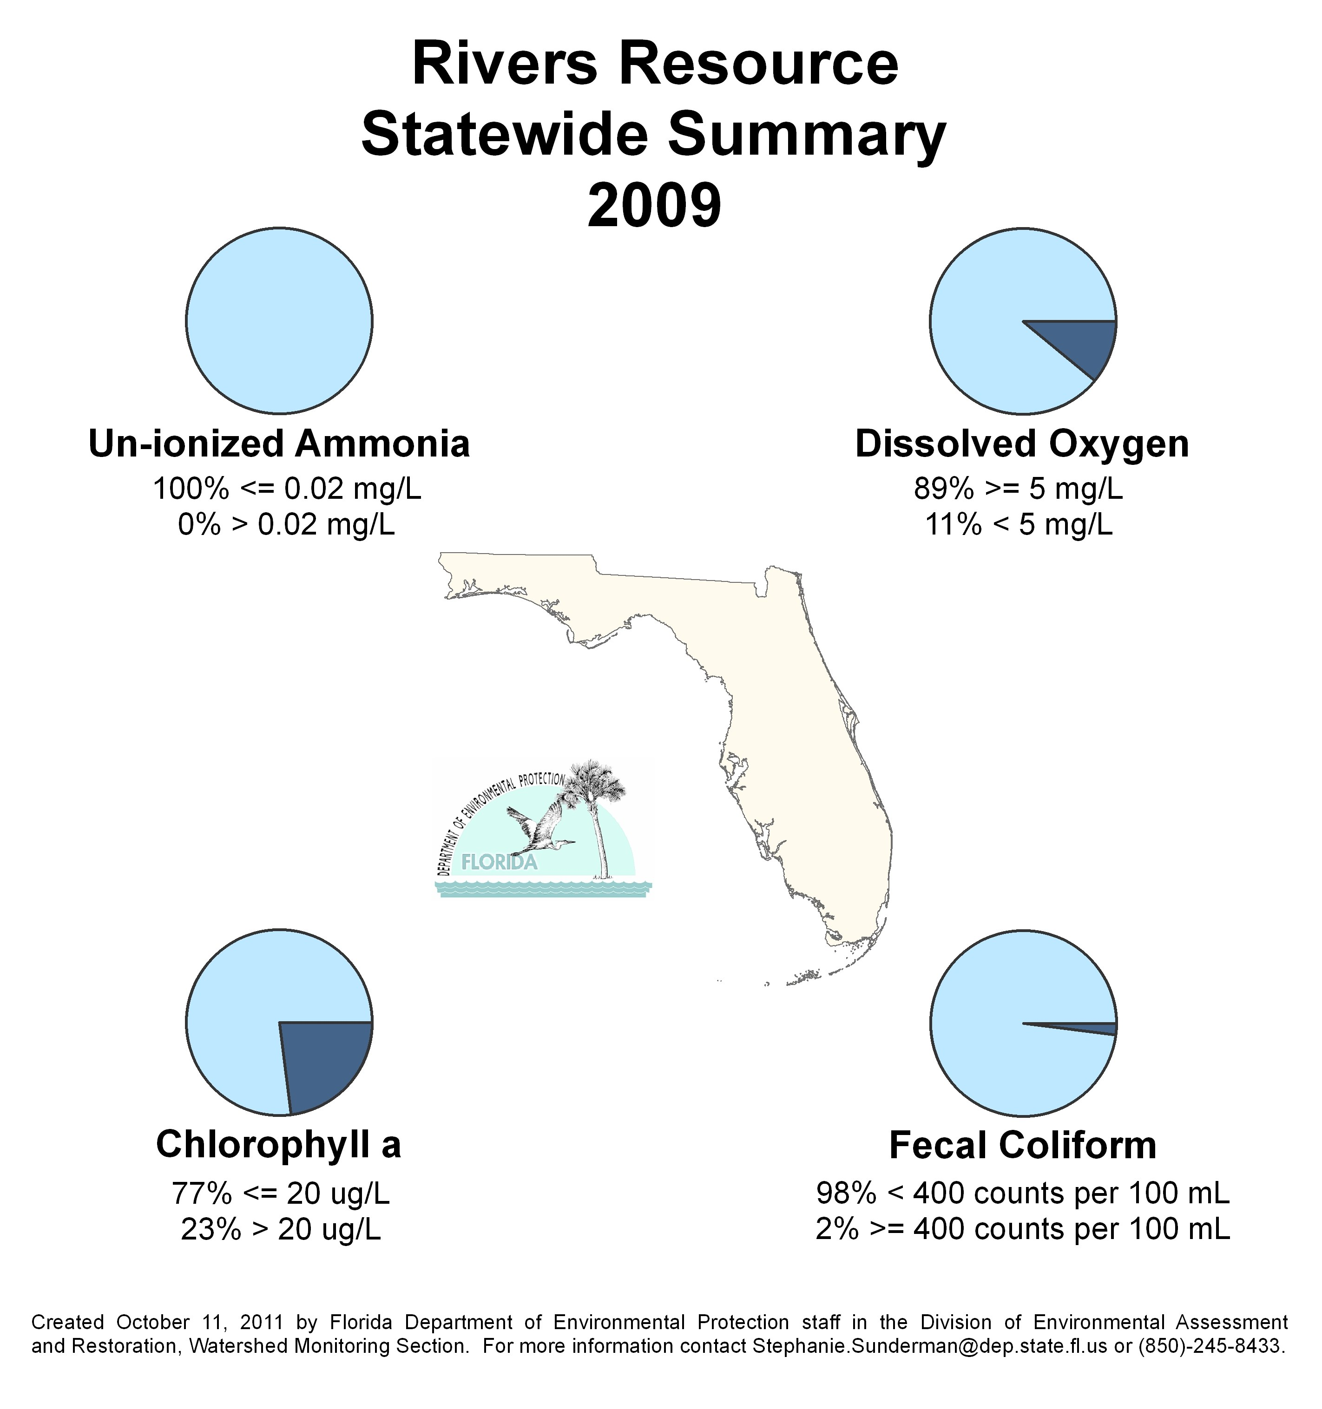
Figure B.1. 2009 Statewide Summary of River Results

Table B.2. 2010 Statewide Percentage of Rivers Meeting Threshold Values for Indicators Calculated Using Probabilistic Monitoring Design
Status Network Designated Use: Recreation and Aquatic Life Units: Miles
This is a 6-column table. Column 1 lists the analyte, Column 2 lists the target population, Column 3 lists the number of samples, Column 4 lists the percent meeting threshold, Column 5 lists the percent not meeting the threshold, and Column 6 lists the assessment period.
Analyte | Target Population (miles) | Number of Samples | % Meeting Threshold | % Not Meeting Threshold | Assessment Period
Chlorophyll a | 3,927 | 60 | 97 | 3 | 2010
Un-ionized Ammonia | 3,927 | 60 | 98 | 2 | 2010
Fecal Coliform | 3,927 | 60 | 91 | 9 | 2010
DO | 3,927 | 60 | 64 | 36 | 2010

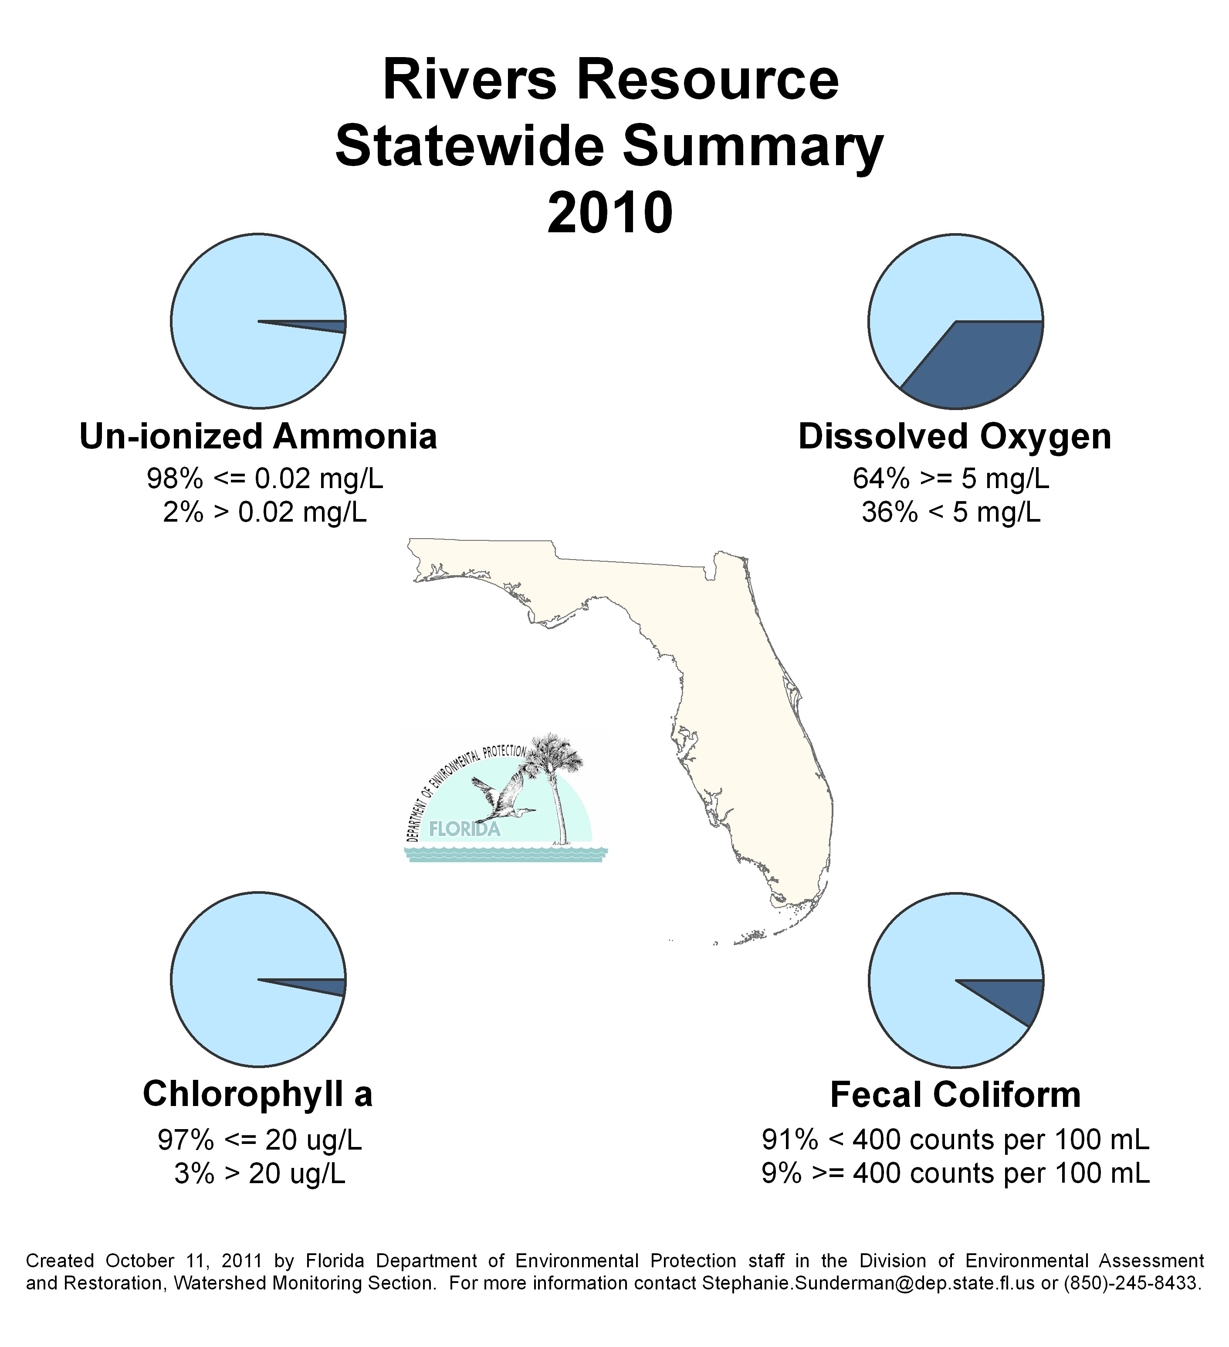
Figure B.2. 2010 Statewide Summary of River Results

Table B.3. 2009 Statewide Percentage of Streams Meeting Threshold Values for Indicators Calculated Using Probabilistic Monitoring Design
Status Network Designated Use: Recreation and Aquatic Life Units: Miles
This is a 6-column table. Column 1 lists the analyte, Column 2 lists the target population, Column 3 lists the number of samples, Column 4 lists the percent meeting threshold, Column 5 lists the percent not meeting the threshold, and Column 6 lists the assessment period.
¹ Miles
Analyte | Target Population¹ | Number of Samples | % Meeting Threshold | % Not Meeting Threshold | Assessment Period
Chlorophyll a | 24,732 | 51 | 74 | 26 | 2009
Un-ionized Ammonia | 24,732 | 51 | 100 | 0 | 2009
Fecal Coliform | 24,732 | 51 | 71 | 29 | 2009
DO | 24,732 | 51 | 66 | 34 | 2009

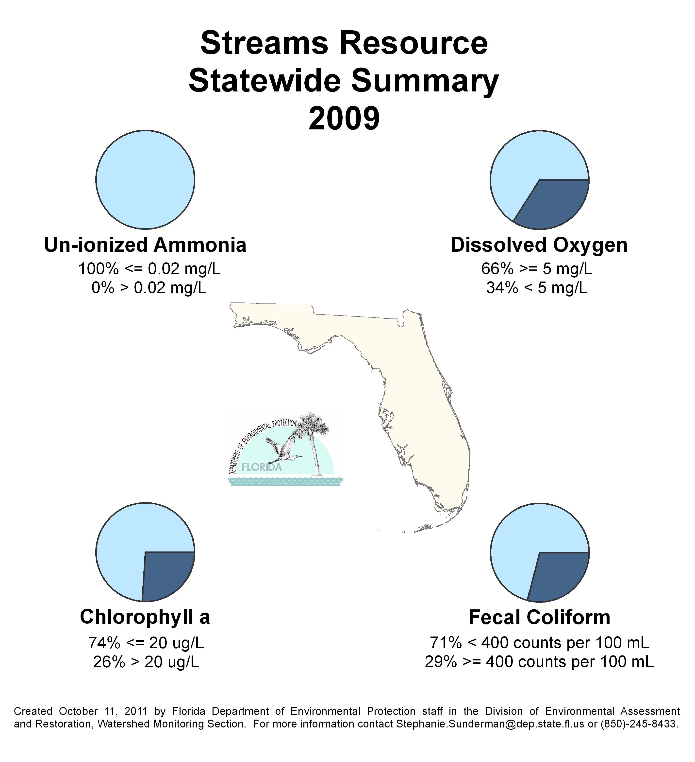
Figure B.3. 2009 Statewide Summary of Stream Results

Table B.4. 2010 Statewide Percentage of Streams Meeting Threshold Values for Indicators Calculated Using Probabilistic Monitoring Design
Status Network Designated Use: Recreation and Aquatic Life Units: Miles
This is a 6-column table. Column 1 lists the analyte, Column 2 lists the target population, Column 3 lists the number of samples, Column 4 lists the percent meeting threshold, Column 5 lists the percent not meeting the threshold, and Column 6 lists the assessment period.
Analyte | Target Population (miles) | Number of Samples | % Meeting Threshold | % Not Meeting Threshold | Assessment Period
Chlorophyll a | 16,861 | 57 | 93 | 7 | 2010
Un-ionized Ammonia | 16,861 | 57 | 98 | 2 | 2010
Fecal Coliform | 16,861 | 57 | 87 | 13 | 2010
DO | 16,861 | 57 | 68 | 32 | 2010

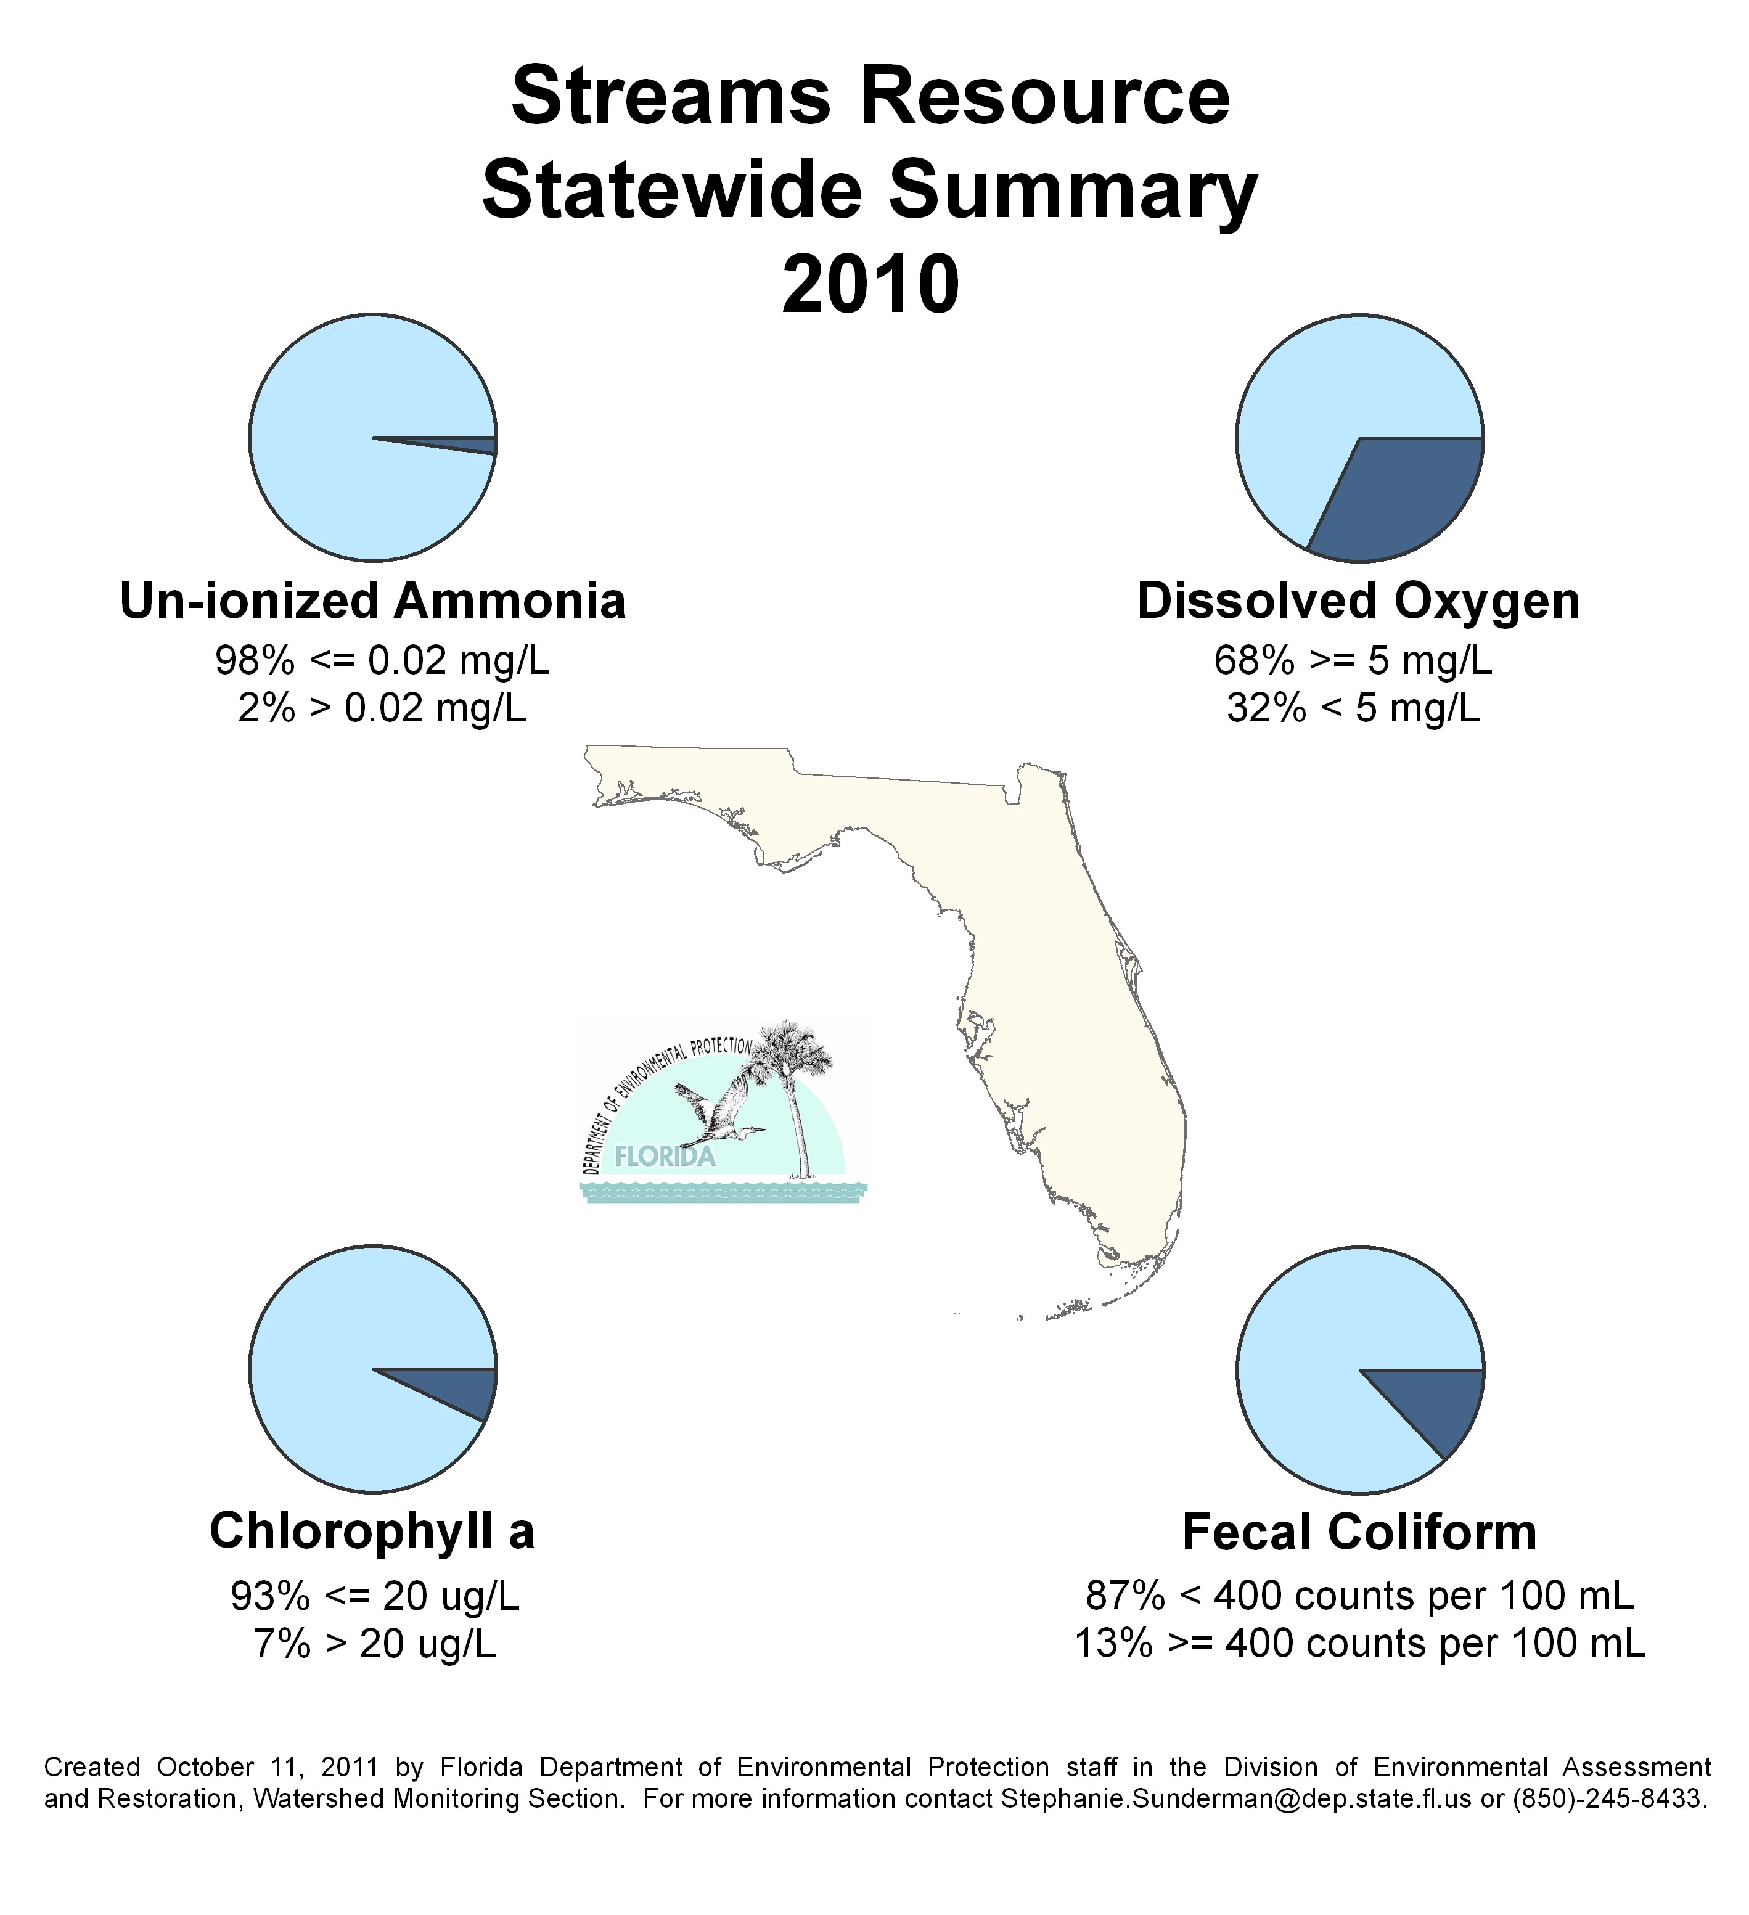
Figure B.4. 2010 Statewide Summary of Stream Results

Table B.5. 2009 Statewide Percentage of Large Lakes Meeting Threshold Values for Indicators Calculated Using Probabilistic Monitoring Design
Status Network Designated Use: Recreation and Aquatic Life Units: Lakes
This is a 6-column table. Column 1 lists the analyte, Column 2 lists the target population, Column 3 lists the number of samples, Column 4 lists the percent meeting threshold, Column 5 lists the percent not meeting the threshold, and Column 6 lists the assessment period.
Analyte | Target Population (lakes) | Number of Samples | % Meeting Threshold | % Not Meeting Threshold | Assessment Period
Trophic State Index | 1,918 | 60 | 73 | 27 | 2009
Un-ionized Ammonia | 1,918 | 60 | 97 | 3 | 2009
Fecal Coliform | 1,918 | 60 | 97 | 3 | 2009
DO | 1,918 | 60 | 89 | 11 | 2009

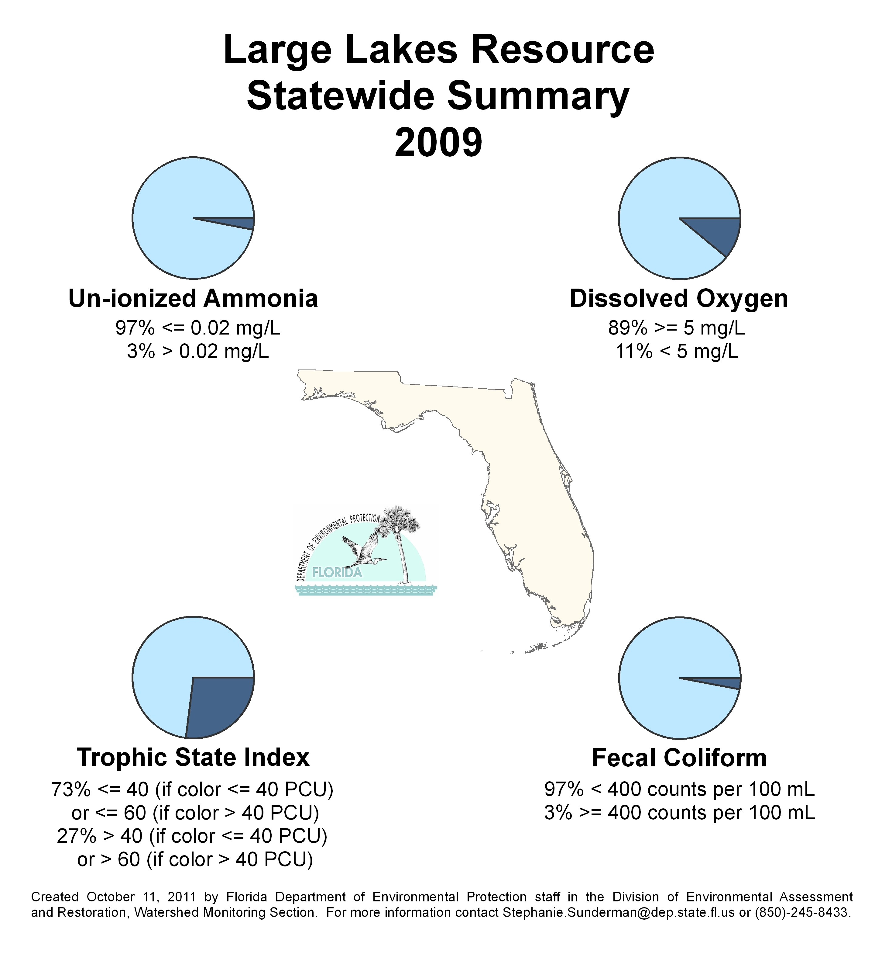
Figure B.5. 2009 Statewide Summary of Large Lake Results

Table B.6. 2010 Statewide Percentage of Large Lakes Meeting Threshold Values for Indicators Calculated Using Probabilistic Monitoring Design
Status Network Designated Use: Recreation and Aquatic Life Units: Lakes
This is a 6-column table. Column 1 lists the analyte, Column 2 lists the target population, Column 3 lists the number of samples, Column 4 lists the percent meeting threshold, Column 5 lists the percent not meeting the threshold, and Column 6 lists the assessment period.
Analyte | Target Population (lakes) | Number of Samples | % Meeting Threshold | % Not Meeting Threshold | Assessment Period
Trophic State Index | 1,725 | 60 | 57 | 43 | 2010
Un-ionized Ammonia | 1,725 | 60 | 93 | 7 | 2010
Fecal Coliform | 1,725 | 60 | 100 | 0 | 2010
DO | 1,725 | 60 | 93 | 7 | 2010

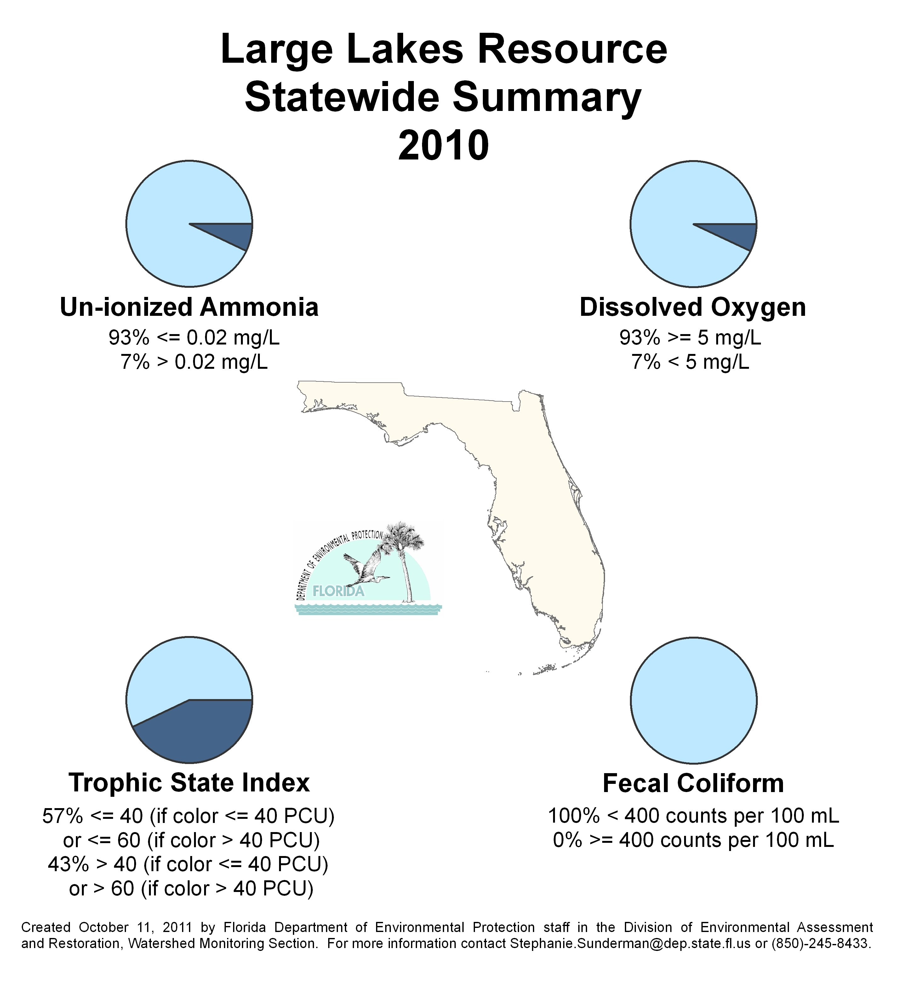
Figure B.6. 2010 Statewide Summary of Large Lake Results

Table B.7. 2009 Statewide Percentage of Small Lakes Meeting Threshold Values for Indicators Calculated Using Probabilistic Monitoring Design
Status Network Designated Use: Recreation and Aquatic Life Units: Lakes
This is a 6-column table. Column 1 lists the analyte, Column 2 lists the target population, Column 3 lists the number of samples, Column 4 lists the percent meeting threshold, Column 5 lists the percent not meeting the threshold, and Column 6 lists the assessment period.
Analyte | Target Population (lakes) | Number of Samples | % Meeting Threshold | % Not Meeting Threshold | Assessment Period
Trophic State Index | 3,708 | 58 | 83 | 17 | 2009
Un-ionized Ammonia | 3,708 | 58 | 100 | 0 | 2009
Fecal Coliform | 3,708 | 58 | 99 | 1 | 2009
DO | 3,708 | 58 | 95 | 5 | 2009

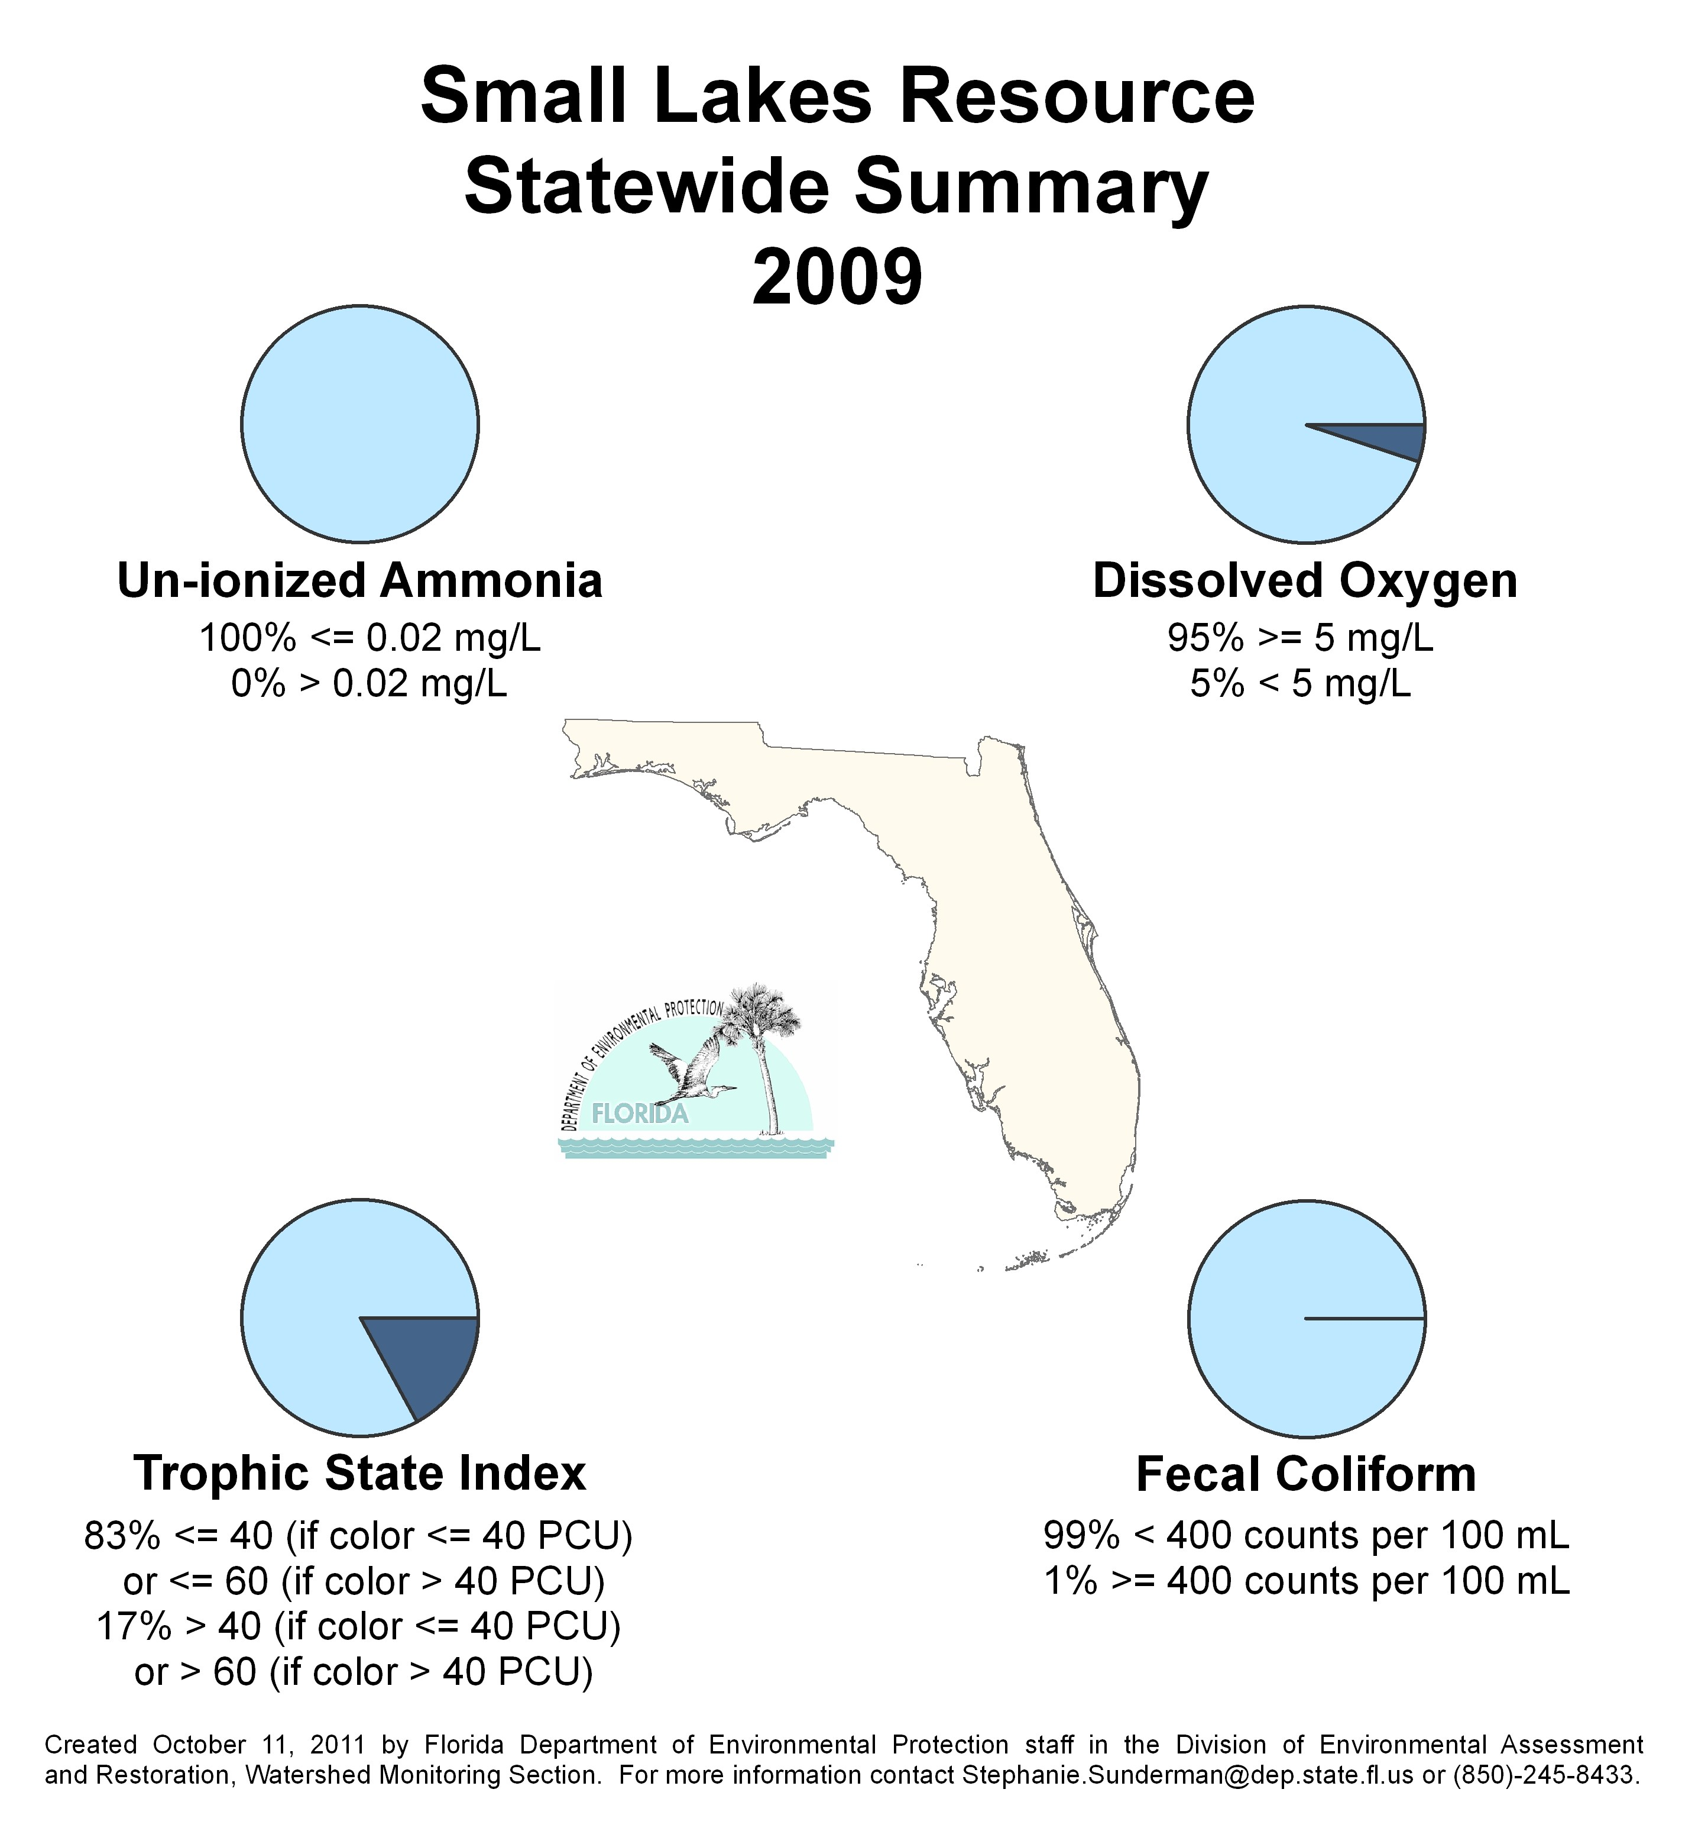
Figure B.7. 2009 Statewide Summary of Small Lake Results

Table B.8. 2010 Statewide Percentage of Small Lakes Meeting Threshold Values for Indicators Calculated Using Probabilistic Monitoring Design
Status Network Designated Use: Recreation and Aquatic Life Units: Lakes
This is a 6-column table. Column 1 lists the analyte, Column 2 lists the target population, Column 3 lists the number of samples, Column 4 lists the percent meeting threshold, Column 5 lists the percent not meeting the threshold, and Column 6 lists the assessment period.
Analyte | Target Population (lakes) | Number of Samples | % Meeting Threshold | % Not Meeting Threshold | Assessment Period
Trophic State Index | 2,676 | 49 | 88 | 12 | 2010
Un-ionized Ammonia | 2,676 | 49 | 100 | 0 | 2010
Fecal Coliform | 2,676 | 49 | 100 | 0 | 2010
DO | 2,676 | 49 | 100 | 0 | 2010

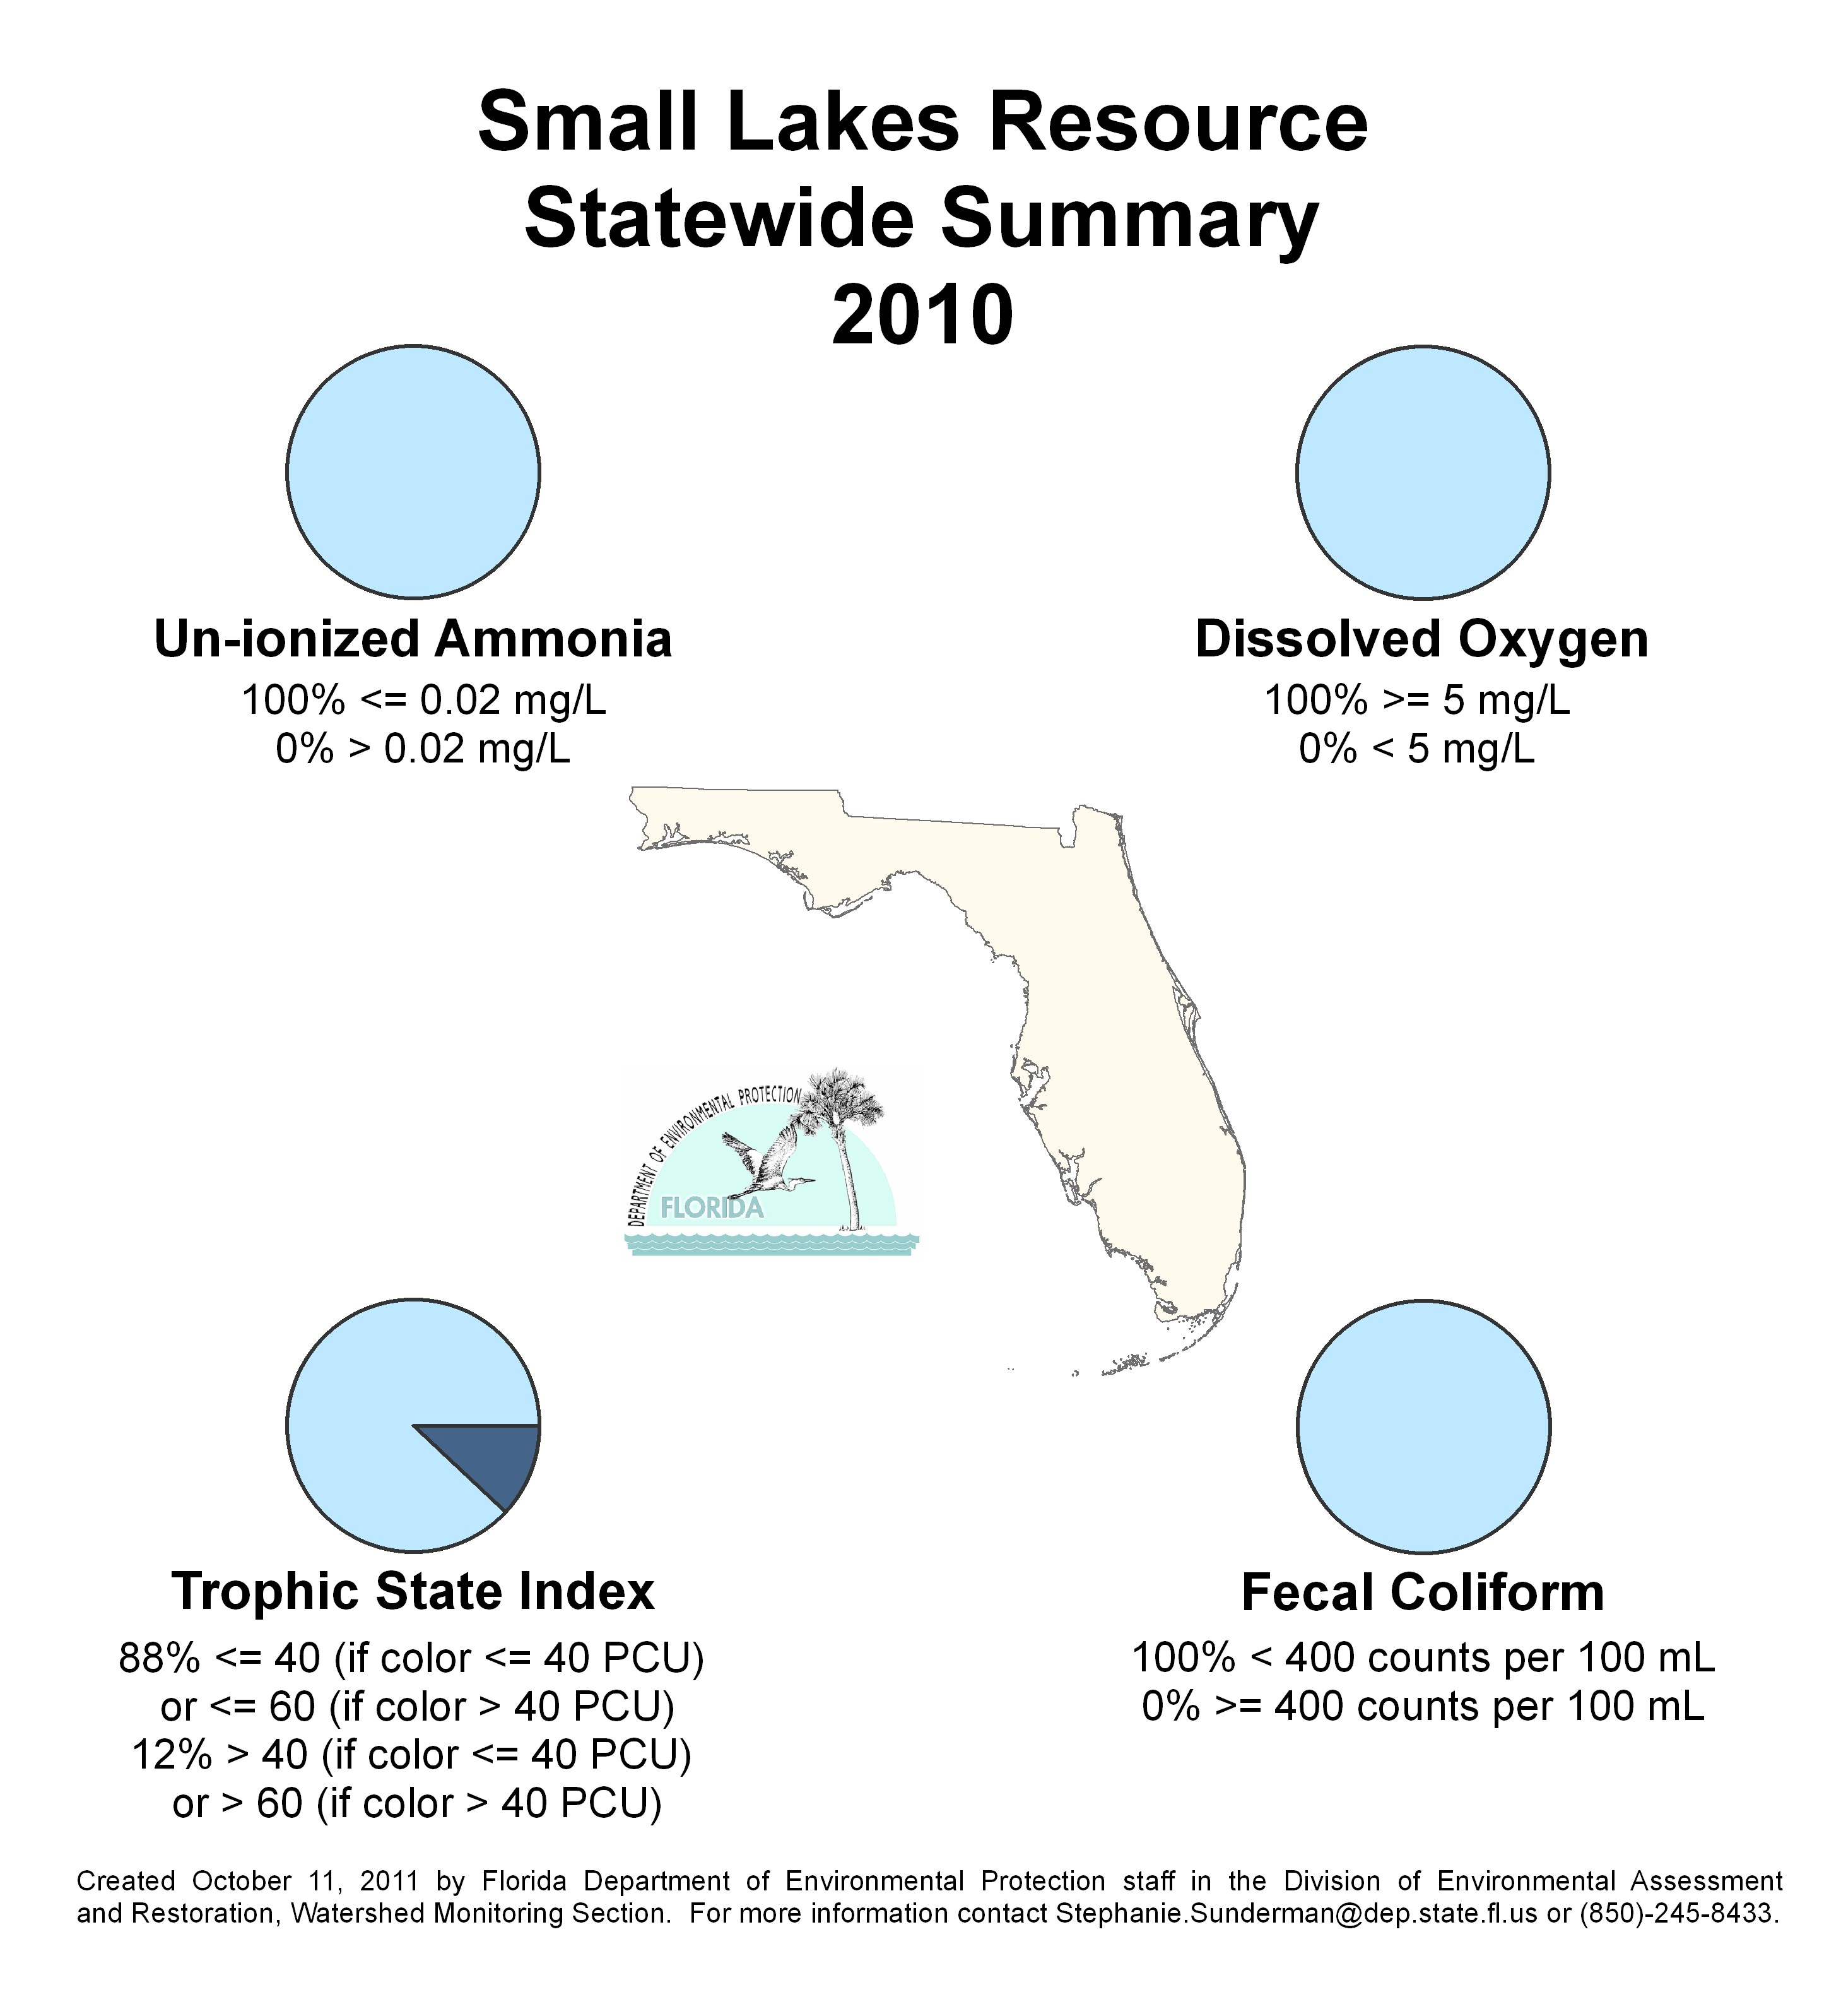
Figure B.8. 2010 Statewide Summary of Small Lake Results

The Status Network design focuses on the following two ground water resource types:
- Confined Aquifers
- Unconfined Aquifers

This appendix contains information on the following indicators for Confined and Unconfined Aquifers for the Status Network:
- Arsenic
- Cadmium
- Chromium
- Fluoride
- Lead
- Nitrate + nitrite
- Sodium
- Fecal coliform
- Total coliform

Table B.9 lists the threshold criteria for these ground water analytes, with the associated criterion for each analyte.

Table B.9. Status Monitoring Network Water Quality Criteria/Thresholds for Ground Water
This is a two-column table. Column 1 lists the indicator, and Column 2 lists the criterion/threshold.

¹ Appendix A provides additional information on whether the thresholds listed in the tables in this appendix are water quality standards or screening levels.
Indicator | Criterion/Threshold¹
Arsenic | ≤ 10 μg/L
Cadmium | ≤ 5 μg/L
Chromium | ≤ 100 μg/L
Lead | ≤ 15 μg/L
Nitrate–Nitrite | ≤ 10 mg/L
Sodium | ≤ 160 mg/L
Fluoride | ≤ 4 mg/L
Fecal Coliform Bacteria  (counts/100mL) | < 2 (sample maximum)
Total Coliform Bacteria  (counts/100mL) | ≤ 4 (sample maximum)

Table B.10. 2009 Statewide Percentage of Confined Aquifers Meeting Threshold Values for Indicators Calculated Using Probabilistic Monitoring Design
Status Network Designated Use: Primary Drinking Water Standards Units: Number of wells in list frame
This is a 6-column table. Column 1 lists the analyte, Column 2 lists the target population, Column 3 lists the number of samples, Column 4 lists the percent meeting threshold, Column 5 lists the percent not meeting the threshold, and Column 6 lists the assessment period.
Analyte | Target Population (wells) | Number of Samples | % Meeting Threshold | % Not Meeting Threshold | Assessment Period
Arsenic | 227 | 111 | 100 | 0 | 2009
Cadmium | 227 | 111 | 100 | 0 | 2009
Chromium | 227 | 111 | 100 | 0 | 2009
Lead | 227 | 111 | 100 | 0 | 2009
Nitrate-Nitrite | 227 | 111 | 100 | 0 | 2009
Sodium | 227 | 111 | 95 | 5 | 2009
Fluoride | 227 | 111 | 100 | 0 | 2009
Fecal Coliform | 227 | 111 | 100 | 0 | 2009
Total Coliform | 227 | 111 | 93 | 7 | 2009

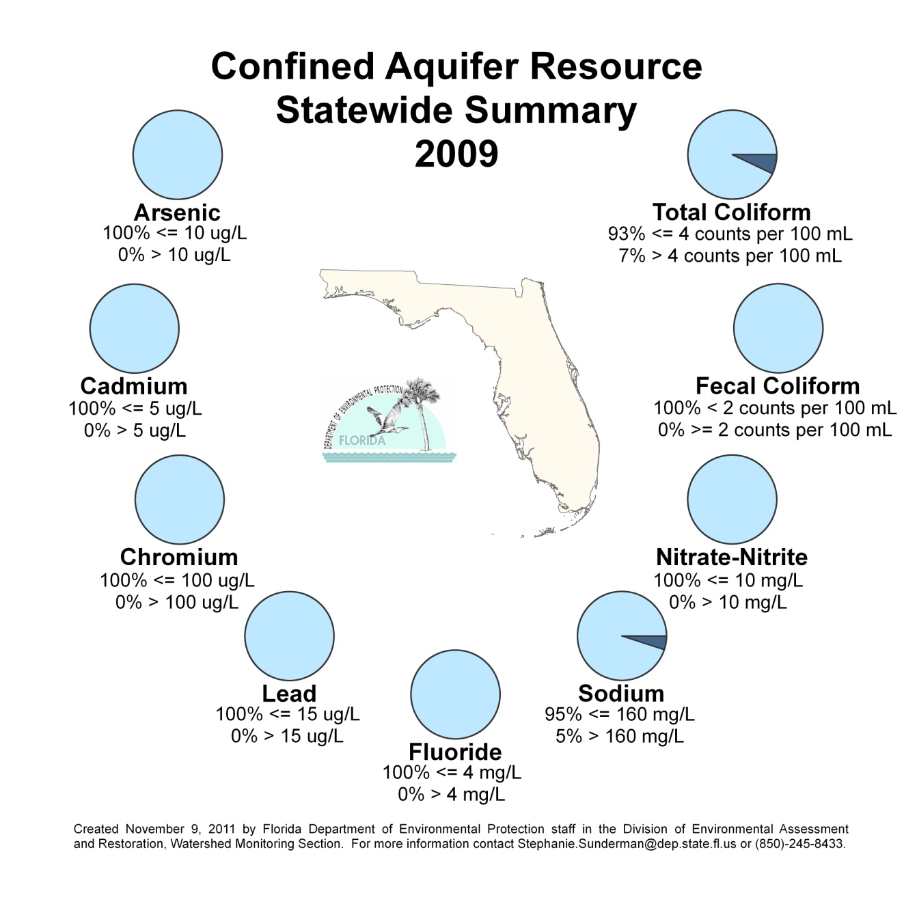
Figure B.9. 2009 Statewide Summary of Confined Aquifer Results

Table B.11. 2010 Statewide Percentage of Confined Aquifers Meeting Threshold Values for Indicators Calculated Using Probabilistic Monitoring Design
Status Network Designated Use: Primary Drinking Water Standards Units: Number of wells in list frame
This is a 6-column table. Column 1 lists the analyte, Column 2 lists the target population, Column 3 lists the number of samples, Column 4 lists the percent meeting threshold, Column 5 lists the percent not meeting the threshold, and Column 6 lists the assessment period.
Analyte | Target Population (wells) | Number of Samples | % Meeting Threshold | % Not Meeting Threshold | Assessment Period
Arsenic | 380 | 112 | 97 | 3 | 2010
Cadmium | 380 | 112 | 100 | 0 | 2010
Chromium | 380 | 112 | 100 | 0 | 2010
Lead | 380 | 112 | 100 | 0 | 2010
Nitrate-Nitrite | 380 | 112 | 100 | 0 | 2010
Sodium | 380 | 112 | 96 | 4 | 2010
Fluoride | 380 | 112 | 100 | 0 | 2010
Fecal Coliform | 380 | 112 | 100 | 0 | 2010
Total Coliform | 380 | 112 | 95 | 5 | 2010

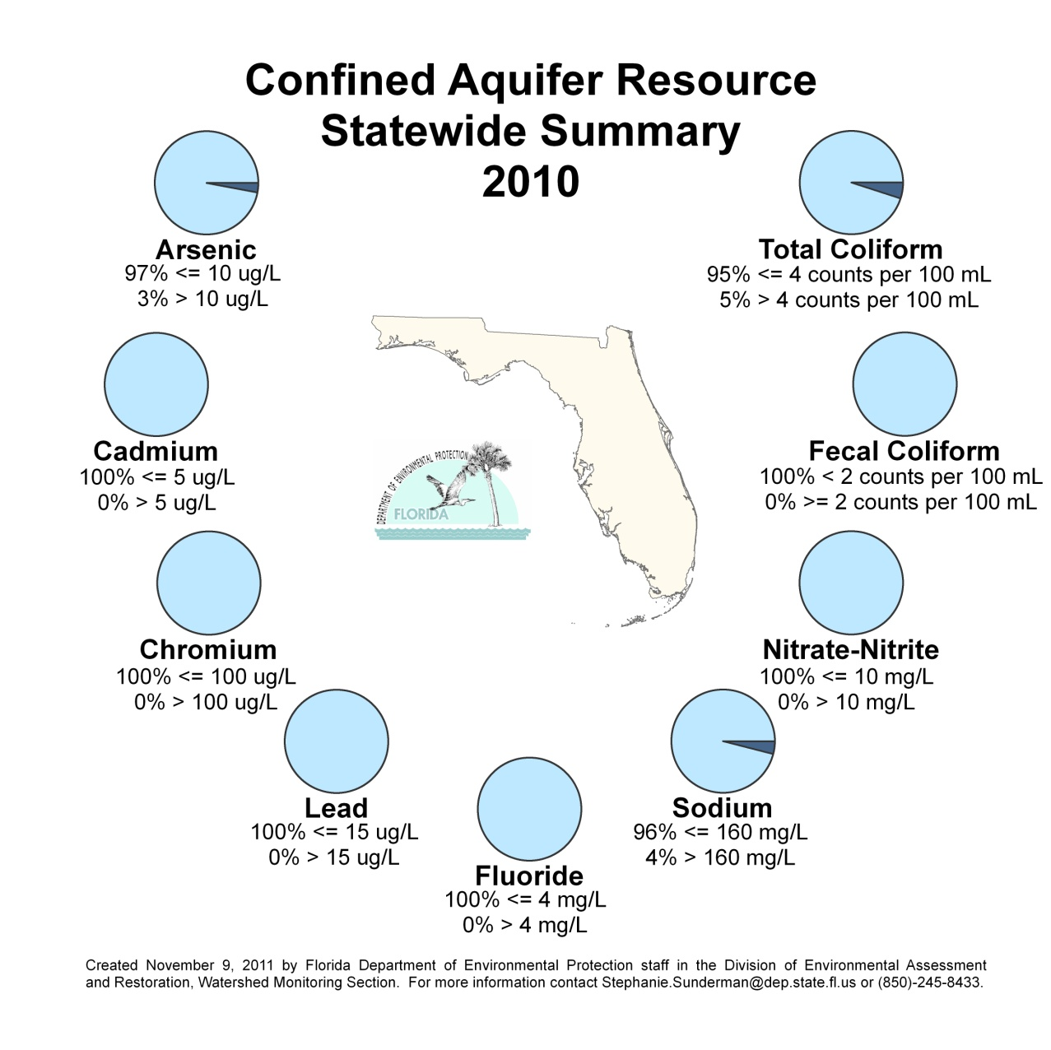
Figure B.10. 2010 Statewide Summary of Confined Aquifer Results

Table B.12. 2009 Statewide Percentage of Unconfined Aquifers Meeting Threshold Values for Indicators Calculated Using Probabilistic Monitoring Design
Status Network Designated Use: Primary Drinking Water Standards Units: Number of wells in list frame
This is a 6-column table. Column 1 lists the analyte, Column 2 lists the target population, Column 3 lists the number of samples, Column 4 lists the percent meeting threshold, Column 5 lists the percent not meeting the threshold, and Column 6 lists the assessment period.
Analyte | Target Population (wells) | Number of Samples | % Meeting Threshold | % Not Meeting Threshold | Assessment Period
Arsenic | 280 | 120 | 100 | 0 | 2009
Cadmium | 280 | 120 | 100 | 0 | 2009
Chromium | 280 | 120 | 100 | 0 | 2009
Lead | 280 | 120 | 98 | 2 | 2009
Nitrate-Nitrite | 280 | 120 | 100 | 0 | 2009
Sodium | 280 | 120 | 98 | 2 | 2009
Fluoride | 280 | 120 | 100 | 0 | 2009
Fecal Coliform | 280 | 120 | 96 | 4 | 2009
Total Coliform | 280 | 120 | 89 | 11 | 2009

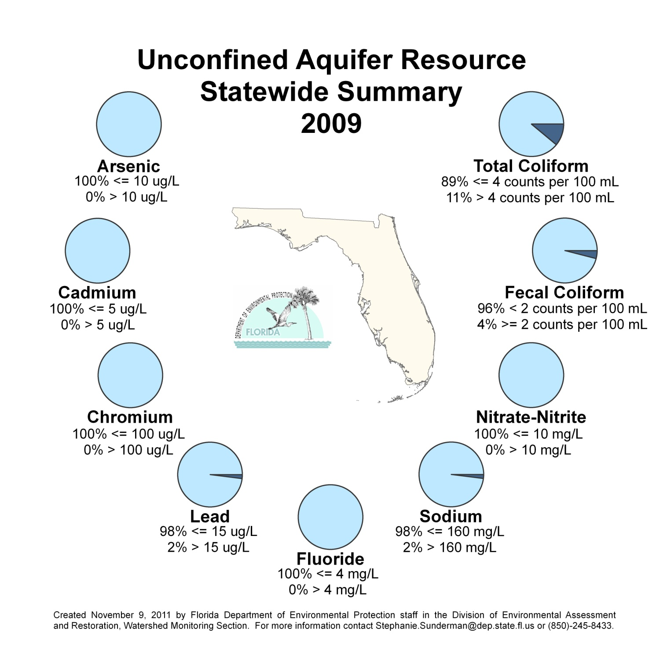
Figure B.11. 2009 Statewide Summary of Unconfined Aquifer Results

Table B.13. 2010 Statewide Percentage of Unconfined Aquifers Meeting Threshold Values for Indicators Calculated Using Probabilistic Monitoring Design
Status Network Designated Use: Primary Drinking Water Standards Units: Number of wells in list frame
This is a 6-column table. Column 1 lists the analyte, Column 2 lists the target population, Column 3 lists the number of samples, Column 4 lists the percent meeting threshold, Column 5 lists the percent not meeting the threshold, and Column 6 lists the assessment period.
Analyte | Target Population (wells) | Number of Samples | % Meeting Threshold | % Not Meeting Threshold | Assessment Period
Arsenic | 381 | 120 | 99 | 1 | 2010
Cadmium | 381 | 120 | 100 | 0 | 2010
Chromium | 381 | 120 | 100 | 0 | 2010
Lead | 381 | 120 | 98 | 2 | 2010
Nitrate-Nitrite | 381 | 120 | 97 | 3 | 2010
Sodium | 381 | 120 | 99 | 1 | 2010
Fluoride | 381 | 120 | 100 | 0 | 2010
Fecal Coliform | 381 | 120 | 96 | 4 | 2010
Total Coliform | 381 | 120 | 75 | 25 | 2010

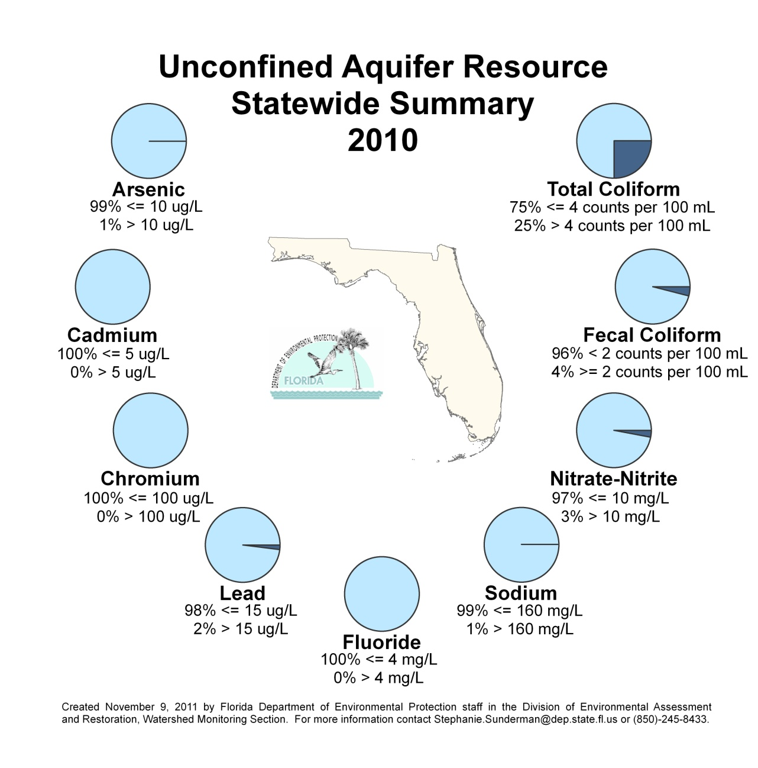
Figure B.12. 2010 Statewide Summary of Unconfined Aquifer Results

Appendix C. IWR Methodology for Evaluating Impairment

To identify impairments in the attainment of designated uses, the IWR is structured around four attainment categories, as follows:
- Aquatic life use support;
- Primary contact and recreation use support;
- Fish and shellfish consumption use support; and
- Drinking water use support and protection of human health.

The particular type of data and/or information required to determine use attainment varies by designated use and—in addition to discrete measurements of analytical results that reflect the physical and chemical characteristics of the water column and bacteriological data—includes biological data, fish consumption advisories, beach closure and advisory information, and information related to changes in the classification of shellfish-harvesting areas. At times information from field surveys and recons is also used to help identify impairments.
Numeric and narrative water quality criteria from the Florida Water Quality Standards (Rule 62-302, F.A.C.) are used to determine aquatic life use support, drinking water use support, and protection of human health for Class I, II, and III waters. In addition, the bacteriological criteria from the Florida Standards are used in conjunction with IWR assessments performed under the IWR for determinations of primary contact and recreation use support (Section 62-303.360, F.A.C.) for Class I, II, and III waters; and fish and shellfish consumption use support (Section 62-303.370, F.A.C.) for Class II waters.

Aquatic Life Based Use Attainment
The methodology described in Rule 62-303, F.A.C., determines aquatic life based use attainment based on evaluation of the following three distinct types of data (Section 62-303.310, F.A.C.):
- Comparisons of discrete water quality measurements with specific numeric threshold values, consisting of comparisons with class-specific numeric criteria from the Florida Standards (and other, similarly worded numeric threshold values, as outlined in Section 62-303.320, F.A.C.);
- Comparisons of results calculated for multimetric biological indices with waterbody type–specific biological assessment thresholds (as outlined in Section 62-303.330, F.A.C); and
- Comparisons of annual summary statistics with threshold values based on an interpretation of narrative criteria from the Florida Standards (as outlined in Section 62-303.350, F.A.C.)

These evaluations rely primarily on discrete sample data primarily obtained from Florida STORET; subject to data sufficiency and data quality requirements, exceedances of applicable thresholds indicate that aquatic life based use attainment is not met.

Primary Contact and Recreation Use Attainment
The methodology described in Rule 62-303, F.A.C., determines primary contact and recreation use attainment based on the evaluation of the following types of information (Section 62-303.360, F.A.C.):
- Comparisons of discrete water quality measurements with specific numeric thresholds values for bacteria, consisting of comparisons with the relevant class-specific numeric criteria from the Florida Standards (and other, similarly worded numeric threshold values, as outlined in Section 62-303.320, F.A.C.);
- Evaluation of beach closure, or beach advisories or warning, information; this information must be based on bacteriological data, issued by the appropriate governmental agency; and
- Comparison of summary measures of bacteriological data with threshold values described in Section 62-303.360, F.A.C.

For assessment purposes using discrete sample data for bacteria, FDOH reports data directly to Florida STORET; beach advisory and beach closure information is received directly from FDOH. Subject to data sufficiency and data quality requirements, exceedances of applicable thresholds indicate that primary contact and recreational use attainment is not met.

Fish and Shellfish Consumption Use Attainment
The evaluation of fish and shellfish consumption use attainment relies on the following evaluation of both quantitative and qualitative information (as described in Section 62-303.370, F.A.C.):
- Comparisons of discrete water quality measurements with specific quantitative threshold values for bacteria consisting of comparisons with the relevant class-specific numeric criteria from the Florida Standards (and other, similarly worded numeric threshold values, as outlined in Section 62-303.320, F.A.C.);
- Evaluation of fish advisory information issued by FDOH, or other authorized governmental entity; and
- Evaluation of shellfish-harvesting actions taken by FDACS, provided those actions were based on bacteriological contamination or water quality data).

Assessments performed under the IWR that are based on the evaluation of discrete sampling results to determine fish and shellfish use attainment rely on data reported to Florida STORET by FDACS (as well as other by data providers statewide). FDOH issues fish consumption advisories for surface waters based on mercury levels found in fish tissue studies. The Department receives information related to fish advisories directly from FDOH; in addition, information related to shellfish area actions is received directly from FDACS.
When a Class I, II, or III waterbody fails to meets its applicable Class II water quality criteria for bacteriological quality, the waterbody is assessed as impaired under the IWR. Subject to data sufficiency and data quality requirements, exceedances of applicable thresholds indicate that the aquatic life–based use attainment is not met.
In addition, if FDOH has issued a fish consumption advisory, or if FDACS has classified a Class II waterbody segment as anything other than approved for shellfish harvesting or propagation, that segment is verified as impaired, and determined not to meet its designated use.

Drinking Water Use Attainment
The evaluation of drinking water use attainment is based on the following type of information (Section 62-303.380, F.A.C.):
- Comparisons of discrete water quality measurements with threshold values consisting of comparisons with class-specific numeric criteria from the Florida Standards (and other, similarly worded numeric threshold values, as outlined in Section 62-303.320, F.A.C.).

Evaluation and Determination of Use Attainment

Exceedances of Numeric Criteria from the Florida Standards
Table C.1 lists analytes for which numeric criteria in the Florida Standards exist and counts of sample results available for assessments performed under the IWR.

Table C.1. Sample Counts for Analytes Having Numeric Criteria in the Florida Standards
This is a two-column table. Column 1 lists the analyte, and Column 2 lists the number of observations.

Analyte | Number of Observations
2,4-D | 42
Anthracene | 228
Silver | 22,718
Aluminum | 944
Aldrin | 812
Alkalinity | 83,108
Gross Alpha | 29
Acenaphthene | 190
Arsenic | 31,737
Barium | 1,329
Beta Benzenehexachloride  (β-BHC) | 210
Cadmium | 4,666
Chlordane | 804
Chloride | 8,107
Chlorine | 46
Cyanide | 121
Specific Conductance | 226,540
Chlorophenol | 56
Chromium 6 | 23
Copper | 7,673
2,4-Dichlorophenol | 182
DDT | 724
Demeton | 609
Detergents | 19
Dieldrin | 835
Dissolved Solids | 4,785
2,4-Dinitrophenol | 178
Dissolved Oxygen | 390,051
Endosulfan | 833
Endrin | 800
Fluoride | 39,535
Fecal Coliform | 267,900
Iron | 34,767
Fluoranthene | 227
Fluorene | 191
Guthion | 190
Heptachlor | 818
Mercury | 3,153
Lindane | 885
Malathion | 766
Mirex | 195
Manganese | 205
Methoxychlor | 702
Nickel | 1,922
Nitrate | 1,503
Oil/Grease | 282
Parathion | 7
Lead | 5,964
Polychlorinated Biphenyls (PCBs) | 26
Pentachlorophenol | 220
Phenol | 975
Pyrene | 227
Radium | 29
Antimony | 6,928
Selenium | 18,104
Silvex | 12
Thallium | 6444
Toxaphene | 819
Turbidity | 172,601
Un-ionized Ammonia | 93,290
Zinc | 5,433

Since the numeric water quality criteria from Rule 62-302, F.A.C., are class and waterbody–type specific, segments are first classified by their appropriate waterbody class and as one of four waterbody types—stream (including springs), lake, estuary, or coastal. For each analyte having a criterion in the Florida Standards, four-day station-median concentrations are calculated, and these values are then compared with the applicable class-specific criterion values in the Florida Standards (in some instances, however, the IWR specifies the use of daily values, rather than the four-day station median).
For waters assessed under Subsection 62-303.320(1), F.A.C., for each segment and analyte combination, the count of the number of samples and exceedances of the applicable criterion from the Florida Standards is calculated, and the exceedance count is compared with the listing threshold value for the corresponding sample size. The listing thresholds represent the minimum number of samples not meeting the applicable water quality criterion necessary to obtain the required confidence levels for samples of known sizes and to place an assessed segment on the Planning List and Verified List (Tables 1 and 3, respectively, of Subsection 62-303.320[1], F.A.C.). Comparisons performed for acute toxicity-based exceedances, or exceedances of synthetic organics and pesticides, have a lower listing threshold of more than a single exceedance in any consecutive three-year period.
Subject to data sufficiency requirements, a waterbody segment assessed under Subsection 62-303.320(1), F.A.C., is placed on the Planning List if there are a sufficient number of samples to attain at least 80% confidence that the actual criterion exceedance rate was greater than or equal to 10%. Waters placed on the Planning List are subject to additional data collection and subsequent review. Sample size requirements for placing a waterbody segment on the Planning List include a minimum of 10 samples from the 10-year period preceding the Planning List assessment (waters may also be placed on the Planning List if there are at least 3 exceedances of the applicable water quality criterion when this sample size requirement is not met).
To place a waterbody segment assessed under Subsection 62-303.420(2), F.A.C., on the Verified List, the number of samples must be sufficient to attain at least a 90% confidence that the actual criterion exceedance rate was greater than or equal to 10%. Sample size requirements for placing a waterbody segment on the Verified List include a minimum of at least 20 samples from the last 7.5 years preceding the Verified List assessment (however, waters may be placed on the Verified List if there are at least 5 exceedances of the applicable water quality criterion when the sample size requirement is not met).

Interpretation of Narrative Nutrient Criterion
The Florida Standards also include a narrative nutrient criterion rather than a numeric value for nutrient thresholds. This narrative criterion states, “In no case shall nutrient concentrations of a body of water be altered so as to cause an imbalance in natural populations of aquatic flora or fauna.” In Section 62-303.350, F.A.C., the IWR provides a working interpretation of the criterion. Under this interpretation, annual mean chlorophyll a concentrations (for segments that are not lakes) and annual mean TSI (for lake segments) are the primary means for assessing whether a waterbody should be further assessed for nutrient impairment, as follows:
- For streams assessed under Section 62-303.351, F.A.C., nutrient enrichment is indicated when the annual mean chlorophyll a concentrations are greater than 20 μg/L, or if annual mean chlorophyll a concentrations have increased by more than 50% over historical values for at least 2 consecutive years. The IWR interpretation of the narrative criterion for nutrients also incorporates consideration of direct evidence and additional information, when such information is available, indicative of an imbalance in flora or fauna due to nutrient enrichment, such as algal blooms, excessive macrophyte growth, a decrease in the distribution (either in density or aerial coverage) of seagrasses or other submerged aquatic vegetation, changes in algal species richness, or excessive diel oxygen swings.
- Section 62-303.352, F.A.C., of the IWR provides the following narrative nutrient interpretation for lakes:
- For lakes having a mean color greater than 40 PCUs, an annual mean TSI exceeding 60 suggests potential nutrient enrichment; and
- For lakes having a mean color less than or equal to 40 PCUs, an annual mean TSI exceeding 40 indicates potential nutrient enrichment.

Potential nutrient enrichment is also indicated for any lake by a statistically significant increase in TSI over the assessment period, or if TSI values increased by 10 units over historical values.
- In estuarine areas and open coastal waters (Section 62-303.353, F.A.C.), nutrient enrichment is indicated when the annual mean chlorophyll a concentrations are greater than 11 μg/L, or if annual mean chlorophyll a concentrations have increased by more than 50% over historical values for at least 2 consecutive years.

Exceedances of Biological Thresholds
Biological assessment is an applied scientific discipline that uses the response of resident aquatic biological communities to various stressors as a method of evaluating ecosystem health. The rationale in using bioassessment methodology to characterize surface water quality status and attainment of designated uses recognizes the fact that biological components of the environment can manifest long-term water quality conditions. Thus these components can potentially provide a more comprehensive indication of a waterbody’s health than can be characterized by discrete chemical or physical measurements alone.
Bioassessment results are particularly significant because biota inhabiting a waterbody function as continual natural monitors of environmental quality, capable of detecting the effects of both episodic, as well as cumulative, water quality, hydrologic, and habitat alterations. Monitoring the composition, abundance, and health of these natural communities enhances the state’s ability to evaluate the health of its waters.
In conjunction with assessments performed under the IWR, bioassessment tools can often provide a direct measure of whether the designated aquatic life use, a “well-balanced population of fish and wildlife,” is being attained (Section 62.302-400, F.A.C.). In addition to their use as an adjunct to physical and chemical water quality measurements to determine the impairment status of waterbody segments, bioassessment tools often can provide insights into appropriate restoration strategies.

Metrics Used
Bioassessment tools used in conjunction with assessments performed under the IWR incorporate multimetric methods to quantify biological community structure or function that responds in a predictable manner to changes in the environment. When multimetric methods are used, individual metrics (e.g., number of long-lived taxa, number of sensitive taxa, percent filter feeders, percent clingers) are determined, and the results of the individual metrics are combined into a single dimensionless, multimetric index. Such indices offer potential advantages over the use of individual metrics in that they can integrate multiple nonredundant measures into a single score that reflects a wider range of biological information.
The SCI and BioRecon are two examples of multimetric indices used to in conjunction with IWR assessments to quantify the health of rivers and streams based on the biological health of macroinvertebrates.
Recalibrations of the SCI and the BioRecon methods completed in 2007 involved the use of the HDG, which ranks sites based on independent assessments of habitat quality, degree of hydrologic disturbance, water quality, and human land use intensity. SCI and BioRecon scores calculated prior to August 2007 used a somewhat smaller, but similar, set of input metrics than those that were ultimately included in the final recalibrated index; however, since both sets of scores represent valid biological assessments performed during discrete periods, both are used in assessments of biological health performed under the IWR.
Additional efforts in the development of multimetric indices for periphyton (attached algae) and phytoplankton (drifting algae) that incorporate the HDG have also been attempted, but significant relationships between human disturbance and biological response in these communities have not been established. The Department has since developed, and implemented, a RPS method to evaluate periphyton communities and continues to use chlorophyll a concentrations to quantify imbalances in phytoplankton communities.

Bioassessment Data Used
Only macroinvertebrate data from ambient sites located in surface waters of the state were used in the bioassessments included in water quality assessments performed under the IWR. Although sites designated as test and/or background sites for NPDES fifth-year inspections may be included, data from locations established to sample effluent outfalls from discharging facilities, or from monitoring sites not clearly established to collect ambient water quality data, are excluded from assessments performed for IWR purposes.
Site-specific habitat and physicochemical assessment (e.g., % suitable macroinvertebrate habitat, water velocities, extent of sand or silt smothering, and riparian [or streamside] buffer zone widths) provides adjunct information that can be important in identifying the stressors responsible for a failed bioassessment and is collected when a bioassessment is performed. This information is also evaluated in conjunction with IWR assessments and can be extremely useful in a definitive determination of biological impairment, since biological communities sometimes respond to factors other than water quality, such as habitat disruption and hydrologic disturbances.
In using bioassessment data in conjunction with water quality assessments performed under the IWR, waterbody segments that are adversely affected only by pollution (e.g., a lack of habitat or hydrologic disruption) but not by a pollutant (a water quality exceedance) are not placed on the Verified List.
The Department’s SOPs provide definitions and specific methods for the generation and analysis of bioassessment data. Because these bioassessment procedures require specific training and expertise, the IWR additionally requires that persons conducting the bioassessments must comply with the quality assurance requirements of Rule 62-160, F.A.C.; attend at least eight hours of Department-sanctioned field training; and pass a Department-sanctioned field audit verifying that the sampler follows the applicable SOPs in Rule 62-160, F.A.C., before their bioassessment data can be used in conjunction with assessments performed under the IWR.

Stream Condition Index
A total SCI score was calculated by averaging the scores of the 10 metrics in the method: total number of taxa, total number of taxa belonging to the order Ephemeroptera, total taxa of the order Trichoptera, percent filter feeders, percent long-lived taxa, clinger taxa, percent dominant taxa, percent taxa in the Tanytarsini, percent sensitive taxa, and percent very tolerant taxa (see Table C.2 for calculations). A poor or very poor (or Category 3) rating based on the total score constituted a failed bioassessment, based on the IWR.

Table C.2. SCI Metrics for the Northeast, Panhandle, and Peninsula Regions of Florida
This is a four-column table. Column 1 lists the SCI metric, Column 2 lists the calculation for northeast Florida, Column 3 lists the calculation for the Panhandle region, and Column 4 lists the calculation for the Peninsula region.

SCI Metric | Northeast | Panhandle | Peninsula
Total taxa | 10 * (X–16)/26 | 10 * (X–16)/33 | 10 * (X–16)/25
Ephemeroptera taxa | 10 * X /3.5 | 10 * X /6 | 10 * X /5
Trichoptera taxa | 10 * X /6.5 | 10 * X /7 | 10 * X /7
% filterer | 10 * (X–1)/41 | 10 * (X–1)/44 | 10 * (X–1)/39
Long-lived taxa | 10 * X /3 | 10 * X /5 | 10 * X /4
Clinger taxa | 10 * X /9 | 10 * X /15.5 | 10 * X /8
% dominance | 10 – ( 10 * [ ( X–10)/44 ] ) | 10 – ( 10 * [ ( X–10)/33 ] ) | 10 – ( 10 * [ ( X–10)/44 ] )
% Tanytarsini | 10 * [ ln( X + 1) /3.3] | 10 * [ ln( X + 1) /3.3] | 10 * [ ln( X + 1) /3.3]
Sensitive taxa | 10 * X /11 | 10 * X /19 | 10 * X /9
% Very tolerant | 10 – (10 * [ ln( X + 1)/4.4 ] ) | 10 – (10 * [ ln( X + 1)/3.6 ] ) | 10 – (10 * [ ln( X + 1)/4.1 ] )

BioRecon
To establish an impairment rating based on BioRecon data, the six metrics as calculated in Table C.3 and the index thresholds in Table C.4 were used.

Table C.3. BioRecon Metrics for the Northeast, Panhandle, and Peninsula Regions of Florida
This is a four-column table. Column 1 lists the BioRecon metric, Column 2 lists the calculation for northeast Florida, Column 3 lists the calculation for the Panhandle region, and Column 4 lists the calculation for the Peninsula region.

BioRecon Metric | Northeast | Panhandle | Peninsula
Total taxa | (X–14)/23 | (X–16)/33 | (X–11)/25
Ephemeroptera taxa | X /3.5 | X /12 | X /5
Trichoptera taxa | X /6.5 | X /7 | X /7
Long–lived taxa | X /6 | X /10 | X /7
Clinger taxa | X /7 | X /15.5 | X /8
Sensitive taxa | X /11 | X /19 | X /9

Table C.4. BioRecon Sample Size and Index Range
This is a two-column table. Column 1 lists the BioRecon sample size and score, and Column 2 lists the index range.

BioRecon | Index Range
1 sample: Pass | (6–10)
1 sample: Fail | (0–6)
2 samples: Good | (7–10)
2 samples: Fair | (4–7)
2 samples: Poor | (0–4)

Appendix D: Impaired Lakes in Florida, Group 1–5 Basins
This is a five-column table. Column 1 lists the basin group, Column 2 lists the basin name, Column 3 lists the WBID number, Column 4 lists the waterbody name, and Column 5 lists the parameters causing impairment.

Note: The most up-to-date Verified List of impaired waters, by basin group, is available at the Department’s Watershed Assessment Program website.

Basin Group | Basin Name | WBID | Waterbody Name | Listed Parameters
Group 1 | Everglades West Coast | 3259W | Lake Trafford | DO, pH, TSI, Un-ionized Ammonia
Group 1 | Everglades West Coast | 3259Z | Little Hickory Bay | Mercury in Fish Tissue
Group 1 | Lake Okeechobee | 3212A | Lake Okeechobee | DO, Iron, Mercury in Fish Tissue, TSI, Turbidity
Group 1 | Lake Okeechobee | 3212B | Lake Okeechobee | Mercury in Fish Tissue, TSI, Turbidity
Group 1 | Lake Okeechobee | 3212C | Lake Okeechobee | DO, Iron, Mercury in Fish Tissue, TSI
Group 1 | Lake Okeechobee | 3212D | Lake Okeechobee | DO, Iron, Mercury in Fish Tissue, pH, TSI, Turbidity, Un-ionized Ammonia
Group 1 | Lake Okeechobee | 3212E | Lake Okeechobee | Alkalinity, Iron, Mercury in Fish Tissue, TSI, Turbidity
Group 1 | Lake Okeechobee | 3212F | Lake Okeechobee | Iron, Mercury in Fish Tissue, pH, TSI, Turbidity
Group 1 | Lake Okeechobee | 3212G | Lake Okeechobee | Mercury in Fish Tissue, TSI, Turbidity, Un-ionized Ammonia
Group 1 | Lake Okeechobee | 3212H | Lake Okeechobee | Iron, Mercury in Fish Tissue, pH, TSI, Turbidity
Group 1 | Lake Okeechobee | 3212I | Lake Okeechobee | Mercury in Fish Tissue, pH, TSI, Turbidity
Group 1 | Ochlockonee–St. Marks | 1297C | Lake Talquin | DO, Mercury in Fish Tissue, TSI
Group 1 | Ochlockonee–St. Marks | 1297D | Lake Talquin | DO, Mercury in Fish Tissue, TSI
Group 1 | Ochlockonee–St. Marks | 540A | Tallavanna Lake | TSI
Group 1 | Ochlockonee–St. Marks | 647C | Lake Killarney | DO
Group 1 | Ochlockonee–St. Marks | 689A | Lake Overstreet | DO
Group 1 | Ochlockonee–St. Marks | 689B | Lake Hall | DO
Group 1 | Ochlockonee–St. Marks | 756B | Lake Piney Z | DO, TSI
Group 1 | Ochlockonee–St. Marks | 756C | Lake Lafayette  (Lower Segment) | DO, TSI
Group 1 | Ochlockonee–St. Marks | 791N | Lake Miccosukee | DO, TSI
Group 1 | Ochlockonee–St. Marks | 807C | Lake Munson | DO, TSI, Turbidity
Group 1 | Ochlockonee–St. Marks | 878C | Lake Hiawatha | DO
Group 1 | Ochlockonee–St. Marks | 878D | Cascade Lake | DO
Group 1 | Ochlockonee–St. Marks | 889A | Moore Lake | DO, Mercury in Fish Tissue
Group 1 | Ochlockonee–St. Marks | 971A | Lake Erie | DO
Group 1 | Ochlockonee–St. Marks | 971B | Lake Weeks | DO
Group 1 | Ocklawaha | 2705B | Newnans Lake | DO, TSI, Turbidity, Un-ionized Ammonia
Group 1 | Ocklawaha | 2718B | Bivans Arm | TSI, TSI2, Turbidity
Group 1 | Ocklawaha | 2720A | Alachua Sink | Fecal Coliform, TSI, TSI2
Group 1 | Ocklawaha | 2723A | Cowpen Lake | Mercury in Fish Tissue
Group 1 | Ocklawaha | 2738A | Lockloosa Lake | TSI, TSI2
Group 1 | Ocklawaha | 2740B | Lake Ocklawaha | Mercury in Fish Tissue
Group 1 | Ocklawaha | 2741A | Wauberg Lake | TSI
Group 1 | Ocklawaha | 2749 | Orange Lake Reach | DO
Group 1 | Ocklawaha | 2749A | Orange Lake | DO, TSI
Group 1 | Ocklawaha | 2771A | Lake Eaton | DO, Mercury in Fish Tissue
Group 1 | Ocklawaha | 2779A | Mill Dam Lake | Mercury in Fish Tissue
Group 1 | Ocklawaha | 2782C | Lake Bryant | Mercury in Fish Tissue, TSI
Group 1 | Ocklawaha | 2785A | Smith Lake | Mercury in Fish Tissue
Group 1 | Ocklawaha | 2790A | Lake Weir | TSI
Group 1 | Ocklawaha | 2797A | Ella Lake | DO, Mercury in Fish Tissue
Group 1 | Ocklawaha | 2803A | Holly Lake | DO, Mercury in Fish Tissue
Group 1 | Ocklawaha | 2807 | Lake Yale Canal | DO, TSI
Group 1 | Ocklawaha | 2807A | Lake Yale | DO, TSI, TSI2
Group 1 | Ocklawaha | 2814A | Lake Griffin | DO, TSI, Un-ionized Ammonia
Group 1 | Ocklawaha | 2817B | Lake Eustis | DO, TSI, Un-ionized Ammonia
Group 1 | Ocklawaha | 2819A | Trout Lake | DO, TSI
Group 1 | Ocklawaha | 2821B | Lake Joanna | TSI
Group 1 | Ocklawaha | 2825A | Silver Lake | TSI
Group 1 | Ocklawaha | 2831B | Lake Dora | DO, TSI, Un-ionized Ammonia
Group 1 | Ocklawaha | 2832A | Lake Denham | DO, TSI
Group 1 | Ocklawaha | 2834C | Lake Beauclair | TSI
Group 1 | Ocklawaha | 2835D | Lake Apopka | TSI
Group 1 | Ocklawaha | 2837B | Lake Carlton | DO, TSI
Group 1 | Ocklawaha | 2838A | Lake Harris | DO, TSI
Group 1 | Ocklawaha | 2838B | Little Lake Harris | DO, TSI
Group 1 | Ocklawaha | 2839A | Lake Minneola | Mercury in Fish Tissue
Group 1 | Ocklawaha | 2839B | Lake Hiawatha | DO
Group 1 | Ocklawaha | 2839C | Lake Wilson | DO
Group 1 | Ocklawaha | 2839D | Lake Cherry | DO, Mercury in Fish Tissue, TSI
Group 1 | Ocklawaha | 2839M | Lake Louisa | DO, Mercury in Fish Tissue
Group 1 | Ocklawaha | 2839N | Lake Minnehaha | DO, Mercury in Fish Tissue
Group 1 | Ocklawaha | 2873C | Johns Lake | Mercury in Fish Tissue, TSI, TSI2
Group 1 | Suwannee | 3321A | Lake Octahatchee | Mercury in Fish Tissue
Group 1 | Suwannee | 3322A | Lake Cherry | Mercury in Fish Tissue
Group 1 | Suwannee | 3438A | Peacock Lake | DO
Group 1 | Suwannee | 3496A | Low Lake | DO
Group 1 | Suwannee | 3516A | Alligator Lake | DO, TSI
Group 1 | Suwannee | 3593A | Lake Crosby | Mercury in Fish Tissue
Group 1 | Suwannee | 3598D | Lake Sampson | Mercury in Fish Tissue
Group 1 | Suwannee | 3605G | Santa Fe Lake | DO, Mercury in Fish Tissue
Group 1 | Suwannee | 3605H | Lake Alto | Mercury in Fish Tissue
Group 1 | Suwannee | 3635A | Hampton Lake | Mercury in Fish Tissue
Group 1 | Suwannee | 3703A | Watermelon Pond | DO
Group 1 | Suwannee | 3731A | Lake Marion | DO
Group 1 | Tampa Bay | 1463M | Little Lake Wilson | Fecal Coliform, TSI
Group 1 | Tampa Bay | 1473W | Lake Juanita | TSI
Group 1 | Tampa Bay | 1473X | Mound Lake | TSI
Group 1 | Tampa Bay | 1473Y | Calm Lake | TSI
Group 1 | Tampa Bay | 1474V | Crescent Lake | TSI
Group 1 | Tampa Bay | 1474W | Lake Dead Lady | TSI
Group 1 | Tampa Bay | 1478H | Lake Reinheimer | TSI
Group 1 | Tampa Bay | 1486A | Lake Tarpon | DO, TSI
Group 1 | Tampa Bay | 1493E | Buck Lake | TSI
Group 1 | Tampa Bay | 1496A | Sunset Lake | TSI
Group 1 | Tampa Bay | 1516B | Lake Magdalene | TSI
Group 1 | Tampa Bay | 1530A | Moccasin Creek | DO, Fecal Coliform, TSI
Group 1 | Tampa Bay | 1574A | Alligator Lake | DO
Group 1 | Tampa Bay | 1579A | Bellows Lake (East Lake) | TSI
Group 1 | Tampa Bay | 1603D | Lake Chautauqua | DO
Group 1 | Tampa Bay | 1700A | Crescent Lake | DO
Group 1 | Tampa Bay | 1731A | Lake Maggiore | DO, TSI, Un-ionized Ammonia
Group 2 | Apalachicola–Chipola | 272 | Thompson Pond | TSI
Group 2 | Apalachicola–Chipola | 344 | Ocheesee Pond | DO
Group 2 | Apalachicola–Chipola | 51A | Dead LakeS | Mercury in Fish Tissue
Group 2 | Apalachicola–Chipola | 60 | Lake Seminole | TSI
Group 2 | Apalachicola–Chipola | 926A1 | Lake Mystic | Mercury in Fish Tissue
Group 2 | Lower St. Johns | 2213G | St. Johns River above Doctors Lake | Mercury in Fish Tissue, Thallium, TSI
Group 2 | Lower St. Johns | 2213H | St. Johns River above Julington Creek | Mercury in Fish Tissue, TSI
Group 2 | Lower St. Johns | 2213I | St. Johns River above  Black Creek | Silver, Mercury in Fish Tissue, TSI
Group 2 | Lower St. Johns | 2213J | St. Johns River above  Palmo Creek | Mercury in Fish Tissue, TSI
Group 2 | Lower St. Johns | 2213K | St. Johns River above Tocoi | Mercury in Fish Tissue, TSI
Group 2 | Lower St. Johns | 2213L | St. Johns River above Federal Point | DO, Mercury in Fish Tissue, TSI, TSI2
Group 2 | Lower St. Johns | 2308 | Eagle Run | DO, Fecal Coliform
Group 2 | Lower St. Johns | 2389 | Doctors Lake | TSI
Group 2 | Lower St. Johns | 2476B | Kingsley Lake | DO, TSI, TSI2
Group 2 | Lower St. Johns | 2509 | Lake Geneva | Lead, TSI
Group 2 | Lower St. Johns | 2509H | Lily Lake | Lead
Group 2 | Lower St. Johns | 2528B | Lake Sheelar | DO, TSI
Group 2 | Lower St. Johns | 2541 | Georges Lake | Mercury in Fish Tissue, TSI, TSI2
Group 2 | Lower St. Johns | 2543F | Lake Ross | Lead, TSI
Group 2 | Lower St. Johns | 2575 | Cue Lake | Mercury in Fish Tissue
Group 2 | Lower St. Johns | 2593A | Davis Lake | DO
Group 2 | Lower St. Johns | 2606B | Crescent Lake | Mercury in Fish Tissue, TSI
Group 2 | Lower St. Johns | 2615A | Dead Lake | Mercury in Fish Tissue
Group 2 | Lower St. Johns | 2617A | Lake Broward | Mercury in Fish Tissue
Group 2 | Lower St. Johns | 2630B | Lake Disston | Mercury in Fish Tissue, Lead
Group 2 | Lower St. Johns | 2659A | Lake Winona | TSI, TSI2
Group 2 | Lower St. Johns | 2667A | Lake Dias | TSI
Group 2 | Lower St. Johns | 2671A | Lake Daugharty | Mercury in Fish Tissue
Group 2 | Lower St. Johns | 2680A | Lake Molly | TSI
Group 2 | Middle St. Johns | 2892 | Lake Margaret | Mercury in Fish Tissue
Group 2 | Middle St. Johns | 2893A | Lake George | Mercury in Fish Tissue, TSI
Group 2 | Middle St. Johns | 2893D | Lake Monroe | DO, Mercury in Fish Tissue, TSI
Group 2 | Middle St. Johns | 2893H | Mullet Lake | Mercury in Fish Tissue
Group 2 | Middle St. Johns | 2893J | Mud Lake | Mercury in Fish Tissue
Group 2 | Middle St. Johns | 2894 | Lake Delancy | Mercury in Fish Tissue
Group 2 | Middle St. Johns | 2899B | Lake Kerr | Mercury in Fish Tissue, TSI
Group 2 | Middle St. Johns | 2905C | Wildcat Lake | Mercury in Fish Tissue
Group 2 | Middle St. Johns | 2912A | Lake Emporia | TSI, TSI2
Group 2 | Middle St. Johns | 2916B | South Grasshopper Lake | Mercury in Fish Tissue
Group 2 | Middle St. Johns | 2917 | Boyd Lake | Mercury in Fish Tissue
Group 2 | Middle St. Johns | 2921 | Lake Woodruff | Mercury in Fish Tissue
Group 2 | Middle St. Johns | 2921C | Lake Dexter | Mercury in Fish Tissue
Group 2 | Middle St. Johns | 2925A | Lake Ashby | Mercury in Fish Tissue, TSI
Group 2 | Middle St. Johns | 2929B | Lake Norris | Mercury in Fish Tissue
Group 2 | Middle St. Johns | 2929C | Lake Dorr | Mercury in Fish Tissue
Group 2 | Middle St. Johns | 2931 | Lake Winnemissett | TSI, TSI2
Group 2 | Middle St. Johns | 2953A | Broken Arrow Lake | TSI
Group 2 | Middle St. Johns | 2954 | Konomac Lake Reservoir | Mercury in Fish Tissue
Group 2 | Middle St. Johns | 2956A1 | Linden Lake | DO
Group 2 | Middle St. Johns | 2956E | Sand Lake | TSI
Group 2 | Middle St. Johns | 2961 | Lake Sylvan | Mercury in Fish Tissue
Group 2 | Middle St. Johns | 2964A | Lake Harney | DO, Mercury in Fish Tissue, TSI
Group 2 | Middle St. Johns | 2981 | Lake Jesup | TSI, Un-ionized Ammonia
Group 2 | Middle St. Johns | 2981A | Lake Jesup near  St. Johns River | TSI, TSI2
Group 2 | Middle St. Johns | 2986B | Lake Myrtle | DO
Group 2 | Middle St. Johns | 2987A | Spring Lake | TSI, TSI2
Group 2 | Middle St. Johns | 2991B | Buck Lake | TSI
Group 2 | Middle St. Johns | 2991D | Horseshoe Lake | DO
Group 2 | Middle St. Johns | 2994C | Fairy Lake | TSI
Group 2 | Middle St. Johns | 2994D | Island Lake | TSI
Group 2 | Middle St. Johns | 2994E | Red Bug Lake | TSI
Group 2 | Middle St. Johns | 2994X | Little Lake Howell | TSI
Group 2 | Middle St. Johns | 2994Y | Fruitwood Lake | TSI, TSI2
Group 2 | Middle St. Johns | 2994Y1 | Lake Tony | TSI
Group 2 | Middle St. Johns | 29971 | Leftover Lake Ivanhoe | TSI
Group 2 | Middle St. Johns | 29975 | Lake Sybella | TSI
Group 2 | Middle St. Johns | 29977 | Lake of the Woods | TSI
Group 2 | Middle St. Johns | 2997B | Howell Lake | TSI, TSI2
Group 2 | Middle St. Johns | 2997B1 | Lake Ann | TSI, TSI2
Group 2 | Middle St. Johns | 2997I | Lake Sue | TSI
Group 2 | Middle St. Johns | 2997J | Lake Rowena | TSI
Group 2 | Middle St. Johns | 2997K | Lake Estelle | TSI
Group 2 | Middle St. Johns | 2997M | Lake Formosa | TSI
Group 2 | Middle St. Johns | 2997O | Park Lake | TSI
Group 2 | Middle St. Johns | 2997Q | Lake Dot | Fecal Coliform, TSI, TSI2
Group 2 | Middle St. Johns | 2997R | Lake Adair | TSI
Group 2 | Middle St. Johns | 2997S | Lake Spring | TSI
Group 2 | Middle St. Johns | 2997U | Lake Park | TSI
Group 2 | Middle St. Johns | 2997X | Lake Killarney | TSI
Group 2 | Middle St. Johns | 2998A | Lake Florida | TSI, TSI2, TSI2
Group 2 | Middle St. Johns | 2998C | Lake Orienta | TSI, TSI2
Group 2 | Middle St. Johns | 2998E | Lake Adelaide | TSI, TSI2, TSI2
Group 2 | Middle St. Johns | 2999A | Lake Hayes | TSI
Group 2 | Middle St. Johns | 3000 | Lake Pearl | TSI
Group 2 | Middle St. Johns | 3000A | Lake Harriet | DO, Fecal Coliform
Group 2 | Middle St. Johns | 3002J | Lake Hiawassee | TSI
Group 2 | Middle St. Johns | 3004A | Bear Lake | Mercury in Fish Tissue, TSI
Group 2 | Middle St. Johns | 3004B | Lake Fairview | TSI
Group 2 | Middle St. Johns | 3004C | Lake Lawne | TSI, TSI2
Group 2 | Middle St. Johns | 3004D | Silver Lake | TSI, TSI2
Group 2 | Middle St. Johns | 3004E | Lake Daniel | TSI
Group 2 | Middle St. Johns | 3004F | Lake Sarah | TSI
Group 2 | Middle St. Johns | 3004G | Bay Lake | TSI, TSI2
Group 2 | Middle St. Johns | 3004J | Lake Gandy | TSI, TSI2
Group 2 | Middle St. Johns | 3004K | Lake Wekiva (Orlando) | TSI
Group 2 | Middle St. Johns | 3004N | Lake Fairview | TSI
Group 2 | Middle St. Johns | 3004O | Asher Lake | TSI
Group 2 | Middle St. Johns | 3004P | Cub Lake | TSI
Group 2 | Middle St. Johns | 3009 | Bear Gulley Lake | TSI
Group 2 | Middle St. Johns | 3009C | Lake Burkett | TSI
Group 2 | Middle St. Johns | 3009E | Lake Georgia | TSI, TSI2
Group 2 | Middle St. Johns | 3011A | Lake Weston | TSI
Group 2 | Middle St. Johns | 3011B | Lake Shadow | TSI
Group 2 | Middle St. Johns | 3011C | Lake Lucien | Mercury in Fish Tissue
Group 2 | Middle St. Johns | 3023C | Lake Sasannah | TSI
Group 2 | Middle St. Johns | 3023D | Lake Gear | TSI
Group 2 | Middle St. Johns | 3023E | Lake Barton | TSI
Group 2 | Middle St. Johns | 3036 | Lake Frederica | Mercury in Fish Tissue
Group 2 | St. Lucie–Loxahatchee | 3194C | Savannas | Copper, DO
Group 2 | Tampa Bay Tributaries | 1451G | King Lake | TSI
Group 2 | Tampa Bay Tributaries | 1451W | Saxon Lake | TSI
Group 2 | Tampa Bay Tributaries | 1522B | Lake Thonotosassa | DO, TSI, TSI2, Un-ionized Ammonia
Group 2 | Tampa Bay Tributaries | 1537 | Lake Wire | Lead, TSI
Group 2 | Tampa Bay Tributaries | 1543 | Lake Hunter | TSI, TSI2
Group 2 | Tampa Bay Tributaries | 1807B | Lake Manatee Reservoir | DO, Fecal Coliform, TSI
Group 3 | Caloosahatchee | 3237C | Lake Hicpochee | DO
Group 3 | Choctawhatchee–  St. Andrew | 1009A | Western Lake | DO
Group 3 | Choctawhatchee–  St. Andrew | 1027A | Camp Creek Lake | DO
Group 3 | Choctawhatchee–  St. Andrew | 1037 | Eastern Lake | DO
Group 3 | Choctawhatchee–  St. Andrew | 1055A | Lake Powell | DO
Group 3 | Choctawhatchee–  St. Andrew | 210A | Double Pond | Mercury in Fish Tissue
Group 3 | Choctawhatchee–  St. Andrew | 283 | Lake Juniper | Mercury in Fish Tissue
Group 3 | Choctawhatchee–  St. Andrew | 553A | Deerpoint Lake | Mercury in Fish Tissue
Group 3 | Choctawhatchee–  St. Andrew | 61A | Sand Hammock Pond | Mercury in Fish Tissue
Group 3 | Choctawhatchee–  St. Andrew | 959 | Morris Lake | DO
Group 3 | Choctawhatchee–  St. Andrew | 959D | Draper Lake | DO
Group 3 | Choctawhatchee–  St. Andrew | 959E | Alligator Lake | DO
Group 3 | Choctawhatchee–  St. Andrew | 959G | Fuller Lake | DO
Group 3 | Choctawhatchee–  St. Andrew | 959I | Big Redfish Lake | DO
Group 3 | Choctawhatchee–  St. Andrew | 959J | Little Redfish Lake | DO
Group 3 | Lake Worth Lagoon–Palm Beach Coast | 3245B | Lake Clarke | DO, Fecal Coliform
Group 3 | Lake Worth Lagoon–Palm Beach Coast | 3245C2 | Clear Lake | TSI
Group 3 | Lake Worth Lagoon–Palm Beach Coast | 3245C4 | Pine Lake | DO, Fecal Coliform, TSI
Group 3 | Lake Worth Lagoon–Palm Beach Coast | 3256A | Lake Osborne | DO
Group 3 | Lake Worth Lagoon–Palm Beach Coast | 3262A | Lake Ida | TSI
Group 3 | Sarasota Bay–Peace–Myakka | 1488A | Lake Smart | TSI
Group 3 | Sarasota Bay–Peace–Myakka | 1488B | Lake Rochelle | TSI
Group 3 | Sarasota Bay–Peace–Myakka | 1488C | Lake Haines | TSI
Group 3 | Sarasota Bay–Peace–Myakka | 1488D | Lake Alfred | TSI
Group 3 | Sarasota Bay–Peace–Myakka | 1488G | Lake Silver | TSI
Group 3 | Sarasota Bay–Peace–Myakka | 1488P | Lake Martha | TSI
Group 3 | Sarasota Bay–Peace–Myakka | 1488Q | Lake Maude | TSI
Group 3 | Sarasota Bay–Peace–Myakka | 1488S | Lake Buckeye | TSI
Group 3 | Sarasota Bay–Peace–Myakka | 1488U | Lake Conine | TSI
Group 3 | Sarasota Bay–Peace–Myakka | 1488V | Lake Swoope | TSI
Group 3 | Sarasota Bay–Peace–Myakka | 1488Y | Lake Pansy | TSI
Group 3 | Sarasota Bay–Peace–Myakka | 1488Z | Lake Echo | TSI
Group 3 | Sarasota Bay–Peace–Myakka | 14921 | Lake Tracy | TSI
Group 3 | Sarasota Bay–Peace–Myakka | 1497A | Crystal Lake | TSI
Group 3 | Sarasota Bay–Peace–Myakka | 1497B | Lake Parker | TSI
Group 3 | Sarasota Bay–Peace–Myakka | 1497C | Lake Teniroc | TSI
Group 3 | Sarasota Bay–Peace–Myakka | 1497D | Lake Gibson | TSI
Group 3 | Sarasota Bay–Peace–Myakka | 1497E | Lake Bonny | TSI
Group 3 | Sarasota Bay–Peace–Myakka | 15001 | Little Lake Hamilton | TSI
Group 3 | Sarasota Bay–Peace–Myakka | 15003 | Lake Confusion | TSI
Group 3 | Sarasota Bay–Peace–Myakka | 1501 | Lake Lena | TSI
Group 3 | Sarasota Bay–Peace–Myakka | 1501B | Lake Ariana | TSI
Group 3 | Sarasota Bay–Peace–Myakka | 1501W | Sears Lake | TSI
Group 3 | Sarasota Bay–Peace–Myakka | 15041 | Lake Hamilton | Mercury in Fish Tissue
Group 3 | Sarasota Bay–Peace–Myakka | 15101 | Lake Eva | TSI
Group 3 | Sarasota Bay–Peace–Myakka | 1521 | Lake Lulu | TSI
Group 3 | Sarasota Bay–Peace–Myakka | 1521B | Lake Eloise | TSI
Group 3 | Sarasota Bay–Peace–Myakka | 1521D | Lake Shipp | TSI
Group 3 | Sarasota Bay–Peace–Myakka | 1521E | Lake May | TSI
Group 3 | Sarasota Bay–Peace–Myakka | 1521F | Lake Howard | TSI
Group 3 | Sarasota Bay–Peace–Myakka | 1521G | Lake Mirror | TSI
Group 3 | Sarasota Bay–Peace–Myakka | 1521H | Lake Cannon | TSI
Group 3 | Sarasota Bay–Peace–Myakka | 1521J | Lake Idylwild | TSI
Group 3 | Sarasota Bay–Peace–Myakka | 1521K | Lake Jessie | TSI
Group 3 | Sarasota Bay–Peace–Myakka | 1521L | Lake Marianna | TSI
Group 3 | Sarasota Bay–Peace–Myakka | 1521P | Deer Lake | TSI
Group 3 | Sarasota Bay–Peace–Myakka | 1521Q | Lake Blue | TSI
Group 3 | Sarasota Bay–Peace–Myakka | 1539C | Lake Annie | TSI
Group 3 | Sarasota Bay–Peace–Myakka | 1539P | Lake Dexter | Mercury in Fish Tissue
Group 3 | Sarasota Bay–Peace–Myakka | 1539Q | Lake Ned | TSI
Group 3 | Sarasota Bay–Peace–Myakka | 1539R | Lake Daisy | TSI
Group 3 | Sarasota Bay–Peace–Myakka | 1539Z | Lake Menzie | TSI
Group 3 | Sarasota Bay–Peace–Myakka | 1548 | Lake Elbert | TSI
Group 3 | Sarasota Bay–Peace–Myakka | 1549B | Banana Lake | TSI
Group 3 | Sarasota Bay–Peace–Myakka | 1549B1 | Lake Stahl | DO, TSI
Group 3 | Sarasota Bay–Peace–Myakka | 1549X | Hollingsworth Lake | TSI
Group 3 | Sarasota Bay–Peace–Myakka | 1588A | Lake Mcleod | TSI
Group 3 | Sarasota Bay–Peace–Myakka | 1617A | Lake Effie | DO
Group 3 | Sarasota Bay–Peace–Myakka | 1623L | Lake Hancock | DO, TSI
Group 3 | Sarasota Bay–Peace–Myakka | 1623M | Eagle Lake | TSI
Group 3 | Sarasota Bay–Peace–Myakka | 1623M1 | Grassy Lake | TSI
Group 3 | Sarasota Bay–Peace–Myakka | 1677C | Lake Buffum | Mercury in Fish Tissue
Group 3 | Sarasota Bay–Peace–Myakka | 1971 | Clark Lake | TSI
Group 3 | Sarasota Bay–Peace–Myakka | 1981 | Lake Myakka (Lower Segment) | Mercury in Fish Tissue
Group 3 | Sarasota Bay–Peace–Myakka | 1981C | Lake Myakka (Upper Segment) | Mercury in Fish Tissue, TSI
Group 3 | Sarasota Bay–Peace–Myakka | 2041B | Shell Creek Reservoir (Hamilton Reservoir) | DO
Group 3 | Upper St. Johns | 28931 | Sawgrass Lake | DO, Mercury in Fish Tissue, TSI, TSI2
Group 3 | Upper St. Johns | 28932 | Lake Cone at Seminole | Mercury in Fish Tissue
Group 3 | Upper St. Johns | 2893K | Lake Poinsett | DO, Mercury in Fish Tissue, TSI
Group 3 | Upper St. Johns | 2893O | Lake Washington | DO, Mercury in Fish Tissue, TSI
Group 3 | Upper St. Johns | 2893Q | Lake Helen Blazes | DO, Mercury in Fish Tissue, TSI, TSI2, TSI2
Group 3 | Upper St. Johns | 2893V | Blue Cypress Lake | Mercury in Fish Tissue, TSI
Group 3 | Upper St. Johns | 2893Y | Lake Winder | DO, Mercury in Fish Tissue, TSI
Group 3 | Upper St. Johns | 2964B | Puzzle Lake | DO, Mercury in Fish Tissue
Group 3 | Upper St. Johns | 2964C | Ruth Lake | Mercury in Fish Tissue, TSI
Group 3 | Upper St. Johns | 2966A | Buck Lake | Mercury in Fish Tissue
Group 3 | Upper St. Johns | 3008A | Fox Lake | DO, Mercury in Fish Tissue
Group 3 | Upper St. Johns | 3008B | South Lake | Mercury in Fish Tissue
Group 4 | Kissimmee River | 1436A | Lake Davenport | BOD 5Day
Group 4 | Kissimmee River | 1472B | Lake Hatchineha | Mercury in Fish Tissue, TSI, TSI2, TSI2
Group 4 | Kissimmee River | 1480 | Lake Marion | Mercury in Fish Tissue, TSI
Group 4 | Kissimmee River | 1532A | Lake Pierce | TSI
Group 4 | Kissimmee River | 1532B | Lake Marie | TSI
Group 4 | Kissimmee River | 1573A | Tiger Lake | Mercury in Fish Tissue
Group 4 | Kissimmee River | 1573E | Lake Weohyakapka | TSI, TSI2
Group 4 | Kissimmee River | 1619A | Lake Wales | TSI
Group 4 | Kissimmee River | 1663 | Crooked Lake | Mercury in Fish Tissue
Group 4 | Kissimmee River | 1685A | Lake Arbuckle | Mercury in Fish Tissue
Group 4 | Kissimmee River | 1685D | Reedy Lake | TSI
Group 4 | Kissimmee River | 1706 | Lake Clinch | Mercury in Fish Tissue, TSI
Group 4 | Kissimmee River | 1730 | Hickory Lake | TSI
Group 4 | Kissimmee River | 1730B | Livingston Lake | Mercury in Fish Tissue
Group 4 | Kissimmee River | 1730E | Pabor Lake | DO
Group 4 | Kissimmee River | 1761H | Lake Lucas | DO
Group 4 | Kissimmee River | 1813E | Bonnet Lake | TSI
Group 4 | Kissimmee River | 1813F | Lake Angelo | TSI
Group 4 | Kissimmee River | 1813G | Little Bonnet Lake | TSI
Group 4 | Kissimmee River | 1813L | Lake Glenada | TSI
Group 4 | Kissimmee River | 1842 | Lake Sebring | Mercury in Fish Tissue
Group 4 | Kissimmee River | 1856B | Lake Istokpoga | Mercury in Fish Tissue, TSI, TSI2
Group 4 | Kissimmee River | 1860B | Lake Josephine | Mercury in Fish Tissue
Group 4 | Kissimmee River | 1893 | Huckleberry Lake | TSI
Group 4 | Kissimmee River | 1938A | Lake June in Winter | Mercury in Fish Tissue
Group 4 | Kissimmee River | 1938C | Lake Placid | Mercury in Fish Tissue
Group 4 | Kissimmee River | 1938H | Lake Annie | DO, Mercury in Fish Tissue
Group 4 | Kissimmee River | 3168C | Lake Jessamine | TSI
Group 4 | Kissimmee River | 3168D | Lake Gatlin | TSI
Group 4 | Kissimmee River | 3168H | Lake Holden | TSI
Group 4 | Kissimmee River | 3168I | Lake Pinelock | TSI, TSI2
Group 4 | Kissimmee River | 3168J | Jennie Jewel Lake | TSI
Group 4 | Kissimmee River | 3168Q | Lake Warren (Lake Mare Prairie) | TSI
Group 4 | Kissimmee River | 3168W1 | Lake Mary Gem | TSI
Group 4 | Kissimmee River | 3168W2 | Druid Lake | TSI
Group 4 | Kissimmee River | 3168W3 | Lake Wade | TSI
Group 4 | Kissimmee River | 3168W5 | Lake Tyner | DO
Group 4 | Kissimmee River | 3168W6 | Lake Warren | DO
Group 4 | Kissimmee River | 3168W7 | Lake Bumby | TSI
Group 4 | Kissimmee River | 3168X1 | Lake Tennessee  (Orange County) | TSI, TSI2
Group 4 | Kissimmee River | 3168X5 | Lake Condel | Fecal Coliform
Group 4 | Kissimmee River | 3168X8 | Lake Angel | TSI
Group 4 | Kissimmee River | 3168Y2 | Lake Como (Orange County) | DO
Group 4 | Kissimmee River | 3168Y3 | Lake Greenwood | DO
Group 4 | Kissimmee River | 3168Y4 | Lake Davis | TSI
Group 4 | Kissimmee River | 3168Y7 | Lake Theresa | DO
Group 4 | Kissimmee River | 3168Z1 | Lake Lucerne (West) | TSI
Group 4 | Kissimmee River | 3168Z9 | Lake Lawsona | TSI, TSI2
Group 4 | Kissimmee River | 3169C | Big Sand Lake | Mercury in Fish Tissue
Group 4 | Kissimmee River | 3169G | Clear Lake | TSI
Group 4 | Kissimmee River | 3169G4 | Lake Kozart | TSI
Group 4 | Kissimmee River | 3169G5 | Lake Walker | TSI
Group 4 | Kissimmee River | 3169G6 | Lake Richmond | TSI
Group 4 | Kissimmee River | 3169G8 | Lake Beardall | TSI
Group 4 | Kissimmee River | 3169I | Lake Mann | TSI
Group 4 | Kissimmee River | 3169P | Lake Catherine | DO, TSI
Group 4 | Kissimmee River | 3169Q | Rock Lake | TSI
Group 4 | Kissimmee River | 3169S | Lake Roger (Lake Christie) | TSI
Group 4 | Kissimmee River | 3170B | Lake Russell | Mercury in Fish Tissue
Group 4 | Kissimmee River | 3170FE | Lake Britt | DO
Group 4 | Kissimmee River | 3170H | Pocket Lake (Lake Sheen) | Mercury in Fish Tissue
Group 4 | Kissimmee River | 3170J3 | Cypress Lake  (Orange County) | TSI
Group 4 | Kissimmee River | 3170Q | Lake Butler | Mercury in Fish Tissue
Group 4 | Kissimmee River | 3170S | Lake Down | Mercury in Fish Tissue
Group 4 | Kissimmee River | 3170T | Lake Bessie | Mercury in Fish Tissue
Group 4 | Kissimmee River | 3170W | Lake Louise | Mercury in Fish Tissue
Group 4 | Kissimmee River | 3170X | Lake Palmer (Lake Isleworth) | TSI
Group 4 | Kissimmee River | 3170Y | Lake Tibet Butler | Mercury in Fish Tissue
Group 4 | Kissimmee River | 3171 | Lake Hart | Mercury in Fish Tissue
Group 4 | Kissimmee River | 3171A | Lake Mary Jane | Iron, Mercury in Fish Tissue
Group 4 | Kissimmee River | 3171C | Re Lake | Copper
Group 4 | Kissimmee River | 3172 | East Lake Tohopekaliga | Mercury in Fish Tissue, TSI
Group 4 | Kissimmee River | 3173A | Lake Tohopekaliga | Mercury in Fish Tissue, TSI
Group 4 | Kissimmee River | 3176 | Alligator Lake | Mercury in Fish Tissue
Group 4 | Kissimmee River | 3177 | Lake Gentry | Mercury in Fish Tissue
Group 4 | Kissimmee River | 3177A | Brick Lake | Mercury in Fish Tissue
Group 4 | Kissimmee River | 3180A | Lake Cypress | Mercury in Fish Tissue, TSI
Group 4 | Kissimmee River | 3183B | Lake Kissimmee | Mercury in Fish Tissue, TSI, TSI2
Group 4 | Kissimmee River | 3183G | Lake Jackson (Osceola County) | DO, TSI
Group 4 | Kissimmee River | 3184 | Lake Marian | TSI
Group 4 | Nassau–St. Marys | 2105A | Hampton Lake | DO
Group 4 | Nassau–St. Marys | 2339 | Ocean Pond | Mercury in Fish Tissue
Group 4 | Pensacola | 10EA | Woodbine Springs Lake | Mercury in Fish Tissue
Group 4 | Pensacola | 145 | Lake Karick | DO
Group 4 | Pensacola | 179A | Bear Lake | DO
Group 4 | Pensacola | 83A | Hurricane Lake | DO
Group 4 | Withlacoochee | 1329B | Lake Rousseau | DO, Mercury in Fish Tissue
Group 4 | Withlacoochee | 1329H | Lake Lindsey | DO
Group 4 | Withlacoochee | 1340A | Davis Lake | DO, TSI
Group 4 | Withlacoochee | 1340B | Fort Cooper Lake | DO
Group 4 | Withlacoochee | 1340C | Magnolia Lake | DO
Group 4 | Withlacoochee | 1340D | Hampton Lake | DO
Group 4 | Withlacoochee | 1340E | Little Lake (Consuella) | TSI
Group 4 | Withlacoochee | 1340K | Cato Lake | DO
Group 4 | Withlacoochee | 1340L | Cooter Lake | DO, TSI
Group 4 | Withlacoochee | 1340M | Little Henderson Lake | DO
Group 4 | Withlacoochee | 1340P | Spivey Lake | DO
Group 4 | Withlacoochee | 1340Q | Tussock Lake | DO
Group 4 | Withlacoochee | 1340R | Tsala Apopka Lake  (Floral City Arm) | DO
Group 4 | Withlacoochee | 1347 | Lake Okahumpka | Mercury in Fish Tissue
Group 4 | Withlacoochee | 1351B | Lake Panasoffkee | DO, TSI
Group 4 | Withlacoochee | 1449A | Lake Deeson | TSI
Group 4 | Withlacoochee | 1467 | Mud Lake | TSI, TSI2
Group 4 | Withlacoochee | 1484A | Lake Tennessee | TSI
Group 4 | Withlacoochee | 1484B | Lake Juliana | TSI
Group 5 | Everglades | 3289X | Everglades Lakes | Mercury in Fish Tissue
Group 5 | Springs Coast | 1392B | Lake Hancock | DO
Group 5 | Springs Coast | 1450B | Lake Nash | Mercury in Fish Tissue
Group 5 | Springs Coast | 1618 | Lake Seminole | DO, pH, TSI, Turbidity

Much of the information in this section was abstracted from Abbott et al. 2009. Other sources are listed in the References section at the end of this report.
At the federal level, Section 305(b) of the 1972 CWA (Federal Water Pollution Control Act, 33 U.S. Code 1251–1375, as amended) directs each state to (1) prepare and submit a report every two years that includes a description of the water quality of all of its navigable surface waters to the EPA, and (2) analyze the extent to which navigable waters provide for the protection and propagation of a balanced population of shellfish, fish, and wildlife. Section 303(d) of the CWA requires states to submit to the EPA lists of surface waters that are impaired (i.e., that do not meet their designated uses, such as drinking water, recreation, and shellfish harvesting, as defined by applicable water quality standards). TMDLs must be developed for each of these impaired waters on a schedule. Also, Section 106 (e)(1) of the CWA directs the EPA to determine whether states meet the prerequisites for monitoring their aquatic resources. Monitoring is required under Florida law through a series of rules that govern the Department’s regulatory activities. The 1997 Water Quality Assurance Act (Section 403.063, F.S.) directs the Department to establish and maintain a ground water quality monitoring network designed to detect or predict contamination of the state’s ground water resources. In addition, Section 62-40.540, F.A.C., Florida’s Water Policy, states that the Department “. . . shall coordinate district, state agency, and local government water quality monitoring activities in order to improve data quality and reduce costs.”
The qualifiers are as follows: - Data qualified with an O indicate that the site was sampled but a chemical analysis was lost or not performed. - The V value qualifier indicates that the analyte was detected in both the sample and any of the associated blanks at similar concentrations. - Data with the Y value qualifier indicate the laboratory analysis is from an unpreserved or improperly preserved sample, and therefore the data may not be accurate.
Data qualified with a J for the following reasons were excluded from Trend Network analysis: - Field, equipment, and trip blank failures. - Field instrument calibration failures.
This particular analysis is described in Nonparametric Statistical Methods, by M. Hollander and D. Wolfe (1999 ed.), pp. 376 and 724, which is incorporated in the IWR by reference.
Wetlands owned entirely by one person other than the state are not considered waters of the state; this would include isolated wetlands owned entirely by one permit (Section 403.031[13], F.S.).
Paragraph 373.461(3)(a), F.S., and Section 11.7 of the SJRWMD Applicant’s Handbook: Management and Storage of Surface Waters.
Although this last designation, created in 1989, applies to Everglades and Biscayne National Parks, it has not been confirmed by the Florida Legislature.

