Chapter 2: Background Information

Overview
Florida's 65,758 square miles support abundant, diverse natural resources (Statistical Abstract of the United States 2010). Some of these resources—such as the Everglades—are found nowhere else. Florida also contains the only coral reef in the continental United States. The state has a total of 12,154 square miles of water, with 5,373 square miles of inland water area (ranking third in the country in inland water area) and large supplies of fresh water in its underground aquifers. Florida depends on water resources in many ways—for example, for its $8.2 billion fishing and $62.7 billion tourism industries (Morris and Morris 2009; Visit Florida 2012).
The pressures of population growth, its accompanying development, and the 70 million tourist visitors a year are impacting the state’s freshwater, ground water, and saltwater resources. Although the state ranks 22nd in the country in total area, it currently ranks 4th in population, and that population continues to grow. Most Floridians live in coastal areas where less fresh water is available, and about three-fourths of new Florida residents choose coastal locations for their new homes. As development continues, different users vie for water resources. Major challenges include maintaining overall water quality and supplies, protecting public health, satisfying competing and rapidly increasing demands for finite quantities of fresh water, minimizing damage to future water reserves, and ensuring healthy populations of fish and wildlife.
Despite the fact that water is plentiful in many areas, water quantity and quality are critical issues. In 1950, Florida’s population of 2.8 million used about 1.5 billion gallons per day (BGD) of fresh ground water and surface water. In 2005, that number had risen to 6.9 BGD (Marella 2009), and consumption is projected to rise to 9.3 BGD by 2020 (Morris and Morris 2009). Surface water and ground water quality has been impacted by industrial, residential, and agricultural land uses in areas throughout the state. While many point sources of pollution such as sewage treatment plant discharges have been eliminated, addressing pollutant loading from widespread, diffuse nonpoint sources such as urban development and agriculture remains a challenge.
This chapter provides background information about Florida’s population, water resources, climate, and physical features. Table 2.1 summarizes basic information on the state and its surface water resources.

Table 2.1. Florida Atlas
This is a two-column table. Column 1 lists individual statistics for the state, and Column 2 lists the numbers for Florida associated with those statistics.

Statistic | Number
2010 estimated population (U.S. Census Bureau) | 18,801,310 people
Ranking by population among 50 states | 4th largest
% change, 2000–10 | + 17.6%
Total surface area (as of 2008) | 65,758 square miles
Ranking by total area among 50 states | 22rd in size
Land surface area | 53,603 square miles
Ranking by land area among 50 states | 26th in size
Total water area (as of 2008) | 12,154 square miles
Inland water area (as of 2008)¹ | 5,373 square miles
Ranking by inland water area among 50 states | 3rd largest
Coastal waters² | 1,128 square miles
Territorial waters | 5,653 square miles
Number of counties | 67
Number of U.S. Geological Survey (USGS) hydrologic units (i.e., watersheds with hydrologic unit codes, or HUCs) | 52
Total number of rivers and streams | More than 1,700
Total number of river and stream miles | 54,836 miles
Total river miles bordering other states | 238 miles
Chattahoochee River | 26 miles
Perdido River | 63 miles
St. Marys River | 139 miles
Longest river (entirely in Florida) | St. Johns River (273 miles)
Largest discharge | Apalachicola River (average flow of  25,374 cubic feet per second [cfs])
Total number of ditch and canal miles | 49,128 miles
Number of lakes, reservoirs, and ponds | 12,288 (area greater than or equal to 10 acres)
Area of lakes, reservoirs, and ponds | 1,811,329 acres
Area of largest lake | Lake Okeechobee (423,680 acres)
Area of freshwater and tidal wetlands | 16,812 square miles
Prominent wetland systems | Everglades and Big Cypress Swamp, Green Swamp, Okefenokee Swamp, Big Bend coastal marshes, St. Johns River marshes
Number of islands greater than 10 acres | 4,510 islands
Area of islands greater than 10 acres | 840,727 acres
Total coastline (measurement of general outline) | 1,350 statute miles
Total tidal shoreline (includes bays, sounds, etc.) | 8,426 statute miles
Number of known springs | More than 1,000
Combined spring outflow | 17, 017 cfs
Largest noncoastal spring | Silver Springs (average discharge of 851 cfs)
Largest coastal spring | Spring Creek Springs (average discharge  of 2,000 cfs)
Number of first-magnitude springs  (discharge greater than 100 cfs) | 33
Number of state parks (as of 2009–10) | 160
Total attendance at state parks, aquatic preserves, and greenways and trails (2009–10) | 25,545,099

¹ Inland water is defined as lakes, reservoirs, ponds and rivers, canals, estuaries, and bays from the point downstream at which they are narrower than 1 nautical mile to the point upstream where they appear as a single line feature on the U.S. Census Bureau’s TIGER file.
² Coastal waters are within embayments separated from territorial waters by 1 to 24 nautical miles. They exclude territorial waters (waters between the 3-mile limit and the shoreline).

Population
According to the U.S. Census Bureau (2012a), Florida’s population in 2010 was 18,801,310. Population growth has slowed during the current economic downturn, and is expected to reach only 0.85% from 2011–14 (Florida Legislature Bureau of Economic and Demographic Research 2011). However, Florida is still projected to become the third most populated state sometime before 2016, behind California and Texas. Within the next two decades, the state’s total population is expected to increase by 9.9 million people (U.S. Census Bureau 2012b). Florida is also expected to gain 1.8 million people through international migration between 1995 and 2025, the third largest net gain in the country (Campbell 1997).
As the baby-boom generation (those born between 1946 and 1964) reaches retirement age, the number of residents aged 65 and over will accelerate rapidly in all states. In Florida, the proportion of people over 65 was 17.42% as of 2009, and this number is projected to grow to 19.5% in 2015 (U.S. Census Bureau 2010a).
The state has a number of large, expanding population centers, including southeastern Florida (Dade, Broward, and Palm Beach Counties), Jacksonville, Tampa–St. Petersburg, southwest Florida (from Sarasota to Naples), and Orlando (Figure 2.1). In contrast, other relatively large areas of Florida are sparsely populated.

Climate
The state’s climate ranges from a transitional zone between temperate and subtropical in the north and northwest, to tropical in the Florida Keys. Summers are long, with periods of very warm, humid air. Maximum temperatures average about 90°F, although temperatures of 100°F or greater can occur in some areas. Winters are generally mild, except when cold fronts move across the state. Frosts and freezes are possible, but typically, temperatures do not remain low during the day, and cold weather usually lasts no more than two or three days at a time.
Rainfall across the state varies with location and season. On average, more than 60 inches per year falls in the far northwest and southeast, while the Florida Keys receive about 40 inches annually (Figure 2.2). The heaviest rainfall occurs in northwestern Florida and in a strip 10 to 15 miles inland along the southeast coast. Variability in rainfall, both spatially and temporally, can contribute to local water shortages. Historically, Florida has had periods of high rainfall along with periods of low rainfall (e.g., drought). Precipitation data are available for rain gauges across the state for a period of record from 1895 to the present. Based on these data, 2006 and 2007 were the driest back-to-back calendar years Florida has experienced in 50 years (Southeast Regional Climate Center [SERCC] 2011).
Except for the northwestern part of the state, most of Florida has a rainy season and a relatively long dry season. In the peninsula, half of the average annual rainfall usually falls between June and September. In northwestern Florida, a secondary rainy season occurs in late winter to early spring. The lowest rainfall for most of the state occurs in fall (October and November) and spring (April and May). The varying patterns of rainfall create differences in the timing of high and low discharges from surface waters.

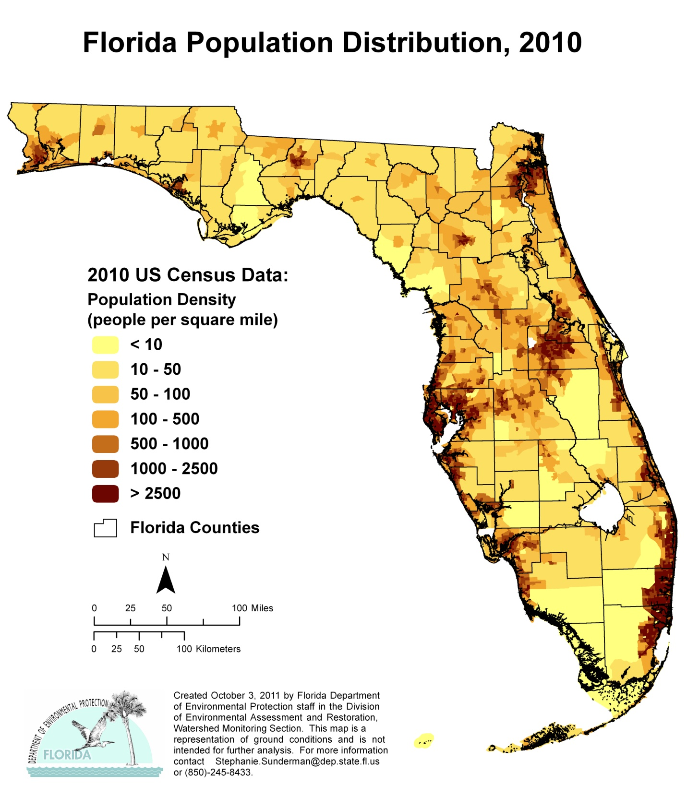

Figure 2.1. Florida’s Population Distribution, 2010

Figure 2.2. Florida’s Average Annual Rainfall, 1981–2010

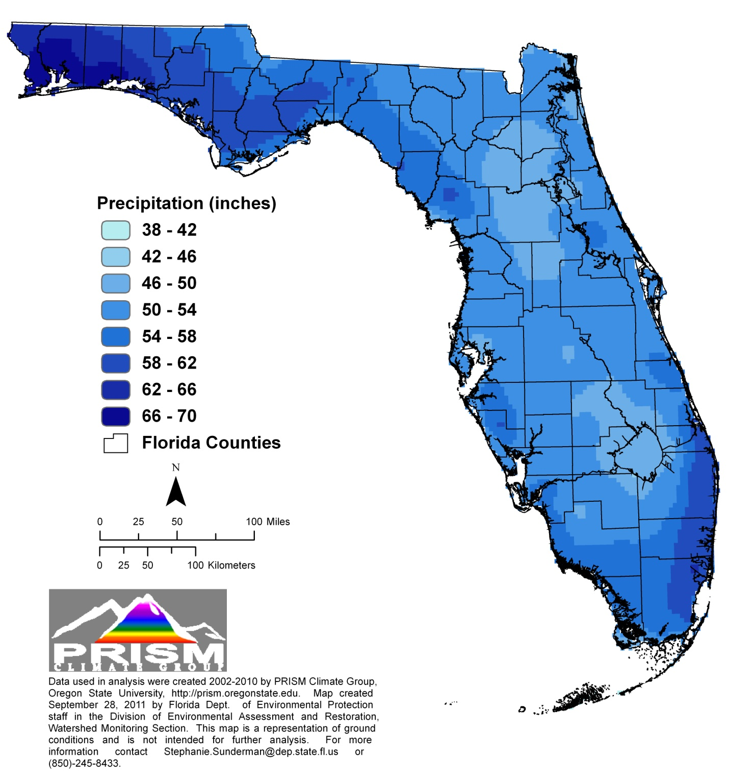

An approximate diagonal line drawn from the mouth of the St. Johns River at the Atlantic Ocean to the boundary of Levy and Dixie Counties on the Gulf of Mexico depicts a climatic river basin divide. North and northwest of the divide, streams have high discharges in spring and late winter (March and April) and low discharges in the fall and early winter (October and November). A second low-water period occurs from May to June. South of the climatic divide, high stream discharges occur in September and October, and low discharges occur from May to June.

Surface Water and Ground Water Resources
Even though Florida has many water sources, it is critical to the state’s well-being that both water quality and quantity be protected. The state has 54,836 miles of streams and rivers and 49,128 miles of ditches and canals. It has more than 12,288 lakes greater than 10 acres in size, with a total surface area of 1,811,329 acres. Florida also has 16,812 square miles of freshwater and tidal wetlands, and a coastline ranking second in length only to Alaska. A line running from the northeast corner of the state to Key West and back up to the northwest corner along the Gulf Coast would extend 1,350 statute miles (U.S. Census Bureau 2010b). If the distance around barrier islands and estuaries (tidal shoreline) were included, the line would stretch 8,426 statute miles (U.S. Census Bureau 2010b). Several sources of high-quality ground water underlie virtually all of Florida. Ninety percent of the state’s population relies on these ground water resources for their drinking water. Springs, another ground water resource, are very prominent throughout the state.

Streams and Rivers
The state has more than 1,700 streams and rivers. Differences in climate, hydrogeology, and location all affect their water quality. The longest river entirely in the state is the St. Johns, which flows north as a recognizable stream about 273 miles from the St. Johns Marsh in northern St. Lucie County, to its mouth at Jacksonville. The river drains a land area equal to about one-sixth of Florida's surface. The Apalachicola River, in the Florida Panhandle, has the largest discharge flow, averaging more than 25,374 cfs from 1977 to 1992. Its basin, draining about 19,600 square miles within Alabama, Georgia, and Florida (Northwest Florida Water Management District [NWFWMD] 2012), extends to north Georgia’s southern Appalachian Mountains. In the Panhandle, spring discharges give rise to rivers, where the ground water base flow comprises 80% of river flows.
The state has several types of natural river systems, including blackwater streams, spring runs, and estuarine or tidal streams, and these systems can be perennial or intermittent. Most of Florida’s rivers exhibit characteristics of more than one type of river system, either at different places along their length or at different times of the year. The links between surface water and ground water can also affect natural systems. For example, the Suwannee River, which originates in the Okefenokee Swamp as a blackwater stream, becomes spring fed south of Ellaville. During periods of high flow, it carries sand and sediments, behaving like a true alluvial stream (sediment carrying). During low flow, however, the river’s base flow comes from multiple springs, including several first-magnitude springs. These variations in flow affect the downstream stretches of the river and the receiving estuary. Ground water in the region has elevated nitrate concentrations that can affect animals and plants downstream (Suwannee River Water Management District 2010).
In north and northwest Florida, many rivers are alluvial. The Choctawhatchee, Apalachicola, and Escambia Rivers best represent this type of river. Common features include a well-developed floodplain, levees, terraces, oxbows, and remnant channels (sloughs) that parallel the active riverbed. Typically, because flows fluctuate more than with other types of rivers, habitats are more diverse.
Florida contains many blackwater streams and rivers. Blackwater rivers usually have acidic, highly colored, slowly moving waters containing few suspended sediments. These systems typically drain acidic flatwoods or swamps. The upper Suwannee River and north New River are examples of this type of river system.
Many major river systems that originate as springs are found in central and north Florida, the Big Bend area of the Gulf Coast, and the southern portion of the Tallahassee Hills. Chemically, these rivers are clear, alkaline, and well buffered. They have little temperature variation, relatively constant flows, and little sediment. Their clear water encourages the growth of submerged plants that provide habitat for diverse animal species. Many spring-fed rivers flow directly into estuaries, and the constant temperatures offer protection from temperature extremes to a number of species, including estuarine fish such as spotted seatrout and red drum, as well as marine mammals, such as manatees.
Major dams have been built on the Apalachicola, Ocklawaha, Ochlockonee, Hillsborough, and Withlacoochee (Citrus County) Rivers. The most extreme alterations were damming the Ocklawaha to create the Cross-Florida Barge Canal and channelizing the Kissimmee River. The hydrology of the southern third of Florida's peninsula has been significantly altered, and few naturally flowing streams and rivers remain. Most fresh waterbodies in south Florida are canals.
Several efforts are under way to reverse some of the alterations, thus restoring natural flows and function to waterbodies. Significant work on the Kissimmee River since the 1990s has successfully restored flow in portions of the historical river channel, leading to improved habitat, fisheries, and water quality. Additional information on the Kissimmee restoration is available on the South Florida Water Management District Kissimmee River website.

Canals

Lakes
Florida's lakes provide important habitats for plant and animal species and are a valuable recreational resource. The state has more than 12,288 lakes, which occupy approximately 4% of its surface area. The largest, Lake Okeechobee (covering 423,680 acres), is the 9th largest lake in surface area in the United States and the second largest freshwater lake wholly within the conterminous United States (Fernald and Purdum 1998). Most of the state’s lakes are shallow, averaging 7 to 20 feet deep, although many sinkhole lakes and parts of other lakes can be much deeper.
Florida’s lakes are physically, chemically, and biologically diverse. Some lakes are spring fed; others are seepage lakes fed by ground water, and still others are drainage lakes fed by surface water sources. Most Florida lakes are seepage lakes—nearly 70% of the lakes in Florida have no surface water streams flowing into or out of them (Palmer 1984). Florida lakes are classified according to water pH, water color, and the ecoregion of the lake basin. The Department identified 47 different lake regions as part of its Lake Bioassessment/Regionalization Initiative.
Within each lake region, the lakes have similar geology, soils, chemistry, hydrology, and biology, and lakes in one region may differ significantly from those in another region. For example, most lakes in the New Hope Ridge/Greenhead Slope lake region in northwestern Florida (Washington, Bay, Calhoun, and Jackson Counties) have lower total nitrogen (TN), lower total phosphorus (TP), lower chlorophyll concentrations, and higher clarity compared with other Florida lakes. In contrast, lakes in the Lakeland/Bone Valley Upland lake region in central Florida (Polk and Hillsborough Counties) have higher TN, higher TP, higher chlorophyll concentrations, and lower clarity. Additional information on Florida lake regions and the ecology of Florida’s lakes is available from the LAKEWATCH website and the EPA Ecoregions of Florida website.

Estuaries and Coastal Waters
With more than 8,400 coastal miles, Florida is second only to Alaska in amount of coastline. The state’s west coast alone contains almost 22% of the Gulf Coast estuarine acreage in the United States. Florida's estuaries are some of the nation's most diverse and productive. They include embayments, low- and high-energy tidal salt marshes, lagoons or sounds behind barrier islands, mangrove swamps, coral reefs, oyster bars, and tidal segments of large river mouths. Florida has more Estuaries of National Significance (Tampa Bay, Sarasota Bay, Charlotte Harbor, and Indian River Lagoon), designated by EPA, than any other state in the nation.
The Atlantic coast of Florida from the mouth of the St. Marys River to Biscayne Bay is a high-energy shoreline bordered by long stretches of barrier islands, behind which lie highly saline lagoons. This 350-mile stretch of coast contains only 18 river mouths and inlets. Biscayne Bay spans the transition from high- to low-energy shorelines.
At the southern end of the state lie Florida Bay and the Ten Thousand Islands, both of which are dominated by mangrove islands fronting expansive freshwater marshes on the mainland. Many tidal creeks and natural passes connect the islands and marshes. Historically, the area’s fresh water came mainly from sheet flow across the Everglades.
Florida's west coast has low relief, and the continental shelf extends seaward for many miles. Unlike the east coast, numerous rivers, creeks, and springs contribute to estuarine habitats. Generally, the west coast’s estuaries are well-mixed systems with broad variations in salinity. They often lie behind low-energy barrier islands or at the mouths of rivers that discharge into salt marshes or mangrove-fringed bays. The Big Bend coast from the Anclote Keys north to Apalachee Bay is low-energy marsh shoreline. While it does not conform to the classical definition of an estuary, its flora and fauna are typically estuarine. Many freshwater rivers and streams feeding the shoreline here are either spring runs or receive significant quantities of spring water. The Florida Panhandle from Apalachee Bay west to Pensacola Bay comprises high-energy barrier islands, with sand beaches fronting the Gulf of Mexico.
Major coastal and estuarine habitats vary from northern to southern Florida. Salt marshes dominate from Apalachicola Bay to Tampa Bay and from the Indian River Lagoon north to the Georgia state line, while there are few salt marshes west of Apalachicola Bay. Mangrove swamps dominate the southwestern Florida coast and are found along the southeastern coast. There are about 6,000 coral reefs between the city of Stuart on the Atlantic Coast south and west to the Dry Tortugas. Seagrasses are most abundant in the Big Bend region, from Tarpon Springs to Charlotte Harbor, and from Florida Bay to Biscayne Bay (Hale et al. 2004).

Wetlands
Because of its low elevation and peninsular nature, Florida has many varied types of wetlands, including estuarine Spartina and mangrove salt marshes, as well as freshwater sawgrass marshes, cypress swamps, and floodplain marshes. Wetlands comprise almost one-third of the state. The largest and most important are as follows:
The Everglades and the adjacent Big Cypress Swamp. Including the Water Conservation Areas (diked portions of the original Everglades system) and excluding the developed coastal ridge, this system extends from about 20 miles south of Lake Okeechobee to Florida Bay.
The Green Swamp in the state’s central plateau.
The Big Bend coast from the St. Marks River to the (south) Withlacoochee River.
Vast expanses of Spartina salt marsh between the Nassau and St. Mary’s Rivers.
The system of the St. Johns River marshes. Before alteration by humans, all but the northernmost one-fifth of the river basin was an extensive freshwater system of swamps, marshes and lakes (Kushlan 1990). Even today, half of the length of the St. Johns River is actually marsh, and in many respects it functions like a northern-flowing Everglades.
The headwaters and floodplains of many rivers throughout the state, especially the Apalachicola, Suwannee, St. Johns, Ocklawaha, Kissimmee, and Peace Rivers.

In the past, many wetlands were drained for agriculture and urban development, and numerous rivers were channelized for navigation. The modifications were most intense in south Florida, where, beginning in the 1920s, canals and levees were built to control flooding and to drain wetlands. These modifications resulted in the loss of much of the original Everglades wetlands from Lake Okeechobee south. The Everglades restoration under way is intended to improve water quality. There are preliminary successes; however, restoration is a long-term effort involving many agencies working to revitalize the heavily altered system.

Aquifers and Springs
Florida lies atop aquifer systems that provide potable water to most of the state’s population. Ground water naturally discharges into streams, lakes, wetlands, coastal waters, and springs. Florida has more than 1,000 known springs (Florida Department of Environmental Protection 2011), which discharge a total of about 17,017 cfs; the state may contain the largest concentration of freshwater springs on Earth. The largest coastal spring by discharge is Spring Creek Springs, with an average discharge of 2,000 cfs; the largest noncoastal spring, Silver Springs, has an average discharge of 851 cfs. Florida also contains 33 of the 78 first-magnitude springs (defined as springs that discharge on average at least 100 cfs) in the United States (Figure 2.3). Several river systems in the state originate as or are largely supported by spring discharges.
Archaeological evidence indicates that humans have been attracted to Florida’s life-giving springs for thousands of years. Fourteen of Florida’s state parks named for springs attract millions of visitors each year, and private spring attractions and parks are a multimillion-dollar tourist industry.
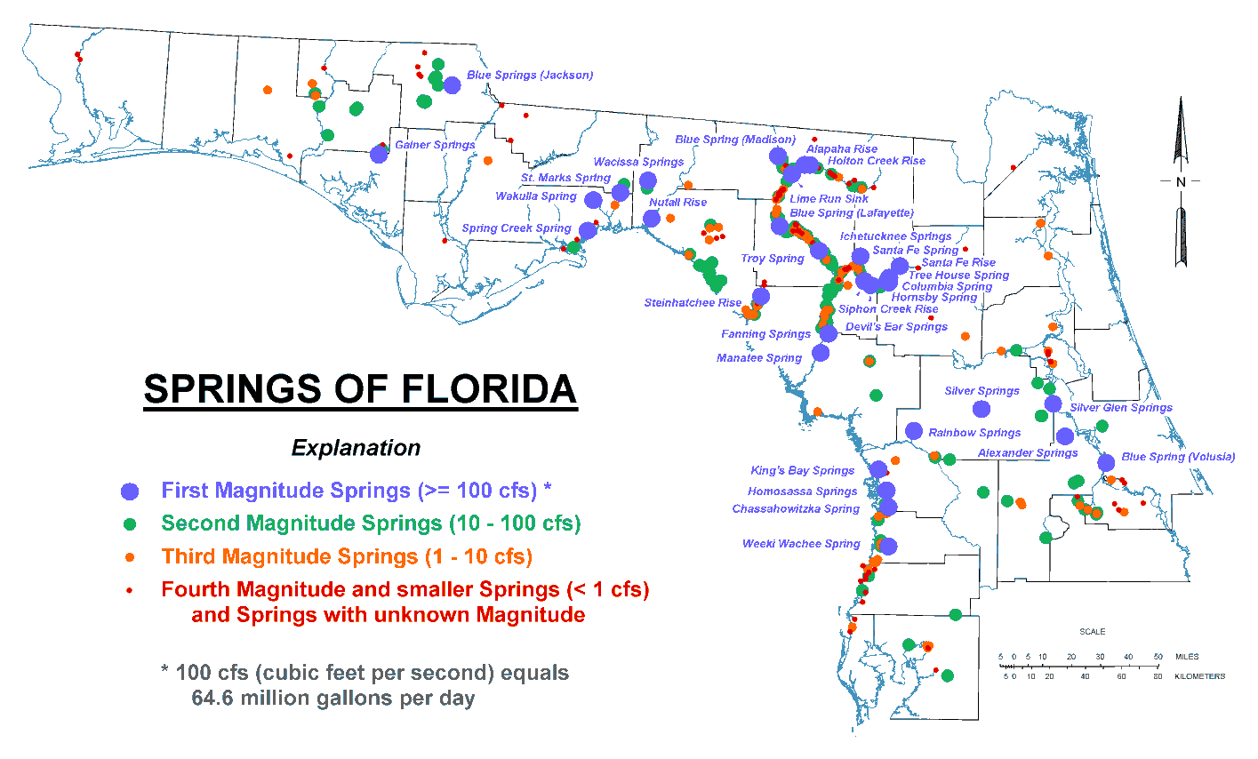
Figure 2.3. Springs of Florida

Hydrogeology

Surface Water
Most of Florida is relatively flat. At 345 feet, Britton Hill (near Lakewood, in Walton County) has the highest elevation in the state (americasroof.com website 2010). The longest river, the St. Johns on Florida’s east coast, only falls about a tenth of a foot per mile from the headwaters to the mouth. Surface drainage and topographic relief are greatest in the streams and rivers entering north and northwest Florida from Alabama and Georgia. Most of these streams are alluvial, or sediment carrying. As the land flattens farther south, surface drainage becomes less distinct, and the rivers and streams are typically slower moving, meandering, and nonalluvial.
Many of Florida’s rivers have their headwaters in wetlands. In its natural setting, the Green Swamp in central Florida is the headwater for five major river systems: Withlacoochee (South), Ocklawaha, Peace, Kissimmee, and Hillsborough. In north Florida, the Suwannee and St. Marys Rivers originate in the Okefenokee Swamp. Throughout the state, smaller streams often disappear into wetlands and later re-emerge as channeled flows.

Ground Water
Florida is in the Coastal Plain physiographic province, which is blanketed by surficial sands and underlain by a thick sequence of bedded limestone and dolomite. Together the surficial sands, limestone, and dolomites form enormous reservoirs that provide proportionally larger quantities of ground water than is found in any other state.
These sources of high-quality, potable ground water underlying virtually all of Florida supported average withdrawals of more than 4,247 million gallons per day (MGD) in 2005 (Marella 2009). This remarkable resource supplies more than 90% of the drinking water for more than 18 million residents. In addition, ground water resources supply over 50% of all water needs, including agricultural, industrial, mining, and electric power generation.
Florida primarily relies on the following four aquifer systems as drinking water sources:
- The Floridan aquifer system, one of the most productive sources of ground water in the United States, extends beneath all of Florida, southern Georgia, and adjoining parts of Alabama and South Carolina. Many public water systems—including those of Jacksonville, Orlando, Clearwater, St. Petersburg, and Tallahassee—tap into the Floridan. It is also a major supplier of water for industrial, irrigation, and rural use. This aquifer provides 60% (4,124 MGD) of Florida’s potable water supplies.
- Unnamed surficial and intermediate aquifers, which are present over much of the state, are used when the deeper aquifers contain nonpotable water. They supply water needs for about 10% of the population, especially in rural locations. These aquifers provide 20% (1,375 MGD) of the state’s potable water supplies.
- In southeast Florida, the Biscayne aquifer supplies virtually all the water needs for over 4 million residents in densely populated Dade, Broward, Palm Beach, and Monroe Counties. This aquifer provides 18% (1,237 MGD) of Florida’s potable water supplies. The EPA has designated the Biscayne aquifer as a sole source drinking water aquifer.
- The sand and gravel aquifer, the major source of water supply in the western part of the Florida Panhandle, provides 2% (137 MGD) of Florida’s potable water.

Surface Water–Ground Water Interactions
Florida’s low relief, coupled with its geologic history, has created unique hydrogeologic features. Large areas are characterized by karst topography, which forms when ground water dissolves limestone. Landforms in these areas include streams that disappear underground, springs and seeps where ground water rises to the surface, sinkholes, and caves. Surface water commonly drains underground and later reappears, sometimes in a completely different surface water basin from where it entered the ground. For example, drainage from a large karst area in Marion County provides water for Silver Springs and Silver River, which discharges to the Ocklawaha River and then to the St. Johns River and the Atlantic Ocean. Karst areas in western Marion County provide water for Rainbow Springs and Rainbow River, which discharges to the Withlacoochee River and then to the Gulf of Mexico. The entire Suwannee River drainage basin depends on ground water discharge via springs to support base flow to rivers.
Florida's porous and sandy soils, high average rainfall, and shallow water table promote close and extensive interactions between ground water and surface water. By the same mechanisms, surface waters recharge underlying aquifers. The fact that Florida contains more than one-third of the first-magnitude springs in the United States is an indication of significant ground water and surface water interchange in the extensive areas of the state dominated by karst terrain. Most lakes and streams receive water from and discharge water to ground water. In general, ground water base flow can be 40% to 60% of the total stream flow, and in karst areas where springs discharge, it can provide 70% to 80% of the flow to streams.
Although there are many surface water–ground water interactions, a hydrologic divide exists that interrupts the movement of Florida’s water resources. The divide is represented by an approximate line extending from near Cedar Key on the Gulf Coast to New Smyrna Beach on the Atlantic Coast. Except for the St. Johns and Ocklawaha Rivers, little, if any, surface water or ground water flows south across this barrier. Most major rivers north of the line receive part of their discharges from outside Florida, in addition to rain. South of the divide, rain is the sole fresh water source. Hydrologically, the half of Florida lying south of the divide is isolated. About 75% of the state’s population lives in this area in peninsular Florida.

