Focused Implementation of Best Management Practices in the Santa Fe River Basin

Annual Progress Report for 2013

A Joint Document Prepared by:

Division of Environmental Assessment and Restoration
Florida Department of Environmental Protection
Tallahassee, FL

and

Office of Agricultural Water Policy
Florida Department of Agriculture and Consumer Services
Tallahassee, FL

Draft: March 28, 2013


Introduction
As part of the Basin Management Action Plan to address nutrient total maximum daily loads (TMDLs) in the Suwannee River basin, the Florida Department of Environmental Protection (FDEP) and the Florida Department of Agriculture and Consumer Services (FDACS) selected a restoration focus area (RFA) in the Santa Fe Springs basin. The Ginnie and Gilchrist Blue springsheds were selected to evaluate how reductions in nitrogen loading from best management practices (BMPs) impact water quality. The RFA concept will be evaluated for possible use in other BMAP areas around the state.
The Santa Fe Basin RFA shown in Figure 1 was delineated using springshed maps from a ground-water flow model developed by Geohydros, LLC (Kinkaid et al. 2009), and the generalized area is based on a composite of modeled low-flow (worst case) ground water capture areas (springsheds) for Ginnie and Gilchrist Blue Springs. The RFA also includes the smaller Twin Spring springshed to the west, a small area between the Ginnie-Gilchrist Blue and Poe-Lily springsheds, and the major springs that discharge into the Santa Fe River west of Poe Spring from south of the river. This area is bounded to the north by the Santa Fe River, to the east by the springshed of Poe and Lily Springs, to the west by the edge of the Waccasassa Flats, and to the south by the southern boundary of the Santa Fe River ground water contributing area. The criteria for selection of this area are listed in the joint FDEP-FDACS document, “Focused Implementation of Best Management Practices in the Santa Fe River Basin.”
The RFA includes approximately 185 square miles in Gilchrist and Alachua Counties. According to the most recent land use/land cover map of the Suwannee River Water Management District (SRWMD) (based on 2010 and 2011 aerial photographs), the major land uses/land cover in the area include forest land (44%), agriculture (29%), and urban/residential (about 12%, most of which is low-density residential). A recently updated land use map (2012) is shown in Figure 2 that highlights land uses that may contribute nitrate to ground water. Land use changes in the RFA that may influence the relationship between land use and nitrogen loading are being monitored and documented.
The city of Newberry, the only incorporated area in the RFA, covers approximately 54.6 square miles. Newberry has its own wastewater treatment facility (WWTF), which serves the more densely developed portion of the city and has a design flow of approximately 0.415 million gallons per day (MGD). The remaining residents are on septic systems, also referred to as onsite treatment and disposal systems (OSTDS). Overall, there are approximately 3,500 OSTDS in the Santa Fe Basin RFA, most of them in the Newberry area. Also, the High Springs Wastewater Treatment Facility in Alachua County lies just outside (east) of the RFA boundary and this facility has a design capacity of approximately 0.24 MGD.
The strategy for evaluating the water-quality effects of BMPs and other actions in the RFA includes two main components: (1) quarterly water-quality monitoring of ground water, springs, and river water, and (2) enrollment and implementation of BMPs. This second component includes obtaining agricultural landowner participation in the BMP Program, identifying priority practices to focus cost-share and implementation assurance efforts, and determining compliance with applicable ordinances in urban areas.
The document entitled, “Focused Implementation of Best Management Practices in the Santa Fe River Basin,” describes the RFA process, criteria for selecting the RFA, actions completed to attain stakeholder involvement in the RFA effort, steps for assessing progress in the RFA, and the water-quality monitoring plan. As set forth in that document, a progress report will be provided at the end of each year of monitoring and BMP enrollments that includes a summary of the status of BMP implementation in the RFA and an analysis of water-quality information collected from the ground water, springs, and river monitoring stations. This first annual RFA report also addresses monitoring objectives and provides recommendations for changes in the RFA monitoring plan.
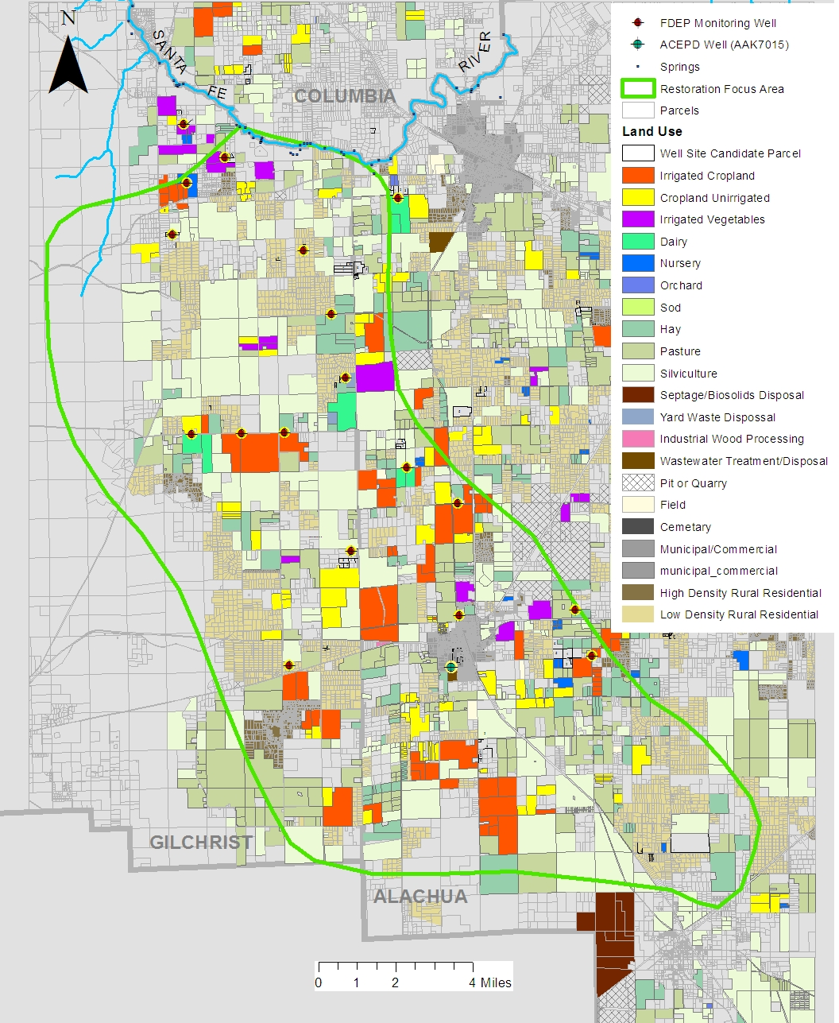
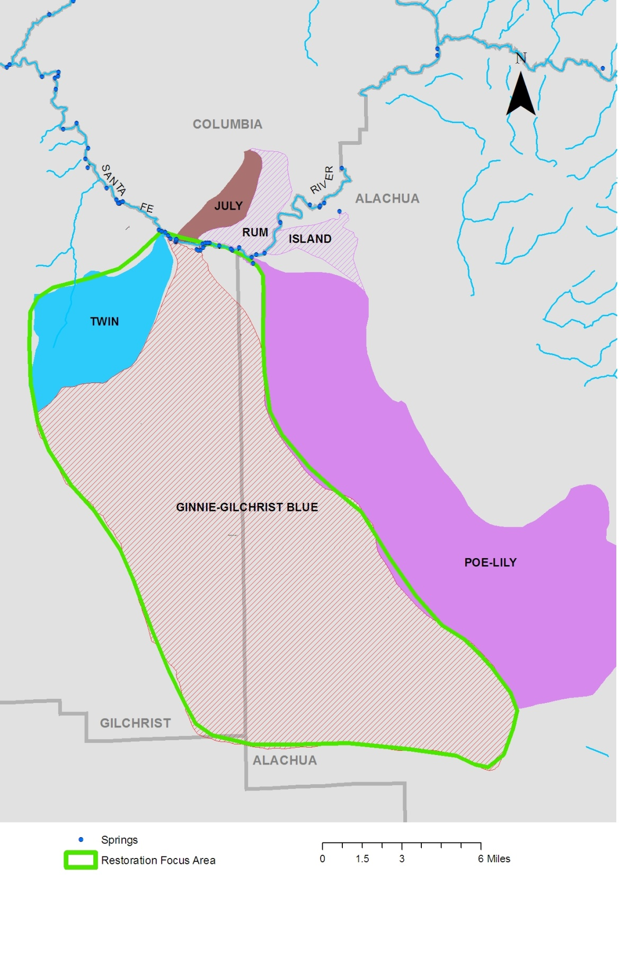
3
2
20
6
5
8
9
12
11
1
4
7
13
15
16
17
14
18
AAK
7015
19
Figure 1. Santa Fe Springs Basin and adjacent springsheds.

Water-Quality Monitoring Network
Ground Water Sites
Table 1 lists the 20 monitoring wells that were installed, developed, and surveyed between November 2012 and January 2013. Figure 2 shows the locations of the ground water monitoring wells with respect to land use and land cover designations in the RFA. All 20 monitoring wells were sampled during January and May 2013. Table 2 lists the water-quality constituents that were analyzed in ground water samples, and Table 3 lists the field-measured physical and chemical indicators for ground water sites. After reviewing the water quality data from these two sampling events, two modifications were made to the sampling network: (1) monitoring well #19 was not sampled in August and December because the water quality data from this well was providing redundant background information, and (2) a well was added to the sampling network for the August and December sampling that is being used for irrigation at a cemetery adjacent to the city of Newberry wastewater spray field (AAK7015). This well was included in the RFA monitoring network because this wastewater spray field is the most significant wastewater source (by volume) in the RFA.
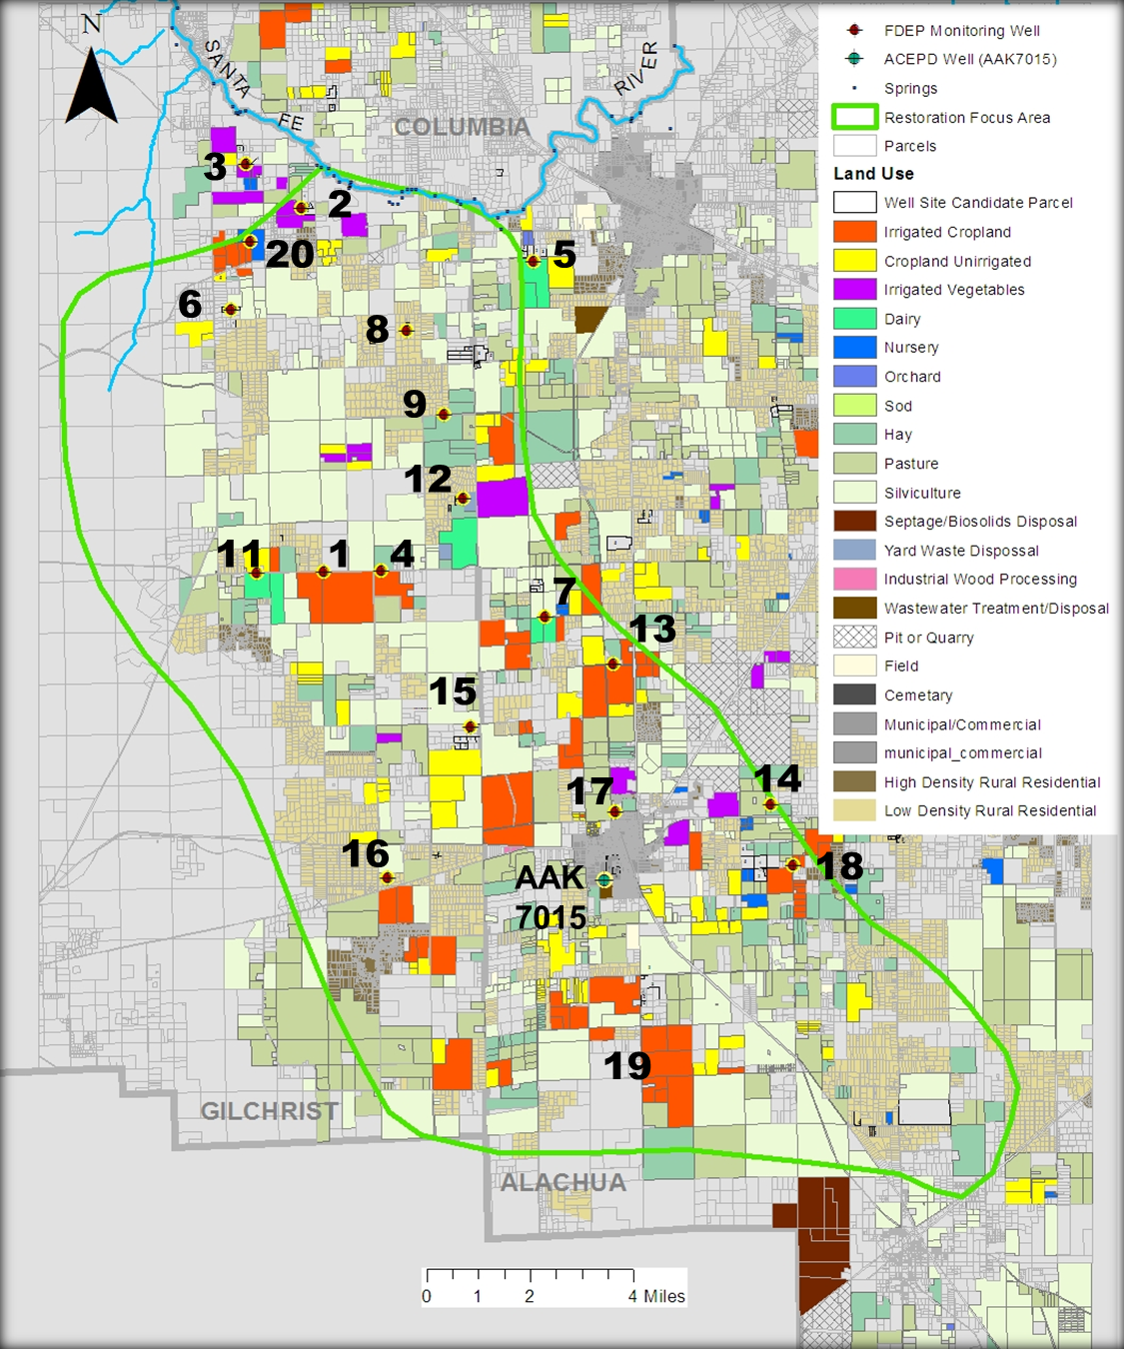
Figure 2. Land use and monitoring well locations in the Santa Fe Basin RFA.

Springs and Surface Waters
Spring samples were collected four times in 2013 (January, May, August, and December) from the two main vents, Ginnie Spring and Blue Spring, as well as from Devil’s Ear Spring (to represent the Devil’s Ear spring complex input). Twin Spring was added to the springs sampling network in August 2013 and was also sampled in December 2013. These springs represent the major contributions of discharge to the Santa Fe River from these three springsheds. After the addition of Twin Spring in August, Poe Spring was removed from the sampling network after samples were collected in January and May 2013.
In addition to the springs network, three stations on the Santa Fe River were sampled four times during 2013 (January, May, August, and December). These stations include a site immediately upstream of the RFA boundary to determine water quality conditions from the upstream river system, a site immediately downstream from the cluster of springs within the RFA boundary, and an additional site farther downstream to evaluate water quality in the river after nitrate has been assimilated to some degree. These stations are located at Alachua County’s Poe Spring Park, just below the Poe Spring vent (upstream of the RFA); at the U.S. Geological Survey (USGS) Fort White staff gage (immediately downstream from the RFA); and at the State Road 47 bridge (farther downstream to evaluate nitrate assimilation). Santa Fe River discharge will be obtained from the USGS. The spring and river monitoring locations are shown in Figure 3. Table 2 lists the water-quality constituents that were analyzed in spring water and river water samples, and Table 3 lists the field-measured physical and chemical indicators for these sites.
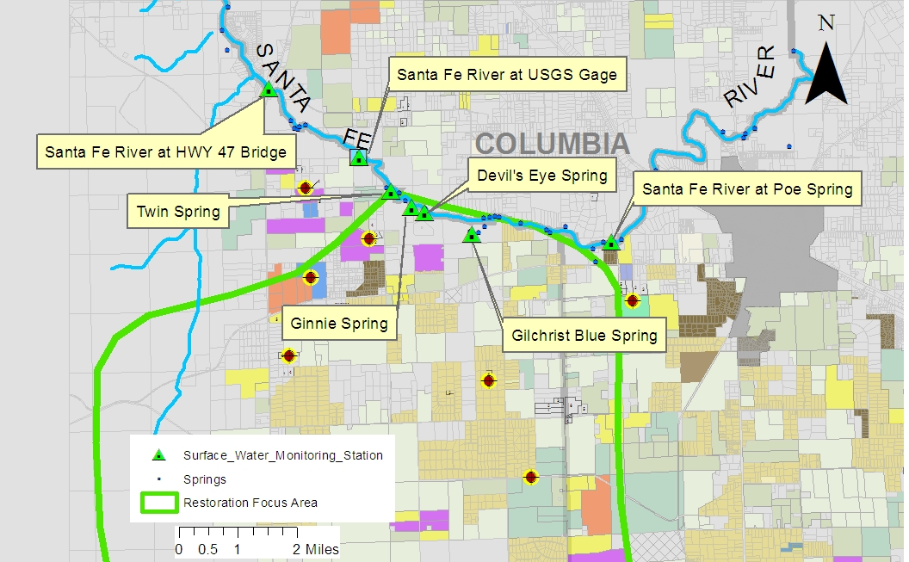
Figure 3. Santa Fe Basin RFA spring and river monitoring stations.

Quality Assurance/Quality Control (QA/QC) Samples
All sample collection, shipping, and analytical test methods were conducted in accordance with Rule 62-160, F.A.C., Quality Assurance, and specified in the Department document titled Standard Operating Procedures for Field Activities. All samples except for isotopes were shipped to the Department’s Bureau of Laboratories in Tallahassee for analysis. The Department’s Bureau of Laboratories has Standard Operating Procedures for laboratory activities that address handling and analyzing samples; reporting precision, accuracy, and method detection limits; and other data reporting guidelines. No analytes were found above method detection limits in equipment and field blanks collected during 2013. Analyses of chemical constituents in duplicate samples generally agreed within ± 2 percent.
Water samples with nitrate concentrations greater than 0.1 mg/L were analyzed at the University of Northern Arizona’s Colorado Plateau Stable Isotope Laboratory (CPSIL) for nitrogen and oxygen isotopes of nitrate. Isotope results are reported as permil (parts per thousand, ‰) using delta (δ) notation, which is expressed as the ratio of the heavy to light isotope, normalized to a standard (equation 1):
δ _{sample} = 1000[(R_{sample}/R_{standard})-1] (1)
where R_{sample} and R_{standard} are the ratio of the heavy to the light isotope in the sample and in the standard, respectively. Isotopes of nitrogen and oxygen of nitrate are analyzed by bacterial conversion of nitrate to nitrous oxide and reported relative to nitrogen gas in air and Vienna Standard Mean Ocean Water, respectively. CPSIL reported δ¹⁵N and δ¹⁸O analyses of International Atomic Energy Agency (IAEA) and USGS nitrate standards are within ±0.1‰ and ±0.5‰ of expected values, respectively.

Table 1. Summary information on monitoring wells used in the RFA pilot study.
¹ Used in Alachua Co. Environmental Protection Division quarterly monitoring program; N/A = Not available; - = Empty cell/no data
Nutrient Fate Study ID | Well Screen Interval Depth | Adjacent  Land Use | Well Distance from  Land Use | Comments
MSFMW1 | 38-48 | Irrigated cropland | 40 | In production since 2012, previously scrub
MSFMW2 | 38-48 | Irrigated vegetables | 30 | In production since 2012, previously pasture
MSFMW3 | 21-31 | Irrigated vegetables | 430 | Vegetables since 2004 aerial, pasture before that
MSFMW4 | 58-68 | Irrigated cropland | 40 | Partially irrigated cropland since before 1994
MSFMW5 | 48-58 | Irrigated field crop supporting dairy | 75 | Dairy since before 1994, small
MFMW6 | 25-35 | Low-density residential |  | Potential septic tank influence
MSFMW7 | 48-58 | Irrigated field crop supporting dairy | 20 | Dairy since before 1994
MSFMW8 | 58-68 | Low density residential | N/A | Background
MSFMW9 | 44-54 | Pasture | 90 | Pasture or nonirrigated crops approximately 20 years +
MSFMW10 | 61-71 | Irrigated cropland | 100 | Irrigated cropland since before 1994
MSFMW11 | 38-48 | Irrigated field crop and pasture supporting dairy | 40 | Dairy since before 1994
MSFMW12 | 68-78 | Residential, irrigated field crop supporting dairy | 35 | Dairy since early 2000s, residential developed in early 2000s
MSFMW13 | 51-61 | Irrigated cropland | 90 | Was pasture until approximately 2010
MSFMW14 | 48-58 | Hay | 20 | Hayfield or pasture since before 1994
MSFMW15 | 61-71 | Nonirrigated cropland | 2,300 | Multiple agricultural land uses in vicinity
MSFMW16 | 58-68 | Pasture | 60 | No change in land use since before 1994
MSFMW17 | 35-45 | Urban | NA | In Newberry urban area
MSFMW18 | 55-65 | Irrigated cropland | 80 | Cropland since before 1994, not irrigated until possibly 2010
MSFMW20 | 58-68 | Irrigated cropland | 360 | Approximately 20 years +; irrigated in early 2000s
AAK7015¹ | - | Domestic wastewater sprayfield and cemetery | - | Adjacent to city of Newberry WWTP sprayfield

Table 2: List of analytes in water samples from sites in the Santa Fe RFA monitoring network.
- = Empty cell/no data
mg/L = milligrams per liter; mg N/L = milligrams per liter of nitrogen;mg P/L = milligrams per liter of phosphorus; µg/L = micrograms per liter
Chemical Indicators | Unit | Laboratory (L) or  Field (F) Analysis Method | Justification
Alkalinity | mg CaCO3/L | SM 2320 B (L) | Aquifer properties
Chloride | mg/L | Method 300 (L) | Source indicator
Fluoride | mg/L | SM 4500 F-C (L) | Confinement indicator
Sulfate | mg/L | Method 300 (L) | Source indicator
Total Dissolved Solids | mg/L | SM 2540 C (L) | Source indicator
Total Suspended Solids | mg/L | SM 2540 D (L) | Source indicator
Bromide | mg/L | - | Source indicator
Boron | mg/L | - | Source indicator
Calcium | mg/L | Method 200.7 (L) | Aquifer properties
Magnesium | mg/L | Method 200.7 (L) | Aquifer properties
Potassium | mg/L | Method 200.7 (L) | Source indicator
Sodium | mg/L | Method 200.7 (L) | Source indicator
Ammonia-N | mg N/L | Method 350.1 (L) | Source indicator/aquifer properties
Nitrate-Nitrite | mg N/L | Method 353.2 | Management action influence, source indicator/  nitrogen species transformation
Total Phosphorus | mg P/L | In-house based on  Method 365.4 (L) | Aquifer properties, Hawthorne influence
Total Kjeldahl Nitrogen | mg/L | In-house based on  Method 351.2 (L) | Source indicator/  nitrogen species transformation
Organic Carbon | mg/L | In-house based on  Method 415.1 (L) | Aquifer properties
Orthophosphate | mg/L | Method 365.1 (L) | Aquifer properties,  Hawthorne influence
Sucralose | µg/L | In-house | Source indicator
Nitrogen and Oxygen Isotopes (δ15N and δ18O in NO₃) | Per mil | Colorado Plateau Stable Isotope Laboratory | Nitrate source indicator, denitrification indictor

Table 3: List of field-measured physical and chemical indicators for sites in the Santa Fe RFA monitoring network.
- = Empty cell/no data; DO, dissolved oxygen; SU = standard units; µs/cm = micromhos per centimeter; NTU – Nephelometric Turbidity Units; CFS, cubic feet per second; PCU = Platinum cobalt units
Physical Indicators | Unit | Analysis Method | Justification
DO | mg/L | DEP-SOP-001/01 FT 1500 (F) | Aquifer properties/  redox conditions
pH | SU | DEP-SOP-001/01 FT 1100 (F) | Aquifer properties
Specific Conductance | µS/cm | DEP-SOP-001/01 FT 1200 (F) | Aquifer properties
Turbidity | NTU | Method 180.1 (L) | Aquifer properties
Color | PCU | SM 2120 B (L) | Aquifer properties
Temperature | ° C | DEP-SOP-001/01 FT 1400 (F) | Aquifer properties
Depth to Water (wells) | Feet | Field Measurement | Recharge to aquifer
Spring Flow Measurement | CFS | Field Measurement | Load calculations

RESULTS
Ground Water Levels
There were no consistent trends in ground water levels from one sampling event to another during 2013 (January, May, August, and December). Ten of the monitoring wells (#1,3,11,12,13,14,15,16,17,18) showed their highest water levels in December, but the remaining wells did not show any consistent trend (Figure 4). There appears to be at least a one-month lag between rainfall and ground water level response, based on the minor change in water levels in August and December after high rainfall amounts recorded in June and July 2013 at the nearby SRWMD Forest Grove rainfall station (Figure 5).

Figure 4. Ground water levels measured for the four sampling periods in the RFA.

Figure 5. Monthly rainfall totals at Forest Grove station, near Newberry, Florida.

Water Quality Results
A complete list of field measurements and laboratory analytical results for 2013 samples of ground water, spring waters, and surface water sites is included as Appendix 1. The following sections discuss the water quality data for ground water, springs, and surface water sites. One of the main objectives of the RFA study is to investigate the transport and fate of nitrate; therefore, the focus of this section will be on nitrate and indicators of nitrogen sources in ground water, springs, and river water samples collected during 2013.
Nitrate-N concentrations in water samples from each well site were remarkably uniform for all four sampling events, and varied little even with large fluctuations in ground water levels at some wells (e.g. wells #11, 16). Fluctuations in nitrate-N concentrations in the well samples were generally minor over the four sampling events (Figure 6). Fourteen of the 20 wells sampled had nitrate-N concentrations less than 5 mg/L; however, water from four wells had nitrate concentrations that exceeded 10 mg/L from at least one sampling event.
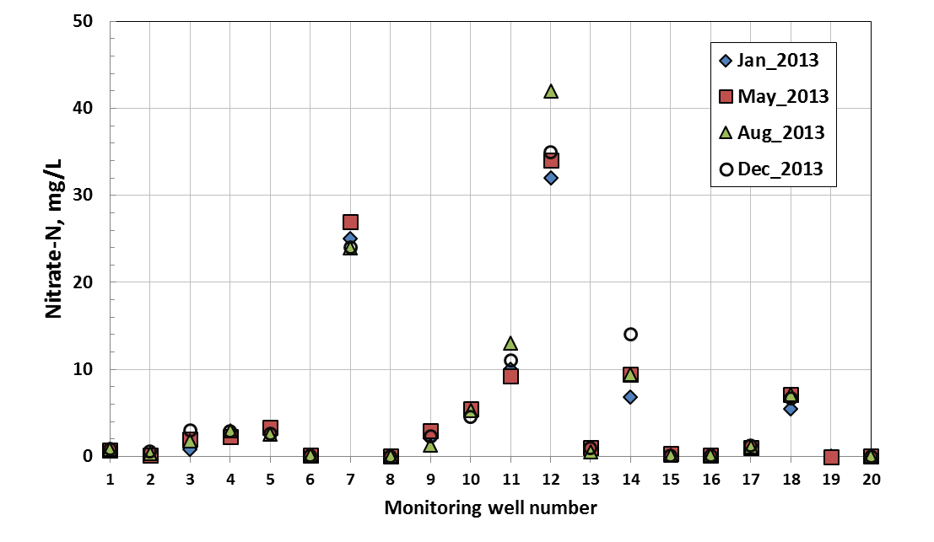
Figure 6. Nitrate-N concentrations in RFA ground water samples collected in 2013.

Nitrate-N concentrations in spring water samples were also relatively constant during 2013; although, only Devil’s Eye and Ginnie Springs were sampled four times (Figure 7). Poe Spring had the lowest nitrate-N concentrations (<0.1 mg/L) in samples collected in January and May 2013. Poe Spring was dropped from the sampling network after the May sampling and was replaced by Twin Spring, which was sampled in August and December. Gilchrist Blue Spring had the highest nitrate concentration (2.0-2.2 mg/L), compared to Ginnie Spring 1.4-1.6 mg/L) and Devil’s Eye (1.4-1.9 mg/L) during 2013. Dissolved oxygen concentrations in spring waters generally were greater than 2.9 mg/L, with the exception of Twin Spring (2.1-2.2 mg/L) and Poe Spring (0.3-0.7 mg/L).

Figure 7. Nitrate-N concentrations in spring water samples in 2013 along with mean daily discharge for the Santa Fe River at Ft. White.
River water samples were collected at base flow conditions in January and December (mean daily discharge 846 and 865 ft³/s, respectively). The May samples were collected on the falling limb of a runoff event (mean daily discharge 1720 ft³/s) and the August samples were collected on a rising limb of a small runoff event following a larger runoff event (mean daily discharge 1840 ft³/s). During base flow conditions in January and December, nitrate-N concentrations in river water samples (at the CR47 bridge and the USGS station at Ft. White) were about a factor of two higher than during elevated discharge conditions in May and August (Figure 8). Nitrate-N concentrations in river water upstream from Poe Spring were also higher during baseflow conditions but considerably lower than nitrate-N concentrations in river water at the CR47 bridge and the Ft. White sites (Figure 8). Dissolved oxygen concentrations decreased slightly in river water samples during elevated discharge conditions, but remained above 4.5 mg/L (Appendix 1).

Figure 8. Mean daily discharge data for Santa Fe River near Ft. White for 2013 and nitrate-N concentrations in river water samples.

Sources of nitrate
Nitrate-N concentrations in ground water at each site typically were related to the nearest land use. Monitoring well water samples with nitrate-N concentrations greater than 10 mg/L were near land use that contained a mixture of irrigated cropland, pasture, and active or historical dairy operations (Figure 9). Water samples from monitoring wells near hayfields generally had nitrate-N concentrations between 5 and 10 mg/L. Wells near irrigated cropland showed a larger range in nitrate-N concentrations (<0.1 to 7.1 mg/L).
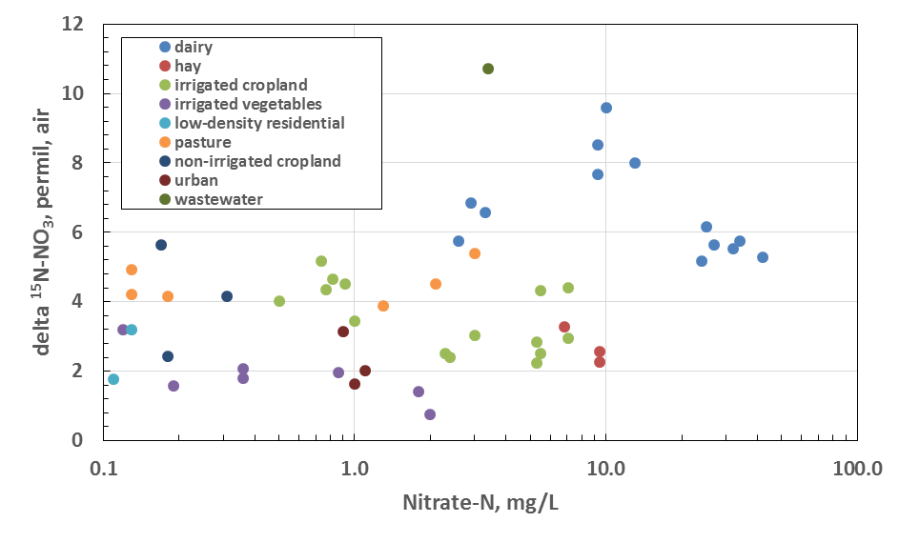
Figure 9. Plot showing nitrogen isotope composition relative to nitrate-N concentrations in ground water samples for various land uses.
Many previous studies in Florida and elsewhere have used the isotopic composition of nitrate (δ¹⁵N, δ¹⁸O) to determine sources of nitrate in ground water and surface water. Inorganic fertilizer, animal manure, and wastewater are anthropogenic sources of nitrate that have relatively distinct ranges of δ¹⁵N and δ¹⁸O values. The isotopic composition of nitrate also can be used to assess the extent of denitrification, which results in enrichment of δ¹⁵N and δ¹⁸O values compared to initial values derived from the original nitrate source.
Nitrate isotope results have been received from the laboratory only for samples collected in January, May, and August 2013. For these samples, most had δ ¹⁵N-nitrate values below 6.0‰, which is consistent with an inorganic (fertilizer) nitrogen source (Figure 9). Water samples from several wells (Figure 10) showed considerable fluctuation in nitrate isotopic composition from January, May, and August. However, with the exception of monitoring wells #5 and #7 the isotopic composition remained below 6‰, indicating that inorganic fertilizer remained the most likely source of elevated nitrate in most wells. Only samples from three wells (AAK7075, MW5, MW11) had slightly higher δ¹⁵N-nitrate values, which are consistent with an organic (waste) nitrogen source, a mixture of inorganic and organic N, or denitrification of nitrate from an inorganic source. However, denitrification likely is minimal based on low dissolved organic carbon concentrations and most dissolved oxygen concentrations that generally are greater than 2 mg/L (Figure 11).

Figure 10. Changes in nitrate isotopic composition in RFA monitoring wells sampled in January, May, and August 2013.

Figure 11. Nitrate-N and dissolved oxygen concentrations by land use (December data not included due to dissolved oxygen meter problems).

Using the nitrate isotope composition alone can result in ambiguous nitrate source attributions due to overlap of δ¹⁵N and δ¹⁸O values from different sources (particularly from animal manure and wastewater sources) and denitrification, which results in enrichment of δ¹⁵N and δ¹⁸O values from their initial composition. Therefore, the use of other chemical indicators, such as major ions, major ion ratios, and human wastewater indicators (sucralose, an artificial sweetener) can help distinguish among the various sources of nitrate.
Potassium is a major component of fertilizers and elevated levels of potassium above background concentrations in ground water would likely indicate a fertilizer source. Water samples from most wells (16 of 21) had elevated potassium concentrations, greater than 1 mg/L, which would indicate that fertilizers are an important source of potassium. However, there does not appear to be a relation between nitrate-N and potassium (Figure 12), which is surprising given that most nitrate isotope values are indicative of a fertilizer source. The highest potassium concentrations were 120 mg/L and 56 mg/L in August and December 2013 samples, respectively, at site monitoring well #17 (located in the Newberry urban land use). Nitrate isotope analyses of the August sample indicated a value consistent with an inorganic fertilizer source (δ¹⁵N=2.0‰) (Figure 13). Ground water concentrations at this site were 10 and 7.9 mg/L in samples collected in January and May 2013, respectively.

Figure 12. Potassium and nitrate concentrations in ground water, springs, and river water samples. Two outlier potassium concentrations (56 and 120 mg/L) for monitoring well 17 are not plotted.

Figure 13. Potassium concentrations and δ¹⁵N of nitrate in water samples from monitoring wells, springs, and river sites.
Boron also is present in trace amounts in most inorganic fertilizers. There is a relation between potassium and boron in ground water, springs, and river water samples (Figure 14). This finding is consistent with other indicators of inorganic fertilizers as an important anthropogenic source of nitrate in the RFA. More definitive information about boron as an indicator of fertilizer would be obtained from the analysis of boron isotopes, which have been used in combination with nitrogen and other isotopes to assess sources of nitrate in ground water (Widory et al., 2004). Boron is also elevated in domestic wastewater due to detergent contributions.

Figure 14. Potassium and boron concentrations in water samples from monitoring wells, springs, and river sites.
The mass ratio of Cl/Br also has been used to assess sources of solutes in ground water and surface water. Relatively distinct ranges of the Cl/Br ratio have been reported for sewage and septic tank effluent, road salt, animal waste, atmospheric deposition, seawater, and landfill leachate (Katz et al., 2011). Based on the RFA water samples collected in 2013, the Cl/Br ratio shows a direct relation with δ¹⁵N-NO₃ values, and therefore might be considered for use as a surrogate for assessing sources of nitrate (Figure 15).

Figure 15. Cl/Br mass ratio and ¹⁵N-NO₃ composition of ground water, springs, and river water.
Sucralose, an artificial sweetener chemical, has been used as an indicator of the influence of human wastewater in rivers, ground water, and marine water (Oppenheimer et al., 2011). Water from monitoring well AAK7015 was the only site where sucralose was detected. This is not surprising given that this well is located near the Newberry wastewater treatment facility. Sucralose also was detected in water samples from Poe Spring and Devil’s Eye Spring in Gilchrist County (Appendix 1).

Implementation of Management Actions
The implementation of agricultural management actions in the RFA includes securing landowner participation in the BMP Program. There have been several activities that have helped to obtain stakeholder involvement in the RFA. These activities have included presentations to stakeholders at public meetings to discuss the Santa Fe River BMAP (Santa Fe Springs Working Group, IFAS workshops, county Farm Bureau meetings, county commission meetings). Also, the Suwannee River Partnership staff have attended several meetings and workshops to provide information on BMPs and updates on the RFA progress.
Assessing progress in the RFA involves increasing the percentage of growers and the number of agricultural acres enrolled in the BMP Program. The three main types of agriculture in the RFA (in terms of acreage) are improved pasture (50.8%), hay (26.6%), and field and row crops (9.5%). At the end of 2012, there were 6,126 acres of agricultural land use enrolled in BMP programs and 29 Notices of Intent (NOIs) (Table 4). During 2013, an additional 12,470 acres were enrolled in and implementing BMPs bringing the total acreage enrolled to 18,596, with 66 NOIs. Most of the acreage enrolled in BMPs are following the guidelines in the manual entitled, “Water Quality/Quantity BMPs for Florida Vegetable and Agronomic Crops.” This manual describes key aspects of water quality and water conservation that include nutrient management, irrigation management, and water resource protection measures to minimize impacts to ground water and surface water.

Table 4. Information on agricultural BMP enrollment for the Santa Fe RFA.

Conclusions
Based on water quality information from four rounds of sampling during 2013, nitrate-N concentrations in ground water and springs have remained relatively constant throughout the year. Fertilizer nitrogen appears to be the dominant source of elevated nitrate-N concentrations in ground water and spring water based on data from nitrate isotopes, potassium, and boron. The lack of a response of ground water nitrate concentrations to an increase in acres enrolled in BMPs may result from several factors: an insufficient time for changes in agricultural practices to affect ground water quality, elevated nitrate concentrations that originated from agricultural practices over the past several decades may not have exited the system (legacy nitrate), the mixture of present-day recharge with ground water may reside in the aquifer for years to decades. Continued water quality monitoring is needed to determine the impact from present-day agricultural practices and the length of time needed to see water quality improvements from the increased implementation of BMPs in the RFA.

Next Steps
- Continue to update land use information, particularly conversion of pastureland or forest land to cropland.
- Continue to enroll growers and acreage in agricultural BMP Programs to achieve the target of 100% enrollment for BMP implementation, particularly in areas where there are high ground water nitrate concentrations. Continue to conduct implementation assurance site visits periodically to ensure that priority BMPs are being implemented.
- Initiate special nitrate remediation project with Del Bottcher (SWET, Inc.) and Mark Clark (University of Florida). One area has been identified for a special project to reduce high nitrate concentrations in ground water (>30 mg/L) using a pump-and-treat system with a denitrification bioreactor at this site. This project will be jointly funded by the SRWMD, FDACS OAWP, and FDEP. The treatment system will be evaluated over the next year for its ability to remediate high nitrate concentrations in ground water.
- Identify priority agricultural practices on which to focus cost-share and implementation assurance efforts
- Consider reducing the sampling frequency of selected monitoring wells, particularly seven wells that are yielding ground water with background nitrate-N concentrations. These monitoring wells include numbers 1, 2, 6, 8, 15, 16, and 20.
- Analyze continuous nitrate data from the Submersible Ultraviolet Nitrate Analyzer (SUNA) installed at Ginnie Springs and relate changes in nitrate concentrations to spring flow, dissolved oxygen concentrations, rainfall, and ground water levels.

References:

Florida Department of Environmental Protection and Florida Department of Agriculture and Consumer Services, 2013. Focused Implementation of Best Management Practices in the Santa Fe River Basin, 30 p.
Katz, B.G., Eberts, S.M., and Kauffman, L.J. 2011. Using Cl/Br ratios and other indicators to assess potential impacts on groundwater quality from septic systems: A review and examples from principal aquifers in the United States. Journal of Hydrology 397:151-166.
Kincaid, T.R., B.A. Meyer, and J. Radtke. 2009. Western Santa Fe River Basin Groundwater Resource Model, modeling results and methods. Presentation for the Suwannee River Water Management District, St. Johns River Water Management District, and U.S. Geological Survey at the CCDA Waters Bottling Facility in High Springs, FL, on August 3, 2009. GeoHydros, LLC, Reno, NV: www.geohydros.com/CCNA/ - last accessed 6/12/13.
Oppenheimer, J., Eaton, A., Badruzzaman, M., Haghani, A.W., and Jacangelo, J.G. 2011. Occurrence and suitability of sucralose as an indicator compound of wastewater loading to surface waters in urganized regions. Water Research 45: 4019-4027.
Widory, D., Kloppmann, W., Chery, L., Bonnin, J., Rochdi, H., Guinamant, J. 2004. Nitrate in groundwater: an isotopic multi-tracer approach. Journal of Contaminant Hydrology 72: 165-188.

