Alexander Spring
Lake County, Florida
-----------------------------------------------------------------------------------------------

Water Quality

Alexander Spring is a first-magnitude spring, discharging ground water from the upper Floridan aquifer system. It has been sampled for major ions and nutrients as far back as 1956 by the U.S. Geological Survey (USGS) and quarterly by the Florida Department of Environmental Protection (FDEP) since 2002 for a larger number of analytes, including major ions, nutrients, field analytes and salinity indicators. Table 1 summarizes these results for selected analytes.

Unlike many Florida springs, nutrient levels in Alexander Spring have remained very low, with values for both total nitrate + nitrite (measured as nitrogen) and dissolved orthophosphate (measured as phosphorus) generally at or below 0.05 mg/L. Based on the data presented here (Figure 1), as well as historic and recent data collected by the USGS and St. Johns River Water Management District, no upward trend in macronutrient concentrations has been detected throughout the entire period of record. A large portion of the springshed for Alexander Spring lies within the Ocala National Forest, and existing land use patterns (primarily silviculture) likely do not contribute significant nutrients from surface sources.

Salinity indicators (sodium, chloride, sulfate and specific conductance) have been slowly increasing over time. Chloride and sulfate concentrations have been increasing since about 1990, and the trends have continued to the present (Figure 2). Specific conductance trends have historically shown a slow increase since the mid-1950’s (based on available USGS data). Table 1 shows that the mean value from 2002-2012, based on FDEP data, is 1101 µmhos/cm, a decrease from mean values measured in the 1990’s.

The measured increases in salinity indicators reflect potential upconing of deeper, more saline ground water due to increasing fresh ground water withdrawals from shallower portions of the Floridan aquifer system, decreasing precipitation patterns, or a combination of these two causes.

Dissolved oxygen levels are important for fish and other biota, and are generally measured at levels below 5 mg/L in fresh ground water issuing from spring vents. The levels measured in Alexander Spring (Table 1) are within this normal ground water range.

Boron, not known to occur naturally in high concentrations in fresh Floridan aquifer system ground water, has recently been sampled as a possible wastewater tracer in wells and springs, due to its widespread use in laundry detergents. Elevated boron concentrations were detected in Alexander Spring (Table 1); however, when the boron/chloride ratio is calculated for the spring, it is very close to the ratio found from measurements made in North Atlantic Ocean seawater (approximately 0.00025 – Rakestraw et al, 1935). Therefore, it is likely that the measured boron concentrations in Alexander Spring are due to elevated salinity indicators, resulting from relict seawater trapped within the Floridan aquifer system during the last interglacial high sea stand (mid-Pleistocene, about 120,000 years ago - Muhs et al, 2009).

Sucralose is used as an artificial sweetener. Because it passes through water treatment systems largely intact, it has recently used as a potential wastewater tracer. No sucralose has been detected in Alexander Spring.

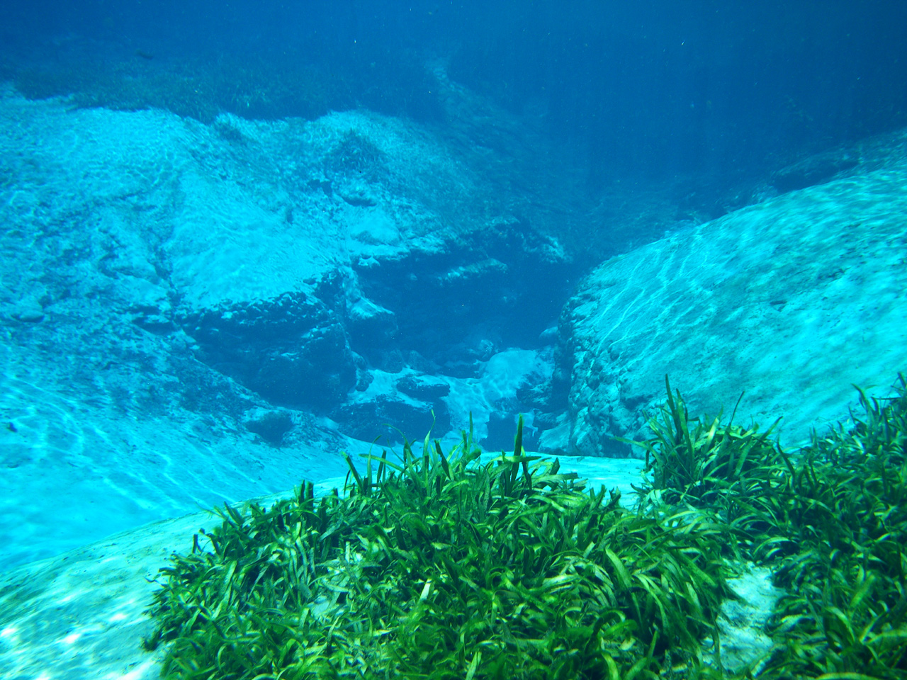

Vallisnaria americana (Tape Grass) surrounding Alexander Spring vent. Historically, this was the dominant submerged aquatic vegetative (SAV) species growing throughout the upper portion of Alexander Spring Creek. Healthy patches of Vallisnaria are now only seen immediately around the spring vent. Photo taken in June, 2009 (Gary Maddox – FDEP).

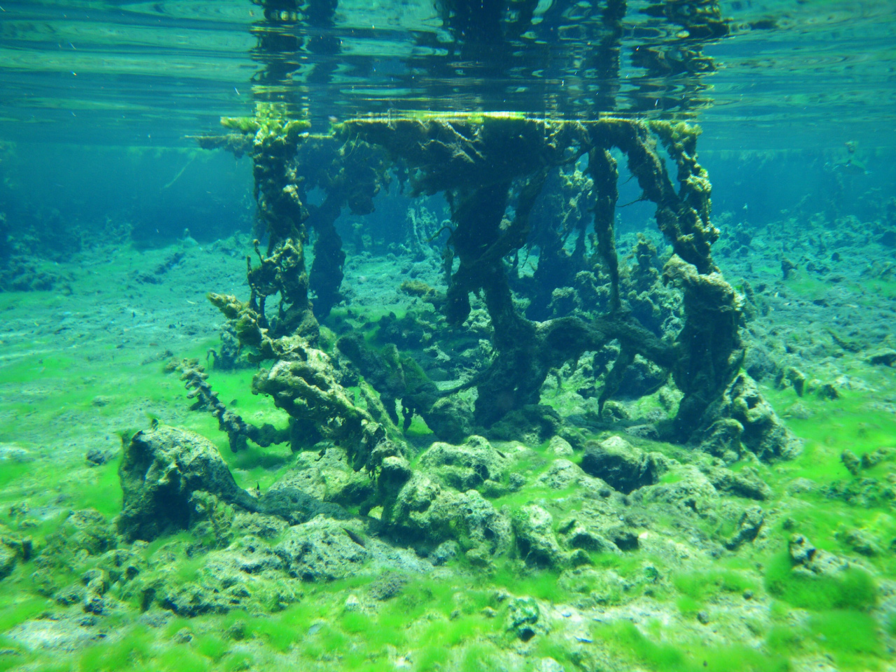

Algae smothering remnants of Vallisnaria americana in Alexander Springs Creek, with large areas of exposed mud and limestone downstream from the Alexander Spring vent. Various algal species have now replaced Vallisnaria as the dominant SAV in the spring run. Photo taken in June, 2009 (Gary Maddox – FDEP).

References:

Rakestraw, Noris W. and Henry E. Mahncke, 1935, Boron content of sea water of the North Atlantic Coast: Industrial Analytical Chemistry – Analytical Edition, Volume 7, Number 6, p. 425. Online at: http://pubs.acs.org/doi/abs/10.1021/ac50098a026

Scott, T.M., et al, 2004, Springs of Florida; Florida Geological Survey Bulletin No. 66; 377 p. Online at: http://www.dep.state.fl.us/geology/geologictopics/springs/bulletin66.htm

SJRWMD, Water bodies, watersheds and storm water: Alexander Springs; SJRWMD website: http://floridaswater.com/springs/lake/alexander.html

U.S. Environmental Protection Agency, STORET/WQX: EPA’s repository and framework for sharing water monitoring data; Online at: http://www.epa.gov/storet/

For more information, contact:
Gary Maddox, FDEP Ground Water Management Section, 2600 Blair Stone Rd; Tallahassee, FL 32399; (850)245-8511; Gary.Maddox@dep.state.fl.us

Figure 1: Macronutrient trends in Alexander Spring: 2002 - 2012

Figure 2: Salinity indicator trends in Alexander Spring: 2002 - 2012

Table 1: Summary of selected water quality results for Alexander Spring

