Blue Spring (Volusia)
Volusia County, Florida
-----------------------------------------------------------------------------------------------

Water Quality

Blue Spring (Volusia) is a first-magnitude spring, discharging ground water from the upper Floridan aquifer system. It has been sampled for major ions and nutrients as far back as 1960 by the U.S. Geological Survey (USGS), more recently by the St. Johns River Water Management District (SJRWMD) and quarterly by the Florida Department of Environmental Protection (FDEP) since 2002 for a large number of analytes, including major ions, nutrients, field analytes and salinity indicators. Table 1 summarizes these results for selected analytes.

Like many Florida springs, nitrate levels in Blue Spring have been trending upward over the last half century, with mean values increasing from around 0.15 mg/L in the late 1970’s to around 0.50 mg/L during the 2000’s. During the same time period, predominant land use in the Blue Spring springshed has transitioned from primarily silviculture to single-family residential. The FDEP has determined that nitrate concentrations above 0.35 mg/L indicate potential waterbody impairment; this number is based on recent research conducted in Florida spring waters which found that some species of algae proliferate when nitrate levels exceed that concentration. Nitrate + nitrite concentrations show considerable variability in the range of measured values since 2002, likely due to aquifer recharge effects during periods of above-average precipitation. This can be seen when one superimposes nitrate + nitrite values with monthly precipitation measured at DeLand, the closest rainfall station to Blue Spring. This relationship is nicely shown in Figure 1, where one can see the correlation between high rainfall events and spikes in nitrate concentrations. High rainfall events can carry additional nutrients from surface sources down into the Floridan aquifer system, and from there to the spring vent.

Plotting the ratios of nitrogen isotopes (¹⁵N_{NO3}/¹⁴N_{NO3}) versus oxygen isotopes (¹⁸O_{NO3}/¹⁶O_{NO3}) in nitrate measured from ground water can reveal likely nitrate sources: inorganic (chemical fertilizers) or organic (wastewater, septic discharge, animal waste) (Roadcap et al, 2002). Nitrogen and oxygen isotopes were analyzed from samples collected quarterly from Blue Spring in 2011 and early 2012; the results show a distinct denitrification trend, accompanied by low dissolved oxygen values measured in the field at the same time the samples were collected (mean dissolved oxygen value = 0.38 mg/L). Following the denitrification trend backward indicates that the initial isotopic signature predominantly favors an inorganic nitrate source.

The other macronutrient of concern in Florida surface waters, orthophosphate, is only present in low concentrations at Blue Spring (Figure 1). Based on data presented by the SJRWMD, long-term trends indicate that concentrations have not increased over time. While elevated orthophosphate levels are problematic in many of Florida’s lakes and rivers where surface runoff carries this nutrient into these waterbodies from its sources, orthophosphate is generally not an issue in springs. This is due to it’s attenuation within limestone aquifers where, given enough time, orthophosphate reacts with calcium carbonate to produce low-solubility calcium phosphate minerals which remain within the host rock (Brown, 1981). This effectively removes orthophosphate from the waters within the aquifer, and is the probable geochemical mechanism by which “hard rock” phosphate deposits have developed in the state.

Salinity indicators (sodium, chloride, sulfate and specific conductance), while showing an apparent increasing trend during the last decade (Figure 2), have not significantly increased over the longer time period from the 1960’s to present (SJRWMD). Long-term data show relatively long periods of cyclic increases and decreases in salinity indicators, sometimes spanning several years to a decade, but overall mean concentrations have remained fairly steady over the last half century.

Area long-term precipitation data for the period from 1950 – 2012 shows that there was a slightly increasing trend at DeLand of about 0.125 inches/year (1950-2008), but a slightly decreasing trend during the last decade (Florida Climate Center, 2012).

The longer-term measured increases in salinity indicators reflect potential upconing of deeper, more saline ground water due to increasing fresh ground water withdrawals from shallower portions of the Floridan aquifer system, decreasing precipitation patterns, or a combination of these two causes. The shorter-term precipitation trends shown graphically in Figure 1 appear to be inversely correlated with salinity indicator trends shown in Figure 2, with high rainfall episodes resulting in depressed salinity indicator values. This relationship reflects higher aquifer recharge from land surface during periods of heavier precipitation, indicative of fresh water from rainfall comprising a larger portion of Blue Spring discharge following these rainfall events.

Dissolved oxygen levels are important for fish and other biota, and are generally measured at levels below 5 mg/L in fresh ground water issuing from spring vents. The levels measured in Blue Spring (Table 1) are within this normal ground water range. Some fish species can tolerate lower dissolved oxygen levels, and thrive in spring vent environments. Dissolved oxygen levels generally rise rapidly in surface waters downstream from spring vents, due to plant respiration; however, Blue Spring Run is largely devoid of submerged aquatic vegetation other than some species of filamentous algae.

Boron, not known to occur naturally in high concentrations in fresh Floridan aquifer system ground water, has recently been sampled as a possible wastewater tracer in wells and springs, due to its widespread use in laundry detergents. Elevated boron concentrations were detected in Blue Spring (Table 1); however, when the boron/chloride ratio is calculated for the spring, it is very close to the ratio found from measurements made in North Atlantic Ocean seawater (approximately 0.00025 – Rakestraw et al, 1935). Therefore, it is likely that the measured boron concentrations in Blue Spring are due to elevated salinity indicators, resulting from relict seawater trapped within the Floridan aquifer system during the last interglacial high sea stand (mid-Pleistocene, about 120,000 years ago - Muhs et al, 2009). Most low-elevation springs discharging into the St. Johns River Basin have been shown to have elevated salinity indicators when compared to other non-coastal Florida springs.

Sucralose is used as an artificial sweetener. Because it passes through water treatment systems largely intact, it has recently been used as a potential human wastewater tracer. Low levels of sucralose have been detected in samples collected during 2012, indicative of possible wastewater influences within the Blue Spring springshed.

References:

Brown, J.L., 1981, Calcium phosphate precipitation: Identification of kinetic parameters in aqueous limestone suspensions: Soil Science Society of America Journal, Volume 45, Number 3, pp. 475-477. Abstract online at: https://www.crops.org/publications/sssaj/abstracts/45/3/SS0450030475?access=0&view=pdf

Florida Climate Center, Florida State University; Products and Services – Data: Long-Term Precipitation Data through 2012. Online at: http://climatecenter.fsu.edu/products-services/data

Muhs, Daniel R., J.F. Wehmiller, K.R. Simmons and L.L. York, 2009, Quaternary sea-level history of the United States: Developments In Quaternary Science, Volume 1; Elsevier; pp. 147-183. Online at: http://www.clim-past-discuss.net/5/C628/2009/cpd-5-C628-2009-supplement.pdf

Rakestraw, Noris W. and Henry E. Mahncke, 1935, Boron content of sea water of the North Atlantic Coast: Industrial Analytical Chemistry – Analytical Edition, Volume 7, Number 6, p. 425. Online at: http://pubs.acs.org/doi/abs/10.1021/ac50098a026

Roadcap, George S., K.C. Hackley, and H. Hwang, 2002, Application of nitrogen and oxygen isotopes to identify sources of nitrate: Report to the Illinois Groundwater Consortium, Southern Illinois University; 30 p.

Scott, T.M., et al, 2004, Springs of Florida; Florida Geological Survey Bulletin No. 66; 377 p. Online at: http://www.dep.state.fl.us/geology/geologictopics/springs/bulletin66.htm

SJRWMD, Water bodies, watersheds and storm water: Blue Springs (Volusia); SJRWMD website: http://floridaswater.com/springs/volusia/blue.html

U.S. Environmental Protection Agency, STORET/WQX: EPA’s repository and framework for sharing water monitoring data; Online at: http://www.epa.gov/storet/

For more information, contact:
Gary Maddox, FDEP Ground Water Management Section, 2600 Blair Stone Rd; Tallahassee, FL 32399; (850)245-8511; Gary.Maddox@dep.state.fl.us

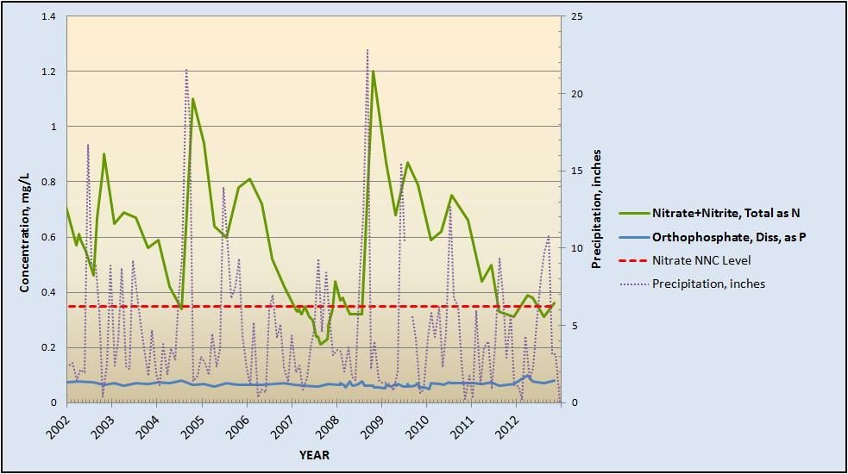

Figure 1: Macronutrient trends in Blue Spring, shown with DeLand monthly precipitation: 2002 – 2012

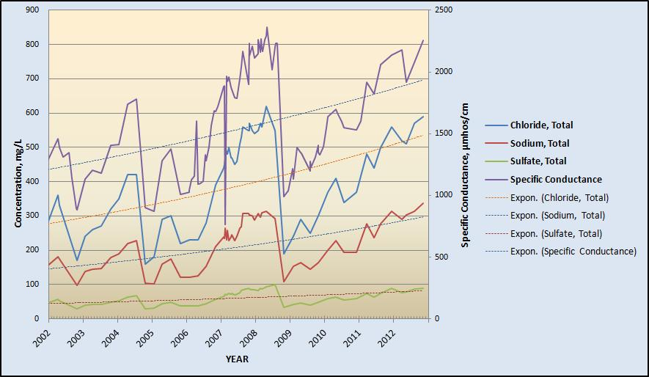

Figure 2: Salinity indicator trends in Blue Spring: 2002 - 2012

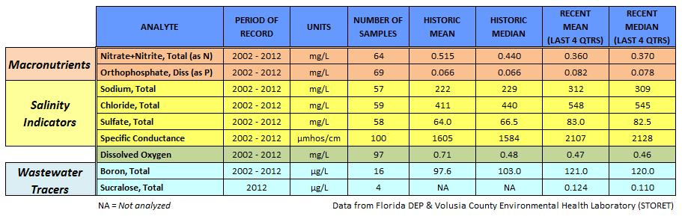

Table 1: Summary of selected water quality results for Blue Spring

