FLORIDA DEPARTMENT OF ENVIRONMENTAL PROTECTION

Division of Environmental Assessment and Restoration, Bureau of Watershed Restoration
NORTHWEST DISTRICT • APALACHICOLA–CHIPOLA BASIN

FINAL REPORT

Nutrient TMDL for Jackson Blue Spring and Merritts Mill Pond (WBIDs 180Z and 180A)

James Dodson

Ground Water Management Section

October 2012

Acknowledgments
This analysis could not have been accomplished without significant contributions from Teayann Tinsley, Debra Harrington, Edgar Wade, and Akia Laurant in the Florida Department of Environmental Protection’s Bureau of Watershed Restoration, Ground Water Management Section.
Editorial assistance was provided by Linda Lord.
Map production assistance was provided by Teayann Tinsley.
For additional information on the watershed management approach and impaired waters in the Apalachicola–Chipola Basin, contact:
John Abendroth
Florida Department of Environmental Protection
Bureau of Watershed Restoration
Watershed Planning and Coordination Section
2600 Blair Stone Road, Mail Station 3565
Tallahassee, FL 32399-2400
Email: john.abendroth@dep.state.fl.us
Phone: (850) 245–8555
Fax: (850) 245–8434

Access to all data used in the development of this report can be obtained by contacting:
Richard Hicks, P.G.
Florida Department of Environmental Protection
Bureau of Watershed Restoration
Ground Water Management Section
2600 Blair Stone Road, Mail Station 3575
Tallahassee, FL 32399-2400
Email: richard.w.hicks@dep.state.fl.us
Phone: (850) 245–8229
Fax: (850) 245–8236

Contents
Acknowledgments ii
Chapter 1: INTRODUCTION 1
1.1 Purpose of Report 1
1.2 Identification of Waterbody 1
1.3 Background 9
Chapter 2: DESCRIPTION OF WATER QUALITY PROBLEM 11
2.1 Statutory Requirements and Rulemaking History 11
2.2 Information on Verified Impairment 11
2.3 Nutrients 12
2.3.1 Nitrate 12
2.3.2 Phosphorus 12
2.4 Ecological Issues Related to Nutrients 13
2.4.1 Algal Mats 13
2.4.2 Other Ecological Issues 17
2.5 Monitoring Sites and Sampling 18
2.6 Rainfall and Temperature Data 18
2.7 Discharge Data 20
2.8 Monitoring Results 22
2.8.1 Nitrogen 22
2.8.2 Phosphorus 24
Chapter 3. DESCRIPTION OF APPLICABLE WATER QUALITY STANDARDS AND TARGETS 28
3.1 Classification of the Waterbody and Criteria Applicable to the TMDL 28
3.2 Applicable Water Quality Standards and Numeric Water Quality Targets 28
3.2.1 Nutrients 28
3.2.2 Outstanding Florida Water Designation 29
Chapter 4: ASSESSMENT OF SOURCES 30
4.1 Types of Sources 30
4.2 Documentation of Nutrient Sources in the Jackson Blue Spring Contributing Area 30
4.2.1 Wastewater and Stormwater Sources 32
4.2.2 Land Uses and Nonpoint Sources 34
Chapter 5: DETERMINATION OF ASSIMILATIVE CAPACITY 40
5.1 Determination of Loading Capacity 40
5.2 TMDL Development Process 41
5.2.1 Establishing the Nitrate (NO3) Target Concentration 41
5.2.2 Target Setting 47
5.3 Setting the Monthly Average Concentration for Nitrate 50
5.4 Critical Conditions/Seasonality 51
5.5 Calculation of the TMDL Percent Reduction 52
Chapter 6: DETERMINATION OF THE TMDL 54
6.1 Expression and Allocation of the TMDL 54
6.2 Load Allocation 56
6.3 Wasteload Allocation 56
6.3.1 NPDES Wastewater Discharges 56
6.3.2 NPDES Stormwater Discharges 56
6.4 Margin of Safety 56
Chapter 7: NEXT STEPS—IMPLEMENTATION PLAN DEVELOPMENT AND BEYOND 57
7.1 Basin Management Action Plan 57
References 59
Appendices 62
Appendix A: Background Information on Federal and State Stormwater Programs 62
Appendix B: Change-Point Analysis of the Suwannee River Algal Data 63

List of Tables
Table 2.1. Verified Impaired Spring-Related Segments in the Apalachicola–Chipola Basin 11
Table 2.2. Temperature and Precipitation at the NOAA Weather Station (Chipley - 081544), 1981–2010 20
Table 2.3. Comparative Discharge Measurements (cfs) for Jackson Blue Spring vs. Merritts Mill Pond, 2006–10 (USGS and NWFWMD) 21
Table 2.4. Nitrate and TN Concentrations for Jackson Blue Spring, 2001–11 25
Table 2.5. Nitrate and TN Concentrations for Merritts Mill Pond, 2001–11 26
Table 2.6. Phosphorus Concentrations for Jackson Blue Spring, 2001–11 27
Table 2.7. Phosphorus Concentrations for Merritts Mill Pond, 2001–11 27
Table 4.1. Classification of Land Use Categories for the Jackson Blue Spring–Merritts Mill Pond Contributing Area in 2009 34
Table 4.2. Livestock Nitrogen Contribution in the Jackson Blue Spring Watershed in 2007 (Barrios 2011) 38
Table 4.3. USDA Census—Acres under Tillage and Nitrogen Loading Estimate for the Jackson Blue Spring–Merritts Mill Pond Contributing Area in 2007 (Barrios 2011) 38
Table 5.1. Monthly Median Nitrate Concentrations for Jackson Blue Spring and Merritts Mill Pond, 2001–11 52
Table 6.1. Daily Maximum for Target Nitrate Concentration (mg/L) 54
Table 6.2. TMDL Components for Jackson Blue Spring and Merritts Mill Pond 55

List of Figures
Figure 1.1. Major Geopolitical and Hydrologic Features in the Jackson Blue Spring–Merritts Mill Pond Contributing Area 2
Figure 1.2. Aerial Photograph of Merritts Mill Pond Showing Weir and Dam in the Lower Right Corner (J. Van Dyke, Department 2006) 3
Figure 1.3. Contributing Area for Jackson Blue Spring and Merritts Mill Pond 4
Figure 1.4. Locations of Springs in the Merritts Mill Pond Contributing Area 5
Figure 1.5. Generalized Geologic Cross-Section in the Vicinity of Jackson Blue Spring and Merritts Mill Pond 7
Figure 1.6. Floridan Aquifer Vulnerability Map in the Portion of the Jackson Blue Spring–Merritts Mill Pond Contributing Area within Florida 8
Figure 2.1. Algal Bloom at the Southern End of Merritts Mill Pond Just North of the Weir at U.S. Highway 90 in 2003 (Source: J. Van Dyke, Department) 14
Figure 2.2. Floating Hydrilla verticillata Mats at Merritts Mill Pond Just Below Jackson Blue Spring in May 2004 (Source: Florida Geological Survey) 14
Figure 2.3. Merritts Mill Pond Below Jackson Blue Head Spring in May 2004 (Green Algae and Hydrilla verticillata on Bottom) (Source: Florida Geological Survey) 15
Figure 2.4. Water Meal (Algae) Bloom in Merritts Mill Pond in September 2006 (Source: J. Van Dyke, Department) 15
Figure 2.5. Algae at Gator Hole Spring in Merritts Mill Pond in May 2011 (Source: G. Maddox, Department) 16
Figure 2.6. Algae at Bottom of Main Spring Run in Merritts Mill Pond on February 7, 2012 (Source: P. Madden, Department) 16
Figure 2.7. Record Shellcracker (4.86 lbs.) Caught in Merritts Mill Pond by Joey Floyd on March 13, 1986 (Photo: S. Kirkland, Florida Fish and Wildlife Conservation Commission) 17
Figure 2.8. Surface Water Monitoring Sites Associated with the Impaired Waterbodies 19
Figure 2.9. Historical Annual Rainfall for Chipley, FL, 1980–2010 20
Figure 2.10. Contribution of Jackson Blue Spring to the Merritts Mill Pond Discharge, 2006–11 (Barrios 2011) 22
Figure 2.11. Historical Nitrite+Nitrate Concentrations for Jackson Blue Spring, 1960–2011 (Barrios 2011) 23
Figure 2.12. Nitrate Concentrations, Merritt’s Mill Pond, 2007–11 (Barrios 2011) 24
Figure 2.13. Nitrogen Trends for Jackson Blue Spring, 2001–11 25
Figure 2.14. Nitrogen Trends for Merritts Mill Pond, 1981–2011 26
Figure 4.1. Nitrate-N Concentration vs. Delta ¹⁵N (Barrios 2011) 31
Figure 4.2. Delta ¹⁵N vs. Delta ¹⁸O (Barrios 2011) 32
Figure 4.3. Population Density in Jackson County in 2010 33
Figure 4.4. Principal Land Uses in the Jackson Blue Spring–Merritts Mill Pond Contributing Area in 2009 35
Figure 4.5. Density of OSTDS (Septic Tanks) in Jackson County and the Jackson Blue Spring–Merritts Mill Pond Contributing Area in 2009 (Hall and Clancy 2009) 37
Figure 5.1. Correlation between Ecological Efficiency and Nitrate Concentration in the Wekiva River, Rock Springs Run, Alexander Springs Creek, and Juniper Creek 42
Figure 5.2. Springs Included in the Florida Springs Report (Stevenson et al. 2007) 43
Figure 5.3. Change-Point Study Sites 44
Figure 5.4. Relationship between Mean Nitrate Concentration and Mean Periphyton Biomass from 12 Sampling Sites on the Suwannee, Santa Fe, and Withlacoochee Rivers 45
Figure 5.5. Relationship between Mean Nitrate Concentration and Mean Periphyton Cell Density from 12 Sampling Sites on the Suwannee, Santa Fe, and Withlacoochee Rivers 46
Figure 5.6. Change-Point Analyses (the 95% Confidence Interval) 48
Figure 5.7. Central Tendency and Upper 95% Confidence Interval Approach 49
Figure 5.8. Upper and Lower 95% Confidence Interval Approach 50

Websites

Florida Department of Environmental Protection, Bureau of Watershed Restoration
TMDL Program
http://www.dep.state.fl.us/water/tmdl/index.htm

Identification of Impaired Surface Waters Rule
http://www.dep.state.fl.us/legal/Rules/shared/62-303/62-303.pdf

Florida STORET Program
http://www.dep.state.fl.us/water/storet/index.htm

2012 Integrated Report
http://www.dep.state.fl.us/water/docs/2012_integrated_report.pdf

Criteria for Surface Water Quality Classifications
http://www.dep.state.fl.us/legal/Rules/shared/62-302/62-302.pdf

Basin Status Report and Water Quality Assessment Report:
Apalachicola–Chipola
http://www.dep.state.fl.us/water/basin411/apalach/index.htm
Florida Springs
http://www.floridasprings.org/

U.S. Environmental Protection Agency, National STORET Program
Region 4: TMDLs in Florida
http://www.epa.gov/region4/water/tmdl/florida/

National STORET Program
http://www.epa.gov/storet/

Chapter 1: INTRODUCTION

1.1 Purpose of Report
This report presents the Total Maximum Daily Load (TMDL) for nitrate (NO₃), which was determined to cause the impairment of Jackson Blue Spring and its receiving water, Merritts Mill Pond. These waterbodies are located in the Chipola River Planning Unit of the Apalachicola–Chipola Basin. Jackson Blue Spring and Merritts Mill Pond were verified by the Florida Department of Environmental Protection (Department) as impaired by nutrients and were included on the Verified List of impaired waters for the Apalachicola–Chipola Basin that was adopted by Secretarial Order in May 2009. The TMDL establishes the allowable level of nutrient loadings to Jackson Blue Spring and Merritts Mill Pond that would restore these waterbodies so that they meet their applicable water quality criterion for nutrients. This report will be used as the basis for discussions during the development of the Basin Management Action Plan (BMAP).

1.2 Identification of Waterbody
Jackson Blue Spring and Merritts Mill Pond are located in Jackson County, approximately 4.2 miles east of the city of Marianna (Figure 1.1). Jackson Blue Spring forms the headwaters of the 270-acre Merritts Mill Pond, which was once the upper portion of a free-flowing spring run (Spring Creek) prior to 1860. In the 1920s, Merritts Mill Pond was expanded to its current extent with the construction of a dam and weir structure at U.S. Highway 90 (Figure 1.2). The impounded Merritts Mill Pond now forms the headwaters of Spring Creek, a tributary to the Chipola River (which is designated as an Outstanding Florida Water [OFW]). The Chipola River is the largest tributary in Florida to the Apalachicola River. Jackson Blue Spring and Merritts Mill Pond support a complex aquatic ecosystem and together are an important cultural and economic resource for the state.
For assessment purposes, the Department has divided the waters of the state into water assessment polygons with a unique waterbody identification (WBID) number for each watershed or stream reach. Jackson Blue Spring is WBID 180Z, and Merritts Mill Pond is WBID 180A. Figure 1.3 shows a map of the two impaired WBIDs and the springs within them.
In addition to Jackson Blue Spring, 7 named springs are associated with Merritts Mill Pond (Figure 1.4): Shangri-La, Twin Caves, Hole-in-the-Wall, Heidi Hole, Gator Hole, Indian Washtub, and Lamar’s Landing. In June 2007, the Northwest Florida Water Management District (NWFWMD) measured the discharge of the exit conduits of the 6 springs that were currently discharging and found that Jackson Blue Spring has by far the largest discharge of the 8 springs. Jackson Blue Spring contributed approximately 69% of the total flow of Merritts Mill Pond (as measured at the pond outfall), the 7 minor springs contributed 14%, and the remaining 17% was from other unmeasured sources. Using historical data, the NWFWMD has calculated that from 2006 to 2010, Jackson Blue Spring accounted for 70% of the pond outflow on average.

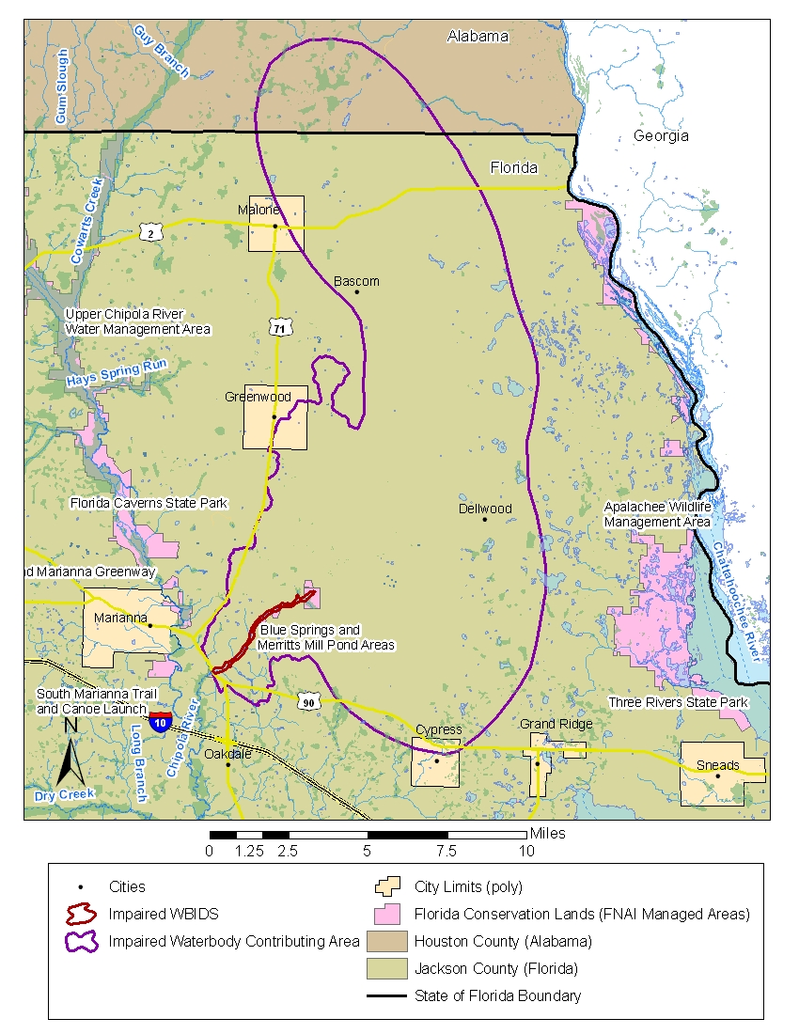
Figure 1.1. Major Geopolitical and Hydrologic Features in the Jackson Blue Spring–Merritts Mill Pond Contributing Area

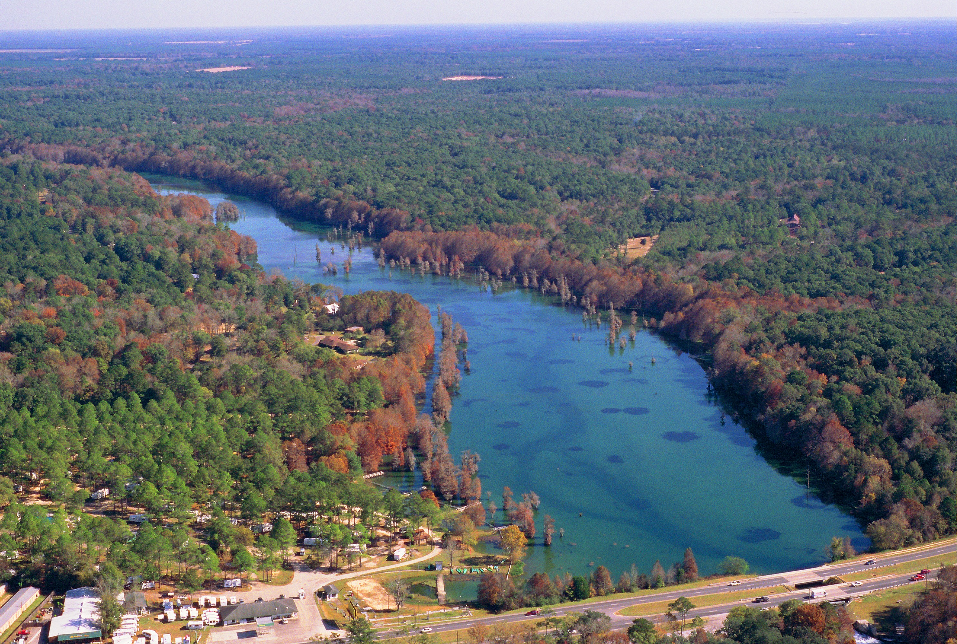
Figure 1.2. Aerial Photograph of Merritts Mill Pond Showing Weir and Dam in the Lower Right Corner (J. Van Dyke, Department 2006)

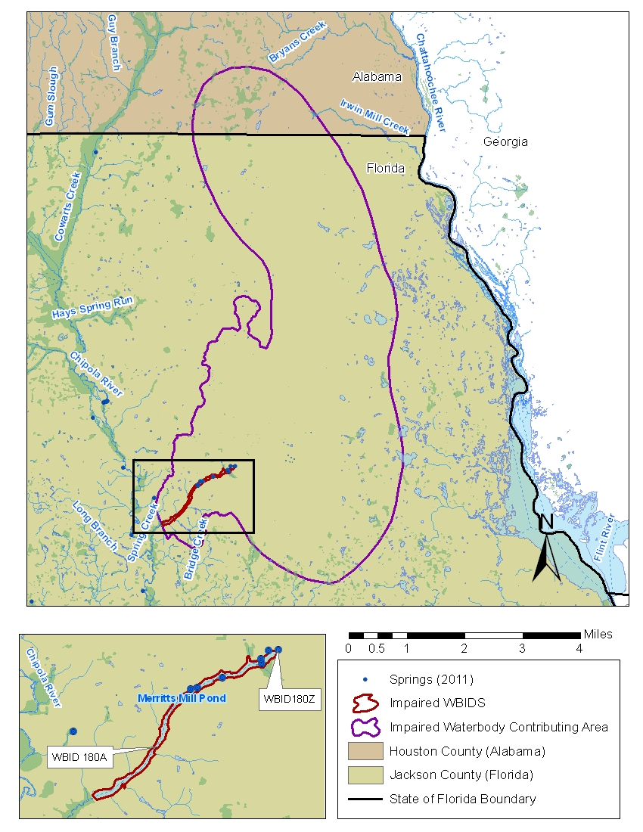
Figure 1.3. Contributing Area for Jackson Blue Spring and Merritts Mill Pond
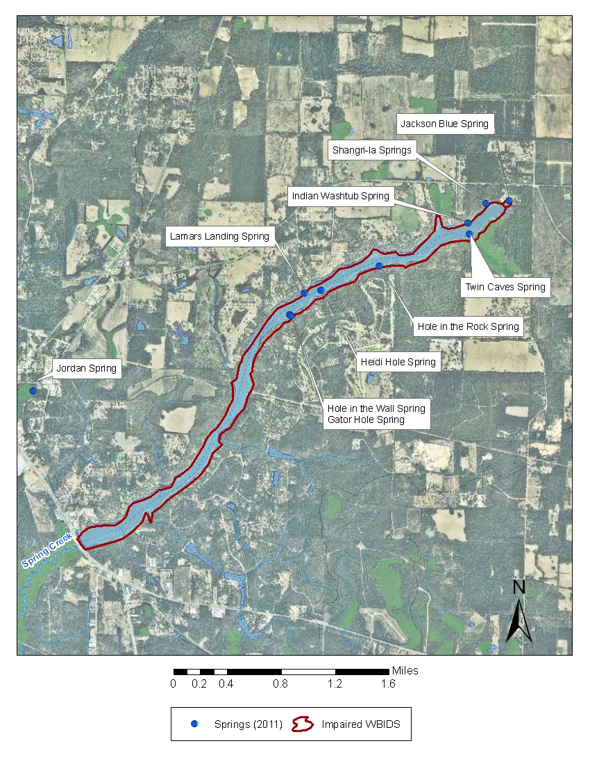
Figure 1.4. Locations of Springs in the Merritts Mill Pond Contributing Area
In geologic terms, Jackson Blue Spring and its associated receiving waters are located within the Dougherty Karst Plain District, which lies mainly in southern Georgia but also encompasses the northern portions of Bay and Calhoun Counties, all of Jackson County, and the majority of Washington and Holmes Counties. In this region, the Floridan aquifer is recharged through the overlying intermediate system (where present), and ground water from it discharges to springs and rivers. The rate of ground water recharge is estimated at 12 to 18 inches per year in the area that supplies water to Jackson Blue Spring. Given the near absence of surface drainage in this area, this amount is essentially the remainder of precipitation after accounting for evapotranspiration. The semiconfined condition of the Floridan aquifer in the Dougherty Karst Plain allows for large amounts of local recharge, but also makes the Floridan especially vulnerable to contamination from activities on the land surface.
In the karst plain region that includes Jackson Blue Spring and Merritts Mill Pond, the landforms and surface water features depend on the underlying geology. In general, the topographic features and internal drainage in karst regions are caused by the underground erosion and subsidence of near-surface carbonate rocks. Within the rock, slightly acidic rainwater causes the limestone to dissolve, and further dissolution along zones of fractured rock and bedding planes causes the development of caves and interconnected openings known as conduits. Ground water migrates within these zones, and springs occur where hydraulic head differences in the aquifer coincide with openings in the land surface.
The entire area that contributes water to a spring via ground water and surface water inflows is known as its springshed. The NWFWMD has delineated the springshed for Jackson Blue Spring based on an analysis of ground water elevation maps, called potentiometric surface maps (Barrios 2011), as well as the use of both instrument survey and Light Detection and Ranging (LiDAR) elevation models. Delineation based on potentiometric surface maps provides a good general description of springshed boundaries but is limited by the resolution of the potentiometric surface map, the climatic conditions that existed when the map was created, and the assumption of uniform drainage over the mapped area. The 2011 Barrios report introduced a new springshed that took into consideration the flows from all of the springs within Merritts Mill Pond. In the Barrios report, the statistics for land use were generated from the original springshed.
In evaluating potential sources of nutrients impacting Jackson Blue Spring and Merritts Mill Pond, the Department considered the springshed as well as the surface watershed of the impaired receiving waters. Based on measurements in 2007, the combined contributing area of water to Jackson Blue Spring and Merritts Mill Pond includes the springshed of Jackson Blue Spring and the surface water watershed of Merritts Mill Pond. Together they encompass an area of 153.6 square miles (mi²) (Figure 1.3 shows the combined contributing area, and Figure 1.1 shows the major geopolitical and hydrologic features in the area). This area includes 140.58 square miles in Jackson County, Florida, and 13.06 square miles in Houston County, Alabama.
Figure 1.5 shows a generalized geologic north-south cross-section in the area of Jackson Blue Spring and Merritts Mill Pond. This cross-section was created from drilling logs that were generated in the 1990s during the installation of wells for the Very Intense Study Area (VISA) ground water quality network. Numerous VISA networks were established throughout Florida to monitor specific land uses. Although this network is no longer funded, the information from these drilling logs provides valuable insight into the subsurface.
In Jackson County, the Floridan aquifer comprises the Chattahoochee Formation, the undifferentiated Marianna/Suwannee Limestone, and the Ocala Limestone (Scott 1993; Campbell 1993). The region is characterized by a thin intermediate system confining unit, generally less than 50 feet thick, that is often absent or breached by sinkholes. The Floridan aquifer itself is relatively thin, with a thickness of approximately 100 feet in northern Jackson County, where its occurrence is limited to the Ocala Limestone (Moore 1955). Continuing south to the Jackson County–Calhoun County line, the Floridan aquifer thickens to approximately 500 feet with the occurrence of the younger limestone formations (Pratt et al. 1996).
Figure 1.6 shows a Floridan aquifer vulnerability map in the area contributing to Jackson Blue Spring. This map is created based on conditions such as soil characteristics, depth to ground water, recharge rate, and the prevalence of sinkhole features. The map shows that the northeastern portion of Jackson County, which includes the Jackson Blue Spring–Merritts Mill Pond contributing area, is more vulnerable to ground water contamination in comparison to other areas in the Apalachicola–Chipola Basin.
Additional information about the spring’s hydrology and hydrogeologic setting is available in the Basin Status Report for Apalachicola–Chipola (Department 2002a).
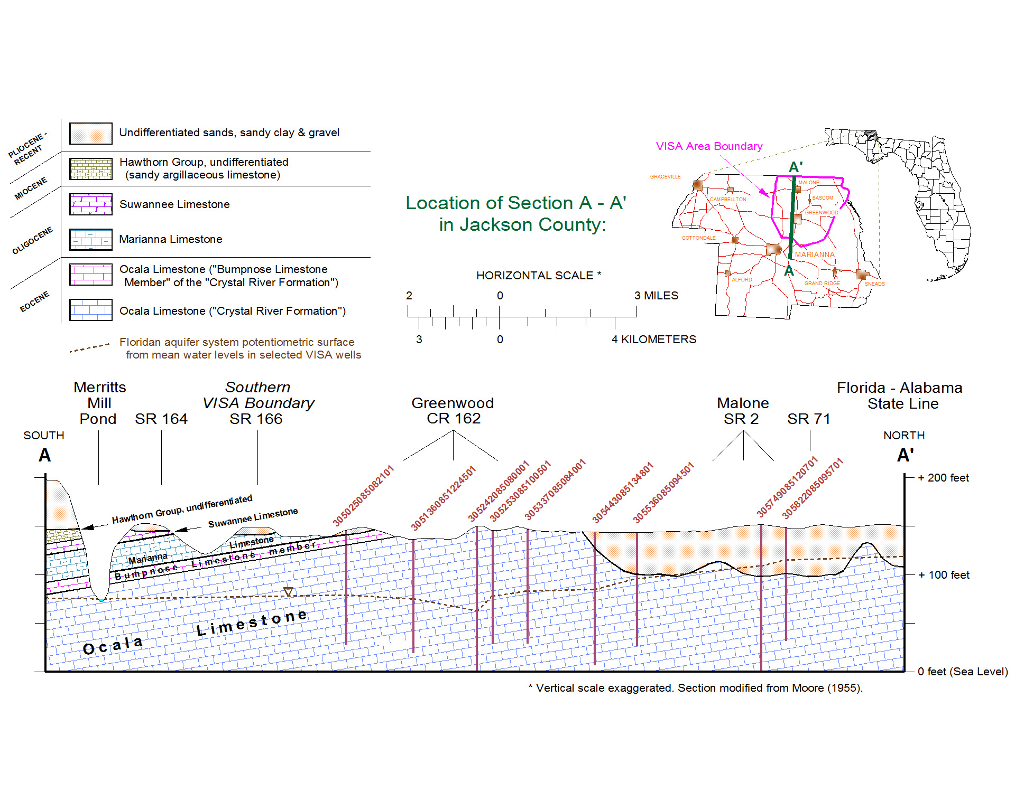Figure 1.5. Generalized Geologic Cross-Section in the Vicinity of Jackson Blue Spring and Merritts Mill Pond

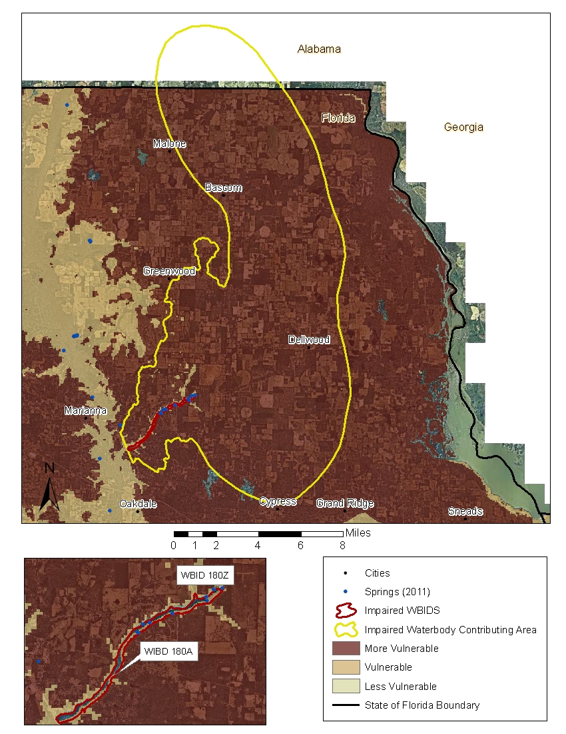
Figure 1.6. Floridan Aquifer Vulnerability Map in the Portion of the Jackson Blue Spring–Merritts Mill Pond Contributing Area within Florida

1.3 Background
This report was developed as part of the Department’s watershed management approach for restoring and protecting state waters and addressing TMDL Program requirements. The watershed approach, which is implemented using a cyclical management process that rotates through the state’s 52 river basins over a 5-year cycle, provides a framework for implementing the TMDL Program–related requirements of the 1972 federal Clean Water Act and the 1999 Florida Watershed Restoration Act (FWRA) (Chapter 99-223, Laws of Florida).
A TMDL represents the maximum amount of a given pollutant that a waterbody can assimilate and still meet water quality standards, including its applicable water quality criteria and its designated uses. TMDLs are developed for waterbodies that are verified as not meeting their water quality standards. They provide important water quality restoration goals that will guide restoration activities.
This TMDL Report will be followed by the development and implementation of a BMAP to reduce the amount of nutrients that caused the verified impairment of Jackson Blue Spring and Merritts Mill Pond. The restoration of these waterbodies will depend heavily on the active participation of stakeholders in the contributing area, including Jackson County, the city of Marianna, other local governments, landowners, businesses, and private citizens. The NWFWMD and Florida Department of Agriculture and Consumer Services (FDACS) will also play important roles in the implementation of restoration activities.
Jackson Blue Spring and Merritts Mill Pond are economically valuable to the state and local communities. The land surrounding Jackson Blue Spring is owned by the state and administered by the Department’s Division of State Lands (DSL). The DSL currently leases a 195-acre park (Blue Springs Recreational Area) located at the spring to the Jackson County Board of County Commissioners. Typically, the park is open from Memorial Day weekend to Labor Day weekend. In 2011 annual attendance at the park exceeded 36,000 visitors, up from 34,233 in 2009. Direct revenue from attendance in 2009 was $108,635 (Hatcher 2009). The period of operation for 2012 has been expanded. The park is now open for visitation 3 weeks earlier, beginning in the first week of May rather than the last.
The open conduits and shallow depths of the caves associated with the springs (45 feet below the land surface versus 300 feet at Wakulla Spring) are a draw for cave divers from around the world. Cave Adventures, owned by Edd Sorenson, is a scuba dive shop that is located on Merritts Mill Pond. The shop oversees these activities and helps the County Sheriff’s Department coordinate the restricted access to the caves. The majority of the divers come from out of state. In 2009 the caves attracted divers from 37 different states (including Alaska) and 18 different countries (Hatcher 2009).
Arrowhead Campground is a large private campground with 200 campsites located on the southwestern bank of Mill Pond. The campground has been in business for decades and stays occupied year-round.
Immediately downstream of the Mill Pond is Spring Creek Park, which is also owned by the DSL and leased to the Jackson County Board of County Commissioners. This location is a very popular launch site for recreational canoeing and tubing. Common visitors on the weekends are church groups and college groups from Tallahassee. The largest vendor providing assistance to visitors at Spring Creek Park is Bear Paw Adventures, Inc., which is located several miles downstream of the park.
From 2006 to 2010, the Department, through the Florida Springs Initiative, provided funding to Chipola College to coordinate a Springs Working Group for Jackson Blue Spring. The college coordinated quarterly meetings where presentations were given on environmental activities in the vicinity of the springs. The Working Group focused on educating stakeholders about how the various land use practices affected the springs and identified and promoted best management practices (BMPs) within the springshed. Meeting agendas and the associated presentations are available at http://www.chipola.edu/Grants/Blue%20Springs/events.htm.

Chapter 2: DESCRIPTION OF WATER QUALITY PROBLEM

2.1 Statutory Requirements and Rulemaking History
Section 303(d) of the federal Clean Water Act requires states to submit to the U.S. Environmental Protection Agency (EPA) a list of surface waters that do not meet applicable water quality standards (impaired waters) and establish a TMDL for each pollutant causing the the impairment of listed waters on a schedule. The Department has developed such lists, commonly referred to as 303(d) lists, since 1992. The list of impaired waters in each basin, referred to as the Verified List, is also required by the FWRA (Subsection 403.067[4], Florida Statutes [F.S.]), and the state’s 303(d) list is amended annually to include basin updates.
Florida’s 1998 303(d) list included 20 waterbodies in the Apalachicola–Chipola Basin. However, the FWRA (Section 403.067, F.S.) stated that all previous Florida 303(d) lists were for planning purposes only and directed the Department to develop, and adopt by rule, a new science-based methodology to identify impaired waters. After a long rulemaking process, the Environmental Regulation Commission adopted the new methodology as Rule 62-303, Florida Administrative Code (F.A.C.) (Identification of Impaired Surface Waters Rule, or IWR), in April 2001. The IWR was modified in 2006 and 2007.

2.2 Information on Verified Impairment
Rule 62-303, F.A.C., includes a methodology for listing nutrient-impaired surface waters based on documentation that supports the determination of an imbalance of flora or fauna. In 2009, the Department used available water quality data in the IWR database, data from the Department’s Springs Initiative monitoring network, and other available information to document the nitrate concentrations and effects of nutrient enrichment at Jackson Blue Spring and Merritts Mill Pond. The Department’s spring monitoring data, collected by the NWFWMD from 2001 to 2008, comprised the bulk of the nitrate data used in the evaluation. Biological assessment documents prepared by the Department’s Environmental Assessment Section and photographic evidence collected by Department staff were used to provide evidence of algal smothering.
These spring-related waters were listed as impaired by nutrients because of their consistently elevated concentrations of nitrate (above 0.6 milligrams per liter [mg/L]) and corresponding evidence of imbalance of flora and fauna caused by algal smothering. This information, documented by Hicks et al. (2009), supplemented the determination of impairment for the 2009 Verified List of impaired waters. Table 2.1 lists the spring-related segments in the Apalachicola–Chipola Basin that are on the Cycle 2 Verified List based on this assessment.

Table 2.1. Verified Impaired Spring-Related Segments in the Apalachicola–Chipola Basin
WBID | Waterbody Segment | Parameters Assessed  Using the IWR | Priority for TMDL Development | Projected Year of TMDL Development
180Z | Jackson Blue Spring | Nutrients (algal mats by association with WBID 180A) | Medium | 2012
180A | Merritts Mill Pond | Nutrients (algal mats) | Medium | 2012

2.3 Nutrients
Nutrient overenrichment causes the impairment of many surface waters, including springs. The two major nutrient groups monitored are nitrogen (N) and phosphorus (P). These are essential nutrients to plant life, including algae. For aquatic vegetation and algae to grow, both nutrients have to be present. In fact, one can be present in excess, but if the other is absent, the overgrowth of vegetation or algae is unlikely to occur. Historically, many spring systems have had sufficient naturally occurring phosphorus to trigger an imbalance, but it did not occur because there was very little nitrogen in the water.
Nitrogen is found in several forms and is ubiquitous in the environment. Nitrate (NO₃) is the form of nitrogen that occurs in the highest concentrations in ground water and springs. Nitrite-nitrogen (NO₂), an intermediate form of nitrogen, is almost entirely converted to nitrate in the nitrogen cycle. While nitrate and nitrite are frequently analyzed and reported together as one concentration (nitrate + nitrite-nitrogen), the nitrite contribution is always insignificant. Historically, nitrogen was only a minor constituent of spring water, and typical nitrate concentrations in Florida were less than 0.2 mg/L until the early 1970s. Since then, elevated concentrations of nitrate have been found in many springs. With sufficient phosphorus in the water column, seemingly low nitrogen concentrations can actually cause a significant shift in the balance of spring ecological communities, leading to the degradation of biological systems due to the overgrowth of algae and sometimes aquatic plants (Harrington et al. 2010).

2.3.1 Nitrate
In this report nitrate is NO₃ as nitrogen (NO₃N) and, unless otherwise stated, the sum of NO₃ and NO₂ is used to represent NO₃ due to minimal contributions of NO₂. Chapter 5 discusses the NO₃ nutrient impairment and the setting of the target concentration of NO₃.
According to Barrios (2011), in his assessment of the nutrient sources of springs discharging to Merritts Mill Pond, the semiconfined condition of the Floridan aquifer across the Dougherty Karst Plain allows for large amounts of local recharge, but also makes the Floridan aquifer especially vulnerable to contamination from activities on the land surface.
The transmissivity of the Floridan aquifer, a measure of the ease with which water flows through the aquifer, reportedly ranges from about 1,600 to about 1,300,000 square feet per day (ft²/d) (Sever 1965a, b; Hayes et al. 1983; Wagner and Allen 1984). The NWFWMD has used a transmissivity value of 108,870 ft²/d when modeling the ground water flow in the Jackson Blue Spring springshed (Bartel 2012). The high transmissivities can allow very short ground water transit times and as a result, recharge and nutrient leaching to the Floridan aquifer and transport to spring vents can occur rapidly.
The Floridan aquifer’s vulnerability to contamination can be observed in the springs and wells within the contributing area, where nitrate concentrations increased as land use transitioned from natural land to agricultural and urban development. Anthropogenic sources of nitrate in the contributing area include atmospheric deposition, agricultural and residential fertilizers, and human and animal wastes. The nitrate concentration measured at Jackson Blue Spring has increased from about 0.30 mg/L in the 1960s to the current value of 3.2 to 3.6 mg/L.

2.3.2 Phosphorus
Phosphorus is naturally abundant in Florida limestone and is often detected in different forms within both surface water and ground water. Neither orthophosphate nor total phosphorus (TP) has shown an increasing temporal trend in Jackson Blue Spring or Merritts Mill Pond, and concentrations remain close to those levels found in the early 1980s. Therefore, phosphorus was not considered a target nutrient for the TMDL. In general, only the inorganic form of phosphorus, orthophosphate, is found in ground water in Florida.

2.4 Ecological Issues Related to Nutrients

2.4.1 Algal Mats
The Environmental Assessment Section’s EcoSummary for Jackson Blue Spring (Department 2002b) reports that excessive submerged and floating algal mats were observed near the south end of the pond, indicating nutrient-induced imbalances of algal communities. However, algal accumulation was not found to be significant in the upper 100 meters of the Jackson Blue Spring run, despite the excessive nitrate concentrations. This may be due to the higher water velocities and the disturbance of the stream bottom in this area by swimmers. At other times, accounts have indicated that algae is a problem in the Jackson Blue Spring pool feature that is created by the main spring vent as well as other segments of the spring run (Merritts Mill Pond). The 2004 Springs of Florida publication noted that there was approximately 40% algae coverage on the pool bottom and very little aquatic or emergent vegetation (Scott et al. 2004). The excessive growth of algae as well as the profuse overgrowth of invasive aquatic vegetation commonly manifest themselves in Merritts Mill Pond. There are also many anecdotal accounts of nuisance algae in the pond. Field visits as recently as February 2012 document that algae growth remains excessive. Figures 2.1 through 2.6 provide visual documentation of the growth through the years.
Jackson Blue Spring was included in the 57 spring locations surveyed by Stevenson et al. (2004) and was included in the overall assessment of biological and chemical measurements performed by Hand (2009). Hand’s assessment of Stevenson’s data showed that for Jackson Blue Spring, macroalgae thickness was in the “moderate” range (25% to 50%), epiphyte thickness was in the “moderate” range (25% to 50%), and algal mat coverage was also in the “moderate” range (25% to 50% coverage). This survey included the spring run above Merritts Mill Pond.
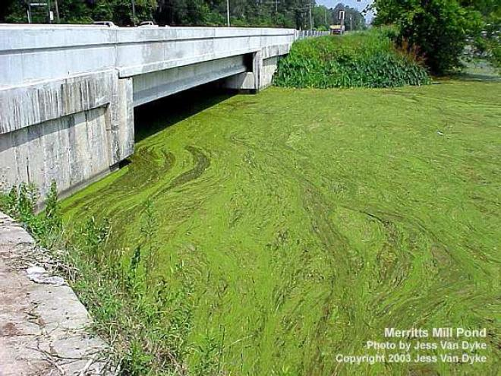

Figure 2.1. Algal Bloom at the Southern End of Merritts Mill Pond Just North of the Weir at U.S. Highway 90 in 2003 (Source: J. Van Dyke, Department)

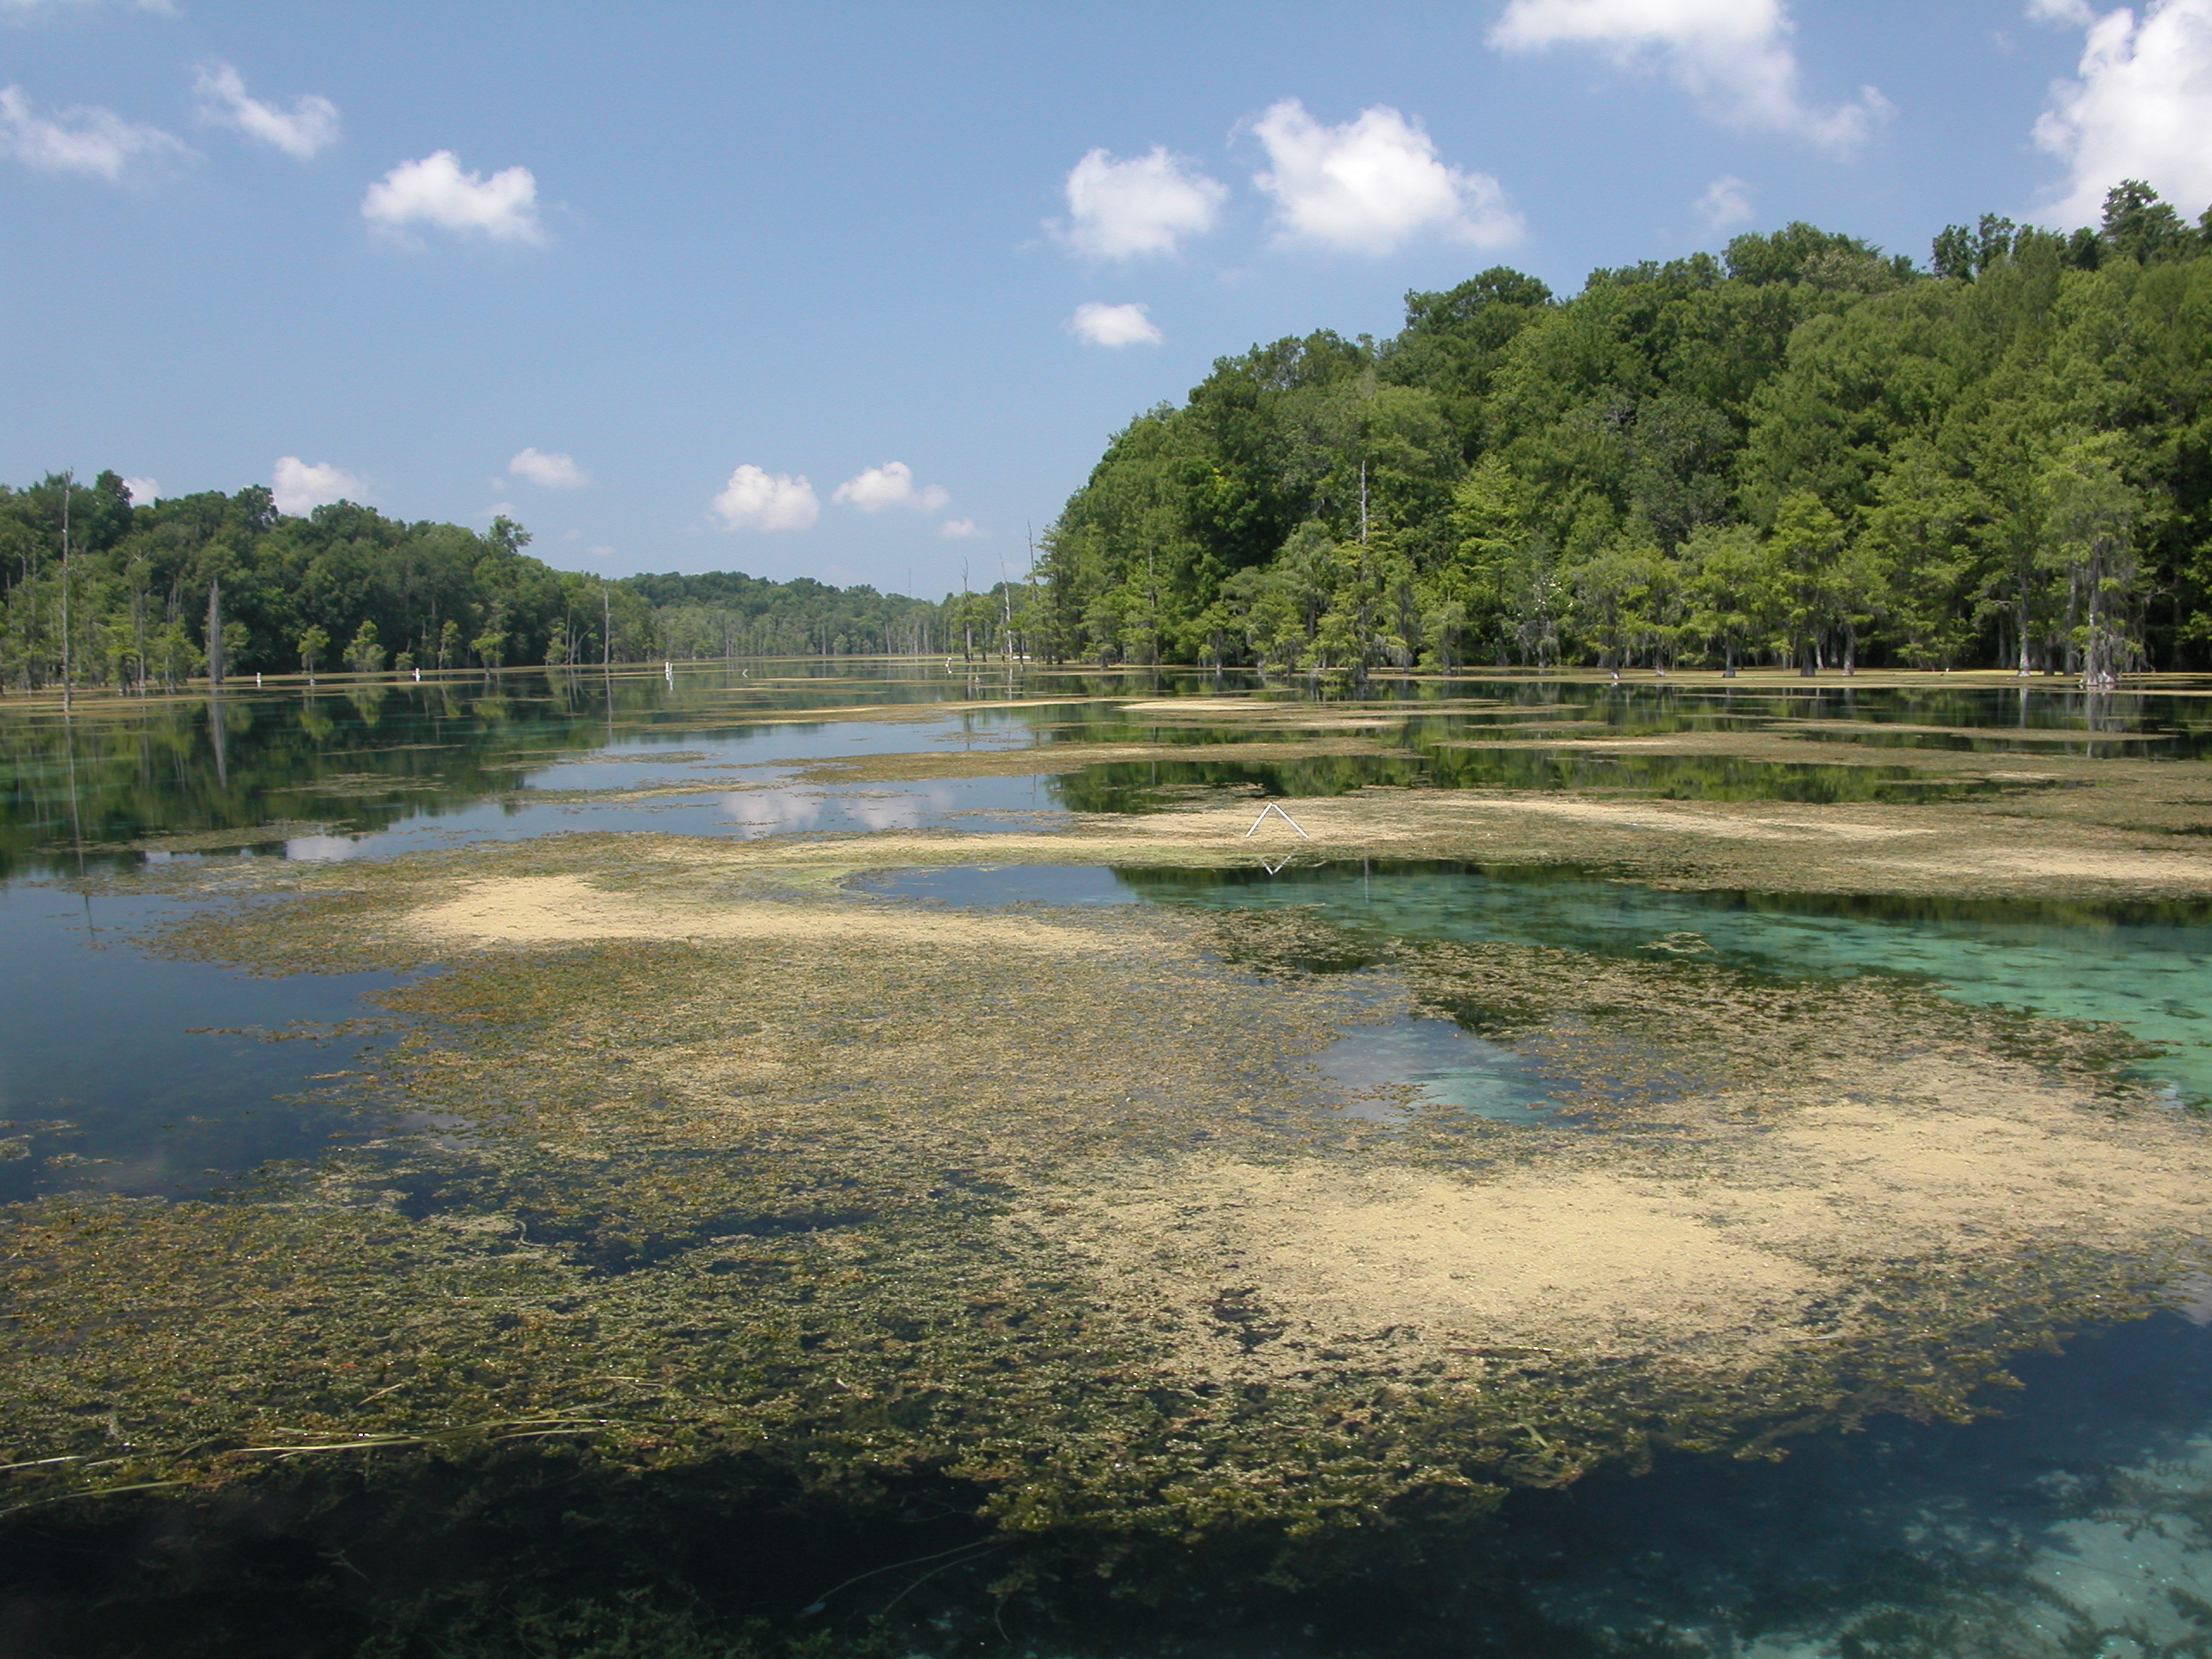
Figure 2.2. Floating Hydrilla verticillata Mats at Merritts Mill Pond Just Below Jackson Blue Spring in May 2004 (Source: Florida Geological Survey)

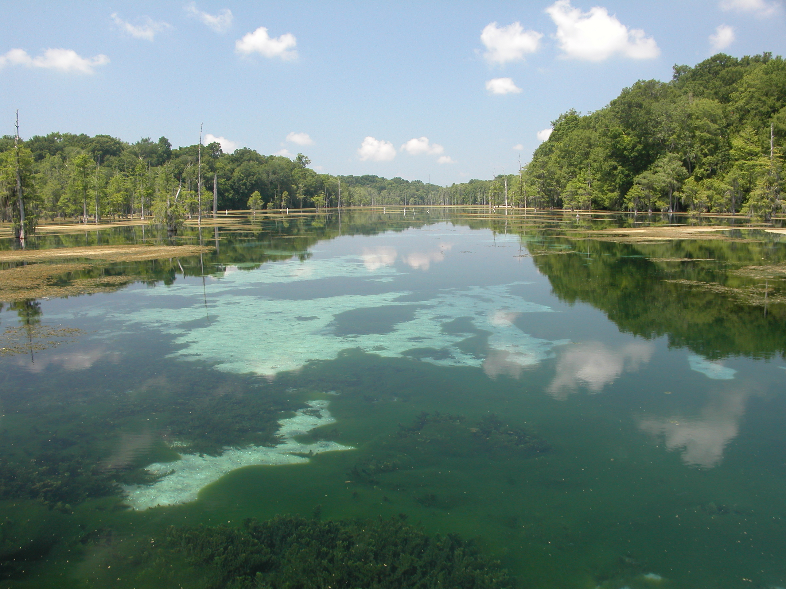

Figure 2.3. Merritts Mill Pond Below Jackson Blue Head Spring in May 2004 (Green Algae and Hydrilla verticillata on Bottom) (Source: Florida Geological Survey)

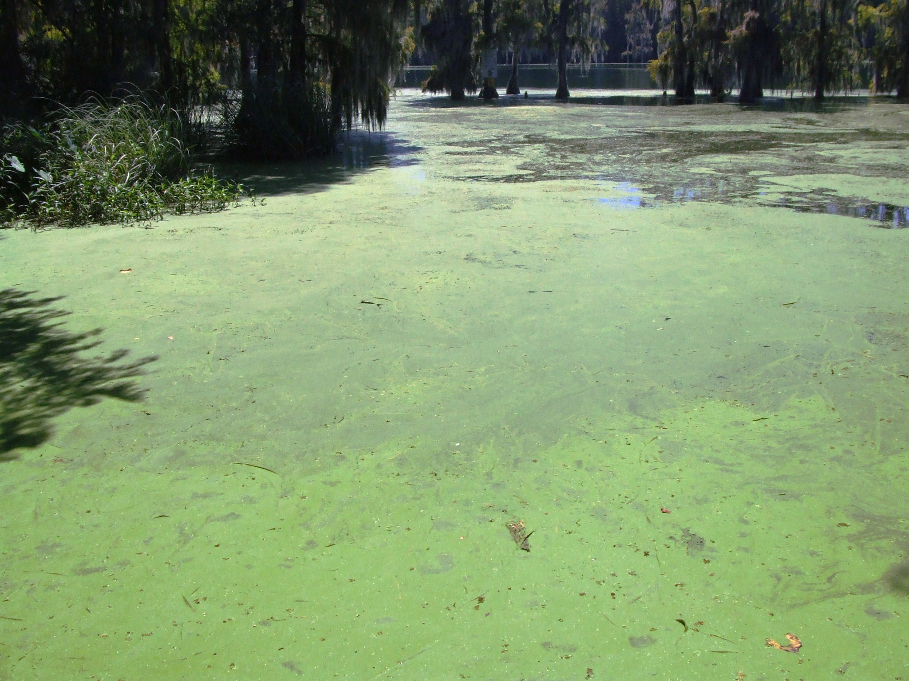
Figure 2.4. Water Meal (Algae) Bloom in Merritts Mill Pond in September 2006 (Source: J. Van Dyke, Department)

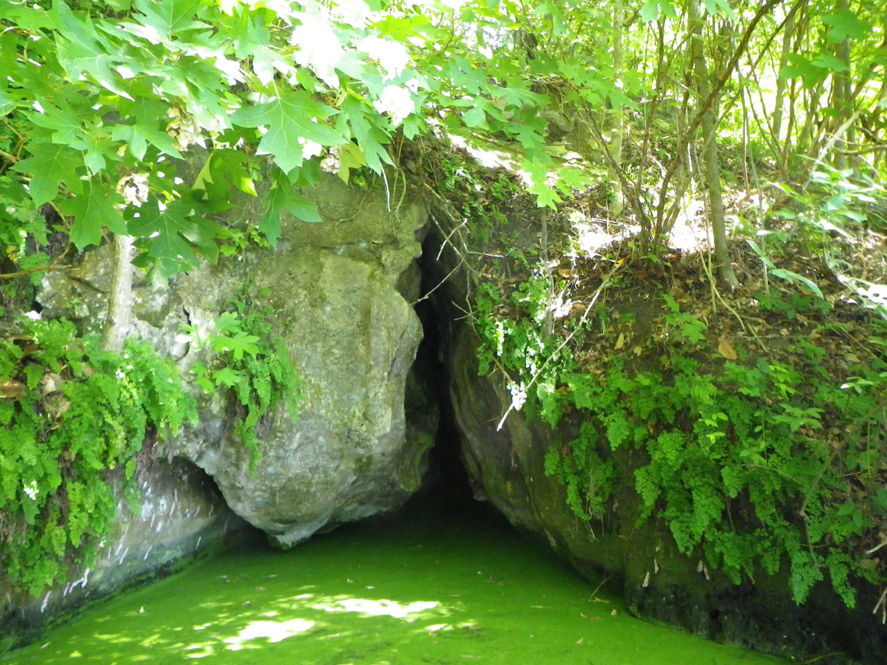

Figure 2.5. Algae at Gator Hole Spring in Merritts Mill Pond in May 2011 (Source: G. Maddox, Department)

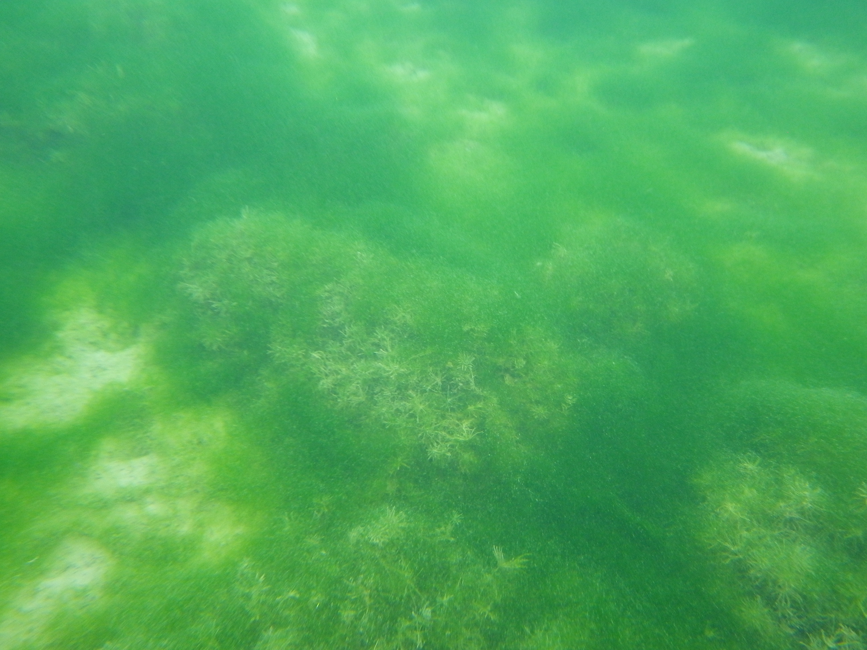

Figure 2.6. Algae at Bottom of Main Spring Run in Merritts Mill Pond on February 7, 2012 (Source: P. Madden, Department)

2.4.2 Other Ecological Issues
Other ecological concerns have been studied for Merritts Mill Pond. In the past, the pond has produced seven state record and two world record redear sunfish (also known as shellcracker) (Figure 2.7). One of the primary food sources for the fish is the Florida apple snail (Pomacea paludosa). Based on anecdotal evidence suggesting that apple snail populations had declined in a number of Florida spring-fed systems, in 2002 the Department contracted with the University of West Florida (Contract S0033) to study nitrate impacts on apple snail growth and survival. The study concluded that nitrate does not have acute or chronic toxic effects on apple snails at environmentally relevant doses. It suggested that die-offs may be more related to habitat structure changes, reducing the survivability of apple snail eggs. These changes may be indirectly related to the algal succession of native vegetation related to nitrate.
The invasive aquatic plant Hydrilla verticillata was first discovered in Merritts Mill Pond in 1991. From 1993 to 2001 this plant dominated the pond. During this period the state spent $70,000 a year for 6 years applying the aquatic herbicide Sonar® to control hydrilla. The short residence time of the herbicide in the pond due to the flow velocity reduced the effectiveness of Sonar®. The weed is now managed using the aquatic herbicide Aquathol®, which requires less contact time on the plant.


Figure 2.7. Record Shellcracker (4.86 lbs.) Caught in Merritts Mill Pond by Joey Floyd on March 13, 1986 (Photo: S. Kirkland, Florida Fish and Wildlife Conservation Commission)

2.5 Monitoring Sites and Sampling
Historical water quality data for Jackson Blue Spring and Merritts Mill Pond are limited, but they do provide a glimpse of current versus “background” water quality. Water quality data have been collected from various locations in both of these waters. Various entities have stored these data in the EPA’s Storage and Retrieval (STORET) and U.S. Geological Survey’s (USGS) National Water Information System (NWIS) databases. The earliest water quality data were collected by the USGS in 1960 for total nitrogen (TN).
The water quality data presented in this report are for 2001 through April 2011, and are the result of sampling done by the Department and the NWFWMD. Figure 2.8 shows the locations of the current and past routine water quality sampling stations and biological stations monitored by the Department.

2.6 Rainfall and Temperature Data
The climate in the Jackson County area is humid subtropical, with hot, rainy summers and cool, generally dry winters. Recharge to ground water is entirely dependent on rainfall. The closest long-term annual rainfall total data for Jackson County were obtained from the Chipley National Weather Service reporting station, approximately 20 miles west of Marianna. In a typical year, 38% of the annual rainfall occurs during the summer rainy season from June through September. May and October are typically the driest months. Rainfall and temperature data were reviewed for the 30-year period of record from 1981 to 2010 (Table 2.2). Annual rainfall averages about 58 inches per year (in/yr) with an average air temperature of about 66ºF (National Oceanic and Atmospheric Administration [NOAA] 2010).
There is a significant relationship between the temporal and spatial patterns of rainfall. From 2006–07 was the second driest two-year period of record (the lowest was 1954–55). Associated with this drought was a period of low spring discharge and high ground water pumpage for irrigation. Periods of low spring discharge may follow periods of low rainfall and high ground water pumpage. Periods of high spring discharge may similarly follow periods of higher rainfall and lower pumpage (Bartel et al. 2011).
Figure 2.9 shows the 30-year historical rainfall trend measured at the Chipley station. Over this period, the lowest annual rainfall of 42.48 inches occurred in 2006–07, and the highest annual rainfall of 73.91 inches occurred in 2002. The NOAA “normal” value for rainfall from 1981 to 2010 is 58.24 inches.

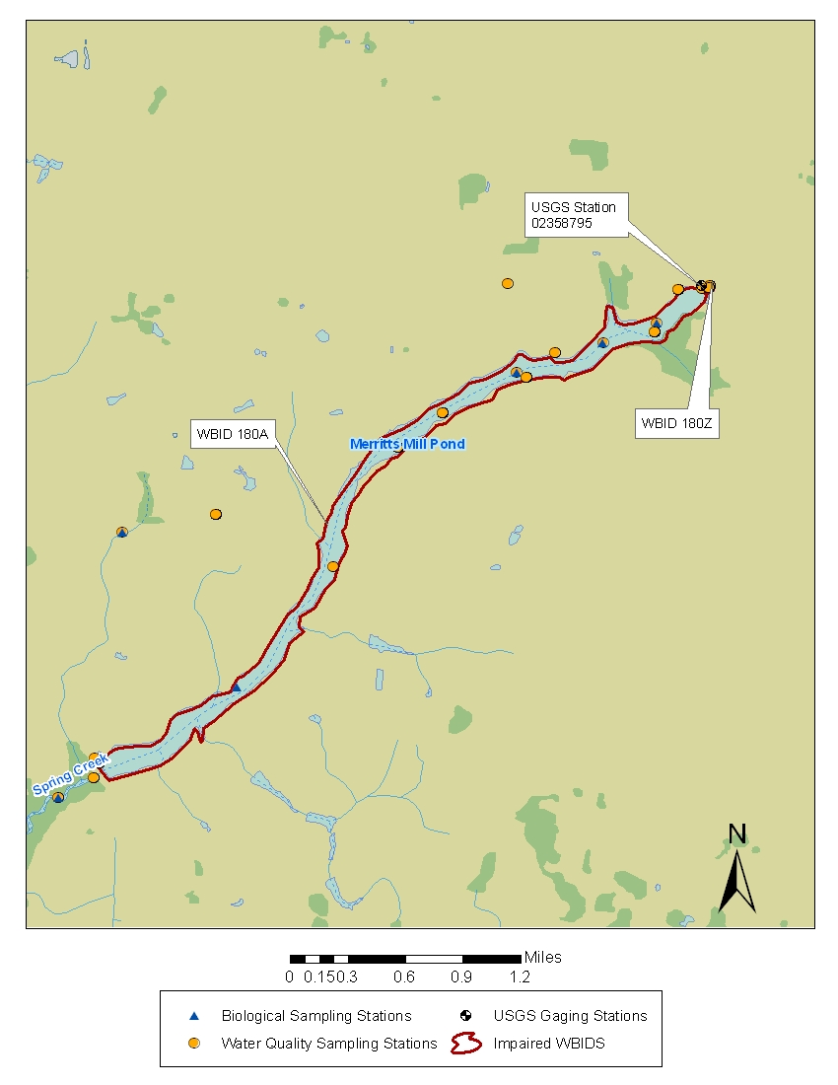
Figure 2.8. Surface Water Monitoring Sites Associated with the Impaired Waterbodies

Table 2.2. Temperature and Precipitation at the NOAA Weather Station (Chipley - 081544), 1981–2010
Source: NOAA 2011
Analysis | Jan | Feb | Mar | Apr | May | Jun | Jul | Aug | Sep | Oct | Nov | Dec | Annual
30-Year Mean–Maximum Temperature (°F) | 61 | 65.3 | 72.4 | 78.8 | 86.2 | 90.5 | 92 | 91.3 | 88 | 80.6 | 71.9 | 63.2 | 78.4
30-Year Mean–Minimum Temperature (°F) | 37 | 40.3 | 46.4 | 52.1 | 60.9 | 68.5 | 70.9 | 70.6 | 65.2 | 54.8 | 46 | 39.4 | 54.5
30-Year Mean–Average Temperature (°F) | 49.1 | 52.8 | 59.4 | 65.4 | 73.6 | 79.6 | 81.5 | 81 | 76.6 | 67.7 | 58.9 | 51.4 | 66.5
30-Year Mean–Precipitation (inches) | 5.24 | 5.09 | 5.73 | 4.12 | 3.97 | 6.05 | 7.22 | 6 | 4.6 | 3.32 | 4.05 | 4.49 | 59.57

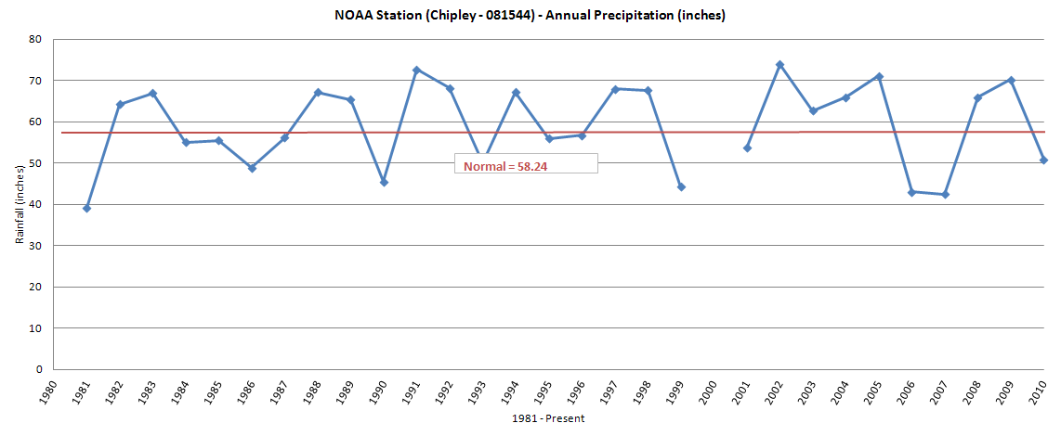
Figure 2.9. Historical Annual Rainfall for Chipley, FL, 1980–2010

2.7 Discharge Data
NWFWMD staff measure the discharge at Jackson Blue Spring and the discharge downstream of the Merritts Mill Pond impoundment on Spring Creek. The difference between the two measurements represents the additional discharge contributed to Merritts Mill Pond from the other sources in the system. These other sources primarily reflect flow contributions from other smaller springs within Merritts Mill Pond and a small amount of localized runoff.
For the entire period of recorded data, the discharge measurements at Jackson Blue Spring have ranged from a low of 28.1 cubic feet per second (cfs) in September 2007 (see drought discussion above) to a high of 305 cfs in April 2003. The average discharge at Jackson Blue Spring is 116 cfs based on 76 field measurements collected by both the USGS and the NWFWMD from December 2001 through December 2009. Table 2.3 lists the statistics for the Jackson Blue Spring discharge. The average discharge at the Merritts Mill Pond weir from November 2006 through June 2010 was 141 cfs. The average discharge at the Blue Springs main vent was 104.5 cfs for the same set of measurements.
Based on measurements of the discharge from springs and pond outflow taken from 2006 to 2010, Jackson Blue Spring accounts for 70% of the pond outflow on average, with the remaining discharge coming from named springs and unidentified springs and seeps within Merritts Mill Pond (Barrios 2011). Figure 2.10 shows the trend of the contribution of Blue Spring discharge to the total discharge of Merritts Mill Pond from 2006 through 2010.

Table 2.3. Comparative Discharge Measurements (cfs) for Jackson Blue Spring vs. Merritts Mill Pond, 2006–10 (USGS and NWFWMD)

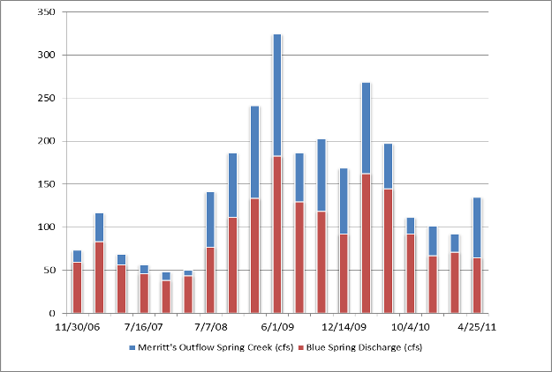
Figure 2.10. Contribution of Jackson Blue Spring to the Merritts Mill Pond Discharge, 2006–11 (Barrios 2011)

2.8 Monitoring Results
Jackson Blue Spring was monitored as part of the Department’s Ambient Ground Water Program’s VISA network in the early 1990s and most recently has been monitored quarterly by the Department. The majority of water quality samples from Merritts Mill Pond are from the numerous spring vents identified previously in this report. Nonspring vent water samples from Merritts Mill Pond have only been collected in two sampling events, with both sets collected in 1996. The recent TN data for Jackson Blue Spring and Merritts Mill Pond are presented below in Figures 2.13 and 2.14 and summarized in Tables 2.4 and 2.5.

2.8.1 Nitrogen
The predominant form of nitrogen in the samples from Jackson Blue Spring and Merritts Mill Pond is nitrate. The nitrate concentrations measured at Jackson Blue Spring have increased from about 0.30 mg/L in the 1960s to the most recent value of 3.2 to 3.6 mg/L. Figure 2.11 depicts the change in concentration over time.

The Jackson Blue Spring vent contributes the majority of the flow to Merritts Mill Pond. The secondary springs located on Merritts Mill Pond are have also been sampled. Figure 2.12 shows the comparative concentrations of nitrate found in waters flowing from these springs.
Figures 2.13 and 2.14 and Tables 2.4 and 2.5 depict TN and nitrate data for Jackson Blue Spring and Merritts Mill Pond, in mg/L, for the most recent 10 years of data. The sum of nitrate and nitrite is used below to represent nitrate due to minimal concentrations of nitrite. In all cases, the comparative data show that nitrate is the predominant form of nitrogen. The nitrate data in Tables 2.4 and 2.5 are for the 10-year period of record used in developing the TMDL. These data show that the concentrations found immediately at the Jackson Blue Spring vent are consistently higher than the concentrations found in the spring samples collected from Merritts Mill Pond.

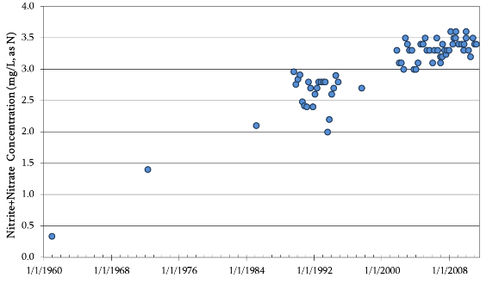
Figure 2.11. Historical Nitrite+Nitrate Concentrations for Jackson Blue Spring, 1960–2011 (Barrios 2011)

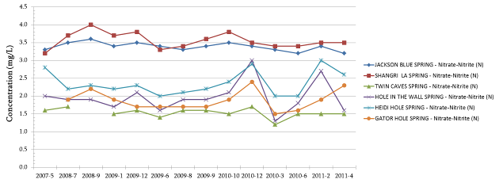

Figure 2.12. Nitrate Concentrations, Merritt’s Mill Pond, 2007–11 (Barrios 2011)

Over the monitoring period, median nitrate+nitrite concentrations in Jackson Blue Spring have ranged from 3.1 to 3.40 mg/L. Over the most recent 10-year period of record used for TMDL development, the median nitrate+nitrite concentration in Jackson Blue Spring was 3.3 mg/L.
Over the same monitoring period as Jackson Blue Spring, the median nitrate+nitrite concentrations in the samples representing Merritts Mill Pond (mainly from springs) have ranged from 1.85 to 2.9 mg/L. Over the recent 10-year period, the median nitrate+nitrite concentration for Merritts Mill Pond was 2.2 mg/L.

2.8.2 Phosphorus
Tables 2.6 and 2.7 depict the TP data for Jackson Blue Spring and Merritts Mill Pond. Median phosphorus concentrations have not varied greatly over the period of record and remain relatively consistent with background ground water concentrations over the region. There was no correlation between phosphorus and nitrate values from 2000 through 2010. Phosphorus concentrations for Jackson Blue Spring samples and Merritts Mill Pond samples (mostly from springs) are similar.

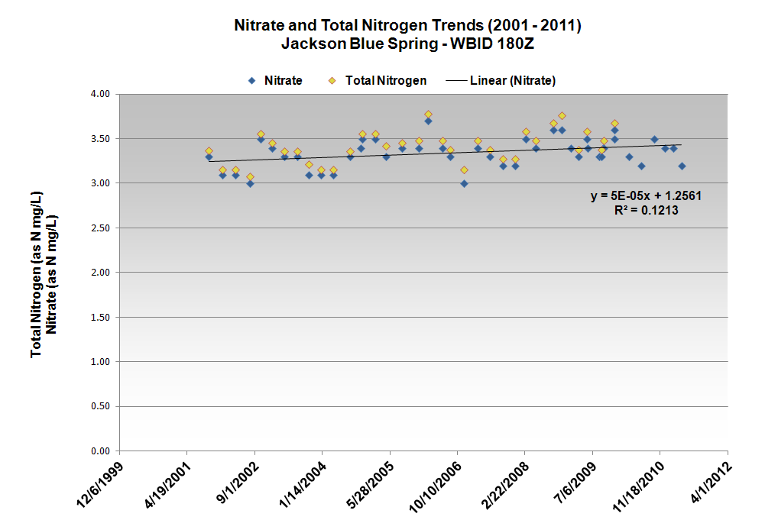
Figure 2.13. Nitrogen Trends for Jackson Blue Spring, 2001–11

Table 2.4. Nitrate and TN Concentrations for Jackson Blue Spring, 2001–11
Figure 2.14. Nitrogen Trends for Merritts Mill Pond, 1981–2011

Table 2.5. Nitrate and TN Concentrations for Merritts Mill Pond, 2001–11

Table 2.6. Phosphorus Concentrations for Jackson Blue Spring, 2001–11

Table 2.7. Phosphorus Concentrations for Merritts Mill Pond, 2001–11

Chapter 3. DESCRIPTION OF APPLICABLE WATER QUALITY STANDARDS AND TARGETS

3.1 Classification of the Waterbody and Criteria Applicable to the TMDL
Florida’s surface waters are protected for five designated use classifications, as follows:
Class I Potable water supplies
Class II Shellfish propagation or harvesting
Class III Recreation, propagation, and maintenance of a healthy, well-balanced population of fish and wildlife
Class IV Agricultural water supplies
Class V Navigation, utility, and industrial use (there are no state waters currently in this class)

Merritts Mill Pond and Jackson Blue Spring are Class III fresh waterbodies (with a designated use of recreation, propagation, and maintenance of a healthy, well-balanced population of fish and wildlife). The Class III freshwater quality criterion applicable to the impairment addressed by this TMDL is nutrients, which in excess have been demonstrated to adversely affect flora or fauna.

3.2 Applicable Water Quality Standards and Numeric Water Quality Targets

3.2.1 Nutrients
Thresholds of nutrient impairment for streams have been interpreted in the IWR, Section 62-303.351, F.A.C. (Nutrients in Streams), to include stream segments if an imbalance of flora or fauna occurs due to nutrient enrichment. This imbalance includes algal blooms, changes in alga species richness, excessive macrophyte growth, a decrease in the areal coverage or density of seagrasses or other submerged aquatic vegetation (SAV), and excessive diel oxygen variation.
For Jackson Blue Spring and Merritts Mill Pond, the excessive growth of algae has been shown to be a significant problem. Algal growth causes a variety of ecological impairments, including, but not limited to, habitat smothering, the provision of nutrition and habitat for pathogenic bacteria, the production of toxins that may affect biota, the reduction of oxygen levels, and an increase in diurnal swings of the dissolved oxygen (DO) regime in the stream. Macroalgae mats can produce human health problems, foul beaches, inhibit navigation, and reduce the aesthetic value of clear springs or stream runs.
Ongoing research on many Florida springs, including Silver Springs, has made significant progress in understanding the threshold concentrations of nitrogen or phosphorus that cause nuisance macroalgae growth (Stevenson et al. 2007). Macroalgae may sequester ground water sources of nutrients or sediment nutrients that are not measured with surface water sampling. In the case of Jackson Blue Spring and Merritts Mill Pond, TP concentrations average about 0.02 mg/L, which is in the range of natural background levels. As nitrate is the dominant form of nitrogen in the Merritts Mill Pond system based on concentration, the nutrient linked to the algal growth in WBIDs 180Z and 180A is nitrate nitrogen.
Chapter 5 discusses the NO₃ nutrient impairment and the setting of the TMDL target concentration of NO₃.

3.2.2 Outstanding Florida Water Designation
The OFW criterion in Section 62-302.700, F.A.C., requires no degradation of water quality for Special Waters. The OFW rule language states that the last day of the baseline year for determining the degradation compared with ambient quality is March 1, 1979. Neither Jackson Blue Spring nor Merritts Mill Pond is designated as an OFW.

Chapter 4: ASSESSMENT OF SOURCES

4.1 Types of Sources
An important part of the TMDL analysis is the identification of pollutant source categories, source subcategories, or individual sources of nutrients in the watershed and the magnitude of pollutant loading contributed by each of these sources. Sources are broadly classified as either “point sources” or “nonpoint sources.” Historically, the term “point sources” has meant discharges to surface waters that typically have a continuous flow via a discernible, confined, and discrete conveyance, such as a pipe. Domestic and industrial wastewater treatment facilities (WWTFs) discharging directly to surface waters are examples of traditional point sources. In contrast, the term “nonpoint sources” was used to describe intermittent, rainfall-driven, diffuse sources of pollution associated with human activities and those sources that do not directly discharge to the impaired surface water, including runoff from urban land uses, wastewater treatment sites, stormwater drainage wells, agriculture, silviculture, mining, discharges from failing septic systems, and atmospheric deposition.
However, the 1987 amendments to the Clean Water Act redefined certain nonpoint sources of surface water pollution as point sources subject to regulation under the EPA’s National Pollutant Discharge Elimination System (NPDES) Program. These nonpoint sources included certain urban stormwater discharges to surface water, such as those from local government master drainage systems, construction sites over five acres, and a wide variety of industries (see Appendix A for background information on the federal and state stormwater programs).
To be consistent with Clean Water Act definitions, the term “point source” will be used to describe traditional point sources (such as domestic and industrial wastewater discharges to surface water) and stormwater system discharges to surface water that require an NPDES stormwater permit when allocating pollutant load reductions required by a TMDL (see Section 6.1). However, the methodologies used to estimate nonpoint source loads do not distinguish between NPDES stormwater discharges and non-NPDES stormwater discharges, and as such, this source assessment section does not make any distinction between the two types of stormwater.

4.2 Documentation of Nutrient Sources in the Jackson Blue Spring Contributing Area
The results of several isotope studies indicate that the nitrate in Jackson Blue Spring and Merritts Mill Pond is principally from inorganic fertilizers that leach to ground water within the contributing area. As referenced earlier in this document, the NWFWMD conducted an extensive study on the sources of nitrate in the springs discharging to Merritts Mill Pond (Barrios 2011). As part of this study the NWFWMD completed an isotopic analysis of the major springs to estimate ground water age, recharge domain, and nutrient sources.

The nitrogen component of nitrate in ground water is composed of two stable isotopes, ¹⁴N and ¹⁵N, of which the vast majority of naturally occurring elemental nitrogen is ¹⁴N. The difference between the two isotopes involves an extra neutron present in the nucleus of the ¹⁵N isotope. The ratio of the two isotopes in the atmosphere is constant; however, the additional weight conveyed by the presence of the neutron in ¹⁵N causes isotope fractionation in natural systems. Due to its lighter weight, ¹⁴N is preferentially returned to the atmosphere during denitrification. Because animal and plant tissue is ¹⁵N enriched, nitrogen in ground water can be traced to an organic or inorganic source. Typically, nitrate in ground water with an enrichment of over 10 parts per thousand (⁰/₀₀) ¹⁵N is considered representative of septic tank discharge and animal waste. Levels below 3 ⁰/₀₀ ¹⁵N are representative of sources of nitrogen not entrained in the natural system, such as inorganic fertilizer. Levels between 3 and 10 ⁰/₀₀ indicate mixed inorganic and organic sources (Katz et al. 1999). The anthropogenic sources of inorganic nitrate include fertilizer applied to agricultural fields, yards, and golf courses. Anthropogenic sources of nitrate derived from organic material include domestic wastewater and residuals, septic tank effluent, and animal waste derived from equine, poultry and cow/calf operations.
The NWFWMD has reported that ¹⁵N values for Jackson Blue Spring and all of the Merritts Mill Pond springs fall within or close to the range for inorganic sources of nitrogen and agree closely with the previously measured value for Jackson Blue Spring (Katz 2004). However, when charted against nitrate-N concentration (Figure 4.1), the springs separate into two groups. One group is composed of Jackson Blue and Shangri-La Springs, both with high nitrate concentrations and a relatively low ¹⁵N ratio. The other four springs sampled fall into the second group with lower nitrate concentrations, two (Twin Caves and Gator Hole) with higher ¹⁵N ratios indicating more mixed nitrogen sources. The second group of springs also has significantly higher concentrations of total Kjeldahl nitrogen (TKN), and the two with lower ¹⁵N ratios have relatively elevated ammonia concentrations. Concentrations of chloride and potassium correspond to elevated levels of nitrate, further supporting the fertilizer origin of nutrient contamination in ground water within and surrounding the Jackson Blue Spring springshed (Barrios and DeFosset 2005).
The ratio of Delta ¹⁵N to Delta ¹⁸O is also an indicator of nitrogen sources. Figure 4.2 compares these ratios with those of other springs. The low Delta ¹⁸O levels in combination with lower Delta ¹⁵N are attributable to an ammonia-based fertilizer source (Wassenaar 1995).

Figure 4.1. Nitrate-N Concentration vs. Delta ¹⁵N (Barrios 2011)

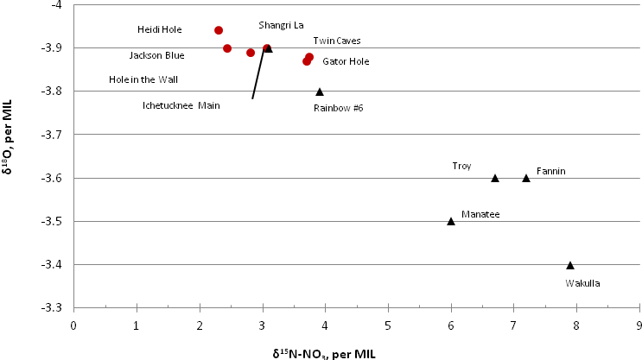

Figure 4.2. Delta ¹⁵N vs. Delta ¹⁸O (Barrios 2011)

4.2.1 Wastewater and Stormwater Sources
At this time, there are no permitted wastewater or stormwater facilities in the Jackson Blue Spring–Merritts Mill Pond contributing area and no facilities in its vicinity that discharge directly to the impaired surface waters addressed in this TMDL.

Population
The Jackson Blue Spring–Merritts Mill Pond contributing area is sparsely populated. In 2010, the U.S. Census Bureau reported that the total population of Jackson County was 49,747, with 17,417 households (HH) and 21,003 housing units (HU). The population density was 54.2 people per square mile of land area, and the housing density was 22.9 HU per square mile. Figure 4.3 shows the population density of the surrounding area Census tracts for Jackson County. Only a little over 6% of land use in the contributing area for Merritts Mill Pond and Jackson Blue Spring is residential. The denser areas occur in the eastern portion of the town of Greenwood, the town of Bascom, and the residential area along the perimeter of Merritts Mill Pond.

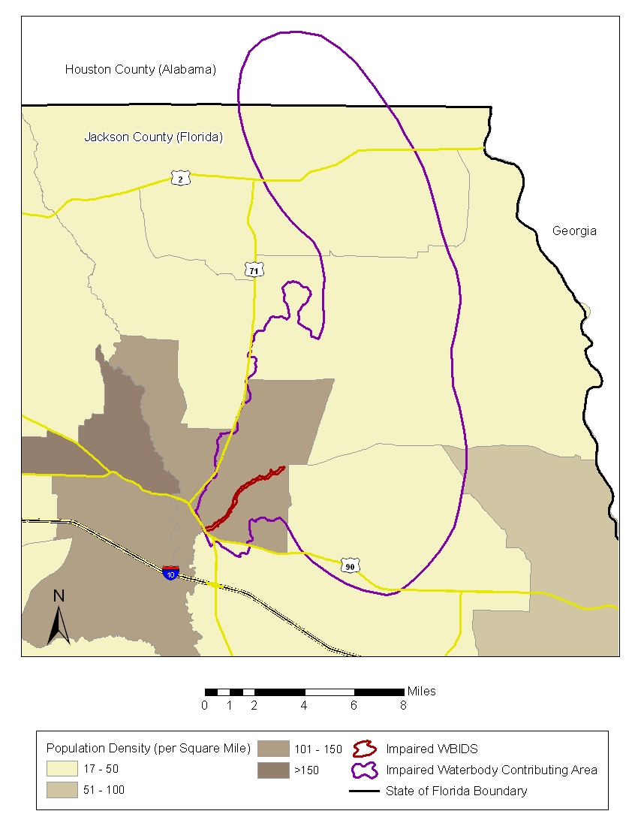
Figure 4.3. Population Density in Jackson County in 2010

4.2.2 Land Uses and Nonpoint Sources
In the contributing area, nitrate loading may come from nonpoint sources that discharge to ground water. These sources include septic tanks, fertilizers from home gardens, lawns, a golf course, agricultural operations, and atmospheric deposition.

Land Uses
The land uses in the contributing area for Jackson Blue Spring and Merritts Mill Pond were identified using the most recent (2009) NWFWMD land use Geographic Information System (GIS) coverage and were aggregated using the simplified Level 1/Level 3 codes tabulated in Table 4.1. Figure 4.4 shows the acreage of the principal land uses in the WBID. “Agricultural” was the predominant land use category in the contributing area (42.78%), followed closely by “forestry/rural open” (42%). Urban land uses comprise only about 10% of the contributing area.
From 1994 to 2004, developed land in the contributing area increased by 1,699 acres. In this same period an additional 528 acres of agricultural land were added. Both of these increases were primarily at the expense of forest land (Barrios 2011).

Table 4.1. Classification of Land Use Categories for the Jackson Blue Spring–Merritts Mill Pond Contributing Area in 2009

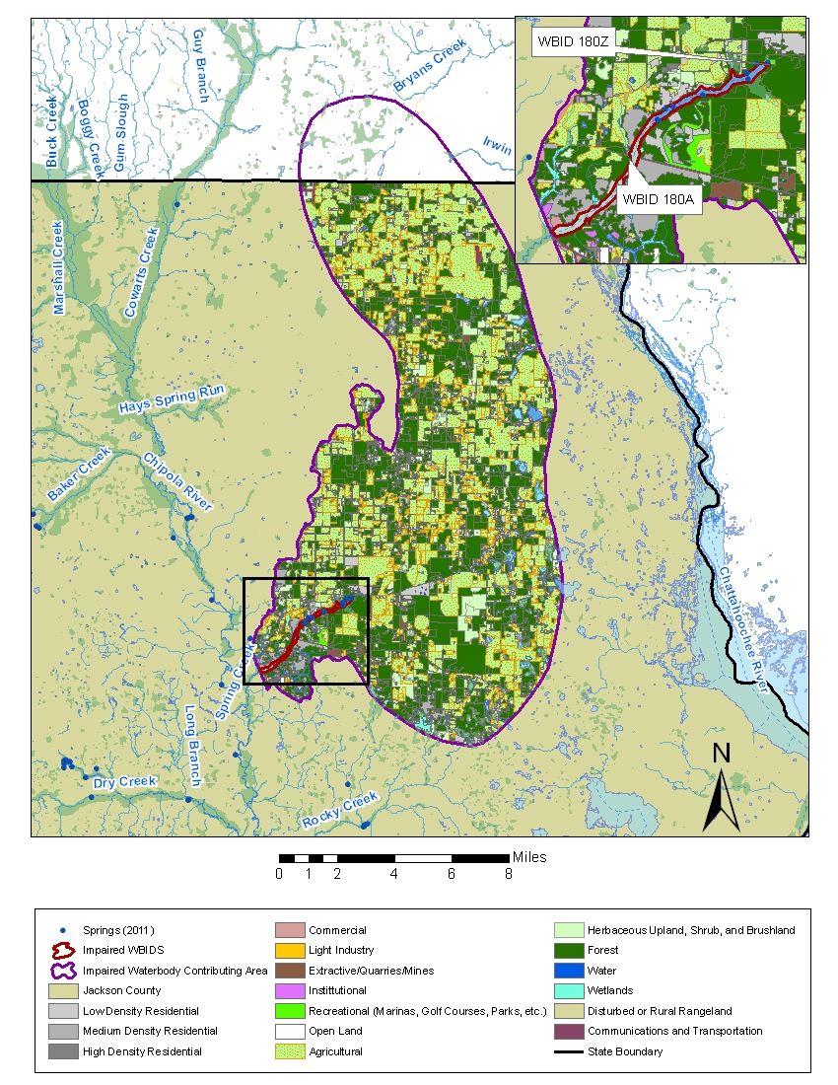
Figure 4.4. Principal Land Uses in the Jackson Blue Spring–Merritts Mill Pond Contributing Area in 2009

Nonpoint Sources

Septic Tanks
Onsite sewage treatment and disposal systems (OSTDS) are used for the disposal of domestic wastes at homes that are not on central sewer, often because providing central sewer is not cost-effective or practical. When properly sited, designed, constructed, maintained, and operated, OSTDS are a sanitary means of disposing of domestic waste. The effluent from a well-functioning OSTDS is generally higher in TN concentration than secondarily treated wastewater from a sewage treatment plant, although the wastewater profile can vary from home to home. On average, the TN concentration released to the environment by a typical OSTDS is 57.7 mg/L (Hazen and Sawyer 2009). In a low-density residential setting, loadings of nitrogen by OSTDS may not be significant, but under a higher density setting, one could expect a TN loading of 129 pounds per acre per year (lb/acre/yr) (Harrington et al. 2010).
Data for septic tanks are based on the Florida Department of Health (FDOH) statewide inventory of OSTDS (Hall and Clancy 2009). As of 2009, Jackson County had approximately 40,000 OSTDS (FDOH 2009). Approximately 5,500 of these OSTDS are in the contributing area of Jackson Blue Spring and Merritts Mill Pond (Figure 4.5). Single-family dwellings with OSTDS are found on both the east and west banks of Merritts Mill Pond, with the denser concentration on the west bank.

Livestock
The NWFWMD estimated the nitrogen loading to the Jackson Blue Spring contributing area from livestock (Barrios 2011) by using the U.S. Department of Agriculture (USDA) 2007 Agricultural Census data on the Jackson County livestock population (Table 4.2). The American Society of Agricultural Engineers (2005) provided estimates of nitrogen generated by animal waste.
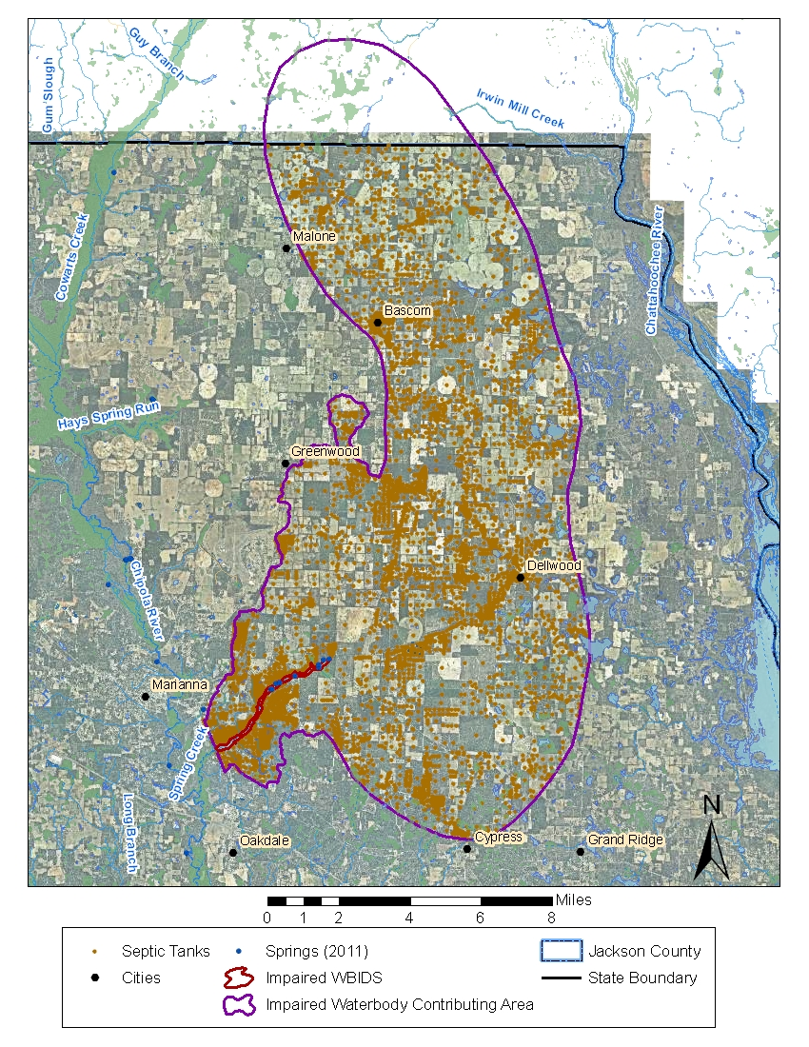
Figure 4.5. Density of OSTDS (Septic Tanks) in Jackson County and the Jackson Blue Spring–Merritts Mill Pond Contributing Area in 2009 (Hall and Clancy 2009)

Table 4.2. Livestock Nitrogen Contribution in the Jackson Blue Spring Watershed in 2007 (Barrios 2011)

Fertilizer
Most of the fertilizer applied in the contributing area is used on large, intensively managed farms that use center pivot irrigation. Using the USDA 2007 Census results for acres under tillage, the NWFWMD estimated nitrogen loading by multiplying the acreage by the University of Florida Institute of Food and Agricultural Sciences (UF-IFAS) recommended fertilization rate (Barrios 2011). Table 4.3 lists the nitrogen loading estimate for acres under tillage in the Jackson Blue Spring and Merritts Mill Pond contributing area.
Another possible source of nitrogen loading in the contributing area is fertilizer application to the Indian Springs Golf Club, which is located on the east bank of Merritts Mill Pond in the vicinity of Hole-in-the-Wall Spring. This minor spring contributes less than 3% of the total water flow to the impaired surface waterbody.

Table 4.3. USDA Census—Acres under Tillage and Nitrogen Loading Estimate for the Jackson Blue Spring–Merritts Mill Pond Contributing Area in 2007 (Barrios 2011)
- = Empty cell/no data
Crops | Acres | N  (pounds/  acre) | Contributing  Area  (acres) | Estimated Fertilizer Application (pounds) | Estimated Fertilizer Application  (tons)
Cotton | 31,200 | 60 | 5,241.6 | 314,496 | 157
Peanuts | 32,743 | 0 | 5,500.8 | 0 | 0
Forage | 20,116 | 100 | 3,379.5 | 337,949 | 169
Corn-Grain | 4,886 | 125 | 820.8 | 102,606 | 51
Vegetables | 3,883 | 200 | 652.3 | 130,469 | 65
Totals for Acreage under Tillage | 92,828 | - | 15,595 | 885,520 | 442

Atmospheric Deposition
The National Atmospheric Deposition Program conducts water quality testing of rainfall samples. The closest station to Merritts Mill Pond is located in Gadsden County, FL. Measurements of nitrate and ammonium in rainfall collected at this station between 2000 and 2010 indicate a combined wet deposition concentration ranging from the lowest annual mean of 0.17 mg/L in 2008 to the highest annual mean of 0.30 mg/L in 2006.
To estimate the atmospheric deposition of nitrogen in the contributing area, a concentration of 0.23 mg/L was used based on the annual mean of precipitation samples collected in 2007. This year was selected to correspond with the information that was available from the 2007 USDA Census. The NWFWMD calculated that due to drought, the annual rainfall accumulation of 2007 was very low at an average of approximately 38 inches for the watershed, leading to an annual atmospheric loading of 28 tons. Care must be taken to consider atmospheric loadings directly onto surface water separately from landscape loadings to avoid double counting the direct loadings onto the water surface.

Chapter 5: DETERMINATION OF ASSIMILATIVE CAPACITY
The Department often uses hydraulic and water quality models to simulate loading and the effect of the loading within a given waterbody. However, there are other appropriate methods to develop a TMDL that are just as credible as a modeling approach. Such an alternative approach was used to estimate existing conditions and calculate the TMDL for Jackson Blue Spring and Merritts Mill Pond.

5.1 Determination of Loading Capacity
Typically, the target loading and existing loading for a stream or watershed are based on hydrologic and water quality modeling. Many of these models depend on the relationship between flow and surface water drainage area, as well as the relationship between land use and soils and pollutant delivery.
The predominant source of nitrate loading to Jackson Blue Spring and Merritts Mill Pond is ground water. Ground water discharges from Jackson Blue Spring vents as well as the smaller springs and provides the majority of the water and nutrient load to Merritts Mill Pond. Thus, a direct relationship between surface water loadings in the watershed is not appropriate. This nontypical situation requires the use of an alternative approach for establishing the nutrient TMDL.
Existing stream loading can be estimated by multiplying the measured stream flow by the measured pollutant concentrations in the stream. To estimate the pollutant loading this way, synoptic flow and concentration data measured at the outlet of each stream segment are required. These data were not available for all sources covering the same period.
The Department considered the feasibility of using the available flow measurements to estimate the flow at each segment outlet based on the drainage area ratio among these stream segments. This method would normally provide an approximation of flow at the outlets. However, because the contributing area of Merritts Mill Pond and Jackson Blue Spring is a karst plain, most surface drainage flows toward sinkholes and closed depressions, where it infiltrates and reaches Jackson Blue Spring and Merritts Mill Pond via ground water. Thus flow estimation based on drainage area ratio is not possible.
Estimates of current nutrient loads from Jackson Blue Spring and Merritts Mill Pond could still be made based on spring flow and concentration. However, as both current and TMDL loads would be generated from the same flow data, there would be a linear or proportional relationship based on current and target concentrations. Therefore, the loads of nitrate were not explicitly calculated.
Instead, the percent load reduction required to achieve the nitrate concentration target was calculated assuming that the percent loading reduction would be the same as the percent concentration reduction. The percent reduction required to achieve the water quality target was calculated using the following formula:
[(existing mean concentration – target concentration)/existing mean concentration] x 100

5.2 TMDL Development Process

5.2.1 Establishing the Nitrate (NO3) Target Concentration
The target nitrate concentration for Jackson Blue Spring and Merritts Mill Pond was established based on several lines of evidence, including the following: (1) carrying out laboratory nutrient amendment bioassays; (2) comparing metabolic rates, specifically, the ecological efficiency of aquatic communities; (3) examining the ecological condition of algae and nutrients as described in the 2007 Florida springs report (Stevenson et al. 2007); and (4) examining the relationship between periphyton biomass and cell density and the nitrate concentration from studies conducted here and at other spring-dominated systems.

Carrying Out Laboratory Nutrient Amendment Bioassays
The nutrient amendment bioassay work was conducted by Cowell and Dawes (2004), who examined the required nitrate concentration in the Rainbow River, Marion County, to achieve a reduction of biomass of Lyngbya wollei. L. wollei is a nuisance blue-green benthic algal species that dominates the Rainbow River due to elevated nitrate concentrations. Using Lyngbya cultures incubated in a series of nitrate amendments, Cowell and Dawes (2004) found that at the end of the nutrient amendment experiments, both the biomass and growth rates were low in treatment groups with nitrate concentrations at or below 0.30 mg/L, and significantly higher in groups with nitrate concentrations at or higher than 0.60 mg/L. In addition, the experiment showed that the biomass and growth rates in the 0.30 and 0.070 mg/L treatment groups were similar, suggesting that a further reduction of nitrate concentration below the 0.30 mg/L level probably would not achieve a dramatic further reduction of L. wollei.

Evaluating the Relationship between Ecological Efficiency and Nitrate Concentration
Wetland Solutions, Inc. (WSI) (2005) studied the effects of nutrient concentrations on community metabolic rates in the Wekiva River, Rock Springs Run, Alexander Springs Creek, and Juniper Creek. The gross community primary production, community respiration, net primary production, and ecological efficiency were measured and examined. The community metabolic parameter shown to have a significant functional relationship with nutrient concentrations was ecological efficiency, which is defined as the quotient between the rate of gross primary productivity (GPP) and the incident photosynthetically active radiation (PAR) during a specified interval. It is an ecosystem-level property that estimates the overall efficiency of an aquatic ecosystem in using incident solar radiation.
Figure 5.1 shows the correlation between ecological efficiency and nitrogen oxide (NOx, an equivalent term for nitrate) concentration. The target ecological efficiency defined using this method is 0.25 grams of oxygen per mole (g O₂/mol). Using the ecological efficiency nitrate concentration equation defined in Figure 5.1, the target nitrate concentration is 0.293 mg/L.

Figure 5.1. Correlation between Ecological Efficiency and Nitrate Concentration in the Wekiva River, Rock Springs Run, Alexander Springs Creek, and Juniper Creek

Examining the Ecological Condition of Algae and Nutrients in the 2007 Florida
Springs Report
The nutrient concentration at which macroalgae growth is predicted to be elevated by 90% above the level for which no effects of nutrient reduction would be expected is referred to as the saturating concentration. The saturating concentration was documented by Stevenson et al. (2007) for 2 species of macroalgae (L. wollei and Vaucheria spp) that have been documented to produce extensive algal mats. Surveys of Florida springs indicated that almost all springs had macroscopic algae growing in them, an average of 50% of the spring bottoms were covered by macroalgae, and the thickness of macroalgal mats was commonly 0.5 meters (m) and as thick as 2 m in one spring boil. L. wollei and Vaucheria spp. were the 2 most common taxa of macroalgae that occurred in areas with extensive growths in the studied springs; however, 23 different macroalgal taxa were observed in the spring survey.
The study involved both field and laboratory components. In the field experiments, excessive growth and cover of Vaucheria were found at sites with nitrate-nitrite concentrations at or above 0.454 mg/L. In the laboratory experiments, the taxa L. wollei and Vaucheria spp. were found to have saturating nitrate concentrations of 0.230 and 0.261 mg/L, respectively (Stevenson et al. 2007). The study examined 28 springs throughout Florida, including Merritts Mill Pond and Jackson Blue Spring (Figure 5.2).
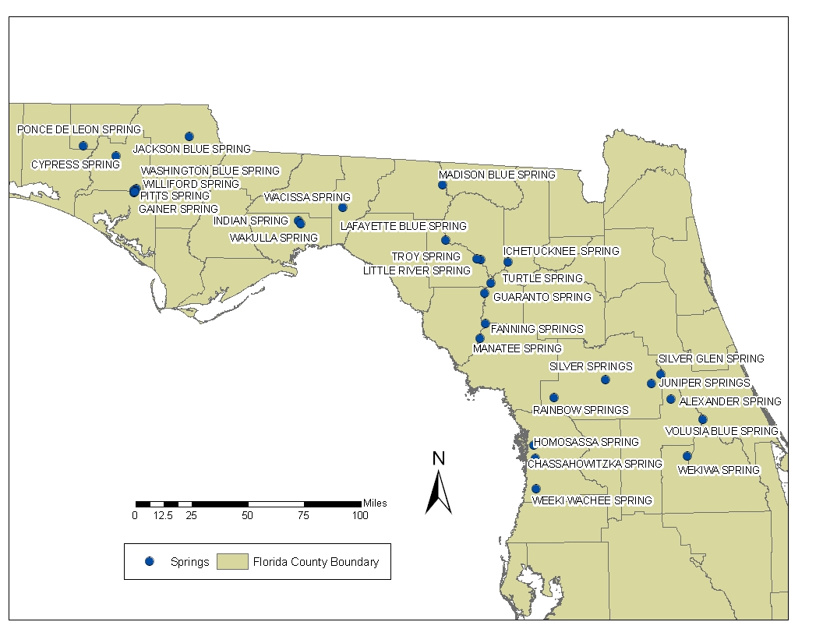
Figure 5.2. Springs Included in the Florida Springs Report (Stevenson et al. 2007)

Examining the Relationship between Periphyton Biomass and Cell Density and Nitrate Concentration
The nitrate target suggested by the Rainbow River study (Cowell and Dawes 2004) was corroborated by the findings of Hornsby et al. (2000), who evaluated periphyton and water quality data collected from the Suwannee River and 2 tributaries, the Withlacoochee and Santa Fe Rivers. Much of the length of the Suwannee River is heavily influenced by spring inflow. Hornsby et al. showed positive correlations for both periphyton biomass versus nitrate concentration and cell density versus nitrate concentration. The functional relationships of periphyton biomass (represented as ash-free dry mass [AFDM]) versus nitrate concentration and cell density versus nitrate concentration are shown in long-term average biomass, cell densities, and nitrate concentrations measured at 13 stations within the Suwannee River system (including the Withlacoochee and Santa Fe Rivers) (Figure 5.3).
Figure 5.3. Change-Point Study Sites

To further define the nitrate concentration that may significantly impact the periphyton biomass and cell density per unit increase of nitrate concentration, the Department contracted with Dr. Xufeng Niu of the Department of Statistics, Florida State University (FSU), to conduct a change-point analysis for a dataset of 13 long-term periphyton monitoring sites from 1990 to 2007 provided by the Suwannee River Water Management District (SRWMD). The applied method fits a step-function through observed data by examining the probability of each data point as the change point. A nitrate concentration change point was identified (at a 5% significance level) if the change of cell density or periphyton biomass caused by the nitrate concentration was 3.5 times higher (the T-test critical value) than the standard error of the change of cell density or periphyton biomass. The identified step-function (the change-point model) was also compared with linear regression and nonlinear regression models for its goodness-of-fit and the extent of overfitting based on the Bayesian Information Criterion (BIC).
For both periphyton cell density and periphyton biomass, change-point step functions were shown to be the best model among those tested. This supports the use of the change-point model identified in the T-test. Appendix B provides details of the change-point analyses. For both methods based on these analyses, the major changes in mean abundance and mean biomass happened at a mean nitrogen oxide (NOx) around 0.441 mg/L (Figures 5.4 and 5.5).
Figure 5.4. Relationship between Mean Nitrate Concentration and Mean Periphyton Biomass from 12 Sampling Sites on the Suwannee, Santa Fe, and Withlacoochee Rivers
Figure 5.5. Relationship between Mean Nitrate Concentration and Mean Periphyton Cell Density from 12 Sampling Sites on the Suwannee, Santa Fe, and Withlacoochee Rivers

When explaining the functional relationship between cell density and nitrate concentration, the change-point step function identified two cell density levels (Table 2 in Appendix B). One level is about 218,732 cells per square centimeter (cells/cm²) (P = 0.0000), and the other is about 218,732 + 427,894 = 646,626 cells/cm² (P = 0.0001). In this study, the 218,732 cells/cm² was considered the baseline condition below which no significant nitrate impact was detected. The nitrate concentration that significantly changed the cell density level from 218,732 to 646,626 cells/cm² was identified by the change-point step function as 0.441 mg/L, indicating that, to prevent the periphyton cell density from switching to the higher level, the nitrate concentration should not exceed 0.441 mg/L. In addition, the cell density switch occurred when the nitrate concentration reached 0.441 mg/L.
Based on the functional relationship between periphyton biomass and nitrate concentration, the change-point step function identified 2 biomass levels (Table 4 in Appendix B). One level is about 1.82 grams per square meter (g/m²) (P= 0.0000), and the other level is about 1.82 + 2.97 = 4.79 g/m² (P = 0.0000). In this study, 1.82 g/m² was considered the baseline condition under which no significant nitrate impact was detected. The nitrate concentration that significantly changed the biomass level from 1.81 to 4.79 g/m² was identified by the change-point step function as 0.441 mg/L, indicating that to prevent the periphyton biomass from switching to the higher level, the nitrate concentration should not exceed 0.441 mg/L. In addition, the highest observed nitrate concentration that allowed the biomass baseline condition was 0.441 mg/L (Appendix B).

5.2.2 Target Setting
Based on the 4 lines of evidence discussed in the previous sections, nitrate was the primary factor causing the elevated growth of algae at concentrations above 0.230 to 0.263 mg/L. Nuisance accumulations of Vaucheria occurred at nitrate-nitrite concentrations at or above 0.454 mg/L. Nitrate concentrations lower than 0.441 mg/L should be appropriate to maintain periphyton cell density and biomass at baseline conditions, respectively. An appropriate target (neither under- nor overprotective) should include a margin of safety to address uncertainty, as well as to sustain environmental conditions below the imbalance point. In the change-point analysis for mean cell density, the mean NO₃ was 0.441 mg/L, with the test statistic of 7.68 and confidence level over 95%. The 95% confidence interval for the change point was between 0.378 and 0.629 mg/L NO₃ (Figure 5.6), the lower boundary being 0.378 mg/L NO₃.
It is important to note that the change-point analysis provides a concentration of nitrate at which change (algal growth) occurs. The TMDL target must be established at a level that prevents such a change. Given that the Department is 95% confident that change occurs between 0.378 and 0.629 mg/L of NO₃, the TMDL threshold must be established below that interval to be protective of the resource.
While the change-point analysis provided a definitive conclusion that the change in periphyton is related to nitrate, the second part was finding the relationship of nitrate concentration to periphyton. The best relationship between nitrate and periphyton cell density is an exponential relationship, as shown in Figure 5.7. This relationship can be used to define a nitrate target that prevents change.
The first approach to finding a target was using the change point of 0.441 mg/L to identify an equivalent cell density concentration relative to the central tendency (an exponential curve R² = 0.72) of the relationship. Once identified, the nitrate concentration prior to the change point was identified by finding the equivalent upper 95% confidence interval, i.e., an NO₃ value of 0.38 mg/L.
In the second approach, the same change point of 0.441 mg/L was used to find the lower 95% confidence interval of cell density to help establish a margin of safety. The relationship between nitrate and cell density has confidence intervals between which the Department is 95% confident that the relationship holds. By taking the lower cell density at the change point of 0.441 mg/L, the Department targeted a more conservative condition in the waterbody. Once identified, that cell density was again used to identify a nitrate number prior to the change point by finding the equivalent lower 95% confidence interval (Figure 5.8), i.e., an NO₃ value of 0.33 mg/L.
Considering that the lower confidence interval value of the change-point analysis was 0.378 mg/L and the 2 approaches above found values of 0.38 and 0.33 mg/L, respectively, an average of the 2 techniques was used to set the target of 0.35 mg/L.
In conclusion, based on the information currently available, the Department believes that a monthly average nitrate concentration of 0.35 mg/L should be sufficiently protective of the aquatic flora or fauna in Jackson Blue Spring and Merritts Mill Pond. A monthly average is considered to be the appropriate time frame, as the periphyton dataset was based on a 28-day deployment, and the response of algae to nutrients is on the order of days to weeks. An elevated pollutant concentration in the system alone does not necessarily constitute impairment as long as there is no negative response from the local aquatic flora or fauna.
Based on the information provided above, 0.35 mg/L nitrate is the target concentration that will not cause an imbalance in the aquatic flora or fauna in Jackson Blue Spring and Merritts Mill Pond. The reductions in NO₃ will reduce any pollutant impacts associated with the excessive growth of algae. The excessive growth of algae may result in localized large diurnal fluctuations in DO due to photosynthesis during the day (oxygen production) and respiration during the night (oxygen consumption). The subsequent decomposition of the excessive algal biomass also consumes large quantities of DO. In addition, the implementation of the TMDL for nutrients may result in improvements to the DO regime in the river by reducing the excessive growth of algae.

Figure 5.6. Change-Point Analyses (the 95% Confidence Interval)

Figure 5.7. Central Tendency and Upper 95% Confidence Interval Approach
Figure 5.8. Upper and Lower 95% Confidence Interval Approach

5.3 Setting the Monthly Average Concentration for Nitrate
After carefully reviewing all the above studies, the Department believes that establishing 0.35 mg/L nitrate (nutrient) as the TMDL for Jackson Blue Spring and Merritts Mill Pond as a monthly average is appropriate. This is mainly because the changes in aquatic vegetation biomass do not respond to the change of nutrient concentration instantaneously. Therefore, a short-term exceedance of the target concentration may not produce negative biological or ecological effects. The nitrate TMDL target obtained from the Suwannee River study (Hornsby et al. 2000) was based on the correlation between long-term average nitrate concentration and long-term average cell density and biomass. Therefore the TMDL target should be considered a long-term average target instead of an instantaneous value. The nitrate range suggested by the Lyngbya study (Cowell and Dawes 2004) was from a nutrient amendment experiment. Significant differences in growth rate and biomass between the above-0.600 mg/L treatment groups and below-0.300 mg/L treatment groups were not observed until 8 to 12 days after the nutrient amendment study started. This apparently suggested a time lag between the change of the nitrate concentration and the response from Lyngbya.
In addition, the Lyngbya nutrient amendment study conducted by Cowell and Dawes (2004) was carried out under tightly controlled laboratory conditions with no competition from other periphyton and plants, no grazing from aquatic animals, no removal effects from the shearing force of stream flow, and no light attenuation from changing water color. These natural processes are very common in natural stream systems such as Merritts Mill Pond and could significantly influence the response of Lyngbya to changes in water column nitrate concentrations. Therefore, treating the nitrate concentration obtained from the Lyngbya study as an exact instantaneous value is also not necessary.
The same concept also applies to the target nitrate value obtained from the correlation between ecological efficiency and nitrate concentration. The ecological efficiency results are average values obtained over a period of three to four weeks (WSI 2005). The nitrate target value derived from an equation, based on average ecological efficiency, should not be treated as an exact instantaneous value. It is more appropriate to treat the target value as an average concentration over a certain period.
Based on the above discussions, the Department established the nitrate TMDL for both the Wekiva and Suwannee Rivers as a monthly average target. Expressing the target as a monthly average provides a margin of safety because restoration activities designed to address the highest monthly average nitrate concentration should help ensure that average nitrate concentrations over the rest of the year are even lower.
As discussed above, the nitrate target will be established as a monthly average in this TMDL. Therefore, long-term monthly average concentrations were calculated for each month based on measured concentrations over a reasonable period that is representative. To make sure that the monthly average concentrations will meet the concentration target even under the worst-case scenario, the highest monthly average nitrate concentrations were used as existing monthly mean concentrations to calculate the percent reduction required to achieve the nitrate target. This approach adds to the margin of safety of the TMDL.
For Jackson Blue Spring and Merritts Mill Pond, the percent reductions required for this TMDL were calculated using the monthly values for nitrate averaged over the most recent 11-year period (January 1, 2000, through December 31, 2011). The longer period including more recent data was used instead of the Cycle 2 verified period (2000–07) because nitrate concentrations have increased in these WBIDs since 2007. The maximum monthly average for each WBID was then considered in the calculation of a target for percent reduction (Table 5.1). Table 5.1 summarizes the monthly averages and monthly average rainfall for Jackson Blue Spring and Merritts Mill Pond. These data show that elevated nitrate concentrations occur in both wet and dry months.

5.4 Critical Conditions/Seasonality
Establishing the critical conditions for algae growth in a given watershed depends on many factors. For typical surface waters, the critical conditions exist when there is an extended dry period followed by a rainfall runoff event. During the wet weather period, rainfall washes off nutrients that have built up on the land surface under dry conditions. Similar correlations have also been noted for some spring systems, but they may not be as dramatically influenced by rain events. The water from the springs that discharge into Merritts Mill Pond comes from infiltrating precipitation somewhere in the springshed that migrated within the Floridan aquifer system to the spring vents. Water discharged from the vents is from a mixture of sources and may range from days to decades in age. At Jackson Blue Spring and Merritts Mill Pond, fluctuations in spring water quality have been observed, and these could be a response to flushing from seasonal rainfall events or to seasonal nonpoint impacts such as fertilization. However, throughout the year, nitrate concentrations have remained above the 0.35 mg/L threshold for algal growth.

Table 5.1. Monthly Median Nitrate Concentrations for Jackson Blue Spring and Merritts Mill Pond, 2001–11
ND = No data
Month | Jackson Blue Spring (WBID 180Z)  Verified Period Median  (mg/L) | Merritts Mill Pond (WBID 180A)  Verified Period Median  (mg/L) | 30-Year Monthly Median  Rainfall  (inches)
January | 3.18 | 0.715 | 5.24
February | 3.50 | 0.48 | 5.09
March | 3.30 | 2.1 | 5.73
April | 3.23 | 1.48 | 4.12
May | 3.45 | 1.08 | 3.97
June | 3.35 | 2.47 | 6.05
July | 3.15 | 1.12 | 7.22
August | 3.33 | 1.4 | 6.00
September | 3.36 | ND | 4.60
October | 3.33 | 1.34 | 3.32
November | 3.37 | 1.11 | 4.05
December | 3.40 | 2.22 | 4.49
Maximum  Monthly Average | 3.50 | 2.47 | -

One potential seasonal influence on the growth of some forms of algae may be stream velocity, which is based on spring discharge, which is in turn influenced by precipitation. In addition, sediments that have accumulated for months may provide a flux of nutrients to the water column under certain weather or DO conditions. For the Jackson Blue Spring and Merritts Mill Pond TMDL, it is noted that the highest concentrations occur during April and December (Table 5.1). For these reasons, establishing the percent reductions based on the data for Jackson Blue Spring for the month with the highest required percent reduction will be protective for all seasons and add to the implicit margin of safety.

5.5 Calculation of the TMDL Percent Reduction
Based on an examination of the data depicted in Table 5.1, the percent reductions were based on the data from Jackson Blue Spring, which has the highest monthly median nitrate concentrations, and the month (February) from the assessed period with the highest average nitrate concentration (3.50 mg/L). This approach will be protective for all seasons and add to the implicit margin of safety.
The maximum monthly mean nitrate concentrations for Jackson Blue Spring and Merritts Mill Pond are 3.50 and 2.47 mg/L, respectively. The highest mean concentrations occurred in February for Jackson Blue Spring and in June for Merritts Mill Pond.
To obtain a percent reduction that is reasonably representative of both WBIDs and is adequately protective, the maximum monthly mean nitrate concentration for Jackson Blue Spring was used. The percent reduction required to achieve the water quality target was calculated using the following formula:
[(highest monthly mean concentration – target concentration)/highest monthly mean concentration] x 100

[(3.5 mg/L – 0.35 mg/L) / 3.5 mg/L] * 100
This equals a 90% reduction in nitrate concentration.
A 90% percent reduction in the nitrate concentrations for both WBIDs is proposed because it is a protective value that, when achieved, will satisfy the nutrient reduction requirement for the system. The nitrate in Merritts Mill Pond comes mainly from ground water discharging from Jackson Blue Spring and the other springs associated with Merritts Mill Pond.

Chapter 6: DETERMINATION OF THE TMDL

6.1 Expression and Allocation of the TMDL
The percent load reductions listed in Table 6.2 were established to achieve the monthly average nitrate concentration of 0.35 mg/L. While these percent reductions are the expression of the TMDL that will be implemented, the EPA recommends that all TMDLs and associated load allocations and wasteload allocations include a daily time increment in conjunction with other appropriate temporal expressions that may be necessary to implement the relevant water quality standard. Daily Maximum Limit targets for nitrate were established using the following equation, established by the EPA (2006) (in the equation, it is assumed that the nitrate data distributions are lognormal):
MDL = LTA * exp(Z_{p}σ_{y} – 0.5σy²)
σ_{y} = sqrt(ln(CV² + 1))
Where:
LTA = Long-term average (0.35 mg/L)
Z_{p} = p^{th} percentage point of the standard normal distribution, at 95% (Z_{p} = 1.645)
σ = Standard deviation
CV = Coefficient of variance

For the daily maximum nitrate concentration, it was assumed that the average monthly target concentration should be the same as the average daily concentration. Also, assuming the target dataset will have the same CV as the existing measured dataset (Table 6.1) and allowing a 5% exceedance (EPA 2007, pp. 19 and 20), the daily maximum nitrate concentration for Jackson Blue Spring and Merritts Mill Pond is 0.91 mg/L.

Table 6.1. Daily Maximum for Target Nitrate Concentration (mg/L)
Statistics | Jackson Blue Spring (WBID 180Z)
Mean (mg/L) | 3.34
CV | 0.05295
Daily maximum to achieve monthly average nitrate of 0.35 mg/L | 0.9140

It should be emphasized that these daily maximum targets were developed for illustrative purposes. The implementation of the TMDL will be based on the monthly average concentration targets.
The objective of a TMDL is to provide a basis for allocating acceptable loads among all of the known pollutant sources in a watershed so that appropriate control measures can be implemented and water quality standards achieved. A TMDL is expressed as the sum of all point source loads (wasteload allocations, or WLAs), nonpoint source loads (load allocations, or LAs), and an appropriate margin of safety (MOS), which takes into account any uncertainty concerning the relationship between effluent limitations and water quality:
TMDL = ∑  WLAs + ∑  LAs + MOS

As discussed earlier, the WLA is broken out into separate subcategories for wastewater discharges and stormwater discharges regulated under the NPDES Program:
TMDL ≅ ∑  WLAs_{wastewater} + ∑  WLAs_{NPDES Stormwater} + ∑  LAs + MOS

It should be noted that the various components of the revised TMDL equation may not sum up to the value of the TMDL because (1) the WLA for NPDES stormwater is typically based on the percent reduction needed for nonpoint sources and is also accounted for within the LA, and (2) TMDL components can be expressed in different terms (for example, the WLA for stormwater is typically expressed as a percent reduction, and the WLA for wastewater is typically expressed as mass per day).
WLAs for stormwater discharges are typically expressed as “percent reduction” because it is very difficult to quantify the loads from municipal separate storm sewer systems (MS4s) (given the numerous discharge points) and to distinguish loads from MS4s from other nonpoint sources (given the nature of stormwater transport). The permitting of stormwater discharges also differs from the permitting of most wastewater point sources. Because stormwater discharges cannot be centrally collected, monitored, and treated, they are not subject to the same types of effluent limitations as wastewater facilities, and instead are required to meet a performance standard of providing treatment to the “maximum extent practical” through the implementation of best management practices (BMPs).
This approach is consistent with federal regulations (40 CFR § 130.2[I]), which state that TMDLs can be expressed in terms of mass per time (e.g., pounds per day), toxicity, or other appropriate measure. The TMDL for Jackson Blue Spring and Merritts Mill Pond is expressed in terms of concentration of nutrients and represents the loading the waterbodies can assimilate and maintain the biological criterion (Table 6.2).

Table 6.2. TMDL Components for Jackson Blue Spring and Merritts Mill Pond
¹ N/A = Not applicable
WBID | Parameter | TMDL  (mg/L) | TMDL  %  Reduction | Wasteload Allocation for Wastewater¹ | Wasteload Allocation for NPDES Stormwater % Reduction¹ | LA  %  Reduction | MOS
Jackson Blue Spring (WBID 180Z), Merritts Mill Pond (WBID 180A) | Nitrate as monthly average | 0.35 | 90% | N/A | N/A | 90% | Implicit

6.2 Load Allocation
Because no target loads were explicitly calculated in this TMDL report, the TMDL was represented as the percent reduction required to achieve the nitrate target. The percent reduction assigned to all the nonpoint source areas (LA) is the same as that defined for the TMDL percent reduction. To achieve the monthly average nitrate target of 0.35 mg/L in Jackson Blue Spring and Merritts Mill Pond, the nitrate loads from the nonpoint source areas contributing to these impaired WBIDs need to be reduced by 90%. The target monthly average nitrate of 0.35 mg/L and the percent reduction represent an estimate of the maximum reduction required to meet the target.

6.3 Wasteload Allocation

6.3.1 NPDES Wastewater Discharges
Currently, there are no NPDES wastewater facilities that discharge directly into Jackson Blue Spring or Merritts Mill Pond. As recently as the late 1990s, Arrowhead Campground operated a wastewater facility that had a permitted discharge to Merritts Mill Pond. The campground was connected to a municipal wastewater service when the service was extended out to the interstate highway. Any new potential discharger is expected to comply with the Class III criterion for nutrients and with nitrogen limits consistent with this TMDL.

6.3.2 NPDES Stormwater Discharges
Currently, there are no NPDES MS4 stormwater facilities identified as discharging directly into Jackson Blue Spring or Merritts Mill Pond. Any new potential discharger is expected to comply with the Class III criterion for nutrients and with nitrate limits consistent with this TMDL.

6.4 Margin of Safety
Consistent with the recommendations of the Allocation Technical Advisory Committee (Department 2001), an implicit MOS was used in the development of this TMDL, and was provided by the conservative decisions associated with a number of assumptions and the development of assimilative capacity. For example, the nitrate target was established based on a conservative concentration from the 4 lines of evidence (Section 5). Requiring the 0.35 mg/L target to be met every month should result in a nitrate concentration even lower than the target concentration during the summer algal growth season, based on a seasonal analysis of the nitrate concentration, and therefore adds to the MOS. In addition, when estimating the required percent reduction to achieve the water quality target, the highest long-term monthly average of measured nitrate concentrations was used instead of the average of the monthly averages. This will make estimating the required percent load reduction more conservative and therefore adds to the MOS.

Chapter 7: NEXT STEPS—IMPLEMENTATION PLAN DEVELOPMENT AND BEYOND

7.1 Basin Management Action Plan
Following the adoption of this TMDL by rule, the Department will determine the best course of action regarding its implementation. Depending on the pollutant(s) causing the waterbody impairment and the significance of the waterbody, the Department will select the best course of action leading to the development of a plan to restore the waterbody. Often this will be accomplished cooperatively with stakeholders by creating a Basin Management Action Plan, referred to as the BMAP. BMAPs are the primary mechanism through which TMDLs are implemented in Florida (see Subsection 403.067[7], F.S.). A single BMAP may provide the conceptual plan for the restoration of one or many impaired waterbodies.
If the Department determines that a BMAP is needed to support the implementation of this TMDL, it will be developed through a transparent, stakeholder-driven process intended to result in a plan that is cost-effective, is technically feasible, and meets the restoration needs of the applicable waterbodies.
Once adopted by order of the Department Secretary, BMAPs are enforceable through wastewater and municipal stormwater permits for point sources and through BMP implementation for nonpoint sources. Among other components, BMAPs typically include the following:
- Water quality goals (based directly on the TMDL);
- Refined source identification;
- Load reduction requirements for stakeholders (quantitative detailed allocations, if technically feasible);
- A description of the load reduction activities to be undertaken, including structural projects, nonstructural BMPs, and public education and outreach;
- A description of further research, data collection, or source identification needed in order to achieve the TMDL;
- Timetables for implementation;
- Implementation funding mechanisms;
- An evaluation of future increases in pollutant loading due to population growth;
- Implementation milestones, project tracking, water quality monitoring, and adaptive management procedures; and
- Stakeholder statements of commitment (typically a local government resolution).

BMAPs are updated through annual meetings and may be officially revised every five years. Completed BMAPs in the state have improved communication and cooperation among local stakeholders and state agencies; improved internal communication within local governments; applied high-quality science and local information to the management of water resources; clarified the obligations of wastewater point source, MS4, and non-MS4 stakeholders in TMDL implementation; enhanced transparency in the Department’s decision making; and built strong relationships between the Department and local stakeholders that have benefited other program areas.

References
American Society of Agricultural Engineers. 2005. Manure production and characteristics. Publication D384.2.
Barrios, K. June 2011. Nitrate sources of springs discharging to Merritt’s Mill Pond, Jackson County, Florida. Northwest Florida Water Management District Technical File Report 2011-01.
Barrios, K., and K. DeFosset. July 2005. Ground water chemical characterization of Jackson Blue Spring and Wakulla Springs, Florida. Northwest Florida Water Management District Water Resources Special Report 05-01.
Bartel, R.L. May 2, 2012. Electronic mail “Re: Transmissivity” to James Dodson.
Bartel, R.L., K. Barrios, M. Pritzl, and K. Coates. June 2011. Jackson Blue Spring water resources assessment. Northwest Florida Water Management District Water Resources Assessment 11-01.
Campbell, K. 1993. Geologic map of Calhoun County. Florida Geological Survey Open File Map Series No. 20.
Cowell, B.C., and C.J. Dawes. 2004. Growth and nitrate-nitrogen uptake by the cyanobacterium Lyngbya wollei. Journal of Aquatic Plant Management 42:69-71.
Florida Department of Environmental Protection. February 2001. A report to the Governor and the Legislature on the allocation of Total Maximum Daily Loads in Florida. Tallahassee, FL: Bureau of Watershed Management.
———. 2002a. Basin status report: Apalachicola–Chipola. Tallahassee, FL: Division of Water Resource Management, Bureau of Watershed Restoration.
———. 2002b. EcoSummary: Jackson Blue Spring. Tallahassee, FL: Environmental Assessment Section.

———. 2008. Standard Operating Procedure (SOP) FS7420. Available: http://www.dep.state.fl.us/water/sas/sop/sops.htm.
Florida Department of Health. 2009. Available: http://www.doh.state.fl.us/.
Gao, X. November 15, 2007. Nutrient TMDLs for the Wekiva River (WBIDs 2956, 2956A, and 2956C) and Rock Springs Run (WBID 2967). TMDL report. Tallahassee, FL: Division of Environmental Assessment and Restoration, Bureau of Watershed Restoration. Available: http://www.dep.state.fl.us/water/tmdl/docs/tmdls/final/gp2/Wekiva_MainStem04182008.pdf.
Hall, P., and S.J. Clancy. June 29, 2009. The Florida statewide inventory of onsite sewage treatment and disposal systems (OSTDS): Final draft report and database. Prepared for the Florida Department of Health, Bureau of Onsite Sewage Programs, by EarthSTEPS and GlobalMind. Available: http://www.doh.state.fl.us/environment/ostds/research/07-01-09Materials/Statewide_Inventory_OSTDS.pdf.
Hallas, J.F., and W. Magley. September 2008. Nutrient and dissolved oxygen TMDL for the Suwannee River, Santa Fe River, Manatee Springs (3422R), Fanning Springs (3422S), Branford Spring (3422J), Ruth Spring (3422L), Troy Spring (3422T), Royal Spring (3422U), and Falmouth Spring (3422Z) . TMDL report. Tallahassee, FL: Division of Environmental Assessment and Restoration, Bureau of Watershed Restoration. Available: http://www.dep.state.fl.us/water/tmdl/docs/tmdls/final/gp1/suwanneebasinnutrienttmdl.pdf.
Hand, J. February 2009. Florida springs assessment decision matrix. Tallassee, FL: Florida Department of Environmental Protection, Watershed Assessment Section.
Harrington, D., G. Maddox, and R. Hicks. February 2010. Florida Springs Initiative Monitoring Network report and recognized sources of nitrate. Tallahassee, FL: Florida Department of Environmental Protection, Division of Environmental Assessment and Restoration, Bureau of Watershed Restoration, Ground Water Protection Section.
Hatcher, C. 2009. Jackson Blue Spring cave diving 2009. Jackson County Parks and Recycling presentation at the October 8, 2009 meeting of the Jackson Blue Spring Basin Working Group.
Hayes, L.R., M.L. Maslia, and W.C. Meeks. 1983. Hydrology and model evaluation of the principal artesian aquifer, Dougherty Plain, Southwest Georgia. Georgia Geologic Survey Bulletin 97.
Hazen and Sawyer. August 2009. Florida onsite sewage nitrogen reduction strategies study: Task A.2, Final report, Literature review of nitrogen reduction technologies for onsite sewage treatment systems. Florida Department of Health Contract CORCL.
Hicks, R., D. Harrington, and G. Maddox. March 2009. Documentation to support listing of nutrient impaired springs and spring runs (Volusia Blue Spring and Volusia Blue Spring Run; DeLeon Spring; Jackson Blue Spring and Merritts Mill Pond; Silver Springs, Silver Springs Group, and Upper Silver River; Rainbow Springs Group and Rainbow Springs Group Run; and Weeki Wachee Spring and Weeki Wachee Spring Run. Tallahassee, FL: Florida Department of Environmental Protection, Division of Environmental Assessment and Restoration, Bureau of Watershed Restoration, Ground Water Protection Section.
Hornsby, D., R.A. Mattson, and T. Mirti. 2000. Surface water quality and biological monitoring. Annual report 1999. Suwannee River Water Management District Technical Report WR-00-04.
Katz, B.G. 2004. Sources of nitrate contamination and age of water in large karstic springs of Florida. Environmental Geology 46, 689–706.
Katz, B.G., H.D. Hornsby, J.K. Bohlke, and M.F. Mokray. 1999. Sources and chronology of nitrate contamination in spring waters, Suwannee River Basin, Florida. U.S. Geological Survey Water-Resources Investigations Report 99-4252.
Moore, W.E. 1955. Geology of Jackson County, Florida. Florida Geological Survey Bulletin 37.
National Oceanic and Atmospheric Administration. 2010. Available: http://www.noaa.gov.
Niu, X.-F. June-August 2008. Change point analysis of Suwannee River algal data based on an updated data set. Tallahassee, FL: Florida State University, Department of Statistics.
Pratt, T.R., C. Richards, K. Milla, J. Wagner, J. Johnson, and R. Curry. 1996. Hydrogeology of the Northwest Florida Water Management District. Northwest Florida Water Management District Water Resources Special Report 96-4.
Scott, T.M. 1993. Geologic map of Jackson County. Florida Geological Survey Open File Map Series No. 25.
Scott, T.M., G.H. Means, R.P. Meegan, R.C. Means, and S.B. Upchurch et al. 2004. Springs of Florida. Florida Geological Survey Bulletin No. 66.
Sever, C.W. 1965a. Groundwater resources and geology of Seminole, Decatur and Grady Counties, Georgia. U.S. Geological Survey Water-Supply Paper 1809–Q,
Sever, C.W., 1965b. Groundwater resources of Bainbridge, Georgia. Georgia Geological Survey Information Circular 32.
Stevenson, R.J., A. Pinowska, and Y. K. Yang. 2004. Ecological condition of algae and nutrients in Florida springs. Tallahassee, FL: Florida Department of Environmental Protection.

Stevenson, R.J., A. Pinowska, A. Albertin, and J.O. Sickman. 2007. Ecological condition of algae and nutrients in Florida springs: The synthesis report. Submitted to the Florida Department of Environmental Protection. Available: http://publicfiles.dep.state.fl.us/dear/sas/library/docs/springs/synthesisreport.pdf.
U.S. Census Bureau. Available: http://www.census.gov/.
U. S. Environmental Protection Agency. November 2006. Memorandum establishing TMDL “daily” loads in light of the decision by the U.S. Court of Appeals for the D.C. Circuit in Friends of the Earth, Inc. v. EPA et al., No.05-5015 (D.C. Cir. 2006) and implications for NPDES permits. Available: http://water.epa.gov/lawsregs/lawsguidance/cwa/tmdl/dailyloadsguidance.cfm.
———. June 2007. Options for expressing daily loads in TMDLs. Available: http://www.epa.gov/owow/tmdl/draft_daily_loads_tech.pdf.
Wagner, J.R., and T.W. Allen. 1984. Groundwater section. In: Water assessment for the Apalachicola-Chattahoochee-Flint River Basin water management study (U.S. Army Corps of Engineers and the states of Alabama, Florida, and Georgia, v. 3, app. III, sec. 3).
Wassenaar, L. 1995. Evaluation of the origin and fate of nitrate in the Abbotsford aquifer using the isotopes of 15N and 18O in NO3. Applied Geochemistry 10, 391–405.
Wetland Solutions Inc. 2005. Pollutant load reduction goal (PLRG) analysis for the Wekiva River and Rock Springs Run, Florida, 2006–2007. Final report. Prepared for the St. Johns River Water Management District. Available: http://www.sjrwmd.com/technicalreports/pdfs/SP/SJ2008-SP5.pdf.

Appendices

Appendix A: Background Information on Federal and State Stormwater Programs
In 1982, Florida became the first state in the country to implement statewide regulations to address the issue of nonpoint source pollution by requiring new development and redevelopment to treat stormwater before it is discharged. The Stormwater Rule, as authorized in Chapter 403, F.S., was established as a technology-based program that relies on the implementation of BMPs that are designed to achieve a specific level of treatment (i.e., performance standards) as set forth in Rule 62-40, F.A.C. In 1994, the Department’s stormwater treatment requirements were integrated with the stormwater flood control requirements of the water management districts, along with wetland protection requirements, into the Environmental Resource Permit (ERP) regulations.
Rule 62-40, F.A.C., also requires the state’s water management districts to establish stormwater pollutant load reduction goals (PLRGs) and adopt them as part of a Surface Water Improvement and Management (SWIM) plan, other watershed plan, or rule. Stormwater PLRGs are a major component of the load allocation part of a TMDL. To date, they have been established for Tampa Bay, Lake Thonotosassa, the Winter Haven Chain of Lakes, the Everglades, Lake Okeechobee, and Lake Apopka.
In 1987, the U.S. Congress established Section 402(p) as part of the federal Clean Water Act Reauthorization. This section of the law amended the scope of the federal NPDES permitting program to designate certain stormwater discharges as “point sources” of pollution. The EPA promulgated regulations and began implementing the Phase I NPDES stormwater program in 1990. These stormwater discharges include certain discharges that are associated with industrial activities designated by specific standard industrial classification (SIC) codes, construction sites disturbing 5 or more acres of land, and the master drainage systems of local governments with a population above 100,000, which are better known as MS4s. However, because the master drainage systems of most local governments in Florida are interconnected, the EPA implemented Phase I of the MS4 permitting program on a countywide basis, which brought in all cities (incorporated areas), Chapter 298 urban water control districts, and the Florida Department of Transportation throughout the 15 counties meeting the population criteria. The Department received authorization to implement the NPDES stormwater program in 2000.
An important difference between the federal NPDES and the state’s Stormwater/ERP Programs is that the NPDES Program covers both new and existing discharges, while the state’s program focus on new discharges only. Additionally, Phase II of the NPDES Program, implemented in 2003, expands the need for these permits to construction sites between 1 and 5 acres, and to local governments with as few as 1,000 people. While these urban stormwater discharges are now technically referred to as “point sources” for the purpose of regulation, they are still diffuse sources of pollution that cannot be easily collected and treated by a central treatment facility, as are other point sources of pollution such as domestic and industrial wastewater discharges. It should be noted that all MS4 permits issued in Florida include a reopener clause that allows permit revisions to implement TMDLs when the implementation plan is formally adopted.

Appendix B: Change-Point Analysis of the Suwannee River Algal Data

Change Point Analysis of Suwannee River Algal Data
Based on an Updated Data Set (13 Stations).

Xu-Feng Niu

Department of Statistics
Florida State University
Tallahassee, FL 32306-4330

June 30-August 31, 2008

Technical Report Submitted to
the Florida Department of Environmental Protection
for the Fulfillment of Task 3, Assignment 4,
Contract No. LAB027

- Background

Per the request of the Wekiva Parkway and Protection Act (WPPA) passed by the Florida Legislature in 2004 (Chapter 369, Part III, FS), the Florida Department Environmental Protection is developing a nitrate Total Maximum Daily Load (TMDL) for the Wekiva River and Rock Springs Run in the central Florida area. Establishing a nitrate target for the Wekiva River and Rock Springs Run is a critical part of the TMDL development. To define this target, a functional relationship between the periphyton abundance and nitrate concentration needs to be characterized. Ideally, the functional relationship would be built upon data collected from the Wekiva River and Rock Springs Run. Unfortunately, because of the limit amount of time available to this project, not enough data were available to establish the relationship in these two waterbodies. Therefore, this study uses nitrate and periphyton data collected from a monitoring network on the Suwannee River, which was established for the Surface Water Improvement and Management (SWIM) program by the Suwannee River Water Management District (Hornsby et al. 2000). Much of the length of the Suwannee River is heavily influenced by spring inflow, and the algal communities appear to be generally similar in composition to those in the Wekvia River and Rock Springs Run. Therefore, results from the Suwannee River are considered applicable to the Wekiva River and Rock Springs Run (Mattson et al. 2006).
Nitrate and periphyton data were collected from 13 stations across the Suwannee River and two tributaries (Withlacoochee River and Santa Fe River). Figure 1 (Niu and Gao 2007) shows locations of these water quality stations. Periphyton abundance was measured as both the cell density (cells/cm²) and biomass density (ash free dry mass – AFDM/cm²). Niu and Gao (2007) performed a change point analysis of the Suwannee River algal data collected during the period of 1990-1998 for the purpose of identifying a threshold nitrate concentration., in which mean periphyton cell density and mean periphyton biomass were treated as response variables and mean nitrate concentration (NOx) was treated as the predictor. The main finding of Niu and Gao (2007) are: 1) for the change point analysis of mean abundance vs mean NOx, one change point was detected at NOx=0.401 that is corresponding to the data at the site SUW100. The change point is significant at the confidence level 95%; 2) for the change point analysis of mean biomass vs mean NOx, one change point was detected at NOx=0.420 that is corresponding to the data at the site SUW130. The change point is significant at the confidence level 95%.
Recently, the Suwannee River Water Management District (SRWMD) provides an updated data set for the 13 stations along the Suwannee River and its two major tributaries (Withlacoochee and Santa Fe). The updated data set covered the period from 1990 through 2007. In this report, change point analysis of the Suwannee River algal data will be performed based on the updated data set. For self-completeness, the statistical methods used in Niu and Gao (2007) will be restated in this report.

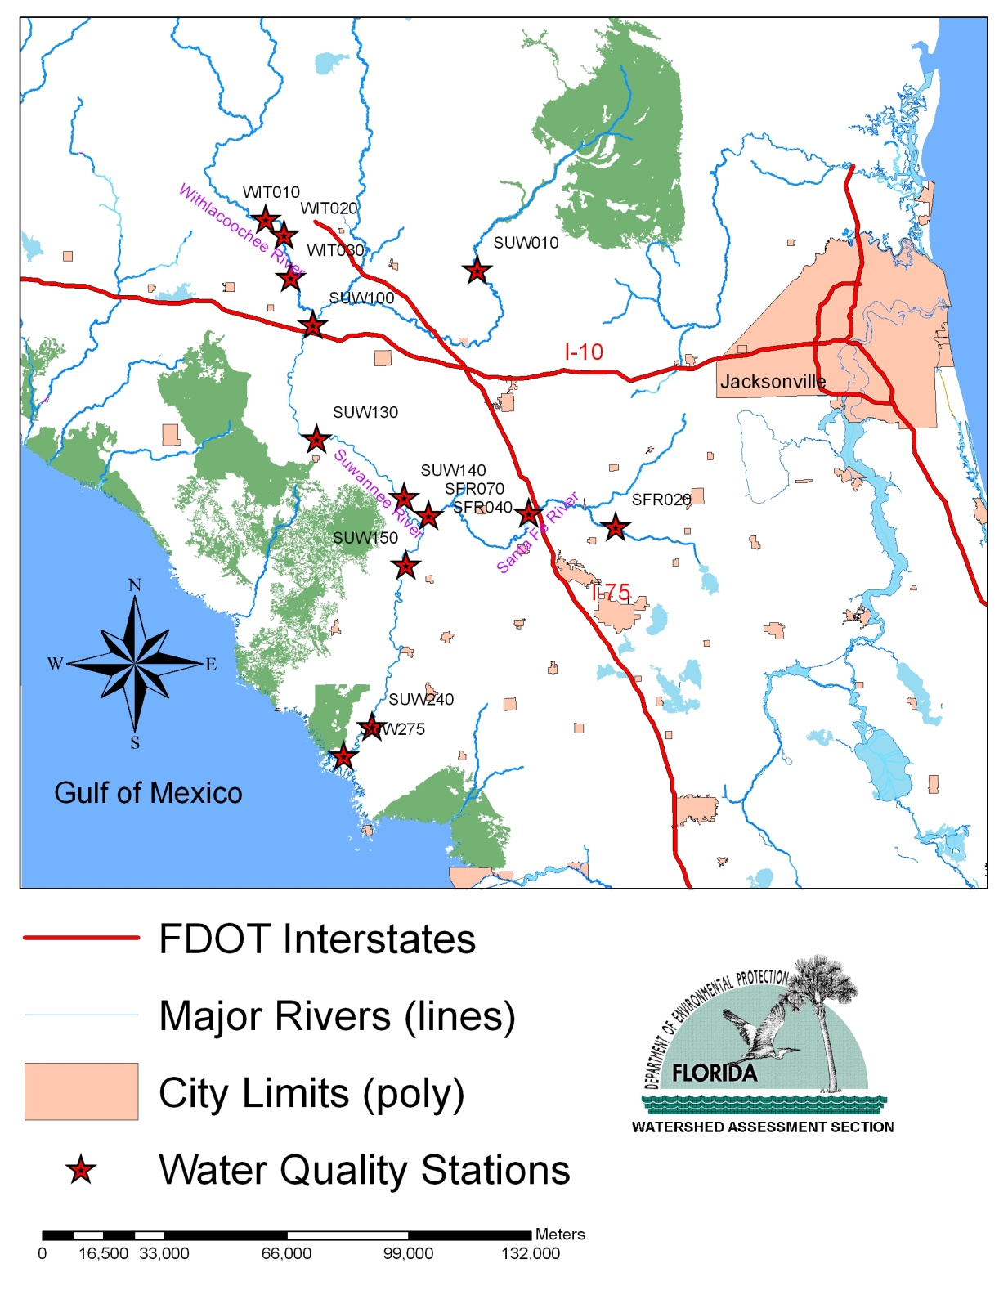

Figure 1. Locations of Water Quality Stations from which Measured Nitrate and Periphyton Abundance Were Used for This Analysis
Table 1 lists the period of records and number of samples for each station. Long-term average nitrate concentrations and periphyton measurements were calculated for each sampling station. Functional relationships between nitrate and periphyton abundance were established by plotting either long-term average cell densities or biomass density to long-term average nitrate concentrations from all water quality stations.
Table 1. Period of Records and Number of Paired Nitrate and Periphyton Samples from Each Station

- = Empty cell/no data
Station | Sample Size | Station | Sample Size
SUW010(90-94) | 11 | SUW240(95-98) | 18
SUW010(95-98) | 13 | SUW240(99-02) | 14
SUW010(99-02) | 14 | SUW240(03-07) | 13
SUW010(03-07) | 16 | SUW275(90-92) | 11
SUW100(90-94) | 14 | SFR020(90-94) | 18
SUW100 (95-98) | 14 | SFR020(95-98) | 14
SUW100(99-02) | 14 | SFR020(99-02) | 13
SUW100(03-07) | 15 | SFR020(03-07) | 11
SUW130(90-94) | 19 | SFR040(90-94) | 19
SUW130 (95-98) | 14 | SFR040(95-98) | 15
SUW130(99-02) | 14 | SFR040(99-02) | 14
SUW130(03-07) | 17 | SFR040(03-07) | 14
SUW140 (95-98) | 8 | SFR070(90-94) | 20
SUW140(99-02) | 16 | SFR070(95-98) | 13
SUW140(03-07) | 18 | SFR070(99-02) | 10
SUW150(90-94) | 15 | SFR070(03-07) | 17
SUW150 (95-98) | 14 | WIT010(90-91) | 6
SUW150(99-02) | 13 | WIT020(90-91) | 6
SUW150(03-07) | 16 | WIT030(90-91) | 5
SUW240(90-94) | 10 | - | -

For each of the 13 stations, sample averages of NOx, total abundance, and biomass for the periods 1990-1994, 1995-1998, 1999-2002, and 2003-2007 were calculated based on the original measurements. Sample averages are used in the analysis instead of individual samples for the purpose of reducing randomness variation and better representing the environmental conditions during the given time periods. Sample sizes for each of the 13 stations in the four time periods range from 5 to 20. Annual averages were not used due to small sample sizes (There were no, or only one or two observations for some years at some stations).
It was noticed that data at station SUW275 were collected only in 1990-1992 and stations WIT010, WIT020, and WIT030 had measurements only during the period of 1990-1991. At other 9 stations, data were collected up to 2007 or 2006. Therefore, the change point analysis will be performed with and without data from these four stations.
The purpose of this study is to use change-point statistical analysis to identify the threshold nitrate concentration. This nitrate threshold, once being identified, can be used as the target nitrate concentration for the nitrate TMDL of the Wekiva River and Rock Springs Run.

- The Detection Procedure

Niu et al. (2000) introduced an iterative procedure for detecting and modeling level-shift change points. Niu and Miller (2007) reported the change point analysis and a model comparison procedure for the Stream Condition Index (SCI) and Biological Condition Gradient (BCG) data. The change-point detection procedure in Niuet al. (2000) is similar to that suggested by Chang (1982) and further developed by Chang et al. (1988) for detecting outliers and level shifts in time series analysis. Statistical details of this procedure can also be found in Pankratz (1991, Chapter 8).
For simplicity, let us consider a response variable Y, after an appropriate transformation. Suppose that observations {, } are available where n is the sample size and X is an independent variable. Moreover, we assume that the observations are arranged in the following manner:
The values { } are distinct. If several are corresponding to a single X value, the median of the is taken to be the response value for the X value.

- {, } are sorted according to the values of X from least to greatest.

For each integer , define the step variable for and for .

Step 1. Fit the linear regression model:
, , (1)

where for a fixed l, the are assumed to be independent and identically distributed normal random variables with mean zero and variance .

Step 2. Calculate the values {, } where is the estimated standard error of .

Step 3. Let and compare with the critical value C=3.0 (or C=3.5). The critical value C=3.0 (or C=3.5) corresponds roughly to (or), or the 10% (or the 5%) significance level, based on the simulation results of Chang et al. (1988). If is significant, we conclude that the response Y has a change point at with a level-shift.

Step 4. Let . Repeat Steps 1-3 on the new response variable for detecting a possible second change point. Continue the process until no further change point can be identified.

Step 5. Suppose that k change points are detected in the response variable Y and the corresponding X values are . Fit the model
, . (2)

Then the estimated coefficients will be the k estimated level-shift values.

- Model Comparison

Model (2) fits a step function to estimate the mean (or median) value of the response variable Y and the predictor variable X. In practice, many other models may be considered to describe the relationship between Y and X. In particular, if the scatter plot of observations {, } shows a straight line or a smooth curve pattern, a linear regression model or a nonlinear smooth-curve model should be fitted to the data instead of the step-function change point model in (2).
For the response variable Y and the predictor variable X, the linear regression model has the form:
, . (3)

If the relationship between Y and X is nonlinear, many smooth-curve models may be considered. One of the choices is transforming the predictor variable X and fitting a regression model. For example, we may use the natural logarithm transformation log(X) instead of X as the predictor variable and fit the regression model:
, . (4)

When different models are fitted to the observations {, }, model selection techniques need to be used to decide which model fits the data better. Statistical inferences such as estimation and prediction will then be based on the best model selected. The Bayesian Information Criterion (SBC) suggested by Schwartz (1978) is one of the popular criteria for model comparison. For a fitted model (linear or nonlinear) with p parameters, the SBC is defined as
SBC(p) = log(maximum likelihood function)+ p log(n),

where the likelihood function is based on the distribution assumption of the model such as normal or log-normal or other distribution families, and n is the sample size. When the random errors’s have a normal distribution, the SBC(p) has the simplified form:
SBC(p) = + p log(n), (5)
where is the fitted value based on one of the candidate models and is the Residual Sum of Squares (RSS) based on the fitted candidate model.
Intuitively, there are two parts in (5), the first part is
= ,

which is a measure of the goodness-of-fit of the candidate model. In general, increasing the number of parameters in a model will improve the goodness-of-fit of the model to the data regardless how many parameters are in the true model that generated the data. When a model with too many predicators (significant or not significant ones) is fitted to a data set, we may get a perfect fit but the model will be useless for inference such as prediction. In statistics, fitting a model with too many unnecessary parameters is called over-fitting. The second part in SBC, p log(n), puts a penalty term on the complexity of a candidate model, which will increase when the number of parameters in a candidate model increases. Thus the criterion SBC requires a candidate model fitting the data well and penalizing the complexity of the model. For a group of candidate models, the SBC value can be calculated for each of the models and the preferred model is the one with the lowest SBC value.

- Change Point Analysis of Suwannee River Algal Data

- Mean Abundance (Cell Density) vs Mean NOx

a). Change Point Analysis
Table 1 presents the mean NOx and mean abundance data at stations along the Suwannee river and its two major tributaries (Withlacoochee and Santa Fe). The data were collected by the Suwannee River Water Management District (SRWMD).
Change point analysis was performed for mean abundance vs mean NOx. When all the 13 stations are included, one change points was detected at the mean NOx values of 0.473. The change point has the statistic and is significant at the 5% level (95% confidence). When the four stations, SUW275, WIT010, WIT020, and WIT030, are excluded, the change points was detected at the mean NOx values of 0.441. The change point has the statistics and is also significant at the 5% level (95% confidence). Figures 1 and 2 present the fitted step-function regression models to the mean abundance values.

Table 1. Mean NOx and Mean Abundance Data at the 13 Suwannee River Stations (Sorted by Mean NOx)

With Stations SUW275, WIT010, WIT020, and WIT030:
One change point was detected at Mean NOx=0.473 with the test statistic of 7.86 and confidence level over 95%. The 95% confidence interval for the change point based on 1000 Bootstrapping samples is [0.378, 0.629].

Without Stations SUW275, WIT010, WIT020, and WIT030:
One change point was detected at Mean NOx=0.441 with the test statistic of 7.03 and confidence level over 95%. The 95% confidence interval for the change point based on 1000 Bootstrapping samples is [0.378, 0.657].

- = Empty cell/no data
Station | Mean NOx | Mean Abundance | Station | Mean NOx | Mean Abundance
SUW010(03-07) | 0.015 | 215863 | SUW130(03-07)⁽²⁾ | 0.441 | 446534
SUW010(95-98) | 0.023 | 72775 | SUW275(90-92) | 0.466 | 163244
SUW010(99-02) | 0.027 | 229545 | SUW130(95-98)⁽¹⁾ | 0.473 | 774970
SUW010(90-94) | 0.050 | 153580 | SUW150(90-94) | 0.487 | 598208
SFR020(99-02) | 0.050 | 177079 | SUW130(99-02) | 0.522 | 334294
SFR020(90-94) | 0.064 | 62343 | SFR070(90-94) | 0.553 | 732480
SFR020(95-98) | 0.065 | 78021 | SUW240(90-94) | 0.561 | 282885
SFR040(99-02) | 0.081 | 184470 | SFR070(95-98) | 0.584 | 557997
SFR020(03-07) | 0.084 | 115671 | SFR070(03-07) | 0.629 | 795424
SFR040(90-94) | 0.155 | 216861 | SFR070(99-02) | 0.657 | 791649
SFR040(03-07) | 0.156 | 252165 | SUW150(03-07) | 0.677 | 579348
WIT020(90-91) | 0.223 | 191813 | SUW240(99-02) | 0.695 | 656715
SFR040(95-98) | 0.225 | 153825 | SUW150(95-98) | 0.698 | 1264802
WIT010(90-91) | 0.256 | 176644 | SUW240(03-07) | 0.726 | 703205
WIT030(90-91) | 0.286 | 241469 | SUW140(03-07) | 0.728 | 586243
SUW100(95-98) | 0.378 | 567218 | SUW240(95-98) | 0.741 | 785583
SUW130(90-94) | 0.381 | 332953 | SUW150(99-02) | 0.760 | 699194
SUW100(99-02) | 0.386 | 266619 | SUW140(99-02) | 0.848 | 524728
SUW100(90-94) | 0.421 | 402964 | SUW140(95-98) | 0.900 | 525039
SUW100(03-07) | 0.435 | 282783 | - | - | -

Figure 1. Change Point Analysis for Data from the 13 Stations at the Suwannee River System (Mean Abundance vs Mean NOx)

Change Points: Mean NOx=0.473 with the test statistic of 7.86 and confidence level over 95%

Figure 2. Change Point Analysis for the 9 Stations at the Suwannee River System (Mean Abundance vs Mean NOx). Stations SUW275, WIT010, WIT020, and WIT030 are excluded from the analysis.

Change Points: Mean NOx=0.441 with the test statistic of 7.03 and confidence level over 95%

b). Model Comparison
For the purpose of model comparison, two other models, a linear regression model and a non-linear regression model, were also fitted to the data with and without the data from the four stations. Figures 3 and 4 present the fitted models.

Figure 3. Linear Model (Solid Black) and Non-linear Model (Mean Cell Density on Log(Mean NO)) for Data for the 13 Stations at the Suwannee River System

Figure 4. Linear Model (Solid Black) and Non-linear Model (Mean Cell Density on Log(Mean NO)) for Data for the 9 Stations at the Suwannee River System. Stations SUW275, WIT010, WIT020, and WIT030 are excluded from the analysis.

The three fitted regression models for data from all the 13 stations are presented in Table 2. The SBC values for the change-point model, the linear regression model, and the non-linear regression model are 946.8, 948.1, and 959.7, respectively. Thus, the change-point model was the best model among the three models. Based on the fitted change-point model, the change point at Mean NOx of 0.473 is extremely significant (with p-values =0.000). The mean abundance value at the change point increased 431832.6.

Table 2. Fitted Regression Models for Data from All the 13 Stations

Model 1. Step-Function Regression (Change Point Model) :

Coefficients:
Value Std. Error t value Pr(>|t|)
(Intercept) 218732.9466 38352.8296 5.7032 0.0000
NOx_0.441 427894.7336 55725.3694 7.6786 0.0000

Residual standard error: 171500 on 36 degrees of freedom
Multiple R-Squared: 0.6209
F-statistic: 58.96 on 1 and 36 degrees of freedom, the p-value is 4.316e-009

SBC Value: 946.8

Model 2. Linear Regression Model (Cell Density vs MN=Mean NOx):

Coefficients:
Value Std. Error t value Pr(>|t|)
(Intercept) 87402.0924 51031.6858 1.7127 0.0951
MN 802790.0355 105060.8570 7.6412 0.0000

Residual standard error: 173100 on 37 degrees of freedom
Multiple R-Squared: 0.6121
F-statistic: 58.39 on 1 and 37 degrees of freedom, the p-value is 4.035e-009

SBC Value: 948.1

Model 3. Non-Linear Regression Model (Cell Density vs MN1 = log(Mean NOx)):

Coefficients:
Value Std. Error t value Pr(>|t|)
(Intercept) 634867.3215 49633.9010 12.7910 0.0000
MN1 168800.0255 28999.9917 5.8207 0.0000

Residual standard error: 200800 on 37 degrees of freedom
Multiple R-Squared: 0.478
F-statistic: 33.88 on 1 and 37 degrees of freedom, the p-value is 1.098e-006

SBC Value: 959.7

The three fitted regression models for data from the 9 stations are presented in Table 3 (Stations SUW275, WIT010, WIT020, and WIT030 are excluded from the analysis). The SBC values for the change-point model, the linear regression model, and the non-linear regression model are 853.7, 851.3, and 856.0, respectively. Thus, the linear regression model fits the data slightly better than the change-point model and the non-linear model. Based on the fitted change-point model, the change point at Mean NOx of 0.441 is extremely significant (with p-values =0.000). The mean abundance value at the change point increased 425172.8.

Table 3. Fitted Regression Models for Data from the 9 Stations with Data up to 2007

Model 1. Step-Function Regression (Change Point Model):

Coefficients:
Value Std. Error t value Pr(>|t|)
(Intercept) 221454.9156 43384.8047 5.1044 0.0000
NOx_0.441 425172.7646 60497.2197 7.0280 0.0000

Residual standard error: 178900 on 33 degrees of freedom
Multiple R-Squared: 0.5995
F-statistic: 49.39 on 1 and 33 degrees of freedom, the p-value is 4.852e-008

SBC Value: 853.7

Model 2. Linear Regression Model (Cell Density vs MN=Mean NOx):
Coefficients:
Value Std. Error t value Pr(>|t|)
(Intercept) 108276.6620 53344.5835 2.0298 0.0505
MN 791490.9787 106462.4745 7.4345 0.0000

Residual standard error: 172800 on 33 degrees of freedom
Multiple R-Squared: 0.6262
F-statistic: 55.27 on 1 and 33 degrees of freedom, the p-value is 1.525e-008

SBC Value: 851.3

Model 3. Non-Linear Regression Model (Cell Density vs MN1 = log(Mean NOx) ):

Coefficients:
Value Std. Error t value Pr(>|t|)
(Intercept) 666028.2110 49095.1979 13.5661 0.0000
MN1 172012.7222 27950.4366 6.1542 0.0000

Residual standard error: 192900 on 33 degrees of freedom
Multiple R-Squared: 0.5344
F-statistic: 37.87 on 1 and 33 degrees of freedom, the p-value is 6.133e-007

SBC Value: 856.0

- Mean Biomass vs Mean NOx

a). Change Point Analysis
Table 4 presents the mean NOx and mean biomass data (ash free dry mass – AFDM/cm²) at stations along the Suwannee river and its two major tributaries (Withlacoochee and Santa Fe). Biomass data are not available for the period of 1999-2002 at the 13 stations.
Change point analysis was performed for mean biomass vs mean NOx. When all the 13 stations are included, one change points was detected at the mean NOx values of 0.441. The change point has the statistic and is significant at the 5% level (95% confidence). When the four stations, SUW275, WIT010, WIT020, and WIT030, are excluded, the change points was detected at the same point with mean NOx values of 0.441. The change point has the statistics and is also significant at the 5% level (95% confidence). Figures 5 and 6 present the fitted step-function regression models to the mean biomass values.

Table 4. Mean NOx and Mean Biomass Data at the Suwannee River Stations (Sorted by Mean NOx)

With Stations SUW275, WIT010, WIT020, and WIT030:
One change point was detected at Mean NOx=0.441 with the test statistic of 7.51 and confidence level over 95%. The 95% confidence interval for the change point based on 1000 Bootstrapping samples is [0.441, 0.584] with Bootstrapping average estimate for the change point at NOx=0.468.

Without Stations SUW275, WIT010, WIT020, and WIT030:
One change point was detected at Mean NOx=0.441 with the test statistic of 7.90 and confidence level over 95%. The 95% confidence interval for the change point based on 1000 Bootstrapping samples is [0.441, 0.629] with Bootstrapping average estimate for the change point at NOx=0.464.

Both Bootstrapping 95% confidence intervals (with and without the 4 stations) are skewed towards higher values than NOx=0.441. The Bootstrapping method removes some samples and repeats some other samples in the original data. Therefore bootstrapping samples may change the structure of the original data. For small sample size below 30, bootstrapping interval estimates are not recommended.

Station | Mean NOx | Mean Biomass | Station | Mean NOx | Mean Biomass
SUW010(03-07) | 0.015 | 1.871 | SUW100(03-07) | 0.435 | 1.795
SUW010(95-98) | 0.023 | 1.030 | SUW130(03-07)^{(1,2)} | 0.441 | 5.340
SUW010(90-94) | 0.050 | 1.624 | SUW275(90-92) | 0.466 | 2.173
SFR020(90-94) | 0.064 | 1.103 | SUW130(95-98) | 0.473 | 6.301
SFR020(95-98) | 0.065 | 1.717 | SUW150(90-94) | 0.487 | 4.124
SFR020(03-07) | 0.084 | 2.037 | SFR070(90-94) | 0.553 | 4.735
SFR040(90-94) | 0.155 | 1.396 | SUW240(90-94) | 0.561 | 2.019
SFR040(03-07) | 0.156 | 1.619 | SFR070(95-98) | 0.584 | 4.616
WIT020(90-91) | 0.223 | 1.867 | SFR070(03-07) | 0.629 | 5.781
SFR040(95-98) | 0.225 | 1.287 | SUW150(03-07) | 0.677 | 5.495
WIT010(90-91) | 0.256 | 1.456 | SUW150(95-98) | 0.698 | 5.333
WIT030(90-91) | 0.286 | 2.187 | SUW240(03-07) | 0.726 | 4.460
SUW100(95-98) | 0.378 | 2.428 | SUW140(03-07) | 0.728 | 6.328
SUW130(90-94) | 0.381 | 2.991 | SUW240(95-98) | 0.741 | 3.106
SUW100(90-94) | 0.421 | 2.702 | SUW140(95-98) | 0.900 | 4.644

Figure 5. Change Point Analysis for Data from the 13 Stations at the Suwannee River System (Mean Biomass vs Mean NOx)

Change Points: Mean NOx=0.441 with the test statistic of 7.51 and confidence level over 95%

Figure 6. Change Point Analysis for the 9 Stations at the Suwannee River System (Mean Biomass vs Mean NOx). Stations SUW275, WIT010, WIT020, and WIT030 are excluded from the analysis.

Change Points: Mean NOx=0.441 with the test statistic of 7.90 and confidence level over 95%

b). Model Comparison
For the purpose of model comparison, two other models, a linear regression model and a non-linear regression model, were also fitted to the data with and without the data from the four stations. Figures 7 and 8 present the fitted models.

Figure 7. Linear Model (Solid Black) and Non-linear Model (Mean Biomass on Log(Mean NO)) for Data for the 13 Stations at the Suwannee River System

Figure 8. Linear Model (Solid Black) and Non-linear Model (Mean Biomass on Log(Mean NO)) for Data for the 9 Stations at the Suwannee River System. Stations SUW275, WIT010, WIT020, and WIT030 are excluded from the analysis.

The three fitted regression models for data from all the 13 stations are presented in Table 5. The SBC values for the change-point model, the linear regression model, and the non-linear regression model are 7.6, 13.5, and 23.1, respectively. Thus, the change-point model was the best model among the three models. Based on the fitted change-point model, the change point at Mean NOx of 0.441 is extremely significant (with p-values =0.000). The mean biomass value at the change point increased 2.7847.
Table 5. Fitted Regression Models for Data from All the 13 Stations

Model 1. Step-Function Regression (Change Point Model):

Coefficients:
Value Std. Error t value Pr(>|t|)
(Intercept) 1.8193 0.2533 7.1826 0.0000
NOx_0.441 2.7847 0.3708 7.5102 0.0000

Residual standard error: 1.013 on 28 degrees of freedom
Multiple R-Squared: 0.6683
F-statistic: 56.4 on 1 and 28 degrees of freedom, the p-value is 3.518e-008

SBC Value: 7.6

Model 2. Linear Regression Model (Mean Biomass vs MN=Mean NOx):

Coefficients:
Value Std. Error t value Pr(>|t|)
(Intercept) 1.0300 0.3838 2.6835 0.0121
MN 5.2755 0.8209 6.4268 0.0000

Residual standard error: 1.118 on 28 degrees of freedom
Multiple R-Squared: 0.596
F-statistic: 41.3 on 1 and 28 degrees of freedom, the p-value is 5.849e-007

SBC Value: 13.5

Model 3. Non-Linear Regression Model ( Mean Biomass vs MN1 = log(Mean NOx) ):

Coefficients:
Value Std. Error t value Pr(>|t|)
(Intercept) 4.5030 0.3781 11.9093 0.0000
MN1 1.0671 0.2256 4.7300 0.0001

Residual standard error: 1.312 on 28 degrees of freedom
Multiple R-Squared: 0.4441
F-statistic: 22.37 on 1 and 28 degrees of freedom, the p-value is 0.00005801

SBC Value: 23.1

The three fitted regression models for data from the 9 stations are presented in Table 6 (Stations SUW275, WIT010, WIT020, and WIT030 are excluded from the analysis). The SBC values for the change-point model, the linear regression model, and the non-linear regression model are 4.4, 13.9, and 20.0, respectively. Thus, change-point model l fits the data much better than the linear regression model and the non-linear model. Based on the fitted change-point model, the change point at Mean NOx of 0.441 is extremely significant (with p-values =0.000). The mean abundance value at the change point increased 2.9756.
Table 6. Fitted Regression Models for Data from the 9 Stations with Data up to 2007

Model 1. Step-Function Regression (Change Point Model):

Coefficients:
Value Std. Error t value Pr(>|t|)
(Intercept) 1.8154 0.2662 6.8195 0.0000
NOx_0.441 2.9756 0.3765 7.9037 0.0000

Residual standard error: 0.9598 on 24 degrees of freedom
Multiple R-Squared: 0.7224
F-statistic: 62.47 on 1 and 24 degrees of freedom, the p-value is 3.908e-008

SBC Value: 4.4

Model 2. Linear Regression Model (Cell Density vs MN=Mean NOx):

Coefficients:
Value Std. Error t value Pr(>|t|)
(Intercept) 1.1829 0.4192 2.8221 0.0094
MN 5.1775 0.8622 6.0049 0.0000

Residual standard error: 1.152 on 24 degrees of freedom
Multiple R-Squared: 0.6004
F-statistic: 36.06 on 1 and 24 degrees of freedom, the p-value is 3.367e-006

SBC Value: 13.9

Model 3. Non-Linear Regression Model (Cell Density vs MN1 = log(Mean NOx) ):

Coefficients:
Value Std. Error t value Pr(>|t|)
(Intercept) 4.7236 0.3879 12.1769 0.0000
MN1 1.0850 0.2239 4.8451 0.0001

Residual standard error: 1.295 on 24 degrees of freedom
Multiple R-Squared: 0.4945
F-statistic: 23.47 on 1 and 24 degrees of freedom, the p-value is 0.00006159

SBC Value: 20.0

- Summary and Conclusions

In this report, change point analysis was performed for the algal data at stations along the Suwannee River and its two major tributaries (Withlacoochee and Santa Fe) based on the updated data set. The main findings in this report are the following:
- Change point analysis of mean abundance vs mean NOx. When all the 13 stations are included, one change points was detected at the mean NOx values of 0.473. The change point has the statistic and is significant at the 5% level (95% confidence). When the four stations, SUW275, WIT010, WIT020, and WIT030, are excluded, one change points was detected at the mean NOx values of 0.441. The change point has the statistics and is also significant at the 5% level (95% confidence).

- Change point analysis of mean biomass vs mean NOx. When all the 13 stations are included, one change points was detected at the mean NOx values of 0.441. The change point has the statistic and is significant at the 5% level (95% confidence). When the four stations, SUW275, WIT010, WIT020, and WIT030, are excluded, one change points was detected at the same point with mean NOx values of 0.441. The change point has the statistics and is also significant at the 5% level (95% confidence).

Based on this analysis, we conclude that the major changes in mean abundance and mean biomass happened at mean NOx around 0.441. Confidence Intervals for the change point are provided based on Bootstrapping samples. But cautions should be taken for the bootstrapping intervals when the original sample size is smaller than 30.

References
Chang, I. 1982. Outliers in time series. Unpublished Ph.D. Dissertation. Madison, WI: University of Wisconsin, Department of Statistics.
Chang, I., G.C. Tiao, and C. Chen. 1988. Estimation of time series parameters in the presence of outliers. Technometrics 30: 193–204.
Hornsby, D., R.A. Mattson, and T. Mirti. 2000. Surface water quality and biological monitoring. Annual report 1999. Suwannee River Water Management District Technical Report WR-00-04.
Mattson, R.A., E.F. Lowe, C.L. Lippincott, J. Di, and L. Battoe. 2006. Wekiva River and Rock Springs Run pollutant load reduction goals. Report to the Florida Department of Environmental Protection. St. Johns River Water Management District.
Niu, X-F., P. Lin, and D. Meeter. 2000. Detecting change points in the species composition and water quality data of WCA2A. Tallahassee, FL: Florida State University, Department of Statistics. Technical report submitted to the Florida Department of Environmental Protection.
Niu, X-F., and Gao, X-Q. 2007. Change point analysis of the Suwannee River algal data. Technical report submitted to the Florida Department of Environmental Protection.
Niu, X-F., and D. Miller. 2007. Change point analysis and model comparison of Stream Condition Index and Biological Condition Gradient data. Technical report submitted to the Florida Department of Environmental Protection.
Pankratz, A. 1991. Forecasting with dynamic regression models. New York: John Wiley & Sons Inc.
Schwartz, G. 1978. Estimating the dimension of a model. The Annals of Statistics 6: 461–464.


Florida Department of Environmental Protection
Division of Environmental Assessment and Restoration
Bureau of Watershed Restoration
2600 Blair Stone Road, Mail Station 3565
Tallahassee, FL 32399-2400

