SPRINGS ATLAS
Jackson Blue Spring – Jackson County, Florida
October, 2012

-----------------------------------------------------------------------------------------------

Background

Jackson Blue Spring (aka Blue Spring) is located within the southwestern portion of the Dougherty Karst Plain geomorphic region, at the head of Merritts Mill Pond, about 4.2 miles east of the city of Marianna in east-central Jackson County, Florida. Jackson Blue Spring forms the headwaters of the 270-acre Merritts Mill Pond (Figure 1), which was once the upper portion of a free-flowing spring run (Spring Creek), prior to 1860. In the 1920s, Merritts Mill Pond was expanded to its current extent with the construction of a dam and weir structure at U.S. Highway 90. Merritts Mill Pond now forms the headwaters of Spring Creek, a tributary to the Chipola River (designated as an Outstanding Florida Water). Jackson Blue Spring and Merritts Mill Pond support a complex aquatic ecosystem and together are an important cultural and economic resource for the region and state.

In addition to Jackson Blue Spring, there are seven additional named springs which discharge directly into the upper half of Merritts Mill Pond (Figure 2).

Based on measurements made in 2007 by the Northwest Florida Water Management District (NWFWMD), the combined surface watershed and ground water catchment basin (springshed) for Merritts Mill Pond (including Jackson Blue and the other springs within the Mill Pond) extends north and eastward into northeastern Jackson County and extreme southeastern Alabama, comprising 153.6 mi² (397.8 km²) in aerial extent. Over 91% of this combined watershed/springshed lies within the confines of Jackson County (Barrios, 2011).

Predominant land use within the Merritts Mill Pond / Jackson Blue Spring watershed/springshed consists of a roughly equal mix of forested and rural open lands (42%) and agricultural croplands (~43%), based on 2009 NWFWMD data. Urban land use only accounts for about 10% (Barrios, 2011).

Water Quality

Blue Spring has been sampled for major ions and nutrients as far back as 1924 and quarterly since 2002 for a larger number of analytes, including major ions, nutrients, saline indicators and field analytes. Table 1 summarizes these results for selected analytes.

Nutrients are of major concern in Jackson Blue Spring. Nitrate levels are relatively high (over 3 mg/L NO₂+NO₃, measured as N), and are in fact the second-highest measured among Florida’s first-magnitude springs. Figure 3 shows the historic nitrate plus nitrite concentrations from Jackson Blue Spring. The upward trend shown in this graph depicts a greater than eightfold increase in nitrate plus nitrite concentrations from 1960 to 2011. Figure 4 shows nitrate plus nitrite values for the eight named spring vents discharging into Merritts Mill Pond, measured over a five-year period from 2007 – 2011. Based on similar nitrate-nitrite values and trends, Jackson Blue and Shangri-La springs appear to discharge ground water from similar sources and produce the highest nitrate-nitrite values.

Stable isotopic analyses were utilized to help determine possible sources for the elevated nitrate concentrations found in spring waters discharging into the Mill Pond. Nitrogen and oxygen isotopes were measured from six Merritts Mill Pond springs sampled in April-May, 2011 and February, 2012. Results of δ¹⁵N plotted against δ¹⁸O (Figure 5) show relatively low ¹⁵N/¹⁴N and ¹⁸O/¹⁶O enrichment, indicative of possible nitrate sources which include mineralized (inorganic) reduced nitrate fertilizers and/or soil organic matter (Roadcap et al, 2002). These values do not indicate the prevalence of organic nitrate sources, such as animal waste or wastewater from human sources.

With regard to other nutrients, orthophosphate concentrations are within the expected normal ranges for Floridan aquifer system ground water, and neither orthophosphate nor total phosphorus display increasing temporal trends.

Saline indicators (Sodium, chloride – Table 1) reflect potential upconing of deeper, more saline ground water due to excessive pumping or drought conditions. The median sodium and chloride values measured from Jackson Blue Spring fall well below the median background values for these analytes measured in Floridan aquifer system wells and springs (Maddox et al, 1992).

A full pesticide scan of water and sediment samples from Jackson Blue Spring and a second site approximately 50m downstream was conducted in April, 2002. Hexazinone was detected in both water samples, but concentrations were very low - below the practical quantitation limits set by the analytical lab. No other pesticides were detected in either water or sediment samples (FDEP, 2002).

Discharge

Jackson Blue Spring is an historic first-magnitude spring, with an average discharge of 75 mgd (116 ft³/second). However, during the drought years of 2006 and 2007, discharge dropped to a low of about 18.2 mgd (28 ft³/second). These low discharge values reflect a combination of below normal precipitation (and resulting low aquifer recharge levels) combined with large agricultural withdrawals within the springshed area. Figure 6 shows the discharge from Jackson Blue Spring measured from 2004 – 2009.

In addition to Jackson Blue Spring, 7 named springs are associated with Merritts Mill Pond: Shangri-La, Twin Caves, Hole-in-the-Wall, Heidi Hole, Gator Hole, Indian Washtub, and Lamar’s Landing. In June 2007, NWFWMD measured the discharge of the exit conduits of the 6 springs that were currently discharging and found that Jackson Blue Spring has by far the largest discharge of the 8 springs. Jackson Blue Spring contributed approximately 69% of the total flow of Merritts Mill Pond (as measured at the Mill Pond outfall), the 7 minor springs contributed 14%, and the remaining 17% was from other unmeasured sources. Using historical data, the NWFWMD has calculated that from 2006 to 2010, Jackson Blue Spring accounted for 70% of the pond outflow on average (Barrios, 2011).

Quarterly discharge measurements were made by Northwest Florida Water Management District (NWFWMD), the Florida Geological Survey, and the U.S. Geological Survey from 2004 – 2009 (Figure 6). A USGS gaging station (02358975) was established in Merritts Millpond just below Blue Spring, and collected real-time discharge data from 2002 through 2010. Include?

Ecological Balance

Merritts Mill Pond is an artificial reservoir, and no data exists on biological conditions within the spring run prior to impoundment. An FDEP EcoSummary report published in April, 2002 listed the spring as impaired due to elevated nitrate concentrations.

Floating algal mats, benthic algae and the invasive plant species Hydrilla verticillata have been documented within Merritts Mill Pond (Figure 7), but isolated patches of native Vallisnaria can still be found in the vicinity of Blue Spring. In the upper portions of the Mill Pond just below Jackson Blue Spring, benthic algae has been observed covering about 40% of bottom substrate (Figure 8). Benthic algae is also present in the swimming area adjacent to Jackson Blue Spring, but human disturbance by swimmers in the summer months dislodges much of this. Floating algal mats are more commonly observed in the middle and southern portions of Merritts Mill Pond, likely due to lower flow rates and the downstream accumulation of floating biomass at the downstream terminus of the Mill Pond (Figure 9).

Actions

In October, 2012, a TMDL was established for Jackson Blue Spring and Merritts Mill Pond, based on persistent elevated nitrate concentrations and biological impairment due to algal smothering in the Mill Pond (Dodson, 2012). A TMDL (Total Maximum Daily Load) represents the maximum amount of a given pollutant that a waterbody can assimilate and still meet water quality standards, including its applicable water quality criteria and its designated uses. TMDLs are developed for waterbodies that are verified as not meeting their water quality standards.

Following the establishment of a TMDL, a Basin Management Action Plan (BMAP) will be developed for Jackson Blue Spring and Merritts Mill Pond. A BMAP is a "blueprint" for restoring impaired waters by reducing pollutant loadings to meet the allowable loadings established in a TMDL. It represents a comprehensive set of strategies - permit limits on wastewater facilities, urban and agricultural best management practices, conservation programs, financial assistance and revenue generating activities, etc., designed to implement the pollutant reductions established by the TMDL. These broad-based plans are developed with local stakeholders - they rely on local input and local commitment, and they are adopted by Secretarial Order to be enforceable (FDEP, 2012).

Selected References:

Barrios, Kristopher and Kevin DeFosset, 2005, Ground water chemical characterization of Jackson Blue Spring and Wakulla Springs, Florida; NWFWMD Water Resources Special report 05-01; 54 p.

Barrios, K.F., 2011, Nitrogen Sources in the Jackson Blue Spring Basin, Jackson County, FL; NWFWMD Technical File Report 2011‐01.

Dodson, James, 2012, Final report – Nutrient TMDL for Jackson Blue spring and Merritts Mill Pond (WBIDs 180z and 180A); FDEP, 87p.

FDEP, April, 2002, Ecosummary – Jackson Blue Spring; 1 p.

FDEP, 2012: Total Maximum Daily Loads website: http://www.dep.state.fl.us/water/tmdl/index.htm

Maddox, G.L., J.M. Lloyd, T.M. Sacott, S.B. Upchurch and R.E Copeland, 1992, Florida’s Ground Water Quality Monitoring program – Backgrouind hydrogeochemistry: Florida Geological Survey Special Publication No. 34; 364 p.

Roadcap, George S., K.C. Hackley, and H. Hwang, 2002, Application of nitrogen and oxygen isotopes to identify sources of nitrate: Report to the Illinois Groundwater Consortium, Southern Illinois University; 30 p.

Scott, T.M., et al, 2004, Springs of Florida; Florida Geological Survey Bulletin No. 66; 377 p.

For more information, contact:
Gary Maddox, FDEP Ground Water Management Section, 2600 Blair Stone Rd; Tallahassee, FL 32399; (850)245-8511; Gary.Maddox@dep.state.fl.us

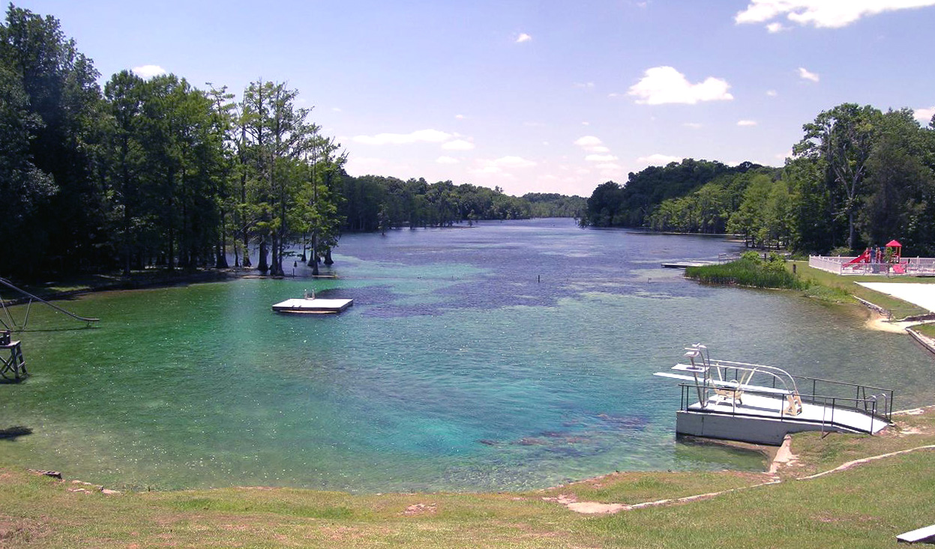

Figure 1: Jackson Blue Spring – view southwest from above spring vent

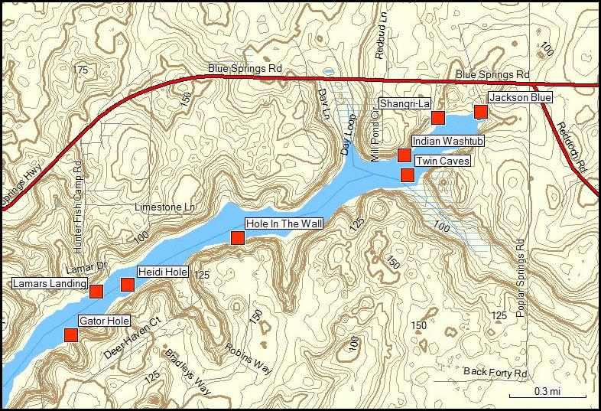

Figure 2: Location of named spring vents in the upper portion of Merritts Mill Pond

ANALYTE | PERIOD OF RECORD | UNITS | NUMBER OF SAMPLES | HISTORIC MEAN | HISTORIC MEDIAN | RECENT MEAN (LAST 4 QTRS) | RECENT MEDIAN (LAST 4 QTRS)
NO2+NO3 (as N) | 1924 - 2011 | mg/L | 30 | 2.55 | 2.4 | 3.3 | 3.3
Phosphorus (total) | 1960 - | mg/L | 29 | 0.021 | 0.016
Sodium | 1960 | mg/L | 29 | 1.82 | 1.76
Chloride | 1924 - | mg/L | 29 | 3.8 | 3.5
Specific Conductance | 1946 - | µS/cm | 29 | 237 | 231
Dissolved Oxygen |  | mg/L | 29 | 7.41 | 8.3
Boron | 1972 - | mg/L
Sucralose |  | mg/L

Table 1: Summary of Water Quality results 2002-2011 Placeholder - incomplete

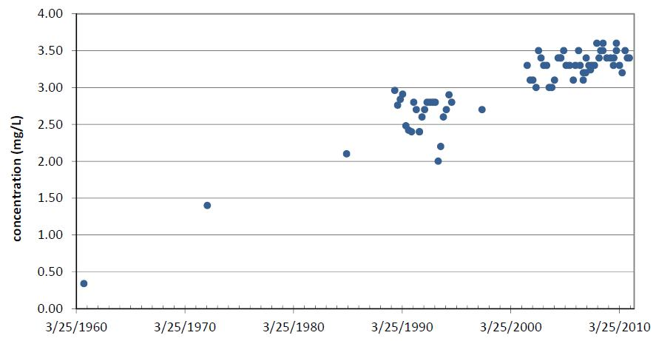
Figure 3: Historic Nitrate + Nitrite (as N) concentrations in Jackson Blue Spring 1960-2011 (Barrios, 2011)
Re-do with data points from 1924 & 1946?
1924: NO₃ (as N) = 0.36 mg/L
1946: NO₃ (as N) = 1.29 mg/L

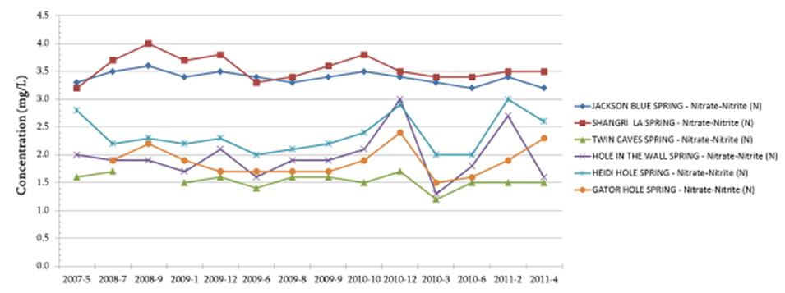
Figure 4: Summary of nitrate plus nitrite (as N) results for Merritts Mill Pond springs from 2007-2011 (Barrios, 2011)

Figure 5: δ¹⁵N vs. δ¹⁸O for Merritts Mill Pond springs sampled April-May, 2011 and February, 2012

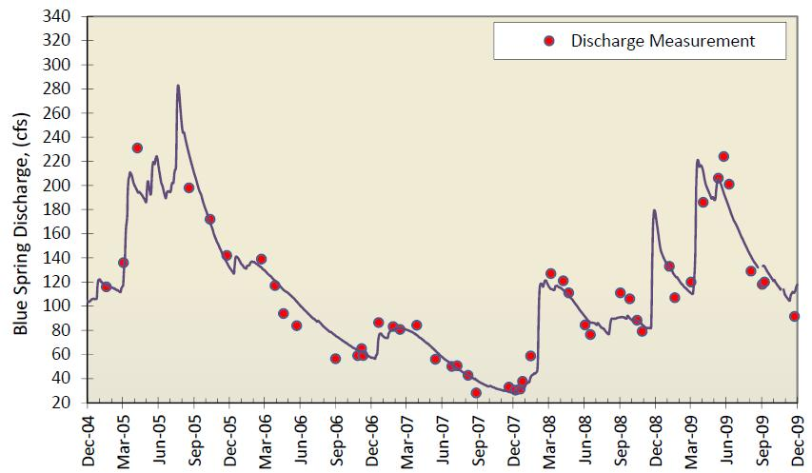
Figure 6: Jackson Blue Spring discharge 2004-2009 (Barrios, 2011)

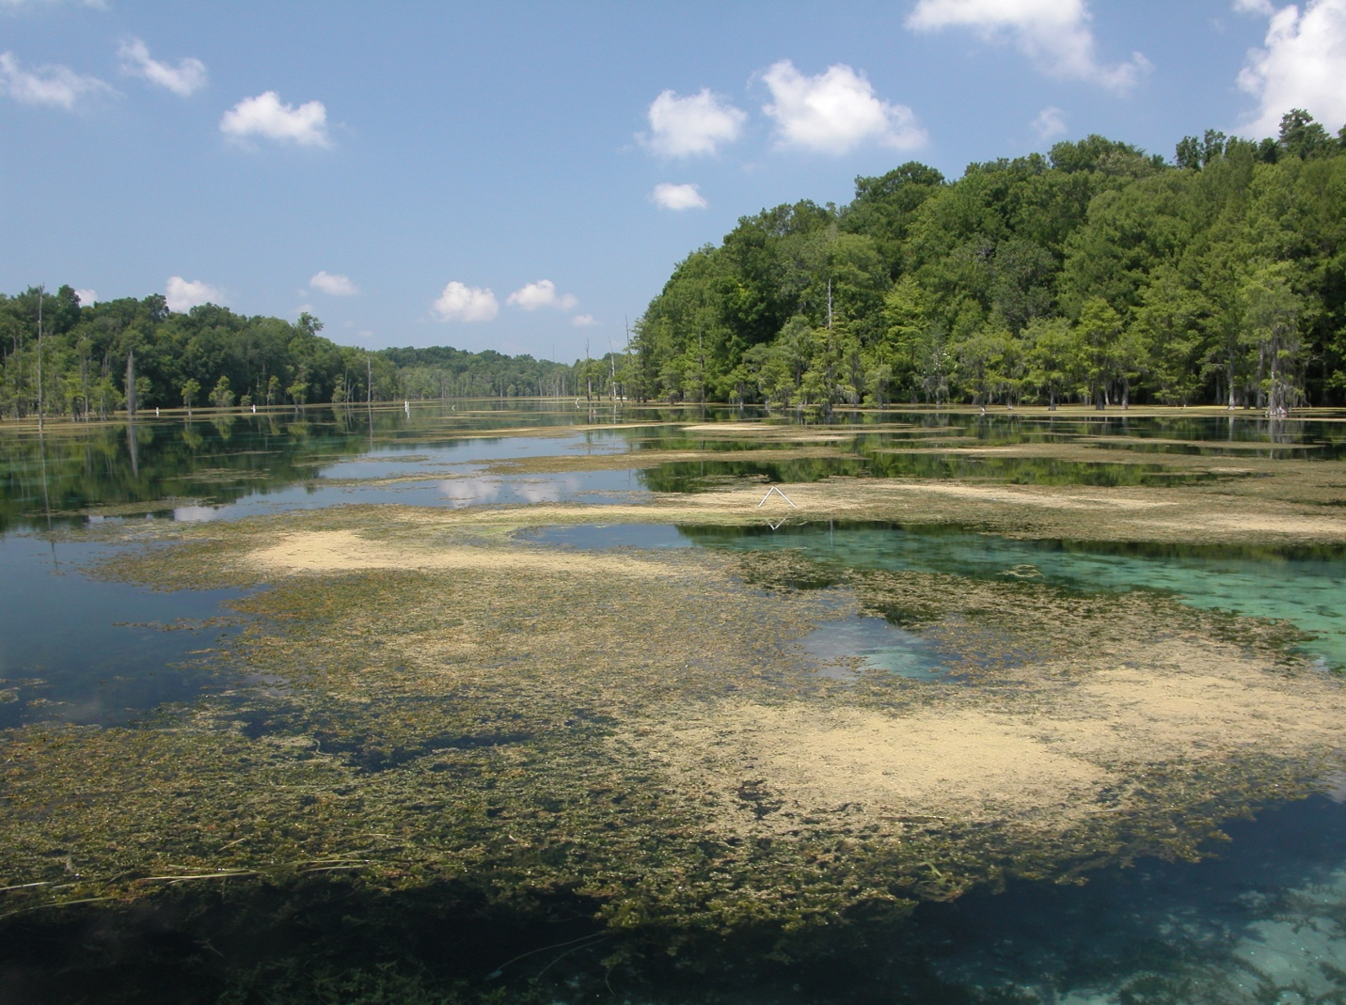
Figure 7: Hydrilla verticillata in Merritts Mill Pond just below Jackson Blue Spring (FGS, 2004)

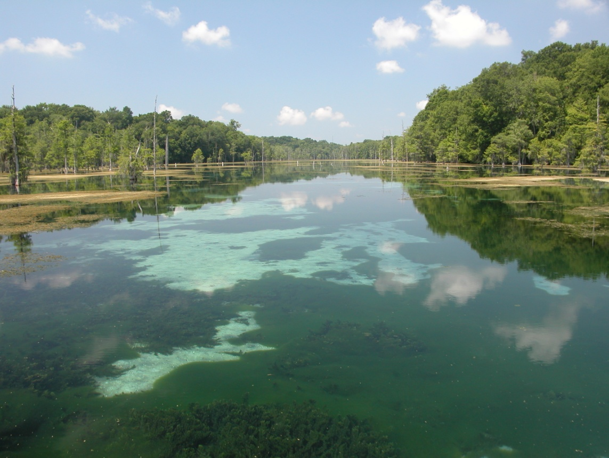
Figure 8: Benthic algae and Hydrilla verticillata in Merritts Mill Pond just below Jackson Blue Spring (FGS)

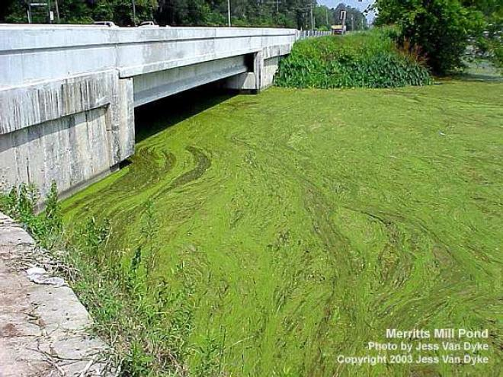
Figure 9: Algal bloom at southwestern end of Merritts Mill Pond in 2003 (Jess Van Dyke, FDEP)

