SPRINGS ATLAS
Blue Spring – Jackson County, Florida
October, 2012
--------------------------------------------------------------------------------------------------------------

Background

Blue Spring (aka Jackson Blue Spring) is located at the head of Merritts Mill Pond in east-central Jackson County, Florida. It is a part of the greater Chipola River surface water basin. The ground water catchment basin (springshed) for Blue Spring comprises an area of approximately 300 km² within the Floridan aquifer system, trending generally southeast and north from the head spring and extending into southeasatern Alabama. Land use within the springshed primarily consists of a roughly equal mix of upland forest and agricultural lands.

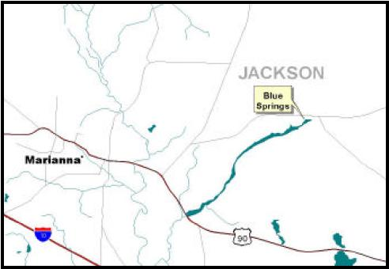
Figure 1: Location of Blue Spring in Jackson County, FL

Water Quality

Blue Spring has been sampled quarterly since 2002 for a large number of analytes, including major ions, nutrients, saline indicators and field analytes. Figure 2 summarizes these results for selected analytes.
Nitrate levels are relatively high, and are in fact the second-highest measured among Florida’s first-magnitude springs. Phosphorus values are within the expected normal ranges for Floridan aquifer system ground water. Figure 3 shows trend plots for both of these nutrients.

Figure 2: Summary of Water Quality results 2002-2011

The pesticide hexazinone was detected in samples collected in 2002 by FDEP, but concentrations were very low - below the practical quantitation limits set by the analytical lab.
(Placeholder for nutrient trend graph: NO₂+NO₃ & Phosphorus 2002-2011)

Figure 3: Nutrient trends 2002-2011

Ecological Balance

Despite elevated nitrate concentrations, bioassessments at Blue Spring have not shown an imbalance in submerged aquatic vegetation distribution; however, Merritts Mill Pond is an artificial reservoir, and no data exists on biological conditions within the spring run prior to impoundment. An FDEP ecosummary conducted in April, 2002 listed the spring as impaired due to elevated nitrate concentrations.
Discharge

Blue Spring is an historic first-magnitude spring, with an average discharge of 86 mgd (133 ft³/second). However, during the drought years of 2006 and 2007, discharge dropped to a low of about 18.2 mgd (28 ft³/second). These low discharge values reflect a combination of below normal precipitation (and resulting low aquifer recharge levels) combined with large agricultural withdrawals within the springshed area.

Quarterly discharge measurements were made by Northwest Florida Water Management District (NWFWMD), the Florida Geological Survey, and the U.S. Geological Survey from 2002 – 2010 (Figure 4). A USGS gaging station (02358975) was established in Merritts Millpond just below Blue Spring, and collected real-time discharge data from 2002 through 2010.

(Placeholder for quarterly discharge graph 2002-2010)

Figure 4: Blue Spring discharge 2002-2010

Actions

Blue Spring is currently monitored quarterly by the Northwest Florida Water Management District for water quality. Although measured nitrate levels are very high relative to most other Florida springs of this magnitude, there is little evidence of significant impacts to aquatic vegetation or biota within Blue Spring and the receiving waters of Merritts Mill Pond. There is currently no proposed TMDL for Blue Spring.
Selected References:

Barrios, Kristopher and Kevin DeFosset, 2005, Ground water chemical characterization of Jackson Blue Spring and Wakulla Springs, Florida; NWFWMD Water Resources Special report 05-01; 54 p.
FDEP, April, 2002, Ecosummary – Jackson Blue Spring; 1 p.

For more information, contact:
Gary Maddox, FDEP Ground Water Management Section, 2600 Blair Stone Rd; Tallahassee, FL 32399; (850)245-8511; Gary.Maddox@dep.state.fl.us

