Well and Spring Sampling to Evaluate Nitrogen Sources in Alachua County Portion of the Santa Fe BMAP Area- DRAFT
Prepared by Richard Hicks and Kathryn Holland,
Ground Water and Springs Protection Section
Florida Department of Environmental Protection
Bureau of Watershed Restoration

Introduction
In support of the Santa Fe River Basin TMDL (total maximum daily load) and BMAP (basin management action plan) efforts being conducted by FDEP Watershed Planning and Coordination Section, representatives from Alachua County Environmental Protection Department (EPD) and FDEP Ground Water and Springs Protection Section (GWSP) obtained baseline samples from 21 private wells, 1 waste water treatment plant, and 9 springs, within the BMAP area of the Santa Fe River Basin (one well was on the outer eastern edge of the area). Sampling took place during February and March, 2011.
The 2008 TMDL for the Suwannee and Santa Fe Rivers established the maximum threshold nitrate nitrogen concentration the waterbodies can support while maintaining a healthy ecosystem. Identification of potential nitrate sources is needed to implement appropriate restoration activities for the BMAP. The BMAP process currently underway for the Santa Fe River has identified potential nitrate source types, however, background data on nutrient sources and levels within the basin is somewhat lacking.
Most water in this segment of the Santa Fe River system comes from springs that discharge from the Upper Floridan Aquifer System. The contributing area of these springs (or combined springshed) includes the potential sources of nitrate that are causing the impairment of the system. The objectives of this initial assessment were to: 1) assess baseline nitrate concentrations in the springsheds within the Santa Fe River Basin; 2) evaluate the nitrate sources by using chemical and isotopic tracers to differentiate between organic (from domestic wastewater or animal waste), inorganic (from inorganic fertilizer), or both, e.g., a mixture of nitrate inputs from both inorganic and organic sources.

Site Description
The Alachua County portion of the Santa Fe BMAP area lies within a karst plain region with minimal surface water features except for the river. Soil is sandy and well drained with a discontinuous clay layer providing minimal protection for the underlying carbonate Floridan Aquifer System. The Upper Floridan Aquifer System is the source of water to springs discharging into the Santa Fe River. The assessment area includes portions of three Santa Fe River springsheds, as defined by Kincaid et al (2009). These are shown in Figure 1.
This area is mainly rural, with the towns of High Springs, Alachua, and Newberry being the only population centers. The Suwannee River Water Management District (FDEP 2008) and St. Johns River Water Management District (FDEP 2004) land use coverage was used to identify the major land use types in the assessment area. Approximately 26% of land use within the study area is defined as Cropland and Pastureland which includes mainly improved and unimproved pastures, row crops, field crops, and mixed crops; 20% is in Tree Plantation, which includes coniferous pine and forest regeneration areas. Other land use types include Upland Mixed Forest (16%), Low Density Residential (12%), Swamps and Wetlands (~4%) and Medium Density Residential (~2.7%).

Sampling Approach and Springsheds
Springs that were selected for the assessment included those that provide a good geographic representation of the area as well as those with known elevated nitrate concentrations. Wells for sampling were selected by the Alachua County Department of Environmental Services (ACDES) to provide good areal distribution within the springshed area of Alachua County and to provide a good cross section of typical land use types within the area.
Sampling sites are located within the southern portion of the Santa Fe River planning unit and primarily within the Hornsby, Poe-Lily, and Ginnie-Gilchrist-Blue springsheds. These were defined by Kincaid et al (2009), using the FEFLOW model (finite element design) which allows simulation of conduit and matrix flow, porous mediation equations for matrix, and pipe flow equations for conduits. The springshed delineation modeling strategy included a 3D structure (surficial aquifer, intermediate confining layer, and Floridan aquifer), definition of conduit locations from cave maps, tracer tests, and groundwater levels (high and low water conditions), definition of conduit capacities from levels and flows at high water conditions, a steady-state (designed to simulate average conditions), and calibration to both high water and low water conditions. The spring modeling resulted in a good estimate of the area contributing to springs under average conditions with the understanding that the springshed area may vary under extreme high or low conditions. Kincaid generally concluded that the Ginnie-Gilchrist-Blue, Poe and Lily springsheds primarily encompasses the southern part of the model region, or the southwestern portion of the Santa Fe River BMAP area. The springs and springsheds are predominantly south of the Santa Fe River and are primarily drawing water from the Bell Ridge south to Waters Lake and from Hogtown Prairie where Hogtown Creek disappears to Haile sink (southeast to northwesterly flow direction). General results of the modeling include:
- Rapid conduit flow is likely within these springsheds
- Ground water velocities within conduits range between ~100 to 3000m/day depending on water levels.
- Flow in the aquifer matrix is primarily toward closest conduits.
- Areas closer to conduits are of higher concern than areas more distant from conduits regardless of proximity to well or springs

Utilizing this information the ground water sampling stations utilized for this study were located mostly within the Ginnie-Gilchrist-Blue Hornsby, and Poe-Lily springsheds (Figure 1). The private wells that were sampled in this assessment have been previously sampled by the Alachua County Health Department (ACHD) and EPD and some of these have had nitrate concentrations exceeding the potable ground water standard of 10 mg/L. The springs that were sampled in this study have previously been sampled by the Suwannee River Water Management District and some are routinely sampled by FDEP. The spring sampling locations are shown in Figure 2.

Sampling and Analysis
Representatives of GWSP conducted the spring sampling and a team from EPD conducted the well sampling. All of the samples were analyzed for nitrite and nitrate-nitrogen (NOx), chloride, sulfate, boron and isotopes (δ¹⁵N and δ¹⁸O in nitrate). Both sampling teams followed FDEP sampling SOPs. The isotope samples were analyzed by the Colorado Plateau Stable Isotope Laboratory at the University of Northern Arizona. All other samples that were collected for this report were analyzed by the FDEP Central Laboratory. The laboratory results for the baseline sampling are presented in Table 1.
Figure 1. Ground Water Monitoring Locations for Evaluating Nitrogen Sources in the Santa Fe BMAP Area
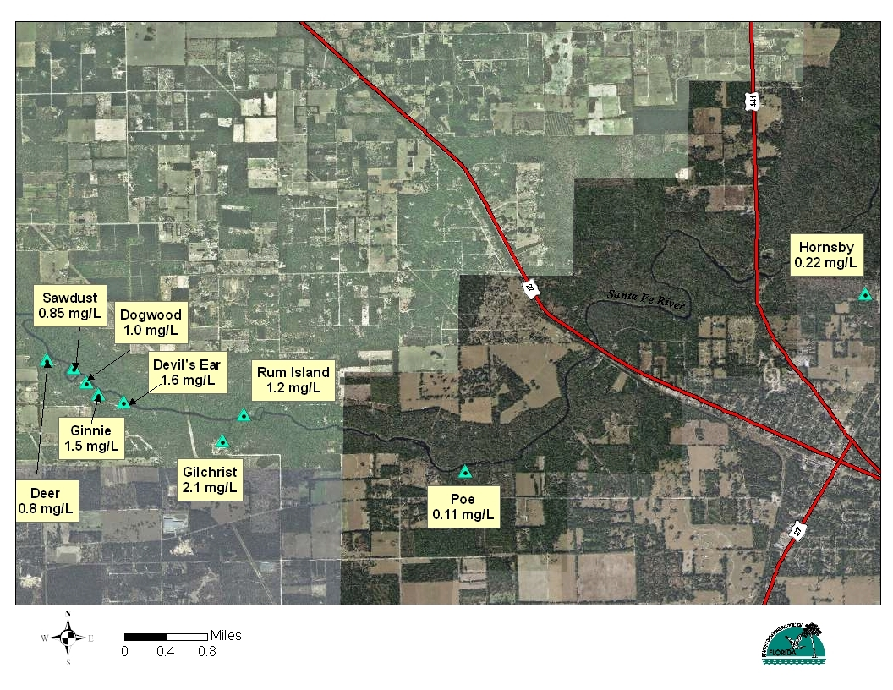
Figure 2. Spring Sampling Locations with NOx Concentrations

Table 1. Laboratory Results for Spring and Ground Water Samples, Baseline Sampling
Site ID | Springshed | Date | NOx (mg/L) | Ammonia (mg/L) | Sulfate (mg/L) | Chloride (mg/L) | Boron (μg/L) | Potassium (mg/L) | δ¹⁵NAIR (⁰⁄₀₀) | δ¹⁸OVSMOW (⁰⁄₀₀)
SPRING
Dogwood Spring | Ginnie-Gilchrist-Blue | 2/22/2011 | 1.0 | 0.01U | 12.0 | 5.8 | 15U | 0.57I | 5.22 | 6.68
Gilchrist-BlueSpring | Ginnie-Gilchrist-Blue | 2/22/2011 | 2.1 | 0.012 | 14.0 | 6.5 | 16I | 0.74I | 4.07 | 4.92
Ginnie Spring | Ginnie-Gilchrist-Blue | 2/22/2011 | 1.5 | 0.01U | 11.0 | 6.2 | 15U | 0.68I | 4.57 | 5.70
Hornsby Spring | Hornsby | 2/28/2011 | 0.22 | 0.01U | 95.0 | 14.0 | 26I | 1.40 | 15.91 | 14.12
Devil's Ear Spring | July | 2/22/2011 | 1.6 | 0.01U | 18.0 | 9.5 | 17I | 0.85I | 4.45 | 6.75
Poe Spring | Poe-Lily | 2/23/2011 | 0.11 | 0.02 | 31.0 | 16.0 | 26I | 1.30 | 23.32 | 19.04
Rum Island Spring | Rum Island | 2/23/2011 | 1.2 | 0.01U | 15.0 | 9.2 | 18I | 0.88I | 6.49 | 6.80
Deer Spring | Twin | 2/24/2011 | 0.8 | 0.01U | 10.0 | 5.1 | 15U | 0.63I | 4.45 | 6.75
Sawdust Spring | Twin | 2/23/2011 | 0.85 | 0.01U | 14.0 | 6.8 | 15U | 0.76I | 5.66 | 6.32
SPRING MEDIAN |  |  | 1 | BDL | 14 | 6.8 | 16 | 0.76 | 5.22 | 6.75
GROUND WATER
AAE1421 | Ginnie-Gilchrist-Blue | 2/21/2011 | 2.1 | 0.01U | 6.9 | 5.5 | 16I | 0.34I | 5.80 | 5.94
AAK7015 | Ginnie-Gilchrist-Blue | 2/21/2011 | 3.3 | 0.01U | 13.0 | 30.0 | 94 | 2.20 | 10.93 | 4.93
AAK7031 | Ginnie-Gilchrist-Blue | 2/21/2011 | 1.4 | 0.01U | 9.0 | 5.2A | 15U | 0.30U | 2.58 | 5.73
AAJ3890 | Hornsby | 2/22/2011 | 12.0 | 0.01U | 110.0 | 170.0 | 30I | 0.80I | 3.19 | 5.91
AAK7008 | Hornsby | 2/28/2011 | 0.86 | 0.025 | 66.0 | 24.0 | 26I | 2.00 | 20.29 | 10.49
AAK7011 | Hornsby | 2/21/2011 | 0.33 | 0.022 | 7.6 | 8.3 | 21I | 0.33I | 4.90 | 4.88
Brunner | Hornsby | 3/1/2011 | 0.61 | 0.01U | 3.9 | 11.0 | 19I | 0.95I | 3.54 | 2.05
AAK7030 | Hornsby | 2/21/2011 | 4.4 | 0.01U | 4.4 | 14.0 | 25I | 0.50I | 7.37 | 4.80
AAK7033 | Hornsby | 3/7/2011 | 3.2 | 0.01U | 1.3 | 6.1 | 17I | 0.4I | 4.28 | 3.44
AAK7044 | Hornsby | 2/23/2011 | 3.0 | 0.01U | 26.0 | 11.0 | 36I | 0.97I | 7.20 | 5.88
AAL4185 | Hornsby | 3/7/2011 | 1.3 | 0.01U | 5.5 | 15.0 | 19I | 0.80I | 6.05 | 7.42
AAM0898 | Poe-Lily | 2/22/2011 | 1.4 | 0.01U | 9.3 | 6.2 | 16I | 0.32I | 5.10 | 6.06
AAA6137 | Poe-Lily | 2/21/2011 | 1.3 | 0.01U | 11.0 | 15.0 | 27I | 0.42I | 4.07 | 9.05
AAE1420 | Poe-Lily | 2/22/2011 | 1.2 | 0.01U | 11.0 | 11.0 | 23I | 0.59I | 7.33 | 4.70
AAK7018 | Poe-Lily | 2/22/2011 | 1.1 | 0.01U | 4.5 | 5.4A | 15U | 0.72I | 3.77 | 3.15
AAK7022 | Poe-Lily | 2/22/2011 | 0.87 | 0.014I | 4.8 | 11.0 | 15U | 0.30U | 3.54 | 3.31
AAK7014 | Santa Fe Rise | 2/24/2011 | 3.2 | 0.01U | 4.5 | 6.0 | 15U | 0.56I | 3.36 | 6.64
AAE6052 | Not identified | 3/3/2011 | 23 | 0.01U | 3.3 | 16 | 17 | 1.4 | 7.77 | 7.17
AAK7037 | Not identified | 2/22/2011 | 2.5 | 0.011 | 7.8 | 12.0 | 25I | 0.44I | 10.98 | 5.55
Haynes | Not identified | 3/3/2011 | 4.0 | 0.01U | 5.3 | 6.3 | 15U | 0.87I | 8.22 | 7.74
IFASD | Not identified | 2/22/2011 | 0.21 | 0.01U | 48.0 | 12.0 | 24I | 0.79I | 8.08 | 7.09
GROUNDWATER MEDIAN |  |  | 1.4 | BDL | 7.6 | 11.0 | 19 | 0.59 | 5.8 | 5.88
High Springs Wastewater Plant Effluent |  |  | 3/1/2011 | 11.0 | 0.089I | 70.0 | 84.0 | 203 | 14.40 | 23.25
Notes: U-analyte undetected, associated value is method detection limit; I-estimated concentration, reported value is between the method detection limit and the instrument detection limited; A- reported value is an average of two or more analysis runs. BDL-below detection limits.

Results

NOx Detections
The TMDL for nitrate in the Santa Fe River is 0.35 mg/L and most of the concentrations of NOx in the spring and ground water samples were higher than that value (Table 1). Spring sampling locations and NOx concentrations in the spring samples are shown in Figure 2.
The range in NOx concentrations in the wells and springs of the main springsheds of this area showed some variability, particularly in wells at known sources (e.g., wastewater plants). All springs but two, Hornsby and Poe, had NOx concentrations greater than 0.8 mg/L. The springs with the highest NOx concentrations are in the Ginnie-Gilchrist-Blue Blue springshed. The results organized by springshed are discussed below.
Hornsby Springshed. NOx concentrations in springs and private wells in the Hornsby springshed ranged from 0.23 mg/L in the Hornsby spring vent to 12 mg/L in well AAJ3890, a private well near several potential sources (a wastewater treatment site, an agricultural field and a former meat-packing plant).
Poe-Lilly Springshed. NOx concentrations in the private wells and springs sampled in the Poe-Lily springshed ranged from 0.11 mg/L in the Poe Spring vent to 1.4 mg/L in well AAM0898.
Ginnie- Gilchrist Blue Springshed. The NOx concentrations in the Ginnie-Gilchrist-Blue springshed spring and private well samples ranged from 1.0 at the Dogwood Spring vent to 3.4 mg/L in well AAK7015 at the Newberry Cemetery adjacent to the WWTF. Highest NOx concentrations measured in spring samples were from Ginnie Spring (1.5 mg/L) and Gilchrist-Blue Spring (2.1 mg/L
Two of the 21 wells sampled had nitrate concentrations greater than the ground water standard of 10 mg/L: AAE6052 (23 mg/L); and AAJ3890 (12 mg/L) within the Hornsby Spring springshed. The elevated NOx concentrations in these wells had been identified previously by EPD and ACHD and they were selected for this study to aid in evaluating the nitrate sources.

Chemical Tracers
Samples were analyzed for several inorganic chemicals that can be used to help evaluate the sources of nitrate in private wells. When these data are plotted, their relationship to one another and background concentrations can sometimes help us better understand potential influences on the ground water chemistry. In this study, samples were collected for sulfate, chloride, potassium, and boron. In addition, the samples were analyzed for sulfate, which can be an indicator of denitrification.
Chloride and potassium are common constituents of both inorganic fertilizer and domestic wastewater from wastewater plants and residential septic tanks. High concentrations of these also correlate with elevated specific conductance and, in some cases, boron. Chloride can be associated with fertilizer as a component of potassium chloride but it also occurs as a strong signal for treated domestic wastewater. Boron can also be associated with both fertilizer and domestic wastewater. Boron is an essential trace nutrient for peanuts, which are grown in this area and is applied where it is deficient in soils (0.5 to 0.75 lb boron/acre in fertilizer [IFAS, 2003]), however its most significant occurrence as a human influence is from domestic wastewater where it is derived from perborate-containing laundry and dish detergents.
Several of the ground water samples collected during this study were intentionally collected from wells at or near domestic wastewater treatment sites to help characterize their chemical signatures. In addition, one domestic wastewater effluent sample was obtained. The sample from a High Springs Wastewater Plant (Table 1) contained chloride, boron and potassium concentrations at least 10 times higher than the median concentration of the ground water samples. Only one other sample, from a private well near Alachua’s wastewater sprayfield, had concentrations similar to these (AAJ3890 in Table 1). The potential influence of domestic wastewater from effluent sites or septic tanks on other wells and for springs can be evaluated by comparing the concentrations of these against the medians for all wells and springs. We found the concentration of chloride and boron to be particularly useful as they correlate fairly well in domestic wastewater. This relationship is shown in Figure 3.
This analysis showed that 4 of the 9 spring samples and 4 of the 21 ground water samples are above the median concentrations for both chloride and boron. These samples also have above-median potassium concentrations. These samples may be influenced by domestic wastewater. The springs with the highest chloride and boron concentrations are Poe and Hornsby, and Devils Ear Spring also has slightly above-median chloride, boron and potassium concentrations. Two of the wells with above median chloride and boron concentrations are in the Hornsby springshed, one is in the Ginnie-Gilchrist-Blue springshed (near a wastewater application site) and the other is not in any of the identified springsheds.

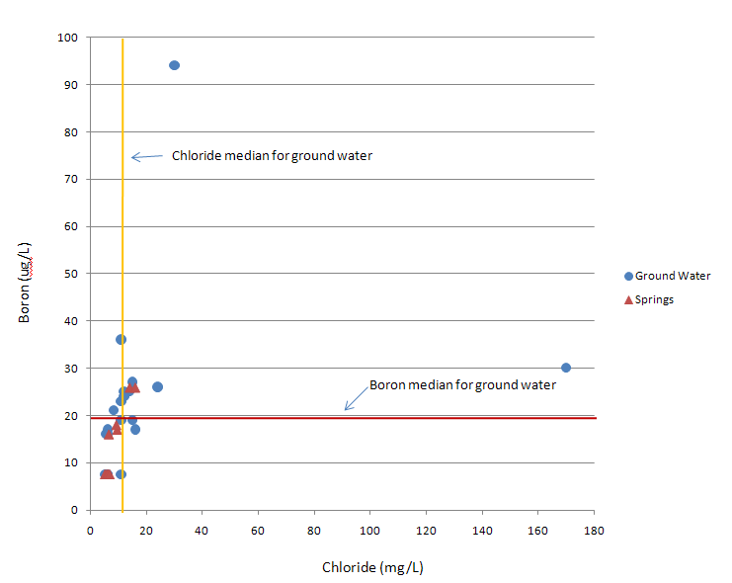
Figure 3. Relationship of Boron to Chloride Concentrations in Ground Water and Spring Samples

While these samples may indicate domestic wastewater influence causing elevated chloride and boron, that evidence alone does not confirm the source of elevated NOx, nor do elevated chloride and boron necessarily coincide with elevated NOx.. The attenuation of boron and chloride in ground water occurs mainly through dilution, which is why these parameters are considered conservative tracers. However, nitrate in NOx can be reduced through other means, most notably denitrification. There is some evidence that the nitrate in some of the springs has been reduced by denitrification, which can cause reduction of sulfur and increased concentrations of sulfate in the water. We noted that sulfate concentrations were elevated in Hornsby and Poe Springs, well AAJ3890 (near wastewater application site), and well AAK7044, all of which had chloride and boron signatures potentially indicative of wastewater influence. This could be due to denitrification of nitrate in wastewater, which has its own organic food source for bacteria.
Elevated NOx in the absence of these signatures, which was observed in the majority of the spring and well samples, could be related to other sources such as inorganic fertilizer or animal waste. The use of isotopic tracers can provide better confidence in our interpretations of nitrate sources and denitrification.

Isotopic Tracers
Measurements of nitrogen and oxygen isotope ratios, ¹⁵N/¹⁴N and ¹⁸O/¹⁶O_{NO3}, have been used for years to help differentiate between sources of nitrate in ground water and to evaluate whether nitrogen concentration changes are due to the mixing of nitrate sources or to denitrification (Kendall and McDowell, 1988; Roadcap et al., 2002; Xue et al, 2009). These ratios for nitrogen and oxygen isotopes are represented in the delta notation, δ¹⁵N and δ¹⁸O, respectively and are reported as parts per thousand (‰) deviations from recognized standards.
Over the years, researchers have associated isotopic ratios in ground water with a variety of sources and from that data general δ¹⁵N ranges have been assigned for the types of sources. These are shown along the x axis in Figure 4. The three main nitrogen source categories are inorganic (from fertilizer), organic (from animal waste or domestic wastewater), and soil (which includes nitrogen from any source that is assimilated by the soil and accumulated in soil organic matter).
Inorganic nitrogen sources like fertilizers and mineralized fertilizer residues have δ¹⁵N values in the range of -4 to approximately 4‰. Organic sources of nitrogen like septic tank effluent and animal manure have δ¹⁵N values in the range of approximately 7 to 20‰. Soil nitrogen, which includes the nitrogen that has been assimilated by the soil from a variety of sources, may be represented by δ¹⁵N values ranging from approximately 0 to 12‰. Soil nitrogen may be less of a factor where soils have low organic carbon content, such as the sandy soils in this area, because these types of soils do not much retain nitrogen.
One factor that complicates the interpretation of data when using δ¹⁵N data to attribute nitrate to types of source is fractionation of the nitrogen isotopes. Fractionation, through either chemical or biological processes, usually results in the product becoming enriched in the lighter isotopes and the residual, which is what we measure, being enriched in the heavier isotope. The common fractionation mechanism for stable isotopes in NO₃ is denitrification. In it, the lighter ¹⁴N isotope is consumed by bacteria which leave a residual ¹⁵N/¹⁴N product that is enriched in the heavier ¹⁵N isotope.

Figure 4. Potential sources of nitrate in ground water and springs (labeled) and denitification potential based on isotopic ratios (modified after Roadcap et al, 2002)

In recent years, researchers began to employ a “dual isotope method” to help evaluate the denitrification that is occurring in ground water. The second isotope in this dual approach is δ¹⁸O_{NO3}, which is the ratio of the heavier ¹⁸O in NO₃ to the lighter ¹⁶O. Denitrification results in the preferential fractionation of the lighter ¹⁶O and enrichment of the heavier ¹⁸O in the residue. Research has shown that when plotted against one another, the enriched δ¹⁸O can indicate that the corresponding δ¹⁵N value is influenced by denitrification. When samples from multiple points at the same site are plotted, the enrichment of the two isotopes due to denitrification generally results in a slope of roughly 2 to 1 (Roadcap et al, 2002).
Assuming that soil nitrogen contribution to the NOx is minimal, which is reasonable based on the low organic content of the soils in this area, the dual isotope plot indicates that the source of nitrate in the majority of the spring and ground water samples is inorganic fertilizer. When the isotope data from this study are plotted, 23 of the 31 stations sampled indicate that the NO₃ is from inorganic sources, with the majority of samples falling within or on the boundary of mineralized reduced N fertilizer and are trending slightly towards dentrification.
Nitrate levels in two of the wells, AAE6052 (Whistling Pines site where biolsolids are applied) and AAJ3890 exceed 10 mg/L (23 and 12.0 mg/L respectively). Well AAE6052 is directly adjacent to a center pivot field and surrounded by land use identified as hay fields. Land use directly south and east of well AAJ3890 is defined as field crops in SRWMD land use coverage. Additionally, the City of Alachua has a spray field and series of WWTF monitoring wells in acreage close to this property, which could explain elevated concentrations of chloride, boron and potassium in the sample from this well.
Isotopic signatures in 4 well samples indicate the nitrate is from mainly organic sources, which from chemical data and several of their locations appear to be domestic wastewater sites. Three of these 4 wells are in direct proximity to wastewater treatment facilities. AAK7015 (Newberry Cemetery) is north of Newberry WWTF; Hornsby is due west of Camp Kulaqua WWTF; AAK7008 is on Camp Kulaqua WWTP property adjacent to a percolation pond.
When plotted, (Figure 4) the isotopic signatures from the samples from Hornsby Spring, Poe Spring, well AAK7008 (located in a horse pasture), and the High Springs WWTP indicate that the samples have been subjected to denitrification to the point that attributing the samples to a specific nitrate source type is difficult. However, the elevated chloride and boron concentrations in all of these samples indicate that domestic wastewater could be a significant component. For the High Springs WWTP effluent sample, it is of course the only component and well AAK7008 is near a wastewater treatment site.
Isotope data from well AAK7037, which lies outside the delineated recharge area, is within the range for an organic source but chemical tracer data do not suggest a domestic wastewater source. Similarly, the sample from well AAK7030 has an isotopic signature in the organic range but it does not have chemical signatures that clearly point to wastewater as a source. It is possible that the nitrate in these samples is from another type of organic source such as animal waste or septic tanks where chlorine and boron use is low. It is also possible that these wells are influenced by a mixture of organic and inorganic sources, which may be typical of residential settings.

Summary of Findings

- Isotope and chemical signatures in the majority of springs and wells in their springsheds that were sampled indicate that the NOx in the water is from inorganic fertilizers. This would suggest that inorganic fertilizer is the main source of NOx in the Santa Fe River to be addressed under the BMAP. However, the isotope and chemical signatures in samples from two of the major springs, Poe and Hornsby, indicate that domestic wastewater may be a significant source of NOx in the water they discharge.
- NOx concentrations in the springs samples collected during this study range from 0.11 to 2.1 mg/L. The springs with the higher NOx concentrations appear to be related to inorganic fertilizer sources. Hornsby and Poe Springs, which may be influenced by wastewater, had the lowest NOx concentrations.
- Several of the wells that were sampled and one wastewater effluent sample were selected to intentionally target known wastewater application sites to help in the interpretation of the data. These were helpful in characterizing the chloride, boron and potassium signatures as well as the isotope ratios and amount of denitrification that is going on.
- The amount of denitrification, which can generally be assessed using the dual isotope method and the sulfate data, appears to vary between springs. The isotopic signatures from the majority of the springs, which were influenced by inorganic nitrogen sources, indicated some but not a great amount of denitrification. However, the signatures from Poe and Hornsby Springs, apparently influenced by domestic wastewater sources, indicated that the nitrate had been subjected to a greater amount of denitrification. The difference between these springs could be related to the NOx sources and presence of favorable conditions for denitrification to occur.
- It is possible to draw some conclusions as to land use influences on the types of NOx sources in the springs and wells. Generally, springs and wells within springsheds that were dominated by agricultural land uses such as row crop and pasture were more likely to be influenced by inorganic nitrogen sources (fertilizer). Springs and wells in springsheds and subspringshed areas with more residential development and with wastewater disposal have a greater likelihood of being influenced by wastewater. The design of a permanent monitoring network to evaluate the effectiveness of activities under the BMAP should take into account these types of land uses and their likely contributions to the springs.
- These findings will be updated and refined as additional data are gathered. A second sampling of the ground water network was conducted in July 2011 and the results of that sampling will be included in the final report.

References
Aravena, R., and W. D. Robertson, 1998. Use of Multiple Isotopes Tracers to Evaluate Denitrification in Ground Water: Study of Nitrate from a Large-Flux Septic System Plume. Ground Water, Vol. 36. No. 6.
IFAS Extension, May 2003. Agronomy Notes. University of Florida.
Kendall, C., and J. J. McDowell (Eds.), 1998. Isotope Tracers in Catchment Hydrology. Elsevier Science B. V., Amsterdam. Pp. 519-576.
Kincaid, T.R., Meyer, B.A., and Radtke, J., 2009. Western Santa Fe River Basin Groundwater Resource Model, Modeling Results & Methods. Presentation for the Suwannee River Water Management District, St. Johns River Water Management District, and the U.S. Geological Survey at the CCDA Waters Bottling Facility in High Springs Florida on August 3, 2009. GeoHydros, LLC, Reno NV: www.geohydros.com/CCNA/ - last accessed 6/28/11.
Newton, J. L., and R. W. Hicks, 2010. Old Post Office Lane Nitrate Study, Eustis, Lake County, Florida, Preliminary Contamination Assessment Report. FDEP SIS Report No. 2010-03
Roadcap, G. S., K. C. Hackley, and H. H. Hwang, 2002. Application of Nitrogen and Oxygen Isotopes to Identify Sources of Nitrate. Report to the Illinois GW Consortium, S. Illinois Univ.
Xue, D., J. Botte, B. DeBaets, F. Accoe, A. Nestler, P. Taylor, O. Van Cleemput, <. Bergludn and P. Boeckx, 2009. Present Limitations and Future Prospects of Stable Isotope Methods for Nitrate Source Identification in Surface- and Groundwater. Water Research, 43 (2009) 1159-1170.

NO₂ occurs at very low concentrations in water if at all, thus the total concentration of NO₂+NO₃ is equivalent to NO₃ alone. Mono nitrogen oxides are often referred to by the generic term NOx.

