NITROGEN SOURCE INVENTORY of
the Basin Management Action Plan Area for Wakulla Spring and River

Kirstin T. Eller and Brian G. Katz, Ph. D.
Division of Environmental Assessment and Restoration
Water Quality Evaluation and Total Maximum Daily Loads Program
Ground Water Management Section
Florida Department of Environmental Protection

October 2013


2600 Blair Stone Road
Tallahassee, FL 32399
http://www.dep.state.fl.us

This assessment was conducted by the Florida Department of Environmental Protection (FDEP) Ground Water Management Section of the Water Quality Evaluation and Total Maximum Daily Loads (TMDL) Program to assist in the development and implementation of the Upper Wakulla River Basin Management Action Plan (BMAP) to address the TMDL for nitrate.

For more information on this report, contact:

Kirstin Eller, Environmental Specialist
850/245–8652
kirstin.eller@dep.state.fl.us

Brian Katz, Ph.D., Environmental Consultant
850/245–8233
brian.katz@dep.state.fl.us

Table of Contents
Executive Summary vii
1. Introduction 1
2. Study Area 1
2.1 Climate 3
2.2 Hydrogeologic Setting 3
2.3 Land Use and Population 6
3. Estimating Nitrogen Inputs 7
3.1 Atmospheric Deposition 7
3.1.1 Wet Deposition 7
3.1.2 Dry Deposition 10
3.1.3 Total Atmospheric Deposition of Nitrogen 10
3.2 Wastewater Treatment Facilities 11
3.3 Septic Tanks 14
3.4 Fertilizer 16
4.4.1 Farm Fertilizer 18
4.4.2 Residential Fertilizer 19
3.5 Livestock Waste 20
3.6 Sinking Streams 24
3.7 Nitrogen Input Summary 26
4. Environmental Attenuation of Nitrogen and Loading to Ground Water 27
4.1 Attenuation Factors 28
4.2 Recharge and Aquifer Confinement 29
4.3 Nitrogen Loads to Ground Water 29
5. Conclusions 33
6. References 34
Appendix A: Tables 38

List of Figures
Figure 1: Wakulla Spring and River BMAP area. 2
Figure 2: Physiographic regions in and around the Wakulla Spring and River BMAP area. 4
Figure 3: Recharge areas within the Wakulla Spring BMAP boundary. Recharge in the confined areas ranges from 0-2 inches, 3-8 inches in the semi-confined and 9-20 inches in the unconfined. 5
Figure 4: Atmospheric deposition monitoring stations for the NADP and Clean Air Status and Trends Network (CASTNET) programs. 8
Figure 5: Map of the WWTFs included in the nitrogen loading evaluation. 12
Figure 6: Distribution of septic tanks throughout the Wakulla BMAP area. 15
Figure 7: Examples of cows (A at left) and horses (B at right) in pastures as observed through the aerial imagery analysis. 23
Figure 8: Map showing locations of sinking streams in Wakulla BMAP area. 25
Figure 9: Relative nitrogen inputs to the land surface in the Wakulla Spring and River BMAP area from major source categories. 27
Figure 10: Relative nitrogen loads to the UFA from the nitrogen source categories evaluated for the Wakulla Spring and River BMAP area. 31
Figure 11: Loading percentages attributed to the recharge areas and nitrogen source categories within the Wakulla Spring and River BMAP area. 32

List of Tables
Table 1: Average annual TN concentrations (kg-N/ha) measured in wet atmospheric deposition from NADP monitoring stations in northwest Florida. 9
Table 2: Annual total atmospheric deposition data in kg-N/ha. For both wet and dry deposition, projected values are included for 2012 due to incomplete data. 11
Table 3: Nitrogen input from atmospheric deposition in the Wakulla Spring and River BMAP area divided by recharge area. 11
Table 4: Summary data for WWTFs in the Wakulla Spring and River BMAP area. 13
Table 5: Estimated number of septic tanks in the Wakulla Spring and River BMAP area, by county and degree of UFA confinement (Hall and Clancy 2009). 16
Table 6: Potential input of nitrogen as agricultural fertilizer in BMAP area. 19
Table 7: Land use areas derived nitrogen input for residential lands in the BMAP area. 20
Table 8: Daily loading factors for livestock 21
Table 9: Livestock population estimates for Leon, Wakulla, Gadsden, and Jefferson Counties. Note that the aerial imagery analysis values are actual counts observed in each area and are not calculated using the land use percentages. 22
Table 10: Summary of estimated nitrogen inputs from livestock waste by degree of confinement of the UFA in the Wakulla BMAP area. 24
Table 11: Annual discharge and TN data for the sinking streams. 26
Table 12: Attenuation factors applied to the nitrogen loading calculations. These percentages represent the amount of nitrogen removed by the environment. 28
Table 13: Estimated nitrogen inputs and loads to UFA in Wakulla Spring and River BMAP Area. 30

List of Appendix Tables
Table A-1: Useful conversion factors. 38
Table A-2: Wet deposition data, 2002–12. 38
Table A-3: Dry deposition data from SUM156, 2002–12. 39
Table A-4: Fertilizer sales data for Leon County, 2002–12. 39
Table A-5: Fertilizer sales data for Wakulla County, 2002–12. 40
Table A-6: Fertilizer sales data for Gadsden County, 2002–12. 40
Table A-7: Fertilizer sales data for Jefferson County, 2002–12. 41
Table A-8: Farm fertilizer land use percentages in Leon, Wakulla, Gadsden, and Jefferson Counties. 42
Table A-9: Residential fertilizer land use percentages in Leon, Wakulla, Gadsden, and Jefferson Counties. 43
Table A-10: Gadsden County livestock populations from the CoA, 2002 and 2007. 44
Table A-11: Jefferson County livestock populations from the CoA, 2002 and 2007. 45
Table A-12: Leon County livestock population data from the CoA, 2002 and 2007. 46
Table A-13: Wakulla County livestock population data from the CoA, 2002 and 2007. 47
Table A-14: Cattle population data from NASS, 2007–12. 47
Table A-15: Livestock land use percentages in Leon, Wakulla, Gadsden, and Jefferson Counties. 48
Table A-16: Sinking streams discharge data. 49
Table A-17: Munson Slough nutrient data from the southernmost monitoring station (in mg/L). 49
Table A-18: Lost Creek nutrient data from the southernmost monitoring stations (in mg/L). 50
Table A-19: Black Creek nutrient data from southernmost monitoring station (in mg/L). 50
Table A-20: Fisher Creek nutrient data from the southernmost monitoring stations (in mg/L). 50
Table A-21: Final summary of loading source data to the UFA (in kg/ha), by county. 51
Table A-22: Final summary of loading source data to the UFA (in kg/ha), by degree of confinement and recharge. 51
Table A-23: Final summary of total loading source estimates to the UFA (in kg/ha). 51

Executive Summary
The Florida Department of Environmental Protection has developed a Nitrogen Source Inventory and Loading Tool (NSILT) to identify and quantify the major sources contributing nitrogen to ground water in impaired spring basins. This GIS- and spreadsheet-based tool provides spatial estimates of the relative contribution of nitrogen from various sources, and takes into consideration the transport pathways and processes affecting the various forms of nitrogen as they move from the land surface through soil and geologic strata that overlie and comprise the Upper Floridan aquifer (UFA).
The designated area for the Wakulla Spring Basin Management Action Plan (BMAP) was used as the prototype basin for developing and testing this tool. Wakulla Spring is one of the largest freshwater springs in the world, and is a major discharge point for water from the UFA. Wakulla Spring provides the main source of water to the Wakulla River, which was identified as impaired because of a biological imbalance caused by excessive concentrations of nitrate in the water. The NSILT is being used in the Wakulla Spring and River BMAP to identify areas where nitrogen source reduction efforts could be focused to achieve the most beneficial effects on water quality. For the Wakulla Spring and River BMAP area, the NSILT includes data from measurements of nitrogen species in rainfall and dry deposition, treated wastewater applied to the land surface, and water entering the aquifer from sinking streams. Also, nitrogen inputs to the land surface are estimated from farm and non-farm fertilizer sales, livestock wastes, and onsite sewage treatment and disposal systems (septic tanks) based on county agricultural census data, fertilizer nitrogen sales information, and the population using septic tanks. Estimates of nitrogen loading to ground water are a function of the rate of recharge to the UFA, the degree of aquifer confinement, and various environmental processes that can attenuate nitrate in the subsurface. For example, areas where the aquifer is unconfined typically have the highest ground-water recharge rates and hence ground water in these areas is more vulnerable to contamination than areas where the aquifer is semi-confined or confined. Thus, nitrate inputs in areas where the UFA is unconfined are multiplied by a higher weighting factor (0.9) than for areas where the UFA is semi-confined (0.4) or confined (0.1). After accounting for recharge and aquifer confinement, estimated nitrogen loads to ground water are calculated by multiplying the recharge-weighted nitrogen by an attenuation factor that is specific for each source. These attenuation factors are based on information from previously published studies in Florida and elsewhere on various processes that remove nitrogen as it moves through the subsurface.
The NSILT results indicate that septic tanks presently contribute the largest amounts of nitrogen to ground water in the entire BMAP area, comprising about 43% of the total nitrogen loads to the UFA. Septic tanks have lower environmental attenuation factors than other sources, which results in potentially more nitrogen reaching the UFA. In areas where the UFA is unconfined and semi-confined, septic tank is the leading nitrogen loading source category and the second largest in the confined areas following farm fertilizer.
Sources in areas where the aquifer is unconfined should become the initial focus of nitrogen reduction efforts, given the high vulnerability of the aquifer to contamination in unconfined areas. By significantly reducing the nitrogen input from septic tanks, especially in areas where the UFA is unconfined, substantially less nitrogen loading to ground water would result along with a potential decrease in nitrate concentrations in Wakulla Spring over time. However, reducing nitrogen discharges from septic tanks throughout the BMAP area will also lower nitrogen loading to Wakulla Spring. While septic tanks are the leading nitrogen loading source, reducing nitrogen from other sources will only enhance restoration efforts.
This report describes the methods, information, and data sources used in developing the NSILT to estimate nitrogen loads to ground water. The NSILT is an effective first step in quantifying nitrogen loads to ground water from various sources in areas of spring basins most susceptible to ground-water contamination. This tool can also be used to evaluate various nitrogen reduction scenarios that would likely provide restoration benefits to impaired waters in spring basins throughout Florida.

1. Introduction
In Florida, springs provide sites of recreational and cultural value as well as sources of potable water, and afford a way to assess regional ground water quality. Springs integrate ground water vertically, spatially, and temporally from the expanse of the aquifer system (Bush and Johnston 1988; Katz 1992; Davis 1996). To recharge into the aquifer, infiltrating water travels through the soil profile and underlying geological substrate, a process that influences nutrient concentrations in the infiltrating water by the time it reaches ground water.
Elevated nitrate concentrations in Florida’s springs contribute to ecological imbalances in their receiving surface waters. This problem will continue if reductions in nitrogen source inputs are not achieved. Restoration plans to reduce nitrogen inputs must include activities that will address the major sources, and detailed loading information from nonpoint and point sources within springsheds is needed to identify priority projects and areas. This information would cover sources such as fertilizers applied to cropland and turf grass, septic tanks, the land application of treated domestic wastewater, atmospheric deposition, animal wastes, and stormwater runoff to sinkholes and other direct conduits to the aquifer.
To help identify and quantify the most significant contributing nitrogen sources to ground water, a Nitrogen Source Inventory and Loading Tool (NSILT) was developed to estimate nitrogen loading to ground water. This tool, as described in this report, provides summary information on nitrogen inputs and estimated loads of nitrogen to ground water, as well as information on the relative loads from regions within spring contributing areas based on their ground water recharge rates and capability to attenuate nitrogen. The results of this tool can be used in Basin Management Action Plans to identify areas where nitrogen source reduction efforts should be concentrated to achieve the most beneficial effects on water quality.

2. Study Area
Wakulla Spring is one of the largest freshwater springs in the world, with an average discharge of 580 cubic feet per second (cfs) based on measurements made by the Northwest Florida Water Management District (NWFWMD) and U.S. Geological Survey (USGS). Wakulla Spring is a major discharge point for water from the Upper Floridan Aquifer (UFA) and includes a large contributing area. Wakulla Spring is the main source of water to the Wakulla River, which was identified as impaired because of a biological imbalance caused by excessive concentrations of nitrate in the water. In 2012, a Total Maximum Daily Load for nitrate was developed as a water quality restoration target for the Wakulla River (Gilbert 2012). To address the TMDL, a BMAP is being developed that will include activities to address the elevated nitrogen concentrations measured in Wakulla Spring and River. To help stakeholders identify the most important sources of nitrogen to address under the BMAP, the NSILT was developed for the Wakulla Spring BMAP area.
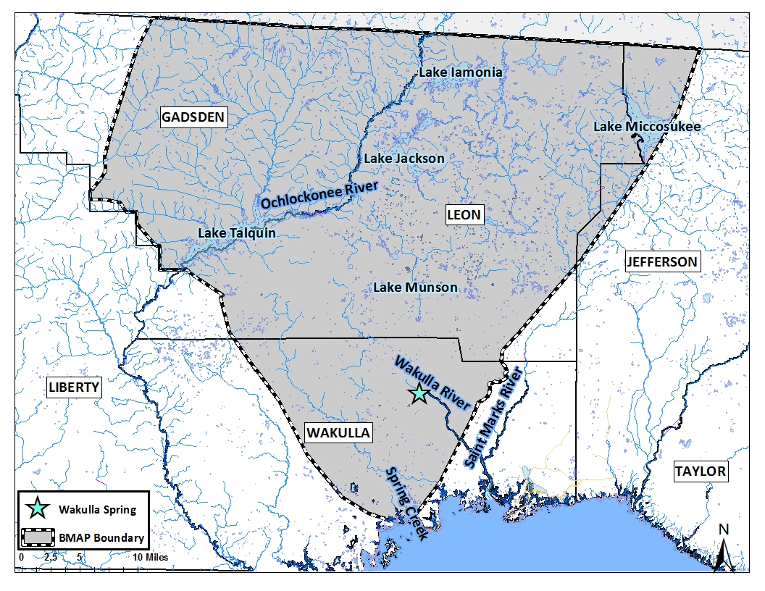
Figure 1: Wakulla Spring and River BMAP area.
The BMAP area generally includes the portion of the ground water contributing area for Wakulla Spring that lies within Florida (Figure 1). This area covers almost 344,000 hectares (ha) (848,000 acres) encompassing parts of four different counties: Leon, Wakulla, Gadsden, and Jefferson. Wakulla Spring is the major source of the Wakulla River, which flows southward and joins the St. Marks River before discharging into Apalachee Bay.

2.1 Climate
The climate in this area is humid subtropical, with a 30-year mean annual temperature of 68 ºF and a 30-year mean annual rainfall of 63.2 inches measured at the National Oceanic and Atmospheric Administration (NOAA) weather station at Tallahassee Regional Airport (Gilbert 2010). The highest monthly rainfall typically occurs during June, July, and August, and the lowest in April, October, and November. The average yearly potential evapotranspiration for the Tallahassee area was estimated to be about 46 inches per year (Davis et al. 2010). Thus, on average approximately 20 inches of precipitation per year infiltrates through the soil.

2.2 Hydrogeologic Setting
The hydrogeologic framework of the area comprises sedimentary rocks of Tertiary through Quaternary age that consist of limestone, dolostone, clay, and sand of varying degrees of lithification (Miller 1986; Davis and Katz 2007). Several previous studies have provided detailed descriptions of the stratigraphic nomenclature and geology of the region encompassing the BMAP area (Hendry and Sproul 1966; Miller 1986; Davis 1996; Chelette et al. 2002; Davis et al. 2010). This report briefly describes several key hydrogeologic factors affecting the movement of infiltrating water and nitrogen from the land surface to the UFA.
The BMAP area lies within the Coastal Plain physiographic province and is characterized by two main geomorphic zones. The Northern Highlands, which occurs north of the Cody Scarp (Figure 2), comprises an extensive upland area where surface drainage is perched above the UFA due to the presence of relatively thick clayey sediments overlying the UFA. The UFA, which is composed of limestones and dolostones of Eocene to Miocene age, is part of the Floridan aquifer system that occurs in Florida and parts of Georgia, South Carolina, and Alabama.
The Woodville Karst Plain (WKP) extends southward from the Cody Scarp in southern Leon County to the Gulf Coast. It is characterized as a flat or gently rolling surface of highly porous quartz sand overlying the limestone units (Suwannee Limestone and St. Marks Formation) of the UFA (Miller 1986; Rupert 1988). Limestone is generally within 25 feet of the surface in most of the karst plain. The top of the limestone rock in both units has undergone extensive dissolution by chemically aggressive waters, resulting in the development of large cavity and conduit systems (Miller 1986). Consequently, the karst plain contains numerous wet and dry sinkholes, natural bridges, and disappearing streams (Rupert and Spencer 1988).
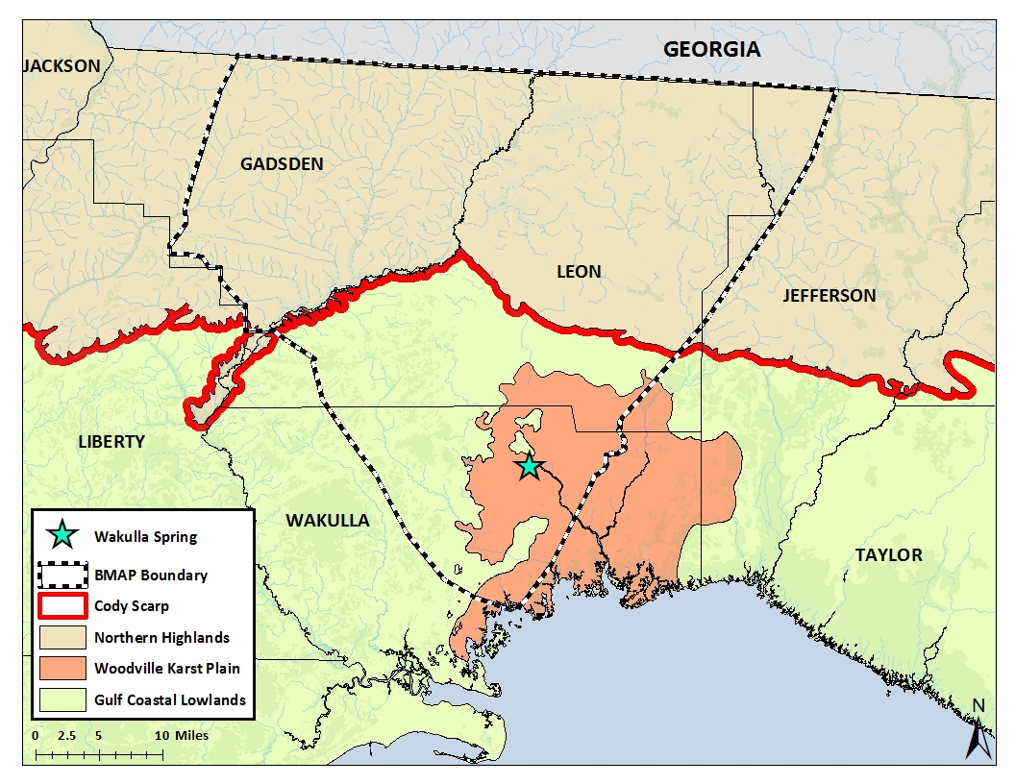
Figure 2: Physiographic regions in and around the Wakulla Spring and River BMAP area.

The degree of confinement of the UFA in the BMAP area (Figure 3) is characterized on the thickness of overlying sediments as described by Miller (1986) and is broken into three categories: unconfined, semi-confined, and confined. The UFA is unconfined where the aquifer crops out near the surface or where overlying sediments are sandy, thin, or absent. Where confining units are less than 100 feet thick and breached by sinkholes, the UFA is referred to as semi-confined. Where these units are greater than 100 feet thick, the UFA is considered to be confined.
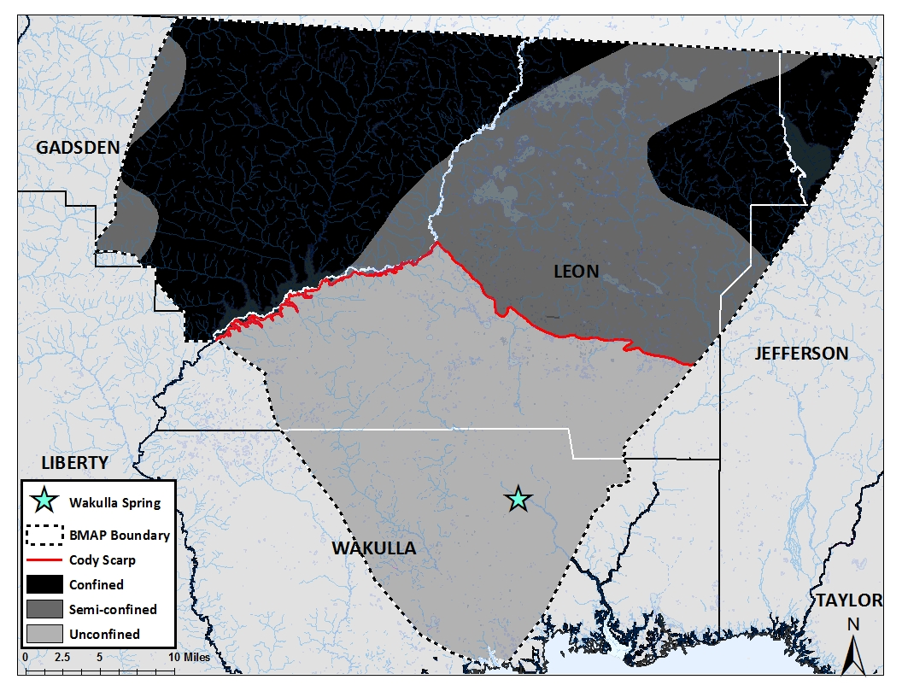
The composition of the material overlying the UFA varies in the amounts of sand, marl, limestone, clay, and dolomite present. The sand layers readily transport infiltrating water and in some areas of the BMAP area serve as a surficial aquifer system when there is a confining unit beneath them. This confining unit, consisting of mostly clay and lower-permeability dolomite beds, can significantly retard infiltrating water and comprise the intermediate aquifer system or the intermediate confining unit. The lithology, thickness, and integrity of this material have a controlling effect on the development of permeability and local ground water flow (Bush and Johnston 1988). The UFA is most vulnerable to contamination from the land surface in areas where it is unconfined. Detailed maps showing vulnerability assessments for the UFA have been prepared for Leon County (Advanced Geospatial Inc. 2007) and Wakulla County (Advanced Geospatial Inc. 2009).
Figure 3: Recharge areas within the Wakulla Spring BMAP boundary. Recharge in the confined areas ranges from 0-2 inches, 3-8 inches in the semi-confined and 9-20 inches in the unconfined.

Ground water in the UFA of the BMAP area generally flows from the northeast to the southwest or from north to south based on potentiometric surface maps for the UFA (Davis 1996; Davis et al. 2010). Extremely high transmissivities in the UFA (greater than 1,000 square feet per day [ft²/d]) (Davis 1996) are associated with conduit systems for Wakulla Spring and account for a flattening of the potentiometric surface about 3 to 4 miles south of the Cody Scarp. Wakulla Spring is a major discharge point for water from the UFA in the karst plain. Flows from Wakulla Spring fluctuate greatly depending on rainfall conditions (Davis and Katz 2007; Davis et al. 2010).
The major source of recharge to the UFA is rainfall. The rate of recharge is largely governed by the permeability of the geologic material through which the infiltrating water migrates. Recharge to the UFA ranges from approximately 1 to more than 20 inches per year in the northern and southern parts of the BMAP area, respectively. The lowest rates of recharge to the UFA occur in the confined area (approximately 0-2 inches per year) and the highest rates occur in the unconfined area (approximately 9-20 per year). Intermediate rates of recharge of 3-8 inches per year occur where the UFA is semi-confined. In addition, several disappearing streams, such as Munson Slough, Lost Creek, and Fisher Creek, recharge the UFA through sinkholes. Fisher and Lost Creeks originate in the coastal lowlands and in the Apalachicola National Forest, respectively.

2.3 Land Use and Population
Land use in the Wakulla BMAP area in 2009 was predominantly upland forests (50%). Other land use types, in order of decreasing percentages of the total, were water and wetland (24%), urban and built-up (14%), agriculture (6%), rangeland (3%), and transportation (2%). The land use data were based on the 2009/2010 Florida Ortho Quarterly Quad Aerial Imagery True color photography. The flight dates for each county varied: Leon County in January 2009, Jefferson County in January 2010, Gadsden County in February 2010, and Wakulla County in February to March 2010. Photo interpretation and ground-truthing were performed by the Florida Department of Environmental Protection’s Water Resource Monitoring staff. Land use categories that are of particular interest to this evaluation as significant sources of nitrogen are within the agricultural and urban subcategories.
The estimated populations of the four counties in the BMAP area, based on the 2010 U.S. Census, are as follows: Leon (275,487), Gadsden (46,389), Jefferson (14,761), and Wakulla (30,776). Most of the population in Wakulla County is concentrated in the WKP, since most of the western half of Wakulla County and southwestern Leon County lies in the Apalachicola National Forest and is closed to development. The populations of Leon and Wakulla Counties are projected to increase by approximately 7.5% and 15.7%, respectively, from 2010 to 2020 (http://www.edr.state.fl.us). Also expected to increase along with population is the discharge of domestic wastewater, the number of new homes with septic tanks, and the use of fertilizer which will all result in increased source impacts to ground water and surface waters.

3. Estimating Nitrogen Inputs
Estimated inputs of nitrogen include the amounts (in kilograms per year [kg/yr]) of nitrogen that are discharged or applied to the land from the major source categories: atmospheric deposition, wastewater facilities, septic tanks, fertilizer, and sinking streams.

3.1 Atmospheric Deposition

3.1.1 Wet Deposition
In the 1970s, atmospheric deposition was recognized as a significant nitrogen source, as acid rain and the other effects of air pollution were beginning to be understood. As a result, the National Atmospheric Deposition Program (NADP) was created in 1978 and now has over 250 stations throughout the United States. Samples are collected weekly at each station and analyzed for many different chemicals, including ammonia (NH₄) and nitrate (NO₃). There are two stations of interest for the BMAP area: FL14 in Quincy, FL, and FL23 in Sumatra, FL (Figure 4). Nitrogen deposition data from both sites were analyzed because of their close proximity to the BMAP area and because of the additional monitoring capacity at the Sumatra location for dry deposition. This is discussed in more detail later in this report.
The data for these stations, as well as others, are available to the public and can be obtained at the NADP website (http://nadp.sws.uiuc.edu). Monthly data from 2002 to 2012 for both stations (FL14 and FL23) were downloaded and used in the nitrogen input calculations. Annual data were also available for download, but these were found to have errors related to periods with missing data. Missing data can be caused by issues with quality control or equipment maintenance. As a result, the monthly data were found to be more reliable overall. For years with complete monthly data, the annual data available through NADP are also reliable.
Nitrogen inputs are expressed as kilograms of nitrogen per year (kg-N/yr). The retrieved NADP data are in mg/L for both NO₃ and NH₄ and can be converted using Equations 1 and 2. Appendix A (Table A-1) contains the conversion factors that convert the NADP data in milligrams of nitrogen per liter (mg-N/L) to kilograms of nitrogen per hectare (kg-N/ha).
Equation 1 $\frac{mg-{NO}_{3}}{L}×2.260e^{-4}×Rainfall \left(\frac{L}{ha}\right)× 0.001= \frac{kg-N}{ha} {NO}_{3}$

Equation 2 $\frac{mg-{NH}_{4}}{L} ×7.765e^{-4}×Rainfall \left(\frac{L}{ha}\right)C× {0.001}^{D}= \frac{kg-N}{ha} {NH}_{4}$

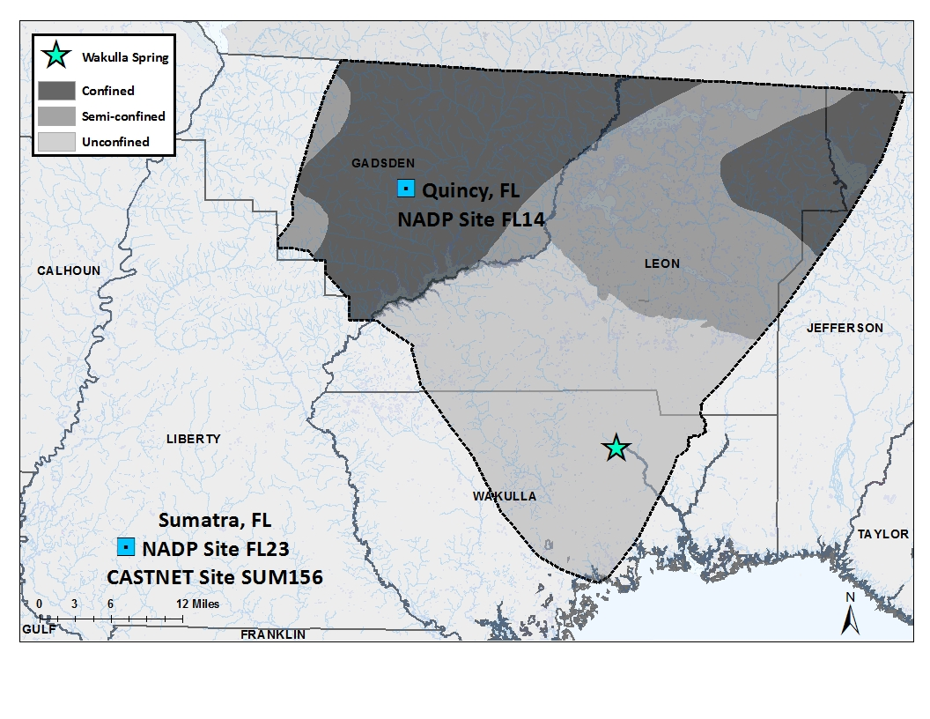
To determine the total yearly deposition, the monthly data were summed for each individual year. These annual totals were then averaged to determine the average annual wet deposition over the most recent 10-year period (2002–12). November and December data were not yet available for 2012, and so the concentrations for these months were projected based on the available 2012 data. The average concentration of NH₄ and NO₃ for January-October 2012 was calculated and used as the deposition for November and December.

Figure 4: Atmospheric deposition monitoring stations for the NADP and Clean Air Status and Trends Network (CASTNET) programs.

Data from the two NADP monitoring stations were analyzed to evaluate the consistency and comparability between data measured at each station. At Station FL14, the annual NH₄ data ranged from 0.83 to 1.74 kg-N/ha/yr, with average and median values of 1.14±0.27 and 1.20 kg-N/ha/yr, respectively. At Station FL23, the same data had an average value of 1.11±0.34 kg-N/ha/yr, a median of 1.07 kg-N/ha/yr, and a range of 0.59 to 1.68 kg-N/ha/yr. The differences between these data are minor, a conclusion that is supported by the overlapping errors associated with the averages.
The NO₃ data also showed a similar relation between the two monitoring stations. At FL14, the annual NO₃ data were measured between 1.23 and 1.93 kg-N/ha/yr. The average result was 1.59±0.26 kg-N/ha/yr, and the median was 1.67 kg-N/ha/yr. For FL23, the data ranged from 1.17 to 2.32 kg-N/ha/yr, with an average of 1.74±0.35 kg-N/ha/yr and a median of 1.70 kg-N/ha/yr.
After it was verified that the data from the individual stations were comparable, the calculated total nitrogen (TN) values for each station were averaged; these data are listed in Table 1. Given the close proximity of the stations and the consistency between their data, the average concentrations were used in determining the average annual yield of TN from atmospheric deposition. Appendix A (Table A-2) contains a complete listing of the wet deposition data for 2002 to 2012.
Table 1: Average annual TN concentrations (kg-N/ha) measured in wet atmospheric deposition from NADP monitoring stations in northwest Florida.
Year | FL14  (Quincy) | FL23  (Sumatra) | Average
2002 | 2.59 | 3.07 | 2.83
2003 | 3.15 | 3.67 | 3.41
2004 | 2.76 | 2.79 | 2.78
2005 | 3.20 | 4.00 | 3.60
2006 | 2.93 | 3.15 | 3.04
2007 | 2.06 | 2.05 | 2.05
2008 | 2.51 | 2.32 | 2.42
2009 | 3.46 | 3.61 | 3.54
2010 | 2.50 | 2.67 | 2.58
2011 | 2.59 | 2.29 | 2.44
2012 | 2.36 | 1.76 | 2.06
Average ± std. dev | 2.74±0.41 | 2.85±0.72 | 2.80±0.55

3.1.2 Dry Deposition
Dry deposition is monitored through CASTNET, which was established after the passage of the federal Clean Air Act Amendments in 1991. This program monitors ambient air chemistry, including rural ozone, and is the only nationwide program collecting reliable long-term data for acidic dry deposition (U.S. Environmental Protection Agency [EPA] 2013). NADP Station FL23 at Sumatra, FL, is also the location of CASTNET Site SUM156. The dry deposition data from this site are useful for estimating total atmospheric deposition of nitrogen in this analysis because it is the closest sampling site to the BMAP though it is located outside of the study area. Since the wet deposition from this station was comparable with that of the Quincy station located within the BMAP boundary, it was assumed that the dry deposition would be representative of deposition conditions throughout the BMAP area. Therefore, CASTNET Site SUM156 was used to estimate the dry deposition for the BMAP area.
The data for this site can be found on the CASTNET website (http://www.epa.gov/castnet). Total dry deposition and weekly data are available at this site. The total dry deposition data were only available through 2010 when calculations were made, but weekly data were available through May 2012. To include more data and remain consistent in calculating atmospheric deposition for the entire period, this analysis used the weekly data. Since the 2012 data only were available through May 2012, deposition was estimated for June to December 2012 by using the average value measured from January to May 2012. As was the case with wet deposition, the total yearly dry deposition was calculated and averaged to determine the annual average dry deposition.
Data from CASTNET Site SUM156 were calculated to estimate the average annual dry deposition influencing the BMAP area. Appendix A (Table A-3) contains a full listing of these data. NO₃ values ranged between 0.023 and 0.041 kg-N/ha/yr, with an average and median of 0.029 kg-N/ha/yr and a standard deviation of 0.01. NH₄ averaged 0.15±0.04 kg-N/ha/yr, with a median of 0.153 kg-N/ha/yr and a range of values from 0.099 to 0.205 kg-N/ha/yr.

3.1.3 Total Atmospheric Deposition of Nitrogen
After calculating the NO₃-N and NH₄-N (kg-N/ha/yr) for both wet and dry deposition, these two quantities were added together to estimate the annual TN attributed to atmospheric deposition (in kg-N/ha). The TN deposition rate (kg-N/ha/yr) was multiplied by the BMAP area to calculate an estimate of the N input from atmospheric deposition (in kg-N/yr). The result was the estimated annual average atmospheric deposition applied to the land surface of the Wakulla Spring BMAP area. Table 2 lists the combined wet and dry deposition data. The fact that wet deposition nitrogen comprises 93% of the totals may be a result of greater accuracy in collecting information on wet deposition compared with dry deposition.
Table 2: Annual total atmospheric deposition data in kg-N/ha. For both wet and dry deposition, projected values are included for 2012 due to incomplete data.
Year | NO₃ | NH₄ | Total N
2002 | 1.87 | 1.17 | 3.05
2003 | 2.09 | 1.51 | 3.60
2004 | 1.80 | 1.19 | 2.99
2005 | 2.14 | 1.69 | 3.83
2006 | 1.82 | 1.43 | 3.25
2007 | 1.32 | 0.92 | 2.24
2008 | 1.63 | 0.94 | 2.57
2009 | 1.88 | 1.78 | 3.66
2010 | 1.47 | 1.24 | 2.71
2011 | 1.33 | 1.28 | 2.61
2012 | 1.32 | 0.90 | 2.22
Average ± std. dev. | 1.70±0.30 | 1.28±0.30 | 2.97±0.56

Based on this dataset, an estimated total of 2.97±0.56 kg-N/ha/yr was applied to the land surface within the Wakulla Spring BMAP boundary. As already established, varying degrees of recharge exist within the Wakulla BMAP area. Table 3 lists the total input of atmospheric nitrogen per year.
Table 3: Nitrogen input from atmospheric deposition in the Wakulla Spring and River BMAP area divided by recharge area.
Recharge Area | Land Area  (ha) | Atmospheric Deposition  (kg-N/yr)
Unconfined | 121,214 | 360,560
Semi-confined | 93,971 | 279,523
Confined | 127,960 | 380,625
Total BMAP area | 343,146 | 1,020,708

3.2 Wastewater Treatment Facilities
Wastewater treatment facilities (WWTFs) throughout the nation generate large quantities of nitrogen in their effluent, which is discharged to surface waterbodies, applied to the land surface, or injected into deep zones of saline aquifers. Discharges from 20 domestic WWTF and 1 industrial facility contribute nitrogen to the Wakulla BMAP Area (Figure 5). The Wastewater Facility Regulation (WAFR) database is maintained by the Department’s Water Resource Management staff as part of the Water Compliance Assurance Program and was the primary source for these data.
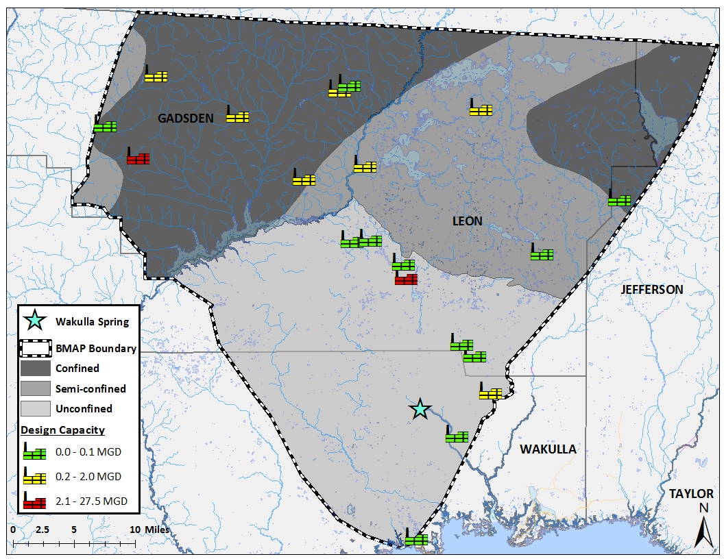
Figure 5: Map of the WWTFs included in the nitrogen loading evaluation.
Most of the permitted WWTFs in the area are small, and their discharges are insignificant when compared to those of larger, municipal facilities. The City of Tallahassee (COT) has the largest facilities in the BMAP area but one of them, the T. P. Smith Water Reclamation Facility, is the main facility. It receives partially treated effluent from the nearby Lake Bradford treatment plant and now provides advanced nitrogen treatment to the entire waste stream for city customers before the effluent is pumped to the COT Southeast Farm sprayfield, located in southern Leon County where the UFA is unconfined.
Effluent and well data were obtained through the Department’s WAFR Discharge Monitoring Reports (DMRs). Smaller WWTF (by volume) are not required to report effluent concentrations and therefore did not have any DMR data. These are largely the facilities with discharges less than 0.01 MGD. For the WWTFs with available DMR data, the TN concentrations reported by the facilities were averaged to determine the annual average concentrations. Depending on the available data, annual average concentrations were calculated from 2002 through 2012 for all but the two COT facilities.
Table 4: Summary data for WWTFs in the Wakulla Spring and River BMAP area.
WWTF Name |  | Facility ID | Years of Available Data | Recharge Area | Annual  Average TN  (mg-N/L) |  | Design Capacity  (MGD) | Nitrogen Input  (kg-N/yr)
COT T.P. Smith Water  Reclamation Facility |  | FLA010139 | 2011-2012 | Unconfined | 2.17 |  | 27.5 | 41,226
Woodville Elementary School |  | FLA010136 | 2002-2007 | Unconfined | 2.502 |  | 0.01 | 17
Disc Village |  | FLA010137 | 2008-2012 | Unconfined | 5.456 |  | 0.02 | 75
Western Estates |  | FLA010152 | 2009-2011 | Unconfined | 3.302 |  | 0.02 | 46
Lake Bradford Estates |  | FLA010148 | 2006-2009 | Unconfined | 0.281 |  | 0.043 | 8
Sandstone Ranch WWTF |  | FLA010167 | 2002 | Unconfined | 2.509 |  | 0.0707 | 122
Oyster Bay Estates |  | FLA010237 | 2002-2004 | Unconfined | 0.681 |  | 0.06 | 28
River Plantation Estates |  | FLA010241 | 2002-2010 | Unconfined | 2.349 |  | 0.025 | 41
Winco Utilities, Inc. |  | FLA016544 | 2002-2006 | Unconfined | 0.242 |  | 0.495 | 83
TOTAL UNCONFINED |  |  |  |  |  |  |  | 41,646
Killearn Lakes | FLA010173 |  | 2002-2011 | Semi-confined | 9.175 | 0.7 |  | 4,437
Lake Jackson | FLA010171 |  | 2002-2005 | Semi-confined | 2.714 | 0.75 |  | 1,406
Meadows-at-Woodrun | FLA010159 |  | 2002-2012 | Semi-confined | 2.000 | 0.07 |  | 97
TOTAL SEMI-CONFINED |  |  |  |  |  |  |  | 5,940
Gadsden East WWTF | FLA187941 |  | 2002-2011 | Confined | 0.163 | 0.25 |  | 28
City Of Gretna | FLA100781 |  | 2002 | Confined | 1.422 | 0.35 |  | 344
Havana | FLA100765 |  | 2002-2012 | Confined | 1.056 | 0.4 |  | 292
Quincy | FL0029033 |  | 2008-2012 | Confined | 3.290 | 1.5 |  | 3709
Gamboa Brothers, Inc. | FLA010088 |  | 2002-2012 | Confined | 11.980 | 20 |  | 165,529
Havana Middle School | FLA010085 |  | 2002-2003 | Confined | 0.473 | 0.015 |  | 5
Greensboro High School | FLA010074 |  | 2002-2009 | Confined | 2.605 | 0.012 |  | 21
Capital City Plaza | FLA010134 |  | 2002-2003 | Confined | 2.723 | 0.03 |  | 56
TOTAL CONFINED |  |  |  |  |  |  |  | 169,684
TOTAL BMAP AREA |  |  |  |  |  |  |  | 217,271

The COT has upgraded the T.P. Smith WWTF to advanced wastewater treatment to achieve a total nitrogen concentration of 3 milligrams per liter or lower. As a result of this project, the COT effluent nitrogen loads in 2012 were substantially lower than in previous years and the average TN load used for this analysis was calculated from data measured between November 2011 and November 2012.
The design capacity of each treatment facility describes the amount of water it is permitted to discharge. Rarely will these facilities meet their design capacity, and actual discharges are generally about 50% of this capacity. Therefore, the loading for all WWTFs was calculated using the average annual TN concentration and assuming 50% of the yearly design capacity volume. The average annual inputs of nitrogen from wastewater discharges were then estimated for the various recharge areas based on the locations of the wastewater application sites for the facilities. Table 4 contains the summary information as well as the design capacity for each facility. Based on the data available between 2002 and 2012, the estimated total input of nitrogen from wastewater facilities to the BMAP area is 217,271 kg-N/yr.

3.3 Septic Tanks
Approximately a third of Florida’s population utilizes onsite sewage treatment and disposal systems (OSTDS), also referred to as septic tanks. These systems can contribute to elevated nitrogen levels in ground water (Chang et al. 2010). In 2009, a contractor for the Florida Department of Health (FDOH) developed a model for estimating the number of septic tanks based on tax parcel data and known sewer service areas (Hall and Clancy 2009). The output of this model was provided in a Geographic Information System (GIS) geodatabase from which the locations of both the known and the estimated septic tanks can be mapped. This file was used to estimate the number of septic tanks in each of the three recharge areas in the Wakulla BMAP area.
The septic tank geodatabase has two different categories of septic tanks: known (based on permit records) and estimated. The estimated tanks were associated with land parcels located in areas where it was assumed that no sewer service existed. The sum of known and estimated septic tanks was used for these calculations and GIS mapping.. Figure 6 shows the distribution of septic tanks throughout the Wakulla BMAP area.
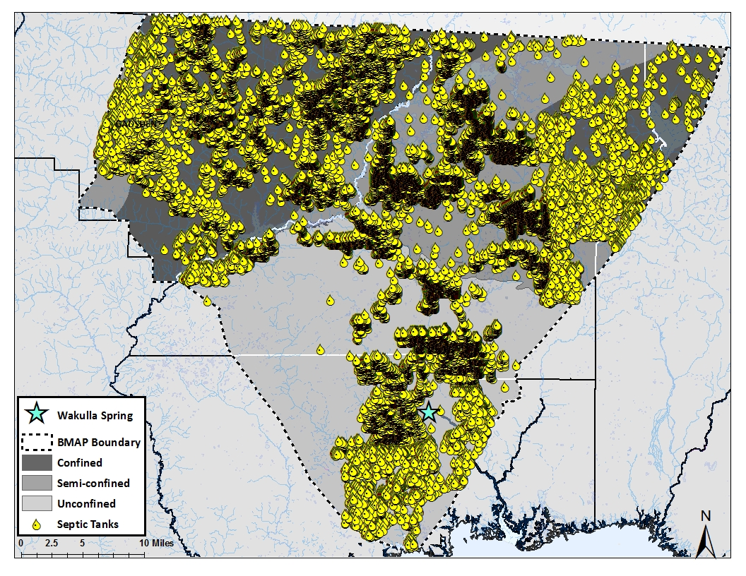
After establishing the number of septic tanks in the BMAP area, the number of people utilizing the septic tanks was estimated. The U.S. Census Bureau collects information on population and household occupancy in each county. This analysis used the 2010 Census data (http://www.census.gov). The Census makes a distinction between occupied and non-occupied households. The populations of Leon, Gadsden, Jefferson, and Wakulla Counties were divided by the number of occupied households in each county, resulting in the average number of people per household. In Leon County, 275,487 people occupied 110,945 households, resulting in an average of 2.48 people per household. In Wakulla County, the population was 30,776 people residing in 10,490 households, giving an average of 2.93 people per household. Gadsden County had 46,389 people in 16,952 houses, with an average of 2.74 people per household. In Jefferson County, there were 5,646 occupied households for 14,761 people, or 2.61 people per household.
Figure 6: Distribution of septic tanks throughout the Wakulla BMAP area.
The number of people served by septic tanks within the BMAP area was estimated by multiplying the average number of people in each household (based on county) by the number of septic tanks in a given area. Toor et al 2001 and EPA 2002 estimated the average person will contribute 4.1 kg-N/yr to a septic tank. This loading factor was applied to the number of people utilizing septic tanks within the different subdivisions of the BMAP area. A summary of this information including the septic tank nitrogen input to the land surface is in Table 5.
Table 5: Estimated number of septic tanks in the Wakulla Spring and River BMAP area, by county and degree of UFA confinement (Hall and Clancy 2009).
Recharge Area | County | Number of  Septic Tanks | Nitrogen Input  (kg-N/yr)
Unconfined | Leon | 8,578 | 87,221
Unconfined | Wakulla | 7,595 | 91,239
Unconfined | Total | 16,173 | 178,460
Semi-confined | Leon | 21,259 | 216,162
Semi-confined | Gadsden | 654 | 7,347
Semi-confined | Jefferson | 92 | 984
Semi-confined | Total | 22,005 | 224,493
Confined | Leon | 2,112 | 21,475
Confined | Gadsden | 11,719 | 131,651
Confined | Jefferson | 437 | 4,676
Confined | Total | 14,268 | 157,802
BMAP Area | Total | 52,446 | 560,755

3.4 Fertilizer
Applying fertilizers is a common practice throughout the nation on a variety of land uses, such as agriculture, residential, golf courses, and silviculture. Some of the nitrogen fertilizer not utilized by plants can leach through the soil zone to ground water, resulting in elevated nutrient concentrations (Bohlke 2002; Hochmuth et al. 2011). The most widely used approach to estimate nitrogen inputs to an area from fertilizer usage is to rely on county fertilizer sales data compiled by the Florida Department of Agriculture and Consumer Services (FDACS) (Chelette et al. 2002; Gronberg and Spahr 2012). This method has some limitations because fertilizer sold in one county may be transported to another county to be applied. Thus the calculations for the county in which the fertilizer is sold could be higher than what is actually applied. Since this information is not tracked, it is not known how much county-to-county transfer of fertilizer occurs, or if the volume of fertilizer transferred between counties is significant. However, in the absence of more detailed information regarding the actual usage of both residential and farm fertilizer, county fertilizer sales data are used to estimate nitrogen inputs to the Wakulla Springs and River BMAP area.
Fertilizer volumes sold by county are available from the Florida Department of Agriculture and Consumer Services (FDACS) Bureau of Compliance Monitoring Fertilizer Section (http://www.freshfromflorida.com/Divisions-Offices/Agricultural-Environmental-Services/Agriculture-Industry/Fertilizer-Distributors). For this analysis, the data from two different reports were used: Summary by County and Nutrients by County. These are .pdf documents that contain historical annual sales records by county, based on the state fiscal year, (July 1 of one year to June 30 of the following year). The annual average fertilizer inputs reported in Table 6 were calculated using the data for the state fiscal year. For example, the FDACS report from July 2011 to June 2012 was used to calculate the loadings for 2012.
The total volume of fertilizer sold can be found in two FDACS reports. The total fertilizer sold for farm and nonfarm practices is in the Summary by County report, and the total nitrogen in the fertilizer sold is available in the Nutrients by County report. All FDACS fertilizer sales quantities are reported in tons. The total input to the land surface for farm fertilizer sold in each county (in kilograms per year) was calculated using to Equation 3. The amount of nitrogen sold as nonfarm or residential fertilizer was also calculated using the same approach.
Equation 3 $\left({fertilizer N \% }_{County}×{ farm fertilizer }_{County}\right)×907.1847={total N in farm fertilizer}_{County}$

The fertilizer percent nitrogen was calculated for each county by taking the N in the fertilizer sold and dividing it by the total fertilizer sold. This percentage varied both by year and among the four counties in the BMAP area. Overall, 10% of the total weight of fertilizer sold was nitrogen. In Leon County, the nitrogen content ranged between 5% and 13% with an average of 9% and a median value of 10%. In Wakulla County, the average nitrogen content was 6%, with a median of 8% and a range of less than 1% to 12%. In Gadsden County, the nitrogen content ranged between 6% and 10%, with a median and average of 7%. In Jefferson County, the percentage of nitrogen in the fertilizers sold was higher than in the other counties, with an average and median of 17% and a range of 11% to 20%. A detailed listing of data used in calculating these percentages can be found in Appendix A (Table A-4 through Table A-7).
The final results of these calculations provide the total nitrogen inputs (kg-N/yr) from farm and nonfarm fertilizer for the entire county while only portions of each county are included in the BMAP area. To estimate the amount of nitrogen in fertilizer applied, the 2009-2010 land use coverage was used to provide a breakdown of land uses that were likely to include fertilizer use in the BMAP area and its subdivisions. The land use/land coverage was created from the NWFWMD aerial photography.
Farm and urban land use areas that were likely to use fertilizer were calculated using relevant land use categories including row crops, field crops, hayfields, groves, nurseries and vineyards, tree nurseries, sod farms, and ornamentals for farmlands. The residential categories of interest were low-, medium- and high-density residential areas as well as golf courses. The land areas were calculated for the entire counties as well as the three categories of recharge within the portions of the counties in the BMAP area. These land areas were used to calculate a land use percentage relative to the whole county for both farm and residential lands in the different recharge areas. These percentages were applied to the calculated farm and nonfarm fertilizer usage for each county. For example, if 100,000 kg-N of fertilizer were sold for farm use in a particular county each year, but only 10% of the county farmlands were inside the BMAP area, it was assumed that an input of only 10,000 kg-N was contributed to the BMAP area. Appendix A contains detailed information on the land use percentages calculated for both the farm (Table A-8) and residential (Table A-9) fertilizers.

4.4.1 Farm Fertilizer
Farm fertilizer sales records show decreases in sales between 2002 and 2012 for all 4 counties. Of these four counties, Jefferson County reported the most fertilizer sold, with an average of 1,359,282 kg-N/yr and a range between 1,053,366 kg-N sold in 2011 and 1,868,995 kg-N sold in 2003. Gadsden County has the most agricultural land and had the second most nitrogen fertilizer sold (707,221 kg-N/yr average, with a range between 358,865 kg-N in 2012 and 1,081,968 in 2007). Amounts of fertilizer sold in Leon County ranged from 91,512 kg-N sold in 2002 to 15,590 kg-N in 2012, with an average sales of 55,369 kg-N/yr for the 10-year period. The sales in Wakulla County were the lowest, with an average of 7,627 kg-N/yr, ranging from 17,451 kg N in 2003 to 877 kg-N in 2012. In general, over the time period evaluated farm fertilizer sales records show decreases in sales between 2002 and 2012 for all 4 counties. This decrease in fertilizer used could be attributed to lower rates of fertilizer use on fields due to fertilizer prices, transition to land uses on agricultural lands that use less fertilizer or more fertilizer purchased out of county.
These sales data were used to approximate the fertilizer nitrogen inputs throughout the Wakulla BMAP area. The land use percentages for each recharge area in the four counties were multiplied by the total N sold in each county resulting in an estimation of the potential nitrogen input from farm practices. These data estimated are summarized in Table 6

Table 6: Potential input of nitrogen as agricultural fertilizer in BMAP area.

County | BMAP Recharge Area | Farm Fertilizer  Land Area  (ha) | Farm Fertilizer  Land  % | Farm Fertilizer  Nitrogen Input  (kg-N/yr)
Leon¹ | Unconfined | 80 | 2.3 | 1,282
Leon¹ | Semi-confined | 1,920 | 55.3 | 30,640
Leon¹ | Confined | 1,435 | 41.4 | 22,895
Wakulla² | Unconfined | 725 | 88.9 | 6,778
Wakulla² | Semi-confined | 0 | N/A | N/A
Wakulla² | Confined | 0 | N/A | N/A
Gadsden³ | Unconfined | 0 | N/A | N/A
Gadsden³ | Semi-confined | 1,077 | 12.7 | 89,643
Gadsden³ | Confined | 6,028 | 71 | 501,906
Jefferson⁴ | Unconfined | 0 | N/A | N/A
Jefferson⁴ | Semi-confined | 204 | 2.1 | 28,993
Jefferson⁴ | Confined | 973 | 10.2 | 138,034
BMAP AREA TOTALS | Unconfined | 805 |  | 8,060
BMAP AREA TOTALS | Semi-confined | 3,201 |  | 149,217
BMAP AREA TOTALS | Confined | 8,436 |  | 662,835
BMAP AREA TOTALS | Total | 12,442 |  | 820,113
Notes:
1-Leon County information: 3,470 ha in agricultural land uses, 55,369 kgN/yr sold.
2-Wakulla County information: 815 ha in agricultural land uses; 7,627 kgN/yr sold.
3-Gadsend County information: 8,494 ha in agricultural land uses, 707,221 kgN/yr sold.
4-Jefferson County information: 9,580 ha in agricultural land uses, 1,359,282 kgN/yr sold.
N/A-not applicable, recharge area not present in applicable region of the county.

4.4.2 Residential Fertilizer
Of the counties evaluated, Leon County had the largest amount of fertilizer sold for nonfarm or residential applications. An average of 200,849 kg-N/yr was sold in Leon County, with a range between 118,179 and 429,529 kg-N. Residential fertilizer sold in Gadsden County ranged from 20,551 to 106,689 kg-N, with an average of 56,391 kg-N/yr and nonfarm fertilizer sold in Jefferson County averaged 66,040 kg-N/yr (with a range of 32,978 to 147,624 kg-N). In Wakulla County, residential fertilizer sales were lower than in the other three counties. The average was 6,776 kg-N/yr, with a range between 301 and 15,736 kg-N. It is assumed that some of the fertilizer purchased for residential use in Wakulla County was purchased in Leon County, but out-of-county purchases cannot be quantified. The residential land use areas were multiplied by the total residential fertilizer nitrogen sold in each county to generally estimate the potential nitrogen input from residential applications (Table 7).
Table 7: Land use areas derived nitrogen input for residential lands in the BMAP area.
County | BMAP Recharge Area | Nonfarm Fertilizer  Land Area  (ha) | Nonfarm Fertilizer  Land  % | Nonfarm Fertilizer  Nitrogen Input  (kg-N/yr)
Leon¹ | Unconfined | 4,748 | 18.1% | 36,337
Leon¹ | Semi-confined | 19,261 | 73.4% | 147,409
Leon¹ | Confined | 1,961 | 7.5% | 15,010
Wakulla² | Unconfined | 6,517 | 80.2% | 5,433
Wakulla² | Semi-confined | 0 | N/A | N/A
Wakulla² | Confined | 0 | N/A | N/A
Gadsden³ | Unconfined | 0 | N/A | N/A
Gadsden³ | Semi-confined | 413 | 4.9% | 2,788
Gadsden³ | Confined | 6,623 | 79.3% | 44,699
Jefferson⁴ | Unconfined | 0 | N/A | N/A
Jefferson⁴ | Semi-confined | 92 | 2.0% | 1,309
Jefferson⁴ | Confined | 341 | 7.3% | 4,853
BMAP AREA TOTALS | Unconfined | 11,265 |  | 41,770
BMAP AREA TOTALS | Semi-confined | 19,766 |  | 151,506
BMAP AREA TOTALS | Confined | 8,925 |  | 64,561
BMAP AREA TOTALS | Total | 39,956 |  | 257,837
Notes:
1-Leon County information: Nonfarm land use fertilizer application area: 26,244 ha; 200, 849 kgN/yr sold.
2-Wakulla County information: Nonfarm land use fertilizer application area: 8,128 ha; 6,776 kgN/yr sold.
3-Gadsden County information: Nonfarm land use fertilizer application area: 8,356 ha; 56,391 kgN/yr sold.
4-Jefferson County information: Nonfarm land use fertilizer application area: 4,656 ha; 66,040 kgN/yr sold.
N/A-not applicable, recharge area not present in applicable region of the county.

3.5 Livestock Waste
Every five years the U.S. Department of Agriculture releases a Census of Agriculture (CoA). This comprehensive report summarizes the agricultural practices and livestock populations for each state and county in the United States. These data are available online (http://www.agcensus.usda.gov) and can be sorted by state and county. Census reports for 2002 and 2007 were used to evaluate livestock populations for this assessment. The 2012 census could not be used because it will not be released until 2014. Alternatively, the National Agricultural Statistics Service (NASS) also estimates the livestock populations on an annual basis. For Florida, these data are available online (http://www.nass.usda.gov/Statistics_by_State) starting in 2007 for cattle only.
Literature-based per-animal inputs of nitrogen were used in this assessment. Table 8 includes the livestock categories evaluated to estimate the nitrogen loading for the BMAP area and their estimated nitrogen loads per animal.
Table 8: Daily loading factors for livestock
Livestock Category | Estimated Per-Animal Input of Nitrogen  (kg-N/day/animal) | References
Cattle, Including Calves | 0.219 | Goolsby et al. 1990; Katz et al. 1999; Chelette et al. 2002;  Ruddy et al. 2006; Katz et al. 2009; Meyer 2012;  Sprague and Gronberg 2013
Chicken, Broilers | 0.072 | Goolsby et al. 1990; Katz et al. 1999; Chelette et al. 2002;  Ruddy et al. 2006; Katz et al. 2009; Meyer 2012;  Sprague and Gronberg 2013
Chicken, Layers | 0.0012 | Goolsby et al. 1990; Katz et al. 1999; Chelette et al. 2002;  Ruddy et al. 2006; Katz et al. 2009; Meyer 2012;  Sprague and Gronberg 2013
Hogs | 0.086 | Goolsby et al. 1990; Katz et al. 1999; Chelette et al. 2002;  Ruddy et al. 2006; Katz et al. 2009; Meyer 2012;  Sprague and Gronberg 2013
Sheep, Including Lambs | 0.09 | Goolsby et al. 1990; Ruddy et al. 2006; Katz et al. 2009
Horses | 0.124 | Goolsby et al. 1990; Ruddy et al. 2006; Katz et al. 2009
Turkeys | 0.0025 | Goolsby et al. 1990; Ruddy et al. 2006; Katz et al. 2009;  Sprague and Gronberg 2013
Goats | 0.016 | Katz et al. 2009

The CoA data are compiled for each county in the state and as was the case with fertilizers, land use percentages were used to determine the loading for the areas of interest within each county. The land in each county was divided using the same method described in Section 3.4 for fertilizers. The following land use categories were used, as appropriate, to apportion the animal populations within counties to the recharge areas within each county: improved pastures, unimproved pastures, woodland pastures, cattle feeding operations, poultry feeding operations, specialty farms, horse farms, dairies and aquaculture. These are not the only possible lands on which livestock populations occur, but they are the most likely ones present in one or more of the counties of interest. A summary of these percentages is in Table 9 with more detailed information in Appendix A (Table A-15).

Table 9: Livestock population estimates for Leon, Wakulla, Gadsden, and Jefferson Counties. Note that the aerial imagery analysis values are actual counts observed in each area and are not calculated using the land use percentages.
County | Recharge Area | Land Area (ha) | Land % | Cattle |  |  | Horses
 |  |  |  | CoA | NASS | Aerial Imagery | CoA | Aerial Imagery
Leon | Full County | 2,904 | 100% | 2,644 | 3,183 | 700 | 1,157 | --
Leon | Unconfined | 181 | 6.2% | 164 | 199 | 76 | 72 | 27
Leon | Semi-confined | 1,815 | 62.5% | 1,653 | 1,989 | 534 | 723 | 193
Leon | Confined | 877 | 30.2% | 798 | 961 | 90 | 349 | 129
Wakulla | Full County | 824 | 100% | 1,080 | 1,000 | 562 | 261 | --
Wakulla | Unconfined | 712 | 86% | 929 | 864 | 562 | 225 | 47
Wakulla | Semi-confined | 0 | N/A | N/A | N/A | N/A | N/A | N/A
Wakulla | Confined | 0 | N/A | N/A | N/A | N/A | N/A | N/A
Gadsden | Full County | 6,354 | 100% | 4,782 | 5,600 | 2,519 | 406 | --
Gadsden | Unconfined | 0 | N/A | N/A | N/A | N/A | N/A | N/A
Gadsden | Semi-confined | 462 | 7.3% | 349 | 407 | 220 | 30 | 8
Gadsden | Confined | 4,833 | 76% | 3,634 | 4,260 | 2,299 | 309 | 288
Jefferson | Full County | 6,291 | 100% | 10,500 | 11,550 | 55 | 904 | --
Jefferson | Unconfined | 0 | N/A | N/A | N/A | N/A | N/A | N/A
Jefferson | Semi-confined | 117 | 1.9% | 200 | 214 | 0 | 17 | 0
Jefferson | Confined | 269 | 4.3% | 452 | 494 | 55 | 39 | 22
N/A-not applicable, recharge area not present in applicable region of the county.

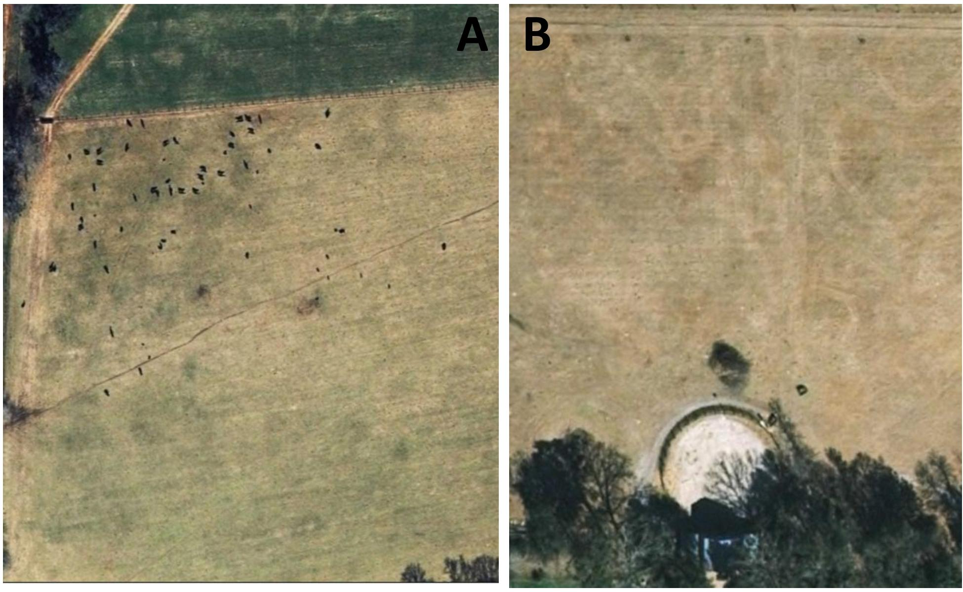
Spot checking of animal populations in representative areas of the BMAP area indicated that the CoA animal census data were not entirely representative of the actual livestock populations in the Wakulla BMAP area. As a cross-check on the CoA data, an aerial imagery analysis was completed to evaluate livestock populations. A grid was overlaid on the NWFWMD 2009 aerial imagery, with each cell covering 900 square miles (30 miles by 30 miles). Using a scale of 1:4,900, pasturelands containing livestock animals are visible. The numbers of cows and/or horses present in a field were counted as the aerial photo was further enlarged. The aerial photographs shown in Figure 7 provide examples of cows and horses in pastures counted using this method. Other livestock animals (pigs, goats, poultry, goats, sheep, lambs) evaluated using the CoA method were not counted because their populations in the BMAP area were minor based on the census. The CoA indicated that cows and horses had the largest populations and additionally have the largest nitrogen loading factors. Therefore, these two animal categories would have the highest nitrogen inputs in the BMAP area.
Figure 7: Examples of cows (A at left) and horses (B at right) in pastures as observed through the aerial imagery analysis.
Annual averages of livestock populations were calculated using the CoA and NASS data for each county. Table 9 contains these results for the BMAP boundary area as well as the aerial imagery analysis results. The CoA and NASS data is appropriated for each recharge area based on the full county data using land use percentages while the aerial imagery is the actual number of cattle and horses observed during the analysis. A more complete listing of livestock species populations from the CoA in the four counties can be found in Appendix A (Table A-10 through Table A-13) while the NASS data is in Table A-14.
The data provided by the CoA and NASS are higher in all cases than what was actually observed through aerial analysis. While it is unrealistic to assume every cow and horse would be visible through aerial imagery, these data are thought to be more representative of the actual livestock populations in these areas. For this analysis, more confidence is placed with the aerial imagery analysis data, and therefore the loading estimates were calculated using this method with the following loading factors: 0.219 kg-N/cow/day and 0.124 kg-N/horse/day. A summary of the nitrogen inputs attributed to livestock is in Table 10.

Table 10: Summary of estimated nitrogen inputs from livestock waste by degree of confinement of the UFA in the Wakulla BMAP area.
Recharge Area | Number of Cattle | Number of Horses | Livestock Waste  Nitrogen Inputs  (kg-N/yr)
Unconfined | 638 | 74 | 54,348
Semi-confined | 754 | 201 | 69,368
Confined | 2,444 | 439 | 215,230
Total BMAP Area | 3,836 | 714 | 338,946

3.6 Sinking Streams
In karst areas, sinkholes can form and capture the flow of surface streams. Water from these sinking streams, also known as swallets, can have a detrimental impact on ground water quality. Contaminants in sinking streams flow directly into the UFA with little or no attenuation or degradation (Katz et al. 1997, 1998). There are four prominent sinking streams in the BMAP area: Lost Creek, Black Creek, Munson Slough, and Fisher Creek (Figure 8). Dye traces have confirmed that Munson Slough (via Ames Sink), Fisher Creek, and Lost Creek have a direct connection to Wakulla Spring http://www.geohydros.com/FGS/Tracing/index.htm). To assess the nitrogen inputs attributed to these streams, discharge data as well as nitrogen concentrations were evaluated.
Discharge data for Fisher Creek (station 02326993) and Lost Creek (station 02327033) were obtained from the USGS National Water Information System. Discharge data were available for 2007–09 for Fisher Creek and for 2002–07 for Lost Creek. A gaging station located on Munson Slough is maintained by the NWFWMD, and data from 2002 to 2010 were obtained by request. Black Creek does not have an active gaging station, but discharge data were provided from a water-quality study conducted from March 2009 to May 2009 (Kulakowski, 2010).

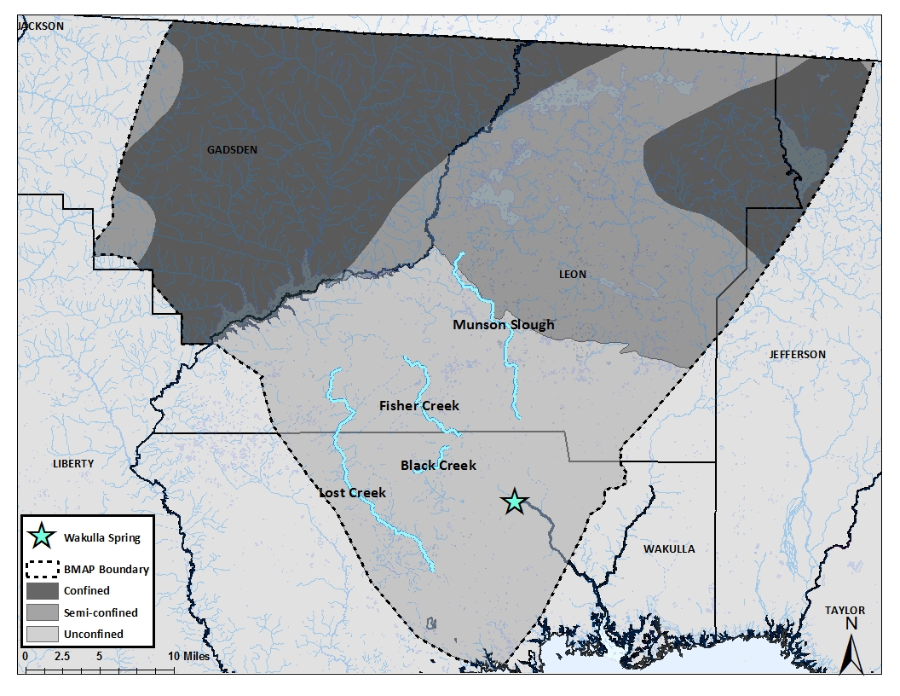
Figure 8: Map showing locations of sinking streams in Wakulla BMAP area.
Water-quality data have been collected on all of these streams intermittently throughout the period of interest. These data were obtained from STORET, and annual averages of nitrogen inputs were estimated using the monitoring stations closest to their swallets (where the streams disappear below the land surface). Nitrogen inputs from the sinking streams were estimated by multiplying the average annual discharges by the average annual nitrogen concentrations. It is important to note that discharge and nutrient data were not necessarily measured at the same times or for the same years.
All four sinking streams are in the area where the UFA is unconfined. Table 11 includes the annual average discharge and TN data that were available for each of the sinking streams. The periods of stream discharge and monitoring dates vary between stream, but do provide an opportunity to evaluate sinking stream inputs of nitrogen to the aquifer and Wakulla Spring. Table A-16 through Table A-20 in Appendix A provides the raw data for these streams. The average TN concentrations measured in each of them are low and below the typical concentrations naturally found in blackwater streams (1.21 mg/L); therefore the estimated inputs from these streams are not thought to be a significant contributor to the elevated nitrogen levels in Wakulla Spring (Hand et al. 2009).
Table 11: Annual discharge and TN data for the sinking streams.
Sinking Stream | Discharge (cfs) |  |  |  | TN concentrations (mg/L) |  | Nitrogen Input  (kg-N/yr)
Sinking Stream | Annual Average | Minimum | Maximum | Years of Data | Annual Average | Years of Data | Nitrogen Input  (kg-N/yr)
Fisher Creek | 35.7 | 0.0 | 587 | 2008–09 | 0.05 | 2007–11 | 894
Lost Creek | 127 | 0.0 | 2,870 | 2002–05,  2007–09 | 0.56 | 2006–07,  2011–12 | 34,579
Black Creek | 23.5 | 1.4 | 236 | 2009 | 1.06 | 2006,  2011–12 | 13,500
Munson Slough | 32 | 0.001 | 1,669 | 2002–10 | 0.17 | 2008–11 | 1,987

3.7 Nitrogen Input Summary
Based on the information and assumptions described in the previous sections, approximately 3.2 million kg-N are input annually to the Wakulla BMAP area landscape. Figure 9 illustrates the percentage of the total N input to the land surface attributed to the various nitrogen sources. Nitrogen inputs from atmospheric deposition (31.2%) and farm fertilizer (25.1%) were identified as the source categories having the greatest inputs of nitrogen followed by septic tanks (17.6%). Inputs from WWTFs (6.7%), livestock waste (10.4%), and residential fertilizer (7.9%) were all considerably lower.
Atmospheric deposition provides the largest input of nitrogen (31.2%) to the Wakulla BMAP area. Wet deposition, in general, contributes higher N inputs than dry deposition because water provides a direct pathway from the atmosphere to the ground. Although the nitrogen concentrations in atmospheric deposition are generally lower than in other sources, the volume of rainfall over the Wakulla BMAP area is large, resulting in high nitrogen inputs to the land surface. However, given the diffuse nature of its dispersal, nitrogen attributed to atmospheric deposition is readily attenuated by the environment. This reduces the impact of atmospheric deposition on ground water quality and nitrogen loading (discussed in Section 4).

Figure 9: Relative nitrogen inputs to the land surface in the Wakulla Spring and River BMAP area from major source categories.
The second largest input of nitrogen is from farm fertilizer (25.1%). This estimate is based on county fertilizer sales and assumed application rates on farm lands in the Wakulla BMAP area. Applied nitrogen in fertilizer is reduced through volatization, plant uptake and denitrification in the soil. The attenuation of nitrogen in fertilizer is also discussed in Section 4.

4. Environmental Attenuation of Nitrogen and Loading to Ground Water
The nitrogen input calculations identify which sources are contributing the largest amount of nitrogen to the land surface. The loads of nitrogen to the UFA in the Wakulla BMAP area include two other considerations: the attenuation factor for each of the source categories and the rate of ground water recharge within the three areas of aquifer confinement (confined, semi-confined, and unconfined).
Nitrogen is an essential nutrient and in its more mobile forms nitrogen is readily utilized by plants and bacteria. However, excess amounts of nitrogen can leach to ground water or be discharged to surface waters before being assimilated (Nolan et al. 1997). The methods utilized to estimate nitrogen inputs to the land surface have been described in the previous sections. To estimate the amount of nitrogen loading to ground water (and potentially to Wakulla Spring), the amount of nitrogen attenuation as it moves from the land surface to the ground water system must be considered.

4.1 Attenuation Factors
Nitrogen attenuation can occur by several naturally occurring physical, chemical, or biological processes such as volatization, biodegradation, dispersion, dilution, adsorption, and cation exchange (ammonium). These processes occur to varying degrees depending on how the nitrogen is introduced, soil properties, and other factors (Cockx and Simonne 2011; Costa et al. 2002; Dudley 2009). Due to this variability, specific attenuation factors are applied to each of the nitrogen source types. The attenuation factors utilized for this assessment were obtained from previous studies in Florida and in other areas that are described in the literature. These factors (which are listed in Table 12) represent the percentage of the nitrogen mass that is removed by processes occurring in the environment and prevented from reaching the aquifer.
Table 12: Attenuation factors applied to the nitrogen loading calculations. These percentages represent the amount of nitrogen removed by the environment.
Nitrogen Source Category | Attenuation Factor | Source
Atmospheric Deposition | 90% | Katz et al. 2009; Lombardo Associates 2011; H.T. Odum Florida Springs Institute 2011
WWTFs | 60% | Katz et al. 2009; Lombardo Associates 2011; H.T. Odum Florida Springs Institute 2011
Septic Tanks | 45% | Katz et al 2010; Lombardo Associates 2011
Farm Fertilizers | 70% | Goolsby et al. 1999; Katz et al. 2009; H.T. Odum Florida Springs Institute 2011; Lombardo Associates 2011
Residential Fertilizers | 80% | Goolsby et al. 1999; Katz et al 2009; H.T. Odum Florida Springs Institute 2011; Lombardo Associates 2011
Livestock Waste | 75% | Goolsby et al. 1999; Katz et al. 1999; Baton et al. 2005; Katz et al 2009; Lombardo Associates 2011
Sinking Streams | 20% | Estimated in this study

To estimate loading to ground water, the previously mentioned nitrogen inputs at the land surface from each category are multiplied by their associated attenuation factors. For example, atmospheric deposition has 90% environmental attenuation (e.g., uptake by vegetation). This means that 10% of the atmospheric nitrogen input to the land surface would reach the UFA.

4.2 Recharge and Aquifer Confinement
The amount of water that recharges the UFA depends on amount of rainfall, evapotranspiration, runoff, and subsurface hydrogeologic properties. The final step in estimating nitrogen loads to ground water is to provide a weighting factor for the amount of recharge for the three categories of aquifer confinement. Davis et al. (2011) reported that of 20 inches of rainfall that infiltrates on an annual basis, 18 inches will reach the aquifer in unconfined areas (90%), 8 inches in semi-confined areas (40%) and 2 inches in confined areas (10%). The amount of recharge is estimated from the annual average rainfall minus the evapotranspiration and runoff. In semi-confined and confined areas, the amount of evaportranspiration is the same as in unconfined areas, but the amount of runoff is higher due to the higher clay content in soil and geologic material overlying the UFA in the area. Because of the higher recharge rate, the water entering the aquifer in an area where the UFA is unconfined can have a much larger impact on ground water and spring water quality and quantity than in areas where the aquifer is confined due to the lower amount of recharge. In the areas where the UFA is semi-confined, there is an overall intermediate amount of recharge which would occur at locations where the confining unit over the UFA is breached. For calculating loads to ground water, the following recharge factors were applied to each source category for the three confinement areas: unconfined (0.9), semi-confined (0.4), and confined (0.1).

4.3 Nitrogen Loads to Ground Water
The final nitrogen loading estimates to ground water are obtained by applying the recharge factors to the attenuated nitrogen inputs for the three confinement categories. Table 13 shows the inputs, the intermediate step with attenuation factors applied and the final estimated loads to the UFA with both attenuation and recharge factors applied. Table A-21 through Table A-23 in Appendix A provide a complete breakdown of these calculations.
The final loading results show that estimated nitrogen load to the UFA in the BMAP area (338,708 kg/yr) is approximately 10 percent of the input to land surface. This decrease is due to the various attenuation mechanisms and the retardation of infiltrating water by the geologic material. The breakdown of estimated loads by source category is shown in Figure 10.

Table 13: Estimated nitrogen inputs and loads to UFA in Wakulla Spring and River BMAP Area.
 | Confinement | NITROGEN LOADING CATEGORIES (Inputs and Loads in kg/yr)
 | Confinement | Atmospheric Deposition | WWTFs | Septic Tanks | Farm Fertilizer | Residential Fertilizer | Livestock | Sinking Streams | Totals
INPUTS | Unconfined | 360,560 | 41,646 | 178,460 | 8,060 | 41,770 | 54,348 | 50,960 | 735,804
INPUTS | Semi-confined | 279,523 | 5,940 | 224,493 | 149,217 | 151,506 | 69,368 | N/A | 880,048
INPUTS | Confined | 380,625 | 169,684 | 157,802 | 662,835 | 64,561 | 215,230 | N/A | 1,650,739
INPUTS | Total Inputs (kg/yr) | 1,020,708 | 217,271 | 560,755 | 820,113 | 257,837 | 338,946 | 50,960 | 3,266,590
ATTENUATION FACTORS APPLIED | Attenuation Factors | 90% | 60% | 45% | 70% | 80% | 75% | 20%
ATTENUATION FACTORS APPLIED | Unconfined | 36,056 | 16,659 | 98,153 | 2,418 | 8,354 | 13,587 | 40,768 | 215,994
ATTENUATION FACTORS APPLIED | Semi-confined | 27,952 | 2,376 | 123,471 | 44,765 | 30,301 | 17,342 | N/A | 246,208
ATTENUATION FACTORS APPLIED | Confined | 38,062 | 67,874 | 86,791 | 198,851 | 12,912 | 53,808 | N/A | 458,298
ATTENUATION FACTORS APPLIED | Total After Attenuation (kg/yr) | 102,071 | 86,908 | 308,415 | 246,034 | 51,567 | 84,737 | 40,768 | 920,500
LOADS TO UFA (RECHARGE FACTORS APPLIED) | Recharge Factors
LOADS TO UFA (RECHARGE FACTORS APPLIED) | Unconfined (90%) | 32,450 | 14,993 | 88,338 | 2,176 | 7,519 | 12,228 | 36,691 | 194,395
LOADS TO UFA (RECHARGE FACTORS APPLIED) | Semi-confined (40%) | 11,181 | 950 | 49,388 | 17,906 | 12,120 | 6,937 |  | 98,483
LOADS TO UFA (RECHARGE FACTORS APPLIED) | Confined (10%) | 3,806 | 6,787 | 8,679 | 19,885 | 1,291 | 5,381 |  | 45,830
LOADS TO UFA (RECHARGE FACTORS APPLIED) | TOTAL LOADS TO UFA (kg/yr) | 47,437 | 22,730 | 146,405 | 39,967 | 20,930 | 24,546 | 36,691 | 338,708

Figure 10: Relative nitrogen loads to the UFA from the nitrogen source categories evaluated for the Wakulla Spring and River BMAP area.

The results indicate that the nitrogen load from the septic tank source category comprises approximately 43.2% of the sum of all source category loads evaluated for the BMAP area overall. The next largest percentages are from atmospheric deposition (14.0%) and farm fertilizer (11.8%). Septic tanks have a lower environmental attenuation factor and most of septic tanks in the BMAP area lie within the semi-confined and unconfined areas, resulting in more nitrogen reaching the UFA.
Figure 11 provides a summary of the estimated loads of nitrogen to the recharge areas and a breakdown of source category loads of nitrogen within each of the three recharge areas. The nitrogen loads to the UFA from sources in the unconfined area are much greater (57%) than the loads in the semi-confined (29%) and confined (14%) areas due to the high rate of recharge that occurs where the UFA is unconfined.
The data indicate that the nitrogen load from the septic tank source category is significant in all three of the recharge areas and is the dominant nitrogen loading source to the UFA in the semi-confined (50%) and unconfined (45%) areas, and that the septic tank load is the greatest overall among the source categories evaluated. The atmospheric deposition and wastewater source categories also have significant nitrogen loads to the UFA in the unconfined area. In the semi-confined area, nitrogen loads from the residential fertilizer and atmospheric deposition source categories are also significant, but they are much lower than the loads from the septic tank category. In the confined area, agricultural fertilizer and septic tanks are the two source categories with the highest percentage of the total load to the UFA but this recharge area contributes a relatively small percentage of the total nitrogen load to the BMAP area.
Figure 11: Loading percentages attributed to the recharge areas and nitrogen source categories within the Wakulla Spring and River BMAP area.

5. Conclusions
The Nitrogen Source Inventory and Loading Tool (NSILT) provides a science-based assessment of the relative contributions and potential impacts of various nitrogen sources on ground water quality in each recharge region of the Wakulla BMAP area. It provides estimates of the relative significance of the different source types, taking into consideration the transport pathways and processes that affect nitrogen as it migrates to ground water through soil and geological strata. The results can be used to evaluate various nitrogen reduction scenarios and quantify their restoration benefits.
The NSILT results indicate that septic tanks contribute the largest amounts of nitrogen to ground water in the entire Wakulla Springs BMAP area, comprising about 43.2% of the total nitrogen loads to ground water. Septic tanks have lower environmental attenuation factors than other sources, which results in potentially more nitrogen reaching the UFA. In areas where the UFA is unconfined and semi-confined, septic tanks is the leading nitrogen loading source and the second largest in the confined areas following farm fertilizers.
Sources in areas where the aquifer is unconfined should become the focus of nitrogen reduction efforts, given the high vulnerability of the aquifer to contamination in unconfined areas. By significantly reducing the number of septic tanks especially in areas where the UFA is unconfined, substantially less nitrogen loading to ground water would result along with a potential decrease in nitrate concentrations in Wakulla Spring over time. However, reducing loads from septic tanks throughout the BMAP area will also lower nitrogen loading to the UFA and Wakulla Spring. While septic tanks are the leading nitrogen loading source, reducing nitrogen from other sources will only enhance restoration efforts.

6. References
Advanced Geospatial Inc. July 19, 2007. Leon County aquifer vulnerability assessment. Tallahassee, FL.
Advanced Geospatial Inc. September 14, 2009. Wakulla County aquifer vulnerability assessment. Tallahassee, FL.
Bohlke, J.K. 2002. Ground water recharge and agricultural contamination. Hydrogeology Journal 10:153–179.
Bush, P.W., and Johnston, R.H. 1988. Ground-water hydraulics, regional flow, and ground-water development of the Floridan aquifer system in Florida and parts of Georgia, South Carolina, and Alabama. U.S. Geological Survey Professional Paper 1403-C.
Chang, N.B., M. Wanielista, A. Daranpob, F.Hossain, and Z.Xuan et al. 2010. Onsite sewage treatment and disposal systems evaluation for nutrient removal. Tallahassee, FL: Florida Department of Environmental Protection, Bureau of Watershed Restoration.
Chelette, A.R., T.R. Pratt, and B.G. Katz. 2002. Nitrate loading as an indicator of nonpoint source pollution in the lower St. Marks-Wakulla Rivers watershed. Northwest Florida Water Management District Water Resources Special Report 02-1,
Cockx, E.M., and E.H. Simonne. 2011. Reduction of the impact of fertilization and irrigation on processes in the nitrogen cycle in vegetable fields with BMPs. HS948. Gainesville, FL: University of Florida, Institute of Food and Agricultural Sciences, 16 p.
Costa, J.E., G. Heufelder, S.Foss, N.P Milham, and B. Howes. 2002. Nitrogen removal efficiencies of three alternative septic system technologies and a conventional septic system. Environment Cape Cod 5(1): 15–24.
Davis, J.H. 1996. Hydrogeologic investigation and simulation of ground-water flow in the UFA of north-central Florida and southwestern Georgia and delineation of contributing areas for selected city of Tallahassee, Florida, water-supply wells. U.S. Geological Survey Water-Resources Investigations Report 95-4296.
Davis, J.H., and B.G. Katz , 2007, Hydrogeologic Investigation, Water Chemistry Analysis, and Model Delineation of contributing Areas for City of Tallahassee Public-Supply Wells, Tallahassee, Florida: U.S. Geological Survey Scientific Investigations Report 2007-5070, 67 p.
Davis, J.H., B.G. Katz, and D.W. Griffin. 2010. Nitrate-N movement in ground water from the land application of treated municipal wastewater and other sources in the Wakulla Springs springshed, Leon and Wakulla Counties, Florida, 1966–2018. U.S. Geological Survey Scientific Investigations Report 2010-5099.
Gilbert, D. 2012. Nutrient (biology) TMDL for the Upper Wakulla River (WBID 1006). Tallahassee, FL: Florida Department of Environmental Protection.
Goolsby, D.A., W.A. Battaglin, G.B. Lawrence, R.S. Artz, and B.T. Aulenbach, et al. Flux and sources of nutrients in the Mississippi-Atchaflaya River Basin. National Oceanic and Atmospheric Administration Coastal Ocean Program No. 17.
Gronberg, J.A.M., and N.E. Spahr. 2012. County-level estimates of nitrogen and phosphorus from commercial fertilizer for the conterminous United States, 1987–2006. U.S. Geological Survey Scientific Investigations Report 2012-5207.
Hall, P., and S.J. Clancy. 2009. The Florida statewide inventory of onsite sewage treatment and disposal systems (OSTDS): A report on the status of knowledge of the number and locations of OSTDS in each county and best management practices for improving this knowledge. Prepared for the Florida Department of Health, Bureau of Onsite Sewage Programs, by EarthSTEPS and GlobalMind.
Hand, J., N. Lewis, and L. Lord. 2009. Typical values for Florida’s lakes, streams, blackwaters, coastal waters, and estuaries. Tallahassee, FL: Florida Department of Environmental Protection, Bureau of Watershed Management, Watershed Assessment Section.
Hendry, C.W., and C.R. Sproul. 1966. Geology and ground water resources of Leon County, Florida. Florida Geological Survey Bulletin 47.
Hochmuth, G., T. Nell, J. Sartain, J.B. Unruh, C. Martinez, L. Trenholm, and J. Cisar. 2011. Urban water quality and fertilizer ordinances: Avoiding unintended consequences: A review of the scientific literature. SL 283. Gainesville, FL: University of Florida, Institute of Food and Agricultural Sciences.
Howard T. Odom Florida Springs Institute. 2011. Wakulla Spring–An adaptive management strategy. Howard T. Odum Florida Springs Institute, 93 p
Katz, B.G. 1992. Hydrochemistry of the Upper Floridan Aquifer, Florida. U.S. Geological Survery Water Resources Investigations Report 91-4196.
Katz, B.G., T.B. Coplen, T.D. Bullen, and J.H. Davis. 1997. Use of chemical and isotopic tracers to characterize the interactions between ground water and surface water in mantled karst. Ground Water 35: 1014–1028.
Katz, B.G., J.S. Catches, T.D. Bullen, and R.L. Michel. 1998. Changes in the isotopic and chemical composition of ground water resulting from a recharge pulse from a sinking stream. Journal of Hydrology 211: 178–207.
Katz, B.G, H.D. Hornsby, J.F. Boklke, and M.F. Mokray. 1999. Sources and chronology of nitrate contamination in spring waters, Suwannee River Basin, Florida. U.S. Geological Survey Water Resources Investigations Report 99-4252.
Katz, B.G., J.K.Bohlke, and H.D Hornsby. 2001. Timescales for nitrate contamination of spring waters, northern Florida, USA. Chemical Geology 179:167–186.
Kaufman, M.I. 1968. Uranium isotope investigation of the Floridan aquifer and related natural waters of north Florida. MS Thesis, Florida State University, Tallahassee, FL.
Lombardo Associates. 2011. Onsite sewage treatment and disposal and management options. Newton, MA.
Meyer, L.H. 2012. Quantifying the role of agriculture and urbanization in the nitrogen cycle across Texas. University of Texas Graduate Thesis.
Miller, J.A. 1986. Hydrologic framework of the Floridan aquifer system in Florida and in parts of Georgia, Alabama, and South Carolina. U.S. Geological Survey Professional Paper 1403-B.
Nolan, B.T., B.C. Ruddy, K.J. Hitt, and D. R. Helsel. 1997. Risk of nitrate in ground waters of the United States–A national perspective. Environmental Science Technology 31: 2229–2236.
Ruddy, B.C., D.L. Lorenz, and D.K. Mueller. 2006. County-level estimates of nutrient inputs to the land surface of the conterminous United States, 1982–2001. U.S. Geological Survey Scientific Investigations Report 2006-5012.
Rupert, F.R. 1988. The geology of Wakulla Springs. Florida Geological Survey Open-File Report 22.
Rupert, F.R., and S. Spencer. 1988. Geology of Wakulla County, Florida. Florida Geological Survey Bulletin No. 60.
Toor, G.S., M. Lusk and T. Obreza. 2011. Onsite Sewage Treatment and Disposal Systems: Nitrogen. SL 348. Gainesville, FL: University of Florida, Institute of Food and Agricultural Sciences.
U.S. Census Bureau. 2010. Available: http://www.census.gov/.
US EPA. 2002. Onsite Wastewater Treatment Systems Manaul. EPA/625/R-00/008. US Environmental Protection Agency, Office of Water, Washington, D.C.

U.S. Environmental Protection Agency. 2013. Clean Air Status and Trends Network (CASTNET). Available: http://epa.gov/castnet/javaweb/index.html.

Appendix A: Tables

Table A-1: Useful conversion factors.
Convert from | To | Multiply by
NO₃ mg/L | NO₃ g-N/L | 2.260 X 10⁻⁴
NH₄ mg/L | NH₄ g-N/L | 7.765 X 10⁻⁴
mg | g | 0.001
g | kg | 0.001
mg | kg | 1 X 10⁻⁶
acre | hectare | 0.4046873
m² | hectare | 0.0001
cm³ | L | 0.001
tons | kg | 907.1847
ft³ | L | 28.31685
second | year | 3.170979 X 10⁻⁸
Rainfall (cm) | Rainfall (L/ha) | 10⁴

Table A-2: Wet deposition data, 2002–12.
Year | NH₄ (mg/L) |  |  |  |  | NO₃ (mg/L) |  |  |  |  | TN (mg/L) |  |  |  |  | Precipitation (cm)
Year | FL14 | FL23 |  | AVG |  | FL14 |  | FL23 | AVG |  | FL14 | FL23 |  |  | AVG | FL14 | FL23 |  |  | AVG
2002 | 1.29 |  | 1.21 |  | 1.25 | 7.82 | 7.80 |  |  | 7.81 | 2.59 |  | 3.07 | 2.83 |  | 136.66 |  | 152.63 | 144.645
2003 | 1.36 |  | 1.29 |  | 1.32 | 7.20 | 6.36 |  |  | 6.78 | 3.15 |  | 3.67 | 3.41 |  | 136.8 |  | 187.25 | 162.025
2004 | 1.28 |  | 0.97 |  | 1.12 | 7.19 | 5.36 |  |  | 6.27 | 2.76 |  | 2.79 | 2.78 |  | 149.16 |  | 137.92 | 143.54
2005 | 1.31 |  | 1.38 |  | 1.34 | 6.52 | 7.29 |  |  | 6.91 | 3.20 |  | 4.00 | 3.60 |  | 152.08 |  | 181.15 | 166.615
2006 | 1.88 |  | 1.87 |  | 1.88 | 8.10 | 8.48 |  |  | 8.29 | 2.93 |  | 3.15 | 3.04 |  | 111.44 |  | 133.71 | 122.575
2007 | 1.62 |  | 0.83 |  | 1.23 | 7.29 | 5.35 |  |  | 6.32 | 2.06 |  | 2.05 | 2.05 |  | 91.65 |  | 116.15 | 103.9
2008 | 1.23 |  | 0.70 |  | 0.96 | 6.23 | 5.34 |  |  | 5.78 | 2.51 |  | 2.32 | 2.42 |  | 162.28 |  | 161.34 | 161.81
2009 | 1.35 |  | 1.31 |  | 1.33 | 5.61 | 6.19 |  |  | 5.90 | 3.46 |  | 3.61 | 3.54 |  | 169.94 |  | 176.41 | 173.175
2010 | 1.49 |  | 1.21 |  | 1.35 | 5.93 | 5.86 |  |  | 5.89 | 2.50 |  | 2.67 | 2.58 |  | 115.88 |  | 145.68 | 130.78
2011 | 1.87 |  | 1.70 |  | 1.78 | 6.24 | 6.42 |  |  | 6.33 | 2.59 |  | 2.29 | 2.44 |  | 114.31 |  | 118.09 | 116.2
2012 | 1.70 |  | 0.77 |  | 1.24 | 8.53 | 4.76 |  |  | 6.65 | 2.36 |  | 1.76 | 2.06 |  | - |  | - | -
Average | 1.49 |  | 1.20 |  | 1.35 | 6.97 | 6.29 |  |  | 6.63 | 2.74 |  | 2.85 | 2.80 |  | 134.02 |  | 151.03 | 142.53
- = Empty cell/no data

Table A-3: Dry deposition data from SUM156, 2002–12.
Year | NO3 FLUX  (kg-no3/ha) | NO3 FLUX  (kg-N/ha) | NH4 FLUX  (kg-nh4/ha) | NH4 FLUX  (kg-N/ha) | Total N  (kg-N/ha)
2002 | 0.133 | 0.030 | 0.237 | 0.184 | 0.952
2003 | 0.101 | 0.023 | 0.215 | 0.167 | 0.890
2004 | 0.127 | 0.029 | 0.240 | 0.186 | 0.889
2005 | 0.112 | 0.025 | 0.264 | 0.205 | 0.934
2006 | 0.117 | 0.026 | 0.232 | 0.181 | 0.876
2007 | 0.154 | 0.035 | 0.197 | 0.153 | 0.743
2008 | 0.142 | 0.032 | 0.151 | 0.117 | 0.614
2009 | 0.127 | 0.029 | 0.127 | 0.099 | 0.427
2010 | 0.103 | 0.023 | 0.136 | 0.105 | 0.501
2011 | 0.113 | 0.026 | 0.177 | 0.137 | 0.663
2012 | 0.179 | 0.041 | 0.144 | 0.112 | 0.552
Average | 0.128 | 0.029 | 0.193 | 0.150 | 0.731

Table A-4: Fertilizer sales data for Leon County, 2002–12.
Year | Total Fertilizer (tons) | Total N All Fertilizer (tons) | Total N All Fertilizer  (kg-N) | % N in Fertilizers | Farm  Fertilizer  (kg-N) | Nonfarm Fertilizer  (kg-N)
2002 | 2,529.33 | 247.53 | 224,555.43 | 9.8% | 91,512.38 | 133,042.16
2003 | 2,772.77 | 271.82 | 246,590.95 | 9.8% | 86,608.36 | 159,982.59
2004 | 3,007.78 | 275.02 | 249,493.94 | 9.1% | 28,143.12 | 221,350.82
2005 | 4,416.7 | 548.41 | 497,509.16 | 12.4% | 67,979.89 | 429,529.27
2006 | 3,195.57 | 423.65 | 384,328.80 | 13.3% | 77,402.88 | 306,925.92
2007 | 2,834.45 | 303.12 | 274,985.83 | 10.7% | 53,985.29 | 221,000.53
2008 | 2,588.03 | 240.51 | 218,186.99 | 9.3% | 60,367.46 | 157,819.53
2009 | 2,629.28 | 271.43 | 246,237.14 | 10.3% | 33,961.94 | 212,276.14
2010 | 2,108.32 | 199.07 | 180,593.26 | 9.4% | 56,410.55 | 124,183.56
2011 | 3,447.04 | 178.73 | 162,141.12 | 5.2% | 37,093.53 | 125,048.07
2012 | 2,999.7 | 147.45 | 133,764.38 | 4.9% | 15,590.01 | 118,179.27
Average | 2,957 | 282 | 256,217.00 | 9.5% | 55,368.67 | 200,848.90

Table A-5: Fertilizer sales data for Wakulla County, 2002–12.
Year | Total Fertilizer (tons) | Total N All Fertilizer (tons) | Total N All Fertilizer  (kg-N) | % N in Fertilizers | Farm  Fertilizer  (kg-N) | Nonfarm Fertilizer  (kg-N)
2002 | 271.61 | 30.58 | 27,741.71 | 11.3% | 12,004.28 | 15,736.41
2003 | 357 | 31.66 | 28,721.47 | 8.9% | 17,450.91 | 11,270.56
2004 | 288.16 | 27.67 | 25,101.80 | 9.6% | 12,104.89 | 12,996.91
2005 | 97.35 | 8.27 | 7,502.42 | 8.5% | 3,082.66 | 4,419.76
2006 | 222.7 | 25.79 | 23,396.29 | 11.6% | 16,550.75 | 6,845.54
2007 | 254.46 | 20.9 | 18,960.16 | 8.2% | 7,744.71 | 11,215.45
2008 | 194.45 | 12.95 | 11,748.04 | 6.7% | 5,942.59 | 5,805.45
2009 | 224.59 | 3.44 | 3,120.72 | 1.5% | 269.57 | 2,851.15
2010 | 1,357.97 | 5.5 | 4,989.52 | 0.4% | 4,675.81 | 313.74
2011 | 1,558.68 | 3.85 | 3,492.66 | 0.2% | 3,191.32 | 301.34
2012 | 164.97 | 4.03 | 3,655.95 | 2.4% | 876.92 | 2,779.03
Average | 453.8127 | 15.87636364 | 14,402.79 | 6.3% | 7,626.76 | 6,775.94

Table A-6: Fertilizer sales data for Gadsden County, 2002–12.
Year | Total Fertilizer (tons) | Total N All Fertilizer (tons) | Total N All Fertilizer  (kg-N) | % N in Fertilizers | Farm  Fertilizer  (kg-N) | Nonfarm Fertilizer  (kg-N)
2002 | 16,122.28 | 1,000.08 | 907,257.27 | 6.2% | 886,706.19 | 20,551.09
2003 | 17,335.09 | 1,157.8 | 1,050,338.45 | 6.7% | 1,011,886.62 | 38,451.82
2004 | 15,072.67 | 928.95 | 842,729.23 | 6.2% | 807,610.36 | 35,118.87
2005 | 12,867.91 | 841.16 | 763,087.48 | 6.5% | 724,709.27 | 38,377.61
2006 | 16,896.61 | 977.06 | 886,373.88 | 5.8% | 800,684.73 | 30,936.46
2007 | 19,150.76 | 1,259.57 | 1,142,662.63 | 6.6% | 1,081,967.88 | 60,694.76
2008 | 11,363.96 | 718.19 | 651,530.98 | 6.3% | 625,541.32 | 25,989.66
2009 | 7,267.58 | 539.71 | 489,616.65 | 7.4% | 403,520.53 | 86,096.80
2010 | 10,070.95 | 695.37 | 630,829.02 | 6.9% | 524,140.03 | 106,689.00
2011 | 8,743.33 | 717.29 | 650,714.51 | 8.2% | 553,796.47 | 96,918.05
2012 | 4,655.08 | 484.29 | 439,340.48 | 10.4% | 358,864.69 | 80,476.73
Average | 12,686.02 | 847.22 | 768,589.15 | 7.0% | 707,220.73 | 56,390.99

Table A-7: Fertilizer sales data for Jefferson County, 2002–12.
Year | Total Fertilizer (tons) | Total N All Fertilizer (tons) | Total N All Fertilizer  (kg-N) | % N in Fertilizers | Farm Fertilizer  (kg-N) | Nonfarm Fertilizer  (kg-N)
2002 | 11,821.07 | 2,013.98 | 1,827,051.84 | 17.0% | 1,784,886.62 | 42,165.22
2003 | 12,739.43 | 2,134.68 | 1,936,549.04 | 16.8% | 1,868,994.80 | 67,554.23
2004 | 12,434.2 | 2,067.58 | 1,875,676.94 | 16.6% | 1,789,949.90 | 85,727.04
2005 | 7,435.26 | 1,278.28 | 1,159,636.06 | 17.2% | 1,095,378.71 | 64,257.34
2006 | 9,703.11 | 1,706.6 | 1,548,201.41 | 17.6% | 1,400,579.05 | 147,623.95
2007 | 8,746.09 | 1,647.12 | 1,494,242.06 | 18.8% | 1,414,979.37 | 79,262.69
2008 | 6,710.28 | 1,290.77 | 1,170,966.80 | 19.2% | 1,085,816.11 | 85,150.69
2009 | 6,930.13 | 1,364.98 | 1,238,288.97 | 19.7% | 1,189,808.99 | 48,479.98
2010 | 11,503.6 | 1,234.45 | 1,119,874.15 | 10.7% | 1,086,892.01 | 32,978.25
2011 | 11,050.43 | 1,202.83 | 1,091,188.97 | 10.9% | 1,053,366.18 | 37,819.83
2012 | 7,117.92 | 1,341.37 | 1,216,870.34 | 18.8% | 1,181,447.70 | 35,422.64
Average | 9,653.775 | 1,571.15 | 1,425,322.42 | 17.2% | 1,359,281.77 | 66,040.17

Table A-8: Farm fertilizer land use percentages in Leon, Wakulla, Gadsden, and Jefferson Counties.
Land Use Type | Leon (ha) |  |  |  |  |  | Wakulla (ha) |  |  | Gadsden (ha) |  |  |  |  | Jefferson (ha)
Land Use Type | County |  | U | S |  | C | County |  | U | County | S |  | C |  | County | S | C
2140: Row Crops | 27 | 1 |  |  | 22 | 4 | 17 | 13 |  | 495 |  | 91 |  | 305 | 401 | 9 |  | 12
2150: Field Crops | 2,587 | 20 |  |  | 1,397 | 1,169 | 166 | 140 |  | 884 |  | 69 |  | 705 | 2,953 | 73 |  | 850
2153: Hay Fields | 669 | 51 |  |  | 388 | 229 | 592 | 550 |  | 5,819 |  | 862 |  | 3,836 | 5,021 | 121 |  | 69
2230: Other Groves | 51 |  |  |  | 6 | 13 | 10 | 9 |  | 179 |  | 1 |  | 128 | 1,086 | 2 |  | 10
2400: Nurseries and Vineyards | 17 | 6 |  |  | 11 |  | 3 | 3 |  | 24 |  | - |  | 19 | 32 | - |  | 8
2410: Tree Nurseries | 27 | 3 |  |  | 5 | 19 | 20 | 3 |  | 30 |  | - |  | 30 | 87 | - |  | 5
2420: Sod Farms | 68 | - |  |  | 68 | - | - | - |  | 446 |  | 22 |  | 420 | - | - |  | -
2430: Ornamentals | 23 | - |  |  | 23 | 1 | 6 | 6 |  | 617 |  | 31 |  | 586 | - | - |  | 19
Total | 3,470 | 80 |  |  | 1,920 | 1,435 | 815 | 725 |  | 8,494 |  | 1,077 |  | 6,028 | 9,580 | 204 |  | 973
% of County Fertilized Land | - | 2.3% |  |  | 55.3% | 41.4% | - | 88.9% |  | - |  | 12.7% |  | 71.0% | - | 2.1% |  | 10.2%
- = Empty cell/no data
U = Unconfined; S = Semi-confined; C = Confined

Table A-9: Residential fertilizer land use percentages in Leon, Wakulla, Gadsden, and Jefferson Counties.
Land Use Type | Leon (ha) |  |  |  | Wakulla (ha) |  | Gadsden (ha) |  |  | Jefferson (ha)
Land Use Type | County | U | S | C | County | U | County | S | C | County | S | C
1110: Low Density, Single Family | 7,583 | 512 | 5,983 | 1,015 | 1,994 | 1,593 | 1,449 | 89 | 1,183 | 1,539 | 50 | 216
1120: Low Density, Mobile Home | 1,053 | 754 | 156 | 43 | 976 | 855 | 733 | 56 | 530 | 311 | 13 | 11
1130: Low Density, Mixed Units | 4,106 | 1,608 | 1,585 | 829 | 2,891 | 2,498 | 1,884 | 102 | 1,245 | 2,117 | 29 | 82
1210: Medium Density, Single Family | 8,937 | 562 | 8,329 | 45 | 921 | 702 | 804 | 13 | 742 | 170 | - | 33
1220: Medium Density, Mobile Home | 622 | 487 | 134 | - | 370 | 305 | 203 | 17 | 174 | 5 | - | -
1230: Medium Density, Mixed | 999 | 581 | 374 | 28 | 780 | 452 | 1,921 | 102 | 1,589 | 456 | - | -
1310: High Density, Single Family | 1,085 | 72 | 1,013 | - | 60 | 2 | 406 | 1 | 387 | 5 | - | -
1320: High Density, Mobile Home | 136 | 100 | 35 | - | 3 | 1 | 156 | 2 | 144 | 5 | - | -
1330: High Density, Low Rise | 1,270 | 34 | 1,236 | - | 27 | 18 | 62 | 3 | 51 | 9 | - | -
1340: High Density, High Rise | 10 |  | 10 | - | - | - | - | - | - | - | - | -
1350: High Density, Mixed | 1 |  | 1 | - | 52 | 39 | 626 | 30 | 469 | - | - | -
1820: Golf Courses | 442 | 37 | 405 | - | 51 | 51 | 111 | - | 111 | 28 | - | -
Total | 26,244 | 4,748 | 19,261 | 1,961 | 8,128 | 6,517 | 8,356 | 413 | 6,623 | 4,645 | 92 | 341
% of Residential Land | - | 18.1% | 73.4% | 7.5% | - | 80.2% | - | 4.9% | 79.3% | - | 2.0% | 7.3%
- = Empty cell/no data
U = Unconfined; S = Semi-confined; C = Confined

Table A-10: Gadsden County livestock populations from the CoA, 2002 and 2007.
Livestock | Amount | 2002 | 2007 | Average
Cattle, Cows, Beef | 1 to 9 head | 326 | - | 326
Cattle, Cows, Beef | 10 to 19 head | - | 418 | 418
Cattle, Cows, Beef | 20 to 49 head | 959 | 1,193 | 1,076
Cattle, Cows, Beef | 50 to 99 head | 804 | 1,103 | 954
Cattle, Cows, Beef | 100 to 199 head | - | 600 | 600
Cattle, Cows, Beef | 200 to 499 head | - | - | -
Cattle, Cows, Beef | Total | 2,710 | 2,500 | 2,605
Cattle Including Calves | 1 to 9 head | - | 88 | 88
Cattle Including Calves | 10 to 19 head | 551 | 226 | 389
Cattle Including Calves | 20 to 49 head | 941 | 1,593 | 1,267
Cattle Including Calves | 50 to 99 head | 1,543 | 1,973 | 1,758
Cattle Including Calves | 100 to 199 head | - | 2,551 | 2,551
Cattle Including Calves | 200 to 499 head | - | - | -
Cattle Including Calves | Total | 4,564 | 5,000 | 4,782
Chicken, Broilers | Total | - | - | -
Chicken, Layers | Total | 70 | 351 | 211
Ducks | Total | 22 | - | 22
Geese | Total | 25 | 14 | 20
Goats | Total | 365 | 723 | 544
Hogs | Total | 551 | 97 | 324
Sheep Including Lambs | Total | 66 | 116 | 91
Turkey | Total | 18 | 5 | 12
Horses | Total | - | 406 | 406
- = Empty cell/no data

Table A-11: Jefferson County livestock populations from the CoA, 2002 and 2007.
Livestock | Amount | 2002 | 2007 | Average
Cattle, Cows, Beef | 1 to 9 head | 202 | 244 | 223
Cattle, Cows, Beef | 10 to 19 head | 278 | 413 | 346
Cattle, Cows, Beef | 20 to 49 head | 748 | 1,045 | 897
Cattle, Cows, Beef | 50 to 99 head | 889 | 1,888 | 1,389
Cattle, Cows, Beef | 100 to 199 head | 1,085 | 1,333 | 1,209
Cattle, Cows, Beef | 200 to 499 head | 1,500 | - | 1,500
Cattle, Cows, Beef | Total | 4,702 | 4,000 | 4,351
Cattle Including Calves | 1 to 9 head | 190 | 263 | 227
Cattle Including Calves | 10 to 19 head | 283 | 384 | 334
Cattle Including Calves | 20 to 49 head | 1,098 | 1,789 | 1,444
Cattle Including Calves | 50 to 99 head | 1,272 | - | 1,272
Cattle Including Calves | 100 to 199 head | 1,410 | 3,055 | 2,233
Cattle Including Calves | 200 to 499 head | 2,932 | 3,019 | 2,976
Cattle Including Calves | Total | 11,000 | 10,000 | 10,500
Chicken, Broilers | Total | - | 43 | 43
Chicken, Layers | Total | 544 | 1,046 | 795
Ducks | Total | 75 | 86 | 81
Geese | Total | - | 158 | 158
Goats | Total | 600 | 1,057 | 829
Hogs | Total | 431 | 239 | 335
Sheep Including Lambs | Total | 532 | 271 | 402
Turkey | Total | 304 | 19 | 162
Horses | Total | 645 | 1,163 | 904
- = Empty cell/no data

Table A-12: Leon County livestock population data from the CoA, 2002 and 2007.
Livestock | Amount | 2002 | 2007 | Average
Cattle, Cows, Beef | 1 to 9 head | 214 | 168 | 191
Cattle, Cows, Beef | 10 to 19 head | 115 | 179 | 147
Cattle, Cows, Beef | 20 to 49 head | 331 | 556 | 444
Cattle, Cows, Beef | 50 to 99 head | - | 343 | 343
Cattle, Cows, Beef | 100 to 199 head | - | - | -
Cattle, Cows, Beef | 200 to 499 head | - | - | -
Cattle, Cows, Beef | Total | 1,500 | 1,246 | 1,373
Cattle Including Calves | 1 to 9 head | 107 | 164 | 136
Cattle Including Calves | 10 to 19 head | 609 | 358 | 484
Cattle Including Calves | 20 to 49 head | 371 | 1,018 | 695
Cattle Including Calves | 50 to 99 head | 263 | - | 263
Cattle Including Calves | 100 to 199 head | - | - | -
Cattle Including Calves | 200 to 499 head | - | - | -
Cattle Including Calves | Total | 2,841 | 2,447 | 2,644
Chicken, Broilers | Total | 50 | - | 50
Chicken, Layers | Total | 436 | 500 | 468
Ducks | Total | 80 | 221 | 151
Geese | Total | 15 | 48 | 32
Goats | Total | 201 | 698 | 450
Hogs | Total | 493 | 330 | 412
Sheep Including Lambs | Total | 72 | 77 | 75
Turkey | Total | 25 | 44 | 35
Horses | Total | - | 1,157 | 1,157
- = Empty cell/no data

Table A-13: Wakulla County livestock population data from the CoA, 2002 and 2007.
- = Empty cell/no data
Livestock | Amount | 2002 | 2007 | Average
Cattle, Cows, Beef | 1 to 9 head | 122 | 141 | 132
Cattle, Cows, Beef | 10 to 19 head | 106 | 282 | 194
Cattle, Cows, Beef | 20 to 49 head | 226 | - | 226
Cattle, Cows, Beef | 50 to 99 head | 187 | - | 187
Cattle, Cows, Beef | 100 to 199 head | - | - | -
Cattle, Cows, Beef | 200 to 499 head | - | - | -
Cattle, Cows, Beef | Total | 641 | 500 | 571
Cattle Including Calves | 1 to 9 head |  | 126 | 126
Cattle Including Calves | 10 to 19 head | 219 | 55 | 137
Cattle Including Calves | 20 to 49 head | 218 | 566 | 392
Cattle Including Calves | 50 to 99 head | 277 | - | 277
Cattle Including Calves | 100 to 199 head | - | - | -
Cattle Including Calves | 200 to 499 head | - | - | -
Cattle Including Calves | Total | 1,159 | 1,000 | 1,080
Chicken, Broilers | Total | - | - | -
Chicken, Layers | Total | 272 | 436 | 354
Ducks | Total | 40 | - | 40
Geese | Total | 72 | - | 72
Goats | Total | 388 | 361 | 375
Hogs | Total | 454 | 180 | 317
Sheep Including Lambs | Total | 8 | - | 8
Turkey | Total | 4 | - | 4
Horses | Total | - | 261 | 261

Table A-14: Cattle population data from NASS, 2007–12.
Year | Leon  County | Gadsden  County | Wakulla  County | Jefferson  County
2007 | 5,000 | 5,000 | 1,000 | 10,000
2008 | 4,000 | 5,000 | 1,000 | 10,000
2009 | 3,000 | 6,000 | 1,000 | 12,000
2010 | 2,000 | 6,000 | 1,000 | 13,600
2011 | 2,000 | 5,500 | 1,000 | 11,500
2012 | 3,100 | 6,100 | 1,000 | 12,200
Average | 3,183 | 5,600 | 1,000 | 11,550

Table A-15: Livestock land use percentages in Leon, Wakulla, Gadsden, and Jefferson Counties.
Land Use Type | Leon (ha) |  |  |  | Wakulla (ha) |  |  | Gadsden (ha) |  |  | Jefferson (ha)
Land Use Type | County | U | S | C | County | U |  | County | S | C | County | S | C
2110: Improved Pastures | 2,246 | 138 | 1,381 | 696 | 649 |  | 557 | 3,168 | 203 | 2,460 | 5,419 | 44 | 207
2120: Unimproved Pastures | 196 | 13 | 135 | 48 | 23 |  | 23 | 1,278 | 98 | 913 | 243 | 2 | 4
2130: Woodland Pastures | 352 | 24 | 230 | 99 | 131 |  | 116 | 1,454 | 109 | 1,093 | 385 | 51 | 23
2310: Cattle Feeding Operations | - | - | - | - | - |  | 1 | 31 | 22 | - | - | - | -
2320: Poultry Feeding Operations | - | - | - | - | - |  | - | 10 | - | 10 | - | - | -
2500: Specialty Farms | - | - | - | - | 1 |  | - | 20 | - | 20 | 5 | - | -
2510: Horse Farms | 110 | 7 | 69 | 34 | 20 |  | 14 | 382 | 29 | 334 | 197 | 19 | 34
2520: Dairies | - | - | - | - | - |  | - |  | - | - | 42 | - | -
2540: Aquaculture | - | - | - | - | 1 |  | 1 | 12 | - | 4 | 1 | - | -
Total | 2,904 | 181 | 1,815 | 877 | 824 |  | 712 | 6,354 | 462 | 4,833 | 6,291 | 117 | 269
% of County Livestock Land | - | 6.2% | 62.5% | 30.2% | - |  | 86.4% | - | 7.3% | 76.1% | - | 1.9% | 4.3%
- = Empty cell/no data
U = Unconfined; S = Semi-confined; C = Confined

Table A-16: Sinking streams discharge data.
Site | Year | N | Average Q  (L/s) | Minimum Q  (L/s) | Maximum Q  (L/s)
Fisher Creek | 2008 | 366 | 1,089.22 | 0.00 | 16,621.99
Fisher Creek | 2009 | 273 | 934.28 | 42.48 | 16,565.36
Fisher Creek | Average | 639 | 1,011.75 | 21.24 | 16,593.67
Black Creek | 2009 | 92 | 665.37 | 39.93 | 6,680.34
Munson Slough | 2002 | 365 | 692.32 | 0.03 | 40,768.78
Munson Slough | 2003 | 365 | 1,785.55 | 10.41 | 16,350.19
Munson Slough | 2004 | 365 | 1,019.77 | 2.57 | 12,748.38
Munson Slough | 2005 | 365 | 1,438.90 | 8.55 | 25,907.49
Munson Slough | 2006 | 341 | 402.83 | 0.24 | 17,509.93
Munson Slough | 2007 | 365 | 371.92 | 0.27 | 14,804.93
Munson Slough | 2008 | 334 | 859.81 | 0.86 | 47,262.11
Munson Slough | 2009 | 325 | 943.49 | 44.87 | 24,619.47
Munson Slough | 2010 | 166 | 630.55 | 33.18 | 17,091.65
Munson Slough | Average | 3,032 | 905.02 | 11.22 | 24,118.10
Lost Creek | 2002 | 365 | 4,222.39 | 56.63 | 76,455.50
Lost Creek | 2003 | 365 | 5,001.72 | 82.12 | 73,340.64
Lost Creek | 2004 | 366 | 3,637.16 | 0.00 | 33,980.22
Lost Creek | 2005 | 273 | 5,960.54 | 124.59 | 70,508.96
Lost Creek | 2007 | 344 | 835.13 | 28.32 | 25,541.80
Lost Creek | 2008 | 366 | 2,534.42 | 28.32 | 66,827.77
Lost Creek | 2009 | 273 | 2,981.30 | 28.32 | 81,269.36
Lost Creek | Average | 2,352 | 3,596.09 | 49.76 | 61,132.03

Table A-17: Munson Slough nutrient data from the southernmost monitoring station (in mg/L).
Station Name | Year | NO3 | NO3 + NO2 | NO2 | NH4 | TKN | TN
21FLLEONLCLMS5303284302 | 2008 | 0.045 | 0.03235 | 0.00076 | 0.019 | 0.89 | 0.92235
21FLLEONLCLMS5303284302 | 2009 | 0.16 | 0.069 | 0.025 | 0.02 | 0.42 | 0.489
21FLLEONLCLMS5303284302 | 2010 | 0.175 | 0.1625 | 0.025 | 0.05375 | 1.0875 | 1.25
21FLLEONLCLMS5303284302 | 2011 | 0.025 | 0.025 | 0.025 | 0.11 | 1.1 | 1.125

Table A-18: Lost Creek nutrient data from the southernmost monitoring stations (in mg/L).
Station Name | Year | NO3 + NO2 | NH4 | TKN | TN
21FLBRA 995-B | 2006 | 0.017738462 | 0.0215385 | 0.3475 | 0.3651333
21FLBRA 995-B | 2007 | 0.00645 | 0.01 | 1.05 | 1.05645
21FLPNS 2327033 | 2011 | 0.0176 | 0.0118 | 0.358 | 0.3756
21FLPNS 2327033 | 2012 | 0.006 | 0.012 | 0.84 | 0.846

Table A-19: Black Creek nutrient data from southernmost monitoring station (in mg/L).
Station Name | Year | NO3 + NO2 | NH4 | TKN | TN
Black Creek at SR 267 | 2006 | 0.02248 | 0.0731 | 0.9225 | 0.94585
Black Creek at SR 267 | 2011 | 0.014 | 0.052 | 0.855 | 0.869
Black Creek at SR 267 | 2012 | 0.004 | 0.019 | 1.4 | 1.404

Table A-20: Fisher Creek nutrient data from the southernmost monitoring stations (in mg/L).
- = Empty cell/no data
Station Name | Year | NO₃ | NO₃ + NO₂ | NO₂ | NH₄ | TKN | TN
21FLLEONLCNF3031384393 | 2007 | 0.004 | 0.004 | 0.00076 | 0.013 | 0.66 | 0.664
21FLLEONLCNF3031384393 | 2008 | 0.004 | 0.00825 | 0.00076 | 0.017 | 0.5825 | 0.59075
21FLLEONLCNF3031384393 | 2009 | 0.025 | 0.013333 | 0.00884 | 0.027667 | 0.566667 | 0.58
21FLLEONLCNF3031384393 | 2010 | 0.025 | 0.02975 | 0.025 | 0.0495 | 0.6575 | 0.68725
21FLLEONLCNF3031384393 | 2011 | 0.025 | 0.025 | 0.025 | 0.02 | 0.58 | 0.605
21FLGW 21788 | 2004 | - | 0.004 | - | 0.011 | 0.49 | 0.494

Table A-21: Final summary of loading source data to the UFA (in kg/ha), by county.
- = Empty cell/no data
County | Area (ha) | Atmospheric  Deposition | WWTFs | Septic Tanks | Farm  Fertilizer | Residential  Fertilizer | Livestock | Sinking  Streams
Leon | 165,141 | 27,090 | 15,889 | 91,911 | 4,710 | 18,634 | 7,110 | 36,691
Wakulla | 57,603 | 15,421 | 55 | 45,163 | 1,830 | 978 | 10,586 | 36,691
Gadsden | 105,279 | 4,264 | 6,785 | 8,857 | 25,814 | 1,117 | 6,715 | -
Jefferson | 15,123 | 662 | 2 | 474 | 7,613 | 202 | 135 | -

Table A-22: Final summary of loading source data to the UFA (in kg/ha), by degree of confinement and recharge.
- = Empty cell/no data
County | Area (ha) | Atmospheric  Deposition | WWTFs | Septic Tanks | Farm  Fertilizer | Residential  Fertilizer | Livestock | Sinking  Streams
Unconfined | 121,214 | 32,450 | 14,993 | 88,338 | 2,176 | 7,519 | 12,228 | 36,691
Semi-confined | 93,971 | 11,181 | 950 | 49,388 | 17,906 | 12,120 | 6,937 | -
Confined | 127,960 | 3,806 | 6,787 | 8,679 | 19,885 | 1,291 | 5,381 | -

Table A-23: Final summary of total loading source estimates to the UFA (in kg/ha).
- = Empty cell/no data
County | Area (ha) | Atmospheric  Deposition | WWTFs | Septic Tanks | Farm  Fertilizer | Residential  Fertilizer | Livestock | Sinking  Streams
Total Area | 343,146 | 47,438 | 22,730 | 146,405 | 39,967 | 20,930 | 24,546 | 36,691
Percentages | - | 14.0% | 6.7% | 43.2% | 11.8% | 6.2% | 7.2% | 10.8%

The 2012 data were only available through October when these calculations were made.
Conversion factor for mg-NO₃/L to g-N/L NO₃.
To convert rainfall to L/ha, multiply rainfall (cm) by 10⁵
Conversion factor for grams (g) to kg.
Conversion factor for mg- NH₄/L to g-N/L NH₄.
Conversion factor for tons to kilograms.

