1. Introduction
In Florida, springs provide sites of recreational and cultural value, sources of potable water, and afford a way to assess regional ground water quality. Springs integrate ground water vertically, spatially and temporally from the expanse of the aquifer system (Bush and Johnson, 1988; Katz 1992; Davis 1996). In order to recharge into the aquifer, rainfall travels through the subsurface geological substrate, which will influence nutrient concentrations in ground water. Karstic springsheds are particularly vulnerable to nitrogen contamination from human activities at the land surface given the numerous sinkholes, disappearing streams, and subterranean conduit systems that allow for relatively rapid movement of contaminants from the land surface to the ground water without much alteration or degradation.

Elevated nitrate concentrations in Florida’s springs are a growing problem and have resulted in ecological imbalances in many spring systems. This problem will continue if reductions in nitrogen source inputs are not addressed. Protecting spring waters from further degradation requires detailed loading information from non-point and point sources in the springshed, including fertilizers applied to cropland and turf grass, septic tanks, land application of treated municipal wastewater, atmospheric deposition, animal wastes, and storm-water runoff to sinkholes and other direct conduits to the karstic Upper Floridan aquifer (UFA) (Chelette et al, 2002; Davis et al 2011; Lombardo Associates, 2011).
To help identify and quantify the most influential contributing sources of nitrogen, a nitrogen source inventory method was developed to estimate the nitrogen loading to ground water. This method, as described in this report, provides a way of accounting for nitrogen inputs from various sources to the land surface, and estimating nitrogen loading to ground water by incorporating nitrogen attenuation by the environment. The results from this method can be used in Basin Management Action Plans (BMAPs) by identifying where nitrogen source reduction efforts should be concentrated to achieve the most beneficial effects on water quality.

2. Study Area
Wakulla Spring is one of the largest freshwater springs in the world with an average discharge of 580 cfs (NWFWMD, USGS, FWS flow data). It is a major discharge point for water from the Upper Floridan aquifer. Wakulla Spring is a large source of freshwater and supports miles of aquatic ecosystems (Chelette et al 2002; Odum, 2011). In 2012, a Total Maximum Daily Load assessment was performed on the Wakulla River because of elevated nutrient concentrations discharging from the spring vent (Gilbert, 2012). In response to this report, a BMAP is currently being written to address ways to reduce loads from the major sources influencing the elevated nitrogen concentrations measured in Wakulla Spring. To help with the BMAP process, the Wakulla Spring BMAP study area was chosen to develop the nitrogen source inventory method described in this report.
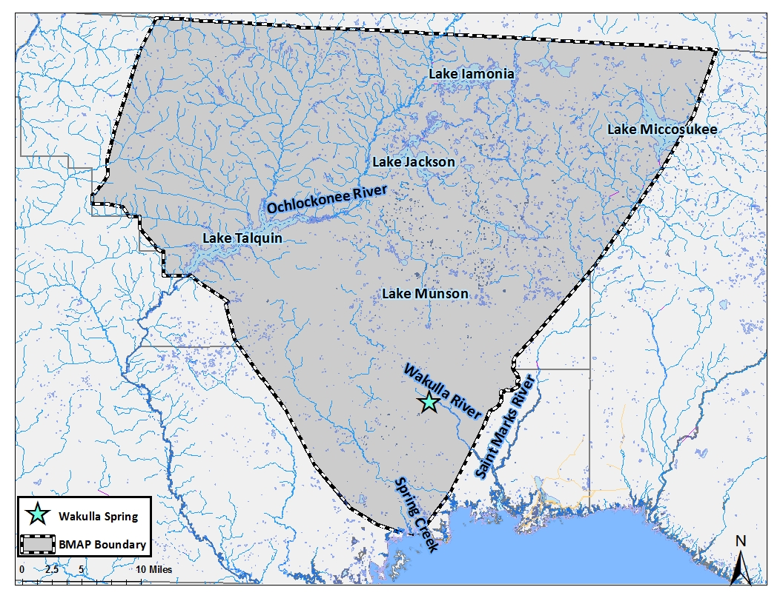
The BMAP study area was derived from the contributing area for Wakulla Spring (Figure 1). It covers almost 344,000 hectares ( 848,000 acres) encompassing parts of 4 different counties: Leon, Wakulla, Gadsden and Jefferson. Wakulla Spring is the start of the Wakulla River, which flows south and connects with the St. Marks River before discharging into Apalachee Bay.
Figure 1: Wakulla Spring BMAP study area.

2.1 Climate
The climate of the BMAP study area is humid subtropical, with a 30-year mean annual temperature of 68 ºF and a 30-year mean annual rainfall of 63.2 inches measured at the NOAA weather station at the Tallahassee Regional Airport (Gilbert, 2010). The largest amount of monthly rainfall typically occurs during June, July, and August, whereas the smallest monthly rainfall typically occurs in April, October, and November. The average yearly potential evapotranspiration for the Tallahassee area was estimated to be about 46 in/yr (Davis et al., 2010).

2.2 Hydrogeologic Setting
The hydrogeologic framework of the BMAP study area consists of sedimentary rocks of Tertiary through Quaternary age that consists of limestone, dolostone, clay and sand of varying degrees of lithification (Miller, 1986; Davis, 2006). Several previous studies have provided detailed descriptions of the stratigraphic nomenclature and geology of the region encompassing the BMAP study area (Hendry and Sproul, 1966; Miller, 1986; Davis, 1996; Chelette et al., 2002; Davis et al., 2010). This report briefly describes several key hydrogeologic factors affecting the movement of nitrogen from the land surface to the Upper Floridan aquifer (UFA).
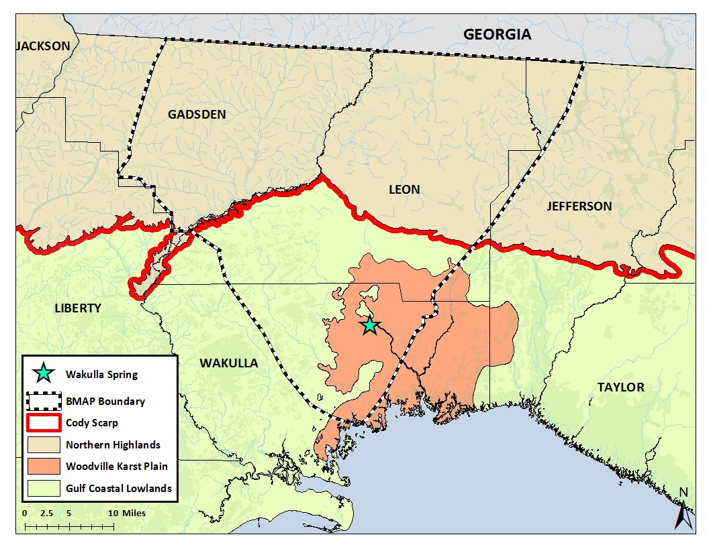
The BMAP study area lies within the Coastal Plain physiographic province and is characterized by two main geomorphic zones. The Northern Highlands, which occurs north of the Cody Scarp (Figure 2), comprises an extensive upland area where surface drainage is perched above the UFA due to the presence of relatively thick clayey sediments overlaying the UFA. The UFA, which is composed of limestones and dolostones of Eocene to Miocene age, is part of the Floridan aquifer system that occurs in Florida and parts of Georgia, South Carolina, and Alabama. The Woodville Karst Plain (WKP) extends southward from the Cody Scarp in southern Leon County to the Gulf Coast. The WKP is characterized as a flat or gently rolling surface of highly porous quartz sand overlying the limestone units (Suwannee Limestone and St. Marks Formation) of the UFA (Miller, 1986; Rupert, 1988). Limestone is generally within 25 ft of the surface in most of the karst plain. The top of the limestone rock in both units has undergone extensive dissolution by chemically aggressive waters, resulting in the development of large cavity and conduit systems (Miller, 1986). Consequently, the karst plain contains numerous wet and dry sinkholes, natural bridges, and disappearing streams (Rupert and Spencer, 1988).
Figure 2: Major geological structures in and around the BMAP boundary
The degree of confinement of the UFA in the BMAP study area (Figure 3) is grouped into three categories based on the thickness of overlying sediments as described by Miller (1986): unconfined, semi-confined, and confined. The UFA is unconfined where the aquifer crops out near the surface or where overlying sediments are thin or absent. Where confining units are less than 100 feet thick and or breached the UFA is referred to as semi-confined. Where these units are greater than 100 feet thick the UFA is considered to be confined. The material overlying the UFA varies in the amounts of sand, marl, limestone, clay, and dolomite of low permeability. The sand layers generally are referred to as the surficial aquifer system, whereas the mostly clay and limestone components comprise the intermediate aquifer system or the intermediate confining unit. The lithology, thickness, and integrity of this material have a controlling effect on the development of permeability and local groundwater flow (Bush and Johnston, 1988). The UFA is most vulnerable to contamination from the land surface in areas where it is unconfined. Detailed maps showing vulnerability assessments for the UFA have been prepared for Leon County (Advanced Geospatial Inc., 2007) and Wakulla County (Advanced Geospatial Inc., 2009).
Groundwater flow generally is from the northeast to the southwest or from north to south based on potentiometric surface maps for the UFA (Davis, 1996; Davis et al., 2010). Extremely high transmissivities in the UFA (greater than 1,000 ft²/d) (Davis, 1996) are associated with conduit systems for Wakulla Spring and account for a flattening of the potentiometric surface about 3-4 miles south of the Cody Scarp. Wakulla Spring is a major discharge point for water from the UFA in the karst plain. Flows from Wakulla Spring fluctuate greatly depending upon rainfall conditions (Davis, 2006; Davis et al., 2010).
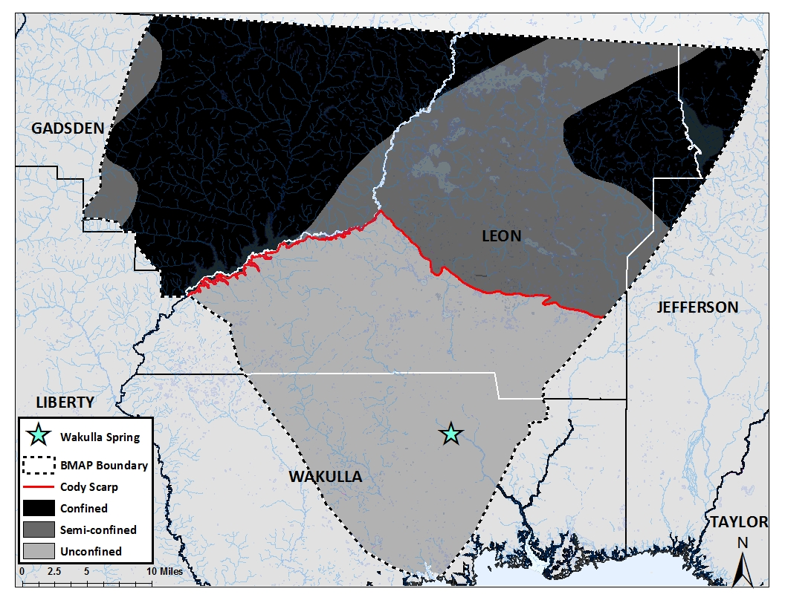
The source of recharge to the UFA is rainfall. Recharge to the UFA in the BMAP study area ranges from approximately 8 to 18 inches per year in the northern and southern parts of the study area, respectively. More recharge occurs in the southern part of the WKP than in the northern part, because there is little direct runoff due to the highly permeable sands overlying the UFA below the Cody Scarp. In addition, several disappearing streams recharge the UFA through sinkholes, such as Munson Slough, Lost Creek, and Fisher Creek. Fisher and Lost Creeks originate in the coastal lowlands and within the Apalachicola National Forest.
Figure 3: Recharge areas within the Wakulla Spring BMAP boundary

2.3 Land Use and Population
Land use (2009) in the BMAP study area is predominantly upland forests (50%). Other land-use types in order of decreasing percentages of the total are as follows: water and wetland (24%), urban and built up (14), agriculture (6%), rangeland (3%), and transportation (2%). The land use data arebased on the 2009/2010 Florida Ortho Quarterly Quad Aerial Imagery True color photography. The flight dates for each county vary: Leon County in January 2009, Jefferson County in January 2010, Gadsden County in February 2010, and Wakulla County in February to March 2010. Photo interpretation and ground-truthing were performed by the FDEP Water Resource Monitoring staff.
The BMAP study area encompasses four counties with the following populations as reported in the 2010 Census: Leon (275,487), Gadsden (46,389), Jefferson (14,761), and Wakulla (30,776). Most of the population in Wakulla County is concentrated in the WKP since most of the western half of Wakulla County and southwestern Leon County lies in the Apalachicola National Forest and closed to development. The population of Leon and Wakulla Counties is projected to increase by approximately 7.5% and 15.7%, respectively, from 2010 to 2020 (edr.state.fl.us). Also expected to increase with population growth is the number of septic tanks for waste disposal that may result in increased source impacts to groundwater and surface waters.

3. Methods for Estimating Nitrogen Inputs and Loads to Ground Water

3.1 Atmospheric Deposition

3.1.1 Wet Deposition
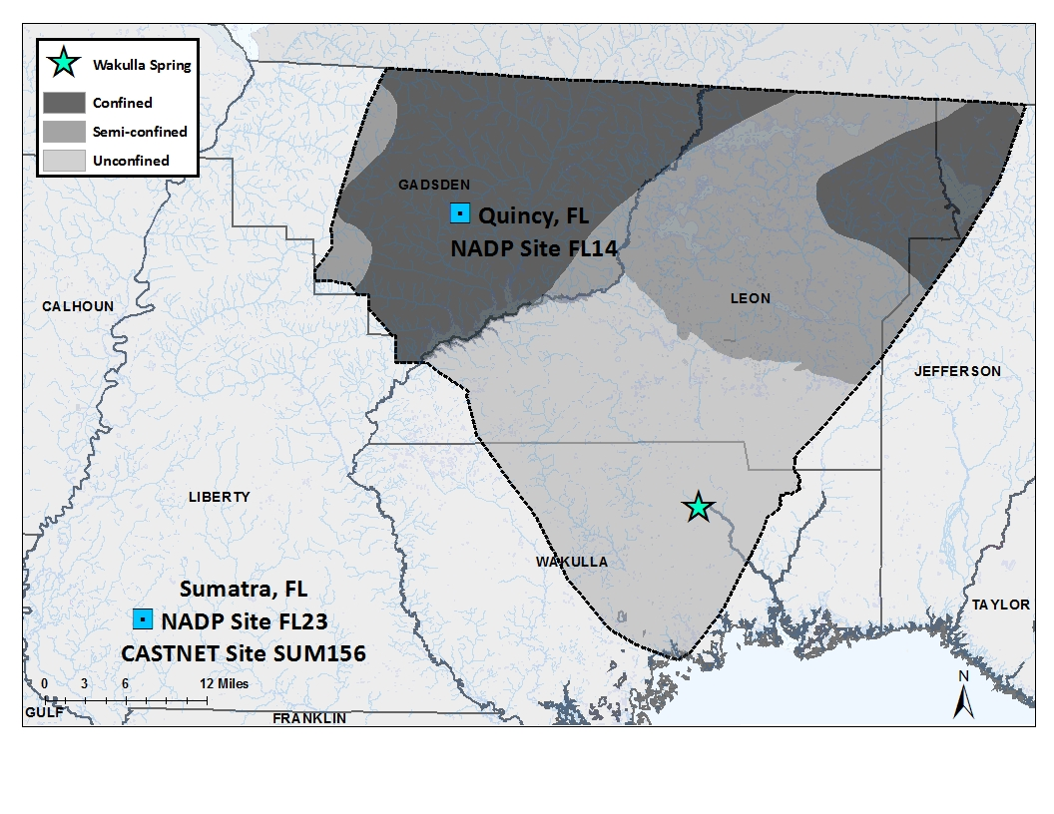
In the 1970s, atmospheric deposition was recognized as causing serious environmental impacts, as acid rain and other effects of air pollution were beginning to be understood. From this attention the National Atmospheric Deposition Program (NADP) was created in 1978 and now has over 250 stations throughout the United States. Samples are collected weekly at each station and analyzed for many different chemicals, including NH₄ and NO₃. There are two stations of interest for our study area: FL14 in Quincy, FL and FL23 in Sumatra, FL (Figure 4). Both sites were analyzed because of their close proximity to the BMAP study area and due to the additional monitoring capacity at the Sumatra location for dry deposition. This will be discussed in more detail later.
The data for these stations as well as others is public information and can be obtained at the NADP website (nadp.sws.uiuc.edu). Monthly data from 2002 to 2012 for both stations (FL14 and FL23) was downloaded and analyzed. Annual data are available for download, but these data were found to have errors relating to years when a month is missing information. Data can be missing because it did not meet quality control assessments or the station was shut down for maintenance. The annual results appeared to include the questionable or missing data skewing the final results. For years with complete monthly data, the annual data available through NADP is a reliable alternative.
Figure 4: Atmospheric deposition monitoring stations for NADP and CASTNET programs.
Nitrogen inputs are expressed as kilograms of nitrogen per year (kg-N/yr). The retrieved NADP data are in mg/L for both NO₃ and NH₄ and can be converted using the below equations. Appendix (Table A 1) contains the conversion factors which convert the NADP data in mg-N/L to kg-N per hectare.
Equation 1 $\frac{mg-{NO}_{3}}{L}×2.260e^{-4}×Rainfall \left(\frac{L}{ha}\right)× 0.001= \frac{kg-N}{ha} {NO}_{3}$
Equation 2 $\frac{mg-{NH}_{4}}{L} ×7.765e^{-4}×Rainfall \left(\frac{L}{ha}\right)× {0.001}^{{}_{c}^{ } }= \frac{kg-N}{ha} {NH}_{4}$
In order to determine the total yearly deposition, the monthly data were summed for each individual year. These annual totals were then averaged to determine the average annual wet deposition between 2002 and 2012.
For 2012, November and December data were not yet available so the concentrations for these months were projected based on the available 2012 data. The average concentration of NH₄ and NO₃ for January-October of 2012 was calculated and used as the deposition for November and December.

3.1.2 Dry Deposition
Dry deposition is monitored through the Clean Air Status and Trends Network (CASTNET) which was established in response to the Clean Air Act Amendments in 1991. This program monitors ambient air chemistry including rural ozone. This is the only nationwide program collecting reliable long-term data for acidic dry deposition (USEPA, 2013). The NADP station FL23 at Sumatra is also the location of the CASTNET site SUM156. The dry deposition data from this site is beneficial for this project which is why wet deposition data also were analyzed for this station. Since the wet deposition from this station was consistent with the Quincy station located within the BMAP boundary, it can be assumed the dry deposition would be representative of deposition conditions throughout the study area. Therefore, the CASTNET site SUM156 was used to estimate the dry deposition for the study area.
The data for this site can be found on the CASTNET website (epa.gov/castnet). Total deposition as well as weekly data are available. The total deposition was only available through 2010 when calculations were made, but was available through May 2012 for the weekly data. To include more data and remain consistent calculations, the weekly data were used for this project. Since the 2012 data only were available through May 2012, the deposition was estimated for June 2012 to December 2012 by using the average value measured from January 2012 to May 2012 . As was the case with wet deposition, the total yearly dry deposition was calculated and averaged to determine the annual average dry deposition.

3.1.3 Total Deposition
After calculating the NO₃-N and NH₄-N for both wet and dry deposition, these two quantities were added together to estimate the annual total nitrogen (TN) attributed to atmospheric deposition (in kg-N per hectare). The TN concentrations are multiplied by the BMAP area to convert to kg-N/yr. The result is the annual average atmospheric deposition applied to the land surface of the Wakulla Spring BMAP boundary.

3.2 Wastewater Treatment Facilities (WWTF)
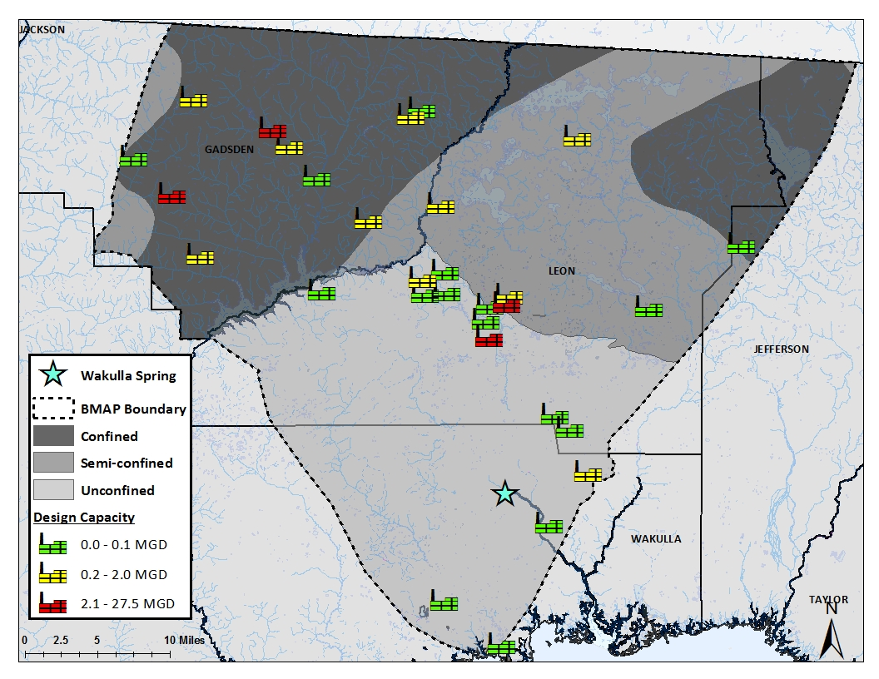
Wastewater treatment facilities throughout the nation generate large quantities of nitrogen in their effluent, which typically is discharged to surface water bodies, applied to the land surface, or injected into deep zones of saline aquifers (Katz et al, 2009). WWTF are under constant pressure to reduce effluent nitrogen concentrations while populations continue to increase. Within the study area, there are 15 domestic WWTF and 1 industrial site with available monitoring data (Figure 5). This database is maintained by the FDEP Water Resource Management staff as part of the Water Compliance Assurance Program. The majority of these sites have low discharge which reduces the overall loading from these facilities. The City of Tallahassee has the largest design capacity and discharge within the entire BMAP boundary. The effluent from the TP Smith Water Reclamation Facility and Lake Bradford Road WWTF are both sprayed onto the southeast spray field located in an area in southern Leon County where the UFA is unconfined.
Figure 5: Map of the WWTF utilized for this project within the BMAP boundary
Effluent and well data were obtained through FDEP’s Wastewater Facility Regulation Discharge Monitoring Reports (DMR). When available, effluent nitrogen data were used to estimate nitrogen inputs; but when effluent data were not available, nitrogen concentrations in samples from monitoring wells closest to the effluent discharge location were used. Depending on the available data, annual average concentrations were calculated from 2002 to 2012. An annual average for the ten-year period was also calculated and was used to determine loading for WWTF.
The design capacity of each treatment facility describes the amount of water it is permitted to discharge. Rarely will these facilities meet their design capacity and in reality will only reach about 50% of this capacity. Therefore, the loading for WWTF was calculated using the average annual TN concentration and assuming 50% of the yearly design capacity volume. The facilities and their average annual inputs were then estimated for the three recharge areas.

3.3 Septic Tanks
Approximately a third of Florida’s population utilizes on-site sewage treatment and disposal systems, (OSTDS), also referred to as septic tanks. These systems can contribute to decreasing ground water quality especially with nitrogen contamination (Chang et al, 2010). In 2009, the Florida Department of Department of Health (FDOH) developed a method for estimating the number of septic tanks based on tax parcel data and known sewer service areas (Hall and Clancy 2009). FDOH created an ArcGIS shapefile which contains the locations of the known as well as estimated septic tanks. From this file, the number of septic tanks in each county and recharge area within the BMAP boundary was determined.
After establishing the number of septic tanks in the study area, the number of people utilizing the septic tanks was estimated. The US Census Bureau collects information pertaining to population and household occupancy in each county. For this project, the 2010 census data were used (US Census Bureau website, www.census.gov). The census makes a distinction between occupied and non-occupied households. The populations within Leon, Gadsden, Jefferson and Wakulla counties were divided by the occupied households within the county resulting in the average number of people per household. This number was multiplied by the number of septic tanks previously determined. This provided an estimate of the number of people contributing waste to septic tanks within the study area. A loading factor of 4.24 kg-N/person/yr was then applied to the population of septic tanks users (Katz et al 2009). This information was used to estimate the nitrogen inputs from septic tanks for the three recharge areas

3.4 Fertilizers
Applying fertilizers is common practice throughout the nation on a variety of land uses, such as agricultural,residential, golf courses, and pine stands. . Excess amounts of fertilizers are frequently flushed through the environment ending up in both surface and ground waters resulting in elevated nutrient concentrations (Bohlke, 2002; Hochmuth et al, 2011). The most widely used approach to estimate nitrogen inputs from fertilizer use is to rely on county fertilizer sales data compiled by the Florida Department of Agriculture and Consumer Services (Chellete et al, 2002; Gronberg and Spahr, 2012). This method has some limitations because fertilizers sold in one county may travel to another to be applied. This causes the calculations for the county in which the fertilizer is sold to be higher than what is actually applied. Since this information is not tracked, it is unknown how much county-to-county transfer of fertilizer occurs or if the travel of fertilizers between counties equals out over time. Without more detailed information regarding the actual usage or application from both residential and farm fertilizers, the county fertilizer sales data are used to estimate nitrogen inputs.
The fertilizer sales data are available from the Florida Department of Agricultural and Consumer Services (www.flaes.org/complimonitoring/past_fertilizer_reports.html). For this project, the data are used from two different reports: Summary by County and Nutrients by County. These are .pdf documents which are available annually. The dates for each report run from July 1 of one year to June 30 of the next. Since this project is analyzing the annual average loadings, the data were calculated using the data from the report ending in that year. For example, the report from July 2011 to June 2012 was used to calculate the loadings for 2012.
The total amount of fertilizers sold can be found in both of the reports. The total fertilizer sold for farm and non-farm practices is in the Summary by County report and the total nitrogen in the fertilizer sold is available in the Nutrients by County report. All FDOA fertilizer data are reported in tons. The total inputs to the land surface for farm fertilizers sold in each county were calculated according to Equation 3. The non-farm fertilizers are also calculated using the same approach.
Equation 3 $\left(\left(\frac{{N in fertilizer }_{County}}{total {fertilizer }_{ County}}\right)×{ farm ferilizer }_{County}\right)×907.1847={total N in farm fertilizer}_{County}$
The results of these calculations provide the total kg-N/yr in farm and non-farm fertilizers for the entire county. The BMAP study area spans Gadsden, Leon, Wakulla and Jefferson counties, but only portions of each county. To estimate the amount of nitrogen in fertilizers applied within the BMAP area, 2009-2010 land use data available from FDEP’s GIS database (DataMiner) were evaluated. An ArcGIS shapefile was created from 2009-2010 Northwest Florida Water Management District (NWFWMD) aerial photography. Farm and non-farm land use areas were determined and calculated. Relevant farm land use categories for the springshed included row crops, field crops, hay fields, groves, nurseries and vineyards, tree nurseries, sod farms and ornamentals. The non-farm categories of interest were low, medium and high density residential areas as well as golf courses.
For each county, the land areas associated with farm and non-farm fertilizer practices were totaled. This was also done for the three categories of recharge within each county. A percentage of the fertilizer nitrogen inputs for the unconfined, semi-confined and confined areas were calculated relative to the county area. These percentages were applied to the total farm and non-farm fertilizer for each county. For example, if 100,000 kg-N of fertilizer was sold in a particular county each year, but only 10% of the county farmlands are inside the study area, it is assumed that an input of only 10,000 kg-N was contributed to the study area.

3.5 Livestock Waste
Every 5 years the US Department of Agriculture releases a Census of Agriculture (CoA). This comprehensive report summarizes the agricultural practices (including livestock populations) for each state and county in the U.S. The data are available on their website (www.agcensus.usda.gov) and can be sorted by state and county. During the study period (2002-2012), two censuses have been completed and released to the public: 2002 and 2007. The 2012 census will be released in 2014 and therefore, these data are not included in this report. The livestock categories used to estimate the nitrogen loading for the springshed are listed in Table 1. Once the inventories for each county were determined, nitrogen inputs to the land surface were estimated for each animal category. Alternatively, the National Agricultural Statistics Service also estimates the livestock populations on an annual basis. For Florida, these data are available (nass.usda.gov/Statistics_by_State) starting in 2007 for cattle only.

The CoA data are compiled for each county in the in the BMAP study area and as was the case with fertilizers, land use percentages were used to determine the loading for the areas of interest within each count. The land was divided using the same method described in Section 3.4 for fertilizers. The following land use categories were used to apportion the animal populations in the area of interest relative to the county area: improved pastures, unimproved pastures, woodland pastures, cattle feeding operations, poultry feeding operations, specialty farms, horse farms, dairies and aquaculture. These are not the only possible livestock lands, but they are the only ones present in one or more of the counties of interest. The land use percentages were used to determine the loading attributed to livestock within each county and recharge area.

Table 1: The daily loading factors for the livestock animals of interest.
Livestock Category | Loading factor  (kg-N/day/animal) | References
Cattle, including calves | 0.219 | Goolsby et al 1990; Katz et al 1999; Chelette et al 2002; Ruddy et al 2006; Katz et al 2009; Meyer 2012; Sprague and Gronberg 2013
Chicken, broilers | 0.072
Chicken, layers | 0.0012
Hogs | 0.086
Sheep, including lambs | 0.09 | Goolsby et al 1990; Ruddy et al 2006; Katz et al 2009
Horses | 0.124 | Goolsby et al 1990; Ruddy et al 2006; Katz et al 2009
Turkeys | 0.0025 | Goolsby et al 1990; Ruddy et al 2006; Katz et al 2009; Sprague and Gronberg 2013
Goats | 0.016 | Katz et al 2009

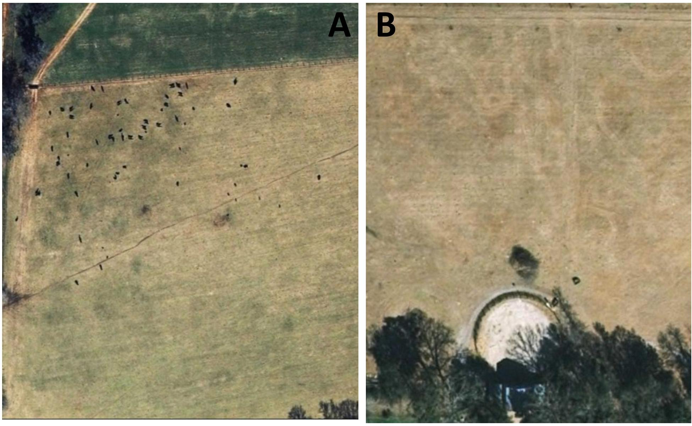
It was apparent the CoA animal census data may not be the most representative of the actual livestock populations in the BMAP study area. As a cross-check on the census data, an aerial imagery analysis was used to assess the accuracy of the CoA information on animal populations. A grid was overlaid on the NWFWMD 2009 aerial imagery with each cell covering 900 square miles (30 mi by 30 mi). Using a scale of 1:4,900, pasture lands containing livestock animals are visible. The numbers of cows and/or horses present in a field were counted as the aerial photo was further enlarged. Figure 6 gives examples of cows and horses in pastures counted using this method. Other livestock animals (pigs, goats, poultry, goats, sheep, lambs) evaluated using the CoA method were not counted because they are too small to be seen in the aerial imagery. The CoA indicated that cows and horses had the largest populations and the largest loading factors. Therefore, these two animal categories would have the highest nitrogen inputs in the study area.
Figure 6: Examples of cows (A) and horses (B) in pastures as observed through the aerial imagery analysis.

3.6 Sinking Streams
Surface water flowing into sinkholes or swallets can have a detrimental impact on ground water quality. Contaminants in sinking streams flow directly into the UFA with little or no attenuation or degradation Katz et al., 1997, 1998). There are four prominent sinking streams within the study area: Lost Creek, Black Creek, Munson Slough, and Fisher Creek (Figure 7). These streams have been traced and are known to contribute to the water which eventually flows from Wakulla Spring. To assess the nitrogen inputs attributed to these streams, discharge data as well as nitrogen concentrations were evaluated.
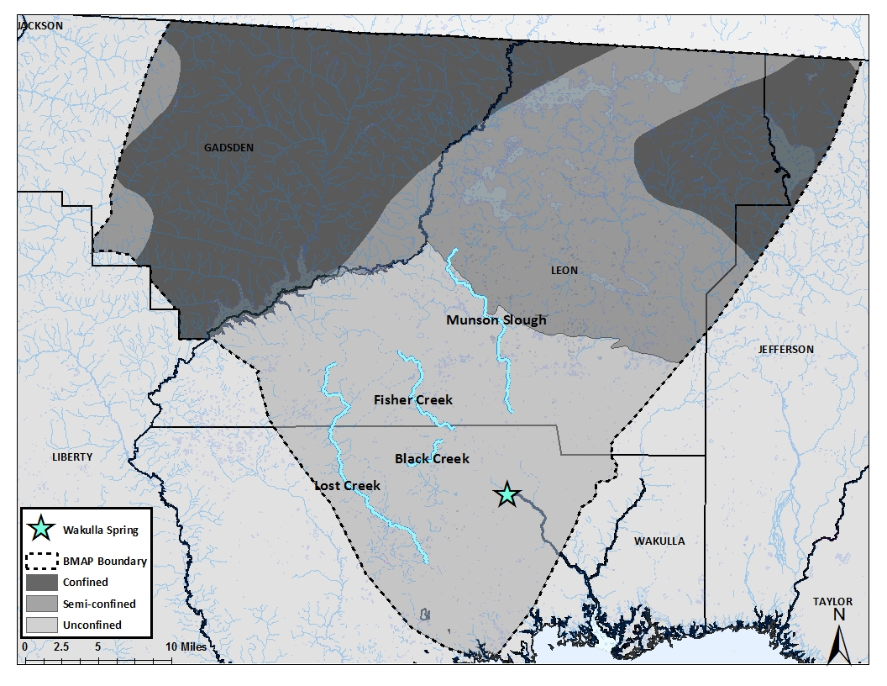
For Fisher Creek and Lost Creek, discharge data were obtained from the USGS National Water Information System for gaging stations 02326993 and 02327033, respectively. Discharge data were available from 2007-2009 for Fisher Creek and from 2002-2007 for Lost Creek. A gaging station is also located on Munson Slough, but is maintained by Northwest Florida Water Management District. Data from 2002 to 2010 was obtained by request from NWFWMD for this station. Black Creek does not have an active gaging station, but discharge data were provided by the author of a Master’s study project from March 2009 to May 2009 (Kulakowski ,2010).
Figure 7: The sinking streams within the BMAP boundary
Water quality data have been collected on all streams intermittently throughout the time period of interest. These data were obtained from STORET and annual averages of nitrogen inputs were estimated using the monitoring stations closest to where the stream disappears below the land surface. Nitrogen inputs from the sinking streams were estimated by multiplying the average annual discharge times the average annual nitrogen concentrations. It is important to note that discharge and nutrient data were not necessarily measured at the same time or for the same years.

3.7 Environmental Attenuation of Nitrogen and Loading to Ground Water
Nitrogen is a vital component to life and is readily assimilated by plants and animals. When nitrogen is applied in excess of what can be processed, elevated nitrogen levels will result in ground water and surface waters because of the high water solubility of nitrogen species (nitrate, nitrite, and ammonium) (Nolan et al, 1997). The methods utilized to estimate nitrogen inputs to the land surface have been described above. To estimate the amount of nitrogen loading to ground water (and Wakulla Spring), the amount nitrogen attenuation as it moves from the land surface to the ground-water system needs to be considered.
Nitrogen attenuation can be influenced by many naturally occurring physical, chemical or biological processes such as biodegradation, dispersion, dilution, adsorption, and cation exchange. These processes are not uniform through the environment and will occur to varying degrees depending on how the nitrogen is introduced, soil properties, and other factors (Cockx and Simonne, 2011; Costa et al, 2002;Dudley, 2009). Due to this variability, attenuation factors are specific for each nitrogen source category. The factors utilized were derived from literature and can be found in Table 2. These factors represent the amount of nitrogen which is removed by processes occurring in the environment and therefore will not reach the aquifer.
To estimate loading to ground water, the aforementioned nitrogen inputs at the land surface from each category are multiplied by their associated attenuation factors. For example, atmospheric deposition has 90% environmental attenuation (e.g. uptake by vegetation). This means that 10% of the atmospheric nitrogen would reach the UFA.
Table 2: Attenuation factors applied to the nitrogen loading calculations. These percentages represent the amount of nitrogen removed by the environment.
Nitrogen Source Category | Attenuation Factor | Source
Atmospheric Deposition | 90% | Katz et al 2009; Lombardo Associates 2011; HT Odum 2011
WWTF | 60% | Katz et al 2009; Lombardo Associates 2011; HT Odum 2011
Septic Tanks | 30% | Katz et al 1999; Costa et al 2002; Rosen et al 2006; Otis 2007; Katz et al 2009; Katz et al 2010; Lombardo Associates 2011
Farm Fertilizers | 70% | Goolsby et al 1999; Katz et al 2009; HT Odum 2011; Lombardo Associates 2011
Residential Fertilizers | 80% | Goolsby et al 1999; Katz et al 2009; HT Odum 2011; Lombardo Associates 2011
Livestock Waste | 75% | Goolsby et al 1999; Katz et al 1999; Baton et al 2005; Katz et al 2009; Lombardo Associates 2011
Sinking Streams | 20%

3.8 Recharge and Aquifer Confinement
The amount of water which recharges the UFA depends on the amount of rainfall, evapotranspiration, and subsurface hydrogeologic properties. The final step for estimating nitrogen loads to ground water is to provide a weighting factor for the amount of recharge for the three categories of aquifer confinement. Davis et al (2011) reported that of 20 inches of rainfall, 18 inches will reach the aquifer in unconfined areas (90%), 8 inches in moderately confined areas (40%) and 2 inches in confined areas (10%). The water entering the aquifer in an unconfined area will have a much larger impact on ground water and spring water quality and quantity than in areas where the aquifer is confined due to the lower amount of recharge which occurs (Katz et al, 2001). For the final nitrogen inputs estimates to the land surface, recharge factors were applied to take into account the varying degrees of aquifer confinement. Thus, based on the above recharge information, the amount of nitrogen inputs to the land surface in each confinement category is multiplied by the following factors: unconfined (0.9), semiconfined (0.4), and confined (0.1). This calculation gives the final estimates of nitrogen loading to the Wakulla Spring BMAP study area.

4. Results—Nitrogen inputs to the land surface

4.1 Atmospheric Deposition

4.1.1 Wet Deposition
Data from the two NADP monitoring stations were analyzed to evaluate the consistency and comparability between data measured at each station. At station FL14, the annual NH₄ data ranged from 0.83 to 1.74 kg-N/ha/yr, with an average and median value of 1.14±0.27 kg-N/ha/yr, and 1.20 kg-N/ha/yr, respectively. At station FL23, the same data had an average value 1.11±0.34 kg-N/ha/yr, median of 1.07 kg-N/ha/yr and a range from 0.59 kg-N/ha/yr to 1.68 kg-N/ha/yr. The differences between these data are minor which is supported by the overlapping errors associated with the averages.
The NO₃ data also showed a similar relation between the two monitoring stations. At FL14, the annual NO₃ data were measured between 1.23 kg-N/ha/yr and 1.93 kg-N/ha/yr. The average result was 1.59±0.26 kg-N/ha/yr, and the median was 1.67 kg-N/ha/yr. For FL23, the data ranged from 1.17 to 2.32 kg-N/ha/yr with an average of 1.74±0.35 kg-N/ha/yr and a median of 1.70 kg-N/ha/yr.
After verifying the data from the individual stations are comparable, the calculated TN for each station was averaged and these data are listed in Table 3. Given the close proximity of these stations and consistency between their data, the average concentrations were used in determining the average annual yield of TN from atmospheric deposition. A complete listing of the wet deposition data is in Appendix (Table A 2).
Table 3: Average annual TN concentrations (kg-N/ha) measured in wet atmospheric deposition from NADP monitoring stations in northwest FL
Year | FL14 (Quincy) | FL23 (Sumatra) | Average
2002 | 2.59 | 3.07 | 2.83
2003 | 3.15 | 3.67 | 3.41
2004 | 2.76 | 2.79 | 2.78
2005 | 3.20 | 4.00 | 3.60
2006 | 2.93 | 3.15 | 3.04
2007 | 2.06 | 2.05 | 2.05
2008 | 2.51 | 2.32 | 2.42
2009 | 3.46 | 3.61 | 3.54
2010 | 2.50 | 2.67 | 2.58
2011 | 2.59 | 2.29 | 2.44
2012 | 2.36 | 1.76 | 2.06
Average | 2.74±0.41 | 2.85±0.72 | 2.80±0.55

4.1.2 Dry Deposition
Data from the CASTNET site SUM156 was calculated to estimate the average annual dry deposition influencing the study area. A full listing of this data can be found in Appendix (Table A 3). There was a range of NO₃ values between 0.023 and 0.041 kg-N/ha/yr with an average and median of 0.029 kg-N/ha/yr with a standard deviation of 0.01. The NH₄ had an average of 0.15±0.04 kg-N/ha/yr with a median of 0.153 kg-N/ha/yr and a range of value of 0.099 to 0.205 kg-N/ha/yr.

4.1.3 Total Atmospheric Deposition
The wet and dry deposition totals were combined to evaluate the total atmospheric deposition for the springshed. The NH₄ and NO₃ data were combined to calculate an annual average TN concentration. Table 4 contains the combined wet and dry deposition data. Wet deposition nitrogen comprises 93% of the totals, which may be related to the greater accuracy in collecting wet deposition than dry deposition.
Table 4: Annual total atmospheric deposition data in kg-N/ha. For both wet and dry deposition, projected values are included for 2012 due to incomplete data.
Year | NO₃ | NH₄ | Total N
2002 | 1.87 | 1.17 | 3.05
2003 | 2.09 | 1.51 | 3.60
2004 | 1.80 | 1.19 | 2.99
2005 | 2.14 | 1.69 | 3.83
2006 | 1.82 | 1.43 | 3.25
2007 | 1.32 | 0.92 | 2.24
2008 | 1.63 | 0.94 | 2.57
2009 | 1.88 | 1.78 | 3.66
2010 | 1.47 | 1.24 | 2.71
2011 | 1.33 | 1.28 | 2.61
2012 | 1.32 | 0.90 | 2.22
Average | 1.70±0.30 | 1.28±0.30 | 2.97±0.56

Based on this data set, a total of 2.97±0.56 kg-N/ha/yr is applied to the land surface within the Wakulla Spring BMAP boundary. As it has already been established, varying degrees of recharge exist within the BMAP study area. The total amount of atmospheric nitrogen per year can be found in Table 5.
Table 5: Total atmospheric deposition applied to the land surface within the Wakulla Spring Springshed divided by recharge area.
Recharge Area | Land Area  (ha) | Atmospheric Deposition  (kg-N/yr)
Unconfined | 121,214 | 360,560
Semi-confined | 93,971 | 279,523
Confined | 127,960 | 380,625
Total BMAP Boundary | 343,146 | 1,020,708

4.2 Wastewater Treatment Facilities (WWTF)
The water-quality monitoring data were downloaded for each WWTF within the study area through WAFR-DMR. Table 6 contains the summary information as well as the design capacity for each facility. It is important to note that the Lake Bradford Road plant is physically located in the semi-confined recharge area, however; the effluent from this plant is applied to the City of Tallahassee’s SE spray field which is located in the unconfined. For this reason, Lake Bradford Road is listed under the unconfined WWTFs.
Table 6: Monitoring data for WWTF within the springshed.
WWTF Name | Facility ID | Recharge Area | Annual Average TN (mg-N/L) | Design Capacity  (MGD)
T P Smith Water Reclamation Facility | FLA010139 | Unconfined | 6.021 | 27.5
Woodville Elementary School | FLA010136 | Unconfined | 2.502 | 0.01
Disc Village | FLA010137 | Unconfined | 5.456 | 0.02
Western Estates | FLA010152 | Unconfined | 3.302 | 0.02
Lake Bradford Estates | FLA010148 | Unconfined | 0.281 | 0.043
Sandstone Ranch WWTF | FLA010167 | Unconfined | 2.509 | 0.0707
Lake Bradford Road | FLA010140 | Unconfined | 24.225 | 4.5
Oyster Bay Estates | FLA010237 | Unconfined | 0.681 | 0.06
River Plantation Estates | FLA010241 | Unconfined | 2.349 | 0.025
Winco Utilities, Inc | FLA016544 | Unconfined | 0.242 | 0.495
Killearn Lakes | FLA010173 | Semi-confined | 9.175 | 0.7
Lake Jackson | FLA010171 | Semi-confined | 2.714 | 0.75
Meadows - At – Woodrun | FLA010159 | Semi-confined | 2.000 | 0.07
Gadsden East WWTF | FLA187941 | Confined | 0.163 | 0.25
City Of Gretna | FLA100781 | Confined | 1.422 | 0.35
Havana | FLA100765 | Confined | 1.056 | 0.4
Quincy | FL0029033 | Confined | 3.290 | 1.5
Gamboa Brothers, Inc. | FLA010088 | Confined | 11.980 | 20
Havana Middle School | FLA010085 | Confined | 0.473 | 0.015
Greensboro High School | FLA010074 | Confined | 2.605 | 0.012
Capital City Plaza | FLA010134 | Confined | 2.723 | 0.03

The nitrogen input calculations are based on the assumption that the facility only discharges 50% of their design capacity at the average annual TN concentrations. The TN inputs attributed to the WWTF in the BMAP study area is in Table 7. Based on the data available between 2002 and 2012, there was 361,297 kg-N/yr applied to the land surface within the study area from WWTF.
Table 7: Total loading attributed to WWTF within the BMAP boundary area.
Recharge Area | WWTF  Nitrogen Loading  (kg-N/yr)
Unconfined | 190,110
Semi-confined | 1,503
Confined | 169,684
Total BMAP Boundary | 361,297

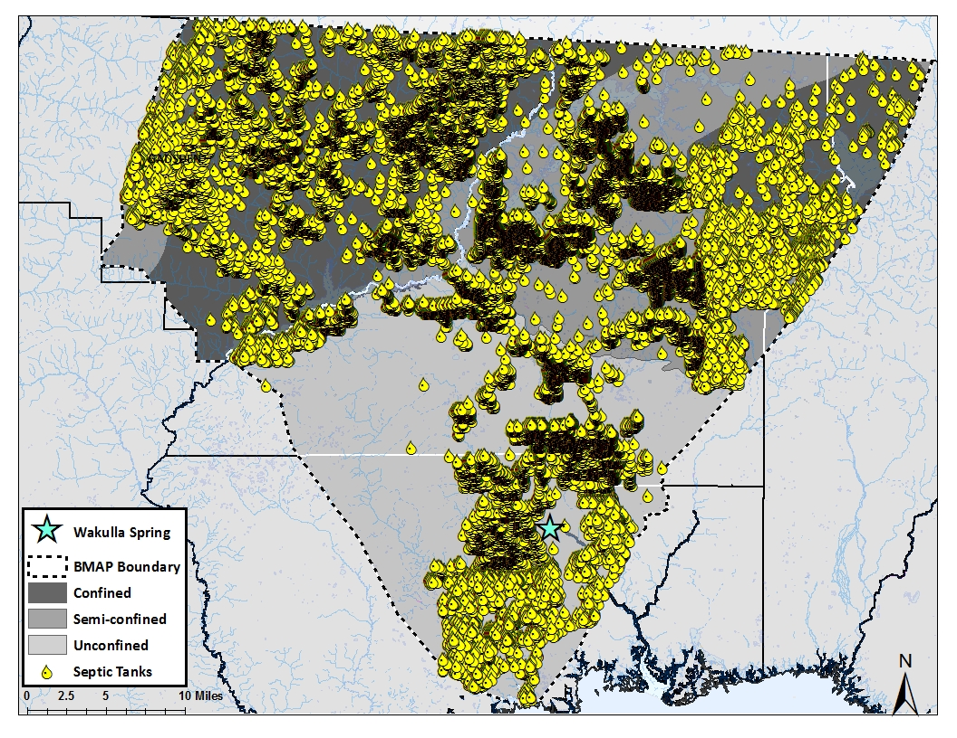
4.3 Septic Tanks
The FDOH septic tank counting method provides two different categories of septic tanks: known and estimated. The estimated tanks are found in parcels with unknown waste disposal but are assumed to contain a septic tank rather than a hook up to a sewer system based on the surrounding disposal systems. The sum of known and estimated septic tanks is used for these calculations and were divided between the different counties and recharge areas (Table 8). The distribution of the septic tanks throughout the BMAP study area is shown in Figure 8.
Table 8: The number of septic tanks, as determined by Hall and Clancy (2009), distributed throughout the springshed.
County | Recharge Area | Number of  Septic Tanks
Leon | Unconfined | 8,578
Leon | Semi-confined | 21,259
Leon | Confined | 2,112
Wakulla | Unconfined | 7,595
Gadsden | Semi-confined | 654
Gadsden | Confined | 11,719
Jefferson | Semi-confined | 92
Jefferson | Confined | 437
Figure 8: Septic tank distribution throughout the BMAP boundary area
The number of people per household was calculated based on the occupied households in the county and the population (2010 Census). In Leon County, the 275,487 people occupy 110,945 households resulting in an average of 2.48 people per household. In Wakulla County, the population was 30,776, which resides in 10,490 households, giving an average of 2.93 people per household. Gadsden County had 46,389 people in 16,952 houses with an average of 2.74 people per household. In Jefferson, there were 5,646 occupied households for 14,761 people or 2.61 people per household. The average number of people per household was multiplied by the number of septic tanks in Table 8. On average, a person will contribute 4.24 kg-N/yr (Katz et al 2009). This factor was applied to the number of people utilizing septic tanks throughout the recharge areas in each county (Table 9).
Table 9: Total nitrogen loading attributed to septic tanks divided into the recharge areas.
Recharge Area | Septic Tank  Nitrogen Loading  (kg-N/yr)
Unconfined | 134,138
Semi-confined | 149,602
Confined | 107,041
Total BMAP Boundary | 390,781

4.4 Fertilizers
The percentage of nitrogen in the fertilizers sold throughout the BMAP study area varied both by year and among the three counties. In total, 10% of the total weight of fertilizer sold was nitrogen. In Leon County, this ranged between 5% and 13% with an average of 9% and a median value of 10%. In Wakulla County, the average nitrogen percentage was 6% with a median of 8%. There was a range of less than one percent to 12%. In Gadsden County, the data ranged between 6% and 10% with a median and average of 7%. In Jefferson County, the percentage of nitrogen in the fertilizers sold was higher than the other counties with an average and median of 17% and a range of 11% to 20%. A detailed listing of data used in making these percentages can be found in Appendix (Table A 4-Table A 7).

4.4.1 Farm Fertilizers
Between 2002 and 2012, annual fertilizer sales have been continually decreasing. While this is not a linear decrease, it is evident for all four counties. Gadsden County contains a substantial amount of agricultural lands and this is reflected in the fertilizer sales data. The average sold was 707,221 kg-N/yr with a range between 358,865 kg-N in 2012 and 1,081,968 in 2007. Leon County ranged from 91,512 kg-N sold in 2002 to 15,590 kg-N in 2012. Over the ten year period, the average sales were 55,369 kg-N/yr. The sales in Wakulla County were the lowest for this project with an average of 7,627 kg-N/yr, ranging from 17,451 kg N in 2003 to 877 kg-N in 2012. Jefferson County reported the largest amount of fertilizers sold with an average of 1,359,282 kg-N/yr with a range between 1,053,366 kg-N sold in 2011 and 1,868,995 kg-N sold in 2003.
The full county data were used to approximate the fertilizer N inputs in the three recharge areas based on the percentage of farmland in the recharge area relative to the full county. These percentages can be found in Table 10. A detailed summary of these data is in Appendix (Table A 8). The loadings for each recharge area were calculated using these percentages and a total loading attributed to farm fertilizers was determined. This summary data can be found in Table 11.

Table 10: Land use areas and percentages for farm lands in the springshed.
County | Recharge Area | Farm Fertilizer
County | Recharge Area | Land Area (ha) | Land % | Loading to  Land Surface  (kg-N/yr)
Leon | Full County | 3,470 | 100 | 55,369
Leon | Unconfined | 80 | 2.3 | 1,282
Leon | Semi-confined | 1,920 | 55.3 | 30,640
Leon | Confined | 1,435 | 41.4 | 22,895
Wakulla | Full County | 815 | 100 | 7,627
Wakulla | Unconfined | 725 | 88.9 | 6,778
Gadsden | Full County | 8,494 | 100 | 707,221
Gadsden | Semi-confined | 1,077 | 12.7 | 89,643
Gadsden | Confined | 6,028 | 71 | 501,906
Jefferson | Full County | 9,580 | 100 | 1,359,282
Jefferson | Semi-confined | 204 | 2.1 | 1,018
Jefferson | Confined | 973 | 10.2 | 138,034

Table 11: Summary of farm fertilizer loading to the springshed.
Recharge Area | Farm Fertilizer  Nitrogen Loading  (kg-N/yr)
Unconfined | 8,060
Semi-confined | 149,217
Confined | 662,835
Total BMAP Boundary | 820,113

4.4.2 Non-farm Fertilizer
Unlike the sales data for farm fertilizers, the largest amount of fertilizers sold for non-farm applications were in Leon County. There was an average of 200,849 kg-N/yr sold in Leon County with a range between 118,179 kg-N to 429,529 kg-N. Gadsden County had a range from 20,551 kg-N to 106,689 kg-N with an average of 56,391 kg-N/yr. Jefferson had an average of 66,040 kg-N/yr with a range of 32,978 kg-N to 147,624 kg-N. In Wakulla County, the fertilizer sales were lower than the other three counties. The average was 6,776 kg-N/yr with a range of data between 301 kg-N to 15,736 kg-N. The land use percentages were also calculated for non-farm fertilizer lands as they were for farm fertilizers (Appendix Table A 9). This data and the loadings for each county and recharge areas are in Table 12. The summary of these data for the springshed are listed in Table 13.

Table 12: Land use areas and percentages for non-farm lands in the springshed.
County | Recharge Area | Non-Farm Fertilizer
County | Recharge Area | Land Area (ha) | Land % | Loading to  Land Surface  (kg-N/yr)
Leon | Full County | 26,244 | 100 | 200,849
Leon | Unconfined | 4,748 | 18.1 | 36,929
Leon | Semi-confined | 19,261 | 73.4 | 149,572
Leon | Confined | 1,961 | 7.5 | 15,111
Wakulla | Full County | 8,128 | 100 | 6,776
Wakulla | Unconfined | 6,517 | 80.2 | 5,446
Gadsden | Full County | 8,356 | 100 | 56,391
Gadsden | Semi-confined | 413 | 4.9 | 2,781
Gadsden | Confined | 6,623 | 79.3 | 45,256
Jefferson | Full County | 4,645 | 100 | 66,040
Jefferson | Semi-confined | 92 | 2.0 | 1,309
Jefferson | Confined | 341 | 7.3 | 4,853

Table 13: Summary of farm fertilizer loading to the springshed.
Recharge Area | Non-farm Fertilizer  Nitrogen Loading  (kg-N/yr)
Unconfined | 42,376
Semi-confined | 153,661
Confined | 65,220
Total BMAP Boundary | 261,257

4.5 Livestock Waste
The 2002 and 2007 livestock population data provided through the Census of Agriculture (CoA) were averaged for each county. The bovine populations are also averaged from the yearly information from the Florida Agricultural Statistics Service (FASS), which are available from 2007-2012. A more complete listing of livestock species populations within the four counties, can be found inAppendix Table A 10-Table A 14. The county data were divided within the springshed and recharge areas using the land use percentage method as described in Section 3.4. The full details of this breakdown are in Appendix (Table A 15). Table 14 contains the distribution of cattle and horses within the springshed based on the CoA and FASS data as well as the aerial imagery analysis results. This analysis does not rely on the land use percentages, but contains the actual number of cattle and horses observed from the analysis of areal imagery within each county and recharge area.

Table 14: Livestock population estimates for the springshed counties. Please note the aerial imagery analysis values are actual counts observed within each area and not calculated using the land use percentages.
County | Recharge Area | Land Area (ha) | Land % | Cattle |  |  | Horses
 |  |  |  | Census of Agriculture | Florida Ag Statistics | Aerial Imagery | Census of Agriculture | Aerial Imagery
Leon | Full County | 2,904 | 100 | 2,644 | 3,183 | 700 | 1,157 | 349
Leon | Unconfined | 181 | 6.2 | 164 | 199 | 76 | 72 | 27
Leon | Semi-confined | 1,815 | 62.5 | 1,653 | 1,989 | 534 | 723 | 193
Leon | Confined | 877 | 30.2 | 798 | 961 | 90 | 349 | 129
Wakulla | Full County | 824 | 100 | 1,080 | 1,000 | 562 | 261 | 47
Wakulla | Unconfined | 712 | 86 | 929 | 864 | 562 | 225 | 47
Gadsden | Full County | 6,354 | 100 | 4,782 | 5,600 | 2,519 | 406 | 296
Gadsden | Semi-confined | 462 | 7.3 | 349 | 407 | 220 | 30 | 8
Gadsden | Confined | 4,833 | 76 | 3,634 | 4,260 | 2,299 | 309 | 288
Jefferson | Full County | 6,291 | 100 | 10,500 | 11,550 | 55 | 904 | 22
Jefferson | Semi-confined | 117 | 1.9 | 200 | 214 | 0 | 17 | 0
Jefferson | Confined | 269 | 4.3 | 452 | 494 | 55 | 39 | 22

The data provided by the CoA and the FASS are higher in all cases than what was actually observed through aerial analysis. While it is unrealistic to assume every cow and horse would be visible through aerial imagery, this data are believed to be more representative of the actual populations within these areas. The CoA and FASS data are also estimates based on communications with livestock farmers. In general, it is in the best interest of the farmer to report higher estimates of their herd sizes to help protect their operation. For this project, more confidence is placed with the aerial imagery analysis data and therefore the loading estimates were calculated using this method with the following loading factors: 0.219 kg-N/cow/day and 0.124 kg-N/horse/day. The estimated nitrogen loading to the land surface within the springshed is listed in Table 15.
Table 15: Summary of loading within the study area attributed to livestock waste
Recharge Area | Livestock Waste  Nitrogen Inputs  (kg-N/yr)
Unconfined | 54,348
Semi-confined | 69,368
Confined | 215,230
Total BMAP Boundary | 338,946

4.6 Sinking Streams
All four sinking streams are within the unconfined recharge area located in Wakulla County and/or Leon County. The annual average discharge and TN data are listed in Table 16. The available data are not consistent among streams nor are they complete for the time period of interest. A complete listing of the available data for these sinking streams is in Appendix (Table A 16-Table A 20). The average TN concentrations are low and below the typical concentrations naturally found in blackwater streams (1.21 mg/L), therefore the estimated inputs from these streams are not believed to be a significant contributor to the elevated nitrogen levels in Wakulla Spring (Hand et al 2009).
Table 16: Annual discharge and total nitrogen data for the sinking streams.
Sinking Stream | Discharge (cfs) |  |  |  | TN concentration  (mg/L) |  | Nitrogen Loading (kg-N/yr)
Sinking Stream | Annual Average | Minimum | Maximum | Years of Available Data | Annual Average | Year of Available Data | Nitrogen Loading (kg-N/yr)
Fisher Creek | 35.7 | 0.0 | 587 | 2008-2009 | 0.05 | 2007-2011 | 894
Lost Creek | 127 | 0.0 | 2,870 | 2002-2005,  2007-2009 | 0.56 | 2006-2007,  2011-2012 | 34,579
Black Creek | 23.5 | 1.4 | 236 | 2009 | 1.06 | 2006,  2011-2012 | 13,500
Munson Slough | 32 | 0.001 | 1,669 | 2002-2010 | 0.17 | 2008-2011 | 1,987

5. Nitrogen Loads to Groundwater

5.1 Environmental Attenuation for the Various Nitrogen Sources
The attenuation factors listed in Table 2 are applied to the nitrogen input estimates for each source as described in the previous section. This provides an estimate of the amount of nitrogen which has the potential to reach the UFA. Table 17 contains a summary of these results.
Table 17: Estimated nitrogen loading before and after attenuation factors are applied. U=unconfined, S=semi-confined, C=confined, T=total springshed
Nitrogen Source | Factor  (%) | Inputs to Land Surface (kg-N/yr) |  |  |  | Loading After Attenuation (kg-N/yr)
Nitrogen Source | Factor  (%) | U | S | C | T | U | S | C | T
Atmospheric Deposition | 90 | 360,560 | 279,523 | 380,625 | 1,020,708 | 36,056 | 27,952 | 38,062 | 102,071
WWTF | 60 | 190,110 | 1,503 | 169,684 | 361,297 | 76,044 | 601 | 67,874 | 144,519
Septic Tanks | 30 | 134,138 | 149,602 | 107,041 | 390,781 | 93,897 | 104,721 | 74,929 | 273,547
Farm Fertilizer | 70 | 8,060 | 149,217 | 662,835 | 820,113 | 2,418 | 44,765 | 198,851 | 246,034
Residential Fertilizer | 80 | 42,376 | 153,661 | 65,220 | 261,257 | 8,475 | 30,732 | 13,044 | 52,251
Livestock | 75 | 54,348 | 69,368 | 215,230 | 338,946 | 13,587 | 17,342 | 53,808 | 84,737
Sinking Streams | 20 | 50,960 | -- | -- | 50,960 | 40,768 | -- | -- | 40,768
Total | -- | 840,551 | 802,875 | 1,600,636 | 3,244,061 | 271,244 | 226,114 | 446,567 | 943,926

5.2 Nitrogen Loading to Groundwater by Aquifer Confinement
The final nitrogen loading estimates are based on the recharge factors applied to the unattenuated nitrogen inputs in each recharge area. The summary of the recharge factors and loading estimates are listed in Table 18. A complete breakdown of these calculations is in Appendix (Table A 21).
Table 18: Summary of Nitrogen Loading Estimates to Ground Water in the Wakulla Springshed.
Recharge Area | Recharge Factor | Estimated Nitrogen  Loading to the Aquifer  (kg-N/yr)
Unconfined | 90% | 244,120
Semi-confined | 40% | 90,446
Confined | 10% | 44,657
Total BMAP Boundary | -- | 379,222

6. Discussion
The purpose of this study was to develop a method to estimate loading to ground water from various sources of nitrogen in the BMAP study area. Unlike surface water ecosystems, there are many pathways and processes that will affect nitrogen species as they travel from the land surface into the aquifer. The results of this study indicate that over 3 million kg-N are input to the BMAP area landscape annually. Figure 9 illustrates the percent loading to the land surface attributed to the various nitrogen sources.
Atmospheric deposition is identified as the largest contributor of nitrogen (31.5%) in the BMAP study area followed by farm fertilizers (25.3%). Atmospheric deposition is a relatively constant process, especially dry deposition. Wet deposition will, in general, have higher concentrations because water provides a direct pathway from the atmosphere to the ground. Dry deposition falls from the atmosphere and accumulates on the soil surface until it rains and the highly soluble molecules are able to move into the soils with the recharge water. Atmospheric deposition provides lower concentrations of nitrogen consistently over the entire study area on a daily basis resulting in high loading estimates to the land surface. However, Given the diffuse nature of its dispersal, nitrogen attributed to atmospheric deposition is readily attenuated by the environment. This reduces the impact atmospheric deposition has on the ground water quality.
Figure 9: Nitrogen inputs to the land surface in the BMAP study area.
The second largest nitrogen source is farm fertilizers, which are known to be applied to the land surface in relatively large quantities. The goal of these fertilizers is to provide the nutrients needed to stimulate crop growth. It is likely that some farmers apply more fertilizer than recommended; however, their intent is not to increase nutrient concentrations in adjacent water bodies, but to provide sufficient nutrients for their crops. Therefore, the majority the nitrogen is utilized by the crops; however, a substantial amount of nitrogen may leach below the soil zone to ground water. .
The nitrogen input calculations identify which sources are contributing the largest amount of nitrogen to the land surface. Although atmospheric deposition and farm fertilizer N inputs to the land surface are high, they are not necessarily contributing the largest percentage of nitrogen to the ground water. The environmental attenuation factors need to be taken into account to estimate the amount of nitrogen from the various nitrogen sources that has the potential for reaching the ground water. . Figure 10 illustrates the percent loading for the various nitrogen sources after the environmental attenuation is taken into account. The percent contribution of atmospheric deposition has decreased whereas the contribution of nitrogen from septic tanks and WWTF have been increased. WWTF and septic tanks are both means of human waste disposal and both are used by the population living in the BMAP study area. While different parts of the BMAP study area will have higher WWTF and/or septic tank attributed loading, both sources impact the entire study area. After adjusting for environmental attenuation, farm fertilizers are still identified as a major contributor. The land uses within the BMAP boundary vary considerably from county to county. For instance, Wakulla County is more rural with a large area of state owned lands which are mostly associated with Wakulla Spring. Leon County’s dominant land use is urban due to the City of Tallahassee. There are some farmland as well as state lands outside of Tallahassee, but neither encompasses very large areas, so N loading from these areas would be minimal. Gadsden and Jefferson Counties contain more agricultural land use than Wakulla or Leon Counties. Especially in Gadsden County, the largest industry is agriculture. Both of these counties are a considerable distance from Wakulla Spring. The UFA in these areas is either confined or semi-confined thus reducing the potential impact of nitrogen loading from these areas on the nitrate concentrations in Wakulla Spring. The reduced recharge associated with areas where the UFA is confined, limits the amount of nitrogen which will reach the aquifer.
Figure 10: Percent loading estimates after attenuation calculations.
The sources in close proximity to the spring and in the unconfined region have a large impact on the ground water quality. These areas have high recharge rates and nitrate in recharge water is readily transported to the aquifer. Additionally, sources close to the spring vent may encounter conduits and travel relatively quickly to the spring. Sources of nitrogen that are tens to hundreds of miles away in the confined areas will have a much lower impact on spring water quality compared to sources in unconfined areas. Figure 11 illustrates the estimated loading percentages to the ground water after the recharge factors were applied.
Figure 11: Estimated percent loading estimates to the aquifer
The results indicate septic tanks and WWTF contribute the largest amounts of nitrogen to ground water within the overall BMAP area. Both of these nitrogen sources have lower environmental attenuation factors resulting in more nitrogen reaching the UFA. Sources within the unconfined area should become the focus of nitrogen reduction efforts given the higher vulnerability of the aquifer in unconfined areas. Figure 12 categorizes the nitrogen sources within each recharge area highlighting those which would potentially impact ground water quality in these areas.
As previously mentioned, sources in the unconfined area, while of similar size to the other two areas, are contributing significantly more nitrogen to the ground water system than sources in the semi-confined and confined areas. The data indicate WWTF are the largest contributor of nitrogen within the unconfined area, which is dominated by the City of Tallahassee facility (T P Smith Water Reclamation Facility). The large loading estimates from this facility are driven by the high design capacity for the current and projected increase in the Tallahassee population. Over the evaluated time period, nitrogen concentrations have been decreasing in the treated wastewater effluent due to the incorporation of advanced wastewater treatment processes to reduce effluent nitrogen concentrations. For example, in 2008 the average nitrogen concentration of the effluent was over 8 mg/L but in 2012 this was reduced to 2.12 mg/L. Due to the lag time associated with the typically slow movement of groundwater, the effect from these reductions in nitrogen has not yet been observed in Wakulla Spring. While loads from WWTF in the unconfined area are the largest nitrogen source within the BMAP study area, it does not necessarily imply that reduction efforts should be focused on this source. Given the achieved reductions in nitrogen associated with the effluent from advanced waste water treatment, additional declines in effluent concentrations may not be feasible.
Reducing the nitrogen loading from septic tanks has the highest potential for decreasing nutrient concentrations within the BMAP study area even though it is not the largest source in the unconfined area. For the entire BMAP study area, septic tanks are the largest source of nitrogen loads and any reduction in nitrogen loading to ground water could be applied to all recharge areas rather than just focusing on the most vulnerable areas. This demonstrates the importance of examining nitrogen loading from each source along with recharge factors and the degree of aquifer confinementto assess where load reduction efforts would be most beneficial to ground-water quality especially in areas where the aquifer is most vulnerable to contamination.
Figure 12: Loading percentages attributed to the recharge areas and nitrogen source categories in the BMAP boundary

6. Conclusions
The nitrogen source inventory method provides a scientifically-based assessment of the relative impact from various nitrogen sources on ground water quality. The method is able to quantify the degree of nitrogen contamination attributable to the different sources. This method takes into consideration the transport pathways and processes that as affect the behavior of nitrogen as it travels through unsaturated zone and into the UFA. It can be used to evaluate various nitrogen reduction scenarios and assess the effect of reducing nitrogen loading from each source would have on ground-water quality in the study area. This process will be helpful in establishing better management practices for ground water and springs. In the Wakulla Spring BMAP study area, septic tanks were identified as the most influential nitrogen source, particularly in areas where the Upper Floridan aquifer is unconfined. By significantly reducing the number of septic tanks in the unconfined part of the BMAP study area, there potentially would be a substantial reduction in nitrogen loading to ground water and to Wakulla Spring.

7. References
Advanced Geospatial Inc., 2007. Leon County Aquifer Vulnerability Assessment. July 19, 2007.
Advanced Geospatial Inc., 2009. Wakulla County Aquifer Vulnerability Assessment. September 14, 2009.
Bohlke, J.K. 2002. Groundwater recharge and agricultural contamination. Hydrogeology Journal 10: 153-179 pp.
Bush, P.W., and Johnston, R.H., 1988, Ground-water hydraulics, regional flow, and ground-water development of the Floridan aquifer system in Florida and parts of Georgia, South Carolina, and Alabama: U.S. Geological Survey Professional Paper 1403-C, 80 p.
Chang, N.B., M. Wanielista, A. Daranpob, F.Hossain, Z.Xuan, J. Miao, S.Liu, Z.Marimon, and S. Debusk. 2010. Onsite Sewage Treatment and Disposal Systems Evaluation for Nutrient Removal. FDEP Bureau of Watershed Restoration.
Chelette, A.R., Pratt, T.R., and Katz, B.G., 2002, Nitrate loading as an indicator of nonpoint source pollution in the lower St. Marks-Wakulla Rivers watershed. Northwest Florida Water Management District Water Resources Special Report 02-1, 138 p.
Cockx, E.M. and E.H. Simonne. 2011. Reduction of the Impact of Fertilization and Irrigation on Processes in the Nitrogen Cycle in Vegetable Fields with BMPs. IFAS Extension HS948. 16 p.
Costa, J.E., G. Heufelder, S.Foss, N.P Milham, and B. Howes. 2002. Enviornment Cape Cod 5 (1): 1-10 pp.
Davis, J.H., 1996. Hydrogeologic investigation and simulation of ground-water flow in the UFA of north-central Florida and southwestern Georgia and delineation of contributing areas for selected city of Tallahassee, Florida, water-supply wells, U.S. Geological Survey Water-Resources Investigations Report 95-4296, 55 p.
Davis, J. H., Katz, B.G., and Griffin, D.W., 2010, Nitrate-N movement in groundwater from the land application of treated municipal wastewater and other sources in the Wakulla Springs Springshed, Leon and Wakulla Counties, Florida, 1966-2018: U.S. Geological Survey Scientific Investigations Report 2010-5099, 90 p.
Davis, J. H., B.G. Katz and D.W. Griffin. 2011. Nitrate-N Movement in Groundwater from the Land Application of Treated Municipal Wastewater and Other Sources in the Wakulla Springs Springshed, Leon and Wakulla Counties, Florida. 1966-2018. 104 pp.
Gilbert, D., 2012. Nutrient (Biology) TMDL for the Upper Wakulla River (WBID 1006). Florida Department of Environmental Protection, Tallahassee, Florida.
Goolsby, D.A., W.A Battaglin, G.B.Lawrence, R.S. Artz, B.T. Aulenbach, R.P. Hooper, D.R. Keeney and G.J. Stensland. Flux and Sources of Nutrients in the Mississippi-Atchaflaya River Basin. NOAA Coastal Ocean Program No. 17. 159 p.
Gronberg, J.A.M., and N.E. Spahr. 2012. County-Level Estimates of Nitrogen and Phosphorus from Commerical Fertilizer for the Conterminous United States, 1987-2006.
Hall, P. and S.J Clancy. 2009. The Florida Statewide Inventory of Onsite Sewage Treatment and Disposal Systems (OSTDS): A Report on the Status of Knowledge of the Number and Locations of OSTDS in each County and Best Management Practices for Improving this Knowledge. FDOH. U.S. Geological Survey Scientific Investigations Report 2012-5207. 30p.
Hand, J., N. Lewis, and L. Lord. 2009. Typical Values for Florida’s Lakes, Streams Blackwaters, Coastal Waters, and Estuaries. FDEP Watershed Assessment Section, Bureau of Watershed Management.
Hendry, C.W., and Sproul, C.R., 1966, Geology and groundwater resources of Leon County, Florida: Florida Geological Survey Bulletin 47, 174 p.
Hochmuth, G., T. Nell, J. Sartain, J.B. Unruh, C. Martinez, L. Trenholm, and J. Cisar. 2011. Urban Water Quality and Fertilizer Ordinances: Avoiding Unintended Consequences: A Review of the Scientific Literature. IFAS Extension SL 283. 31 p.
Katz, B.G., 1992. Hydrochemistry of the Upper Floridan Aquifer, Florida. U.S. Geological Survery Water Resources Investigations Report 91-4196, 43 pp.
Katz, B.G., Coplen, T.B., Bullen, T.D., and Davis, J.H., 1997. Use of chemical and isotopic tracers to characterize the interactions between ground water and surface water in mantled karst. Ground Water 35: 1014-1028.
Katz, B.G., Catches, J.S., Bullen, T.D., and Michel, R.L., 1998. Changes in the isotopic and chemical composition of ground water resulting from a recharge pulse from a sinking stream. Journal of Hydrology 211: 178-207.
Katz, B. G, H. D. Hornsby, J.F. Boklke and M.F. Mokray. 1999. Sources and Chronlogy of Nitrate Contamination in Spring Waters, Suwannee River Basin, Florida. U.S.Geological Survey Water Resources Investigations Report 99-4252, 59 pp.
Katz, B.G., J.K.Bohlke, and H.D Hornsby. 2001. Timescales for nitrate contamination of spring waters, northern Florida, USA. Chemical Geology 179: 167-186 pp.
Katz, B.G., D.W Griffin, and J.H. Davis. 2009. Groundwater quality impacts from the land application of treated municipal wastewater in a large karst spring basin: Chemical and microbiological indicators. Science of the Total Environment 407: 2872-2886 pp.
Kaufman, M.I., 1968. Uranium isotope investigation of the Floridan aquifer and related natural waters of north Florida. MS Thesis. Florida State University, 65 pp.
Lombardo Associates. 2011. Onsite Sewage Treatment and Disposal and Management Options. 200 p.
Meyer, L.H. 2012. Quantifying the Role of Agriculture and Urbanization in the Nitrogen Cycle Across Texas. University of Texas Graduate Thesis. 90 pp.
Miller, J.A., 1986. Hydrologic framework of the Floridan aquifer system in Florida and in parts of Georgia, Alabama, and South Carolina: U.S. Geological Survey Professional Paper 1403-B, 91 p.
Nolan, B.T., B.C.Ruddy, K.J. Hitt, and D. R. Helsel. 1997. Risk of Nitrate in Groundwaters of the United States-A National Perspective. Environmental Science Technology 31: 2229-2236p.
Odum, H.T. 2011.Wakulla Spring-An Adaptive Management Strategy. Howard T. Odum Florida Springs Institute. 101 p.
Ruddy, B.C., D.L. Lorenz and D.K. Mueller. 2006. County-Level Estimates of Nutrient Inputs to the Land Surface of the Conterminous United States, 1982-2001. U.S. Geological Survey Scientific Investigations Report 2006-5012. 23 p.
Rupert, F.R., 1988. The geology of Wakulla Springs, Florida Geological Survey Open-File Report 22, 18 pp.
Rupert, F.R., Spencer, S., 1988. Geology of Wakulla County, Florida, Florida Geological Survey Bulletin No. 60, 46 pp.
USEPA, 2013. Clean Air Status and Trends Network (CASTNET). United States Environmental Protection Agency.

A. Appendix

Table A 1: Useful conversion factors
Unit Conversion | Conversion Factor
NO₃ mg/L → NO₃ g-N/L | 2.60 X 10⁻⁴
NH₄ mg/L → NH₄ g-N/L | 7.765 X 10⁻⁴
mg → g | 0.001
g → kg | 0.001
mg → kg | 1 X 10⁻⁶
acre → hectare | 0.4046873
m² → hectare | 0.0001
Cm³ → L | 0.001
tons → kg | 907.1847
ft³ → L | 28.31685
second → year | 3.170979 X 10⁻⁸

Table A 2: Wet deposition data
Year | NH₄ (mg/L) |  |  | NO₃ (mg/L) |  |  | TN (mg/L) |  |  | Precipitation (cm)
Year | FL14 | FL23 | AVG | FL14 | FL23 | AVG | FL14 | FL23 | AVG | FL14 | FL23 | AVG
2002 | 1.29 | 1.21 | 1.25 | 7.82 | 7.80 | 7.81 | 2.59 | 3.07 | 2.83 | 136.66 | 152.63 | 144.645
2003 | 1.36 | 1.29 | 1.32 | 7.20 | 6.36 | 6.78 | 3.15 | 3.67 | 3.41 | 136.8 | 187.25 | 162.025
2004 | 1.28 | 0.97 | 1.12 | 7.19 | 5.36 | 6.27 | 2.76 | 2.79 | 2.78 | 149.16 | 137.92 | 143.54
2005 | 1.31 | 1.38 | 1.34 | 6.52 | 7.29 | 6.91 | 3.20 | 4.00 | 3.60 | 152.08 | 181.15 | 166.615
2006 | 1.88 | 1.87 | 1.88 | 8.10 | 8.48 | 8.29 | 2.93 | 3.15 | 3.04 | 111.44 | 133.71 | 122.575
2007 | 1.62 | 0.83 | 1.23 | 7.29 | 5.35 | 6.32 | 2.06 | 2.05 | 2.05 | 91.65 | 116.15 | 103.9
2008 | 1.23 | 0.70 | 0.96 | 6.23 | 5.34 | 5.78 | 2.51 | 2.32 | 2.42 | 162.28 | 161.34 | 161.81
2009 | 1.35 | 1.31 | 1.33 | 5.61 | 6.19 | 5.90 | 3.46 | 3.61 | 3.54 | 169.94 | 176.41 | 173.175
2010 | 1.49 | 1.21 | 1.35 | 5.93 | 5.86 | 5.89 | 2.50 | 2.67 | 2.58 | 115.88 | 145.68 | 130.78
2011 | 1.87 | 1.70 | 1.78 | 6.24 | 6.42 | 6.33 | 2.59 | 2.29 | 2.44 | 114.31 | 118.09 | 116.2
2012 | 1.70 | 0.77 | 1.24 | 8.53 | 4.76 | 6.65 | 2.36 | 1.76 | 2.06 | -- | -- | --
Average | 1.49 | 1.20 | 1.35 | 6.97 | 6.29 | 6.63 | 2.74 | 2.85 | 2.80 | 134.02 | 151.03 | 142.53

Table A 3: Dry deposition data from SUM156
Year | NO3 FLUX  (kg-no3/ha) | NO3 FLUX  (kg-N/ha) | NH4 FLUX  (kg-nh4/ha) | NH4 FLUX (kg-N/ha) | Total N  (kg-N/ha)
2002 | 0.133 | 0.030 | 0.237 | 0.184 | 0.952
2003 | 0.101 | 0.023 | 0.215 | 0.167 | 0.890
2004 | 0.127 | 0.029 | 0.240 | 0.186 | 0.889
2005 | 0.112 | 0.025 | 0.264 | 0.205 | 0.934
2006 | 0.117 | 0.026 | 0.232 | 0.181 | 0.876
2007 | 0.154 | 0.035 | 0.197 | 0.153 | 0.743
2008 | 0.142 | 0.032 | 0.151 | 0.117 | 0.614
2009 | 0.127 | 0.029 | 0.127 | 0.099 | 0.427
2010 | 0.103 | 0.023 | 0.136 | 0.105 | 0.501
2011 | 0.113 | 0.026 | 0.177 | 0.137 | 0.663
2012 | 0.179 | 0.041 | 0.144 | 0.112 | 0.552
Average | 0.128 | 0.029 | 0.193 | 0.150 | 0.731

Table A 4: Fertilizer sales data for Leon County
Year | TOTAL Fertilizer (tons) | Total N all fertilizer (tons) | Total N all fertilizer  (kg-N) | Percentage N in fertilizers | Farm Fertilizer (kg-N) | Non-farm Fertilizer (kg-N)
2002 | 2529.33 | 247.53 | 224555.43 | 9.8% | 91512.38 | 133042.16
2003 | 2772.77 | 271.82 | 246590.95 | 9.8% | 86608.36 | 159982.59
2004 | 3007.78 | 275.02 | 249493.94 | 9.1% | 28143.12 | 221350.82
2005 | 4416.7 | 548.41 | 497509.16 | 12.4% | 67979.89 | 429529.27
2006 | 3195.57 | 423.65 | 384328.80 | 13.3% | 77402.88 | 306925.92
2007 | 2834.45 | 303.12 | 274985.83 | 10.7% | 53985.29 | 221000.53
2008 | 2588.03 | 240.51 | 218186.99 | 9.3% | 60367.46 | 157819.53
2009 | 2629.28 | 271.43 | 246237.14 | 10.3% | 33961.94 | 212276.14
2010 | 2108.32 | 199.07 | 180593.26 | 9.4% | 56410.55 | 124183.56
2011 | 3447.04 | 178.73 | 162141.12 | 5.2% | 37093.53 | 125048.07
2012 | 2999.7 | 147.45 | 133764.38 | 4.9% | 15590.01 | 118179.27
AVERAGE | 2957 | 282 | 256217.00 | 9.5% | 55368.67 | 200848.90

Table A 5: Fertilizer sales data for Wakulla County
Year | TOTAL Fertilizer (tons) | Total N all fertilizer (tons) | Total N all fertilizer  (kg-N) | Percentage N in fertilizers | Farm Fertilizer (kg-N) | Non-farm Fertilizer (kg-N)
2002 | 271.61 | 30.58 | 27741.71 | 11.3% | 12004.28 | 15736.41
2003 | 357 | 31.66 | 28721.47 | 8.9% | 17450.91 | 11270.56
2004 | 288.16 | 27.67 | 25101.80 | 9.6% | 12104.89 | 12996.91
2005 | 97.35 | 8.27 | 7502.42 | 8.5% | 3082.66 | 4419.76
2006 | 222.7 | 25.79 | 23396.29 | 11.6% | 16550.75 | 6845.54
2007 | 254.46 | 20.9 | 18960.16 | 8.2% | 7744.71 | 11215.45
2008 | 194.45 | 12.95 | 11748.04 | 6.7% | 5942.59 | 5805.45
2009 | 224.59 | 3.44 | 3120.72 | 1.5% | 269.57 | 2851.15
2010 | 1357.97 | 5.5 | 4989.52 | 0.4% | 4675.81 | 313.74
2011 | 1558.68 | 3.85 | 3492.66 | 0.2% | 3191.32 | 301.34
2012 | 164.97 | 4.03 | 3655.95 | 2.4% | 876.92 | 2779.03
AVERAGE | 453.8127 | 15.87636364 | 14402.79 | 6.3% | 7626.76 | 6775.94

Table A 6: Fertilizer sale data for Gadsden County
Year | TOTAL Fertilizer (tons) | Total N all fertilizer (tons) | Total N all fertilizer  (kg-N) | Percentage N in fertilizers | Farm Fertilizer (kg-N) | Non-farm Fertilizer (kg-N)
2002 | 16122.28 | 1000.08 | 907257.27 | 6.2% | 886706.19 | 20551.09
2003 | 17335.09 | 1157.8 | 1050338.45 | 6.7% | 1011886.62 | 38451.82
2004 | 15072.67 | 928.95 | 842729.23 | 6.2% | 807610.36 | 35118.87
2005 | 12867.91 | 841.16 | 763087.48 | 6.5% | 724709.27 | 38377.61
2006 | 16896.61 | 977.06 | 886373.88 | 5.8% | 800684.73 | 30936.46
2007 | 19150.76 | 1259.57 | 1142662.63 | 6.6% | 1081967.88 | 60694.76
2008 | 11363.96 | 718.19 | 651530.98 | 6.3% | 625541.32 | 25989.66
2009 | 7267.58 | 539.71 | 489616.65 | 7.4% | 403520.53 | 86096.80
2010 | 10070.95 | 695.37 | 630829.02 | 6.9% | 524140.03 | 106689.00
2011 | 8743.33 | 717.29 | 650714.51 | 8.2% | 553796.47 | 96918.05
2012 | 4655.08 | 484.29 | 439340.48 | 10.4% | 358864.69 | 80476.73
AVERAGE | 12686.02 | 847.22 | 768589.15 | 7.0% | 707220.73 | 56390.99

Table A 7: Fertilizer sales data for Jefferson County
Year | TOTAL Fertilizer (tons) | Total N all fertilizer (tons) | Total N all fertilizer  (kg-N) | Percentage N in fertilizers | Farm Fertilizer (kg-N) | Non-farm Fertilizer (kg-N)
2002 | 11821.07 | 2013.98 | 1827051.84 | 17.0% | 1784886.62 | 42165.22
2003 | 12739.43 | 2134.68 | 1936549.04 | 16.8% | 1868994.80 | 67554.23
2004 | 12434.2 | 2067.58 | 1875676.94 | 16.6% | 1789949.90 | 85727.04
2005 | 7435.26 | 1278.28 | 1159636.06 | 17.2% | 1095378.71 | 64257.34
2006 | 9703.11 | 1706.6 | 1548201.41 | 17.6% | 1400579.05 | 147623.95
2007 | 8746.09 | 1647.12 | 1494242.06 | 18.8% | 1414979.37 | 79262.69
2008 | 6710.28 | 1290.77 | 1170966.80 | 19.2% | 1085816.11 | 85150.69
2009 | 6930.13 | 1364.98 | 1238288.97 | 19.7% | 1189808.99 | 48479.98
2010 | 11503.6 | 1234.45 | 1119874.15 | 10.7% | 1086892.01 | 32978.25
2011 | 11050.43 | 1202.83 | 1091188.97 | 10.9% | 1053366.18 | 37819.83
2012 | 7117.92 | 1341.37 | 1216870.34 | 18.8% | 1181447.70 | 35422.64
AVERAGE | 9653.775 | 1571.15 | 1425322.42 | 17.2% | 1359281.77 | 66040.17

Table A 8: Farm fertilizer land percentages
Land Type | Leon (ha) |  |  |  | Wakulla (ha) |  | Gadsden (ha) |  |  | Jefferson (ha)
Land Type | County | U | S | C | County | U | County | S | C | County | S | C
2140: Row Crops | 27 | 1 | 22 | 4 | 17 | 13 | 495 | 91 | 305 | 401 | 9 | 12
2150: Field Crops | 2587 | 20 | 1397 | 1169 | 166 | 140 | 884 | 69 | 705 | 2953 | 73 | 850
2153: Hay Fields | 669 | 51 | 388 | 229 | 592 | 550 | 5819 | 862 | 3836 | 5021 | 121 | 69
2230: Other Groves | 51 |  | 6 | 13 | 10 | 9 | 179 | 1 | 128 | 1086 | 2 | 10
2400: Nurseries and Vineyards | 17 | 6 | 11 |  | 3 | 3 | 24 |  | 19 | 32 |  | 8
2410: Tree Nurseries | 27 | 3 | 5 | 19 | 20 | 3 | 30 |  | 30 | 87 |  | 5
2420: Sod Farms | 68 |  | 68 |  |  |  | 446 | 22 | 420
2430: Ornamentals | 23 |  | 23 | 1 | 6 | 6 | 617 | 31 | 586 |  |  | 19
Total | 3470 | 80 | 1920 | 1435 | 815 | 725 | 8494 | 1077 | 6028 | 9580 | 204 | 973
Percentage of County Fertilized land |  | 2.3% | 55.3% | 41.4% |  | 88.9% |  | 12.7% | 71.0% |  | 2.1% | 10.2%

Table A 9: Residential fertilizer land percentages
Land Type | Leon (ha) |  |  |  | Wakulla (ha) |  | Gadsden (ha) |  |  | Jefferson (ha)
Land Type | County | U | S | C | County | U | County | S | C | County | S | C
1110: Low Density, Single Family | 7583 | 512 | 5983 | 1015 | 1994 | 1593 | 1449 | 89 | 1183 | 1539 | 50 | 216
1120: Low Density, Mobile Home | 1053 | 754 | 156 | 43 | 976 | 855 | 733 | 56 | 530 | 311 | 13 | 11
1130: Low Density, Mixed Units | 4106 | 1608 | 1585 | 829 | 2891 | 2498 | 1884 | 102 | 1245 | 2117 | 29 | 82
1210: Med Density, Single Family | 8937 | 562 | 8329 | 45 | 921 | 702 | 804 | 13 | 742 | 170 |  | 33
1220: Med Density, Mobile Home | 622 | 487 | 134 |  | 370 | 305 | 203 | 17 | 174 | 5
1230: Med Density, Mixed | 999 | 581 | 374 | 28 | 780 | 452 | 1921 | 102 | 1589 | 456
1310: High Density, Single Family | 1085 | 72 | 1013 |  | 60 | 2 | 406 | 1 | 387 | 5
1320: High Density, Mobile Home | 136 | 100 | 35 |  | 3 | 1 | 156 | 2 | 144 | 5
1330: High Density, Low Rise | 1270 | 34 | 1236 |  | 27 | 18 | 62 | 3 | 51 | 9
1340: High Density, High Rise | 10 |  | 10
1350: High Density, Mixed | 1 |  | 1 |  | 52 | 39 | 626 | 30 | 469
1820: Golf Courses | 442 | 37 | 405 |  | 51 | 51 | 111 |  | 111 | 28
Total | 26244 | 4748 | 19261 | 1961 | 8128 | 6517 | 8356 | 413 | 6623 | 4645 | 92 | 341
Percentage of Residential land |  | 18.1% | 73.4% | 7.5% |  | 80.2% |  | 4.9% | 79.3% |  | 2.0% | 7.3%

Table A 10: Gadsden County livestock populations from the Census of Agriculture
Livestock | Amount | 2002 | 2007 | Average
Cattle, Cows, Beef | 1 to 9 heads | 326 |  | 326
Cattle, Cows, Beef | 10 to 19 heads |  | 418 | 418
Cattle, Cows, Beef | 20 to 49 heads | 959 | 1193 | 1076
Cattle, Cows, Beef | 50 to 99 heads | 804 | 1103 | 954
Cattle, Cows, Beef | 100 to 199 heads |  | 600 | 600
Cattle, Cows, Beef | 200 to 499 heads
Cattle, Cows, Beef | total | 2710 | 2500 | 2605
Cattle including Calves | 1 to 9 heads |  | 88 | 88
Cattle including Calves | 10 to 19 heads | 551 | 226 | 389
Cattle including Calves | 20 to 49 heads | 941 | 1593 | 1267
Cattle including Calves | 50 to 99 heads | 1543 | 1973 | 1758
Cattle including Calves | 100 to 199 heads |  | 2551 | 2551
Cattle including Calves | 200 to 499 heads
Cattle including Calves | total | 4564 | 5000 | 4782
Chicken, Broilers | total
Chicken, Layers | total | 70 | 351 | 211
Ducks | total | 22 |  | 22
Geese | total | 25 | 14 | 20
Goats | total | 365 | 723 | 544
Hogs | total | 551 | 97 | 324
Sheep including Lambs | total | 66 | 116 | 91
Turkey | total | 18 | 5 | 12
Horses | total |  | 406 | 406

Table A 11: Jefferson County livestock populations from the Census of Agriculture
Livestock | Amount | 2002 | 2007 | Average
Cattle, Cows, Beef | 1 to 9 heads | 202 | 244 | 223
Cattle, Cows, Beef | 10 to 19 heads | 278 | 413 | 346
Cattle, Cows, Beef | 20 to 49 heads | 748 | 1045 | 897
Cattle, Cows, Beef | 50 to 99 heads | 889 | 1888 | 1389
Cattle, Cows, Beef | 100 to 199 heads | 1085 | 1333 | 1209
Cattle, Cows, Beef | 200 to 499 heads | 1500 |  | 1500
Cattle, Cows, Beef | total | 4702 | 4000 | 4351
Cattle including Calves | 1 to 9 heads | 190 | 263 | 227
Cattle including Calves | 10 to 19 heads | 283 | 384 | 334
Cattle including Calves | 20 to 49 heads | 1098 | 1789 | 1444
Cattle including Calves | 50 to 99 heads | 1272 |  | 1272
Cattle including Calves | 100 to 199 heads | 1410 | 3055 | 2233
Cattle including Calves | 200 to 499 heads | 2932 | 3019 | 2976
Cattle including Calves | total | 11000 | 10000 | 10500
Chicken, Broilers | total |  | 43 | 43
Chicken, Layers | total | 544 | 1046 | 795
Ducks | total | 75 | 86 | 81
Geese | total |  | 158 | 158
Goats | total | 600 | 1057 | 829
Hogs | total | 431 | 239 | 335
Sheep including Lambs | total | 532 | 271 | 402
Turkey | total | 304 | 19 | 162
Horses | Total | 645 | 1163 | 904

Table A 12: Leon county livestock population data from the Census of Agriculture
Livestock | Amount | 2002 | 2007 | Average
Cattle, Cows, Beef | 1 to 9 heads | 214 | 168 | 191
Cattle, Cows, Beef | 10 to 19 heads | 115 | 179 | 147
Cattle, Cows, Beef | 20 to 49 heads | 331 | 556 | 444
Cattle, Cows, Beef | 50 to 99 heads |  | 343 | 343
Cattle, Cows, Beef | 100 to 199 heads
Cattle, Cows, Beef | 200 to 499 heads
Cattle, Cows, Beef | total | 1500 | 1246 | 1373
Cattle including Calves | 1 to 9 heads | 107 | 164 | 136
Cattle including Calves | 10 to 19 heads | 609 | 358 | 484
Cattle including Calves | 20 to 49 heads | 371 | 1018 | 695
Cattle including Calves | 50 to 99 heads | 263 |  | 263
Cattle including Calves | 100 to 199 heads
Cattle including Calves | 200 to 499 heads
Cattle including Calves | total | 2841 | 2447 | 2644
Chicken, Broilers | total | 50 |  | 50
Chicken, Layers | total | 436 | 500 | 468
Ducks | total | 80 | 221 | 151
Geese | total | 15 | 48 | 32
Goats | total | 201 | 698 | 450
Hogs | total | 493 | 330 | 412
Sheep including Lambs | total | 72 | 77 | 75
Turkey | total | 25 | 44 | 35
Horses | total |  | 1157 | 1157

Table A 13: Wakulla county livestock population data from the Census of Agriculture
Livestock | Amount | 2002 | 2007 | Average
Cattle, Cows, Beef | 1 to 9 heads | 122 | 141 | 132
Cattle, Cows, Beef | 10 to 19 heads | 106 | 282 | 194
Cattle, Cows, Beef | 20 to 49 heads | 226 |  | 226
Cattle, Cows, Beef | 50 to 99 heads | 187 |  | 187
Cattle, Cows, Beef | 100 to 199 heads
Cattle, Cows, Beef | 200 to 499 heads
Cattle, Cows, Beef | total | 641 | 500 | 571
Cattle including Calves | 1 to 9 heads |  | 126 | 126
Cattle including Calves | 10 to 19 heads | 219 | 55 | 137
Cattle including Calves | 20 to 49 heads | 218 | 566 | 392
Cattle including Calves | 50 to 99 heads | 277 |  | 277
Cattle including Calves | 100 to 199 heads
Cattle including Calves | 200 to 499 heads
Cattle including Calves | total | 1159 | 1000 | 1080
Chicken, Broilers | total
Chicken, Layers | total | 272 | 436 | 354
Ducks | total | 40 |  | 40
Geese | total | 72 |  | 72
Goats | total | 388 | 361 | 375
Hogs | total | 454 | 180 | 317
Sheep including Lambs | total | 8 |  | 8
Turkey | total | 4 |  | 4
Horses | total |  | 261 | 261

Table A 14: Cattle population data from the Florida Agricultural Statistics Service
Year | Florida Ag Statistics Cattle Populations
Year | Leon | Gadsden | Wakulla | Jefferson
2007 | 5000 | 5000 | 1000 | 10000
2008 | 4000 | 5000 | 1000 | 10000
2009 | 3000 | 6000 | 1000 | 12000
2010 | 2000 | 6000 | 1000 | 13600
2011 | 2000 | 5500 | 1000 | 11500
2012 | 3100 | 6100 | 1000 | 12200
Average | 3183 | 5600 | 1000 | 11550

Table A 15: Livestock land percentages
Land Type | Leon (ha) |  |  |  | Wakulla (ha) |  | Gadsden (ha) |  |  | Jefferson (ha)
Land Type | County | U | S | C | County | U | County | S | C | County | S | C
2110: Improved Pastures | 2246 | 138 | 1381 | 696 | 649 | 557 | 3168 | 203 | 2460 | 5419 | 44 | 207
2120: Unimproved Pastures | 196 | 13 | 135 | 48 | 23 | 23 | 1278 | 98 | 913 | 243 | 2 | 4
2130: Woodland Pastures | 352 | 24 | 230 | 99 | 131 | 116 | 1454 | 109 | 1093 | 385 | 51 | 23
2310: Cattle Feeding Operations |  |  |  |  |  | 1 | 31 | 22
2320: Poultry Feeding Operations |  |  |  |  |  |  | 10 |  | 10
2500: Specialty Farms |  |  |  |  | 1 |  | 20 |  | 20 | 5
2510: Horse Farms | 110 | 7 | 69 | 34 | 20 | 14 | 382 | 29 | 334 | 197 | 19 | 34
2520: Dairies |  |  |  |  |  |  |  |  |  | 42
2540: Aquaculture |  |  |  |  | 1 | 1 | 12 |  | 4 | 1
Total | 2904 | 181 | 1815 | 877 | 824 | 712 | 6354 | 462 | 4833 | 6291 | 117 | 269
Percentage of County Livestock land |  | 6.2% | 62.5% | 30.2% |  | 86.4% |  | 7.3% | 76.1% |  | 1.9% | 4.3%

Table A 16: Sinking streams discharge data
Site | Year | N | Average Q  (L/s) | Minimum Q  (L/s) | Maximum Q  (L/s)
Fisher Creek | 2008 | 366 | 1089.22 | 0.00 | 16621.99
Fisher Creek | 2009 | 273 | 934.28 | 42.48 | 16565.36
Fisher Creek | Average | 639 | 1011.75 | 21.24 | 16593.67
Black Creek | 2009 | 92 | 665.37 | 39.93 | 6680.34
Munson Slough | 2002 | 365 | 692.32 | 0.03 | 40768.78
Munson Slough | 2003 | 365 | 1785.55 | 10.41 | 16350.19
Munson Slough | 2004 | 365 | 1019.77 | 2.57 | 12748.38
Munson Slough | 2005 | 365 | 1438.90 | 8.55 | 25907.49
Munson Slough | 2006 | 341 | 402.83 | 0.24 | 17509.93
Munson Slough | 2007 | 365 | 371.92 | 0.27 | 14804.93
Munson Slough | 2008 | 334 | 859.81 | 0.86 | 47262.11
Munson Slough | 2009 | 325 | 943.49 | 44.87 | 24619.47
Munson Slough | 2010 | 166 | 630.55 | 33.18 | 17091.65
Munson Slough | Average | 3032 | 905.02 | 11.22 | 24118.10
Lost Creek | 2002 | 365 | 4222.39 | 56.63 | 76455.50
Lost Creek | 2003 | 365 | 5001.72 | 82.12 | 73340.64
Lost Creek | 2004 | 366 | 3637.16 | 0.00 | 33980.22
Lost Creek | 2005 | 273 | 5960.54 | 124.59 | 70508.96
Lost Creek | 2007 | 344 | 835.13 | 28.32 | 25541.80
Lost Creek | 2008 | 366 | 2534.42 | 28.32 | 66827.77
Lost Creek | 2009 | 273 | 2981.30 | 28.32 | 81269.36
Lost Creek | Average | 2352 | 3596.09 | 49.76 | 61132.03

Table A 17: Munson Slough nutrient data from the southernmost monitoring station in mg/L
Station Name | Year | NO₃ | NO₃ + NO₂ | NO₂ | NH₄ | TKN | TN
21FLLEONLCLMS5303284302 | 2008 | 0.045 | 0.03235 | 0.00076 | 0.019 | 0.89 | 0.92235
21FLLEONLCLMS5303284302 | 2009 | 0.16 | 0.069 | 0.025 | 0.02 | 0.42 | 0.489
21FLLEONLCLMS5303284302 | 2010 | 0.175 | 0.1625 | 0.025 | 0.05375 | 1.0875 | 1.25
21FLLEONLCLMS5303284302 | 2011 | 0.025 | 0.025 | 0.025 | 0.11 | 1.1 | 1.125

Table A 18: Lost Creek nutrient data from the southernmost monitoring stations in mg/L
Station Name | Year | NO₃ + NO₂ | NH₄ | TKN | TN
21FLBRA 995-B | 2006 | 0.017738462 | 0.0215385 | 0.3475 | 0.3651333
21FLBRA 995-B | 2007 | 0.00645 | 0.01 | 1.05 | 1.05645
21FLPNS 2327033 | 2011 | 0.0176 | 0.0118 | 0.358 | 0.3756
21FLPNS 2327033 | 2012 | 0.006 | 0.012 | 0.84 | 0.846

Table A 19: Black Creek nutrient data from southernmost monitoring station in mg/L
Station Name | Year | NO₃ + NO₂ | NH₄ | TKN | TN
Black Creek at SR 267 | 2006 | 0.02248 | 0.0731 | 0.9225 | 0.94585
Black Creek at SR 267 | 2011 | 0.014 | 0.052 | 0.855 | 0.869
Black Creek at SR 267 | 2012 | 0.004 | 0.019 | 1.4 | 1.404

Table A 20: Fisher Creek nutrient data from the southernmost monitoring stations in mg/L
Station Name | Year | NO₃ | NO₃ + NO₂ | NO₂ | NH₄ | TKN | TN
21FLLEONLCNF3031384393 | 2007 | 0.004 | 0.004 | 0.00076 | 0.013 | 0.66 | 0.664
21FLLEONLCNF3031384393 | 2008 | 0.004 | 0.00825 | 0.00076 | 0.017 | 0.5825 | 0.59075
21FLLEONLCNF3031384393 | 2009 | 0.025 | 0.013333 | 0.00884 | 0.027667 | 0.566667 | 0.58
21FLLEONLCNF3031384393 | 2010 | 0.025 | 0.02975 | 0.025 | 0.0495 | 0.6575 | 0.68725
21FLLEONLCNF3031384393 | 2011 | 0.025 | 0.025 | 0.025 | 0.02 | 0.58 | 0.605
21FLGW 21788 | 2004 |  | 0.004 |  | 0.011 | 0.49 | 0.494

Table A 21: Final summary of loading data to UFA
County | Area (ha) | Atmospheric Deposition | WWTF | Septic Tanks | Fertilizer |  | Livestock | Sinking Streams
 |  |  |  |  | Farm | Residential | Livestock | Sinking Streams
Sorted by County
Leon | 165,141 | 27,090 | 68,625 | 76,413 | 4,710 | 18,915 | 7,110 | 36,691
Wakulla | 57,603 | 15,421 |  | 49,526 | 1,830 | 980 | 10,586 | 36,691
Gadsden | 105,279 | 4,264 | 6,785 | 7,326 | 25,814 | 1,128 | 6,715
Jefferson | 15,123 | 662 |  | 624 | 7,613 | 202 | 135
Sorted by Recharge Area
Unconfined | 121,214 | 32,450 | 68,439 | 84,507 | 2,176 | 7,628 | 12,228 | 36,691
Semi-confined | 93,971 | 11,181 | 240 | 41,889 | 17,906 | 12,293 | 6,937
Confined | 127,960 | 3,806 | 6,787 | 7,493 | 19,885 | 1,304 | 5,381
Total Loading Estimates
Total Area | 343,146 | 47,438 | 75,410 | 133,889 | 39,967 | 21,225 | 24,546 | 36,691
Percentages |  | 12.5% | 19.9% | 35.3% | 10.5% | 5.6% | 6.5% | 9.7%

The 2012 data were only available through October at the time these calculations were made.
Conversion factor for mg-NO₃/L to g-N/L NO₃
Conversion factor for g to kg
Conversion factor for mg- NH₄/L to g-N/L NH₄
Conversion factor for tons to kg

