Division of Environmental Assessment and Restoration

Business Plan 2012
Quarterly Update- April 2012

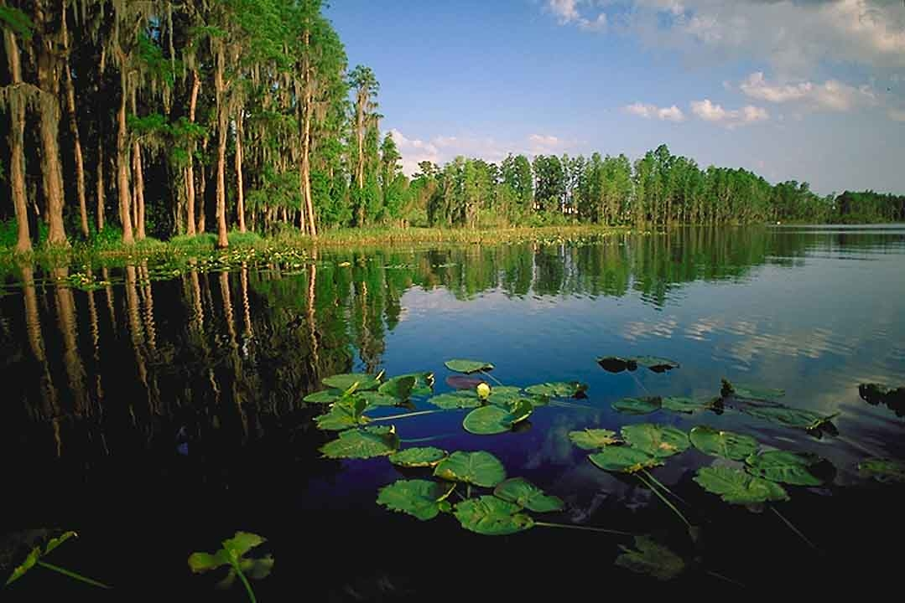

Florida Department of Environmental Protection

The Division’s Mission
The Division’s mission is to assess, protect, and restore Florida’s waters. As we implement our mission, the Division will be guided by the following core principles:

Using science to ensure an efficient use of resources:
The Division uses science to establish more accurate water quality criteria and a more functional water quality standards system to assure that all actions have environmental value and do not impose unnecessary costs on the public.

Using science to more accurately assess and more cost-effectively restore waters:
The Division utilizes advances in scientific instruments, analytical methods and restoration technologies to yield more reliable water quality assessments and more cost-effective restoration.

Streamlining process and maximizing partnerships and outreach to yield greater 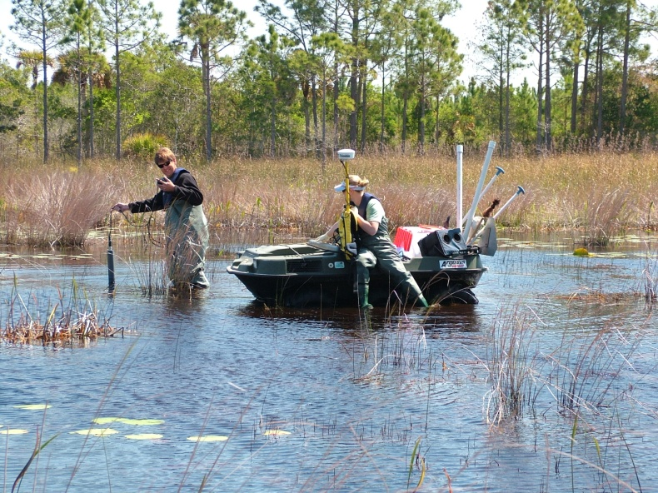environmental results:
The Division works with interested parties to identify cost-effective ways to streamline restoration and take advantage of partnerships to increase restoration activities.

Identifying and reducing redundancies:
The Division evaluates water quality monitoring efforts across the Department as well as state, federal and other agencies to promote adequate data collection while minimizing redundancies. This frees up resources to direct towards more comprehensive coverage of state waters.

Developing staff’s scientific expertise:
The Division depends upon scientific skills and knowledge to successfully carry out its mission and is committed to training and developing its staff to better implement our core mission.

Organization
WATER QUALITY PROCESS
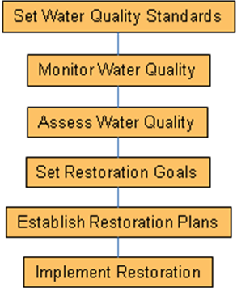

The Division implements the statutory water quality process.
The Bureau of Assessment and Restoration Support (BARS) develops water quality standards as required by the federal CWA and state law. In addition, BARS is responsible for the statewide ambient water quality monitoring network for freshwaters and ground water. BARS uses information from the statewide network and other water quality data to assess and report on water quality in Florida as required by the CWA. BARS relies on a variety of resources to meet its statewide monitoring commitments including contracted services, Tallahassee staff and OPS staff in three district offices. The Division currently has sufficient information to assess approximately 50% (3,180) of Florida’s
defined waterbodies, many of which are impaired for one or more parameters. BARS is also responsible for the Department’s Quality Assurance/Quality Control Program. This program ensures data collection efforts of the Department’s various programs meet acceptable protocols for reliability and validity. Currently, BARS has 38 FTE and 35 OPS.

The Bureau of Watershed Restoration (BWR) partners with local stakeholders to develop restoration goals, known as Total Maximum Daily Loads (TMDL), and restoration plans, called Basin Management Action Plans (BMAP). BWR’s goal is to bring Florida’s impaired waters back into attainment with water quality standards. The BWR also develops and distributes tools and manuals for best management practices for nonpoint source pollution reduction and implements state and federal grant programs aimed at water pollution reductions. BWR relies upon district office staff to support monitoring and sampling activities associated with the TMDL program. BWR is also responsible for springs and groundwater quality assessment. The Division relies on its water quality data experts to manage, evaluate and clearly present data from more than 100 sources and 23 million records to the public. BWR has 52 FTE and 21 OPS staff.

Scientific expertise and defensible data are cornerstones to the success of the Division, and much of this support is provided by the Bureau of Laboratories (Lab). The Lab provides technical support to the Division as well as the rest of the Department and currently has 77 FTE and 22 OPS staff. In FY 2010/2011, the Lab reported results for 134,950 analyses. The vast majority of analyses (105,697, or 78%) were performed on behalf of Division programs (Total Maximum Daily Load – 35% and ambient programs – 34%). Lab staff is also instrumental in evaluating new sampling methods and analytical techniques that will result in more accurate water quality assessment and cost-effective restoration. In addition, Lab staff often provides expertise on high-profile issues such as the Deep Water Horizon oil spill beach monitoring, algal bloom investigations, evaluation of innovative restoration technologies, and laboratory analyses for sensitive issues.
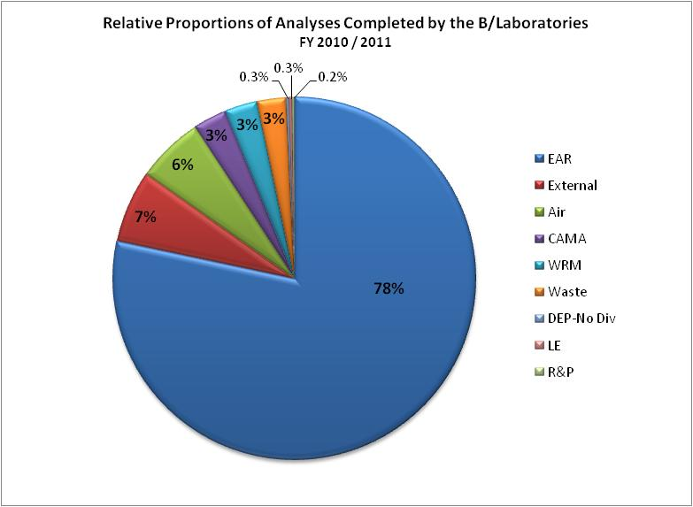

Budget and Staffing
The Division currently has 174 FTE and 79 OPS staff. The Division relies extensively on OPS staff to carry out its core mission. Approximately 34% of the Division staff is OPS. The Division’s budget consists of approximately $20 million in recurring budget authority and $22.7 million in fixed capital outlay funds, most of which are used for grants to local entities for restoration projects.

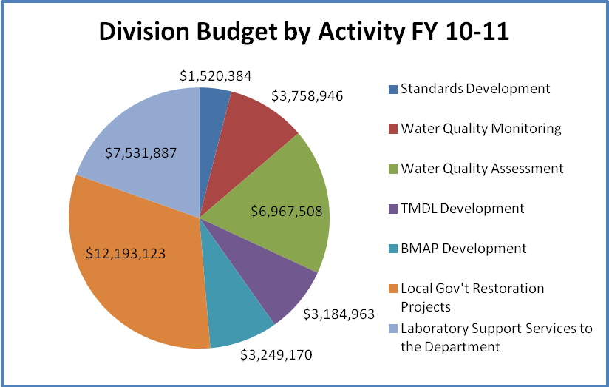

Overview of Division Operations
Unlike the other regulatory programs, the Division does not directly regulate facilities. Florida has over 50,000 miles of rivers and streams, 7800 lakes, and 4000 square miles of estuaries. The Division’s workload is largely driven by water quality monitoring and assessment of these waterbodies as well as prioritized restoration activities for those with impairments for one or more parameters. Each year, the Division monitors its statewide ambient monitoring stations for lakes, streams, and ground water to determine existing water quality and detect water quality trends. In addition to this ambient monitoring, the Division conducts strategic monitoring of specific waterbodies every year. Because of the large number of waterbodies in Florida, the Division developed a five-year rotating schedule to evaluate water quality by watershed basins. Strategic monitoring is conducted in approximately one fifth of the state each year, with waters identified as potentially impaired targeted for monitoring. The data are assessed in the following year and, at the end of the year, the Division prepares a list of impaired waterbodies and prioritizes the development of TMDL and restoration goals for them. The TMDL is the first step in the restoration process, followed by the adoption of Basin Management Action Plans, both of which involve additional sampling and analysis to determine causative pollutants and sources. These activities result in approximately 105,000 laboratory analyses each year. In addition, the Lab also processes approximately 30,000 analyses for other Department and external clients.

Florida’s Rotating Watershed Basins

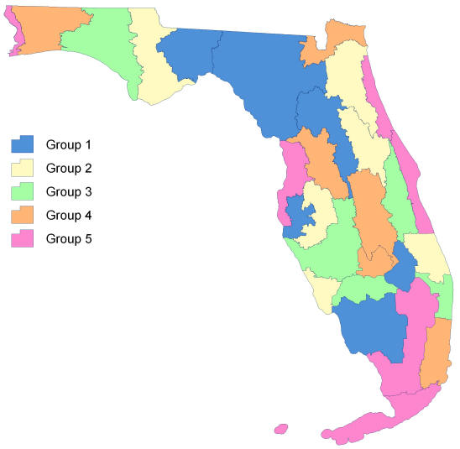

Division’s Short Term (2 Year) Priorities, Objectives and Measures

Establishing Water Quality Standards
States are obligated under the federal CWA to adopt water quality standards to restore and maintain the chemical, physical and biological integrity of the Nation’s waters. The Division is using science to establish more accurate water quality criteria and a more functional standards system so that all agency actions have environmental value and do not impose unnecessary costs.

As part of this effort, the Division is revising criteria to more accurately reflect the conditions of Florida’s waters needed to protect aquatic life and human health, which will allow the Division and local officials to focus activities on waters truly in need of restoration. The Division’s priorities for the next two years include the development of: numeric nutrient criteria for western panhandle estuaries, dissolved oxygen criteria, human health criteria and triennial review revisions. In addition, the Division will launch an effort to collect data & information on the unique ecological and water quality conditions of Florida’s canals with the goal of determining a set of water quality standards appropriate to protect their use and function.

Monitoring and Assessing Water Quality
Each year, the Division assesses a group of watershed basins and develops a list (“verified impaired list”) of those not meeting water quality standards and for which TMDLs must be developed. In addition, the Division develops a study list for waters that require further assessment and data collection.

The Division is actively identifying and reducing redundancies in water quality monitoring in the Department and among other state, federal and local agencies as well as stakeholders. As improvements are implemented, resources can be shifted into restoration, which is currently under-resourced. The Division’s priorities for the next two years are: complete assessment and verified list/delist development, create tools and coordinate efforts to track and ensure efficient use of monitoring resources; implement required changes in models and disseminate guidance to implement numeric nutrient criteria; collect, present, report and ensure quality data.

Initiate Restoration of Impaired Waters through TMDL Development
The Division is required to prioritize TMDL development for those waters on the verified impaired list developed each year. In addition to TMDL development associated with ongoing assessment and listing efforts, the Division is also satisfying TMDL development mandated by a 1998 EPA settlement agreement. Currently, there are 2,478 verified impairments in Florida and the Division has completed 324 TMDLs of which 266 are adopted as rules. The Division is evaluating cost-effective streamlining options for TMDL development, such as allowing local governments to develop restoration goals and plans and allowing adoption of TMDLs by Secretarial Order rather than more time-consuming rulemaking. In addition, the Division is discussing possible means of streamlining the statement of estimated regulatory costs (SERC) with the Office of General Counsel. Statutory changes may be necessary to accomplish some of these objectives. The Division’s priorities for the next two years are: development of a mercury TMDL, complete consent decree TMDLs, complete other high-profile TMDLs, develop tools to prioritize fecal TMDL development.

Implement Restoration of Florida’s Waters through BMAP Development and Restoration Grants
The BMAP program leverages the partnerships of stakeholders in developing water quality restoration plans. This process is consensus-driven and often times and resource intensive. To date, nine BMAPs have been adopted covering 75 waterbodies, with 11 more BMAPs covering 68 waterbodies currently in development (see map, below).

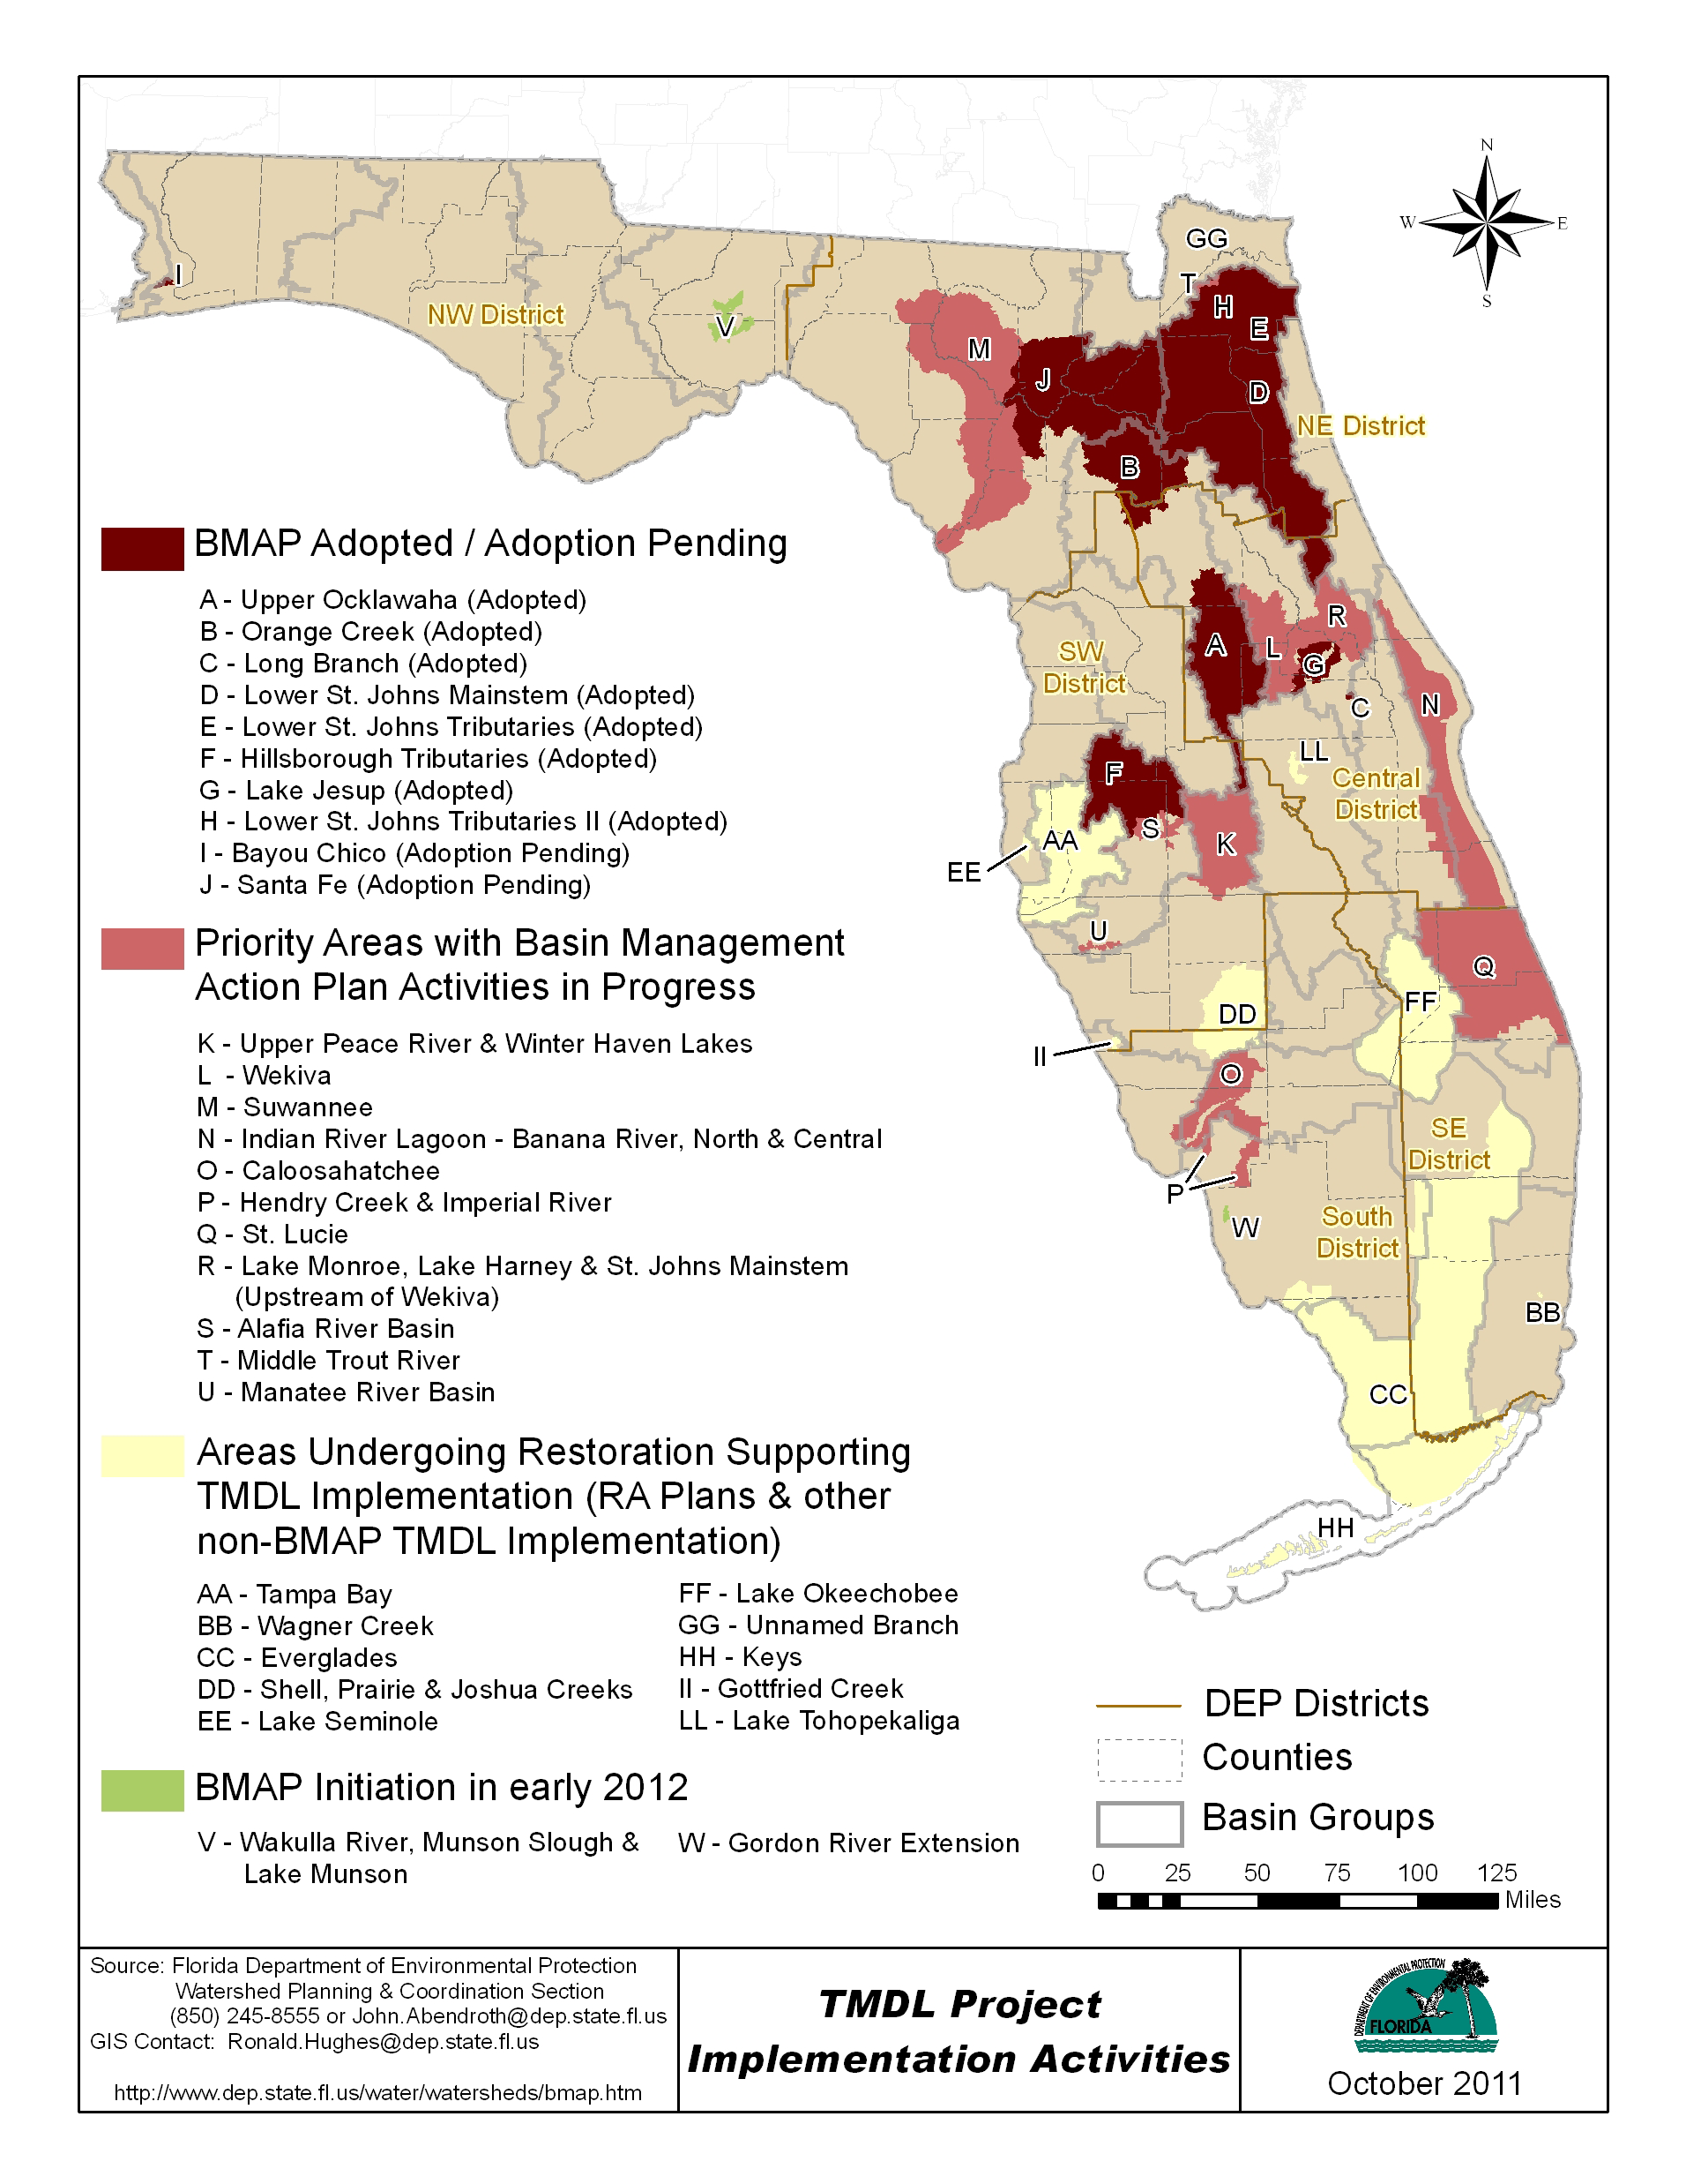

The following BMAPs are currently under development and are in the areas identified on the above map:
  - Suwannee-Santa Fe (6 WBIDs; nutrients & dissolved oxygen)
  - Wekiva (5 WBIDs; nutrients & dissolved oxygen)
  - Upper Peace (11 WBIDs; nutrients & fecal coliform)
  - Indian River Lagoon (13 WBIDs; nutrients & biological oxygen demand)
  - St. Lucie (9 WBIDs; nutrients & biological oxygen demand)
  - Lake Munson (4 WBIDs; nutrients, fecal coliform & biological oxygen demand)
  - Everglades West Coast (3 WBIDs; nutrients & fecal coliform)
  - Caloosahatchee (3 WBIDs; nutrients)
  - Trout River (1 WBID; nutrients)
  - Lakes Harney & Monroe (6 WBIDs; nutrients & dissolved oxygen)
  - Tampa Bay Tributaries (10 WBIDs; nutrients, fecal coliform & biological oxygen demand)

In addition, the Funding for restoration projects is critical to water quality restoration. Each year, the Division receives approximately $11 million in federal grants to fund projects to control nonpoint sources of pollution, typically related to stormwater runoff. In addition, the Division receives state funding, although in decreasing amounts over the last several years, for similar projects along with other activities in the TMDL program.

The Division is evaluating cost-effective options for BMAP development such as encouraging third parties, like counties and cities, to develop TMDLs and BMAPs simultaneously. The Division’s priorities for the next two years are completing at least 3 high-priority BMAPs and identifying allocations or lists of projects for at least 2 others, implementing regional focus area approaches in BMAPs, and educate and empower local stakeholders to implement restoration plans, and timely award grants to fund restoration projects in priority areas.

Data Management
In order to do high-quality and defensible assessments, TMDLs and BMAPs, the Division must have adequate data. Florida accounts for 30 percent of the national water quality dataset, far surpassing any other state in the nation. The Division’s priorities over the next two years are to update the data management system (STORET) and ensure data that is necessary for assessment purposes is entered into STORET.

Developing Public Messaging about the Successes in the Division
The Division is working with the Press Office to better communicate the efforts and successes in water quality assessment and restoration to the public. This is a Division priority over the next two years and involves: developing a “Report Card” for Florida’s water quality, providing EPA with no fewer than two WQ-10 “success stories” for their consideration, recommending articles for publication on water quality and restoration, creating a public-friendly website for water quality information.

Maintain Timely, Cost-Effective and State-of-the-Art Laboratory Support
The Lab’s analytical services largely fall into two main categories: chemical and biological. Chemistry support includes analyses for metals, nutrients, pesticides, organics, air toxics and fine particulate matter. Biology support includes analyses for toxicity, chlorophyll-a, sediment grain size and organic matter, algal and macroinvertebrate identifications, microbiology and biological oxygen demand. Additionally, the Lab provides other technical support, including specialized field sampling, scientific study design, statistical and narrative interpretation of environmental data, and investigations of terrorist threats. Laboratory clients include not only the Division but also DWRM, Division of Waste Management, Law Enforcement, Division of Air Resource Management, Office of Coastal and Aquatic Managed Areas, Recreation and Parks, and the Water Management Districts.

The Division’s priorities for the Lab for the next two years include providing cost-effective services to its customers, providing timely analyses and reports to its customers, evaluating new sampling methods and techniques to allow more accurate water quality assessments.

