Basin Management Action Plan

for the Implementation of Total Daily Maximum Loads for Nutrients Adopted by the Florida Department of Environmental Protection

in the

Santa Fe River Basin

developed by the
Florida Department of Environmental Protection
Division of Environmental Assessment and Restoration
Bureau of Watershed Restoration
Tallahassee, FL 32399

March 2012

Acknowledgments: The Santa Fe River Basin Management Action Plan (BMAP) was prepared as part of a statewide watershed management approach to restore and protect Florida’s water quality. It was developed by the Florida Department of Environmental Protection with input from the major Santa Fe River Basin stakeholders, identified below, and included participation by affected local, regional, and state governmental interests; elected officials and citizens; and private interests.

Santa Fe River BMAP Participants
Entity | Participants
Alachua County | Alachua County Environmental Protection Department
Columbia County | City Manager of Lake City and County Manager
Gilchrist County | Gilchrist County Manager and County Commission
Florida Department of Agriculture and  Consumer Services | Office of Agricultural Water Policy
Suwannee River Partnership | Executive Director and staff
Suwannee River Water Management District | Executive Director and staff
The Ichetucknee Partnership | Director and Board
Union County | County Commission
Bradford County | County Commission
Ichetucknee Springs Working Group | Springs Coordinator and Working Group members
Santa Fe Springs Working Group | Springs Coordinator and Working Group members
Florida Department of Transportation | District 2 staff

For additional information on Total Maximum Daily Loads and the watershed management approach in the Santa Fe River Basin, contact:

Terry Hansen, Basin Coordinator
Florida Department of Environmental Protection
Bureau of Watershed Restoration, Watershed Planning and Coordination Section
2600 Blair Stone Road, Mail Station 3565
Tallahassee, FL 32399-2400
Email: Terry.Hansen@dep.state.fl.us
Phone: (850) 245–8561
Table of Contents

List of Acronyms and Abbreviations vii
Executive Summary ix
Chapter 1 : Context, Purpose, and Scope of the Plan 1
1.1 Water Quality Standards and Total Maximum Daily Loads 1
1.2 TMDL Implementation 2
1.3 The Santa Fe River BMAP 2
1.4 Assumptions and Considerations Regarding TMDL Implementation 9
1.5 Future Growth in the Watershed 10
Chapter 2 : Santa Fe River Basin Setting 12
2.1 Jurisdictions, Population, and Land Uses 12
2.2 Hydrogeology 14
2.3 Water Quality Trends 16
2.4 Pollutant Sources 17
2.5 Anticipated Outcomes 18
Chapter 3 : Management Actions 20
3.1 Municipal Stormwater Permits 20
3.2 Management Actions 21
3.3 Section 319 Funding Elements 37
Chapter 4 : Assessing Progress and Making Changes 38
4.1 Tracking Implementation 38
4.2 Water Quality Monitoring 41
4.3 Adaptive Management Measures 46
Chapter 5 : Commitment to Plan Implementation 47
5.1 Examples of Commitment to BMAP Implementation 47
APPENDICES 57
Appendix A: TMDL Basin Rotation Schedule 58
Appendix B: Summary of Statutory Provisions Guiding BMAP Development and Implementation 59
Appendix C: Stakeholder Involvement in BMAP Development 62
Appendix D: Restoration Focus Areas 63
Appendix E: Summary of EPA-Recommended Elements of a Comprehensive Watershed Plan 68
Appendix F: Well and Spring Sampling To Evaluate Nitrogen Sources in the Alachua County Portion of the Santa Fe BMAP Area–DRAFT 72
Appendix G: Glossary of Terms 86
Appendix H: Bibliography of Key References and Websites 91

List of Figures

Figure 1: Santa Fe River Planning Unit 4
Figure 2. Santa Fe River BMAP area 5
Figure 3. Major land use categories in the Santa Fe River Basin in 2008 13
Figure 4. Confinement conditions of the upper Floridan aquifer in the SRWMD (SRWMD 2010) 15
Figure 5. Historical nitrate data for the Santa Fe River, 1959–2004 16
Figure 6. Calculated sources of nitrogen to the Santa Fe River, based on 1999 land use 19
Figure 7. Agricultural acreage in the Santa Fe River BMAP area as of 2008 26
Figure 8. Agricultural acreage and BMP enrollment in the Santa Fe River Basin as of March 31, 2011 29
Figure 9. Agricultural acreage identification and enrollment process in the Santa Fe River Basin 35
Figure 10. BMP implementation approach for agriculture in the Santa Fe River Basin 36
Figure 11. Stations currently sampled in the Santa Fe River and associated springs 43
Figure 12. Possible locations for monitoring wells in the Santa Fe River Basin 44
Figure D-1. Vegetable and row crop land use and BMP enrollment in the Santa Fe River Basin 64
Figure F-1. Ground water monitoring locations for evaluating nitrogen sources in the Santa Fe BMAP area 75
Figure F-2. Spring sampling locations with NOx concentrations 76
Figure F-3. Relationship of boron to chloride concentrations in ground water and spring samples 81
Figure F-4. Potential sources of nitrate in ground water and springs (labeled) and denitrification potential based on isotopic ratios (modified after Roadcap et al. 2001) 82

List of Tables

Table 1. Designated use attainment categories for Florida surface waters 1
Table 2. Phases of the watershed management cycle 2
Table 3. BMPs being implemented in the Santa Fe River Basin 7
Table 4. Lower Santa Fe Planning Unit TMDLs 9
Table 5. Land use classifications in the Santa Fe River Basin in 2008 12
Table 6. Agricultural land use classifications in the Santa Fe River Basin in 2008 12
Table 7. NO3 + NO2 concentrations (mg/L) in the main stem WBIDs in the Lower Santa Fe River, 1999–2006 17
Table 8. Local governments in the Santa Fe River Basin designated as MS4s 20
Table 9. Project types 22
Table 10. Project summary 23
Table 11. Agricultural acreage and BMP enrollments for the Santa Fe River BMAP area as of March 31, 2011 27
Table 12. EPA elements of a watershed plan 37
Table 13. Proposed BMAP annual reporting form 39
Table 14a. Core water quality indicators and field parameters 42
Table 14b. Supplemental water quality indicators and field parameters 42
Table 15. Anticipated resource responses from BMAP implementation 42
Table A-1. Major hydrologic basins by group and FDEP district office 58
Table F-1a. Laboratory results for spring samples, baseline sampling 77
Table F-1b. Laboratory results for ground water samples, baseline sampling 78

List of Acronyms and Abbreviations
Acronym/  Abbreviation | Explanation
‰ | Parts Per Thousand Deviations
3D | Three-Dimensional
ACEPD | Alachua County Environmental Protection Department
ACF | Alachua County Forever
ACHD | Alachua County Health Department
BDL | Below Detection Limit
BMAP | Basin Management Action Plan
BMP | Best Management Practice
CARES | County Alliance for Responsible Environmental Stewardship
CC&R | Covenants, Conditions, and Restrictions
cfs | Cubic Feet Per Second
CoCAVA | Columbia County Aquifer Vulnerability Assessment
DO | Dissolved Oxygen
EPA | U.S. Environmental Protection Agency
ERP | Environmental Resource Permit
FA | Focus Area
F.A.C. | Florida Administrative Code
FAS | Floridan Aquifer System
FAWN | Florida Automated Weather Network
FDACS | Florida Department of Agriculture and Consumer Services
FDEP | Florida Department of Environmental Protection
FDOH | Florida Department of Health
FDOT | Florida Department of Transportation
FFL-FYN | Florida-Friendly Landscaping–Florida Yards and Neighborhoods
FFS | Florida Forest Service
FNAI | Florida Natural Areas Inventory
F.S. | Florida Statutes
FWRA | Florida Watershed Restoration Act
GIS | Geographic Information System
GPS | Global Positioning System
GWSP | Ground Water and Springs Protection Section
GWTV | Ground Water Temporal Variability
I/E | Information and Education
ISWG | Invasive Species Working Group
IWR | Impaired Surface Waters Rule
LID | Low-Impact Development
LIFE | Learning in Florida’s Environment
M | Million (Dollars)
MGD | Million Gallons Per Day
mg/L | Milligrams per Liter
MIL | Mobile Irrigation Lab
MS4 | Municipal Separate Storm Sewer System
N | Nitrogen
NO2 | Nitrite
NO3 | Nitrate
NO3+NO2 | Nitrate + Nitrite
NOI | Notice of Intent
NOx | Nitrate+Nitrite (NO3+NO2)
NPDES | National Pollutant Discharge Elimination System
NRCS | Natural Resources Conservation Service
OAWP | Office of Agricultural Water Policy
OSTDS | Onsite Sewage Treatment and Disposal Systems
P | Phosphorus
PREC | Program for Resource Efficient Communities
QA/QC | Quality Assurance/Quality Control
RFA | Restoration Focus Area
SCI | Stream Condition Index
SFRB | Santa Fe River Basin
SJRWMD | St. Johns River Water Management District
SMZ | Special Management Zone
SOP | Standard Operating Procedure
SRP | Suwannee River Partnership
SRWMD | Suwannee River Water Management District
SSO | Sanitary Sewer Overflow
SWIM | Surface Water Improvement and Management
TIP | The Ichetucknee Partnership
TKN | Total Kjeldahl Nitrogen
TMDL | Total Maximum Daily Load
TN | Total Nitrogen
TSI | Trophic State Index
TSS | Total Suspended Solids
UA | Urban Area
UF–IFAS | University of Florida–Institute of Food and Agricultural Sciences
ULDC | Unified Land Development Code
USDA | U.S. Department of Agriculture
VAC | Vegetable/Agronomic Crop
WBID | Waterbody Identification (Number)
WLA | Wasteload Allocation
WMD | Water Management District
WWTF | Wastewater Treatment Facility
WWTP | Wastewater Treatment Plant

Executive Summary
Santa Fe River Basin
The Basin Management Action Plan (BMAP) for the Santa Fe River Basin encompasses over 1 million acres and includes all or portions of Alachua, Bradford, Columbia, Gilchrist, and Union Counties. Urban areas include Lake City and Fort White in Columbia County and Alachua, Archer, High Springs, La Crosse, and Newberry in Alachua County. Specifically, the lower portion of the Santa Fe River from River Rise westward to its confluence with the Suwannee River has been determined to be impaired. The BMAP area also includes the Ichetucknee River and associated springs, Alligator Lake and the New River.

Total Maximum Daily Load
The verified period for the Group 1 waterbodies, including the Santa Fe River, was June 1, 2000, through June 30, 2007. Data from this period indicated that the Santa Fe River was impaired for dissolved oxygen (DO) and nutrients. The Total Maximum Daily Load (TMDL) target developed (a monthly average of 0.35 milligrams per liter [mg/L] of nitrate [NO3]) was determined to be sufficiently protective of the aquatic flora or fauna in the Santa Fe River. Achieving reductions in nutrients (NO3) is expected to reduce any pollutant impacts associated with DO.

The Santa Fe River Management Action Plan
The Santa Fe River BMAP will be implemented through a phased process, with different levels of implementation included in each phase based on stakeholder location. The phasing addresses changes in implementation over time, while the level of implementation differentiates effort among stakeholders based on location and source type.
In Phase 1, logical, technically feasible best management practices (BMPs) will be implemented in order to see results in a short time. Stakeholders in the basin will implement BMPs that are focused on pollution prevention (e.g., decreasing nutrient inputs). All BMAP stakeholders will implement BMPs applicable to their jurisdiction and within their authority.

Key Elements of the BMAP
This BMAP addresses the key elements required by the Florida Watershed Restoration Act (FWRA), Chapter 403.067, Florida Statutes (F.S.), including the following:
- Document how the public and other stakeholders were encouraged to participate or participated in developing the BMAP (Section 1.3.1);
- Equitably allocate pollutant reductions in the basin (Section 1.3.3);
- Identify the mechanisms by which potential future increases in pollutant loading will be addressed (Sections 1.5 and 3.2.2);
- Document management actions/projects to achieve the TMDLs (Section 3.2);
- Document the implementation schedule, funding, responsibilities, and milestones (Section 4.1); and
- Identify strategies for monitoring, evaluation, and reporting to evaluate and track reasonable progress over time (Sections 4.2 and 4.3).

Anticipated Outcomes of BMAP Implementation
Through the implementation of projects, activities, and additional source assessments described in this BMAP, stakeholders expect the following outcomes:
- Reduction in nutrients in the Santa Fe River and associated springs;
- Decrease in algal mass in the springs basins;
- Adoption of applicable fertilizer and irrigation ordinances;
- Implementation of applicable agricultural BMPs; and
- Development and implementation of applicable nonagricultural BMPs.

BMAP Cost
The majority of the projects identified in the BMAP have no direct capital costs associated with them. Stormwater and wastewater projects located in the Lake City area have an estimated cost of $22.5 million (M) financed through municipal bonds. Developing and implementing the Alachua County stormwater master plan has cost $1.85M to date. Cost-share for the implementation of agricultural BMPs in the basin to date has totaled about $825,000 collectively from the Florida Department of Agriculture and Consumer Services (FDACS) and the Suwannee River Water Management District (SRWMD), and in excess of $1 million through various cost-share programs with the U.S. Department of Agriculture (USDA). Alachua County has also budgeted over $30M for environmentally sensitive land acquisition in the basin.

BMAP Follow-up
The Phase I monitoring plan will use data currently being collected by FDEP and other entities in the river and associated springs and entered into the STORET database (or its replacement). The research component of the monitoring plan will focus on collecting data for use in refining the implementation of BMPs in the basin and determining future courses of action. In subsequent phases, the monitoring plan will be used to help assess BMP effectiveness and identify areas to be considered for increased load reductions.

Commitment to BMAP Implementation
The agricultural stakeholders (through the Farm Bureau, FDACS and the Suwannee River Partnership [SRP]) in the basin are committed to implementing BMPs and tracking their progress. The nonagricultural stakeholders are implementing the mandated county ordinances, springshed protection ordinances, or comprehensive development plans, and the SRWMD has implemented a district wide irrigation rule. Counties in the basin are developing and implementing appropriate ordinances to reduce nutrients entering ground water and impacting the river.

: Context, Purpose, and Scope of the Plan

Water Quality Standards and Total Maximum Daily Loads
Florida's water quality standards are designed to ensure that surface waters can be used for their designated purposes, such as drinking water, recreation, and agriculture. Currently, most surface waters in Florida, including those in the Santa Fe River Basin, are categorized as Class III waters, meaning that they must be suitable for recreation and must support the propagation and maintenance of a healthy, well-balanced population of fish and wildlife. Table 1 shows all designated use categories for Florida surface waters.
Under Section 303(d) of the federal Clean Water Act, every two years each state must identify its “impaired” waters, including estuaries, lakes, rivers, and streams, that do not meet their designated uses and are not expected to improve within the subsequent two years. The Florida Department of Environmental Protection (FDEP) is responsible for developing this “303(d) list” of impaired waters.

Table 1. Designated use attainment categories for Florida surface waters

* Class I and II waters include the uses of the classifications listed below them.
Category | Description
Class I* | Potable water supplies
Class II* | Shellfish propagation or harvesting
Class III | Recreation, propagation and maintenance of a healthy, well-balanced population of fish and wildlife
Class IV | Agricultural water supplies
Class V | Navigation, utility, and industrial use (no current Class V designations)

Florida's 303(d) list identifies hundreds of waterbody segments that fall short of meeting water quality standards. The three most common water quality concerns are fecal coliform, nutrients, and oxygen-demanding substances. The listed waterbody segments are candidates for more detailed assessments of water quality to determine whether they are impaired according to state statutory and rule criteria. FDEP develops and adopts Total Maximum Daily Loads (TMDLs) for the waterbody segments it identifies as impaired. A TMDL is the maximum amount of a specific pollutant that a waterbody can assimilate while maintaining its designated uses.
The water quality evaluation and decision-making processes for listing impaired waters and establishing TMDLs are authorized by Section 403.067, Florida Statutes (F.S.), known as the Florida Watershed Restoration Act (FWRA), and contained in Florida’s Identification of Impaired Surface Waters Rule (IWR), Rule 62-303, Florida Administrative Code (F.A.C.). The impaired waters in the Santa Fe River Basin addressed in this Basin Management Action Plan (BMAP) are all Class III waters. TMDLs have been established for these waters, identifying the amount of nutrients and other pollutants they can receive and still maintain Class III designated uses.
TMDLs are developed and implemented as part of a watershed management cycle that rotates through the state’s 52 river basins every 5 years (see Appendix A) to evaluate waters, determine impairments, and develop and implement management strategies to restore impaired waters to their designated uses. Table 2 summarizes the five phases of the watershed management cycle.

Table 2. Phases of the watershed management cycle
Phase | Activity
Phase 1 | Preliminary evaluation of water quality
Phase 2 | Strategic monitoring and assessment to verify water quality impairments
Phase 3 | Development and adoption of TMDLs for waters verified as impaired
Phase 4 | Development of management strategies to achieve the TMDL(s)
Phase 5 | Implementation of TMDL(s), including monitoring and assessment

TMDL Implementation
Rule-adopted TMDLs may be implemented through BMAPs, which contain strategies to reduce and prevent pollutant discharges through various cost-effective means. During Phase 4 of the TMDL process, FDEP and the affected stakeholders in the various basins jointly develop BMAPs or other implementation approaches. A basin may have more than one BMAP, based on practical considerations. The FWRA contains provisions that guide the development of BMAPs and other TMDL implementation approaches. Appendix B summarizes the statutory provisions related to BMAP development and implementation.
Stakeholder involvement is critical to the success of the TMDL Program and varies with each phase of implementation to achieve different purposes. The BMAP development process is structured to achieve cooperation and consensus among a broad range of interested parties. Under statute, FDEP invites stakeholders to participate in the BMAP development process and encourages public participation to the greatest practicable extent. FDEP must hold at least one noticed public meeting in the basin to discuss and receive comments during the planning process. Stakeholder involvement is essential to develop, gain support for, and secure commitments to implement the BMAP.

The Santa Fe River BMAP

Stakeholder Involvement
Stakeholder technical meetings were held throughout 2009 and 2010 to explain the BMAP process and, specifically, the technical approach being used in the Santa Fe River Basin.
Except as specifically noted in subsequent sections, this BMAP document reflects the input of the stakeholders, along with public input from workshops and meetings held to discuss key aspects of TMDL and BMAP development. Appendix C provides further details.

Plan Purpose and Scope
The purpose of this BMAP is to implement load reductions to achieve the nutrient and dissolved oxygen (DO) TMDLs for the Santa Fe River Basin and additionally, the DO TMDL for the New River and DO and nutrient TMDL for Alligator Lake. It outlines specific projects that will achieve load reductions and provides a schedule for implementation. The document details a monitoring approach to determine where future actions will need to occur, to measure progress toward meeting load reductions, and to report on how the TMDL is being achieved. The TMDL for the Santa Fe River is included with the TMDL for the Middle and Lower Suwannee River. This separate BMAP for the Santa Fe River, including the Ichetucknee River, New River, and Alligator lake accounts for the regional physiographic differences between the Suwannee and Santa Fe Rivers.
The Santa Fe River is a tributary to the Suwannee River. The Santa Fe River system drains about 1,400 square miles of north Florida, discharging an annual average flow of more than 1,600 cubic feet per second (cfs). The Santa Fe River flows west from its headwaters in the Santa Fe Lakes area, in the easternmost portion of the basin, joining the Suwannee River near Branford. Its two major tributaries, New River and Olustee Creek, have their headwaters in southern Baker County. A third tributary, the Ichetucknee River is a clear, spring-fed stream and a very popular recreational site.
The Upper Santa Fe Basin, in the Northern Highlands, is dominated by surface water runoff. At the Cody Scarp, the river goes underground and re-emerges supplemented by ground water flow. As the Santa Fe flows across the Gulf Coastal Lowlands, it gains significant flow from numerous springs, including the Ichetucknee River. Because ground water dominates its flow, the Lower Santa Fe is for the most part a spring-fed river.
The eastern two-thirds of the Santa Fe Basin has surface drainage features, including lakes, streams, and wetlands. The western third lacks surface drainage, except for the Santa Fe and Ichetucknee Rivers and Cow Creek. The upper basin is characterized by nearly level pine flatwoods with gently rolling hills. Tributary streams are fairly well incised into the landscape, which occasionally opens into broad, forested floodplains. In the middle portion of the basin, moderate to gently rolling hills with areas of prominent karstic features, such as sink depressions and captured streams, create surface relief. The lower basin is primarily a broad, slightly undulating karst plain, with interspersed wetlands (FDEP 2001).
For assessment purposes, FDEP has divided the Santa Fe River Basin into water assessment polygons with a unique waterbody identification (WBID) number for each watershed or stream reach. Figure 1 shows the WBIDs in the Santa Fe River Basin. The BMAP planning area shown in Figure 2 encompasses over 1 million acres and provides a basis for determining where management actions are proposed. For the purpose of this report, the two terms Santa Fe River Basin and The Santa Fe River BMAP planning area are used interchangeably and refer to the Santa Fe River BMAP planning area.

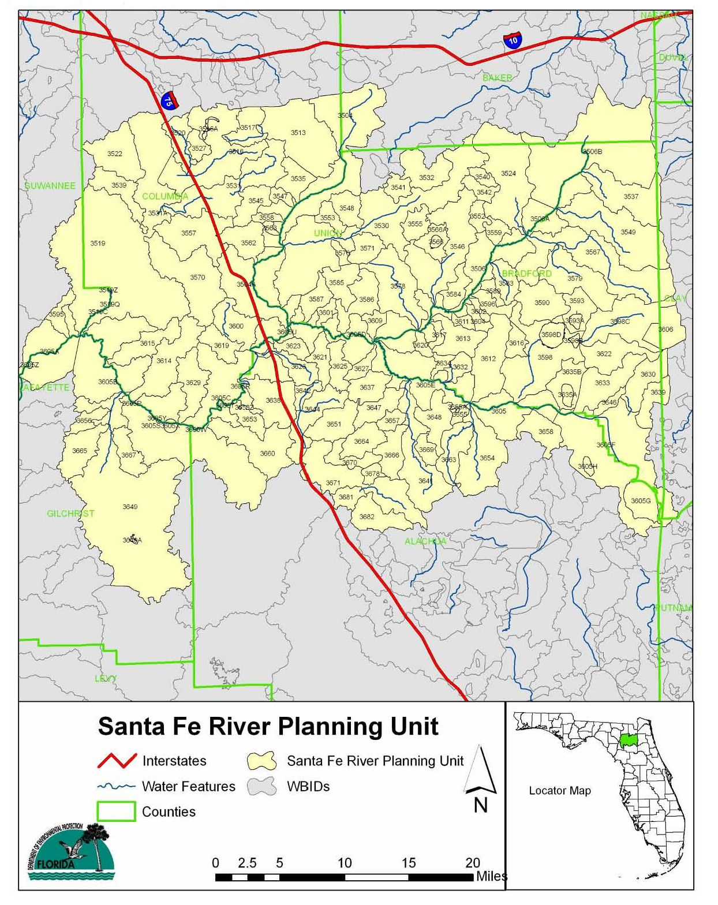
Figure 1: Santa Fe River Planning Unit

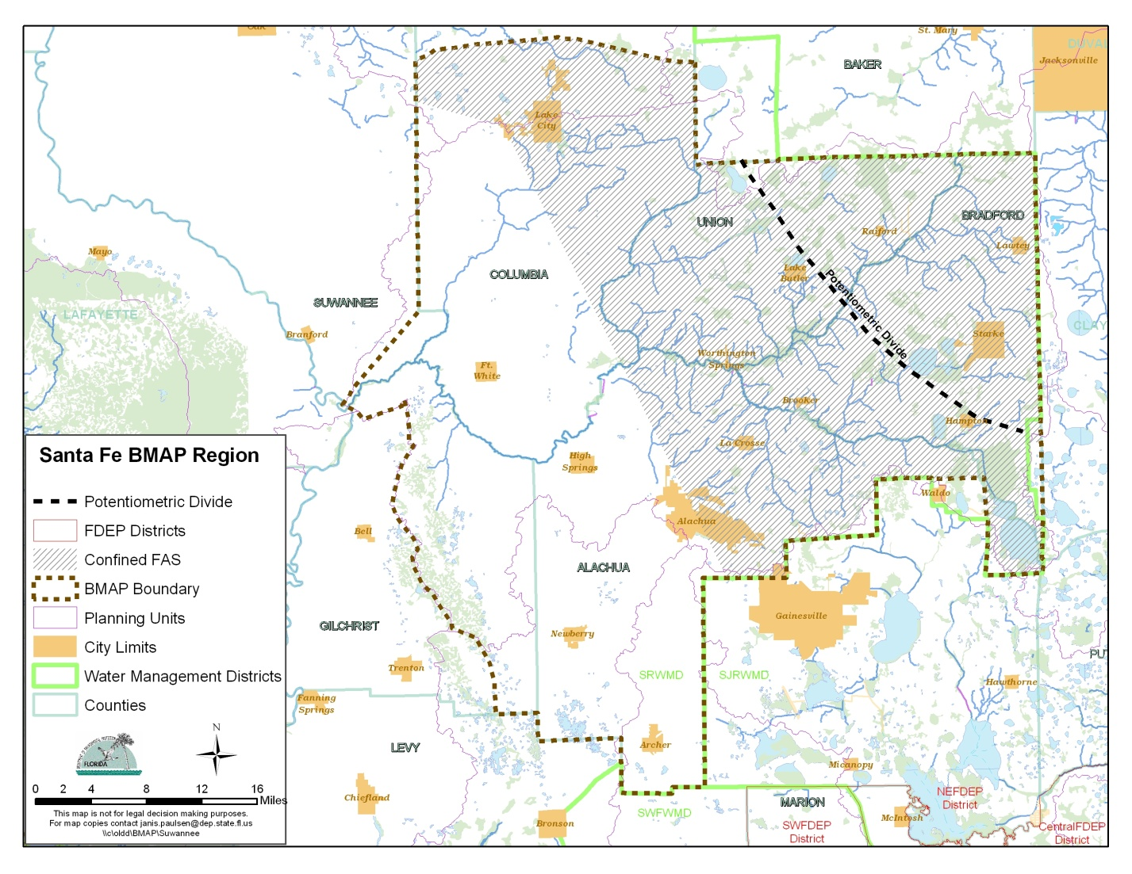
Figure 2. Santa Fe River BMAP area

Pollutant Reduction and Discharge Allocations

Categories for Rule Allocations
The rules adopting TMDLs must establish reasonable and equitable allocations that will alone, or in conjunction with other management and restoration activities, attain the TMDL. Allocations may be to individual sources, source categories, or basins that discharge to the impaired waterbody. The allocations identify either how much pollutant discharge in mass per day each source designation may continue to contribute (discharge allocation), or the mass per day, or the percentage of its loading the source designation must reduce (reduction allocation). Currently, the TMDL allocation categories are as follows:
- Wasteload Allocation (WLA) – The allocation to point sources permitted under the National Pollutant Discharge Elimination System (NPDES) Program includes the following:
  - Wastewater Allocation is the allocation to industrial and domestic wastewater facilities.
  - NPDES Stormwater Allocation is the allocation to NPDES stormwater permittees that operate municipal separate storm sewer systems (MS4s). These permittees are treated as point sources under the TMDL Program.
- Load Allocation – The allocation to nonpoint sources, including agricultural runoff and stormwater from areas that are not covered by an MS4.

Initial and Detailed Allocations
Under the FWRA, the TMDL allocation adopted by rule may be an “initial” allocation among point and nonpoint sources. In such cases, the “detailed” allocation to specific point sources and specific categories of nonpoint sources is established in the BMAP. Both initial and detailed allocations must be determined based on a number of factors listed in the FWRA, including cost-benefit, technical and environmental feasibility, implementation schedule, and others (see Appendix B).
However, this type of quantitative detailed allocation is not appropriate in the Santa Fe River BMAP due to the following three primary factors:
- With a spring-fed river, the consideration of activities in the multiple springsheds is necessary;
- The quantification of denitrification in soil and ground water is not possible at the scale necessary for entity-specific allocations; and
- The Santa Fe River springshed is a hydrogeologically complex system encompassing porous media and conduit flow regimes that comprise multiple springs.

Technology-Based Approach
One objective of the BMAP process is to identify load reduction responsibilities by stakeholder, source type, or groups of stakeholders. In several other BMAPs (Lower St. Johns Mainstem, Lake Jesup), this has taken the form of quantitative detailed allocations by entity (e.g., City X must reduce its load by 500 pounds of nitrogen per year in the next 15 years). The challenge is to develop an implementation approach that provides certainty for stakeholders and protects the health of the river and associated springs, while accounting for scientific unknowns. The approach for all stakeholders in the Santa Fe Basin will be BMP-based. BMPs are individual or combined management and/or structural practices determined through research, field testing, and expert review to be the most effective and practicable means for improving water quality, taking into account economic and technological considerations.
The geology of the BMAP planning area for the Santa Fe River consists of a karstic limestone subsurface overlain in a limited area with lower permeability (sandy clay) surficial sediments (surface watershed) and overlain in a larger area by higher permeability (sand) surficial sediments (springshed). This results in a situation where some entities are located in both the area with the surface watershed and a specific springshed, while others are just in a springshed that exhibits no characteristics of a surface watershed.
Because of this complexity, the Santa Fe River TMDL implementation process will be phased, with different levels of implementation included in each phase based on stakeholder location. The phasing addresses changes in implementation over time, while the level of implementation differentiates effort among stakeholders based on location and source type.
In Phase 1, logical, technically, and economically feasible BMPs will be implemented to decrease nutrient inputs. All BMAP stakeholders will implement BMPs applicable to their jurisdiction and within their authority. These BMPs, to be identified by FDEP, the Florida Department of Agriculture and Consumer Services (FDACS), and stakeholders, will do the following:
- Focus on pollution prevention;
- Address all identified sources;
- Be cost-effective;
- Be implemented as soon as practicable; and
- Achieve nutrient reductions or provide information on which to base future activities for achieving nutrient reductions.

Table 3 summarizes the BMPs being implemented in the initial phase of the Santa Fe River BMAP. Phase 1 BMP implementation initially will be focused in geographically defined restoration areas and/or on specific commodities.

Table 3. BMPs being implemented in the Santa Fe River Basin

Stakeholder Group | Action
Agricultural producers | Submit Notice of Intent (NOI) and implement BMPs
County governments | Develop and implement ordinances (January 1, 2014 deadline for development or implementation of mandated ordinances)
Municipalities | Adopt ordinances, (January 1, 2014 deadline for development or implementation of mandated ordinances)
FDACS in conjunction with  FDEP | Identify commodity groups on which to concentrate resources for BMP implementation
FDEP, FDACS, and other affected stakeholders | Identify geographic restoration focus areas (RFAs) in which to concentrate resources for BMP implementation

The initiation of Phase 2 is contingent on the resolution of key scientific unknowns and evidence that management actions undertaken in Phase 1 do not meet the nutrient targets specified in the TMDL. As appropriate, more advanced BMPs, including the treatment of nutrient loads, may be required for permitted facilities and may be implemented by those stakeholders with the ability to manage surface water/stormwater prior to release. These BMPs potentially achieve greater nutrient reductions but may require more extensive resources and/or funding. An example of Phase 2 agricultural BMP implementation is the evaluation of adopted BMP manuals and identification of new practices or modification of existing practices in order to provide additional nutrient reductions. An example of Phase 2 urban BMP implementation is implementing wastewater reuse practices. As needed, this process of improvement will be continued.
As part of the BMAP development process, FDEP reviews proposed management actions for “sufficiency of effort” in addressing TMDL load reductions. Stakeholders who implement the management actions identified as their responsibility in the BMAP will have met their TMDL obligation.
Even with a BMP-based implementation approach, nutrient reductions will need to be quantified to communicate the extent to which nutrient inputs are being reduced. Nitrate load reductions to be achieved by BMAP projects will be estimated to the greatest extent possible. Monitoring of the Santa Fe River, and associated springs and localized ground water sampling will be done to determine the degree of restoration being achieved

Maximizing Efforts
The identification of restoration focus areas (RFAs) for BMP implementation will allow stakeholders to prioritize their efforts in implementing nitrate reduction strategies more completely and quickly in these areas. Consequently, water quality improvements in the RFAs resulting from BMP implementation and other management actions can be assessed before changes might be observed in the impaired WBIDs. If implemented BMPs in these areas do not result in water quality improvement, the implementation of new or modified BMPs on a localized scale may be appropriate, as economically feasible, before BMPs have been implemented for the entire basin. Modifications to other management actions also may be warranted. Considerations for establishing geographic RFAs may include the following:

- Water quality (nitrate values from monitoring wells and springs, from the Suwannee River Water Management District [SRWMD] and FDEP);
- Delineated springsheds (FDEP);
- Springhead locations (FDEP);
- Aquifer recharge layer (Florida Natural Areas Inventory [FNAI]);
- Current level of BMP enrollment/implementation;
- Areas within specified distance(s) from sensitive natural features such as rivers and springheads;
- SRWMD aquifer recharge layer;
- Concentration of agricultural land use within an area; and
- Commodities being grown within an area.

Within the first year of BMAP implementation, FDEP will work with affected stakeholders to identify at least one RFA. Goals and time frames for BMP implementation and other management actions within each RFA will be developed when the management actions are identified. Ideally, the time frame for BMP implementation in the RFAs is two to three years after work commences, depending on the size of the RFA and the existing level of BMP implementation. This time frame allows for a progress check at each annual update. If this approach is demonstrated to be successful and resources allow, additional RFAs can be identified.
Chapter 4 describes the basic steps in establishing baseline data and conducting monitoring activities within RFAs. Appendix D contains a more detailed description of the RFA process for the Santa Fe River Basin.

Santa Fe River Basin TMDLs
FDEP adopted the nutrient and DO TMDLs for the Santa Fe River Basin in September 2008. This BMAP covers the 150 WBIDs in the Santa Fe Planning Unit and includes the upper and lower Santa Fe River, the Ichetucknee River, and the New River. The TMDL document contains a complete listing of the WBID numbers and names addressed in the BMAP. Table 4 lists the TMDL and pollutant load allocations adopted by rule for the Lower Santa Fe Planning Unit.
Because no target loads were explicitly calculated in the development of the TMDL, due to the lack of flow data at the outlet of each stream segment, the TMDLs are represented as the percent reduction required to achieve the nitrate target. The percent reduction assigned to all the nonpoint source areas (Load Allocation) is the same as that defined for the TMDL percent reduction. To achieve the annual average nitrate target of 0.35 milligrams per liter (mg/L) in the Santa Fe River Basin, the nitrate loads from nonpoint sources need to be reduced by 35%. The target long-term average is 0.35 mg/L, and the percent reduction represents an estimate of the maximum reduction required to meet the target. It may be possible to meet the target before achieving the percent reduction.

Table 4. Lower Santa Fe Planning Unit TMDLs
Planning Unit (WBID) | Parameter | TMDL (mg/L) | WLA NPDES Wastewater | WLA NPDES Stormwater | Load Allocation
Lower Santa Fe (WBIDs 3605A, 3605B, 3605C) | Nitrate, monthly average | 0.35 | Not applicable | 35% | 35%

Assumptions and Considerations Regarding TMDL Implementation
The water quality impacts of BMAP implementation are based on several fundamental assumptions about the pollutants targeted by the TMDLs, modeling approaches, waterbody response, and natural processes. In addition, there are a number of important considerations to keep in mind about the nature of the BMAP and its long-term implementation.

Assumptions
The following assumptions and facts were important in the BMAP development process:
- The use of appropriate BMPs will reduce nutrient loads from nonpoint sources throughout the BMAP area.
- The identification of RFAs for agricultural BMP implementation will allow for the more efficient use of resources, maximizing results in a shorter time.
- Due to the basin’s large surface area, atmospheric deposition is a significant, uncontrollable source of nutrients and is not included in any reduction strategies.
- BMAP implementation will occur in phases, including the evaluation of progress and identification of areas requiring additional actions.
- The majority of the projects and BMP actions will be focused in the Lower Santa Fe River area.
- By law, agricultural producers who implement FDACS-adopted BMPs applicable to their operations (identified through the submittal of a NOI) have a presumption of compliance with state water quality standards.
- The basin contains no NPDES or MS4 point sources that are directly discharging to surface waters and impacting the Santa Fe River.

Considerations
This BMAP requires that all sources in the basin achieve their reductions as soon as practicable. However, the full implementation of the BMAP will be a long-term, phased process. While some of the projects and activities contained in the BMAP are recently completed or currently ongoing, there are many projects, with significant estimated load reductions, that will take many years to achieve their projected load reductions. Specifically, nutrient reductions resulting from the implementation of agricultural BMPs are estimated to require at least 10 years to be measurable in the Santa Fe River.
Since BMAP implementation is a long-term process, the TMDLs established for this basin will not be achieved for several decades. Given that it may take even longer for the river to respond to the reduced loading and fully meet applicable water quality standards, regular follow-up and continued coordination and communication by stakeholders will be essential to ensuring that management strategies are being carried out and that their incremental effects are assessed. Any additional management actions required to achieve the TMDL will be developed as part of BMAP follow-up.
During the BMAP process, the following items were identified that should be continued or undertaken in future watershed management cycles:
- Continually updating the FDACS NOI database;
- Continually updating the land use geographic information system (GIS) layer for agricultural and nonagricultural uses;
- Determining RFAs for BMP implementation;
- Evaluation of domestic wastewater facilities for nitrate removal efficiencies and Department of Health septic tank database for more accurate information;
- Identifying existing BMPs that may provide the greatest nutrient reductions and verifying that these BMPs are being implemented where applicable;
- Collecting information on fertilizer use and irrigation; and
- Monitoring ground water for nutrients, selected indicators and oxygen and nitrogen isotopes.

Future Growth in the Watershed
The FWRA (Paragraph 403.067[7][a][2], F.S.) requires that BMAPs “identify the mechanisms by which potential future increases in pollutant loading will be addressed.” Although population growth and land use changes have not altered significantly in the basin, the proposed BMPs will need to be periodically revised and updated to reflect changes in the agricultural and nonagricultural landscape.
Aerial surveys were conducted for the Suwannee River Water Management District (SRWMD) and FDEP in 2004 and 2007. Future growth in the basin was estimated by comparing previous changes in land use on these aerial surveys—specifically, the conversion of agricultural land to urban uses. Between 1998 and 2004 the percentage of urban and built-up land use increased from 2.3% of the basin to 12%, while agricultural land use increased from 20% to 21%. Based on this information, no significant differences in these percentages are anticipated during Phase 1 of the BMAP.
The SRWMD completed a water supply assessment in 2010 for the entire district and estimates that flow in the upper portion of the Santa Fe River will decline below its allowable minimum flow during the period from 2010 to 2015, and the lower portion of the Santa Fe River will decline below its allowable minimum flow by 2025 (SRWMD 2010). Ground water availability will be a significant constraint on future growth in the basin.
Springshed or karst-sensitive area protection regulations are one way in which county governments may direct future growth. In the Santa Fe River Basin, Alachua County has in place a springshed protection ordinance and corresponding comprehensive plan requirements; Bradford County does not have a specific ordinance but elements of its comprehensive plan restrict activities and development in areas of high aquifer recharge; and Columbia and Gilchrist Counties have evaluated and tabled the process of developing an ordinance.

: Santa Fe River Basin Setting

Jurisdictions, Population, and Land Uses
The population in the Santa Fe River Basin is estimated at 85,523 people in 33,348 households for an average household size of 2.56 people. The largest concentrations of people occur in Lake City, Columbia County, and the portion of Alachua County in the basin. Land use is mainly silviculture and agricultural and has not significantly changed since 1998. Table 5 and Table 6 provide an approximate breakdown of major land use categories and agricultural land uses, respectively, in the Santa Fe River Basin in 2009. Figure 3 shows the information presented in Table 5 for the acreage within the BMAP area in 2008.

Table 5. Land use classifications in the Santa Fe River Basin in 2008
Land Use | Acres | %
Urban and Built-Up | 120,298 | 11%
Agriculture | 231,827 | 22%
Rangeland | 29,096 | 3%
Upland Forest | 508,485 | 47%
Water | 14,735 | 1%
Wetland | 159,915 | 15%
Barren Land | 5,715 | 1%
Transportation, Communication, and Utilities | 13,100 | 1%
Total | 1,083,171 | 100.0%

Table 6. Agricultural land use classifications in the Santa Fe River Basin in 2008
Agricultural Land Use  (by Land Use Code) | Acres | %
2120 Unimproved Pasture | 20,245.6 | 9%
2130 Woodland Pasture | 16,595.4 | 7%
2110 Improved Pasture | 107,334.8 | 46%
2153 Hay | 43,661.1 | 19%
2140 Row Crop | 4,065.4 | 2%
2150 Field Crops | 29,106.9 | 13%
2210 Citrus Groves | 99.8 | <1%
2310 Cattle Feeding Operation | 86.8 | <1%
2400 Nurseries and Vineyards | 150.5 | <1%
2230 Other Groves | 1,903.0 | 1%
2410 Tree Nurseries | 936.7 | <1%
2430 Ornamentals | 629.2 | <1%
2420 Sod Farm | 335.2 | <1%
2500 Specialty Farm | 211.2 | <1%
2510 Horse Farm | 1,693.7 | 1%
2520 Dairies | 77.9 | <1%
2610 Fallow Cropland | 4,103.6 | 2%
2540 Aquaculture | 166.1 | <1%
2330 Poultry Feeding Operation | 424.2 | <1%
Total | 231,827 | 100.0%

Figure 3. Major land use categories in the Santa Fe River Basin in 2008

Hydrogeology
The following description is copied from the information provided on the larger but similar Suwannee River Basin by SRWMD (2010), with figure references omitted:
The two major physiographic provinces in the District include the Northern Highlands and Gulf Coastal Lowlands (White, 1970; Ceryak et al., 1983). Characteristics of the Northern Highlands include gently rolling topography, generally from 100-200 feet above mean sea level. Soils typically range from sand to clayey sand. Clayey sediments in the subsurface serve as a base for the surficial aquifer system and retard infiltration of rainwater into the underlying Upper Floridan aquifer. The result is the presence of abundant surface water features (streams, lakes and ponds) throughout the Northern Highlands.
The Gulf Coastal Lowlands are characterized by elevations ranging from sea level to about 100 feet above mean sea level. The Gulf Coastal Lowlands feature low relief, karstic topography, and shallow sandy soils with muck in many wetland areas. Karst landforms are widespread in the lowlands, with abundant sinkholes, sinking streams and springs, and a high degree of interconnection between surface water and groundwater systems. Carbonate rock (limestone or dolostone) is at or near land surface throughout the Gulf Coastal Lowlands. Whereas the surface water features in the Northern Highlands reflect the surficial aquifer system, those in the Gulf Coastal Lowlands may represent the potentiometric surface of the Upper Floridan aquifer.
A significant geologic region separating the two major physiographic provinces is the Cody Scarp. The Cody Scarp is the most persistent topographic break in Florida (Puri and Vernon, 1964), with as much as 80 feet of relief in some areas. The region is characterized by active sinkhole formation, lakes, springs, sinking streams, and river rises (Ceryak et al., 1983). During average and lower flows, the Santa Fe and Alapaha Rivers are completely captured by sinkholes as they cross the Cody Scarp and re-emerge downgradient as river rises. Due to its size, the Suwannee River is the only stream that is not significantly captured by a sink feature as it crosses the Cody Scarp. Upgradient of the Cody Scarp, surficial drainage has developed, with numerous small creeks branching off the upper Suwannee River and its tributaries. Below the Cody Scarp, drainage is predominantly internal and streams that are tributary to the Suwannee River are rare.
Additional hydrologic information may be found in the following references:

Upchurch, S.B. 2007. An Introduction to the Cody Escarpment, North-central Florida. Prepared for the Suwannee River Water Management District. Sam B. Upchurch, SDII Global Corporation. September 2007. 17 p.

Upchurch, S.B., J. Chen, and C.R. Cain 2011. Springsheds of the Santa Fe River Basin. Second Revision October 28, 2011. SDII Global, Tampa, Florida. 93 p.

Williams, K.E., Nicol, D., and A.F. Randazo. 1977. The geology of the western part of Alachua County, Florida. Report of Investigations No. 85. Florida Bureau of Geology. Tallahassee, Florida. 98 p.

Figure 4 (taken from SRWMD 2010) shows the upper Floridan aquifer confinement conditions for the entire SRWMD, including the Santa Fe River.
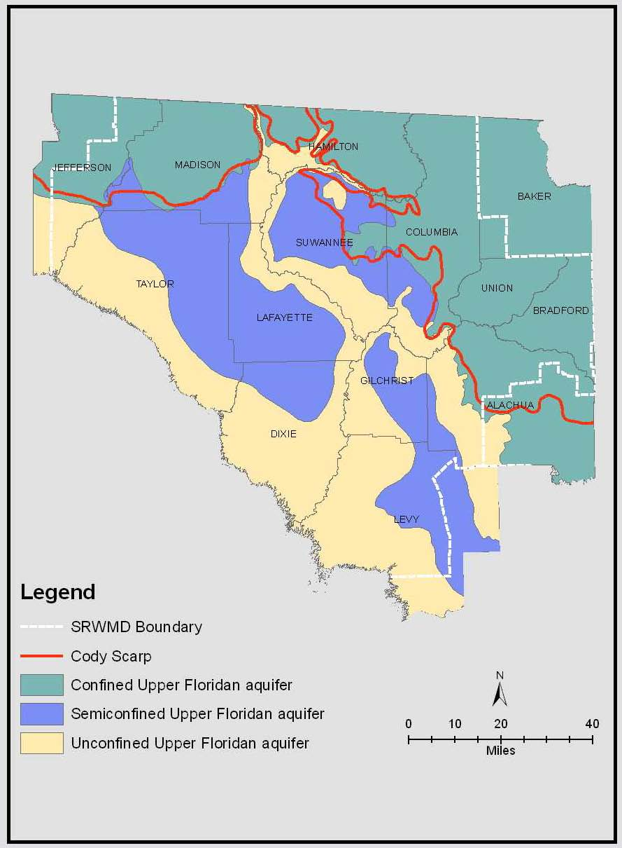
Figure 4. Confinement conditions of the upper Floridan aquifer in the SRWMD (SRWMD 2010)

Water Quality Trends
Water quality trends in the Santa Fe River have shown an increase in nitrate levels since 1954. For the Santa Fe River Basin, the largest increase has occurred in the area between U.S. Highway 441 and State Road 47. Figure 5 (taken from the TMDL report [Hallas and Magley 2008]) shows historical nitrate data for the Santa Fe River from 1959 to 2004.
Katz et al. (1999) completed a study to determine the age of the water flowing from the springs along the Santa Fe and Suwannee Rivers and the likely sources of the water entering the river. Table 7 (taken from the TMDL report [Hallas and Magley 2008]) shows the monthly average nitrate + nitrite (NO3+NO2) concentrations in the lower Santa Fe River Basin from 1999 to 2006 increasing over time.
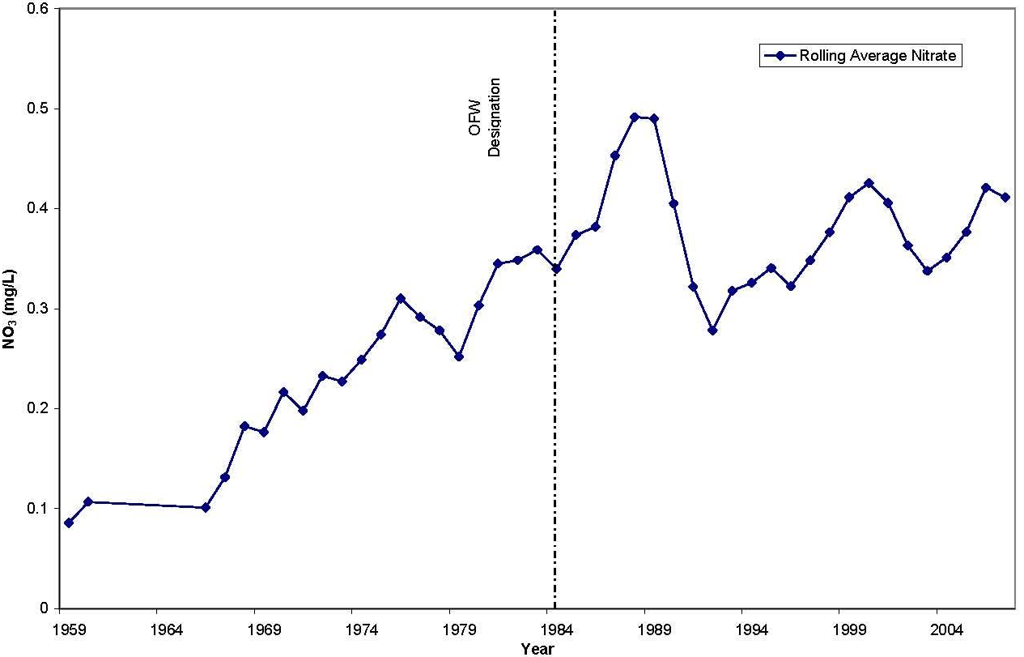
Figure 5. Historical nitrate data for the Santa Fe River, 1959–2004

Table 7. NO3 + NO2 concentrations (mg/L) in the main stem WBIDs in the Lower Santa Fe River, 1999–2006
- = Empty cell/no data
Year | Jan | Feb | Mar | Apr | May | Jun | Jul | Aug | Sep | Oct | Nov | Dec
1999 | - | 0.570 | 0.642 | 0.450 | 0.370 | 0.563 | 0.594 | 0.483 | 0.398 | 0.495 | 0.553 | 0.598
2000 | - | 0.498 | 0.548 | 0.472 | 0.473 | 0.485 | 0.480 | 0.397 | 0.476 | 0.397 | 0.542 | 0.545
2001 | 0.170 | 0.472 | 0.516 | 0.465 | 0.335 | 0.356 | 0.396 | 0.338 | 0.451 | 0.418 | 0.473 | 0.479
2002 | 0.479 | 0.440 | 0.387 | 0.295 | 0.409 | 0.369 | 0.402 | 0.431 | 0.471 | 0.443 | 0.395 | 0.387
2003 | 0.158 | 0.377 | 0.111 | 0.183 | 0.477 | 0.557 | 0.279 | 0.276 | 0.283 | 0.525 | 0.570 | 0.579
2004 | 0.589 | 0.550 | 0.364 | 0.536 | 0.437 | 0.494 | 0.416 | 0.454 | 0.351 | 0.024 | 0.456 | 0.532
2005 | 0.498 | 0.633 | 0.473 | 0.109 | 0.378 | 0.665 | 0.261 | 0.392 | 0.606 | 0.726 | 0.655 | 0.683
2006 | 0.246 | 0.402 | 0.471 | 0.699 | 0.639 | 0.549 | 0.497 | 0.529 | 0.540 | 0.586 | 0.563 | 0.478
Monthly average | 0.437 | 0.493 | 0.439 | 0.401 | 0.440 | 0.505 | 0.416 | 0.412 | 0.447 | 0.452 | 0.526 | 0.535
Monthly % reduction | 20% | 29% | 20% | 13% | 20% | 31% | 16% | 15% | 22% | 23% | 33% | 35%
Maximum of monthly averages | 0.535 | - | - | - | - | - | - | - | - | - | - | -
Maximum% reduction | 35% | - | - | - | - | - | - | - | - | - | - | -

Pollutant Sources
Potential nutrient sources in the Santa Fe River Basin comprise a variety of point and nonpoint sources. The TMDL report (Hallas and Magley 2008) estimated the following quantities of potential nonpoint sources:
- 11,684 on-site sewage treatment systems;
- 354,268 people with an annual total nitrogen (TN) contribution of 1,746 tons (2007 Census results);
- 47,500 in estimated beef cattle with an annual TN contribution of 2,209 tons;
- 4,200 in estimated milk cows and calves with an annual TN contribution of 483 tons;
- 6,465,663 in estimated poultry with an annual TN contribution of 463 tons;
- 21% of the basin in agricultural land use (nonsilviculture) in 2004; and
- 45% of the basin in silviculture land use in 2004.

These potential nonpoint sources reflect the data available when the TMDL was prepared and should be revised during the annual report process to reflect the current state of the nonpoint sources in the basin.
The four Phase II MS4 permittees in the basin are all located in the Alachua County/Gainesville area and have little to no direct impact on the Santa Fe River. Other point sources in the basin, such as wastewater and other NPDES-permitted facilities, have no direct discharge into the river, and their impact on the ground water that feeds the springs has not been accurately determined.
Figure 6 (from the TMDL report [Hallas and Magley 2008]) shows the calculated potential nonpoint sources of nitrogen to the Santa Fe River using the equations in Hornsby (1998) and data from 2007. Additionally, Katz et al. (1999) concluded that nitrate concentrations in spring waters of the Suwannee River Basin have closely followed the estimated contributions of nitrogen from fertilizers to ground water and that the high-nitrate water is recharging the ground water system over a period of less than 10 years.

Anticipated Outcomes
With the implementation of the projects outlined in this BMAP, reductions in nutrient loads are expected to improve conditions in the river such that it meets applicable water quality standards. The first phase of the BMAP is anticipated to generate the following actions:
- The development of geographic RFAs by a stakeholder working group representing all affected interests;
- The identification of commercial agricultural lands not enrolled in FDACS’ BMP programs and the implementation of FDACS-adopted agricultural BMPs (including silviculture BMPs), with an emphasis on identified RFAs;
- The development of county springshed protection ordinances, with an emphasis on identified RFAs;
- The development and implementation of urban BMPs for fertilizer use and irrigation practices in conjunction with applicator training requirements; and
- The determination of nitrate isotope species in ground water from monitoring wells located in the springsheds but distant from the spring.

As the BMAP progresses to later phases of implementation, the anticipated outcomes include the following:
- Reduced nitrate levels in monitoring wells and springs;
- Improved information on the effectiveness of existing BMPs;
- As needed, modified or new BMPs developed and implemented for agricultural lands;
- As needed, ordinances for septic tank maintenance developed and implemented; and
- The identification of additional nutrient reduction strategies for nonagricultural areas.

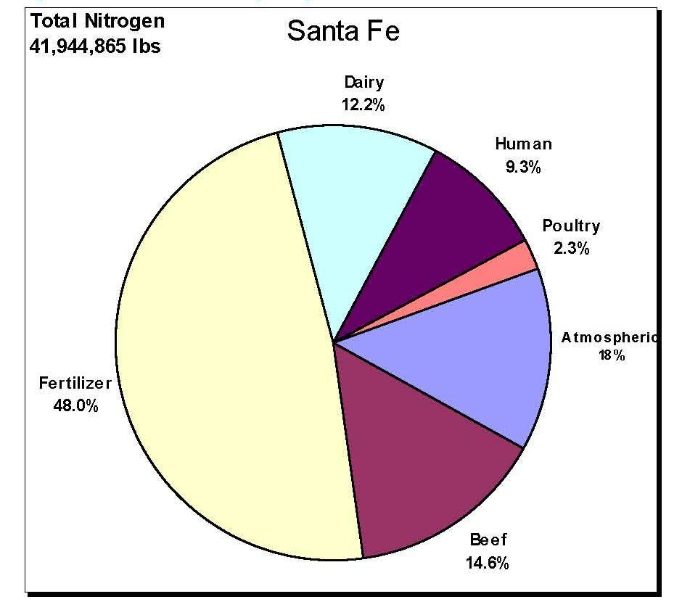
Figure 6. Calculated sources of nitrogen to the Santa Fe River,
based on 1999 land use

: Management Actions

Municipal Stormwater Permits
Several of the basin entities qualify as MS4 permittees and, as such, are regulated by the Florida NPDES MS4 Program. The MS4 permittees in the basin are all Phase II MS4s, the requirements for which are outlined in Chapters 62-4, 62-620, 62-621, and 62-624, F.A.C. Table 8 lists the MS4s in the Santa Fe River Basin.

Table 8. Local governments in the Santa Fe River Basin designated as MS4s
Permittee | Permit Number | MS4 Type
University of Florida | FLR04E067 | Phase II
Florida Department of Transportation (FDOT) District 2 (Gainesville Urban Area [UA]) | FLR04E018 | Phase II
Alachua County | FLR04E005 | Phase II
City of Gainesville | FLR04E006 | Phase II

The Stormwater Management Program that Phase II MS4 operators must develop provides guidelines for effective BMP implementation in nonagricultural areas. The program includes BMPs, with measurable goals, and effectively implements the following six minimum control measures:
- Public Education and Outreach – Perform educational outreach regarding the harmful impacts of polluted stormwater runoff.
- Public Participation/Involvement – Comply with state and local public notice requirements and encourage other avenues for citizen involvement.
- Illicit Discharge Detection and Elimination – Implement a plan to detect and eliminate any nonstormwater discharges to the MS4 and create a system map showing outfall locations. Subsection 62-624.200(2), F.A.C., defines an illicit discharge as “…any discharge to an MS4 that is not composed entirely of stormwater…,” except discharges under an NPDES permit, or those listed in the rule that do not cause a violation of water quality standards. Illicit discharges can include septic/sanitary sewer discharges, car wash wastewater, laundry wastewater, the improper disposal of auto and household toxics, and spills from roadway accidents.
- Construction Site Runoff Control – Implement and enforce an erosion and sediment control program for construction activities.
- Postconstruction Runoff Control – Implement and enforce a program to address discharges of postconstruction stormwater runoff from new development and redevelopment areas. (Note: This minimum control is generally met through state stormwater permitting requirements under Part IV, Chapter 373, F.S., as a qualifying alternative program.)
- Pollution Prevention/Good Housekeeping – Implement a program to reduce pollutant runoff from municipal operations and property and train staff in pollution prevention.

The Phase II generic permit (Paragraph 62-621.300[7][a], F.A.C.) also has a self-implementing clause that requires a permittee to implement its stormwater pollutant load responsibilities within an adopted BMAP. The clause states: “If a TMDL is approved for any water body into which the Phase II MS4 discharges, and the TMDL includes requirements for control of stormwater discharges, the operator must review its stormwater management program for consistency with the TMDL allocation. If the Phase II MS4 is not meeting its TMDL allocation, the operator must modify its stormwater management program to comply with the provisions of the TMDL Implementation Plan applicable to the operator in accordance with the schedule in the Implementation Plan.”
None of the listed stormwater facilities in the basin discharges directly to a surface waterbody with a TMDL.

Management Actions
The stakeholders in the basin are required to carry out the management actions in the Santa Fe River BMAP to achieve the nutrient reductions necessary to meet the TMDL. In the basin, these actions primarily consist of the implementation of BMPs for agricultural stakeholders and the development and implementation of various ordinances for nonagricultural stakeholders. Section 3.2.3 details the agricultural BMPs and management actions proposed for the BMAP. The implementation of the Santa Fe River BMAP is a phased process, with the first five-year phase designed to have the majority of management actions implemented or well under way, and progress toward waterbody restoration documented.

Type and Eligibility of Management Actions
Management actions are eligible if they came on line in January 2007 or later. Stakeholders were asked to review the project types (shown in Table 9) and determine what projects they had undertaken that consisted of these project types.
Basinwide projects proposed or under way in the Santa Fe River BMAP area include educational programs, agricultural BMP implementation, land use development guidelines, and ordinances for nonagricultural fertilizer use. Localized projects occur primarily in the Lake City and Alachua County/Gainesville areas and consist of stormwater and wastewater improvements, hydrologic modeling, land acquisition, and stormwater master plan implementation and updates. The projects are summarized in Table 10 and detailed in Appendix D.

Table 9. Project types
- = Empty cell/no data
Project Type | Information Needed for Review | Notes
Structural stormwater –  new development | Environmental Resource Permit (ERP) Number | Private systems will be considered for credit. Credit for any structural project will only be provided for reductions above and beyond anticipated SRMWD ERP requirements.*
Structural stormwater –retrofit | Design parameters. | -
Nonstructural –  street sweeping | Frequency of sweeping and road miles swept per event | Should be only those roads within the planning area.
Nonstructural –  public education | Descriptive table to be attached | -
On-site treatment/ wastewater management | Sewering projects – number of households/businesses sewered.  Lift station/transmission line repairs – estimate of overflow frequency, leakage rate, or other factor that prioritized the repair/retrofit. Descriptive table to be attached. | Need to clearly identify the entity implementing the project entity and the jurisdiction in which the project occurred.
Agricultural BMPs | Acreage enrolled by commodity | Applicable to FDACS only.
Local ordinances and land development regulations | Ordinance number, name, and brief description | Any local land use regulations or ordinances that contribute to nutrient reductions should be provided.
Research and studies | Scope of services or description of study purpose and expected outcome | Research and studies designed to address key unknowns about the Santa Fe system may be eligible for qualitative credit.
Other nutrient reduction projects | Determined case by case | Projects not captured in the categories above but that achieve nutrient load reductions should be submitted and will be considered on a case-by-case basis.

Table 10. Project summary
- = Empty cell/no data
Project Type | Implementation Area | RFAs | Estimated Costs
Educational activities | Alachua and Gilchrist Counties | Springshed research, public awareness.  Springs Working Group | $275,000
Educational activities | Alachua County | Pet waste campaign, grass clippings campaign, public service announcements on stormwater | Ongoing
Land Acquisition | Alachua County | Springshed protection | 4,354 ac./ $30,000,000
Stormwater master plan implementation and updates | Alachua County | Hydrologic modeling and stormwater management improvements | $1,200,000 master plan, $650,000 modeling
Florida-Friendly Yards and Neighborhoods fertilizer application ordinance | Alachua County | Unincorporated areas of Alachua County | -
Florida-Friendly Yards and Neighborhoods fertilizer application ordinance | Basin wide | Columbia, Levy, Gilchrist, Bradford, Union Counties within 2 years of BMAP adoption | In development
Educational activities | Ichetucknee Springshed (Columbia County) | The Ichetucknee Partnership (TIP) and Invasive Species Working Group (ISWG) educational programs on benefits of and risks to springs | -
FDOT right-of-way fertilizer elimination | Basin wide | State roadways | -
Wastewater reuse facility | Lake City | - | $4,500,000
New wastewater treatment plant (WWTP) and sewering | Lake City | - | $15,00,000
Existing WWTP upgrades | Lake City | - | $3,000,000
Aquifer vulnerability studies | Columbia County, Alachua County, | County specific | Completed
Agricultural BMP implementation | Basin wide | Practices with existing BMP manuals | Varied
Springshed protection/  development ordinance | Alachua County | Vulnerable area identification | In place
Springshed protection/  development ordinance | Columbia County, Gilchrist County | Vulnerable area identification | In development
County Alliance for Responsible Environmental Stewardship (CARES) | Entire basin | Agricultural producers | -
U.S. Department of Agriculture (USDA) Natural Resources Conservation Service (NRCS) cost-share | Entire basin | Agricultural producers | Varies by commodity

Actions to Address Future Growth and BMP Implementation
Future nonagricultural growth in the Santa Fe River Basin is being addressed through the development and implementation of springshed ordinances linked to comprehensive plans in Levy and Alachua Counties. Gilchrist County is in the process of developing a springshed protection ordinance with a target date of 2012. Columbia County is reviewing the process to make a determination on the extent of the proposed protection area and the level of protection to be offered. Columbia, Levy, and Alachua Counties have all completed aquifer vulnerability studies to help county planners determine the areas of greatest vulnerability.
All the counties in the BMAP area are interested in maintaining the rural character of the area and are developing density guidelines in their comprehensive plans for the unincorporated areas of their respective counties.
Continuing the reductions in nutrients added to the Santa Fe River Basin is an important part of addressing future growth while achieving the TMDL. Projects will continue to need to be developed and implemented to achieve this goal. Future projects should be evaluated and detailed in the annual report update process. Examples of projects include the following:
- Green industry practices.
- The conversion of existing septic systems to a centralized wastewater collection and treatment system, such as in the city of Archer. This will help to reduce impacts on the springshed from distributed, unmanaged individual on-site disposal systems. The new city of Archer collection system will replace between 500 and 550 septic systems currently serving residences and businesses and will replace 2 small privately operated package WWTPs. Sewage flows will be conveyed to a 0.25 million-gallon-per-day (MGD) biological nutrient reduction facility. On average, each septic unit conversion will eliminate approximately 200 to 250 gallons per day of discharge with up to 35 mg/L of TN.
- The development of a countywide electronic septic tank permit database with the goal of tracking septic tank maintenance and failures.

The impacts of future agricultural growth in the Santa Fe River Basin will be addressed by implementing applicable BMPs and documenting the nutrient reductions achieved, as well as developing and implementing additional projects. The following sections describe some of the ongoing activities that address future growth. Additionally, examples of the types of projects needing to be developed and implemented include the following:
- The identification of “small farms” and other farms not currently covered by an FDACS BMP program.
- The development of a BMP educational plan for these small farm producers.
- The implementation and verification of applicable BMPs on the identified small farm acreage.
- The identification of BMPs that are key to achieving nutrient reductions within a particular area within the basin (e.g., an RFA). Some of these BMPs may require cost-share in order to be implemented.
- The evaluation of success in achieving nutrient reductions in RFAs.
- The exploration of agricultural practices such as sod-based rotation farming and rotational grazing for dairies.
- Forestry projects to demonstrate how well current BMPs work, and to make recommendations for BMP revisions where necessary. For example, using a combination of hillslope and watershed-scale paired treatments, to evaluate the loading impacts to ground water and ultimately to streams of various fertilization rates, up to and including the published maximum permissible rates (1,000 pounds of nitrogen [N]; 250 pounds of phosphorus [P] per 25-year rotation). Additionally, evaluate nutrient attenuation rates as water passes through the special management zone (SMZ) that buffers aquatic systems from the direct impacts of forest management.

Addressing Agricultural Nonpoint Pollution

Agricultural Industry Strategies To Reduce Nutrient Loadings

Overview of Agriculture in the Santa Fe Basin
The Santa Fe River Basin is situated within the boundaries of the SRWMD. The primary agricultural land uses in the basin are silviculture, pastures for beef production, and row crops and field crops. Other agricultural land uses include dairies, ornamental nurseries, sod production, and equine operations. Most of the agricultural acreage is located in the western portion of the basin. Figure 7 shows the approximate location of agricultural lands in the Santa Fe River BMAP area in 2008. Table 11 contains a breakdown of the types of agricultural land uses in the basin.

Limitations of Land Use Data
Land use data are helpful as a starting point for estimating agricultural acreage and developing BMP implementation strategies; however, their inherent limitations must be noted. To begin with, the time of year when land use data are collected (through aerial photography) affects the accuracy of aerial photo interpretation. This can result in the inappropriate analysis of the data and can hamper decision making.
Another limitation is that the specific agricultural activity being conducted is not always apparent. For example, in the Santa Fe Basin, a large amount of acreage is classified in land use data as improved pasture. Some acreage under this classification may be used for cattle grazing, some may consist of forage grass that is periodically harvested and sold for hay, and/or some may comprise a fallow vegetable field awaiting planting. Operations that may fall into this land use category fertilize at different rates (e.g., hay operations and some other commodities typically fertilize at or below rates recommended by the University of Florida–Institute of Food and Agricultural Sciences [UF–IFAS]); therefore, it is meaningful for the purposes of evaluating potential nutrient impacts to know specific land uses.
It is also important to understand that even if all targeted agricultural operations are enrolled, not all of the acreage listed as agriculture in Table 11 will be included in enrollment figures. The NOIs document the estimated total number of acres on which applicable BMPs will be implemented, not the entire parcel acreage. This is because land use data can contain nonproduction acres (such as buildings, parking lots, and fallow acres) that are not counted on the NOIs submitted to FDACS. There also may be significant amounts of acreage that do not need to be enrolled, such as lands designated as improved pasture that are not actively involved in commercial agriculture (operations conducted as a business). These areas are often low-density residential uses on large parcels of grassed land, or land that was but is no longer in commercial agricultural production. This information frequently is impossible to discern in the photo interpretation process used to generate land use data.

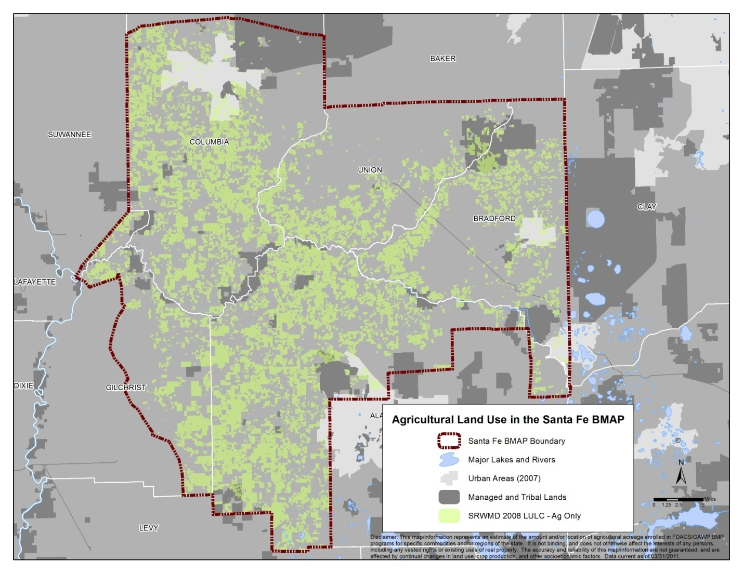
Figure 7. Agricultural acreage in the Santa Fe River BMAP area as of 2008

Table 11. Agricultural acreage and BMP enrollments for the Santa Fe River BMAP area as of March 31, 2011

Addressing Agricultural Nutrient Impacts
Nutrient reductions from commercial agricultural land uses will be achieved through the implementation of agricultural BMPs adopted by FDACS. BMPs relevant to the Santa Fe Basin are those developed by FDACS’ Office of Agricultural Water Policy (OAWP) (for “traditional” agricultural commodities) and Division of Forestry, now called the Florida Forest Service, (for silviculture operations). Noncommercial “agricultural-type” activities (e.g., residential vegetable gardens, hobby horse farms) may be addressed through FDEP-adopted BMPs, local government ordinances, UF–IFAS Extension programs, or other means.
Two key categories of practices included in the BMPs developed by the OAWP are nutrient management and irrigation management. It is important to address these together in an effort to minimize nutrient losses to the environment while maintaining crop yields. They are defined as follows:
- Nutrient management optimizes the amount, timing, and placement of fertilizer, and considers the type of fertilizer. Nutrient management BMPs include tools and techniques such as soil and tissue testing, fertigation (fertilizing through irrigation), split fertilizer applications, foliar applications, controlled-release fertilizer, nutrient budgeting, and variable-rate fertilizer application equipment.
- Irrigation management focuses on scheduling irrigation events and improving the overall efficiency and maintenance of irrigation systems. These BMPs typically include scheduling based on soil moisture monitoring; the consideration of rainfall, temperature, and other climatic conditions; the precise placement of water; and conversion to more efficient low-volume systems.

As previously discussed, irrigation management is important to water quality. Water is the carrier for nearly all pollutants. Overirrigating may exceed the soil’s water-holding capacity and lead to runoff or leaching. The goal of proper irrigation management is to keep both the irrigation water and the fertilizer in the crop root zone. In several areas of the state, FDACS-funded Mobile Irrigation Labs (MILs) identify and demonstrate irrigation efficiency techniques to growers. Currently, there is no MIL in the SRWMD region; however, FDACS and the SRWMD are discussing ways to reinstate services.
Before FDACS adopts BMPs, FDEP reviews the practices to ensure that they will be effective in reducing nutrient impacts. The OAWP has BMP programs for citrus, container nursery, sod, cow/calf, specialty fruit/nut, and vegetable/row crop operations. BMPs will soon be adopted for equine operations.

Agricultural Producers’ Responsibilities under the FWRA
The FWRA (Paragraph 403.067[7][b], F.S.) requires that producers in agricultural areas included in a BMAP demonstrate compliance with a TMDL either by implementing FDACS-adopted BMPs, or by conducting water quality monitoring prescribed by FDEP or the applicable water management district. If producers do not do one or the other, they may be subject to enforcement by FDEP or the water management district. Under the FWRA, enrollment in and implementation of FDACS-adopted BMPs provides a presumption of compliance with state water quality standards. In addition, producers may be eligible for cost-share funding from FDACS, the water management districts, or others.
There are approximately 200 commercial agricultural operations in the Santa Fe River Basin. As of December 31, 2010, producers in the counties in the basin had submitted 105 NOIs covering about 43,320 acres to implement FDACS-adopted BMPs. This does not equate to 105 producers because a single producer who owns more than one operation or who is growing more than one commodity on the operation may need to submit multiple NOIs.
Table 11 shows the estimated agricultural acreage in the watershed by land use, the current NOIs submitted, and the associated acres enrolled in related BMP programs. Although some producers implement water quality monitoring to satisfy permit conditions, none have indicated they will opt to conduct water quality monitoring in place of implementing BMPs for the purposes of the TMDL. Figure 8 shows the location of agricultural lands in the Santa Fe River BMAP area, along with the parcels that have filed NOIs and enrolled in FDACS’ BMP Program as of March 31, 2011.
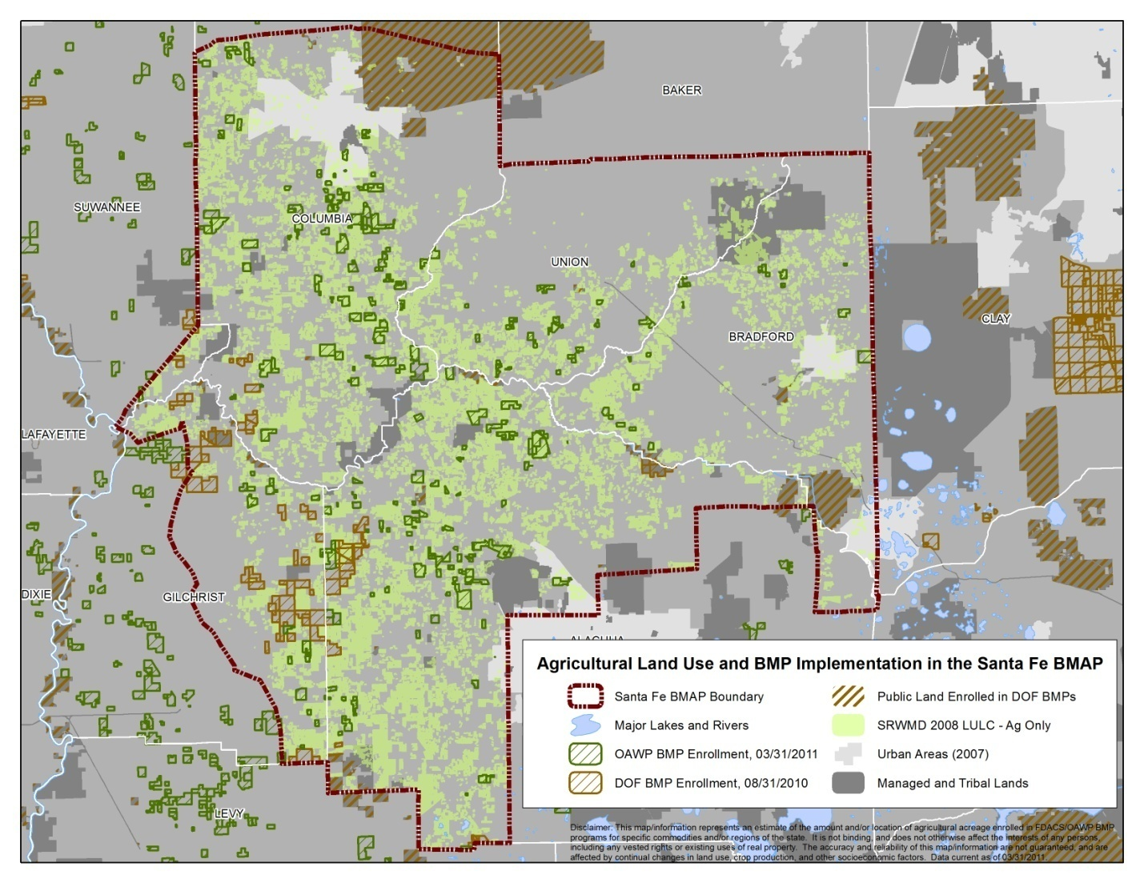
Figure 8. Agricultural acreage and BMP enrollment in the Santa Fe River Basin as of March 31, 2011

Role of the OAWP and the Suwannee River Partnership in Agricultural BMP Implementation
In addition to developing agricultural BMPs, the OAWP helps fund field staff and contractors to assist with enrollment and BMP implementation, primarily through the support of the Suwannee River Partnership (SRP), described below. As funds are available, the OAWP helps provide cost-share funding for BMP implementation. The SRWMD has been an invaluable partner in providing cost share for and technical input into BMP implementation. The SRWMD has been able to maintain BMP funding in years when state-level funding has been lacking. The OAWP also maintains a database to record the submitted NOIs to implement BMPs, the BMPs to be implemented, and the amount of agricultural acreage covered by the NOIs.
The SRP is a group of federal, state, and local agencies; state associations; private businesses; and other organizations that have come together to improve water quality and conserve water in the Suwannee and surrounding watersheds within the SRWMD. The mission of the SRP is “to provide researched-based solutions that protect and conserve the water resources within the SRWMD by emphasizing the implementation of voluntary or incentive-based programs.” The SRP initially was established to reduce nutrient loading in the middle Suwannee River Basin. Over the last decade or so it has expanded to cover the entire SRWMD.
The Suwannee River/Santa Fe River TMDL document (Hallas and Magley 2008) states: “A unique advantage in these basins is the existence of the Suwannee River Partnership, a proven organization that has proactively addressed water quality issues over the past 10 years with advances in pollution reduction, scientific understanding, and community awareness. The Department maintains that this Partnership is on the right path and should continue moving in that direction after the establishment of this TMDL. The Partnership will play a significant role (in) the Basin Management Action Plan process.”

FDACS, SRWMD, and FDEP collectively fund three SRP staff serving the entire water management district. FDACS and SRWMD also fund three technicians districtwide. One technician works primarily in the Santa Fe Basin and is headquartered in the Gilchrist Soil and Water Conservation District. Priority activities for the SRP include the following:
- One-on-one assistance to farmers to enroll in and implement FDACS BMPs.
- Educational workshops, field days, informational materials, and other means of promoting the understanding and implementation of BMPs.
- BMP implementation assurance through site visits and mailed surveys to gauge grower participation and evaluate program strengths and weaknesses.
- Cost-share funds to agricultural producers to help purchase crop tools they can use to manage fertilizer and irrigation. Crop tools include soil moisture probes, automated weather station systems, Global Positioning System (GPS) guidance units, and fertilizer application equipment. SRP staff work with farmers to evaluate how well these tools are being used, identify areas that need improvement, and identify new technology that may be used.
- Progressive Farms is an ongoing demonstration project involving about 20 farms districtwide. UF–IFAS staff work with these producers to install new techniques and technologies and evaluate their success, and to share their experiences with other farmers in the region, thus expanding the use of BMPs and BMP tools.

The SRP has succeeded in obtaining a high level of participation by the agricultural industry. Approximately 70% of crop farms, 90% of dairies, and 99% of poultry farms districtwide are implementing practices that help protect and save water. Not all of these operations have NOIs because FDACS has not had a rule-adopted program for dairies or poultry. However, FDACS adopted a Conservation Plan rule in 2010 that will allow these and other specified operations to enroll formally in FDACS’ BMP Program if they have or develop conservation plans that meet the rule criteria.

BMP Enrollment and Follow-Up Activities
Enrollment in OAWP BMP Programs
Agricultural producers can enroll in BMP programs by submitting a NOI to implement BMPs. The BMP rules, manuals, and NOIs are available on the OAWP website (available: http://www.floridaagwaterpolicy.com), or from SRP field staff. SRP staff and a Soil and Water Conservation District technician are available to provide enrollment assistance to producers in the Santa Fe River Basin. The assisted enrollment process involves an on-site assessment of potential ways to improve nutrient and irrigation management, sedimentation and erosion control, and other water resource–related management actions.

BMP Implementation Assurance
Approximately every five years, on a rotating basis by program, the OAWP mails written surveys to producers with active FDACS NOIs, to evaluate BMP implementation and update information on ownership, land use, acreage, etc. Producers in the Santa Fe Basin are included in these surveys.
In addition, SRP staff and technicians visit agricultural operations that receive cost-share funds, to ensure that they are keeping fertilization and irrigation records, which is a cost-share requirement. On a more routine basis, SRP staff, with the help of FDACS’ Dairy and Animal Industry Divisions, have been visiting dairy and poultry operations every one to two years to ensure that BMPs are being maintained. The inspectors fill out evaluation forms and assign a rating of Satisfactory, Conditional, or Unsatisfactory. For a Conditional or Unsatisfactory rating, one or more follow-up visits are scheduled, allowing a reasonable period for identified issues to be addressed. The following BMPs are commonly reviewed during dairy and poultry site inspections:
Structural
- Dairy
  - Barns or structures that collect manure
  - Pipes or structures that transport manure
  - Manure storage facilities
  - Irrigation systems and other mechanisms for applying manure to crops
- Poultry
  - Litter storage barns
  - Dead bird composters
  - Litter application equipment

Management (Dairy and Poultry)
- Proper operation and management of structures
- Manure/nutrient application rates
- Soil and manure testing
- Record keeping

SRP staff have expanded their site visits to vegetable/agronomic crop farms, and are developing a site visit form specific to those operations. With the anticipated increase in enrollees and the resulting workload, staff will visit operations in the basin that are under an FDACS NOI on approximately a five-year cycle to ensure that BMPs are being implemented. SRP staff will also provide technical assistance as needed and follow up on identified areas/operations of particular concern. Additional information about the results of implementation assurance activities is available at: http://www.floridaagwaterpolicy.com/
ImplementationAssurance.html.

Silviculture BMPs
Silviculture BMPs were developed in the mid-1970s. Without BMPs forestry activities can deliver sediment and nutrients to adjacent water resources at levels that may adversely affect aquatic ecosystems chemically, physically, and biologically. However, Florida silviculture BMPs have been shown to be effective in protecting water quality and aquatic habitat by minimizing or eliminating the delivery of forestry-related sediments, nutrients, and other contaminants, and by maintaining or improving both in-stream and riparian habitats. BMP effectiveness research conducted in Florida reported no evidence of sediment delivery or other impacts to the aquatic ecosystem following intensive silviculture operations on a variety of sites and under varying site conditions (Vowell 2001; Vowell and Frydenborg 2004).
The Florida Forest Service (FFS) (formerly the Division of Forestry) continues to promote Forestry Rule 5I-6, F.A.C., with private and public landowners in the state. Compliance with the rule involves submitting a NOI to the FFS committing to follow BMPs during all forestry operations. To date, over 5.4 million acres of private and public land have been enrolled in the program. FFS monitors landowners’ compliance with BMPs through the following activities:
- Silviculture BMP compliance has been monitored statewide since 1981. FFS conducts BMP evaluations on state forests in Florida where forest management activity involves the implementation of BMPs. These evaluations continue to be an important aspect of the FFS mission in protecting and managing Florida’s forest resources through a stewardship ethic. Thirty state forests were evaluated during Fiscal Year (FY) 2009–10, with an overall BMP compliance rate of 97% for all identified silviculture activities.
- FFS also conducts BMP follow-up in the form of Voluntary Courtesy Checks targeting specific areas (such as TMDL watersheds); these checks are made available to loggers, landowners, and contractors in an effort to enhance FFS’s outreach for BMP training. For 2010, 22 Courtesy Checks were performed, with an overall compliance rate of 98%.

Beyond BMPs
The FWRA requires that, where water quality problems are demonstrated despite the appropriate implementation, operation, and maintenance of adopted agricultural BMPs, FDACS must re-evaluate the practices in consultation with FDEP and modify them if necessary. Continuing water quality problems will be detected through the BMAP monitoring component and other FDEP and water management district monitoring activities.
If agricultural acreage corrections and BMP implementation do not fully account for reductions in estimated agricultural loadings, it may be necessary to implement cost-assisted field- and/or regional-level treatment options that remove nutrients from farm discharges. As needed, FDACS will work with local, regional, state, and federal partners to explore opportunities and funding sources to develop and implement effective treatment projects.

Ongoing and Future Actions in the Santa Fe Basin

Ongoing Activities
SRP staff are working closely with farmers in the Santa Fe Basin and other areas within the SRWMD to enroll in and implement BMPs. These activities, which will be ongoing, are as follows:
- Enroll commercial agricultural acres in the appropriate FDACS BMP programs.
- Provide technical assistance to producers in understanding and implementing BMPs.
- Deliver BMP cost-share funds, as available. The amount of cost-share that has been provided for BMPs and BMP crop tools within the Santa Fe Basin by the SRWMD and FDACS is approximately $825,000. Contributions by NRCS have far exceeded that amount. FDACS and the SRWMD continue to work together with NRCS to provide funding, as available. FDACS and SRP staff are looking to other sources, such as federal grants, to supplement reduced revenues.
- As funding is available, continue the Progressive Farms Program to conduct on-farm demonstrations of key BMPs and communicate the benefit of BMP implementation to other area farmers.
- Work with UF–IFAS and others to conduct workshops and field days to discuss and demonstrate BMPs.
- Continue to recognize farms that implement BMPs through the CARES Program.
- Continue BMP follow-up site visits (implementation assurance) to poultry and dairy farms.

Future Activities
Relatively recent and planned future activities include the following:
- SRP staff will work with dairy and poultry producers in the basin to review their existing conservation plans for consistency with the newly adopted conservation plan rule, assist with any needed revisions to the plan, and assist producers with submitting NOIs;
- As funding is available, FDACS will work with SRWMD, FDEP, UF–IFAS, and others to conduct research and demonstration projects and, as feasible, phase in any new BMPs, technologies, or BMP enhancements that may emerge;
- Through Progressive Farms and/or other voluntary efforts, SRP staff will work with growers to learn about new production schemes that may have added environmental benefits and are economically viable;
- FDACS will assist FDEP in determining whether/where to conduct BMP effectiveness studies (trends and/or full-scale verification); and
- As needed, explore the feasibility of agency-funded projects for achieving nutrient reductions beyond BMPs.

In addition, FDACS and SRP staff will assist FDEP in evaluating the need for outreach/education for property owners conducting noncommercial agriculture-related activities and, as resources allow, assist FDEP, UF–IFAS Extension, NRCS, and local governments in providing outreach/education.

Timeline of Activities
Figure 9 shows a flow chart of activities and approaches that FDACS will use to work with producers to implement BMPs. Figure 10 shows an approximate timeline for these activities.

Maximizing Efforts
The Santa Fe BMAP area contains over 1,000,000 acres, of which approximately 180,000 acres are nonforestry agricultural land. As previously discussed, not all these acres are appropriate for BMP enrollment. To date approximately 43,320 acres (18.7%) have been enrolled in FDACS BMP programs. In evaluating available information and determining what agricultural operations are appropriate for enrollment, FDACS and SRP staff will work closely with growers, grower organizations, and agencies with relevant information.

The identification of RFAs for BMP implementation, as discussed in Section 1.3.4.1, will allow FDACS/SRP staff to prioritize their efforts in enrolling producers in FDACS BMP programs and helping them implement BMPs. Concurrently, FDACS staff will concentrate enrollment efforts on vegetable/row crop (because of the more intensive nature of that land use) and cow/calf operations (because of the number of operations). Figure 9 shows a flow chart of the process for identifying and enrolling agricultural operations, whether in geographic or commodity-based RFAs. Appendix D contains information on the initial vegetable/row crop commodity-based RFA for the Santa Fe Basin. Similar information on geographic or commodity-based RFAs should be detailed and included in the annual reports/updates as new RFAs are identified.

Figure 9. Agricultural acreage identification and enrollment process in the Santa Fe River Basin

Figure 10. BMP implementation approach for agriculture in the Santa Fe River Basin

Section 319 Funding Elements
Although a watershed plan may include many different components, the U.S. Environmental Protection Agency (EPA) has identified a minimum of nine elements that are critical for achieving improvements in water quality. EPA requires that these nine elements be addressed for watershed plans funded using incremental Section 319 funds and strongly recommends that they be included in all other watershed plans that are intended to remediate water quality impairments. This BMAP includes the recommended elements, as shown in Table 12, that benefit the entities applying for Section 319 funding for the projects in the BMAP. Additional information on these elements can be found in the Draft Handbook for Developing Watershed Plans To Restore and Protect Our Waters (available: http://www.epa.gov/owow/nps/
watershed_handbook/. Appendix F summarizes the recommended elements.

Table 12. EPA elements of a watershed plan
EPA Element | Description | Section(s) in BMAP  Where Addressed
1 | Identification of causes of impairment and pollutant sources or groups of similar sources that need to be controlled to achieve needed load reductions and any other goals identified in the watershed plan. | 2.3  2.4
2 | An estimate of the load reductions expected from management measures. | 2.5
3 | A description of the nonpoint source management measures that will need to be implemented to achieve load reductions, and a description of the critical areas where those measures will be needed to implement the plan. | 3.2
4 | Estimate of the amounts of technical and financial assistance needed, associated costs, and/or the sources and authorities that will be relied upon to implement the plan. | Executive Summary,  Table 10  5.1
5 | An information and education component used to enhance the public’s understanding of the project and encourage their early and continued participation in selecting, designing, and implementing the nonpoint source management measures that will be implemented. | Table 10,  3.2.3, 5.1
6 | A reasonably expeditious schedule for implementing the nonpoint source management measures identified in the plan. | 3.2.3
7 | A description of interim measurable milestones for determining whether nonpoint source management measures or other control actions are being implemented. | 3.2  4.1
8 | A set of criteria that can be used to determine whether loading reductions are being achieved over time and substantial progress is being made toward attaining water quality standards. | 4.2  4.3
9 | A monitoring component to evaluate the effectiveness of the implementation efforts over time, measured against the criteria established under Item 8 above. | 4.2

: Assessing Progress and Making Changes
Successful BMAP implementation requires commitment and follow-up. In the Commitment to Plan Implementation (see Chapter 5), stakeholders have expressed their intention to carry out the plan, monitor its effects, and continue to coordinate within and across jurisdictions to achieve water quality targets. The FWRA requires that an assessment be conducted every five years to determine whether reasonable progress has been made in implementing the BMAP and achieving pollutant load reductions. This chapter describes the water quality monitoring component sufficient to make this evaluation.

Tracking Implementation
FDEP will work with stakeholders to collect and organize monitoring data and track project implementation. This information will be presented in an annual report. Stakeholders have agreed to meet at least every 12 months after the adoption of the BMAP to follow up on plan implementation, share new information, and continue to coordinate on TMDL-related issues. The following types of activities may occur at annual meetings:
- Implementation Data and Reporting
  - Collect project implementation information from stakeholders, review BMP/NOI documentation, and compare all the information with the BMAP schedule. Table 13 provides a sample annual reporting form on BMAP project implementation (to be completed by the entities).
  - Discuss the data collection process, including any concerns and possible improvements to the process.
  - Review the monitoring plan implementation, as detailed in Section 4.2.
  - Prioritize areas for focused BMP implementation efforts.
  - Evaluate ongoing focused BMP implementation efforts and adapt the process as needed.

- Sharing New Information
  - Report on results from water quality monitoring and trend information.
  - Provide updates on new projects and programs in the basin that will help reduce nutrient loading.
  - Identify and review new scientific developments for addressing nutrient loads and incorporate any new information into annual progress reports.

- Coordinating TMDL-Related Issues
  - Provide updates from FDEP on the basin cycle and activities related to any impairments, TMDLs, and BMAP.
  - Obtain reports from other basins where tools or other information may be applicable to the Santa Fe River TMDL.

Covering all of these topics is not required for the annual meetings, but the list above provides examples of the types of information that should be considered for the agenda to assist with BMAP implementation and improve coordination among the agencies and stakeholders.

Table 13. Proposed BMAP annual reporting form

2012 Santa Fe River BMAP

___Year__ Annual Implementation Report

Reporting Entity: ___________________________________________________ Date: __________________
Note: Relevant MS4 activities, whether contained in the BMAP or not, may be included in this report.

Implementation Status – BMAP Management Strategies
BMAP  Project #¹ | Affected  Area (WBID) | Brief  Description² | Projected  Start/  End³ | Project/  Activity Status⁴ | Project  Monitoring Results⁵ | Comments⁶

New Management Strategies
BMAP  Project #¹ | Affected  Area (WBID) | Brief  Description² | Projected  Start/  End³ | Project/  Activity Status⁴ | Project  Monitoring Results⁵ | Comments⁶

Directions for BMAP Annual Reporting Format:

¹ BMAP Projects: This includes projects and other management strategies. Use the project number assigned in the BMAP Activities Tables (e.g., A-1). Please include all management strategies for which you have lead responsibility in the BMAP, regardless of their status. New Management Strategies: Include new projects/activities that are not included in the BMAP in the New Management Strategies table. Create a project number for new management strategies by using the prefix, then -N# (e.g., A-N1). If a management action listed in either table is part of the BMP priority area, please shade the project number box in grey.
² Include a brief description of the management action being reported.
³ If applicable, include the start and end dates for the management action. If not applicable, put “N/A” or, if it is a continuous activity, put “Continuous” and indicate how often the activity takes place.
⁴ Clearly summarize the status of the management action, in a way that makes sense for the item listed. For instance, for educational activities, list pertinent publications, events, etc., including name and/or topic for each. Include specific or general time frames (e.g., two public workshops on pet waste disposal in July 2011). Also, describe any significant changes to the management action that have taken place.
⁵ As applicable: If monitoring is required as part of a management action (e.g., in a cost-share situation), or is conducted voluntarily (e.g., as part of an effort to collect information on BMAP effectiveness), include the monitoring results to date, as practicable.
⁶ Include comments on any implementation obstacles, including weather, funding, and technical difficulties. Provide any other comments you consider important.

Water Quality Monitoring

Water Quality Monitoring Objectives
Focused objectives are critical for a monitoring strategy to provide the information needed to evaluate implementation success. Since the BMAP is a phased process, each phase will have primary and secondary objectives. The primary objectives will focus on water quality improvements in the springs and Santa Fe River. The secondary objectives (research objectives) will focus on water quality parameters that can be used to provide information for potential future refinements of the BMAP. The monitoring strategy for additional phases will be developed after the first year of data is collected and analyzed.
The primary and secondary objectives of the Phase 1 monitoring strategy for the Santa Fe River Basin are as follows:

Primary Objectives
- Determine the levels of existing water quality parameters;
- Document decreasing nutrient trends in the Santa Fe River and associated springs; and
- Focus BMP implementation efforts by using the results of sampling data combined with appropriate GIS information, including land use data.

Secondary Objectives
- Identify areas where ground water data might help in understanding the hydrodynamics of the system;
- Develop a BMP implementation plan for future phases;
- Determine more effective nutrient reduction strategies; and
- Determine the effectiveness of nitrogen isotope sampling for identifying organic or inorganic sources.

Water Quality Indicators and Resource Responses
To achieve the objectives above, the monitoring strategy focuses on two types of indicators to track water quality trends: core and supplemental (Table 14a and Table 14b, respectively). The core indicators are directly related to the parameters causing impairment in the river. Supplemental indicators are monitored primarily to support the interpretation of core water quality parameters.
At a minimum, the core parameters will be tracked to determine the progress that has been made towards meeting the TMDL. In addition, resource responses to BMAP implementation may also be tracked (Table 15). Changes in water chemistry are not expected to occur within a relatively short period, depending on the actual rate of project implementation and rainfall conditions. A significant amount of time may be needed for the changes in water chemistry to be observed in the resource responses. However, resource responses represent improvements in the overall ecological health of the Santa Fe River.

Table 14a. Core water quality indicators and field parameters
Core Parameters | Anticipated Trend
Chloride | Indicator of human wastewater
Sulfate | Decrease in concentration
Potassium | Decrease in concentration
Ammonia as N | Decrease in concentration
Nitrate/nitrite as N | Decrease in concentration
Boron | Indicator of human wastewater
Oxygen isotpoes | Change in organic/inorganic ratios
Nitrogen isotopes | Change in organic/inorganic ratios

Table 14b. Supplemental water quality indicators and field parameters
Supplemental Parameters | Anticipated Trend
Specific conductance | Monitored to support interpretation of core indicators
DO | Monitored to support interpretation of core indicators
pH | Monitored to support interpretation of core indicators
Temperature | Monitored to support interpretation of core indicators
Total suspended solids (TSS) | Monitored to support interpretation of core indicators

Table 15. Anticipated resource responses from BMAP implementation
Resource Responses
Santa Fe
Reduction in Trophic State Index (TSI) score
Increase in Stream Condition Index (SCI) score
Increase in Shannon-Wiener diversity index score
Increase in key fish populations

Monitoring Network
In the first phase of BMAP implementation, data from the ongoing sampling effort in the Santa Fe River and associated springs that is being conducted by FDEP and SRWMD will be used to meet the primary objectives. These data will be entered into the STORET (or replacement) database. Figure 11 shows the springs stations currently being sampled.
The secondary (research) objectives will be met initially by the combination of an FDEP and Alachua County/SRWMD sampling effort. Monitoring wells to be sampled will be determined after the initial effort in the priority BMP area provides information on the state of the system and where additional monitoring will be most effective. Figure 12 shows the possible locations for monitoring wells in the basin, based on nitrate concentrations in ground water and Appendix F contains the initial sampling report. Updates for this report and other isotope sampling reports may be obtained from richard.hicks@dep.state.fl.us or terry.hansen@dep.state.fl.us.

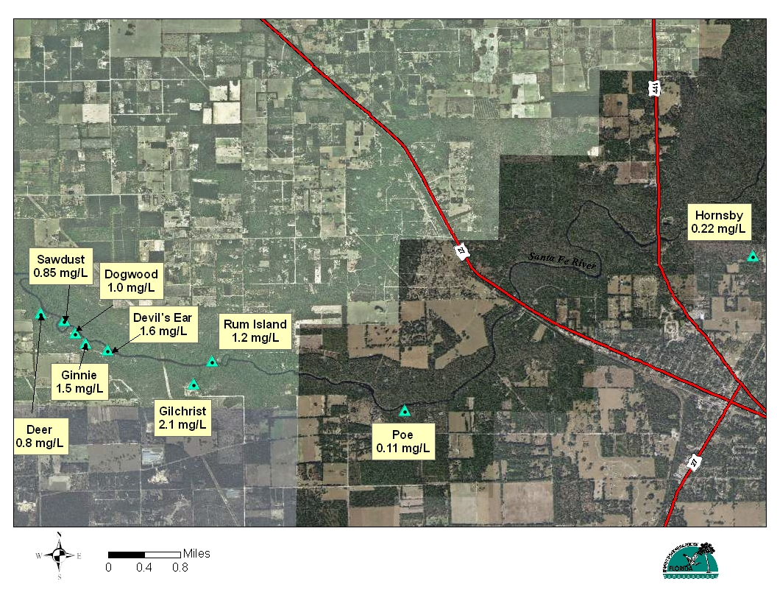

Figure 11. Stations currently sampled in the Santa Fe River and associated springs

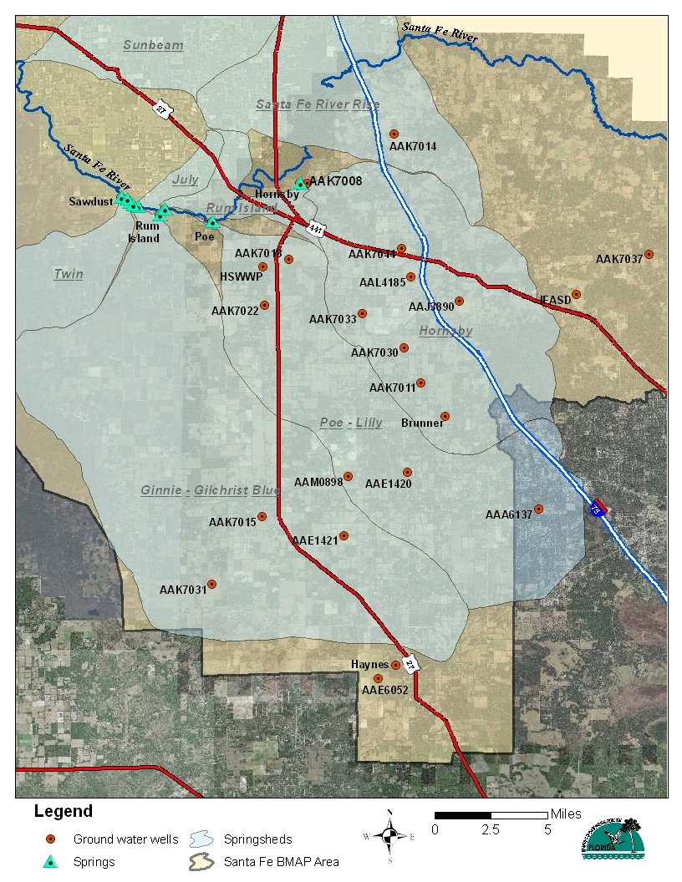
Figure 12. Possible locations for monitoring wells in the Santa Fe River Basin

Assessing Progress in Geographic RFAs
Appendix D contains detailed information on determining geographic RFAs. The general steps for working within a geographic RFA with all sources to assess progress are listed below:
- Step 1 – Identify all potential sources and estimated inputs of nitrate within the RFA in order to create a baseline against which to measure change.
- Step 2 – Identify strategic locations for ground water sampling and conduct ground water monitoring. This will provide information on nitrogen concentrations and sources within the RFA and a water quality baseline against which changes due to management actions could be measured. An important consideration will be how to segregate agricultural impacts from other sources.
- Step 3 – Implement management actions. For agriculture, this will include obtaining a specified degree of landowner participation in the BMP program (e.g., X % or X number of acres enrolled) and determining that the most current set of applicable BMPs is being implemented. For urban stakeholders, this will involve determining compliance with applicable ordinances and ensuring that listed projects are completed and operational.
- Step 4 – Periodically monitor the wells identified in Step 2 to collect information on changes in nitrogen concentrations and evaluate how well management actions are working.
- Step 5 – If needed, explore opportunities to further reduce nitrogen losses without economic impacts to stakeholders. This may include measures that are economically feasible without cost-share, measures that require cost-share, and/or publicly funded water quality improvement projects.

Quality Assurance/Quality Control
Through cooperation on TMDL-related data collection, FDEP and stakeholders have consistently used similar standard operating procedures (SOPs) for field sampling and lab analyses. This consistency will continue into the future to ensure that data can be used not only for tracking BMAP progress but also for future TMDL evaluations and other purposes. Water quality data will be collected in a manner consistent with FDEP’s SOPs for quality assurance/quality control (QA/QC). The most current version of these procedures is available at http://www.dep.state.fl.us/water/sas/sop/sops.htm. All stakeholders contributing data in support of the BMAP agree to follow these SOPs.

Data Management and Assessment
Data collected as part of this monitoring plan will need to be tracked, compiled, and analyzed for it to be useful in support of the BMAP. The Florida STORET database will serve as the primary resource for storing ambient data and providing access for all stakeholders, in accordance with Section 62-40.540, F.S. The data being collected to meet the primary objectives are currently being uploaded to STORET, after the appropriate QA/QC checks have been completed. All applicable data collected by the entities responsible for monitoring will be uploaded to STORET regularly, but at least quarterly. FDEP will be responsible for data storage and retrieval from STORET.
STORET uploads are only appropriate for data that represent ambient conditions. Other data will be maintained by the entity that collected the samples. Stakeholders agree to provide these data to other BMAP partners upon request and when appropriate for inclusion in BMAP data analyses and adaptive management evaluations.
Ground water data collected for the secondary objectives will not be uploaded to STORET.

Adaptive Management Measures
Adaptive management involves setting up a mechanism for adjusting the BMAP when circumstances change or feedback indicates the need for a more effective strategy. Adaptive management measures include the following:
- Procedures to determine whether additional cooperative strategies are needed;
- Criteria/processes for determining whether and when plan components need revision due to changes in costs, environmental impacts, social effects, watershed conditions, or other factors;
- Descriptions of the stakeholders’ role after BMAP completion; and
- The development of additional priority areas for BMP implementation and the continued evaluation of existing ones.

Key components of adaptive management to share information and expertise are tracking plan implementation, monitoring water quality and pollutant loads, and holding periodic meetings.
BMAP execution will be a long-term process. Some projects will extend beyond the first five years of the BMAP cycle. FDEP and the stakeholders will track implementation efforts and monitor water quality to measure effectiveness and ensure BMAP compliance. The stakeholders and FDEP will meet at least every 12 months to discuss implementation issues, consider new information, and, if the watershed is not projected to meet the TMDL, determine additional corrective actions. Project implementation as well as program and activity status will be collected annually from the participating entities. The stakeholders will review these reports to assess progress towards meeting the BMAP’s goals.

: Commitment to Plan Implementation
Section 403.067(7), F.S., lays out the mechanisms for BMAP implementation (see Appendix B). While the BMAP is linked by statute to permitting and other enforcement processes that target individual entities, successful implementation mandates that local stakeholders willingly and consistently work together to attain adopted TMDLs. This collaboration fosters the sharing of ideas, information, and resources. The stakeholders have demonstrated their willingness to confer with and support each other in their efforts, as shown in the following examples:
- The effectiveness of the FDACs and SRP BMP program is shown by agricultural producers’ willingness to sign up for the program and implement the appropriate BMPs. (Section 5.1 below summarizes specific examples of successful BMP implementation.)
- The efforts Lake City has made to upgrade its WWTP to meet advance treatment standards and implement wastewater reuse practices for both agricultural and urban users.
- The efforts of Alachua County to implement water quality, fertilizer, and landscape irrigation ordinances.
- The development of springshed protection ordinances by county governments based on aquifer vulnerability studies.

Examples of Commitment to BMAP Implementation
Multiple projects with the goal of reducing nutrient impacts to the basin are currently under way. The projects listed in this section are examples of these efforts from the SRP and a region-based component of the SRP, the Ichetucknee Partnership (TIP).

Silviculture BMPs
FFS’s Hydrology Section conducted a total of 60 BMP training workshops during 2010. These workshops were presented to a variety of entities, including the Florida Master Logger Program, the Southeastern Wood Producers Association, forestry consulting companies, internal training for Florida Forestry Service / Division of Forestry firefighters, and workshops open to the general public. Collectively, these workshops trained over 1,000 individuals.

SRP
SRP projects include both agricultural BMP implementation and education and outreach to agricultural and nonagricultural stakeholders in the basin. Work with producers on implementing BMPs in the SRP area, including the Santa Fe Basin, has been extensive and has yielded good results. The activities conducted with farmers, and some of the benefits of those activities, include the following:
- During the past 10 years, SRP, UF–IFAS Extension agents, and others have organized more than 50 farmer field days/workshops related to irrigation and fertilizer management, other BMPs, TMDLs, water supply, crop updates, and more.
- At the UF–IFAS Research and Education Center in Live Oak, SRP has worked to demonstrate new technology that helps protect and conserve water. During the past 10 years, UF–IFAS and SRP staff have established crop fertilization and irrigation demonstrations. Currently, demonstrations include sod-based rotation, high-residue conservation tillage, and advanced irrigation management. Using a USDA Conservation Innovation Grant, SRP is helping develop an advanced irrigation scheduling program that will be incorporated in UF’s Florida Automated Weather Network (FAWN) to help crop farmers manage their irrigation more effectively using evapotranspiration rates, ambient air temperature, and rainfall data.
- On-farm demonstrations have played a key role in helping to encourage BMP implementation throughout the Suwannee and Santa Fe River Basins. SRP established the Progressive Farms demonstration program in 2004, with the help of farmers/leaders in the crop industry, to demonstrate vegetable/agronomic crop BMPs. Since 2004, 20 farmers throughout the SRWMD area have demonstrated to their farming neighbors that BMPs work for them and for the environment. This program has allowed UF–IFAS and SRP staff to demonstrate new technology to manage fertilizer and irrigation more effectively. Along with the Crop Tools cost-share program, Progressive Farms has been instrumental in the widespread adoption (186 farms representing 112,000 acres) of crop management tools such as GPS, soil moisture probes, and precision fertilizer application equipment. UF–IFAS determined that the Progressive Farms operations using these tools reduced their nitrogen application by an average of 50 pounds per acre and demonstrated the efficient use of irrigation water.
- In 2010, UF–IFAS Extension staff taught 10 cooperating watermelon farms how to conduct sap tests with their own meters. An informal survey showed that these growers reduced early season irrigation by 50% and nitrogen applications by an average of 25 pounds per acre. One watermelon grower reduced nitrogen use by 50 pounds per acre on 200 acres. Collectively, these 10 farms saved $48,000 in fertilizer and an additional $12,000 in fuel for irrigation pumping.
- Nitrogen fertilizer sales (for agricultural and nonagricultural uses) in counties within the SRWMD dropped from 28,606 tons (57.21 million pounds) in
1997–98 to 19,948 tons (40 million pounds) in 2009–10. While this cannot conclusively be attributed to nutrient management BMPs, it can be assumed that BMP implementation, fertilizer costs, and the heightened awareness of producers about the environmental impacts of nutrients on water quality all played a part.

CARES Program
SRP, along with the Florida Farm Bureau, started the CARES Program in 2001 to recognize agricultural producers who are successfully implementing BMPs to help protect and conserve water. The program’s step-by-step approach to environmental stewardship helps farmers to implement sound, positive environmental practices and establish and follow environmental management plans while maintaining profitability. The CARES Program’s six-step process is as follows:
- Step 1 – Local county farm bureaus promote the program.
- Step 2 – Farmers implement FDACS BMPs or an NRCS conservation plan. Participating agencies help the farmer select and implement practices that include nutrient and irrigation management.
- Step 3 – Each farmer implements BMPs and conservation practices, as applicable.
- Step 4 – Individual farmers sign up for the CARES Program. Farmers who are documented as implementing applicable BMPs are nominated by participating agencies and associations.
- Step 5 – Each selected farmer is recognized as a participant in the CARES Program. SRP provides each recognized farm with a CARES sign to display, letting neighbors and others know the farm is implementing BMPs.
- Step 6 – To maintain CARES status, farmers must continue to operate and maintain their practices over time.

The program concludes each year with an annual dinner and recognition program, attended by 600 to 700 farmers, elected officials, partners, community supporters, businesses, youth organizations, and others. SRP has recognized more than 350 CARES farmers districtwide during the last 10 years. To date, 33 farmers in the Santa Fe Basin have been recognized in the CARES Program.

TIP
TIP was created in 2008 by the Lake City–Columbia County Chamber of Commerce, Columbia County Board of Commissioners, city of Lake City, Lake City Rotary Club, SRWMD, and SRP. TIP is a coalition of people, agencies, and organizations with a common mission “to promote the environmental and economic well-being of the Ichetucknee springshed through locally led, voluntary, incentive-based programs.” TIP has focused on BMPs, monitoring and research, and education and outreach and has made strides in each of these areas, including the following accomplishments:

Agricultural BMPs

Fourteen farming operations in the Ichetucknee Basin are participating in a cost-share program to implement karst-specific BMPs designed to reduce nutrient loading from animal waste and fertilizers, and to reduce water consumption through the use of more efficient irrigation systems. The program is coordinated by SRP, with funding provided by TIP.
Created a map of SRP BMP participants in the springshed.
- Conducted a crop management workshop.
- Held a BMP recognition program (CARES).

Nonagricultural BMPs

- TIP and UF–FAS hosted a low-impact development (LID) workshop in the spring of 2009 for builders, developers, realtors, local governments and others in Columbia and Suwannee Counties. UF’s Program for Resource Efficient Communities (PREC) conducted the workshop. PREC developed and presented a karst-specific module that promotes the best design, construction, and management practices that measurably reduce energy and water consumption and environmental degradation in new master-planned residential communities within a springshed.
- TIP developed cooperative Florida-Friendly Landscaping–Florida Yards and Neighborhoods (FFL-FYN) programs, publications, and displays for distribution.

Monitoring and Research

- TIP contracted with Advanced GeoSpatial, Inc. to develop the Columbia County Aquifer Vulnerability Assessment (CoCAVA). This interpretive mapping tool that identifies the most sensitive and vulnerable areas within the Ichetucknee springshed. Columbia County and Lake City are using the map as a planning tool for water resource protection.
- Monitoring of Blue Hole Spring and other sites.
- Water supply assessment.

Education and Outreach to Schools

- TIP provided about $30,000 to bring the FDEP-administered Learning in Florida’s Environment (LIFE) Program to Richardson Middle School’s (Lake City) advanced placement classes, Grades 6-8. This is the program’s third year.
- TIP provided an estimated $5,000 in funding for Fort White middle and high schools’ LIFE and PARKnership Programs. Projects included the purchase of monitoring kits, dibbles for tree planting, and rain barrels for water conservation projects, as well as funding for a video project.
- The Springs and Farms Activity Book, produced by TIP, SRWMD, and Santa Fe Soil and Water Conservation District, is distributed to kindergarten students throughout Columbia County’s public schools; 2011–12 will be the third year of distribution. The book introduces students to the importance of farms, forests, rivers, and springs in their community, while introducing the concepts of water conservation and protection of the Ichetucknee from pollution. The popular book was adapted to feature Fanning and Manatee Springs and reprinted by the Tri-County (Levy/Dixie/Gilchrist) Soil and Water Conservation Districts.
- The Springs and Farms Activity Book also serves as the basis for “Buddy-Up Day” in Fort White schools. Middle- and high-school students in the PARKnership Program meet with kindergarten students and guide them through the lessons in the book.
- TIP presented $50 and $25 cash awards to four students with the best projects focused on water issues and solutions in the 2011 Columbia County Science and Engineering Fair. Awards were presented at the 5th through 8th grade levels.
- Over 250 students (K–12) participated in the first annual “Drop Savers” water conservation poster contest, cosponsored by Lake City Regional Utilities, Fort White Water Utility, and TIP. Six winners were selected, and all poster entries were on display at the Lake City Mall throughout April and May 2011. The posters from Fort White students then went on display at the Fort White Library.

Public Awareness
- Educational displays –
  - TIP created tabletop educational displays on various topics, including springs protection, water conservation, Florida-Friendly Landscaping, and TIP for use at events, including the Columbia County Fair, Super 8, Alligator Lake Festival, and Fort White and Lake City (west branch) libraries.

- Proclamations –
  - TIP sent formal requests to the city of Lake City, the town of Fort White, and the Columbia County Commission asking that they issue proclamations designating April 2011 as “Water Conservation Month,” which they did.

- Radio –
  - TIP purchased air time for a series of 60-second “Gardening in a Minute” programs to air each spring (2009–11) on Columbia County radio stations 96.5 WJTK, Mix 94.3, and Power Country 102.1. The programs, produced by UF–IFAS, educate listeners on topics such as stormwater runoff, waste and fertilizer management, and water conservation.
  - TIP developed a 60-second public service announcement (PSA) for Columbia County’s annual Toxic Roundup day in April, and paid for the spots to run on 96.5 WJTK, Mix 94.3, and Power Country 102.1 radio stations three times per day for seven days prior to the event. The event provides an opportunity for the public to properly dispose of hazardous household waste. In the two years the PSA was aired, public participation increased over previous years.
  - TIP representatives were featured guests for a 30-minute interview on WJTK’s morning show.

- Video –
  - TIP reproduced and distributed hundreds of copies of the four-minute DVD, The Springs Heartland. The DVD was presented to every member of the Florida Legislature in 2010. It was broadcast in a continuous loop on the public announcement monitors at Lake City’s City Hall and the Columbia County Courthouse. It is also being aired on TV12, the government television channel for Alachua County and the city of Gainesville. Additionally, the DVD was shown to a group of national travel writers participating in a springs and river tour hosted by the Columbia County Tourism Development Council.

- Audio –
  - Development of an Ichetucknee Basin tour map and companion audio podcast

- Social media –
  - Facebook – www.facebook.com/ichetuckneepartnership
  - Website – under construction (a major redesign of the old site)

- Publications –
  - Fertilizer Facts card/door hanger
  - Conserve Water, Protect Springs with Florida-Friendly Landscaping (a brochure containing FFL tips)

- Presentations to clubs, civic organizations

- Grant funding and matching funds –
  - TIP received grant funding and matching funds from partners for two projects that it will complete this year: an educational kiosk at Alligator Lake public park; and a mascot costume representing Bellamy Beaver for appearances at schools, special events, parades, ribbon cuttings, etc.

Alachua County Environmental Protection Program
Alachua County’s Environmental Protection Program focuses on the following four main areas to promote springs and ground water protection: (1) local government implementation of the county’s Comprehensive Plan and the development and administration of regulations in support of the plan policies, (2) water resources monitoring and research, (3) environmental education and outreach, and (4) the acquisition and management of environmentally significant lands,
Comprehensive Plan and Regulations (Alachua County Code)
Alachua County amended its Comprehensive Plan in 2009 to adopt a revised map of high aquifer recharge areas based on aquifer vulnerability (Baker et al. 2005, 2008) and the occurrence of stream-to-sink basins. In 2011 the plan was updated to include additional policies for the protection of Floridan aquifer system ground water and springs.
Regulations have been developed for ground water and surface water protection. The Hazardous Materials Management Code was initially adopted in 1987 and provides countywide standards for hazardous materials management and siting provisions for areas where the Floridan aquifer system is unconfined or highly vulnerable. The Water Quality Code, adopted by ordinance, applies countywide to protect against illicit discharge. The Fertilizer and Irrigation Conservation codes were more recently adopted and apply to the unincorporated area of Alachua County and municipalities that have “opted-in.” In this case both ordinances now apply in Gainesville, Hawthorne, Alachua and Archer. The following regulations are currently in effect:
- Chapter 353 – Article II, Hazardous Materials Management Code
(1-25-2000);

- Chapter 77 – Water Quality Standards and Management Practices
(8-27-2002);

- Chapter 78 – Fertilizer Standards and Management Practices (9-22-2009);

- Chapter 79 – Irrigation Conservation Standards and Management Practices (10-13-2009); and

- Unified Land Development Code (ULDC) springs and ground water protection code for unincorporated Alachua County (various dates):
  - Chapter 404, Article 24, Mining or Excavation and Fill Operations
  - Chapter 406, Article 2, Trees and Native Vegetation
  - Chapter 406, Article 6, Surface Waters and Wetlands
  - Chapter 406, Article 12, Wastewater Treatment Facilities
  - Chapter 406, Article 16, Significant Geologic Features
  - Chapter 407, Article 4, Landscaping
  - Chapter 407, Article 5, Open Space
  - Chapter 407, Article 9, Stormwater Management
  - Pending ULDC changes for springs protection in high aquifer (Floridan) recharge areas proposed for adoption in 2012:
- Chapter 404, Article 14, Entertainment and Recreation (golf courses):
– Requires nutrient management for ground water, surface water, and springs.
- Chapter 406, Article 8, Springs and High Aquifer Recharge Areas:
– Implements outdoor water conservation for new development incorporating Homeowner Association Covenants, Conditions, and Restrictions (CC&R) documents, and applies to development activities for new subdivisions with high-volume irrigation not to exceed 60% of the irrigated area (the basic prerequisite for Florida Water Star Silver certification). The maximum allowed irrigated area is 0.5 acres.
– Prohibits the use of rapid infiltration basins or percolation ponds for wastewater effluent disposal.
– Prohibits new sites for the land application of Class A and B biosolids.

Water Resources Monitoring and Research
Monitoring and research are a main focus for springs protection. The Alachua County Environmental Protection Department (ACEPD) currently samples over 20 wells twice a year with a focus on the Santa Fe Basin and springshed areas where the Floridan aquifer system is unconfined. Sampling is conducted for nutrients, indicator parameters, selected anions and cations, and nitrogen and oxygen isotopes. ACEPD also monitors surface waters in the BMAP area with a focus on stream-to-sink basins and waterbodies not sampled by FDEP or the SRWMD. The following ambient monitoring, cooperative research projects and special studies are currently under way or were recently completed.
- Ambient monitoring of 20 wells twice a year with a focus on the Santa Fe Basin and springshed areas where the Floridan aquifer system is unconfined. The project has been expanded to include nitrogen and oxygen isotope sampling and analyses in coordination with FDEP.
- Participation in the FDEP Watershed Monitoring Program (ongoing since 1986) Ground Water Temporal Variability (GWTV) trend network sampling.
- Quarterly surface water monitoring of selected sites in the Santa Fe BMAP area focused on stream-to-sink watersheds and waterbodies not monitored by FDEP or the water management districts.

Numerous projects and special studies related to springs and ground water protection have been conducted in recent years. The following is a list of projects with brief project summaries; more detailed information and reports is available at: http://www.alachuacounty.us/Depts/EPD/WaterResources/Pages/WaterResources.aspx:
- Springshed delineation project for springs on the Santa Fe River (completed in 2008; second revision 2011). The project was jointly funded by the FDEP Springs Initiative and Alachua County. The final project report is titled Springsheds of the Santa Fe River Basin (Upchurch et al. 2011).
- Springshed Poster. The poster was designed, printed, and distributed in 2010. It displays the springshed and explains the concept and important steps for protecting springs. The poster is located at numerous local businesses, parks, and public buildings within the springshed.
- Protect Florida Springs Tag Grant 2011. The goal of the project is to learn how to encourage springs friendly behaviors by conducting qualitative research via focus groups and interviews with stakeholders. The final product will be preliminary creative materials that can later be further developed into a social marketing public outreach campaign implemented by various agencies or groups.

Education and Outreach
- Continued participation in the following Gainesville Clean Water Partnership illicit discharge and outreach programs, many of which are also protective of springs:
  - The Pet Waste Outreach Program educates and informs the public of the importance of picking up pet waste to improve water quality (nutrients and coliform bacteria).
  - The Grass Clippings Outreach Program educates and informs the public and landscape professionals about removing grass clipping from the street so they can be recycled on the lawn and do not clog storm drains and degrade surface water quality (nutrients).
  - BMPs for the protection of water quality have been developed for water conservation, homeowners, and commercial activities to protect water resources and are available at http://www.alachuacounty.us/Depts/EPD/
WaterResources/Pages/SolutionsforPollution.aspx.

Acquisition and Management of Environmentally Significant Lands
The Alachua County Forever (ACF) land acquisition program mission is to acquire, manage, and improve environmentally significant lands to protect water resources, wildlife habitat, and to provide natural areas suitable for resource-based recreation. In November 2000, 60% of the voters approved a $29 million program funded by a 1/4 mil property levy to create a program that has made the most important investment of all—to protect forever the area’s natural heritage. ACF has achieved all three of its original goals: protecting water resources, protecting wildlife habitats, and providing natural areas for resource-based recreation. That commitment was reaffirmed in 2008 with the passage of the Wild Spaces Public Places referendum creating an additional $15 million in conservation funds.
In the Santa Fe River Basin BMAP area, over 4,200 acres of environmentally sensitive lands have been acquired for protection at a cost of over $30 million. These lands include Mill Creek Preserve, Odom Preserve, Northeast Flatwoods Preserve, Lake Alto Preserve, Turkey Creek Hammock Preserve, Watermelon Pond Preserve, and numerous conservation easements and jointly managed properties. Along the Santa Fe River itself, Alachua County has adopted a Riverine Corridor Protection Plan, the objective of which is to implement Comprehensive Plan policies that conserve land and create buffers along the Santa Fe River corridor through voluntary land acquisition, conservation easements or covenants and education, and partnerships to change landowner practices. As part of the conservation easement negotiations, ACF insists on maintaining the current level of use along the Santa Fe River. For example, where the state's Silvicultural BMPs may allow new and more intense impacts along the river, the easements eliminate that right, maintaining the current level. Thus the county does not reference adopted BMPs as these may get less restrictive and therefore weaken the conservation easement.
More information about the protected environmentally significant lands acquired and managed in the Santa Fe River Basin BMAP area and the ACF program is available at http://www.alachuacounty.us/DEPTS/EPD/LANDCONSERVATION/Pages/LandConservation.aspx.

Santa Fe Springs Working Group
The Santa Fe Springs Working Group was established in 1998 to educate and inform the public about springs protection. A core group representing springs owners (Poe Springs, Blue Springs, and Ginnie Springs) and representatives from Alachua and Gilchrist Counties and a nonprofit (Current Problems) formed the initial coordinating committee. The group was later expanded to include representatives from Hornsby Spring. Group meetings are open to the public. The ACEPD is currently responsible for coordinating meetings and field trips. More information, past meeting presentations, and outreach materials on springs protection are available at http://SantaFeRiverSprings.com.
Activities for 2011 included the following:
- The February 16, 2011 meeting had 22 participants and included a field trip to see experimental container nursery BMPs.
- The annual Springs Celebration/Chili Cookoff was held in March 2011. This growing event reaches a diverse audience with springs protection messages.
- The May 19, 2011 meeting had over 50 participants and included a walk to the River Sink at O'Leno State Park.
- The October 19, 2011 combined meeting with the Manatee and Fanning Working Groups had over 50 participants and included a field trip to a local peanut farm.

Current Problems
Current Problems, Inc., a nonprofit organization, was established in 1993 when a small group of friends began working together to clean up the trash and contaminants in and along the banks of north Florida’s Santa Fe River. Current Problems’ original program, Adopt A River, addresses the visible contaminants in waterways by removing human trash and invasive species. Restore A Shore, the second program under the Current Problems' umbrella, focuses on the invisible contaminants by preserving and revegetating shorelines. Current Problems continues to conduct trash cleanups on the Santa Fe River and provides information on water quality and springs protection. A recent example is the design and installation of six interpretation signs at access points. More information is available at http://www.currentproblems.org/.

Gainesville Clean Water Partnership
The Gainesville Clean Water Partnership is a cooperative partnership between the city of Gainesville, Alachua County, and FDOT dedicated to working with the Gainesville community for healthy waterways. The partnership was established in 2001 to collectively address requirements of the National Pollutant Discharge Elimination System (NPDES) Program in the Gainesville urban area through public outreach and participation, illicit discharge detection and elimination, construction site stormwater controls, post construction stormwater controls, and good housekeeping in municipal operations. The partnership is also involved in working towards better water quality and healthier waterways in watersheds that are currently considered "impaired" through the TMDL Program. More information is available at http://www.gainesvillecreeks.org/
index.htm.

APPENDICES

Appendix A: TMDL Basin Rotation Schedule
TMDLs are developed, allocated, and implemented through a watershed management approach (managing water resources within their natural boundaries) that addresses the state’s 52 major hydrologic basins in 5 groups, on a rotating schedule. Table A-1 shows the hydrologic basins within each of the 5 groups, with the FDEP District Office of jurisdiction.

Table A-1. Major hydrologic basins by group and FDEP district office
FDEP  District | Group 1  Basins | Group 2  Basins | Group 3  Basins | Group 4  Basins | Group 5  Basins
Northwest | Ochlockonee–  St. Marks | Apalachicola–  Chipola | Choctawhatchee–  St. Andrews Bay | Pensacola Bay | Perdido Bay
Northeast | Suwannee– Santa Fe | Lower St. Johns | Not applicable | Nassau–St. Marys | Upper East Coast
Central | Ocklawaha | Middle St. Johns | Upper St. Johns | Kissimmee | Indian River  Lagoon
Southwest | Tampa Bay | Tampa Bay  Tributaries | Sarasota Bay–  Peace–Myakka | Withlacoochee | Springs Coast
South | Everglades  West Coast | Charlotte Harbor | Caloosahatchee | Fisheating Creek | Florida Keys
Southeast | Lake  Okeechobee | St. Lucie–  Loxahatchee | Lake Worth Lagoon–  Palm Beach Coast | Southeast Coast–Biscayne Bay | Everglades

Each group undergoes a cycle of five phases on a rotating schedule, as follows:
Phase 1: Preliminary evaluation of water quality
Phase 2: Strategic monitoring and assessment to verify water quality impairments
Phase 3: Development and adoption of TMDLs for waters verified as impaired
Phase 4: Development of BMAP to achieve the TMDL
Phase 5: Implementation of the BMAP and monitoring of results

The Santa Fe River Basin is a Group 1 basin. As such, the Cycle 1 list of verified impaired waters was developed in 2002 and the Cycle 2 list was developed in 2009. Subsequent TMDL and BMAP development is occurring on a schedule driven by the 1998 303(d) list (see http://www.dep.state.fl.us/water/tmdl/ for more information) and FDEP staff resource availability. FDEP will re-evaluate impaired waters every five years to determine whether improvements are being achieved and to refine loading estimates and TMDL allocations using new data. If any changes in a TMDL are required, the applicable TMDL rule may be revised. Changes to a TMDL would prompt revisions to the applicable BMAP, which will be revisited at least every five years and modified as necessary, regardless of whether the TMDL is modified.

Appendix B: Summary of Statutory Provisions Guiding BMAP Development and Implementation

Sections 403.067(6) and (7), Florida Statutes - Summary of Excerpts

Allocations
- The TMDL shall include reasonable and equitable allocations of the TMDL between or among point and nonpoint sources that will alone, or in conjunction with other management and restoration activities, provide for the attainment of pollutant reductions established pursuant to paragraph (a) to achieve applicable water quality standards.
- The allocations may establish the maximum amount of the pollutant that may be discharged or released in combination with other discharges or releases.
- Allocations may also be made to individual basins and sources or as a whole to all basins and sources or categories of sources of inflow to the water body or water body segments.
- An initial allocation of allowable pollutant loads may be developed as part of the TMDL; in such cases detailed allocations to specific point sources and categories of nonpoint sources shall be established in the basin management action plan.
- The initial and detailed allocations shall be designed to attain pollutant reductions established pursuant to paragraph (a) and shall be based on consideration of:
1. Existing treatment levels and management practices;
2. Best management practices established and implemented pursuant to paragraph (7)(c);
3. Enforceable treatment levels established pursuant to state or local law or
permit;
4. Differing impacts pollutant sources may have on water quality;
5. The availability of treatment technologies, management practices, or other pollutant reduction measures;
6. Environmental, economic, and technological feasibility of achieving the allocation;
7. The cost benefit associated with achieving the allocation;
8. Reasonable timeframes for implementation;
9. Potential applicability of any moderating provisions such as variances, exemptions, and mixing zones; and
10. The extent to which non-attainment of water quality standards is caused by pollution sources outside of Florida, discharges that have ceased, or alterations to water bodies prior to the date of this act.

General Implementation
- DEP is the lead agency in coordinating TMDL implementation, through existing water quality protection programs.
- Application of a TMDL by a water management district does not require WMD adoption of the TMDL.
- TMDL implementation may include, but is not limited to:
  - Permitting and other existing regulatory programs
  - Non-regulatory and incentive-based programs
  - Other water quality management and restoration activities, such as Surface Water Improvement and Management (SWIM) plans or basin management action plans
  - Pollutant trading or other equitable economically based agreements
  - Public works
  - Land acquisition

Basin Management Action Plan Development
- DEP may develop a basin management action plan that addresses some or all of the watersheds and basins tributary to a TMDL waterbody.
- A basin management action plan shall:
  - Integrate appropriate management strategies available to the state through existing water quality protection programs.
  - Equitably allocate pollutant reductions to individual basins, all basins, each identified point source, or category of nonpoint sources, as appropriate.
  - Identify the mechanisms by which potential future increases in pollutant loading will be addressed.
  - Specify that for nonpoint sources for which BMPs have been adopted, the initial requirement shall be BMPs developed pursuant to paragraph (c).
  - Establish an implementation schedule.
  - Establish a basis for evaluating plan effectiveness.
  - Identify feasible funding strategies.
  - Identify milestones for implementation and water quality improvement, and an associated water quality monitoring component to evaluate reasonable progress over time.
  - Be adopted in whole or in part by DEP Secretarial Order, subject to chapter 120.
- A basin management action plan may:
  - Give load reduction credits to dischargers that have implemented load reduction strategies (including BMPs) prior to the development of the BMAP. (Note: this assumes the related reductions were not factored into the applicable TMDL.)
  - Include regional treatment systems or other public works as management strategies.
  - Provide for phased implementation to promote timely, cost-effective actions.
- An assessment of progress in achieving milestones shall be conducted every 5 years and the basin management action plan revised, as appropriate, in cooperation with basin stakeholders, and adopted by secretarial order.
- DEP shall assure that key stakeholders are invited to participate in the basin management action plan development process, holding at least one noticed public meeting in the basin to receive comments, and otherwise encouraging public participation to the greatest practicable extent.
- A basin management action plan shall not supplant or alter any water quality assessment, TMDL calculation, or initial allocation.

Basin Management Action Plan Implementation
- NPDES Permits
  - Management strategies related to a discharger subject to NPDES permitting shall be included in subsequent applicable NPDES permits or permit modifications when the permit expires (is renewed), the discharge is modified (revised), or the permit is reopened pursuant to an adopted BMAP.
  - Absent a detailed allocation, TMDLs shall be implemented through NPDES permit conditions that include a compliance schedule. The permit shall allow for issuance of an order adopting the BMAP within five years. (Note: Intended to apply to individual wastewater permits – not MS4s)
  - Once the BMAP is adopted, the permit shall be reopened, as necessary, and permit conditions consistent with the BMAP shall be established.
  - Upon request by a NPDES permittee, DEP may establish individual allocations prior to the adoption of a BMAP, as part of a permit issuance, renewal, or modification (revision).
  - To the maximum extent practicable, MS4s shall implement a TMDL or BMAP through the use of BMPs or other management measures.
  - A BMAP does not take the place of NPDES permits or permit requirements.
  - Management strategies to be implemented by a DEP permittee shall be completed according to the BMAP schedule, which may extend beyond the 5-year term of an NPDES permit.
  - Management strategies are not subject to challenge under chapter 120 when they are incorporated in identical form into a NPDES permit or permit modification (revision).
- Management strategies assigned to nonagricultural, non-NPDES permittees (state, regional, or local) shall be implemented as part of the applicable permitting programs.
- Nonpoint source dischargers (e.g., agriculture) included in a BMAP shall demonstrate compliance with the applicable TMDLs by either implementing appropriate BMPs established under paragraph 7(c), or conducting water quality monitoring prescribed by DEP or a WMD. (Note: this is not applicable to MS4s, as they are considered point sources under the federal Clean Water Act and TMDL Program.)
  - Failure to implement BMPs or prescribed water quality monitoring may be subject to DEP or WMD enforcement action.
- Responsible parties who are implementing applicable BMAP strategies shall not be required to implement additional pollutant load reduction strategies, and shall be deemed in compliance with this section. However, this does not limit DEP’s authority to amend a BMAP.

Best Management Practices
- DEP, in cooperation with WMDs and other interested parties, may develop interim measures, BMPs, or other measures for non-agricultural nonpoint sources to achieve their load reduction allocations.
  - These measures may be adopted by DEP or WMD rule. If adopted, they shall be implemented by those responsible for non-agricultural nonpoint source pollution.
- DACS may develop and adopt by rule interim measure, BMPs, or other measures necessary for agricultural pollutant sources to achieve their load reduction allocations.
  - These measures may be implemented by those responsible for agricultural pollutant sources. DEP, the WMDs, and DACS shall assist with implementation.
  - In developing and adopting these measures, DACS shall consult with DEP, DOH, the WMDs, representatives of affected farming groups, and environmental group representatives.
  - The rules shall provide for a notice of intent to implement the practices and a system to ensure implementation, including recordkeeping.
- Verification of Effectiveness and Presumption of Compliance -
  - DEP shall, at representative sites, verify the effectiveness of BMPs and other measures adopted by rule in achieving load reduction allocations.
  - DEP shall use best professional judgment in making the initial verification of effectiveness, and shall notify DACS and the appropriate WMD of the initial verification prior to the adoption of a rule proposed pursuant to this paragraph.
  - Implementation of rule-adopted BMPs or other measures initially verified by DEP to be effective, or verified to be effective by monitoring at representative sites, provides a presumption of compliance with state water quality standards for those pollutants addressed by the practices.
- Reevaluation –
  - Where water quality problems are demonstrated despite implementation, operation, and maintenance of rule-adopted BMPs and other measures, DEP, a WMD, or DACS, in consultation with DEP, shall reevaluate the measures. If the practices require modification, the revised rule shall specify a reasonable time period for implementation.

Appendix C: Stakeholder Involvement in BMAP Development
Santa Fe River Stakeholder Involvement

Public Participation in Meetings
All technical meetings were open to the public and noticed in the Florida Administrative Weekly (FAW). Technical meetings were open to anyone interested in participating in the technical discussions. In addition, public meetings were held on the Verified Lists, the adoption of the TMDLs, and the BMAP document.
Public Meeting(s)
Public meetings on the proposed Verified List and the Santa Fe River TMDL were held before each was adopted. In addition, a public workshop on the BMAP was held on October 25, 2011.

Appendix D: Restoration Focus Areas
Initial Agricultural Commodity-Based RFA
The first commodity-based RFA for FDACS will be vegetable and row crop operations, because nutrient applications are so intensive with this land use. Figure D-1 shows row, field, and hay crop acreage within the Santa Fe Basin, with an overlay (striped areas) of the operations that already are enrolled in appropriate BMPs for this industry. Figure 9 in Chapter 3 of this BMAP illustrates the process that FDACS will use to identify and enroll commercial agricultural operations that do not yet formally participate in the BMP program.
To date, approximately 41,759 acres (54%) of an estimated 76,832 vegetable and row crop acres in the basin are enrolled in BMPs. FDACS’ goal is to raise this enrollment percentage to at least 70% within the first five years following BMAP adoption. This is in addition to concentrating efforts in identified geographic RFAs and working to enroll other commodities throughout the basin.
The SRP, with funding from the SRWMD, FDACS, and NRCS, provides cost-share to vegetable growers in the SRWMD to better manage their nutrient and irrigation water applications and to purchase “crop tools,” such as soil moisture probes, automated weather station systems, GPS guidance units, and fertilizer application equipment. SRP staff work with farmers to evaluate how well these tools are being used, identify areas that need improvement, and identify new technology that may be used. SRP staff also will be holding crop management workshops to encourage producer participation and provide updates on new crop management techniques and technology.
In spring 2011, FDACS conducted a written, mailed-out survey for enrolled vegetable and row crop producers statewide, including growers in the Santa Fe Basin. FDACS staff will continue BMP implementation follow-up activities with vegetable and row crop operations in the basin, through site visits and written surveys as described in Chapter 3, to evaluate overall participation in BMP implementation, and provide assistance to growers as needed. Once the vegetable and row crop BMP manual is revised, FDACS will determine that producers with NOIs are aware of improved practices and are implementing them.

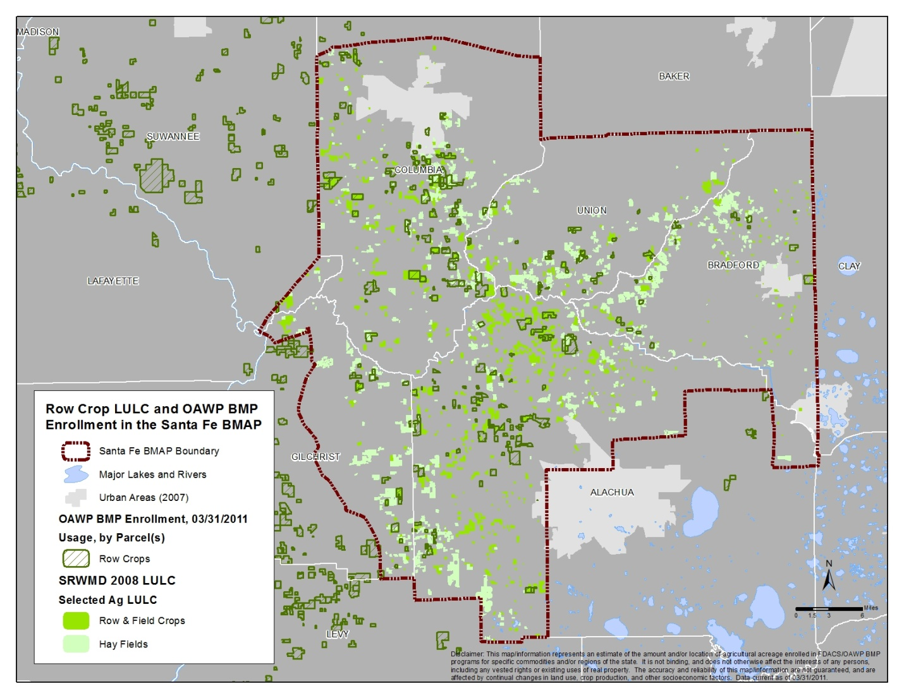
Figure D-1. Vegetable and row crop land use and BMP enrollment in the Santa Fe River Basin

Geographic RFAs
Introduction
Elevated nutrient concentrations are contributing to biological imbalances at many springs throughout Florida. Nutrient concentrations, specifically nitrate, discharging from many spring vents in excess of the 0.35 mg/L target for restoration can have negative impacts on water resources and cause health problems for humans. Isotopic analyses of nitrates have been used for a number of years to determine nitrogen sources in ground water samples, and studies demonstrate that fertilizer applied to cropland, lawns, and pine stands contributes the majority of the nitrogen load to ground water.¹
The Suwannee River Basin, which is a karst area, has the highest known concentration of springs in Florida. Because of the karst topography, pollutants have a greater potential to leach into ground water than in other areas where clayey soils and formations can slow leaching rates. Geological and hydrologic studies within the SRB indicate that preferential flow pathways exist in the underlying aquifer, and dye trace studies have shown that pollutants can be rapidly transported when they are entrained in water that follows these referred pathways (conduits). Because of the complex interactions between older ground water, recently leached water, and diverse modes of transport within the aquifers, it is important to note that all ground water samples reflect a mixture of both “old” water (water that has been stored in the aquifer, possibly for many years) and “young” water (water that has recently entered or “recharged” the aquifer).
BMPs provide the foundation for commercial agricultural operations to protect water resources, and producers often benefit from assistance with selecting appropriate BMPs and properly implementing them on a consistent basis. The SRP, formed in 1999, works with producers in the Suwannee River Water Management District area to reduce nitrate levels in surface waters and ground water through the implementation of applicable BMPs. Based on FDACS’ OAWP data, as of January 2011, the SRP has enrolled approximately 43,320 acres; however, other producers also are implementing BMPs through conservation plans.
The Santa Fe BMAP provides for a BMP-based approach to implementing the TMDLs established for the basin, including urban and agricultural BMPs. The BMAP also provides for the identification of one or more RFAs, where existing staff and financial resources can be concentrated on BMP implementation and on water quality monitoring to demonstrate related nutrient reductions. BMAP stakeholders can prioritize their efforts in implementing nitrate reduction strategies more completely and quickly in these areas. Consequently, it is anticipated that water quality improvements in the RFAs could be assessed before changes might be observed in the impaired WBIDs. If implemented BMPs in these areas do not result in measurable water quality improvements, the implementation of new or modified BMPs on a localized scale may be appropriate, as economically feasible, before existing BMPs have been implemented for the entire basin.
Modifications to other entities’ management actions also may be warranted. This proposal seeks the collaboration of the OAWP, the SRP, FDEP, and other affected BMAP stakeholders to establish one or more water quality restoration RFAs in the Santa Fe Basin. Because (1) a BMAP for the Suwannee River Basin is soon to be developed, (2) it is anticipated that it will include the use of RFAs, and (3) the same staff/financial resources will be have to be distributed between both basins, it may be advisable to look at the two basins together in identifying RFAs.
Proposed Criteria for Establishing an RFA
FDEP and FDACS have agreed that the following criteria are appropriate for the Santa Fe and Suwannee Basins, and details related to each criterion will be provided for consideration in selecting RFAs. Additional criteria may be considered, and stakeholders may want to prioritize or weight criteria for RFA selection. The proposed criteria are as follows:

- Availability of water quality data (nitrate values from monitoring wells and springs, from the Suwannee River Water Management District and FDEP).
- Conditions that provide an opportunity to observe short-term improvements in water quality.
- The existence of the following:
  - Delineated springsheds and spring vent locations (FDEP).
  - Preferred pathways/conduits.
  - Springs that are impaired or otherwise identified as a statewide or regional priority for restoration and protection. Additional consideration should be given to springs that contribute high loads to surface waterbodies.
  - Identified vulnerable areas and areas within specified distance(s) from sensitive natural features (rivers, springheads, etc.).
  - Water resources identified as economically important on a state or local level.

- Concentration of active agricultural land use within an area.
- Commodities being grown within an area.
- Existence of BMPs, including the use of “crop tools,” that are known to contribute to water quality improvement.
- Opportunity for increased level of BMP enrollment/implementation.
- Availability of financial and staffing resources in the area to carry out RFA activities. The size of the RFA should be considered.

The degree of local support from cities and counties, the water management district’s governing board, other political leaders, and the Florida Park Service also may be considered.
Proposed Steps for Establishing an RFA
The following steps should be taken to secure stakeholder involvement in establishing an RFA:
Step 1
FDEP, FDACS, and SRP staff will work together to apply the listed criteria for RFA selection and will develop a list of candidate RFAs for consideration by affected stakeholders.
Step 2
FDEP, FDACS, and SRP staff will organize and conduct a meeting of affected stakeholders to present the list of candidate RFAs and discuss how the list was developed. Stakeholders will have a chance to share their perspectives, ask questions, express preferences, and suggest additional areas for consideration. This may be accomplished through one or more meetings with all the affected stakeholders, or through smaller group meetings with the affected stakeholders within each candidate RFA.
Step 3
Taking into consideration stakeholder feedback, FDEP, FDACS, and SRP (after internal approvals and other processes) will present the final RFA list to the larger group of affected stakeholders. The proposal may include one or more RFAs; if more than one RFA is included, they will be prioritized according to a timeline for implementation.
Proposed Steps for Assessing Progress in an RFA
Once an RFA is established, the following steps should be taken to assess progress in reducing nutrient impacts.
Step 1
Identify all potential sources and estimated inputs of nitrate within the RFA in order to create a baseline against which to measure change. Potential tools to use for this step include the most current land use coverage; land use categories typically associated with nitrogen; and estimated nitrogen inputs from fertilizer use and animal operations, using published data from UF–IFAS, the SRWMD WAM model, and other sources.
Step 2
Develop a written monitoring strategy, which identifies strategic locations for ground water sampling, including ground water monitoring network wells and private wells. Conduct ground water monitoring to provide information on nitrogen concentrations and sources within the RFA, and a water quality baseline against which changes due to management actions could be measured. An important consideration will be how to segregate agricultural impacts from other sources. Attempts may be made to recruit producers who would allow onsite monitoring, with assurances that they would be held harmless with regard to the monitoring results.
Step 3
Implement management actions. For agriculture, this will include obtaining a specified degree of landowner participation in the BMP program (e.g., X % or X number of acres enrolled) and determining that the most current set of applicable BMPs is being implemented. There should be an evaluation of cost-share needs for implementing agricultural nutrient reduction BMPs, and of the availability of cost-share funds. For urban stakeholders, implementing management actions will involve determining compliance with applicable ordinances and ensuring that listed BMAP projects are completed and maintained.
Step 4
Periodically monitor the wells identified in Step 2 to collect information on changes in nitrogen concentrations and evaluate how well management actions are working.
Step 5
If needed, explore opportunities to further reduce nitrogen losses without economic impacts to stakeholders. This may include measures that are economically feasible without cost-share, measures that require cost-share, and/or publicly funded water quality improvement projects.

Appendix E: Summary of EPA-Recommended Elements of a Comprehensive Watershed Plan
The following is an excerpt on the nine elements of a watershed plan from the EPA’s Draft Handbook for Developing Watershed Plans to Restore and Protect Our Waters. Additional information regarding these elements can be found in the full version of the handbook, available at: http://www.epa.gov/owow/nps/watershed_handbook/.

Nine Minimum Elements to Be Included in a Watershed Plan for Impaired Waters Funded Using Incremental Section 319 Funds

Although many different components may be included in a watershed plan, EPA has identified a minimum of nine elements that are critical for achieving improvements in water quality. EPA requires that these nine elements be addressed for watershed plans funded using incremental Section 319 funds and strongly recommends that they be included in all other watershed plans that are intended to remediate water quality impairments.
The nine elements are provided below, listed in the order in which they appear in the guidelines. Although they are listed as a through i, they do not necessarily take place sequentially. For example, element d asks for a description of the technical and financial assistance that will be needed to implement the watershed plan, but this can be done only after you have addressed elements e and i.
Explanations are provided with each element to show you what to include in your watershed plan.

Nine Elements

a. Identification of causes of impairment and pollutant sources or groups of similar sources that need to be controlled to achieve needed load reductions, and any other goals identified in the watershed plan. Sources that need to be controlled should be identified at the significant subcategory level along with estimates of the extent to which they are present in the watershed (e.g., X number of dairy cattle feedlots needing upgrading, including a rough estimate of the number of cattle per facility; Y acres of row crops needing improved nutrient management or sediment control; or Z linear miles of eroded streambank needing remediation).

What does this mean?
Your watershed plan should include a map of the watershed that locates the major sources and causes of impairment. Based on these impairments, you will set goals that will include (at a minimum) meeting the appropriate water quality standards for pollutants that threaten or impair the physical, chemical, or biological integrity of the watershed covered in the plan.

b. An estimate of the load reductions expected from management measures.

What does this mean?
You will first quantify the pollutant loads for the watershed. Based on these pollutant loads, you’ll determine the reductions needed to meet the water quality standards.

You will then identify various management measures (see element c below) that will help to reduce the pollutant loads and estimate the load reductions expected as a result of these management measures to be implemented, recognizing the difficulty in precisely predicting the performance of management measures over time.

Estimates should be provided at the same level as that required in the scale and scope component in paragraph a (e.g., the total load reduction expected for dairy cattle feedlots, row crops, or eroded streambanks). For waters for which EPA has approved or established TMDLs, the plan should identify and incorporate the TMDLs.

Applicable loads for downstream waters should be included so that water delivered to a downstream or adjacent segment does not exceed the water quality standards for the pollutant of concern at the water segment boundary. The estimate should account for reductions in pollutant loads from point and nonpoint sources identified in the TMDL as necessary to attain the applicable water quality standards.

c. A description of the management measures that will need to be implemented to achieve load reductions in paragraph 2, and a description of the critical areas in which those measures will be needed to implement this plan.

What does this mean?
The plan should describe the management measures that need to be implemented to achieve the load reductions estimated under element b, as well as to achieve any additional pollution prevention goals called out in the watershed plan. It should also identify the critical areas in which those measures will be needed to implement the plan. This can be done by using a map or a description.

d. Estimate of the amounts of technical and financial assistance needed, associated costs, and/or the sources and authorities that will be relied upon to implement this plan.

What does this mean?
You should estimate the financial and technical assistance needed to implement the entire plan. This includes implementation and long-term operation and maintenance of management measures, information and education (I/E) activities, monitoring, and evaluation activities. You should also document which relevant authorities might play a role in implementing the plan. Plan sponsors should consider the use of federal, state, local, and private funds or resources that might be available to assist in implementing the plan. Shortfalls between needs and available resources should be identified and addressed in the plan.

e. An information and education (I/E) component used to enhance public understanding of the project and encourage their early and continued participation in selecting, designing, and implementing the nonpoint source management measures that will be implemented.

What does this mean?
The plan should include an I/E component that identifies the education and outreach activities or actions that will be used to implement the plan. These I/E activities may support the adoption and long-term operation and maintenance of management practices and support stakeholder involvement efforts.

f. Schedule for implementing the management measures identified in this plan that is reasonably expeditious.

What does this mean?
You need to include a schedule for implementing the management measures outlined in your watershed plan. The schedule should reflect the milestones you develop in g.

g. A description of interim measurable milestones for determining whether management measures or other control actions are being implemented.

What does this mean?
You’ll develop interim, measurable milestones to measure progress in implementing the management measures for your watershed plan. These milestones will measure the implementation of the management measures, such as whether they are being implemented on schedule, whereas element h (see below) will measure the effectiveness of the management measures, for example, by documenting improvements in water quality.

h. A set of criteria that can be used to determine whether loading reductions are being achieved over time and substantial progress is being made toward attaining water quality standards.

What does this mean?
Using the milestones you developed above, you’ll develop a set of criteria (or indicators) with interim target values to be used to determine whether progress is being made toward reducing pollutant loads. These interim targets can be direct measurements (e.g., fecal coliform concentrations) or indirect indicators of load reduction (e.g., number of beach closings). You must also indicate how you’ll determine whether the watershed plan needs to be revised if interim targets are not met and what process will be used to revise the existing management approach. Where a nonpoint source TMDL has been established, interim targets are also needed to determine whether the TMDL needs to be revised.

i. A monitoring component to evaluate the effectiveness of the implementation efforts over time, measured against the criteria established under item h immediately above.

What does this mean?
The watershed plan must include a monitoring component to determine whether progress is being made toward attainment or maintenance of the applicable water quality standards. The monitoring program must be fully integrated with the established schedule and interim milestone criteria identified above. The monitoring component should be designed to determine whether loading reductions are being achieved over time and substantial progress in meeting water quality standards is being made. Watershed-scale monitoring can be used to measure the effects of multiple programs, projects, and trends over time. In stream monitoring does not have to be conducted for individual BMPs unless that type of monitoring is particularly relevant to the project.

Appendix F: Well and Spring Sampling To Evaluate Nitrogen Sources in the Alachua County Portion of the Santa Fe BMAP Area–DRAFT
By Richard Hicks and Kathryn Holland, Florida Department of Environmental Protection, Bureau of Watershed Restoration, Ground Water and Springs Protection Section

Introduction
In support of the Santa Fe River Basin TMDL and BMAP efforts being conducted by FDEP’s Watershed Planning and Coordination Section, representatives from the Alachua County Environmental Protection Department (ACEPD) and FDEP’s Ground Water and Springs Protection Section (GWSP) obtained baseline samples from 21 private wells, 1 WWTP, and 9 springs within the BMAP area of the Santa Fe River Basin (1 well was on the outer eastern edge of the area). Sampling took place during February and March 2011.
The 2008 TMDL for the Suwannee and Santa Fe Rivers established the maximum threshold nitrate nitrogen concentration these waterbodies can support while maintaining a healthy ecosystem. The identification of potential nitrate sources is needed to implement appropriate restoration activities for the BMAP. The BMAP process currently under way for the Santa Fe River has identified potential nitrate source types; however, background data on nutrient sources and levels within the basin are somewhat lacking.
Most water in this segment of the Santa Fe River system comes from springs that discharge from the upper Floridan aquifer system. The contributing area of these springs (or combined springshed) includes the potential sources of nitrate that are causing the impairment of the system. The objectives of this initial assessment were as follows: (1) to assess baseline nitrate concentrations in the springsheds within the Santa Fe River Basin; and (2) to evaluate the nitrate sources by using chemical and isotopic tracers to differentiate between organic (from domestic wastewater or animal waste), inorganic (from inorganic fertilizer), or both, e.g., a mixture of nitrate inputs from both inorganic and organic sources.
Site Description
The Alachua County portion of the Santa Fe BMAP area lies within a karst plain region with minimal surface water features except for the river. The soil is sandy and well-drained, with a discontinuous clay layer providing minimal protection for the underlying carbonate Floridan aquifer system. The upper Floridan aquifer system is the source of water to springs discharging into the Santa Fe River. The assessment area includes portions of three Santa Fe River springsheds, as defined by Kincaid et al. (2009) (Figure F-1).
This area is mainly rural, with the towns of High Springs, Alachua, and Newberry being the only population centers. The SRWMD (FDEP 2008) and St. Johns River Water Management District (SJRWMD) (FDEP 2004) land use coverage was used to identify the major land use types in the assessment area. Approximately 26% of land use within the study area is defined as cropland and pastureland, which includes mainly improved and unimproved pastures, row crops, field crops, and mixed crops; and 20% is in tree plantation, which includes coniferous pine and forest regeneration areas. Other land use types include upland mixed forest (16%), low-density residential (12%), swamps and wetlands (~4%), and medium-density residential (~2.7%).
Sampling Approach and Springsheds
Springs that were selected for the assessment included those that provide a good geographic representation of the area as well as those with known elevated nitrate concentrations. Wells for sampling were selected by the Alachua County Department of Environmental Services (ACDES) to provide good areal distribution within the springshed area of Alachua County and to provide a good cross-section of typical land use types within the area.
Sampling sites were located within the southern portion of the Santa Fe River Planning Unit and primarily within the Hornsby, Poe-Lily, and Ginnie-Gilchrist-Blue springsheds. These were defined by Kincaid et al. (2009), using the FEFLOW model (finite element design), which allows the simulation of conduit and matrix flow, porous mediation equations for matrix, and pipe flow equations for conduits. The springshed delineation modeling strategy included a three-dimensional (3D) structure (surficial aquifer, intermediate confining layer, and Floridan aquifer); the definition of conduit locations from cave maps, tracer tests, and ground water levels (high and low water conditions); the definition of conduit capacities from levels and flows at high water conditions; a steady state (designed to simulate average conditions); and calibration to both high water and low water conditions. The spring modeling resulted in a good estimate of the area contributing to springs under average conditions, with the understanding that the springshed area may vary under extreme high or low conditions.
Kincaid et al. generally concluded that the Ginnie-Gilchrist-Blue and Poe-Lily springsheds primarily encompass the southern part of the model region, or the southwestern portion of the Santa Fe River BMAP area. The springs and springsheds are predominantly south of the Santa Fe River and are primarily drawing water from the Bell Ridge south to Waters Lake, and from Hogtown Prairie where Hogtown Creek disappears to Haile Sink (southeast to northwesterly flow direction). The general results of the modeling included the following:
- Rapid conduit flow is likely within these springsheds;
- Ground water velocities within conduits range between ~100 to 3,000 meters per day depending on water levels;
- Flow in the aquifer matrix is primarily toward closest conduits; and
- Areas closer to conduits are of higher concern than areas more distant from conduits regardless of their proximity to wells or springs.

Based on this information, the ground water sampling stations used for this study were located mostly within the Ginnie-Gilchrist-Blue, Hornsby, and Poe-Lily springsheds (Figure F-1). The private wells that were sampled in this assessment had been previously sampled by the Alachua County Health Department (ACHD) and ACEPD, and some of these have had nitrate concentrations exceeding the potable ground water standard of 10 mg/L. The springs that were sampled in this study have previously been sampled by the SRWMD, and some are routinely sampled by FDEP. Figure F-2 shows the spring sampling locations.

Sampling and Analysis
Representatives of GWSP conducted the spring sampling, and a team from ACEPD conducted the well sampling. All of the samples were analyzed for nitrite and nitrate-nitrogen (NOx), chloride, sulfate, boron, and isotopes (δ¹⁵N and δ¹⁸O in nitrate). Both sampling teams followed FDEP sampling SOPs. The isotope samples were analyzed by the Colorado Plateau Stable Isotope Laboratory at the University of Northern Arizona. All other samples collected for this report were analyzed by the FDEP Central Laboratory. Table F-1a and Table F-1b present the laboratory results for the baseline sampling.
Figure F-1. Ground water monitoring locations for evaluating nitrogen sources in the Santa Fe BMAP area
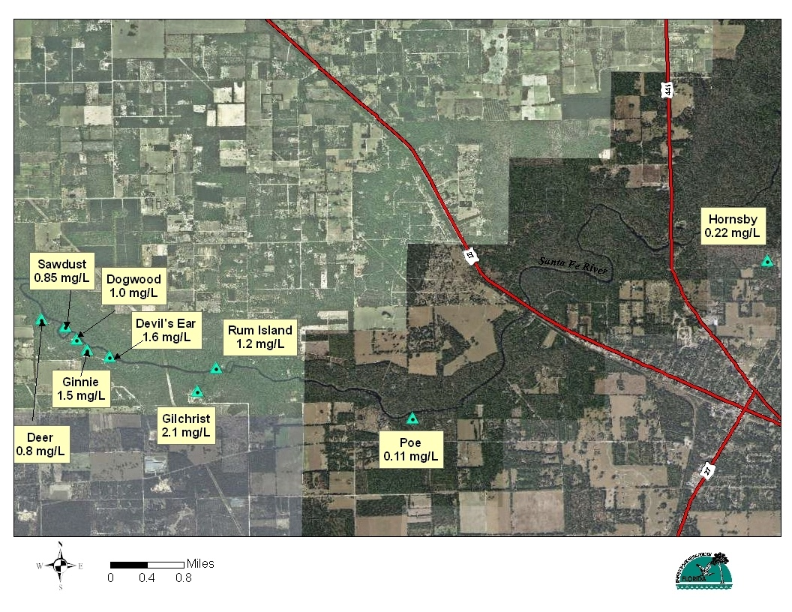
Figure F-2. Spring sampling locations with NOx concentrations

Table F-1a. Laboratory results for spring samples, baseline sampling
Notes: U = analyte undetected; associated value is method detection limit; I = estimated concentration; reported value is between the method detection limit and the instrument detection limit; BDL = below detection limit; - = Empty cell/no data.
Site ID | Springshed | Date | NOx (mg/L) | Ammonia (mg/L) | Sulfate (mg/L) | Chloride (mg/L) | Boron (μg/L) | Potassium (mg/L) | δ¹⁵NAIR (⁰⁄₀₀) | δ¹⁸OVSMOW (⁰⁄₀₀)
Dogwood Spring | Ginnie-Gilchrist-Blue | 2/22/2011 | 1.0 | 0.01U | 12.0 | 5.8 | 15U | 0.57I | 5.22 | 6.68
Gilchrist-Blue Spring | Ginnie-Gilchrist-Blue | 2/22/2011 | 2.1 | 0.012 | 14.0 | 6.5 | 16I | 0.74I | 4.07 | 4.92
Ginnie Spring | Ginnie-Gilchrist-Blue | 2/22/2011 | 1.5 | 0.01U | 11.0 | 6.2 | 15U | 0.68I | 4.57 | 5.70
Hornsby Spring | Hornsby | 2/28/2011 | 0.22 | 0.01U | 95.0 | 14.0 | 26I | 1.40 | 15.91 | 14.12
Devil's Ear Spring | July | 2/22/2011 | 1.6 | 0.01U | 18.0 | 9.5 | 17I | 0.85I | 4.45 | 6.75
Poe Spring | Poe-Lily | 2/23/2011 | 0.11 | 0.02 | 31.0 | 16.0 | 26I | 1.30 | 23.32 | 19.04
Rum Island Spring | Rum Island | 2/23/2011 | 1.2 | 0.01U | 15.0 | 9.2 | 18I | 0.88I | 6.49 | 6.80
Deer Spring | Twin | 2/24/2011 | 0.8 | 0.01U | 10.0 | 5.1 | 15U | 0.63I | 4.45 | 6.75
Sawdust Spring | Twin | 2/23/2011 | 0.85 | 0.01U | 14.0 | 6.8 | 15U | 0.76I | 5.66 | 6.32
SPRING MEDIAN | - | - | 1 | BDL | 14 | 6.8 | 16 | 0.76 | 5.22 | 6.75

Table F-1b. Laboratory results for ground water samples, baseline sampling
Notes: U = analyte undetected; associated value is method detection limit; I = estimated concentration; reported value is between the method detection limit and the instrument detection limit; A = reported value is an average of two or more analysis runs; BDL = below detection limit; - = Empty cell/no data.
Site ID | Springshed | Date | NOx (mg/L) | Ammonia (mg/L) | Sulfate (mg/L) | Chloride (mg/L) | Boron (μg/L) | Potassium (mg/L) | δ¹⁵NAIR (⁰⁄₀₀) | δ¹⁸OVSMOW (⁰⁄₀₀)
AAE1421 | Ginnie-Gilchrist-Blue | 2/21/2011 | 2.1 | 0.01U | 6.9 | 5.5 | 16I | 0.34I | 5.80 | 5.94
AAK7015 | Ginnie-Gilchrist-Blue | 2/21/2011 | 3.3 | 0.01U | 13.0 | 30.0 | 94 | 2.20 | 10.93 | 4.93
AAK7031 | Ginnie-Gilchrist-Blue | 2/21/2011 | 1.4 | 0.01U | 9.0 | 5.2A | 15U | 0.30U | 2.58 | 5.73
AAJ3890 | Hornsby | 2/22/2011 | 12.0 | 0.01U | 110.0 | 170.0 | 30I | 0.80I | 3.19 | 5.91
AAK7008 | Hornsby | 2/28/2011 | 0.86 | 0.025 | 66.0 | 24.0 | 26I | 2.00 | 20.29 | 10.49
AAK7011 | Hornsby | 2/21/2011 | 0.33 | 0.022 | 7.6 | 8.3 | 21I | 0.33I | 4.90 | 4.88
Brunner | Hornsby | 3/1/2011 | 0.61 | 0.01U | 3.9 | 11.0 | 19I | 0.95I | 3.54 | 2.05
AAK7030 | Hornsby | 2/21/2011 | 4.4 | 0.01U | 4.4 | 14.0 | 25I | 0.50I | 7.37 | 4.80
AAK7033 | Hornsby | 3/7/2011 | 3.2 | 0.01U | 1.3 | 6.1 | 17I | 0.4I | 4.28 | 3.44
AAK7044 | Hornsby | 2/23/2011 | 3.0 | 0.01U | 26.0 | 11.0 | 36I | 0.97I | 7.20 | 5.88
AAL4185 | Hornsby | 3/7/2011 | 1.3 | 0.01U | 5.5 | 15.0 | 19I | 0.80I | 6.05 | 7.42
AAM0898 | Poe-Lily | 2/22/2011 | 1.4 | 0.01U | 9.3 | 6.2 | 16I | 0.32I | 5.10 | 6.06
AAA6137 | Poe-Lily | 2/21/2011 | 1.3 | 0.01U | 11.0 | 15.0 | 27I | 0.42I | 4.07 | 9.05
AAE1420 | Poe-Lily | 2/22/2011 | 1.2 | 0.01U | 11.0 | 11.0 | 23I | 0.59I | 7.33 | 4.70
AAK7018 | Poe-Lily | 2/22/2011 | 1.1 | 0.01U | 4.5 | 5.4A | 15U | 0.72I | 3.77 | 3.15
AAK7022 | Poe-Lily | 2/22/2011 | 0.87 | 0.014I | 4.8 | 11.0 | 15U | 0.30U | 3.54 | 3.31
AAK7014 | Santa Fe Rise | 2/24/2011 | 3.2 | 0.01U | 4.5 | 6.0 | 15U | 0.56I | 3.36 | 6.64
AAE6052 | Not identified | 3/3/2011 | 23 | 0.01U | 3.3 | 16 | 17 | 1.4 | 7.77 | 7.17
AAK7037 | Not identified | 2/22/2011 | 2.5 | 0.011 | 7.8 | 12.0 | 25I | 0.44I | 10.98 | 5.55
Haynes | Not identified | 3/3/2011 | 4.0 | 0.01U | 5.3 | 6.3 | 15U | 0.87I | 8.22 | 7.74
IFASD | Not identified | 2/22/2011 | 0.21 | 0.01U | 48.0 | 12.0 | 24I | 0.79I | 8.08 | 7.09
GROUND WATER MEDIAN | - | - | 1.4 | BDL | 7.6 | 11.0 | 19 | 0.59 | 5.8 | 5.88
High Springs Wastewater Plant Effluent | - | 3/1/2011 | - | 11.0 | 0.089I | 70.0 | 84.0 | 203 | 14.40 | 23.25

Results
NOx Detections
The TMDL for nitrate in the Santa Fe River is 0.35 mg/L, and most of the concentrations of NOx in the spring and ground water samples were higher than that value (Table F-1a and Table F-1b, respectively). Figure F-2 shows the spring sampling locations and the NOx concentrations in the spring samples.
The range in NOx concentrations in the wells and springs of the main springsheds of this area showed some variability, particularly in wells at known sources (e.g., wastewater plants). All springs but two, Hornsby and Poe, had NOx concentrations greater than 0.8 mg/L. The springs with the highest NOx concentrations were in the Ginnie-Gilchrist-Blue Blue springshed. The results, organized by springshed, are as follows:
- Hornsby Springshed. NOx concentrations in springs and private wells in the Hornsby springshed ranged from 0.23 mg/L in the Hornsby spring vent to 12 mg/L in Well AAJ3890, a private well near several potential sources (a wastewater treatment site, an agricultural field, and a former meat-packing plant).
- Poe-Lilly Springshed. NOx concentrations in the private wells and springs sampled in the Poe-Lily springshed ranged from 0.11 mg/L in the Poe Spring vent to 1.4 mg/L in Well AAM0898.
- Ginnie- Gilchrist Blue Springshed. The NOx concentrations in the Ginnie-Gilchrist-Blue springshed and private well samples ranged from 1.0 mg/L at the Dogwood Spring vent, to 3.4 mg/L in Well AAK7015 at the Newberry Cemetery adjacent to the wastewater treatment facility (WWTF). The highest NOx concentrations measured in spring samples were from Ginnie Spring (1.5 mg/L) and Gilchrist-Blue Spring (2.1 mg/L).

Two of the 21 wells sampled had nitrate concentrations greater than the ground water standard of 10 mg/L: AAE6052 (23 mg/L); and AAJ3890 (12 mg/L) within the Hornsby springshed. The elevated NOx concentrations in these wells had been identified earlier by ACEPD and ACHD, and they were selected for this study to aid in evaluating the nitrate sources.
Chemical Tracers
Samples were analyzed for several inorganic chemicals that can be used to help evaluate the sources of nitrate in private wells. When these data are plotted, their relationship to one another and background concentrations can sometimes provide a better understanding of potential influences on ground water chemistry. In this study, samples were collected for sulfate, chloride, potassium, and boron. In addition, the samples were analyzed for sulfate, which can be an indicator of denitrification.
Chloride and potassium are common constituents of both inorganic fertilizer and domestic wastewater from wastewater plants and residential septic tanks. High concentrations of these substances also correlate with elevated specific conductance and, in some cases, boron. Chloride can be associated with fertilizer as a component of potassium chloride, but it also occurs as a strong signal for treated domestic wastewater.
Boron can also be associated with both fertilizer and domestic wastewater. Boron is an essential trace nutrient for peanuts, which are grown in this area, and is applied where it is deficient in soils (0.5 to 0.75 pounds of boron per acre in fertilizer [UF-IFAS 2003]); however, its most significant occurrence as a human influence is from domestic wastewater, where it is derived from perborate-containing laundry and dish detergents.
Several of the ground water samples collected during this study were intentionally collected from wells at or near domestic wastewater treatment sites to help characterize their chemical signatures. In addition, one domestic wastewater effluent sample was obtained. The sample from the High Springs Wastewater Plant (Table F-1b) contained chloride, boron, and potassium concentrations at least 10 times higher than the median concentration of the ground water samples. Only one other sample, from a private well near Alachua’s wastewater sprayfield, had concentrations similar to these (AAJ3890 in Table F-1b). The potential influence of domestic wastewater from effluent sites or septic tanks on other wells and for springs can be evaluated by comparing the concentrations of these against the medians for all wells and springs. FDEP found the concentration of chloride and boron to be particularly useful as they correlate fairly well in domestic wastewater. Figure F-3 shows this relationship.
This analysis showed that 4 of the 9 spring samples and 4 of the 21 ground water samples were above the median concentrations for both chloride and boron. These samples also had above-median potassium concentrations. These samples may be influenced by domestic wastewater. The springs with the highest chloride and boron concentrations were Poe and Hornsby, and Devils Ear Spring also had slightly above-median chloride, boron, and potassium concentrations. Two of the wells with above-median chloride and boron concentrations are in the Hornsby springshed; one is in the Ginnie-Gilchrist-Blue springshed (near a wastewater application site), and the other is not in any of the identified springsheds.
While these samples may indicate domestic wastewater influence causing elevated chloride and boron, that evidence alone does not confirm the source of elevated NOx, nor do elevated chloride and boron necessarily coincide with elevated NOx.. The attenuation of boron and chloride in ground water occurs mainly through dilution, which is why these parameters are considered conservative tracers. However, nitrate in NOx can be reduced through other means, most notably denitrification. There is some evidence that the nitrate in some of the springs has been reduced by denitrification, which can cause the reduction of sulfur and increased concentrations of sulfate in the water. Sulfate concentrations were elevated in Hornsby and Poe Springs, Well AAJ3890 (near wastewater application site), and Well AAK7044, all of which had chloride and boron signatures potentially indicative of wastewater influence. This could be due to the denitrification of nitrate in wastewater, which has its own organic food source for bacteria.
Elevated NOx in the absence of these signatures, which was observed in the majority of the spring and well samples, could be related to other sources such as inorganic fertilizer or animal waste. The use of isotopic tracers can provide better confidence in interpretations of nitrate sources and denitrification.

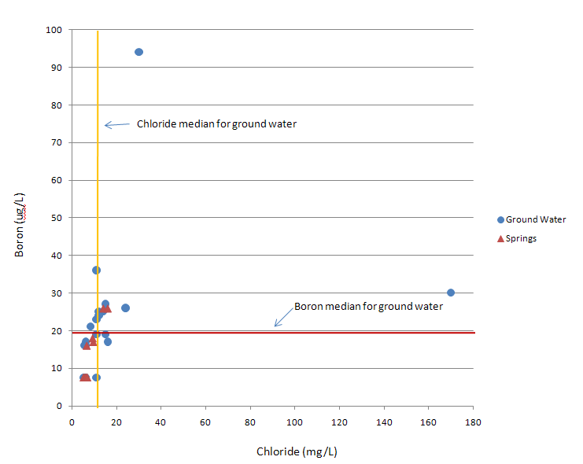
Figure F-3. Relationship of boron to chloride concentrations in ground water and spring samples

Isotopic Tracers
Measurements of nitrogen and oxygen isotope ratios, ¹⁵N/¹⁴N and ¹⁸O/¹⁶O_{NO3}, have been used for years to help differentiate between sources of nitrate in ground water and to evaluate whether nitrogen concentration changes are due to the mixing of nitrate sources or to denitrification (Kendall and McDowell 1988; Roadcap et al. 2001; Xue et al. 2009). These ratios for nitrogen and oxygen isotopes are represented in the delta notation, δ¹⁵N and δ¹⁸O, respectively, and are reported as parts per thousand (‰) deviations from recognized standards.
Over the years, researchers have associated isotopic ratios in ground water with a variety of sources, and from those data, general δ¹⁵N ranges have been assigned for the types of sources. These are shown along the x axis in Figure F-4. The three main nitrogen source categories are inorganic (from fertilizer), organic (from animal waste or domestic wastewater), and soil (which includes nitrogen from any source that is assimilated by the soil and accumulated in soil organic matter).
Inorganic nitrogen sources such as fertilizers and mineralized fertilizer residues have δ¹⁵N values in the range of -4 to approximately 4‰. Organic sources of nitrogen such as septic tank effluent and animal manure have δ¹⁵N values in the range of approximately 7 to 20‰. Soil nitrogen, which includes the nitrogen that has been assimilated by the soil from a variety of sources, may be represented by δ¹⁵N values ranging from approximately 0 to 12‰. Soil nitrogen may be less of a factor where soils have low organic carbon content, such as the sandy soils in this area, because these types of soils do not retain much nitrogen.
One factor that complicates the interpretation of data when using δ¹⁵N data to attribute nitrate to the types of sources is the fractionation of nitrogen isotopes. Fractionation, through either chemical or biological processes, usually results in the product becoming enriched in the lighter isotopes and the residual, which is what researchers measure, being enriched in the heavier isotope. The common fractionation mechanism for stable isotopes in NO₃ is denitrification. In it, the lighter ¹⁴N isotope is consumed by bacteria, which leave a residual ¹⁵N/¹⁴N product that is enriched in the heavier ¹⁵N isotope.

Figure F-4. Potential sources of nitrate in ground water and springs (labeled) and denitrification potential based on isotopic ratios (modified after Roadcap et al. 2001)

In recent years, researchers began to employ a “dual isotope method” to help evaluate the denitrification that is occurring in ground water. The second isotope in this dual approach is δ¹⁸O_{NO3}, which is the ratio of the heavier ¹⁸O in NO₃ to the lighter ¹⁶O. Denitrification results in the preferential fractionation of the lighter ¹⁶O and enrichment of the heavier ¹⁸O in the residue. Research has shown that when plotted against one another, the enriched δ¹⁸O can indicate that the corresponding δ¹⁵N value is influenced by denitrification. When samples from multiple points at the same site are plotted, the enrichment of the 2 isotopes due to denitrification generally results in a slope of roughly 2 to 1 (Roadcap et al. 2001).
Assuming that soil nitrogen contribution to the NOx is minimal, which is reasonable based on the low organic content of the soils in this area, the dual isotope plot indicates that the source of nitrate in the majority of the spring and ground water samples is inorganic fertilizer. When the isotope data from this study are plotted, 23 of the 31 stations sampled indicate that the NO₃ is from inorganic sources, with the majority of samples falling within or on the boundary of mineralized reduced N fertilizer and trending slightly towards dentrification.
Nitrate levels in two of the wells, AAE6052 (the Whistling Pines site where biosolids and inorganic fertilizer are applied) and AAJ3890, exceed 10 mg/L (23 and 12.0 mg/L, respectively). Well AAE6052 is directly adjacent to a center pivot field and surrounded by land use identified as hayfields. Land use directly south and east of Well AAJ3890 is defined as field crops in SRWMD land use coverage. Additionally, the city of Alachua has a sprayfield and a series of WWTF monitoring wells in acreage close to this property, which could explain the elevated concentrations of chloride, boron, and potassium in the sample from this well.
Isotopic signatures in four well samples indicate the nitrate is from mainly organic sources, which from chemical data and several of their locations appear to be domestic wastewater sites. Three of these four wells are close to WWTFs: AAK7015 (Newberry Cemetery) is north of the Newberry WWTF; Hornsby is due west of the Camp Kulaqua WWTF; and AAK7008 is on the Camp Kulaqua WWTP property adjacent to a percolation pond.
When plotted (Figure F-4), the isotopic signatures from the samples from Hornsby Spring, Poe Spring, Well AAK7008 (located in a horse pasture), and the High Springs WWTP indicate that the samples have been subjected to denitrification to the point that attributing the samples to a specific nitrate source type is difficult. However, the elevated chloride and boron concentrations in all of these samples indicate that domestic wastewater could be a significant component. For the High Springs WWTP effluent sample, it is of course the only component, and Well AAK7008 is near a wastewater treatment site.
Isotope data from Well AAK7037, which lies outside the delineated recharge area, is within the range for an organic source, but chemical tracer data do not suggest a domestic wastewater source. Similarly, the sample from Well AAK7030 has an isotopic signature in the organic range, but it does not have chemical signatures that clearly point to wastewater as a source. It is possible that the nitrate in these samples is from another type of organic source such as animal waste or septic tanks where chlorine and boron use is low. It is also possible that these wells are influenced by a mixture of organic and inorganic sources, which may be typical of residential settings.

Summary of Findings
The findings of this study are as follows:
- Isotope and chemical signatures in the majority of springs and wells in their springsheds that were sampled indicate that the NOx in the water is from inorganic fertilizers. This suggests that inorganic fertilizer is the main source of NOx in the Santa Fe River to be addressed under the BMAP. However, the isotope and chemical signatures in samples from two of the major springs, Poe and Hornsby, indicate that domestic wastewater may be a significant source of NOx in the water they discharge.
- NOx concentrations in the spring samples collected during this study range from 0.11 to 2.1 mg/L. The springs with the higher NOx concentrations appear to be related to inorganic fertilizer sources. Hornsby and Poe Springs, which may be influenced by wastewater, had the lowest NOx concentrations.
- Several of the wells that were sampled and one wastewater effluent sample were selected to intentionally target known wastewater application sites to help in the interpretation of the data. These were helpful in characterizing the chloride, boron, and potassium signatures as well as the isotope ratios and the amount of denitrification that is going on.
- The amount of denitrification, which can generally be assessed using the dual isotope method and the sulfate data, appears to vary between springs. The isotopic signatures from the majority of the springs, which were influenced by inorganic nitrogen sources, indicated some but not a great amount of denitrification. However, the signatures from Poe and Hornsby Springs, apparently influenced by domestic wastewater sources, indicated that the nitrate had been subjected to a greater amount of denitrification. The difference between these springs could be related to the NOx sources and presence of favorable conditions for denitrification to occur.
- It is possible to draw some conclusions as to land use influences on the types of NOx sources in the springs and wells. Generally, springs and wells within springsheds that were dominated by agricultural land uses such as row crop and pasture were more likely to be influenced by inorganic nitrogen sources (fertilizer). Springs and wells in springsheds and subspringshed areas with more residential development and with wastewater disposal had a greater likelihood of being influenced by wastewater. The design of a permanent monitoring network to evaluate the effectiveness of activities under the BMAP should take into account these types of land uses and their likely contributions to the springs.
- These findings will be updated and refined as additional data are gathered. A second sampling of the ground water network was conducted in July 2011, and the final report will include the results of that sampling.

References
Aravena, R., and W.D. Robertson. 1998. Use of multiple isotopes tracers to evaluate denitrification in ground water: Study of nitrate from a large-flux septic system plume. Ground Water Vol. 36. No. 6.
University of Florida Institute of Food and Agricultural Sciences (UF–IFAS) Extension. May 2003. Agronomy notes. University of Florida.
Kendall, C., and J.J. McDowell (Eds.). 1998. Isotope tracers in catchment hydrology. Amsterdam, Holland: Elsevier Science B.V.
Kincaid, T.R., B.A. Meyer, and J. Radtke. 2009. Western Santa Fe River Basin Groundwater Resource Model, modeling results and methods. Presentation to the Suwannee River Water Management District, St. Johns River Water Management District, and U.S. Geological Survey at the CCDA Waters Bottling Facility in High Springs, Florida, on August 3, 2009. Reno, NV: GeoHydros, LLC. Available: www.geohydros.com/
CCNA/ – last accessed 6/28/11.
Newton, J.L., and R.W. Hicks. 2010. Old Post Office Lane nitrate study, Eustis, Lake County, Florida: Preliminary contamination assessment report. Florida Department of Environmental Protection Site Investigation Section Report No. 2010-03
Roadcap, G.S., K.C. Hackley, H.H. Hwang, and T.M. Johnson. April 9, 2001. Application of nitrogen and oxygen isotopes to identify sources of nitrate. Report to the Illinois Groundwater Consortium Conference, Southern Illinois University.
Xue, D., J. Botte, B. DeBaets, F. Accoe, A. Nestler, P. Taylor, O. Van Cleemput, M. Bergludn, and P. Boeckx. 2009. Present limitations and future prospects of stable isotope methods for nitrate source identification in surface- and groundwater. Water Research 43 (2009) 1159–1170.

Appendix G: Glossary of Terms
303(d) List: The list of Florida's waterbodies that do not meet or are not expected to meet applicable water quality standards with technology-based controls alone.

305(b) Report: Section 305(b) of the federal Clean Water Act requires states to report biennially to the EPA on the quality of the waters in the state.

Allocation Technical Advisory Committee (ATAC): The 1999 FWRA required FDEP to form a Technical Advisory Committee to address issues relating to the allocation of load reductions among point source and nonpoint source contributors. The ATAC was therefore formed in order to develop recommendations for a report to the legislature on the process for allocating TMDLs.

Background: The condition of waters in the absence of human-induced alterations.

Baffle Box: An underground stormwater management device that uses barriers (or baffles) to slow the flow of untreated stormwater, allowing particulates to settle out in the box before the stormwater is released into the environment.

Baseline Period: A period of time used as a basis for later comparison.

Baseline Loading: The quantity of pollutants in a waterbody, used as a basis for later comparison.

Basin Management Action Plan (BMAP): The document that describes how a specific TMDL will be implemented; the plan describes the specific load and wasteload allocations as well as the stakeholder efforts that will be undertaken to achieve an adopted TMDL.

Basin Status Report: For the Suwannee Basin, this document was published in 2001 by FDEP. The report documents the water quality issues, list of water segments under consideration for a TMDL, and data needs in the basin.

Best Available Technology (BAT) Economically Achievable: As defined by 40 CFR, §125.3, outlines technology-based treatment requirements in permits.

Best Management Practices (BMPs): Methods that have been determined to be the most effective, practical means of preventing or reducing pollution from nonpoint sources.

Coliforms: Bacteria that live in the intestines (including the colon) of humans and other animals, used as a measure of the presence of feces in water or soil.

Clean Water Act (CWA): The Clean Water Act is a 1977 amendment to the Federal Water Pollution Control Act of 1972, which set the basic structure for regulating discharges of pollutants to waters of the United States.

Continuous Deflective Separation (CDS) Unit: A patented stormwater management device that uses the available energy of the storm flow to create a vortex to cause a separation of solids from fluids. Pollutants are captured inside the separation chamber, while the water passes out through the separation screen.

Designated Use: Uses specified in water quality standards for each waterbody or segment (such as drinking water, swimmable, fishable).

Detention Pond: A stormwater system that delays the downstream progress of stormwater runoff in a controlled manner, typically by using temporary storage areas and a metered outlet device.

Domestic Wastewater: Wastewater derived principally from dwellings, business buildings, institutions and the like; sanitary wastewater; sewage.

Dry Season: The dry part of the year when rainfall is low; in Florida, the dry season is defined as November through May.

Effluent: Wastewater that flows into a receiving stream by way of a domestic or industrial discharge point.

Environmental Protection Agency (EPA): This federal agency was created in December 1970 to address the nation's urgent environmental problems and to protect the public health. Most of FDEP’s regulatory programs have counterparts at the EPA or are delegated from the EPA.

Event Mean Concentration (EMC): The flow-weighted mean concentration of an urban runoff pollutant measured during a storm event.

Exfiltration: Loss of water from a drainage system as the result of percolation or absorption into the surrounding soil.

External Loading: Pollutants originating from outside a waterbody that contribute to the pollutant load of the waterbody.

Flocculent: A liquid that contains loosely aggregated, suspended particles.

Florida Department of Environmental Protection (FDEP): FDEP is Florida's principal environmental and natural resources agency. The Florida Department of Natural Resources and the Florida Department of Environmental Regulation were merged to create FDEP effective July 1, 1993.

Ground Water or Groundwater: Water below the land surface in the zone of saturation where water is at or above atmospheric pressure.

Impairment: The condition of a waterbody that does not achieve water quality standards (designated use) due to pollutants or an unknown cause.

Load Allocations (LA): The portions of a receiving water's loading capacity that are allocated to one of its existing or future nonpoint sources of pollution.

Load Capacity: The greatest amount of loading that a waterbody can receive without violating water quality standards.

Loading: The total quantity of pollutants in stormwater runoff that contributes to the water quality impairment.

Margin of Safety (MOS): An explicit or implicit assumption used in the calculation of a TMDL, which takes into account any lack of knowledge concerning the relationship between effluent limitations and water quality. An explicit MOS is typically a percentage of the assimilative capacity or some other specific amount of pollutant loading (e.g., the loading from an out-of-state source). Most FDEP-adopted TMDLs include an implicit MOS based on the fact that the predictive model runs incorporate a variety of conservative assumptions (they examine worst-case ambient flow conditions and worst-case temperature, and assume that all permitted point sources discharge at their maximum permittable amount).

National Pollutant Discharge Elimination System (NPDES): The permitting process by which technology-based and water quality–based controls are implemented.

Nonpoint Source (NPS): Diffuse runoff without a single point of origin that flows over the surface of the ground by stormwater and is then introduced to surface or ground water. NPS includes atmospheric deposition and runoff or leaching from agricultural lands, urban areas, unvegetated lands, on-site sewage treatment and disposal systems (OSTDS), and construction sites.

Nonpoint Source Pollution: Nonpoint source pollution is created by the flushing of pollutants from the landscape by rainfall and the resulting stormwater runoff, or by the leaching of pollutants through the soils into the ground water.

Organic Matter: Carbonaceous waste contained in plant or animal matter and originating from domestic or industrial sources.

Outfall: The place where a sewer, drain, or stream discharges.

Particulate: A minute separate particle, as of a granular substance or powder.

Pollutant Load Reduction Goals (PLRGs): PLRGs are defined as the estimated numeric reductions in pollutant loadings needed to preserve or restore the designated uses of receiving waterbodies and maintain water quality consistent with applicable state water quality standards. PLRGs are developed by the water management districts.

Point Source: An identifiable and confined discharge point for one or more water pollutants, such as a pipe, channel, vessel, or ditch.

Pollutant: Generally any substance, such as a chemical or waste product, introduced into the environment that adversely affects the usefulness of a resource.

Pollution: An undesirable change in the physical, chemical, or biological characteristics of air, water, soil, or food that can adversely affect the health, survival, or activities of humans or other living organisms.

Removal Efficiency: A description of how much of a given substance (metals, sediment, etc.) has been extracted from another substance.

Retention Pond: A stormwater management structure whose primary purpose is to permanently store a given volume of stormwater runoff, releasing it by infiltration and /or evaporation.

Reuse: The deliberate application of reclaimed water for a beneficial purpose. Criteria used to classify projects as “reuse” or “effluent disposal” are contained in Subsection 62-610.810, F.A.C.

Runoff Curve: A calculated number representing the percentage of rainfall that becomes runoff for a given area.

Quality Assurance (QA): An integrated system of management activities that involves planning, implementation, documentation, assessment, reporting, and quality improvement to ensure that a process, product, or service meets defined standards of quality.

Quality Control (QC): The overall system of technical activities that measures the attributes and performance of a process, product, or service against defined standards to verify that they meet the established data quality objectives.

Septic Tank: A watertight receptacle constructed to promote the separation of solid and liquid components of wastewater, to provide the limited digestion of organic matter, to store solids, and to allow clarified liquid to discharge for further treatment and disposal in a soil absorption system.

STORET: The EPA's STOrage and RETrieval database, used nationally for water quality data storage.

Stormwater: Water that results from a rainfall event.

Stormwater Runoff: The portion of rainfall that hits the ground and is not evaporated, percolated, or transpired into vegetation, but rather flows over the ground surface seeking a receiving waterbody.

Submersed: Growing or remaining under water.

Surface Water: Water on the surface of the earth, whether contained in bounds created naturally or artificially or diffused. Water from natural springs is classified as surface water when it exits the spring onto the earth’s surface.

Total Maximum Daily Load (TMDL): The sum of the individual wasteload allocations for point sources and the load allocations for nonpoint sources and natural background. Prior to determining individual wasteload allocations and load allocations, the maximum amount of a pollutant that a waterbody or waterbody segment can assimilate from all sources while still maintaining its designated use must first be calculated. TMDLs are based on the relationship between pollutants and instream water quality conditions.

Wasteload Allocations (WLAs): Pollutant loads allotted to existing and future point sources, such as discharges from industry and sewage facilities.

Wastewater: The combination of liquid and pollutants from residences, commercial buildings, industrial plants, and institutions, together with any ground water, surface runoff, or leachate that may be present.

Waterbody Identification (WBID) Numbers: Numbers assigned to hydrologically based drainage areas in a river basin.

Water Column: The water within a waterbody between the surface and sediments.

Water Quality Assessment Report: The Suwannee Assessment Report, published in 2003, presents the results of additional data gathered during Phase 2 of the watershed management cycle. The report contains a Verified List of impaired waters, adopted by Secretarial Order and approved by the EPA, for which TMDLs must be developed and implemented, unless the impairment is documented to be a naturally occurring condition that cannot be abated by a TMDL or unless a management plan already in place is expected to correct the problem. The Verified List also constitutes the Group 1 basin-specific 303(d) list of impaired waters, so called because it is required under Section 303(d) of the Clean Water Act.

Water Quality Index: Determines the quality of Florida's streams, blackwaters, and springs. Categories include water clarity, DO, oxygen-demanding substances, nutrients, bacteria, and macroinvertebrate diversity.

Water Quality Standards (WQSs): (1) Standards that comprise the designated most beneficial uses (classification of water), the numeric and narrative criteria applied to the specific water use or classification, the Florida Anti-degradation Policy, and the moderating provisions contained in Rules 62-302 and 62-4, F.A.C. (2) State-adopted and EPA-approved ambient standards for waterbodies. The standards prescribe the use of the waterbody (such as drinking, fishing and swimming, and shellfish harvesting) and establish the water quality criteria that must be met to protect designated uses.

Watershed: The topographic area that contributes or may contribute runoff to specific surface waters or an area of recharge.

Watershed Management Approach: The process of addressing water quality concerns within their natural boundaries, rather than political or regulatory boundaries. The process draws together all the participants and stakeholders in each basin to decide what problems affect the water quality in the basin, which are most important, and how they will be addressed.

Wet Season: The rainy part of the year; in Florida, the wet season is defined as June through October.

Appendix H: Bibliography of Key References and Websites

Key References:

Baker, A.E., A.R. Wood, and J.R. Cichon. 2008. Generalization of Alachua County aquifer vulnerability (ACAVA) results. Advanced GeoSpatial, Inc.
Baker, A.E., A.R. Wood, J.R. Cichon, and J.D. Arthur. February 10, 2005. Alachua County aquifer vulnerability assessment. Florida Department of Environmental Protection, Florida Geological Survey.
Florida Department of Agriculture and Consumer Services (FDACS). 2011a. Office of Agricultural Water Policy website. Available: http://www.floridaagwaterpolicy.com.
———. 2011b. BMP implementation assurance website. Available: http://www.
floridaagwaterpolicy.com/ImplementationAssurance.html.
Florida Department of Environmental Protection (FDEP). 2001. Basin status report: Suwannee (including Aucilla, Coastal, Santa Fe, and Waccasassa Basins in Florida). Tallahassee, FL: Bureau of Watershed Management. Available: http://www.dep.state.fl.us/water/
basin411/suwannee/status.htm.
———. 2003. Water quality assessment report: Suwannee (including Aucilla, Coastal, Santa Fe, and Waccasassa Basins in Florida). Tallahassee, FL: Bureau of Watershed Management. Available: http://www.dep.state.fl.us/water/basin411/suwannee/
assessment.htm.
———. 2011a. 2008 Standard Operating Procedures website. Available: http://www.dep.
state.fl.us/water/sas/sop/sops.htm.
———. 2011b. TMDL Program website. Available: http://www.dep.state.fl.us/water/tmdl/.
Hallas, J.F., and W. Magley. 2008. Nutrient and dissolved oxygen TMDL for the Suwannee River, Santa Fe River, Manatee Springs (3422R), Fanning Springs (3422S), Branford Spring (3422J), Ruth Spring (3422L), Troy Spring (3422T), Royal Spring (3422U), and Falmouth Spring (3422Z). Tallahassee, FL: Bureau of Watershed Management. Available: http://www.dep.state.fl.us/water/tmdl/docs/tmdls/final/gp1/suwanneebasin
nutrienttmdl.pdf.
Hornsby, H.D. 2007. Influences on the distribution and occurrence of nitrate-nitrogen and total phosphorus in the water resources of the Suwannee River Water Management District. University of Florida Ph.D. dissertation. Gainesville, FL.
Hornsby, H.D. and R. Ceryak. 1998. Springs of the Suwannee River Basin in Florida. WR99-02. Live Oak, FL: Suwannee River Water Management District.
Katz, B.G., H.D. Hornsby, J.F. Bohlke, and M.F. Mokray. 1999. Sources and chronology of nitrate contamination in spring waters, Suwannee River Basin, Florida. U.S. Geological Survey Water Resources Investigations Report 99-4252.
Katz, B.G., A.A. Sepulveda, and R.J. Verdi. 2009. Estimating nitrogen loading to ground water and assessing vulnerability to nitrate contamination in a large karstic springs basin, Florida. Journal of the American Water Resources Association 45: 607–627.
Normandeau Associates, Inc. June 15, 2011. Ichetucknee Springs and River restoration plan. Prepared for the Florida Department of Environmental Protection, Ground Water and Springs Protection Section. Gainesville, FL. Available: http://www.floridasprings.
org/downloads/florida_141_gimaa5ih.pdf
Suwannee River Water Management District (SRWMD). 2010. Water supply assessment. Available: http://www.srwmd.org/documents/Water%20Resources/Water%20Supply%
20Planning/SRWMD_WSAR_120610.PDF.
Upchurch, S.B., J. Chen, and C.R. Cain. October 28, 2011. Springsheds of the Santa Fe River Basin. Second Revision. Tampa, FL: SDII Global.
U.S. Census Bureau. 2007. Available: http://www.census.gov/.
U.S. Environmental Protection Agency (EPA). March 2008. Draft handbook for developing watershed plans to restore and protect our waters. EPA 841-B-08-002. Available: http://www.epa.gov/owow/nps/watershed_handbook/.
Vowell, J.L. 2001. Using stream bioassessment to monitor best management practice effectiveness. Forest Ecology and Management 143 (2001) 237–244.
Vowell, J.L., and R.B. Frydenborg. 2004. A biological assessment of best management practice effectiveness during intensive silviculture and forest chemical application. Water Air Soil Pollution Focus 4:297–307.

Stormwater and Water Quality Protection Websites:

- = Empty cell/no data
Entity/Program | URL
Local and Regional Sites | -
Alachua County | http://www.alachuacounty.us/Pages/AlachuaCounty.aspx
Alachua County  Environmental Protection Department (ACEPD) | http://www.alachuacounty.us/depts/epd/Pages/EPD.aspx
Bradford County | http://www.bradford-co-fla.org/
City of Lake City | http://www.lcfla.com/
Columbia County | http://www.columbiacountyfla.com/
Gilchrist County | http://gilchrist.fl.us/
Ichetucknee Springs Working Group | http://www.floridasprings.org/protecting/featured/ichetuckneesprings/
Santa Fe Springs Working Group | http://www.santaferiversprings.com/
Suwannee River Partnership (SRP) | http://www.suwannee.org/
Suwannee River Water Management District (SRWMD) | http://www.srwmd.state.fl.us/
The Ichetucknee Partnership (TIP) | http://www.ichetucknee4ever.org/  www.facebook.com/ichetuckneepartnership
Union County | http://www.myunioncounty.com/
State Sites | -
General Portal for Florida | http://www.myflorida.com
Florida Department of Agriculture and Consumer Services (FDACS) | http://www.freshfromflorida.com/
Office of Agricultural Water Policy (OAWP) | http://www.floridaagwaterpolicy.com/
Best management practices (BMPs)  implementation assurance | http://www.floridaagwaterpolicy.com/ImplementationAssurance.html
Florida Forest Service (FFS) | http://www.fl-dof.com/
Florida Department of Environmental Protection (FDEP) | http://www.dep.state.fl.us/
Watershed Management | http://www.dep.state.fl.us/water/watersheds/index.htm
Total Maximum Daily Load (TMDL) Program | http://www.dep.state.fl.us/water/tmdl/index.htm
BMPs, public information, and environmental education resources | http://www.dep.state.fl.us/water/nonpoint/pubs.htm
National Pollutant Discharge Elimination System (NPDES) Stormwater Program | http://www.dep.state.fl.us/water/stormwater/npdes/index.htm
Nonpoint source funding assistance  (Florida Section 319 grant work plans and  project summaries) | http://www.dep.state.fl.us/water/nonpoint/319h.htm
Surface Water Quality Standards | http://www.dep.state.fl.us/legal/Rules/shared/62-302/62-302.pdf
Basin Status Report: Suwannee  (includes the Santa Fe River) | http://tlhdwf2.dep.state.fl.us/basin411/suwannee/status/suwannee.pdf
Water Quality Assessment Report: Suwannee (includes the Santa Fe River) | http://tlhdwf2.dep.state.fl.us/basin411/suwannee/assessment/Suwannee-GP1AR-WEBX.pdf
Learning in Florida’s Environment (LIFE) Program | http://www.dep.state.fl.us/secretary/ed/lifeprogram.htm
Florida Department of Health (FDOH) | http://www.doh.state.fl.us
Standards for onsite sewage treatment and disposal systems (OSTDS) | http://www.doh.state.fl.us/environment/ostds/pdfiles/forms/64e620070924.pdf
Florida Department of Transportation (FDOT) District 2 | http://www.dot.state.fl.us/publicinformationoffice/moreDOT/districts/dist2.shtm
Florida Farm Bureau–County Alliance for Responsible Environmental Stewardship (CARES) Program | http://www.thisfarmcares.org/
Florida Springs Initiative | http://www.floridasprings.org/protecting/initiative/
Florida Natural Areas Inventory (FNAI) | http://www.fnai.org/
University of Florida–Institute of Food and Agricultural Sciences (UF–IFAS) | http://www.ifas.ufl.edu/
Florida-Friendly Landscaping (FFL) Program | http://fyn.ifas.ufl.edu/
Florida Yards | http://www.floridayards.org/
National Sites | -
Center for Watershed Protection | http://www.cwp.org/
U.S. Environmental Protection Agency (EPA) Office of Water | http://www.epa.gov/water
EPA Region 4 (southeast United States) | http://www.epa.gov/region4
EPA Sanitary Sewer Overflow (SSO) Fact Sheet | http://www.epa.gov/npdes/sso/control/

This section was prepared by Richard Hicks and Kathryn Holland, Ground Water and Springs Protection Section, Florida Department of Environmental Protection, Bureau of Watershed Restoration
NO₂ occurs at very low concentrations in water if at all; thus the total concentration of NO₂+NO₃ is equivalent to NO₃ alone. Mono nitrogen oxides are often referred to by the generic term NOx.

