WIN Frequently Asked Questions

Q. Which internet browser(s) is WIN supported by?
A. WIN is fully supported by Chrome per standards set by DEP’s Office of Technology and Information Services (OTIS). Compatibility with other browsers is not guaranteed. If the WIN application has trouble loading or displaying a screen, please check the browser version being used. If you are using Chrome and the application is having difficulty loading or displaying a page, please contact your WIN coordinator.

Q. How often should I submit data to WIN?
A. For agencies that sample weekly or monthly, we suggest loading to WIN monthly. For agencies that sample less frequently, we recommend loading to WIN quarterly. This will help ensure DEP has the most up-to-date data available for not only IWR extractions, but for all DEAR, DEP, and public uses, including providing data to the BMAP Statewide Annual Report (STAR).

Q. What is the data upload process for WIN?
A. The upload process is managed through a web-based system. Once your pipe or tilde delimited text file is uploaded to our application server, data are imported and checked in temporary tables. Once cleaned and verified, the data are migrated into the production and warehouse environments where they can be managed and reported. Project and Monitoring Location data need to be imported, cleaned, and migrated into the WIN production tables before Activities and Results can be loaded. Activity and Result data will reference the Project ID and Monitoring Location ID within each result row; therefore, data associated to each Project ID and Monitoring Location IDonly need to be set up once. Please review the WIN Upload/Import Process Diagram for more information.

Q. What should I do to prepare for WIN uploads?
A. Your Project, Monitoring Location, and Activity/Result data files will need to be prepared and pass all WIN minimum data quality standards (MDQS). You may download example files as well as the latest MDQS rules at: http://publicfiles.dep.state.fl.us/DEAR/WIN. The example files were developed in Excel to provide a spreadsheet format where standard value lists can be selected and data can be easily viewed; however, your file format of choice will need to be converted to a text delimited file (pipe (|) or tilde (~)) prior to upload. Your upload file does not need to follow the same order as the templates, nor does it need to contain optional elements that are irrelevant to the type of data you are loading.
Please contact your WIN Coordinator if you have any questions as you prepare for WIN.

Q. Some of my agency’s samples are contracted to other laboratories. Do I upload data owned by my agency or analyzed by my agency?
A. You should upload all data owned by your agency regardless of where it was analyzed. If a laboratory analyzes data for other entities, they should NOT load those data unless they have specifically been asked to do so by the organization contracting the work and it has been confirmed that data are not being loaded by someone else.

Q. Does WIN have a formatting tool to transform my data to a WIN compatible format?
A. WIN does not contain a formatting tool because there is such a large variety in how data are stored across data providers. Before formatting data, data providers must match their data source to WIN data elements and then modify this source to include any missing requirements. Within the WIN interface, there are tools to translate your data to WIN standard values. If you are submitting large data files, we advise that you translate your data prior to submitting them to WIN. There are also several screens that allow you to review and fix data inside the application. Your upload file does not have to follow the same order as the templates, nor must it contain optional elements that are irrelevant to the type of data you are loading.

Q. Will I be able to fix errors within the WIN application loading process?
A. Yes, WIN has error correction screens for you to review and fix errors caught by the rule engine.

Q. How do I remove a value when editing a data record?
A. For text fields, the phrase ‘REMOVE VALUE’ can be typed into the text box to remove the value. For date fields, type ‘01/01/0000’ into the text box to remove a date. To remove a value from an SVL dropdown list, select ‘* REMOVE VALUE *’ from the list. Note that values cannot be removed from required WIN fields.

Q. How do I create a pipe (|) delimited text file from an Excel spreadsheet?
A. WIN requires data files to be uploaded as pipe-delimited text (txt) files. To convert an Excel spreadsheet to a text file:
- Set the computer’s default delimiter to the pipe symbol (|)
  - Open the computer’s Windows button and type ‘Region’ in the search bar
  - ‘Region Control Panel’ will pop up (as shown below)
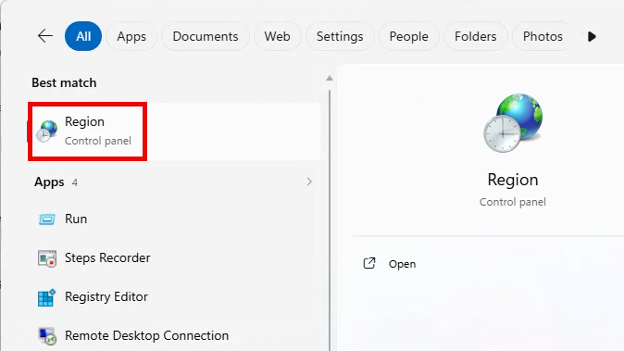
  - Under the ‘Formats’ tab, select ‘Additional Settings’
  - Enter the pipe symbol (|)(shift + pipe symbol) into the ‘List Separator’ text box and select ‘Apply’
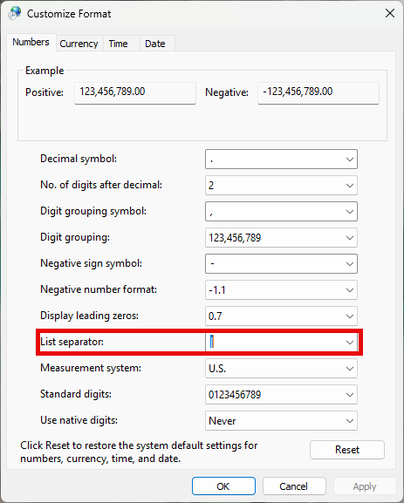
  - The pipe symbol (|) should now display as an option in the ‘List separator’ drop-down menu

- Open the data file in Excel, edit as required, and save it as a pipe-delimited text file
  - From the Excel menu select ‘File’ and ‘Save As’
  - Enter the name of the file, and select the file type ‘CSV (Comma delimited) (*.csv)’ from the dropdown list; save this file and close
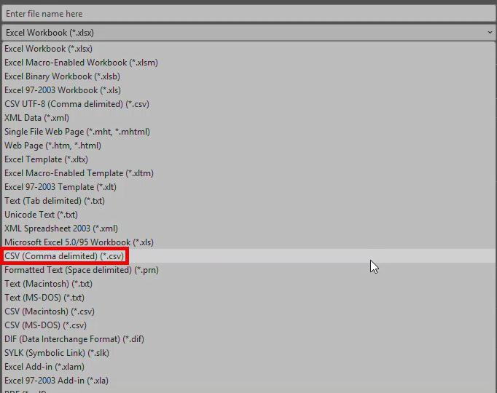
  - Open Windows File Explorer, navigate to the folder containing the .CSV file
  - Select the ‘View’ menu tab, scroll to ‘Show’ and click on ‘File Name Extensions’. This permits file name extensions to be viewed in File Explorer.
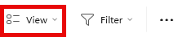
  - Right click on the .CSV file & select ‘Rename’
  - Change the file’s name extension from ‘.csv’ to ‘.txt’, click Enter
  - A rename warning will pop up; click Yes
  - The text (.txt) file is now ready for upload to WIN

Q. What is the difference between Organization ID and Sampling Agency Name?
A. If you have conducted your own sampling, the Sampling Agency Name should match your Organization Name. However, if you have contracted with another agency to conduct the sampling, the name of that sampling agency must be submitted. If the Sampling Agency Name is not in the WIN standard value list, please contact your WIN Coordinator to request an additional value.

Q. How should the “Activity Representative Indicator” field be populated in WIN?
A. The Activity Representative Indicator field is an optional field used to describe if the site conditions on the sampling day and time reflected typical conditions for the site. The decision to define a particular activity as “Not Representative” requires the organization’s staff be familiar with the site (e.g., Samplers, Project Managers, etc.) It is at the discretion of the Data Provider to review and discuss the conditions to determine when to utilize the “Not Representative” indicator. When an activity is defined as “Not Representative”, an Activity Comment is required in WIN to provide a brief explanation for using this definition. Atypical conditions such as extreme low water (below 5th percentile of historical levels), extreme high water (above 95th percentile of historical levels), or discrete release of pollutants (chemical spill, waste spill, high impact infrequent herbicide or pesticide application) are examples of activities that could be defined as “Not Representative”. Sampling events that are considered to exhibit abnormal conditions should be tagged as “Not Representative” in the Activity Representative Indicator field until conditions return to what is considered normal.
If sampling occurred within 48 hours of a significant rain event, the results should be qualified with an “R” in conformance with reporting requirements in the Quality Assurance Rule, Chapter 62-160.700 (Table 1), F.A.C. As noted above, sampling events that you consider to exhibit abnormal conditions due to a hurricane should also be tagged as “Not Representative” in the Activity Representative Indicator field until conditions return to what you consider to represent normal.

Q. When should “!” be used to identify an outlier? Does DEP have a protocol for identifying and labeling outliers?
A. The DEP Quality Assurance Rule, Chapter 62-160.700 (Table 1), F.A.C. includes a qualifier code of “!” for field activities defined as “Data deviating from historically established concentration ranges”. DEP does not have a protocol for identifying and labeling data with an “!”. Application of this qualifier code is at the discretion of the data provider based on the assessment of the data by staff familiar with the specific sampling event, the waterbody, and the data quality objectives for the project(s) for which the data were collected. Greater amounts of historical data allow for more confident determination of whether any particular result deviates from historic ranges.

Q. Are activities associated to a “Not Representative” indicator or results qualified with an exclamation point (“!”) automatically excluded from IWR Assessments?
A. No, data with these tags are not automatically excluded. Data are reviewed using all information provided, including data qualifier codes or indicators. Decisions to include or exclude data are made on a variety of factors.

Q. How are field correlation issues flagged in WIN?
A. WIN implemented two new front-end rules that evaluate the correlations between Salinity and Specific Conductance and Dissolved Oxygen (DO) and DO Saturation readings, respectively. These new rules will compare the reported value to an expected value established by standard formulas. Records that do not meet the established tolerances during initial uploads to WIN will be flagged for review.
Expected Values and Tolerances:
- The Expected Value for Salinity is calculated based on the Reported Specific Conductance reading and a standardized water temperature of 25 deg C. To report Specific Conductance to WIN, the standard temperature of 25 deg C must be used by the instrument. Users may not report Specific Conductance to WIN using the actual temperature of the water. The difference between the Expected Salinity and the Reported Salinity reading must be within + 2 and the percent error between these two values must be within + 5. For more information on the formula used to derive the Expected Value for Salinity, please follow this link.
- The Expected Value for DO Saturation is calculated based on the reported Water Temperature, Salinity, and DO reading. (If Salinity is not reported, the Expected Salinity value will be calculated and used in the comparison.) The difference between the Expected DO Saturation and the Reported DO Saturation reading must be within + 5 and the percent error between these two values must be within + 10. For more information on the formula used to derive the Expected Value for DO Saturation, please follow this link (page 63).

Q. What is the difference between “Method Batch ID” and “Analytical Batch ID”?
A. The ‘Method Batch ID’ is a unique laboratory identifier for a group of samples (1 to 20) that are prepared and/or analyzed together with the same process and personnel, using the same lot(s) of reagents. (NOTE: This data element is synonymous with ‘Preparation Batch’ in the TNI 2016 standard and ‘Prep_Batch_ID’ in ADaPT.) The Method Batch ID field is used to associate batch QC records to an environmental sample within a group of 20 or less samples. Batch QC and their associated samples must have this field populated, including samples that do not have a separate preparation step.

The ‘Analytical Batch ID’ is a unique laboratory identifier for a group of samples analyzed together in an analytical run using the same calibration. (NOTE: This data element is synonymous with ‘Analytical Batch’ in the TNI 2016 standard and ‘Method_Batch_ID’ in ADaPT.) Analytical batches may exceed 20 samples and may contain multiple method batches. This field is also required when submitting batch QC data to WIN.

If there is only one method batch per analytical run, then the Analytical Batch ID can be used for the Method Batch ID. However, if there are more than 20 samples within an analytical run, then unique Method Batch IDs must be used to identify the sets of 20 or less samples (the method batches) that were grouped together within that run.

NOTE: Calibration QC (e.g., Initial Calibration Verification or Continuing Calibration Verification) should not be submitted to WIN.

Q. What is the difference between “Field Replicate” and “Lab Replicate” Activity Types?
A. “Field Replicates” are defined as additional bottle samples collected in the field at the same location, date, and by the same sampling agency and then sent to the laboratory for analysis. “Field Replicates” are not replicate field measurements taken in the field (e.g., two Temperature Air measurements at the same location, date/time, etc.), they are replicate samples collected in the field. If you take replicate field measurements in the field, those data can be loaded under different Activity IDs with the Activity Type “Field”.
“Lab Replicates” are defined as one sample bottle that is partitioned by the laboratory and then analyzed under the same conditions as the original sample to measure for precision.

Q. Are Laboratory and Field QC samples required in WIN?
A. No, these data are not required but should you choose to submit them, they must contain the proper associations. See the table below for the WIN data element that stores the association of the QC sample to the environmental sample based on the Activity Type.

QC Activity Type | WIN data element that holds association
Field Replicate | Master Activity ID*
Field Blank | Field Blank Batch ID*
Equipment Blank | Equipment Blank Batch ID*
Trip Blank | Trip Blank Batch ID*
Lab QC (Method Blank, Surrogate, Laboratory Control Sample, Laboratory Control Sample Replicate, Matrix Spike, Matrix Spike Replicate, Lab Replicate) | Method Batch ID, Analytical Batch ID*

* The following rules have been added to WIN to ensure Field QC and Lab QC are associated properly with environmental samples:
- Field QC
  - Field Replicates
    - Master Activity ID is required for Field Replicate activities.
    - Field Replicates must be associated with its parent sample. See next FAQ for additional instructions.
  - Field Blanks
    - Field Blank Batch ID is required for Field Blank activities.
    - Field Blank must be associated with at least one environmental sample.
  - Equipment Blanks
    - Equipment Blank Batch ID is required for Equipment Blank activities.
    - Equipment Blank must be associated with at least one environmental sample.
  - Trip Blanks
    - Trip Blank Batch ID is required for Trip Blank activities.
    - Trip Blank must be associated with at least one environmental sample.
- Lab QC
  - Method Batch ID and Analytical Batch ID are required when Activity Type is 'Method Blank', 'Surrogate', 'Laboratory Control Sample', 'Laboratory Control Sample Replicate', 'Matrix Spike', 'Matrix Spike Replicate', or 'Lab Replicate'.
  - Lab QC result must be associated with at least one sampled result for the same DEP Analyte Name. There must be at least one activity with Activity Type in 'Sample', 'Sample-Composite', 'Field Replicate', 'Trip Blank', 'Equipment Blank', or 'Field Blank', that contains the same Method Batch ID as the Lab QC sample for the same DEP Analyte Name in either the import file or in migrated.
Below is an excerpt from the WIN Example Files that shows an Equipment Blank for Calcium and Magnesium associated to a Sample using Equipment Blank Batch ID “EB1”.
Project ID | Monitoring Location ID | Activity ID | Activity Type | Equipment Blank Batch ID | ADAPT Analyte ID | Org Analyte Name
TREND | A10001 | L20140316-002S | Sample | EB1 | 7440702 | Calcium
TREND | A10001 | L20140316-002S | Sample | EB1 | 7439954 | Magnesium
TREND |  | L20140316-008EB | Equipment Blank | EB1 | 7440702 | Calcium
TREND |  | L20140316-008EB | Equipment Blank | EB1 | 7439954 | Magnesium

Q. How do I associate one or more Field Replicates with an environmental sample?
A. The association is made using the Master Activity ID column as shown below. The Activity ID associated to the “Sample” Activity Type should be populated in the Master Activity ID column for all Field Replicates. The Master Activity ID for the “Sample” must be blank.
Activity ID | Master Activity ID | Activity Type
Sample 1 |  | Sample
Replicate 1A | Sample 1 | Field Replicate
Replicate 1B | Sample 1 | Field Replicate

Q. Is Florida STORET data still available for download?
A. Yes, Florida STORET data is available for reporting through STORET Public Access (http://storet.dep.state.fl.us/DearSpa/public/welcome). Data loaded prior to WIN’s release can be found using this extraction tool.

Q. Does DEP have a comprehensive extraction tool to simultaneously retrieve data from both Florida STORET and WIN?
A. No, since these databases have different data elements and standard values, extractions must be completed individually from each system. NOTE: Data submitted after 2017 are found in WIN.
- To extract WIN data, select this link.
- To extract STORET data, select this link.

Q. How do I enable WIN pop-up windows in Chrome?
A. Some functionalities require the WIN application to open a pop-up window. By default, most pop-ups are blocked in Chrome. To allow pop-ups from WIN:
- Open the Chrome browser
- Click the three vertical dots in the top-right corner and select ‘Settings’
- Under Settings select ‘Privacy and security’ then select ‘Site Settings’
- Scroll down and select ‘Pop-ups and redirects’
- Under ‘Allowed to send pop-ups and use redirects’, click on ‘Add’
- Enter the WIN parent site name: https://prodenv.dep.state.fl.us and click ‘Add’

If WIN attempts to open a pop-up window and is blocked, the blocked icon ( ) will appear in the Chrome address bar. Click the icon and the link for the pop-up window. Select ‘Always allow pop-ups and redirects from [site]’, then click ‘Done’.

Q. How do I open a pipe delimited text (.txt) file as an Excel spreadsheet?
A. While text files may be edited using the computer’s notepad, it is much easier to do so using Excel:
- Within Excel, select ‘Open’ and browse to the folder containing the text file
- In the bottom right of the Open screen select ‘Text Files’ from the file type dropdown list
- Double click on the text file name to open it; the Text Import Wizard will appear
- Select ‘Delimited’ file type and click ‘Next’
- Uncheck any default delimiters and select ‘Other’; enter a pipe (|) symbol into the ‘Other’ text box
- Click Finish

Q. Will WIN data be loaded to WQX by DEP?
A. Yes, DEP loads WIN data to WQX annually. Loads must be completed by March 31 and include all new and changed records from WIN since the last data submittal. Users may query data in the EPA WQX system through the Water Quality Portal: https://www.waterqualitydata.us/. NOTE: Most organizations will be listed in the Organization ID drop-down twice. Data loaded to EPA prior to 2009 will be associated to the historical STORET Organization ID. Data loaded after the implementation of WQX in 2009 will be associated to the same Organization ID, but with the text “_WQX” appended to the end. To obtain historical and the latest data in WQX, be sure to select both Organization IDs as noted in the screen shot below.
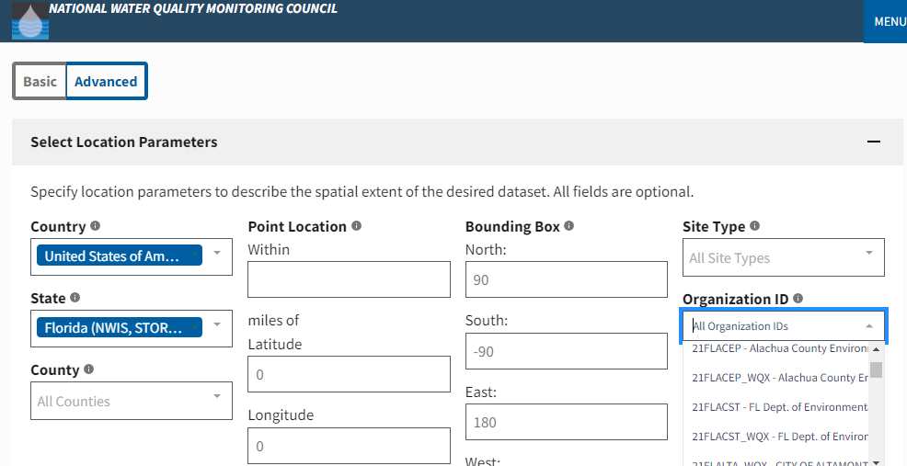

Q. What is an anomaly and what do I need to do to resolve it?
A. As DEAR staff review data, questions may be raised as to whether a record contains an error or is atypical for a given dataset. Staff will tag this record as an “Anomaly”. This action automatically sends a notification to the Data Provider’s welcome screen as noted below in the red outlined box. Data Providers should review their Welcome Screen regularly to see if there are anomalies needing their attention. If the Count next to the yellow exclamation point is greater than 0, the Data Provider should click on this count to be transferred to the list of anomalies. From there, select an Anomaly ID to be transferred to the Anomaly Detail Screen where a response can be provided (Response and Response Flag fields). Once the Anomaly is responded to, it will be removed from the Data Provider’s Welcome Screen count. Staff that initiated the anomaly will then receive a notification on their Welcome Screen to review the response and close out the anomaly. Additional follow-up questions may be necessary and should occur via email before the anomaly is closed.
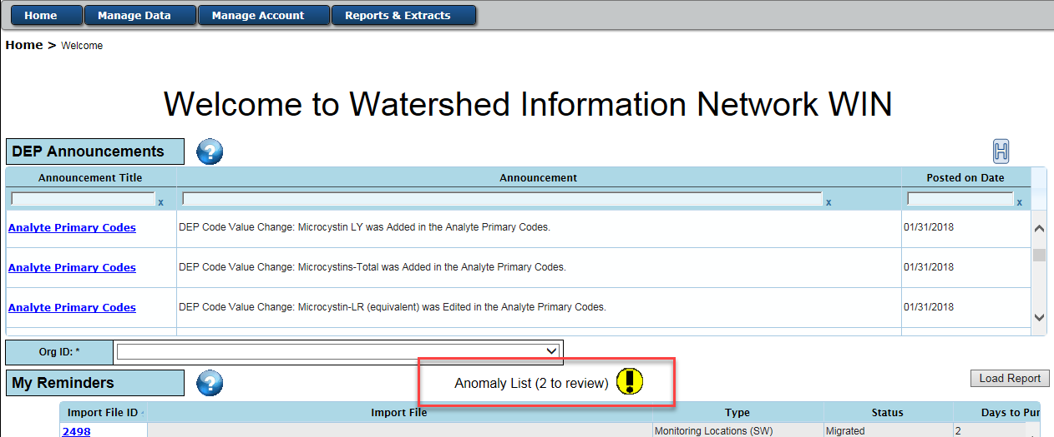

Q. How can I be added to the WIN Distribution List?
A. If you would like your contact information to be on the WIN stakeholder email distribution list, please contact your WIN Coordinator.

