This document lays out the design of the North Florida ROCs Algal Bloom Response Data Management process. The 7 elements covered are as follows: implementation, team responsibilities, DMT and WIN management, file structure, file nomenclature, file hierarchy, and data tracking. It is provided in a list format to facilitate a straightforward approach.

Algal Bloom Dashboard- https://floridadep.gov/AlgalBloom

- Implementation

- Begins immediately after presentation to staff
- Any data collected prior to presentation will be retroactively archived, entered into the DMT, and uploaded to WIN according to the following procedure

- Team Responsibilities

- The North Florida ROC Data Management Team (Cheryl Bunch, Heather Schmuki and Myranda Butler of the NW ROC) are responsible for North Florida ROCs’ DMT data entry and WIN migration for Algal Bloom Response sampling events
  - Cheryl Bunch is responsible for DMT data entry and WIN migration for Northwest ROC
  - Heather Schmuki and Myranda Butler are responsible for DMT data entry and WIN migration for Northeast and Tallahassee ROCs
- Cheryl Bunch will train Heather and Myranda on Algal Bloom WIN migration and data tracking
- Team Leads are responsible for archiving the lab reports since they are the ones ordering sampling kits and will receive the notification from the lab when they are ready
  - Include Alicia Hogue’s email to the LIMS scheduler
- Field staff who collected the samples are responsible for archiving field sheets and calibration logs.

- DMT and WIN Management

- Field ID/WIN Location ID
  - Nomenclature for Field ID/WIN Location ID should have HAB included.
  - Example: NWHAB0001 or HABNW0001

- OrgID and DMT/WIN Projects
  - All bloom response data should be loaded to WIN under the BLOOM-RESP project with the appropriate OrgID.
  - For response samples collected by ROC staff, the OrgID should be whichever ROC collected.
  - For response samples collected by other entities (counties, etc.) on our behalf, the data should be loaded under the appropriate ROC OrgID depending on geography, but then the correct Sampling Entity MUST be selected in the DMT (and they can be added if you don’t see them).

- File Structure (See Folder Heirachy)
- 4 files to be archived in folders and tracked in Data Tracker
  - Field Sheet(s) with Calibration Log
    - Archived by Field Staff
  - Biology report
    - Archived by Team Lead
  - Chemistry report
    - Archived by Team Lead
  - WIN Report (EDD)
    - Archived by Data Management Team

- 1 folder will be generated per RQ per day by field staff archiving Field Sheet(s) and Calibration Log (See Figure 1)
  - If the same RQ is used by multiple teams on the same date, therefore generating multiple Submittal Sheets, the DEP Lab will log them as separate Events for coolers that do not arrive at the same time.
    - This will generate separate lab reports for each Event.
  - Field Sheets with Calibration logs from multiple sites will be labeled with a file nomenclature of RQ_ddmmyyyy_FS(1) and RQ_ddmmyyyy_FS(2) (See File Nomenclature)

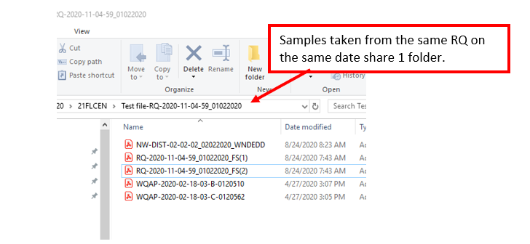
Figure 1.

- File Nomenclature (See Figure 2)

- Field Sheets w/ Calibration Log:
  - Calibration report on 1st page and field sheet(s) to follow
  - For RQs used with a single location
    - RQ_mmddyyyy_FS
  - For RQs used with multiple locations
    - RQ_mmddyyyy_FS(1) and RQ_mmddyyyy_FS(2), ect.
- Biology Report Generated by lab
  - Named by LIMS Event: Customer Number-Year-Month- Day-B (biology)- Serial number
    - Example. WQAP-2020-01-03-01-B-0120064
- Chemistry Report Generated by lab
  - Named by LIMS Event: Customer Number-Year-Month- Day-C (chemistry)- Serial number
    - Ex. WQAP-2020-01-03-01-C-0120064
- WIN Report name Generated by WIN
  - _WINEDD added to the end of file name
    - Ex. NW-DIst-02-02-02_01292021_WINEDD
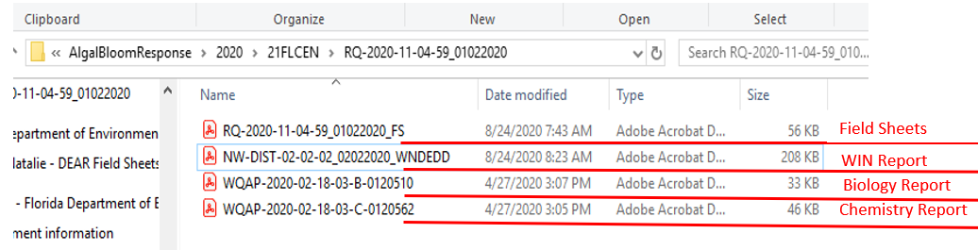
Figure 2.

File Location
- Dear-> WQAPmonitoring->AlgalBloomResponse->Year->ROC->RQ_date
- 1 folder per RQ (RQ_date); folder Contents: Field Sheets w/ Calibration log (RQ_date_FS), Biology report, Chemistry report, Win Report
Algal Bloom Response Data Tracker

- File Hierarchy

- Refer to the chart below for the file hierarchy and nomenclature examples

Figure 3.

- Data Tracker

- Each location sampled is tracked along with the RQ and date (see Figure 3) by Field Staff
  - This is useful when retrieving field sheets and/or lab reports in response to inquiries since the folder and file nomenclature does not refer to the waterbody name.

Figure 4.
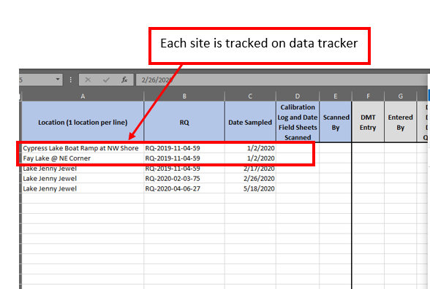

Resources

Win Quick Start Guide: FDEP1/DEAR-> WIN-> WIN_Manuals

