Guide to managing & uploading SFWMD algae reports into WIN
- All these procedures will require you to have access and basic knowledge of LIMS and WIN
- How to find algal bloom reports in LIMS
- How to create data set lists to manage and track algal bloom reports
- How to find information needed for creating WIN ID
- What Information is needed to Finish a LIMS report
- Generating WIN EDD
- Uploading to WIN and updating tracker


1. Finding reports in LIMS
Open LIMS Browser
In “Search By” box
- Select Customer/Project
In “Filter By Date” Box
- Select Sampled
- Select dates you wish to view
Go to
Customer -> Click build list and choose “SFWMD”
Project ID -> Click build list and choose “BLOOM-RESP”
Press OK

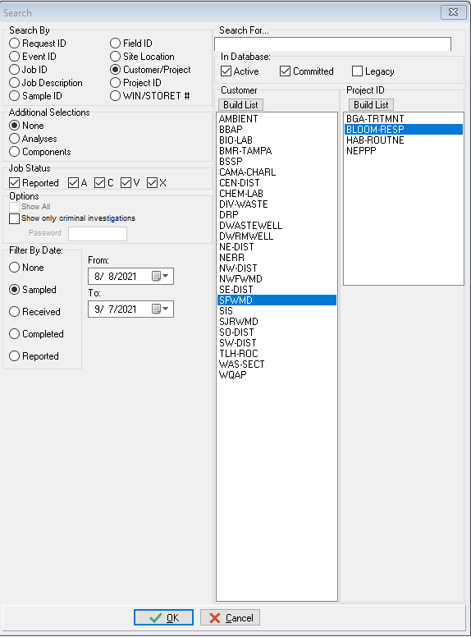
Select Report/Files at top near DMT
- Click “Select All Events”
- Click “Select All Jobs”
Under Available Fields Box add (order does matter)
- DATE SAMPLED
- EVENT ID
- FIELD ID
- REQUEST ID
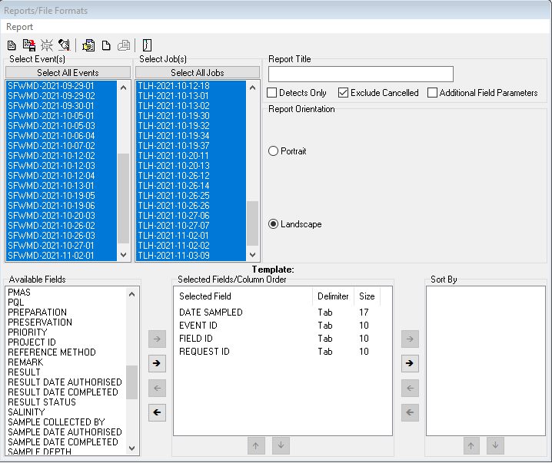
At the top Click “Create Delimited File” and SAVE AS to desktop or your preferred location

2. Creating Data list to add to trackers
Open EXCEL click open and browse for file on desktop of chosen location (be sure to search All Files type as it’s a TXT file)
- Choose file type Delimited NEXT->
- Click Other and Add “|” Pipe NEXT ->
- Finish
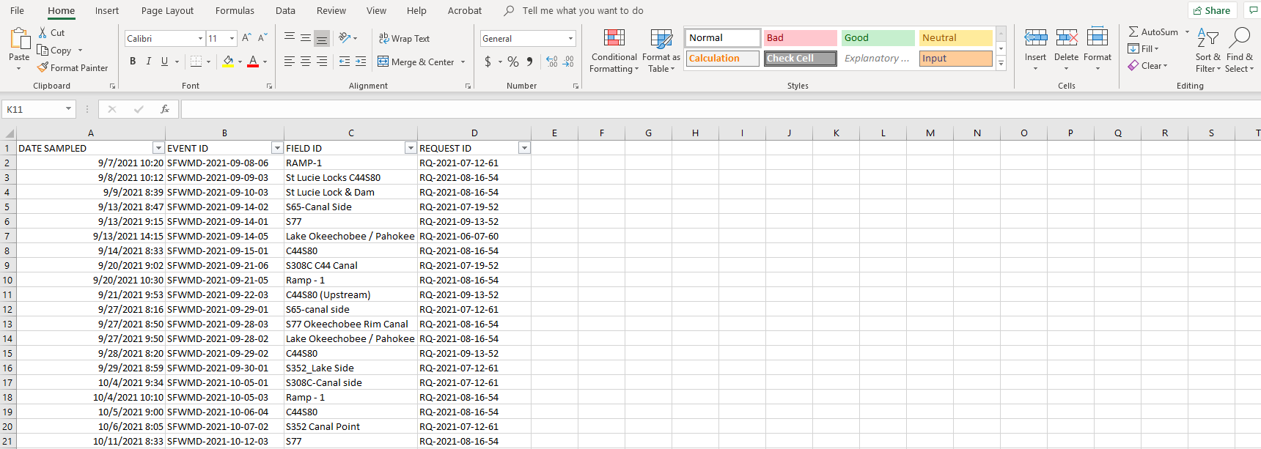
Copy & Paste into HAB tracker exclude test comments https://floridadep-my.sharepoint.com/:x:/g/personal/kirby_wolfe_floridadep_gov/EdsHtXxzn2RHj9zhpgkQyZIBO_Nu2cGW3zjMHyR6gzLF8Q?e=A2DzfX
3. Creating WIN ID
Open tab on tracker WIN ID Location
Copy Information needed for creating monitoring location from SFWMD tab to WIN ID Location tab
You will still need to find resource type and, latitude and longitude.
- Lat and long can be found on COC submitted to lab
- If report is recent check for emails for links to lab reports
- If older use the (you will need lab permission to access) \\fldep1\dear\labs\lab3\lims_archive
- Resource type can be found by typing GPS coordinates into maps
Give Monitoring location a unique WIN ID
- HAB-SFWMD-XXXX we started with 0001 and counting. Feel free to continue counting on our sheet
Picture shows format for uploading monitoring location to win as well as all information needed. In yellow shows most recent monitoring location created and, is updated after each site is created.

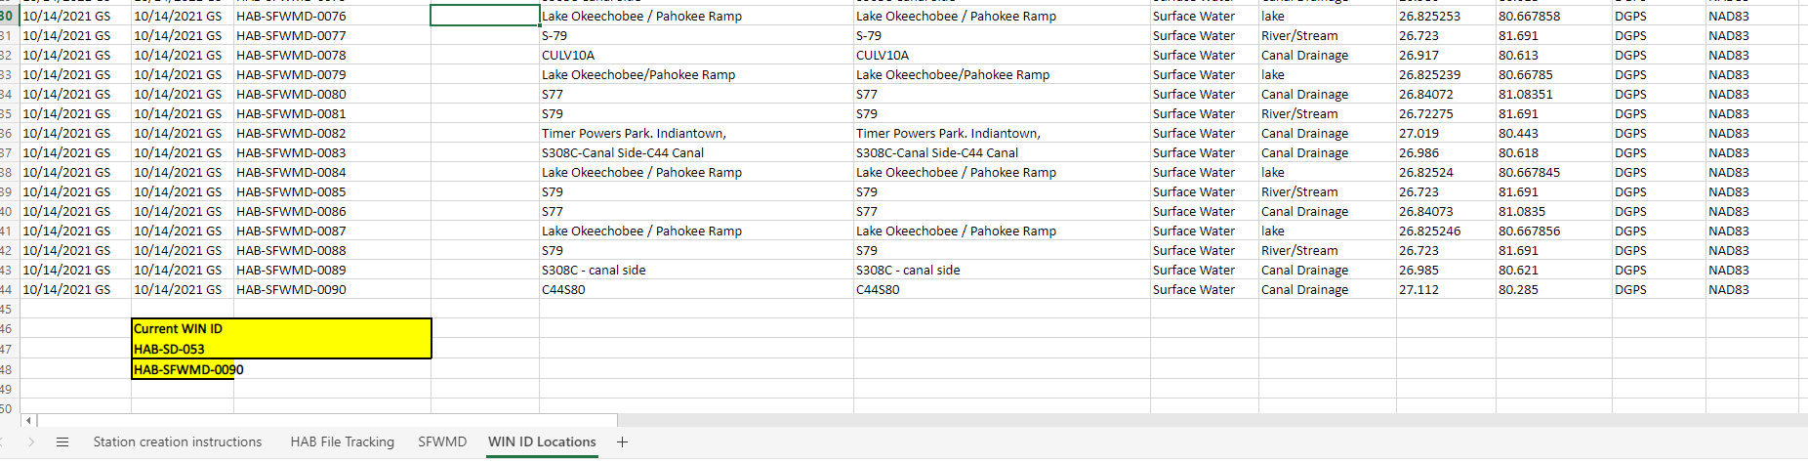

- LIMS data entry
Use tracker to identify all samples needing to be entered in LIMS
Open LIMS browser Search Sites using EVENT ID
- Use COC/Field sheets to fill in any missing information in LIMS (lots will have no reads leave blank)
- Add Unique WIN monitoring location
- Add sampling agency
5. Generate WIN EDD
6. Upload to WIN
- Add Win import ID to tracker
- Fill cells in green on tracker when win upload was successfully migrated

