03/10/21:
FDEP sampled BMAP site Little Fishweir @ Oak Street, E. coli sample result 2,420 MPN/100mL, J. (Note Jan., Feb., and Mar. samples were high)
03/25/21:
TAT call, DEP discussed results and determined need for follow-up actions.
04/07/21:
Kelly M. and Brian D. from FDEP and Bill K. from COJ sampled Little Fishweir at 4 sites upstream of original BMAP site. FDEP sampled the original Little Fishweir @ Oak St without COJ. FDEP sampled E8321-DI/MS Tracers and COJ sampled E. coli and those results are as follows:

The List of sites below are ordered in upstream to downstream.
LFW2: 2909 MPN/100 mL, Little Fishweir @ MacArthur. Large pool immediately downstream of culvert. Old sewer line running into creek but has long since been capped off. No picture taken of this site.
LFW1: 5475 MPN/100 mL, End of Azalea @ camp. Potential homeless camp. Highest E.coli values of the day. Dark sludgy mud present at site. Video evidence taken at this site along with Figure 2.
LFW3: 1789 MPN/100 mL, Little Fishweir upstream of Walsh footbridge. Area showed distinct pink and white flocculant associated with bacteria. Large to small patches. Boon park around the site had a heavy presence of dog fecal matter. Signs/bags already in place. Figure 3.
LFW4: 3255 MPN/100 mL, Little Fishweir downstream of confluence. Just below confluence of smaller ditch/stream flowing from north east. The smaller branch did not exhibit the same murky water that most of Little Fishweir showed. Many species of fish living in smaller branch and heavy presence of vegetation in and around water’s edge. Figure 4 & 5.

04/21/21:
FDEP staff along with COJ plan to survey the creek above MacArthur.

__Date__: Field staff received DEP Lab results from 04/08/21 sampling event, for tracers, which indicated:
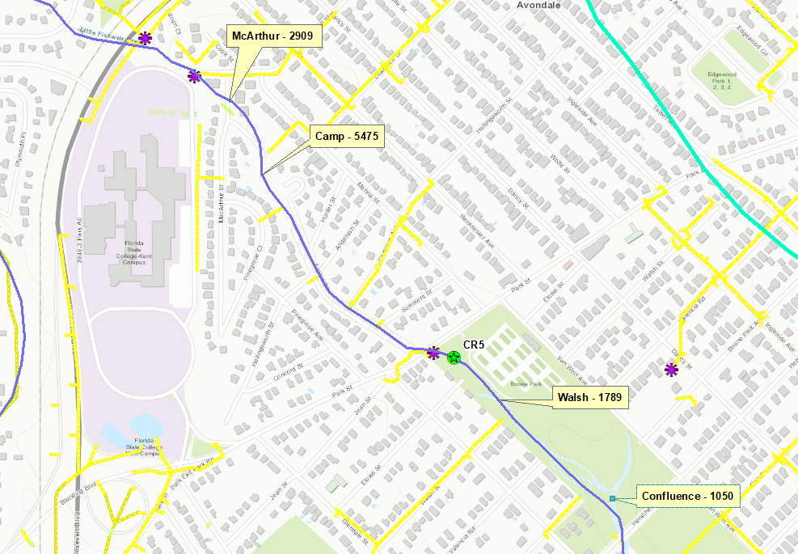
Fig 1. Sites on Little Fishweir from first sampling event 04/07/2021.

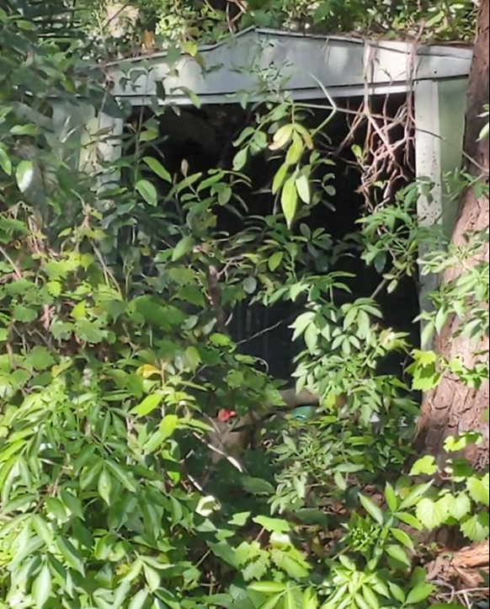
Figure 2. Homeless camp at LFW1 site.
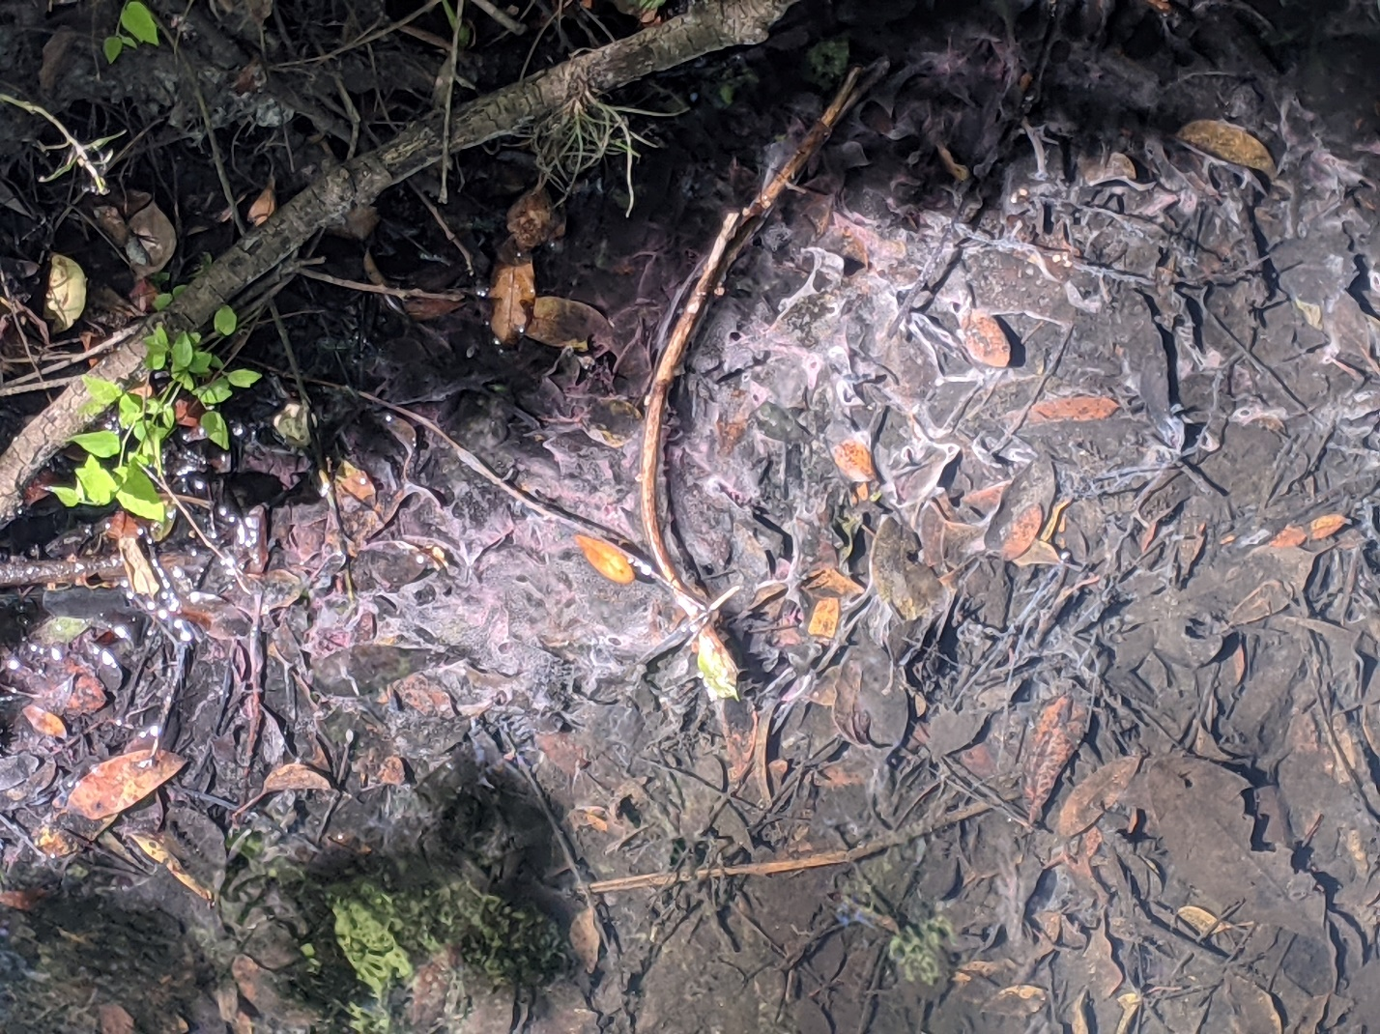
Figure 3. Instream bacteria around LFW3.
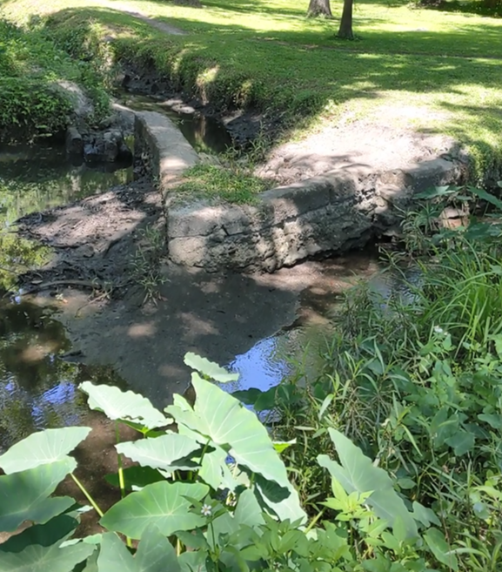
Figure 4. Confluence of Little Fishweir and smaller trib.
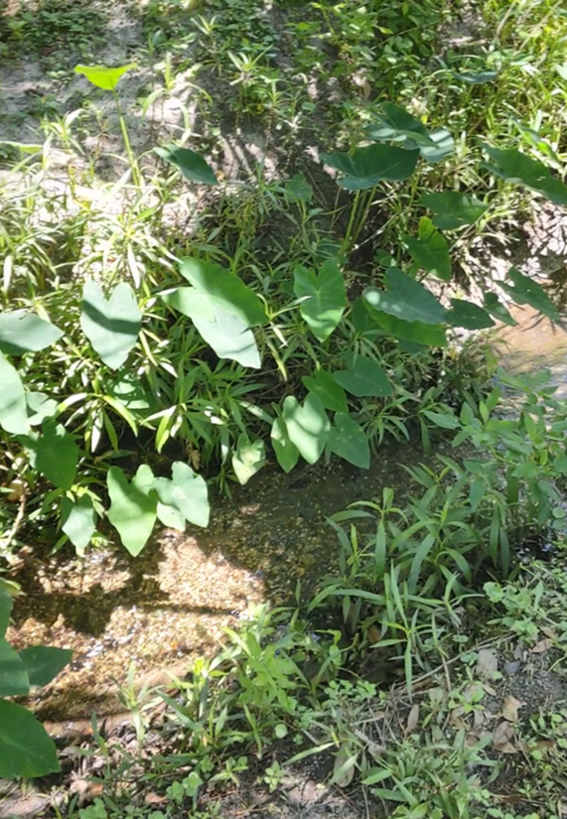
Figure 5. Typical water and vegetation around smaller trib to Little Fishweir.

