Little Fishweir Source Tracking Observations and Notes
Team: Kelly McDonald (FDEP), Brian Davis (FDEP), William (Bill) Karlavige (COJ)
Date: 4/7/2021
Tide: Ortega River Entrance; low 0216, high 0827, low 1455, high 2048
Meter used: NEROC Pro DSS Desi
E. coli samples collected by Bill went to COJ lab for processing.
E. coli samples collected by FDEP went to ALS for processing.
8321 samples collected by FDEP went to FDEP lab for processing.

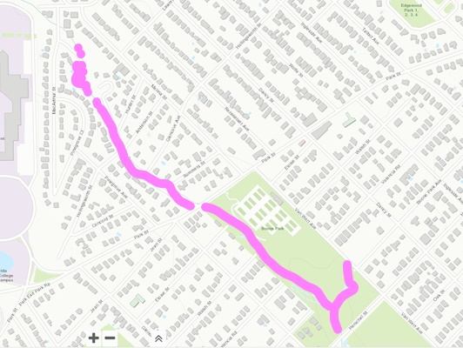
Azalea Dr.
- Started observations at Azalea and Park and went upstream. Observed stormwater pipe contributing to stream, and a large amount of cut brush in the stream from people’s yards. No indicators of large amounts of bacteria observed.
- Observed small amounts of litter and trash present along the entirety of the stream. Not determined to be the likely cause of high E. coli exceedances recorded.
- Going Upstream, we observed several additional stormwater drains into stream. Still no major explanation of E. coli exceedance results.
- One stormwater drain was observed to be blocked up by yard waste. No obvious E. coli contribution to stream though.
- Observed a small pipe crossing the creek that is rusted and sagging. Pipe source and contents are unknown. Location is across from Azalea and Anderson intersection just upstream of the footbridge.
- Observed severe erosion on roadside immediately next to sewer across from Azalea and Hunter. Manhole was opened and no issues were observed.
  - Revisiting this site on the same day revealed that while the manhole didn’t have any issues there was a sewage clean out with a broken cap that could potentially overflow into creek.
- Pipe delivering putative groundwater to stream at the end of Azalea at cul-de-sac. No observed major E. coli issues.
- Further exploration up the stream, slightly past the cul-de-sac revealed a possible homeless camp up the opposite bank of the stream. An abandoned shed, filled with garbage and camp-like accoutrements were observed. No people were observed. A sample was taken, named LFW1. Slight discoloration of benthic sand was observed, but not the typical white or brightly colored bacteria indicators we were expecting.
  - Site name: LFW1: End of Azalea @ Camp. Bill collected an E. coli sample, and we collected an 8321-DI/MS. 30.30130, -81.71632. Time: 1033.
  - Temp: 18.8, DO %: 50.1, DO mg/L: 4.71, SPC: 415.1, Sal ppt: 0.20, pH: 7.18, Secchi: VOB, Sample depth: 0.16m, Total depth: 0.322m.
MacArthur
- To try to reach further upstream, we drove to Little Fishweir at MacArthur and walked along the bank as far down stream as we could. We did not survey the stream for about the equivalent of and took a sample, named LFW2 downstream of culvert. No video or pictures were taken at this site.
  - Site name: LFW2: Little Fishweir @ MacArthur. Bill collected an E. coli sample, and we collected an 8321-DI/MS. 30.30231, -81.71719. Time: 1116.
  - Temp: 17.9, DO %: 42.4, DO mg/L: 4.02, SPC: 415.6, Sal ppt: 0.20, pH: 7.04, Secchi: VOB, Sample depth: 0.17m, Total depth: 0.352m.
Boone Park
- We backpedaled after MacArthur and went to Boone park to begin working our way downstream from Park street.
- We observed dark, gray-colored sand in certain places in clumps. We were unsure of what that would indicate, but was very different from the rest of the sand and mud colors in the stream. Observed upstream of first footbridge in Boone park (Walsh street).
- Not far from the dark colored substrate, we observed white filamentous and pink bacterial colonies int eh water. We collected a sample, called LFW3.
  - Site name: LFW3: Little Fishweir upstream of Walsh footbridge. Bill collected an E. coli sample, and we collected an 8321-DI/MS. 30.297679, -81.711947. Time: 1225.
  - Temp: 19.1, DO %: 65.3, DO mg/L: 5.98, SPC: 446.3, Sal ppt: 0.22, pH: 7.30, Secchi: VOB, Sample depth: 0.11m, Total depth: 0.22m.
- More patches of white bacteria colonies were observed as we went down stream. More colonies observed downstream of second footbridge near pipe. Pipe had no obvious leakage or cracks. No obvious reason for bacterial colony growth.
- We went to the confluence of an unnamed tributary that cuts across Bonne Park from the Northeast and Little Fishweir. We observed lots of algae and one baby turtle at the confluence. We collected a sample there, called LFW4.
  - Site name: LFW4: Little Fishweir downstream of confluence. Bill collected an E. coli sample, and we collected an 8321-DI/MS. 30.29597, -81.70973. Time: 1258.
  - Temp: 19.9, DO %: 56.1, DO mg/L: 5.1, SPC: 436.34 Sal ppt: 0.21, pH: 7.24, Secchi: VOB, Sample depth: 0.1m, Total depth: 0.2m.
- At this point Bill, due to time constraints, had to leave to get his samples processed on time.
- Kelly and Brian proceeded to walk the length of the tributary cutting across Boone park. No obvious signs of E. coli contribution. Sand bottom, clear water, shallow, narrow, fast moving stream. No samples were taken, but video was recorded.
Oak St.
- The last site visited this day by Kelly and Brian was FDEP’s regular BMAP site, Little Fishweir at Oak Street (WIN: 20030953). Water was just turbid enough that you could see the secchi disk on the bottom. There was a trickling noise noted coming from within the culvert, but it was not accessible for pictures or video. No noted change observed on this day compared to the monthly sampling prior. Extremely high dissolved oxygen was noted there. No obvious cause of high DO could be found (algae, fountain, water source, etc). YSI verified for DO per regulations later that day.
  - Site name: 20030953: Little Fishweir at Oak St. FDEP collected an E. coli sample (RQ-2021-04-05-44), and an 8321-DI/MS (RQ-2021-04-05-69). Time: 1445.
  - Temp: 20.5, DO %: 153.5, DO mg/L: 13.89, SPC: 466.9, Sal ppt: 0.22, pH: 7.44, Secchi: VOB, Sample depth: 0.3m, Total depth: 0.59m.

