Little Fishweir Source Tracking Observations and Notes
Team: Kelly McDonald (FDEP), Brian Davis (FDEP), William (Bill) Karlavige (COJ)
Date: 4/21/2021
Tide: Ortega River Entrance; high 0610, low 1304
Meter used: NEROC Pro DSS Stitch
E. coli samples collected by Bill went to COJ lab for processing.
PCR-DG3/HF183 samples and W-E8321-DI/MS 8321 samples collected by FDEP went to FDEP lab for processing (RQ-2021-04-19-73).

Map of Little Fishweir Creek. The pink paths indicate areas that were walked and explored on 4/21/2021. Orange dots indicate locations where FDEP collected a PCR-DG3/HF183 sample and a W-E8321-DI/MS sample and COJ collected an E. coli sample. Blue dots indicate locations where COJ collected an E. coli sample (no FDEP sample). The red dot indicates the location of a sunken repair in front of 1276 Rensselaer Ave that was observed.
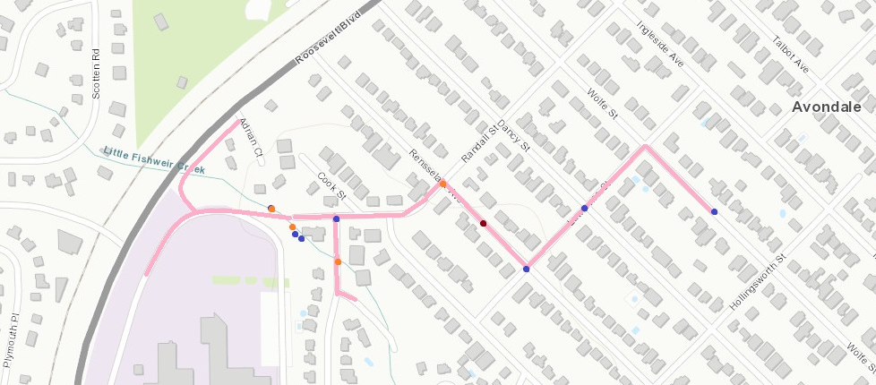

- We started by resampling our last site from last time at MacArthur.

  - Site Name: Little Fishweir @ MacArthur

  - Field ID: LFW2
  - Time: 0935
  - Temp:20.5
  - DO %: 55.7
  - DO mg/l: 5.00
  - SPC: 428.9
  - Sal (ppt): 0.21
  - pH: 7.42
  - sample depth (m): 0.05
  - total depth (m): 0.1
  - secchi: VOB

  - Samples taken: FDEP collected a PCR-DG3/HF183 sample and a W-E8321-DI/MS sample and COJ collected an E. coli sample.
  - Comments: immediately upstream of sample, white and brown foam (meringue-like) and trash visible, iron fixing bacteria. Shallow sand bottom. Slight sewage smell. BD took pics and video. Observed feral cats around.

- We explored the FSCJ parking lot @ 1000. BD took pics and video. Observed a storm drain stopped up and bubbly (30.3029006, -81.7191135). no obvious smell. No samples taken.
- We followed the water upstream to Randall street and took a sample here.

  - Site Name: Stormwater Effluent @ Randall

  - Field ID: LFW5
  - Lat/ Long: 30.302943, -81.717751

  - Time: 1010
  - Temp:20.9
  - DO %: 76.0
  - DO mg/l: 6.75
  - SPC: 480.1
  - Sal (ppt): 0.23
  - pH: 7.4
  - sample depth (m): 0.05
  - total depth (m): 0.1
  - secchi: VOB

  - Samples taken: FDEP collected a PCR-DG3/HF183 sample and a W-E8321-DI/MS sample and COJ collected an E. coli sample.
  - Comments: samples were taken directly from stormwater effluent pipe above stream. YSI data from pool immediately below the effluent. Observed foamy water coming from pipe and foam persisting a small way downstream. Some algae present, it was smothered by bacteria. Near confluence with other pipes that were not foamy (COJ took additional samples at those as well- see below). Observed a lot of bacteria in the culvert and the streambed was covered in it. BD took pics and video.
- COJ also collected E. coli samples at nearby pipes at the same confluence.
  - Site Name: SE Stormwater effluent @ Randall (closest to stream proper)
    - Time: 1015
    - E coli only
  - Site Name: NE Stormwater effluent @ Randall (iron fixing bacteria obvious in pipe)
    - Time: 1018
    - E coli only
- We tried to bracket this road crossing and series of culverts and collected upstream of this confluence as well.
  - Site Name: Upstream of Randall

  - Field ID: LFW6
  - Lat/ Long: 30.303090, -81.177970

  - Time: 1030
  - Temp: 20.9
  - DO %: 28.8
  - DO mg/l: 2.58
  - SPC: 394.4
  - Sal (ppt): 0.19
  - pH: 7.14
  - sample depth (m): 0.12
  - total depth (m): 0.246
  - secchi: VOB

  - Samples taken: FDEP collected a PCR-DG3/HF183 sample and a W-E8321-DI/MS sample and COJ collected an E. coli sample.
  - Comments: BD took pictures and videos here. Lots of live fish observed. Lots of trash. Slightly stagnant looking, upstream of a fallen tree that created a partial blockage. Identified invasive plants around. At edge of FSCJ parking lot. No obvious smell.
- Following the direction of the previously sampled foamy pipe (LFW5), we pulled up the manhole cover at the Macarthur and Randall stop sign and COJ collected E. coli.
  - Site name: MacArthur and Randal Stop Sign
    - Time: 1050
    - E coli only
    - Comments: stormwater manhole upstream of LFW5 site. conflict box visible inside. Visible foam and bacteria. No obvious leaks from conflict. BD took pictures.
- We continued to follow the direction of the obvious bacteria pipe and took samples.
  - Site Name: Rensselaer and Randall manhole

  - Field ID: LFW7
  - Lat/ Long: 30.303360, -81.715968

  - Time: 1110
  - Temp: 21.8
  - DO %: 88.2
  - DO mg/l: 7.73
  - SPC: 540
  - Sal (ppt): 0.26
  - pH: 7.48
  - sample depth (m): 0.10
  - total depth (m): 0.205
  - secchi: VOB

  - Samples taken: FDEP collected a PCR-DG3/HF183 sample and a W-E8321-DI/MS sample and COJ collected an E. coli sample.
  - Comments: visible bacteria. Manhole flowing towards previous samples, upstream of LFW5 site. PCR bottle needed rinsing 3x with site water after it hit bottom and stirred up sediment in manhole. We allowed sediment to flow through and settle out, then rinsed and dumped in nearby grass 3x, then collected remaining samples.
- Followed direction of pipe down Rensselaer (upstream of bacteria observed). Observed sunken repair on road in front of 1276 Rensselaer Ave. Lat/Long: 30.303120, -81.715610. Denoted above by red mark on map.
- We pulled the manhole cover on Rensselaer and Lawrence
  - Site Name: Rensselaer and Lawrence Manhole
    - Time: 1140
    - E coli only
    - Comments: sample taken from Lawrence effluent pipe, observed bacteria in effluent, no foam observed. Direction of bacteria indicates the source from Lawrence
- Followed Lawrence line to Dancy and Lawrence manhole
  - Site Name: Dancy and Lawrence Manhole
    - Time: 1200
    - E coli only
    - Comments: sample taken from Dancy effluent pipe, bacteria obvious in pipe, flow direction unclear. Put dye in culvert running along Dancy, but flow was not enough to show in manhole.
  - Site Name: Manhole E side of same intersection
    - Time: 1215
    - No samples taken. Pictures and video taken.
    - Observed bacteria water flowing in manhole.
- We followed the direction of the bacteria water flow to Wolfe street, where it was immediately apparent there was a water leak further down the street. We followed flow of bacteria-laden water down the street.
  - Site Name: 1343 Wolfe St Leak
    - Time: 1255
    - Lat/Long: 30.303010, -81.712560
    - E coli only
    - Comments: crack in the road asphalt with water visibly/ obviously bubbling up and into the road and draining into storm drains. BD took pictures and video. COJ called JEA Service. JEA service said, “normal leak” and not sewage. COJ collected sample before JEA fixed leak.
- We went back to Wolfe and Lawrence to check storm drains. Observed cloudy water and flow towards Dancy. BD took video.
- Opened manhole on opposite side of Wolfe on Lawrence. Milky water coming from leak. Flow observed towards Dancy. “clean” inflow observed from unknown pipe. Observed cockroaches (canary for sewer gas in sewer lines, but rarely observed in stormwater lines, per Bill).

