03/10/21:
DEP sampled BMAP site BUTCHER PEN CR AT WESCONNETT, E. coli sample result 2,420 MPN/100mL, J. (Note Jan., Feb., and Mar. samples were high)
03/25/21:
TAT call, DEP discussed results and determined need for follow-up actions.
04/08/21:
Kelly M. and Brian D. from FDEP and Bill K. from COJ resample Butcher Pen at original BMAP site and 3 additional upstream sites. FDEP sampled E8321-DI/MS Tracers and COJ sampled E. coli and those results are as follows:
The list of sites below is ordered in upstream to downstream.
BP2: >24196 MPN/100 mL, Open stormwater conveyance @ Arthur Durham. Upstream of stormwater grate. Did not have a sewage smell but still has a high cell count. Diluted 10x.
BP1: 129706 MPN/100 mL, Stormwater Grate @ lift station. Very heavy smell of sewage within the grate. White flocculant and iron fixing bacteria found in storm grate. Figure 2. Diluted 100x
BP3: 1086 MPN/100 mL, Butcher Pen downstream of car camp. A large concentration of trash that was downstream of a homeless encampment. Sampled in the creek proper. Diluted 10x.
20030762: 1860 MPN/100 mL, Butcher Pen Creek at Wesconnett. Site of the initially high E. coli count. Homeless camp upstream of sampling site between Weconnett and Blanding Blvd. Sampled in the creek proper. Figure 3 & 4. Diluted 10x.
20030082: 586 MPN/100 mL, Butcher Pen Creek at Confederate Rd. Regularly visited BMAP site. Tidal body. Apartment complex has large green way up to the creek bank that which has large presence of geese and dog fecal matter. Sampled in the creek proper. Figure 5. Diluted 10x.

4/12/21:
JEA surface inspected manholes and utility owned lift stations, no leaks visually detected.
4/12/21:
Bill at COJ investigated area again, took 3 samples, all were over 24,196 MPN/100mL.
04/14/21:
Kelly M. and Jeremy P. from FDEP and Bill K. from COJ resample Butcher Pen at 3 additional sitesupstream of Arthur Durham Dr. FDEP sampled E8321-DI/MS Tracers with qPCR and COJ sampled E. coli and those results are as follows:

The list of sites below is ordered in upstream to downstream.
HC1: 4960 MPN/100 mL, Conveyance @ Harlow Blvd. Site just downstream of residents with backed up storm drain in yard. Heavy presence of iron fixing bacteria. Also, storm drain at road crossing had backpack and wallet. Gave to JSO. Figure 6 and 7.
HC3: 129970 MPN/100 mL, Conveyance upstream of Fender & Graves. Drain pipes were found along the banks of the conveyance. Presence of dog/wildlife fecal matter noted.
HC2: 77010 MPN/100 mL, Conveyance downstream of Fender & Graves. Presence of dog/wildlife fecal matter noted along with iron fixing bacteria coming from ground water percolating through banks.
2104017-04: 92080 MPN/100 mL, Open stormwater conveyance @ Arthur Durham. Sampled by COJ only on this event.

__Date__: Field staff received DEP Lab results from 04/08/21 sampling event, for tracers, which indicated:

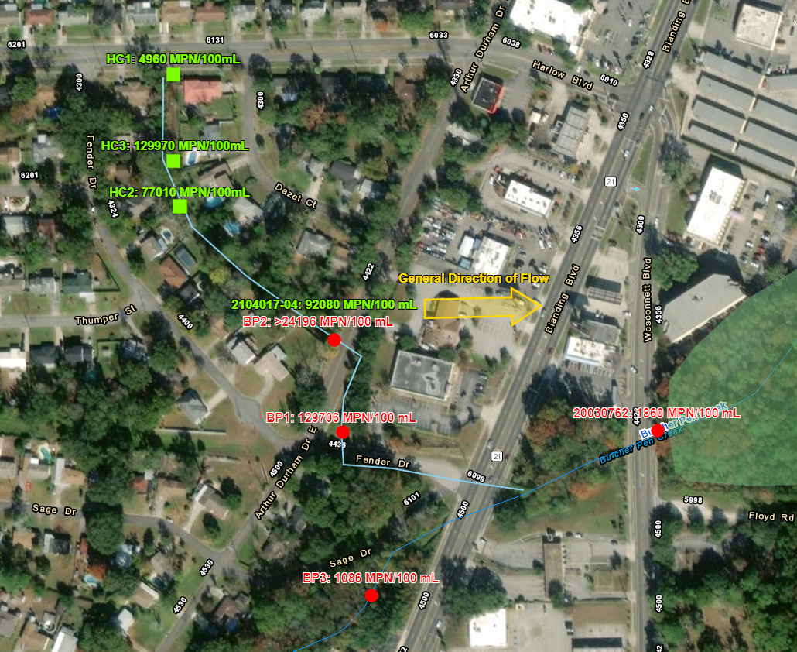
Fig 1. Map of Butcher Pen Creek sampling events on 04/08/2021 (RED) and 04/14/2021 (GREEN).
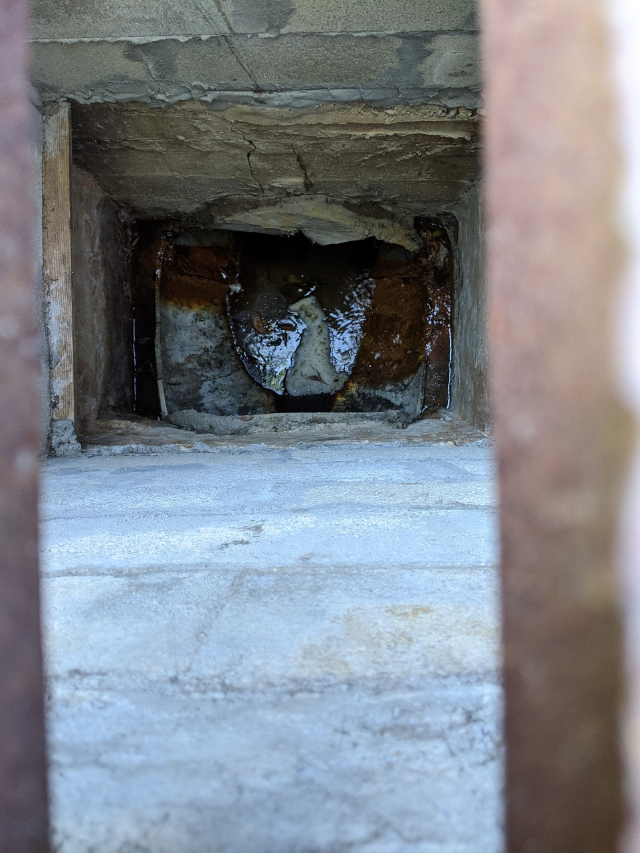
Figure 2. BP1 Storm grate with heavy sewage smell.
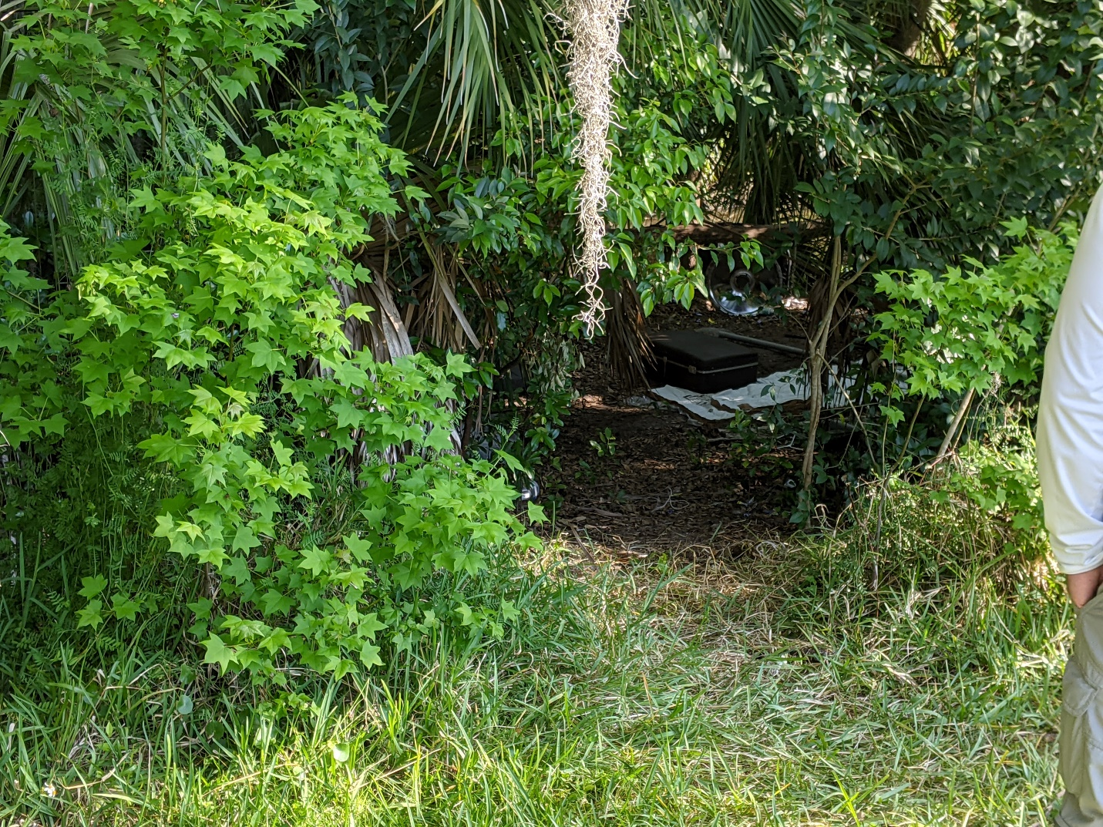
Figure 3. Butcher Pen at Wesconnett. Homeless camp just upstream of site.
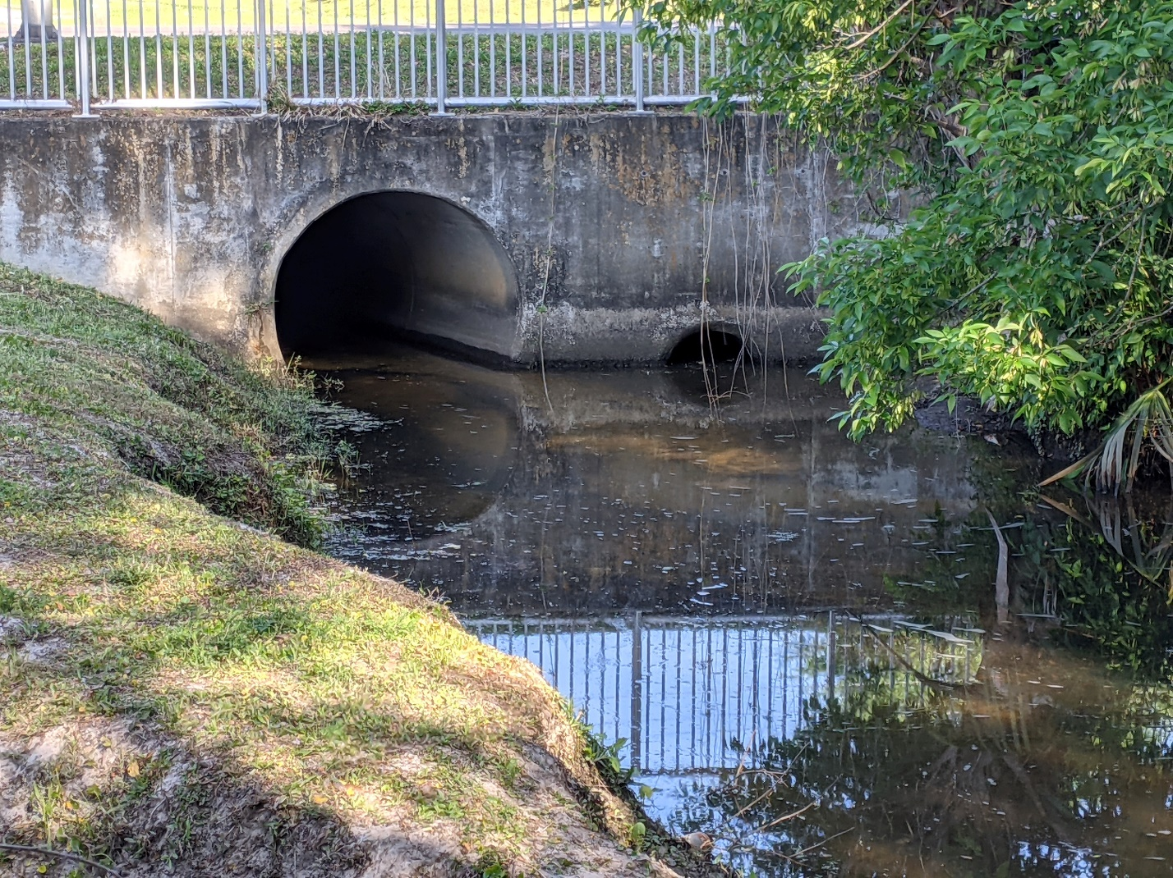
Figure 4. Confluence just above Wesconnett site. The smaller culver connects to storm water coming from BP1 site.

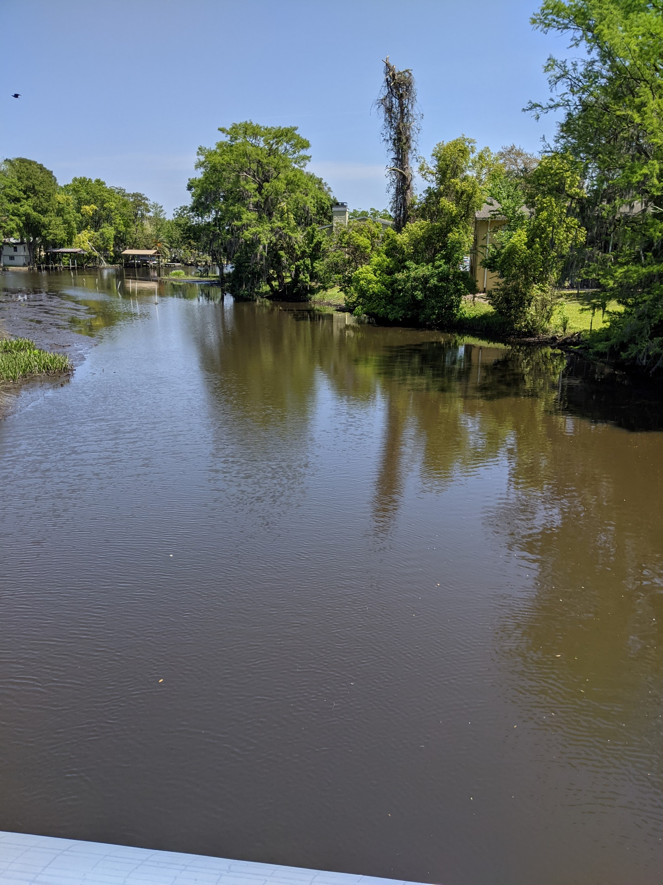
Figure 5. Downstream of Butcher Pen at Confederate.
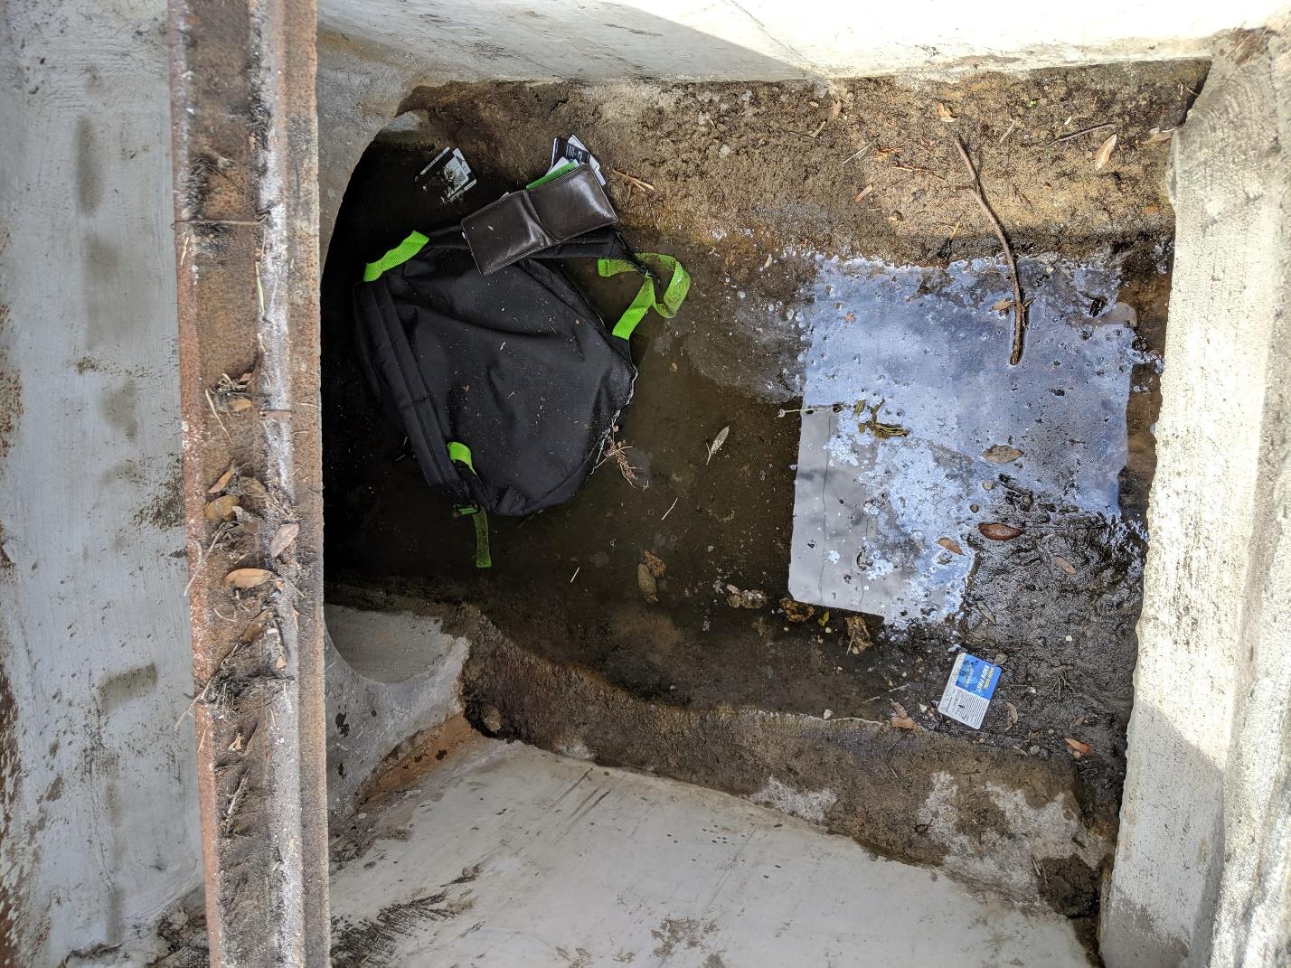
Figure 6. Conveyance at Harlow with back pack and wallet.
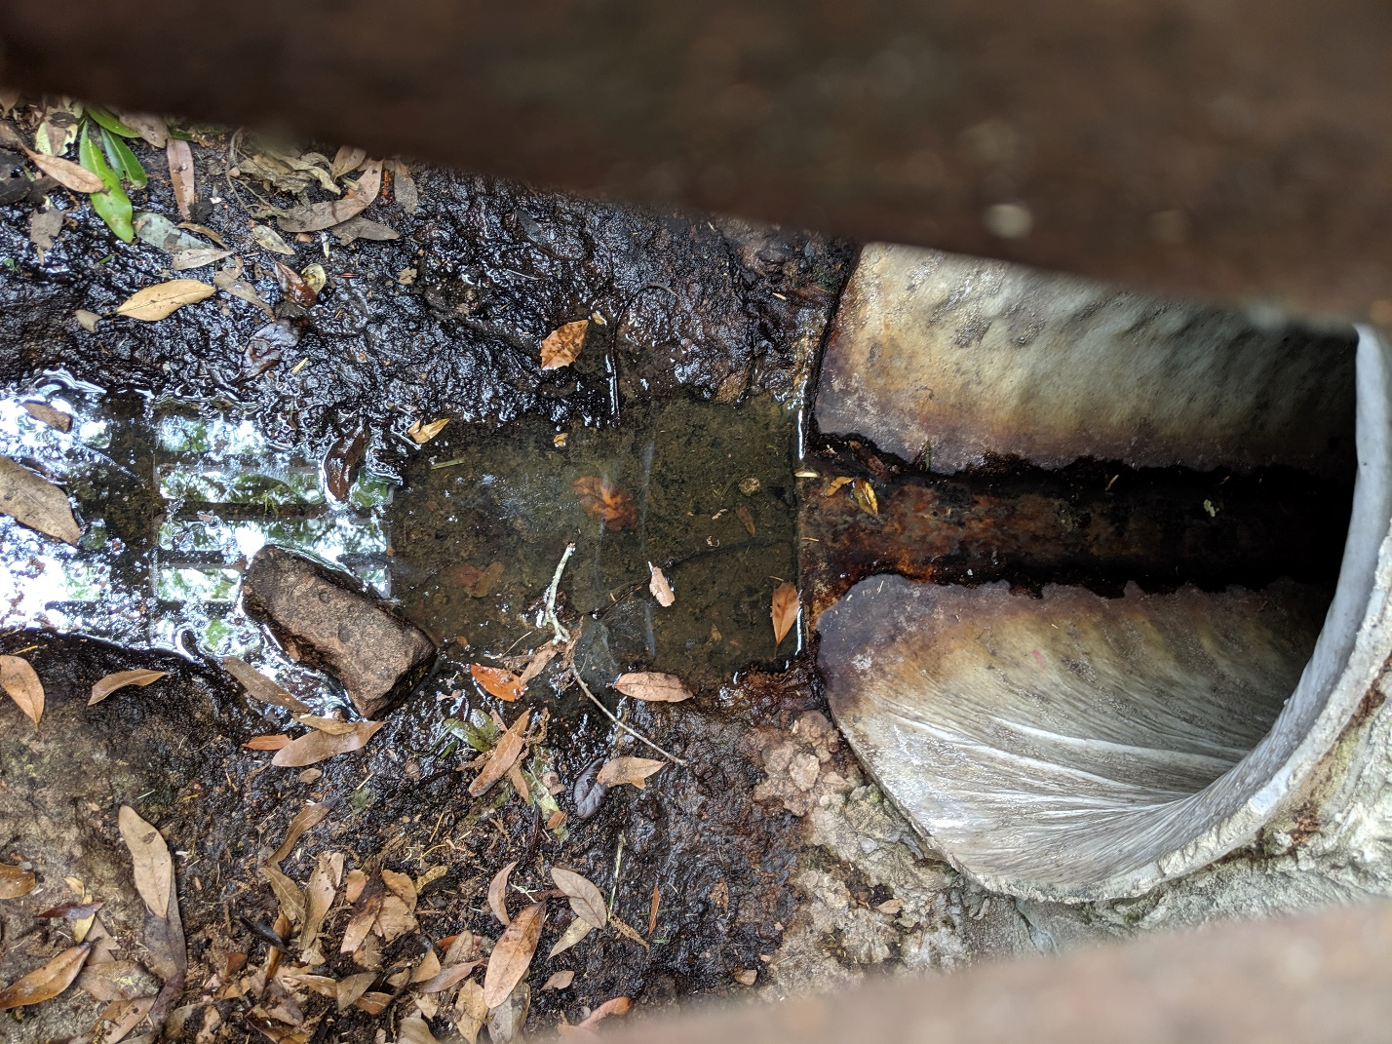
Figure 7. Storm drain at Residence.
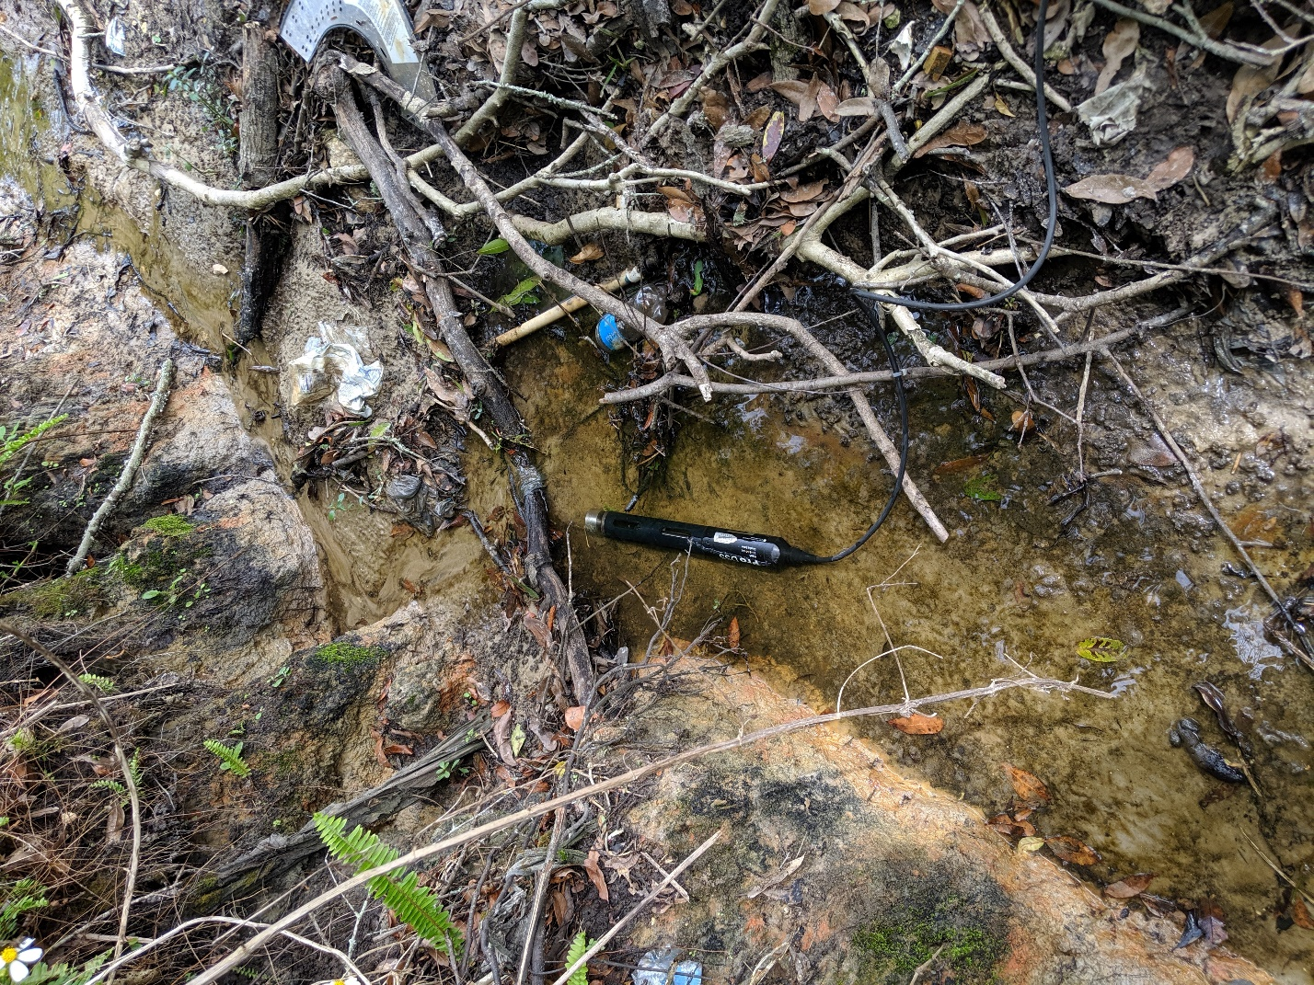
Figure 8. Typical depth of conveyance above Arthur Durham. Very shallow depth. Heavy amount of fecal matter around creek.
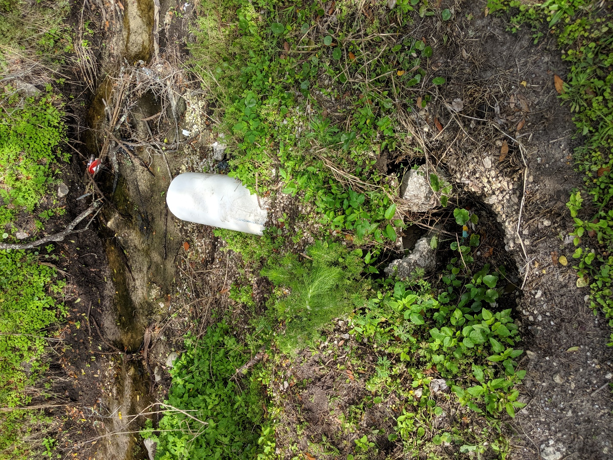
Figure 9 Example of pipe coming out of banks within conveyance.
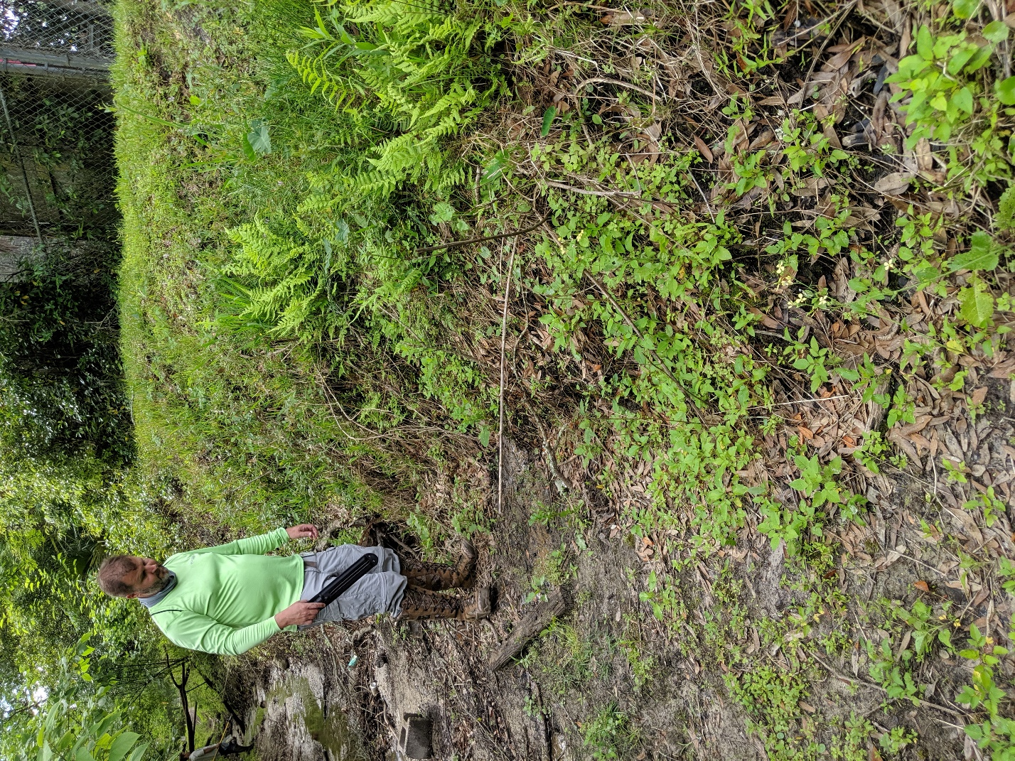
Figure 10. Typical bank for conveyance.

