Julie Espy, Program Administrator
Division of Environmental Assessment and Restoration
Florida Department of Environmental Protection
2600 Blair Stone Road, M.S. 3560
Tallahassee, FL 32399-2400
Date: April 19, 2016

Subject: Request water sampling and analysis for Lake Istokpoga

Dear Ms. Espy:
The Highlands County Board of County Commissioners, through the Lake Istokpoga Management Committee, has been made aware of concerns about harmful algal blooms on Lake Istokpoga. In the LIMC discussion, the potential dangers posed by harmful algal blooms to fish and wildlife to water bodies throughout South Florida were highlighted. Concerns from citizens on the lake, observations by wildlife, water management and environmental protection agencies show a potential for formation of harmful algal blooms in Lake Istokpoga.
The Highlands Count Board of County Commissioners, as recommended by the Lake Istokpoga Management Committee, requests that the FDEP collect and analyze samples once monthly for twelve months, beginning as soon as possible. We request that samples be analyzed for nutrients, algae species, algal toxins and standard water quality parameters including turbidity and color. A map of six suggested sampling stations is attached for your review.
The Board of County Commissioners appreciates the FDEP’s continued efforts to protect our natural resources, and looks forward to continuing the excellent working relationship for water quality monitoring that we have developed.

Sincerely,

James L. Brooks,
Chairman, Highlands County Board of County Commissioners
Attachment
Cc: June Fisher, Administrator, Highlands County Board of County Commissioners,
Senator Denise Grimsley, State Senate - District 21,
Representative Cary Pigman, State House of Representatives - District 55,
Lake Istokpoga Management Committee
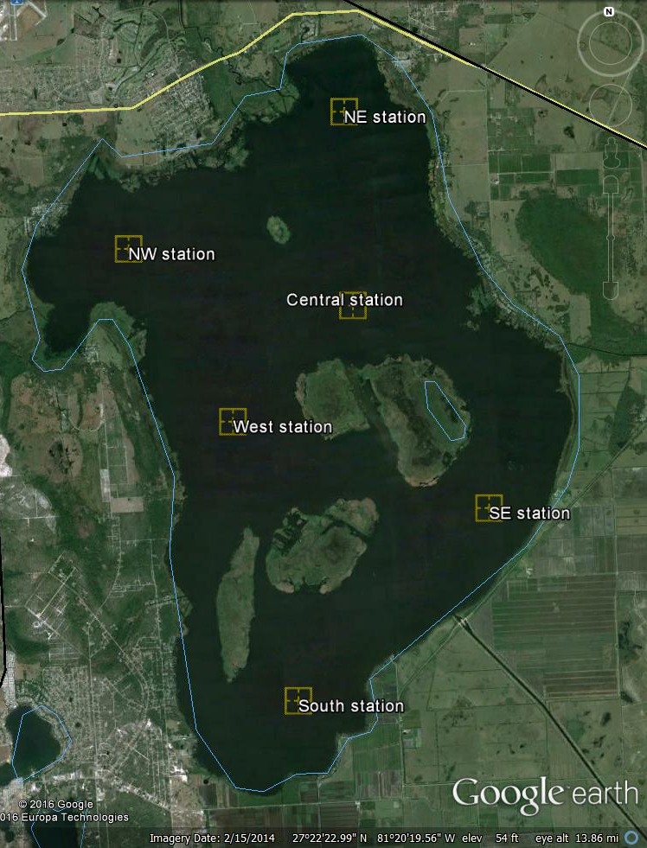
Lake Istokpoga

MAP OF reqUested MONTHLY SAMPLING AT SIX STATIONS ON LAKE ISTOKPOGA FOR DETERMINATION OF ALGAE, ALGAE TOXINS, NUTRIENTS AND WATER QUALITY PARAMETERS IN THE LAKE

