Sampling the Spring Ranch site for Biosolids permit 3/25/2020-JP
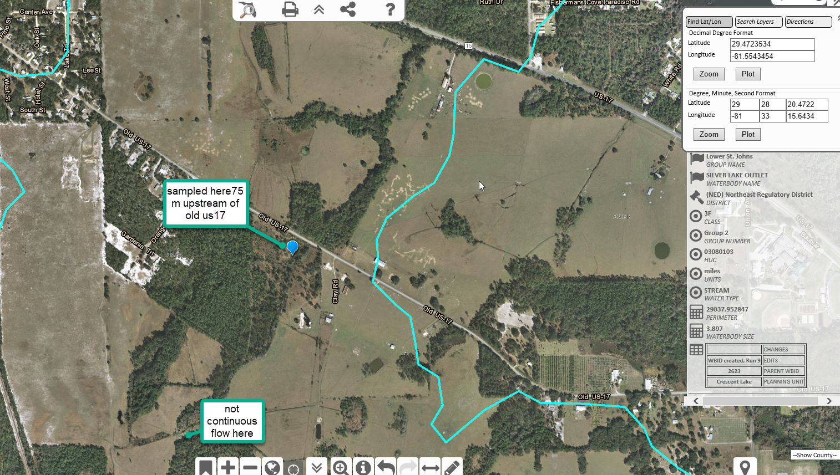

Site one=Downstream site=Silver lake outlet 75m above Old Highway 17=29.472353/-81.554345
Site two=Middle site=Silver lake outlet 0.5 miles above Old Highway 17=29.467076/-81.5579178

Sampled Site one on 3/25/2020,
Did not sample site two, due to no flow on 3/25/2020

