See this site for additional photos
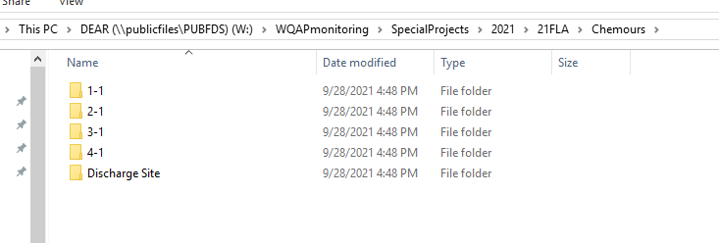

Construction has begun, and future Discharge point -Weir will discharge into this area and flow down to a remnant hole) depicted in map as star area
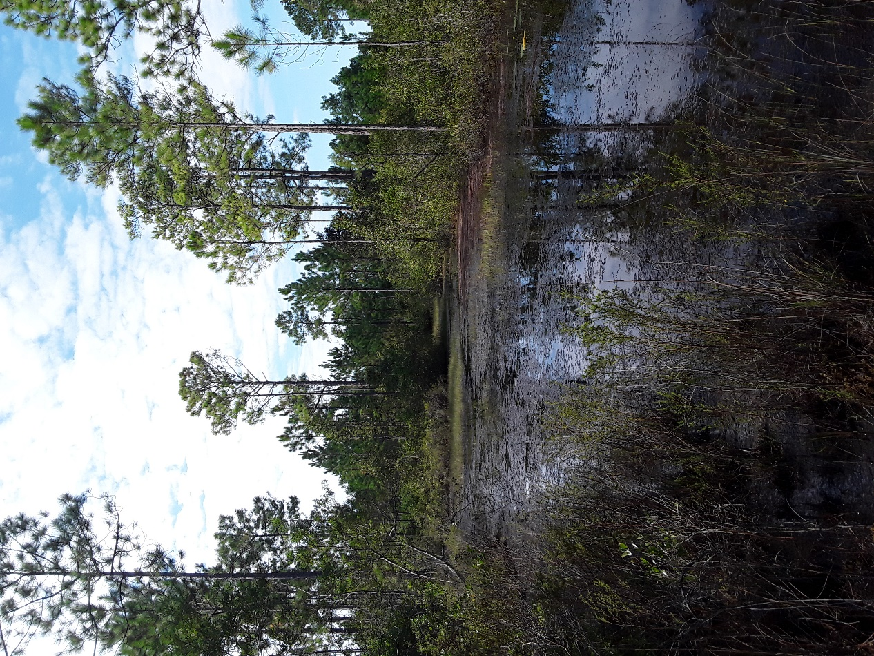

Site 1-1 It was a flowing wetland , due to the amount of vegetation, and lack of banks- No HA done, water meter parameters taken(similar values to downstream 2-1)

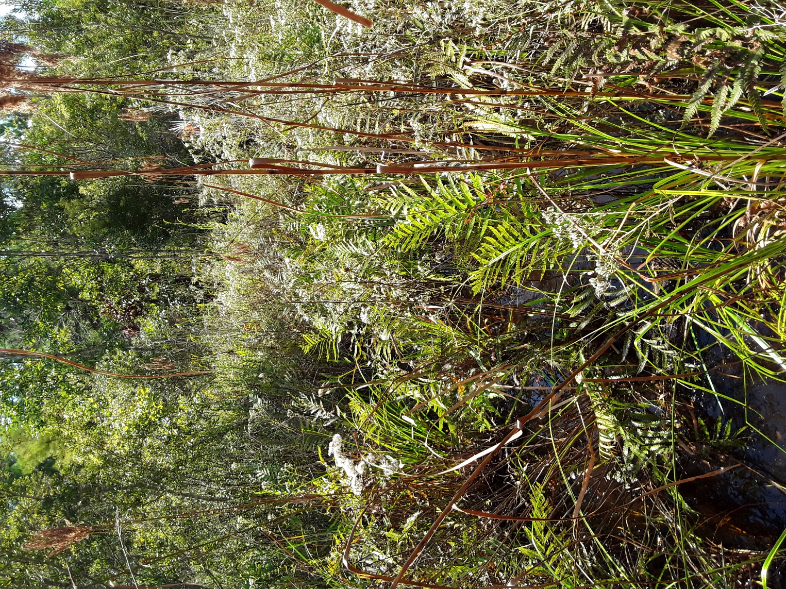

Site 2-1 was a straight line channelized stream- see attached document HA, phys chem

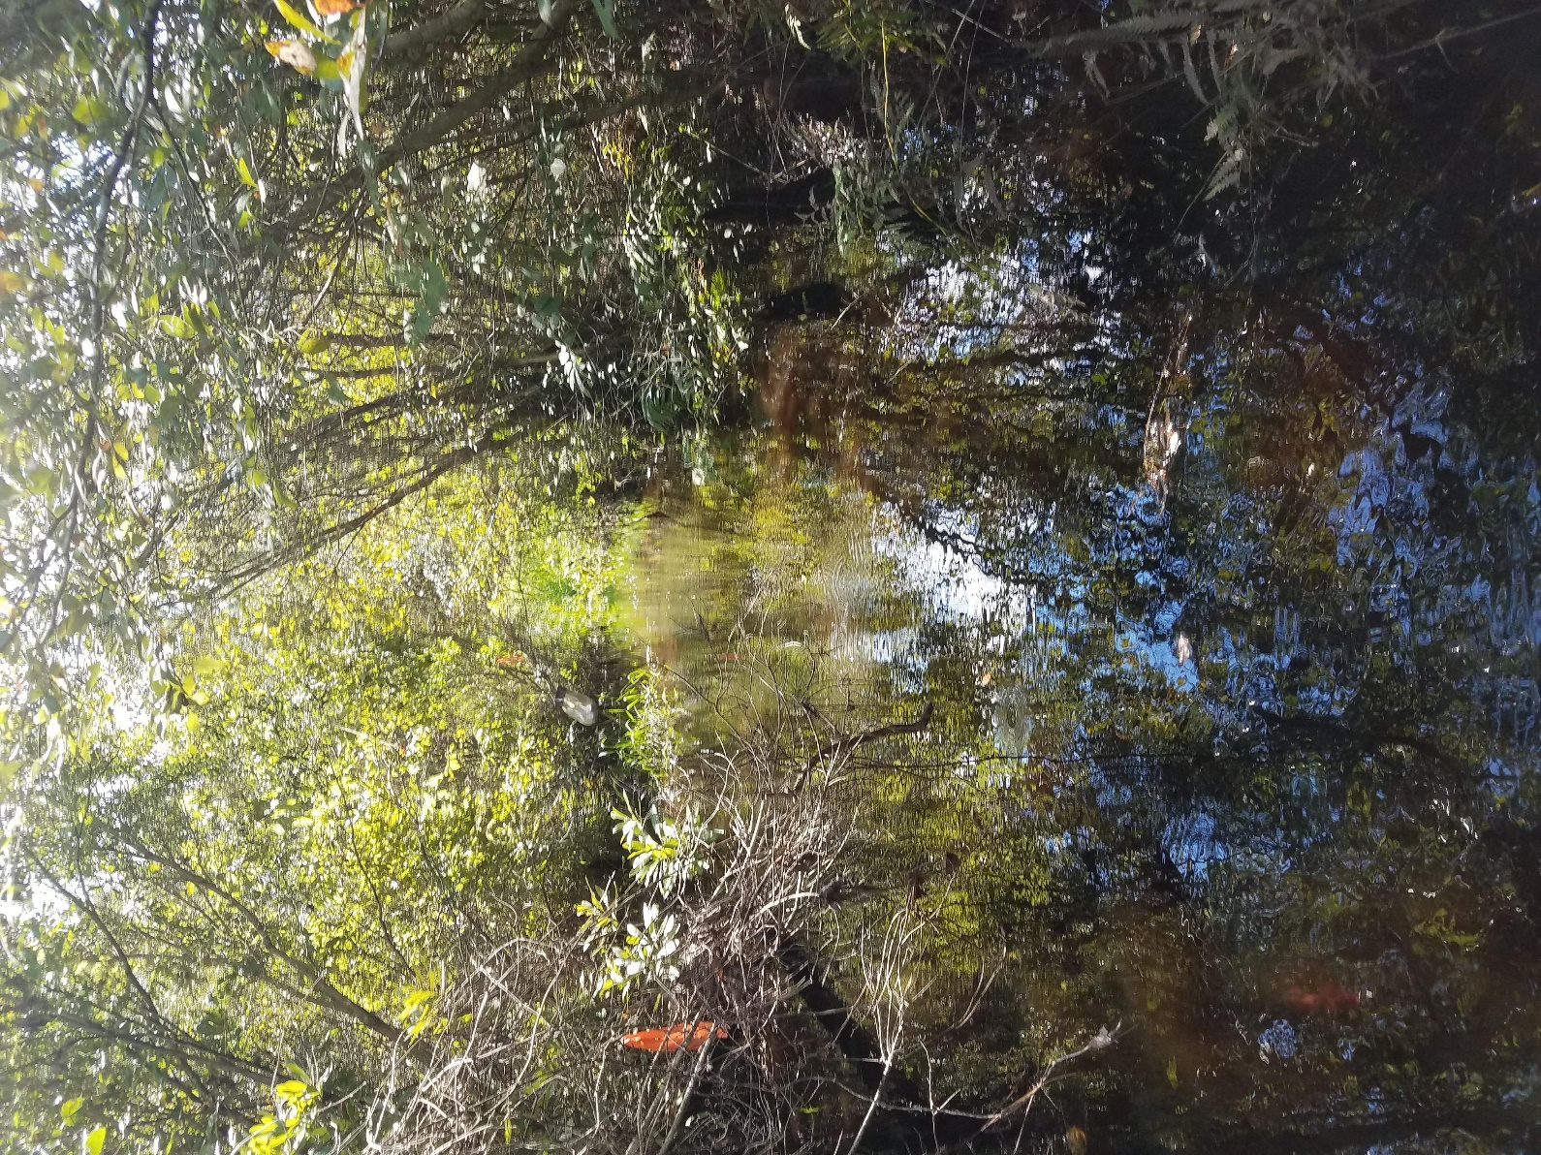

Map

