YSI Pro DSS Calibration Discussion – 07/12/2018
Dissolved Oxygen (DO)
Issue 1:
When calibrating DO, a barometer value is needed. Users have the option to use the barometer reading populated by the meter’s internal sensor, or manually enter a barometer value (usually 760 mmHg).
The meter uses the barometer reading from the internal sensor when making a DO measurement at a field site. This occurs regardless of whether the meter’s barometer reading was used during calibration. Therefore, the meter may be calibrated incorrectly if the barometer value entered was much different than the internal barometer reading.
Field data collected by Mike D. show that barometer value used during calibration does affect DO field readings.
- DO calibrated in field using barometer value of 760mmHg (entered manually). Measured DO at a field site = 7.94 mg/L.
- DO calibrated in field using barometer value of 740mmHg (entered manually). Measured DO at same field site = 8.15 mg/L.
Resolution:
- When calibrating DO, use the barometer reading populated by the meter’s internal sensor. Do not manually enter a barometer value.
- To determine result (pass / fail) of each calibration / verification, use a DO solubility reference chart that lists DO solubility according to temperature and pressure (see attached example, or see https://water.usgs.gov/software/DOTABLES/ for single-value calculator tool or oxygen solubility table creation tool).
- Need to verify accuracy of each sonde’s barometer annually using NIST-traceable barometer. Stephanie will work with Tom B. to coordinate barometer verifications at trainings, ROC Fest meetings, etc.

Issue 2:
DO calibrations in water saturated air are performed using the ODO% method. The DO mg/L is not displayed on the ODO% calibration screen or on the GLP record for ODO% calibration. However, a DO mg/L value must be recorded on the DEP ROC calibration log form.
The DO mg/L is displayed during ODO% calibration when the calibration is performed using a computer instead of the handheld display unit, but most teams do not have computer access in the area of their office / lab where calibrations are performed.
Resolution:
There are two ways to obtain a DO mg/L calibration value:
1) Record the DO mg/L value that is displayed on the main screen immediately after exiting the ODO% calibration screen.
2) Perform DO calibration using ODO% method. Then select the ODO mg/L calibration option, but do not perform the ODO mg/L calibration. Instead, just record the DO mg/L post-cal value displayed at the bottom of the screen.
Update: Hannah spoke with YSI after the group discussion. YSI indicated that both methods should work, but recommends using option 1.

Firmware Updates
Issue:
Guidance needed regarding sonde / probe firmware update frequency.
Resolution:
On a quarterly basis (once every 3 months), all YSI Pro DSS sondes should be checked for firmware updates by connecting them to a computer that has KorDSS software installed.

pH and Specific Conductance
Issue:
Group is seeking guidance on possible techniques for conserving buffer / standard during calibration & verification.
Reusing buffers / standards for rinsing pH or conductivity sensors is not allowed, per DEP SOPs.
Pouring an aliquot of buffer / standard into calibration cup and using it to calibrate or verify multiple sondes is not allowed, per DEP SOPs
YSI Pro DSS probes store calibration information, so it is possible to put multiple pH probes on one sonde and calibrate / verify them at the same time. However, switching the probes frequently may increase the likelihood of accidentally damaging them. Additionally, using this method may present documentation issues because the DEP ROC Calibration Log form is set up to track calibration / verification activities by sonde ID, not by probe ID.
Resolution:
- When calibrating or verifying pH, rinsing with the next buffer is not required. The probe must be rinsed with DI water between buffers, but rinsing with the next pH buffer is optional. If the pH calibration / verification fails or if the meter is having difficulty stabilizing, the probe should be rinsed again, with both DI water and fresh buffer, and the calibration / verification should be reattempted.
Note that the guidance above is for pH only, and does not apply to specific conductance. Specific conductance probes must be rinsed with both DI water and fresh standard before each calibration / verification activity, per DEP SOPs.
- One acceptable method for conserving standard / buffer, is to use a small sample container instead of the calibration cup, when calibrating or verifying pH or specific conductance. A ~125 mL plastic sample container can be used when calibrating / verifying both of these parameters (see photo below).
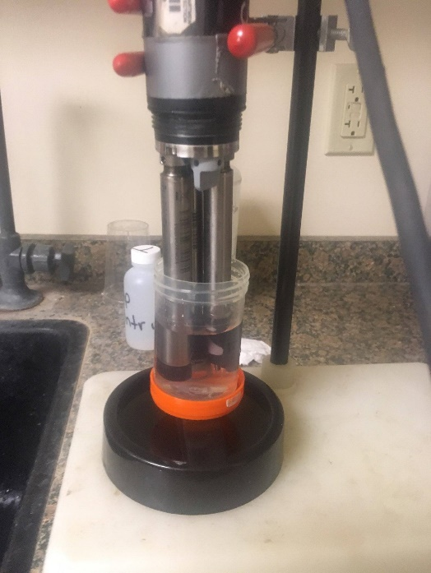
- The amount of standard can be further reduced during specific conductance calibrations / verifications by placing a ~60 mL plastic centrifuge tube over the conductivity/temperature probe. Optionally, the threads on the top of the centrifuge tube can be cut off to make it easier to slide the tube onto the probe (see photos below). Note that this method cannot be used for pH calibrations / verifications because both the pH and conductivity/temperature probes must be submerged in pH buffer to achieve the most accurate readings.
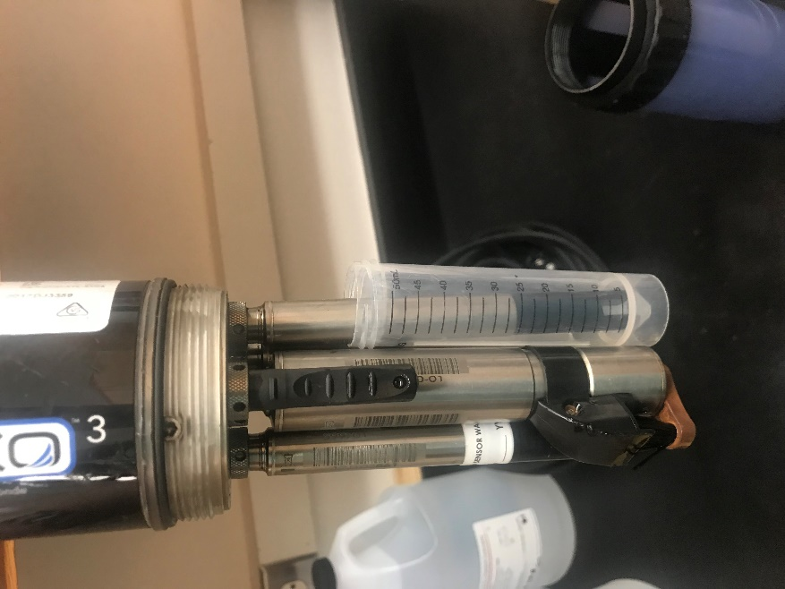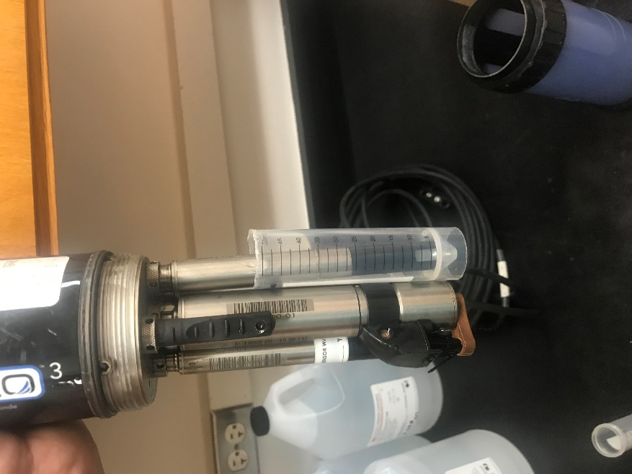

DEP ROC Calibration Log Form
Issue:
Additional space on the form is needed to record meter’s barometer reading during each DO calibration / verification. Modifications were also requested to the depth sensor sections, to help document which device is being used to measure total depth. Additional modifications were also made to pH section, to allow users to record temperature for each activity and to more easily document temperature-adjusted pH buffer values.
Resolution:
A new version of the DEP ROC daily YSI calibration log is being drafted (see attached). The new version of the form is dated August 1, 2018.
Note that calibration location information at top of form was removed to make space for requested changes. This information was redundant with space provided to document location of each activity (lab / field).

