SharePoint Standard/Reagent Log How-To

PART 1: Adding New Standards
This step needs to be done when new standards are brought into the office.
Step 1: logon to the WQAP SharePoint Main page
Step 2: select the “Standard and Reagent Log”
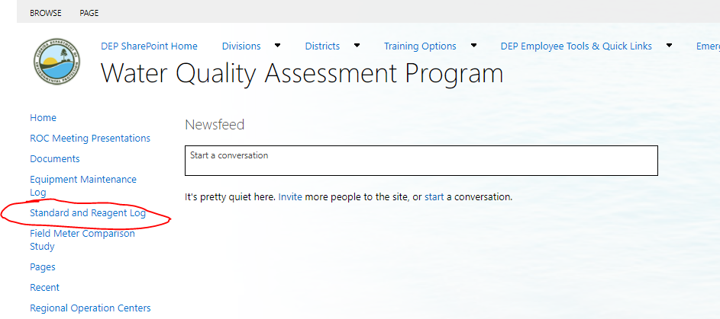
Step 3: Click on “+ new item”

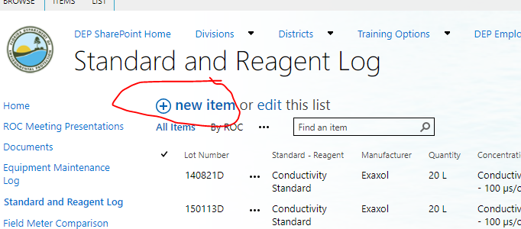

Step 4: Enter the information required into the fields. This information is available on the label of the standards.
Step 5: Once you reach the “Certificate Section” Obtain the Certificate of Analysis for the standard.
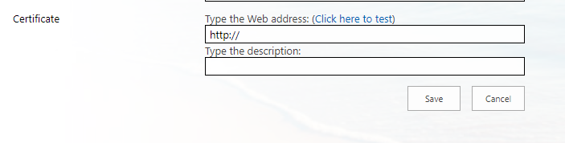

- For RICCA it is at: https://www.riccachemical.com/ . Select the “Certificate of Analysis” option on the right hand side of the screen and enter the lot number in the space provided.
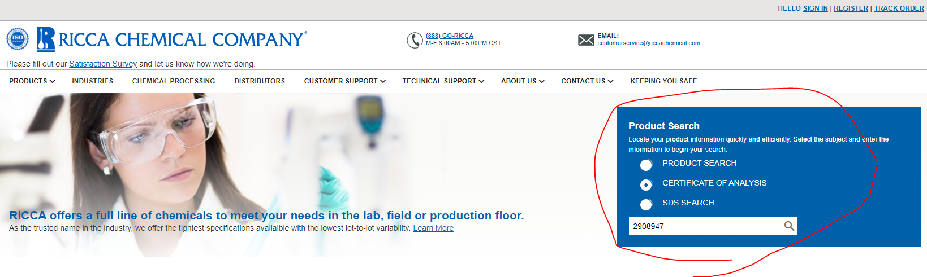
- For Fischer go to: https://www.fishersci.com/us/en/catalog/search/certificates.html. Enter the information needed. The Catalog Number(along with lot number) is on the label of the standard. For document type, select “Certificate of Analysis”.
Step 6: Download the Certificate of Analysis to \\fldep1\DEAR\WQAP\Sol_Z\Tampa\COAs.
Step 7: Copy the location of the file and paste it into where it says “type the web address” (I know it says web address, but they want the file downloaded into our folder).
Step 8: For description, type “Certificate of Analysis”.
Step 9: Click “Save”

PART 2: EDITING STANDARD ENTRIES
This will need to be done once a standard is opened or thrown away
Step 1: Follow Steps 1 and 2 in Part 1 of the document.
Step 2: Type the standard lot number into the search bar.
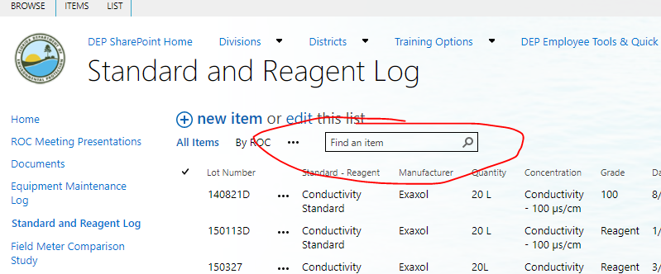

Step 3: Click on the lot number on the left side of the screen.
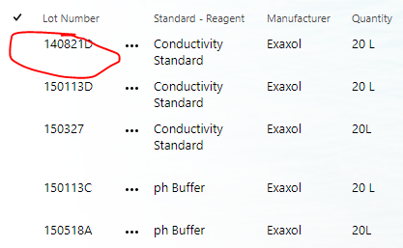

Step 4: Click “edit item” on the left side of the screen to open the form.
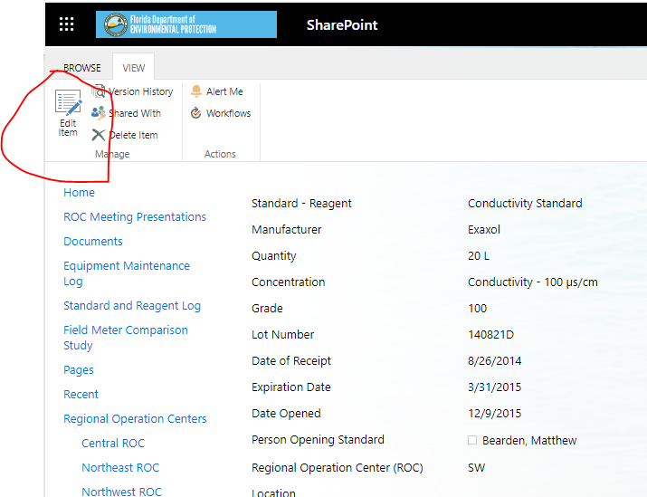

Step 5: Enter the date and the name of the person opening the standard in the fields provided. If the standard has expired and has been thrown away, fill in those fields.
Step 6: Save the form and exit the screen.

