Z1-SL-12020. Z1-SL-12020 (Private Lake). Vernon, FL 09/20/2018
Unknown Creeping. Submerged. Section 8). This portion of lake inundated bu downstream dam consturcted approx. 2 years ago (2016)
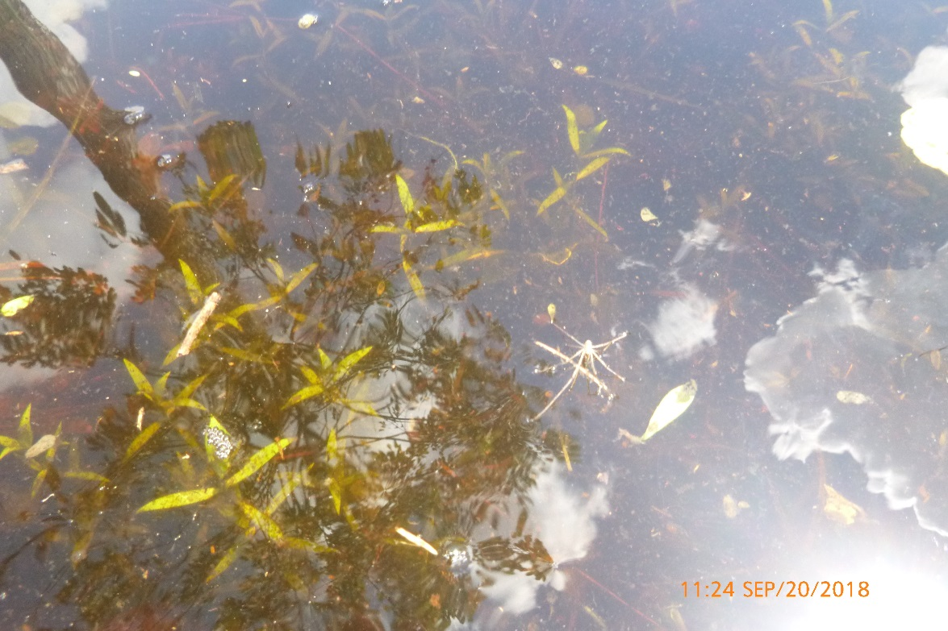

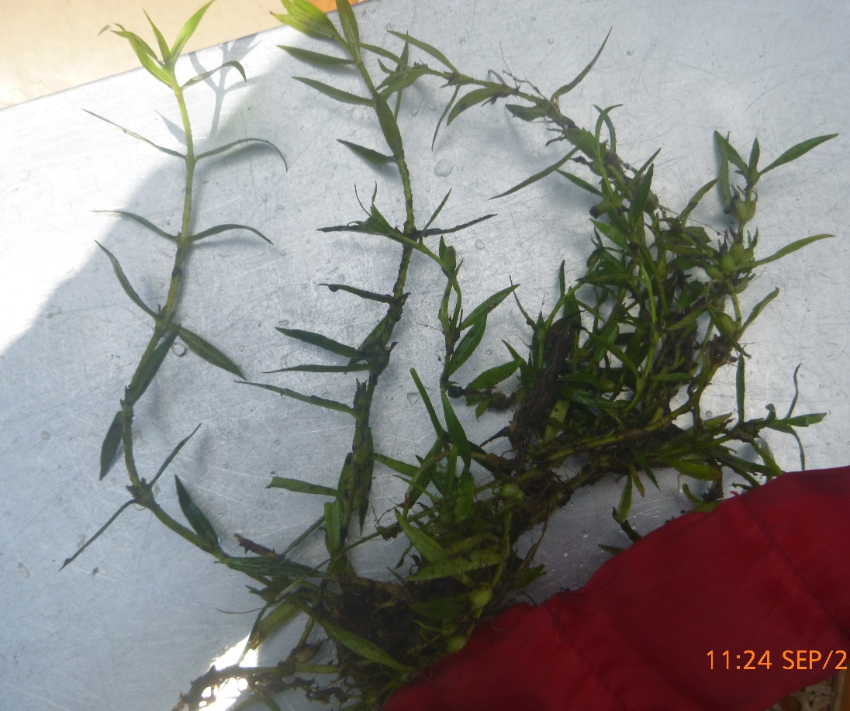
Z1-SL-12020. Z1-SL-12020 (Private Lake). Vernon, FL 09/20/2018
