Stream Condition Index 2019 WBID 2987B, Little Wekiva (West)
Todd or Ellen Vallancourt, 99 Horse Lovers Ln, Altamonte Springs, FL
Contact Ahead or need Code?
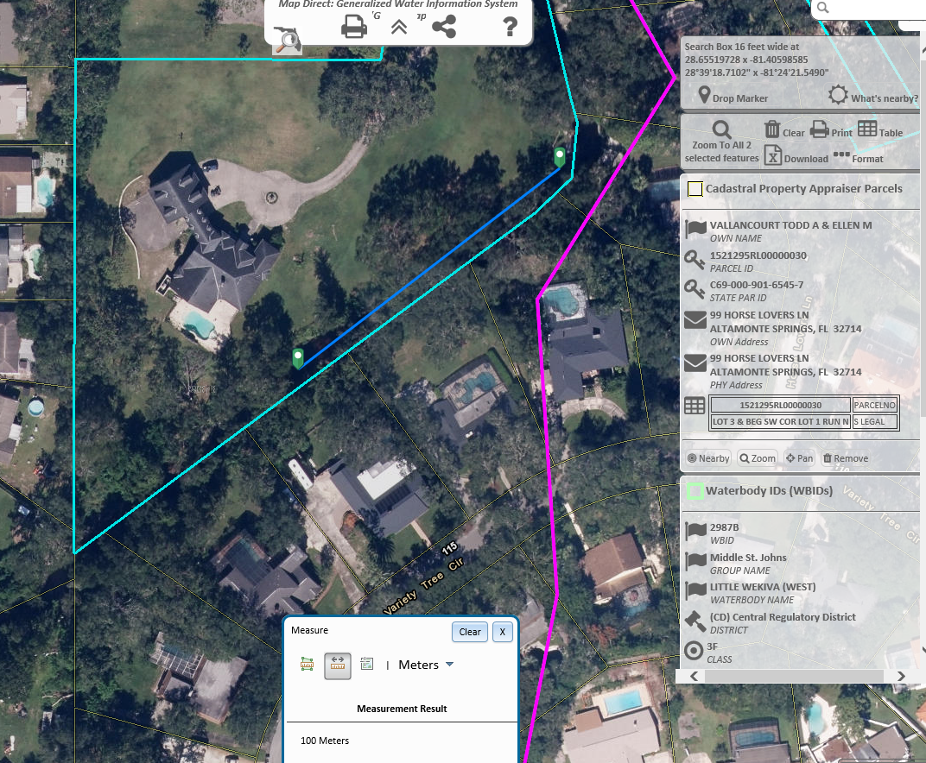

Super Lite Aluminum Products Inc located in Altamonte Springs, FL

(407) 682-2121

1090 Rainer Dr
Altamonte Springs, FL 32714

