WBID 3006 Roberts Branch
SCI Recon Notes
Site notes:
Previous SCIs
Station | Date | SCI Score | Water Level ft (Econ) | Discharge FT3/S (Econ)
20010333 | 07/22/2010 | 74 A | 1.86 | 106
20010333 | 03/11/2010 | 60 A | 2.67 | 163
20010333 | 10/29/2009 | 63 A | 2.29 | 103
20010333 | 10/14/2008 | 72 A | 10.06 | 1380
20010333 | 03/18/2008 | 71 A | 3.8 | 260
20010333 | 03/28/2006 | 61 | n/a | 48
SEM426LV | 12/20/2005 | 62 | n/a | 279
SEM426LV | 06/27/2005 | 42 | n/a | 1,240

Nearest Gauge Location: ECONLOCKHATCHEE RIVER NEAR CHULUOTA, FL

Project: SMP
WBID: 3006
Description: Roberts Branch @ Curryville Rd
WIN Station: G3CE0011
County: Seminole
Lat: 28.62292019
Long: -81.06677062
SMP: 1 SCI
Remaining Visits: 5

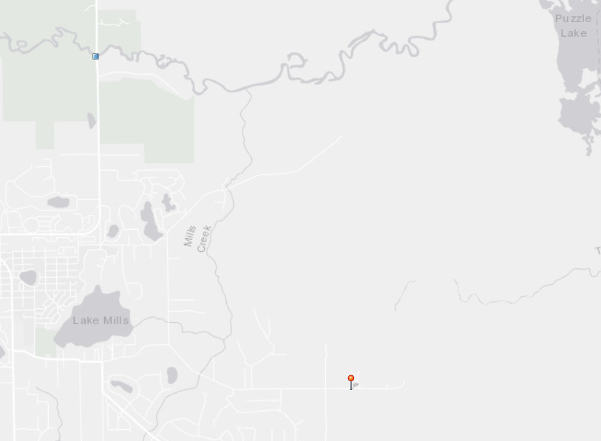

Water Level and Discharge

January 2017 to April 2019

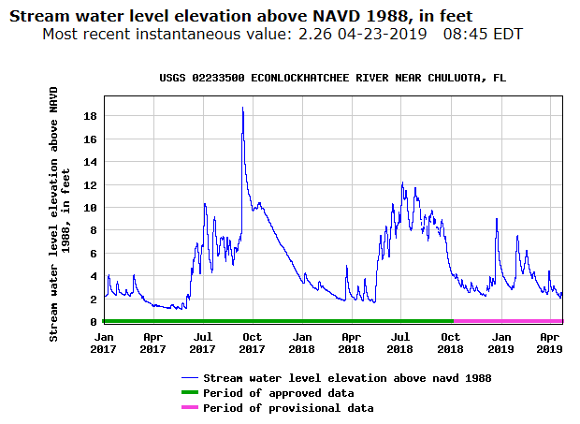
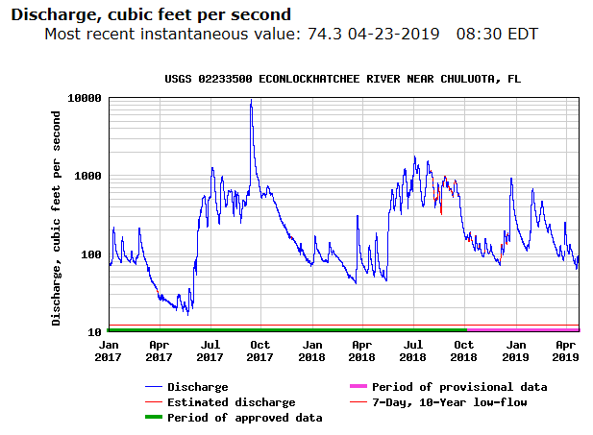

Water Level and Discharge

January 2018 to April 2019

