WBID 3037 Crabgrass Creek
SCI Recon Notes
Site notes:
- Extremely low to no flow April through May.
- Monitor flow asap to determine best date for SCI.
Previous SCIs
Station | Date | SCI Score | Water Level | Discharge
OSC686LV | 02/05/2007 | 69 A | 37.91 | 8.31
USJ055 | 01/03/2005 | 32 | 37.75 | 6.48
20010045 | 07/29/2003 | 15 | 38.80 | 53
20010045 | 03/03/2003 | 31 | 38.47 | 24.60

Gauge Location: Crabgrass Creek at 192 near G3CE0008.

Project: SMP
WBID: 3073
Description: Crabgrass Crk @ 87m S of Highway 192 Bridge
WIN Station: G3CE0008
County: Osceola
Lat: 28.12946
Long: -81.00116
SMP: 1 SCI
Remaining Visits: 1

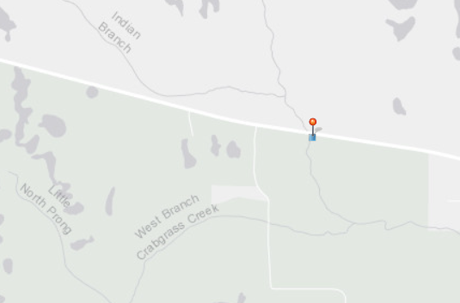

Water Level and Discharge

January 2017 to April 2019

Water Level and Discharge

January 2018 to April 2019

