SMP Tracker – 2021 Changes/Upgrades
December 14, 2020
2021 Tab:
- New Sampling Requirements Column (J)
  - PhysChem row added for stream bioassessments
  - Phytoplankton is a new bottle for 2021. 19 WBIDs in the peninsula.
  - W-DIELDRIN is a new pesticide bottle. W-DEILDRIN is to be included with the pesticide suite. 14 stations have W-DIELDRIN specific requirements
  - Lab specific micro rows have been added and replace the generic E. coli, Enterococci, and Fecal Coliform row used in the past. If the wrong lab is listed let Curtis know and he will edit it.
- Sample Size/Frequency Notes (Minimum) Column (M)
  - NNC season requirements request for bioassessments (RPS/LVS) and PCR in a few select stations. See Season 1 Count and Season 2 Count columns (BY & BZ) also.
  - Monthly requirement, n=10. Some stations have a monthly monitoring requirement but only 10 samples request. To give you the sampler a bit of wiggle room the sample size is 10, not 12.
  - Bimonthly = every other month.
  - Some stations have quarter requirements.
  - Microbiology at continuous monitoring stations; n = 10, Days = 10; Pair with Sond deployment and Pickup. Microbiology samples should be collected with sone deployment and retrieval even if the two even are not a week or more apart. Notice there is a “Days” requirement and not a “Weeks” requirement.
- Station ID Column (N)
  - This year and all future SMP are station specific. Sample collection needs to be tracked by station and not by WBID.
  - Some WBIDs will have multiple rows for the same analyte group (ex. Nutrients).
  - A temporary Station ID (Format: New-ROC-##) has been used as a place holder until a G# is created in WIN. See the New Stations Tab. Let Curtis know when new stations are created in WIN and he will replace the temporary station IDs with the new WIN G#s.
  - Two 21FLGW Trend stations are in this column also as temporary place holders too. One in NW, one in TLHR regions. These will need to be replaced with SMP WIN G#s also.
- Week Count Column (BX):
  - Counts the number of events that are from different calendar weeks.
  - Only rows with a week requirement will have a numeric value in this column. Rows without a week requirement will be populated with a “-“.
- Season 1, Season 2 Count Columns (BY & BZ):
  - Counts the number of events that are from each NNC Nutrient Season.
  - Only rows with a NNC Seasonal requirements will have a numeric value in this column. Rows without NNC Seasonal requirements will be populated with a “-“.
Kit/Analytes Tab:
The Kit/Analytes tab was not added to the 2021 trackers. One version of the SMP analytes is saved in 2021 SMP FTP folder.
See the notes highlighted in yellow in the SMP analytes spreadsheet for changes. Please update your LIMS Scheduled templates.
- W-DILEDRIN is a new pesticide test for 2021.
- Phytoplankton is a new analyte suit for 2021. There are 7 LIMS test codes, 4 matrix biological, 3 matrix water.
- The metals analyte suites (W-ICP, W-ICPMS) been tweaked a bit.
QC Tracking Tab:
- Field blanks and equipment blanks (QC blanks) collected for SMP must be tracked by month in the cells in the top half of the page. Tracking QC blanks was optional in 2020. In 2021 tracking QC blanks is a program requirment.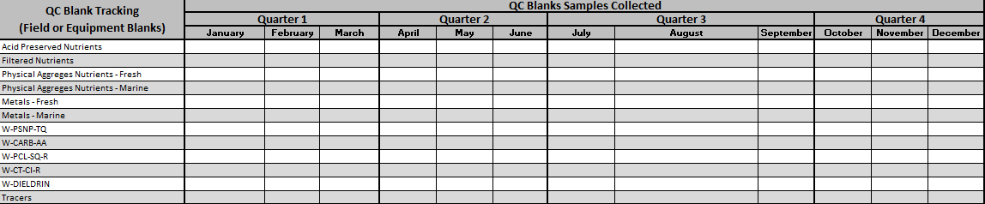
- The required number of QC blanks is calaulated and displayed in the bottom half of this page. 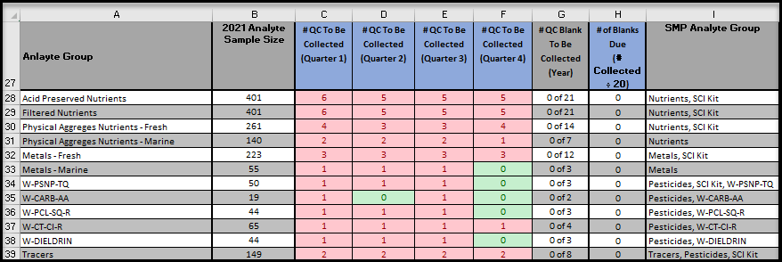
  - Columns C – F display the number of QC blank required per quarter, per analyte group.
  - Column H will be populated with a value > 0 if 20 or more samples have been collected since the last QC blank
  - The numeric values entered in the cells in the top half of the page will be subtracted from the corresponding values (quarter, analyte group) in the bottom half of the page.
- Until further notice field replicate samples are not required and should not be collected for the SMP.
Scheduling Tool Tab: No change, same as 2020 scheduling tool. Not required.
Summary Tab: No change same as 2020 summary tab.
New Stations Tab: The list of new stations with their coordinates. Will be used to cross reference the temporary station IDs with the new WIN G#s.

