
FLORIDA DEPARTMENT OF ENVIRONMENTAL PROTECTION STRATEGIC MONITORING PROGRAM FIELD SHEET
Meter Passed End of Day CCV
Yes / No
January 2020

WIN Station Name: |  |  | Peace River Estuary @ Harbour Heights |  |  |  |  |  |  |  |  |  | Date: | 2/2/2021
WIN/Field ID: |  | G3SD0148 |  |  | WBID: | 2056C2 |  |  |  | ENR: | ENRD8 | Latitude:  26.9889
County: | CHARLOTTE |  |  |  |  |  | Org ID: |  | 21FLFTM |  |  | Longitude: |  |  |  | -81.994
Receiving Body of Water: |  |  |  | Sarasota Bay - Peace - Myakka |  |  |  |  |  |  |  | RQ- |  |  | 2021-1-25-50

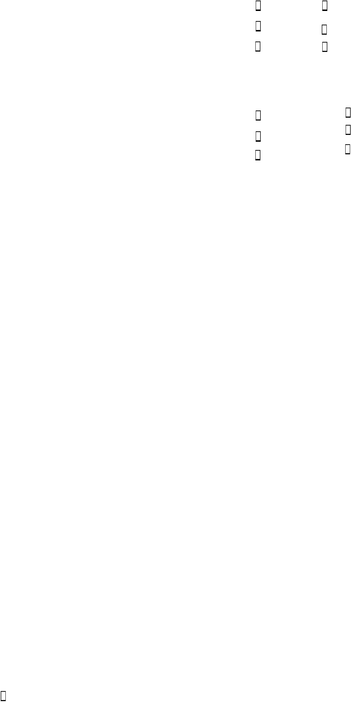

X

X
X
Depth measured with: Secchi
Secchi Equipment ID: 3312B
Sample Container Carboy
Dipper Van Dorn
Syringe Pole
Canoe/Kayak Electric Motor
Gasoline Motor
Wading From Shore
Other
Collection Method
Sampling Equipment
Sampling Team Members | WQ Measurements  X | Sample Collection | Documentation  X | Preservation  X | Preservation Check
Kirby Wolfe  X  X |  | X
Miranda Carroll

X
SNEK
Tide Times:
High:

X
Normal Low High Dry Pooled Flooded
Tide:
Flow:
Meter ID#
Water Level:
Photos:

Low:

N/A
Flow
No

X

Biological Samples Collected:
None
HA
SCI
RPS
Algae ID
LVS
LVI
Other:

SBIO ID Numbers:

Notes:

Duplicate Sample

(WIN ID_DUP)
Time:
Time Zone: EST

Field ID: N/A

(Blank Type_DDMMYYYY)

WIN DMT Activity ID:

Blank
Time Zone:

Time:

Field ID:

DI Source:
DI Type:

Location:
Equipment ID:

DI Container (Name/ID): __ _ DI Container Type:

LIMS EVENT ID: WIN Import ID:
Enter Field Parameters, Verify Station ID In LIMS DMT: QC Station ID, Field Parameters In LIMS DMT:
(Initials/Date) (Initials/Date)

Scan/Save Field Sheets Migrate Data to WIN: Verify Data In WIN:

(Initials/Date)
(Initials/Date)
(Initials/Date)

RQ-2021-1-25-50 Collected By: Kirby Wolfe, Miranda Carroll

Customer: WQAP Project ID: SMP
Field Report Prepared By: Kirby Wolfe Sampling Agency: FDEP
WIN ID/Field ID: *G3SD0148*

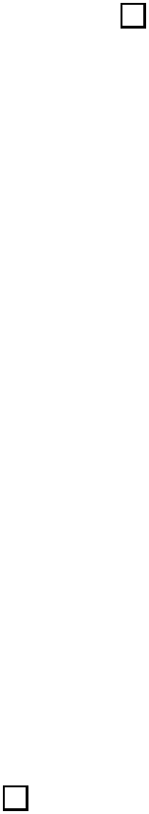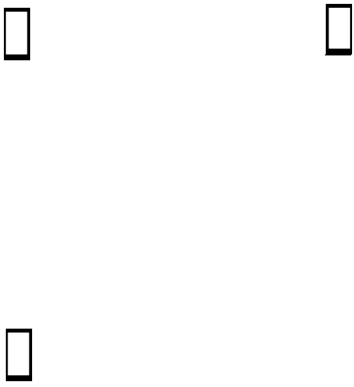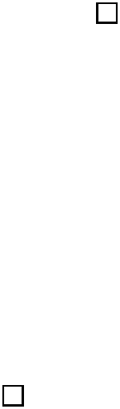
Place Label Here  G3SD0148  Location:  Peace River Estuary @ Harbour Heights |  |  |  |  |  |  |  |  |  |  |  |  |  |  |  |  |  |  |  | Comments: Microbiology sample(s) submitted to contract laboratory  X
Matrix: Marine |  |  |  |  |  |  |  |  |  |  |  |  |  |  |  |  |  |  |  | (Check one) |  |  |  | GRAB |  | COMPOSITE
Date | Time | DO  (mg/L) |  |  |  | DO (%SAT) |  |  |  | Temp. (C⁰) |  |  |  | pH |  |  |  |  | Sample Depth (m) |  |  | Secchi Disk (m) |  |  | Total Depth (m) | Sp COND  (µmhos/cm) | Salinity (PPTh)
2/2/2021 | 1335  EST | 8.91 |  |  |  | 97.9 |  |  |  | 18.6 |  |  |  | 7.64 |  |  |  |  | 0.15 |  |  | 0.3  VOB (S)  X |  |  | 0.3 | 8351 | 4.67
 | Central Lab please use top row for login purposes
 | EST
Parameter Suite |  |  | Parameter Methods |  |  |  |  |  |  |  |  |  |  |  |  |  |  |  |  |  | Preservation |  |  |  | pH Check | # Bottles  sent to Lab | Bottle  Group
Preserved Nutrients (P-500ML) |  |  | W-NH3 / W-NO2NO3 / W-TKN / W-TOC / W-S-A-TP  X |  |  |  |  |  |  |  |  |  |  |  |  |  |  |  |  |  | X  X  Ice |  | H2SO₄* |  | <2  X | 1 | C
 |  |  | Lot # |  |  |  | SA0038110 |  |  |  |  |  |  |  | Exp: |  |  |  |  |  | 2/7/21
Metals  (P-500ML) |  |  |  W-ICPMS W-ICP  W-HARD |  |  |  |  |  |  |  |  |  |  |  |  |  |  |  |  |  | Ice |  | HNO₃* |  | <2
 |  |  | Lot #  X |  |  |  | X |  |  |  |  |  |  |  | Exp: |  |  |  |  |  | X
Filtered Nutrients (P125ML) |  |  |  W-PO4-F Field Filtered 0.45 µm Filter  17024971 |  |  |  |  |  |  |  |  |  |  |  |  |  |  |  |  |  | Ice |  |  |  |  | C  1
 |  |  | Filter  Lot # |  |  |  | 0118593
Syringe
Lot #
Chlorophyll  (BP-1L) |  |  | CHLSUITE-W  X |  |  |  |  |  |  |  |  |  |  |  |  |  |  |  |  |  | Ice  X |  |  |  |  | 1 | C
Physical/Aggregate (Fresh)  (P-1L) |  |  |  |  | Alkalinity / W‐F / W‐TSS / TURBIDITY / W‐Cl‐IC / W‐COLOR / TDS |  |  |  |  |  |  |  |  |  |  |  | W‐SO4‐IC / W‐ |  |  |  | Ice
Physical/Aggregate (Marine)  (P-1L) |  |  | X  Alkalinity / W-BR-IC / W-F / W-TSS / TURBIDITY |  |  |  |  |  |  |  |  |  |  |  |  |  |  |  |  |  | X  Ice |  |  |  |  | 1 | C
Macroinvertebrates  (PJ-2L) |  |  | MI-FW-QLDC |  |  |  |  |  |  |  |  |  |  |  |  |  |  |  |  |  | Formalin
Periphyton  (PT-50ML) |  |  | ALGAE-ID  X |  |  |  |  |  |  |  |  |  |  |  |  |  |  |  |  |  |  Ice
Microbiology  (Contract Lab Bottle) |  |  | E Coli F Coli Enterococci Contract Lab  X |  |  |  |  |  |  |  |  |  |  |  |  |  |  |  |  |  | Ice  X |  |  |  |  | 1 | C
Molecular  (QPCR-P-500ML) |  |  | PCR-HF183 PCR-BacR PCR-DG3  PCR-GULL2 PCR-GFD |  |  |  |  |  |  |  |  |  |  |  |  |  |  |  |  |  | Ice
Tracers  (BG-500ML) |  |  | W-E8321-DI W-E8321-MS |  |  |  |  |  |  |  |  |  |  |  |  |  |  |  |  |  | Ice
Pesticides  (BG-500ML) (BG-1L) |  |  |  | W-E8321-DI |  |  |  |  | WE8321-MS |  |  |  | W-PSNP-TQ |  |  |  |  | W-CT-CL-R |  |  | Ice
 |  |  |  | W-PCL-SQ-R |  |  |  |  | W-CARB-AA ( 5 ml of MCAA** Buffer Solution) |  |  |  |  |  |  |  |  | W-DIELDRIN
Phytoplankton/Periphyton |  |  |  | DTM-QL-C |  |  |  |  | PEN-QL-C |  |  |  | DTY-QN-C |  |  |  |  | PKD-QN-C |  |  |  Ice
 |  |  |  | DTM-QN-C |  |  |  |  | PRN-QN-C |  |  |  | PKD-QN-BV
Name:  Kirby Wolfe  Miranda Carroll |  |  |  |  |  |  |  |  |  |  | Signature: |  |  |  |  |  |  |  |  |  |  |  |  |  |  | Date:
*2.0 ml of Preservative used unless noted otherwise.
**MCAA: Monochloroacetic acid buffer solution

